

[Egyptian Informatics Journal (2013) 14, 79–88](http://dx.doi.org/10.1016/j.eij.2013.02.002)

Cairo University

Egyptian Informatics Journal

[www.elsevier.com/locate/eij](http://www.elsevier.com/locate/eij) [www.sciencedirect.com](http://www.sciencedirect.com/science/journal/11108665)

ORIGINAL ARTICLE

On determining eﬃcient finite mixture models with compact and essential components for clustering data

Ahmed R. Abas *

*Department of Computer Science, College of Computer in Leith, Umm Al-Qura University, Makka Al-Mukarrama, Saudi Arabia Department of Computer Science, Faculty of Computers and Informatics, Zagazig University, Zagazig, Egypt*

Received 25 June 2012; revised 19 January 2013; accepted 11 February 2013

Available online 13 March 2013

Abstract In this paper, an algorithm is proposed to learn and evaluate different finite mixture models (FMMs) for data clustering using a new proposed criterion. The FMM corresponds to the minimum value of the proposed criterion is considered the most efficient FMM with compact and essential components for clustering an input data. The proposed algorithm is referred to as the EMCE algorithm in this paper. The selected FMM by the EMCE algorithm is efficient, in terms of its complexity and composed of compact and essential components. Essential components have minimum mutual information, that is, redundancy, among them, and therefore, they have minimum overlapping among them. The performance of the EMCE algorithm is compared with the perfor- mances of other algorithms in the literature. Results show the superiority of the proposed algorithm to other algorithms compared, especially with small data sets that are sparsely distributed or gen- erated from overlapping clusters.

© 2013 Faculty of Computers and Information, Cairo University. Production and hosting by Elsevier B.V. All rights reserved.

1. Introduction

KEYWORDS

Finite mixture models; Clustering;

Model selection; Mutual information; Compact components

Cluster analysis is an important task in pattern recognition. It is interested in grouping similar feature vectors in an input

* Address: Department of Computer Science, Faculty of Computers and Informatics, Zagazig University, Zagazig, Egypt. Tel.: +966 580016325.

E-mail addresses: [armohamed@uqu.edu.sa](mailto:armohamed@uqu.edu.sa), [arabas@zu.edu.eg](mailto:arabas@zu.edu.eg).

Peer review under responsibility of Faculty of Computers and Information, Cairo University.

**Production and hosting by Elsevier**

data set into a number of clusters. Feature vectors in one cluster are similar to each other more than to other feature vectors in the other clusters. Different clustering algorithms are proposed in the literature such as the K-means algorithm and the FMM [1,2]. The FMM produces a certainty estimate of the membership of each feature vector to each one of the clusters in the input data set. This advantage is important for cluster analysis as it helps data analysts in interpreting clustering results. Each component in the FMM is usually a Gaussian distribution. Unsupervised learning of the FMM parameters is usually achieved via the Expectation–Maximiza- tion (EM) algorithm [3]. The EM algorithm determines the FMM parameters that maximize the likelihood of this FMM to fit the input data set. However, the EM algorithm has some limitations. First, it produces sub-optimal results because it

1110-8665 © 2013 Faculty of Computers and Information, Cairo University. Production and hosting by Elsevier B.V. All rights reserved. <http://dx.doi.org/10.1016/j.eij.2013.02.002>

converges to the nearest local maximum of the likelihood function to the starting point. Second, it produces biased esti- mates for the mixture parameters when clusters are poorly sep- arated, that is, overlapped, or when mixing weights of the mixture components have extreme values, that is, data are sparsely distributed [4]. Optimization of a FMM is defined as the minimization of the number of components in the FMM required for fitting an input data set. Optimization is a difficult problem in cluster analysis [5]. The optimum FMM is therefore less complex in terms of the number of its parameters, that is, it is efficient.

Several criteria are proposed in the literature for the esti- mation of the number of FMM components and hence the number of clusters assuming that each cluster is represented by a component in the FMM. A group of these criteria is the penalized-likelihood criteria, which include the Bayesian Information Criterion (BIC) [6], Bezdek’s Partition Coeffi- cient (PC) [7], and the Minimum Message Length (MML) criterion [8]. Other examples are the Information Theoretic Measure of Complexity (ICOMP) [9,10], the Minimum Description Length (MDL) criterion [11], Akaike’s Informa- tion Criterion (AIC) [12], the Approximate Weight of Evi- dence (AWE) criterion [13], and the Evidence-Based Bayesian (EBB) criterion [14]. It has been shown that the BIC/MDL criterion performs comparably with both of the EBB and the MML criteria, and it outperforms many other criteria in the literature [14]. The Component-Wise EM (CEM) algorithm [15] is used with an MML-like criterion that is proposed [16] to estimate the number of FMM compo- nents. The resulting algorithm overcomes problems of the common EM algorithm such as obtaining sub-optimal results and approaching the boundary of the parameter space when at least one of the components becomes too small. However, due to the dependency on the EM algorithm, the model se- lected using these criteria is not necessarily the best model for clustering small data sets. The selected model does not necessarily represent well-separated clusters that are clearly associated with the model components [17].

However, although the BIC/MDL criterion is preferred when data clusters are separated, and the data size is large [18], and it produces a good approximation to Bayes factor

[19]; it tends to overestimate the number of components when cluster shapes are not Gaussian [4]. On the other hand, it tends to underestimate the number of components when clusters are overlapping or when the number of feature vectors in the given data set is small [20]. Also, both of the BIC and the MML cri- teria have poor performance with sparsely distributed data [21]. Penalized-likelihood criteria compromise the goodness of fit- ting of the FMM to the input data set with the complexity of that FMM. Since the mixture complexity is a quadratic func- tion of the number of features (dimensions) in the input data set, these criteria are sensitive to the increase of the number of features in the input data set. In the rest of this paper, the algorithms that use the BIC and the MML criteria for deter- mining the number of FMM components are referred to as the BIC algorithm and the MML algorithm respectively.

A different group of criteria for estimating the number of FMM components is based on the mutual information theory. Based on the Bayesian–Kullback Ying–Yang learning theory [22], a criterion is proposed [23] and used in determining the number of FMM components [5]. However, due to the depen- dency on the EM algorithm for learning mixture model

parameters, this criterion has the same drawbacks of the penalized-likelihood criteria. Therefore, this criterion produces inaccurate results with small data sets [5]. It includes Data En- tropy that is used to evaluate different mixture models with different number of components [24]. However, this criterion may overestimate the number of components in the presence of outliers because it is biased toward producing separated components. Based on the mutual information theory, another algorithm is proposed [20]. However, this algorithm removes the largest component that is overlapping with other small components in the FMM. This produces inaccurate cluster structure that is obtained from the resulting FMM because large components in the FMM are supported by the data more than small components. In addition, deleting large compo- nents in the FMM causes high losses in the likelihood func- tion. This algorithm underestimates the number of mixture components when some clusters are poorly separated. A dif- ferent algorithm based on mutual information theory is pro- posed [25]. However, this algorithm has initialization problem due to starting with small number of components in the mixture model. This algorithm has satisfactory results only when the size of the input data set is large as reported by the authors. With sparse data sets and other data sets con- taining overlapping clusters, this algorithm underestimates the number of mixture components due to the use of the histo- gram method for density estimation. A Bayesian Ying–Yang (BYY) scale-incremental EM algorithm is proposed [26]. How- ever, this algorithm has initialization problem due to starting with small number of components in the mixture model and using the BYY harmony function as a stopping criterion that depends on the estimated values of mixture parameters via the EM algorithm. With data sets that are sparsely distributed and generated from overlapping clusters, this algorithm underesti- mates the number of mixture components because the BYY harmony function is biased toward producing well-separated clusters of nearly equal size. Recently, an algorithm based on the mutual information theory, called Tuned Mutual Infor- mation (TUMI) algorithm, is proposed [21]. This algorithm overcomes problems of the algorithms that use the penal- ized-likelihood or the mutual information criteria [21]. How- ever, the TUMI algorithm contains parameters that need empirical adjustment. Also, it uses a heuristic condition based on the change in the likelihood function in selecting the opti- mal FMM. Finally, the TUMI algorithm does not have a cri- terion to evaluate the resulting FMM from a specific initialization point in the data space. Therefore, different re- sults may be obtained using different initialization points in the data space, and the optimal number of components of the FMM is considered the average of the number of compo- nents of the resulting FMMs [21].

Different criteria for estimating the number of FMM com- ponents include Adaptive Mixtures algorithm that is a recur- sive form of the EM algorithm [27]. This algorithm may overestimate the number of components when the given data set contains sparsely distributed data [20]. Also, it may under- estimate the number of components when some clusters in the data space are poorly separated [21]. In addition, this algo- rithm does not have a measure that compromises the increase in the FMM complexity with the goodness of fitting of that model to the given data. A cross-validated likelihood criterion is proposed to estimate the number of components in the FMM using large data sets [28]. However, this criterion re-

quires a large data set and a sufficient range of the number of components. In addition, it may overestimate the number of components when the given data set is sparse [21]. Statistical tests are proposed to estimate the number of components in the FMM [29]. However, the output of these tests depends on a threshold that controls the decision of splitting non- Gaussian-shape components. In addition, these tests are sensi- tive to the outliers in the given data set [29]. Finally, these tests do not compromise fitting the mixture model to the given data set with the complexity of this model. An algorithm that uses Markov-Chain Monte Carlo (MCMC) sampling to explore the space of different model sizes is proposed to estimate the opti- mum number of components in the FMM according to an en- tropy-based measure [30]. However, this algorithm may stop at a local minimum of the entropy function resulting in a model that is not the optimal one [31]. In addition, this algorithm re- quires large number of computations similar to the Bayesian algorithms [32], and therefore, it is not practical [15,31]. A Riv- al Penalized Expectation–Maximization (RPEM) algorithm is proposed to learn the model parameters via maximizing a weighted likelihood [33,34]. This algorithm forces the compo- nents in a FMM to compete each other such that the parame- ters of the winner component are updated to adapt to an input feature vector and all rivals’ parameters are penalized with the strength proportional to the corresponding posterior probabil- ities. Therefore, some components in a FMM fade out during the learning process. However, determining the optimal num- ber of clusters depends on the number of components with large weights in the resulting FMM. This number may change for different runs of the algorithm on the same data set due to the sensitivity of the EM algorithm to the initialization and the

change in the order of presentation of the input data feature

vectors to the algorithm. The algorithm does not have a crite-

1. The proposed EMCE algorithm

The EMCE algorithm uses a new proposed EMCE criterion. This criterion is based on the theory that the best cluster struc- ture for a given data set should have dense and well-separated clusters that have the minimum number of parameters to be estimated. To realize this theory, the EMCE criterion selects the cluster structure that minimizes the within-cluster varia- tions, the mutual information among clusters and the product of the relative weights of clusters in representing the given

data. To introduce the notation, let D = {x1; x2; ... ; xn} be a

given data set that consists of *n* feature vectors that are inde-

pendently and identically distributed in *d*-feature space. The values on each feature are scaled such that they range from 0 to 1. This reduces the sparsity of the data and increases the accuracy of estimating its cluster structure [35]. The cluster structure is revealed using the FMM that fits the input data set. Each component in this model is assumed to represent a cluster in the input data set. The components of the mixture model have non-restricted Gaussian distributions. Then, using a mixture model *Mk* that contains *k* components, the density function of this data set is defined as:

*k*

*p*(x)= *p*(x|h*i*)*P*(h*i*) (1)

X

*i*=1

where x ∈ D and h*i* are the set of parameters that define the *i*th component in *Mk,* that is, *hi* = {*li* ; R*i*; *P*(*i*)}, where mean, the covariance matrix, and the mixing weight of the *i* = 1:*k*. This density function is redefined as:

X*k*

*p*(x)=

*fi*(x) (2)

*i*=1

rion to evaluate its different results in order to point out the

optimal FMM for the input data set. In addition, this algo- rithm assumes that each feature vector in the input data is gen- erated only from one component in the FMM, which contradicts the main assumption of the FMM that feature vec-

tors of the input data are generated from all its components

*i*

*j*

where *fi*(x)= *p*(x|h*i*)*p*(h*i*). This equation shows that the mix-

ture model can be regarded as the summation of *k* sub-density functions. Based on the general definition of the mutual infor- mation [2,21], the mutual information between two sub-density functions *fi* and *fj* in *Mk* is defined as:

with different probabilities. Therefore, clustering results of

x∈D y∈D

the resulting FMM are inaccurate especially when data are

*I*(*f* ; *f* )= XX*r*(x; y)log *r*(x; y)

(3)

generated from partially overlapping clusters.

2 *f*(x)*f*(y)

In this paper, a new algorithm that is referred to as the EMCE algorithm is proposed to integrate the unsupervised learning and the optimization of the FMM. It learns and eval- uates different FMMs for clustering an input data set using a new proposed criterion that is referred to as the EMCE crite- rion. The FMM corresponds to the minimum value of the EMCE criterion is considered the most efficient FMM, in terms of its complexity, that is composed of compact and essential components for clustering the input data set. This FMM has the minimum number of components, which have the minimum within-component variation and the least mutual information, that is, redundancy among them. The rest of this paper is organized as follows: Section 2 presents the proposed

where *r*(x, y) is the joint distribution of finding x and y feature

vectors. The mutual information measures how much two dis- tributions differ from statistical independence. Since x and y are conditionally independent, the value of *r*(x, y) can be deter- mined as:

*r*(x; y)= [*fi*(x)+ *fj*(x)][*fi*(y)+ *fj*(y)] (4)

From Eqs. (3) and (4), it is easy to notice that when two sub-

density functions represent two statistically independent distri- butions, the mutual information between them is zero, other- wise it is greater than zero. The mutual information between a certain sub-density function *fi* and the rest of the mixture model *Mk* is then defined as:

EMCE criterion and the proposed EMCE algorithm. Section 3 presents a comparison study of the EMCE algorithm and

*I*(*fi*; *Mk* — *fi*)=

*fj* ∈*Mk* —*fi*

X

m = P

*I*(*fi*; *fj*) (5)

other algorithms in the literature such as the TUMI, the

MML, and the BIC algorithms in determining the optimal

Let the total mean of the given data set be m, where

number of FMM components and learning their parameters

*k*

*i*=1

l*i* /*k*. The covariance matrix R*T*

can be decomposed

for clustering an input data set. Section 4 presents the conclu- sions and the future work.

into the within and the between-clusters covariance matrices

as follows:

R*T* = R*W* + R*B* (6)

The within-clusters covariance matrix R*W* is defined as

follows:

X*k*

R*W* =

R*i* (7)

*i*=1

Parameters of the FMM components are estimated in every iteration of the CEM algorithm in an ascending order accord- ing to their mixing weights. This allows small components to survive and reduces the likelihood that a large component ab- sorbs small neighboring ones. Finally, the mixture model that

has the minimum EMCE criterion value is considered the opti-

mal mixture model for the input data set, and its number of

The between-clusters covariance matrix R*B* is defined as follows:

*k*

R = (l — m)(l — m)*T* (8)

*B*

*k* — 1

*i*=1

*i*

*i*

1 X

Then, the proposed EMCE criterion for evaluating differ-

ent mixture models and determining the most efficient model with compact and essential components corresponds to the minimum criterion value is as follows:

components is considered the optimal number of clusters from which the input data set is generated. This mixture model has the minimum number of components that have the minimum within-component variation and the minimum mutual infor-

mation among its components. In other words, it is efficient

because it has a small number of parameters, that is, small complexity, and its components are compact and essential, that is, not redundant. Finally, the steps of the proposed EMCE algorithm are shown as follows.

Program model = EMCE (data)

*EMCE* =

|R*W*|

*k I*(*f* ; *M* — *f* )

P*k*max

*i*=1 *i k*  *i*

+

*i*=1 *I*(*fi*; *Mk*max — *fi*)

P

1/Q*k P*(*i*)

Q*k*  (9)

*i*=1

*i*=1

1/

max *P*(*i*)

+

Step 0. Normalize the values of each input data feature to range from 0 to 1.

Step 1. The mutual information among components of the

Minimizing the first term in the EMCE criterion produces the minimum within-component variation, which in turn re- sults in the most compact components of the mixture model. In addition, minimizing the second term produces the mini- mum mutual information among components, that is, the mix- ture model is composed of essential and well-separated components. Finally, minimizing the third term in the EMCE criterion produces the minimum product of component mixing weights, that is, the minimum number of components in the mixture model that have approximately equal weights. This in turn results in the most efficient model in terms of its com- plexity. Therefore, minimizing the EMCE criterion produces the most efficient mixture model with compact and essential components to represent the given data set. To achieve opti- mality of the resultant FMM, the three terms of the EMCE cri- terion are made percentages to make them comparable and allow for the best compromise between them. Starting with a mixture model with *k*max components, the first term of the EMCE criterion will be too small while each one of the other terms evaluates to one. As *k* decreases, the first term increases because the sizes of the components increase, while the other two terms decrease because components become more sepa- rated, and their mixing weights become larger. The minimum EMCE criterion value assures the best compromise between compactness of the mixture components, mutual information among them, that is, essentiality and their number, that is, mixture complexity.

|R*T*|

The EMCE algorithm uses both the random parameter ini- tialization and the CEM algorithm [16] in order to reduce the effect of obtaining sub-optimal results or approaching the boundary of the parameter space while learning the FMM parameters. The algorithm starts with a mixture model with large number components *k*max that is twenty in the experi- ments shown in this paper. The CEM algorithm is used to esti- mate parameters of the mixture model. After convergence of the CEM algorithm, the EMCE criterion value of the current FMM is computed. The component that has the smallest mix- ing weight in the FMM is considered unnecessary. Therefore, this component can be deleted from the FMM. Parameters of the new FMM are computed by the CEM algorithm. This process continues until there is one component in the model.

FMM and the number of these components should be min-

imized and the within-component variation should be min- imally increased during optimization.

Step 2. Start with a mixture model *M* that has a large num- ber of components *k*max.

Step 3. Sort the mixture components in an ascending order according to their mixing weights.

Step 4. Use the CEM algorithm to learn parameters of *M*. Step 5. Compute the EMCE criterion value (see, Eq. (9)) for the mixture model *M*.

Step 6. If Bestmodel is Empty then:

* Save the current mixture model *M* as Bestmodel.
* Save the current EMCE criterion value as

BestEMCE.

Step 7. If the current EMCE criterion value <BestEMCE then:

* Save the current mixture model *M* and the cur-

rent EMCE criterion value as Bestmodel and

BestEMCE, respectively.

Step 8. If *k* == 1 then Go To Step 9. Else:

* Delete from *M* the component *fa* that has the minimum mixing weight.
* Decrement *k*.
* Adjust the mixing weights of the other compo- nents in *M* such that their summation is unity.
* Go To Step 3.

Step 9. Assign the Bestmodel that corresponds to the mini-

mum EMCE criterion value to the optimal FMM for the input data set.

Step 10. Stop.

1. Experimental results and discussion

The performance of the EMCE algorithm is compared to the performances of the TUMI, the MML, and the BIC algorithms in determining the optimal number of components in a FMM that is used for data clustering and learning parameters of these

components using different data sets. All algorithms are implemented, and experiments are carried out using the MAT- LAB software. Data sets used are described in Section 3.1. The method of initialization and the convergence condition of the EM algorithm are described in Section 3.2. The measure used to quantify how good the clustering results obtained from the resulting FMM from each algorithm is described in Section

3.3. Results of experiments and their discussion are shown in Section 3.4.

* 1. *Data sets*

Data sets used in the experiments shown in this paper have dif- ferent types of cluster separation and different numbers of fea- tures. These data sets are described as follows:

* + 1. *The Iris data set*

This data set is commonly used in classification analysis [36]. It consists of 150 feature vectors each of which is a vector in four- feature space. These feature vectors represent three clusters of equal sizes. Two clusters are overlapped in the data space. The purpose of using this data set is to test the algorithms com- pared when data clusters are poorly separated and when the number of features is small.

* + 1. *The Wine data set*

This data set is also commonly used in classification analysis [36]. It consists of 178 feature vectors each of which is a vector in 13-feature space. These feature vectors represent three clus- ters whose sizes are 59, 71, and 48 feature vectors. The clusters are separable in the data space. The purpose of using this data set is to test the algorithms compared when data clusters are separated and when the number of features is large compared to the number of feature vectors.

* + 1. *The third data set*

This data set is artificially generated such that it consists of

90 feature vectors each of which is a vector in 10-feature space. These feature vectors are generated from three poorly separated Gaussian-shape clusters with equal probabilities. The centers of these clusters are l1 = [0, 0, 0, 0, 0, 0,

0, 0, 0, 0]*T*, l2 = [—2,—2,—2,—2,—2,—2,—2,—2,—2,—2]*T*, and

l3 = [2, 2, 2, 2, 2, 2, 2, 2, 2, 2]*T*, while their covariance matrices

are identical and equal to R = I10. The purpose of using this

* 1. *Initialization and convergence of the EM algorithm*

In all experiments, the EM algorithm is initialized with a mix- ture model that consists of 20 Gaussian components. These components are equally weighted and they have non-restricted covariance matrices. The center locations of these components are randomly chosen from the data set. The covariance matri- ces of these components are initialized similarly as R = [(1/ 10*d*)*trace*(R*T*)]I*d*, where *d* is the number of features of the data set and R*T* is the covariance matrix of the data set used. The convergence condition used for the EM algorithm is |[*LOG-*

*LH*(*t*) — *LOGLH*(*t* — 10)]/*LOGLH*(*t* — 10)| < 0.01, where

*LOGLH*(*t*) and *LOGLH*(*t* — 10) are the natural logarithm of the likelihood function at iterations (*t*) and (*t* — 10), respec- tively. A Bayesian regularization method [37,38] is used to pre-

vent the algorithm from approaching the boundary of the parameter space. This happens when at least one component of the FMM collapses onto one data point resulting in a singu- lar covariance matrix for this component. A regularization term kI*d*, where k is a regularization constant and I*d* is the identity matrix of order *d*, is added to the update equation of the covariance matrix in the M-step of the CEM algorithm. In the experiments shown in this paper, *k* is set to 0.0001.

* 1. *The evaluation criterion for FMM clustering results*

The mutual information is a symmetric measure to quantify the statistical information shared between two distributions [39]. Therefore, this measure is used to quantify how good the clustering results obtained using a FMM for a certain data set is by comparing it to the true classification of this data set [40]. Let X and Y be two random variables represent the true class labels [1 ... *m*] for a certain data set and the cluster labels [1 ... *k*] resulting from a FMM clustering for the same data set,

fined as *I*(X; Y)= *m k P* log (*P* /*P P* ), where *P* is the respectively. The mutual information between X and Y is de- probability that a member of cluster *j* belongs to class *i*, *Pi* is

*i*=1

*j*=1

*ij*

2

*ij*

*i*

*j*

*ij*

P P

the probability of class *i,* and *Pj* is the probability of cluster

*j*. Since this measure is not bounded by the same constant for all data sets, a normalized version that ranges from 0 to 1 is proposed for easier interpretation and comparison [40]. This normalized version is called the normalized mutual infor- mation (NMI) and is computed as follows:

*I*(X; Y)

data set is to test the algorithms compared when data clusters

are poorly separated and when the number of features is large compared to the number of feature vectors, that is,, the data set is sparsely distributed.

*3.1.4. The fourth data set*

This data set is artificially generated such that it consists of 150 feature vectors each of which is a vector in 10-feature space. These feature vectors are generated from five separated Gaussian-shape clusters with equal probabilities. The centers of these clusters are l1 = [2, 2, 2, 2, 2, 2, 2, 2, 2, 2]*T*, l2 = [6, 2, 2, 2, 6, 6, 2, 2, 6, 6]*T*, l3 = [2, 6, 6, 6, 2, 2, 6, 6, 2, 2]*T*,

l4 = [4, 4, 4, 4, 4, 4, 4, 4, 4, 4]*T* and l5 = [6, 6, 6, 6, 6, 6, 6, 6, 6, 6]*T*,

while their covariance matrices are identical and equal to

*NMI*(X; Y)=

p*H*ﬃﬃﬃﬃ(ﬃﬃXﬃﬃﬃﬃ)ﬃﬃ*H*ﬃﬃﬃﬃ(ﬃYﬃﬃﬃﬃ)**ﬃ**

(10)

R = 0.5I10. The purpose of using this data set is to test the

Table 1 A comparison of the EMCE, the TUMI, the MML and the BIC algorithms in determining the number of compo- nents (clusters) in the FMM used for clustering data. The number between brackets with the name of each data set is the number of classes of this data set.

|  |  |  |  |  |  |  |  |  |  |  |  |
| --- | --- | --- | --- | --- | --- | --- | --- | --- | --- | --- | --- |
| Data | EMCE |  |  | TUMI |  |  | MML |  |  | BIC |  |
|  | NMI | *K* |  | NMI | *K* |  | NMI | *K* |  | NMI | *K* |
| Iris (3) | 0.90 | 3 |  | 0.88 | 3 |  | 0.78 | 5 |  | 0.76 | 2 |
| Wine (3) | 0.97 | 3 |  | 0.04 | 1 |  | 0.54 | 2 |  | 0.73 | 2 |
| Data3 (3) | 1.00 | 3 |  | 0.02 | 1 |  | 0.00 | 1 |  | 0.00 | 1 |
| Data4 (5) | 1.00 | 5 |  | 0.00 | 1 |  | 0.53 | 2 |  | 0.00 | 1 |

algorithms compared when data clusters are separated and when the number of features is large compared to the number of feature vectors, that is, the data set is sparsely distributed.

1

0.9

0.8

0.7

0.6

Feature 4

0.5

0.4

0.3

0.2

0.1

0

EMCE

0 0.2 0.4 0.6 0.8 1

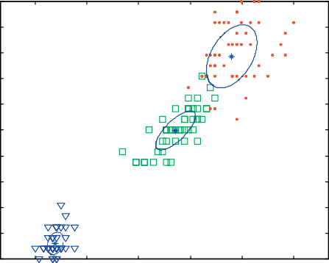

0.36633

0.30034

0.33333

Feature 3

1

0.9

0.8

0.7

0.6

Feature 4

0.5

0.4

0.3

0.2

0.1

0

TUMI

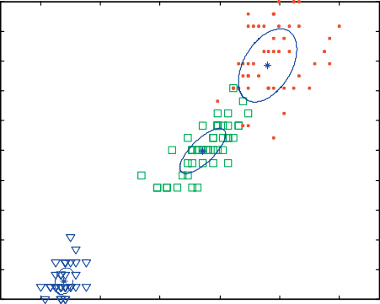

0.3674

0.29904

0.33355

0 0.2 0.4 0.6 0.8 1

Feature 3

# (a) (b)

1

0.9

0.8

0.7

0.6

Feature 4

0.5

0.4

0.3

0.2

0.1

0

MML

0 0.2 0.4 0.6 0.8 1

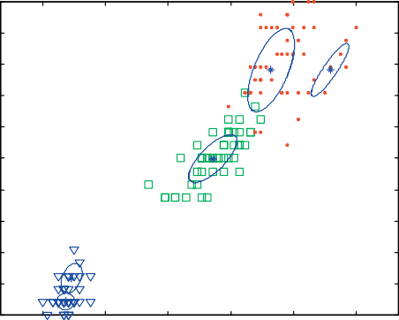

0.3923 0.012836

0.28378

0.032643

0.27844

Feature 3

1

0.9

0.8

0.7

0.6

Feature 4

0.5

0.4

0.3

0.2

0.1

0

BIC

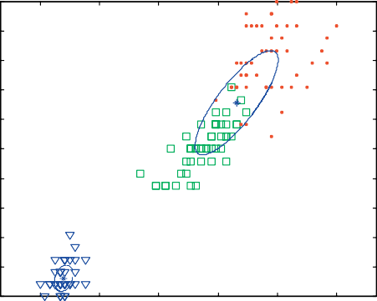

0.66667

0.33333

0 0.2 0.4 0.6 0.8 1

Feature 3

# (c) (d)

2.5

2

1.5

EMCE

1

0.5

0

EMCE

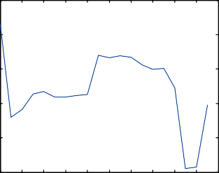

-300

-320

-340

-360

MML

-380

-400

-420

-440

-460

MML

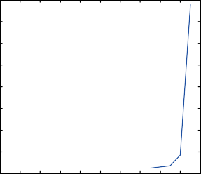

900

800

700

600

500

BIC

400

300

200

100

0

BIC

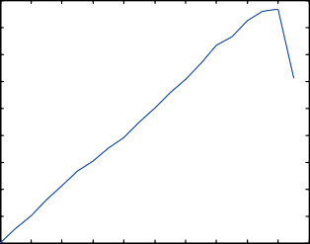

20 18 16 14 12 10 8 6

K

4 2 0

20 18 16 14 12 10 8 6

K

4 2 0

20 18 16 14 12 10 8 6 4 2 0

K

# (e) (f) (g)

Figure 1 The FMMs obtained from the algorithms compared and the distribution of the criteria used against the number of mixture components *k* with the Iris data set.

where *H*(X) and *H*(Y) denote the entropy of X and Y. The NMI has the value of 1 when there is a one to one mapping between the clusters obtained and the true classes (i.e., *k* = *m*) of a given data set. Since this measure is not biased to- ward large *k*, it is preferred to compare different data parti- tions [40,41].

* 1. *Discussion of results*

Table 1 shows the performances of the algorithms compared with each one of the data sets used. The performance of each

algorithm is evaluated by the values of the NMI criterion and the number of FMM components corresponding to the optimal value of the criterion used by the algorithm resulting from 100 experiments. Each experiment has different random initializa- tion values of the EM algorithm. This repetition of the experi- ments removes the effect of initialization values of the EM algorithm on the results of the algorithms [21]. Since the TUMI algorithm has no criterion to evaluate its results, the average values of the NMI criterion and the number of FMM compo- nents rounded to the nearest integer number are used in the comparison as shown in [21]. The shaded cells in this table rep-

1

0.9

0.8

0.7

0.6

Feature 12

0.5

0.4

0.3

0.2

0.1

0

EMCE

0 0.2 0.4 0.6 0.8 1

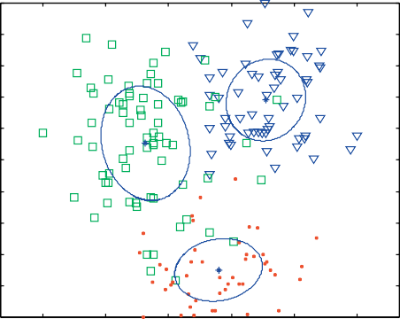

0.33773

0.39261

0.26966

Feature 1

1

0.9

0.8

0.7

0.6

Feature 12

0.5

0.4

0.3

0.2

0.1

0

TUMI

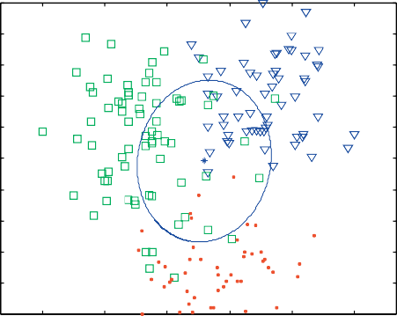

1

0 0.2 0.4 0.6 0.8 1

Feature 1

# (a) (b)

1

0.9

0.8

0.7

0.6

Feature 12

0.5

0.4

0.3

0.2

0.1

0

MML

0 0.2 0.4 0.6 0.8 1

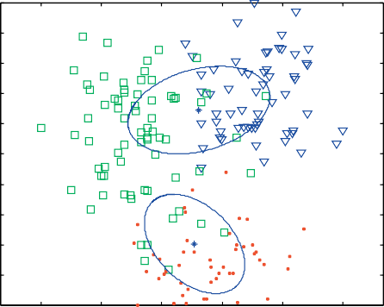

0.84977

0.15023

Feature 1

1

0.9

0.8

0.7

0.6

Feature 12

0.5

0.4

0.3

0.2

0.1

0

BIC

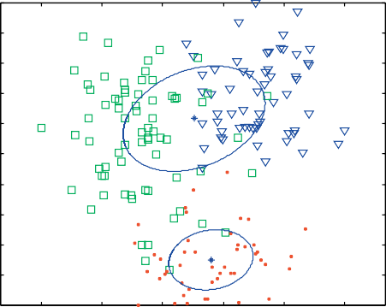

0.73034

0.26966

0 0.2 0.4 0.6 0.8 1

Feature 1

# (c) (d)

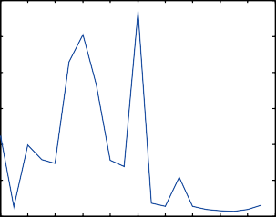6 EMCE

5

4

EMCE

3

2

1

0

-860

-880

-900

MML

-920

-940

-960

-980

MML

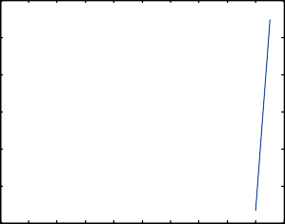

2000

1000

0

-1000

BIC

-2000

-3000

-4000

BIC

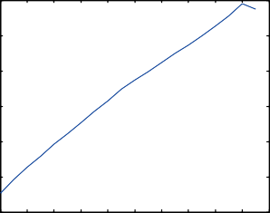

20 18 16 14 12 10 8 6 4 2 0

K

20 18 16 14 12 10 8 6

K

4 2 0

20 18 16 14 12 10 8 6 4 2 0

K

# (e) (f) (g)

Figure 2 The FMMs obtained from the algorithms compared and the distribution of the criteria used against the number of mixture components *k* with the Wine data set.

resent the maximum values of the NMI among all algorithms and the correct number of mixture components (clusters) with each data set. Figs. 1–4(a–d) show examples of the FMMs ob- tained from the algorithms compared with each one of the four data sets used. The ellipses in these figures are isodensity curves of each component in the FMM. These figures (e–g) also show the distribution of the EMCE, MML and the BIC criteria against the number of components *k* in the FMM through the runtime of the corresponding algorithms.

Table 1 and Figs. 1–4 show the superiority of the EMCE

algorithm over other algorithms in all data sets. The EMCE

algorithm results in the largest NMI criterion values and the correct number of mixture components with all data sets. These results show that the EMCE algorithm is less sensitive to the curse of dimensionality than all other algorithms com- pared. This is because the proposed EMCE criterion only de- pends on the characteristics of the FMM representing the input data set such as the within-component/cluster variation, the mutual information among components/clusters and the rela- tive mixing weights of components/clusters. On the other hand, the criteria used in the other algorithms compared de- pend explicitly on the dimensionality of the input data set

1

0.9

0.8

0.7

0.6

Feature 2

0.5

0.4

0.3

0.2

0.1

0

EMCE

0 0.2 0.4 0.6 0.8 1

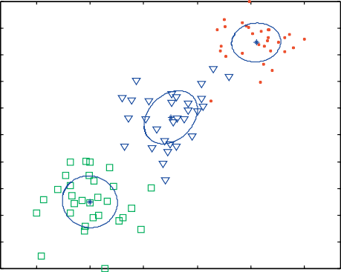

0.33333

0.33333

0.33333

Feature 1

1

0.9

0.8

0.7

0.6

Feature 2

0.5

0.4

0.3

0.2

0.1

0

TUMI

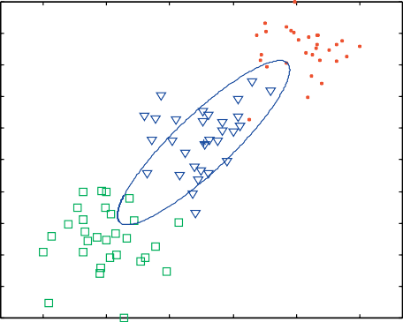

1

0 0.2 0.4 0.6 0.8 1

Feature 1

# (a) (b)

1

0.9

0.8

0.7

0.6

Feature 2

0.5

0.4

0.3

0.2

0.1

0

MML

0 0.2 0.4 0.6 0.8 1

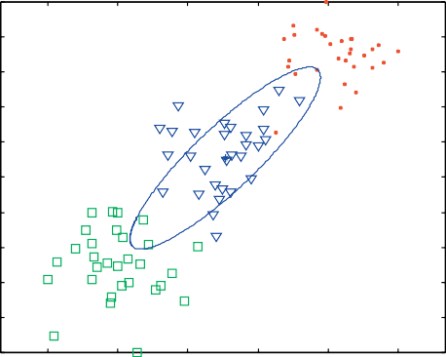

1

Feature 1

1

0.9

0.8

0.7

0.6

Feature 2

0.5

0.4

0.3

0.2

0.1

0

BIC

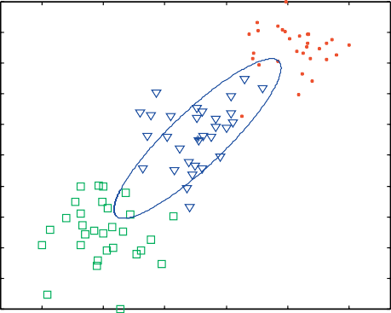

1

0 0.2 0.4 0.6 0.8 1

Feature 1

# (c) (d)

2.5

2

1.5

EMCE

1

0.5

0

EMCE

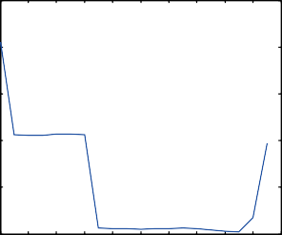

-510

-510.5

-511

MML

-511.5

-512

-512.5

MML

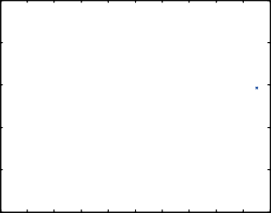

1500

1000

500

0

BIC

-500

-1000

-1500

-2000

BIC

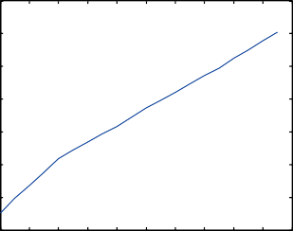

20 18 16 14 12 10 8 6

K

4 2 0

20 18 16 14 12 10 8 6

K

4 2 0

20 18 16 14 12 10 8 6

K

4 2 0

# (e) (f) (g)

Figure 3 The FMMs obtained from the algorithms compared and the distribution of the criteria used against the number of mixture components *k* with the third data set.

either as a penalty to the likelihood of the FMM to represent the input data set as in the MML and the BIC algorithms or as a main factor in determining the density of the feature vectors in the input data set that are used in computing the likelihood of the FMM to represent this data set as in the TUMI algo- rithm. In addition, the penalty term in these criteria depends on the size of the data set *n,* and therefore, they underestimate the number of clusters with small-size data sets. In the MML algorithm, components of zero mixing weights are deleted through learning of parameters of the FMM; therefore, the

MML/K curve does not cover the whole range of *K* in the examples shown in Figs. 1–4. This problem results from poor initialization of FMM parameters that lead to the generation of empty components or clusters [43].

1. Conclusions and future work

In this paper, the commonly used criteria for determining the number of FMM components required to fit an input data set are reviewed. A new algorithm, called the efficient model with

1

0.9

0.8

0.7

0.6

Feature 2

0.5

0.4

0.3

0.2

0.1

0

EMCE

0 0.2 0.4 0.6 0.8 1

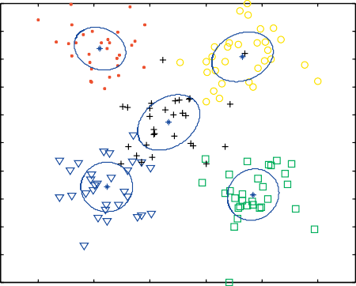

0.2

0.2

0.2

0.2

0.2

Feature 1

1

0.9

0.8

0.7

0.6

Feature 2

0.5

0.4

0.3

0.2

0.1

0

TUMI

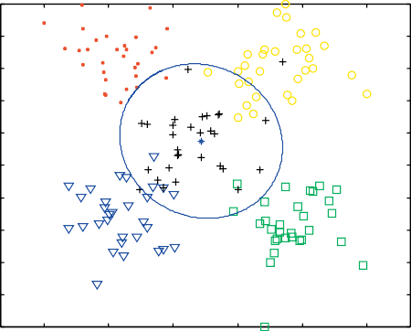

1

0 0.2 0.4 0.6 0.8 1

Feature 1

# (a) (b)

1

0.9

0.8

0.7

0.6

Feature 2

0.5

0.4

0.3

0.2

0.1

0

MML

0 0.2 0.4 0.6 0.8 1

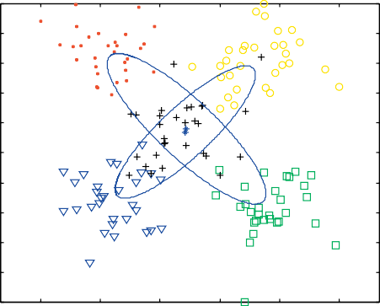

0.55937

0.44063

Feature 1

1

0.9

0.8

0.7

0.6

Feature 2

0.5

0.4

0.3

0.2

0.1

0

BIC

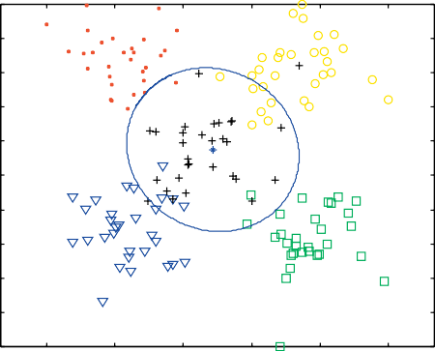

1

0 0.2 0.4 0.6 0.8 1

Feature 1

# (c) (d)

2.5

2

1.5

EMCE

1

0.5

0

EMCE

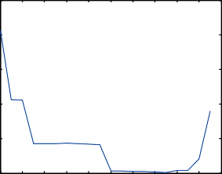

-750

-755

-760

-765

MML

-770

-775

-780

-785

MML

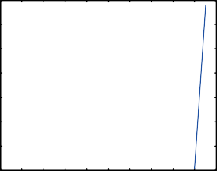

2000

1500

1000

500

BIC

0

-500

-1000

-1500

-2000

BIC

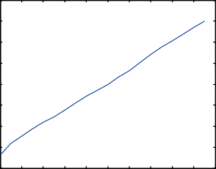

20 18 16 14 12 10 8 6 4 2 0

K

20 18 16 14 12 10 8 6 4 2 0

K

20 18 16 14 12 10 8 6

K

4 2 0

# (e) (f) (g)

Figure 4 The FMMs obtained from the algorithms compared and the distribution of the criteria used against the number of mixture components *k* with the fourth data set.

compact and essential components (EMCE) algorithm is pro- posed. It is based on a new proposed model selection crite- rion, called the EMCE criterion. This algorithm overcomes problems of the algorithms that use the penalized-likelihood or the Mutual Information criteria with small and sparse data. This algorithm produces a single frame for model esti- mation and selection for data clustering. Empirical analysis shows that the proposed algorithm outperforms the TUMI, the MML, and the BIC algorithms, especially with small and sparse data that may be generated from overlapping clusters.

In the future, feature weighting may be used to reduce the effect of redundant features of the input data set. This will al-

low the EMCE algorithm to accurately handle too sparse data sets to find out their cluster structures, both the optimum num- bers of clusters and cluster membership for each input feature vector. For example, the EMCE algorithm may be used in determining the Health Inequality structure of the world coun- tries when applied on Health Inequality data sets [42]. These data sets contain a large number of features compared with the number of feature vectors, that is, sparse data.

References

1. Duda RO, Hart PE, Stork DG. Pattern classification. 2nd ed. USA: John Wiley & Sons; 2001.
2. Webb A. Statistical pattern recognition. 2nd ed. UK: John Wiley & Sons; 2002.
3. Dempster AP, Laird NM, Rubin DB. Maximum Likelihood from incomplete data via the EM algorithm (with discussion). J Roy Stat Soc 1977;B39:1–38.
4. Biernacki C, Govaert G. Using the classification likelihood to choose the number of clusters. J Comput Sci Stat 1997;29(2):451–7.
5. Guo P, Chen CLP, Lyu MR. Cluster number selection for a small set of samples using the Bayesian Ying–Yang Model. J IEEE Trans Neural Netw 2002;13(3):757–63.
6. Schwarz G. Estimating the dimension of a model. J Ann Stat 1978;6:461–4.
7. Bezdek J. Pattern recognition with fuzzy objective function algorithms. New York: Plenum Press; 1981.
8. Wallace C, Freeman P. Estimation and inference via compact coding. J Roy Stat Soc 1987;B49(3):241–52.
9. Bozdogan H. ICOMP: a new model-selection criterion. In: Bock HH, editor. Classification and related methods of data analysis. Amsterdam: North Holland Publishing Company; 1988. p. 599–608.
10. Bozdogan H. On the information-based measure of covariance complexity and its application to the evolution of multivariate linear models. J Commun Stat – Theory Methods 1990;19(1):221–78.
11. Rissanen J. Stochastic complexity in statistical inquiry. Singapore: World Scientific; 1989.
12. Whindham M, Cutler A. Information ratios for validating mixture analysis. J Am Stat Assoc 1992;87:1188–92.
13. Banfield J, Raftery A. Model-based Gaussian and non-Gaussian clustering. J Biomet 1993;49:803–21.
14. Roberts SJ, Husmeier D, Rezek I, Penny W. Bayesian approaches to gaussian mixture modelling. J IEEE Trans Pattern Anal Mach Intell 1998;20:1133–42.
15. Celeux G, Chre´tien S, Forbes F, Mkhadri A. A component-wise EM algorithm for mixtures. J Comput Graph Stat 2001;10(4):697–712.
16. Figueiredo M, Jain A. Unsupervised learning of finite mixture models. J IEEE Trans Pattern Anal Mach Intell 2002;24(3):381–96.
17. Celeux G, Soromenho G. An entropy criterion for assessing the number of clusters in a mixture model. J Classif 1996;13:195–212.
18. Cutler A, Windham MP. Information-based validity functionals for mixture analysis. In: Bozdogan H, editor. Proceedings of the first US/Japan conference on the frontiers of statistical modeling: an information approach. Netherlands: Kluwer Academic Pub- lishers; 1994. p. 149–70.
19. Kass RE, Wasserman L. A reference bayesian test for nested hypotheses and its relationship to the schwarz criterion. J Am Stat Assoc 1995;90(431):928–34.
20. Yang ZR, Zwolinski M. Mutual information theory for adaptive mixture models. J IEEE Trans Pattern Anal Mach Intell 2001;23(4):396–403.
21. Abas AR. An algorithm for unsupervised learning and optimiza- tion of finite mixture models. Egypt Inform J 2011;12(1):19–27 [March].
22. Xu L. How many clusters?: A Ying–Yang machine based theory for a classical open problem in pattern recognition. Proc IEEE Int Conf Neural Netw 1996;3:1546–51.
23. Xu L. Bayesian Ying–Yang machine, clustering and number of clusters. J Pattern Recogn Lett 1997;18:1167–78.
24. Roberts S, Everson R, Rezek I. Maximum certainity data partitioning. J Pattern Recogn 1999;33:833–9.
25. Still S, Bialek W. How many clusters? An information-theoretic perspective. J Neural Comput 2004;16(12):2483–506.
26. Li L, Ma J. A BYY scale-incremental EM algorithm for Gaussian mixture learning. J Appl Math Comput 2008;205:832–40.
27. Priebe CE. Adaptive mixture density estimation. J Am Stat Assoc 1994;89:796–806.
28. Smyth P. Model selection for probabilistic clustering using cross- validated likelihood. J Stat Comput 2000;10(1):63–72.
29. Vlassis N, Likas A, Kro¨se B. A multivariate kurtosis-based approach to Gaussian mixture modeling, Technical report IAS- UVA-00-04. The Netherlands: Computer Science Institute, Uni- versity of Amesterdam; 2000. <[http://citeseer.ist.psu.edu/](http://citeseer.ist.psu.edu/vlassis00multivariate.html) [vlassis00multivariate.html](http://citeseer.ist.psu.edu/vlassis00multivariate.html)>.
30. Roberts S, Holmes C, Denison D. Minimum-entropy data partitioning using reversible jump Markov chain Monte Carlo. J IEEE Trans Pattern Anal Mach Intell 2001;23:909–14.
31. Figueiredo MAT, Leitao JMN, Jain AK. On fitting mixture models. In: Hancock E, Pellilo M, editors. Energy minimization methods in computer vision and pattern recognition. Berlin: Springer-Verlag; 1999. p. 54–69.
32. Richardson S, Green P. On Bayesian analysis of mixtures with unknown number of components. J Roy Stat Soc 1997;B59:731–92.
33. Cheung YM. Maximum weighted likelihood via rival penalized EM for density mixture clustering with automatic model selection. In: IEEE transactions on knowledge and data engineering, vol. 17, no. 6, June 2005. p. 750–61.
34. Zeng H, Cheung YM. A new feature selection method for Gaussian mixture clustering. Pattern Recogn 2009;42:243–50.
35. Rafat A. An adaptive approach for clustering incomplete data sets: an application to health inequality analysis. Germany: LAP LAMBERT Academic Publishing AG & Co. KG; 2010.
36. UCI Repository of machine learning databases. Irvine, CA: University of California, Department of Information and Com- puter Science; March 2012. <<http://archive.ics.uci.edu/ml/>>.
37. Ormoneit D, Tresp V. Improved Gaussian mixture density estimates using Bayesian penalty terms and network averaging. In: Touretzky DS, Mozer MC, Hasselmo ME, editors. Advances in neural information processing systems, vol. 8. The MIT Press; 1996. p. 542–8.
38. Ueda N, Nakano R, Ghahramani Z, Hinton GE. SMEM algorithm for mixture models. J Neural Comput 2000;12(9):2109–28.
39. Cover TM, Thomas JA. Elements of information theory. Wiley; 1991.
40. Strehl A, Ghosh J. Cluster ensembles – a knowledge reuse framework for combining multiple partitions. J Mach Learn Res 2002;3:583–617.
41. Fern XZ, Brodley CE. Random projection for high dimensional data clustering: a cluster ensemble approach. In: Proceeding of the 20th international conference on machine learning (ICML 2003); 2003, p. 186–93.
42. World Health Organization (WHO). Data and statistics, August 2010. <<http://www.who.int/research/en/>>.
43. Ossama O, Mokhtar HMO, El-Sharkawi ME. An extended *k*- means technique for clustering moving objects. Egypt Inform J 2011;12:45–51.