Available online at [www.sciencedirect.com](http://www.sciencedirect.com/)

[Electronic Notes in Theoretical Computer Science 346 (2019) 159–169](https://doi.org/10.1016/j.entcs.2019.08.015)

[www.elsevier.com/locate/entcs](http://www.elsevier.com/locate/entcs)

On the Minimum Eccentricity Isometric Cycle Problem

E´tienne Birmel´e1, Fabien de Montgolfier2 and L´eo Planche 3

*Laboratoire MAP5, Universit´e Paris Descartes and CNRS, Sorbonne Paris Cit´e, Paris, France* 1*,*3

*IRIF, Universit´e Paris Diderot - Paris 7* 2*,*3

**Abstract**

In this paper we investigate the Minimum Eccentricity Isometric Cycle (MEIC) problem. Given a graph, this problem consists in finding an isometric cycle with smallest possible eccentricity *k*. We show that this problem is NP-Hard and we propose a 3-approximation algorithm running in *O*(*n*(*m* + *kn*)) time.

*Keywords:* isometric cycle; eccentricity; *k*-domination; *k*-covering

# Introduction

For both graph classification purposes and applications, it is an important issue to summarize a graph into a more simple object such as a tree or a path, or in the case of this article, a cycle. Different constructions and metrics offer such a characterization, for example tree-decompositions and tree-width [8]. Another approach, on which we focus in this article, is to study the problem in terms of domination.

In the path case, the problem consists in finding a path such that every vertex in the graph belongs to or has a neighbor in the path. Several graphs classes were defined in terms of dominating paths. Graphs containing a dominating pair, that is vertices such that every path linking them is dominating are studied in [5]. Graphs such that short dominating paths are present in all induced subgraphs are characterized in [1]. Linear-time algorithms to find dominating paths or dominating vertex pairs were also developed for AT-free graphs [3,4].

1 Email: [etienne.birmele@parisdescartes.fr](mailto:etienne.birmele@parisdescartes.fr)

2 Email: [fm@irif.fr](mailto:fm@irif.fr)

3 Email: [leoplanche@gmail.com](mailto:leoplanche@gmail.com)

<https://doi.org/10.1016/j.entcs.2019.08.015> 1571-0661/© 2019 Published by Elsevier B.V.

This is an open access article under the CC BY-NC-ND license (<http://creativecommons.org/licenses/by-nc-nd/4.0/>).

Dominating paths do not exist however in every graph. A natural extension of the notion of domination is the notion of *k*-coverage (also called *k*-domination). For a given integer *k*,a path *k-covers* the graph if every vertex is at distance at most *k* from the path. The smallest *k* such that a path *k*-covers the graph is then a metric as desired.

Another formulation for this metric is the notion of *eccentricity*. Given a graph *G*, *x ∈ V* (*G*) and *S ⊂ V* (*G*), we note *d*(*x, S*) = min*s∈S dG*(*x, s*). The eccentricity of *S*, denoted *ecc*(*S*), is the smallest *k* such that for any *x ∈ V* (*G*)*, dG*(*x, S*) *≤ k*.

The *minimum-eccentricity shortest path* (MESP) problem was introduced by Dragan and Leitert [6]. The name is transparent as it consists in finding a shortest path with minimal eccentricity. The study of this problem was originally motivated by its link to the embedding with low distortion of graphs into the line. Dragan and Leitert have shown that this problem is NP-complete, and designed some ap- proximation algorithms, and established its relationship with the Line Embedding problem [6]. The MESP problem is also related with graphs problems arising from biological data set [2].

A problem related to the MESP problem consists in finding an isometric cycle with minimal eccentricity, as defined in [2]. A cycle is *isometric* if it preserves distances:

**Definition 1.1** [Isometric cycle] Let *G* be a graph and *C* a cycle of *G*. *dG* denotes the distance in *G* and *dC* the distance in *G*[*C*]. *C* is an *isometric* cycle if and only if, for every two vertices *u*, *v* of *C* we have: *dG*(*u, v*)= *dC*(*u, v*).

In other words, one of the two paths linking *u* and *v* in the cycle is a shortest path in the graph. Note that an isometric cycle is necessarily an induced cycle. The problem we are interested in consists in finding an isometric cycle with minimum eccentricity.

**Definition 1.2** [Minimum Eccentricity Isometric Cycle Problem (MEIC)] Given a graph *G*, find an isometric cycle *C* such that, for every isometric cycle *U* , *ecc*(*C*) *≤ ecc*(*U* ).

A longest isometric cycle may be computed in *O*(*n*4*.*752*log*(*n*)) time [7], which gives a polynomial-time 3-approximation for the MEIC problem [2]. It was also shown that a graph admitting an isometric cycle with low eccentricity admits a cycle embedding of low distortion [2].

In this paper, we first show that the MEIC problem is NP-complete. To do so, we propose a reduction of MESP to MEIC. Then we propose a *O*(*n*(*m* + *kn*)) -time 3-approximation algorithm. This is faster than the *O*(*n*4*.*752*log*(*n*)) time algorithm proposed in [2] but with the additional constraint that the size of the isometric cycle of minimal excentricity has to be at least 32 times its eccentricity (see Theorem 4.6). Notice that finding a minimum-eccentricity isometric cycle is useful only in “donut- shaped” graphs, implying the cycle is long and has short eccentricity.

*Deﬁnitions and Notations*

Through this paper we consider finite connected undirected graphs. For a graph *G* = (*V, E*), we use *n* = *|V |* and *m* = *|E|* to denote the cardinality of the vertex set and the edge set of *G*. A *shortest path* between two vertices *u* and *v* is a path whose length is minimal among all *u, v*-paths. Its length (counting edges) is the *distance d*(*u, v*). When the precision is needed, we denote *dG*(*u, v*) the distance between two vertices *u* and *v* in the graph *G*. Depending on the context, we consider a path either as a sequence, or as a set of vertices. The *distance d*(*v, S*) between a vertex *v* and a set *S* is the smallest distance between *v* and a vertex from *S*. The *eccentricity ecc*(*S*) of a set *S* is the largest distance between *S* and any vertex of *G*. The *ball* of center *v* and radius *r*, noted *B*(*v, r*), is the set of vertices at distance at most *r* from *v*. Given two sets of vertices *A* and *B*, we note *A \ B* the set of vertices of *A* which are not in *B*.

# NP-completeness

We propose a polynomial reduction of MESP to MEIC.

Let *f* be the function which associates to a graph with vertices *V* (*G*)= *{v*1*, ...vn}* a family of graphs *f* (*G*)= *{H*(*i,j*)*∈{*1*...n}*2 *}* such that for every (*i, j*) *∈ {*1*...n}*2, *H*(*i,j*) is the graph *G* to which a path *Pi,j* is added of size 2*n* between *vi* and *vj*.

**Lemma 2.1** *Given a graph G, the shortest path of minimal eccentricity of G is of eccentricity k if and only if, for any graph of f* (*G*)*, its isometric cycle of minimal eccentricity is of eccentricity at least k.*

**Proof.** Let us show that for every graph *Hi,j* in *f* (*G*), any isometric cycle of minimal eccentricity contains *Pi,j* and a shortest path of minimal eccentricity in *G* between *vi* and *vj*.

*Claim 1 : Any isometric cycle of minimal eccentricity in Hi,j contains Pi,j.*

Consider any cycle *C* of *G*. It does not contain any vertex of *Pi,j* other than *vi* and *vj*. The path *Pi,j* being of length 2*n*, the eccentricity of the cycle *C* in *Hi,j* is of size at least *n*. Consider now any cycle in *Hi,j* containing *Pi,j* and a shortest path between *vi* and *vj*. This cycle is isometric and of eccentricity at most *n −* 2.

*Claim 2 : Any isometric cycle of minimal eccentricity in Hi,j contains Pi,j and a shortest path of minimal eccentricity in G between vi and vj.*

We have already established that such a cycle *C* contains *Pi,j* and a path *Q* in *G* between *vi* and *vj*. Furthermore, *Q* or *Pi,j* has to be a shortest path as *C* is isometric. The distance *dG*(*vi, vj*) being at most *n−* 1 and *Pi,j* being of size 2*n*, *Q* is thus a shortest path linking *vi* and *vj*. Moreover, as every shortest path between any vertex of *Pi,j* and any vertex of *G* contains either *vi* or *vj*, *ecc*(*C*)= *eccG*(*Q*), where *eccG* stands for the eccentricity in the graph *G*. *C* being of minimal eccentricity among the isometric cycles, *Q* is of minimal eccentricity among the shortest paths between *vi* and *vj*. *2*

Lemma 2.1 implies that the solution of MESP in *G* may be computed by solving

MEIC in *f* (*G*), and the transformation *f* is clearly polynomial. MESP being an NP-complete problem [6], it follows that :

**Theorem 2.2** *The problem MEIC is NP-complete.*

# Preliminary results

We define for every cycle *C* an arbitrary cyclic orientation and for every *u*, *v* vertices of the cycle, we note *Cuv* and *Cvu* the two paths in *C* linking *u* and *v*. In order to make proofs clearer, we define the operator ’ as follows :

**Definition 3.1** Let *G* be a graph with an isometric cycle *C k*-dominating *G*. For every vertex *x* in *G*, *xj* denotes a vertex of *C* at distance at most *k* from *x*, randomly chosen if several choices are possible.

The following lemma is a crucial preliminary result, which will allow us later to build 3*k*-dominating cycles if the graph contains an isometric cycle *k*-dominating it.

**Lemma 3.2** *Let G be a graph with an isometric cycle C k-dominating G, and u and v be any two vertices in G. Every path between u and v* 2*k-dominates either Cu′,v′ or Cv′,u′ .*

## Proof.

Notations used in the proof are illustrated in Figure 1.

Let *P* be a path between *u* and *v*. Suppose that *P* does not 2*k*-dominate some vertex *b* on the path *Cu′,v′* and consider any vertex *a* in *Cv′,u′* . We have *uj* (resp. *vj*) in the path *Ca,b* (resp. *Cb,a*).

Then *u* is at distance at most *k* of *Ca,b* and *v* is at distance at most *k* of *Cb,a*. Moreover, as every vertex of *G* is at distance at most *k* of one of those two paths, there exist *c* and *d* that are adjacent vertices in *P* such that *cj* is in *Ca,b* and *dj* in *Cb,a*.

As *d*(*cj, dj*) *≤ d*(*cj, c*)+ *d*(*c, d*)+ *d*(*d, dj*) *≤* 2*k* + 1 and *C* is an isometric cycle, either *Cc′,d′* or *Cd′,c′* is of length at most 2*k* + 1 and is thus 2*k*-dominated by *{c, d}*. Furthermore *b* and *a* are not in the same subpath of *C* between *cj* and *dj*, hence either *a* or *b* is 2*k*-dominated by *{c, d}*. As *b* cannot be 2*k*-dominated by *P* it follows that *a* is 2*k*-dominated by *{c, d}* hence by *P* .

The previous claim being true for every *a* in *Cv′,u′* , the lemma follows. *2*

1. **Approximation in** *O*(*n*(*m* + *kn*)) **time**

In this section we develop a new approximation algorithm for the MEIC problem, with a better complexity compared to [2] (Theorem 4) but requiring a graph with a longer isometric cycle.

Consider a graph with an isometric cycle of eccentricity *k*. Algorithm 1 (*FirstCycle*) first computes a cycle *U* 0 of eccentricity at most 3*k* but non nec-

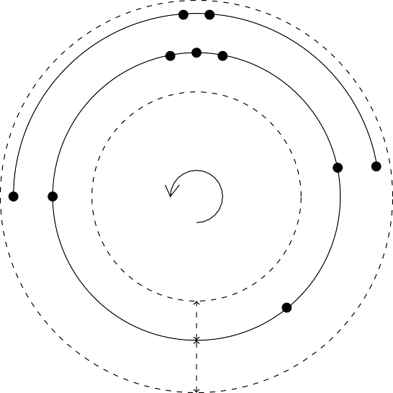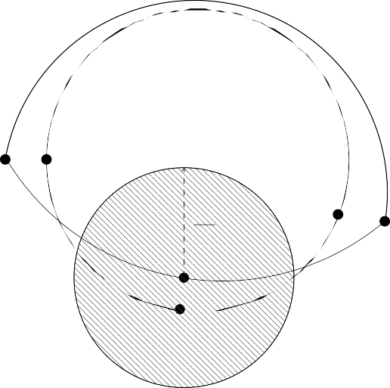

*c*

*P*

*d*

*P′*

*cj a dj*

*vj*

*a*

*v*

*aj*

*u*

*uj*

*P*

*|P |*

4

*bj*

*b*

*C*

*m*

*C*

*≤ k*

*b*

*m*

*j*

*≤ k*

Fig. 1. Notations used in Lemma 3.2 (left) and in Lemma 4.1 (right)

essarily isometric. Its size is then iteratively reduced while keeping an eccentricity of at most 3*k*. The algorithm ends when the last computed cycle is isometric.

**Algorithm 1:** Pseudocode of the algorithm *FirstCycle*

**1 FirstCycle**

**Input:** A graph *G*

**Output:** A cycle *U* 0

**2** Let *a* be any vertex of *G*

**3** Compute *b* a vertex furthest from *a*

**4** Compute *P* a shortest path from *a* to *b*

**5** Let *m* be a vertex in the middle of *P*

**6 If** *a and b are connected in Gj* = *G \ B*(*m, [ |P | ♩*) **then**

*c,d*

**11** Return an error ”MEIC too short with respect to *k*”

4

**7** Let *Pj* be a shortest path between *a* and *b* in *Gj*

**8** Let *c* be the vertex of *Pa,m ∪ Pj* furthest from *a*

**9** Let *d* be the vertex of *Pm,b ∪ Pj* furthest from *b*

**10** Return *Pc,d ∪ Pj*

**Lemma 4.1** *Let G be a graph with a k-dominating isometric cycle C.*

*If C is of size at least* 26*k* +6 *then FirstCycle*(*G*) *returns a cycle U* 0 2*k- dominating C. Furthermore U* 0 *is of size at most |C|* + 4*k and at least |C|−* 2*k −* 2*.*

## Proof.

Notations used in the proof are illustrated in Figure 1.

If *FirstCycle*(*G*) returns a cycle *U* 0, it is the union of two paths *P* and *Pj*. Let

*m* be a vertex in the middle of *P* (randomly chosen among the two possible ones if

—P— is odd) and assume w.l.o.g. that *mj* is in *Ca′b′* .

*Claim 1: P is of length at least* 12*k.* Let *aj* be a vertex of *C* furthest from *aj*.

*ecc*(*a*) *≥ d*(*a, aj*) *≥ d*(*aj, aj*) *− k*

*C k ≥* 12*k* +3 2

As *b* is a vertex of *G* furthest from *a*, we have the result.

*♩−*

*≥[*

*Claim 2: B*(*m, [ |P | ♩*) *does not disconnect a from b.*

4

Consider any vertex *y* in *Cb′a′* , as *mj* is in *Ca′b′* ,

*d*(*m, y*) *≥ d*(*mj, y*) *− d*(*m, mj*) *≥ min*(*d*(*mj, aj*)*, d*(*mj, bj*)) *− k*

But

*d*(*mj, aj*) *≥ d*(*a, m*) *− d*(*a, aj*) *− d*(*m, mj*)

*|P |*

*≥[ ♩−* 2*k*

*d*(*mj, bj*) *≥ d*(*b, m*) *− d*(*b, bj*) *− d*(*m, mj*)

2

*|P |*

*≥[ ♩−* 2*k*

so that

*|P |*

*d*(*m, y*) *≥[*

2

*♩−* 3*k |P |*

4

*≥[*

*|P|*

*♩* + *[*

*|P |*

4

2

*♩−* 3*k > [*

*|P |♩*

4

*Cb′a′* is therefore at distance at least *[* 4 *♩* of *m*. Furthermore,

*d*(*a, m*)= *[*

*d*(*b, m*)= *[*

*|P |*

2

*|P |*

2

*|P |*

*♩≥[*

4

*|P |*

*♩≥[*

4

*♩* + 3*k*

*♩* + 3*k*

It follows that the paths of length *k* from *a* to *aj* and *b* to *bj* are at distance greater than *[ |P | ♩* + 2*k* of *m*. The vertices *a* and *b* are thus connected in *Gj*. This claim implies that *FirstCycle*(*G*) returns a cycle.

4

*Claim 3: U* 0 2*k-dominates C.*

Without loss of generality, assume that *mj* is in *Cc′d′* . Let us first show that *Pcm* 2*k*-dominates *Cc′m′* . To do so, assume that it is not the case. Then, by Lemma 3.2, *Pcm* 2*k*-dominates *Cm′c′* . The vertex *mj* being in *Cc′d′* , it follows that *dj* is in *Cm′c′* and that there exists a vertex *x* in *Pcm* at distance at most 2*k* from *dj*. It follows that,

*|Pcm|* = *d*(*c, x*)+ *d*(*x, m*)

*|Pcm|≥ d*(*c, d*) *−* 3*k* + *d*(*d, m*) *−* 3*k d*(*c, m*) *≥ d*(*c, m*)+ *d*(*m, d*)+ *d*(*d, m*) *−* 6*k*

6*k ≥* 2*d*(*d, m*)

As *d* is a vertex of *Pj*, it is at distance more than *[ |P | ♩* from *m*, it follows,

4

*|P |*

6*k ≥[ ♩*

2

This contradicts the fact that *P* is of size larger than 12*k*, hence *Pcm* 2*k*-

dominates *Cc′m′* . Similarly, we show that *Pmd* 2*k*-dominates *Cm′d′* , it follows that

*P* 2*k*-dominates *Cc′d′* .

Lemma 3.2 moreover implies that *Pj* 2*k*-dominates either *Cc′d′* or *Cd′c′* . But, as *[ |P | ♩* is greater than 3*k*, *mj* cannot be 2*k*-dominated by a vertex in *Gj*. As *mj* is on *Cc′d′* , *Pj* 2*k*-dominates *Cd′c′* . It follows that *U* 0 2*k*-dominates *C*.

4

*Claim 4: |C|−* 6*k −* 2 *≤ |U* 0*|≤ |C|* + 4*k*

*|P| ≤ |Ca′b′ |* + 2*k* as *P* is a shortest path between *a* and *b*. Similarly, as *Pj* is a shortest path in *Gj*, *|P j|≤ |Cb′a′ |* + 2*k*. Consequently, *|P |* + *|P j|≤ |C|* + 4*k*.

The other inequality is a direct result of Lemma 4.2.

*Claim 5: U* 0 *does not contain the same vertex twice*

Assume that a vertex *x* appears more than once in *U* 0. As both *P* and *Pj* are shortest path, they each contain *x* at most (and exactly) once. If *x* is in *Pc,m* then it is more distant from *a* than *c* and it should have been selected at line 8 instead of *c*. This leads to a contradiction. The same contradiction appears if we assume *x* in *Pm,d*.

*2*

**Lemma 4.2** *Let G be a graph with an isometric cycle C k-dominating G. Let a*

*and b be two vertices, possibly a* = *b, linked by a path P* 2*k-dominating Ca′,b′ . Then,*

*|P|≥ |Ca′b′ |−* 6*k −* 2*.*

*In particular, if U is a cycle* 2*k-dominating C, U is of size at least |C|−* 6*k −* 2*.*

**Proof.** Consider any two vertices *a* and *b* and a path *P* linking them and 2*k*- dominating *Ca′,b′* .

Let *m* be the middle of *Ca′,b′* and *z* a vertex of *P* which is 2*k*-dominating *m*. *Ca′,m*

being of length at most *[ |C| |*, *|Ca′,m|≤ d*(*aj, m*)+1. Similarly, *|Cm,b′ |≤ d*(*m, bj*)+1.

2

It follows that

*|Ca′b′ |≤ d*(*a , m*)+ *d*(*m, b* )+2 *≤* (*k* + *|Pa,z|* + 2*k*)+ (*k* + *|Pz,b|* + 2*k*)+2

*j j*

*≤ |Pa,b|* + 6*k* +2

The affirmation concerning the cycle follows by choosing *a* = *b*. *2*

The function *FirstCycle* creates a cycle *U* 0, not necessarily isometric, 3*k*- dominating the graph. Starting with *U* 0, the size of the cycle is iteratively de- creased by the *NextCycle* procedure described by Algorithm 2, while keeping the 3*k*-domination property.

**Lemma 4.3** *Let G be a graph containing an isometric cycle C, k-dominating G. For every path P, there exists a subpath I*(*P* ) *of C such that:*

* *Every vertex of C at distance at most k of P is in I*(*P* ) *and the extremities of*

*I*(*P* ) *are such vertices;*

* *P* 2*k-dominates I*(*P* )

## Proof.

Notations used in the proof are ilustrated with figure 2.

Let *uj* and *vj* be two vertices of *C* such that *u* and *v* both belong to *P* and such that *P* 2*k*-dominates *Cu′v′* (such a pair exists as we may always pick *uj* = *vj*).

**Algorithm 2:** Pseudocode of the algorithm *NextCycle*

**1 NextCycle**

**Input:** A graph *G* and a cycle *Ui*

**Output:** A cycle *Ui*+1

**2 for** *a ∈ Ui* **do**

**3 If**

**4**

**5**

*S* = *{b | dUi* (*a, b*)= *[* 2 *♩ and dG*(*a, b*) *< dUi* (*a, b*)*} /*= *∅*

Compute *Q* a shortest path between *a* and *b*

*|Ui|*

**then**

Compute the eccentricity of *Q ∪ Ui* and *Q ∪ Ui*

*a,b*

Return the set with the lowest eccentricity

*b,a*

**6**

**7** Return *Ui*

Fig. 2. Illustration of Lemma 4.3

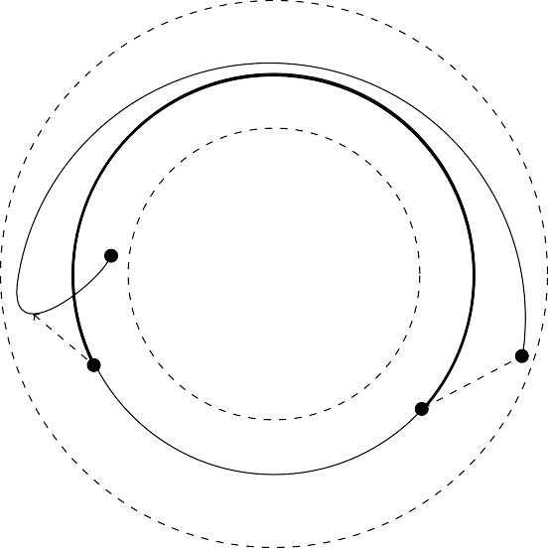

*P*

**I**(**P**)

*k*

*k*

*C*

Assume that there exists a vertex *wj* not in *Cu′v′* and such that *w* is in *P* . By Lemma 3.2, *P* 2*k*-dominates either *Cu′w′* or *Cw′u′* . In the first case, *Cu′v′* is a subset of *Cu′,w′* . In the second case, *P* 2*k*-dominates *Cw′u′* and *Cu′v′* hence *Cw′v′* . As *vj* is in *Cu′w′* and *uj* is in *Cw′v′* , the sizes of *Cu′w′* and *Cw′v′* are strictly larger than the one of *Cu′v′* . The length of *C* being finite, there exists a pair of vertices verifying the property and such that the considered arc is maximal. *2*

**Lemma 4.4** *Assume that |C|≥* 32*k* + 7*. Let U be a cycle of size at most |C|* + 4*k*

*which* 3*k-dominates G and let a and b be two vertices of U.*

*Then, Ca′b′ and Cb′a′ are both included in either I*(*Ua,b*)*, or in I*(*Ub,a*)*.*

**Proof.** Assume that this is not the case. By symmetry, assume that *Ca′b′* is neither included in *I*(*Ua,b*), nor in *I*(*Ub,a*).

Let *wj*

1

2

1

be the extremity of *I*(*Ua,b*) such that *Ca′w′*

*⊂ Ca′b′* and *wj*

the extremity

of *I*(*Ub,a*) such that *Ca′w′*

1

2

*⊂ Ca′b′* . By symmetry, assume that *Ca′w′*

*⊂ Ca′w′*

and

let us note *wj* = *wj* . There exists *w ∈ Ua,b* such that *d*(*w, wj*)= *k*.

2

1

**Case 1:** *d*(*wj, bj*) *≤* 4*k* +1

In this case, *|Cb′,w′ |≥ |C|−* 4*k −* 2. By definition of *wj*, *Cb′,w′ ⊂ I*(*Uw,b*) hence is 2*k*-dominated by *Uw,b*. The Lemma 4.2 then implies that *|Uw,b|≥ |Cb′,w′ |−* 6*k−* 2 *≥*

*|C|−* 10*k −* 4.

By the definition of *wj*, we also have that *Ca′,w′ ⊂ I*(*Ua,w*). Furthermore *Cb′,a′ ⊂ I*(*Ub,a*) by Lemma 3.2 as, by hypothesis, *I*(*Ub,a*) does not contain *Ca′,b′* . Therefore, *Cb′,w′ ⊂ I*(*Ub,w*) and by the Lemma 4.2, *|Ub,w|≥ |Cb′,w′ |−* 6*k −* 2 *≥ |C|−* 10*k −* 4. Finally, *|U|* = *|Ub,w|* + *|Uw,b|≥* 2*|C|−* 20*k −* 8. As *|U|≤ |C|* + 4*k*, it implies that

*|C|≤* 24*k* + 8, which contradicts our hypothesis.

**Case 2:** *d*(*wj, bj*) *≥* 4*k* +1

Let *z* be the vertex of *Ca′b′* at distance 4*k* +1 of *wj*. *U* is 3*k*-dominating *G* by hypothesis, therefore *z* is at distance at most 3*k* of a vertex *y* of *U* . The fact that *d*(*wj, z*) *>* 4*k* then implies that *yj* is not in *Ca′,w′* . We now have to study three different sub-cases, corresponding to *y ∈ Ua,w*, *y ∈ Uw,b* and *y ∈ Ub,a*, but the arguments are very similar.

Let *y ∈ Ua,w*, as shown on the right of Figure 3. Let us decompose *U* as

*U* = *Uy,w ∪* (*Uw,b ∪ Ub,y*). By definition of *wj*, *I*(*Uy,w*) contains *Cy′w′* . Therefore

*|Uy,w|≥ |Cy′,w′ |−* 6*k −* 2 *≥ |C|− d*(*yj, z*) *− d*(*z, wj*) *−* 6*k −* 2 *≥ |C|−* 14*k −* 3.

Moreover, *I*(*Uw,b*) contains *Cb′,w′* by definition of *wj* and *I*(*Ub,y*) contains *Cy′,b′*

by definition of *wj* . Consequently, *I*(*Uw,b ∪ Ub,y*) contains *Cy′,w′* and *|Uw,b ∪ Ub,y|≥*

1

*|C|−* 14*k −* 3.

Finally, 2(*|C|−* 14*k −* 3) *≤ |C|* + 4*k*, meaning that *|C| ≤* 32*k* + 6, which is a contradiction.

Let *y ∈ Uw,b*. Let us decompose *U* as *U* = *Uw,y ∪* (*Uy,b ∪ Ub,a ∪ Ua,w*).

By definition of *wj*, *I*(*Uw,y*) contains *Cy′w′* , therefore *|Uw,y|≥ |Cy′,w′ |−* 6*k −* 2 *≥*

*|C|− d*(*yj, z*) *− d*(*z, wj*) *−* 6*k −* 2 *≥ |C|−* 14*k −* 3.

Furthermore, *I*(*Uy,b*) contains *Cy′,b′* by definition of *wj* , *I*(*Ub,a*) contains *Cb′,a′* by hypothesis and *I*(*Ua,w*) contains *Ca′,w′* by definition of *wj*, therefore *I*(*Uy,b ∪ Ub,a ∪ Ua,w*) contains *Cy′,w′* . Consequently, its length is also greater that *|C|−* 14*k −* 2.

2

It implies again that *|C|≤* 32*k* + 6, which is a contradiction.

Finally, assume now that *y ∈ Ub,a*. Let us decompose *U* as *U* = (*Uw,b ∪ Ub,y*) *∪*

(*Uy,a ∪ Ua,w* ).

*I*(*Uw,b*) contains *Cb′,w′* by definition of *wj* and *I*(*Ub,y*) contains *Cy′,b′* by definition of *wj* . Consequently, *I*(*Uw,b ∪ Ub,y*) contains *Cy′,w′* and *|Uw,b ∪ Ub,y|≥ |C|−* 14*k −* 3. Furthermore, *I*(*Uy,a*) contains *Cy′,a′* as it does not contain *Ca′,y′* by hypothesis and *I*(*Ua,w*) contains *Ca′,w′* by definition of *wj*. It follows that *I*(*Uy,a∪Ua,w*) contains

1

*Cy′,w′* and *|Uy,a ∪ Ua,w|≥ |C|−* 14*k −* 3.

Once again, it implies that *|C|≤* 32*k* + 6, leading to a contradiction. *2*

**Lemma 4.5** *Let G be a graph with an isometric cycle C k-dominating G and of size at least* 32*k* + 7*.*

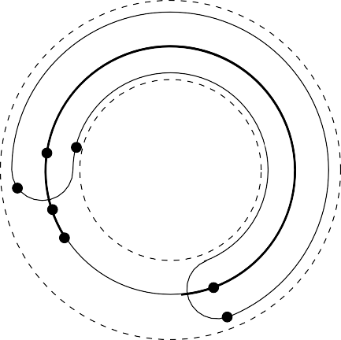

**I**(**Ua***,***b**)

*U*

*aj*

*a*

*w*

*wj*

2

*wj*

*C*

*bj*

*b*

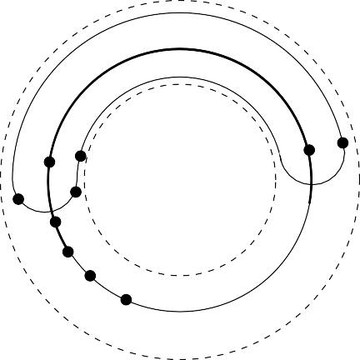

**I**(**Ua***,***b**)

*U*

*aj*

*a*

*y*

*bj b*

*w*

*wj*

2

*wj*

*yj*

*z*

*C*

Fig. 3. Notations used in the proof of Lemma 4.4, in **case 1** on the left and **case 2** on the right

*Let Ui be a cycle such that:*

* *Ui* 2*k-dominates C.*
* *|C|−* 6*k −* 2 *≤ |Ui|≤ |C|* + 4*k*

*Then Ui*+1 = *NextCycle*(*Ui*) *has the same properties and |Ui*+1*| < |Ui|.*

**Proof.** The inequalities concerning the length are straightforward given Lemma 4.2 and the fact that *Ui*+1 is obtained by replacing an arc of *Ui* with a path of smaller length.

To prove the 2*k*-domination, consider the path *Q* linking the vertices *a* and *b* of *Ui* as selected by the algorithm. By Lemma 3.2, one can assume w.l.o.g. that *I*(*Q*) contains *Ca′,b′* and therefore 2*k*-dominates it. Furthermore, Lemma 4.4 implies that

*Cb′,a′* is included in *I*(*Ui*

*a,b*

*b,a*

) or *I*(*Ui*

). By symmetry , assume that it is included in

*a,b*).

*I*(*U*

*i*

Then, *I*(*Q ∪ Ui*

*a,b*

*a,b*

) = *C*, and it follows that *Q ∪ Ui*

2*k*-dominates *C* and is of

eccentricity at most 3*k*. The property is verified if *Ui*+1 = *Q ∪ Ui* .

*a,b*

*b,a*

If *Ui*+1 = *Q ∪ Ui*

*b,a*

, *Q ∪ Ui*

also 3*k*-dominates *G* as it is of a lower eccentricity.

Lemma 4.4 then implies that either *Ui* or *Q* 2*k*-dominates *Cb′a′* , and therefore

*b,a*

*i b,a*

*Q ∪ U*

2*k*-dominates *C*. *2*

The algorithm *FirstCycle* requires to compute three BFS trees, its complexity is *O*(*m*). The complexity bottleneck is testing the **If** condition on *n*2 vertex pairs in Line 3 of *NextCycle*. The distances *dG* inside *G* may be precomputed in *O*(*nm*) time using *n* BFS, while evaluating the distance *dUi* inside the cycle take constant time if the vertices are numbered. Testing this condition therefore takes *O*(*n*2) time. When a pair (*a, b*) is found the block until Line 6 takes *O*(*m*) time, using three BFS again, and is done once. Algorithm 6 (*NextCycle*) thus takes *O*(*n*2) time.

We know by Lemma 4.5 that the length of the cycles of the sequence *Ui* strictly decreases and is at least *|C|−*6*k−*2. As *|U* 0*|≤ |C|* +4*k*, it follows that the sequence converges after at most one execution of *FirstCycle* and at most 10*k* + 2 executions of *NextCycle*. Not forgetting the *O*(*nm*)-time distance precomputation, we have :

**Algorithm 3:** Pseudocode of the algorithm *ApproximationCycle*

**1 ApproximationCycle Input:** A graph *G* **Output:** A cycle

**2** *U* = *FirstCycle*(*G*)

**3** *V* = *NextCycle*(*G, U* )

**4 While** *V /*= *U* **do**

**5** *U* = *V*

**6** *V* = *NextCycle*(*G, V* )

**7** Return *V*

**Theorem 4.6** *Let a graph with an isometric cycle of eccentricity k and of size l ≥* 32*k* + 7*, an isometric cycle of eccentricity at most* 3*k may be computed in* *O*(*n*(*m* + *kn*)) *time.*

# References

1. Bacs´o, G., Z. Tuza and M. Voigt, *Characterization of graphs dominated by induced paths*, Discrete mathematics **307** (2007), pp. 822–826.
2. Birmel´e, E´., F. de Montgolfier, L. Planche and L. Viennot, *Decomposing a graph into shortest paths with bounded eccentricity*, in: *28th International Symposium on Algorithms and Computation (ISAAC)*, 2017, pp. 15:1–15:13.
3. Corneil, D. G., S. Olariu and L. Stewart, *A linear time algorithm to compute a dominating path in an AT-free graph*, Inf. Process. Lett. **54** (1995), pp. 253–257.
4. Corneil, D. G., S. Olariu and L. Stewart, *Linear time algorithms for dominating pairs in asteroidal triple-free graphs*, SIAM J. Comput. **28** (1999), pp. 1284–1297.
5. Deogun, J. S. and D. Kratsch, *Dominating pair graphs*, SIAM Journal on Discrete Mathematics **15**

(2002), pp. 353–366.

1. Dragan, F. F. and A. Leitert, *On the minimum eccentricity shortest path problem*, Theoretical Computer Science **694** (2017), pp. 66 – 78.
2. Lokshtanov, D., *Finding the longest isometric cycle in a graph*, Discrete Applied Mathematics **157**

(2009), pp. 2670–2674.

1. Robertson, N. and P. D. Seymour, *Graph minors. I. Excluding a forest*, Journal of Combinatorial Theory, Series B **35** (1983), pp. 39–61.