

[Egyptian Informatics Journal (2010) 11, 67](http://dx.doi.org/10.1016/j.eij.2010.10.003)–[74](http://dx.doi.org/10.1016/j.eij.2010.10.003)

Cairo University

Egyptian Informatics Journal

[www.elsevier.com/locate/eij](http://www.elsevier.com/locate/eij) [www.sciencedirect.com](http://www.sciencedirect.com/science/journal/11108665)

ORIGINAL ARTICLE

On the effects of fading and mobility in on-demand routing protocols

L. Nassef

*Department of Computer and Information Sciences, Institute of Statistical Studies and Research, Cairo University, 5 Ahmed Zewail Street, Orman, Dokki, Giza, P.O. Box 12613, Egypt*

Received 6 June 2010; accepted 14 July 2010

Available online 28 October 2010

KEYWORDS

Ad hoc networks;

NS-2 network simulator; Routing protocols; Performance metrics; Propagation models

Abstract One of the most overlooked factors in evaluating performance of ad hoc routing proto- cols is the variation in received signal strength known as fading. Many types of routing protocols have been proposed based on simplified assumptions and unrealistic propagation models that neglect the effect of fading. The choice of propagation models have a great impact on performance, so realistic models are necessary to consider the effect of fading as far as an accurate analysis of performance of the routing protocols is concerned. In this paper, comparative analysis of two on demand ad hoc routing protocols is performed in order to study the impact of mobility and fading on performance. The non-fading models such as free space and two ray ground are simulated for comparison with fading models such as Shadowing, Ricean, and Rayleigh fading. The simulation results reveal that the fading models have a significantly degraded network performance with respect to two mobility scenarios.

© 2010 Faculty of Computers and Information, Cairo University. Production and hosting by Elsevier B.V. All rights reserved.

1. Introduction

A mobile node discovers a route or a set of routes to a desti-

E-mail address: [lnassef@hotmail.com](mailto:lnassef@hotmail.com)

1110-8665 © 2010 Faculty of Computers and Information, Cairo University. Production and hosting by Elsevier B.V. All rights reserved.

Peer review under responsibility of Faculty of Computers and Information, Cairo University.

doi:[10.1016/j.eij.2010.10.003](http://dx.doi.org/10.1016/j.eij.2010.10.003)

Production and hosting by Elsevier

nation by using a route discovery mechanism. On the other hand, a mobile node detects any network topology change by using the route maintenance mechanism. While using any of these two mechanisms, a routing protocol relies on radio wave propagation, which places a fundamental limitation on the performance of the ad hoc network. The phenomena which effects radio wave propagation can generally be described by five mechanisms as follow. Reflection is the abrupt change in the direction of a wave front at an interface between two dis- similar media so that the wave front returns into the medium from which it originated. Scattering is a phenomenon in which the direction of the wave is changed when the wave encounters

propagation medium discontinuities smaller than the wave- length, which results in a random change in the energy distri- bution. Diffraction is the mechanism that the waves spread as they pass barriers in an obstructed radio path. Diffraction is important when evaluating potential interference between ter- restrial and stations sharing the same frequency. Absorption is the conversion of the transmitted electromagnetic energy into another form, usually thermal. The conversion takes place as a result of interaction between the incident energy and the material medium. Refraction is redirection of a wave front passing through a medium having a refractive index that is a continuous function of position or through a boundary be- tween two dissimilar media [2].

Routing protocols are responsible for identifying, establish- ing and maintaining multihop routes between sender and recei- ver and facilitating communication when the nodes can no more communicate through a direct one hop link. Thus, how well the protocols perform in the given scenario depends on how well they can identify between a good link and bad link during active communication [20]. In wireless environment, the movements of mobile nodes (transmitter, receiver or any object) can cause a change in radio wave propagation and hence a change in the received signal’s strength causing fading [21]. Fading causes alternating constructive and destructive signal interference at the receiving node. As a result, there is no direct line of sight path and multiple propagated signals are received. This affects the received signal strength, which be- comes the superimposition of the direct signal as well as the re- flected, scattered and diffracted signals [4]. Consequently, the received signal will have a wide varying amplitude and phase, which causes multiple copies that interfere with each other. The interference of two or more multipath signals arriving at the receiver at slightly different times causes multipath fading [1,14]. This fluctuation in received signal strength may give misleading information about the received signal strength and this could affect the performance of the routing protocols in two ways. First, the receiver makes a false assumption that the link is no longer usable when it is still usable. This forces the routing protocol to start a new route search resulting in in- creased consumption of network resources, bandwidth and the battery power of the processing nodes. Second, the receiver as- sumes a bad link to be a good one and includes it in its route. Thus, during the data transmission, the link fails causing in- creased network activities through route recovery or additional route discoveries as will be indicated in the paper’s results.

Network simulator NS-2 [17] is frequently used to analyze the performance of ad hoc routing protocols. In all currently implemented propagation models, the receiver signal strength only depends on the distance between sender and receiver as a variable parameter. They assume an obstacle free area and a free line of sight between all communicating nodes. As a con- sequence, the communication range is modeled by a simple cir- cle around the mobile node. These simplified assumptions with unrealistic propagation models give inaccurate results. More attention must be paid to study impact of mobility and realistic propagation models on the performance of ad hoc routing pro- tocols. The default propagation models in NS-2 are free space and two ray ground. They are deterministic propagation mod- els that assume perfect signal strength for any transmission range ignoring the effects of obstacles present in the environ- ments. This leads to inaccurate simulation results. Signal prop- agation in high obstacle environments is unpredictable and its

strength fades not only because of the distance between sender and receiver but also because of the antenna position, transmis- sion power, attenuation due to buildings etc. The probabilistic propagation models such as shadowing, Rayleigh, and Ricean can have a great impact on the performance of the mobile wire- less ad hoc network [19]. This paper presents a simulation study on the effects of mobility and different propagation mod- els on the performance of two on demand routing protocols. The motivation is to determine how the mobility and propaga- tion models affect performance metrics such as packet delivery ratio, delay and routing overhead. The results revealed that the use of fading propagation models changed the simulation results considerably.

The remainder of this paper proceeds as follows. In the next section, a brief discussion of the different propagation models is provided. In Section 3, simulation environment, models, and performance metrics are introduced in details. In Section 4, simulation results and analysis are described with several fig- ures to show the result of packet delivery ratio, end-to-end de- lay, and routing overhead under two mobility scenarios. Finally, Section 5 provides a conclusion and future work.

1. Propagation models

The characteristics of wireless channels cause fundamental lim- itations on the performance of wireless ad hoc networks. The quality of a wireless channel is a complex combination of ef- fects due to path loss, and multipath fading. Radio propaga- tion can vary significantly based upon the environment, frequency of operation, node speed, sources of interference, and other dynamic factors. Path loss quantifies the loss in sig- nal strength due to the distance and the absorption of the ob- jects between the two nodes. Shadow fading characterizes the fluctuations around the average path loss. Multipath accounts for the result of multiple paths between sender and receiver combining at the receiver. The variation in the received signal strength that is due to the path loss or shadow fading is char- acterized as having a large scale average value [15]. Rapid fluc- tuations of the signal amplitude are referred to as small scale fading. Therefore, the wireless channels are very variable, with different propagation models in different ad hoc environments. The propagation models are usually characterized as: non- fading and fading. The non-fading propagation models ac- count for the fact that a radio wave has to cover a growing area when the distance to the sender is increasing. Examples are free-space and two ray ground [8,3]. On the other hand, fading propagation models calculate the signal strength depending on node’s movements or small time frames. There is signal attenuation due to different objects (large scale fad- ing) as well as variability due to multipath (small scale fading). Large scale fading is characterized by a large distance separat- ing transmitter and receiver, while in small scale fading, the re- ceiver gets multiple copies of a signal which interfere with each other and causes fluctuation is signal strength over a short dis- tance [20]. Several statistical models are used to describe fading in wireless environments and the most frequently used distri- bution for large scale fading is shadowing, while for small scale fading, Rayleigh, and Ricean [5,6,12] can be used. In these models, the instantaneous received power of a given signal may be treated as a stochastic random variable that varies with distance and the selection of a particular model associates a

known probability distribution with this random variable.

* 1. *Non-fading models*

In non-fading models, the received signal power *Pr* is calcu- lated for every transmission between two nodes with the cho- sen propagation model. The channel model distinguishes primarily between three cases. In case *Pr* is greater than the receiving threshold RXThresh, the transmission has enough power to allow proper reception at the receiver side. Other simultaneous transmissions with reasonable transmission pow- ers may certainly interfere with this transmission and make a correct reception impossible. If *Pr* is below RXThresh but great- er than the carrier sense threshold CSThresh, the receiving node must drop the packet. However, the receiving power of this transmission is still strong enough to interfere with other simultaneous transmissions. Consequently, these interfered packets are also invalid and nodes must drop them as well. Transmissions with receiving powers *Pr* smaller than CSThresh do not even obstruct other simultaneous transmissions at the same node. Two different propagation models are considered as non-fading: the free space model and the two ray ground models [3,13,20].

* + 1. *Free space model*

The free space model is used to predict the signal strength when the transmitter and the receiver have a clear, unobstructed line of sight path between them. It predicts that the received power decays as a function of transmitter – receiver distance raised to some power; typically to the second power. The well-known Friis equation is used to calculate the received power. A direct

* 1. *Fading models*

Statistical models are used to accurately predict the fading ef- fect. In large scale fading, the shadowing model shows how the signal strength fades with distance according to power law and reflects the variation of power at a distance. In small scale fad- ing, a fading in which the reflected signal components reaching the receiver are of almost equal strength is called a Rayleigh fading and the one in which there is one principal component that has higher contribution towards signal reception is called Ricean fading. The following is based on [7,9,18].

* + 1. *Shadowing model*

In non-fading models, the sender-receiver distance is the only variable parameter during simulations. This forms a circular coverage around a sending node and a sharp range limit. Be- yond this range, no further reception is possible. To introduce random events, the shadowing model utilizes a random vari- able *X*. It requires a reference distance *d*0 to calculate the aver- age received free space signal strength *Pr*,FS(*d*0). The path loss exponent b in the coming Eq. (3) depends on the environment and it is constant. Values vary between two (free space) and six (indoor, non-line-of-sight). *X* is the normal distributed with an average of zero and a standard deviation r (called shadow deviation). Again it is a non-variable and reasonable values vary between three (factory, line of sight) and twelve (outside of buildings). Values for b and r are empirically determined.

—b

path between transmitter t and receiver r is assumed. The re-

ceived power *Pr* depends on the transmitted power *Pt*, the gain

*Pr*; SH = *Pr*;FS(*d*0)

*d*

· 10*X*

(3)

of the receiver and transmitter antenna (*Gt*, *Gr*) the wavelength

k, the distance *d* between both nodes and a system loss coeffi- cient *L*. All parameters, but the distance *d*, are system wide con- stant parameters. Therefore, the received signal power (*Pr*) only changes with the distance between sender and receiver. As both receiving parameters RXThresh and CSThresh are also constant, then receiving nodes must be inside a perfect disc. Otherwise, they are unable to collect packets properly. The received signal is given by the following equation:

*P G G* k2

*X*(*x*) : {*x*e(—∞; ∞)|*P*(*x*)= *N*(0; r2)}

Thus the shadowing model introduces some kind of unpre- dictability for packet transmissions. Correct receptions are guaranteed for close proximities and are impossible over long distances, whereas correct receptions are unpredictable for medium distances. Nevertheless, the correct reception area still forms a circle when considering many transmissions. The sig- nal strength variations are not direction dependent and possi- ble errors can occur during every transmission. It varies

*d*0

*P* = *t t r*

(1)

significantly between consecutive transmissions and even dif-

*r*;FS

(4p)2*d*2*L*

fers for the reception of the same transmission at different receivers.

*2.1.2. Two ray ground model*

The two-ray reflection model assumes that there are two paths between a source and a destination. One path is the line of sight path and the other one is the reflected path from the ground. It is an improved version of the free space model. The heights of both antennas over the ground are depicted with *ht* and *hr* which are constant. Up to the crossover distance *d* < *d*Thresh, *d*Thresh = (4p Æ *ht* Æ *hr*)/k, the two ray ground model is equal to the free space model in Eq. (1). Beyond this distance (*d* P *d*Thresh), the ground reflection destructively interferes with the direct ray and further reduces the signal strength.

* + 1. *Ricean and Rayleigh fading*

One main factor dictating the fading behavior is the presence or not of a direct line of sight. When there is no direct path, all the energy is received over scattered paths and the channel presents Rayleigh fading. On the other hand, when there is a strong line of sight component, the channel is classified as a Ri- cean fading channel. The probability density function for the received power in a Ricean fading channel is given by the fol- lowing equation:

sﬃﬃﬃﬃﬃﬃﬃﬃﬃﬃﬃﬃﬃﬃﬃﬃﬃﬃﬃﬃﬃﬃ!

to the fourth power of the distance *d*4. Just like the free space *p*

The receiving signal strength is then inversely proportional

model, two ray ground contains only the distance between sen-

*e e p I*0

*p*¯ *p*¯

*f* (*P*|*P*; *K*)= 1 + *k*

—*k p*(1+*k*)

4*k*(1 + *k*)*p*

(4)

der and receiver as a variable parameter.

*PtGtGrh*2 *h*2 *Pr*;TR = *t r*

*d*4*L*

(2)

where *P* is the average received power obtained by a large scale

propagation model, *I*0 is the modified Bessel function of the first kind and zero order, and *K* is the Ricean factor. Defining *Pd* as the power in the direct path component and *Ps* as the

average power in the scattered components, then defining the following factor:

Table 1 NS-2 simulation parameters.

Simulator NS-2.31

Examined protocols AODV, DYMO

Simulation duration 200 s

Simulation area 1000 m · 1000 m

Transmission power (*Pt*) 15 dBm

Transmission speed 2 Mbps

Receive threshold (RXThresh) —88 dBm

Carrier-sense threshold (CSThresh) —108 dBm

System loss coeﬃcient (*L*) 1

Antenna type Omnidirectional

Antenna gain (*Gt*, *Gr*) 1

Antenna height (*ht*, *hr*) 1.5 m

Ricean *K* factor 6

Shadowing deviation (r) 4 dB

Path loss exponent (b) 2

Number of mobile nodes 50 nodes

Transmission range 250 m

Send buffer 64 packets

Send buffer timeout 30 s

Interface queue size 50 packets

Mobility model Random way point

Communication model Constant bit rate

Data payload 512 bytes

Packet rate 4 packets/s

*P*

*K* = *d*

*Ps*

(5)

The higher the *K*-factor of a link is, the greater the influence of the direct path. The Rayleigh fading channel can be seen as a special case of the Ricean channel where *K* = 0, meaning that all the signals are received through scattered paths. In this case, (4) reduces to an exponential distribution and the proba- bility distribution function of the received power is

 1

*fp*(*P*|*P*)= *p*¯

*p*

*ep*¯

(6)

Comparing Eqs. (4)–(6), Rayleigh channel is characterized by only one parameter, the average received power, whereas the Ricean channel is characterized by two parameters, the average received power and the amount of energy in the direct path. The Rayleigh probability distribution function is given by the following equation:

q

*fpi*(q*i*|*p*¯*i*; *K* = 0)=

q1

*p*¯*i*

exp —

2

*i*

2*Pi*

(7)

where *Pi* is the local mean power and q*i* is the instantaneous amplitude. With substitutions [9], the total instantaneous power *Pi* received from the *i*th mobile node that is exponen- tially distributed about the mean power is illustrated by the following equation:

*d*q 1 *p*

The output is plotted using Excel to represent the perfor- mance metrics graphically.

*fpi*(*Pi*|*Pi*; *K* = 0)= *fpi*(q |*p*¯*i*; *K* = 0) *i* = exp — *i* (8)

*i*

*dpi*

*p*¯*i*

*p*¯*i*

*3.2. Simulation methodology*

1. Network simulation

Network simulator NS-2.31 allinone package [17] is used to analyze the impact of mobility and fading on the performances of two on demand routing protocols: ad hoc on demand rout- ing (AODV) [16] and dynamic MANET on demand (DYMO) [10]. The simulations incorporated common values of techno- logical specifications of IEEE 802.11b wireless network with a setting of physical layer specifications as indicated in Table 1. Other network performance parameters have been chosen such that real communication environment is depicted more accu- rately [11].

* 1. *Simulation environment*

The simulation is performed under window operating system using Cygwin [18]. The fading models are still not incorpo- rated in NS-2 simulator. Modifications are done to incorpo- rate the different fading models using C++ code to the wireless physical layer specifications [5,9,21]. The mobility and communication scenario files are created and the simula- tion Tool Command Language (TCL) code is written to set- up the wireless simulation component. The TCL script is compiled and run to generate a trace file that records traffic and node movement. It contains a list of all major events such as number of packets transmitted, packets received, packets dropped, source, and destination during the simula- tion. The traced data is stored in an output file for post pro- cessing. These files are parsed using AWK in order to extract the information needed to evaluate the performance metrics.

Simulation is performed by changing the node’s mobility and the results are evaluated under two mobility scenarios of vary- ing node’s speed and varying node’s pause time. The nodes move according to a random way point model with a velocity that allows a uniform distribution that ranges from minimum speed to maximum speed. The simulations incorporate a ran- domized node placement, which is obtained from running the simulator ‘‘setdest’’ routine. This routine essentially ran- domizes the placement of the nodes within the terrain area. The traffic pattern can also be considered to be randomized as the initial placement and movement model will define the active routes throughout the entire simulation time. In each simulation there are 30 source nodes which initiate a continu- ous communication demand for the entirety of the simulation time to 30 specific intended respective receiver nodes. These source nodes transmit 512 byte – data packets per second at a constant bit rate along the established routes for the entire simulation time of 200 s. This randomization results in a ran- domization of the routes within the scenarios since the nodes are placed randomly from one scenario to the other. The routes stay consistent throughout all scenarios. This is neces- sary in order to enable fair comparisons among the routing protocols and to expose them to identical environmental conditions.

*3.3. Simulation metrics*

The impact of mobility and different propagation models on performance of two reactive routing protocols is evaluated using the following performance metrics.

1. Packet delivery ratio, which is the ratio of the data pack- ets delivered to the destinations over the data packets generated by the traffic sources. Legitimate packet loss is due to MAC layer collisions or saturation of network interface queues.
2. Average end-to-end delay of packets which accumulates all possible delays caused by buffering during route dis- covery process, queuing at the interface queue, retrans- missions at the MAC, and propagation and transfer through channel.
3. Routing overhead, which is the number of control pack- ets transmitted per data packet delivered at the destina- tion. Each hop-wise transmission of a control packet is counted as one transmission. The total number of con- trol packets is calculated by number of route requests, route replies, and route errors of each protocol.
4. Simulation results and analysis

The goal of this paper is to evaluate the impact of different propagation models on the performance of two on demand routing protocols. The fading effect is closely tied to mobility and its effect cannot be neglected when protocol performance is evaluated. Therefore, it is important to incorporate fading effects and to compare it with non-fading models for a fair comparison when simulating the signal behavior and conse- quently the network performance. The results indicate that the effect of fading increases with the speed of mobile nodes. The analysis of simulation results is performed based on the three previously defined metrics. Simulation is performed by changing the node’s mobility with respect to two different sce- narios: varying pause time and varying node’ maximum speed. The results revealed that incorporating fading models have sig- nificantly deteriorated network performance and in most cases AODV outperformed DYMO.

* 1. *Scenario 1: performance with varying node’s maximum speed*

AODV and DYMO show an approximately similar behavior at different levels of speed, As speed increases, DYMO delivers less packets and exhibits more delay and more routing over- head than AODV, as shown in the following figures.

* + 1. *Packet delivery ratio*

The packet delivery ratio decreases with the increase of speed, which implies that the links are relatively stable and more reliable at lower speed. AODV delivers more packets than DYMO as shown in Fig. 1. The main reason for packet drops in wireless ad hoc routing protocols are mobility, con- gestion, and characteristics of wireless channel. Free space, shadowing and two ray ground models deliver more packets than Rayleigh and Ricean models when packet delivery ratio is considered as metric. The fading models deteriorate the network performance significantly, with Rayleigh and Ricean exhibiting the worst performance. This is due to a random drop in signal strength which causes packets being lost on reliable links, falsely indicating that links have failed, leading to interruption and the need for a new route search. This would also increase both delay and routing overhead. As speed increases, DYMO exhibits more delay and more rout- ing overhead than AODV.

* + 1. *End-to-end delay*

AODV exhibits lower delay than DYMO under all speed vari- ations and delay increases with the increase of speed as indi- cated in Fig. 2. In comparison to free space and shadowing, the two ray ground, Rayleigh and Ricean models show higher delay. As expected Ricean model and Rayleigh exhibit more delay than the non-fading models. The abnormality of graphs may be due to higher congestion and increased MAC retries caused by unreliable routes that enforce on demand routing protocols to spend a significant number of their time perform- ing route updates.

* + 1. *Routing overhead*

In general, the DYMO shows increase in the routing overhead when compared with AODV. Furthermore, much increase is observed under high speed as compared to low speed condi- tion. Increase in the routing overhead is due to local connectiv- ity through hello packets. Under all propagation models DYMO shows a higher increase in the routing overhead with increasing speed which can be attributed to ineffective usage of the routing packets. A lot of packets are dropped and up- dated each time the topology changes. This can be attributed to the constructive interference phenomena due to multipath signal propagation. In free space model, a sharp increase was observed in the routing overhead as the speed increases and

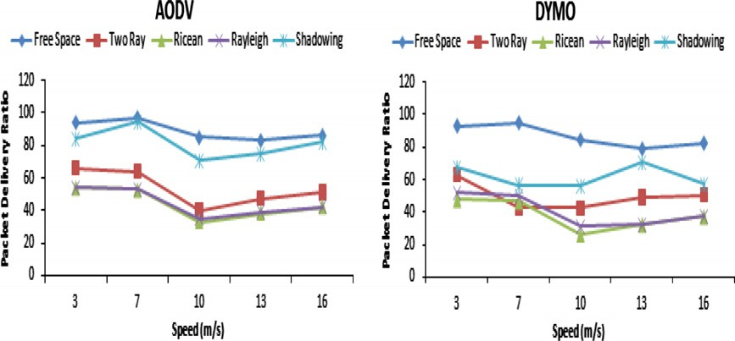

Figure 1 Packet delivery ratio versus node’s maximum speed.

72 L. Nassef

Figure 2 End-to-end delay versus node’s maximum speed.

Figure 3 Routing overhead versus node’s maximum speed.

this is essentially due to frequent link breaks. A similar behavior was obtained for two ray ground model, with AODV performing better than DYMO. In fading model, the two pro- tocols have higher routing overhead compared with non-fad- ing models as indicated in Fig. 3. This can be attributed to higher congestion and high inter-nodal interference.

* 1. *Scenario 2: performance with varying node’s pause time*

AODV and DYMO show an approximately similar behavior at different levels of pause time when considering packet deliv-

ery ratio. As pause time increases, DYMO exhibits more delay and more routing overhead than AODV as shown in the fol- lowing figures.

* + 1. *Packet delivery ratio*

The two protocols relatively do the same performance when packet delivery ratio over a variety of pause time, for two ray ground, Rayleigh and Ricean models, while free space model exhibits the highest packet delivery ratio as presented in Fig. 4. The lowest delivery ratio is for Ricean model, it is a con- sequence of the random variations in received signal strength.

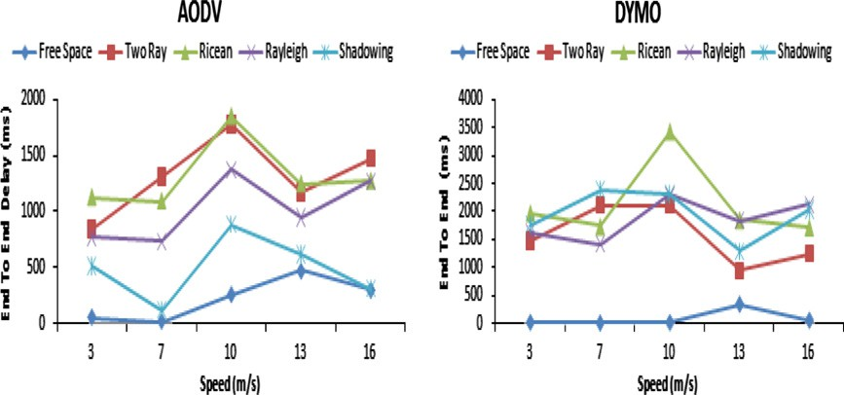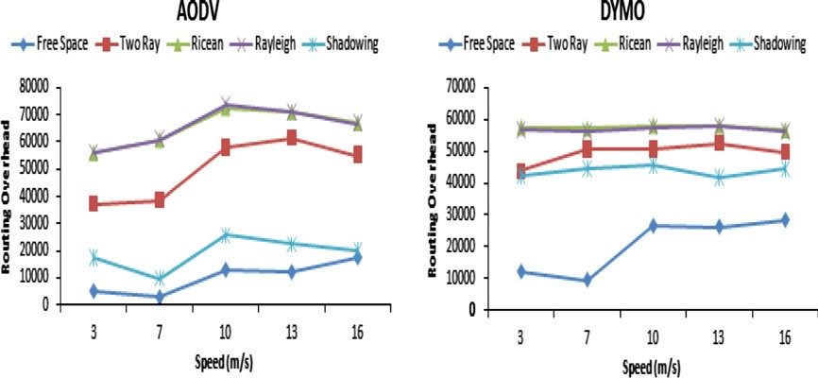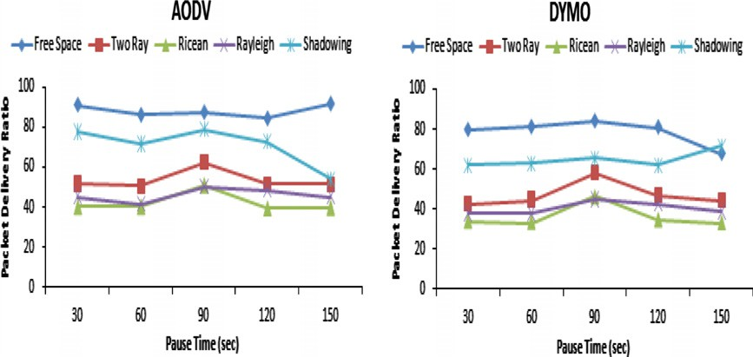

Figure 4 Packet delivery ratio versus node’s pause time.

On the effects of fading and mobility in on-demand routing protocols 73

Figure 5 End-to-end delay versus node’s pause time.

Packets are lost on a reliable link, falsely indicating that the link has failed leading to the interruption in protocol operation and initiates the need for a new path search which would also in- crease delay and routing overhead. The results indicate that un- der Ricean and Rayleigh models, DYMO drops more packets than AODV over a variety of pause times.

* + 1. *End-to-end delay*

The free space and shadowing show better performance than two ray ground, Rayleigh, and Ricean models. The two proto- cols show similar results with DYMO showing higher delay than AODV as presented in Fig. 5. As expected the highest de- lay is for fading propagation models.

* + 1. *Routing overhead*

The routing overhead for Ricean and Rayleigh is high com- pared to other models with free space which exhibited lowest routing overhead. As pause time increases, the routing over- head decreases, however, under higher pause time the routing overhead starts to increase. When modeled under the Ricean and Rayleigh fading, two protocols show an approximately similar behavior at different levels of pause time with DYMO performing worse than AODV as indicated in Fig. 6.

1. Conclusion and future work

In this paper, the effects of different propagation models on the performance of ad hoc networks have been investigated.

Although the non-fading models of free space and two-ray models have been widely used in ad hoc network’s simula- tion, these models are inappropriate as they are based on simplified assumptions that neglect the effect of fading, which represents the actual ad hoc environment. From the simula- tion results, the choice of propagation models have a great impact on performance of the routing protocol, so realistic and representative propagation models are necessary as far as the accurate analysis of the performance routing protocols is concerned. The simulation results revealed that the differ- ent propagation models affected the performance of the mobile ad hoc network considerably. Consequently, different performance evaluation results were obtained. The perfor- mance has deteriorated very quickly when fading models were taken into account; for shadowing, Rayleigh, and Ri- cean models. The main reasons for this deterioration resulted from the large variation of the received signal strength. Hence packets are not received successfully by mobile nodes due to the poor signal quality, which causes problems to the normal operations of the ad hoc routing protocols. The two on de- mand protocols performed quite differently and this gives a hint to the fact that simulation results for mobile ad hoc net- works have to be interpreted with a lot of care in order to conclude accurate results especially when quality of service awareness routing protocols are considered. A layer that pre- dicts the channel characteristics and improves the quality of service of routing protocols is needed. This layer can enhance the performance of on demand routing protocol to achieve robustness and to operate under realistic environments.

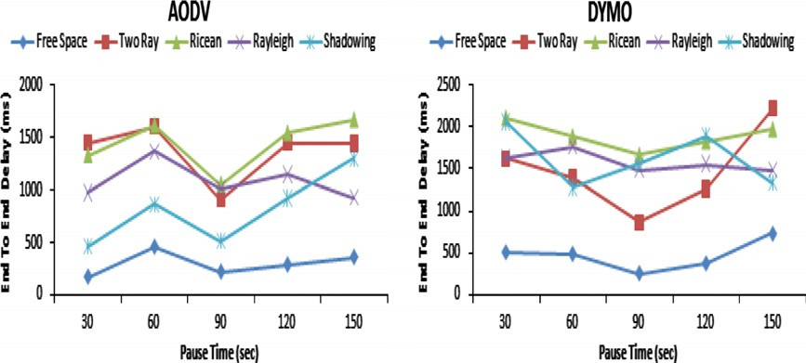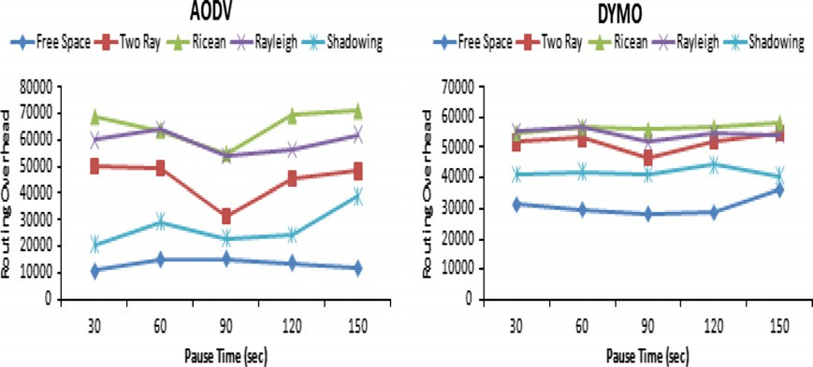

Figure 6 Routing overhead versus node’s pause time.

74 L. Nassef

Therefore, immediate future work is to develop a routing strategy that incorporates fading and mobility awareness into the existing on demand routing protocols such that less stable and unreliable links can be avoided.

References

1. Mullen J, Hong H. Impact of multipath fading in wireless ad hoc networks. In: Proceedings of the second ACM workshop on performance evaluation of wireless ad hoc, sensor, and ubiquitous networks (PE-WASUN.05); 2005.
2. Khider Ibrahim, Wang Furong, Yin WeiHua, Sacko. The impact of different radio propagation models for mobile ad-hoc networks (MANET) in urban area environment. World J Model Simul 2009;5(1):45–52.
3. Guardiola IG, Matis TI. Fast-fading, an additional mistaken axiom of wireless-network research. Int J Mobile Network Des Innovation 2007;2(3–4):153–8.
4. Lindhe M, Johansson KH, Bicchi A. An experimental study of exploiting multipath fading for robot communications. Atlanta, GA, USA: Robotics: Science and Systems; 2007.
5. Bandana Paudel. On the effects of small-scale fading and mobility in mobile wireless communication network, master thesis, Faculty of the Graduate School of the Missouri University of Science and Technology; 2009.
6. Punnoose NR, Stancil D. Efficient simulation of Ricean fading within a packet simulator. In: Proceedings of IEEE vehicular technology conference; 2000. p. 764–767.
7. Lenders, Wagner J, May M. Analyzing the impact of mobility in ad hoc networks. ACM/Sigmobile Workshop on Multi-hop Ad Hoc Networks: from Theory to Reality (REALMAN), Italy; 2006.
8. Puccinelli D, Haenggi M. Multipath fading in wireless sensor networks: measurements and interpretation. IEEE/ACM interna- tional wireless communications and mobile computing conference (IWCMC’06); 2006.
9. Ivan G. Guardiola. Mitigating the stochastic effects of fading in mobile wireless ad-hoc networks, Ph.D. thesis, Graduate Faculty of Texas Tech University; 2007.
10. Chakeres Perkins C. Dynamic MANET on-demand (DYMO) routing. Internet-draft, draft-ietf-manet-dymo-06.txt; 2006.
11. Aziz SRA, Endut NA, Abdullah S, Doud M. Performance evaluation of AODV, DSR and DYMO routing protocol in MANET. Conference on Scientific and Social Research; 2009.
12. Schmitz A, Wenig M. The effect of the radio wave propagation model in mobile ad hoc networks. In: Proceedings of ACM MSWiM; 2006.
13. Sridhana V, Bohacek S. Realistic propagation simulation of urban mesh networks. University of Delaware, Department of Electrical and Computer Engineering, Technical Report; 2006.
14. Kathirvel Ayyaswamy, Srinivasan Rengaramanujam. Analysis of propagation model using mobile ad hoc network routing proto- cols. Int J Res Rev Comput Sci (IJRRCS) 2007;1(1):7–14.
15. Vinay Sridhara, Stephan Bohacek. Realistic propagation simula- tion of urban mesh networks. Computer Networks, vol. 51. Elsevier; 2007. p. 3392–412.
16. Perkins CE, Royer EM, Das SR. Ad hoc on-demand distance vector (AODV) routing. IETF mobile ad hoc networks working group, IETF RFC3561; 2003.
17. The network simulator; NS-2: [<http://www.isi.edu/nsnam/ns/>](http://www.isi.edu/nsnam/ns/).
18. Nasri Amir, Schober Robert, Ma Yao. Unified asymptotic analysis of linearly modulated signals in fading, non-Gaussian noise, and interference. IEEE Trans Commun 2008;56(6):980–90.
19. Hossain Anwar, Tarique Mohammed, Islam Rumana. Shadowing effects on routing protocol of multihop ad hoc networks. Int J Ad Hoc, Sensor, Ubiquitous Comput 2010;1(1).
20. Hasti AhleHagh. Techniques for communications and geolocation using wireless ad hoc networks. Master of Science thesis, Worcester Polytechnic Institute; 2004.
21. Mineo Takai, Jay Martin, Rajive Bagrodia. Effects of wireless physical layer modeling in mobile ad hoc network. In: Proceedings of the ACM international symposium on mobile ad hoc network- ing and computing (MobiHoc 2001); 2001. p. 87–94.