[Engineering Science and Technology, an International Journal 48 (2023) 101564](https://doi.org/10.1016/j.jestch.2023.101564)

Contents lists available at [ScienceDirect](http://www.sciencedirect.com/science/journal/22150986)

Engineering Science and Technology, an International Journal

journal homepage: [www.elsevier.com/locate/jestch](https://www.elsevier.com/locate/jestch)

[](http://crossmark.crossref.org/dialog/?doi=10.1016/j.jestch.2023.101564&domain=pdf)Full Length Article

Optimal sizing of an integrated renewable energy system and effective utilization of surplus energy in electric vehicle charging

Vishal Saini *, S.K. Singal

*Hydro and Renewable Energy Department, Indian Institute of Technology Roorkee, Roorkee 247667, Uttarakhand, India*

A R T I C L E I N F O

*Keywords:*

Stand-alone integrated renewable energy system

Life cycle cost

Chimp optimization algorithm Surplus energy

Electric vehicles

Integrated charging strategy

A B S T R A C T

Renewable energy based power generation has proven to be a viable standalone option in areas where extending the grid is challenging. This study addresses this issue by assessing the possibility of an integrated renewable energy system (IRES) to electrify twelve villages in the Uttarakhand state of India. Four battery energy storage

(BES) devices, namely Lead-Acid (LA), Sodium-Sulfur (NAS), Lithium-Ion (Li-Ion), and Nickel-Iron (Ni-Fe) are considered for storage in this study. Using the Chimp optimization algorithm (ChOA) on the MATLAB© platform, eight different configurations consisting of solar photovoltaic (SPV) array, a micro-hydropower (MHP) plant, and

a biogas generator (BGG) are modeled and optimized. The study reveals that the optimal IRES configuration with the lowest cost and highest performance comprises 676 SPV panels (260 kWp), one MHP plant (25 kW), one BGG (40 kW), and 648 NAS batteries (778 kWh). This configuration has a total system life cycle cost (LCC) of INR

68.77 million and cost of energy (COE) of 16.77 INR/kWh at 0 % loss of power supply probability. The opti- mization problem was run 1–50 times and found that the proposed ChOA algorithm is more robust compared to others, displaying the lowest Best, Worst, and Mean values of LCC (across all eight configurations), convergence

rapidity (26th iteration), and least computational time (3481 sec). However, GWO (seven configurations), MFO (34th iteration), and GA (4154 sec) stand very close to ChOA performance in terms of providing minimum LCCs, convergence rapidity, and computational time, respectively. Furthermore, surplus energy (SE) is effectively utilized by incorporating electric vehicles (EVs) as dump load in the system. The proposed integrated charging (IC) strategy outperforms other charging strategies by energizing 134 EVs, utilizing 99.59 % of SE, and reducing the total COE to 10.57 INR/kWh. Finally, the proposed IC strategy results in a net saving of 94,479.39 tons of greenhouse gas emissions. These findings support the feasibility of implementing a standalone IRES to electrify the study area and provide electricity to EVs.

# Introduction

* 1. *Motivation and incitement*

Energy is one of the necessities in today’s era for the welfare of the

people [1]. However, a significant portion of the global population lacks access to basic energy services [2]. In developing countries, distributed renewable energy systems have emerged as a successful solution for meeting the electricity demand [3,4]. These systems, based on renew- able energy sources, have proved particularly beneficial in remote rural communities where grid electrification is challenging and costly [5]. The idea of a renewable energy-based system, which is a microgrid encompassing various loads and generators in a confined region, is un- dergoing transformation because of increased effectiveness, minimal

power loss during transmission, an economical transmission infra- structure, bolstered resilience, and heightened stability [6].

Nevertheless, renewable energy-based systems encounter various challenges, including the intermittent nature of renewable resources, the sizing of system components, system control, energy management, and power quality issues [22]. To address the intermittent nature of renewable energy (RE) sources, integrated renewable energy systems (IRESs) are often equipped with energy storage systems (ESSs) to ensure reliable matching of load demand [7,8]. In RE-based systems, batteries are considered prominently for energy storage purpose [9]. Batteries can augment solar and wind power, allowing for the optimization of total power output to maximize the use of renewable energy sources [10].

The conventional power system deals with variability in the form of random demand patterns. Whereas, RE-based power system introduces randomness in energy sources too. To address this increased variability

* Corresponding author.

*E-mail address:* [vsaini@ah.iitr.ac.in](mailto:vsaini@ah.iitr.ac.in) (V. Saini).

<https://doi.org/10.1016/j.jestch.2023.101564>

Received 30 June 2023; Received in revised form 21 October 2023; Accepted 28 October 2023

Available online 16 November 2023

2215-0986/© 2023 Karabuk University. Publishing services by Elsevier B.V. This is an open access article under the CC BY license (<http://creativecommons.org/licenses/by/4.0/>).

# Nomenclature

Abbreviations

AC Alternating current

ACs Air conditioners

AEU Annual energy utilization BES Battery energy storage BGG Biogas generator

BSC Battery swapping charging CC Charge controller

CHP Combined heat and power CM Chemicals

CO2 Carbon dioxide

CH4 Methane

ChOA Chimp optimization algorithm

SSA Salp swarm algorithm WT Wind turbine

Constant and variable parameters AFC Annual fuel cost

AMC Annual maintenance cost ARC Annual replacement cost Atemp Ambient temperature CCWS Cost of civil work

CMS Cost of mechanical structure Cpw Present worth factor

Cref, temp SPV cell temperature under standard test conditions CVBG Calorific value of biogas

CO2eq CO2 equivalents

*d* Journey distance

ef Emission factor

COE Cost of energy

CRF Capital recovery factor

max BES

min BES

E

E

Maximum energy storage limit of BES devices Minimum energy storage limit of BES devices

CS Cold storage

CSA Cuckoo search algorithm CT Computational time

DBC Dumb charging

DC Direct current

DG Diesel generator DOD Depth of discharge EE Excess energy

EMS Energy management strategy ESS Energy storage system

EVs Electric vehicles

FPA Flower pollination algorithm GA Genetic algorithm

GHG Greenhouse gas

GVs Gasoline vehicles GWO Grey wolf optimization

EEAC AC form of generated electrical energy EEDC DC form of generated electrical energy EETD Electrical energy demanded

EEGen Electrical energy generated Em Annual GHG emission

Farr Arrival time of EVs Fdep Departure time of EVs G Solar radiation

Gref Solar radiation under standard test conditions HBGG Daily operating hours of BGG

HCWD Hourly clean water demand Hnet Net head of the MHP plant N Population size

PL Project lifetime

Pmax,PC Maximum power transmitted by the PC QBES Total count of BES devices

Q

HSA Harmony search algorithm

max BES

Maximum count of BES devices

IC Integrated charging

QSPV Total count of SPV panels

ICC Initial capital cost

max SPV

Maximum count of SPV panels

IRES Integrated renewable energy system

Q

kWp Peak-kilowatt

LA Lead-Acid battery

LCC Life cycle cost

QBG Amount of biogas generated per day QCTD Quantity of cattle dung

Qturbine Design flow rate of the turbine SBES Ampere-hour rating of BES devices

Li-Ion Lithium-Ion battery

LPSP Loss of power supply probability

max BES

min

SOC

SOC

BES

Maximum SOC of BES devices

Minimum SOC of BES devices

LPS Loss of power supply

MA Mayfly algorithm

MB Membrane

MFO Moth flame optimization MHP Micro-hydropower

NAS Sodium-Sulfur battery Ni-Fe Nickel-Iron battery N2O Nitrous oxide

OC Operational cost

PC Power converter PHEVs Plug-in hybrid EVs

tu Usage time of component in years T Iterations in number

Tcoef Maximum power temperature coefficient of SPV panels VBES Voltage rating of BES devices

Greek symbols

ηBGG Efficiency of BGG

ȠCC Efficiency of CC

ȠMHP Efficiency of MHP plant ȠPC Efficiency of PC

ȠRT,BES Round trip efficiency of BES devices

σSDR Self-discharge rate of BES devices

|  |  |  |  |
| --- | --- | --- | --- |
| PSO | Particle swarm optimization | σt | Standard deviation time of EVs |
| PUF | Polyurethane foam | δ | Discount rate |
| RE | Renewable energy | δn | Nominal interest rate |
| ROD | Reverse osmosis desalination | µ | Inflation rate |
| SC | Smart charging | µt | Mean time of EVs |
| SE | Surplus energy | ρ | Water density |
| SOC | State of charge | Δt | Time step of one hour |
| SPV | Solar photovoltaic |  |  |

**Table 1**

Summary of literature review.

|  |  |  |  |  |  |
| --- | --- | --- | --- | --- | --- |
| Ref. | System components | Scenario | Approach | Evaluating criteria and constraints | Key results |
| [15] | PV/LA battery at | Both grid- | GA | Total NPC, COE, constraints on the number of | -NPC, COE of the grid-connected and stand- |
|  | 80 % DOD | connected and |  | PV modules and batteries. | alone systems are found as $6,115, 0.183 |
|  |  | stand-alone |  |  | $/kWh and $6,244, 0.196$/kWh, |
|  |  |  |  |  | respectively. |
| [16] | PV/WT/DG/ | Stand-alone | PSO algorithm | Total NPC, LPSP, constraints on the capacity | -PV/Li-Ion battery with 100 % RF was found as |
|  | LA and Li-Ion |  |  | of PV panels, batteries, DG, converter and | optimal system with total NPC and COE of |
|  | batteries |  |  | number of WTs. | $23,427 and 0.23 $/kWh. |
|  |  |  |  |  | -However, lower RF reduces energy |
|  |  |  |  |  | consumption and CO2 emission by 19 % and  57 %, respectively. |
| [17] | SPVG/WTG/ | Stand-alone | Gradient descent algorithm | LCC, Energy index ratio (EIR), Expected | -SPV module of 0.25 kWp (Type-3), WTG of 1 |
|  | BMG/ |  | and PSO algorithm | energy not supplied (EENS), Excess energy, | kW (Type-1), and the LA battery of 360 Ah |
|  | BGG/LA battery |  |  | constraints on the number of SPV modules, | (Type-1) provided the least LCCs of 268242$, |
|  |  |  |  | WTGs, batteries, output power of BMG and | 252952$ and 305524$ at EIR of 85 %, 90 %, |
|  |  |  |  | BGG. | and 95 %, respectively. |
| [18] | SPV/WT/DG/ | Stand-alone | HOMER PRO software | NPC, COE, Life cycle emission, Renewable | -SPV/WT/DG/LA battery based optimal |
|  | LA battery |  |  | penetration (RP), Unmet load (UL), Duty | system provided the least NPC as 63,116$ and |
|  |  |  |  | factor, Human development index (HDI), | COE as 0.179$/kWh at 0 % unmet load. |
|  |  |  |  | Particulate matter, Job formation factor | -The other social parameters viz: HDI, JFF and |
|  |  |  |  | (JFF), Local transport-based employment | LTE was obtained as 0.6362, 0.0321 and |
|  |  |  |  | (LTE). | 12.13, respectively. |
| [19] | solar/wind/DG/ | Stand-alone | SA algorithm | COE, Loss of load probability (LOLP), | -Hybrid multi-criterion decision-making |
|  | PHS/LA battery |  |  | Payback time, Resource availability, Energy | approach reveals that solar/wind/PHS/DG |
|  | at 70 % DOD |  |  | utilization ratio, RF, Environmental impact. | provided best results under four scenarios. |
|  |  |  |  |  | -solar/wind/PHS provided best results under |
|  |  |  |  |  | two |
|  |  |  |  |  | Scenarios. |
|  |  |  |  |  | -solar/wind/DG/LA battery provided best |
|  |  |  |  |  | results under the no-preference scenario. |
| [20] | PV/wind/ | Both grid- | Generalized reduced gradient | Net present value (NPV), COE, RF, Demand | -The best configuration was PV/wind/ |
|  | biomass/ | connected and | algorithm | supply fraction (DSF), Autonomy of the | biomass/Zinc-Bromine battery/PHS with COE, |
|  | Zinc-Bromine | stand-alone |  | system. | demand–supply fraction, and RF as 0.1626 |
|  | battery/PHS |  |  |  | $/kWh, 98.86 %, and 99.59 %, respectively. |
| [21] | PV panels/WTs/ | Stand-alone | GA | Total NPV, Levelized Cost of Electricity | -This study showed that the steep price decline |
|  | battery bank/ |  |  | (LCOE) and heat, total RP, RF, Excess ratio, | in renewable energy generators, particularly |
|  | DG/CHP/boiler/ |  |  | and UL. | WTs and PV panels, significantly affects the |
|  | thermal storage |  |  |  | optimal configuration. |
|  | tank |  |  |  |  |
| [22] | PV/WT/DG/ | Both grid- | Pseudo-inspired gravitational | ACS, LCOE, constraints on the maximum | -Grid connected rural electrification is cheaper |
|  | Li-Ion battery | connected and | search algorithm, and HOMER | number of PV panels, WTs, maximum energy | and more reliable (NPC of 320,395,303.04₦) |
|  |  | stand-alone | PRO software | stored and supplied by the batteries, | than the stand-alone system (NPC of |
|  |  |  |  | minimum and maximum DG generation, | 416,355,120.39₦). |
|  |  |  |  | constraint on the power exchange between |  |
|  |  |  |  | grid and system. |  |
| [23] | PV/WT/ | Stand-alone | Hybrid whale optimization | Total OC, constraint on the power exchanged | -Among all the algorithms HWOAPS provided |
|  | Microturbine(MT) |  | algorithm and pattern search | with the grid, limitations on the hourly power | the best results.-Scenario 1 (without PHEV) |
|  | /FC/ |  | (HWOAPS), GA, PSO, Pattern | generation and demand, minimum and | was cheaper (262.78 €ct) than scenario 2 (with |
|  | nickel-metal |  | search (PS), and WOA. | maximum power generated by the units, | PHEV) |
|  | hydride(Ni-MH) |  |  | constraints on the charging and discharging | .-Scenario 2 provided the least charging cost |
|  | battery/ |  |  | rate of battery. | (325.63 €ct) |
|  | PHEV |  |  |  | of PHEV under the SC plan. |
| [24] | PV/wind/DG/ | Grid-connected | General algebra modeling | Total OC, RE curtailment, emission benefits, | -The microgrid’s DRP and electric vehicle |
|  | plug-in EVs |  | system (GAMS) | limitations related to the DG operation, plug- | synchronization reduce daily costs, DG |
|  |  |  |  | in EV, DRP limits, AC-power flow equations, | generation, power purchase from the market, |
|  |  |  |  | wind and PV power limits. | emission pollution, and RE curtailment by |
|  |  |  |  |  | 9.97 %, 3.6 %, 3.8 %, 12.34 %, and 8.49 %, |
|  |  |  |  |  | respectively. |
| [25] | WT/CHP/ | Grid-connected | GAMS | Total OC, limitations on active and reactive | -Integrating natural gas storage reduces |
|  | hydrogen energy |  |  | power generation, WT generation, thermal | pipeline congestion in the natural gas network, |
|  | storage (HES) |  |  | and electrical power generation of a CHP | lowering operation costs. |
|  | / |  |  | unit, ramp up/down power throughput and | - HES, power to gas technology, and DRP |
|  | plug-in EVs |  |  | minimum on/off time of generation units, | increase system flexibility by reducing peak |
|  |  |  |  | HES limitations, DRP limits, gas network | load. It reduces total operating costs. |
|  |  |  |  | limitations. |  |
| [26] | Wind farm/PHEV | Grid-connected | GAMS | Energy cost, degradation cost of PHEV | -Proposed system can influence locational |
|  |  |  |  | battery, emission curtailment, limitations on | marginal prices by 4.4 % and cut emissions by |
|  |  |  |  | the PHEV fleet. | 40 %. |
|  |  |  |  |  | -Ignoring battery degradation can increase |
|  |  |  |  |  | operational costs dramatically. |
| [27] | PV/WT/battery | Grid-connected | Antlion optimization | COE, LPSP, RF, limitations on wind and SPV | -The proposed method achieves 0.0936 |
|  | at 80 % DOD/ |  | algorithm | power, and on autonomy days. | $/kWh, 0.1044 %, and 0.9940 % for COE, |
|  | EV |  |  |  | LPSP, and RF, respectively. |

(*continued on next page*)

**Table 1** (*continued* )

|  |  |  |  |  |  |
| --- | --- | --- | --- | --- | --- |
| Ref. | System components | Scenario | Approach | Evaluating criteria and constraints | Key results |
| [28] | LUT energy system | Grid-connected | MOSEK optimizer | ACS, LCOE, limitations on hourly heat and | -A fully integrated system can reduce the LCOE |
|  | transition model |  |  | energy supply matches load demand. | from 62 €/MWh in 2015 to 46 €/MWh in 2050, |
|  |  |  |  |  | while heat stays at 30–35 €/MWh, resulting in |
|  |  |  |  |  | an energy system cost of 40–45 €/MWh. |
|  |  |  |  |  | -By 2050, 100 % renewable energy reduces |
| [29] | PV/WT/MT/FC/ | Grid-connected | Hybrid crow search-pattern | Electricity price, limitations on hourly energy | CO2eq emissions from these sectors to zero.  -In the first and second scenario without |
|  | Ni-MH battery/ |  | search (HCS-PS) algorithm, | supply matches demand, on DG generation, | PHEV, the HCS-PS algorithm provided best |
|  | PHEV |  | GA, PSO, Crow search | limitations on energy supplied and absorbed | results of 262.7 €ct and 299.8 €ct, respectively. |
|  |  |  |  | by the grid and batteries. | -In the first and second scenario with PHEV, |
|  |  |  |  |  | the HCS-PS algorithm provided best results of |
|  |  |  |  |  | 336.3 €ct and 326.6 €ct under smart charging |
|  |  |  |  |  | method, respectively. |
| [30] | PV/WT/ Li-Ion | Stand-alone | HOMER PRO software, | Total NPC, LPSP, WTs, PV panels and | -PV/WT/battery system achieved the total |
|  | battery/ EV |  | MOPSO, NSGA-II, NSGA-III, | batteries | NPC of $564,846, COE of 0.2521 $/kWh at |
|  | charging stations |  | and MOEA/D |  | 1.21 % LPSP. |
|  |  |  |  |  | -Among the four algorithms, NSGA-II |
|  |  |  |  |  | demonstrated the best overall performance. |
| [31] | WT/PV/BES/EVs | Grid-connected | GAMS | Total OC subjected to | -In Case 4, the minimum total OC was |
|  |  |  |  | equality and inequality | $494,157.4 per day. This was 16.3 % lower |
|  |  |  |  | constraints | than in Case 1, 4.2 % lower than in Case 2, and |
|  |  |  |  |  | 1.3 % lower than in Case 3. |

ACS = Annualized cost of the system, BMG = Biomass generator, DRP = Demand response program, MOEA/D = Multi-objective evolutionary algorithm based on decomposition, MOPSO = Multi-objective particle swarm optimization, NPC = Net present cost, NSGA = Non-dominated sorting genetic algorithm, WTG = Wind turbine generator, ₦ = Nigerian dollar.

stemming from RE resources, solving the problem requires the use of cutting-edge optimization tools capable of handling randomness [11]. It is noted that metaheuristic optimization algorithms have recently captured attention in the area of RE-based power system studies as they can efficiently tackle issues of randomness, and assist in operation control and energy management [22]. Moreover, they efficiently determine the quantities and dimensions of integrated system compo- nents while minimizing cost and addressing the common issue of converging to local minima, often encountered in traditional methods [12].

In these systems, excess energy generated during off-peak hours is used to charge the ESS. When the ESS is fully charged, any remaining excess energy (called surplus energy) is typically wasted in dump load that can be utilized in cooking, water heating, or baking [13]. Recently, electric vehicles (EVs) have played a crucial role in microgrid systems as emerging energy consumers, offering potential solutions to address system challenges [14]. Hence, EVs can be utilized as a promising consumer of surplus energy (SE) in future IRESs. As a result, the goal of this study is, firstly, to develop the optimal IRES model to electrify the chosen study area. Secondly, effective utilization of SE in standalone IRES for enhancing energy utilization and reducing the cost of energy by deploying EVs as a dump load.

* 1. *Literature review*

Several researchers have conducted studies on the optimal sizing problems of IRES from various perspectives. Hassan [15] used solar photovoltaic (PV)/lead acid (LA) battery-based system to meet the electricity needs of an Iraqi household in grid-connected and off-grid modes. Results reveal that in grid-connected and off-grid modes, 4,600 kWh/year and 1,468 kWh/year amount of SE is transferred to the grid and dump load, respectively. Mokhtara et al. [16] optimized wind tur- bine (WT)/PV/diesel generator (DG)/LA/lithium-ion (Li-Ion) battery- based off-grid system and found that the demand-side management at 100 % renewable fraction reduces SE transferred to dump load by 29 %. Patel and Singal [17] conducted a study on an optimal system comprising 0.25 kWp of solar PV, 1 kW of WT, a biomass generator (BMG), a biogas generator (BGG), and a 360 Ah LA battery. They found that this system transmitted 14,124 kWh, 14,238 kWh, and 18,748 kWh amount of SE to the dump load at energy index ratio levels of 85 %, 90

%, and 95 %, respectively. Faizan et al. [18] found that the SPV/WT/ DG/LA-based optimal system dumps 13,975 kWh/year amount of SE. Javed et al. [19] discovered that the optimal solar/wind/DG/LA/pump hydro storage (PHS) injected 25,450 kWh/year amount of SE to dump load.

Ghussain et al. [20] found that the optimal PV/wind/biomass and PV/wind/biomass/PHS/Zinc-Bromine battery-based system dumped 6,297 MWh and 4,811 MWh amount of SE to grid and PHS, respectively. Kahwash et al. [21] devised PV panels/WTs/battery bank/DG/CHP/ boiler/thermal storage tank-based system and found that the total excess generation is more than 50 % with 15 % unutilized. Shukla and Momoh

[22] discovered that the PV/DG/grid and PV/WT/DG/Li-Ion-based system generates 13,335 kWh/year and 11,818 kWh/year amount of SE in grid-connected and off-grid mode, respectively.

Recently integration of electric vehicles (EVs) in power systems has gained significant attention. In the present literature, several authors have incorporated EVs in their systems and analyzed their impacts on systems performance. Tao et al. [23] created a plug-in hybrid EV (PHEV)/PV/WT/Microturbine (MT)/Fuel cell (FC)/nickel-metal hy-

dride (Ni-MH) battery system to reduce the system’s operational cost (OC) by avoiding PHEV charging during peak demand. Guo et al. [24]

investigated a system comprising PV/DG/plug-in EVs and demonstrated that integrating a demand response program with plug-in EVs lead to reductions in daily OC, DG generation, power purchases from the mar- ket, emission pollution, and renewable energy curtailment by 9.97 %,

3.6 %, 3.8 %, 12.34 %, and 8.49 %, respectively. Ibrahim et al. [25] integrated plug-in EVs into a system consisting of WT, CHP, and hydrogen energy storage, finding that the integration of plug-in EVs resulted in higher OC.

Zeynali et al. [26] investigated the integrated operation of a wind farm and PHEV fleets in a day-ahead wholesale market, taking into ac- count the influence of battery degradation on OC under a smart charging scheme. Alsharif et al. [27] designed a microgrid comprising EVs, PV, WT, the grid, and batteries, aiming to minimize the COE while maxi- mizing energy reliability and the renewable fraction. Bogdanov et al.

[28] created a power, heat, transportation, and desalination energy system transition model to maintain the integrated energy system’s total cost as low as possible.

Xiaoluan et al. [29] proposed a PHEV/grid/PV/WT/MT/FC/Ni-MH battery-based system and found that smart charging strategy reduces

**Table 2**

General information about the study area [42].

Property Details

Country India

State Uttarakhand

District Pithoragarh

Block Munsyari

Name of villages Milam, Bilju, Pachhu Gunth, Ganghar, Mapa, Burphu,

Tola, Martoli, Lwa, Laspa, Khilach and Ralam.

Region Hilly

Latitude and Longitude 30.36 N, 80.18 E Number of households 335

Total population 1100

Population age group (0)– 49

(6)

Literates 544

Language Kumauni

**Table 3**

Daily seasonal energy demand in kWh.

|  |  |  |  |
| --- | --- | --- | --- |
| Seasons | Minimum | Maximum | Average |
| Winter (Dec–Mar) | 35 | 103 | 55 |
| Summer (Apr–Jun) | 8 | 101 | 45 |
| Monsoon (Jul–Sep) | 8 | 101 | 39 |
| Post-monsoon (Oct–Nov) | 8 | 76 | 28 |





**Fig. 1.** Seasonal load demand curves.

PHEV charging cost significantly. Alshammari et al. [30] optimized hybrid EV charging systems for sustainability, considering technical and economic factors. Four different algorithms were deployed for multi- objective optimization, focusing on minimizing total NPC and reducing power supply interruptions. Reddy [31] proposed optimal scheduling for a microgrid, maximizing renewable energy use (wind and solar PV) while considering uncertainty. It minimized total operating cost (including grid exchange, renewables, storage, EVs, and demand response) using probability distribution functions and GAMS software. The literature review is summarized in Table 1, which includes the main evaluating objectives, commonly used software and algorithms,

and key findings from selected works in the literature.

The literature highlights several research gaps regarding the IRESs and the challenges associated with them. These points can be summa- rized as follows:

1. The cost of storage, particularly batteries, is a significant concern in IRES due to the imbalance between renewable generation and demand. Surplus renewable generation often needs to be dis- carded to maintain system stability. The increased fraction of renewable energy and lower generation cost can further exacer- bate this issue.
2. Many studies on IRES do not emphasize the utilization of SE effectively. This implies that there is potential to optimize the utilization of surplus renewable energy to enhance the overall efficiency and economic viability of IRES.
3. Several authors have considered EVs as part of the main load in IRES. Such integration of EVs increases the overall cost and size of the system. However, there is a lack of research on the charging of EVs in 100 % renewable energy-based stand-alone IRES, sug- gesting a gap in the current literature.
   1. *Contribution and paper organization*

Based on the identified gaps in the literature, the novelty and sig- nificant contributions of this study can be outlined as follows:

1. This study proposes the stand-alone IRES to meet the electricity demand of the selected villages in Munsyari Block of Uttarakhand state (India), using solar photovoltaic (SPV) array, micro- hydropower (MHP) plant, biogas generator (BGG), Lead-Acid (LA), Sodium-Sulfur (NAS), Lithium-Ion (Li-Ion) and Nickel- Iron (Ni-Fe).
2. Resilience, proficiency, and computational time performance of the proposed Chimp optimization algorithm (ChOA) [32] have been compared with other optimization algorithms such as Ge- netic algorithm (GA) [33], Particle swarm optimization (PSO) [34], Moth flame optimization (MFO) [35], Salp swarm algo- rithm (SSA) [36], Mayfly algorithm (MA) [37], Grey wolf opti- mization (GWO) [38], Cuckoo search algorithm (CSA) [39], Flower pollination algorithm (FPA) [40] and Harmony search algorithm (HSA) [41].
3. This study addresses the underutilization of surplus renewable energy in IRESs. It aims to develop an optimization strategy to effectively utilize the SE generated by renewable sources. Maxi- mizing SE use improves the economic viability and efficiency of IRESs.
4. Unlike previous studies, this research investigates the charging of EVs in stand-alone IRES that solely rely on renewable energy sources. By exploring this aspect, it aims to provide insights into the feasibility, challenges, and potential benefits of integrating EV charging in 100 % renewable energy-based systems.

Overall, this study brings novel perspectives and significant contri- butions by addressing the gaps in existing literature, particularly in terms of SE utilization, EV integration in stand-alone IRES, cost and size optimization using a novel ChOA algorithm, and comprehensive per- formance analysis of the proposed ChOA algorithm with other optimi- zation techniques.

To achieve the abovementioned objectives, details regarding the study area and load-resource assessment are provided in the subsequent Section 2. Afterward, Section 3 elaborates on the methodology adopted to carry out the study. Followed by Section 4, which presents the results and findings. Finally, Section 5 summarizes the paper and highlight the conclusions.

# Identification of study area

The study area involves twelve un-electrified villages in the Mun- syari Block of Uttarakhand, India. Munsyari Block is located in the Great Himalayas physiographic zone, at a high latitude, and low temperature. A heating season that can extend up to six months a year is brought on by





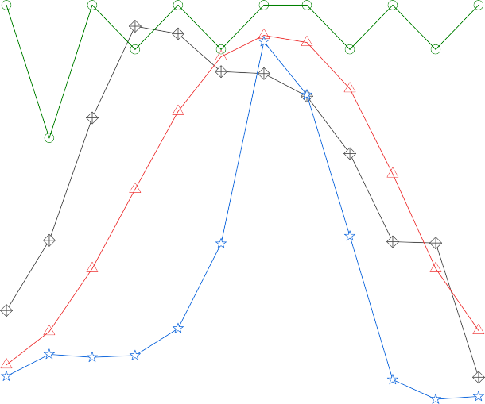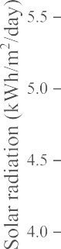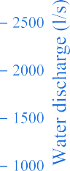

**Fig. 2.** Monthly profile of renewable resources.



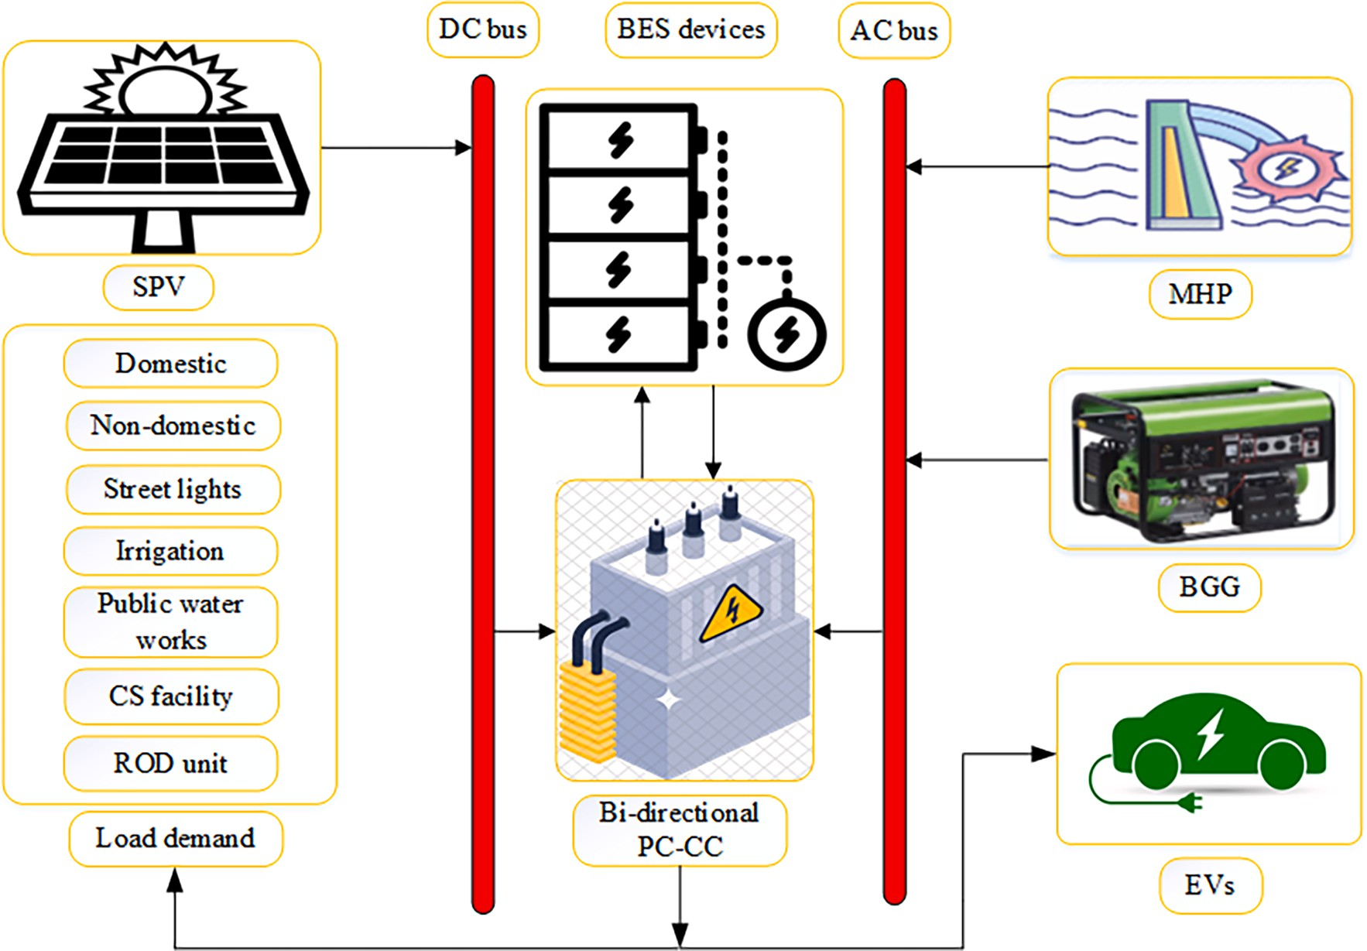

**Fig. 3.** Layout of the proposed integrated renewable energy system.

the long and chilly winters there. Table 2 contains general information about the study region.

°

* 1. *Load-resource assessment of the study area*

Daily load demand in the study area includes energy needs for various purposes such as domestic, non-domestic, street lights,

irrigation, public water works, a cold storage (CS) facility, and a reverse osmosis desalination (ROD) unit. Table 3 presents the minimum, maximum, and average energy demand for different seasons. Addi- tionally, Fig. 1 illustrates the seasonal load demand curves, showcasing the variations in load demand throughout the year.

During the site survey, it was observed that the study area has abundant solar radiation, water streams, and significant availability of

cattle dung for biomass. Solar radiation and ambient temperature data for a span of 20 years (1995–2015) were provided by the National Renewable Energy Laboratory (USA), as depicted in Fig. 2. The annual

average solar radiation on an inclined plane recorded approx. 5 kWh/

* + 1. *Biogas generator (BGG)*

The total power generated by the BGG (PBGG (t)) in kW on daily basis is expressed by Eq. (3) as [17]:

*QBG* × *CVBG* × *ηBGG*

m2/day, while the ambient temperature averaged 19 ◦C. In order to estimate the hydropower potential discharge, rainfall data spanning 20

*PBGG*(*t*) =

860 × *HBGG*

(3)

years (1995–2015) were collected from the Indian Meteorological

Department, Pune (India). Fig. 2 illustrates the monthly water discharge for the micro-hydropower (MHP) plant. Annual dependable water discharge for the MHP plant was estimated to be 232 L per second. In addition, the study area is home to a significant number of cattle, and their dung can be utilized to generate biogas and electricity [43]. Fig. 2 also demonstrates that the research region produces approximately 989 tons of dung per year, which is expected to yield around 42,705 cubic meters of biogas.

# Methodology adopted

This section details power and economic modeling of all system components. Subsequently, this section explains the objective function

where, QBG is the amount of biogas generated per day (117 m3), CVBG is the calorific value of biogas (4700 kcal/m3), ȠBGG is the efficiency of BGG (25 %), and HBGG is the daily operating hours of BGG (4 h from 4p. m. to 8p.m.).

* + 1. *Battery energy storage (BES) devices*

Excess energy stored by the BES devices when hourly energy gen- eration exceeds load demand is illustrated by Eq. (4). Similarly, the required deficit load supplied by the BES devices when hourly load demand exceeds energy generation is illustrated by Eq. (5). The avail- able capacity of BES devices at time t can be stated as [45]:

*EBES*(*t*) = [(1 — *σSDR*) × *EBES*(*t* — 1) + (*EEGen* (*t*) — *EETD* (*t*) ) × *ηCC*

*ηPC*

and constraints of the study. Finally, it depicts the developed energy management strategy.

× *ηRT*,*BES*

]*QBES* (4)

* 1. *Power modeling of the integrated renewable energy system (IRES) components*

The layout of the proposed IRES is shown in Fig. 3, which comprises SPV array, MHP plant, BGG, BES devices, Bi-directional power converter with a charge controller (PC-CC), load demands, and EVs as a dump load. The SPV array is connected to the DC bus, while the MHP plant and BGG are connected to the AC bus. The BES devices are connected to both the AC and DC bus through the bi-directional PC-CC. This allows them to store and supply power as needed. Similarly, the EVs are also connected to both the buses through the bi-directional PC-CC, enabling them to consume the SE generated on an hourly basis.

* + 1. *Solar photovoltaic (SPV) array*

The SPV array mainly comprises several SPV panels that transform solar energy into electricity. Based on hourly solar radiation (G (t)) and ambient temperature (Atemp (t)), the power delivered by the SPV array (PSPV (t)) can be calculated as [16]:

*PSPV* (*t*) = *SPVrated*(*G*(*t*) ){1 + [*Atemp*(*t*) + 0.0256\**G*(*t*) ]

*Gref*

* + - * *Cref* ,*temp* )*Tcoef* }*QSPV* (1)

where, SPVrated is the SPV panel’s rated output power. Gref and Cref, temp

are solar radiation and SPV cell temperature under standard conditions, respectively. Tcoef is the maximum power temperature coefficient (0.0037/◦C) and QSPV is the total count of SPV panels.

* + 1. *Micro-hydropower (MHP) plant*

The assessment of hydropower potential in this study is conducted using the soil conservation service-curve number method, as described in reference [44]. This method is utilized to estimate the monthly discharge of direct run-off stream, as depicted in Fig. 2. Hourly power output of the MHP plant (PMHP (t)) in kW is evaluated by using Eq. (2) as [44]:

*EBES*(*t*) = [(1 — *σSDR*) × *EBES*(*t* — 1) — (*EETD* (*t*)

* + - * *EEGen* (*t*) )/*ηRT*,*BES* ]*QBES* (5)

*ηPC*

*EEGen*(*t*) = (*EEDC* + *EEAC*)×*ηPC* (6)

*EEDC*(*t*) = *PSPV* (*t*) × Δ*t* (7)

*EEAC*(*t*) = (*PMHP*(*t*) + *PBGG*(*t*) ) × Δ*t* (8)

where, EBES (t) and EBES (t-1) are the states of energy of BES devices at the time ‘t’ and ‘t-1′, respectively. σSDR is the hourly self-discharge rate of BES devices. EEGen (t) and EETD (t) are the total electrical energy

generated and demanded at any time ‘t’, respectively. ƞPC is the effi-

ciency of power converter (PC), ƞCC is the efficiency of charge controller (CC), ƞRT, BES is the round-trip efficiency of the BES devices, and QBES is the total count of BES devices. EEDC and EEAC are the generated direct current (DC) and alternating current (AC) forms of electrical energy, respectively. Δt is the time step of one hour.

* + 1. *Bi-directional power converter with a charge controller (PC-CC) system*

The bi-directional power converter (PC) in the system serves two purposes: converting AC to DC in rectifier mode and DC to AC in inverter mode. This allows for the utilization of both AC and DC electrical energy in the system. In IRES, charge controllers (CC) play a pivotal role in safeguarding BES devices against potential harm caused by excessive charging and discharging. It is achieved by regulating the flow of current to and from the BES devices, ensuring their longevity and optimal per- formance. The power rating of bi-directional PC-CC (PPC-CC) is calcu- lated by Eq. (9) as:

*PPC*—*CC* = *Pmax*,*PC* × 1.1 (9)

where, Pmax,PC is the maximum power transmitted by the PC and the

*PMHP*(*t*) =

9.81 × *ρ* × *Qturbine* × *Hnet* × *ηMHP* (2)

1000

multiplication factor of 1.1 shows the 10 % overloading capacity of the PC [17].

Additionally, one ROD unit and one CS facility are proposed in this

where, ρ is the water density (1000 kg/m3), Qturbine is the design flow rate of the hydro turbine, Hnet is the net head (18.25 m), and ȠMHP is the

overall efficiency of the MHP plant (60 %). Based on the available head and discharge, the MHP plant of 25 kW capacity has been proposed in the study area.

study. They require 2 kWh and 4.22 kWh, respectively, on a daily basis.

* + 1. *Integration of electric vehicles (EVs) as dump load with the IRES*

Electric vehicle charging demand is determined by analyzing the









**Fig. 4.** Typical trip chains prepared from daily activities.









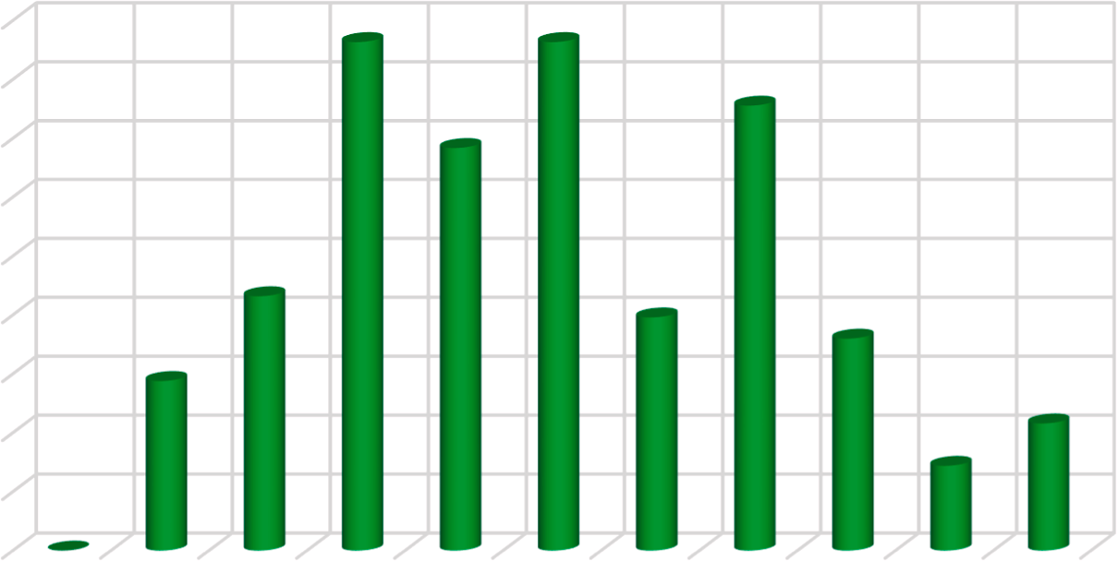**Fig. 5.** Hourly departure and arrival time of EVs.



**Fig. 6.** Daily distance covered by EVs.

daily travel profiles. Data on daily driving patterns were obtained from the Uttarakhand Transport Corporation and residents in the study area. The dynamic travel patterns were captured using the trip chain model, which is based on daily driving patterns [46]. Fig. 4 illustrates six

representative trip chains that reflect daily activities. It is observed that most EVs are charged during the night and early morning hours when they are parked. The hourly departure and arrival timing of EVs are shown in Fig. 5, while Fig. 6 displays the daily travel distance of EVs.

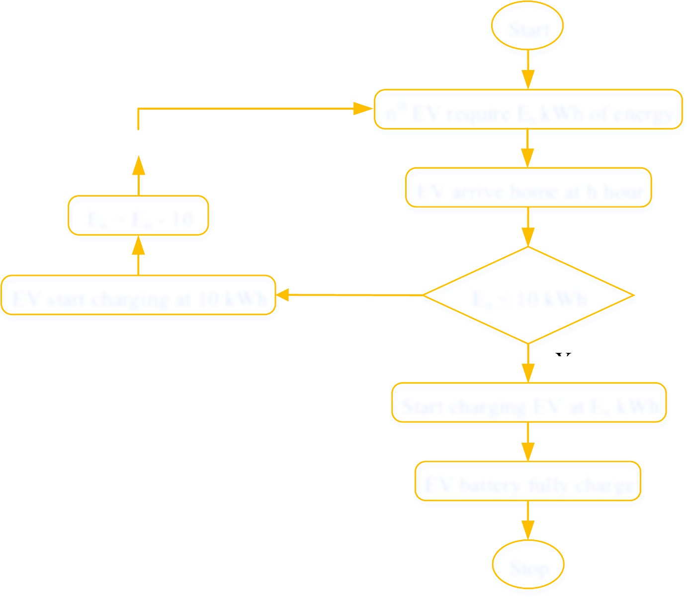

**Fig. 7.** Charging strategy for EVs.







**Fig. 8.** The energy required by EVs for daily distance travel.

For the various factors that contribute to the unpredictability of EVs charging demand, such as driver behavior, travel patterns, and charging

*F* (*t*) =

1

*t*

*e*—(*t*—*μt* )/2*σ*2 , 0 < t < 24 (10)

*dep*

infrastructure availability, a normal distribution function is employed.

*σ* ,̅̅̅*π*̅̅ *t*

To account for the stochastic behavior of EV drivers, the probability distribution function of the departure (Fdep (t)) and arrival (Farr (t)) time

2

where, μt = 10.5, σt = 3.45

of EV drivers are considered which is a normal distribution that can be

*t*

2

*F* (*t*) = 1 *e*—(*t*—*μt*)/2*σ*2

(11)

expressed by Eqs. (10) and (11), respectively as [47]:

*arr*

*σ* ,̅̅̅*π*̅̅

*t* , 0 < t < 24

**Table 4**

CO2 emission from the IRES.

(ICC), cost of mechanical structure (CMS) of SPV panels, cost of civil works (CCWS), annual maintenance cost (AMC), annual replacements cost

Emission source

GHG emission (Em in tons) Emission factor (ef in kgCO2/

kWh)

(ARC), and annual fuel cost (AFC).

The following assumptions are taken into account in the economic analysis:

Grid 8760 0.79 [53]

*Em*,*Grid* = ∑ *EETD* (*t*)\**ef*,*Grid*

=

*t* 1

SPV *Em*,*SPV* = ∑8760 *PSPV* (*t*)\**ef*,*SPV* 0.046 [19]

*t*=1

1. CCWS of all the IRES components viz: SPV panels, MHP plant,

MHP *Em*,*MHP* =

∑8760 *PMHP* (*t*)\**ef*,*MHP*

*t*=1

0.009 [54]

BGG, BES devices, PC-CC, ROD unit, and CS facility are consid-

BGG *Em*,*BGG* = ∑8760 *PBGG* (*t*)\**ef*,*BGG* 0.099 [54]

*t*=1

where, μt = 14.5, σt = 3.6

To account for the stochastic travel pattern of EVs, the probability

distribution function of the daily distance (Fd (d)) covered by EVs is considered and is evaluated by Eq. (12) as [47]:

*F d*) = 1 *e*—(ln(*d*)—*μt*)/2*σ*2 , *d* > 0 (12)

ered as 20 % [17], 40 % [55], 5 % [17], 3 % [17], 3 % [17], 3 %

[56], and 108 % [57] of their initial capital cost, respectively.

1. AMC of IRES components viz: SPV panels, BGG, PC-CC, and CS facility are considered as 2.5 % [17], 2.5 % [17], 2.5 % [17], and 2 % [57] of their initial capital cost, respectively. Whereas, AMC of the MHP plant and ROD unit are taken as 7500 INR/kW [33] and 15 INR/m3 [56], respectively.
2. ARC of all the IRES components viz: BGG, BES devices, PC-CC, MB

(membrane), CM (chemicals), ACs, and PUF insulation material

*d*( *dσ* ,̅̅̅*π*̅̅ *t*

*t*

2

are considered as 70 % [17], 100 % [17], 100 % [17], 100 %

[56], 100 % [56], 100 % [57], and 100 % [57] of their initial

where, *d* is the journey distance, μt is the mean of ln*(d)* (55.62), and σt is the standard deviation (24.16).

The following assumptions are taken into account in the EV charging analysis:

* 1. The probability of charging infrastructure availability at home is 100 %.
  2. This study takes into consideration the capital cost per kilowatt of

all standby EV batteries, as outlined later in Table 6.

capital cost, respectively.

The overall LCC of the IRES is estimated by Eq. (14) as [17]:

*LCC* = ∑ *ICC* + ∑ *CMS* + ∑(*CCWS* + *AMC* + *ARC* + *AFC*).*CPW* (14)

where, Cpw is a present worth factor which includes the change in the value of money over time. It is calculated as follows [17]:

*tu i*—1

*i*

* 1. For simplification, it is also assumed that the standby EV batteries

*CPW* = ∑ (1 + *μ*)

(15)

have a lifespan of 20 years.

* 1. To ensure that future EVs are efficient, this study assumes an EV energy consumption rate of 0.135 kWh/km [48].

In this study, EVs are equipped with a 16.2 kWh Li-Ion battery and 10

*i*=1

*δn* — *μ*

*δ* =

1 + *μ*

(1 + *δ*)

(16)

kWh charger capacity. Fig. 7 presents the developed EV charging strategy, based on the hourly energy required by the EVs as shown in Fig. 8. Each EV is associated with a specific arrival time, and charging

where, δ, δn, µ, and tu represent the discount rate, nominal interest rate,

inflation rate, and usage time of component in years, respectively. Finally, the cost of energy (COE) is evaluated as:

)

begins when the EV arrives at home [49]. For instance, if the energy consumption of an EV is below 10 kWh upon arrival, charging proceeds

at the current energy level until the battery is fully charged. However, if

*COE INR*

*kWh*

( )

=

*LCC*

8760 *EE*

(∑

*t*=1

*TD*

(*t*)

× *CRF*

(17)

the energy consumption is higher, charging occurs at a rate of 10 kWh.

where, CRF is the capital recovery factor and is expressed as:

* + 1. *Avoided greenhouse gas (GHG) emission*

Avoided GHG emission is an important environmental indicator that represents the reduction in equivalent carbon dioxide (CO2) emissions

*CRF*

*δ* 1 *δ PL*

= (1 + *δ*)*PL* — 1 (18)

( + )

achieved by implementing IRES and EVs, compared to the emissions that would have been produced if the conventional grid and gasoline vehicles (GVs) were used instead. The calculation of avoided GHG emissions in this study is expressed by the following formula [50]:

*GHG* = (*GHGGrid* + *GHGGVs*)—(*GHGSPV* + *GHGMHP* + *GHGBGG* + *GHGEVs*)

(13)

In this study, the emission of CO2 from EVs is assumed to be zero, while from GVs is considered to be 0.1135 kgCO2 per kilometer [51], Table 4presents the equations used to estimate the CO2 emissions from the IRES.

where, PL is the project lifetime of 20 years.

* 1. *Objective function and constraints*

The life cycle cost as an objective function and the constraints that were taken into account are explained below.

* + 1. *Life cycle cost (LCC)*

The objective function of this study is to minimize the LCC by considering constraints. The objective function is written as:

*min*

∑

To compare the emissions of different GHGs, they are expressed in terms of CO2 equivalents (CO2eq). CO2 is used as a baseline with a global warming potential of one, while other GHGs specified in the Kyoto Protocol have higher global warming potentials than CO2 [52].

Minimize*LCC*(*QSPV* , *QBES*) =

*m*=*SPV*,*MHP*,*BGG*,*BES*,*PC*—*CC*,*ROD*,*CS*

* + 1. *Energy balance constraints*

(*LCC*)*m*

(19)

This allows for standardized measurement of emissions and their impact

on global warming.

* 1. *Economic analysis modeling of the IRES*

The life cycle cost (LCC) of the system includes initial capital cost

The equality constraint in the IRES ensures the equilibrium between instantaneous energy generation and load demand. This constraint can be articulated as follows:

(*PBGG*(*t*) + *PMHP*(*t*) + *PSPV* (*t*)) × Δ*t* ± *EBES*(*t*) = *EETD*(*t*) + *En* (20)

*t*

where, Et is the SE consumed by the nth EV at hour ‘t’.

n

Techno-economic parameter values.

Parameter Value Parameter Value

Nominal interest rate (%) 13 ICC of ROD unit (INR) 156,600 Annual inflation rate (%) 5 ICC of WST (INR) 76,800 Rated power of SPV panel 385 ICC of MB (INR) 18

(WP)

8760

*LPSP t*=1

∑ *LPS*(*t*)

= ∑

8760 *EETD* (*t*)

*t*=1

* 1. *Energy management strategy (EMS)*

(29)

ICC of SPV panel (INR) 9,600 ICC of CM (INR) 18

EMS ensures efficient operation of the IRES by allocating energy

Lifetime of SPV panel

(years)

20 No. of MB replacement/year 2

units to meet system demand while minimizing LCC and adhering to

MS cost of each SPV panel (INR)

3,075 Rated power of air conditioners (kW)

4.22

reliability constraints. It optimizes the utilization of energy sources (BGG, MHP, and SPV) based on availability, cost, and reliability con-

Lifetime of MS of SPV panel (years)

|  |  |  |  |  |
| --- | --- | --- | --- | --- |
| MHP plant capacity (kW) | 25 | Lifetime of air conditioners  (years) | 10 | (i) If the IRES generates energy equal to the load demand, it is |
| ICC of MHP plant (INR/ | 97,500 | ICC of PUF insulation (INR) | 52,500 | injected into the main load using the bi-directional PC-CC. |
| kW) |  |  |  | (ii) If the total energy generated by the IRES is less than the load |
| Lifetime of MHP plant | 20 | ICC of humidifier (INR) | 18,750 | demand, then BES devices supply the load demand. If the BES |
| (years)  Rated power of BGG (kW) ICC of BGG (INR) | 40  559,050 | ICC of sensors (INR)  Rated power of PC-CC (kW) | 2,250  114 | devices are unable to fully supply the load demand, a portion of the load is interrupted, resulting in the LPSP as the reliability |
| Lifetime of BGG (hours) | 20,000 | ICC of converter (INR) | 92,340 | index. |
| Dung consumed by BGG | 889 | Lifetime of converter (years) | 10 | (iii) If the total energy generated by the IRES is greater than the load |
| (tons/year)  Cost of cattle dung (INR/ ton) | 750 | Efficiency of converter (%) | 95 | demand, the excess energy is delivered to the BES devices. If the injected energy to the BES devices exceeds their rated capacity or |

20 ICC of air conditioners (INR) 135,000

siderations. The EMS is explained as follows:

* + 1. *Upper and lower bound constraints*

This study considers the total count of SPV panels (QSPV) and BES devices (QBES) as decision variables, as expressed by Eqs. (20)-(21):

the BES devices are full, the remaining excess energy (called surplus energy) is used to charge the EVs.

# Results and discussion

0 ≤ *QSPV* ≤ *Qmax*

*SPV*

0 ≤ *QBES* ≤ *Qmax*

*BES*

* + 1. *Energy storage limit on the BES devices*

(21)

(22)

This analysis involves a thorough examination of the best possible configuration and scheduling strategy for renewables BGG, MHP, and SPV with various BES devices, including, LA, Li-Ion, NAS, and Ni-Fe. To find the optimal solution, numerous optimization algorithms are employed, such as ChOA, GA, PSO, MFO, SSA, MA, GWO, CSA, FPA, and

The following expression limits the amount of energy stored in the BES devices at any time ‘t’ given by Eq. (23),

HSA, which are implemented within the optimization model to identify

the most favorable configuration. The optimal configuration is deter- mined based on the concept of the system’s least LCC. To gauge the

*Emin* ≤ *EBES* (*t*) ≤ *Emax*

*BES*

*BES*

(23)

performance of these algorithms, a model is established to assess criteria

The following are the maximum and minimum energy storage limits for BES devices:

like resilience, proficiency, and computational time. The primary

objective of this methodology is to pinpoint the most appropriate BES device and algorithm for achieving optimal results in a system driven by

*Emax* = (*QBES* × *VBES* × *SBES* ) × *SOCmax*

(24)

BGG, MHP plant, and SPV panels. Lastly, the approach is employed to

*BES*

1000

*BES*

charge EVs using the SE generated by the IRES, following different EV

charging strategies.

*Emin* = (*QBES* × *VBES* × *SBES* ) × *SOCmin*

(25)

The total count of SPV panels (QSPV) and BES devices (QBES) are

*BES*

1000

*BES*

considered decision variables and optimized in this study. Whereas, MHP plant, BGG, and converter system capacities are considered fixed

where, VBES is the rated voltage and SBES is the rated ampere-hour (Ah)

capacity of each BES device.

The minimum and the maximum state of charge of BES devices are as follows:

*SOCmin* = 1 — *DOD* (26)

*BES*

*SOCmax* = *SOCmin* + *DOD* (27)

variables. Thus, based on the provided upper and lower limit values of the optimized variable in search space, the optimization algorithm will give the optimum value of that particular component. The BGG gener- ates electricity at its rated capacity throughout the project lifetime. The MHP plant, on the other hand, is expected to generate electricity at its rated capacity for more than 75 % of the year.

*BES*

*BES*

* 1. *Identification of optimal IRES configuration*

where, SOC is the state of charge and DOD is the depth of discharge.

* + 1. *Power reliability constraint*

The loss of power supply probability (LPSP) occurs when IRES is not able to meet the energy demand. This study evaluates hourly power losses (LPS(t)) using hourly generated electricity, hourly load demand, and BES devices energy level at any time (t):

*LPS*(*t*) = (*EETD* (*t*) ) — *EEGen*(*t*)[(1 — *σSDR*) × *EBES*(*t* — 1) — *Emin* ] × *ηRT BES*

This study examines different configurations of the IRES involving BGG, MHP plant, SPV panels, and BES devices with varying depths of discharge (DOD). Four types of BES devices (LA battery, NAS battery, Ni- Fe battery, and Li-Ion battery) are considered for optimization. Earlier ChOA algorithm has been used to address various issues such as breast cancer detection, optimal location of DGs, underwater acoustical data- set, real‑time COVID-19 diagnosis from x-ray images, diagnosis of Par-

kinson’s disease and cleft lip and palate, except optimal sizing of the

*ηPC*

*BES*

,

(28)

IRESs. Therefore, in this study, the ChOA algorithm is implemented in MATLAB© to determine the optimal IRES configuration. A total of eight configurations are simulated and optimized at 0 % LPSP level. The

Techno-economic specification of BES devices.

80 % DOD configuration. The optimal values for QSPV and QBES are 676

|  |  |  |  |  |  |
| --- | --- | --- | --- | --- | --- |
| Battery | Lead-Acid (LA) | Lithium-  Ion  (Li-Ion) | Sodium- Sulfur (NAS) | Nickel- Iron (Ni-Fe) | and 648, respectively.  *4.1.4. Performance analysis of Ni-Fe battery configured IRES configuration* |
| Battery capacity (Ah) | 490 | 300 | 600 | 1000 | The optimization results given in Table 8 show that the Ni-Fe battery |
| Voltage rating (V) | 6 | 12.8 | 2 | 1.2 | performs best with BGG/MHP/SPV at 80 % DOD configuration, pro- |

**Table 7**

|  |  |  |  |  |
| --- | --- | --- | --- | --- |
| Round-trip efficiency | 85 | 92 | 90 | 80 |
| (%) |  |  |  |  |
| Total lifetime (years) | 3 at | 9 at | 20 at | 30 at |
|  | 70 % DOD | 70 % DOD | 70 % DOD | 70 % DOD |
|  | 2.5 at | 7.5 at | 15 at | 30 at |
|  | 80 % DOD | 80 % DOD | 80 % DOD | 80 % DOD |
| Self-discharge rate (%) | 0.30 | 0.20 | 0.20 | 1 |
| ICC (INR) | 30,750 | 248,775 | 45,000 | 79,275 |
| AMC (INR) | 2.5 % of ICC | Nil | 2 % of ICC | 2 % of ICC |

Parameter settings of algorithms.

Algorithm Parameters

ducing LCC and COE of INR 103.575 million and 25.26 INR/kWh, respectively, which are approximately 12.08 % lower than the BGG/ MHP/SPV/Ni-Fe at 70 % DOD configuration. The QSPV and QBES values for BGG/MHP/SPV/Ni-Fe at 80 % DOD configuration are found 836 and 671, respectively.

The findings from subsection 4.1 lead to the following conclusions:

(i) Among all the batteries considered, the BGG/MHP/SPV configuration combined with the NAS battery at 70 % DOD yields the best results. (ii) The NAS battery, LA battery, Ni-Fe battery, and Li-Ion battery exhibit the lowest LCCs and COEs in that order. Based on these results, it is recommended to implement the BGG/MHP/SPV/NAS configuration at 70 % DOD for the electrification of the study area as it offers the most favorable outcomes.

GA N =

100

PSO N =

100

MFO N =

100

SSA N =

100

ChOA N =

100

MA N =

100

CSA N =

100

GWO N =

100

FPA N =

100

HSA N =

100

T = 100 T = 100 T = 100 T = 100 T = 100 T = 100 T = 100 T = 100 T = 100 T = 100

µ = 0.1, CR = 0.9

Wmax = 0.9, Wmin = 0.2, c1 and c2 = 2 a = -1 to —2, b = 1

c1 = rand (0,1), c2 = rand (0,1), c3 = rand (0,1)

m = chaotic, a = 2.5 to 0, f = -1 to 1, r1 and r2 =

rand (0,1)

g = 0.8, a1 = 1, a2 = 1.5, β = 2, d = 5, f1 = 1, CR

= 0.9

pa = 0.25, λ = 1.5, α = 0.01 to 0.1

a = 2 to 0, A = (-2a, 2a), C = rand (0,2) p = 0 to 1, γ = 10-4 to 1, λ = 1.5

p = 0 to 1, m = 0.9, nb = 0.3

* 1. *Performance analysis of the proposed ChOA algorithm*

In this study, the performance of the proposed ChOA algorithm is compared with other optimization algorithms, including Genetic algo- rithm (GA), Particle swarm optimization (PSO), Moth flame optimiza- tion (MFO), Salp swarm algorithm (SSA), Mayfly algorithm (MA), Grey wolf optimization (GWO), Cuckoo search algorithm (CSA), Flower pollination algorithm (FPA) and Harmony search algorithm (HSA). The comparison is based on several factors, namely Best, Worst, and Mean values of LCC, convergence rapidity, and computational time (CT).

Table 8 shows LCC results for all optimized configurations using different algorithms. The Best, Worst, and Mean LCC values show how

well each algorithm finds the optimal solution. Each algorithm’s CT for

one run simulation is shown in seconds (sec). The average CT was estimated from 50 run simulations for all configurations.

Comparing the results shows each algorithm’s resilience and ability to solve the IRES configuration problem optimally. The CT shows how

fast algorithms solve problems. These comparative results help assess

simulations are performed on a computer with an Intel (R) Core (TM) i5- 3470 CPU and 8 GB of RAM. The values of techno-economic parameters of all materials used are shown in Tables 5 and 6. Further, Table 7 dis- plays the parameter settings for the algorithms used.

* + 1. *Performance analysis of LA battery configured IRES configuration*

From Table 8, it is observed that the IRES configuration with LA battery (BGG/MHP/SPV) at 80 % DOD yield the best results. The cor- responding LCC is INR 82.29 million, and the COE is 20.07 INR/kWh. This configuration exhibits a reduction of approximately 0.73 % compared to the BGG/MHP/SPV/LA at 70 % DOD configuration. The optimal values for QSPV and QBES are found 743 and 244, respectively.

* + 1. *Performance analysis of Li-Ion battery configured IRES configuration* According to the results presented in Table 8, the Li-Ion battery performs best with the BGG/MHP/SPV configuration at 80 % DOD. The corresponding LCC and COE are obtained as INR 137.69 million and

33.59 INR/kWh, which are approximately 8.87 % lower than the BGG/ MHP/SPV/Li-Ion at 70 % DOD configuration. At 80 % DOD, the QSPV and QBES corresponding to the BGG/MHP/SPV/Li-Ion are found 654 and 173, respectively.

* + 1. *Performance analysis of NAS battery configured IRES configuration* Based on the findings presented in Table 8, the NAS battery dem- onstrates the most favorable outcome when combined with the BGG/ MHP/SPV configuration at 70 % DOD. The associated LCC is INR 68.77 million, and the COE is 16.77 INR/kWh. These values indicate an

the ChOA algorithm’s solution quality and computational efficiency advantages over other optimization algorithms.

* + 1. *Algorithm ranking based on best, worst, and mean values of LCC*

The rankings of the ten algorithms are detailed below to get the overall Best, Worst, and Mean values of LCCs:

The GA and HSA both ranked seventh by providing the lowest Best, Worst, and Mean values of LCC in two, zero, and zero configurations, respectively, out of the eight configurations. The CSA is ranked sixth because it only produced the lowest Best, Worst, and Mean values of LCC in four, zero, and zero configurations. The PSO and FPA both ranked fifth because they only produced the lowest Best, Worst, and Mean values of LCC in five, two, and two configurations. The MA is ranked fourth because it only produced the lowest Best, Worst, and Mean values of LCC in five, three, and three configurations. The MFO and SSA are ranked third because they produced the lowest Best, Worst, and Mean values of LCC in six, five, and five configurations. The GWO is ranked second because it produced the lowest Best, Worst, and Mean values of LCC in seven, six, and six configurations. Finally, the ChOA is ranked first because it produced the lowest Best, Worst, and Mean values of LCC across all eight configurations.

These rankings show how well each algorithm finds optimal LCC values for different IRES configurations. The ChOA algorithm produces the better Best, Worst, and Mean LCC results across all configurations, while the other algorithms show varying degrees of performance.

**Table 8**

*V. Saini and S.K. Singal*

*Engineering Science and Technology, an International Journal 48 (2023) 101564*

13

Comparison of the optimization results obtained by the algorithms at 0% LPSP.

|  |  |  |  |  |  |  |  |  |  |  |  |  |
| --- | --- | --- | --- | --- | --- | --- | --- | --- | --- | --- | --- | --- |
| Configuration | Parameter |  | GA | PSO | MFO | SSA | ChOA | MA | GWO | CSA | FPA | HSA |
| BGG/MHP/SPV/LA at 70% DOD | LCC (INR) | Best | 82,934,475 | **82,886,850** | **82,886,850** | **82,886,850** | **82,886,850** | **82,886,850** | **82,886,850** | **82,886,850** | **82,886,850** | **82,886,850** |
|  |  | Worst | 86,724,256 | 84,225,356 | **82,886,850** | **82,886,850** | **82,886,850** | **82,886,850** | **82,886,850** | 86,664,250 | **82,886,850** | 85,004,550 |
|  |  | Mean | 84,010,322 | 83,094,606 | **82,886,850** | **82,886,850** | **82,886,850** | **82,886,850** | **82,886,850** | 83,559,763 | **82,886,850** | 83,004,412 |
|  | COE (INR/kWh) | | 20.37 | **20.22** | **20.22** | **20.22** | **20.22** | **20.22** | **20.22** | **20.22** | **20.22** | **20.22** |
|  | QSPV | | 720 | **744** | **744** | **744** | **744** | **744** | **744** | **744** | **744** | **744** |
|  | QBES | | 302 | **281** | **281** | **281** | **281** | **281** | **281** | **281** | **281** | **281** |
|  | CT (sec) | | 4010 | 8136 | 8234 | 5107 | **3364** | 5282 | 4856 | 8569 | 5770 | 6115 |
|  | SE (kWh/yr.) | | 311,235 | 318,844 | 318,844 | 318,844 | 318,844 | 318,844 | 318,844 | 318,844 | 318,844 | 318,844 |
| BGG/MHP/SPV/LA at 80% DOD | LCC(INR) Best | | 82,307,775 | 82,550,015 | 82,294,800 | **82,290,225** | **82,290,225** | **82,290,225** | **82,290,225** | 82,315,510 | 82,297,785 | 82,330,825 |
|  | Worst | | 85,627,121 | 88,821,026 | 84,805,582 | **82,290,225** | **82,290,225** | 83,445,512 | **82,290,225** | 85,445,067 | 88,205,624 | 83,325,116 |
|  | Mean | | 84,294,455 | 84,367,887 | 82,791,644 | **82,290,225** | **82,290,225** | 82,860,142 | **82,290,225** | 83,340,052 | 83,966,301 | 82,850,220 |
|  | COE (INR/kWh) | | 20.13 | 21.25 | 20.09 | **20.07** | **20.07** | **20.07** | **20.07** | 20.17 | 20.11 | 20.20 |
|  | QSPV | | 765 | 1001 | 734 | **743** | **743** | **743** | **743** | 772 | 749 | 788 |
|  | QBES | | 243 | 248 | 245 | **244** | **244** | **244** | **244** | 245 | **244** | 245 |
|  | CT (sec) | | 4383 | 5620 | 5543 | 5403 | **3649** | 5059 | 4732 | 6260 | 5104 | 5579 |
|  | SE (kWh/yr.) | | 309,897 | 298,119 | 306,452 | 308,386 | 308,386 | 308,386 | 308,386 | 314,028 | 319,920 | 315,422 |
| BGG/MHP/SPV/Li-Ion at 70% DOD | LCC(INR) Best | | 149,937,075 | **149,906,400** | **149,906,400** | 149,922,375 | **149,906,400** | 149,915,220 | **149,906,400** | 149,955,240 | **149,906,400** | 149,922,375 |
|  | Worst | | 156,734,044 | 150,424,237 | **149,906,400** | 152,376,298 | **149,906,400** | 152,667,030 | **149,906,400** | 155,247,667 | 151,672,840 | 152,550,882 |
|  | Mean | | 152,891,113 | 149,986,667 | **149,906,400** | 150,725,867 | **149,906,400** | 149,990,214 | **149,906,400** | 150,101,414 | 149,956,786 | 150,886,240 |
|  | COE (INR/kWh) | | 36.67 | **36.57** | **36.57** | 36.62 | **36.57** | 36.60 | **36.57** | 36.81 | **36.57** | 36.62 |
|  | QSPV | | 701 | **683** | **683** | 670 | **683** | 662 | **683** | 694 | **683** | 670 |
|  | QBES | | 198 | **198** | **198** | 199 | **198** | 199 | **198** | 199 | **198** | 199 |
|  | CT (sec) | | 3628 | 5221 | 6654 | 4924 | **3045** | 5986 | 5032 | 6686 | 6590 | 5807 |
|  | SE (kWh/yr.) | | 298,440 | 282,099 | 282,099 | 262,856 | 282,099 | 260,076 | 282,099 | 281,415 | 282,099 | 262,856 |
| BGG/MHP/SPV/Li-Ion at 80% DOD | LCC(INR) Best | | 137,775,600 | 137,696,925 | 137,696,925 | 137,697,975 | **137,691,825** | 137,786,310 | 137,696,540 | 138,237,410 | 137,815,525 | 138,054,440 |
|  | Worst | | 145,667,855 | 139,704,668 | 142,287,112 | 140,917,665 | **137,691,825** | 139,004,922 | 140,165,914 | 145,520,125 | 139,911,330 | 144,367,206 |
|  | Mean | | 142,605,672 | 139,099,253 | 138,827,219 | 138,410,854 | **137,691,825** | 137,985,054 | 138,885,259 | 139,631,119 | 138,255,092 | 138,990,058 |
|  | COE (INR/kWh) | | 33.86 | 33.60 | 33.60 | 33.61 | **33.59** | 33.92 | 33.60 | 34.24 | 33.98 | 34.11 |
|  | QSPV | | 815 | 657 | 657 | 680 | **654** | 666 | 656 | 649 | 672 | 747 |
|  | QBES | | 167 | 173 | 173 | 172 | **173** | 173 | 173 | 175 | 173 | 173 |
|  | CT (sec) | | 4837 | 5758 | 5572 | 5852 | **4057** | 6392 | 5167 | 7204 | 5888 | 6026 |
|  | SE (kWh/yr.) | | 288,135 | 263,589 | 263,589 | 269,454 | 262,617 | 264,339 | 263,011 | 261,110 | 268,225 | 271,356 |
| BGG/MHP/SPV/NAS at 70% DOD | LCC(INR) Best | | 68,797,800 | **68,775,000** | **68,775,000** | **68,775,000** | **68,775,000** | **68,775,000** | **68,775,000** | 68,815,740 | **68,775,000** | 68,789,115 |
|  | Worst | | 73,567,220 | **68,775,000** | **68,775,000** | **68,775,000** | **68,775,000** | **68,775,000** | **68,775,000** | 74,004,625 | **68,775,000** | 73,028,260 |
|  | Mean | | 69,217,164 | **68,775,000** | **68,775,000** | **68,775,000** | **68,775,000** | **68,775,000** | **68,775,000** | 69,600,577 | **68,775,000** | 69,445,012 |
|  | COE (INR/kWh) | | 16.85 | **16.77** | **16.77** | **16.77** | **16.77** | **16.77** | **16.77** | 16.96 | **16.77** | 16.82 |
|  | QSPV | | 730 | **676** | **676** | **676** | **676** | **676** | **676** | 736 | **676** | 722 |
|  | QBES | | 647 | **648** | **648** | **648** | **648** | **648** | **648** | **648** | **648** | 647 |
|  | CT (sec) | | 4253 | 5592 | 5245 | 5239 | **3574** | 6035 | 5811 | 6779 | 5505 | 5994 |
|  | SE (kWh/yr.) | | 284,412 | 273,359 | 273,359 | 273,359 | 273,359 | 273,359 | 273,359 | 284,977 | 273,359 | 283,704 |
| BGG/MHP/SPV/NAS at 80% DOD | LCC(INR) Best | | **80,529,750** | **80,529,750** | **80,529,750** | **80,529,750** | **80,529,750** | 80,781,955 | **80,529,750** | **80,529,750** | **80,529,750** | 80,957,075 |
|  | Worst | | 86,376,228 | 86,044,312 | 85,227,036 | 80,666,263 | **80,529,750** | 82,765,050 | 82,606,820 | 84,415,085 | 82,850,114 | 85,229,935 |
|  | Mean | | 82,105,445 | 82,198,335 | 81,112,903 | 80,587,130 | **80,529,750** | 80,904,616 | 80,992,336 | 82,047,068 | 80,911,157 | 82,690,033 |
|  | COE (INR/kWh) | | **19.64** | **19.64** | **19.64** | **19.64** | **19.64** | 19.79 | **19.64** | **19.64** | **19.64** | 19.95 |
|  | QSPV | | **675** | **675** | **675** | **675** | **675** | 688 | **675** | **675** | **675** | 677 |
|  | QBES | | **564** | **564** | **564** | **564** | **564** | **564** | **564** | **564** | **564** | 565 |
|  | CT (sec) | | 3924 | 4821 | 4791 | 4818 | **3287** | 5976 | 5904 | 6115 | 5786 | 5530 |
|  | SE (kWh/yr.) | | 291,889 | 273,675 | 273,675 | 273,675 | 273,675 | 295,067 | 273,675 | 273,675 | 273,675 | 268,244 |
| BGG/MHP/SPV/Ni-Fe at 70% DOD | LCC(INR) Best | | **116,087,925** | 116,135,775 | **116,087,925** | **116,087,925** | **116,087,925** | **116,087,925** | **116,087,925** | **116,087,925** | 116,659,095 | **116,087,925** |
|  | Worst | | 122,194,827 | 120,876,588 | **116,087,925** | **116,087,925** | **116,087,925** | 120,664,150 | **116,087,925** | 122,404,770 | 123,005,475 | 122,767,450 |
|  | Mean | | 119,074,449 | 117,199,416 | **116,087,925** | **116,087,925** | **116,087,925** | 116,555,087 | **116,087,925** | 117,884,019 | 118,011,788 | 117,347,506 |
|  | COE (INR/kWh) | | **28.32** | 28.47 | **28.32** | **28.32** | **28.32** | **28.32** | **28.32** | **28.32** | 28.75 | **28.32** |
|  | QSPV | | **853** | 863 | **853** | **853** | **853** | **853** | **853** | **853** | 867 | **853** |
|  | QBES | | **787** | 792 | **787** | **787** | **787** | **787** | **787** | **787** | 795 | **787** |

(*continued on next page*)

* + 1. *Convergence rapidity plot of the deployed algorithms*

HSA

6427

349,253

103,667,110

105,918,275

103,756,011

25.62

842

672

5705

342,015

The convergence rapidity plot in Fig. 9 shows how well the algo- rithms find the global optimal solution. Fig. 9 indicates the minimum LCC values achieved by each algorithm at different iterations. The plot shows that the GA, SSA, PSO, FPA, CSA, HSA, GWO, MA, MFO, and ChOA reach their minimum LCC in the 69th, 61st, 56th, 55th, 49th, 47th, 44th, 35th, 34th and 26th iterations, respectively, for NAS battery configuration.

FPA

6145

340,056

**103,575,375**

105,724,995

103,954,066

**25.26**

**836**

**671**

6367

342,932

Similarly, for the LA battery configuration, the algorithms reach their minimum LCC in the 66th, 57th, 57th, 49th, 46th, 51st, 44th, 45th, 37th, and 35th iterations for GA, SSA, PSO, FPA, CSA, HSA, GWO, MA, MFO, and ChOA, respectively.

CSA

7025

349,253

**103,575,375**

105,008,656

103,780,306

**25.26**

**836**

**671**

6318

342,932

For the Ni-Fe battery configuration, the algorithms reach their minimum LCC in the 60th, 45th, 44th, 54th, 44th, 55th, 48th, 49th, 42nd, and 37th iterations for GA, SSA, PSO, FPA, CSA, HSA, GWO, MA, MFO, and ChOA, respectively.

GWO

4909

349,253

**103,575,375**

**103,575,375**

**103,575,375**

**25.26**

**836**

**671**

4887

342,932

For the Li-Ion battery configuration, the algorithms reach their minimum LCC in the 57th, 49th, 45th, 57th, 49th, 57th, 53rd, 46th, 40th, and 31st iterations for GA, SSA, PSO, FPA, CSA, HSA, GWO, MA, MFO, and ChOA, respectively.

MA

6617

349,253

**103,575,375**

**103,575,375**

**103,575,375**

**25.26**

**836**

**671**

5059

342,932

In summary, the rankings of the algorithms for providing the least LCC solution in the minimum iterations are as follows: ChOA (1st rank), MFO (2nd rank), MA (3rd rank), CSA (4th rank), GWO (5th rank), PSO (6th rank), HSA (7th rank), SSA (8th rank), FPA (9th rank), and GA (10th rank).

ChOA

**3251**

349,253

**103,575,375**

**103,575,375**

**103,575,375**

**25.26**

**836**

**671**

**3616**

342,932

* + 1. *Average computational time (CT) of deployed algorithms*

The amount of time it takes to complete one run simulation by an algorithm is called computational time (CT). To examine the resilience of each algorithm after the entire simulation process is completed, the average CT of each algorithm in eight configurations is evaluated and compared to the other algorithms as explained below.

SSA

5063

349,253

**103,575,375**

**103,575,375**

**103,575,375**

**25.26**

**836**

**671**

5300

342,932

According to the results given in Table 8, the CSA algorithm is ranked tenth because it takes an average of 6870 s to complete one run simu- lation. The HSA ranks ninth with an average CT of 5898 s. The FPA ranks eighth with an average CT of 5895 s. The MA ranks seventh with an average CT of 5801 s. The MFO ranks sixth with an average CT of 5797 s. The PSO ranks fifth with an average CT of 5651 s. The SSA ranks fourth with an average CT of 5214 s. The GWO ranks third with an average CT of 5163 s. Whereas, GA on the other hand, has an average CT of 4154 s and is ranked second. Finally, the ChOA is ranked first because its average CT to complete one run simulation is 3481 s.

PSO

4751

347,886

**103,575,375**

**103,575,375**

**103,575,375**

**25.26**

**836**

**671**

5303

342,932

MFO

5065

349,253

**103,575,375**

**103,575,375**

**103,575,375**

**25.26**

**836**

**671**

5270

342,932

Therefore, the ChOA algorithm demonstrates the highest resilience and efficiency among the compared algorithms, as it achieves the min- imum average CT to complete one run simulation.

GA

3875

352,044

103,592,925

104,806,225

103,713,852

25.45

854

670

4317

354,124

Based on the Best, Worst, and Mean values of LCC, convergence rapidity, and average CT of algorithms, the ranking criterion has been developed and shown in Table 9. It shows that the HSA, FPA, CSA, GA, PSO, SSA, MA, MFO, GWO, and ChOA are ranked 10th, 9th, 8th, 7th, 6th, 5th, 4th, 3rd, 2nd, and 1st overall, respectively. Based on this ranking, the proposed ChOA algorithm is highly recommended for optimal sizing of the IRESs as it achieves the highest ranking among the compared algorithms.

Parameter

CT (sec)

SE (kWh/yr.) LCC(INR)

Best Worst Mean

COE (INR/kWh) QSPV

QBES

CT (sec)

SE (kWh/yr.)

* 1. *Analysis of electric vehicle (EV) charging strategies*

EVs are widely recognized as pollution-free and environmentally friendly modes of transportation. However, integrating EVs into the transportation industry necessitates careful consideration of charging infrastructure. Without a coordinated charging plan, the full potential of battery storage capacity remains untapped, and unmanaged charging can lead to increased peak demand, thereby straining the power system. Therefore, a well-planned charging approach is crucial to yield positive outcomes. Consequently, this study explores four charging strategies, namely: i) Dumb charging, ii) Battery swapping charging, iii) Smart charging, and iv) Integrated charging.

**Table 8** (*continued* )

Configuration

BGG/MHP/SPV/Ni-Fe at 80% DOD

    



**Fig. 9.** Convergence rapidity plot of NAS at 70% DOD battery configured optimal IRES.



**Table 9**

Overall ranking criterion of applied algorithms.

|  |  |  |  |  |  |  |  |  |  |  |
| --- | --- | --- | --- | --- | --- | --- | --- | --- | --- | --- |
| Ranking criterion | GA | PSO | MFO | SSA | ChOA | MA | GWO | CSA | FPA | HSA |
| Best, Worst, and Mean values of LCC | 7 | 5 | 3 | 3 | 1 | 4 | 2 | 6 | 5 | 7 |
| Convergence rapidity | 10 | 6 | 2 | 8 | 1 | 3 | 5 | 4 | 9 | 7 |
| CT | 2 | 5 | 6 | 4 | 1 | 7 | 3 | 10 | 8 | 9 |
| Overall rank | **7** | **6** | **3** | **5** | **1** | **4** | **2** | **8** | **9** | **10** |



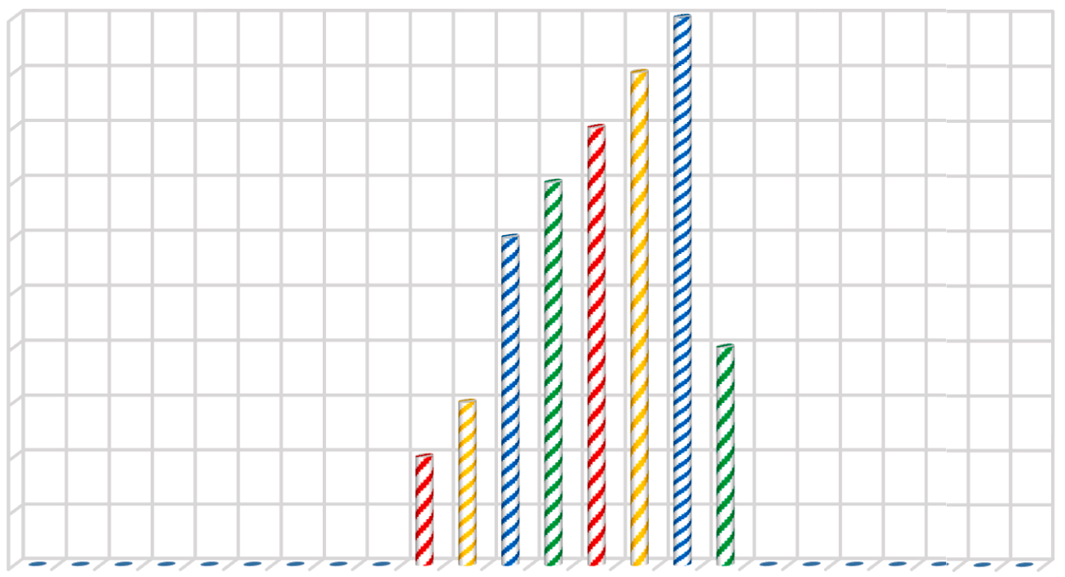**Fig. 10.** Number of EVs charging per hour in the DBC strategy.

* + 1. *Dumb charging (DBC) strategy*

The DBC strategy involves simply plugging in and charging EVs when they arrive home, without any advanced coordination or control. However, this strategy can lead to exceed the system’s peak-load

demand. Fig. 10 presents the number of EVs charging every hour for a 24-hour period, under the DBC strategy. In this strategy, the system is able to charge 49 EVs per day, utilizing only 38.83 % of the available SE. The daily utilization of SE in EV charging under the DBC strategy is







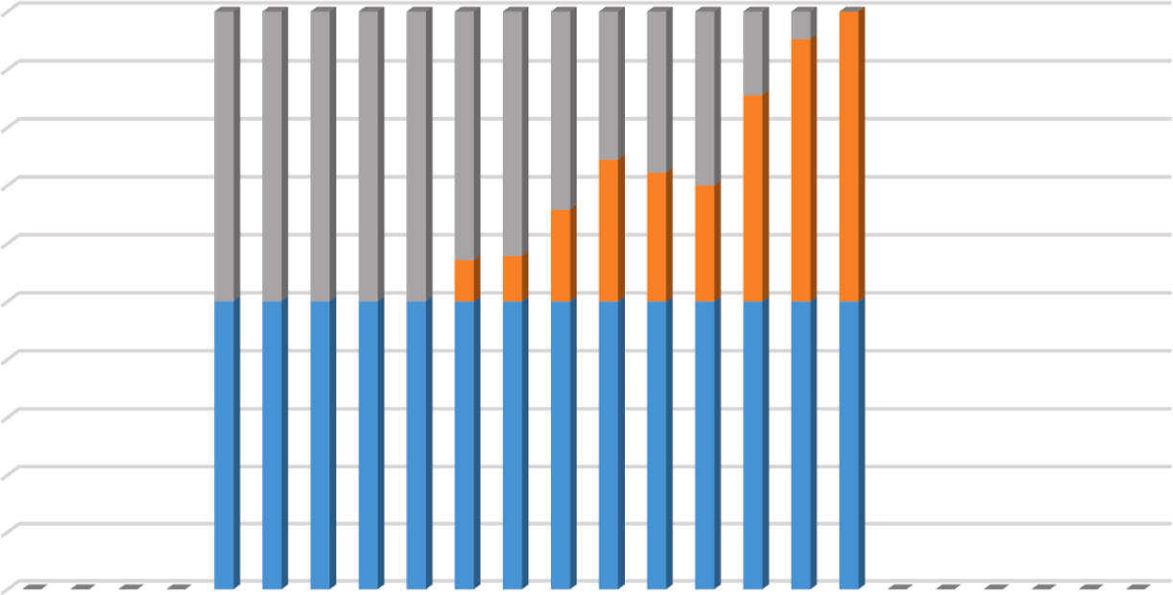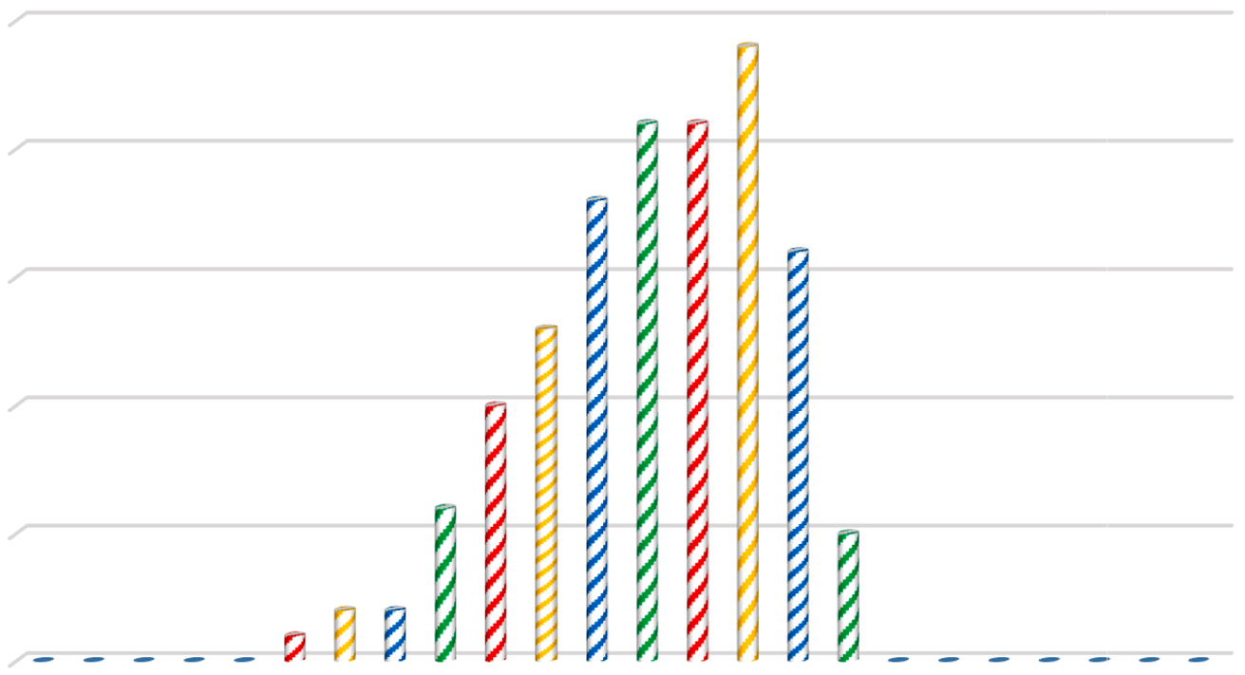**Fig. 11.** Daily utilization of SE in EV charging under the DBC strategy.



**Fig. 12.** Number of EVs charging per hour in the BSC strategy.

depicted in Fig. 11. Additionally, the DBC strategy result in a significant

26.88 % reduction in the total COE, while increasing the total annual energy utilization (AEU) by 36.77 %.

* + 1. *Battery swapping charging (BSC) strategy*

The BSC strategy involves EV owners charging an additional battery at home whenever SE is available, irrespective of their EV arrival time. Fig. 12 illustrates the hourly EV battery charging patterns based on the availability of SE.

Under the BSC strategy, the current system is capable of energizing 139 EVs per day, utilizing 100 % of the available SE, as demonstrated in Fig. 13. However, the introduction of standby batteries leads to an in- crease in the total COE to consumers by 50.52 %, and the total AEU experiences a significant boost of 99.69 %.

* + 1. *Smart charging (SC) strategy*

The SC strategy enables EV drivers to charge a greater number of EVs per day without incurring additional COE. This feat is achieved by smartly adjusting the departure-arrival time of EVs belonging to trip chain activities viz: goods transport, shopping/errands, gathering/ functions, temple/mosque/church, etc. to maximize the utilization of SE

in EVs charging. However, it is important to note that trip chains with fixed times, such as school and work/offices, cannot be altered. For other activities, the arrival times of EVs can be smartly adjusted to optimize the utilization of SE. Fig. 14 presents the new arrival times of EVs under the SC strategy.

Fig. 15 demonstrates that by utilizing 66.63 % of the SE, a total of 75 EVs can be charged per day using the SC strategy. This strategy leads to a reduction in total COE by 38.69 % while increasing the total AEU by

63.1 %. Furthermore, Fig. 16 illustrates the daily utilization of SE in EV charging under the SC strategy.

* + 1. *Integrated charging (IC) strategy*

The proposed IC strategy combines elements of dumb charging, battery swapping, and smart charging to address the drawbacks of in- dividual charging strategies while harnessing their respective benefits. The objective is to create a hybrid strategy that optimizes EV charging operations.

In the IC strategy, the departure-arrival timings of trip chain activ- ities such as goods transport, shopping/errands, gatherings/functions, and temple/mosque/church visits are smartly adjusted, similar to the approach in the SC strategy. This allows for the efficient utilization of SE







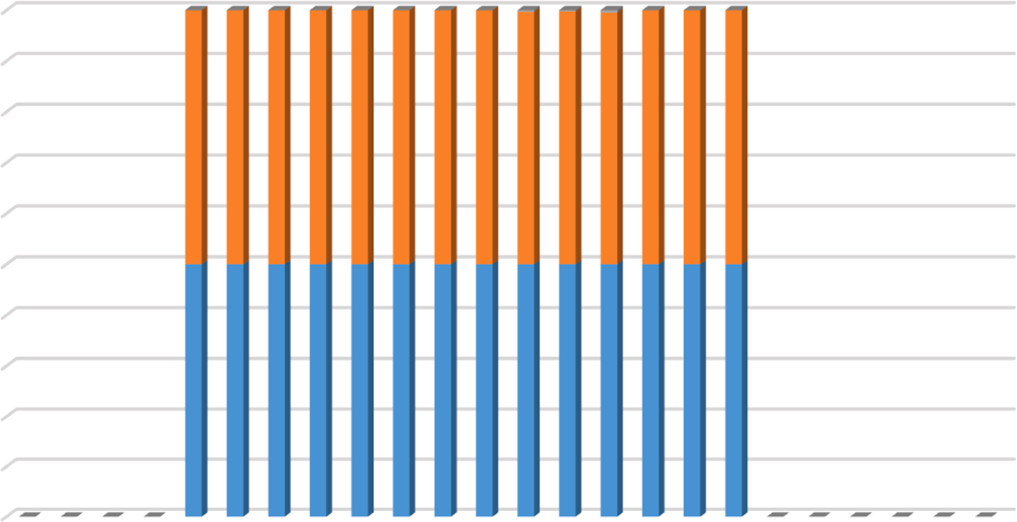**Fig. 13.** Daily utilization of SE in charging standby batteries of EVs under the BSC strategy.



**Fig. 14.** The new arrival time of EVs under the SC strategy.

during EV charging. Additionally, to maximize SE utilization and enhance EV penetration, EV standby batteries are utilized to store remaining hourly available SE. Standby batteries are allocated to EVs involved in trip chains like schools and work/offices, where the trip times cannot be changed.

Fig. 17 demonstrates how the IC strategy power 134 EVs by utilizing

99.59 % of SE. Specifically, 75 EVs are charged using the SC strategy, 44 EVs using the DBC strategy, and 15 EVs using the BSC strategy. More- over, the IC strategy reduces the total COE by 37.93 % while increasing the total AEU by 99.3 %. Fig. 18 illustrates the daily utilization of SE in EV charging under the IC strategy.

Table 10 summarizes the performance of all charging strategies. The IC strategy charges more EVs by using over 99 % of SE than the DBC and SC strategies. Additionally, it reduces total COE more than the others. The BSC strategy, on the other hand, achieves the maximum number of charged EVs, while increasing the total COE.

Performance analysis shows that the IC strategy is best for microgrid EV charging. It uses SE to charge a significant number of EVs at the lowest COE than other methods. Overall, the findings support the suit- ability of the IC strategy for efficient and sustainable EV charging in microgrid systems.

* 1. *Emission analysis*

Table 11 shows GHG emissions from the conventional grid, RE re- sources, and GVs under the IC strategy. The proposed IRES net CO2 savings and tons of CO2, CH4, and N2O emissions are listed. The table indicates that the proposed IRES emits 9646 tons of GHGs, 9.3 % of the conventional grid emissions. It is estimated that the IC strategy saves 94479.39 tons of GHG emissions. In addition to Table 11, Fig. 19 shows the avoided CO2 emissions from implementing the IRES with EVs under DBC, BSC, SC, and IC strategies.

These findings underscore the positive impact of the IC strategy in reducing CO2 emissions, promoting sustainability, and contributing to the overall decarbonization efforts associated with EV integration and RE utilization.

# Conclusions

This study investigates the feasibility of a stand-alone integrated renewable energy system (IRES) to supply electricity for various pur- poses to a cluster of twelve un-electrified villages in Munsyari Block, Uttarakhand, India. This study presented a stand-alone IRES design

 



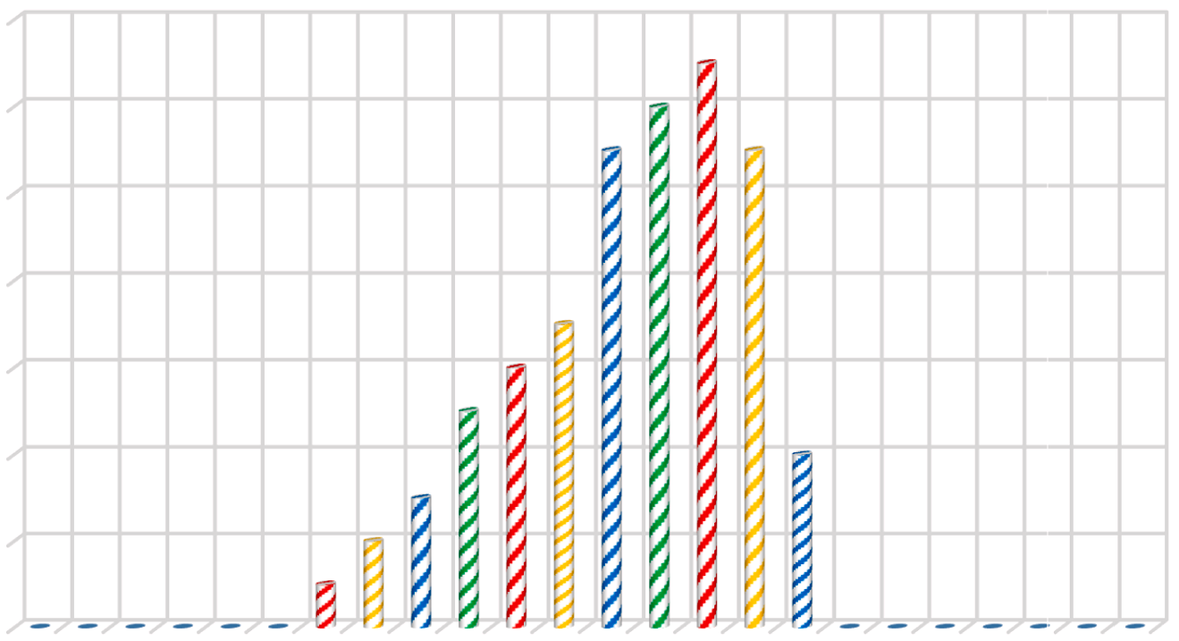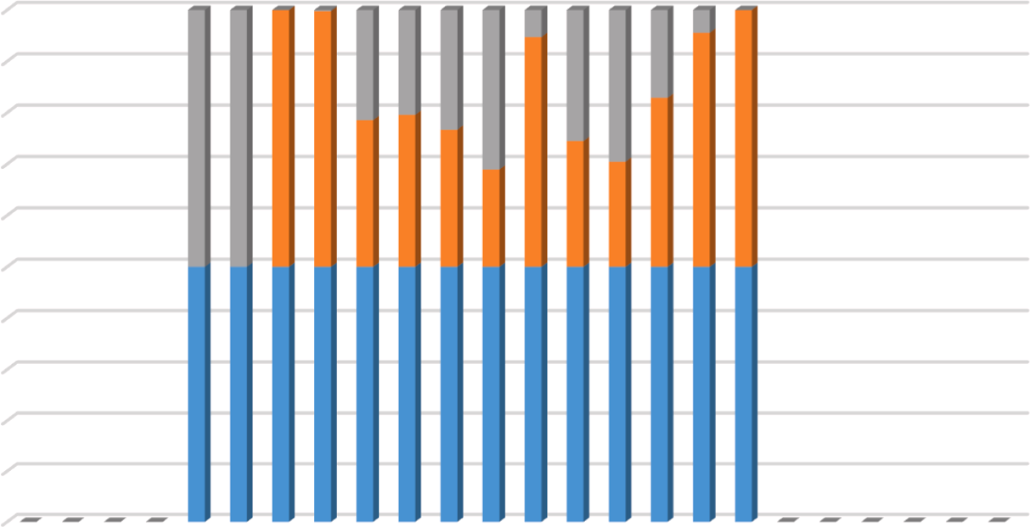**Fig. 15.** Number of EVs charging every hour in the SC strategy.





**Fig. 16.** Daily utilization of SE in EV charging under the SC strategy.

framework with diverse BES devices. The developed system has been optimized using the novel Chimp optimization algorithm (ChOA). Electric Vehicles (EVs) are used as dump load to consume surplus energy (SE). Finally, the optimal IRES and EVs under different charging stra- tegies were analyzed for greenhouse gas (GHG) emission reduction. The following are the findings of the study:

1. The study proposes the electrification of the study area using the optimal IRES configuration, including BGG/MHP/SPV/NAS at a depth of discharge (DOD) of 70 %. The cost of energy (COE) for this configuration is found 16.77 INR/kWh, and the life cycle cost (LCC) amount to 68.77 million INR.
2. The optimal IRES configuration includes 676 solar photovoltaic (SPV) panels with a capacity of 260 kWp, one micro-hydropower (MHP) plant with a capacity of 25 kW, one biogas generator (BGG) with a capacity of 40 kW, and 648 sodium-sulfur (NAS) batteries with a capacity of 778 kWh.
3. Alternative configurations, such as BGG/MHP/SPV/LA at 80 % DOD, BGG/MHP/SPV/Ni-Fe at 80 % DOD, and BGG/MHP/SPV/

Li-Ion at 80 % DOD, have LCCs and COEs approximately 20 %, 50

%, and 100 % higher than the optimal configuration, respectively.

1. Among all the deployed algorithms, ChOA secures 1st rank in all the ranking criteria such as Best, Worst, and Mean values of LCC, convergence rapidity, and average computational time (CT) taken while searching global best results. Indicating its effec- tiveness in optimizing the IRES design.
2. Among the EV charging strategies considered, the integrated charging (IC) strategy yielded the best results, enabling the charging of 134 EVs using 99.59 % of SE, and reducing the total COE to 10.57 INR/kWh.
3. The IC strategy achieved significant GHG emission reductions, with an overall net saving of 94,479.39 tons. The IRES alone and the IRES with EVs under various strategies avoided approxi- mately 290.77 to 291.61 tons of CO2 emissions.

The adopted methodology can be useful in designing IRES for other remote rural areas that are not yet electrified. However, there is room for further research into other energy storage devices such as hydrogen energy storage, pump hydro storage, or hybrid energy storage systems.

  



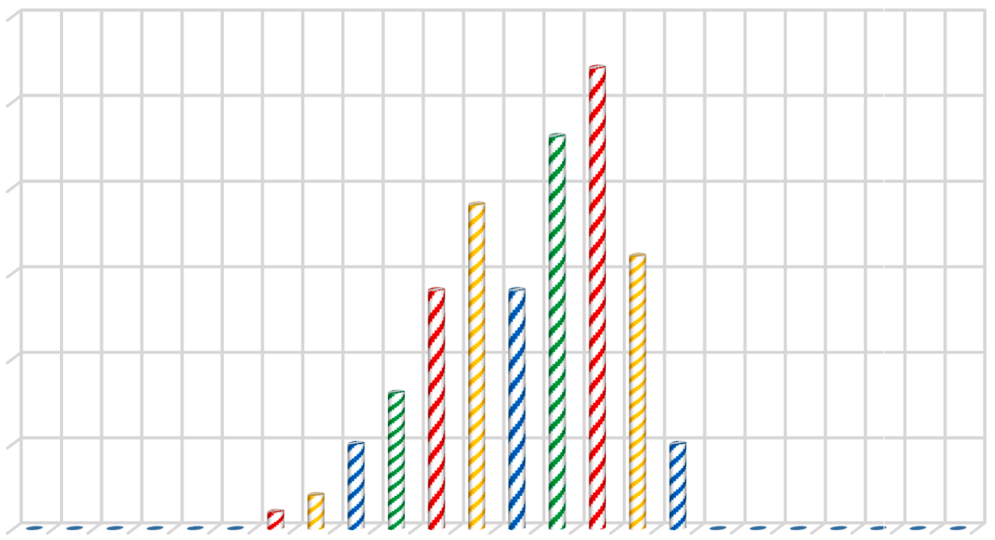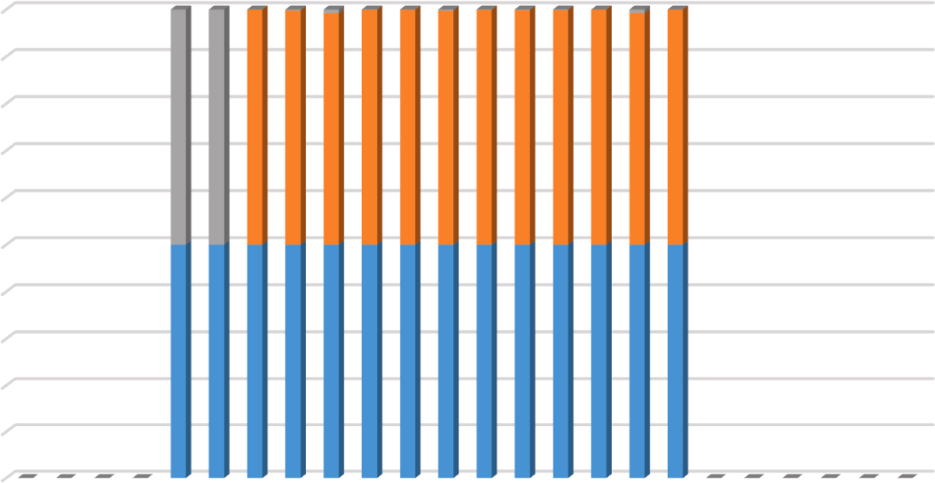**Fig. 17.** Number of EVs charging per hour in the IC strategy.





**Fig. 18.** Daily utilization of SE in EV charging under the IC strategy.

**Table 10**

Performance analysis of all the charging strategies.

|  |  |  |  |  |
| --- | --- | --- | --- | --- |
| Parameters | DBC strategy | BSC strategy | SC strategy | IC strategy |
| Charged EVs | 49 | 139 | 75 | **134** |
| Utilization of SE (%) | 38.83 | 100 | 66.67 | **99.59** |
| COE (INR/kWh) | 12.22 | 26.85 | 10.27 | **10.57** |
| Increase in AEU (%) | 36.77 | 99.69 | 63.1 | **99.3** |

Furthermore, the performance of EVs in terms of fuel cost and carbon emissions should be compared with other vehicles such as hybrid energy vehicles and flex-fuel vehicles.

# Declaration of Competing Interest

The authors declare that they have no known competing financial interests or personal relationships that could have appeared to influence the work reported in this paper.



**Table 11**

The overall CO2 emission.

|  |  |  |  |  |  |  |
| --- | --- | --- | --- | --- | --- | --- |
| GHG emission (tons) | Grid | SPV | MHP | BGG | IC | Net saving |
| CO2 | 320.53 | 22.25 | 1.73 | 5.78 | 0.84 | 291.61 |
| CH4 | 8013.35 | 556.32 | 43.41 | 144.54 | 21.00 | 7290.07 |
| N2O | 95519.20 | 6631.36 | 517.56 | 1722.91 | 250.35 | 86897.71 |
| Total GHG | 103853.09 | 7209.93 | 562.72 | 1873.23 | 272.20 | 94479.39 |

 



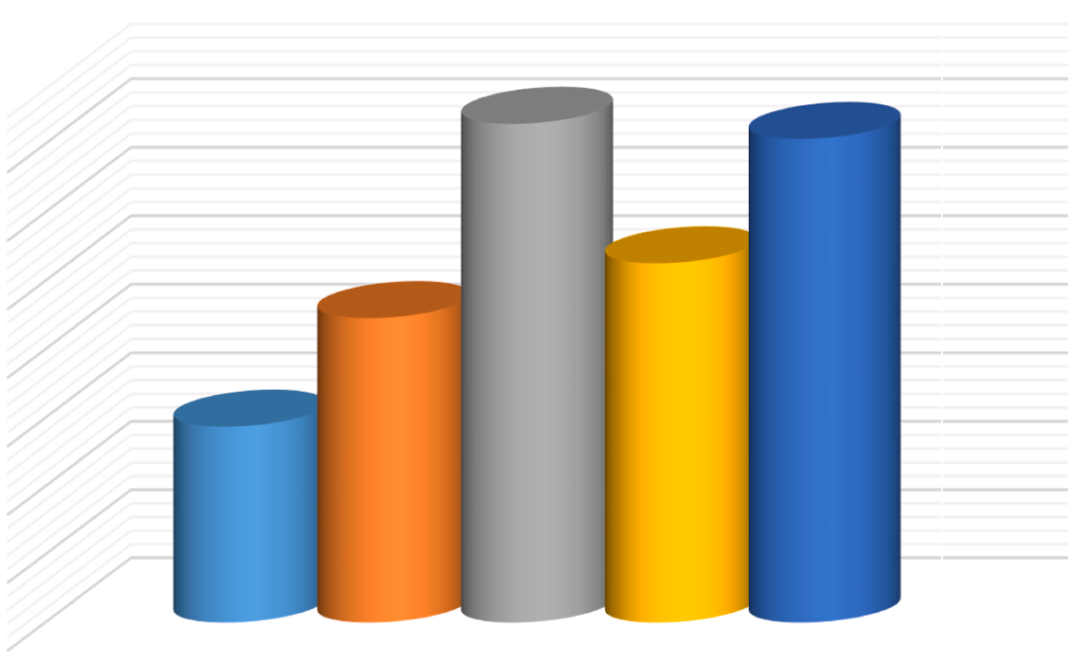**Fig. 19.** Total CO2 emission avoided by the IRES with EVs under different charging strategies.

# Acknowledgment



The first author wishes to express gratitude to the Ministry of Edu- cation (MOE), Government of India, for giving financial assistance in the form of a fellowship for the research work.

# References

1. R. Pachauri, R. Singh, A. Gehlot, R. Samakaria, S. Choudhury, Experimental analysis to extract maximum power from PV array reconfiguration under partial

shading conditions, Eng. Sci. Technol. Int. J. 22 (1) (2019) 109–130, [https://doi.](https://doi.org/10.1016/j.jestch.2017.11.013) [org/10.1016/j.jestch.2017.11.013](https://doi.org/10.1016/j.jestch.2017.11.013).

1. E. Biyik, et al., A key review of building integrated photovoltaic (BIPV) systems, Eng. Sci. Technol. Int. J. 20 (3) (2017) 833–858, [https://doi.org/10.1016/j.](https://doi.org/10.1016/j.jestch.2017.01.009) [jestch.2017.01.009](https://doi.org/10.1016/j.jestch.2017.01.009).
2. “Global status report.” [Online]. Available: [https://www.ren21.net/gsr-2023/.](http://www.ren21.net/gsr-2023/)
3. T.R. Ayodele, A.S.O. Ogunjuyigbe, K.O. Akpeji, O.O. Akinola, Prioritized rule based

load management technique for residential building powered by PV/battery system, Eng. Sci. Technol. Int. J. 20 (3) (2017) 859–873, [https://doi.org/10.1016/](https://doi.org/10.1016/j.jestch.2017.04.003) [j.jestch.2017.04.003](https://doi.org/10.1016/j.jestch.2017.04.003).

1. D. Kumar, H.D. Mathur, S. Bhanot, R.C. Bansal, Modeling and frequency control of community micro-grids under stochastic solar and wind sources, Eng. Sci. Technol.

Int. J. 23 (5) (2020) 1084–1099, <https://doi.org/10.1016/j.jestch.2020.02.005>.

1. M.S. Alam, F.S. Al-Ismail, S.M. Rahman, M. Shafiullah, M.A. Hossain, Planning and protection of DC microgrid: A critical review on recent developments, Eng. Sci. Technol. Int. J. 41 (2023), 101404, <https://doi.org/10.1016/j.jestch.2023.101404>.
2. D. Sadeghi, A. Hesami Naghshbandy, S. Bahramara, Optimal sizing of hybrid renewable energy systems in presence of electric vehicles using multi-objective particle swarm optimization, Energy 209 (2020), 118471, [https://doi.org/](https://doi.org/10.1016/j.energy.2020.118471) [10.1016/j.energy.2020.118471](https://doi.org/10.1016/j.energy.2020.118471).
3. A. Dogan, Optimum sitting and sizing of WTs, PVs, ESSs and EVCSs using hybrid

soccer league competition-pattern search algorithm, Eng. Sci. Technol. Int. J. 24

(3) (2021) 795–805, <https://doi.org/10.1016/j.jestch.2020.12.007>.

1. M.M. Samy, A. Emam, E. Tag-Eldin, S. Barakat, Exploring energy storage methods for grid-connected clean power plants in case of repetitive outages, J. Storage Mater. 54 (2022), 105307, <https://doi.org/10.1016/j.est.2022.105307>.
2. S.S. Reddy, Optimal power flow with renewable energy resources including storage, Electr. Eng. 99 (2) (2017) 685–695, [https://doi.org/10.1007/s00202-016-](https://doi.org/10.1007/s00202-016-0402-5)

[0402-5](https://doi.org/10.1007/s00202-016-0402-5).

1. J.A. Momoh, S.R. Salkuti, Feasibility of Stochastic Voltage/VAr Optimization Considering Renewable Energy Resources for Smart Grid, Int. J. Emerg. Electr.

Power Syst. 17 (3) (2016) 287–300, <https://doi.org/10.1515/ijeeps-2016-0009>.

1. A. Fatih Güven, M. Mahmoud Samy, Performance analysis of autonomous green energy system based on multi and hybrid metaheuristic optimization approaches, Energ. Conver. Manage. 269 (2022), 116058, [https://doi.org/10.1016/j.](https://doi.org/10.1016/j.enconman.2022.116058) [enconman.2022.116058](https://doi.org/10.1016/j.enconman.2022.116058).
2. [A. Chauhan, R.P. Saini, A review on Integrated Renewable Energy System based](http://refhub.elsevier.com/S2215-0986(23)00242-2/h0065) [power generation for stand-alone applications: Configurations, storage options,](http://refhub.elsevier.com/S2215-0986(23)00242-2/h0065)

[sizing methodologies and control, Renew. Sustain. Energy Rev. 38 (2014) 99–120](http://refhub.elsevier.com/S2215-0986(23)00242-2/h0065).

1. S. Turkdogan, Design and optimization of a solely renewable based hybrid energy system for residential electrical load and fuel cell electric vehicle, Eng. Sci.

Technol. Int. J. 24 (2) (2021) 397–404, [https://doi.org/10.1016/j.](https://doi.org/10.1016/j.jestch.2020.08.017) [jestch.2020.08.017](https://doi.org/10.1016/j.jestch.2020.08.017).

1. [Q. Hassan, Evaluation and optimization of off-grid and on-grid photovoltaic power](http://refhub.elsevier.com/S2215-0986(23)00242-2/h0075) [system for typical household electrification, Renew. Energy 164 (2021) 375–390](http://refhub.elsevier.com/S2215-0986(23)00242-2/h0075).
2. [C. Mokhtara, B. Negrou, A. Bouferrouk, Y. Yao, N. Settou, M. Ramadan, Integrated](http://refhub.elsevier.com/S2215-0986(23)00242-2/h0080) [supply–demand energy management for optimal design of off-grid hybrid](http://refhub.elsevier.com/S2215-0986(23)00242-2/h0080) [renewable energy systems for residential electrification in arid climates, Energ.](http://refhub.elsevier.com/S2215-0986(23)00242-2/h0080)

[Conver. Manage. 221 (2020), 113192](http://refhub.elsevier.com/S2215-0986(23)00242-2/h0080).

1. [A.M. Patel, S.K. Singal, Optimal component selection of integrated renewable](http://refhub.elsevier.com/S2215-0986(23)00242-2/h0085)

[energy system for power generation in stand-alone applications, Energy 175](http://refhub.elsevier.com/S2215-0986(23)00242-2/h0085) [(2019) 481–504](http://refhub.elsevier.com/S2215-0986(23)00242-2/h0085).

1. F.A. Khan, N. Pal, S.H. Saeed, Optimization and sizing of SPV/Wind hybrid

renewable energy system: A techno-economic and social perspective, Energy 233 (2021), 121114, <https://doi.org/10.1016/j.energy.2021.121114>.

1. M. S. Javed, T. Ma, J. Jurasz, and J. Mikulik, “A hybrid method for scenario-based techno-economic-environmental analysis of off-grid renewable energy systems,” *Renewable and Sustainable Energy Reviews*, vol. 139, no. December 2020, p. 110725,

2021, doi: 10.1016/j.rser.2021.110725.

1. L. Al-Ghussain, A. Darwish Ahmad, A. M. Abubaker, and M. A. Mohamed, “An integrated photovoltaic/wind/biomass and hybrid energy storage systems towards 100% renewable energy microgrids in university campuses,” *Sustainable Energy Technologies Assessments*, vol. 46, no. December 2020, p. 101273, 2021, doi:

10.1016/j.seta.2021.101273.

1. F. Kahwash, A. Maheri, K. Mahkamov, Integration and optimisation of high- penetration Hybrid Renewable Energy Systems for fulfilling electrical and thermal demand for off-grid communities, Energy Convers. Manage. 236 (2021), 114035, <https://doi.org/10.1016/j.enconman.2021.114035>.
2. A. Shukla, J.A. Momoh, Pseudo inspired gravitational search algorithm for optimal sizing of grid with integrated renewable energy and energy storage, J. Storage Mater. 38 (2021), 102565, <https://doi.org/10.1016/j.est.2021.102565>.
3. H. Tao F.W. Ahmed H. Abdalqadir kh ahmed, M. Latifi, H. Nakamura, and Y. Li, Hybrid whale optimization and pattern search algorithm for day-ahead operation of a microgrid in the presence of electric vehicles and renewable energies Journal of Cleaner Production vol. 308, no. April 2021 127215 10.1016/j. jclepro.2021.127215.
4. Q. Guo, S. Nojavan, S. Lei, X. Liang, Economic-environmental analysis of renewable-based microgrid under a CVaR-based two-stage stochastic model with efficient integration of plug-in electric vehicle and demand response, Sustain. Cities Soc. 75 (2021), 103276, <https://doi.org/10.1016/j.scs.2021.103276>.
5. I. AlHajri, A. Ahmadian, and A. Elkamel, “Stochastic day-ahead unit commitment

scheduling of integrated electricity and gas networks with hydrogen energy storage (HES), plug-in electric vehicles (PEVs) and renewable energies,” *Sustainable Cities and Society*, vol. 67, no. December 2020, p. 102736, 2021, doi: 10.1016/j.

scs.2021.102736.

1. S. Zeynali, N. Nasiri, M. Marzband, S.N. Ravadanegh, A hybrid robust-stochastic framework for strategic scheduling of integrated wind farm and plug-in hybrid electric vehicle fleets, Appl. Energy 300 (2021), 117432, [https://doi.org/10.1016/](https://doi.org/10.1016/j.apenergy.2021.117432) [j.apenergy.2021.117432](https://doi.org/10.1016/j.apenergy.2021.117432).
2. A. Alsharif, C. W. Tan, R. Ayop, K. Y. Lau, and A. M. d. Dobi, “A rule-based power

management strategy for Vehicle-to-Grid system using antlion sizing optimization,” *Journal of Energy Storage*, vol. 41, no. April, p. 102913, 2021, doi: 10.1016/j.est.2021.102913.

1. D. Bogdanov, A. Gulagi, M. Fasihi, C. Breyer, Full energy sector transition towards 100% renewable energy supply: Integrating power, heat, transport and industry sectors including desalination, Appl. Energy 283 (2021), 116273, [https://doi.org/](https://doi.org/10.1016/j.apenergy.2020.116273) [10.1016/j.apenergy.2020.116273](https://doi.org/10.1016/j.apenergy.2020.116273).
2. Z. Xiaoluan, H. Farajian, W. Xifeng, M. Latifi, K. Ohshima, Scheduling of renewable energy and plug-in hybrid electric vehicles based microgrid using hybrid crow- Pattern search method, J. Storage Mater. (2021), 103605, [https://doi.org/](https://doi.org/10.1016/j.est.2021.103605) [10.1016/j.est.2021.103605](https://doi.org/10.1016/j.est.2021.103605).
3. N.F. Alshammari, M.M. Samy, S. Barakat, Comprehensive Analysis of Multi- Objective Optimization Algorithms for Sustainable Hybrid Electric Vehicle

Charging Systems, Mathematics 11 (7) (2023) pp, [https://doi.org/10.3390/](https://doi.org/10.3390/math11071741) [math11071741](https://doi.org/10.3390/math11071741).

1. S.R. Salkuti, Optimal operation of microgrid considering renewable energy sources, electric vehicles and demand response, E3S Web Conference 87 (201) (2019) 9, <https://doi.org/10.1051/e3sconf/20198701007>.
2. [M. Khishe, M.R. Mosavi, Chimp optimization algorithm, Expert Syst. Appl. 149](http://refhub.elsevier.com/S2215-0986(23)00242-2/h0160) [(2020), 113338](http://refhub.elsevier.com/S2215-0986(23)00242-2/h0160).
3. R.J. Kuo, M.N. Alfareza, T.P.Q. Nguyen, “Genetic based density peak possibilistic

fuzzy c-means algorithms to cluster analysis- a case study on customer segmentation, Eng. Sci. Technol. Int. J. 47 (2023), 101525, [https://doi.org/](https://doi.org/10.1016/j.jestch.2023.101525) [10.1016/j.jestch.2023.101525](https://doi.org/10.1016/j.jestch.2023.101525).

1. S. Tyagi, P. Kumar, A. Kumar, Advancements in performance of zinc oxide / carbon quantum dots based photovoltaic trigeneration system using genetic algorithm and particle swarm optimization, Sustain. Energy Technol. Assess. 60 (2023), 103501, <https://doi.org/10.1016/j.seta.2023.103501>.
2. C.C.W. Chang, et al., Moth flame optimization for the maximum power point tracking scheme of photovoltaic system under partial shading conditions, Energy

Rep. 9 (2023) 374–379, <https://doi.org/10.1016/j.egyr.2023.09.026>.

1. M.H. Sulaiman, Z. Mustaffa, “An application of improved salp swarm algorithm for optimal power flow solution considering stochastic solar power generation”, e-

Prime - Advances in Electrical Engineering, Electron. Energy 5 (2023), 100195, <https://doi.org/10.1016/j.prime.2023.100195>.

1. J. Li, et al., Optimal planning of Electricity-Hydrogen hybrid energy storage system considering demand response in active distribution network, Energy 273 (2023), 127142, <https://doi.org/10.1016/j.energy.2023.127142>.
2. I˙. Yazıcı and E. K. Yaylacı, “Modified grey wolf optimizer based MPPT design and

experimentally performance evaluations for wind energy systems,” *Engineering*

*Science and Technology, an International Journal*, vol. 46, no. March, 2023, doi: 10.1016/j.jestch.2023.101520.

1. Y. W. Kohol´e, C. A. Wankouo Ngouleu, F. C. V. Fohagui, and G. Tchuen, “Quantitative techno-economic comparison of a photovoltaic/wind hybrid power system with different energy storage technologies for electrification of three remote areas in Cameroon using Cuckoo search algorithm,” *Journal of Energy Storage*, vol. 68, no. February, 2023, doi: 10.1016/j.est.2023.107783.
2. H. Zhang, J. Gao, L. Kang, Y. Zhang, L. Wang, K. Wang, State of health estimation of lithium-ion batteries based on modified flower pollination algorithm-temporal convolutional network, Energy 283 (2023), 128742, [https://doi.org/10.1016/j.](https://doi.org/10.1016/j.energy.2023.128742) [energy.2023.128742](https://doi.org/10.1016/j.energy.2023.128742).
3. V. Pandiya Raj, M. Duraipandian, “Energy conservation using PISAE and cross-

layer-based opportunistic routing protocol (CORP) for wireless sensor network, Eng. Sci. Technol. Int. J. 42 (2023), 101411, [https://doi.org/10.1016/j.](https://doi.org/10.1016/j.jestch.2023.101411) [jestch.2023.101411](https://doi.org/10.1016/j.jestch.2023.101411).

1. “Census of India.” https://censusindia.gov.in/2011census/Listofvillagesandtowns. aspx (accessed Jan. 26, 2023).
2. “Uttarakhand Tehsilwise and Districtwise Livestock Census.” Accessed: Jan. 29, 2023. [Online]. Available: https://dahd.nic.in/documents/statistics/livestock-

census.

1. [M. Ramesh, R.P. Saini, Dispatch strategies based performance analysis of a hybrid](http://refhub.elsevier.com/S2215-0986(23)00242-2/h0220) [renewable energy system for a remote rural area in India, J. Clean. Prod. 259](http://refhub.elsevier.com/S2215-0986(23)00242-2/h0220) [(2020), 120697](http://refhub.elsevier.com/S2215-0986(23)00242-2/h0220).
2. [A. Chauhan, R.P. Saini, Discrete harmony search based size optimization of](http://refhub.elsevier.com/S2215-0986(23)00242-2/h0225) [Integrated Renewable Energy System for remote rural areas of Uttarakhand state in](http://refhub.elsevier.com/S2215-0986(23)00242-2/h0225)

[India, Renew. Energy 94 (2016) 587–604](http://refhub.elsevier.com/S2215-0986(23)00242-2/h0225).

1. H. Liang, Z. Lee, G. Li, A Calculation Model of Charge and Discharge Capacity of Electric Vehicle Cluster Based on Trip Chain, IEEE Access 8 (2020)

142026–142042, <https://doi.org/10.1109/ACCESS.2020.3014160>.

1. S. Sachan, S. Deb, S.N. Singh, Different charging infrastructures along with smart charging strategies for electric vehicles, Sustain. Cities Soc. vol. 60, no. May (2020), 102238, <https://doi.org/10.1016/j.scs.2020.102238>.
2. Q. Wu *et al.*, “Driving Pattern Analysis for Electric Vehicle (EV) Grid Integration Study,” pp. 1–6, 2011, doi: 10.1109/isgteurope.2010.5751581.
3. M. Li, Y. Ahad, “A novel real-time pricing for optimal DRP, considering price

elasticity, and charging control methods of PHEV integrated with smart grids, using GMO algorithm, Eng. Sci. Technol. Int. J. 47 (2023), 101538, [https://doi.](https://doi.org/10.1016/j.jestch.2023.101538) [org/10.1016/j.jestch.2023.101538](https://doi.org/10.1016/j.jestch.2023.101538).

1. D.S. Kourkoumpas, G. Benekos, N. Nikolopoulos, S. Karellas, P. Grammelis,

E. Kakaras, A review of key environmental and energy performance indicators for

the case of renewable energy systems when integrated with storage solutions, Appl. Energy 231 (September) (2018) 380–398, [https://doi.org/10.1016/j.](https://doi.org/10.1016/j.apenergy.2018.09.043) [apenergy.2018.09.043](https://doi.org/10.1016/j.apenergy.2018.09.043).

1. N. Singh, T. Mishra, R. Banerjee, Emission inventory for road transport in India in 2020: framework and post facto policy impact assessment, Environ. Sci. Pollut.

Res. (2021) 1–31, <https://doi.org/10.1007/s11356-021-17238-3>.

1. N. Alshammari, J. Asumadu, Optimum unit sizing of hybrid renewable energy system utilizing harmony search, Jaya and particle swarm optimization algorithms, Sustain. Cities Soc. 60 (2020), 102255, [https://doi.org/10.1016/j.](https://doi.org/10.1016/j.scs.2020.102255) [scs.2020.102255](https://doi.org/10.1016/j.scs.2020.102255).
2. “CO2 Baseline Database for the Indian Power Sector.” Accessed: May 06, 2023. [Online]. Available: https://cea.nic.in/?lang en&s CO2 database.

= = +

1. D. Weisser, A guide to life-cycle greenhouse gas (GHG) emissions from electric supply technologies, Energy 32 (9) (2007) 1543–1559, [https://doi.org/10.1016/j.](https://doi.org/10.1016/j.energy.2007.01.008) [energy.2007.01.008](https://doi.org/10.1016/j.energy.2007.01.008).
2. A.H. Elbatran, O.B. Yaakob, Y.M. Ahmed, H.M. Shabara, Operation, performance and economic analysis of low head micro-hydropower turbines for rural and

remote areas: A review, Renew. Sustain. Energy Rev. 43 (2015) 40–50, [https://doi.](https://doi.org/10.1016/j.rser.2014.11.045) [org/10.1016/j.rser.2014.11.045](https://doi.org/10.1016/j.rser.2014.11.045).

1. A. Maleki, Design and optimization of autonomous solar-wind-reverse osmosis desalination systems coupling battery and hydrogen energy storage by an improved bee algorithm, Desalination 435 (March) (2018), [https://doi.org/](https://doi.org/10.1016/j.desal.2017.05.034) [10.1016/j.desal.2017.05.034](https://doi.org/10.1016/j.desal.2017.05.034).
2. R. Mishra, S.K. Chaulya, G.M. Prasad, S.K. Mandal, G. Banerjee, Design of a low cost, smart and stand-alone PV cold storage system using a domestic split air conditioner, J. Stored Prod. Res. 89 (2020), 101720, [https://doi.org/10.1016/j.](https://doi.org/10.1016/j.jspr.2020.101720) [jspr.2020.101720](https://doi.org/10.1016/j.jspr.2020.101720).