[Egyptian Informatics Journal 24 (2023) 117–128](https://doi.org/10.1016/j.eij.2022.12.006)

Contents lists available at [ScienceDirect](http://www.sciencedirect.com/science/journal/11108665)

Egyptian Informatics Journal

journal homepage: [www.sciencedirect.com](http://www.sciencedirect.com/)

[](http://crossmark.crossref.org/dialog/?doi=10.1016/j.eij.2022.12.006&domain=pdf)Optimization of accuracy in estimating the dynamic viscosity of MWCNT-CuO/oil 10W40 nano-lubricants

Mohammad Hemmat Esfe a, Davood Toghraie b,⇑, Fatemeh Amoozadkhalili a, Soheyl Alidoust a,c

a *Nanofluid advanced research team, Isfahan, Iran*

b *Department of Mechanical Engineering, Khomeinishahr Branch, Islamic Azad University, Khomeinishahr, Iran*

c *School of Chemistry, Damghan University, Damghan, Iran*

a r t i c l e i n f o

*Article history:*

Received 6 April 2022

Revised 3 December 2022

Accepted 10 December 2022

Available online 21 December 2022

*Keywords:* Dynamic viscosity Nano-lubricant Correlation

ANN

a b s t r a c t

Artificial neural network (ANN) is one of the best models with good performance for predicting labora- tory data, Due to its high accuracy, this design can be a suitable alternative to frequent and costly testing.

by experimental data. l*nf* is measured in u ¼ *SVF*=(0.05-1% and temperature range T=5 to 55°C to train In this study, the viscosity (l*nf* ) of MWCNT-CuO (10-90)/Oil 10W40 nano-lubricant is modeled by ANNs the ANNs. To check the precision of predicted data by ANN, mean square error (MSE), regression coeffi-

cient, and also margin of deviation (MOD) are used. The optimal structure was selected from among 400 ANN samples for MWCNT-CuO (10:90)/Oil 10W40 nano-lubricant, which has two hidden layers and the number of 4 and 8 neurons, as well as *tansig* and *logsig* transfer functions. The inputs of the ANN model are solid volume fraction (SVF or u), temperature (T), and shear rate (SR), and the output of the ANN is the

l*nf* . A comparison shows that the ANN calculates the laboratory data more accurately.

© 2023 THE AUTHORS. Published by Elsevier BV on behalf of Faculty of Computers and Artificial Intel- ligence, Cairo University. This is an open access article under the CC BY license ([http://creativecommons.](http://creativecommons.org/licenses/by/4.0/)

[org/licenses/by/4.0/](http://creativecommons.org/licenses/by/4.0/)).

1. Introduction

Extensive research was carried out in the field of nano today, so that most researchers in various fields of this field, such as nanoflu- ids (NFs), nanopowders, nanofibers, nanocomposites, etc., have conducted extensive studies [1–12]. Nanoscience is used in various scientific fields, one of the most important of which is in the field of fluids and heat transfer. Because since ancient times, fluids have been used in various applications such as lubrication, heat transfer, pumping, etc. they were tested in numerical, analytical and exper- imental ways [13–17], and for this reason, the use of nanotechnol- ogy can have a great impact on the performance of fluid-containing systems. Also, extensive research was done to investigate and increase the heat transfer coefficient and improve viscosity in var- ious processes and industries [18]. In 1995, to increase the thermal

* Corresponding author.

*E-mail address:* [davoodtoghraie@iaukhsh.ac.ir](mailto:davoodtoghraie@iaukhsh.ac.ir) (D. Toghraie).

Peer review under responsibility of Faculty of Computers and Information, Cairo University.

**Production and hosting by Elsevier**

conductivity of base fluids (BFs), the idea of using nanoparticles (NPs) in BFs was proposed [19]. NPs dispersed in composites or fluids maintain a much higher surface-to-volume ratio compared to particles in the range of millimeters and micrometers. Hence, mechanical and physical properties increase with increasing sur- face area [20–22]. Since nanofluids (NFs) are considered suspen- sions of NPs (smaller than 100 nm) in BFs, heat transfer occurs on the surface of suspended NPs. On the other hand, many researchers have tried to use this method to significantly increase the thermophysical properties of BFs [23]. The increase in fluid properties ultimately leads to the reduction of equipment size, reduction of industrial unit costs, and higher energy efficiency [24–27]. For this purpose, scientists have always tried to produce new NFs and identify factors affecting thermophysical properties.

l*nf* and *knf* can affect NF applications. Various experimental studies

show that adding more NPs to BFs can increase the l*nf* and *knf* [28–](#_bookmark22) [29].

In addition, one of the important parameters that can increase the *knf* is increasing the temperature [30–34]. Various studies show that changes in temperature and *SVF* can also affect l*nf* . Any tem-

perature increase can decrease the l*nf* . However, the addition of

NPs can increase l*nf* [35–39]. In investigating the characteristics of NFs, some equations are proposed to predict the behavior of NFs. These equations are useful to make laboratory research more

<https://doi.org/10.1016/j.eij.2022.12.006>

1110-8665/© 2023 THE AUTHORS. Published by Elsevier BV on behalf of Faculty of Computers and Artificial Intelligence, Cairo University. This is an open access article under the CC BY license (<http://creativecommons.org/licenses/by/4.0/>).

practical. Table 1 lists the studies that led to new empirical equa- tions. Fig. 1.

For more than a decade, the use of artificial intelligence to model the behavior of systems have received much attention (see Fig. 2). The results show that this method has high accuracy compared to the classical method. On the other hand, in recent years, this method was increasingly used to model the behavior and thermophysical properties of NFs [44]. Esfe et al.[45] used ANN to estimate the laboratory findings of MWCNT-MgO (25:75)/SAE40 NF in different parameters (T, SVF, and SR). The ANN was used by the MLP method with LM algorithm. The optimal structure with 5 and 8 neurons in the first and second layers has been selected among different structures.The MOD for the grid

data set is in the range of less than —1% < MOD < +1%. It shows high

accuracy and a great ability to predict data.

Researchers who study NFs tried, by designing ANNs with dif- ferent algorithms, to predict the *knf* or l*nf* . In this type of modeling, the effects of different factors, such as SVF, temperature, particle size, *knf* , type of BF, NPs, and their density can be investigated.

Table 2 shows some investigations on the modeling of NFs.

Raising the quality of oils by enhancing their viscosity is one of the main concerns of scientists. As mentioned before, adding NPs to BFs can fulfill this need. The prediction of l*nf* is one of the

aspects of the studies on fluids. In general, the rheological behavior of fluids can be distributed into two categories: Newtonian and non-Newtonian. A fluid is Newtonian if there is a linear relation between *SR* and shear stress, but if there is not a linear relation between *SR* and shear stress, the fluid has a non-Newtonian behav- ior [50–55]. In a study on ethylene glycol/ZrO2 NF, Goharshadi et al. [56] showed that this NF at*SVF* = 0.01 %, 0.02 % and 0.04 %

shows Newtonian behavior at T = 25 to 45 °C. However, in *SR* = 70–120 s—1, the this NF shows a non-Newtonian behavior. Esfe et al. [57] measured the *knf* of MWCNT-MgO/water-EG NF in seven

SVFs from 0.015 to 0.96 % and in T = 30 to 50 °C. The cost- effectiveness evaluation of the *knf* data shows that the hybrid NFs are better than the mono NFs. In the study on Ag/oil NF, Aberoumand et al. [58] examined the l*nf* of Ag/oil NF. The l*nf*

at*SVF* = 0.12 % to 0.72 % and T = 25–60 °C was measured. The

results show that with any increase in *SVF*, the NF’s behavior shifts from Newtonian to non–Newtonian. In addition, NFs had non- Newtonian and Newtonian behaviors at T < 35 °C, respectively. Several investigations show that utilize of CNTs, even in small quantities, can also have a important influence on thermophysical propertiess of NFs. Hemmat Esfe research team [59–60] has done a lot of research in the field of hybrid NFs and is one of the pioneer

groups in this field. Comparison of the l*nf* of MWCNT-TiO2/10W40

Table 1

Investigations on prediction of the thermophysical properties of NFs.

|  |  |  |  |  |
| --- | --- | --- | --- | --- |
| Ref. | NPs | BF | The purpose of the experiment | Conclusion |
| [40] | Al2O3 | Water | Enhancing solar systems efficiency | 2.1 % difference between the RSM and CFD results. |
| [41] | DWCNT | Water | Thermal performance improvement | The maximum coefficient of thermal performance in u = 0.365. |
| [42] | SWCNT | EG | l*nf* | The correlation and experimental results overlap or have a small deviation |
| [43] | SiO2 | Bio Glycol/Water | l*nf* | Correlations with a maximum deviation of 3 % for estimating |

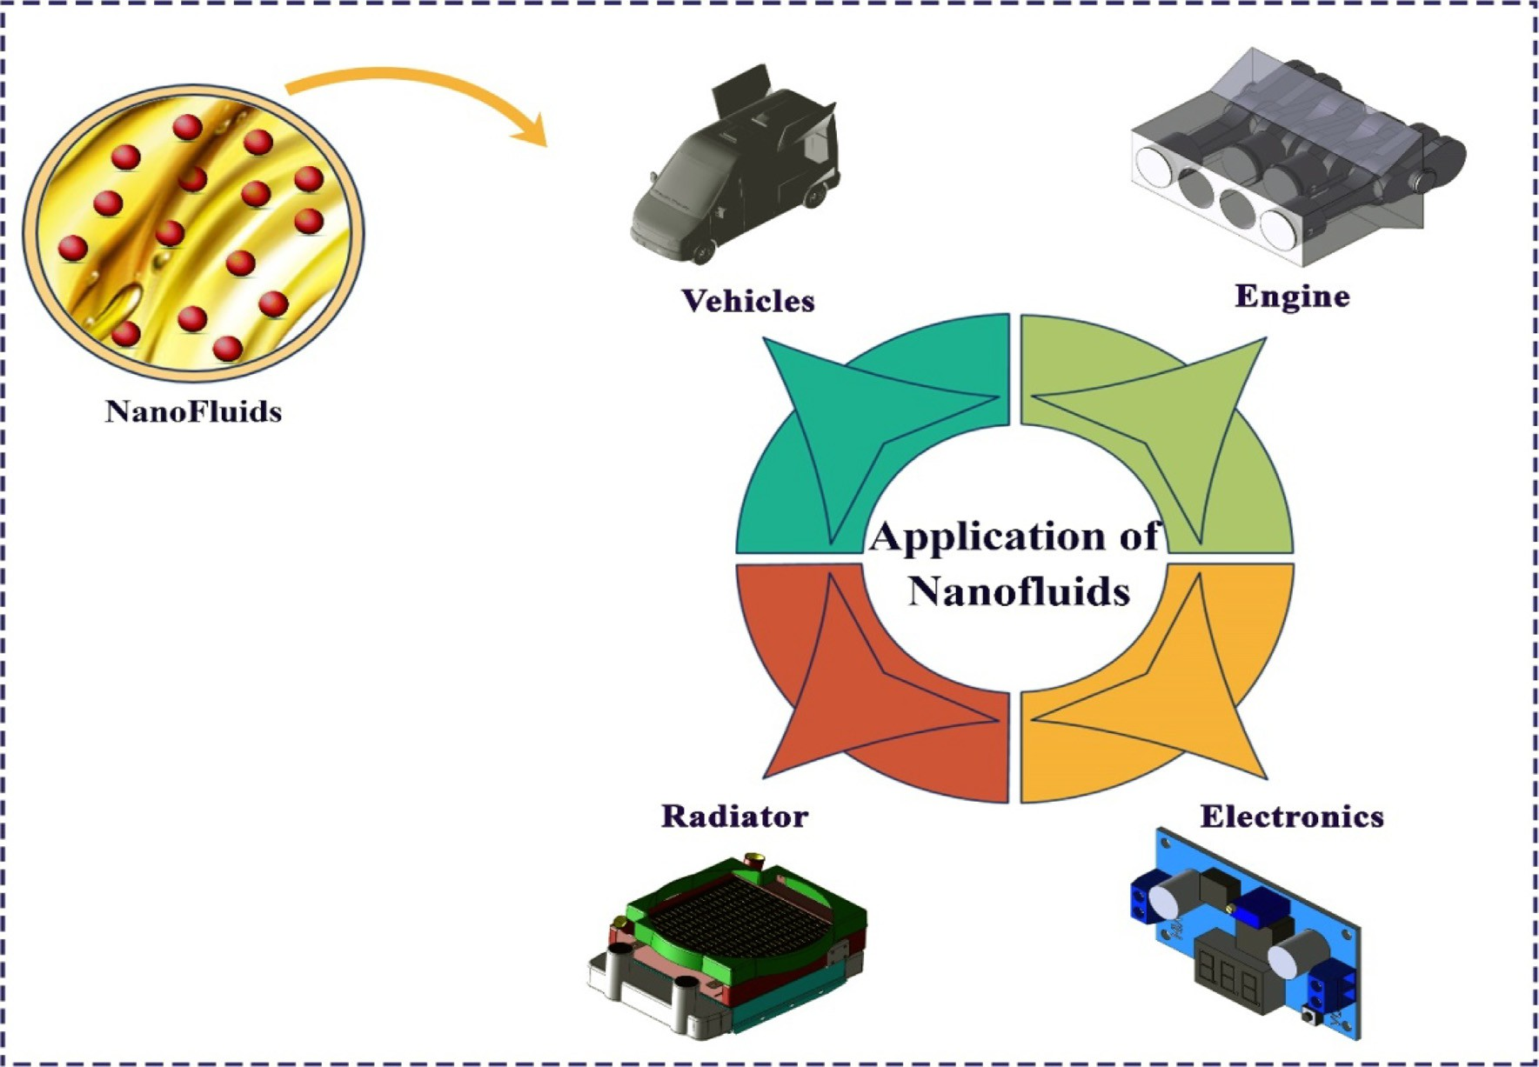

Fig. 1. Applications of NFs.

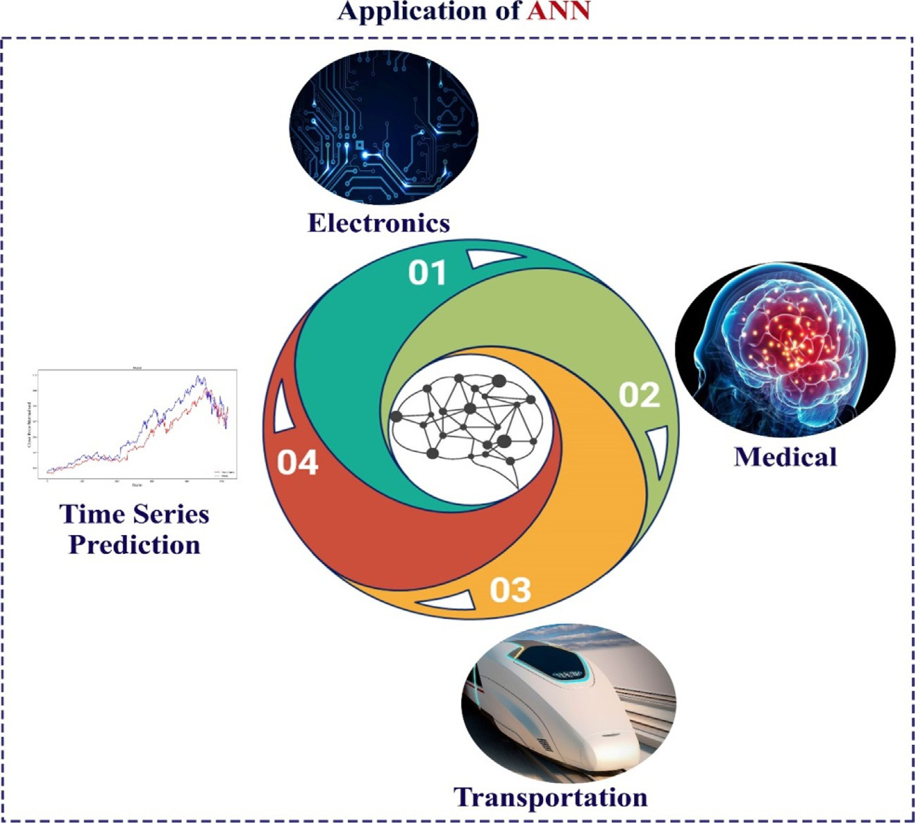

Fig. 2. Utilization of artificial intelligence for modeling the behavior of fluids.

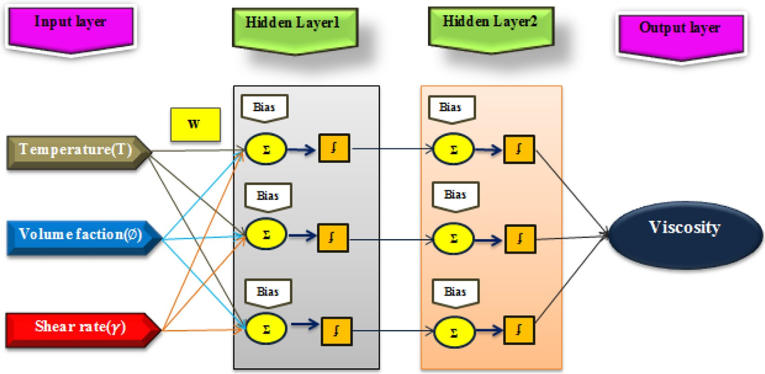

Fig. 3. Topology of ANN.

Table 3

Parameters of the top 4 ANN examples.

|  |  |  |  |  |  |  |  |
| --- | --- | --- | --- | --- | --- | --- | --- |
| Candidate Topology No. | Structure | Function 1 | Function 2 | R | Train | Val | Test |
| 1 | [3 5] | tansig | logsig | 0.9999422 | 0.9999441 | 0.9999516 | 0.9999389 |
| 2 | [3 8] | logsig | tansig | 0.9999648 | 0.9999754 | 0.9999383 | 0.9999028 |
| 3 | [4 6] | tansig | logsig | 0.9999656 | 0.9999753 | 0.9999807 | 0.9999124 |
| 4 | [4 8] | tansig | logsig | 0.9999744 | 0.9999859 | 0.9998709 | 0.9999098 |

Table 2

Studies on modeling of NF properties through artificial intelligence technique to predict properties.

|  |  |  |  |  |  |  |
| --- | --- | --- | --- | --- | --- | --- |
| Errors | ANN  topology | ANN  outputs | ANN inputs | Number of data | NFs | Ref. |
| The values of R2 and RMSE and total AARD% were estimated at 0.99996 and 0.0089 and  0.2 in the l*nf* estimation, respectively.  MSE = 4.73×10—4 | 3–4-3 | l*nf* | SVF, T, lbf, qnp, NP size | 1490 | Different NPs and BFs | [46] |
| AARD = 1.27 %  R2 = 0.971875 | 3–14-1 | *knf* | SVF, T | 285 | Al2O3/Water | [47] |
| RMSE = 1.109×10—4 |  |  |  |  |  |  |
| SSE = 1.55×10—6 MAPE = 3.717 %  R2 = 0.995 | 5–14-1 | l*nf* | SVF, T, lbf, qnp, | 399 | Al2O3/Water | [48] |
| RMSE = 5.824×10—5 |  |  | dnp |  |  |  |
| SSE = 1.889×10—7 MAPE = 1.489 %  R2 = 0.9998 | 5–14-1 | l*nf* | SVF, T, lbf, qnp, | 140 | CuO/Water | [49] |
|  |  |  | dnp |  |  |  |



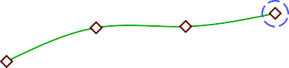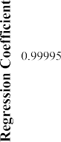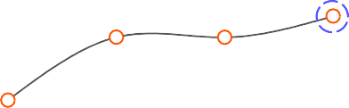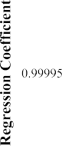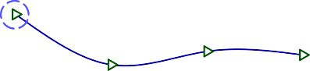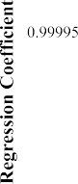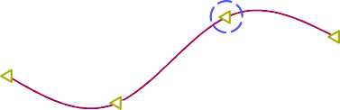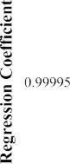

Fig. 4. The regression in terms of hidden layer neurons.

 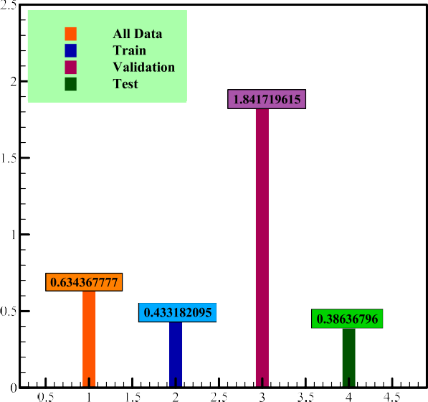



Fig. 5. The MSE in terms of hidden layer neurons.

NF at different percentages (10–90 % and 45–55 %), T = 15–55 °C and SVF = 0.25–1 % was done. The SR parameter is considered to evaluate the l*nf* . In all types of NFs, the l*nf* decreases by about 80 % with increasing temperature. Also, experimental results show that increasing the percentage of CNTs has a significant effect on the non-Newtonian behavior of NFs, and this increase in the per-

centage of CNTs increases the shear-thinning behavior of NFs.

In the present study, an optimized ANN was used to accurately estimate the l*nf* of MWCNT-CuO (10 % – 90 %)/10W40 NF under different conditions (temperature, SVF and SR). The selected struc-

ture is selected after measuring and evaluating the number of neu- rons and the activation function in each layer. According to the authors, no research was done on modeling the l*nf* of MWCNT- CuO (10 % – 90 %)/10W40 NF. Also, to increase the accuracy of data

estimation, different structures are studied in the design of ANN and the most optimal structure is selected.

1. About ANN

ANN is one of the important branches of artificial intelligence that has the ability to learn the relationship between several sets of data and can store each of these data for similar cases. [61–62]. The data proposed by ANN has high accuracy and performance. ANN modeling has wide applications in various sciences, a limited

 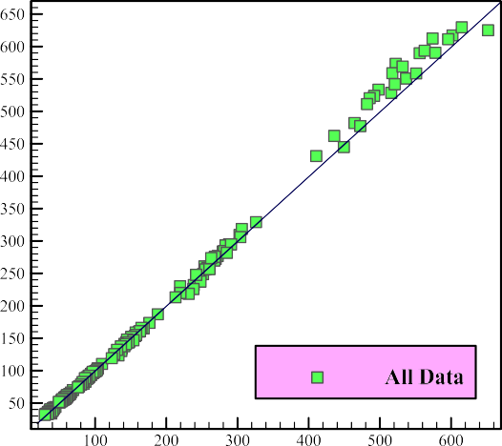  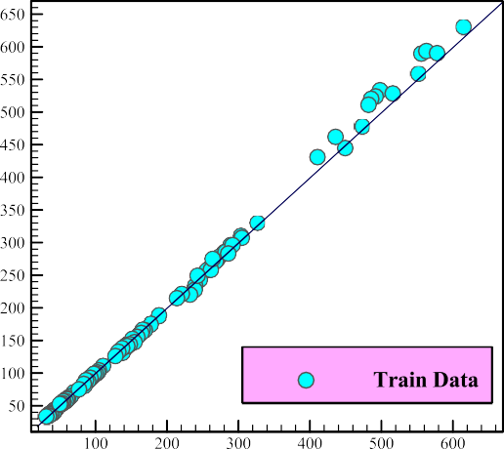

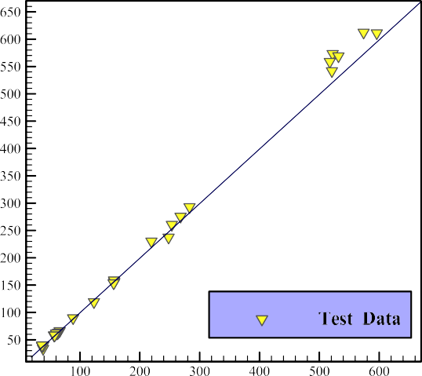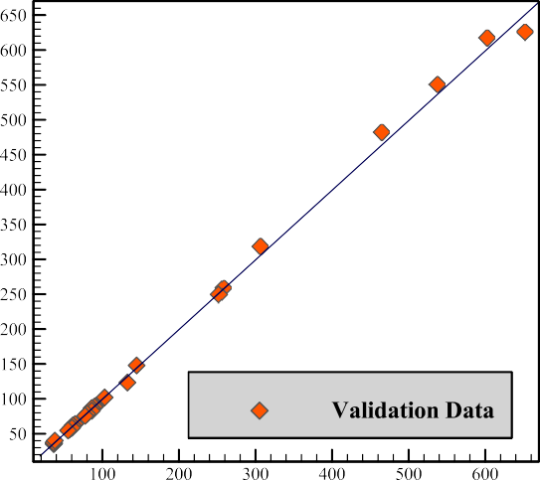

Fig. 6. Evaluation of the proposed ANN model data with laboratory data.

 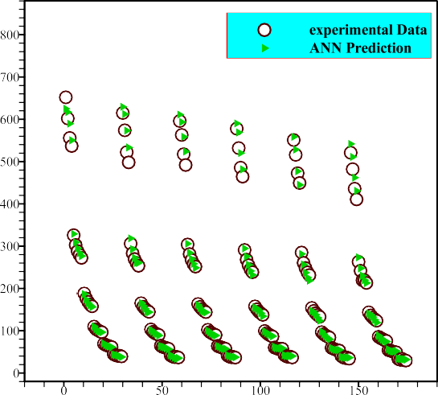  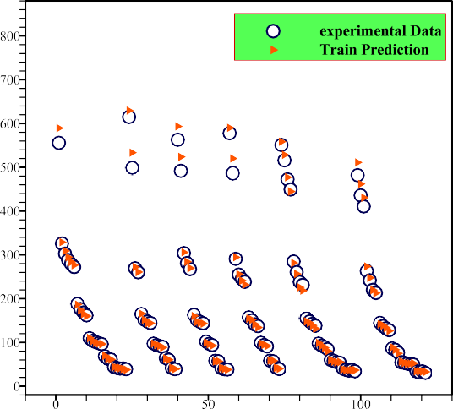

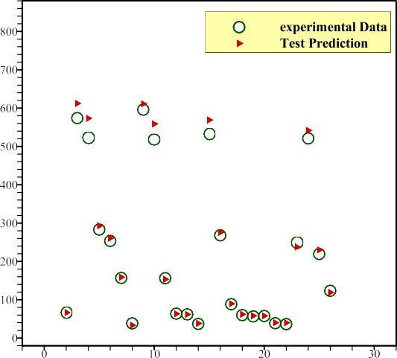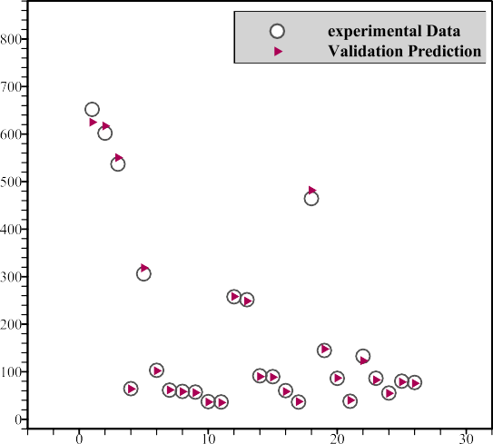

Fig. 7. Comparison between proposed ANN data with laboratory data.

number of which can be mentioned, including medical sciences, astronomy, and pharmaceuticals. [63–64]. Recently, ANN is used to estimate complex problems. These networks are trained to pre- dict the rheological properties of nanomaterials. Some researchers used ANNs to predict the behavior of nanofluids. In recent years,

researchers used this efficient tool in their studies due to ANN’s ability to estimate the l*nf* [65–66]. Summary of past studies shows that there is still no accurate theory for determining the l*nf* , and the existing classical models for NFs are used, which are not very accurate. MLP is one of the most important neural network models. [67–68]. The activation position of a neuron in the ANN is deter- mined by the activation function. [70,71].

1. Laboratory data and ANN training

In the current work, the l*nf* of a hybrid nano-lubricant was computed with modeling experimental data by ANNs, for which the MLP-ANN algorithm was utilized. For this purpose, the labora- tory data of l*nf* includes 174 data for the ANN modeling procedure.

ANN inputs are divided into three kinds including temperature, *SR* and *SVF*, and the ANN output is the l*nf* . *Sigmoid* activation function is used for each layer of this modeling. Each function is *tan-sigmoid*

and *log-sigmoid*. The selected structure is then selected from the above set of network structure, which has 4 and 8 morons in each

layer. In each part of this modeling, the number of each neuron and the activation function for the hidden layers were set to define the optimal ANN structures. The input data for ANN is divided into

three collections of training, validation, and testing. Of the 174 experimental l*nf* data, 70 % of the data was evaluated in the train- ing stage, 15 % was used for the validation stage, and 15 % of the data was used to assess performance. The foremost sample from the 400 investigated samples to forecast the l*nf* is plotted in Fig. 3. To analyze and check the performance of the ANNs, the regres- sion coefficients for different stages are reported in Table 1.

According to Table 1, the highest value of R belongs to the fourth structure, which has 4 and 8 neurons in each hidden layer and is equal to 0.9999744. In Table, 4 optimal structures were presented among different network structures.

1. Results and discussion

After defining the optimal structure among different network structures based on the number of neurons and hidden layers in the ANN, it is necessary to analyze and check the performance of the proposed data. Regression (R) coefficients for different steps are drawn in 4 separate sections. Regression coefficients close to 1 indicate high accuracy of this model. As you can see in Fig. 4, R for the data set is more than 0.999. In this section, the results

 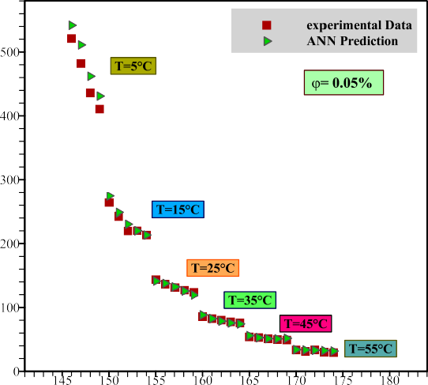  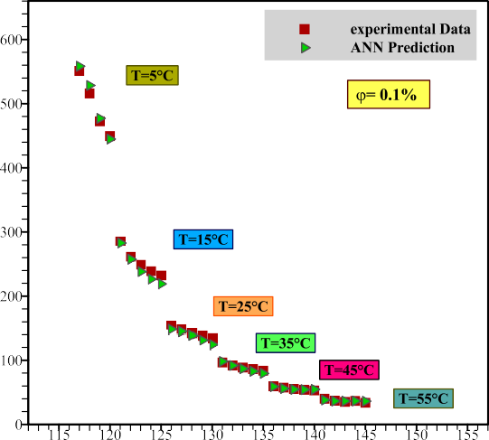

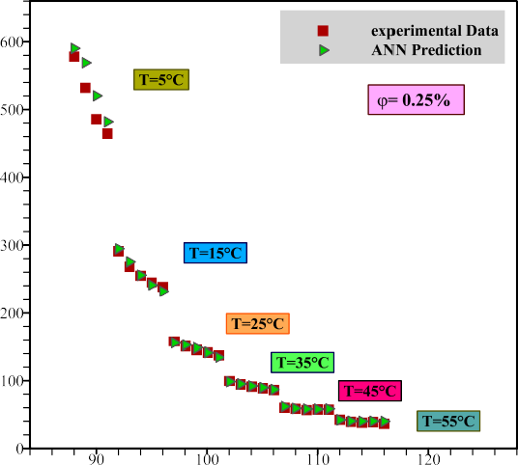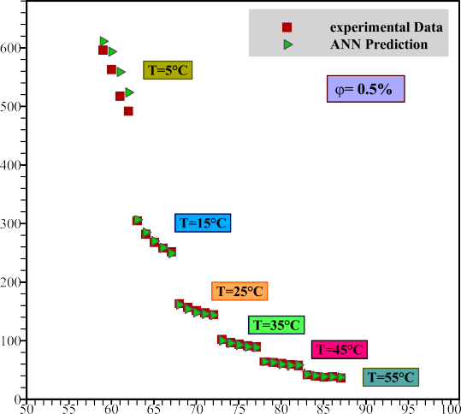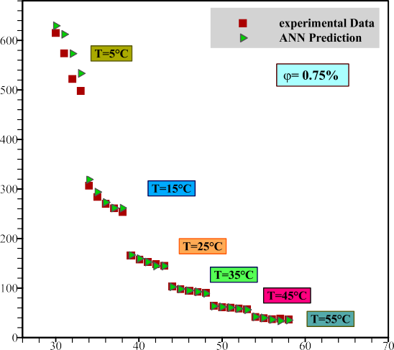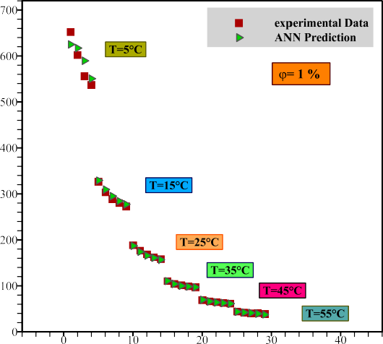

 

Fig. 8. Comparison of ANN by experimental data.

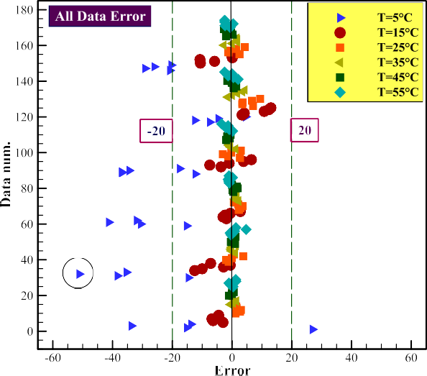

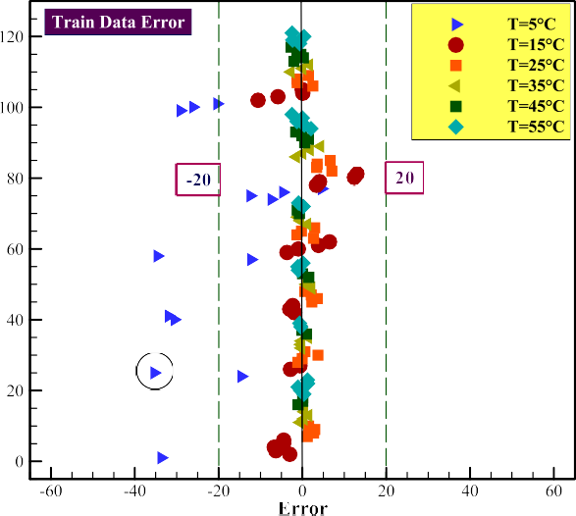

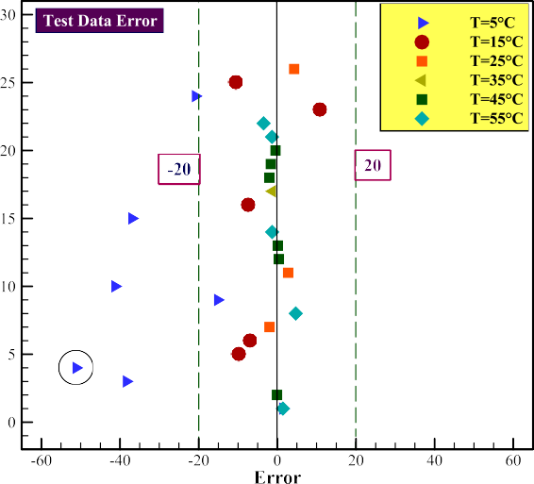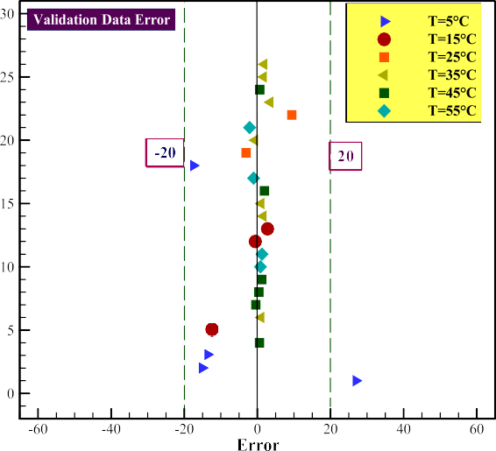

Fig. 9. Calculated error values.

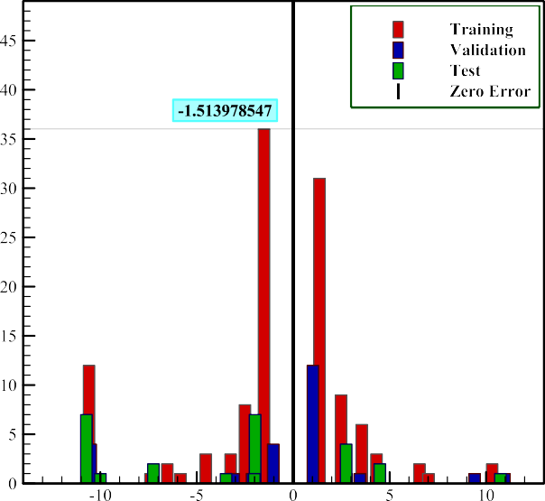of R are more important than other coefficients, which is equal to 0.9999744 and belongs to fourth structure.

In this part of the research, the different stages of the ANN based on accuracy and proper performance were evaluated to introduce the best ANN model selected from the MSE criterion. The MSE is according to Eq. 1, which is between experimental data and predicted data. As shown in Fig. 5, the MSE in the training phase is lower than other phases. Based on Eq. 1, the MSE value is 0.433182095.

*MSE* = 1 X(l |

*N*

— l | )2

*N i*=1

*rel Exp*

*rel Pred*

In Fig. 6, the results of the laboratory data are evaluated with the proposed ANN data for different stages. As shown in Fig. 6, there is a good match between the proposed data and the experi- mental data. This shows the high accuracy of ANN data compared to other data.

Fig. 7 compares the ANN results at different stages, with exper- imental data collection at different SVFs using the ANN technique. According to Fig. 7, a good homogeneity can be seen between all the data proposed by ANN with the experimental data, which indi- cates the proper performance and correctness of the proposed data of the ANN model with practical data.



Fig. 10. Histogram plot.

 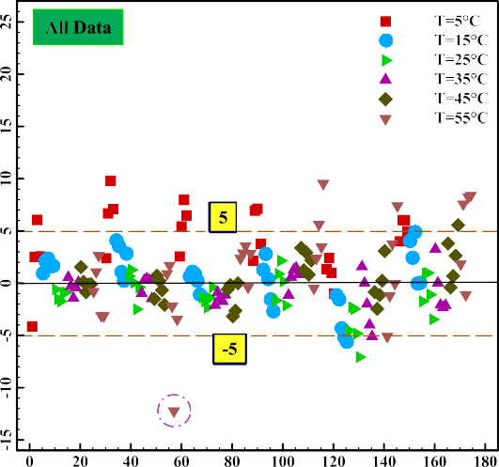  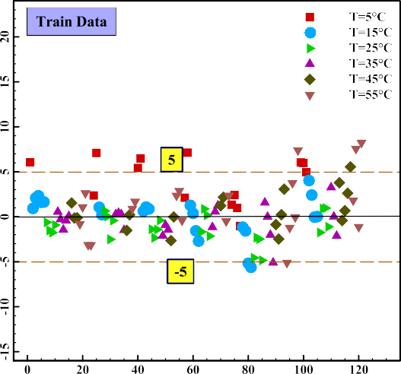

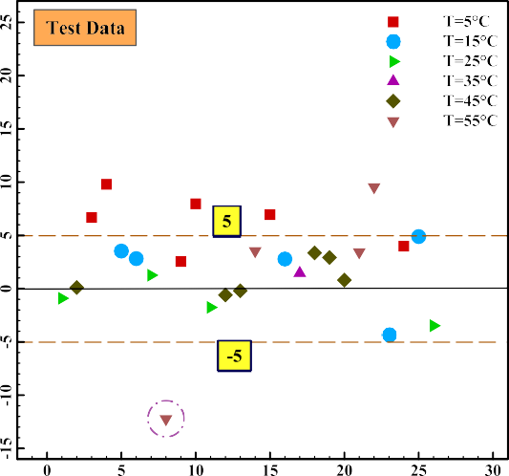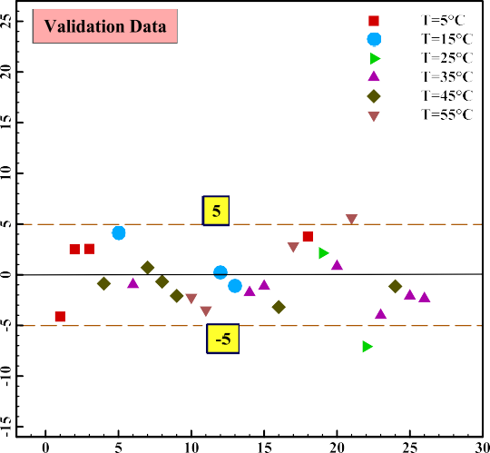

Fig. 11. MOD diagrams.

In Fig. 8, the laboratory data and ANN data are drawn and com- pared separately in different temperature ranges for *SVF* = 0.05 %

—1%. According to Fig. 8, it is observed that at low temperatures

such as T =25oC, there is no good agreement between the data,

but with the increase in temperature, the agreement of the pro- posed ANN data with the experimental data increases, and this indicates the high accuracy and accuracy of the proposed data by

tal data can estimate l*nf* with a maximum error of less than 5 %. The concept of MOD is used to better understand the deviation of data from the actual values of ANN modeling outputs. This value

data is in the range of less than —15 %, which shows the correct- is obtained from Eq. (2). The maximum MOD for all data and test ness of the predicted data from the proposed correlation for esti-

mating the l*nf* of MWCNT-CuO/10W40 nano-lubricant.

ANN. l l

Fig. 9 predicts l*nf* -related errors and compares the data of dif-

ferent stages for collected data in 4 separate parts. Based on Fig. 9, the maximum error is between ± 20, which shows the high precision of the predicted viscosities from the ANN model. As shown in Fig. 9, the highest error at T = 5 0C was seen in all data,

training, and testing stages in the range greater than —20. The least

error in the validation stage is less than ± 20.

The error histogram of the proposed ANN data for different stages is shown in Fig. 10. If the data error is closer to the origin or zero, this indicates the high accuracy of this modeling. Accord- ing to Fig. 10, most of the data are in the range of less than ±10. Also, the training stage has the lowest error and the highest type of frequency and is equal to -1.513978547.

According to Fig. 11, the proposed ANN can have an acceptable adjustment with the benchmark line, and therefore the experimen-

*MOD*(%) = *Pre*— *Exp* × 100 (2)

l*Exp*

The l*nf* of the MWCNT-CuO/10W40 nano-lubricant is calcu- lated according to Eq. (3) [69] based on th *e*l*bf* and at different *SVF* for l*nf* :

l*nf* = l*bf* (1 + 10.6*SVF* + 10.6 *SVF*2) (3)

By comparing the results of the predicted data by ANN, the pro-

comparison was performed at *SR* = 3999 s—1 and T = 5, 25 and posed new data is plotted versus the laboratory data in Fig. 12. This 35 °C and various *SVFs*. As shown in Fig. 12, the ANN technique

was more capable of predicting data. The results of mathematical relationship calculations and ANN data show that with increasing T and *SVF*, the l*nf* of There is a slight deviation between the data

 



 





Fig. 12. Comparison between different methods.

of the mathematical relationship with the laboratory data, but as you can see, as the temperature increases, the agreement between the proposed data and the experimental data increases, and this indicates the high accuracy of ANN data compared to the computa- tional data.

1. Conclusion

Due to the high benefits of NFs in changing the proper function- ing of heat transfer such as reactors or vehicles, in this study, the research was done to estimate the l*nf* of MWCNT-CuO (10:90)/10W40 nano-lubricant using ANN. Also, a set of from the

experimental data set in terms of T (T = 55–55 0C), and *SVF* = 0.05 %-1% was used for l*nf* modeling by ANN. Based on the studies, the following can be mentioned:

* + The design of this ANN was done with the MLP method and LM algorithm.
  + To evaluate the accuracy of the proposed model by ANN, MSE, regression coefficient and also MOD were used.
  + The optimal model with 4 and 8 neurons in each hidden layer was presented among 400 different ANN structures.
  + The results of the data error check show that the proposed data have an error of less than -20 < error < +20.
  + l*nf* The data comparison results (laboratory, computational and proposed model) show that the data of the proposed model is

better and more accurate than the computational data.

* + Laboratory investigations are very time-consuming and require a lot of laboratory equipment, so it is suggested to use ANN

model for prediction of l*nf* .

Declaration of Competing Interest

The authors declare that they have no known competing finan- cial interests or personal relationships that could have appeared to influence the work reported in this paper.

References

1. [Fakhar MH, Fakhar A, Tabatabaei H. Nanotechnology efficacy on improvement](http://refhub.elsevier.com/S1110-8665(22)00084-6/h0005) [of acute velocity in fluid-conveyed pipes under thermal load. Int J](http://refhub.elsevier.com/S1110-8665(22)00084-6/h0005) [Hydromechatronics 2021;4(2):142–54](http://refhub.elsevier.com/S1110-8665(22)00084-6/h0005).
2. Huo J, Wei H, Fu L, Zhao C, He C. Highly active Fe36Co44 bimetallic nanoclusters catalysts for hydrolysis of ammonia borane: The first-principles study. Chin Chem Lett 2022. doi: <https://doi.org/10.1016/j.cclet.2022.02.066>.
3. Zhang Y, Li C, Jia D, Zhang D, Zhang X. Experimental evaluation of the lubrication performance of MoS2/CNT nanofluid for minimal quantity lubrication in Ni-based alloy grinding. Int J Mach Tool Manu 2015;99:19–33. doi: <https://doi.org/10.1016/j.ijmachtools.2015.09.003>.
4. [Bakhshkandi R, Ghoranneviss M. Investigating the synthesis and growth of](http://refhub.elsevier.com/S1110-8665(22)00084-6/h0020) [titanium dioxide nanoparticles on a cobalt catalyst. Journal of Research in](http://refhub.elsevier.com/S1110-8665(22)00084-6/h0020) [Science, Engineering and Technology 2019;7(4):1–3](http://refhub.elsevier.com/S1110-8665(22)00084-6/h0020).
5. [Safa M, Ahmadi M, Mehrmashadi J, Petkovic D, Mohammadhassani M, Zandi Y,](http://refhub.elsevier.com/S1110-8665(22)00084-6/h0025) [et al. Selection of the most influential parameters on vectorial crystal growth of](http://refhub.elsevier.com/S1110-8665(22)00084-6/h0025) [highly oriented vertically aligned carbon nanotubes by adaptive neuro-fuzzy](http://refhub.elsevier.com/S1110-8665(22)00084-6/h0025) [technique. Int J Hydromechatronics 2020;3(3):238–51](http://refhub.elsevier.com/S1110-8665(22)00084-6/h0025).
6. Zhang J, Li C, Zhang Y, Yang M, Jia D, Liu G, et al. Experimental assessment of an environmentally friendly grinding process using nanofluid minimum quantity lubrication with cryogenic air. J Clean Prod 2018;193:236–48. doi: [https://doi.](https://doi.org/10.1016/j.jclepro.2018.05.009) [org/10.1016/j.jclepro.2018.05.009](https://doi.org/10.1016/j.jclepro.2018.05.009).
7. [Keshtegar B, Correia JAFO, Trung N-T. Optimisation of nanocomposite pipes](http://refhub.elsevier.com/S1110-8665(22)00084-6/h0035) [under internal fluid reinforced by FRP and CNTs under seismic load. Int J](http://refhub.elsevier.com/S1110-8665(22)00084-6/h0035) [Hydromechatronics 2020;3(3):213–27](http://refhub.elsevier.com/S1110-8665(22)00084-6/h0035).
8. Cui X, Li C, Zhang Y, Said Z, Debnath S, Sharma S, et al. Grindability of titanium alloy using cryogenic nanolubricant minimum quantity lubrication. J Manuf Process 2022;80:273–86. doi: <https://doi.org/10.1016/j.jmapro.2022.06.003>.
9. Zahmatkesh R, Mohammadiun H, Mohammadiun M, Dibaei Bonab M, Sadi M. Theoretical Investigation of Entropy Generation in Axisymmetric Stagnation Point Flow of Nanofluid Impinging on the Cylinder Axes with Constant Wall Heat Flux and Uniform Transpiration. Iranian Journal of Chemistry and Chemical Engineering (IJCCE) 2021;40(6):1893–908. doi: [https://doi.org/](https://doi.org/10.30492/ijcce.2020.43346) [10.30492/ijcce.2020.43346](https://doi.org/10.30492/ijcce.2020.43346).
10. Bilal A, Mabood F. Numerical Investigation of Mixed Convection Flow of Viscoelastic Nanofluid with Convective Conditions over an Exponentially Stretching Surface. Iranian Journal of Chemistry and Chemical Engineering (IJCCE) 2021;40(6):1931–42. doi: [https://doi.org/10.30492/](https://doi.org/10.30492/ijcce.2021.120531.3936) [ijcce.2021.120531.3936](https://doi.org/10.30492/ijcce.2021.120531.3936).
11. Mansouri M, Nademi M, Ebrahim Olya M, Lotfi H. Study of Methyl tert-butyl Ether (MTBE) Photocatalytic Degradation with UV/TiO2-ZnO-CuO Nanoparticles. Journal of Chemical Health Risks 2017;7(1):19–32. doi: <https://doi.org/10.22034/jchr.2017.544161>.
12. Dwijendra NKA, Patra I, Ahmed YM, et al. Carbonyl sulfide gas detection by pure, Zn- and Cd-decorated AlP nano-sheet. Monatsh Chem 2022. doi: [https://](https://doi.org/10.1007/s00706-022-02961-5) [doi.org/10.1007/s00706-022-02961-5](https://doi.org/10.1007/s00706-022-02961-5).
13. [Wangjian CHENG, Yunlong ZHANG, Lilong GAO, et al. Research on Rheological](http://refhub.elsevier.com/S1110-8665(22)00084-6/h0065) [Properties and Constitutive Equation of GHL Explosive. Journal of Ordnance](http://refhub.elsevier.com/S1110-8665(22)00084-6/h0065) [Equipment. Engineering 2021;42(10):103–8](http://refhub.elsevier.com/S1110-8665(22)00084-6/h0065).
14. Yang M, Li C, Zhang Y, Jia D, Zhang X, Hou Y, et al. Maximum undeformed equivalent chip thickness for ductile-brittle transition of zirconia ceramics under different lubrication conditions. Int J Mach Tool Manu 2017;122:55–65. doi: <https://doi.org/10.1016/j.ijmachtools.2017.06.003>.
15. Yang M, Li C, Zhang Y, Jia D, Li R, Hou Y, et al. Predictive model for minimum chip thickness and size effect in single diamond grain grinding of zirconia ceramics under different lubricating conditions. Ceram Int 2019;45 (12):14908–20. doi: <https://doi.org/10.1016/j.ceramint.2019.04.226>.
16. Xiaoming Wang, Changhe Li, Yanbin Zhang, Hafiz Muhammad Ali, Shubham Sharma, Runze Li, Min Yang, Zafar Said, Xin Liu, Tribology of enhanced turning using biolubricants: A comparative assessment, Tribology International, 2022, 107766. <http://dx.doi.org/10.1016/j.triboint.2022.107766>.
17. Wenhao Xu, Changhe Li, Yanbin Zhang, Hafiz Muhammad Ali, Shubham Sharma, Runze Li, Min Yang, Teng Gao, Mingzheng Liu, Xiaoming Wang, Zafar Said, Xin Liu, Zongming Zou. 2022. Electrostatic atomization minimum quantity lubrication machining: from mechanism to application. Int. J. Extrem. Manuf. 4 042003 (2022). <http://dx.doi.org/10.1088/26317990/ac9652>.
18. [Abdollahi A, Reza Salimpour M. Experimental investigation on the boiling heat](http://refhub.elsevier.com/S1110-8665(22)00084-6/h0090) [transfer of nanofluids on a flat plate in the presence of a magnetic field. The](http://refhub.elsevier.com/S1110-8665(22)00084-6/h0090) [European Physical Journal Plus 2016;131(11):1–16](http://refhub.elsevier.com/S1110-8665(22)00084-6/h0090).
19. Choi, S. U., & Eastman, J. A. (1995). Enhancing thermal conductivity of fluids with nanoparticles (No. ANL/MSD/CP-84938; CONF-951135-29). Argonne National Lab.(ANL), Argonne, IL (United States).
20. [DENG J et al. Numerical Simulation of Penetration Behavior of Tungsten](http://refhub.elsevier.com/S1110-8665(22)00084-6/h0101) [Particle Reinforced Zirconium Matrix Amorphous Composites Projectile. J](http://refhub.elsevier.com/S1110-8665(22)00084-6/h0101) [Ordnance Equip Eng 2021; 42(05):173-179](http://refhub.elsevier.com/S1110-8665(22)00084-6/h0101).
21. [DONG B et al. Research Review of Bulletproof Performance of Graphene](http://refhub.elsevier.com/S1110-8665(22)00084-6/h0105) [Reinforced Composites. J Ordnance Equip Eng 2021;42 (01):137–43](http://refhub.elsevier.com/S1110-8665(22)00084-6/h0105).
22. [GAO T et al. Fiber-reinforced composites in milling and grinding: machining](http://refhub.elsevier.com/S1110-8665(22)00084-6/h0109) [bottlenecks and advanced strategies. Front Mech Eng 2022; 17(2): 24](http://refhub.elsevier.com/S1110-8665(22)00084-6/h0109).
23. [Barzegar Gerdroodbary M, Ganji DD, Moradi R, Abdollahi A. Application of](http://refhub.elsevier.com/S1110-8665(22)00084-6/h0115) [Knudsen thermal force for detection of CO2 in low-pressure micro gas sensor.](http://refhub.elsevier.com/S1110-8665(22)00084-6/h0115) [Fluid Dyn 2018;53(6):812–23](http://refhub.elsevier.com/S1110-8665(22)00084-6/h0115).
24. Wang, X., Luo, L., Xiang, J., Zheng, S., Shittu, S., Wang, Z., & Zhao, X. (2021). A comprehensive review on the application of nanofluid in heat pipe based on the machine learning: Theory, application and prediction. Renewable and Sustainable Energy Reviews, 150, 111434.
25. Chaturvedi, K. R., Fogat, M., & Sharma, T. (2021). Low Temperature rheological characterization of single-step silica nanofluids: An additive in refrigeration and gas hydrate drilling applications. Journal of Petroleum Science and Engineering, 204, 108742.
26. [Stalin PMJ, Arjunan TV, Matheswaran MM, Kumar PM, Sadanandam N.](http://refhub.elsevier.com/S1110-8665(22)00084-6/h0130) [Investigations on thermal properties of CeO2/water nanofluids for heat](http://refhub.elsevier.com/S1110-8665(22)00084-6/h0130) [transfer applications. Mater Today: Proc 2021;47:6815–20](http://refhub.elsevier.com/S1110-8665(22)00084-6/h0130).
27. Yashawantha, K. M., & Vinod, A. V. (2021). ANFIS modelling of effective thermal conductivity of ethylene glycol and water nanofluids for low temperature heat transfer application. Thermal Science and Engineering Progress, 24, 100936.
28. [Karimipour A, Malekahmadi O, Karimipour A, Shahgholi M, Li Z. Thermal](http://refhub.elsevier.com/S1110-8665(22)00084-6/h0140) [conductivity enhancement via synthesis produces a new hybrid mixture](http://refhub.elsevier.com/S1110-8665(22)00084-6/h0140) [composed of copper oxide and multi-walled carbon nanotube dispersed in](http://refhub.elsevier.com/S1110-8665(22)00084-6/h0140) [water: experimental characterization and artificial neural network modeling.](http://refhub.elsevier.com/S1110-8665(22)00084-6/h0140) [Int J Thermophys 2020;41(8):1–27](http://refhub.elsevier.com/S1110-8665(22)00084-6/h0140).
29. [Bakhtiari R, Kamkari B, Afrand M, Abdollahi A. Preparation of stable TiO2-](http://refhub.elsevier.com/S1110-8665(22)00084-6/h0145) [Graphene/Water hybrid nanofluids and development of a new correlation for](http://refhub.elsevier.com/S1110-8665(22)00084-6/h0145) [thermal conductivity. Powder Technol 2021;385:466–77](http://refhub.elsevier.com/S1110-8665(22)00084-6/h0145).
30. [Fuxi S, Hamedi S, Hajian M, Toghraie D, Alizadeh As’ad, Hekmatifar M, et al.](http://refhub.elsevier.com/S1110-8665(22)00084-6/h0150) [Addition of MWCNT-Al2O3 nanopowders to water-ethylene glycol (EG) base](http://refhub.elsevier.com/S1110-8665(22)00084-6/h0150) [fluid for enhancing the thermal characteristics: Design an optimum feed-](http://refhub.elsevier.com/S1110-8665(22)00084-6/h0150) [forward neural network. Case Studies. Therm Eng 2021;27:101293](http://refhub.elsevier.com/S1110-8665(22)00084-6/h0150).
31. Jamei, M., Olumegbon, I. A., Karbasi, M., Ahmadianfar, I., Asadi, A., & Mosharaf- Dehkordi, M. (2021). On the Thermal Conductivity Assessment of Oil-Based Hybrid Nanofluids using Extended Kalman Filter integrated with feed-forward neural network. International Journal of Heat and Mass Transfer, 172, 121159.
32. [Yang X, Boroomandpour A, Wen S, Toghraie D, Soltani F. Applying Artificial](http://refhub.elsevier.com/S1110-8665(22)00084-6/h0160) [Neural Networks (ANNs) for prediction of the thermal characteristics of water/](http://refhub.elsevier.com/S1110-8665(22)00084-6/h0160) [ethylene glycol-based mono, binary and ternary nanofluids containing](http://refhub.elsevier.com/S1110-8665(22)00084-6/h0160) [MWCNTs, titania, and zinc oxide. Powder Technol 2021;388:418–24](http://refhub.elsevier.com/S1110-8665(22)00084-6/h0160).
33. Tian, S., Arshad, N. I., Toghraie, D., Eftekhari, S. A., & Hekmatifar, M. (2021). Using perceptron feed-forward Artificial Neural Network (ANN) for predicting the thermal conductivity of graphene oxide-Al2O3/water-ethylene glycol hybrid nanofluid. Case Studies in Thermal Engineering, 26, 101055.
34. [Nfawa SR, Abu Talib AR, Basri AA, Masuri SU. Novel use of MgO nanoparticle](http://refhub.elsevier.com/S1110-8665(22)00084-6/h0170) [additive for enhancing the thermal conductivity of CuO/water nanofluid. Case](http://refhub.elsevier.com/S1110-8665(22)00084-6/h0170) [Studies. Therm Eng 2021;27:101279](http://refhub.elsevier.com/S1110-8665(22)00084-6/h0170).
35. [Banisharif A, Estellé P, Rashidi A, Van Vaerenbergh S, Aghajani M. Heat transfer](http://refhub.elsevier.com/S1110-8665(22)00084-6/h0175) [properties of metal, metal oxides, and carbon water-based nanofluids in the](http://refhub.elsevier.com/S1110-8665(22)00084-6/h0175) [ethanol condensation process. Colloids Surf A Physicochem Eng Asp](http://refhub.elsevier.com/S1110-8665(22)00084-6/h0175) [2021;622:126720](http://refhub.elsevier.com/S1110-8665(22)00084-6/h0175).
36. Zhu, Y., Zamani, M., Xu, G., Toghraie, D., Hashemian, M., & Alizadeh, A. A. (2021). A comprehensive experimental investigation of dynamic viscosity of MWCNT-WO3/water-ethylene glycol antifreeze hybrid nanofluid. Journal of Molecular Liquids, 333, 115986.
37. Mousavi, S. B., Heris, S. Z., & Estellé, P. (2021). Viscosity, tribological and physicochemical features of ZnO and MoS2 diesel oil-based nanofluids: An experimental study. Fuel, 293, 120481.
38. Chu, Y. M., Ibrahim, M., Saeed, T., Berrouk, A. S., Algehyne, E. A., & Kalbasi, R. (2021). Examining rheological behavior of MWCNT-TiO2/5W40 hybrid nanofluid based on experiments and RSM/ANN modeling. Journal of Molecular Liquids, 333, 115969.
39. Keykhosravi, A., Vanani, M. B., & Aghayari, C. (2021). TiO2 nanoparticle- induced Xanthan Gum Polymer for EOR: Assessing the underlying mechanisms in oil-wet carbonates. Journal of Petroleum Science and Engineering, 204, 108756.
40. [Rashidi S, Bovand M, Rahbar N, Esfahani JA. Steps optimization and](http://refhub.elsevier.com/S1110-8665(22)00084-6/h0200) [productivity enhancement in a nanofluid cascade solar still. Renew Energy](http://refhub.elsevier.com/S1110-8665(22)00084-6/h0200) [2018;118:536–45](http://refhub.elsevier.com/S1110-8665(22)00084-6/h0200).
41. [Esfe MH, Hajmohammad H, Moradi R, Arani AAA. Multi-objective optimization](http://refhub.elsevier.com/S1110-8665(22)00084-6/h0205) [of cost and thermal performance of double walled carbon nanotubes/water](http://refhub.elsevier.com/S1110-8665(22)00084-6/h0205) [nanofluids by NSGA-II using response surface method. Appl Therm Eng](http://refhub.elsevier.com/S1110-8665(22)00084-6/h0205) [2017;112:1648–57](http://refhub.elsevier.com/S1110-8665(22)00084-6/h0205).
42. [Baratpour M, Karimipour A, Afrand M, Wongwises S. Effects of temperature](http://refhub.elsevier.com/S1110-8665(22)00084-6/h0210) [and concentration on the viscosity of nanofluids made of single-wall carbon](http://refhub.elsevier.com/S1110-8665(22)00084-6/h0210) [nanotubes in ethylene glycol. Int Commun Heat Mass Transfer](http://refhub.elsevier.com/S1110-8665(22)00084-6/h0210) [2016;74:108–13](http://refhub.elsevier.com/S1110-8665(22)00084-6/h0210).
43. [Abdolbaqi MK, Sidik NAC, Rahim MFA, Mamat R, Azmi WH, Yazid MNAWM,](http://refhub.elsevier.com/S1110-8665(22)00084-6/h0215) [et al. Experimental investigation and development of new correlation for](http://refhub.elsevier.com/S1110-8665(22)00084-6/h0215) [thermal conductivity and viscosity of BioGlycol/water based SiO2 nanofluids.](http://refhub.elsevier.com/S1110-8665(22)00084-6/h0215) [Int Commun Heat Mass Transfer 2016;77:54–63](http://refhub.elsevier.com/S1110-8665(22)00084-6/h0215).
44. [Esfe MH. Designing a neural network for predicting the heat transfer and](http://refhub.elsevier.com/S1110-8665(22)00084-6/h0220) [pressure drop characteristics of Ag/water nanofluids in a heat exchanger. Appl](http://refhub.elsevier.com/S1110-8665(22)00084-6/h0220) [Therm Eng 2017;126:559–65](http://refhub.elsevier.com/S1110-8665(22)00084-6/h0220).
45. [Esfe MH, Esfande S, Amoozad F, Toghraie D. Increasing the accuracy of](http://refhub.elsevier.com/S1110-8665(22)00084-6/h0225) [estimating the dynamic viscosity of hybrid nano-lubricants containing](http://refhub.elsevier.com/S1110-8665(22)00084-6/h0225) [MWCNT-MgO nanoparticles by optimizing using an artificial neural](http://refhub.elsevier.com/S1110-8665(22)00084-6/h0225) [network. Arab J Chem 2022;104405](http://refhub.elsevier.com/S1110-8665(22)00084-6/h0225).
46. [Barati-Harooni A, Najafi-Marghmaleki A. An accurate RBF-NN model for](http://refhub.elsevier.com/S1110-8665(22)00084-6/h0230) [estimation of viscosity of nanofluids. J Mol Liq 2016;224:580–8](http://refhub.elsevier.com/S1110-8665(22)00084-6/h0230).
47. [Ariana MA, Vaferi B, Karimi G. Prediction of thermal conductivity of alumina](http://refhub.elsevier.com/S1110-8665(22)00084-6/h0235) [water-based nanofluids by artificial neural networks. Powder Technol](http://refhub.elsevier.com/S1110-8665(22)00084-6/h0235) [2015;278:1–10](http://refhub.elsevier.com/S1110-8665(22)00084-6/h0235).
48. [Zhao N, Wen X, Yang J, Li S, Wang Z. Modeling and prediction of viscosity of](http://refhub.elsevier.com/S1110-8665(22)00084-6/h0240) [water-based nanofluids by radial basis function neural networks. Powder](http://refhub.elsevier.com/S1110-8665(22)00084-6/h0240) [Technol 2015;281:173–83](http://refhub.elsevier.com/S1110-8665(22)00084-6/h0240).
49. Yang, Y., Grulke, E. A., Zhang, Z. G., & Wu, G. (2006). Thermal and rheological properties of carbon nanotube-in-oil dispersions. Journal of Applied Physics. 99(11). 114307.
50. [Lu K. Rheological behavior of carbon nanotube-alumina nanoparticle](http://refhub.elsevier.com/S1110-8665(22)00084-6/h0250) [dispersion systems. Powder Technol 2007;177(3):154–61](http://refhub.elsevier.com/S1110-8665(22)00084-6/h0250).
51. [Kole M, Dey TK. Effect of aggregation on the viscosity of copper oxide–gear oil](http://refhub.elsevier.com/S1110-8665(22)00084-6/h0255) [nanofluids. Int J Therm Sci 2011;50(9):1741–7](http://refhub.elsevier.com/S1110-8665(22)00084-6/h0255).
52. [Susan-Resiga D, Socoliuc V, Boros T, Borbáth T, Marinica O, Han A, et al. The](http://refhub.elsevier.com/S1110-8665(22)00084-6/h0260) [influence of particle clustering on the rheological properties of highly](http://refhub.elsevier.com/S1110-8665(22)00084-6/h0260) [concentrated magnetic nanofluids. J Colloid Interface Sci 2012;373(1):110–5](http://refhub.elsevier.com/S1110-8665(22)00084-6/h0260).
53. [Wang B, Wang X, Lou W, Hao J. Thermal conductivity and rheological](http://refhub.elsevier.com/S1110-8665(22)00084-6/h0265) [properties of graphite/oil nanofluids. Colloids Surf A Physicochem Eng Asp](http://refhub.elsevier.com/S1110-8665(22)00084-6/h0265) [2012;414:125–31](http://refhub.elsevier.com/S1110-8665(22)00084-6/h0265).
54. [Tajik Jamal-Abad M, Dehghan M, Saedodin S, Valipour MS, Zamzamian A. An](http://refhub.elsevier.com/S1110-8665(22)00084-6/h0270) [experimental investigation of rheological characteristics of non-Newtonian](http://refhub.elsevier.com/S1110-8665(22)00084-6/h0270) [nanofluids. Journal of Heat and Mass Transfer Research 2014;1(1):17–23](http://refhub.elsevier.com/S1110-8665(22)00084-6/h0270).
55. [Anoop K, Sadr R, Al-Jubouri M, Amani M. Rheology of mineral oil-SiO2](http://refhub.elsevier.com/S1110-8665(22)00084-6/h0275) [nanofluids at high pressure and high temperatures. Int J Therm Sci](http://refhub.elsevier.com/S1110-8665(22)00084-6/h0275) [2014;77:108–15](http://refhub.elsevier.com/S1110-8665(22)00084-6/h0275).
56. [Goharshadi EK, Hadadian M. Effect of calcination temperature on structural,](http://refhub.elsevier.com/S1110-8665(22)00084-6/h0280) [vibrational, optical, and rheological properties of zirconia nanoparticles.](http://refhub.elsevier.com/S1110-8665(22)00084-6/h0280) [Ceram Int 2012;38(3):1771–7](http://refhub.elsevier.com/S1110-8665(22)00084-6/h0280).
57. [Hemmat Esfe M, Kiannejad Amiri M, Alirezaie A. Thermal conductivity of a](http://refhub.elsevier.com/S1110-8665(22)00084-6/h0285) [hybrid nanofluid. J Therm Anal Calorim 2018;134(2):1113–22](http://refhub.elsevier.com/S1110-8665(22)00084-6/h0285).
58. [Aberoumand S, Jafarimoghaddam A, Moravej M, Aberoumand H, Javaherdeh K.](http://refhub.elsevier.com/S1110-8665(22)00084-6/h0290) [Experimental study on the rheological behavior of silver-heat transfer oil](http://refhub.elsevier.com/S1110-8665(22)00084-6/h0290) [nanofluid and suggesting two empirical based correlations for thermal](http://refhub.elsevier.com/S1110-8665(22)00084-6/h0290) [conductivity and viscosity of oil based nanofluids. Appl Therm Eng](http://refhub.elsevier.com/S1110-8665(22)00084-6/h0290) [2016;101:362–72](http://refhub.elsevier.com/S1110-8665(22)00084-6/h0290).
59. [Esfe MH, Rostamian H, Sarlak MR. A novel study on rheological behavior of](http://refhub.elsevier.com/S1110-8665(22)00084-6/h0295) [ZnO-MWCNT/10w40 nanofluid for automotive engines. J Mol Liq](http://refhub.elsevier.com/S1110-8665(22)00084-6/h0295) [2018;254:406–13](http://refhub.elsevier.com/S1110-8665(22)00084-6/h0295).
60. [Esfe MH, Arani AAA, Madadi MR, Alirezaie A. A study on rheological](http://refhub.elsevier.com/S1110-8665(22)00084-6/h0300) [characteristics of hybrid nano-lubricants containing MWCNT-TiO2](http://refhub.elsevier.com/S1110-8665(22)00084-6/h0300) [nanoparticles. J Mol Liq 2018;260:229–36](http://refhub.elsevier.com/S1110-8665(22)00084-6/h0300).
61. Wang, J., Zhai, Y., Yao, P., Ma, M., & Wang, H. (2020). Established prediction models of thermal conductivity of hybrid nanofluids based on artificial neural network (ANN) models in waste heat system. International Communications in Heat and Mass Transfer, 110, 104444.
62. [Esfe MH, Arani AAA. An experimental determination and accurate prediction](http://refhub.elsevier.com/S1110-8665(22)00084-6/h0310) [of dynamic viscosity of MWCNT (% 40)-SiO2 (% 60)/5W50 nano-lubricant. J](http://refhub.elsevier.com/S1110-8665(22)00084-6/h0310) [Mol Liq 2018;259:227–37](http://refhub.elsevier.com/S1110-8665(22)00084-6/h0310).
63. [Rostamian H, Lotfollahi MN. New functionality for energy parameter of](http://refhub.elsevier.com/S1110-8665(22)00084-6/h0315) [Redlich-Kwong equation of state for density calculation of pure carbon dioxide](http://refhub.elsevier.com/S1110-8665(22)00084-6/h0315) [and ethane in liquid, vapor and supercritical phases. Period Polytech, Chem](http://refhub.elsevier.com/S1110-8665(22)00084-6/h0315) [Eng 2016;60(2):93–7](http://refhub.elsevier.com/S1110-8665(22)00084-6/h0315).
64. [He W, Ruhani B, Toghraie D, Izadpanahi N, Esfahani NN, Karimipour A, Afrand](http://refhub.elsevier.com/S1110-8665(22)00084-6/h0318)

[M. Using of artificial neural networks (ANNs) to predict the thermal](http://refhub.elsevier.com/S1110-8665(22)00084-6/h0318) [conductivity of zinc oxide–silver (50%–50%)/water hybrid Newtonian](http://refhub.elsevier.com/S1110-8665(22)00084-6/h0318) [nanofluid. International Communications in Heat and Mass Transfer](http://refhub.elsevier.com/S1110-8665(22)00084-6/h0318) [2020;116:104645](http://refhub.elsevier.com/S1110-8665(22)00084-6/h0318).

1. [Van Gerven M, Bohte S. Artificial neural networks as models of neural](http://refhub.elsevier.com/S1110-8665(22)00084-6/h0325) [information processing. Front Comput Neurosci 2017;11:114](http://refhub.elsevier.com/S1110-8665(22)00084-6/h0325).
2. [Ruhani B et al. Statistical investigation for developing a new model for](http://refhub.elsevier.com/S1110-8665(22)00084-6/h0331) [rheological behavior of Silica–ethylene glycol/Water hybrid Newtonian](http://refhub.elsevier.com/S1110-8665(22)00084-6/h0331) [nanofluid using experimental data. Physica A 2019;525:616–27](http://refhub.elsevier.com/S1110-8665(22)00084-6/h0331).
3. [Geetha MCS. Forecasting the crop yield production in trichy district using](http://refhub.elsevier.com/S1110-8665(22)00084-6/h0335) [fuzzy C-Means algorithm and multilayer perceptron (MLP). International](http://refhub.elsevier.com/S1110-8665(22)00084-6/h0335) [Journal of Knowledge and Systems Science (IJKSS) 2020;11(3):83–98](http://refhub.elsevier.com/S1110-8665(22)00084-6/h0335).
4. [Ghazvini M, Maddah H, Peymanfar R, Ahmadi MH, Kumar R. Experimental](http://refhub.elsevier.com/S1110-8665(22)00084-6/h0340) [evaluation and artificial neural network modeling of thermal conductivity of](http://refhub.elsevier.com/S1110-8665(22)00084-6/h0340) [water based nanofluid containing magnetic copper nanoparticles. Physica A](http://refhub.elsevier.com/S1110-8665(22)00084-6/h0340) [2020;551:124127](http://refhub.elsevier.com/S1110-8665(22)00084-6/h0340).
5. [Chen H, Ding Y, He Y, Tan C. Rheological behaviour of ethylene glycol based](http://refhub.elsevier.com/S1110-8665(22)00084-6/h0345) [titania nanofluids. Chem Phys Lett 2007;444(4–6):333–7](http://refhub.elsevier.com/S1110-8665(22)00084-6/h0345).
6. [Ruhani B et al. Statistical investigation for developing a new model for](http://refhub.elsevier.com/S1110-8665(22)00084-6/h0346) [rheological behavior of ZnO–Ag (50%–50%)/Water hybrid Newtonian nanofluid](http://refhub.elsevier.com/S1110-8665(22)00084-6/h0346) [using experimental data. Physica A 2019;525:741–51](http://refhub.elsevier.com/S1110-8665(22)00084-6/h0346).
7. [Ruhani B et al. Statistical modeling and investigation of thermal characteristics](http://refhub.elsevier.com/S1110-8665(22)00084-6/h0347) [of a new nanofluid containing cerium oxide powder. Heliyon 2022;8](http://refhub.elsevier.com/S1110-8665(22)00084-6/h0347) [(11):11373](http://refhub.elsevier.com/S1110-8665(22)00084-6/h0347).