[Engineering Science and Technology, an International Journal 43 (2023) 101439](https://doi.org/10.1016/j.jestch.2023.101439)

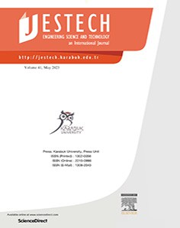

Contents lists available at [ScienceDirect](http://www.sciencedirect.com/science/journal/22150986)

Engineering Science and Technology, an International Journal

journal homepage: [www.elsevier.com/locate/jestch](http://www.elsevier.com/locate/jestch)

[](http://crossmark.crossref.org/dialog/?doi=10.1016/j.jestch.2023.101439&domain=pdf)Optimization of transformer parameters at distribution and power levels with hybrid Grey wolf-whale optimization algorithm

Murat Toren

*Department of Electric and Electronic Engineering in Recep Tayyip Erdogan University, Rize 53100, Turkey*

a r t i c l e i n f o

*Article history:*

Received 22 December 2022

Revised 12 May 2023

Accepted 15 May 2023

Available online 31 May 2023

*Keywords:*

Oil-type transformer Grey wolf algorithm

Whale optimization algorithm Hybrid optimization

a b s t r a c t

Oil-type transformers (OTT) are used more than dry-type transformers, based on cost in the transmission and distribution of electrical energy. Therefore, this usage density increases the importance of cost in OTT. Weight is important in transformer cost. The weight of the transformers depends on the variable parameters of the weights of the core and windings, C (iron cross section conformity factor) and s (cur- rent density), respectively. In this study, unlike the previous heuristic optimization studies, an innovative and complementary optimum weight was obtained by using the Gray Wolf - Whale Optimization hybrid algorithm for both distribution type and power transformer type OTT. A weight reduction of 44% and approximately 14% in power transformers was achieved. It was determined that this decrease in weights provided the same reduction in OTT costs. The comparison test of the study was performed both with the values of other algorithms and statistically.

© 2023 Karabuk University. Publishing services by Elsevier B.V. This is an open access article under the CC

BY-NC-ND license (<http://creativecommons.org/licenses/by-nc-nd/4.0/>).

1. Introduction

Power and distribution OTTs are static system machines that decrease and increase the voltage level of the generated electricity without changing the power and frequency values.

Transformers are divided into many subclasses based on their different characteristics. Power and distribution transformers that are widely used in industry are oil type transformers and dry type transformers based on the type of cooling. OTT transformers shown in Fig. 1 are more in number as they are more economical than dry type transformers among the distribution and power transformer types. This has caused OTTs to be included in many studies in every aspect in the literature. Studies have been con- ducted on operating systems, fault detections, optimization of these electrical machines. OTT design optimization is the detailed calculation of transformer component characteristics based on pre- scribed specifications, using available materials economically to achieve lower cost, lower weight, reduced size, and improved oper- ating performance [1]. In these optimization studies, results were obtained by using *meta*-heuristic algorithms, taking into account the constraints for certain purposes. The heuristic algorithms such as Genetic Algorithm (GA), which is one of the most well-known algorithms [2], Partial Swarm Optimization (PSO) [3], Ant Colony Algorithm (ACA) [4], Artificial Bee Colony (ABC) Algorithm [5], Fire- fly Algorithm (FA) [6],Simulated Annealing (SA) [7], Gravitational

*E-mail address:* [murat.toren@erdogan.edu.tr](mailto:murat.toren@erdogan.edu.tr)

Search (GSA) [8] have been included in many studies to adapt designs, costs and weight optimization of transformers.

From these studies, it was determined that the weight of a dry- type distribution transformer was reduced by using the optimal value variable parameters in the study using genetic algorithm [10]. Similarly, genetic algorithm optimization was developed by using variable parameters s and C to optimize the weight of oil- filled distribution transformers [11]. In another study using parti- cle swarm optimization, a distribution type dry type transformer weight was optimized with the same variable parameters [12]. Optimal values were obtained by using artificial neural networks in dry-type transformer design [13] In dry-type transformer, better results were obtained with firefly algorithm, one of the current heuristic algorithms, and better weight optimization compared to previous algorithms [14] micro genetics for optimal design trans- former optimization studies with an algorithm-based design also included positive results [15].

In addition to these studies, Gray Wolf Optimization (GWO) [16], which is a part of the hybrid algorithm developed in 2014 and applied in this article, is also included in transformer design optimization.

GWO is good at reaching optimum parameters in less iterations in both dynamic and static operating conditions, and the time response is fast in systems where it is applied.

In these features, an improved hybrid GWO is proposed to increase the performance of support vector machine used in trans- former fault diagnosis [17].

<https://doi.org/10.1016/j.jestch.2023.101439>

2215-0986/© 2023 Karabuk University. Publishing services by Elsevier B.V.

This is an open access article under the CC BY-NC-ND license (<http://creativecommons.org/licenses/by-nc-nd/4.0/>).

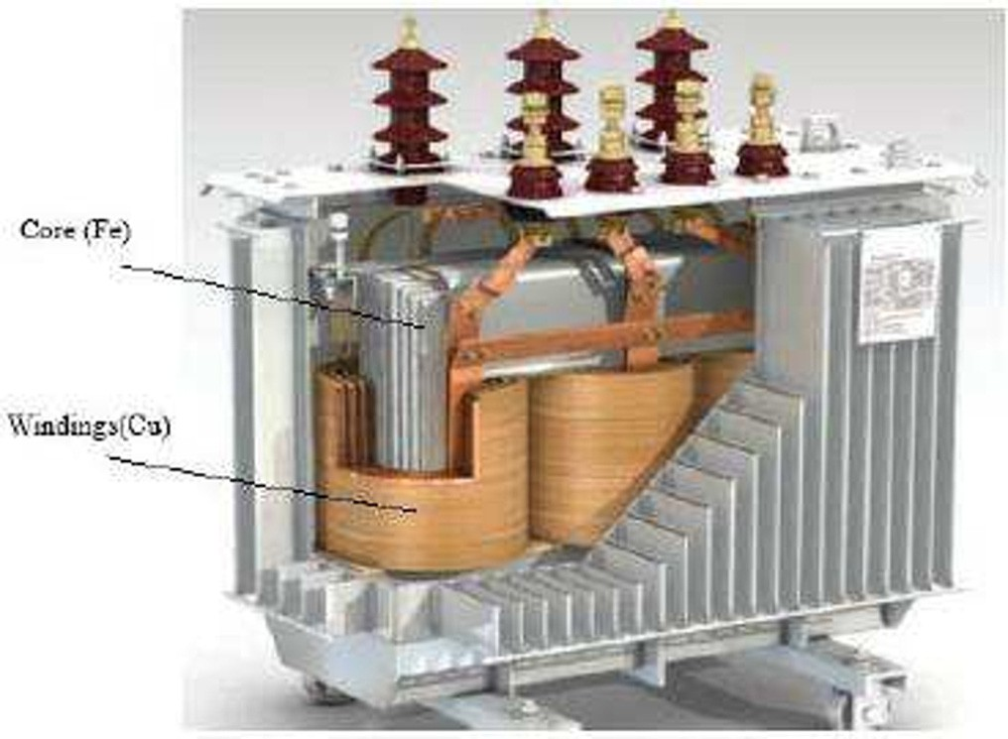

Fig. 1. Internal Structure of Oil Type Transformer [9].

In another study dealing with power loss and weight reduction in transformers, it was investigated that GWO provided 3.76% reduction in 1000 kVA transformer weight in optimization with heuristic algorithms [18].

Likewise, a part of the hybrid algorithm, the Whale Optimiza- tion Algorithm (WOA) [19] which was developed in 2016, has an efficient, virtuous global search capability, slow but highly accu- rate convergence performance in solving real-world optimization problems.

In transformer optimization studies using WOA, it was deter- mined that, similar to GWO, a hybrid structure was created with genetic algorithm by using support vector machine optimization used in transformer fault diagnosis, and fault diagnosis results were realized by 94.05% and the margin of error was reduced by 5% [20]. In a different study, WOA was used in transformer fault diagnosis with an extreme learning machine and it was deter- mined that it could increase fault diagnosis efficiency by optimiz- ing power transformers [21].

Furthermore, heuristic optimization algorithms such as FA, ABC, GWO, WOA etc., recently created in the field of transformers, are utilized for solving a variety of issues in electrical-electronics, com- puter, and mechanical engineering.

GWO has been used to increase the performance of an opti- mized model of hybrid kernel function relevance vector machine (HKRVM) for battery prognostics and health management [22], solve problems related to load frequency control in high scale power systems [23], reconfigure the control circuit designed to keep the four-layer chopper placed on the DC connection of the variable speed drive system (VSDS) under control and has yielded better results than previous methods and practices used in the sys- tem [24].

WOA has been used in optimization studies that provide greater accuracy and reliability to the global values of the values obtained in the stability analysis of power systems [25]. In addition to this study, WOA found positive results in finding electric vehicle charg- ing stations with service capacity, and that it was effective for prac- tical positioning, planning projects and reducing social costs [26]. These heuristic algorithms have been created in hybrid struc- tures through different algorithms that can work in harmony, con- sidering their features. With these hybrid algorithm applications, it is aimed to obtain better results than the studies in which the algo-

rithms are applied separately

Based on research that complements this hybridization, the drilling process using a cryogenically treated drill bit on Inconel 718 super alloy was used in the optimization of the parameters

to be used in obtaining minimum surface roughness as well as maximizing the torque and thrust force during the drilling process and provided better results to the systems compared to their cur- rent conditions [27].

In addition, in order to obtain the best values in the optimiza- tion of the systems, studies have been carried out in the definition of facial emotions with the hybridization of the developed whale algorithm and the Teaching-learning-based algorithm in recent years [28]. For static and dynamic crack identification, PSO and gray wolf hybrid algorithms produced optimal results [29]. In a dif- ferent hybrid study, the genetic algorithm and the worm algorithm obtained values that could obtain more optimal peak values in PV systems [30]. The modified gray wolf algorithm and the cuckoo search algorithm provided optimization in low-frequency con- troller design [31].

When the gray wolf algorithm is hybridized through the bee algorithm, a unique algorithm providing general optimization has been created [32]. Workplace scheduling problems were optimally solved through the whale and Levy flight application with a similar optimization application [33].

The hybrid Gray wolf-whale optimization algorithm mentioned in this article is used in several investigations, In the cloud task scheduling problem, it was aimed to benefit from the advantages of both algorithms in order to minimize the costs, energy con- sumption and the total execution time required for the task imple- mentation, as well as to improve the resource usage, and an improvement was achieved.[34].

Another study, investigated if the hybrid GWO-WOA algorithm, which was compared with the Partical swarm optimization algo- rithm in determining the robot model parameter, provided an improvement in parameter determination [35]. Similarly, for the Leader-Follower Robot (LFR), which is a different robot, the average was calculated while obtaining the model obtained through the gray wolf algorithm It was determined that the squared error value improved from 73.6% to 78% with the hybrid gray wolf whale algo- rithm [36].

A holistic multi-objective optimization framework(MO-HPM) is proposed for the participation of charged electric vehicles in clear- ing the harmonic power market in a microgrid properly, and the study is presented in the field of electric machines. The proposed study focuses on the ability of harmonic balancers to simultane- ously optimize conflicting targets, including the total distortion pay function and the average of the total harmonic distortion, while meeting the constraints associated with the grid, instru- ments, and market price. In the study, a new hybrid algorithm con- sisting of whale optimization, gray wolf optimization, and differential evolution is proposed to create the new market frame- work, and it is examined whether using the algorithm for various defined situations may be the best option for solving mathematical and technical problems, especially MO-HPM [37].

Hybrid gray wolf-whale algorithm is used to obtain high param- eter values in the improvement of performance parameters in the image encryption model for medical image security in the field of medicine [38].

In another study conducted in the same field, a hybrid heuristic swarm-based support vector machine classifier named Gray Wolf- Whale Optimization Algorithm and Support Vector Machine (GWWOA-SVM) has been proposed for early detection of breast cancer disease. The performance of the proposed model is evalu- ated on various metrics such as accuracy, precision, recall, speci- ficity, and F1 score. Our model achieves a classification accuracy of 97.721% for the WDBC dataset. This model outperforms the 92.98% validation rate obtained in the study with PSO, the 96.65 validation rate obtained with WOA, etc., showing that better results are obtained and the hybrid algorithm has better perfor- mance [39].

From these studies, a new approach has been developed, which allows to increase the performance of the hybrid gray wolf-whale algorithm by applying the chaos theory. Better results were obtained from the study compared with other algorithms and gray wolf-whale hybridization [40].

It is examined from the studies in which hybrid algorithms can produce better results compared to the performance of the current heuristic algorithm. According to this evaluation, the studies of hybrid heuristic algorithms used in the optimization of OTT weight, which is the main subject of the study, include the objec- tives of weight reduction-cost minimization of parameters. Of these, the optimization of the protection dimensions of oil-type transformers and the optimization of the operating cost by using firefly and ant colony algorithms are examined [41].

In order to improve the cooling performance of the oil used in oil-based transformers, the Taguchi method and Gray Wolf Opti- mization were hybridized and the mixing ratio of various oil types was optimized [42].

Some studies focus on achieving maximum efficiency on a dry

type 100 kVA transformer by optimizing the current density (s)

culations in [44,45] are used. The weight values determined for powers at both the transmission and distribution levels are deter- mined using the following parameters.

It is stated that iron core and copper windings are the two most important parts that make up the weight in OTT. Accordingly, the total weight of OTT (*GT*) is expressed as follows.

*GT* = *Gcu* + *Gfe* (1)

where; *Gfe* indicates iron weight and *Gcu* indicates copper weight.

The weight of the iron core, which is the first part of the OTT’s weight, is the sum of the weights of the legs and yokes that make up the core.

*Gfe* = *Gfeb* + *Gfej* (2)

It can be expressed as the sum of the yoke weight (*Gfej*) and leg weights (*Gfeb*) in the equation. The equations of the yoke and leg weights here are obtained using the following expressions.

s1ﬃﬃﬃ0ﬃﬃﬃ2ﬃﬃ*S*ﬃﬃ

and iron cross section conformity (C) factor using the Particle Swarm Algorithm, Simulating Annealing and Tree Seed algorithms

*qfe* = *C* 3*f*

(3)

[43].

In the studies reviewed, it has not been observed that the Gray Wolf, Whale algorithm or their hybrid algorithms, which have been developed in recent years, have been applied in design opti- mization studies to improve the performance of OTTs that are widely used in the industry.

Unlike other heuristic algorithms (ABC, FA, ACO, etc.) examined above, Gray Wolf Optimization Algorithm can reach the result it shows quickly with the ability to reach optimum parameters in a limited number of iterations. The Whale Algorithm, on the other hand, works slower than the gray wolf algorithm, but it reaches the optimum value with maximum accuracy and gives better results in verification. It has the ability to converge. It shows that when these algorithms are hybridized with each other, they have a complementary structure.

The OTT weight optimization results of the Gray wolf-whale algorithm to be applied as a hybrid and the advantages such as cost, size and footprint of these values will benefit the OTT design optimization. In conclusion:

The industrial operating cost will be reduced in production of the transformer with optimum weight value,

●

The performance of the hybrid made with heuristic Whale and Grey Wolf algorithms will be assessed,

●

* The acquirability of classical method weight values, weight val-

*qfej* = 1.1*qfe* (4)

*Gfeb* = 3.10—3*cfeqfe Ls* (5)

*Gfej* = 3.10—3*cfeqfej* 2(2*M* + 0.8*D*) (6)

In these equations; *qfe* (*cm*2) and *qfej* (*cm*2), indicate the iron cross section parameters between the transformer legs and the lower–upper part of the core, *c*fe indicates the specific gravity of iron, *M* indicates the width of the transformer window, *D* indicates

the diameter of the circle surrounding the core, f indicates fre- quency, S indicates the apparent power value, and Ls indicates the yoke length.

As can be seen in these equations, C iron cross-section suitabil- ity factor is determined as an important and variable parameter for the calculation of iron weight.

The total copper weight which is the other OTT weight factor is indicated with equation (7).

*Gcu* = *Gcu*1 + *Gcu*2 (7)

In the equation, *Gcu*1 is the primary winding weight and *Gcu*2 is the secondary winding weight. The weight in the windings can be obtained using the equations given below.

*I*

ues obtained through other heuristic algorithms and the values obtained in this study will be tested against other application values and interpreted,

The compatibility of statistical data and the values obtained in this study will be determined.

*q*1 = 1

*I*2

*s*

*q* =

2 *s*

(8)

(9)

1. Materials and methods
   1. *Mathematical model of oil type transformers*

While obtaining weights for both power transformer and distri- bution transformer types in OTT, a calculation methodology that makes use of the used materials and assumptions expressed as empirical approaches based on experience during the design is used.

The industrial design parameters of the transformers in this study and the parameters and hypothetical values given in the cal-

*Gcu*1 = 3.10—5*ccuw*1*q*1*Lm*1 (10)

*Gcu*2 = 3.10—5*ccuw*2*q*2 *Lm*2 (11)

In these equations, *w*1 and *w*2 indicate the coiling numbers of the first and second windings, *q*1 and *q*2 indicate the first and sec- ond winding cross sections, s indicates the current density, *I1* and *I2*

indicate the first and second winding currents, c*cu* indicates the

specific gravity of copper, L*m1*and L*m*2 indicate the average lengths of the windings.

It can be seen here that s current density value is an important variable affecting the copper winding value and thus the copper weight.

In this case, as shown in (1), the total weight of the transformer will be obtained as follows if the total weights of the primary and secondary windings, the yoke and the legs are indicated separately.

*GT* = *Gcu*1 + *Gcu*2 +*Gfeb* +*Gfej* (12)

The label weight values of the OTT for both distribution trans- formers (50kVA-100kVA) and power transformers (1000KVA) will be determined and compared with the previous weight optimiza- tion value obtained through heuristic algorithms and optimum val- ues obtained through the Whale-Grey Wolf hybrid algorithm, and their accuracy will be statistically determined.

Table 1 shows the label parameters of the 50 kVA, 100 kVA and 1000 kVA OTTs used in this study. The weights of the OTTs are

332.28 kg, 757.81 kg and 1664 kg respectively.

1. Methods
   1. *Grey wolf optimization (GWO) algorithm*

The Grey Wolf Algorithm developed by Mirjalili et al.[16] in 2014 is one of the other common population-based intuitive algo- rithms such as the Genetic Algorithm, Particle Swarm Optimiza- tion, Firefly algorithm etc. However, this innovative algorithm has better convergence capability and can reach the optimum point in a shorter time as well as having simple and easily applica- ble features.

The leadership hierarchy used for the implementation of the Grey Wolf Algorithm includes four different dominant grey wolf groups. In the leadership hierarchy seen in Fig. 2, the first layer is

alpha (a) and it represents the leading wolf which is the strongest

and most talented. Beta (b) wolves in the second layer command the other inferior wolves and communicate with alpha wolves. Beta wolves fortify the commands of the alpha, convey them to the inferior wolves, and give feedback to the alpha wolf. Wolves in the third layer are classified as delta wolves (d) which are not included in the other three layers and have to succumb to alpha and beta class wolves but dominate omega wolves. Here

a > b > d, and the lowest layer includes omega wolves (x) that

are directed by these grey wolves and will perform the optimiza- tion. x grey wolves make up a large part of the population and are mainly responsible for stabilizing the internal affairs of the population and protecting and monitoring the young wolf popula- tion. This class of wolves is the most dominant group.

The hunting process used for the implementation of the grey wolf algorithm consists of searching for prey, tracking and moni- toring, surrounding, and attacking.

In the Grey Wolf Algorithm, the search for prey is carried out mainly by a, b, d. In optimization, the first optimal solution is con- sidered to be alpha (a), while beta (b) and delta (d) are considered the second and third best solutions, respectively. Omega wolves

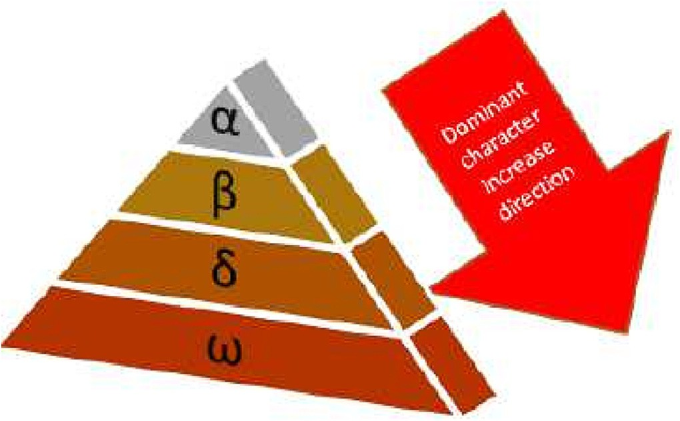

Fig. 2. Algorithm of Grey wolves’ leadership hierarchy.

(x) follow these three wolves. For the optimal implementation of the algorithm, all grey wolves follow the prey, determine its loca- tion and begin to surround it. (13) and (14) are used for mathemat- ical modelling of this behavior.

*Dp* = *CXp*(*t*) — *X*(*t*) (13)

*X*(*t* + 1) = *Xp*(*t*) — *ADp* (14)

where Dp indicates the wolf’s distance to wolf x, which is the dominant character, or its diameter in a circle, t indicates the num- ber of iterations, *X*(*t*) indicate a member of the grey wolf popula- tion, and *Xp* indicates the current position of the prey. *A* and *C* are called coefficient vectors in (13) and (14) and calculated as shown in (15) and (16).

*A* = 2*ar*1 — *a* (15)

*C* = 2*r*2 (16)

where a denotes a coefficient that decreases from 2 to 0 as the iteration progresses while *r*1 and *r*2 are numbers that are randomly selected between 0 and 1. Grey wolves (a, b and d) hunt their prey after surrounding it. In other words, they focus on the optimum

point. Fig. 2 shows the hunting strategy of grey wolves.

The |A| dimension determines the optimization mode of the population while the grey wolves are surrounding the prey. When

|A|>1, the wolves will hunt globally; when |A|<1, the wolves will gather for local hunt. Meanwhile, C in the GWO will affect the posi- tion of the prey and therefore the wolves will perform random searching behavior while looking for prey to achieve global optimization.

The positions of grey wolves are determined by (17) and (18) in the hunting mechanism given in Fig. 3.

Table 1

Parameter values of transformers with different power levels.

|  |  |  |  |  |
| --- | --- | --- | --- | --- |
| Parameters | Unit | 50 kVA | 100 kVA | 1000 kVA |
| Iron cross- section convenience value (C) | *cm2joule-1/2* | 4–6 |  | 4–8 |
|  |  |  | 5.6 |  |
| Current density value (s) | *A/cm2* | 2.2 | 2.2 | 6 |
| Primary winding turn | *turn* | 5798 | 3287 | 420 |
| Secondary winding turn | *turn* | 70 | 44 | 16 |
| Primary winding weight | *kg* | 68.2 | 79.57 | 198 |
| Secondary winding weight | *kg* | 45.6 | 45.01 | 126 |
| Three-legged weight of the Transformer | *kg* | 105.8 |  | 652 |
|  |  |  | 391.03 |  |
| Yoke weight of the Transformer | *kg* | 112.8 | 242.2 | 688 |
| Total Weight of the Transformer | *kg* | 332.28 | 757.81 | 1664 |
| Efficiency | *%* | 95 | 92 | 98.04 |

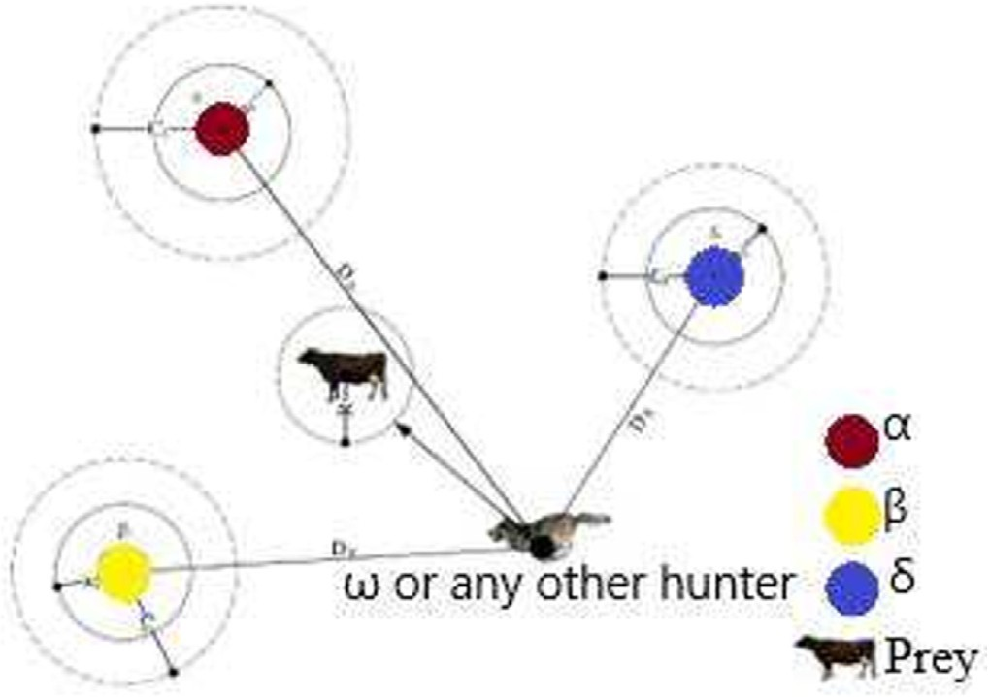

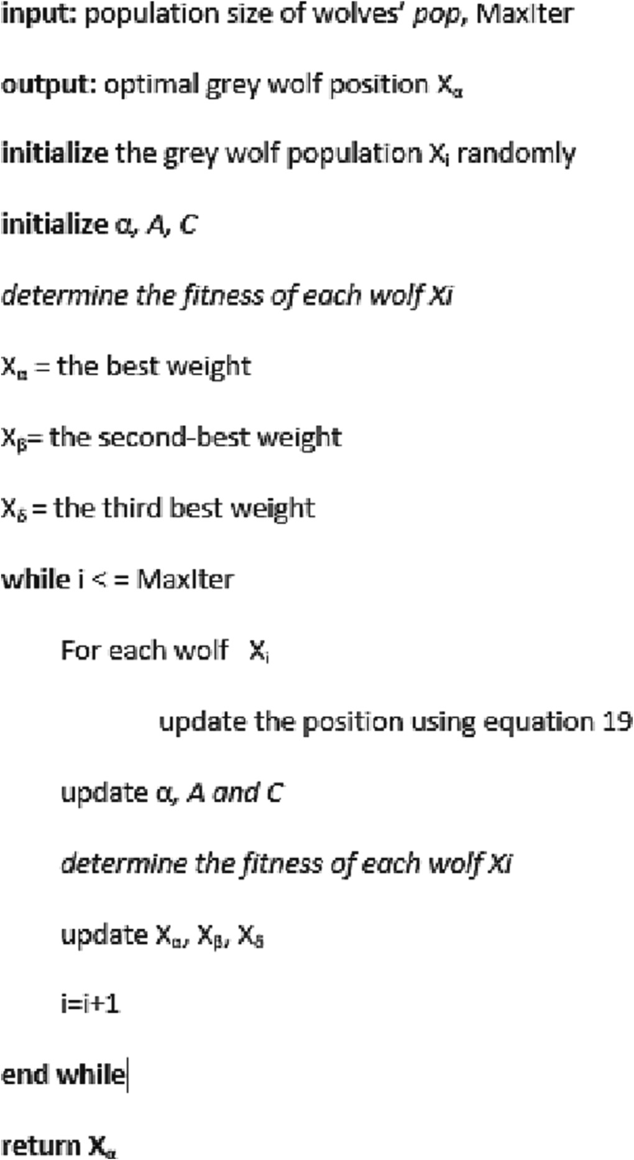Fig. 3. Hunting strategy of Grey wolves [16].

*Da* = |*C*1*Xa* — *X*(*t*)|

*Db* = *C*2*Xb* — *X*(*t*) (17)

*Dd* = |*C*3*Xd* — *X*(*t*)|

*X*1 = *Xa*(*t*) — *A*1*Da*

*X*2 = *Xb*(*t*) — *A*2*Db* (18)

*X*3 = *Xd*(*t*) — *A*3*Dd*

In these equations, Xa, Xb and Xd indicate the position of the grey wolves. (19) shows the new location of the prey after hunting.

*X*(*t* + 1) = *X*1 + *X*2 + *X*3

3

(19)

The basic pseudo-code describing the operation of the grey wolf algorithm is as follows (see Fig. 4).

* 1. *Whale optimization algorithm (WOA)*

WOA was developed by Mirjalili and Lewis in 2016 in order to achieve good results in solving problems that could not be solved by deterministic methods [19]. WOA is an optimization approach that simulates the hunting strategies of humpback whales. The bubble hunting strategy inspires what humpback whales use when hunting. Humpback whales generally feed on small shoals of fish. They have a unique hunting strategy. They form bubble clouds by exhaling underwater. Thus, thanks to these bubbles, they gather their prey together. In these bubbles they create, they move towards the surface of the water and continue to form bubbles as they rise to the surface. This way, they ensure that preys stays

inside the bubbles and hide themselves. Fig. 5(a) represents hump-

Fig. 4. Grey Wolf Optimization Pseudo Code Scheme.

matical model of the target surrounding behavior is shown in (20) - (23).

→*D* = →*C* —*X*→* (*t*) — →*X* (*t*) (20)

→*X* (*t* + 1)= —*X*→* (*t*) — →*A* .→*D* (21)

back whales’ bubble strategy hunting methods. Fig. 5(b) accurately depicts humpback whales hunting with the bubble strategy. Hunt- ing technique in Humpback Whale optimization method is mod- eled in 3 parts, surrounding the target, advancing towards the

→*A* = 2 * →*a* * →*r* — →*a*

→*C* = 2 * →*r*

(22)

(23)

target, and seeking the target.

In the whale optimization algorithm, surrounding the target is considered the optimum solution to be reached. In cases where the optimum solution is not known in optimization problems, it is accepted as the best solution reached or a point around it. In the next step, the positions of the other solutions are updated using the best solution after finding the best solution. The mathe-

*t* represents the current iteration, →*X* *(*t*) represents the best solution vector, →*A* and →*C* are the coefficient vectors, and →*r* is a ran-

dom variable and its value is between 0 and 1.

In move towards the target of WOA, narrowing the circle around the prey is possible by decreasing the value of an →*A* in

(22). Fig. 6 shows the spiral motion and the location of the best

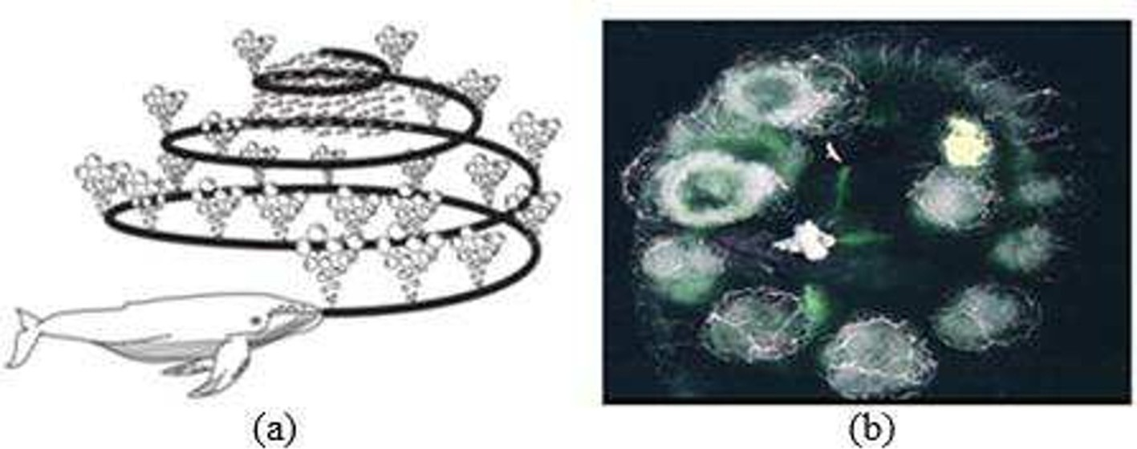

Fig. 5. (a) A picture representing humpback whales’ bubble strategy fishing methods,

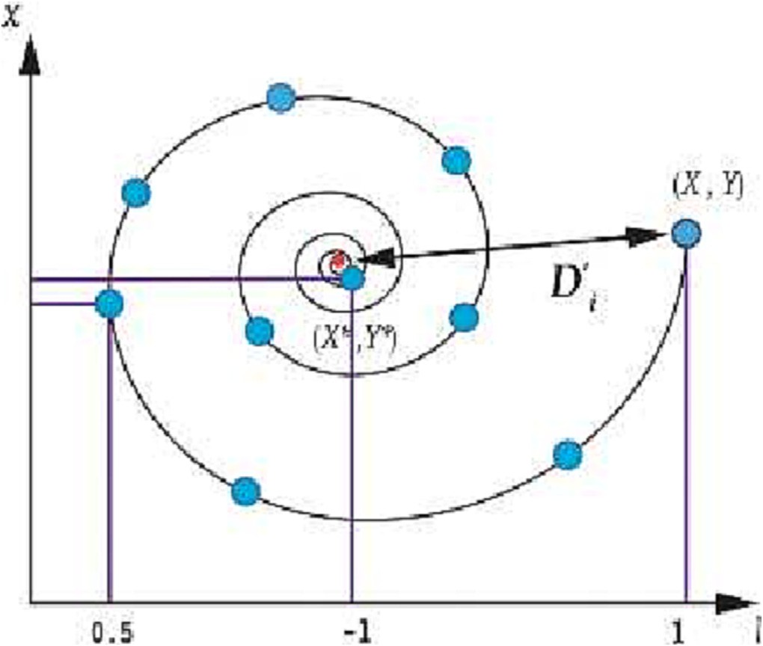*Xrand* represents a random solution vector selected. Whether global or local searches are to be made is decided according to

the value of vector →*A* . For vector →*A* , when A > 1 or A < 1, a point

further away from the best moment can be selected. These cases are considered a global search, and (27) and (28) are applied.

* 1. *Hybrid Grey Wolf-Whale optimization algorithm (HGWOA)*

A hybrid algorithm using the Grey Wolf Algorithm’s prey search method is created in this study to optimize the prey equation of WOA.

It is aimed to calculate the optimum values obtained in the hybrid algorithm equations (19) and the optimum transformer

weight seen in (29) as →*X* (*t* + 1) value, which gives the best result.

→*X* (*t* + 1) = *X*1 + *X*2 + *X*3

3

(29)

Fig. 6. Spiral movement.

solution. (24) and (25) were created by calculating the distance between the target location and the solution candidate for this motion (see Fig. 7).

→*X* (*t* + 1) = —*D*→'. *ebl*. cos (2*pl*) + —*X*→* (*t*) (24)

→*D*' = *X*→* (*t*) — →*X* (*t*) (25)

—

*b* is the logarithmic spiral constant, and *l* is a random number in the range [-1,1].

The algorithm determines which X(t) value will make spiral or linear motion with ½ probability, as shown in the figure below(26).

→ ( →*X* *(*t*) — →*A* * →*D* , *p* < 0.5 )

In this way, the fast and in-population approach of the Grey Wolf Algorithm to find a prey is combined with WOA’s approach that yields the result closest to the optimum value in finding a prey. It will be possible to reduce the operating cost affected by weight through this optimum weight obtained using this hybrid algorithm. Fig. 8. shows the flowchart applied for this study.

1. Performance of HGWOA in OTT weight optimization
   1. *Benchmark test of HGWOA*

The HGWOA algorithm created in the paper was tested for effi- ciency by solving 10 functions that are commonly used for opti- mization test problems [16,19]. The average cost function and standard deviation measurements are used to compare HGWOA performance to that of GWO and WOA. The average cost function is used to demonstrate the algorithm’s capacity to discover a global

*X* (*t* + 1) =

—*D*→' *

*ebl*

* cos (2*pl*) + →*X*
* (*t*), *p*

> 0.5

(26)

minimum, whereas the standard deviation test is used to deter- mine how dependable the algorithm is in finding the global mini-

p is a random number in the range [0,1].

At the end of the WOA search for the target, the new positions of the solution candidates are determined around a randomly cho- sen solution candidate instead of the best-known point for the glo- bal solution. Its mathematical model is shown in (27) and (28).

mum. Fig. 9 depicts typical 2D cost function graphs for some of the test scenarios covered in this study.

Table 2. shows benchmark functions for evaluating an algo- rithm’s exploration and exploitation capabilities, which include unimodal, multimodal, and fixed-dimension multimodal functions.

Unimodal functions assess an algorithm’s exploitation capabili-

→*D* = →*C X*——*ra*→*nd* — →*X*

→*X* (*t* + 1) = *X*——*ra*→*nd* — →*A* .→*D*

(27)

(28)

ties, whereas multimodal functions assess an algorithm’s explo- ration capabilities.

The variables ’Dim’, ‘Range’, and fmin represent the dimension, range, and ideal value f min mentioned in the literature, respec- tively. The number of searches and the maximum number of iter-

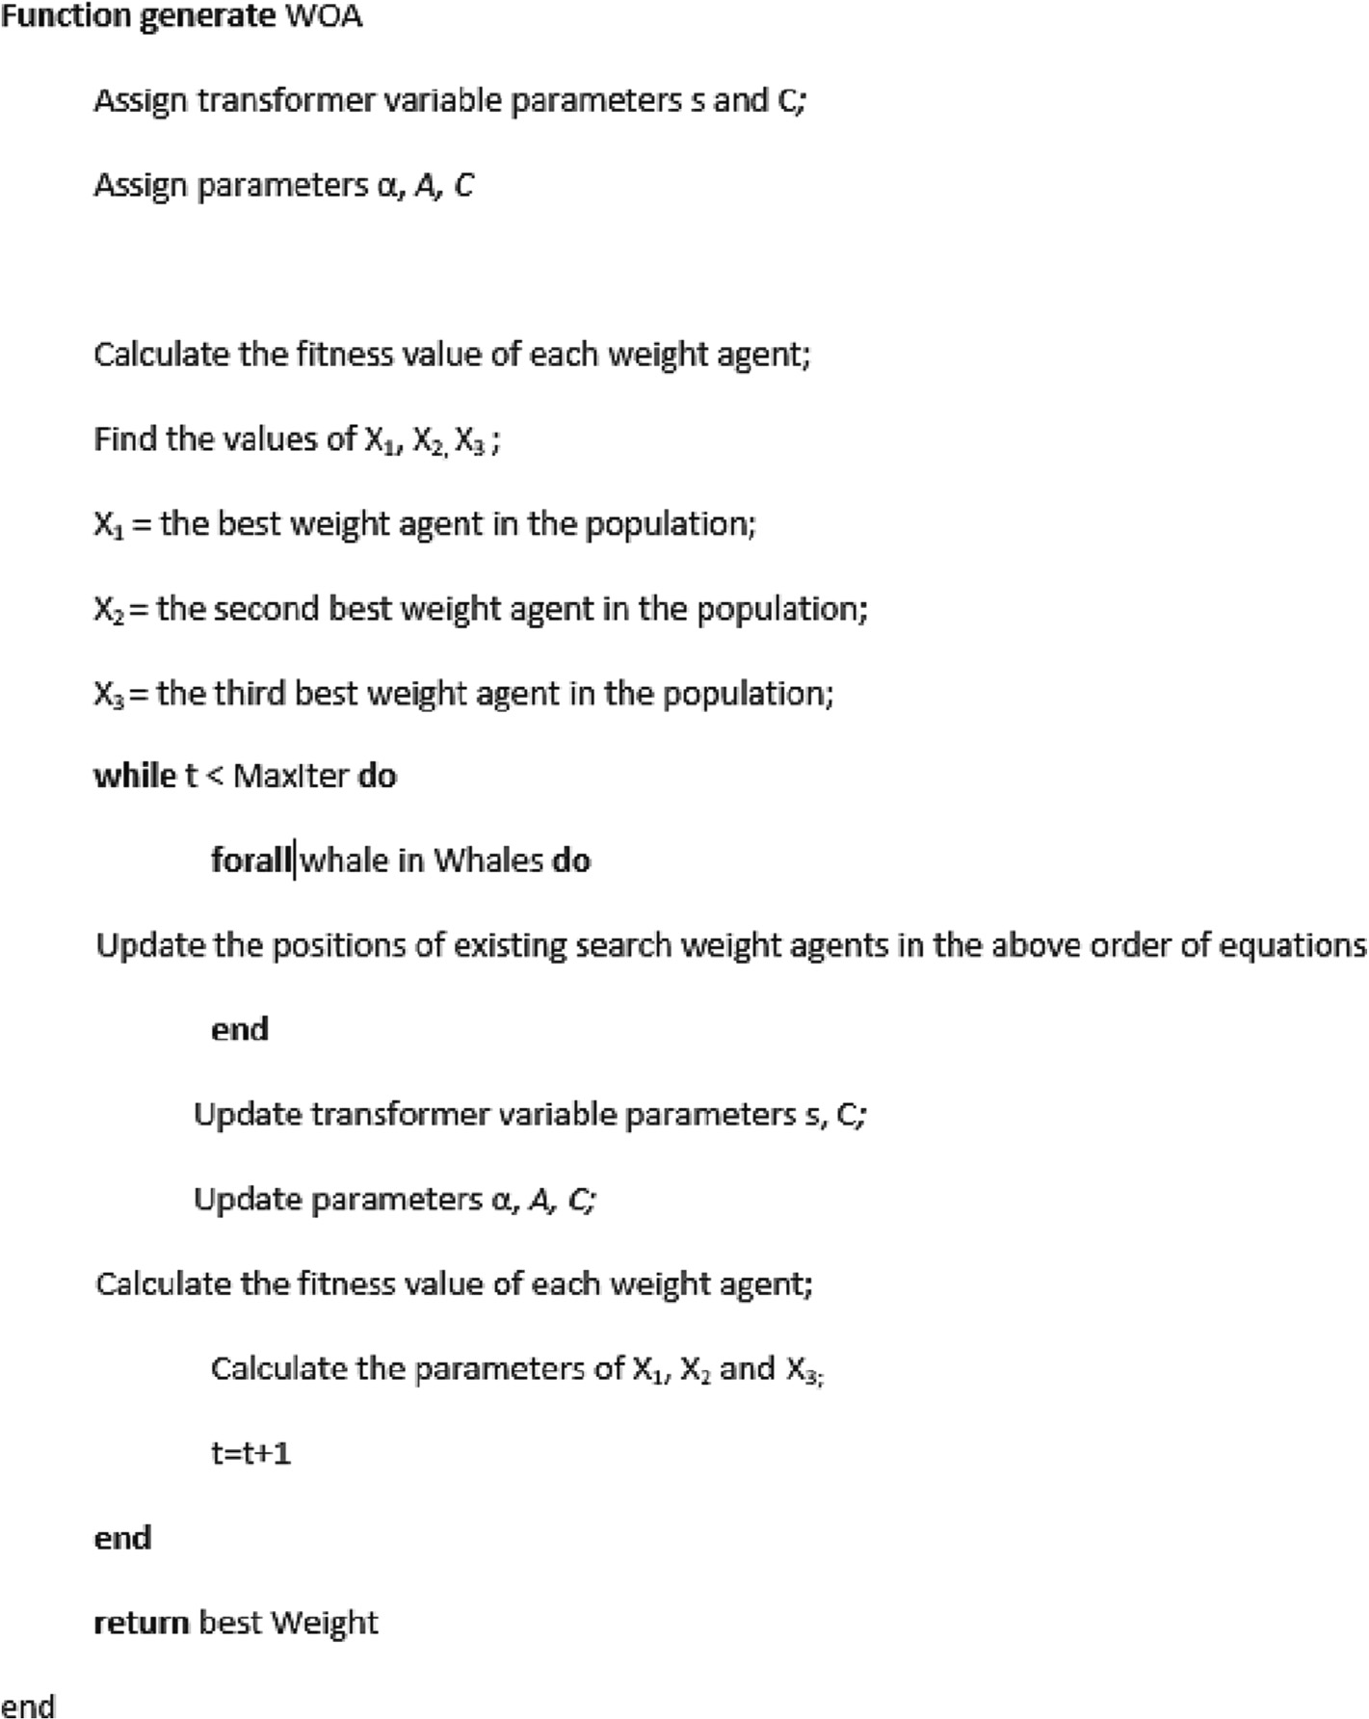

Fig. 7. Whale Optimization Algorithm Pseudo Code Scheme.

ations used to execute these algorithms in this study are 30 and 1000, respectively.

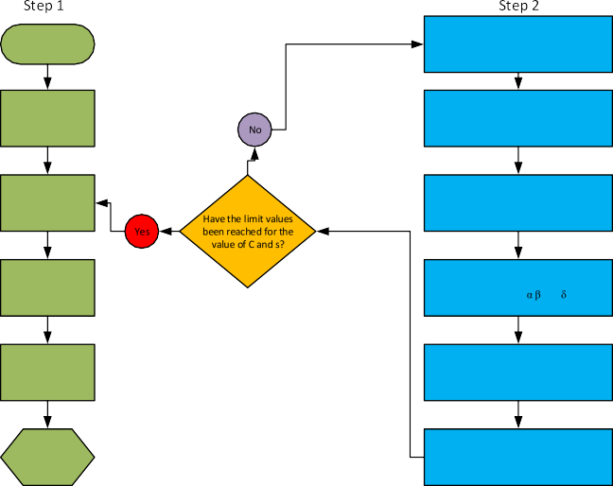

Start

Initialize WOA parameters

As d C

sign a and coefficients A an

OTT Data Preprocessing

Population Initialization and Fitness Values calculation

Determining qfe and qfej based on C values

According to the best selection obtained

form WOA , This time the HGWOA

pa lati

rameters are updated and the popu

is maintained

Determining q1 and q2 based on s values

Individual initialization select the first three fitness ( , and )

Determining Gfe

and Gcu values

Uptade the GreyWolf population and

Position according to the |A|

Best Weight of OTT

When A <1, The population is obtained u to the determined C and s value.sWeight values are updated accordingly.

Tables 3. shows the mean and standard deviation values derived from ten independent runs. The bolded values represent the best performance (smallest cost function or standard deviation value). Tables III shows that the HGWOA algorithm produces very competitive outcomes. For example, in unimodal functions F2-F6, and multimodal functions F7, F9, HGWOA beats GWO and WOA algorithms*.*

In the benchmark test of the analysis made at different strengths of OTT, cost function data obtained from the average val- ues of the proposed HGWOA optimization algorithm are included. The convergence curves created according to these values were obtained according to the data of the F1 function and F9 functions used in the test. In Fig. 10 curve, it can be determined that the best values are in HGWOA.Fig. 11.

* 1. *OTT analysis and Comparison of results*

Fig. 8. Flowchart of HGWOA.

The OTTs whose weights were optimized using HGWOA are 50 kVA and 100 kVA distribution and 1000 kVA power transformers.

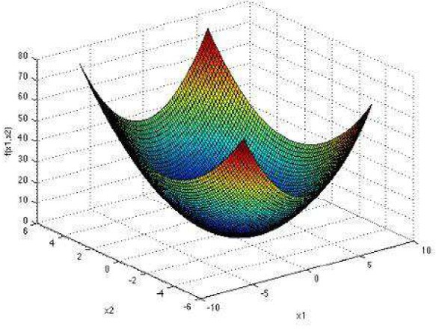 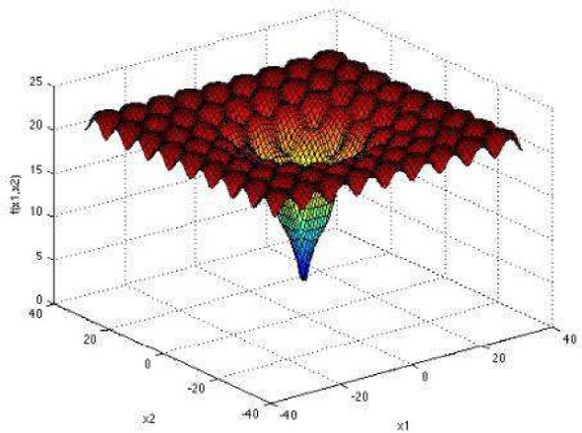

(a)F1 (b)F9

Fig. 9. Examples of how math functions are usually shown in two dimensions:(a)Unimodal (b) Multimodal.

Table 2

Benchmark Functions.

Function Group Dim Range fmin

F1=P*n x*2

*i*=1 *i*

Unimodal 30 [-100,100] 0

F2=P*n* |*xi*| + Q*n*

*i*=1

*i*=1

|*xi*| Unimodal 30 [-10,10] 0

F3=P*n*

*i*=1

*j*—1 *j*

(P*i*

*x* )2 Unimodal 30 [-100,100] 0

F4= *max i*{|*xi*|, 1 ≤ *i* ≤ *n*} Unimodal 30 [-100,100] 0

F5=P*n*—1 h100(*xi* 1 — *x*2 2

*i*=1

+

*i* ) +(

*xi* — 1)2 i Unimodal 30 [-30,30] 0

F6=P*n*

F7=P*n*

*i*=1

pﬃﬃﬃﬃﬃﬃﬃ

*i*

F8=P*n*

*i*=1

*i*=1

*ix*4 + *random*[0, 1) Unimodal 30 [-1.28,1.28] 0

—*xi* sin |*xi* | Multimodal 30 [-500,500] —418.9829x5

*x*2 — 10 cos (2p*xi*) + 10 Multimodal 30 [-5.12,5.12] 0

*i*

F9=—20 exp —0.2qﬃ1ﬃﬃPﬃﬃﬃﬃﬃ*n*ﬃﬃﬃﬃﬃﬃ*x*ﬃﬃﬃ2ﬃﬃ — exp 1 P*n*

*n*

*i*=1 *i*

*n*

*i*=1

cos (2p*xi* ) + 20 + *e* Multimodal 30 [–32,32] 0

F10= 1 P*n*

400

*i*=1 *i*

*i*=1

,*i*

*x*2 — Q*n*

cos *xi*ﬃﬃ + 1 Multimodal 30 [-600,600] 0

Table 3

Benchmark numerical comparison of HGWOA, GWO and WOA algorithms.

Function GWO WOA HGWOA

F(x) Average Std Average Std Average Std

F1 5.05x10-41 1.38x10-40 5.14x10-89 3.24x10-88 1.34861 × 10-56 6.8784 × 10-56 F2 4.99x10-6 6.73x10-5 4.30x10-23 5.95x10-22 1.6308 x10-27 8.9323 × 10-27 F3 1.23x10-2 4.63x10-2 4.55x1025 9.36x1025 1.8513 x10-10 9.9615 × 10-10 F4 8.76x10-6 3.48x10-5 2.15x1013 1.38x1014 7.7533 x10-17 3.1568 × 10-16 F5 4.92 9.17 5.08 20.5 4.8596 10.8535

F6 3.10x10-4 3.22x10-4 1.19x10-3 1.64x10-3 1.5093 x10-4 1.2007 × 10-4 F7 —1.41x104 9.61x10-2 —1.89x104 0.180 —1.2569 x104 0.0396

F8 0 0 0 0 0 0

F9 5.28x10-15 2.6x10-15 2.70x10-15 1.81x10-15 3.4047 × 10-15 1.3467 × 10-15

F10 0 0 0 0 0 0

Objective function in these transformers’ weights optimization is shown in (30):

100

( ) = (X[ ( )+ ( )]) ( )

*GT C*, *s* min *Gfeij Cij* , *sij Gcuij Cij*, *sij* 30

*i*,*j*

Here, the objective function can be calculated with different restrictions according to the usage area and power value of the transformers. Conventionally used constraints of transformer stan- dard design parameters are as given in [18], as well as special con- straints in this specific work is:

Constraints for 50kVA and 100kVA OTTs;

2.2*A*/*mm*2 < *s* < 3.5*A*/*mm*2 (31)

4*cm*2*joules*—1/2 < *C* < 6*cm*2*joules*—1/2 (32)

Constraints for 1000kVA and 100kVA OTTs;

3.5 *A*/*mm*2 < *s* < 5 *A*/*mm*2 (33)

4 *cm*2*joules*—1/2 < *C* < 8 *cm*2*joules*—1/2 (34)

100 random values are assigned to each variable (s, C) within the specified range. The analyses include 100 iterations for HGWOA optimization. Accordingly, weight calculations are per- formed with different s and *C* values with 100 100 size for each OTT. In the HGWOA algorithm, the hunting population optimized through the Grey Wolf algorithm reaches the best value with 10,000 whales. In this way, the optimum transformer weight value will be obtained as a result of optimization. All parameters of OTT (magnetic current density, specific ampere turn value etc.) used in weight calculation are updated in compliance with the design. These values have been added to calculations in accordance with the OTT types as shows in Table 4.

×

Furthermore, the weight values obtained with HGWOA are compared with values obtained with classical methods and those obtained with methods used in other studies.

In these comparisons, the algorithms used in the studies in [42] and [43] in 50 kVA OTT weight optimization were compared. BA, FA, and ACO algorithm optimization values were compared with

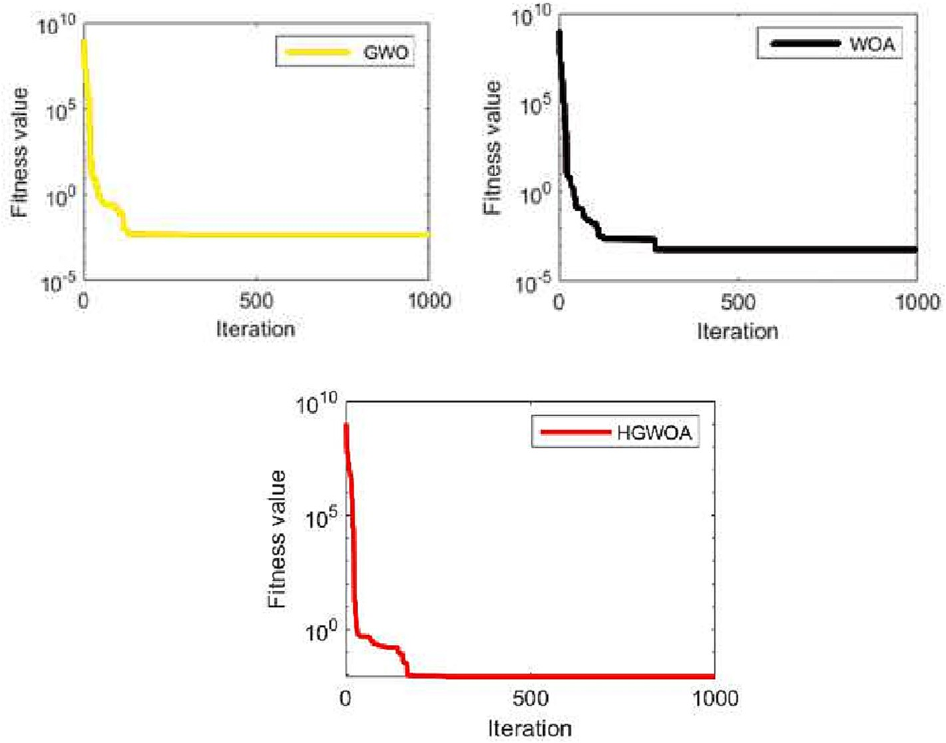

Fig. 10. Convergence Curve of Unimodal Benchmark Function F1.

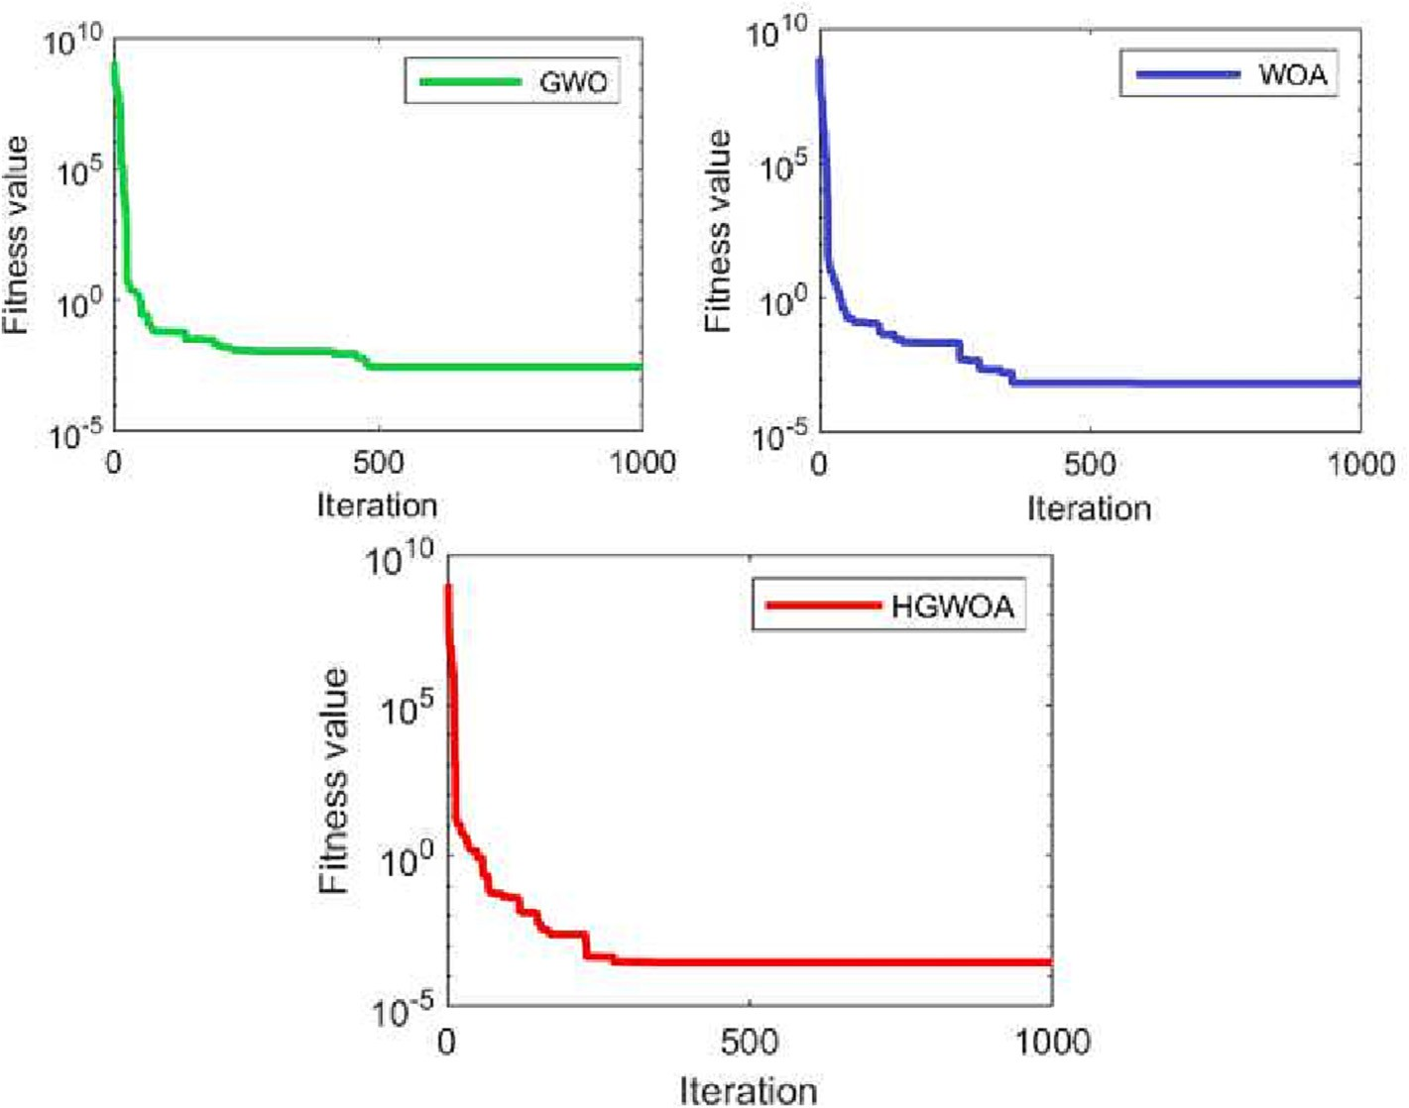

Fig. 11. Convergence Curve of Multimodal Benchmark Function F9.

Table 4

Values Of Some Of The Other Parameters Used In OTT Weight Calculation.

|  |  |  |  |  |
| --- | --- | --- | --- | --- |
| Parameters | Unit | 50 kVA | 100 kVA | 1000 kVA |
| Magnetic Flux Density (B) | *Gauss* | 1.28*104 | 1.38*104 | 1.43*104 |
| Specific Ampere turn (As) | *A*turn* | 330 | 370 | 800 |

HGWOA values, together with the optimization values of the orig- inal GWO and WOA algorithms that formed the hybrid algorithm with 50kVA OTT label parameters. it can be seen that the closest values to HGWOA are the original GWO and WOA that make up the algorithm.

For 100kVA OTT, the PSO, SA, GSA results used in [46,47] and the optimization values of the GWO and WOA algorithms are given together with the suggested HGWOA results and compared.

In the optimization of 1000kVA OTT weight parameters in the power transformer class, the optimization values of the BA, ACA, FA and original GWO and WOA algorithms used in the [48,49] studies were compared with the proposed HGWOA optimization values.

Table 5 shows that in the weight optimizations obtained with heuristic algorithms applied according to the power of the trans- formers in the analysis, the values of the HGWOA algorithm further improve the results compared to the values obtained with other algorithms.

Moreover, the compatibility of the values obtained from the study is also verified using the regression method and the least squares method, which are statistical quantitative methods.

Accordingly, Fig. 12. shows the graph of the values obtained by C and s variables in the population in the calculation of the HGWOA weight for 50kVA and 100 kVA distribution OTTs and 1000 kVA power OTT.

It was determined that the values obtained through the HGWOA algorithm which was developed as an innovative algo- rithm with the values given in Table V and which has not been seen in any hybrid studies on transformer optimization before create more optimum values than weight values calculated with the

known classical design methods. While the weight of 50 kVA OTT is 332.28 kg in distribution transformers, whose quantity is quite high among the total number of transformers in the distribu- tion type of electrical energy, this value becomes 264.454 kg after optimization. This value provides 20.4% weight gain. At 100 kVA, the weight decreases from 757.81 kg to 419.83 kg and provides a weight reduction of approximately 44%. In 1000kVA, which is a power transformer, this value decreases from 1664 kg to 1420.33 kg, providing a weight reduction of approximately 14%. Table 6 shows the gains of these weight reductions in relation to the cost values obtained from previous studies. It was determined in the comparisons made in Table 6, which includes the evalua- tions made according to the data in the economic estimation study made in [50], that there will be a cost decrease in approximately the same direction according to the weight values.

When the weight values obtained in the study were compared with the weight values calculated according to the OTT power val- ues in other studies, it was determined that the values obtained through the HGWOA algorithm used in our study are more optimal than the other values. Fig. 13. (a) shows that although the values obtained in previous studies for 50 kVA OTT are better than the values obtained through the classical method, the HGWOA values include more optimal values. As can be seen in Fig. 13(b), it was observed in a comparison performed to a limited extent due to the shortage of studies conducted on 100 kVA OTT that the value obtained by applying the HGWOA algorithm calculates a more optimal weight value.

Fig. 14 shows that, in other studies on 1000 kVA OTT power transformer, the values are compared with the values obtained

Table 5

HGWOA and Other Algorithms’ Optimization Results for Different Power Type OTT.

|  |  |  |  |  |  |  |  |  |
| --- | --- | --- | --- | --- | --- | --- | --- | --- |
|  | | | 50kVA OTT |  | | | | |
| Parameters | Classical Method | BA | ACA | FA | GWO | WOA | HGWOA |  |
| Iron cross- section convenience value (C) | 4–6 | 4.4 | 4.5 | 4.1 | 3.02 | 3 | 3.02 |  |
| Current density value(s) | 2.2 | 2.8 | 2.6 | 3.5 | 2.4 | 2.4 | 2.4 |  |
| Primary winding turn | 5798 | 6610 | 9756 | 6610 | 3287 | 3287 | 5662 |  |
| Secondary winding turn | 70 | 80 | 118 | 80 | 44 | 44 | 42 |  |
| Primary winding weight | 68.2 | 60.42 | 91.86 | 60.42 | 67 | 68 | 66,6 |  |
| Secondary winding weight | 45.6 | 48.92 | 71.02 | 48.92 | 31.4 | 29.3 | 26,94 |  |
| Three-legged weight of the Transformer | 105.8 | 106,8 | 106.79 | 74.6 | 86.86 | 79.6 | 81,36 |  |
| Yoke weight of the Transformer | 112.8 | 83,93 | 83.90 | 59.8 | 88.82 | 89 | 89,50 |  |
| Total Weight of the Transformer | 332.28 | 300.07 | 307.51 | 47.4 | 269.47 | 265.9 | 264.454 |  |
| Efficiency  Parameters | 95  Classical Method | 95.1  PSO | 94.8  100kVA OTT SA | 95  GSA | 95  GWO | 95  WOA | 95.1  HGWOA |  |
| Iron cross- section convenience value (C) | 5.6 | 4.12 | 4.09 | 4.16 | 4.7 | 4–6 | 4–6 |  |
| Current density value(s) | 2.2 | 3.09 | 3.0868 | 3.1158 | 2.7 | 2.7 | 4 |  |
| Primary winding turn | 3287 | 8621 | 8622 | 8624 | 2060 | 2060 | 8394 |  |
| Secondary winding turn | 44 | 92 | 92 | 92 | 24 | 24 | 98 |  |
| Primary winding weight | 79.57 | 97.79 | 98.35 | 96.76 | 98,8 | 88 | 98.15 |  |
| Secondary winding weight | 45.01 | 45.65 | 46.04 | 44.99 | 36.1 | 45 | 40.08 |  |
| Three-legged weight of the Transformer | 391.03 | 134 | 134 | 134 | 141.8 | 138.6 | 134.09 |  |
| Yoke weight of the Transformer | 242.2 | 146.63 | 145.68 | 148.34 | 151.6 | 150 | 147,5 |  |
| Total Weight of the Transformer | 757.81 | 425,07 | 424.07 | 424.09 | 428.3 | 421.6 | 419,83 |  |
| Efficiency | 92 | 97  1000kVA OTT | 97 | 97 | 95 | 95 | 92.1 |  |
| Parameters | Classical Method | BA | ACA | FA | GWO | WOA | HGWOA |  |
| Iron cross- section convenience value (C) | 4–8 | 7 | 7.2 | 7.1 | 4.2 | 77.2 | 7.19 |  |
| Current density value(s) | 6 | 4.9 | 4.9 | 4.89 | 4.7 | 4.9 | 4.98 |  |
| Primary winding turn | 420 | 420 | 420 | 420 | 380 | 380 | 1990 |  |
| Secondary winding turn | 16 | 16 | 16 | 16 | 15 | 15 | 23 |  |
| Primary winding weight | 198 | 198 | 191 | 190 | 181 | 181.7 | 151.89 |  |
| Secondary winding weight | 126 | 114.5 | 114.82 | 102.75 | 115 | 105 | 62.56 |  |
| Three-legged weight of the Transformer | 652 | 644 | 660 | 606 | 594 | 584.5 | 574.23 |  |
| Yoke weight of the Transformer | 688 | 636 | 635 | 626 | 626 | 632.75 | 631.65 |  |
| Total Weight of the Transformer | 1664 | 1592.50 | 1597.82 | 1524.75 | 1515 | 1503.95 | 1420.33 |  |
| Efficiency | 98.04 | 96 | 96 | 96 | 96.8 | 96.8 | 98 |  |

50kVA

100kVA

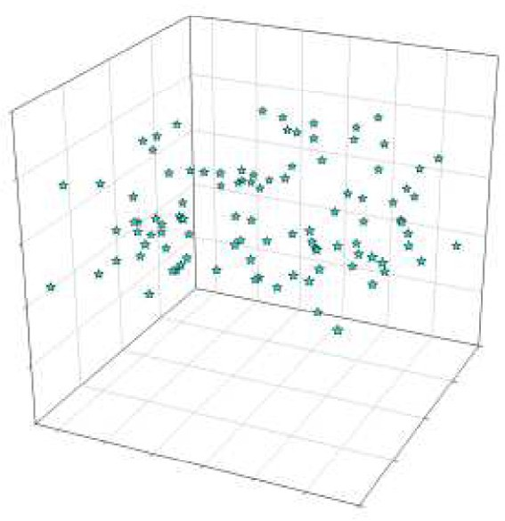

270

268

266

264

6,0

262

5,5

260

5,0

3,4 3,2

3,0

4,5

2,8

2,6

2,4 4,0

2,2

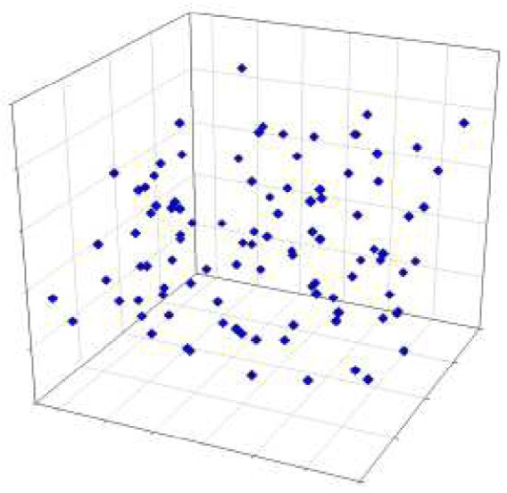

400

380

360

340

6,0

320

5,5

300

5,0

3,4 3,2

3,0

4,5

2,8

2,6

2,4 4,0

2,2

(a) (b)

Weight corresponding to C-s values

Weight corresponding to C-s values

Fig. 12. (a)50kVA (b) 100 kVA (c) 1000kVA OTTs Values of C-s Scheme.

1000 kVA

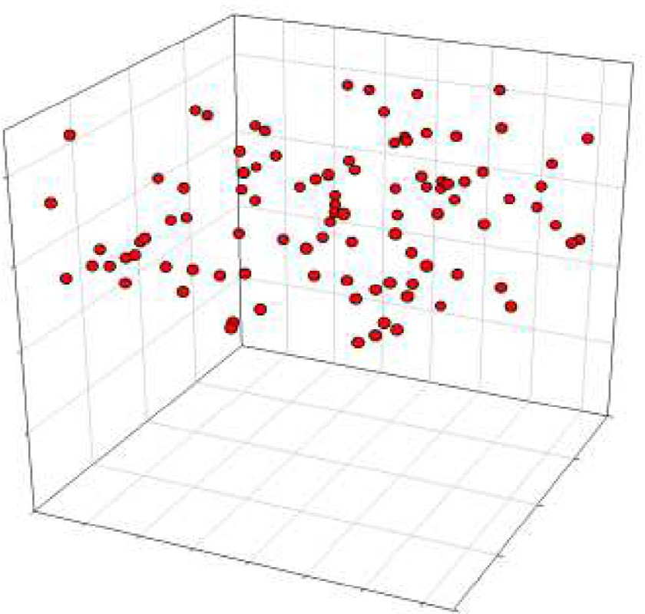

800

1700

1600

8

1500

7

1400

6

4,8

4,6

4,4

5

4,2

4,0

3,8

3,6

4

1

Weight corresponding to C-s Values

# (c)

Fig. 12 (*continued*)

by implementing the HGWOA algorithm and a significant optimum value is calculated.

The values constituting the transformer weight could be reduced by performing optimum weight calculation through HGWOA algorithm in both power and distribution OTT transform-

ers, thus decreasing the impact of this weight on the operating costs. This assessment was statistically verified with a test per- formed through the Least Squares method and Regression Analysis using the values obtained in this study and those obtained in other studies. The equations and the R2 value providing information about the graph accuracy are specified on the graphs in the statis- tical evaluation. It is known that the closer the R2 value to 1, the more accurate results the equation yields. Accordingly, the graphs where the R2 value is closest to 1 were verified with the weight values calculated in this study.

In Fig. 15 (a), the equation accuracy in the graph created using the values obtained in studies where 50-kVA weight optimization was performed and the values obtained through HGWOA was determined based on the convergence of R2 value to 1 and the value was found compatible. Likewise, in Fig. 15 (b), although there are not many studies on 100 kVA, the HGWOA value was found to be accurate considering that the values were low. Fig. 16 shows the statistical verification of the values obtained as a result of studies conducted for 1000 kVA power OTT and HGWOA.

1. Conclusion

OTTs are electric machines that are widely used for conveying and distributing electric power. The place held by these machines in operating costs becomes permanent accordingly. These trans- former costs can be reduced by optimizing weight in an industrial manner. As a result, while operating profitability can be increased, the service life of transformers can be positively affected.

Therefore, this study attempts to optimize weights of OTTs with different power levels by adding the ability of the Grey Wolf Opti- mization to reach the optimal point in the fastest way possible to the ability of the Whale Algorithm, which is an innovative heuristic algorithm, to achieve the value closest to the optimum result. The values to be reduced were calculated as approximately 20.4% to

Table 6

50kVA-100kVA Distribution OTT and 1000 kVA Power OTT Parameters Of HGWOA Cost Comparison.

Optimization 50kVA Distribution OTT 100kVA Distribution OTT 1000kVA Power OTT

|  |  |  |  |  |  |  |  |  |  |  |  |  |
| --- | --- | --- | --- | --- | --- | --- | --- | --- | --- | --- | --- | --- |
| Method | Calculeted Weight | Per weight cost | Total Cost (€) |  | Calculeted Weight | Per weight cost | Total Cost (€) |  | Calculeted Weight | Per weight cost | Total Cost (€) |  |
| Classical Method | 332,28 | 14,37 | 4776,00 |  | 757,81 | 14,37 | 10892,32142 |  | 1664 | 14,37 | 23911,68 |  |
| GWO | 269.47 | 14.37 | 3872.28 |  | 428.3 | 14.37 | 6154.67 |  | 1515 | 14.37 | 21770.55 |  |
| WOA | 265.90 | 14.37 | 3820.98 |  | 421.60 | 14.37 | 6058.39 |  | 1503.95 | 14.37 | 21611.76 |  |
| HGWOA | 264,454 | 14,37 | 3801,34 |  | 419,83 | 14,37 | 6034,39292 |  | 1420,33 | 14,37 | 20410,14 |  |

350

300

250

Weight of OTT(kg)

200

150

100

50kVA



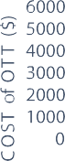50

**300.07**

**307.51**

**295.13**

**269.47**

**265.90**

**264.45**



0

500

BA ACA FA GWO WOA HGWOA

Optimization Methods

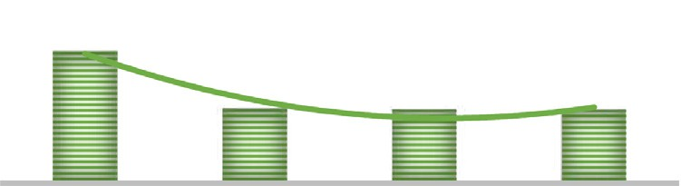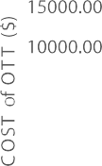

# (a)

100kVA





400

**425.07**

**424.07**

**424.09**

**428.30**

**421.60 419.83**

Fig. 15. (a)50kVA (b)100kVA OTT Cost Comparison Statistical Scheme.

300

Weight of OTT (kg)

200

100

0

PSO SA GSA GWO WOA HGWOA

25000

24000

COST of OTT ($)

23000

22000

21000

20000

19000

18000

Cost of 1000kVA OTT

y = 234.88x2 - 2240.7x + 25766

R² = 0.9281

Optimization Methods

# (b)

Fig. 13. (a) 50kVA (b) 100kVA OTT Weights Comparison Scheme.

Classical Method

GWO WOA HGWOA

Optimization Method

Fig. 16. 1000kVA Power OTT Cost Comparison Statistical Scheme.

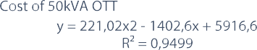

1800

1600

1400

1200

Weight of OTT (kg)

1000

800

600

400

200

0

1000kVA

BA ACA FA GWO WOA HGWOA

**1592.50**

**1597.82**

**1524.75 1515**

**1503.95**

**1420.33**

Optimization Methods

Fig. 14. 1000kVA OTT Weights Comparison Scheme.

44% for 50 kVA and 100 kVA distribution OTTs and approximately 14% for 1000 kVA power OTT. It was determined that optimization methods where different prominent features were used yielded better results and the results produced more optimal values than the results obtained in other studies. These values were verified by testing through statistical analyses.

In future research, the hybridized GWO and WHO algorithms will be able to leverage their performance to deliver optimal solu- tions for a variety of industrial and experimental situations. Fur- thermore, they will make original contributions to issue solving through the new hybridizations they will create using the newly discovered algorithms.

Declaration of Competing Interest

The authors declare that they have no known competing finan- cial interests or personal relationships that could have appeared to influence the work reported in this paper.

Acknowledgments

I would like to thank the respected Dr. Eda OZKUL, whose expe- rience I benefited from in the study.

References

1. E.I. Amoiralis, M.A. Tsili, D.G. Paparigas, A.G. Kladas, Global transformer design optimization using deterministic and nondeterministic algorithms, IEEE Trans. Ind. Appl. 50 (2014) 383–394, <https://doi.org/10.1109/TIA.2013.2288417>.
2. [John H. Holland, Adaptation in Natural and Artificial Systems: An Introductory](http://refhub.elsevier.com/S2215-0986(23)00117-9/h0010) [Analysis with Applications to Biology, Control, and Artificial Intelligence,](http://refhub.elsevier.com/S2215-0986(23)00117-9/h0010) [MIT](http://refhub.elsevier.com/S2215-0986(23)00117-9/h0010) [Press, 1992](http://refhub.elsevier.com/S2215-0986(23)00117-9/h0010).
3. A. Slowik, Particle Swarm Optimization, Ind. Electron. Handb. - Five Set (2011) 1942–1948, <https://doi.org/10.1007/978-3-319-46173-1_2>.
4. [M. Dorigo,](http://refhub.elsevier.com/S2215-0986(23)00117-9/h0020) [T. Stützle (Eds.), Ant Colony Optimization, The MIT Press, 2004](http://refhub.elsevier.com/S2215-0986(23)00117-9/h0020).
5. D. Karaboga, B. Akay, A comparative study of Artificial Bee Colony algorithm, Appl. Math. Comput. 214 (2009) 108–132, [https://doi.org/10.1016/j.](https://doi.org/10.1016/j.amc.2009.03.090) [amc.2009.03.090](https://doi.org/10.1016/j.amc.2009.03.090).
6. X.-S.S. Yang, M. Karamanoglu, Nature-Inspired Metaheuristic Algorithms Second Edition, 2013. <http://www.sciencedirect.com/science/article/pii/> [B9780124051638000016%0Ahttp://linkinghub.elsevier.com/retrieve/pii/](http://linkinghub.elsevier.com/retrieve/pii/) B978012405163800020X.
7. Y. Zhu, Z. Xu, A reliable prediction of the global phase stability for liquid-liquid equilibrium through the simulated annealing algorithm: Application to NRTL and UNIQUAC equations, Fluid Phase Equilib. 154 (1999) 55–69, [https://doi.](https://doi.org/10.1016/S0378-3812(98)00417-8) [org/10.1016/S0378-3812(98)00417-8](https://doi.org/10.1016/S0378-3812(98)00417-8).
8. H. Mittal, A. Tripathi, A.C. Pandey, R. Pal, Gravitational search algorithm: a comprehensive analysis of recent variants, Multimed. Tools Appl. 80 (2021) 7581–7608, <https://doi.org/10.1007/s11042-020-09831-4>.
9. https://shop58002.sellbycar.com/catagory?name=siemens%20distribution% 20transformers, (n.d.).
10. [M. Çelebi, Genetik Algoritma ile Kuru Bir Trafonun Ag˘ırlık](http://refhub.elsevier.com/S2215-0986(23)00117-9/h0050) [Optimizasyonu ve](http://refhub.elsevier.com/S2215-0986(23)00117-9/h0050) [Sonlu Elemanlar Metodu ile Analizi, KSÜ J. Eng. Sci. 12 (2009) 30–36](http://refhub.elsevier.com/S2215-0986(23)00117-9/h0050).
11. M. Çelebi, Genetik Algoritma ile Yaglı Bir Trafonun Maliyet Optimizasyonu, 1 (2007) 41–48.
12. [H. Demir, Kuru Tip Transformatörün Parçacık](http://refhub.elsevier.com/S2215-0986(23)00117-9/h0060) [Sürü Optimizasyon Yöntemi](http://refhub.elsevier.com/S2215-0986(23)00117-9/h0060) I_[le](http://refhub.elsevier.com/S2215-0986(23)00117-9/h0060)

[Ag˘ırlıkOptimizasyonu,](http://refhub.elsevier.com/S2215-0986(23)00117-9/h0060) [Düzce Üniversitesi, 2011](http://refhub.elsevier.com/S2215-0986(23)00117-9/h0060).

1. M.A.F. Finocchio, J.J. Lopes, J.A. de França, J.C. Piai, J.F. Mangili Jr, Neural networks applied to the design of dry-type transformers: an example to analyze the winding temperature and elevate the thermal quality, Int. Trans. Electr. Energy Syst. 27 (2017) 1–10, <https://doi.org/10.1002/etep.2257>.
2. [T. Demirdelen, Kuru Tip Transformatör Optimizasyonuna Yeni Bir Yaklas](http://refhub.elsevier.com/S2215-0986(23)00117-9/h0070) [ım:](http://refhub.elsevier.com/S2215-0986(23)00117-9/h0070) [Ate](http://refhub.elsevier.com/S2215-0986(23)00117-9/h0070)s [Böceg˘ i Algoritması,](http://refhub.elsevier.com/S2215-0986(23)00117-9/h0070) [Çukurova Üniversitesi](http://refhub.elsevier.com/S2215-0986(23)00117-9/h0070) [Mühendislik-Mimarlık](http://refhub.elsevier.com/S2215-0986(23)00117-9/h0070) [Fakültesi Derg. 33 (1) (2018) 87–96](http://refhub.elsevier.com/S2215-0986(23)00117-9/h0070).
3. Y.W. Zhai, X.W. Shi, Y.J. Zhao, Optimized design of ideal and actual transformer based on improved micro-genetic algorithm, J. Electromagn. Waves Appl. 21 (2007) 1761–1771, <https://doi.org/10.1163/156939307781891094>.
4. S. Mirjalili, S.M. Mirjalili, A. Lewis, Grey Wolf Optimizer, Adv. Eng. Softw. 69 (2014) 46–61, <https://doi.org/10.1016/j.advengsoft.2013.12.007>.
5. Y. Wu, X. Sun, B. Dai, P. Yang, Z. Wang, A transformer fault diagnosis method based on hybrid improved grey wolf optimization and least squares-support vector machine, IET Gener. Transm. Distrib. 16 (2022) 1950–1963, [https://doi.](https://doi.org/10.1049/gtd2.12405) [org/10.1049/gtd2.12405](https://doi.org/10.1049/gtd2.12405).
6. M.H. Hashemi, U. Kilic, S. Dikmen, Applications of Novel Heuristic Algorithms in Design Optimization of Energy-Efficient Distribution Transformer, IEEE Access. 11 (2023) 15968–15980, [https://doi.org/10.1109/](https://doi.org/10.1109/ACCESS.2023.3245327) [ACCESS.2023.3245327](https://doi.org/10.1109/ACCESS.2023.3245327).
7. S. Mirjalili, A. Lewis, The Whale Optimization Algorithm, Adv. Eng. Softw. 95 (2016) 51–67, <https://doi.org/10.1016/j.advengsoft.2016.01.008>.
8. Q. Fan, F. Yu, M. Xuan, Transformer fault diagnosis method based on improved whale optimization algorithm to optimize support vector machine, Energy Reports. 7 (2021) 856–866, <https://doi.org/10.1016/j.egyr.2021.09.188>.
9. Z. He, T. Kari, Y. Yaermaimait, L. Du, Y. Zhou, Z. Liu, Hybrid Feature Selection Approach for Power Transformer Fault Diagnosis Based on Whale Optimization Algorithm and Extreme Learning Machine, Prog. Electromagn. Res. C. 127 (2022) 83–99, <https://doi.org/10.2528/PIERC22091804>.
10. Z. Lyu, G. Wang, R. Gao, Synchronous state of health estimation and remaining useful lifetime prediction of Li-Ion battery through optimized relevance vector machine framework, Energy. 251 (2022), [https://doi.org/10.1016/j.](https://doi.org/10.1016/j.energy.2022.123852)

[energy.2022.123852](https://doi.org/10.1016/j.energy.2022.123852) 123852.

1. D. Guha, P.K. Roy, S. Banerjee, Load frequency control of large scale power system using quasi-oppositional grey wolf optimization algorithm, Eng. Sci. Technol. an Int. J. 19 (2016) 1693–1713, [https://doi.org/10.1016/](https://doi.org/10.1016/j.jestch.2016.07.004) [j.jestch.2016.07.004](https://doi.org/10.1016/j.jestch.2016.07.004).
2. [S. Nadweh, O. Khaddam, G. Hayeh, B. Atieh, H. Haes Alhelou, Steady state](http://refhub.elsevier.com/S2215-0986(23)00117-9/h0120) [analysis of modern industrial variable speed drive systems using controllers](http://refhub.elsevier.com/S2215-0986(23)00117-9/h0120) [adjusted via grey wolf algorithm & particle swarm optimization, Heliyon. 6](http://refhub.elsevier.com/S2215-0986(23)00117-9/h0120) [(2020) e05438](http://refhub.elsevier.com/S2215-0986(23)00117-9/h0120).
3. M. Suhail Shaikh, C. Hua, S. Raj, S. Kumar, M. Hassan, M. Mohsin Ansari, M. Ali Jatoi, Optimal parameter estimation of 1-phase and 3-phase transmission line for various bundle conductor’s using modified whale optimization algorithm, Int. J. Electr. Power Energy Syst. 138 (2022), [https://doi.org/10.1016/j.](https://doi.org/10.1016/j.ijepes.2021.107893) [ijepes.2021.107893](https://doi.org/10.1016/j.ijepes.2021.107893) 107893.
4. H. Zhang, L. Tang, C. Yang, S. Lan, Locating electric vehicle charging stations with service capacity using the improved whale optimization algorithm, Adv. Eng. Informatics. 41 (2019), <https://doi.org/10.1016/j.aei.2019.02.006> 100901.
5. A.K. Sahoo, S. Jeet, D.K. Bagal, A. Barua, A.K. Pattanaik, N. Behera, Parametric optimization of CNC-drilling of Inconel 718 with cryogenically treated drill-bit using Taguchi-Whale optimization algorithm, Mater. Today Proc. 50 (2021) 1591–1598, <https://doi.org/10.1016/j.matpr.2021.09.121>.
6. A. Vijaya Lakshmi, P. Mohanaiah, WOA-TLBO: Whale optimization algorithm with Teaching-learning-based optimization for global optimization and facial emotion recognition, Appl. Soft Comput. 110 (2021), [https://doi.org/10.1016/j.](https://doi.org/10.1016/j.asoc.2021.107623) [asoc.2021.107623](https://doi.org/10.1016/j.asoc.2021.107623) 107623.
7. F. Al Thobiani, S. Khatir, B. Benaissa, E. Ghandourah, S. Mirjalili, M. Abdel Wahab, A hybrid PSO and Grey Wolf Optimization algorithm for static and dynamic crack identification, Theor. Appl. Fract. Mech. 118 (2022), [https://doi.](https://doi.org/10.1016/j.tafmec.2021.103213) [org/10.1016/j.tafmec.2021.103213](https://doi.org/10.1016/j.tafmec.2021.103213) 103213.
8. K. Yadav, B. Kumar, J.M. Guerrero, A. Lashab, A hybrid genetic algorithm and grey wolf optimizer technique for faster global peak detection in PV system under partial shading, Sustain. Comput. Informatics Syst. 35 (2022), [https://](https://doi.org/10.1016/j.suscom.2022.100770) [doi.org/10.1016/j.suscom.2022.100770](https://doi.org/10.1016/j.suscom.2022.100770) 100770.
9. R.K. Khadanga, A. Kumar, S. Panda, A modified Grey Wolf Optimization with Cuckoo Search Algorithm for load frequency controller design of hybrid power system, Appl. Soft Comput. 124 (2022), [https://doi.org/10.1016/j.](https://doi.org/10.1016/j.asoc.2022.109011) [asoc.2022.109011](https://doi.org/10.1016/j.asoc.2022.109011) 109011.
10. S.V. Konstantinov, U.K. Khamidova, E.A. Sofronova, A novel hybrid method of global optimization based on the grey Wolf optimizer and the bees algorithm, Procedia Comput. Sci. 150 (2019) 471–477, [https://doi.org/10.1016/j.](https://doi.org/10.1016/j.procs.2019.02.081) [procs.2019.02.081](https://doi.org/10.1016/j.procs.2019.02.081).
11. M. Liu, X. Yao, Y. Li, Hybrid whale optimization algorithm enhanced with Lévy flight and differential evolution for job shop scheduling problems, Appl. Soft Comput. J. 87 (2020), <https://doi.org/10.1016/j.asoc.2019.105954> 105954.
12. [J. Ababneh, M. Gaggero, A Hybrid Approach Based on Grey Wolf and Whale](http://refhub.elsevier.com/S2215-0986(23)00117-9/h0170) [Optimization Algorithms for Solving Cloud Task Scheduling Problem, Math.](http://refhub.elsevier.com/S2215-0986(23)00117-9/h0170) [Probl. Eng. 2021 (2021) 1–14](http://refhub.elsevier.com/S2215-0986(23)00117-9/h0170).
13. O.O. Obadina, M.A. Thaha, K. Althoefer, M.H. Shaheed, Dynamic characterization of a master–slave robotic manipulator using a hybrid grey wolf–whale optimization algorithm, JVC/Journal Vib, Control. 28 (2022) 1992–

2003, <https://doi.org/10.1177/10775463211003402>.

1. O.O. Obadina, M.A. Thaha, Z. Mohamed, M.H. Shaheed, Grey-box modelling and fuzzy logic control of a Leader-Follower robot manipulator system: A hybrid Grey Wolf-Whale Optimisation approach, ISA Trans. 129 (2022) 572– 593, <https://doi.org/10.1016/j.isatra.2022.02.023>.
2. H.J. Siahroodi, H. Mojallali, S.S. Mohtavipour, A novel multi-objective framework for harmonic power market including plug-in electric vehicles as harmonic compensators using a new hybrid gray wolf-whale-differential evolution optimization, J. Energy Storage. 52 (2022), [https://doi.org/10.1016/j.](https://doi.org/10.1016/j.est.2022.105011) [est.2022.105011](https://doi.org/10.1016/j.est.2022.105011) 105011.
3. M. Raja, S. Dhanasekaran, V. Vasudevan, Opposition Based Joint Grey Wolf- Whale Optimization Algorithm Based Attribute Based Encryption in Secure Wireless Communication, Wirel. Pers. Commun. 127 (2022) 635–655, [https://](https://doi.org/10.1007/s11277-021-08357-8) [doi.org/10.1007/s11277-021-08357-8](https://doi.org/10.1007/s11277-021-08357-8).
4. I. Singh, R. Bansal, A. Gupta, A. Singh, A hybrid grey wolf-whale optimization algorithm for optimizing SVM in breast cancer diagnosis, PDGC 2020 - 2020 6th Int. Conf. Parallel, Distrib. Grid Comput. (2020) 286–290. https://doi.org/ 10.1109/PDGC50313.2020.9315816.
5. K. Asghari, M. Masdari, F.S. Gharehchopogh, R. Saneifard, A chaotic and hybrid gray wolf-whale algorithm for solving continuous optimization problems, Prog. Artif. Intell. 10 (2021) 349–374, [https://doi.org/10.1007/s13748-021-](https://doi.org/10.1007/s13748-021-00244-4)

[00244-4](https://doi.org/10.1007/s13748-021-00244-4).

1. [M. Zile, Design of power transformers using heuristic algorithms, Int. J. Tech.](http://refhub.elsevier.com/S2215-0986(23)00117-9/h0205) [Phys. Probl. Eng. 11 (2019) 42–47](http://refhub.elsevier.com/S2215-0986(23)00117-9/h0205).
2. [S. Senthilkumar, A. Karthick, R. Madavan, A. Arul Marcel Moshi, S.R. Sundara](http://refhub.elsevier.com/S2215-0986(23)00117-9/h0210) [Bharathi, S. Saroja, C. Sowmya Dhanalakshmi, Sowmya Dhanalakshmi,](http://refhub.elsevier.com/S2215-0986(23)00117-9/h0210) [Optimization of transformer oil blended with natural ester oils using](http://refhub.elsevier.com/S2215-0986(23)00117-9/h0210) [Taguchi-based grey relational analysis, Fuel. 288 (2021) 119629](http://refhub.elsevier.com/S2215-0986(23)00117-9/h0210).
3. S. Kül, S.A. Celtek, I_. Iskender, Metaheuristic Algorithms Based Approaches for

Efficiency Analysis of Three-Phase Dry-Type Transformers, Konya J. Eng. Sci. 8055 (2021) 889–903. https://doi.org/10.36306/konjes.946496.

1. T. Bodurog˘ lu, Beitrag zur Entwicklung kupferarmer Luft-und Öltransformatoren Durch Mehrfache Stufung der auBeren Wicklung, Elektrotechnische Zeitschrift. Ausgabe A: Zentralblatt, 1962.
2. [T. Bodurog˘ lu, Elektrik makimeleri Dersleri:Transformatörler,](http://refhub.elsevier.com/S2215-0986(23)00117-9/h0225) I_[TÜ Elektrik](http://refhub.elsevier.com/S2215-0986(23)00117-9/h0225)

[fakültesi,](http://refhub.elsevier.com/S2215-0986(23)00117-9/h0225) I_[stanbul, 1982](http://refhub.elsevier.com/S2215-0986(23)00117-9/h0225).

1. M. Akdag˘ , M. Çelebi_,, Ates Böceg˘ i Algoritması ile Yag˘ lı Tip Transformatörün Ag

˘ırlık Optimizasyonu, DÜMF Mühendislik Derg. 2 (2022) 169–180, [https://doi.](https://doi.org/10.24012/dumf.1075008) [org/10.24012/dumf.1075008](https://doi.org/10.24012/dumf.1075008).

1. [A. Ozturk, H. Demir, L. Kuru, S. Tosun, E. Kuru, Weight optimization of a core](http://refhub.elsevier.com/S2215-0986(23)00117-9/h0235) [form oil transformer by using heuristic search algorithms, J. Eng. Res. Appl. Sci.](http://refhub.elsevier.com/S2215-0986(23)00117-9/h0235) [1 (2012) 44–54](http://refhub.elsevier.com/S2215-0986(23)00117-9/h0235).
2. H. Toren, M. Mollahasanoglu, Weight optimization of power and distribution type transformer by Gray Wolf optimization algorithm, Nigde Ömer Halisdemir Univ, J Eng. Sci. 12 (2023) 96–103, [https://doi.org/10.28948/](https://doi.org/10.28948/ngmuh.1127837) [ngmuh.1127837](https://doi.org/10.28948/ngmuh.1127837).
3. M. Toren, H. Mollahasanoglu, Comparison of Heuristic Approaches in Weight Optimization of Different Power Levels Transformers Comparison of Heuristic Approaches in Weight Optimization of Different, Power (2022), [https://doi.](https://doi.org/10.1080/03772063.2022.2098188) [org/10.1080/03772063.2022.2098188](https://doi.org/10.1080/03772063.2022.2098188).
4. [A. Safigianni, V. Sarris, Economical Estimation of the Maintenance of](http://refhub.elsevier.com/S2215-0986(23)00117-9/h0250) [Distribution Transformers, Proc. EighthIASTED Int, Conf. Power Energy Syst.](http://refhub.elsevier.com/S2215-0986(23)00117-9/h0250) [Eur. (2008) 23–25](http://refhub.elsevier.com/S2215-0986(23)00117-9/h0250).

Murat Toren was born in 1983 in Kayseri, Turkey. He graduated from Omer Halis Demir University as Electrical-Electronics Engineering in 2007 in Nigde Turkey. He received the Master degree in Electric and Electronic Engineering from Erciyes University in 2013 in Kayseri, Turkey. He received the PhD degree in Elec- tric and Electronic Engineering (Electrical Machinery Department of Science) from Atatürk University in 2018 in Erzurum, Turkey. He is working subjects are electric machine design, power electronic, electric machinery. Now, he works as an assistant professor in Department of Electric and Electronic Engineering of Engineering

Faculty, Recep Tayyip Erdogan University, Turkey. Dr.Toren, is the new member of the IEEE and is the Provincial President of the Chamber of Electrical Engineers