[Egyptian Informatics Journal 24 (2023) 129–138](https://doi.org/10.1016/j.eij.2023.01.001)

Contents lists available at [ScienceDirect](http://www.sciencedirect.com/science/journal/11108665)

Egyptian Informatics Journal

journal homepage: [www.sciencedirect.com](http://www.sciencedirect.com/)

[](http://crossmark.crossref.org/dialog/?doi=10.1016/j.eij.2023.01.001&domain=pdf)Pattern recognition of omicron variants from amalgamated multi-focus EEG signals and X-ray images using deep transfer learning

Saad Al-Ahmadi, Farah Mohammad ⇑

*Department of Computer Science, College of Computer and Information Sciences, King Saud University, Riyadh 11543, Saudi Arabia*

a r t i c l e i n f o

*Article history:*

Received 12 April 2022

Revised 1 January 2023

Accepted 15 January 2023

Available online 20 January 2023

*Keywords:*

COVID-19

Omicron EEG

Transfer learning Deep learning EfficentNet

a b s t r a c t

The World Health Organization (WHO) in March 2020 declared an infectious disease caused by the Sars- CoV-2 virus known as COVID-19 as global epidemic. COVID-19 has many variants, the most recent and lethal being the Omicron variant, which has seen an exponential increase in infected cases. The fast spread of Omicron makes diagnosis a key responsibility for health care practitioners. Moreover, recogniz- ing and isolating infected people helps to control the Omicron’s spread. For the diagnosis, RT-PCR test is performed which is time consuming and costly. Moreover, in most of the countries the testing is not available for large number of patients due to the unavailability of resources. This research work presents a deep learning-based approach for effectively diagnosis the virus-infected patients using EEG and X-ray images. Effective layered architecture composed of preprocessing, feature extraction (wavelet transfor- mation and efficientNet) and transfer learning based classification has been designed to identify the Omicron patient. From the experimental analysis, it has been concluded that the proposed model pro- duces 96.98 %accuracy with only 12 percent loss and 96 % correct prediction. In order to validate the pro- posed model, a dataset of EEG Images as well as chest X-rays based images have been collected from online repositories and further classified into 30 % EEG images of normal COVID and 70 % EEG images of Omicron respectively.

© 2023 THE AUTHORS. Published by Elsevier BV on behalf of Faculty of Computers and Artificial Intel-

ligence, Cairo University. This is an open access article under the CC BY-NC-ND license ([http://creative-](http://creativecommons.org/licenses/by-nc-nd/4.0/)

[commons.org/licenses/by-nc-nd/4.0/](http://creativecommons.org/licenses/by-nc-nd/4.0/)).

1. Introduction

‘‘Corona Virus” presented as a ‘‘novel COVID-19” due to its dif- ferent variations and wide spread from person to person through social gathering, which the world has never seen before. The WHO has suggested, corona viruses belong to a wide variety of families, from common cold to severe infectious diseases [1]. Some of these diseases can infect people by its rapid spreading from human to human. These viruses are generated from the combina- tion of two classes, named as severe acute respiratory syndrome (SARS) and the Middle East Respiratory Syndrome (MERS), which

* Corresponding author.

*E-mail addresses:* [salahmadi@ksu.edu.sa](mailto:salahmadi@ksu.edu.sa) (S. Al-Ahmadi), farahnazar30.21@ gmail.com (F. Mohammad).

Peer review under responsibility of Faculty of Computers and Information, Cairo University.

**Production and hosting by Elsevier**

started from the spread in Wuhan of China’s Hubei province. Con- tamination of the coronavirus symptoms is extreme due to infec- tion of the respiratory system, such as pneumonia, kidney disease and lung liquid growth.

On February 11, 2020, WHO Director-General outbreak the new CoV caused by ‘‘COVID-19” that has abbreviation ‘‘Coronavirus 2019”, whereas, its two variants have been identified in the last two decades i.e. MERS and SARS. MERS started from Saudi Arabia, with 2500 reported cases and 800 recorded deaths. Whereas, SARS started in China and spread to twenty-four countries with 800 deaths [2]. In 2019, approximately 180,000 cases confirmed for COVID-19 caused by corona virus SARS CoV-2, including an almost 8,000 deaths in 160 countries [3]. On March 11, 2020, the World Health Organization declared COVID-19 an epidemic [4].

Right from the beginning of COVID-19, the shape of the virus has been changed into different variants because of the RNA based properties and its genetic sequence. One of these variants is called Delta that was diagnosed in September 1, 2021 having more infec- tious properties. November 26, 2021, World Health Organization (WHO) announces a new variant of Covid-19 named as Omicron on the bases of the evidence that has been obtained from technical

<https://doi.org/10.1016/j.eij.2023.01.001>

1110-8665/© 2023 THE AUTHORS. Published by Elsevier BV on behalf of Faculty of Computers and Artificial Intelligence, Cairo University. This is an open access article under the CC BY-NC-ND license (<http://creativecommons.org/licenses/by-nc-nd/4.0/>).

advisory group (TAG-VE) [5]. Omicron has many iterative muta- tions that have severe impacts on its behaviors, spreading and severity of illness.

Effective diagnosis of Omicron can be helpful in quarantining patients and their families in all affected countries. As the disease spreads, it becomes increasingly important to get acute cases into specialized hospitals as quickly as possible and keep the spread under control. Due to prohibitive costs, as the identification of COVID-19 has become a rapid process relatively. Furthermore, there are financial and budgetary issues coming from diagnostic tests that affect both governments and patients with restricted access to health care. In March 2020, there was an increase in pub- licly available datasets of different images of chest X-rays and EEG of all such patient to diagnose this pandemic disease. Also diagnos- ing the visual images of the disease helps researchers to search and recognize potential trends for detecting disease. The high trans- mission rate of COVID-19 has caused a rapid inflow of patients into hospitals, imposing a major pressure on imaging physicians and often leading in physician shortages in the battle against the ill- ness. This problem can be solved using deep learning methods, which have made significant advancements in recent years. The goal of deep learning is to learn more accurate features by con- structing a multi-hidden layer machine learning model that is trained with a huge quantity of sample data in order to ultimately enhance classification or prediction accuracy.

Over the past 5 years, intensive machine learning applications have evolved rapidly to handle such pandemic diseases. Deep learning is the special type of machine learning approaches that focus primarily on the classification and extraction of automatic identification of image information. Object detection and medical picture classification are among the most common applications that using Machine Learning based algorithms. Machine learning is in-depth learning have proven disciplines in applying artificial intelligence as well as neural networks to extract, analyze and identify patterns of the medical data. When innovations emerge, it is becoming increasingly nontrivial to retake the inventions in this field of benefits in computer-aided and clinical decision- making systems [6].

Instead of traditional RT-PCR test that is usually considered as a gold standard for the diagnosing COVID-19 and omicron, machine learning based models gets more popularity because of its easy and quick processing. Furthermore, RT-PCR is expensive and time- consuming process. Another problem with this test is that it neces- sitates a laboratory kit, which might be difficult or impossible to get in many countries during times of crisis or epidemic. This research work provides a deep learning model for the diagnosis of Omicron from EEG and chest X-ray images. Instead of traditional machine learning methods that only focuses on chest X-rays for the diagnosis of patient that are ambiguous in results due to its bluer quality images [7]. There exists a need to provide some alter- native and most sensitive reading of patient such as EEG to effi- ciently diagnose. The early diagnosis to reduce the spread and death rate, it is very important to effectively dealt with sophisti- cated technical solutions. In this work a transfer learning based deep learning model has been designed that classify that weather the patient is diagnosed for COVID-19 or its Omicron variant.

* 1. *Research contribution*

The following are the main contributions of the paper:

* Because of the novelty of the variant and very less availability of datasets, in this work, the dataset of 5,544 images amalgamated

with EEG for classification of Omicron have been created. The

dataset is further divided by using train test split strategy of 80–20, in which 80 % are train images and 20 % is the test images.

* This research work provides an efficient deep learning model

for omicron detection that is considered being the better model

for omicron detection rather than expensive RT-PCR process.

* The experimental evaluation of the proposed model has been carried out by using sensitivity, specificity, ROC curve and cross

validation. It has been concluded that the proposed model pro- duces better detection than current state-of-the-art techniques.

The remainder of the paper is organized as follows: Past research on COVID and Omicron is examined in Section 2 Section 3 illustrates the proposed architecture for detection of Omicron from EEG and X-rays images. In Section 4, the outcomes of the experi- ments are presented, along with a comparison to current best prac- tices. Following the conclusion and future work in Section 5.

1. Literature review

There exist several studies based on machine learning that attempts to perform screening of COVID-19. From 18 April, more than 33.15 million COVID-19 cases were confirmed and almost 5,563,834 people died worldwide [1]. Due to the unavailability of vaccination or medical medication for the COVID-19 disease, early identification of COVID-19 is very helpful for the person infected. After which one can have the ability to successfully eliminate him- self and the risk of contamination to a healthy population is mini- mized. Literary studies suggest several machine learning efforts for the screening of COVID-19 have been performed and still research- ers works on it.

The effect of COVID-19 on medical facilities including cardiac surgery, cardiac imaging and ambulatory appointments have been studied [8]. Their work suggest that COVID-19 has a momentous effect on the worldwide cardiac healthcare systems. They also con- clude that COVID-19 creates a growing need for remote health care and the pandemic has intensified the push toward telemedicine. In their work, they conducted a survey for the implementation of tele rehabilitation services between April and May 2020. In which the electronic questionnaire had sent to the heads of 42 Belgian CR centers via email [9].

A comparison was carried out using seven different well- recognized architectures of deep learning neural networks [10]. In their study, they collected highest performing architecture including VGG19 [11] and DenseNET201 [12]. The performed clas- sification on CXR images for COVID-19 and Pneumonia by using new CNN software named as COVID-net [13]. In their work, they use dataset of 13,800 CXR images of which 182 images were obtained from Covid-19 patients. From experimental evaluation they obtained a recorded accuracy of 92.4 %. At the end they con- cluded that sensitivity of the COVID-NET model [14] and ResNet50

[15] is better for classifying CXRs of normal patients, COVID-19, viral pneumonia and bacterial-pneumonia. They claimed almost

96.23 % overall accuracy and 99.5 % COVID-19 sensitivity by com- paring to the COVID-net.

A new dataset that consists of 1,203 stable, 931 bacterial pneu- monias, 660 nonvoid-19 viral pneumonia patients, 68 COVID-19 radiographs and 45 COVID-19 patients have been developed [16]. The authors performed a hierarchical analysis to identify the COVID-19 pattern on CXR images [17]. They also performed an experiment on another dataset that was made-up of 1,144 X-ray images of COVID-19. The dataset was composed of six different classes of which five types were of pneumonia and one common (healthy) type class. In their work, they applied several methods to extract image properties from the dataset, focusing on the deep

integrated network Inception-V3 [18]. They also utilized Convolu- tional Neural Network to automate detection of chest X-ray images that are infected with COVID-19 called Coronet [19].

From the past literature it has been analysed that machine learning models play a vital role in the diagnosis of pandemic dis- eases such as COVID-19 [20]. However, there still exists a need to provide more accurate and efficient model to do the said. Tradi- tional machine learning models are complex and may fail to pro- vide accurate detection of the new variant of COVID-19 such as omicron due to the less availability of features and test/train data [21]. Moreover, due to the poor and blur quality of trained images may also reduce the effectiveness of the classifiers. On the other hand, the RT-PCR process is expensive, rare, manual and time consuming.

This research work exploits the natural classification problem and explores the use of binary classification on X-ray images and EEG for COVID-19 and Omicron detection. In this paper, a transfer learning model has been presented to detect either the patient is COVID-19 or Omicron variant effected. Initially, COVID-19 and Omicron based images and EEG with specified properties such as rotation, small rotation and adding small amounts of distortion have been created. Later on, a deep learning based architecture has been deployed for feature extraction, pre-training and final classification to get desirable results. The training process has been performed with the collected images, the splitting ratio of dataset is recorded as 80 % & 20 % for train and test respectively. This work also includes the Receiver Operating Characteristics (ROC) curve for this model and cross validation to provide effectiveness of this model.

1. Materials and methods

In this section, the proposed Omicron detection technique from an EEG and X-ray images has been presented. Fig. 1 portray the architecture of the model. Initially, the description of the main dataset has been outlined, while later on, the proposed Efficient- Net and wavelet baseline system along with in-depth learning strategies has been discussed. A standard machine learning model that solely considers photos as input might often fail to give improved results when the images are blurry or of poor quality. The proposed approach fixes this problem by introducing a hybrid feature extraction method based on wavelet and EfficentNet.

* 1. *Dataset of the study*

In this study, a new dataset based on several web sources of EEG and X-ray reports of different hospitalized patients has been col- lected for the experiments. Some of Omicron and Non– Omicron EEG images were also collected from GitHub and Kaggle reposito- ries. However, majority of Omicron images were collected from miscellaneous laboratories on public request. The distribution of dataset has been shown in Table 1 and the collected data contains total 5,544 images in which 787 images with a confirmed Omicron and 4757 images of normal patients [25,26]. The images have resized to 260x260 resolution.

The COVID-19 Radiography database was utilized to find X-ray images of patients who tested positive for COVID-19. Qatar Univer-

sity in Doha, Qatar; the University of Bangladesh; and its col-

have been added to the database since the first update, along with 10,192 cases of normal pneumonia, 6012 cases of non-COVID lung infections, and 1345 images of viral pneumonia. As per their opin- ion, this database will be updated as soon as fresh X-ray images for COVID-19 pneumonia patients become available. COVID-ARC is a data repository for COVID-19-related multimodal (e.g., demo- graphic) and longitudinal (e.g., imaging scans) data, as well as other statistical and analytic tools. Access to data and user- friendly analysis tools are provided in this collection to help aca- demics better understand COVID-19 and encourage collaboration. Global collaboration among scientists is urgently needed to model the virus, analyses how it has changed and will change in the future, understand how it spreads, and discover a vaccine. In the case of a pandemic, this dataset can help scientists by establishing the infrastructure needed to quickly gather and analyses data in the event of an emergency.

* 1. *Preprocessing*

In this phase, EEG signals and X-ray images have been prepro- cessed before feature extraction. It is observed that the power line and EMG generated noises frequently interfere with EEG signals that have significant impact on clinical diagnosis and must be eliminated in order to provide a clearer picture. Therefore, Interfer- ences Reduction Algorithm (IRA) [27] has been applied to prepro- cessed the dataset. Additionally, the X-ray images were filtered

to remove noise and then resized to 260 × 260 pixels for better

viewing. The Omicron and COVID cases for each image in the col-

lection were labelled using a Numpy array. In this work, zero label stands for Omicron images and one for Non– Omicron images. Later on the data was merged by concatenate method and at the end, it was randomly shuffled.

* 1. *Features extraction*

The feature extraction process has been carried out in two dif- ferent dimensions. Initially omicron and COVID-19 features are extracted from EEG data through wavelet transformation (WT) process [22]. There exist numerous methods for signals feature extraction such as Fast Fourier Transformation [23] Eigenvectors and Time-Frequency Distributions [24]. However, WT is consid- ered to be the most optimal method due to its key role in diagnos- tic field and its noncomplex compression of data points in biomedical signals. In this process, the EEG signals are represented as building block usually called as wavelet. A customized wavelet functions known as shift and stretching on a particular time axis has been applied to raise the obtained wavelet from the mother wavelet. There are two categories of wavelet that are continued and discrete.

The Continuous Wavelet Transform (CWT) can be expressed as:

∞

Z

*CWT* (*a*; *b*) = *x*(*t*)W(*a*; *b*)(*t*)(*dti*) (1)

—∞

tion factors W(*a*; *b*)(*t*) represents the complex conjugation that can where x(t) is the EGG signals, a and b are the dilation and transla- be computed by using.

1 *t* — *b*

|

leagues from Pakistan and Malaysia collaborated with medical specialists to create this database. The first dataset contains differ-

W(*a*; *b*)(*t*) =

p|ﬃﬃ*a*ﬃﬃﬃ W *a*

(2)

ent photos includes almost 250 COVID-19, 1420 normal, and 1725 Omicron chest X-rays (CXRs). Figs. 2a and 2b shows the snippet of both COVID-19 and Omicron image of chest X-ray. The COVID-19 class has been enlarged to 1200 CXR pictures in the initial release. More than 3600 new instances of COVID-19-positive pneumonia

where W(*t*) represents the wavelet.

Alternatively, discrete wavelet transformation (DWT) has also

been considered when there exists a need for multi-scale feature extraction in which each scale represents a particular thickness of EGG data. The DWT can be expressed as:

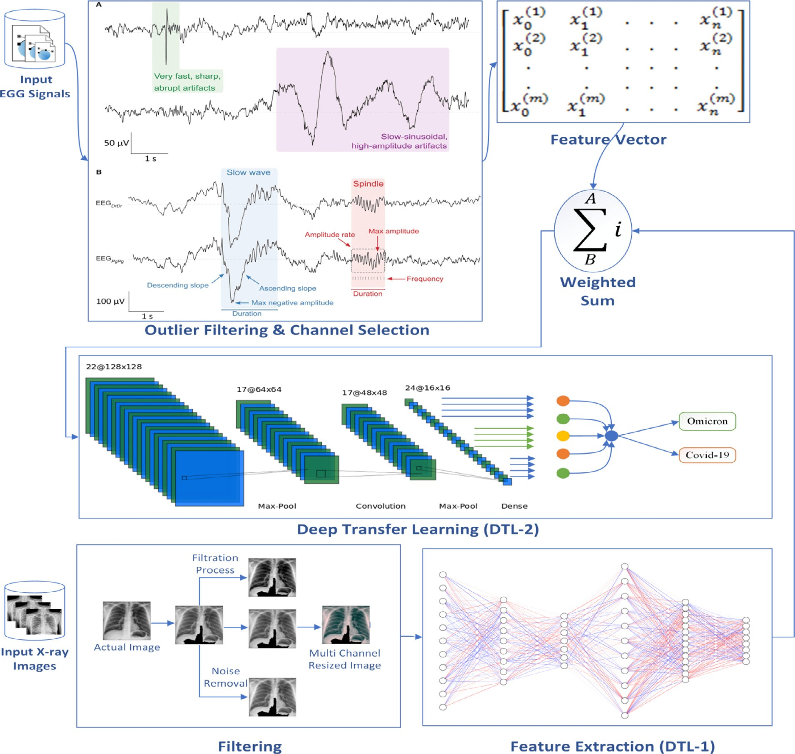

Fig. 1. Architecture of Omicron detection from chest X-ray and EEG.

Table 1

Dataset description.

|  |  |  |  |  |
| --- | --- | --- | --- | --- |
| S.No. | Dataset type | Dataset repository | No. of records | Web source |
| 1 | Radiography Dataset (Chest X-ray Images) | Kaggle | 3615 Images | <https://www.kaggle.com/tawsifurrahman/covid19-radiography-database> |
| 2 | EEG (Signals) | COVID Archive | – | [https://covid-arc.loni.usc.edu/#dataset](https://covid-arc.loni.usc.edu/%23dataset) |

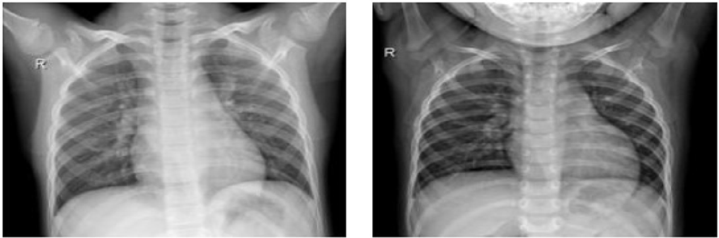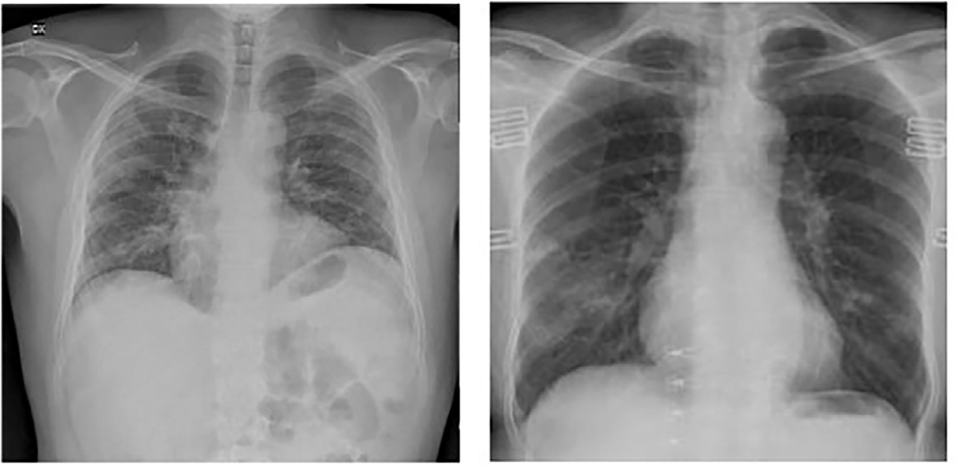

Fig. 2a. X-ray images without Omicron Symtoms. Fig. 2b. X-ray images with Omicron Symptoms.

*DWT* (*a*, *b*) =

∞

*x*(*t*)W(*a*, *b*)(*t*)(*dti*), < = *x*(*t*), W(*a*, *b*)(*t*) (3)

Z

—∞

Table 2

The efficentnet architecture.

After the successful transformation process, the extracted fea- tures have been normalized to unit variance and zero means that are further optimized using Fisher discriminant ratio (FDR). Fig. 3 provides the stepwise feature extraction process using WT process. In another stream of the proposed architecture the X-ray images data has been filtered and further processed for feature extraction. In order to reduce the complexity of the proposed work an EfficientNet deep learning model has been designed. In the first step of EfficentNet model has been considered for the extraction of features from chest X-rays due to its enhanced depth and breadth

features.

The feature extraction and optimization process has been per- formed in floating point operations per second (FLOPS). The perfor- mance of the proposed work has been optimized by using the same search space introduce by Tan et al. [25] using the optimization

goal as *Accuracy* × *FLOPS*(*m*)/*T*, where m rpresents model and T

represent time. In the proposed EfficentNet there are total 18 lay-

224 × 224 pixel respectively. The detailed layer wise description ers with K = 3,3 kernel = 5,5. The size of each X-ray image is has been shown in Table 2 whereas, the code snippet of EfficentNet

model summary is shown in Fig. 4.

* 1. *Model training and validation*

In order to start the training phase of selected transfer learning model, the preprocessed dataset was split with the ratio of 80–20 % as already discussed in the previous section by using train_test_s- plit function from sklearn. model_selection library. In which, 20 % of image data used for testing phase and remaining 80 % for train- ing set. Later on, the deep learning classifier has been validated with the support of subsample random selections of training image data. At the end, the evaluation metrics have been applied to show the recorded performance on the test set.

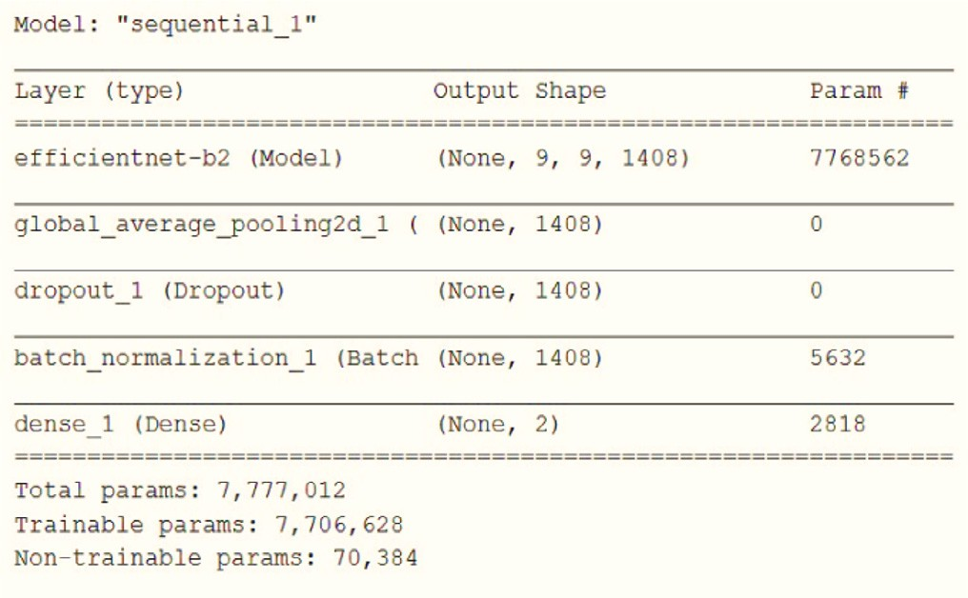

Fig. 4. Programming based Summary of the Proposed Architecture.

|  |  |  |  |
| --- | --- | --- | --- |
| Time Slot (S*i*) | Kernel Operator | Resolution (height × Width) | No of Filters |
| 1 | EC1 K (3 × 3) | 224 × 224 | 32 |
| 2 | EC6 K (3 × 3) | 112 × 112 | 16 |
| 3 | EC6 K (3 × 3) | 112 × 112 | 24 |
| 4 | EC6 K (5 × 5) | 56 × 56 | 40 |
| 5 | EC6 K (5 × 5) | 28 × 28 | 80 |
| 6 | EC6 K (5 × 5) | 14 × 14 | 112 |
| 7 | EC6 K (3 × 3) | 14 × 14 | 192 |
| 8 | EC6 K (3 × 3) | 7 × 7 | 320 |
| 9 | Pooling & FC | 7 × 7 | 1280 |

* 1. *Fully connected transfer learning based classification*

In this work, Omicron disease detection using an adapted Con- volutional Neural Network architecture [28] has been trained in the transfer-learning mode. While for feature extraction, an Effi- cientNet has been applied. All the obtained features were used to

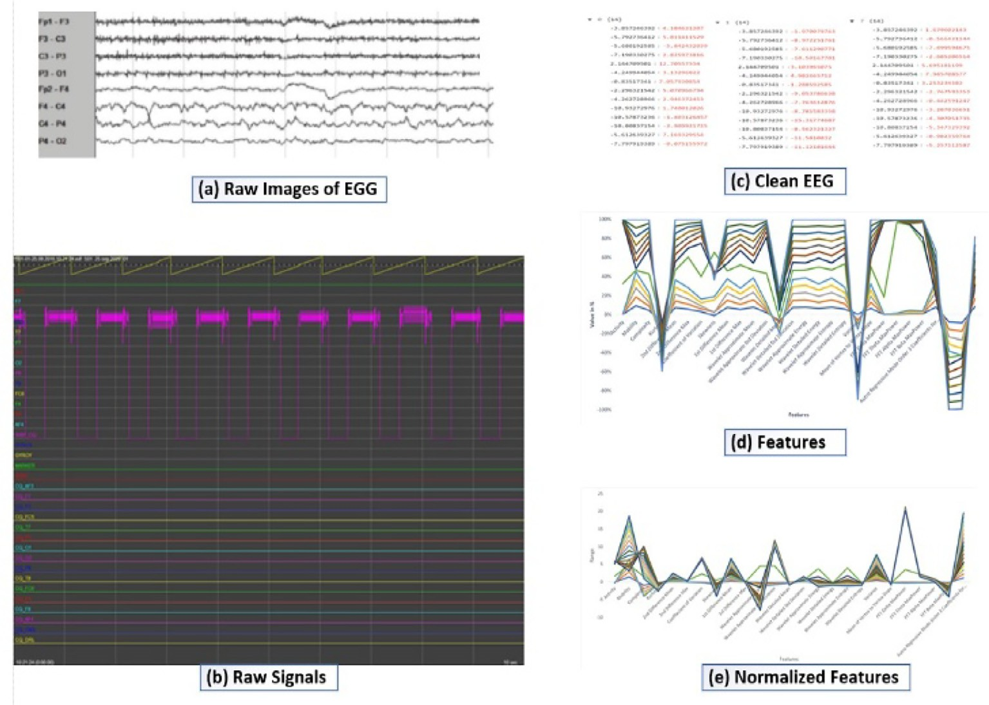

Fig. 3. Features Extraction Process from EEG Signals.

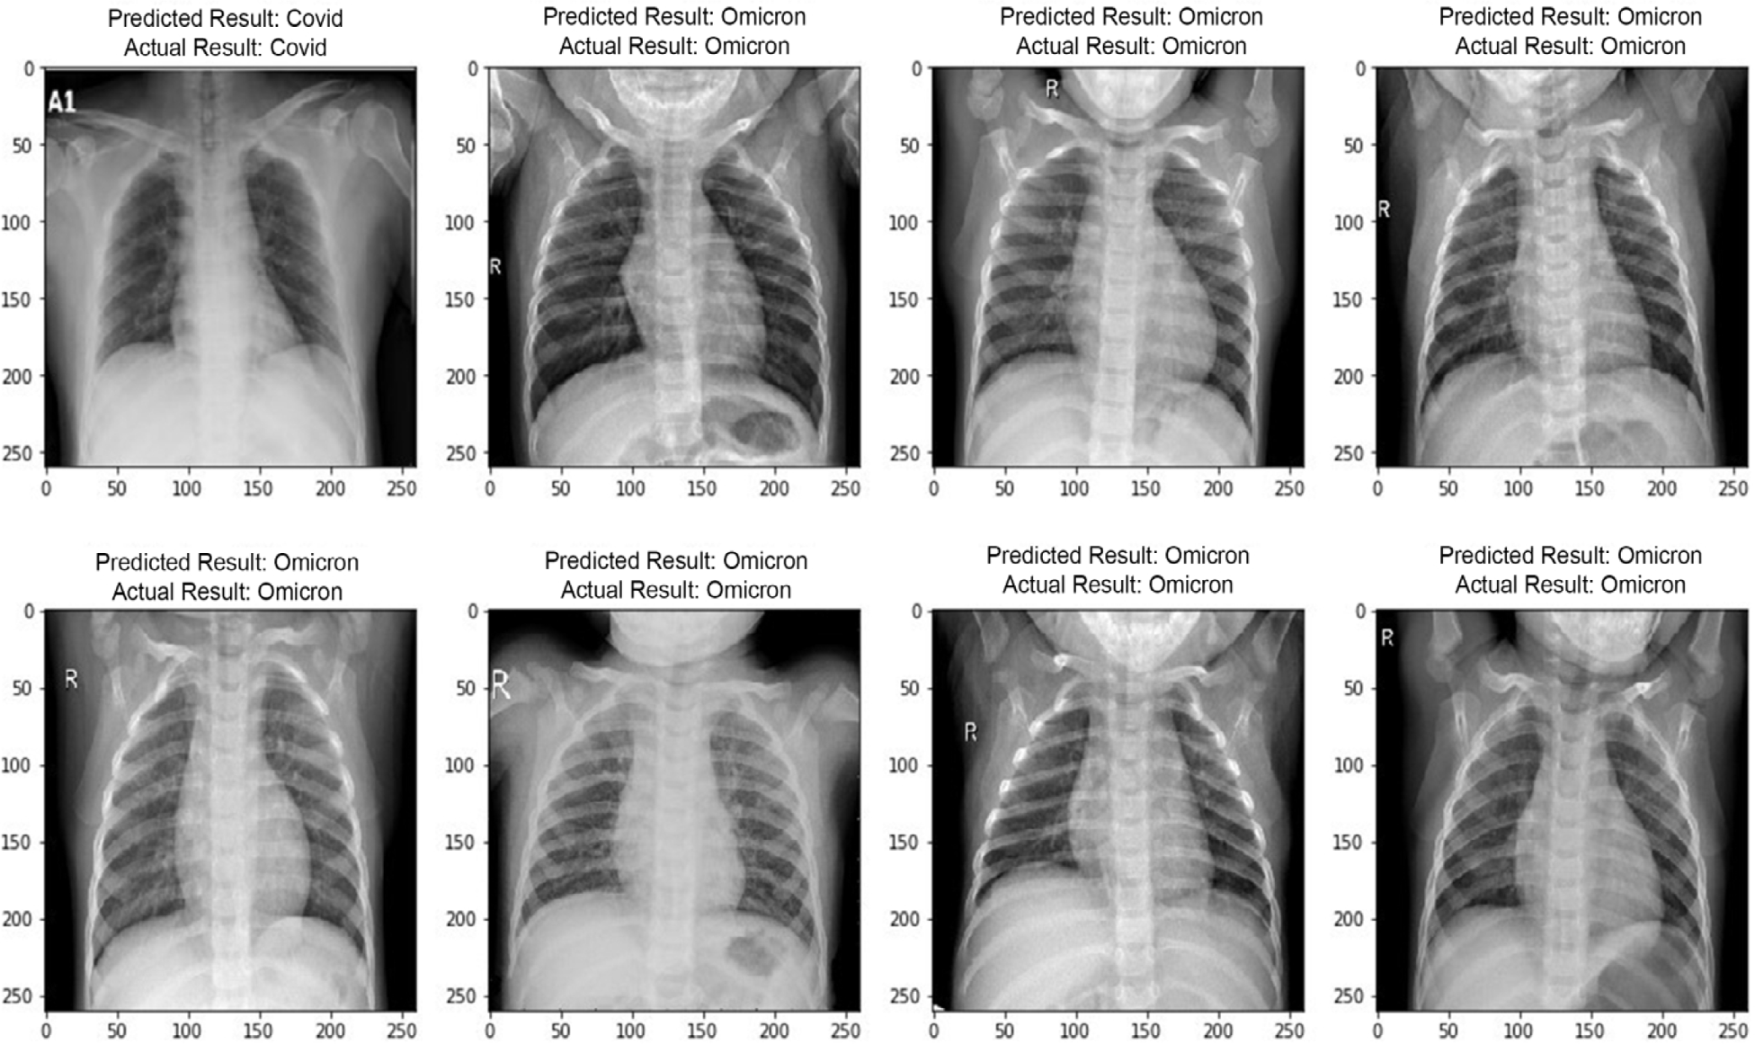

Fig. 5. Comparison of Obtained Results and Actual Results.

Table 3

Confusion matrix.

Actual Class

Positive (P) Negative (N)

rizing emerging diseases and medical images. An addition to the benefit of transfer learning, working with the transfer practice, the parameters of the model work with good values, which require only a small change to be well adjusted for the new task. Sometime the model of pre-trained phase is also used as a feature extractor

Predicted Class Positive (P) True Positive (TP) False Positive (FP) Negative (N) False Negative (FN) True Negative (TN)

enhance the knowledge transfer and feature extraction process for

and is taxonomically qualified to perform the classification. But it’s become quite hectic when processing both task on the same model due to its scalability and optimality. The second solution for the entire network is to fine-tune, and subset of the network, for new task.

new images. Algorithm 1, demonstrate the working of Transfer

learning classifier for Omicron detection on EEG images.

Transferring learning is a recursive model that is trained for a particular task that can be further re used for similar activity hav- ing same characteristics. For detection of Omicron on a sensitive data such as EEG, the same procedure has been adopted. To start any work from scratch, for which initially sufficient data is not available the transfer learning is very useful, particularly in catego-

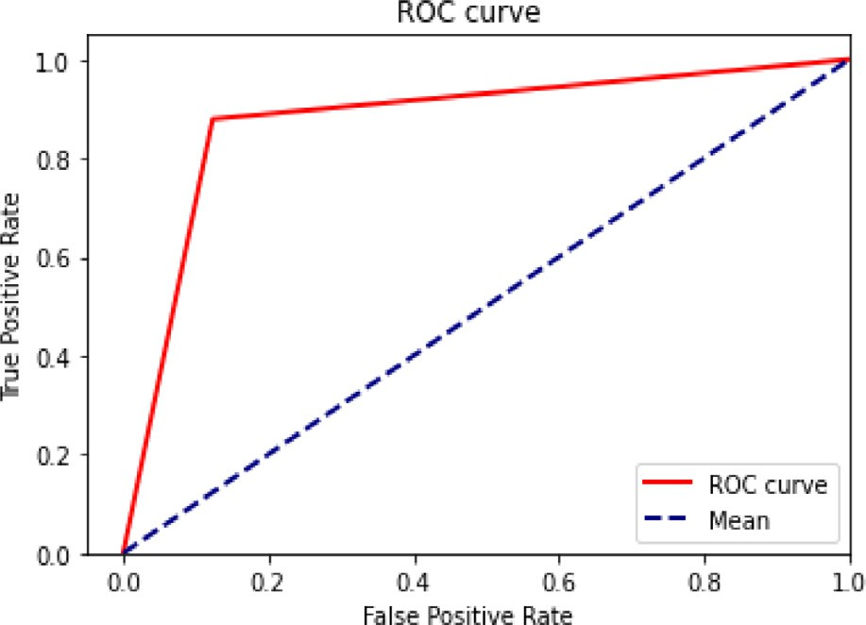

Fig. 6. A typical ROC Curve Example.

Algorithm 1: Deep Transferred Learning process

*Input:* Images (EEG, X-Ray)

*Output:* sub-models

//Dataset is divided in to training, testing and validation

*INITALIATION*: class_weight = [0:10, 1:2, 1:1]

for *i* ¼ 1 to N do Train (dataset, training_images, image_label, image_class_weight)

if (*i* ¼¼ *l*1) then

model_1 = save(dataset) // Save dataset

end if end for

model_2= save(dataset) // Save dataset

for *i* ¼ 1 to M do

Train (dataset, training_images, image_label, image_class_weight)

if (*i* ¼¼ *l*2) then model_3= save (Xcep) // Save Xception

Else

if (*i* ¼¼ *l*3) then model_4= save (Xcep) // Save Xception

end if end if

end for

sub-model#5 = save (Xcep) // Save Xception return *models*

1. Results

This section describes the evaluation of the proposed model. The analysis of model performance evaluated for each intensive classification based on accuracy is summarized.

* 1. *Hyper-Parameter configuration*

For every 100 epochs, the proposed model detected some pat- terns. The learning rate of the model that has been observed as 0.0001 and batch size is set to 20. In this work, the ADAM

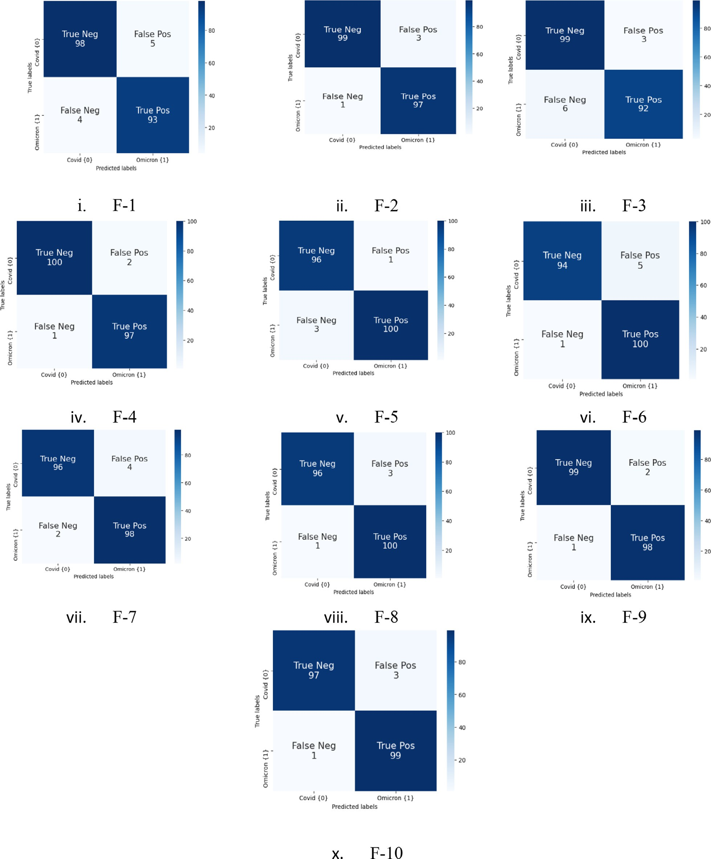

Fig. 7. Cross Fold Validation of the Proposed Work.

Table 4

Performance of the Model on Classification of Covid and Omicron.

Table 6

Performance of Models.

|  |  |  |  |  |  |  |  |  |  |  |  |
| --- | --- | --- | --- | --- | --- | --- | --- | --- | --- | --- | --- |
| Fold k | Accuracy (%) | Precision (%) | Recall (%) | F Score (%) | Class |  | Model | Accuracy | AUC | Sensitivity | Positive Predictive |
| 1 | 95.5 | 95 | 96 | 96 | Covid |  |  |  |  |  | Value (PPV) |
|  | 95.5 | 96 | 95 | 95 | Omicron |  | EfficientNet B0 | 91.40 % | 84.60 % | 86.30 % | 72.40 % |
| 2 | 98 | 97 | 99 | 98 | Covid |  | EfficientNet B1 | 96.50 % | 92.50 % | 95.70 % | 85.90 % |
|  | 98 | 99 | 97 | 98 | Omicron |  | EfficientNet B3 | 95.20 % | 93.30 % | 86.80 % | 90.00 % |
| 3 | 95.5 | 97 | 94 | 96 | Covid |  | VGG16 | 92.95 % | 84.60 % | 100 % | 69.23 % |
|  | 95.5 | 94 | 97 | 95 | Omicron |  | VGG19 | 93.70 % | 85.50 % | 89.50 % | 72.90 % |
| 4 | 98.5 | 98 | 99 | 99 | Covid |  | MobileNet | 92.70 % | 86.50 % | 93.40 % | 74.70 % |
|  | 98.5 | 99 | 98 | 98 | Omicron |  | ResNet50 | 90.70 % | 81.70 % | 90.00 % | 63.60 % |
| 5 | 98 | 99 | 97 | 98 | Covid |  | Proposed | 96.98 % | 93.90 % | 95.95 % | 88.75 % |
|  | 98 | 97 | 99 | 98 | Omicron |  |  |  |  |  |  |
| 6 | 97 | 99 | 95 | 97 | Covid |  |  |  |  |  |  |
|  | 97 | 99 | 95 | 97 | Omicron |  |  |  |  |  |  |

performance of taxonomic models were accuracy classification, accuracy, F1-score, sensitivity and specificity.

|  |  |  |  |  |  |
| --- | --- | --- | --- | --- | --- |
| 7 | 97 | 96 | 98 | 97 | Covid |
|  | 97 | 98 | 96 | 97 | Omicron |
| 8 | 98 | 97 | 99 | 98 | Covid |
|  | 98 | 99 | 97 | 98 | Omicron |
| 9 | 98.5 | 98 | 99 | 99 | Covid |

*TP* + *TN*

*Accuracy* = (4)

|  |  |  |  |  |  |  |
| --- | --- | --- | --- | --- | --- | --- |
|  | 98.5 | 99 | 98 | 98 | Omicron | *TP* + *TN* + *FP* + *FN* |
| 10 | 98 | 97 | 99 | 98 | Covid |  |

98 99 97 98 Omicron

Pr*ecision* = *TP*

*TP* + *FP*

*Recall* = *TP TP* + *FN*

*F*1 = 2 × (*P* × *R*)

(*P* + *R*)

(5)

# (6)

(7)

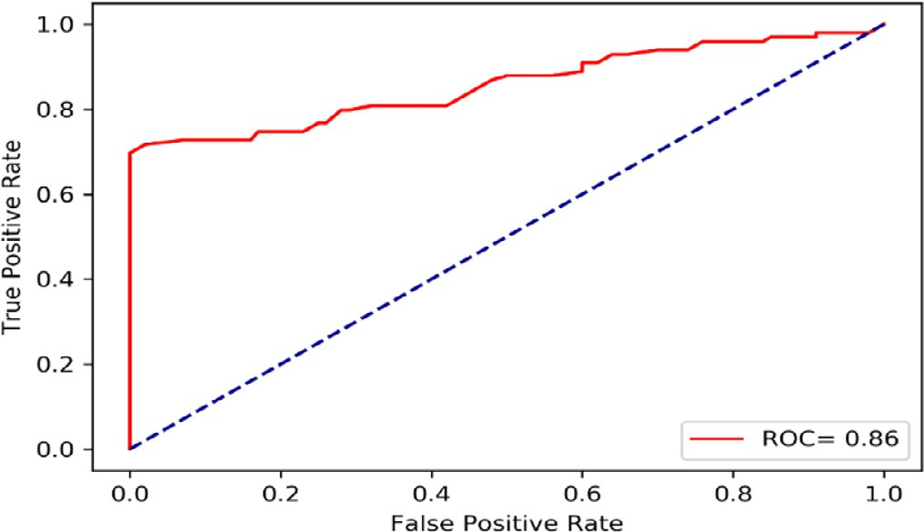Fig. 8. The accuracy of Implemented Model.

optimizer used to reduce loss performance. We have resized all images according to selected models requirements and collected the results one by one. Similarly, all the images are resized by 260x260 before fed into the neural network EfficientNet. After the classification model with some specific image resolution Fig. 5 demonstrates the actual and predicted results of the model.

* 1. *Model evaluation metrics*

Two different types of results matrices have been considered for the evaluation of the proposed work that are most typical for deep learning models. The detail of each of them is presented in below sub section.

* + 1. *Confusion matrix*

The performance of the deep learning model has been evaluated by implementing EfficientNet model. Numerous metrics has been used to check the correct and incorrect diagnoses of Omicron by testing the chosen dataset. The different criteria for assessing the

Due to the unbalanced nature of the test dataset i.e. 787 COVID images and 4757 Non– Omicron images, sensitivity and specificity are considered to be the most appropriate matrices used to report model performance on such datasets. The traditional calculation for each measure has been presented in equations 4 to 7. A confu- sion matrix as shown in Table 3 has some effects on prediction over a classification problem such as the number of predictions that are right or wrong are categorized by class with count values that leads to matrix uncertainty.

However, sometimes to characterize a classification model out- put on collection of test data, the true values are usually known. This work test dataset or a validation dataset with expected results. We make test dataset for prediction of each instance. The number of predictions is correct for each class counts from the pre- dicted outcomes and predictions.

* + 1. *The ROC curve*

The Comparison of different models is difficult for us when we have only dataset information of sensitivity and specificity, we can change or adjust the data set by using thresholds cut-off method. We also used Operating Characteristic Receiver (ROC) curve that is provide the TF rate as a function of the FP rate. We have plotted Fig. 6 of ROC to represent false positive rate is against the true pos- itive rate. The AUC metric 93.9 % has the shortest margin of error with a more reliable estimation than the other ensemble methods. The weighted averaging ensemble, taking the F-score, outper- formed the other ensemble strategies in classifying EEG images as Non– Omicron & Omicron. We have displayed curve of ROC in the following steps:

Table 5

Classification Report of Proposed Model.

|  |  |  |  |  |  |  |  |
| --- | --- | --- | --- | --- | --- | --- | --- |
|  | Precision | Recall | f1-score | Support | Accuracy | macro avg | weighted avg |
| 0 | 0.96 | 0.89 | 0.92 | 80 | 0.97 | 0.94 | 0.93 |
| 1 | 0.97 | 0.99 | 0.98 | 317 | 0.98 | 0.95 | 0.94 |

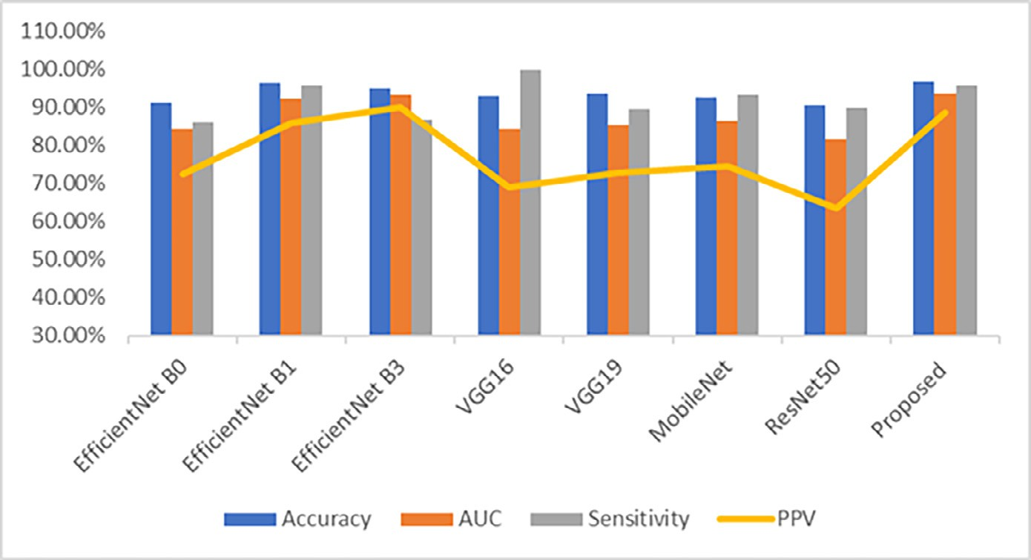

Fig. 9. Performance of Benchmarked Model in term of Accuracy, AUC, Sensitivity and PPV.

* + - * This ROC represents specification trade-off between sensitivity and specificity.
      * Here the curves represent in quadrant of top left side is diagnos- tic of accurate correctness of test output inclination toward the

border. Correspondingly, diagonal shows the less correctness of output result of the curve.

* + 1. *Experimental setup and evaluation*

As far as the experimental setup is concerned, a classification model was developed to categorize the images of X-rays and EEG data into COVID and Omicron respectively. The implementation has been performed using MATLAB 2019 with following configura- tion of the PC: Core i9, 3.7 GH (Intl R), and 16 GB RAM. For the ease of processing some of open source tools and models such as Tensor Flow (2.0) and open source deep learning model have also been installed. A histogram based designated images has been present to depict the results of the proposed work.

The evaluation of the proposed model has been performed on a set of features that were split into test and train by K-Fold cross validation. From analysis it has been shown that the stratified cross validation shows the generates the same distribution in evaluation set. The validation splits the feature into a number of K subsets for training and testing. Fig. 7 and Table 4 represent the best perfor- mance on each fold for the proposed model. From this, it has been shown that the proposed work diagnoses both COVID-19 and Omi- cron classes correctly. The matrix presents a high level of correct- ness of which the first diagonal represents correct identification of COVID-19 (TP) and Omicron.

Fig. 8 shows the accuracy curve used for the model to calculate that how accurately our model is perform on validation set. The accuracy of the proposed model on the selected dataset is recorded as 96.98 %.

Table 5 is for the classification report shows the model’s accu- racy, recall, F1, and help ratings. Table 6 demonstrates the results of different model architectures in comparison of the proposed work. In term of accuracy and AUC (Area under Curve), the pro- posed model gives best results among all in term of accuracy, AUC, sensitivity and Positive Prediction Values that are recorded as 96.98 %, 93.90 %, 95.95 % and 88.75 % respectively. While Effi- cientNetB1 was runner up as it secures 96.50 %, 92.50 %, 95.70 % and 85.90 % in accuracy, AUC, sensitivity and Positive Prediction Values respectively. Moreover, we can see that in term of sensitiv- ity, VGG16 gave 100 % results but it gave worst result, 69.23 % only,

in Positive Predictive Value (PPV). The proposed model performed significantly better than the state-of-the-art models.

Fig. 9 shows the performance of observed models. As per this bar graph, it is very clear each model performed well to predict Omicron from X-ray images and EEG signals. We can observe that the proposed model performed better in terms of accuracy, AUC, sensitivity and PPV than the EfficientNet B0, EfficientNet B1, Effi- cientNet B3, VGG16, VGG19, MobileNet and ResNet50 models.

1. Conclusion & future work

In this paper, we tried to detect pattern of Omicron Variants from EEG Signals and X-ray Images using deep transfer learning. An effective transferred learning network architecture has been applied to identify Omicron through EEG images and X-rays. The proposed model has been composed of data gathering, preprocess- ing, feature extraction using WT transformation method and Effi- centNet and finally classification using transfer learning classifier. Numerous experiments have been conducted to evaluate the planned work’s performance. From experimental evaluation, it has been observed that the proposed deep learning-based approach considerably improved the accuracy and AUC of low- cost EEG Omicron screening EEG and X-ray images can also be used to successfully test virus-infected patients, to detect Omicron patients. In this work, preprocessing, feature extraction, and trans- fer learning-based classification were combined to construct a robust network architecture for tracking down the Omicron patient.

In the future, the proposed approach can be further utilized to diagnose many other infectious diseases, such as tuberculosis. whereas a more refined model can be built by introducing advanced machine learning models like enforcement learning and federated learning to the proposed work. One more possible feature direction could be the addition of an advanced similarity measure to the proposed work in order to detect other variants of COVID-19.

Declaration of Competing Interest

The authors declare that they have no known competing finan- cial interests or personal relationships that could have appeared to influence the work reported in this paper.

Acknowledgment

This research project was supported by a grant from the ‘‘Research Center of College of Computer and Information Scien- ces”, Deanship of Scientific Research, King Saud University.

References

1. [Ayittey FK, Dzuvor C, Ayittey MK, Chiwero NB, Habib A. Updates on Wuhan](http://refhub.elsevier.com/S1110-8665(23)00001-4/h0005) [2019 novel coronavirus epidemic. J Med Virol 2020;92(4):403–7](http://refhub.elsevier.com/S1110-8665(23)00001-4/h0005).
2. [Islam N, Ebrahimzadeh S, Salameh JP, Kazi S, Fabiano N. Thoracic imaging tests](http://refhub.elsevier.com/S1110-8665(23)00001-4/h0010) [for the diagnosis of COVID-19. Cochrane Database Syst Rev 2021;9(1):1–147](http://refhub.elsevier.com/S1110-8665(23)00001-4/h0010).
3. [Maguolo G, Nanni L. A critic evaluation of methods for covid-19 automatic](http://refhub.elsevier.com/S1110-8665(23)00001-4/h0015) [detection from x-ray images. Inform Fusion 2021;76(1):1–7](http://refhub.elsevier.com/S1110-8665(23)00001-4/h0015).
4. [Abbas A, Abdelsamea MM, Gaber MM. Classification of COVID-19 in chest X-](http://refhub.elsevier.com/S1110-8665(23)00001-4/h0020) [ray images using DeTraC deep convolutional neural network. Appl Intell](http://refhub.elsevier.com/S1110-8665(23)00001-4/h0020) [2021;51(2):854–64](http://refhub.elsevier.com/S1110-8665(23)00001-4/h0020).
5. [Cameroni E, Bowen JE, Rosen LE. Broadly neutralizing antibodies overcome](http://refhub.elsevier.com/S1110-8665(23)00001-4/h0025) [SARS-CoV-2 Omicron antigenic shift. Nature 2021;602(7):664–70](http://refhub.elsevier.com/S1110-8665(23)00001-4/h0025).
6. [Singh J, Thakur D, Ali F, Gera T, Kwak KS. Deep feature extraction and](http://refhub.elsevier.com/S1110-8665(23)00001-4/h0030) [classification of android malware images. Sensors 2020;20(24):7013](http://refhub.elsevier.com/S1110-8665(23)00001-4/h0030).
7. [Rajaraman S, Siegelman J, Alderson PO, Folio LS, Folio LR, Antani SK. Iteratively](http://refhub.elsevier.com/S1110-8665(23)00001-4/h0035) [pruned deep learning ensembles for COVID-19 detection in chest X-rays. IEEE](http://refhub.elsevier.com/S1110-8665(23)00001-4/h0035) [Access 2021;8(1):115041–50](http://refhub.elsevier.com/S1110-8665(23)00001-4/h0035).
8. [Adam S, Zahra SA, Chor CYT, Khare Y, Harky A. COVID-19 pandemic and its](http://refhub.elsevier.com/S1110-8665(23)00001-4/h0040) [impact on service provision: A cardiology prospect. Acta Cardiol 2020;76](http://refhub.elsevier.com/S1110-8665(23)00001-4/h0040) [(8):830–7](http://refhub.elsevier.com/S1110-8665(23)00001-4/h0040).
9. [Scherrenberg S, Frederix I, De Sutter J, Dendale P. Use of cardiac](http://refhub.elsevier.com/S1110-8665(23)00001-4/h0045) [telerehabilitation during COVID-19 pandemic in Belgium. Acta Cardiol](http://refhub.elsevier.com/S1110-8665(23)00001-4/h0045) [2020;76(7):773–6](http://refhub.elsevier.com/S1110-8665(23)00001-4/h0045).
10. [Konar D, Panigrahi BK, Bhattacharyya S, Dey N, Jiang R. Auto-diagnosis of](http://refhub.elsevier.com/S1110-8665(23)00001-4/h0050) [covid-19 using lung ct images with semi-supervised shallow learning](http://refhub.elsevier.com/S1110-8665(23)00001-4/h0050) [network. IEEE Access 2021;9(1):28716–28](http://refhub.elsevier.com/S1110-8665(23)00001-4/h0050).
11. A. Makris, I. Kontopoulos, and K. Tserpes, ‘‘COVID-19 detection from chest X- Ray images using Deep Learning and Convolutional Neural Networks,” *In 11th hellenic conference on artificial intelligence*, Athens, Greece, 2020, pp. 60–66.
12. J. Deng, W. Dong, and R. Socher, ‘‘Ima- genet: A large-scale hierarchical image database,” *In 2009 IEEE conference on computer vision and pattern recognition*, Miami, USA, 2020, pp. 248–255.
13. [Rawat W, Wang Z. Deep convolutional neural networks for image](http://refhub.elsevier.com/S1110-8665(23)00001-4/h0065) [classification: A comprehensive review. Neural Comput 2017;29(9):2352–449](http://refhub.elsevier.com/S1110-8665(23)00001-4/h0065).
14. Y. Huang, Y. Cheng, A. Bapna, O. Firat, D. Chen, M. Chen, ‘‘Efficient training of giant neural networks using pipeline parallelism,” *In Advances in neural information processing systems*, Vancouver, Canada, 2019, pp. 103–112.
15. [Wang W, Wong A. COVID-net: a tailored deep convolutional neural network](http://refhub.elsevier.com/S1110-8665(23)00001-4/h0075) [design for detection of COVID-19 cases from chest X-ray images. Sci Rep](http://refhub.elsevier.com/S1110-8665(23)00001-4/h0075) [2020;10(1):1–12](http://refhub.elsevier.com/S1110-8665(23)00001-4/h0075).
16. [Rahman M, Abdur M, Gupta BB. A multimodal, multimedia point-of-care deep](http://refhub.elsevier.com/S1110-8665(23)00001-4/h0080) [learning framework for COVID-19 diagnosis. ACM Trans Multimidia Comput](http://refhub.elsevier.com/S1110-8665(23)00001-4/h0080) [Commun Appl 2021;17(1):1–24](http://refhub.elsevier.com/S1110-8665(23)00001-4/h0080).
17. C. Szegedy S. Ioffe, V. Vanhoucke, and A. A. Alemi, ‘‘Inception- v4, inception- resnet and the impact of residual connections on learning,” *In Thirty-first AAAI conference on artificial intelligence*, San Francisco, USA, 2017, pp. 4278–4284.
18. [Pereira RM, Bertolini D, Teixeira LO. COVID-19 identification in chest X-ray](http://refhub.elsevier.com/S1110-8665(23)00001-4/h0090) [images on flat and hierarchical classi- fication scenarios. Comput Methods](http://refhub.elsevier.com/S1110-8665(23)00001-4/h0090) [Programs Biomed 2020;194(1):1–18](http://refhub.elsevier.com/S1110-8665(23)00001-4/h0090).
19. A. I. Khan, J. L. Shah, and M. M. Bhat, ‘‘Coronet: A deep neural network for detection and diagnosis of COVID-19 from chest x-ray images,” *Computer Methods and Programs in Biome*dicine, vol. 196, vo. 1, pp. 1–9, 2020.
20. [El-Rashidy N, Abdelrazik S, Abuhmed T, Amer E, Ali F, Hu JW, et al.](http://refhub.elsevier.com/S1110-8665(23)00001-4/h0100) [Comprehensive survey of using machine learning in the COVID-19](http://refhub.elsevier.com/S1110-8665(23)00001-4/h0100) [pandemic. Diagnostics 2021;11(7):1155](http://refhub.elsevier.com/S1110-8665(23)00001-4/h0100).
21. [Gill R, Singh J. A review of feature extraction techniques for EEG-based](http://refhub.elsevier.com/S1110-8665(23)00001-4/h0105) [emotion recognition system. Soft Comput Theor Appl 2021:83–95](http://refhub.elsevier.com/S1110-8665(23)00001-4/h0105).
22. [Dhaka A, Nandal A, Rosales HG, Malik H, Monteagudo FLM, Martinez-Acuna](http://refhub.elsevier.com/S1110-8665(23)00001-4/h0110) [MI, et al. Likelihood estimation and wavelet transformation based](http://refhub.elsevier.com/S1110-8665(23)00001-4/h0110) [optimization for minimization of noisy pixels. IEEE Access 2021;9](http://refhub.elsevier.com/S1110-8665(23)00001-4/h0110) [(1):132168–90](http://refhub.elsevier.com/S1110-8665(23)00001-4/h0110).
23. W. Wang, C. Chen, L. Zhu, W. Qiu, K. Sun, X. Deng, and Y. Liu, ‘‘Model-less source location for forced oscillation based on synchrophasor and moving fast fourier transformation,” *In 2020 IEEE PES Innovative Smart Grid Technologies Europe (ISGT-Europe)*, Delft, The Netherlands, 2020, pp. 404–408.
24. [Padhmashree S, Bhattacharyya A. Human emotion recognition based on time–](http://refhub.elsevier.com/S1110-8665(23)00001-4/h0120) [frequency analysis of multivariate EEG signal. Knowl-Based Syst 2022;238](http://refhub.elsevier.com/S1110-8665(23)00001-4/h0120) [(1):1–14](http://refhub.elsevier.com/S1110-8665(23)00001-4/h0120).
25. [Pham TD. Classification of COVID-19 chest X-rays with deep learning: new](http://refhub.elsevier.com/S1110-8665(23)00001-4/h0125) [models or fine tuning? Health Inform Sci Syst 2021;9(1):1–11](http://refhub.elsevier.com/S1110-8665(23)00001-4/h0125).
26. T. D. Team, ‘‘Pneumonia detection in chest radiographs,” arXiv preprint arXiv:1811.08939, vol. 10, no. 1, pp. 1–5, 2018.
27. [Chen BQ, Zheng B, Wang CQ. Adaptive sparse suppressing powerline](http://refhub.elsevier.com/S1110-8665(23)00001-4/h0135) [component in EEG measurements. Front Public Health 2021;8(1):1–9](http://refhub.elsevier.com/S1110-8665(23)00001-4/h0135).
28. [Ghosh S, Kim S, Ijaz MF, Singh PK, Mahmud M. Classification of mental stress](http://refhub.elsevier.com/S1110-8665(23)00001-4/h0140) [from wearable physiological sensors using image-encoding-based deep neural](http://refhub.elsevier.com/S1110-8665(23)00001-4/h0140) [network. Biosensors 2022;12(12):1153](http://refhub.elsevier.com/S1110-8665(23)00001-4/h0140).