

[Egyptian Informatics Journal (2016) 17, 285–293](http://dx.doi.org/10.1016/j.eij.2016.02.001)

Cairo University

Egyptian Informatics Journal

[www.elsevier.com/locate/eij](http://www.elsevier.com/locate/eij) [www.sciencedirect.com](http://www.sciencedirect.com/science/journal/11108665)

FULL-LENGTH ARTICLE

Performance validation of a cascade control system through various network architectures



A. Lakshmi Sangeetha a, N. Bharathi a, A. Balaji Ganesh b,*

a *Department of Electronics and Instrumentation, Velammal Engineering College, Chennai, India*

b *TIFAC-CORE, Velammal Engineering College, Chennai, India*

Received 27 October 2014; revised 13 January 2016; accepted 11 February 2016

Available online 7 March 2016

Abstract The work analyzes the performance characteristics of a cascade control system when interconnected with various network architectures, such as Internet, mobile and wireless networks. The cascade control system consists of level and flow as primary and secondary variables, respec- tively. The web-enabled monitoring and control are realized using three techniques namely remote client–server, ActiveX-data socket and web publishing tool. Mobile network is established by inter- facing the control system with a GSM modem which enables the monitoring of process parameters through mobile phones. The cascade control system is also monitored wirelessly from remote loca- tions with advent of an indigenous wireless sensor node. The performance analysis proved that wireless monitoring may be considered as an effective alternate technique to the Internet-based communication especially for shorter distances.

© 2016 Production and hosting by Elsevier B.V. on behalf of Faculty of Computers and Information,

KEYWORDS

Cascade control system; Internet;

Wireless network; Mobile communication

Cairo University. This is an open access article under the CC BY-NC-ND license [(http://creativecommons.](http://creativecommons/)

org/licenses/by-nc-nd/4.0/).

1. Introduction

The vital role of network mediated automation has been signif- icantly appreciated in almost all kinds of industries in the last three decades. The networking of industrial processes can be established over a small-scale network as intranet (LAN) or over a large-scale network as Internet (WAN). The makeover

* Corresponding author. Tel.: +91 44 2659 1860; fax: +91 44 2659

1771.

E-mail address: [abganesh@velammal.edu.in](mailto:abganesh@velammal.edu.in) (A.B. Ganesh).

Peer review under responsibility of Faculty of Computers and Information, Cairo University.

**Production and hosting by Elsevier**

process of Internet communication in conventional process environment is influenced by many factors, including number of nodes, Internet bandwidth, time-delay, processing speed, amount of data, managerial policies, safety and security [1,2]. Classical control theory suggested that a delay in the con- trol loop is an important factor causing the system instability as it increases the phase shift between the input and the output signals of the control system and this limits the maximum allowable gain [3]. Some researchers reported as today’s Inter- net provide no real time guaranteed delivery and have essen- tially unbounded end-to-end latency [4]. On the other hand, reports have experimentally proven that time-delays associated with the network do not affect most of the industrial process plants because of their sluggish nature [5,14]. In general, Programmable Logic Controller (PLC) and SCADA have been widely adopted for monitoring and controlling in many

<http://dx.doi.org/10.1016/j.eij.2016.02.001>

1110-8665 © 2016 Production and hosting by Elsevier B.V. on behalf of Faculty of Computers and Information, Cairo University. This is an open access article under the CC BY-NC-ND license [(http://creativecommons.org/licenses/by-nc-nd/4.0/).](http://creativecommons.org/licenses/by-nc-nd/4.0/))

286 A.L. Sangeetha et al.

Figure 1 Functional block diagram of various network architectures enabled cascade control system.

Figure 2 SCADA representation of cascade control system.

process industries. They have great features, including flexibil- ity, reliability, low power consumption and ease of expandabil- ity [6,7]. SCADA stands for Supervisory, control and data acquisition which offers graphical visual representation of pro- cess parameters even from the remote places [7]. It is under- stood that the efficiency of plant automation can be further improved by integrating PLC with SCADA through tags of information [8–11]. The Internet based engineering laborato- ries are seen as revolution in technical education which not

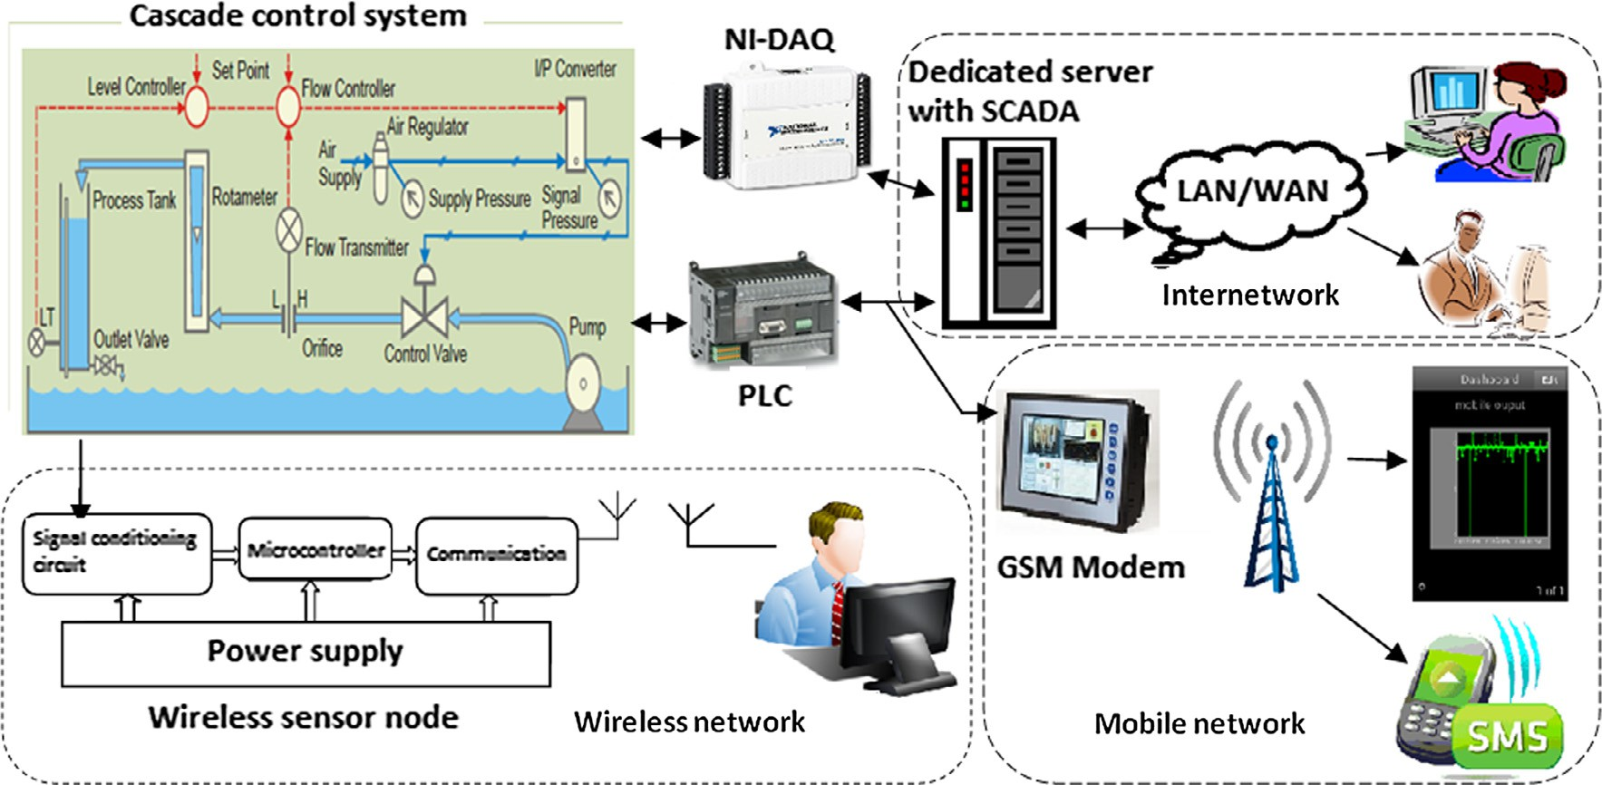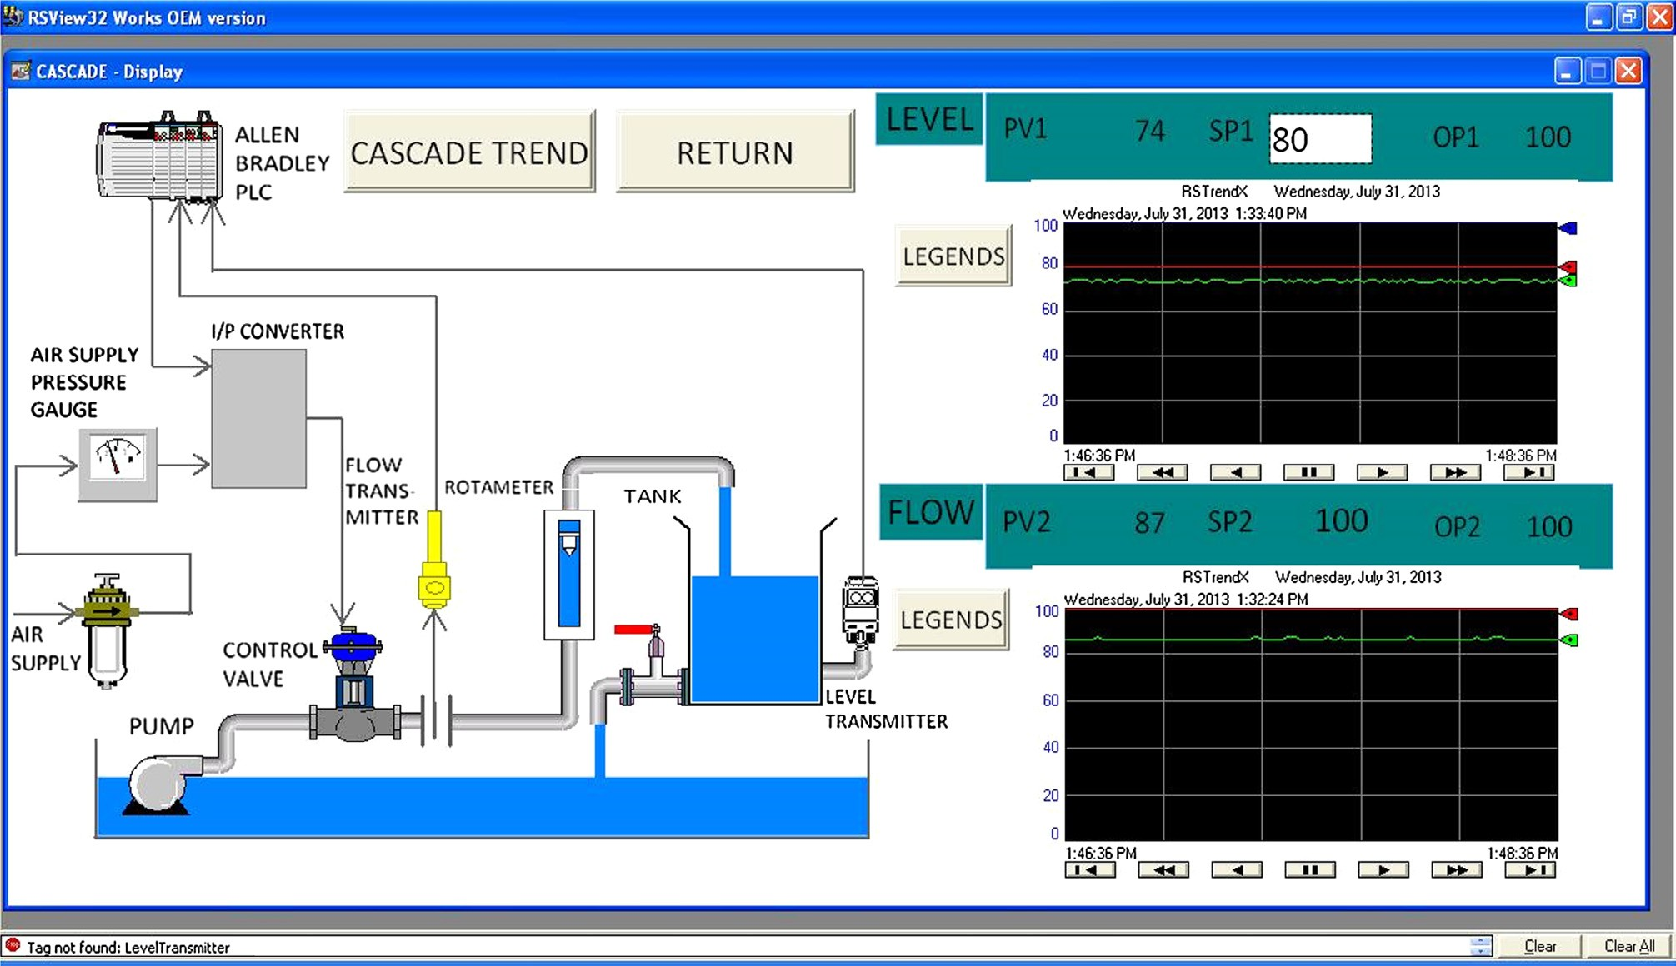

merely brings the equipments to the student’s home but also ensures sharing of resources among universities [12,13]. All the leading PLC manufacturers including Siemens and Allen- Bradley have started to adapt the web-enabled automation in order to increase the productivity.

Most of the industries prefer to use wireless communication as it scores better than the wired to monitor the process param- eters from remote locations. The mobile and wireless network requires minimal effort for the installation and maintenance

Performance validation of a cascade control system 287

Figure 3 Performance characteristics of cascade control system.

since both not involve messy and lengthy cables [16,17]. Gen- erally, a wireless sensor node consists of a computational mod- ule, communication module, power supply and appropriate sensing system [18,19,26]. Both wired and wireless technologies are extensively used for monitoring and controlling [16,20]. In future, both wireless sensor network and mobile communica- tion may assume an indispensable part of our lives due to their flexibility, deployment and low cost [21].

The objective of this study is to analyze the changes in per- formance indices, such as peak time, rise time and settling time of PLC–SCADA enabled cascade control system when it is operated through various network architectures namely, Inter- net, mobile and wireless networks. The error values such as

to pressure) converter which produces equivalent pressure in the range of 3–15 psi. The pressure actuates the pneumatic control valve which opens or closes and eventually the error value is brought to zero. Generally, the experiments are con- ducted in run-time mode and visualization and modification done in the development mode.

The cascade process is considered as the product of the transfer functions of primary loop (level process) and sec- ondary loop (flow process). The transfer function for the cas- cade control system is obtained using two time constant method [25]. The transfer function is given in Eq. (1) as obtained from the experimental data.

0.604 0.4

Integral Square Error (ISE) and Integral Absolute Error (IAE) are also calculated [22,23]. The cascade control system

Transfer function T(S) =

158s + 1

4.2s + 1

e—6s (1)

is the combination of level (primary process) and flow (sec- ondary) processes. The web-enabled monitoring and control are realized through three techniques namely remote client– server, ActiveX-data socket and web publishing tool available in LabVIEW software [15]. The effectiveness of mobile and Zigbee communication is also practically examined. The sen- sor node performance is also validated by its power consump- tion, wireless range and throughput analysis.

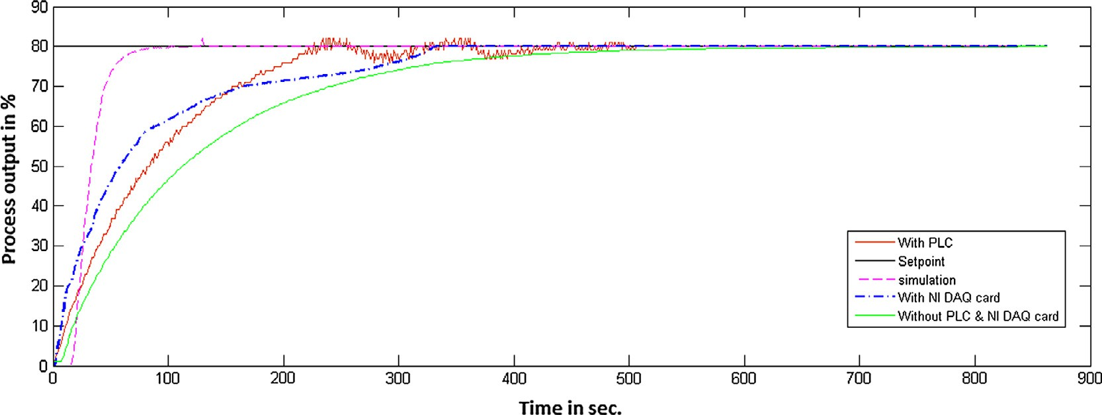

1. Experimental overview

The architecture of a cascade control system integrated with various network architectures is shown in Fig. 1.

The description about the cascade control system and its performance characteristics are validated and described else- where [24]. In brief, the conventional cascade control system consists of a serial dual loop PID controller which has level transmitter as a primary measuring device and flow transmitter as a secondary measuring device. A dedicated communication is established through MODBUS (ADAM-4022T, M/s Advan- tech, Germany) with a personal computer and it is automated using SCADA based software architecture. In this study, PID is implemented on Micrologix-1200 PLC and RSView-32 SCADA has been used with RSLinx communication software. The PLC–SCADA control loop is implemented with real time data analysis, set point modifications, automatic report gener- ation and integration of data with MS-Excel and MS-Access [24]. The controller produces controller output in the ranges between 4 and 20 mA and the same is given to I/P (current

The web-based architecture of cascade control system is created with four functionalities, such as publishing process variable over the Internet, sharing of data, remote control and distributed execution. An industrial standard GSM modem (M/s Horner GSM 0308) is programmed using CSCAPE software to monitor the live status of cascade control system. The modem is operated at 900 MHz with the power transmission of 2 W. The modem has been configured to deli- ver the alert message that can contain up to 20 variables to the registered users for every one minute. This duration can be reprogrammed for any minutes, for seconds and for hours depending on the requirement.

A wireless sensor node that has been constructed using PIC18LF4620, a nano-watt microcontroller is used along with Zigbee wireless communication module (MRF24J40). The sen- sor node operates at 2.5 GHz frequency with the data rate of 250 Kbps [26,27]. In this study the wireless sensor node described in [26] is successfully interfaced with cascade control system.

* 1. *Interfacing of wireless sensor node with cascade control system*

The microcontroller in wireless sensor node has been pro- grammed as a full function device (FFD) and is responsible for operations such as computation, conversion of sensed information into respective engineering unit and to perform the execution of Zigbee protocol stack for wireless communi- cation [28,29]. After immediate initiation, the node is

288 A.L. Sangeetha et al.

|  |  |  |  |  |
| --- | --- | --- | --- | --- |
| Table 1 Performance characteristics of cascade control system. | | | | |
| System characteristics | Simulation | Without PLC and NI DAQ card | With PLC | With NI DAQ card |
| Integral Square Error (ISE) | 1.60E+05 | 3.70E+05 | 2.60E+05 | 1.95E+05 |
| Integral Absolute Error (IAE) | 2541.43 | 9185.6 | 6277 | 5766.44 |
| Peak time (*tp* in sec) | – | – | 234 | – |
| Rise time (*tr* in sec) | 41 | 186 | 129 | 59 |
| Settling time (*ts* in sec) | 107 | 838 | 406 | 332 |
|  |  |  |  |  |

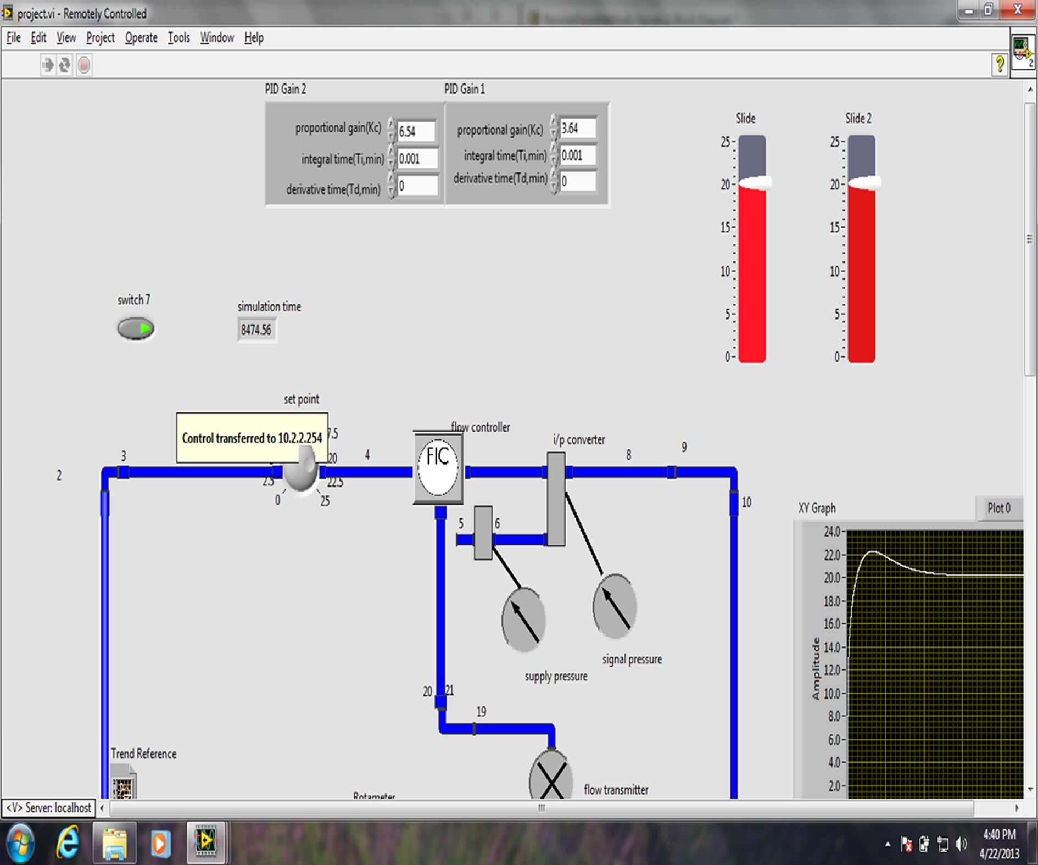

Figure 4 Monitoring and controlling over the Internet using remote client–server method.

programmed to read the corresponding sensor port, performs computation and eventually transmits the signal before it goes to sleep mode. The software design of Zigbee protocol specifi- cations is implemented in medium access control layer (MAC) [30]. The hardware configurations are initiated and the Zigbee processes are invoked to establish the wireless network. After establishing the network, the primary process variable (level) is collected and eventually the computational analysis is per- formed. After successful transmission of message the sensor node is entered into sleep mode for every 2 min and the above procedures are repeated [26,27]. The present study compares the performance of wireless sensor network with mobile

communication as an extension of previous work described elsewhere [27].

1. Results and discussion

Fig. 2 shows the SCADA representation of cascade control system and its operational sequence. The process can be mon- itored either by individually (flow or level) or concurrently both at a time. It has been configured to have history of data by linking it with Ms-Excel.

The performance characteristics such as peak time, rise time and settling time of cascade control system when it is

Performance validation of a cascade control system 289

Figure 5 Monitoring and controlling of process parameters using web publishing method.

interfaced with NI-DAQ card are evaluated. It is found that, the system when it is interfaced with NI-DAQ card shows min- imal rise time and settling time with minimal error than it is interfaced with PLC which is shown in Fig. 3 and in Table 1. Also, the overall performance of the system significantly improves and eventually becomes more stable. Such improved performance can be attributed through data acquiring speed of NI-DAQ.

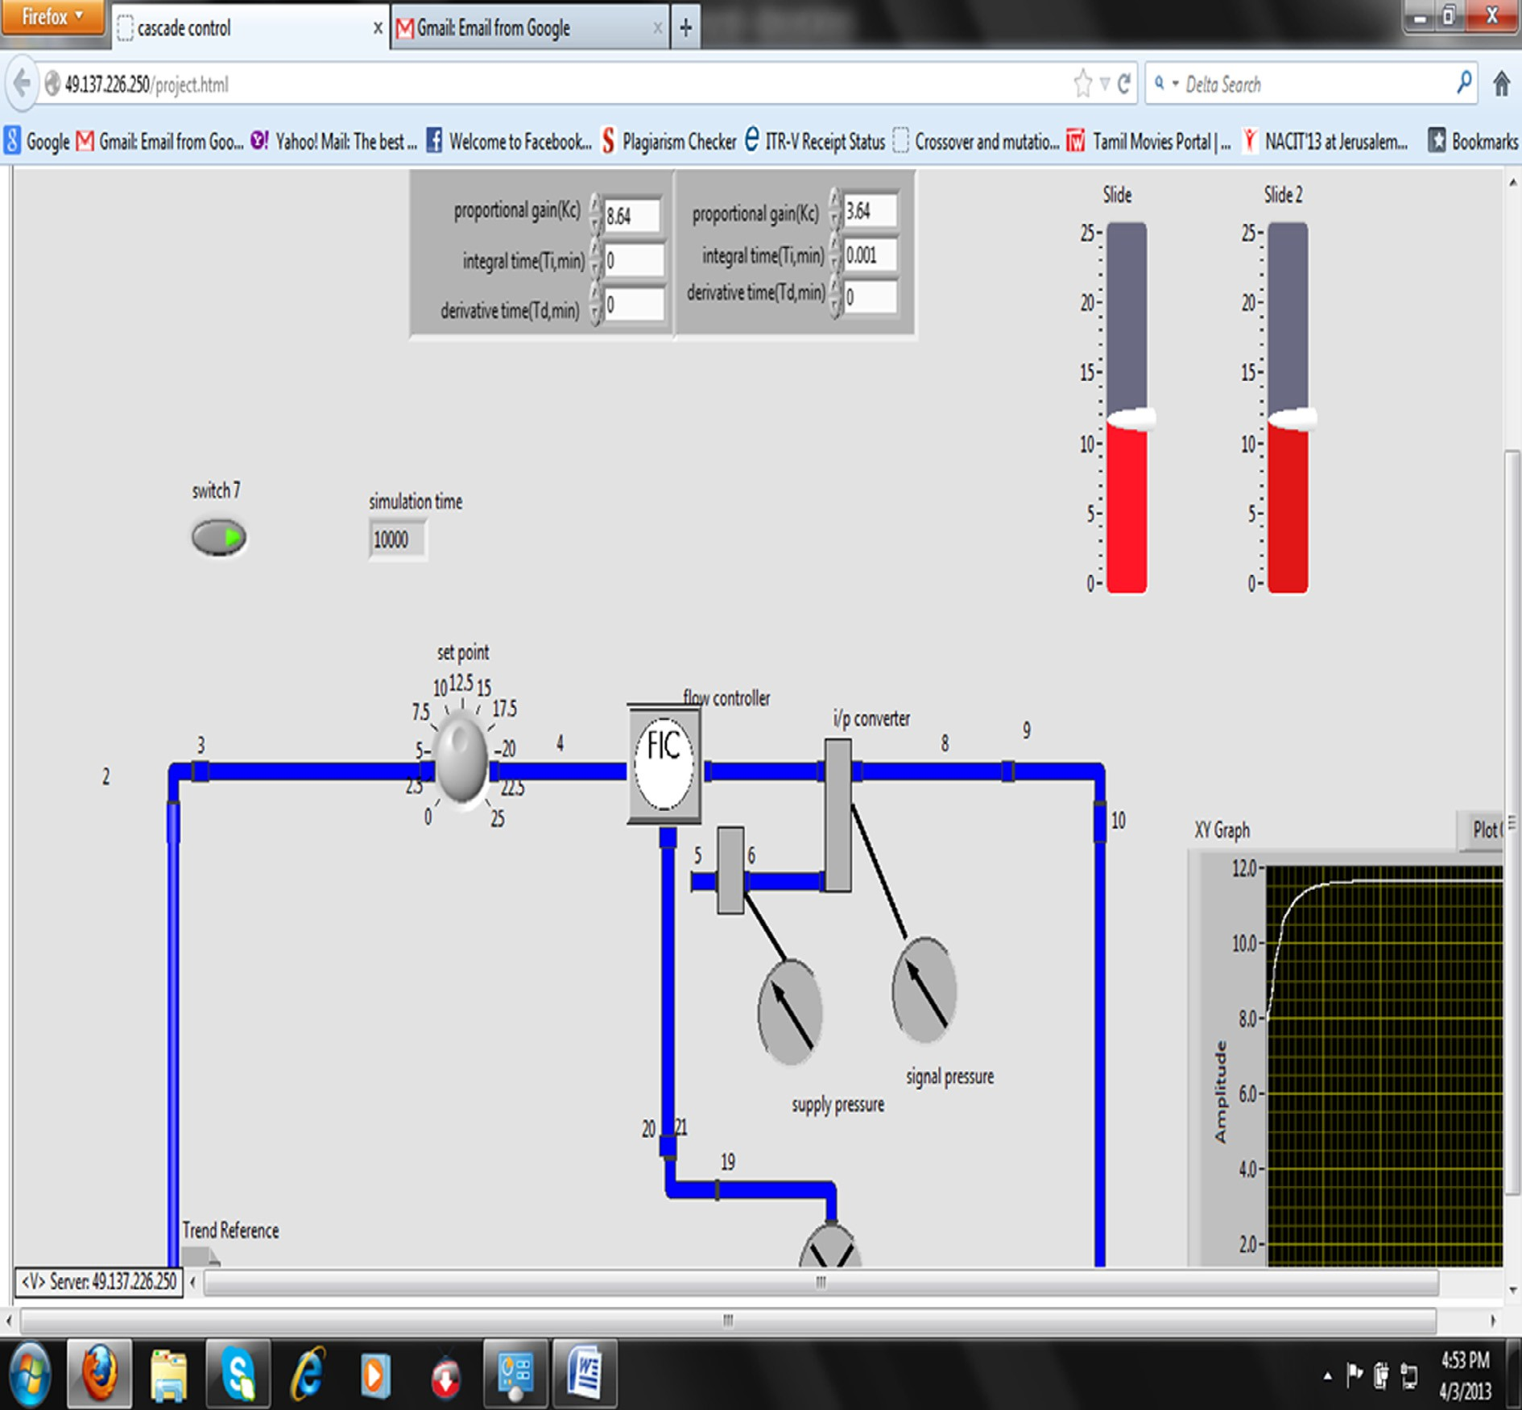

The cascade control system that integrated with NI-DAQ card is successfully made available in Internet by using three methods, namely remote client–server, ActiveX-data socket and web publishing tool.

* 1. *Details on remote client server method*

In the remote client–server method, it is presumed that both client and server machines are installed with similar version of LabVIEW software. To establish a connection, three com- ponents, such as IP address of server, name of program and

port address are required. The connection will be established after server machine acknowledges the connection request from client by providing the IP address, program name and port address. The client must enter the IP address of the server and the name of program to be controlled with port address. Once the connection is established, the client machine is allowed to monitor as well as to change the process variables from remote location which is shown in Fig. 4. The server machine regains its control over the process whenever the con- nection has been terminated.

* 1. *Details on web publishing tool method*

In this method, LabVIEW software needs not to be installed in all client machines. However, a LabVIEW runtime plug-in engine called web server has to be added with web browser at the client side. The initial access control over the process from server is transferred to the client when client invokes the connection by accessing the URL of the Internet server

290 A.L. Sangeetha et al.

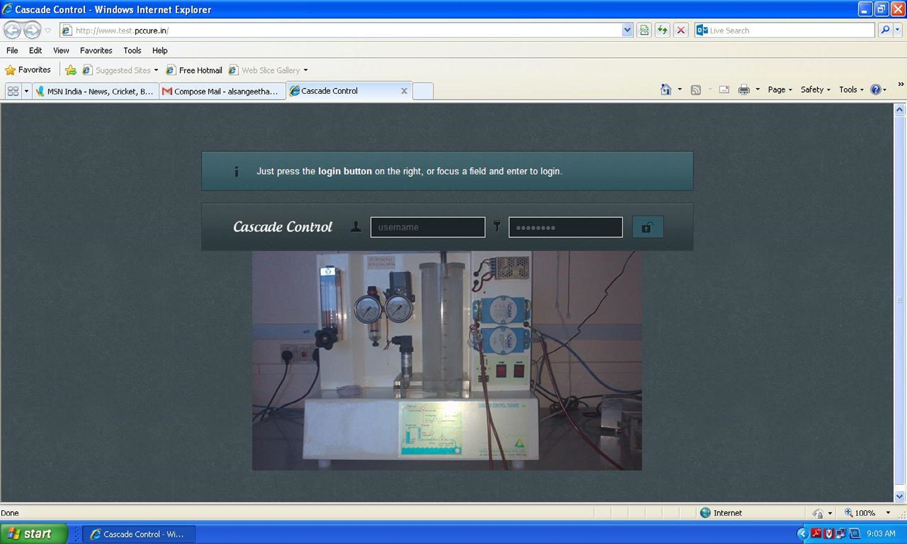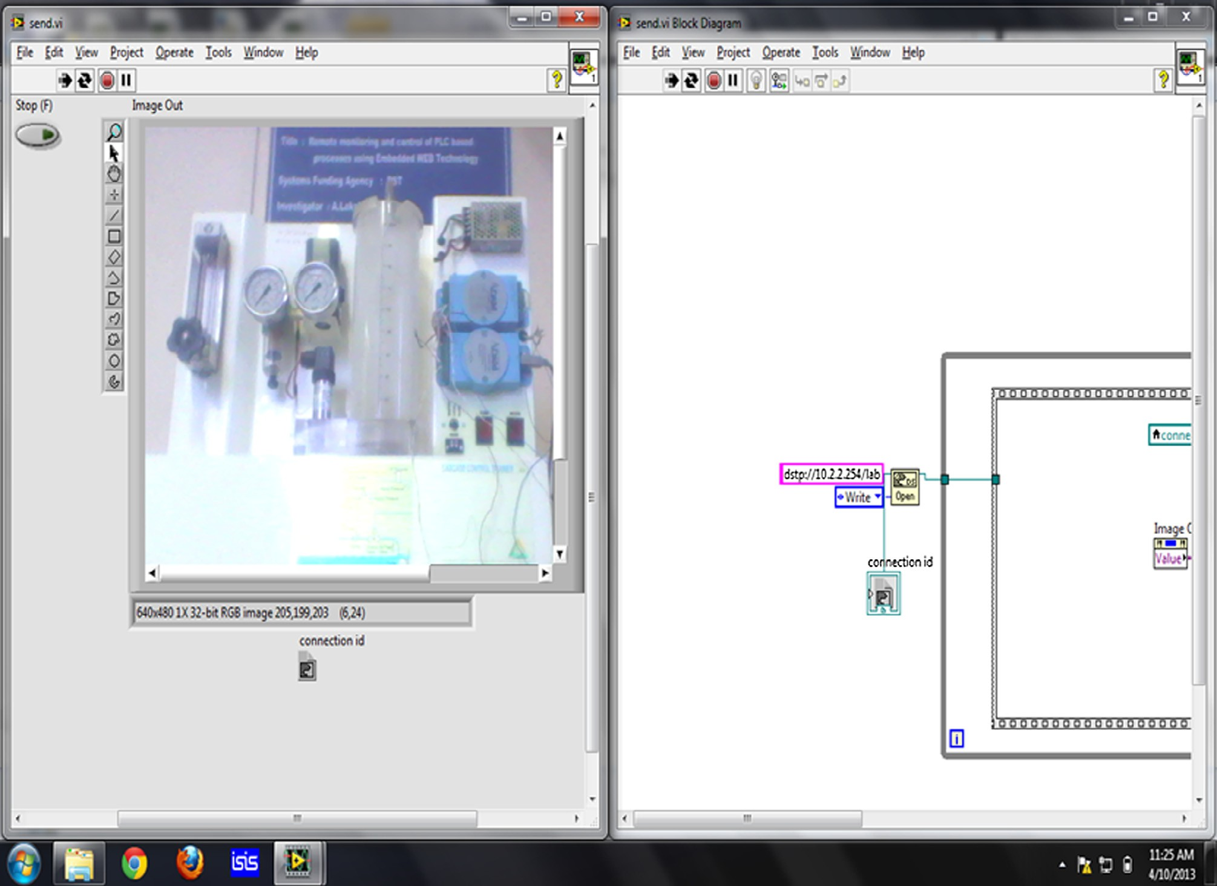

Figure 6 Screen shot of web page created for cascade control system.

Figure 7 Accessing remote application using data socket method.

Performance validation of a cascade control system 291

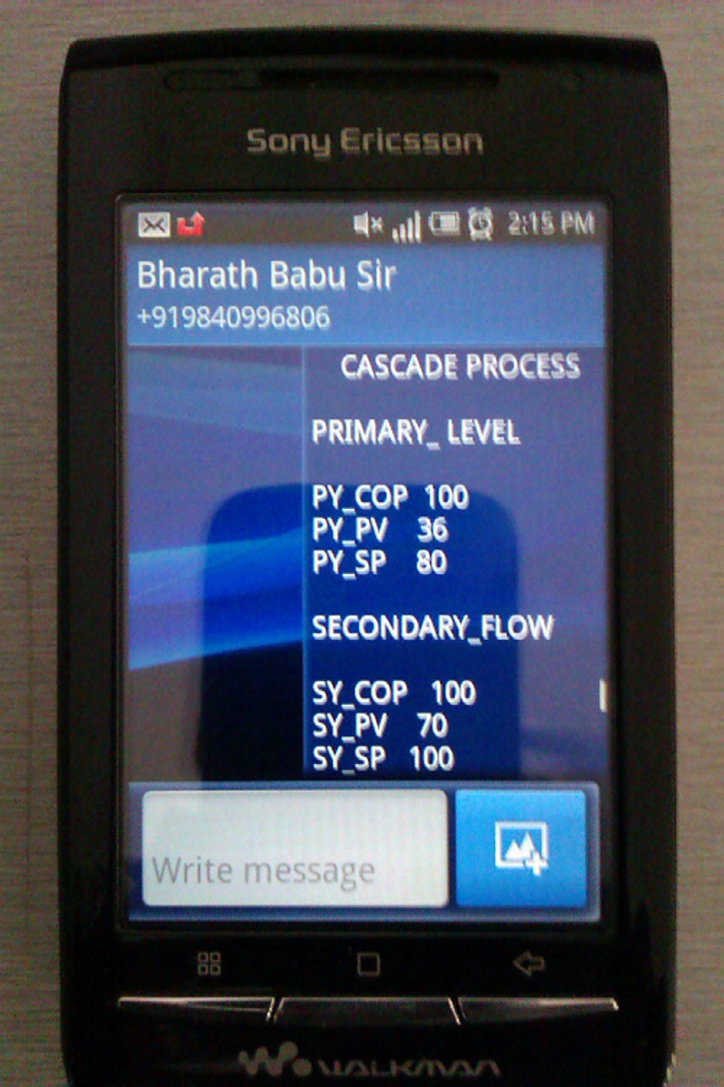

Table 2 Functional differences between various methods available in LabVIEW for web applications.

Methods Range of applications

User interaction Security Cost Additional software

Remote server client

Within LAN Very good (no lag) Good Requires LabVIEW in

client side

None

Web publishing tool

No restriction Depends upon Internet

bandwidth (0–2 s)

Good None LabVIEW Run Time Engine (Web Browser Plug-in)

Data socket- ActiveX

No restriction Depends upon Internet

bandwidth (0–2 s)

Minimum Additional LabVIEW Software

NI Vision Acquisition NI Vision Run Time Engine

through web browser. The client is now able to view and change the set point through web browser which is shown in Fig. 5.

A URL [http://test.pccure.in](http://test.pccure.in/) has been created using PHP (Hypertext Pre-processor) and to evaluate the performance of process control system over the internetwork. A minimum level user authentication mechanism has been provided using CGI scripts to ensure an authenticated user by prompting to enter username and password as shown in Fig. 6. The web page is configured to be accessed by many clients simultane- ously. The user can view the response as graphical chart which is uploaded at server side.

* 1. *Details on data socket and Active X method*

The ActiveX-data socket is used to build interactive Internet- based process automation. It allows the user to broadcast as well as to receive high content live data as shown in Fig. 7. To access this method, the LabVIEW software has to be installed with ActiveX controls. Both client and server should have similar version of LabVIEW environment and the output of data socket can be viewed through web publishing tool. The functional and performance characteristics of all three meth- ods are compared and given in Table 2 [31].

* 1. *Details on mobile and wireless sensor network*

For the mobile-based applications, the GSM modem is config- ured to display both primary level value and secondary flow values. The screen shot of message appeared on a mobile phone is shown in Fig. 8.

The message is delivered for every 1 min. to the mobile user. Fig. 9 shows the corresponding value of process output against the time period.

The wireless sensor node is programmed to capture the pro- cess parameters at a regular time interval of 2 min. It is clearly observed that the sensor node is able to track the process vari- able continuously which is shown in Fig. 10. From the results, it is understood that the integration of wireless and mobile net- work creates the possibilities of tracking the process variables from remote locations, very efficiently. The performance com- parison between mobile and wireless network is evaluated based on the settling time of cascade control system. The wire- less sensor node has a less settling time of 240 s. compared to mobile network which has a settling time of 300 s.

The cascade control system is interfaced through NI-DAQ and the communication is streamlined to match the data rate

Figure 8 Short message in a mobile phone.

to ethernet connectivity. For the wireless network, the data rate of wireless Zigbee communication is 250 Kbps, so the packets are sent as much higher speed to the coordinator node. The effect of time-delay in both wireless and Internet commu- nication on the process parameters is noted insignificantly. In other words, there is no significant time delay and its impact on the monitoring of process parameter of system is observed. Further experimental analysis is required on the obtained resultant data for the effective usage of combined NI DAQ- PLC–SCADA-Wireless network–Mobile interface in industrial applications. In addition, intelligent controllers need to be adopted to make the control system compatible to the operators. Security systems also need to be strengthened and

292 A.L. Sangeetha et al.

Figure 9 Process output received at mobile phone at an interval of every 1 min.

Figure 10 Process parameters received through wireless sensor node.

eventually safety of operators should be ensured. In the near future, miniaturization of components used here is envisaged.

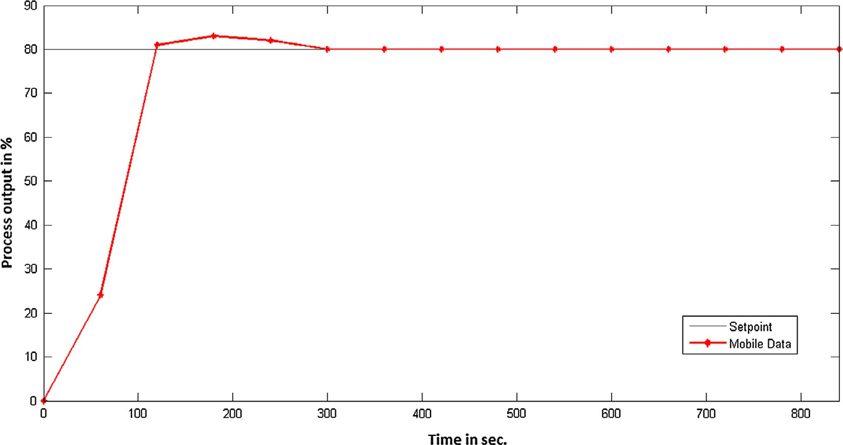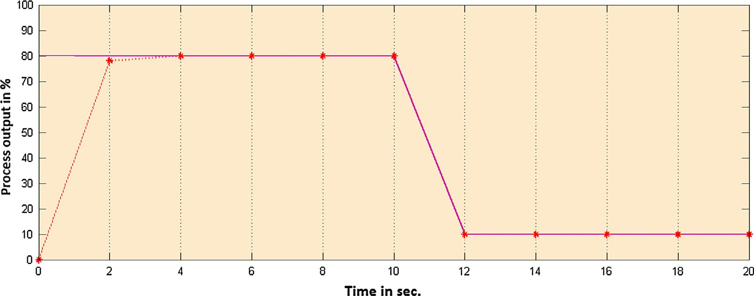

1. Conclusions

A stand-alone cascade control system is made available in Internet and the process variables are published, shared and controlled. The web publishing tool method is found very use- ful for the web related applications as it does not require any additional software to be installed in the client machines. Fur- ther, it provides good security and can be accessed through most of the available web browsers. The performance indices of cascade control system are analyzed and it is found that the control system is operated very efficiently when it is inter- faced with NI-DAQ card. The compatibility of sensor node is verified and it has been successfully integrated with cascade control system. The results obtained create the possibility of using wireless and mobile networks for other industrial process monitoring applications.

Acknowledgment

Author, A. Lakshmi Sangeetha gratefully acknowledges the financial support of Department of Science and Technology, New Delhi, India through a project with D.O. IDP/ IND/22/2012 under Instrumentation Development Pro- gramme (IDP) to Velammal Engineering College, Chennai.

References

1. [Cetinceviz Yucel, Bayindir Ramazan. Design and implementation](http://refhub.elsevier.com/S1110-8665(16)00006-2/h0005) [of an Internet based effective controlling and monitoring system](http://refhub.elsevier.com/S1110-8665(16)00006-2/h0005) [with wireless field-bus communications technologies for process](http://refhub.elsevier.com/S1110-8665(16)00006-2/h0005) [automation—an experimental study. ISA Trans 2012;51(3):](http://refhub.elsevier.com/S1110-8665(16)00006-2/h0005) [461–70](http://refhub.elsevier.com/S1110-8665(16)00006-2/h0005).
2. [Yang Lili, Yang SH. A framework of security and safety checking](http://refhub.elsevier.com/S1110-8665(16)00006-2/h0010) [for internet-based control systems. Int J Inform Comput Secur](http://refhub.elsevier.com/S1110-8665(16)00006-2/h0010) [2007;1(1/2):185–200](http://refhub.elsevier.com/S1110-8665(16)00006-2/h0010).
3. [Levine William S, editor. The control handbook. CRC Press;](http://refhub.elsevier.com/S1110-8665(16)00006-2/h0015) [2010](http://refhub.elsevier.com/S1110-8665(16)00006-2/h0015).

Performance validation of a cascade control system 293

1. [Phuritatkul Jumpot, Nguyen Kien, Koibuchi Michihiro, Ji](http://refhub.elsevier.com/S1110-8665(16)00006-2/h0020) [Yusheng, Fukuda Kensuke, Abe Shunji, Matsukata Jun, Urushi-](http://refhub.elsevier.com/S1110-8665(16)00006-2/h0020) [dani Shigeo, Yamada Shigeki. Impact of QoS operations on an](http://refhub.elsevier.com/S1110-8665(16)00006-2/h0020) [experimental test-bed network. Simul Model Pract Theory](http://refhub.elsevier.com/S1110-8665(16)00006-2/h0020) [2009;17(3):528–37](http://refhub.elsevier.com/S1110-8665(16)00006-2/h0020).
2. [Bauer NW, Donkers MCF, van de Wouw N, Heemels WPMH.](http://refhub.elsevier.com/S1110-8665(16)00006-2/h0025) [Decentralized observer-based control via networked communica-](http://refhub.elsevier.com/S1110-8665(16)00006-2/h0025) [tion. Automatica 2013;49(7):2074–86](http://refhub.elsevier.com/S1110-8665(16)00006-2/h0025).
3. [Rehg JA, Sartori GJ. Programmable logic controllers. 2nd ed.](http://refhub.elsevier.com/S1110-8665(16)00006-2/h0030) [New Jersey: Prentice Hall; 2008](http://refhub.elsevier.com/S1110-8665(16)00006-2/h0030).
4. [Boyer SA. SCADA: supervisory control and data acquisition. 4th](http://refhub.elsevier.com/S1110-8665(16)00006-2/h0035) [ed. International Society of Automation; 2009](http://refhub.elsevier.com/S1110-8665(16)00006-2/h0035).
5. [Salihbegovic Adnan, Marinkovic´ Vlatko, Cico Zoran, Karavdic´](http://refhub.elsevier.com/S1110-8665(16)00006-2/h0040) [Elvedin, Delic Nina. Web based multilayered distributed](http://refhub.elsevier.com/S1110-8665(16)00006-2/h0040) [SCADA/HMI system in refinery application. Comput Stand](http://refhub.elsevier.com/S1110-8665(16)00006-2/h0040) [Interfaces 2009;31:599–612](http://refhub.elsevier.com/S1110-8665(16)00006-2/h0040).
6. [Bailey D, Wright E. Practical SCADA for industry. England:](http://refhub.elsevier.com/S1110-8665(16)00006-2/h0045) [Newnes; 2003](http://refhub.elsevier.com/S1110-8665(16)00006-2/h0045).
7. [Igure VM, Laughtera SA, Williamsa RD. Security issues in](http://refhub.elsevier.com/S1110-8665(16)00006-2/h0050) [SCADA networks. Comput Secur 2006;25:498–506](http://refhub.elsevier.com/S1110-8665(16)00006-2/h0050).
8. [Jun Kim Hyung. Security and vulnerability of SCADA systems](http://refhub.elsevier.com/S1110-8665(16)00006-2/h0055) [over IP-based wireless sensor networks. Int J Distrib Sens Netw](http://refhub.elsevier.com/S1110-8665(16)00006-2/h0055) [2012;2012:10 268478](http://refhub.elsevier.com/S1110-8665(16)00006-2/h0055).
9. [Vargas H, Sanchez Moreno Jose, Jara CA, Candelas FA,](http://refhub.elsevier.com/S1110-8665(16)00006-2/h0060) [Torres F, Dormido S. A network of automatic control](http://refhub.elsevier.com/S1110-8665(16)00006-2/h0060) [web-based laboratories. IEEE Trans Learn Technol](http://refhub.elsevier.com/S1110-8665(16)00006-2/h0060) [2011;4:197–208](http://refhub.elsevier.com/S1110-8665(16)00006-2/h0060).
10. [Vargas H, Farias G, Sanchez J, Dormido S, Esquembre F. Using](http://refhub.elsevier.com/S1110-8665(16)00006-2/h0065) [augmented reality in remote laboratories. Int J Comput Commun](http://refhub.elsevier.com/S1110-8665(16)00006-2/h0065) [2013;8:622–34](http://refhub.elsevier.com/S1110-8665(16)00006-2/h0065).
11. [Ganesh AB, Sangeetha AL, Ravi VR. Network model based](http://refhub.elsevier.com/S1110-8665(16)00006-2/h0070) [automation of thermal processes using an embedded digital](http://refhub.elsevier.com/S1110-8665(16)00006-2/h0070) [controller. Proc Conf Emerg Trends Electr Photonic Devices Syst](http://refhub.elsevier.com/S1110-8665(16)00006-2/h0070) [2009:166–9](http://refhub.elsevier.com/S1110-8665(16)00006-2/h0070).
12. Whitepaper – NI tutorial-3301-en <[http://www.ni.com/white-](http://www.ni.com/white-paper/3301/en/) [paper/3301/en/](http://www.ni.com/white-paper/3301/en/)>.
13. [Flammini Alessandra, Ferrari Paolo, Marioli Daniele, Sisinni](http://refhub.elsevier.com/S1110-8665(16)00006-2/h0080) [Emiliano, Taroni Andrea. Wired and wireless sensor networks for](http://refhub.elsevier.com/S1110-8665(16)00006-2/h0080) [industrial applications. Microelectron J 2009;40(9):1322–36](http://refhub.elsevier.com/S1110-8665(16)00006-2/h0080).
14. [Ja¨ msa¨ -Jounela SL. Future trends in process automation. Annu](http://refhub.elsevier.com/S1110-8665(16)00006-2/h0085) [Rev Control 2007;31(2):211–20](http://refhub.elsevier.com/S1110-8665(16)00006-2/h0085).
15. [Song Guangming, Zhou Yaoxin, Wei Zhigang, Song Aiguo. A](http://refhub.elsevier.com/S1110-8665(16)00006-2/h0090) [smart node architecture for adding mobility to wireless sensor](http://refhub.elsevier.com/S1110-8665(16)00006-2/h0090) [networks. Sens Actuators A 2008;147:216–21](http://refhub.elsevier.com/S1110-8665(16)00006-2/h0090).
16. [Yan Ruqiang, Sun Hanghang, Qian Yuning. Energy-aware sensor](http://refhub.elsevier.com/S1110-8665(16)00006-2/h0095) [node design with its application in wireless sensor networks. IEEE](http://refhub.elsevier.com/S1110-8665(16)00006-2/h0095) [Trans Instrum Meas 2013;62:1183–91](http://refhub.elsevier.com/S1110-8665(16)00006-2/h0095).
17. [Haydn AT. Wireless and internet communications technologies](http://refhub.elsevier.com/S1110-8665(16)00006-2/h0100) [for monitoring and control. Control Eng Pract 2004;12:781–91](http://refhub.elsevier.com/S1110-8665(16)00006-2/h0100).
18. [Yick Jennifer, Mukherjee Biswanath, Ghosal Dipak. Wireless](http://refhub.elsevier.com/S1110-8665(16)00006-2/h0105) [sensor network survey. Comput Netw 2008;52(12):2292–330](http://refhub.elsevier.com/S1110-8665(16)00006-2/h0105).
19. [Li Y, Ang KH, Chong GCY. PID control system analysis and](http://refhub.elsevier.com/S1110-8665(16)00006-2/h0110) [design. IEEE Control Syst Mag 2006;26(1):32–41](http://refhub.elsevier.com/S1110-8665(16)00006-2/h0110).
20. [Lakhekar GV, Waghmare LM, Asutkar VG. Fuzzy approach for](http://refhub.elsevier.com/S1110-8665(16)00006-2/h0115) [cascade control of interconnected system. Int J Soft Comput](http://refhub.elsevier.com/S1110-8665(16)00006-2/h0115) [2010;5:116–27](http://refhub.elsevier.com/S1110-8665(16)00006-2/h0115).
21. [Sangeetha AL, Kumar BN, Ganesh AB, Bharathi N. Experimen-](http://refhub.elsevier.com/S1110-8665(16)00006-2/h0120) [tal validation of PID based cascade control system through](http://refhub.elsevier.com/S1110-8665(16)00006-2/h0120) [SCADA-PLC-OPC and internet architectures. Measurement](http://refhub.elsevier.com/S1110-8665(16)00006-2/h0120) [2012;45:643–9](http://refhub.elsevier.com/S1110-8665(16)00006-2/h0120).
22. [Bequette BW. Process dynamics: modeling, analysis, and simula-](http://refhub.elsevier.com/S1110-8665(16)00006-2/h0125) [tion. New Jersey: Prentice Hall; 2003](http://refhub.elsevier.com/S1110-8665(16)00006-2/h0125).
23. [Jero SE, Ganesh AB, Radhakrishnan TK. Implementation of a](http://refhub.elsevier.com/S1110-8665(16)00006-2/h0130) [simple wireless sensor node for the detection of gaseous sub-](http://refhub.elsevier.com/S1110-8665(16)00006-2/h0130) [stances leakage. Int J Smart Sens Intell Syst 2011;4:482–95](http://refhub.elsevier.com/S1110-8665(16)00006-2/h0130).
24. [Sangeetha AL, Jero SE, Palaniappan R, Ganesh AB, Bharathi N.](http://refhub.elsevier.com/S1110-8665(16)00006-2/h0135) [Integration of customizable wireless sensor node with cascade](http://refhub.elsevier.com/S1110-8665(16)00006-2/h0135) [control system. Proc Int Conf Adv Commun, Netw, Comput](http://refhub.elsevier.com/S1110-8665(16)00006-2/h0135) [2013:136–41](http://refhub.elsevier.com/S1110-8665(16)00006-2/h0135).
25. PIC18LF4620 data sheet. <[http://www.microchip.com](http://www.microchip.com/)>.
26. MRF24J40MA data sheet. <[http://www.microchip.com](http://www.microchip.com/)>.
27. Microchip stack for the ZigBeeTM protocol. <[http://www.](http://www.microchip.com/) [microchip.com](http://www.microchip.com/)>.
28. Naghedolfeizi M, Arora S, Garcia S. Survey of LabVIEW technologies for building web/internet enabled experimental setups. In: Proceedings of the 2002 American Society for engineering education annual conference & exposition; 2002. p. 2248–57.