[Egyptian Journal of Basic and Applied Sciences 4 (2017) 30–36](http://dx.doi.org/10.1016/j.ejbas.2016.11.001)

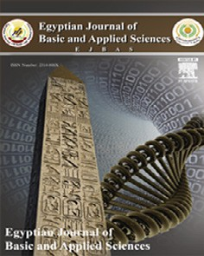

Contents lists available at [ScienceDirect](http://www.sciencedirect.com/science/journal/2314808X)

Egyptian Journal of Basic and Applied Sciences

journal homepage: [www.elsevier.com/locate/ejbas](http://www.elsevier.com/locate/ejbas)

Full Length Article

Physiological and biochemical responses of the green alga



*Pachycladella chodatii* (SAG 2087) to sodicity stress

Mustafa A. Fawzy a,⇑, Dalia A. Abdel-Wahab b, Awatief F. Hifney a

a *Botany and Microbiology Department, Faculty of Science, Assiut University, Assiut 71516, Egypt*

b *Botany Department, Faculty of Science (New Valley Branch), Assiut University, Egypt*

# a r t i c l e i n f o

*Article history:*

Received 3 March 2016

Received in revised form 4 October 2016 Accepted 19 November 2016

Available online 1 December 2016

*Keywords: Pachycladella chodatii* Lipoxygenase Antioxidant enzymes Hydrogenase Sodicity

Fatty acid fractionation

# a b s t r a c t

The effects of various concentrations of different carbon sources (Na2CO3 and NaHCO3) as sodicity stress on growth parameters, CO2 consumption rate, enzyme activity, intracellular lipid content, and fatty acid profiles of *Pachycladella chodatii* were studied. Generally, the total chlorophyll was increased by increas- ing the concentrations of Na2CO3 and NaHCO3. The biomass productivity as well consumption rate of car- bon dioxide of *P. chodatii* reached the highest values with increasing concentrations of Na2CO3 and NaHCO3. The soluble protein content of *P. chodatii* was highest at the lowest Na2CO3 and NaHCO3 concen- trations. The addition of different concentrations of Na2CO3 and NaHCO3 in the growth media induces lipoxygenase and superoxide dismutase specific activity. Catalase and total antioxidant enzymes were increased by supplementing the growth media with 60 and 45 mg l—1 of Na2CO3 and NaHCO3, respec-

tively. Hydrogenase uptake activity in *P. chodatii* increased gradually in all treated cultures with the time

elapsed recording the maximum activity after 11 days of growth especially at 60, 45 mg l—1 of Na2CO3 and NaHCO3 respectively. Lipids content was increased at low concentration of Na2CO3 (40 and 15 mg l—1) and NaHCO3 (60, 45 mg l—1) respectively. Subsequent to algal cultivation in different concentrations of Na2CO3, the cultures were filtered and biodiesel was prepared by direct esterification of dry algal bio-

mass. Methyl esters of palmitic, elaidic and stearic acids represented the major components while myris- tic, pentadecanoic and 9,12-octadecenoic acids represented a minor component of biodiesel produced from *P. chodatii* treated with different concentrations of Na2CO3 and NaHCO3.

© 2016 Mansoura University. Production and hosting by Elsevier B.V. This is an open access article under

the CC BY-NC-ND license (<http://creativecommons.org/licenses/by-nc-nd/4.0/>).

1. Introduction

Microalgae, a group of fast-growing unicellular or simple multi- cellular microorganisms, offer several advantages, including higher photosynthetic efficiency, compared to crop plants. They possess high CO2 fixation capacities and under optimal culture condition express growth rates several orders of magnitudes higher than con- ventional crop plants [1,2]. Microalgae can fix CO2 from different sources, which can be categorized as CO2 from the atmosphere, industrial exhaust gases, and fixed CO2 in the form of soluble car- bonates (NaHCO3 and Na2CO3). Salinization is one of the major environmental factors limiting global crop productivity, because it restricts crop yield particularly in the arid and semi-arid regions [3]. Salinization occurs not only in Na2CO3 and NaHCO3 the soil, but also in the surface water and groundwater mainly caused by high evaporation [4,5]. Chloride and carbonate salts, which are the main salts causing salinization, widely exist in aquatic environment.

* Corresponding author.

*E-mail address:* [mostafa.mahmoud@science.au.edu.eg](mailto:mostafa.mahmoud@science.au.edu.eg) (M.A. Fawzy).

Therefore, algae, the most abundant lower plants living in water, may suffer from salinization stress for high water evaporation [6]. Compared with lots of studies on algae stressed by chloride salt, data on the carbonate stress responses are rather limited. In higher plants, Na2CO3 and NaHCO3 stresses can inhibit seed germination [7], seedling growth [8], photosynthesis [9,10], ion absorption

[11] and antioxidant enzyme activity [8]. In algae, lower dose of NaHCO3 can promote the photosynthesis as HCO— is the carbon source [12,13], but a higher dose of NaHCO3 and Na2CO3 is harmful due to the high pH and Na+ toxic effects. It has been reported that

3

high pH reduces algal photosynthetic ability and pigment content, because it limits dissolved CO2 concentration in water [14]. The depletion of dissolved CO2 can stimulate ROS formation, increase antioxidant enzyme activity [15]. Algal biomass contains all essen- tial amino acids, a variety of unsaturated fatty acids, carbohydrates, dietary fiber as well as numerous vitamins and other bioactive com- pounds, it is a highly suitable alternative in livestock feeding and rather advantageous (e.g., through aquaculture of food additive) for human nutrition [16,17]. It is also used to produce high-value biofuels, including methane produced by anaerobic digestion of

<http://dx.doi.org/10.1016/j.ejbas.2016.11.001>

2314-808X/© 2016 Mansoura University. Production and hosting by Elsevier B.V.

This is an open access article under the CC BY-NC-ND license (<http://creativecommons.org/licenses/by-nc-nd/4.0/>).

algal biomass, biodiesel derived from oil as well as biohydrogen and bioethanol [18]. These cellular processes could be affected by abi- otic stresses such as sodicity. Where, there is information is avail- able about the effects of carbonate stress on algae, although it widely exists in and even dominates water bodies [6]. Therefore, this study was carried out to determine the different effects of car- bon sources (Na2CO3, NaHCO3) on the growth parameters, CO2 con- sumption rate, enzyme activity (LOX, SOD, CAT and Hup), intracellular lipid content, and fatty acid profiles of the green alga *Pachycladella chodatii* in batch culturing technique cultivation.

1. Materials and methods
   1. *Microorganism and culture medium*

The culture of *P. chodatii* (SAG 2087) used in this study was kindly donated to Prof. R. Abdel-basset from the Collection of Algal Cultures at the University of Göttingen (Germany). The culture was

kept in modified BG11 medium [19]. The alga was grown autotrophically and axenically in batch cultures under 25 ± 1 °C with continuous illumination at intensities of 48.4 lmole pho- ton m—2 s—1. Instead of aeration the culture was shaked during the experiment period, pH of the medium was adjusted to pH 7.5

prior to autoclaving.

* 1. *Experimental design*

Twenty milliliters of exponential cultures were centrifuged, standardized at an optical density at 680 nm of 0.1, and inoculated into 300 ml of BG11 medium in 500 ml Erlenmeyer flasks in tripli- cate. The effect of different carbon source namely Na2CO3 [(control

(20 mg l—1), 100% (40 mg l—1), 150% (60 mg l—1) and 200%

(80 mg l—1)], NaHCO3 [(control (0 mg l—1), (15, 45, 75 mg l—1)], on growth and biochemical composition of *P. chodatii* were studied. The cultures were grown as previously mentioned conditions. The alga was harvested by centrifugation at the beginning of sta-

tionary phase.

* 1. *Monitoring of algal growth*

Growth of *P. chodatii* was monitored by determining the dry weight and biomass productivity that was calculated according to Chisti [2]. The biomass productivity (*P*, mg l—1d—1) was calcu- lated using the following equation:

*P* = D*X*/D*t*

where D*X* is the variation of biomass concentration (mg l—1), during the culture time D*t* (d). Biomass was determined as the cellular dry weight and measured gravimetrically at the beginning and end of

the study. A known volume of culture was filtered through pre- weighed GF/C filter paper. The filtered cell mass was oven dried at 105 °C for 24 h until constant weight.

* 1. *Estimation of pigments (chlorophylls and carotenoids)*

Chlorophyll (a + b) and carotenoids were extracted in methanol (80%) then estimated spectrophotometrically, and determined according to Metzner et al. [20].

* + 1. *Estimation of specific growth rate*

The specific growth rate (l) calculated as chlorophyll *a* was determined using the following formula:

l(h—1) = (Ln*N*2 — Ln*N*1)/(*t*2 — *t*1), where *N*2 and *N*1 represent the

chlorophyll *a* concentrations at times *t*1 (day 0) and *t*2 (day 11), respectively.

* 1. *Determination of the CO2 consumption rate*

The CO2 consumption rate (PCO2, mg l—1d—1) was determined depending the biomass productivity (*P*) from the following equa- tion as described by Chisti [2].

*P*CO2 = 1.88 × *P*

* 1. *Determination of soluble proteins*

Protein contents were determined in the algal extract by Folin reagent according to Lowry et al. [21]. A calibration curve was con- structed using bovine serum albumin (BSA) and the data were expressed as mg BSA g—1 dry weight.

* 1. *Assay of enzyme activity*
     1. *Preparation of enzyme extract*

Hundred ml of algal culture were centrifuged at 5000 rpm and the pellet was homogenized in 5 ml of 100 mM potassium phos- phate buffer (pH 7.8) containing 0.1 mM of EDTA and 0.1 g polyvi-

nyl pyrrolidone (PVP). The homogenate was centrifuged at 18,000 rpm for 10 min. at 4 °C and the supernatants were collected and used for the assays of Lipoxygenase (LOX), superoxide dismu- tase (SOD), catalase (CAT) and total antioxidant activity. All colori- metric measurements (including enzyme activities) were made at 20 °C using a Unico UV-2100 spectrophotometer. The specific activity was expressed as units/mg protein.

* + 1. *Assay of lipoxygenase activity*

Lipoxygenase (LOX; EC 1.13.11.12) activity was estimated according to the method of Minguez-Mosquera et al. [22].

* + 1. *Assay of antioxidant enzymes activity*
       1. *Superoxide dismutase.* Superoxide dismutase (SOD; EC 1.15.1.1) activity was assayed by following the autoxidation of epi- nephrine (adenochrome) as described by Misra and Fridovich [23], with some modifications. Activity was measured in a final volume of 2 ml of the reaction medium containing 50 mM of sodium car-

bonate buffer (pH 10.2), 0.1 mM EDTA, 100 ll protein extract and

100 ll of 5.5 mg/ml epinephrine (dissolved in 10 mM HCl, pH 2). Autoxidation of epinephrine was determined colorimetrically using a spectrophotometer (Unico UV-2100 spectrophotometer) at 480 nm for 1 min. Activity was reported as specific activity.

* + - 1. *Catalase.* Catalase (CAT; 1.11.1.6) activity was assayed by following the consumption of H2O2 for 1 min. as described by Aebi

[24] and Matsumura et al. [25].

* + - 1. *Determination of total antioxidant capacity.* Total antioxi- dant activity of the methanol extracts was evaluated by the phos- phomolybdenum method [26]. Methanol (0.3 ml) in the place of extract was used as the blank. Ascorbic acid (AA) was used as standard.
  1. *Assay of hydrogenase activity*

The sum uptake activity of Hup (uptake hydrogenase) and the bidirectional hydrogenase assay mixture contained 1 ml algal cul- ture, 2.75 ml phosphate buffer (50 mM), 0.25 ml methyl blue (50 mM), 1 ml sodium dithionite (100 mM), flushed with nitrogen to remove oxygen followed by hydrogen, as conducted by Yu et al.

[27] and Colbeau et al. [28]. The reduction of methyl blue by Hup and hydrogen was monitored at 540 nm (spectrophotometer thermoscientific).

* 1. *Determination of total lipids*

The total lipids were determined by the sulfophosphovanilin method (SPV) Drevon and Schmit [29].

* 1. *Fatty acid methyl esters analysis*

Fatty acid methyl esters (FAMEs), from the alga was produced by direct acid esterification of its dry biomass according to [30,31], with modification. Algal biomass was air dried at 50 °C. The dry algal biomass (0.05 g) was suspended in 20 ml of mixture A (methanol 2: Chloroform 1: conc. HCl 1) and left overnight at 40 °C with shaking at 120 rpm. *n*-Hexane was used for extraction the produced fatty acid methyl esters and analyzed using GC/MS, Agilent Model 6890N/5975B [Column DB 5 ms, Agilent form (30, 0.25 mm, 0.25 mm)] in the Analytical Chemistry Unit, Chemistry Department, Faculty of Science, Assiut University.

* 1. *Statistical analysis*

All data obtained were subjected to one-way analysis variance (ANOVA), using the SPSS statistical package. For comparison of the means, the Duncan’ multiple range tests (*p* < 0.05) were used.

1. Results and discussion
   1. *Effect of different concentrations of Na2CO3 and NaHCO3 on the growth, biomass productivity and CO2 consumption rate of P. chodatii*

The content of chlorophyll a + b in the investigated alga sub- jected to different concentrations of Na2CO3 and NaHCO3 was shown in Table 1. The result showed that, the increase in concen- trations of Na2CO3 caused significant increment in chl. a + b con- tent for *P. chodatii* compared to the control culture (*p* < 0.05). The high concentration of NaHCO3 (70 mg l—1) caused non-significant

increase in the content of chl. a + b. Results obtained dealt with

the carotenoids content in *P. chodatii* cleared that, low concentra- tion of Na2CO3 (40 mg l—1) caused significant increase in carote- noids content, but increasing of NaHCO3 concentrations led to

slight decrease in the carotenoids content at *p* > 0.05.

The results in Table 1, indicated that the specific growth rate varied according to the concentration of Na2CO3 and NaHCO3. From these data, it concluded that the highest specific growth rate calcu- lated on the basis of chl. *a* in *P. chodatii* was 0.84 that recorded at the control culture. The biomass productivity of *P. chodatii* reached

the highest values at 60, 80 mg l—1 d—1 of Na2CO3 and 45, 75 mg l—1 mg l—1 of NaHCO3, which were 20.9, 21.4 mg l—1 d—1 and 18.2, 23.6 mg l—1 d—1, respectively. Srinivasan et al. [32] observed increase in the biomass of *Dunaliella* sp. grown on media

with NaHCO3 in compared to control, the maximum growth and biomass were attained at 100 mM concentration of bicarbonate. Microalgae species have the capacity to use carbonate such as

Na2CO3 and NaHCO3 for the cell growth [33]. Some of algal species typically have a high extracellular carbon hydrase activity, which is responsible for the conversion of carbonate to free CO2 and thereby facilitate the assimilation.

The analysis of the carbon dioxide consumption rate of *P. cho- datii* confirms that *P. chodatii* has a great capacity utilization of car-

bon dioxide with an estimated range of 39.3, 40.2 mg l—1 d—1 in case of the treatment with 60, 80 mg l—1 of Na2CO3 respectively. While, the highest capacity utilization of carbon dioxide was 34.2, 44.4 mg l—1 d—1 that obtained for *P. chodatii* treated with 45,

75 mg l—1 of NaHCO3, respectively Table 1. In this respect, Elvira- Antonio et al. [33] found that the consumption rate of carbon diox- ide of *Neochloris oleoabundans* had a greater capacity and tolerance for using carbon dioxide and carbonate (112.8–115.2 mg l—1 d—1) while in case of *Chlorella vulgaris* the values were (95.76–105.75 mg l—1 d—1).

* 1. *Effect of different concentrations of Na2CO3 and NaHCO3 on the soluble proteins content of P. chodatii*

Protein content in algae is an important criterion for their use as food. In the present study, addition of 40 mg l—1 of Na2CO3 induced protein accumulation as shown in Fig. 1. Manjunath and Geeta [34]

found that high protein content was recorded in *Spirulina platensis*

strains SM, S4 and G1 with higher carbonate levels.

* 1. *Effect of different concentrations of Na2CO3 and NaHCO3 on lipoxygenase, antioxidant enzymes (LOX, SOD and CAT) and hydrogenase activity of P. chodatii*

Under normal growth conditions, reactive oxygen species (ROS), like singlet oxygen, superoxide radical, peroxide and hydroxyl rad- ical are formed at low rate in photosynthetic cells as byproducts of

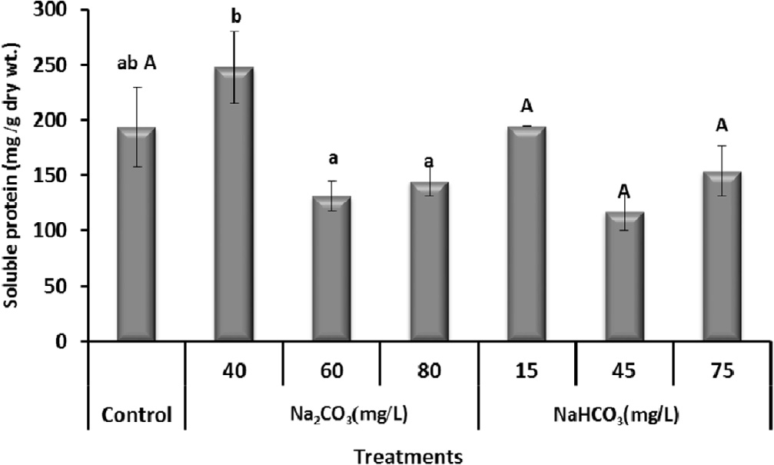

Fig. 1. Effect of different carbon sources on soluble proteins of *P. chodatii*. Data represents mean ± SE of three replicates. Different letters are, Capital for NaHCO3 and small for Na2CO3, *p* < 0.05 was considered as significant.

Table 1

Growth parameters, biomass productivity and consumption rate of CO2 of *Pachycladella chodatii* at various concentrations of Na2CO3 and NaHCO3.

|  |  |  |  |  |  |  |  |
| --- | --- | --- | --- | --- | --- | --- | --- |
| Treatments |  | (Chl. a+b) | Carotenoids | l (d—1) | Biomass productivity | Consumption rate of CO2 |  |
|  |  | (lg ml—1) |  |  | (mg l—1d—1) |  |  |
|  | Control | 2.5 ± 0.00aB | 0.91 ± 0.02aB | 0.84 | 16.4 ± 0.8abA | 30.8 ± 1.5abA |  |
| Na2CO3 (mg/L) | 40 | 3.05 ± 1.03b | 1.04 ± 0.00b | 0.80 | 11.1 ± 2.7a | 20.9 ± 5.1a |  |
|  | 60 | 2.99 ± 0.8b | 0.88 ± 0.06a | 0.72 | 20.9 ± 2.4b | 39.3 ± 4.4b |  |
|  | 80 | 3.33 ± 0.9 c | 0.91 ± 0.00a | 0.78 | 21.4 ± 0.5b | 40.2 ± 0.9b |  |
| NaHCO3 (mg/L) | 15 | 2.57 ± 0.7A | 0.72 ± 0.00A | 0.55 | 13.6 ± 6.0A | 25.6 ± 11.3A |  |
|  | 45 | 1.63 ± 0.6B | 0.63 ± 0.03A | 0.17 | 18.2 ± 3.4A | 34.2 ± 6.4A |  |
|  | 75 | 2.84 ± 0.6 B | 0.60 ± 0.08A | 0.51 | 23.6 ± 3.4A | 44.4 ± 6.4A |  |

l = the specific growth rate, Chl. a + b = chlorophyll a and b

aerobic metabolism, but many stresses can produce a dramatic increase in the ROS production rate. ROS induce the activation of defense enzymes such as lipoxygenases (LOXes) that are key enzymes to adjust the production of hormones and defensive metabolites in plants and algae [35,36]. The results in this study cleared that, in general, LOX enzyme and SOD specific activity were stimulated in *P. chodatii* by increment of NaHCO3 and Na2CO3 con- centrations in the growth media Fig. 2a, b. In this respect, Wang et al. [37] reported that the activity of SOD under Na2CO3 stress

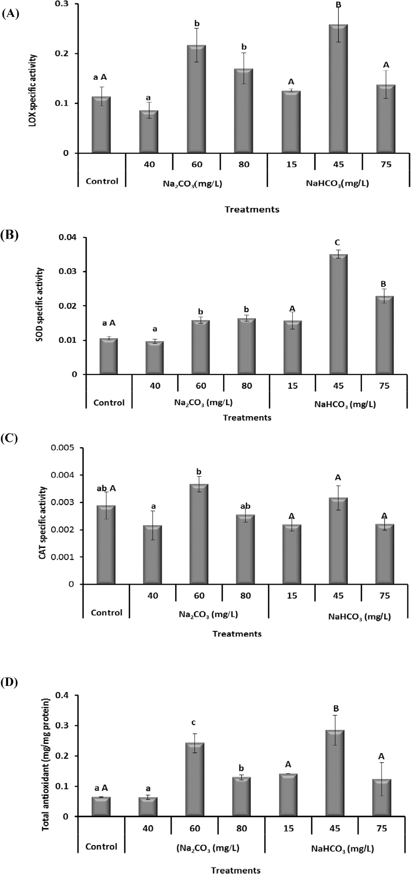

Fig. 2. Lipoxygenase specific activity (A), superoxide dismutase specific activity (B), catalase specific activity (C), total antioxidant activity (D) of *P. chodatii* as influenced by the addition of different carbon sources. Data represents mean ± SE of three replicates. Different letters are, Capital for NaHCO3 and small for Na2CO3, *p* < 0.05 was considered as significant.

was clearly higher than that of NaCl stress in *Puccinellia tenuiflora*. Zuo et al. [6] documented that compared to the NaCl stress, Na2CO3 stress induced more ROS production and had more toxic effects on algal photosynthetic pigments and ability, which might be caused by the high pH. Superoxide dismutase is the first enzyme of the enzymatic antioxidative pathway to convert superoxide anion into peroxides, which are scavenged by catalase. In this study, catalase specific activity was increased by supplementing the growth media with 60 and 45 mg l—1 of Na2CO3 and NaHCO3, respectively Fig. 2c.

Catalase, is one of the most important enzymes, scavenges H2O2 by

directly breaking down to form H2O and O2 in peroxisomes and glyoxisomes [38]. Variations in total antioxidant activity of *P. cho- datii* affected by sodicity stress are shown in Fig. 2d. Results of the present study show that, all applicable levels stimulate total antioxidant activity especially at (60 and 45 mg l—1 of Na2CO3

and NaHCO3, respectively). Under various abiotic stresses, the

extent of ROS production exceeds the antioxidant defense capabil- ity of the cell, resulting in cellular damages. To mitigate and repair damage initiated by ROS, algae have developed a complex antiox- idant system, *Chlorella* sp. [39], *Spirulina* sp. [40], *Botryococcus* sp. [41], *Dunaliella* sp. [42] and *Nostoc* sp. [43]. Concerning hydroge- nase activity of *P. chodatii*, increased in general with the time and the highest activity recorded at 60, 45 mg l—1 of Na2CO3 and

NaHCO3 respectively Fig. 3. Kapulnik and Phillips [44] showed that

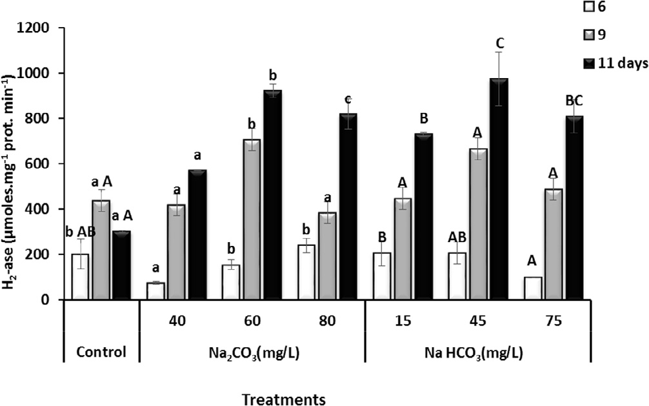

Fig. 3. Hydrogenase activity (Hup) of *P. chodatii* as influenced by the addition of different carbon sources. Data represents mean ± SE of three replicates. Different letters are, Capital for NaHCO3 and small for Na2CO3, *p* < 0.05 was considered as significant.

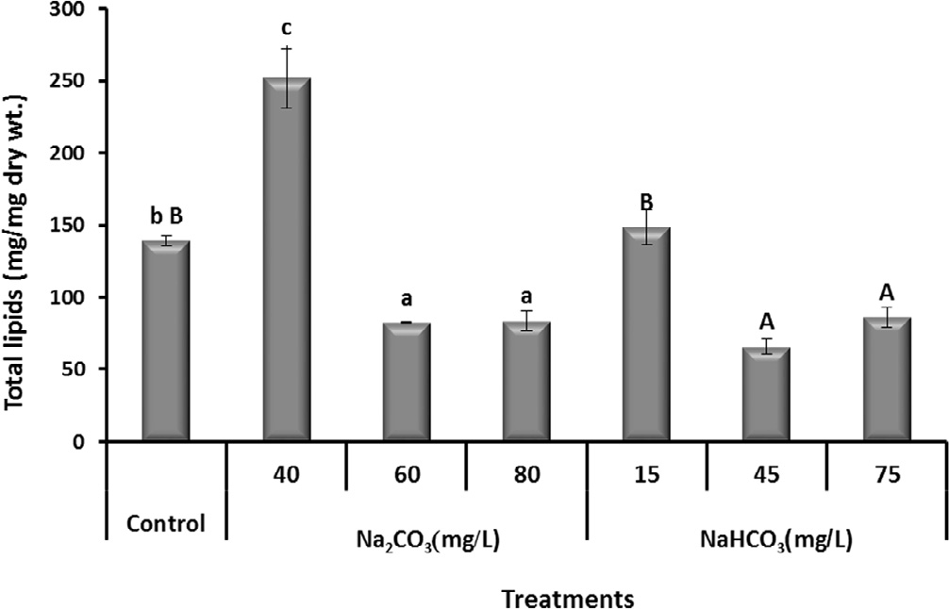

Fig. 4. Total lipids of *P. chodatii* as influenced by the addition of different carbon sources. Data represents mean ± SE of three replicates. Different letters are, Capital for NaHCO3 and small for Na2CO3, *p* < 0.05 was considered as significant.

Table 2

Fatty acid methyl ester (FAME) profile of *P. Chodatii* grown under various concentrations of Na2CO3 and NaHCO3.

|  |  |  |  |  |  |  |  |  |  |
| --- | --- | --- | --- | --- | --- | --- | --- | --- | --- |
| FAME | Control | Na2CO3 |  |  |  | NaHCO3 |  | | |
|  |  | 40 | 60 | 80 |  | 15 | 45 | 75 |  |
|  |  | (mg l—1) |  |  |  |  |  |  |  |
|  | FAME (%) |  |  |  |  |  |  |  |  |
| Lauric acid | 0.57 | 2.05 | – | 0.69 |  | – | – | – |  |
| Hexanoic anhydride | – | – | 1.29 | – |  | – | – | – |  |
| Myristic acid | 5.42 | 6.62 | 1.4 | 4.73 |  | 0.89 | 1.19 | 0.46 |  |
| Pentadecanoic acid | 0.87 | 0.85 | 1.99 | 0.67 |  | 084 | 0.52 | 1.49 |  |
| 13-Methyltetradecanoic acid | – | – | – | – |  | – | 1.39 | – |  |
| Palmitic acid | 27.41 | 29.3 | 26.52 | 30.45 |  | 26.22 | 25.56 | 24.43 |  |
| Methyl isohexadecanoate | – | – | 1.88 | 1.32 |  | – | – | – |  |
| Stearic acid | 2.66 | 27.6 | 5.88 | 24.33 |  | 1.44 | 3.35 | 1.13 |  |
| Pentadecyl 2-chlorpropanoate | – | – | 1.99 | – |  | – | – | – |  |
| Heptadecanoic acid | – | – | – | 1.07 |  | – | – | – |  |
| Palmitic acid b-monoglyceride | 3.42 | 4.35 | – | – |  | – | – | – |  |
| Propanoic acid, 2-chloro-, hexadecyl ester | – | – | – | – |  | – | – | 0.81 |  |
| Pentadecan-4-yl pentanoate | – | – | 2.22 | – |  | – | – | 0.46 |  |
| Arachidic acid | 0.86 | 1.25 | – | 0.94 |  | – | – | – |  |
| Propanoic acid,2-chloro-,octadecyl ester | – | – | – | – |  | 0.84 | – | – |  |
| Heptadecylperfluorobutyrate | – | – | – | 1.26 |  | – | – | – |  |
| 2-Hydroxy-1-(hydroxymethyl) | 3.26 | 5.76 | – | – |  | – | – | – |  |
| Octadecanoic acid ethyl ester |  |  |  |  |  |  |  |  |  |
| Heptafluorobutyric acid | 0.57 | – | – | – | – | | – | – | |
| Crotonic acid | – | 0.59 | – | – | – | | – | – | |
| 2-Maleic acid, monomethyl ester | – | – | – | – | – | | – | 2.03 | |
| Palmitoleic acid | .870 | .950 | – | – | – | | 3.16 | 9.94 | |
| Valeric acid, undec-2-enyl ester | 1.23 | – | – | – | 2.52 | | – | – | |
| Methyl palmitoleate | – | – | – | 2.68 | 4.65 | | – | – | |
| Elaidic acid | 6.52 | 3.01 | 2.85 | 22.43 | 5.16 | | 38.83 | 2.33 | |
| 8-Octadecenoic acid | 4.55 | – | – | – | – | | – | – | |
| Octadec-11-enoic acid | – | – | – | – | – | | 1.55 | – | |
| 1-Nonadecenoic acid | 0.87 | – | – | – | – | | – | – | |
| 9,12-Octadecenoic acid | 2.67 | 2.76 | 9.39 | 4.76 | 7.61 | | 9.04 | 6. 0 | |
| Hexadecatrienoic acid | 1.1 | 1.16 | – | 1.261 | 2.64 | | – | 2.06 | |
| 9,12,15-Octadecatrien-1-ol, (*Z*,Z,*Z*) | – | – | – | – | – | | 1.49 | – | |
| cis,cis,cis-9,12,15 Octadecatrienoic acid | 23.95 | – | 39.04 | – | – | | – | 40.48 | |
| Linolenic acid | 12.42 | 12.48 | – | – | 46.37 | | – | – | |
| c-Linolenic acid | – | – | – | .380 | .780 | | – | – | |
| 11,14,17-Eicosatrienoic acid | – | 1.76 | – | – | – | | – | – | |
| 2-Linolenoylglycerol | – | 1.75 | – | – | – | | – | – | |
| Methyl eicosapentaenoate | 3.42 | – | – | – | – | | 7.18 | 8.41 | |
| Methyl eicosa-5,8,11,14,17-pentaenoate | – | – | – | – | – | | – | 3.43 | |

the sodium ion stimulates hydrogenase activity in pea root nodules containing *Rhizobium leguminosarum* bacteria.

* 1. *Effect of different concentrations of Na2CO3 and NaHCO3 on the total lipids content and fatty acid methyl ester (FAME) of P. chodatii*

Results concerning the influence of addition of different carbon sources on the total lipid contents of *P. chodatii* are depicted in Fig. 4. The results indicated that, the low concentration (40 and 15 mg l—1) of Na2CO3 and NaHCO3, respectively, led to increasing

the total lipids, but reversible trend was observed when the culture

of *P. chodatii* treated with higher concentrations of Na2CO3 and NaHCO3. Gardner et al. [45] reported that, inorganic carbon sources mostly could be one of the chief factors that help improve the car- otenoids and lipids content in the algal cells by improving photo- synthetic efficiency and growth rate. Zheng et al. [46] demonstrated that, lipid yield of *C. vulgaris* reached its peak with the concentration increase of the inorganic carbon source after 10 days cultivation, but dropped again by further increase of the concentration. Inorganic carbon, in the form of bicarbonate (HCO-3

—), is an effective lipid accumulation trigger [45]. Furthermore, it was recently shown that the addition of sodium bicarbonate is a viable strategy to increase lipid accumulation in marine Chloro- phytes [47] and *Dunaliella* sp. [32].

A systematic analysis of the fatty acid methyl ester composition is very important for species selection for biodiesel production. The most common fatty acids of microalgae are palmitic, stearic, lino- lenic acids [48]. Most algae have only small amounts of eicosapen- taenoic acid and docosahexaenoic acid; however, in some species of particular genera these polyunsaturated fatty acids can accumu- late in appreciable quantities depending on cultivation conditions [49].

In this study, the direct esterification of dry mass was applied to

*P. chodatii* and the produced fatty acid methyl esters (biodiesel) were analyzed by GC/MS as shown in Table 2. Methyl esters of pal- mitic, elaidic and stearic acids represented a major amount of bio- diesel produced from *P. chodatii* treated with all concentration of Na2CO3 and NaHCO3; while, myristic, pentadecanoic and 9,12- octadecenoic acids represented a minor component of biodiesel produced from all treatments in this study. Low concentration of NaHCO3 (15 mg l—1) stimulated a giant production of linolenic acid

about four fold compared with control. As well, cis,cis,cis-9,12,15-

Octadecatrienoic acid was improved and recorded 39.04, 40.48% in the algal culture grown in 60 mg l—1 of Na2CO3 and 75 mg l—1 of NaHCO3, respectively, compared with the control culture that

recorded 23.95%. In this respect, the composition of fatty acids of *Chlamydomonas mexicana* and *Scenedesmus obliquus* was also enhanced by the increased NaCl concentration. Whereas, at 50 mM NaCl palmitic acid (35%) and linoleic acid (41%) were the

predominant fatty acids in *C. mexicana*, while oleic acid (41%) and a-linolenic acid (20%) were the major fraction found in *S. obliquus* [50]. The degree of membrane fatty acids is an important parame- ter in the algal adaptation to the environmental conditions [51].

Generally, the compositional profiles of fatty acid for the algal strains are influenced by the conditions of growth such as nutrient levels, light intensities and temperatures [52]. This makes it more difficult to define a single compositional profile for algal-based bio- diesel [53]. As well, clear changes in the carbon chain length and degree of unsaturation are important algal oil features for the bio- diesel production and may influence its properties and perfor- mance [54].

1. Conclusion

The current study tends to investigate the effects of various concentrations of Na2CO3 and NaHCO3 on the growth parameters, CO2 consumption rate, enzyme activity, intracellular lipid content and fatty acid profiles of *P. chodatii*. The biomass productivity as well consumption rate of carbon dioxide of *P. chodatii* were increased by increasing Na2CO3 and NaHCO3 concentrations. Simi- larly, lipoxygenase and superoxide dismutase specific activity were enhanced with different concentrations of Na2CO3 and NaHCO3. Catalase and total antioxidant enzymes of *P. chodatii* was increased with 60 and 45 mg l—1 of Na2CO3 and NaHCO3, respectively. The

low concentration of Na2CO3 and NaHCO3 increased the lipid con-

tent of *P. chodatii*. The concentration of fatty acid methyl ester pro- duced from *P. chodatii* were altered by the treatment with different concentrations of Na2CO3 and NaHCO3.

References

1. [Chisti Y. Biodiesel from microalgae. Biotechnol Adv 2007;25:294–306](http://refhub.elsevier.com/S2314-808X(16)30164-6/h0005).
2. [Chisti Y. Biodiesel from microalgae beats bioethanol. Trends Biotechnol](http://refhub.elsevier.com/S2314-808X(16)30164-6/h0010) [2008;26:126–31](http://refhub.elsevier.com/S2314-808X(16)30164-6/h0010).
3. Shannon MC, Grieve CM, Francois LE, Whole-plant response to salinity. In: W.

R.E. editor, Plant–environment interactions, New York, 1994, p. 199–24.

1. [Sereda J, Bogard M, Hudson J, Helps D, Dessouki T. Climate warming and the](http://refhub.elsevier.com/S2314-808X(16)30164-6/h0020) [onset of salinization: rapid changes in the limnology of two northern plains](http://refhub.elsevier.com/S2314-808X(16)30164-6/h0020) [lakes. Limnologica 2011;41:1–9](http://refhub.elsevier.com/S2314-808X(16)30164-6/h0020).
2. [Yu R, Liu T, Xu Y, Zhu C, Zhang Q, Qu Z, et al. Analysis of salinization dynamics](http://refhub.elsevier.com/S2314-808X(16)30164-6/h0025) [by remote sensing in Hetao Irrigation District of North China. Agric Water](http://refhub.elsevier.com/S2314-808X(16)30164-6/h0025) [Manage 2010;97:1952–60](http://refhub.elsevier.com/S2314-808X(16)30164-6/h0025).
3. [Zuo Z, Chen Z, Zhu Y, Bai Y, Wang Y. Effects of NaCl and Na2CO3](http://refhub.elsevier.com/S2314-808X(16)30164-6/h0030) [stresses on](http://refhub.elsevier.com/S2314-808X(16)30164-6/h0030) [photosynthetic ability of *Chlamydomonas reinhardtii*. Biologia](http://refhub.elsevier.com/S2314-808X(16)30164-6/h0030) [2014;69:1314–22](http://refhub.elsevier.com/S2314-808X(16)30164-6/h0030).
4. [Guan B, Zhou D, Zhang H, Tian Y, Japhet W, Wang P. Germination responses of](http://refhub.elsevier.com/S2314-808X(16)30164-6/h0035) [*Medicago ruthenica* seeds to salinity, alkalinity, and temperature. J Arid Environ](http://refhub.elsevier.com/S2314-808X(16)30164-6/h0035) [2009;73:135–8](http://refhub.elsevier.com/S2314-808X(16)30164-6/h0035).
5. [Manivannan P, Jaleel CA, Sankar B, Kishorekumar A, Murali P, Somasundaram](http://refhub.elsevier.com/S2314-808X(16)30164-6/h0040) [R, et al. Mineral uptake and biochemical changes in *Helianthus annuus* under](http://refhub.elsevier.com/S2314-808X(16)30164-6/h0040) [treatment with different sodium salts. Colloid Surf., B 2008;62:58–63](http://refhub.elsevier.com/S2314-808X(16)30164-6/h0040).
6. [Yang C, Jianaer A, Li C, Shi D, Wang D. Comparison of the effects of salt-stress](http://refhub.elsevier.com/S2314-808X(16)30164-6/h0045) [and alkali-stress on photosynthesis and energy storage of an alkali-resistant](http://refhub.elsevier.com/S2314-808X(16)30164-6/h0045) [halophyte *Chloris virgata*. Photosynthetica 2008;46:273–8](http://refhub.elsevier.com/S2314-808X(16)30164-6/h0045).
7. [Yang C, Xu H, Wang L, Liu J, Shi D, Wang D. Comparative effects of salt-stress](http://refhub.elsevier.com/S2314-808X(16)30164-6/h0050) [and alkali-stress on the growth, photosynthesis, solute accumulation, and ion](http://refhub.elsevier.com/S2314-808X(16)30164-6/h0050) [balance of barley plants. Photosynthetica 2009;47:79–86](http://refhub.elsevier.com/S2314-808X(16)30164-6/h0050).
8. [Chen W, Cui P, Sun H, Guo W, Yang C, Jin H, et al. Comparative effects of salt](http://refhub.elsevier.com/S2314-808X(16)30164-6/h0055) [and alkali stresses on organic acid accumulation and ionic balance of](http://refhub.elsevier.com/S2314-808X(16)30164-6/h0055) [seabuckthorn (*Hippophae rhamnoides* L.). Ind Crop Prod 2009;30:351–8](http://refhub.elsevier.com/S2314-808X(16)30164-6/h0055).
9. [Bhatti S, Colman B. Evidence for the occurrence of photorespiration in](http://refhub.elsevier.com/S2314-808X(16)30164-6/h0060) [synurophyte algae. Photosynth Res 2011;109:251–6](http://refhub.elsevier.com/S2314-808X(16)30164-6/h0060).
10. [Huege J, Goetze J, Schwarz D, Bauwe H, Hagemann M, Kopka J. Modulation of](http://refhub.elsevier.com/S2314-808X(16)30164-6/h0065) [the major paths of carbon in photorespiratory mutants of *Synechocystis*. PLoS](http://refhub.elsevier.com/S2314-808X(16)30164-6/h0065) [One 2011;6:e16278](http://refhub.elsevier.com/S2314-808X(16)30164-6/h0065).
11. [Olischläger M, Bartsch I, Gutow L, Wiencke C. Effects of ocean acidification on](http://refhub.elsevier.com/S2314-808X(16)30164-6/h0070) [growth and physiology of *Ulva lactuca* (Chlorophyta) in a rockpool-scenario.](http://refhub.elsevier.com/S2314-808X(16)30164-6/h0070) [Phycol Res 2013;61:180–90](http://refhub.elsevier.com/S2314-808X(16)30164-6/h0070).
12. [Sültemeyer D, Biehler K, Fock HP. Evidence for the contribution of pseudocyclic](http://refhub.elsevier.com/S2314-808X(16)30164-6/h0075) [photophosphorylation to the energy requirement of the mechanism for](http://refhub.elsevier.com/S2314-808X(16)30164-6/h0075) [concentrating inorganic carbon in *Chlamydomonas*. Planta 1993;189:235–42](http://refhub.elsevier.com/S2314-808X(16)30164-6/h0075).
13. [Del Campo JA, García-González M, Guerrero MG. Outdoor cultivation of](http://refhub.elsevier.com/S2314-808X(16)30164-6/h0080) [microalgae for carotenoid production: current state and perspectives. Appl](http://refhub.elsevier.com/S2314-808X(16)30164-6/h0080) [Microbiol Biotechnol 2007;74:1163–74](http://refhub.elsevier.com/S2314-808X(16)30164-6/h0080).
14. [Spolaore P, Joannis-Cassan C, Duran E, Isambert A. Commercial applications of](http://refhub.elsevier.com/S2314-808X(16)30164-6/h0085) [microalgae. J Biosci Bioeng 2006;101:87–96](http://refhub.elsevier.com/S2314-808X(16)30164-6/h0085).
15. [Mudimu O, Rybalka N, Bauersachs T, Friedl T, Schulz R. Influence of different](http://refhub.elsevier.com/S2314-808X(16)30164-6/h0090) [CO2](http://refhub.elsevier.com/S2314-808X(16)30164-6/h0090) [concentrations on microalgae growth, a-tocopherol content and fatty acid](http://refhub.elsevier.com/S2314-808X(16)30164-6/h0090) [composition. Geomicrobiol J 2015;32:291–303](http://refhub.elsevier.com/S2314-808X(16)30164-6/h0090).
16. Rippka R, Herdman M, Pasteur culture collection of cyanobacterial strains in axenic culture. In: Pasteur editor, Catalogue of Strains 103 P Paris; 1993.
17. [Metzner H, Rau H, Senger H. Untersuchungen zur synchronisierbarkeit](http://refhub.elsevier.com/S2314-808X(16)30164-6/h0100) [einzelner pigmentmangel-mutanten von *Chlorella*. Planta 1965;65:186–94](http://refhub.elsevier.com/S2314-808X(16)30164-6/h0100).
18. [Lowry OH, Rosebrough NJ, Farr AL, Randall RJ. Protein measurement with the](http://refhub.elsevier.com/S2314-808X(16)30164-6/h0105) [Folin phenol reagent. J Biol Chem 1951;193:265–75](http://refhub.elsevier.com/S2314-808X(16)30164-6/h0105).
19. [Minguez-Mosquera M, Jaren-Galan M, Garrido-Fernandez J. Lipoxygenase](http://refhub.elsevier.com/S2314-808X(16)30164-6/h0110) [activity during pepper ripening and processing of paprika. Phytochemistry](http://refhub.elsevier.com/S2314-808X(16)30164-6/h0110) [1993;32:1103–8](http://refhub.elsevier.com/S2314-808X(16)30164-6/h0110).
20. [Misra HP, Fridovich I. The role of superoxide anion in the autoxidation of](http://refhub.elsevier.com/S2314-808X(16)30164-6/h0115) [epinephrine and a simple assay for superoxide dismutase. J Biol Chem](http://refhub.elsevier.com/S2314-808X(16)30164-6/h0115) [1972;247:3170–5](http://refhub.elsevier.com/S2314-808X(16)30164-6/h0115).
21. [Aebi H. Catalase in vitro. Methods Enzymol 1984;105:121–6](http://refhub.elsevier.com/S2314-808X(16)30164-6/h0120).
22. [Matsumura T, Tabayashi N, Kamagata Y, Souma C, Saruyama H. Wheat catalase](http://refhub.elsevier.com/S2314-808X(16)30164-6/h0125) [expressed in transgenic rice can improve tolerance against low temperature](http://refhub.elsevier.com/S2314-808X(16)30164-6/h0125) [stress. Physiol Plant 2002;116:317–27](http://refhub.elsevier.com/S2314-808X(16)30164-6/h0125).
23. [Prieto P, Pineda M, Aguilar M. Spectrophotometric quantitation of antioxidant](http://refhub.elsevier.com/S2314-808X(16)30164-6/h0130) [capacity through the formation of a phosphomolybdenum complex: specific](http://refhub.elsevier.com/S2314-808X(16)30164-6/h0130) [application to the determination of vitamin E. Anal Biochem 1999;269:337–41](http://refhub.elsevier.com/S2314-808X(16)30164-6/h0130).
24. [Yu RJ, Harmon SR, Blank F. Hair Digestion by a Keratinase of *Trichophyton*](http://refhub.elsevier.com/S2314-808X(16)30164-6/h0135)[*Mentagbophytes*. J. Invest. Dermatol. 1969;53:166–71](http://refhub.elsevier.com/S2314-808X(16)30164-6/h0135).
25. [Colbeau A, Kelley BC, Vignais PM. Hydrogenase activity in *Rhodopseudomonas*](http://refhub.elsevier.com/S2314-808X(16)30164-6/h0140)[*capsulata*: relationship with nitrogenase activity. J Bacteriol 1980;144:141–8](http://refhub.elsevier.com/S2314-808X(16)30164-6/h0140).
26. [Drevon B, Schmit JM. La reaction sulfo-phospho-vanilli-que dans l’etude des](http://refhub.elsevier.com/S2314-808X(16)30164-6/h0145) [lipides seriques Applications biochemiques, cliniques et pharmacologique.](http://refhub.elsevier.com/S2314-808X(16)30164-6/h0145) [Bull Trav Soc Pharm Lyon 1964;8:173–8](http://refhub.elsevier.com/S2314-808X(16)30164-6/h0145).
27. [Vicente G, Bautista LF, Gutiérrez FJ, Rodríguez RA, Martínez V, Rodríguez-](http://refhub.elsevier.com/S2314-808X(16)30164-6/h0150) [Frómeta RA, et al. Direct transformation of fungal biomass from submerged](http://refhub.elsevier.com/S2314-808X(16)30164-6/h0150) [cultures into biodiesel. Energy Fuel 2010;24:3173–8](http://refhub.elsevier.com/S2314-808X(16)30164-6/h0150).
28. [Vicente G, Bautista LF, Rodríguez R, Gutiérrez FJ, Sádaba I, Ruiz-Vázquez RM,](http://refhub.elsevier.com/S2314-808X(16)30164-6/h0155) [et al. Biodiesel production from biomass of an oleaginous fungus. Biochem Eng](http://refhub.elsevier.com/S2314-808X(16)30164-6/h0155) [J 2009;48:22–7](http://refhub.elsevier.com/S2314-808X(16)30164-6/h0155).
29. [Srinivasan R, Kumar VA, Kumar D, Ramesh N, Babu S, Gothandam KM. Effect of](http://refhub.elsevier.com/S2314-808X(16)30164-6/h0160) [dissolved inorganic carbon on b-carotene and fatty acid production in](http://refhub.elsevier.com/S2314-808X(16)30164-6/h0160) [*Dunaliella* sp.. Appl Biochem Biotechnol 2015:1–12](http://refhub.elsevier.com/S2314-808X(16)30164-6/h0160).
30. [Elvira-Antonio N, Ruíz-Marí A, Canedo-López Y. Effect of nitrogen content and](http://refhub.elsevier.com/S2314-808X(16)30164-6/h0165) [CO2](http://refhub.elsevier.com/S2314-808X(16)30164-6/h0165) [consumption rate by adding sodium carbonate in the lipid content of](http://refhub.elsevier.com/S2314-808X(16)30164-6/h0165) [*Chlorella vulgaris* and *Neochloris oleoabundans*. Int J Environ Prot 2013](http://refhub.elsevier.com/S2314-808X(16)30164-6/h0165).
31. [Manjunath R, Geeta G. Optimization of carbon and magnesium source and](http://refhub.elsevier.com/S2314-808X(16)30164-6/h0170) [their effect on growth and cell constituents of strains of *Spirulina platensis*.](http://refhub.elsevier.com/S2314-808X(16)30164-6/h0170) [Karna J Agric Sci 2010:18](http://refhub.elsevier.com/S2314-808X(16)30164-6/h0170).
32. [Liavonchanka A, Feussner I. Lipoxygenases: occurrence, functions and](http://refhub.elsevier.com/S2314-808X(16)30164-6/h0175) [catalysis. J Plant Physiol 2006;163:348–57](http://refhub.elsevier.com/S2314-808X(16)30164-6/h0175).
33. [Zhu Z, Qian F, Yang R, Chen J, Luo Q, Chen H, et al. A lipoxygenase from red alga](http://refhub.elsevier.com/S2314-808X(16)30164-6/h0180) [*Pyropia haitanensis*, a unique enzyme catalyzing the free radical reactions of](http://refhub.elsevier.com/S2314-808X(16)30164-6/h0180) [polyunsaturated fatty acids with triple ethylenic bonds. PLoS One 2015;10:](http://refhub.elsevier.com/S2314-808X(16)30164-6/h0180) [e0117351](http://refhub.elsevier.com/S2314-808X(16)30164-6/h0180).
34. [Wang Y, Sun G, Suo B, Chen G, Wang J, Yan Y. Effects of Na2CO3](http://refhub.elsevier.com/S2314-808X(16)30164-6/h0185) [and NaCl](http://refhub.elsevier.com/S2314-808X(16)30164-6/h0185) [stresses on the antioxidant enzymes of chloroplasts and chlorophyll](http://refhub.elsevier.com/S2314-808X(16)30164-6/h0185) [fluorescence parameters of leaves of *Puccinellia tenuiflora* (Turcz.) scribn. et](http://refhub.elsevier.com/S2314-808X(16)30164-6/h0185) [Merr. Acta Physiol Plant 2008;30:143–50](http://refhub.elsevier.com/S2314-808X(16)30164-6/h0185).
35. [Mittler R. Oxidative stress, antioxidants and stress tolerance. Trends Plant Sci](http://refhub.elsevier.com/S2314-808X(16)30164-6/h0190) [2002;7:405–10](http://refhub.elsevier.com/S2314-808X(16)30164-6/h0190).
36. [Wu L-C, Ho J-AA, Shieh M-C, Lu I-W. Antioxidant and antiproliferative](http://refhub.elsevier.com/S2314-808X(16)30164-6/h0195) [activities of *Spirulina* and *Chlorella* water extracts. J Agric Food Chem](http://refhub.elsevier.com/S2314-808X(16)30164-6/h0195) [2005;53:4207–12](http://refhub.elsevier.com/S2314-808X(16)30164-6/h0195).
37. [Jaime L, Mendiola JA, Herrero M, Soler-Rivas C, Santoyo S, Señorans FJ, et al.](http://refhub.elsevier.com/S2314-808X(16)30164-6/h0200) [Separation and characterization of antioxidants from *Spirulina platensis*](http://refhub.elsevier.com/S2314-808X(16)30164-6/h0200)[microalga combining pressurized liquid extraction, TLC, and HPLC-DAD. J](http://refhub.elsevier.com/S2314-808X(16)30164-6/h0200) [Sep Sci 2005;28:2111–9](http://refhub.elsevier.com/S2314-808X(16)30164-6/h0200).
38. [Rao AR, Sarada R, Baskaran V, Ravishankar GA. Antioxidant activity of](http://refhub.elsevier.com/S2314-808X(16)30164-6/h0205) [*Botryococcus braunii* extract elucidated in vitro models. J Agric Food Chem](http://refhub.elsevier.com/S2314-808X(16)30164-6/h0205) [2006;54:4593–9](http://refhub.elsevier.com/S2314-808X(16)30164-6/h0205).
39. [Herrero M, Jaime L, Martín-Álvarez PJ, Cifuentes A, Ibáñez E. Optimization of](http://refhub.elsevier.com/S2314-808X(16)30164-6/h0210) [the extraction of antioxidants from *Dunaliella salina* microalga by pressurized](http://refhub.elsevier.com/S2314-808X(16)30164-6/h0210) [liquids. J Agric Food Chem 2006;54:5597–603](http://refhub.elsevier.com/S2314-808X(16)30164-6/h0210).
40. [Li H-B, Cheng K-W, Wong C-C, Fan K-W, Chen F, Jiang Y. Evaluation of](http://refhub.elsevier.com/S2314-808X(16)30164-6/h0215) [antioxidant capacity and total phenolic content of different fractions of](http://refhub.elsevier.com/S2314-808X(16)30164-6/h0215) [selected microalgae. Food Chem 2007;102:771–6](http://refhub.elsevier.com/S2314-808X(16)30164-6/h0215).
41. [Kapulnik Y, Phillips DA. Sodium stimulation of uptake hydrogenase activity in](http://refhub.elsevier.com/S2314-808X(16)30164-6/h0220) [symbiotic *Rhizobium*. Plant Physiol 1986;82:494–8](http://refhub.elsevier.com/S2314-808X(16)30164-6/h0220).
42. [Gardner RD, Lohman EJ, Cooksey KE, Gerlach R, Peyton BM. Cellular Cycling,](http://refhub.elsevier.com/S2314-808X(16)30164-6/h0225) [Carbon Utilization, and Photosynthetic Oxygen Production during](http://refhub.elsevier.com/S2314-808X(16)30164-6/h0225) [Bicarbonate-Induced Triacylglycerol Accumulation in a *Scenedesmus* sp..](http://refhub.elsevier.com/S2314-808X(16)30164-6/h0225) [Energies 2013;6:6060–76](http://refhub.elsevier.com/S2314-808X(16)30164-6/h0225).
43. [Zheng H, Gao Z, Zhang Q, Huang H, Ji X, Sun H, et al. Effect of inorganic carbon](http://refhub.elsevier.com/S2314-808X(16)30164-6/h0230) [source on lipid production with autotrophic *Chlorella vulgaris* Chinese. J](http://refhub.elsevier.com/S2314-808X(16)30164-6/h0230) [Biotechnol 2011;27:436–44](http://refhub.elsevier.com/S2314-808X(16)30164-6/h0230).
44. [White D, Pagarette A, Rooks P, Ali S. The effect of sodium bicarbonate](http://refhub.elsevier.com/S2314-808X(16)30164-6/h0235) [supplementation on growth and biochemical composition of marine](http://refhub.elsevier.com/S2314-808X(16)30164-6/h0235) [microalgae cultures. J Appl Phycol 2012;25:153–65](http://refhub.elsevier.com/S2314-808X(16)30164-6/h0235).
45. [Knothe G. Improving biodiesel fuel properties by modifying fatty ester](http://refhub.elsevier.com/S2314-808X(16)30164-6/h0240) [composition. Energy Environ Sci 2009;2:759–66](http://refhub.elsevier.com/S2314-808X(16)30164-6/h0240).
46. [Huerlimann R, De Nys R, Heimann K. Growth, lipid content, productivity, and](http://refhub.elsevier.com/S2314-808X(16)30164-6/h0245) [fatty acid composition of tropical microalgae for scale-up production.](http://refhub.elsevier.com/S2314-808X(16)30164-6/h0245) [Biotechnol Bioeng 2010;107:245–57](http://refhub.elsevier.com/S2314-808X(16)30164-6/h0245).
47. [Salama E-S, Kim H-C, Abou-Shanab RA, Ji M-K, Oh Y-K, Kim S-H, et al. Biomass,](http://refhub.elsevier.com/S2314-808X(16)30164-6/h0250) [lipid content, and fatty acid composition of freshwater *Chlamydomonas*](http://refhub.elsevier.com/S2314-808X(16)30164-6/h0250)[*mexicana* and *Scenedesmus obliquus* grown under salt stress. Bioprocess](http://refhub.elsevier.com/S2314-808X(16)30164-6/h0250) [Biosyst Eng 2013;36:827–33](http://refhub.elsevier.com/S2314-808X(16)30164-6/h0250).
48. [Zhila NO, Kalacheva GS, Volova TG. Effect of salinity on the biochemical](http://refhub.elsevier.com/S2314-808X(16)30164-6/h0255) [composition of the alga *Botryococcus braunii*, Kütz IPPAS H-252. J Appl Phycol](http://refhub.elsevier.com/S2314-808X(16)30164-6/h0255) [2011;23:47–52](http://refhub.elsevier.com/S2314-808X(16)30164-6/h0255).
49. [Hu Q, Sommerfeld M, Jarvis E, Ghirardi M, Posewitz M, Seibert M, et al.](http://refhub.elsevier.com/S2314-808X(16)30164-6/h0260) [Microalgal triacylglycerols as feedstocks for biofuel production: perspectives](http://refhub.elsevier.com/S2314-808X(16)30164-6/h0260) [and advances. Plant J 2008;54:621–39](http://refhub.elsevier.com/S2314-808X(16)30164-6/h0260).
50. [Hoekman SK, Broch A, Robbins C, Ceniceros E, Natarajan M. Review of biodiesel](http://refhub.elsevier.com/S2314-808X(16)30164-6/h0265) [composition, properties, and specifications. Renew Sustain Energy Rev](http://refhub.elsevier.com/S2314-808X(16)30164-6/h0265) [2012;16:143–69](http://refhub.elsevier.com/S2314-808X(16)30164-6/h0265).
51. [Griffiths MJ, Harrison ST. Lipid productivity as a key characteristic for choosing](http://refhub.elsevier.com/S2314-808X(16)30164-6/h0270) [algal species for biodiesel production. J Appl Phycol 2009;21:493–507](http://refhub.elsevier.com/S2314-808X(16)30164-6/h0270).