

[Egyptian Informatics Journal (2012) 13, 95–101](http://dx.doi.org/10.1016/j.eij.2012.05.001)

Cairo University

Egyptian Informatics Journal

[www.elsevier.com/locate/eij](http://www.elsevier.com/locate/eij) [www.sciencedirect.com](http://www.sciencedirect.com/science/journal/11108665)

ORIGINAL ARTICLE

Power controlled routing in wireless ad hoc networks using cross layer approach

R. MadhanMohan *, K. Selvakumar

*Department of Computer Science and Engineering, Annamalai University, India*

Received 14 March 2012; accepted 6 May 2012

Available online 1 June 2012

Abstract This paper presents a new power control routing which is applied to wireless ad hoc net- works, because applying power control into routing protocols has become a hot research issue. This work not only reduces network energy consumption and also improve network throughput, Packet Delivery Ratio and other performance of ad hoc networks. We proposed an on-demand routing algorithm based on power control termed as Power Control Ad hoc On-Demand Distance Vector (PC-AODV). This algorithm builds different routing entries according to the node power levels on demand, and selects the minimum power level routing for data delivery. This PC-AODV uses dif- ferent power control policies to transmit data packets, as well as control packets of network layer and MAC layer. Simulation results show that our algorithm not only reduce the average commu- nication energy consumption, thus prolong the network life time, but also improve average end-to- end delay and packet delivery ratio.

© 2012 Faculty of Computers and Information, Cairo University. Production and hosting by Elsevier B.V. All rights reserved.

KEYWORDS

AODV;

PC-AODV;

Power levels; *PL*MAC; *PL*DATA

1. Introduction

* Corresponding author. Tel.: +91 04144 238774/08903128494.

E-mail addresses: [Madhanmohan_mithu@yahoo.com](mailto:Madhanmohan_mithu@yahoo.com) (R. Madhan Mohan), [kskaucse@yahoo.co.in](mailto:kskaucse@yahoo.co.in) (K. Selvakumar).

1110-8665 © 2012 Faculty of Computers and Information, Cairo University. Production and hosting by Elsevier B.V. All rights reserved.

Peer review under responsibility of Faculty of Computers and Information, Cairo University. <http://dx.doi.org/10.1016/j.eij.2012.05.001>

Production and hosting by Elsevier

Wireless ad hoc networks are self configured networks formed by a collection of wireless mobile nodes without fixed infra- structure or a centralized administrator. These networks used in variety of applications including disaster, millitary applica- tions, entertainments and so on. Due to considerations such as radio power limitation, channel utilization, and Power conservation, each node in the network may operate as a rou- ter to forward packets to other nodes. Traditional routing pro- tocols cannot be applied to ad hoc networks directly because ad hoc networks inherently have some special characteristics and unavoidable limitations such as dynamic topologies, band- width-constrained, variable capacity links, and energy-con- strained operations compared with traditional networks. Consequently, research on routing protocols in ad hoc

96 R. MadhanMohan, K. Selvakumar

networks becomes a fundamental and challenging Task [1–3]. The existing popular routing protocols in ad hoc networks such as Dynamic Source Routing (DSR) [1], Destination Se- quenced Distance Vector (DSDV) [2] and Ad hoc On demand Distance Vector (AODV) [3] are all the shortest paths, that is, the minimum hop count routings. Although these algorithms are easy to be implemented, they do not consider the network energy consumption. The minimum hop count routings could not guarantee that the packet reaches the destination node using minimum energy consumption. Designing an effective power control strategy to reduce network energy consumption is very important and useful in some application environments such as battlefield, where node battery recharging is usually impossible.

The power control in ad hoc networks determines the qual- ity of Physical layer link. MAC layer bandwidth and degree of spatial reuse, while at the same time affects the network layer routing, transport layer congestion control and QOS of appli- cation layer, etc. [4–11].

Research on routing protocols based on power control in ad hoc networks has received increasing attention in recent years. Power aware routing schemes try to find routes which consist of links consuming low energy or prolong the network lifetime. In [4], Tan and Bose introduced a cost function based on AODV to find a path consisting of minimum number of intermediate forwarding nodes between a source and a destina- tion. Considering that AODV using IEEE 802.11 CSMAICA MAC protocol could not guarantee to find a minimum energy route, Lee et al. in [5] added a wait time to RREQ packets to set up a more energy-efficient path than the shortest hop rout- ing energy consumption, thus reducing the network energy consumption. In [6], Woo et al. improved the route discovery process of DSR where each node decides whether to partici- pate in route discovery process according to its own residual energy, and thus extend the network lifetime. In [7], Narayanaswamy et al. built and maintained more than one routing tables at different transmission power level.

By comparing the entries in different routing tables, each node in network can determine the smallest common power that ensures the maximal numbers of nodes are connected. The authors argued that if each node uses the smallest com- mon power required to maintain the network connectivity, the traffic carrying capacity of the entire network is maxi- mized, the battery life is extended, and the contention at the MAC layer is reduced. Considering that the network commu- nication power may be very large if nodes in uniform in [7], Kawadia and Kumar in [8] forwarded a packet at minimum power level to the next node which has a route to the destina- tion node to save energy consumption. In [9,10] Bing et al. based on AODV dynamically adjusted the transmission power

of nodes using the data link layer information to save the net-

work energy consumption. However, these studies in [4–10]

based on the relationship between transmission power and dis- tance of nodes.

Most of approaches in routing protocols based on power control in ad hoc networks present their own aspects of inter- est. Although the existing research has made some progress, there is no accurate and efficient description and solution be- tween routing protocols and power control in ad hoc net- works. For example, some studies try to reduce the energy consumption [4–11], but just partly or even have not take into account the energy consumption of the other layers [11]. Fur- thermore, numerous studies [4–5,9–11] require geographical coordinates given by GPS for the power controlled connection with nearby nodes accurately and the distance between nodes. To address the above mentioned problems, we propose an on-demand routing algorithm based on power control called PC-AODV. PC-AODV differs from the above protocols in the following important respects. First, unlike the other proto- cols, it does not require geographical coordinates of nodes accurately and the distance between nodes to dynamically ad- just transmission power. Second, it changes transmission power in a few discrete power levels, at the same time considers energy consumption of network layer and MAC layer. This is an important feature and has a profound effect on energy con- sumption which could sustain the network mobility favorably. It is an available approach to incorporate routing protocols with power control in ad hoc networks. The rest of the paper is organized as follows. Section 2 presents network model and definition for the proposed algorithm. Section 3 describes algo- rithm idea, route discovery and maintenance in details, and

analyses its characteristics.

Section 4 presents the simulations and analytical compari- sons of our algorithm with AODV. Finally, conclusion and fu- ture works are given in Section 5.

1. Network model and definitions

In this section, we introduce the network model and some essential definitions for description our algorithm in this paper.

* 1. *Network model*

Power control is a very complex issue, Kirousis et al. simplified it into assignment of transmission ranges, short to as RA prob- lem (Range Assignment) [12], and analyzed its computational complexity in details. Let *N* = {*u*1,.. . , *un*} be a set of *n* points in the *d*-dimensional Euclidean space (*d* = 1, 2, 3), denoting the positions of the network nodes and *r*(*ui*) be the transmis- sion radius of node *ui*, the network transmission power *f* [*r*(*ui*)] can be expressed as:

*f*[*r*(*u* )] = X[*r*(*u* )]*a* (1)

*i*

*ui* ∈*N*

*i*

have a major drawback that only considered network layer en-

ergy consumption without considering corresponding MAC layer energy consumption, which cannot farthest reduce net-

where 2 6 *a* 6 5.

RA problem is to minimize *f* [*r*(*ui*)] while maintaining the network connectivity, that is:

*i*

min

*ui* ∈*N*

*i*

work energy consumption, some cross-layer routing protocols

based on power control can be better to solve this problem. In

[11], Gomez and Andrew sent Data ACK packets at minimum

*f*[*r*(*u* )]

= min X[*r*(*u* )]*a* (2)

power level with the goal of reducing the overall transmission power needed to deliver packets in the network, which increas- ing the relay nodes between the source–destination nodes

In the one-dimensional case, (2) can be solvable in o(n4)

time, while it is shown to be NP-hard in the case of the two- dimensional [13] and three-dimensional [12] networks. The

Power controlled routing in wireless ad hoc networks using cross layer approach 97

actual power control problem is more complex than RA prob- lem. For the RA problem, in this paper we try to reduce pack- ets transmission power based on cross-layer to reduce network energy consumption .Assume that the link is symmetric and the maximum transmission power Ptrnax is known and the same to all nodes which are capable of changing their trans- mission power below it, and the relation between the power *Pt* used to transmit packets and the received power *Pr* can be characterized as:

*cPtd*—*a* = *Pr* (3)

where *c* is a constant, and *a* is a loss constant between 2 and 5

that depends on the wireless medium. For Free Space propaga- tion model and Two-Ray Ground propagation model, *a* is 2 and 4 respectively. Suppose that in order to receive a packet, the received power must be at least, *T* i.e.,

*cPtd*—*a* P *T* (4)

From (4) it comes out that:

*P* P *T da* (5)

*t*

*c*

In order to effectively support node mobility and reduce network energy consumption while simplify the network mod- el, we only adjust the node’s transmission power in a number of different discrete power levels (see definition 1). The corre- sponding support hardware are Cisco Aironet 350 and 1200 series Cards [14] and so on, in which 350 series has six power levels (1, 5, 20, 30, 50 and 100 mW) and 1200 series has three

power levels (5, 10 and 30 mW). Eq. (3) and in Eq. (5) show that: different transmission power level covers nodes of differ- ing distances.

* 1. *Definitions*

In order to facilitate expression, we make the following definitions:

Definition 1 (*Power Level*). Power levels (termed as *PL*) are defined as the discrete grades of node transmission power. The power level between node *A* and node *B* is expressed as *PL*(*A*, *B*), the minimum power level between node A and node B is expressed as *PL*min(*A*, *B*), and the power level for a node to send data packets and MAC layer control packets are expressed as *PL*DATA and *PL*MAC respectively.

*RT*(*S,D*) ) at different power levels to destination node *D*, then Definition 2 (*routing selection rules 1*). If node *S* have *k* routes node *S* select a route at smallest power level to transmit data

(*PL,h*)

packets.

than one routes) *RT*(*S,D*) at the same power levels to destina- Definition 3 (*routing selection rules 2*). If node *S* have more tion node *D*, the node select the route with the minimum

*PL,h*

hop to transmit data packets.

1. PC-AODV algorithm

In this section, we introduce the operation of PC-AODV based on AODV routing protocol in detail.

First we describe algorithm idea, route discovery and then analyze its characteristics.

* 1. *Algorithm idea*

PC-AODV is an on-demand routing protocol, the essential idea is that it:

* building different routing entries at different power levels on demand, and a node selects the route

according to routing selection rules 1, 2;

* using different power control policies to transmit data packets as well as control packets of network

layer and MAC layer.

PC-AODV consists of two main phases: route discovery and route maintenance. We assume that each node uses the MAC protocol specified by IEEE 802.11 Distributed Coordi- nation Function (DCF) which mainly uses three kinds of MAC layer control packets including RTS (Request To Send), CTS (Clear To Send) and ACK (Acknowledge). Our algorithm uses different power control strategies to transmit data pack- ets, and control packets of network layer and MAC layer, that is, use different PLs to send network layer control packets, and the transmission power to send actual data packets is set according to the routing table entry. Furthermore, the trans- mission power to send MAC layer control packets is set and varied according to transmission power to send network layer control packets and actual data packets.

* 1. *Route discovery and maintenance*

1. Route Discovery: PC-AODV extends AODV by adding a power control metric. There are four main steps as follows in our algorithm.

*Step 1 Determining whether there is a route to the destination node.*

When a node *S* desires to send a message to destination node *D*, it searches the routing table firstly. If there is a valid route to the destination node *D*, then executes step 4, otherwise executes step 2.

*Step 2 Establish a route to the destination node at different power levels.*

If source node *S* has data packets to send and no route is known to destination node *D*. it immediately forwards RREQ packets at different *PL* = *i* (i = 1, 2,.. ., *n*), to establish a route to destination node *D*, where *n* is the total amount of Power

levels. Thus form *m* routes *RT*(*S,D*) (*m* 6 *n*) at different power levels *PL* = *i* (*i* = *n* — *m* + 1, ..., *n*) from the source node *S* to destination node *D*. The transmission power of the same *PL*

(*PL,h*)

route discovery is unified, and it is identical with transmission power level *PL*MAC to send the corresponding MAC layer con- trol packets, that is:

*PL*MAC = *PL* (6)

The transmission power of route discovery at different PL

is not the same. The differences between single power level route discovery of PC-AODV and that of AODV are summa- rized as follows:

98 R. MadhanMohan, K. Selvakumar

* We add PL to RREQ, RREP, ERROR and HELLO packets respectively. The transmission power level of

packets is identical with their corresponding PL, while AODV has not considered power control.

* Intermediate nodes forward RREQ packets is deter- mined on (ID, Broadcast ID, PL), while AODV is deter-

mined on (ID, Broadcast ID).

* PC-AODV has taken into account power control of MAC lay control packets, while AODV not.

*Step 3 Select a route to destination node according to routing selection rules 1, 2.*

*Uj*

Let *Uj*—1 → *D* denote a selected route by node *Uj*—1 to the destination node *D* according to routing selection rules 1, 2.

Where node *Uj* is the next hop of the node *Uj*—1 on the route from the node *S* to the destination node *D*, 1 6 *j* 6 *k* 6 *d*, *k*

is the total number of routing hops, *d* is network diameter,

*U*0 is source node *S*, and *Uk* is destination node *D*.

The nodes select routes to the destination node *D* according

to routing selection rules 1, 2, namely: *Uk*—1

* 1. *Sample analysis*

As shown in Fig. 1a, the minimum *PL* among nodes are as fol- lows: *PL*min(*A*, *B*)= 1, *PL*min(*B*, *C*)= 2, *PL*min(*C*, *D*)= 3, *PL*min(*A*, *D*)= 3, *PL*min(*A*, *C*)= 3, *PL*min(*C*, *E*)= 1, *PL*min(*C*, *F*)= 2, *PL*min(*D*, *E*)= 3, *PL*min(*E*, *F*) = 3. When

the nodes have data to send, we try to establish three routes at *PL* = 1, 2, 3 to analyze the route discovery and route main- tenance as well as data transmission process.

1. In Fig. 1a, node *A* is source and node *F* is destination. Node *A* first searches whether there is route to the node *F* in its routing table, if it is node *A* immediately for- wards actual data packs, and that the transmission power to send MAC layer control packets is the same as transmission power to send network layer control packets and actual data packets. Otherwise, node *A* must find a route to node *F* at *PL* = 1 or 2 or 3 respec- tively. Because *PL* =1 < *PL*min(*B*, *C*) = 2 and *PL* =

*U*0 (*S,D*)

(*S,D*)

1< *PL*min(*A*, *D*) = 3, node *A* could not find a route

*S* → *D*(*S* ∈ *RT*(*PL,h*) *, U*1 ∈ *RT*(*PL,h*)

to node *F* at *PL* = 1. The routes at *PL* = 2, 3 are shown

*U*2 (*U*1 *,D*)

(*U*2 *,D*)

in Fig. 1b and c.

*U*1 → *D*(*U*1 ∈ *RT*(*PL,h*) *, U*2 ∈ *RT*(*PL,h*)

*B C*

.. .

U

*Uk*—1

(*Uk*—2*,D*)

(*Uk*—2 *,D*)

According to the routing selection rules 1, 2, *A* → *F*, *B* → *F*,

*F*

*C* → *F*, nodes *A*, *B*, *C* and *F* choose a route at *PL* = 2 to send

*k*—2 → *D*(*Uk*—2 ∈ *RT*(*PL,h*) *, Uk*—1 ∈ *RT*(*PL,h*)

data packets, the routing tables of nodes *A*, *B* and *C* are shown

*Uk*—1

U

(U*k*—1 *,D*)

(*Uk*—1*,D*)

in Fig. 2, whose valid routes are indicated in bold font.

*k*—1 → *D*(*Uk*—1 ∈ *RT*(*PL,h*) *, U*2 ∈ *RT*(*PL,h*)

where

*PL*min(*S, U*1) P *PL*min(*U*1*, U*2) P ·· · P *PL*min(*Uk*—3*, Uk*—2)

P *PL*min(*Uk*—2*, Uk*—1) P *PL*min(*Uk*—1*, D*)

Thus form a route of non-increasing and minimum power

levels from the source *S* to the destination node *D*.

*Step 4 Use different power control policies to transmit data packets and MAC layer control packets.*

After the route is established, the nodes *Uj* on the active route start to send data packets according to their respective routing tables, and furthermore the power level *PL*Data to send packets is set as the same as *PL* of its routing table, that is:

*PL*DATA(*Ui, Uj*)= *PL* (7)

where node *Uj*+1 is next hop of node *Uj* whose Power levels ex-

press as *PL* in its routing table, 0 6 *j* 6 *k* 6 *d*, *k*, *d*, *U*0 and *Uk* are the same as abovementioned parameters Moreover, the power level *PL*MAC to send corresponding MAC layer control packets is consistent with *PL* of its routing table, that is:

PLMAC(U*i,* U*j*)= PL (8)

1. Route Maintenance: The route maintenance of PC-

AODV is only suitable for active routes and is similar to AODV which uses of Hello packets and RERR pack- ets. The differences in process with AODV are that:

* + When a node on the route monitors the route is not available, it will notify the source node *S* to repair the

route.

* + The transmission power level of the node to send Hello packets and RERR packets is set as the same as *PL* of

the existing effective routing table, at the same time the corresponding MAC layer control packets with the same transmission power level.

Throughout the transmission process in sending data pack- ets and network layer control packets, nodes *A*, *B*, *C* and *F* use power level *PL* = 2, furthermore the power level *PL*MAC to send corresponding MAC layer control packets is 2.

If in the route discovery process at *PL* = 2, node *C* has learn the route to node *F* at *PL* = 1, then the route to send data packets from node *A* to node *F* consists of two parts

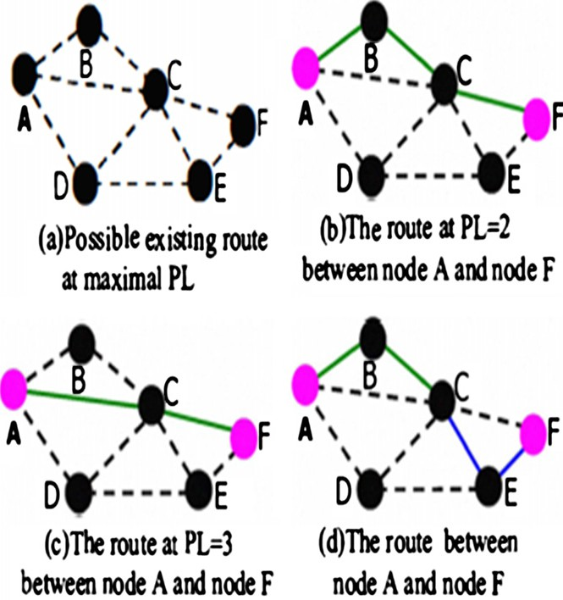

Figure 1 Sample analysis figure.

Power controlled routing in wireless ad hoc networks using cross layer approach 99

Figure 2 Routing table for all nodes on the route.

according to the routing selection rules 1, 2, as shown in Fig. 1d. And the routing tables of node *A*, *B*, *C* and *E* are listed in Fig. 3, whose valid routes indicated in bold font. The entire route from node *A* to node *F* is *A*–*B*–*C*–*E*–*F*. The nodes *A*, *B* and *C* send data packets and network layer control packets at *PL* = 2 in the first part, and send corresponding MAC layer control packets at *PL* = 2. And yet, the nodes *C*, *E* and *F* send data packets as well as network layer control packets at *PL* = 1 in the last part, and send corresponding MAC layer control packets at *PL* = 2.When any one of nodes *B*, *C*, *E* and *F* monitors the route failed, will notify the source node A to repair it.

1. When the source nodes find no any route at *PL* = 1, 2, 3, then will discard the data packets.
2. Simulation and analysis

In this section, we evaluate the performance of PC-AODV by Simulations. We first describe the simulation environments And performance evaluation metrics, then evaluate the perfor- mance with given environments and parameters. Finally, We show the comparisons between our scheme and, AODV

* 1. *Simulation conditions*

In the simulation, we randomly selected source node and des- tination node to simulate our scheme and AODV on NS2 (Network Simulator) [15], 100 nodes have initial energy of

2001 respectively and randomly distribute in 1000 · 1000 square region. Detailed simulation parameters are listed in Table 1.

* 1. *Performance metrics*

The following metrics are used to evaluate the different protocols:

* Packet delivery ratio – This is defined as the ratio of the number of data packets received by the destinations to

those Sent by the sources.

* Average end-to-end delay – This is defined as the delay between the time at which the data packet was origi-

nated at the source and the time it reaches the destina- tion. Data packets that get lost en route are not considered. Delays due to route discovery, queuing and retransmissions are included in the delay metric.

* Network lifetime [16,17] – This is defined as the time at which the first node failure occurs, that is, the time at

which some node’s energy reserve is reduced to zero.

* Network residual energy [18] – This is defined as the total number of residual battery power of all nodes in network

at the time when the communication terminates.

* 1. *Simulation results*

In our simulation scenarios, each result on the curve is the average of 100 simulation runs.

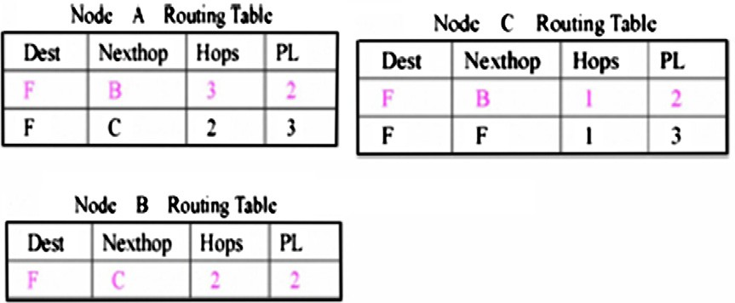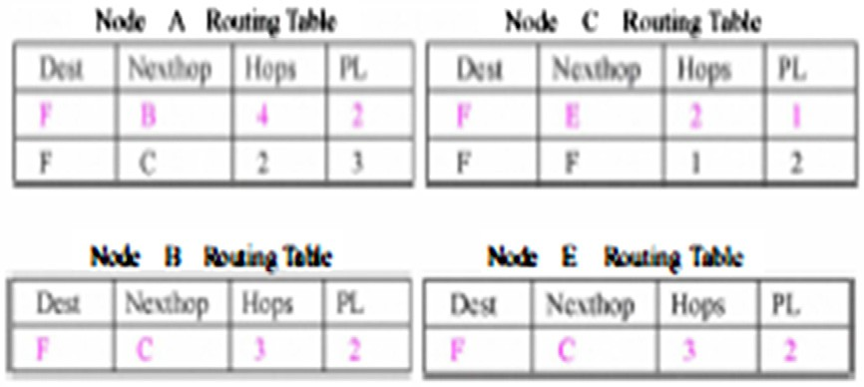

Figure 3 Routing table for all nodes on the route.

100 R. MadhanMohan, K. Selvakumar

160

Table 1 Simulation parameters.

Parameter Value

NS version 2.34

Number of nodes 100

Terrain range (m2) 1000 · 1000

Mobility model Random-way point

Propagation model Two-ray ground reflection Number of transmission power levels 5

Ranges corresponding to the PL (m) 90, 130, 170, 210, 250 Average node degree 5

Node’s mobility speed (m/s) 0–20

Rate of channel (Mbps) 2

Type of traﬃc TCP

Number of FTP flows 10–36

Packet size (bytes) 1400

MAC IEEE 802.11

Simulation time (s) 1000

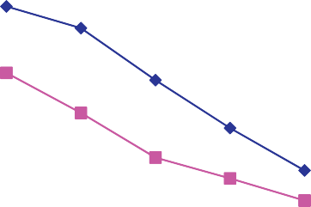

140

120

**Residual Energy (J)**

100

80

60

40

20

0

512 1024 1536 2048 2560

**Data Rate (KBPS)**



PC-AODV

AODV

Figure 5 Network residual energy.

* + 1. *Network lifetime and residual energy*

Figs. 4 and 5 show the network lifetime and the residual energy of three algorithms at different traffic load respectively.

When there is only small traffic load, two protocols almost achieve the same the network lifetime and the residual energy. As increase in network average load, all network lifetime and residual energy. The results in Fig. 4 indicate that the network lifetime Of PC-AODV is higher than AODV under the same conditions. At the same time, the results in Fig. 5 indicate the residual energy of CPC-AODV is more than of AODV in the same circumstances. This is because AODV does not take measures to network energy consumption, and just uses the default maximum power to transmit data will consume more energy. Some nodes of burdening heavy flow excessively consumed their energy, thus the corresponding residual energy is less and the network lifetime is shortened due to uneven energy consumption. However, CPC-AODV consumes less energy because of using power control scheme. Comparing PC-AODV 15% average energy savings, thus prolonging the

network lifetime. These results show that PC-AODV can save the network energy consumption and prolong network life.

* + 1. *Average end-to-end delay*

Fig. 6 displays the average end-to-end delay of three algo- rithms with varying average traffic load. As increase in net- work average load, the average end-to-end delay of two algorithms will increase.

In Fig. 6 we can see that CPC-AODV provides an obvious lower network delay compared with AODV. Under the same conditions, CPC-AODV can reduce the delay compared with other AODV protocols. This is due to the fact that CPC- AODV uses smaller transmission power to send data packets along the route. In wireless Ad Hoc network, uses smaller transmission power to send data packets can reduce interfer- ence and collision which benefit to decrease the retransmission, thus reduce the responding queue and transmission delay. In addition, CPC-AODV can update the routing table in time in mobile environment, thus reduce the queue delay. These im- ply that CPC-AODV can improve the network delay.

1000

900

800

700

**Life Time (Sec)**

600

500

400

300

200

100

0

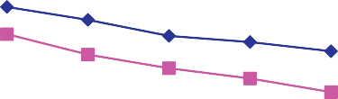

512 1024 1536 2048 2560

**Data Rate (KBPS)**



PC-AODV

AODV

Figure 4 Network life time.

300

250

200

**Delay (ms)**

150

100

50

0



512 1024 1536 2048 2560

**Data Rate (KB)**



 MPRAODV AODV

Figure 6 Average end-to-end delay.

Power controlled routing in wireless ad hoc networks using cross layer approach 101

105

100

95

**PDR (%)**

90

85

80

75

70

20 40 60 80 100

**No of Nodes**

Figure 7 Packet delivery ratio.



PC-AODV

AODV

delay and energy consumption. We will incorporate it with de- lay, and packet loss ratio and so onto optimize network perfor- mance. We hope that in the future studies we could not only provide multiple routings that meet the QoS requirements, but also use the compound routing that meets the QoS require- ments when the single routing is not available.

References

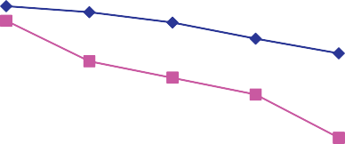

1. Johnson DJ, Maltz DA, Hu YC. lETF RFC4728. The dynamic source routing protocol for mobile ad hoc networks (DSR); 2007.

[<http://www.ietf.orglrfclrfc4728.txt>.](http://www.ietf.orglrfclrfc4728.txt/)

1. Perkins CE, Bhagwat P. Highly dynamic destination-sequenced distance vector routing (DSDY) for mobile computers. London, UK: ACM SIGCOMM 94; October 1994. p. 234–44.
2. Perkins CE, Royer EM. lETF RFC3561. Ad hoc on-demand distance vector routing (AODY); 2003. <[http://www.ietf.orglrfc/](http://www.ietf.orglrfc/rfc3561.txt) [rfc3561.txt>.](http://www.ietf.orglrfc/rfc3561.txt)
3. Tan CW, Bose SK. Modifying AODY for efficient power-aware routing in MANETs. In: TENCON 2005, Melbourne, Australia; 2005. p. 1–6.
4. Lee SH, Choi E, Cho DH. Timer-based broadcasting for power-
   * 1. *Packet delivery ratio*

Fig. 7 indicates the packet delivery ratio of two algorithms for the case when the nodes are increased from 10 to 100.

For all approaches, there is a decrease in packet delivery ra- tio when the load increases. The results shown in Fig. 7 indi- cate that packet delivery ratio of PC-AODV is higher than of AODV under the same conditions. The key contributing to this significant improvement in packet delivery ratio is the fact that PC-AODV considers power control, while AODV just uses the default maximum power to transmit data. Since the larger the transmission range is, the serious the local con- flicts become, thus maximum power transmissions result in degradation in packet delivery ratio. As the network load in- creases, the probability of one successful transmission will drastic reduced. PC-AODV exploits a power control scheme, and each node tries to send data packet at a lower power level, this can reduce local conflict and improve the packet delivery ratio. From these we can see that PC-AODV can increase the network packet delivery ratio, and reduce the network packet loss ratio.

1. Conclusion and future work

In this paper, we proposed an on-demand routing algorithm based on power control. This algorithm builds different rout- ing entries according to the node power levels on demand, and selects the minimum power level routing for data delivery. In addition, PC-AODV uses different power control policies to transmit data packets, as well as control packets of network layer and MAC layer. Simulation results show that our algo- rithm cannot only reduce the average communication energy consumption, thus prolong the network lifetime, but also im- prove packet delivery ratio and average end-to-end delay. It is a needed approach to incorporate routing protocols with power control in ad hoc networks.

In the future, our research will be improved on the basis of the above mentioned results. Power control is therefore a pro- totypical cross-layer problem affecting all layers of the proto- col stack from physical to transport, and affecting several key performance measures, including the trinity of throughput,

aware routing in power-controlled wireless ad hoc networks. Commun Lett 2005;9(3):222–4.

1. Woo Kyungtae, Yu Chansu. Non-blocking localized routing algorithm for balanced energy consumption in mobile ad hoc networks. In: IEEE international workshop on modeling, analy- sis, and simulation of computer and telecommunication systems 2001, MASCOTS 2001, Ohio, USA; 2001. p. 117–24.
2. Narayanaswamy S, Kawadia Y, Sreenivas RS. Power control in adhoc networks theory, architecture, algorithm and implementa- tion of the COMPOW protocol. In: European wireless conference 2002, Florence, Italy; 2002. p. 156–62.
3. Kawadia Yikas, Kumar PR. Principles and protocols for power control in wireless ad hoc networks. IEEE J Select Areas Commun 2005;23(1):76–88.
4. Bing Li, Zhigang Jin, Yantai Shu. Cross-layer design of energy- saving AODV routing protocol. Trans Tianjin Univ 2009;15(5): 343–9.
5. Bing Li, Zhigang Jin, Yantai Shu. CEMAODY: cross-layer design of energy-conserving multicast AODV routing protocol. In: 3rd international conference on communications and networking in China, ChinaCom 2008, Hangzhou, China; 2008. p. 743–47.
6. Gomez Javier, Campbel Andrew T. PARO: supporting dynamic power controlled routing in wireless ad hoc networks 2003;9(5): 443–60.
7. Kirousis LM, Kranakis E, Krizanc DPelc A. Power consumption in packet radio networks. Theor Comput Sci 2000;243(1–2): 289–305.
8. Clementi A, Penna P, Silvestri R. On the power assignment problem in radio networks. ACMlKluwer Mobile Networks Appl (MONET) 2004;9(2):125–40.
9. [http://www.cisco.com.2010](http://www.cisco.com.2010/).
10. The network simulator-ns-2. <[http://www.isi.edulnsnarnlns.2010](http://www.isi.edulnsnarnlns.2010/)>.
11. Julius Hossain M, Ali Akber Dewan M, Oksam Chae. Maximiz- ing the effective lifetime of mobile ad hoc networks. IEICE Trans Commun 2008;91(9):2818–27.
12. Sankar Arvind, Liu Zhen. Maximum lifetime routing in wireless ad-hoc networks. In: INFOCOM 2004. Twenty-third annual joint conference of the IEEE computer and communications societies, vol. 2, Hong Kong, China; March 2004. p. 1089–97.
13. Asokan R, Natarajan AM. Performance evaluation of energy and delay aware quality of service (Qos) routing protocols in mobile adhoc networks. Int J Business Data Commun Network (IJBDCN) 2008;4(1):52–63.