[Egyptian Informatics Journal 23 (2022) 427–436](https://doi.org/10.1016/j.eij.2022.03.004)

Contents lists available at [ScienceDirect](http://www.sciencedirect.com/science/journal/11108665)

Egyptian Informatics Journal

journal homepage: [www.sciencedirect.com](http://www.sciencedirect.com/)

Full length article

[](http://crossmark.crossref.org/dialog/?doi=10.1016/j.eij.2022.03.004&domain=pdf)Prediction the dynamic viscosity of MWCNT-Al2O3 (30:70)/ Oil 5W50 hybrid nano-lubricant using Principal Component Analysis (PCA) with Artificial Neural Network (ANN)

Mohammad Hemmat Esfe a, Mehdi Hajian b, Davood Toghraie c, Mohamad Khaje khabaz d,

Alireza Rahmanian e, Mostafa Pirmoradian c, Hossein Rostamian f

a *Nanofluid advance research team, Tehran, Iran*

b *PhD Graduate from Department of Mechanical Engineering, Isfahan University of Technology, Isfahan 84156-83111, Iran*

c *Department of Mechanical Engineering, Khomeinishahr Branch, Islamic Azad University, Khomeinishahr, Iran*

d *Young Researchers and Elite Club, Khomeinishahr Branch, Islamic Azad University, Khomeinishahr, Iran*

e *Department of Biosystems Engineering, College of Agriculture, Isfahan University of Technology, Isfahan 84156-83111, Iran*

f *University of Applied Science and Technology, Center of Chloran Chemical Production Company, Semnan, Iran*

a r t i c l e i n f o

*Article history:*

Received 3 February 2022

Revised 14 March 2022

Accepted 29 March 2022

Available online 12 April 2022

*Keywords:*

Dynamic viscosity Hybrid nano-lubricant ANN

Support Vector Machine (SVM) Partial Least Squares (PLS) Principal Component Regression

a b s t r a c t

In this study, the prediction of dynamic viscosity (lnf) of MWCNT-Al2O3 (30:70)/ Oil 5W50 hybrid nano- lubricant using Artificial Neural Network (ANN) is performed. The objective of the present research is to investigate the effect of temperature and solid volume fraction (SVF) to predict the shear rates (SR) and

lnf using ANN. The feed-forward ANN consists of a multilayer perceptron network (MLP), which is cap-

able of predicting lnf in connection with experimental data of temperature, SR and SVF. Sensitivity anal- ysis is used to evaluate the importance and role of temperature, SR, and SVF in experimental lnf

variations. ANN is generated and tested with experimental data sets and the results show that there was a good agreement between the actual and predicted ANN values. Moreover, the results of ANN sim- ulation are compared with other data processing methods such as Support Vector Machine (SVM), Partial Least Squares (PLS), Principal Component Regression. In addition, the results of the residual value of ANN

with seven neurons for lnf can be very small and close to the expected normal value. From this, it can be

concluded that the given model can expect exact values.

© 2022 THE AUTHORS. Published by Elsevier BV on behalf of Faculty of Computers and Artificial Intel- ligence, Cairo University. This is an open access article under the CC BY-NC-ND license ([http://creative-](http://creativecommons.org/licenses/by-nc-nd/4.0/)

[commons.org/licenses/by-nc-nd/4.0/](http://creativecommons.org/licenses/by-nc-nd/4.0/)).

1. Introduction

Nowadays, the use of nanotechnology in almost all branches of science is being seriously pursued [1,2]. In addition, the use of intelligent systems for predicting data, along with nanotechnology, has helped researchers in the growth and development of various branches of science [3–13]. Therefore, it seems that different branches of science in the fields of chemistry, physics, mechanics, etc. can experience many advances with nanotechnology [14–20].

*E-mail address:* [Toghraee@iaukhsh.ac.ir](mailto:Toghraee@iaukhsh.ac.ir) (D. Toghraie)

Peer review under responsibility of Faculty of Computers and Information, Cairo University.

**Production and hosting by Elsevier**

The development of the lubricant industry is an important part of the improvement of the machine industry and other related indus- tries. Statistical data show that with a small increase in the cost of producing and choosing a better lubricant, many additional and undesirable costs can be reduced. This is due to the important and beneficial effects of using lubricants, which can reduce the amount of friction between parts with a relative motion by sepa- rating them with a film of oil, and cooling the engine and its inter- nal components, thereby reducing thermal stresses and longer life. Lubricants also seal the contact parts to prevent the diffusion of gases and fluids containing particles and carry particles due to wearing down of engine components between moving parts and collect them in the filter wall. In recent years, with the advance- ment of technology, the use of nanomaterials in different fields of engineering and various industries has been considered by researchers. These include the dispersion of nanoparticles in a base fluid leading to the formation of a nanofluid, first proposed by Choi

<https://doi.org/10.1016/j.eij.2022.03.004>

1110-8665/© 2022 THE AUTHORS. Published by Elsevier BV on behalf of Faculty of Computers and Artificial Intelligence, Cairo University. This is an open access article under the CC BY-NC-ND license (<http://creativecommons.org/licenses/by-nc-nd/4.0/>).

and Eastman. This led to the development of lubricants with higher efficiency than conventional ones in cooling by changing some thermal properties and hydrodynamic characteristics of the base fluid [21–24]. Studies in this field show that the knf is a function of factors such as the shape, size and properties of the nanoparti- cles, temperature, base fluid properties, and solid volume fraction

(SVF). The lnf of a lubricant is one of the most important and basic

properties of the fluid which affects the flow rate and pumping power of the fluid. The investigations on lnf show their depen- dency on factors like temperature, particle size, SVF, nanoparticle type and base fluid [25]. lnf analysis is one of the most important key factors in determining the hydrodynamic behavior of nanoflu-

ids due to its influence on Rayleigh and Reynolds number values. Therefore, extensive studies were conducted on the effect of nanoparticles on lnf, some of which are given as follows. Kole and Dey [26] dispersed alumina nanoparticles in-car coolant and

analyzed their experimental results on lnf. It was reported that SVF would increase the lnf while an increase in temperature would decrease it. Sundar et al. [27] investigated the lnf and thermal con-

ductivity (knf) of magnetic Fe3O4/water nanofluid experimentally and theoretically. Hemmat Esfe et al. [28] also studied on predict- ing the rheological behavior of MWCNT–Al2O3 (30–70%)/oil SAE40 hybrid nanofluid [28]. The other study on Experimental evaluation of MWCNT–Al2O3 (40–60%)/5W50 hybrid nanofluid and compar- ison with MWCNT–Al2O3 (35–65%)/5W50 hybrid nanofluid with focus on thermophysical properties and cost performance index were reported by Hemmat Esfe and Alidoust [29]. Data analysis and modeling with ANN were reported by Esfe et al. [30] and in case of modeling the thermal conductivity ratio of an antifreeze- based hybrid nanofluid containing graphene oxide and copper oxide for using in thermal systems studied by Rostami et al. [31]. An experimental study on the thermal conductivity of new anti- freeze containing copper oxide and graphene oxide nano- additives were reported by Rostami et al. [32]. Rostami et al. [33] also studied on The effect of hybrid nano-additive consists of gra- phene oxide and copper oxide on rheological behavior of a mixture of water and ethylene glycol. Using the chemical precipitation method, they prepared the nanofluid by synthesizing Fe3O4 nanoparticles and then dispersing them in water. A range of 0.0%

to 2.0% for SVF and a variation of 20–60 °C for the temperature

were considered. Their results show that increasing the SVF would increase the lnf and knf while the amount of lnf enhancement was greater than that of knf. In addition, they proposed analytical equa-

tions without resorting to Maxwell and Einstein models to predict the lnf and knf. In another study, Naina et al. [34] examined the knf of TiO2/Water nanofluid over a range of 0.5–2.5% for SVF and tem- perature varying from T = 10 to 40 °C. They reported a maximum of 50% increase in lnf for 2.5 % TiO2-water nanofluid. Murshed et al.

[35] presented a combined theoretical and experimental investiga- tion on lnf and knf. They found higher values for these parameters of the nanofluid in comparison with the base fluids. It was reported that increasing the SVF would increase lnf and knf. Moreover, they denoted that the temperature would strongly influence knf. Aladag et al. [36] examined the dependency of lnf of CNT/water and Al2O3/water nanofluids on the temperature and shear rates (SR)

at low temperatures and SVFs. Depending on SR, the nanofluid sus- pensions display Newtonian or non-Newtonian behaviors. Hojjat et al. [37] studied three types of non-Newtonian nanofluids and measured their rheological characteristics with different SVFs at various temperatures. The dependency of the rheological proper- ties of the nanofluids on the SVF and temperature was reported. Also, their results show that all nanofluids display pseudo-plastic behavior. Recently, researchers have paid attention to a new class of nanofluids containing a combination of different nanoparticles,

called hybrid nanofluids, and studied their thermophysical proper- ties. Esfe et al. [38] investigated the effect of SVF on lnf and knf of

Ag–MgO/water nanofluid through an experimental study. In another study, Esfe et al. [39] measured knf of SWCNT-MgO/EG nanofluids which were produced at SVF = 0.05% to 2%. The range of temperature was considered from 30 to 50 °C through the tests. A comparison between the results of the hybrid nanofluid and nanofluids made with a single particle of MgO and SWCNT was

performed. Through an experimental study, Rejvani et al. [40] examined the behavior of MWCNTs–SiO2 (30–70)/10W40 nano- fluid. The lnf was measured at SVF = 0.05 to 1% with T = 5 to

55 °C. It was reported that the behavior of the samples was so close

to the pseudo-plastic Ostwald de Waele non-Newtonian model. [Batmunkh](https://pubs.acs.org/action/doSearch?field1=Contrib%26text1%3DMunkhbayar%2b%2bBatmunkh) et al. [41] reported a development in the knf of TiO2 - nanofluids by adding negligible amounts of ‘‘Ag” nanoparticles. The temperature variation was considered 15–40 °C through the experiments. Suresh et al. [42] prepared a stable hybrid nanofluid in SVF = 0.1% by dispersing hybrid nanopowder Al2O3–Cu in deion-

ized water. Their results show an enhancement of 13.56% in Nus- selt number in comparison with that of water. Esfe et al. [43] evaluated the lnf of Al2O3-MWCNT (65:35)/5W50 nanofluid. The

mean diameter of Al2O3 nanoparticles was 50 nm, and the range of inner and outer diameters of MWCNTs was 3–5 nm and 5– 1 nm, respectively. The variation of temperature was between 5 and 55 °C. It was reported that the hybrid nano-lubricant behaves as a non-Newtonian fluid and increasing the SVF magnifies the non-Newtonian behavior; on the contrary while, the temperature

increase had a reverse result. Chen et al. [44] investigated knf of Fe2O3-MWNT /Water hybrid nanofluid. Madhesh et al. [45] per- formed an experimental study to investigate the heat transfer and rheological properties of Cu–titania hybrid nanofluids. Although the experimental studies and the simulations performed based on molecular dynamics to determine the properties of nanofluids have provided useful and efficient results, nevertheless, their high cost and time consumption can be mentioned as disad- vantages of these methods. On the other hand, when it is difficult to provide a mathematical model for a physical system, or detailed information is not available, or the process has time-dependent or nonlinear variables, the results of analytical modeling using scien- tific and knowledge-based methods may not be convincing. For such complex systems, simplifying assumptions may limit the accuracy of the proposed models. In addition, most of the equa- tions used in modeling analyses cannot be applied to a wide range of processes under different conditions, because they are only suit- able for a given set of conditions and can be used under certain assumptions. These ambiguities have led to a strong tendency to present methods based on the direct use of experimental data to predict process results. Examples include ANNs (Artificial Neural Networks), genetic algorithms, adaptive neural-fuzzy inference systems, and fuzzy logic, which were also used to analyze the behavior of nanofluids. Using an ANN, Toghraie et al. [46] inspected

lnf of Ag/Ethylene glycol nanofluid with SVF = 0.2–2% for T = 25–

55 °C. Their results show that ANN could guess the lnf with good accuracy compared to the correlation method. Esfe et al. [10] applied the ANN to predict Nusselt number and pressure drop of aqueous nanofluids. They examined the influence of different vari- ables on pressure drop and Nusselt number. It was shown that the ANN modeling could accurately model the experimental data.

Toghraie et al. [47] applied ANN to investigate the lnf of

MWCNTs–ZnO/water–EG (80:20). After preparing the required experimental data, the ANN was chosen based on different gener- ating architectures. Also, lnf was predicted by the correlation

method. It was reported that the ANN was better than the correla- tion method in forecasting the lnf. Via ANN and RSM, Esfe et al.

[48] modeled the knf of the water–titania nanofluid versus SVF and temperature. It was reported that the influence of temperature on knf was more evident than the effect of SVF. Beigzadeh [49] pre-

sented an ANFIS model to predict the lnf of Cu/Water-Glycerin

Table 1

The experimental dataset of MWCNT-Al2O3 (30:70)/ Oil 5W50 hybrid nano-lubricant [59].

|  |  |  |  |  |  |  |  |  |  |  |
| --- | --- | --- | --- | --- | --- | --- | --- | --- | --- | --- |
| T (°C) | SR value 50 | 100 | 200 | 300 | 400 | 500 | 600 | 700 | 800 | 900 |
| 5 | SVF = 0.05%  525 | 491 | 452.8 | 428.1 |  |  |  |  |  |  |
| 15 |  | 285 | 265.3 | 253.1 | 243.3 | 235.9 |  |  |  |  |
| 25 |  |  | 164.1 | 164.1 | 164.1 | 164.1 | 164.1 |  |  |  |
| 30 |  |  |  |  |  |  |  |  |  |  |
| 35 |  |  | 105 | 101.3 | 98 | 96 | 93.8 |  |  |  |
| 40 |  |  |  |  |  |  |  |  |  |  |
| 45 |  |  |  | 68.1 | 66.1 | 64.9 | 63.1 | 62.1 |  |  |
| 50 |  |  |  |  |  |  |  |  |  |  |
| 55  T (°C) | SR value |  |  |  |  | 46.5 | 43.4 | 42.3 | 42.9 | 40.8 |
| 5 | 50  SVF = 0.0625% | 100  497 | 200  477.2 | 300  461.2 | 400 | 500 | 600 | 700 | 800 | 900 |
| 15 |  | 358 | 345 | 335.6 |  |  |  |  |  |  |
| 25 |  |  |  |  |  |  |  |  |  |  |
| 30 |  |  |  |  | 327.7 | 321.4 |  |  |  |  |
| 35 |  | 272 | 261.6 | 255.6 | 250.3 | 246 |  |  |  |  |
| 40 |  | 203 | 196.9 | 193.1 | 189.8 | 186 |  |  |  |  |
| 45 |  |  | 150.9 | 148.1 | 145.3 | 143.6 | 141.3 |  |  |  |
| 50 |  |  | 117.2 | 114.4 | 113 | 111 | 109.7 |  |  |  |
| 55  T (°C) | SR value |  |  |  |  |  |  |  |  |  |
| 5 | 50  SVF = 0.1%  566 | 100  531 | 200  485.6 | 300  460.6 | 400 | 500 | 600 | 700 | 800 | 900 |
| 15 |  | 306 | 285.9 | 271.9 | 260.6 | 252.4 |  |  |  |  |
| 25 |  |  | 175.3 | 168.8 | 162.7 | 158.2 | 154.1 |  |  |  |
| 30 |  |  |  |  |  |  |  |  |  |  |
| 35 |  |  | 112.5 | 108.1 | 105.5 | 103.1 | 100.9 |  |  |  |
| 40 |  |  |  |  |  |  |  |  |  |  |
| 45 |  |  |  | 73.1 | 71.3 | 70.1 | 67.8 | 67 |  |  |
| 50 |  |  |  |  |  |  |  |  |  |  |
| 55  T (°C) | SR value |  |  |  | 48.8 | 49.1 | 46.9 | 46.1 | 46.2 |  |
|  | 50  SVF = 0.25% | 100 | 200 | 300 | 400 | 500 | 600 | 700 | 800 | 900 |
| 5 | 596 | 561 | 519.4 | 494.4 |  |  |  |  |  |  |
| 15 |  | 324 | 302.8 | 287.5 | 276.6 | 267.8 |  |  |  |  |
| 25 |  | 197 | 185.6 | 178.1 | 172.5 | 167.6 |  |  |  |  |
| 30 |  |  |  |  |  |  |  |  |  |  |
| 35 |  |  | 118.1 | 115 | 112 | 109.9 | 106.6 |  |  |  |
| 40 |  |  |  |  |  |  |  |  |  |  |
| 45 |  |  |  | 80 | 75.9 | 74.3 | 72.8 | 71.3 |  |  |
| 50 |  |  |  |  |  |  |  |  |  |  |
| 55  T (°C) | SR value |  |  |  | 53.9 | 52.5 | 50.3 | 49.8 | 49 |  |
| 5 | 50  SVF = 0.5%  626 | 100  587 | 200  540.9 | 300  514.4 | 400 | 500 | 600 | 700 | 800 | 900 |
| 15 |  | 339 | 317.8 | 303.1 | 291.6 | 281.6 |  |  |  |  |
| 25 |  | 208 | 195 | 186.9 | 180 | 175.1 |  |  |  |  |
| 30 |  |  |  |  |  |  |  |  |  |  |
| 35 |  |  | 124.7 | 120.6 | 117.2 | 114.4 | 111.9 |  |  |  |
| 40 |  |  |  |  |  |  |  |  |  |  |
| 45 |  |  |  | 81.3 | 79.2 | 77.6 | 75.6 | 74.7 |  |  |
| 50 |  |  |  |  |  |  |  |  |  |  |
| 55  T (°C) | SR value |  |  |  | 54.8 | 54.4 | 53.1 | 52 | 51.8 |  |
|  | 50 | 100 | 200 | 300 | 400 | 500 | 600 | 700 | 800 | 900 |
| 5 | SVF = 0.75%  664 | 619 | 568.1 | 542.5 |  |  |  |  |  |  |
| 15 |  | 358 | 331.9 | 316.2 | 304.7 | 295.5 |  |  |  |  |
| 25 |  | 216 | 202.5 | 194.4 | 188 | 183 |  |  |  |  |
| 30 |  |  |  |  |  |  |  |  |  |  |
| 35 |  |  | 130.3 | 125.6 | 121.9 | 118.9 | 116.6 |  |  |  |
| 40 |  |  |  |  |  |  |  |  |  |  |
| 45 |  |  |  | 85.6 | 83 | 81.4 | 80 | 78.2 |  |  |
| 50 |  |  |  |  |  |  |  |  |  |  |
| 55  T (°C) | SR value |  |  |  | 58.6 | 57 | 55 | 54.4 | 53.7 |  |
|  | 50  SVF = 1% | 100 | 200 | 300 | 400 | 500 | 600 | 700 | 800 | 900 |

(*continued on next page*)

Table 1 (*continued*)

|  |  |  |  |  |  |  |  |  |  |  |
| --- | --- | --- | --- | --- | --- | --- | --- | --- | --- | --- |
| T (°C) | SR value 50 | 100 | 200 | 300 | 400 | 500 | 600 | 700 | 800 | 900 |
| 5 | SVF = 0.05%  525 | 491 | 452.8 | 428.1 |  |  |  |  |  |  |
| 5 | 720 | 671 | 618.8 | 587.5 |  |  |  |  |  |  |
| 15 |  | 384 | 358.1 | 341.9 | 329.5 | 318.8 |  |  |  |  |
| 25 |  | 233 | 217.5 | 209.4 | 202.5 | 197.3 |  |  |  |  |
| 30 |  |  |  |  |  |  |  |  |  |  |
| 35 |  |  | 140.6 | 135 | 131.7 | 128.6 | 125.9 |  |  |  |
| 40 |  |  |  |  |  |  |  |  |  |  |
| 45 |  |  | 94.7 | 91.3 | 88.1 | 86.3 | 84.4 |  |  |  |
| 50 |  |  |  |  |  |  |  |  |  |  |
| 55 |  |  |  | 64.4 | 61.4 | 60.4 | 58.7 | 57.9 |  |  |





Fig. 1. Determination of Principal Component Analysis (PCA) for overall data.





Fig. 2. Detection of outliers using PCA method.

nanofluid. Appropriate matching of ANFIS estimating results with the test data set show the reliability of their model. By utilizing

ANN, Esfe et al. [8] examined the impact of different temperatures SVFs on lnf of MWCNT–Al2O3 (30–70%)/Oil SAE40 nanofluid. Some experiments were performed to obtain the required data to train an ANN. The results of well-trained ANN show that when SVF

increases, the lnf would increase at all temperatures while increas- ing the temperature resulted in decreasing the lnf.

In this study, the prediction of lnf of MWCNT-Al2O3 (30:70)/ Oil

5W50 hybrid nano-lubricant using ANN was performed. The objective of the present research is to investigate the effect of temperature and SVF to predict the SRs and lnf using ANN. The feed-forward ANN consists of a MLP, which is capable of predicting

lnf in connection with experimental data of temperature, SR and

SVF.

1. Material and methods

ANNs are numerical and mathematical models composed by a few neurons organized completely different layers, connected

through the variable weights. These weights are calculated by an iterative strategy among the training process when a large amount of training data representing, the pattern to be modeled, input and output pairs are supplied to the network [50]. In the ANN analysis,

multi-layer ANNs with back propagation (BP) learning algorithm were used to predict lnf of MWCNT-Al2O3 (30:70)/ Oil 5W50 hybrid nano-lubricant. Data used in this work is taken from litera- ture [59]. Back propagation is an ANN algorithm which, performed learning on a multilayer feed-forward ANN [46]. In order to achieve

the outputs a large number of inter-connected processors called neurons organized in layers. A three-layer (input, hidden and out- put) ANN with a large number of nodes in each layer connected the knowledge of inputs with outputs. The strength (weights) of con- nections are achieved through a learning process. The main objec-

tive is to study the variation of lnf within a certain range of

temperature, SR and SVF of hybrid nano-lubricant to find critical values of variation in the behavior of hybrid nano-lubricants for each of the parameters. In other words, in the present study, the

ANN is trained by using temperature, SVF, and SR experimental data to estimate the lnf of MWCNT-Al2O3 (30:70)/ Oil 5W50 hybrid nano-lubricant. In order to simulate the ANN model, a real dataset collected from experiment have been used. Table 1 contains some

information from MWCNT-Al2O3 (30:70)/ Oil 5W50 hybrid nano- lubricant.

Initial data is typically split into 70% for training, 10% for valida- tion, and 20% for testing the efficiency of the model. Validation data prevent ANN overtraining due to premature outages and gen- eralize ANN results.

1. Results and discussion

In the present study, experimental data, including temperature, SR, and SVF, are first obtained and compared to lnf data through Principal Component Analysis (PCA), a discounting method. This approach is frequently utilized to calculate the measurements of

large-scale data. A unit that includes an expansive set of parame- ters, gets to be a small set of parameters that contains the greatest value of total data. Fig. 1 shows the results of PCA for overall data. As shown in Fig. 1, the second principal component was utilized as an index of the variation of all data and different measurable char- acteristics. This indicator is usually utilized to recognize outliers. Since the PCA minimizes the quadratic norm, it either has the same least-squares issue or is delicate to exceptions in a Gaussian con- veyance. By squaring, deviations from exceptions overwhelm the common criteria and, as a result, can drive PCA components. Out- liers were analyzed utilizing the PCA strategy and expelled from the general data, as illustrated in Fig. 2 [51,52]. Due to the PCA minimizing quadratic norms, it has the same least-squares prob- lems, or it becomes Gaussian the sensitivity to outliers. By squar- ing, deviations from outliers, can dominate the general norm and consequently drive PCA components.

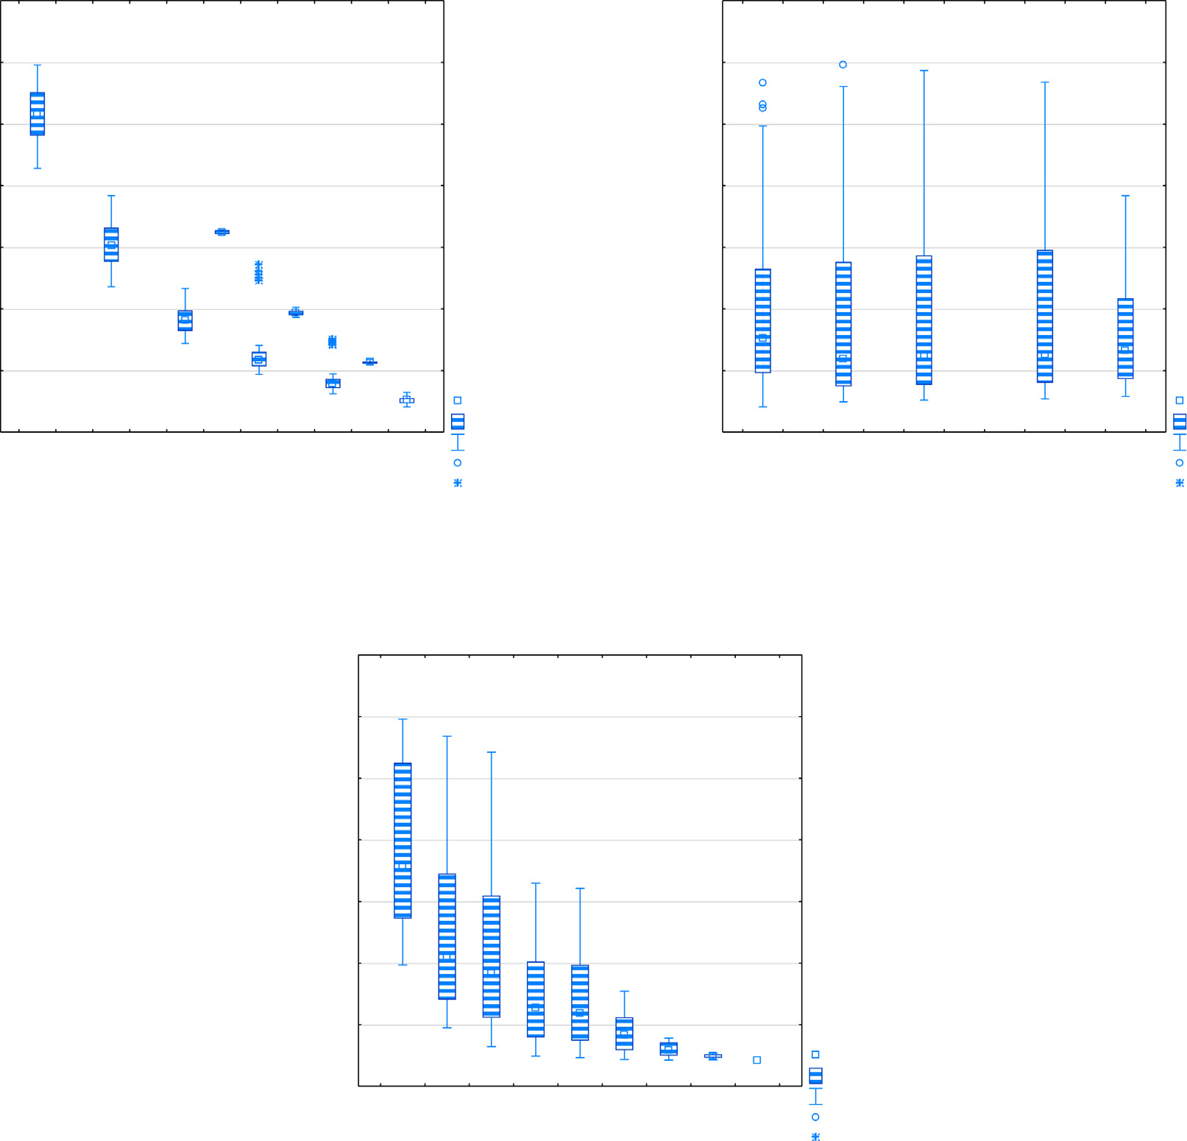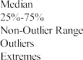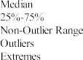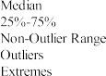



Fig. 3. Dispersion of lnf values against (a) temperatures, (b) SVF and (c) SR.



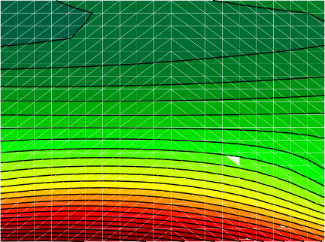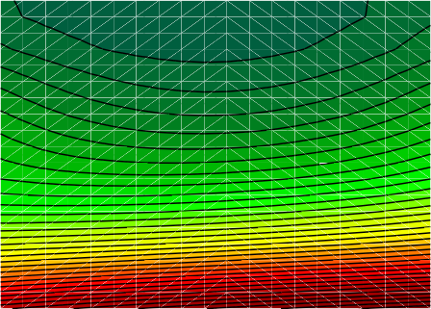

Fig. 4. Effect of SVF changes on lnf of MWCNT-Al2O3 (30:70)/ Oil 5W50 hybrid nano-lubricant in the presence of: (a) SR and (b) temperature.

Table 2

The comparison of the prepared values for error and correlation rate of different simulated networks.

|  |  |  |  |  |  |  |  |
| --- | --- | --- | --- | --- | --- | --- | --- |
| No. | ANNs | Training perf. | Test perf. | Validation perf. | Train error | Test error | Validation error |
| 1 | MLP 3-5-1 | 9.78E-01 | 9.78E-01 | 8.99E-01 | 4.78E-02 | 3.59E-02 | 8.44E-02 |
| 2 | MLP 3-10-1 | 9.79E-01 | 9.79E-01 | 9.02E-01 | 4.60E-02 | 3.40E-02 | 8.38E-02 |
| 3 | MLP 3-9-1 | 9.74E-01 | 9.76E-01 | 8.97E-01 | 5.64E-02 | 3.82E-02 | 8.57E-02 |
| 4 | MLP 3-10-1 | 9.76E-01 | 9.75E-01 | 9.04E-01 | 5.38E-02 | 4.03E-02 | 8.05E-02 |
| 5 | MLP 3-4-1 | 9.49E-01 | 9.56E-01 | 8.94E-01 | 1.13E-03 | 7.46E-02 | 9.89E-02 |
| 6 | MLP 3-7-1 | 9.76E-01 | 9.75E-01 | 8.98E-01 | 5.30E-02 | 4.12E-02 | 8.46E-02 |
| 7 | MLP 3-5-1 | 9.73E-01 | 9.73E-01 | 9.00E-01 | 5.99E-02 | 4.29E-02 | 8.26E-02 |
| 8 | MLP 3-4-1 | 9.69E-01 | 9.69E-01 | 8.99E-01 | 6.68E-02 | 4.92E-02 | 8.40E-02 |
| 9 | MLP 3-9-1 | 9.77E-01 | 9.77E-01 | 8.97E-01 | 4.97E-02 | 3.78E-02 | 8.56E-02 |
| 10 | MLP 3-3-1 | 9.76E-01 | 9.75E-01 | 8.98E-01 | 5.25E-02 | 4.13E-02 | 8.50E-02 |
| 11 | MLP 3-8-1 | 9.75E-01 | 9.75E-01 | 9.02E-01 | 5.61E-02 | 4.09E-02 | 8.15E-02 |
| 12 | MLP 3-10-1 | 9.50E-01 | 9.56E-01 | 8.94E-01 | 1.13E-03 | 7.53E-02 | 1.00E-03 |
| 13 | MLP 3-3-1 | 9.49E-01 | 9.56E-01 | 8.96E-01 | 1.13E-03 | 7.54E-02 | 9.85E-02 |
| 14 | MLP 3-9-1 | 9.77E-01 | 9.78E-01 | 8.93E-01 | 4.98E-02 | 3.66E-02 | 9.02E-02 |
| 15 | MLP 3-8-1 | 9.74E-01 | 9.76E-01 | 8.95E-01 | 5.67E-02 | 3.98E-02 | 8.80E-02 |



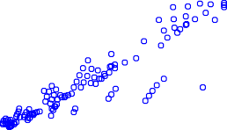



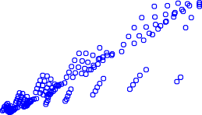



Fig. 5. Correlation diagram between predicted and experimental lnf from: (a) train, (b) test, (c) validation, and (d) all data.

The deviation of lnf of the MWCNT-Al2O3 (30:70)/Oil 5W50 hybrid nano-lubricant and its range are depicted in Fig. 3 based on different temperatures, versus various SVF and SR.

The effects of volume fraction variations versus the different shear rates and temperature were presented in Fig. 4 for MWCNT-Al2O3 (30:70)/Oil 5W50 hybrid nano-lubricant. Notably,

the maximum lnf values for MWCNT-Al2O3 (30:70)/Oil 5W50

hybrid nano-lubricant occurs at values below 5°. It can be observed that the lnf arises decreasing by SR changes from 50

to 900 rpm. Fig. 4 depicts the effect of 3D plot SVF against SR and temperature to determine their maximum and minimum values.

For training data, when the network weights are randomly cho- sen, the amount of MSE is exceptionally high, and significantly decreased by the training loops. To get the best performance ANN for each training calculation, 15 distinctive ANNs are trained with different layers, and the networks with the slightest error and highest performance are chosen to predict the problem. Table 2

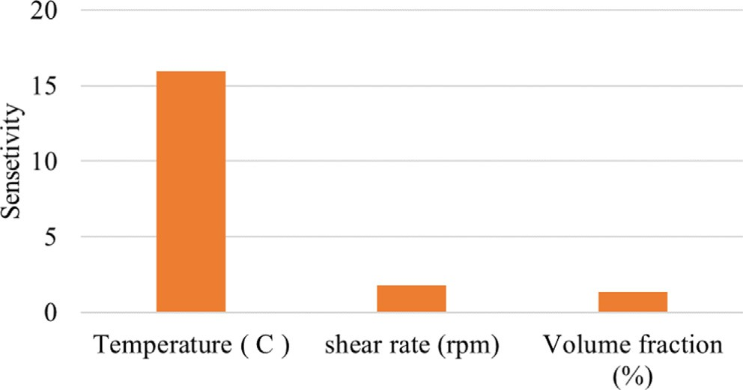

Fig. 6. The sensitivity analysis of ANN model.

lists the comparison of the prepared values for error and correla- tion rate of different simulated ANNs.

The performance results and regression diagram are indicators to ensure proper ANN training, which presented the variations in Mean Square Error (MSE) in terms of training stages. Simulation

No. 11 (MLP 3-8-1) in Table 2, selected as a best-trained ANN. The simulated ANNs shown in Fig. 5, where the great performance and the lowest error, among the validation data, test and training

data lnf of MWCNT-Al2O3 (30:70)/ Oil 5W50 hybrid nano-

lubricant and experimental data can be observed. The regression figures illustrate the dependence of the experimental output on the predicted values. The correlation performance lnf of MWCNT-Al2O3 (30:70)/ Oil 5W50 hybrid nano-lubricant model predicts the outputs with training, test and validation values of

0.97, 0.97 and 0.90, respectively. The ANN models developed in the present study can be successfully utilized to provide an accu- rate prediction of the properties.

Fig. 6 depicts the sensitivity analysis of the ANN model that was achieved from the temperature, SR and SVF parameters. As shown, the most sensitivity values were obtained for temperature, which concluded that these characteristics had the most levels of signifi- cance to predict the results [50]. It guarantees the effectiveness of the ANN method.

Fig. 8 show the three-dimensional surf for lnf of MWCNT-Al2O3

(30:70)/ Oil 5W50 hybrid nano-lubricant output. It can be obtained

 



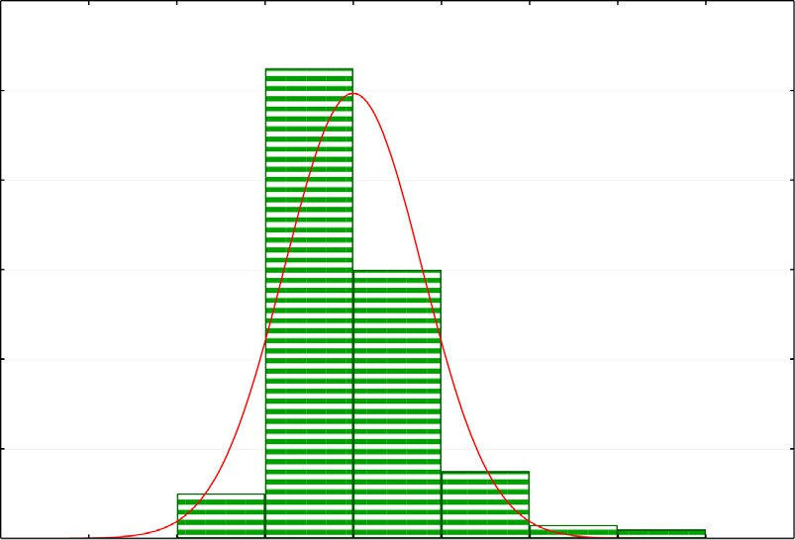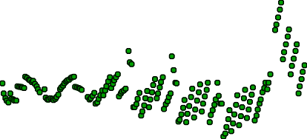



Fig. 7. .The error graphs depicted different error aspects of MLP 3-8-1 in way of histogram of residuals (a), raw residual of case numbers (b).

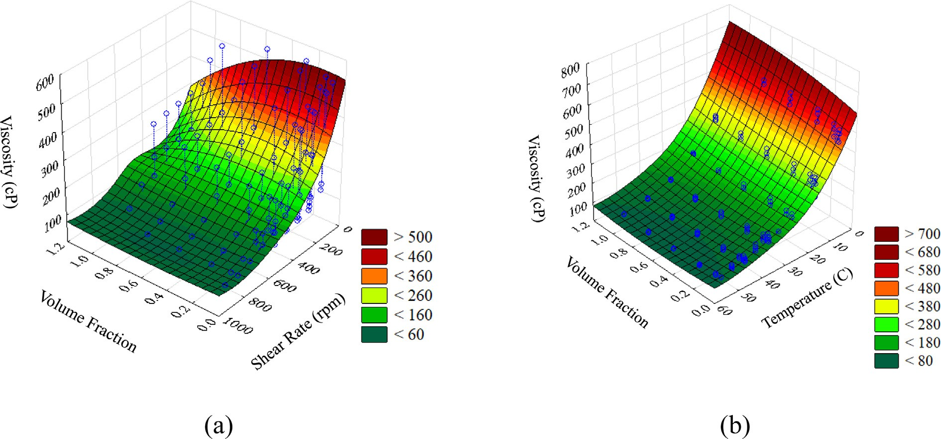

Fig. 8. Three-dimensional surf for lnf of MWCNT-Al2O3 (30:70)/ Oil 5W50 hybrid nano-lubricant against (a) SVF and SR and (b) SVF and temperature.

|  |  |  |  |  |  |
| --- | --- | --- | --- | --- | --- |
|  |  |  |  | |  |
|  |  |  |  |
|  |  |
|  |  |  | |  | |
|  |  |  | |  | |
|  |  |  | |  | |
|  |  |  | |  | |
|  |  |  | |  | |



Fig. 9. Comparing the experimental data and ANN data.



from the figures that the excellent agreement of ANN as an approx- imation function of the lnf is achieved. It can be concluded that the temperature has a significant effect on lnf. In addition, with increasing the SVF of MWCNT-Al2O3 (30:70)/ Oil 5W50 hybrid nano-lubricant the effect of shear rate increases, enhancing the lnf. Fig. 9 illustrates the lnf of MWCNT-Al2O3 (30:70)/ Oil 5W50 hybrid nano-lubricant compared to the experimental data and

the simulated ANN output. From this, we can conclude that the experimental data are close to the simulated ANN and accurately predict the results. The ANN was generated and tested using the collected experimental datasets and the results show that there was a good match between the actual and predicted values of the ANN.

Table 3 shows the results of data processing by various meth- ods. These methods include support vector machines (SVM), par- tial least squares (PLS) method, and PCR. The SVM was presented by Vapnik [53,54]. The distinctive features of SVM and ability to promise empirical performance, causing to utilize them for the facial expression classification problem. SVM is a supervised machine learning algorithm that can be used for classification and regression purposes. Support vector machines can also be used as a regression method, preserving all the key features (maximum margins) that characterize the algorithm. You can use SVM to determine the acceptable error in your model and find a line (or higher dimensional hyperplane) that fits your data. In this case,

Table 3

The results of the error and coefficient correlation rate of method.

Performance Algorithm Function

MLP 3-8-1 0.974831531 BFGS 30 Logistic,

Exponential

the polynomial algorithm and its parameters were used: m = 0.5,

c = 0.3333333. Partial least squares regression (PLS) regression is a fast, efficient, and optimal covariance-based regression method that is recommended for regressions with many explanatory vari- ables [55,56]. The explanatory variables tend to correlate. PLS is a transformer or regressor and is in many ways similar to PCR. It also shrinks the sample before using the linear regressor on the trans- formed data. The main difference from PCR is that PLS Transforma- tion is monitored [50,57].

Multiple Linear Regression (MLR), also known as multiple regression, is a statistical technique that uses several independent variables to predict the outcome of a response variable. MLR is an extension of Linear Regression (LS) that uses only one independent variable. As can be seen from Table 3, the best training methods related to the Broydon - Fletcher - Goldfarb - Shann (BFGS) algo- rithm is due to having the least amount of error and highest perfor- mance. The ANN during the other method led to the selection, which we will explain and analyze in the following Regression and Performance diagrams.

Fig. 7 presents error graphs for various aspects of the MLP 3-8-1 error such as the difference between the residual and the expected normal. In Fig. 7, the error values demonstrate that ANN is work- ing appropriately, which the training approach is satisfactory. Therefore, the expected dynamic viscosity results of MLP 3-8-1 are very good predictors. In addition, the resulting ANN residuals of 8 neurons at dynamic viscosity were very low and probably close to the expected normal. From this, we can conclude that a given model can be expected to have exact values.

Here, a BFGS 30 algorithm of an ANN with a single hidden layer and 8 neurons is used to effectively estimate the lnf [58]. Given the obtained ANN structure, the lnf of MWCNT-Al2O3 (30:70)/ Oil

5W50 hybrid nano-lubricant can be expressed as follows:

SVR (Support Vector Machine)

0.9257911 Polynomial m = 0.5,

c = 0.3333333

Prediction equation for:

PLS (Partial Least Squares) 0.8090009 NIPALS full Cross

validation

Dynamic viscosity (cP) = 617.632880923–0.292162141822×‘‘s

hear rate (rpm)”+3.7711289518e-005*‘‘shear rate (rpm)”2-18.003

PCR (Principal Component Regression)

MLR (Multiple Linear Regression)

0.8090013 NIPALS full Cross

validation

0.8060046 – Leverage correction

3836373×‘‘Temperature (C)”+0.179362244142×‘‘Temperature (C)”2-25.7678671818×‘‘Volume fraction (%)”+68.2130447442×‘‘V

olume fraction (%)”2 + 0.00249886204997×‘‘shear rate

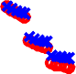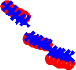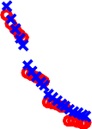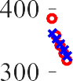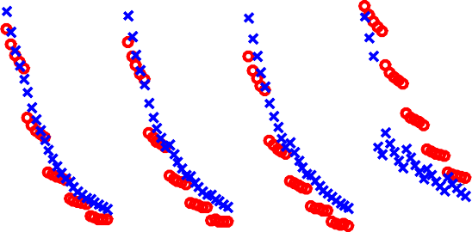

(rpm) × Temperature (C)”+0.145307636612×‘‘shear rate (rpm) × Volume fraction (%)”-2.91427313409×‘‘Temperature

(C) × Volume fraction (%)”(1).

1. Conclusion

In this study, the prediction of lnf of MWCNT-Al2O3 (30:70)/ Oil 5W50 hybrid nano-lubricant using ANN was performed. The feed- forward ANN consists of an MLP, which is capable of predicting lnf in connection with experimental data of temperature, SR and SVF. The following results were obtained:

* + ANN was generated and tested with experimental data sets and the results show that there was a good agreement between the actual and predicted ANN values.
  + The results of the residual value of ANN with eight neurons for

lnf can be very small and close to the expected normal value.

* + Using ANN BFGS algorithm, lead to 5.6e-02 in MSE and 97% as a correlation coefficient for predicting lnf.
  + Error diagrams demonstrated the suitability of ANNs as tools for determining the function of lnf and the learning algorithm used.
  + The results of ANN simulation are compared with other data processing methods such as SVM, PLS, Principal Component Regression.
  + In some cases, the trend of the targets is simply adjusted by a

linear function called identity in the output layer.

References

1. Duan Y, Fu H, Zhang L, Gao R, Sun Q, Chen Z, et al. Embedding of ultra- dispersed MoS2 nanosheets in N, O heteroatom-modified carbon nanofibers for improved adsorption of Hg2+. Compos Commun 2022;31. doi: [https://doi.](https://doi.org/10.1016/j.coco.2022.101106) [org/10.1016/j.coco.2022.101106](https://doi.org/10.1016/j.coco.2022.101106).
2. Xiao X, Bu G, Ou Z, Li Z. Nonlinear in-plane instability of the confined FGP arches with nanocomposites reinforcement under radially-directed uniform pressure. Eng Struct 2022;252:113670. doi: [https://doi.org/10.1016/j.](https://doi.org/10.1016/j.engstruct.2021.113670) [engstruct.2021.113670](https://doi.org/10.1016/j.engstruct.2021.113670).
3. Tian J, Liu Y, Zheng W, Yin L. Smog prediction based on the deep belief - BP neural network model (DBN-BP). Urban Clim 2021. doi: [https://doi.org/](https://doi.org/10.1016/j.uclim.2021.101078) [10.1016/j.uclim.2021.101078](https://doi.org/10.1016/j.uclim.2021.101078).
4. Zhang Z, Tian J, Huang W, Yin L, Zheng W, et al. A Haze Prediction Method Based on One-Dimensional Convolutional Neural Network. Atmosphere 2021;12(10):1327. doi: <https://doi.org/10.3390/atmos12101327>.
5. Wang Y, Wang H, Zhou B, Fu H. Multi-dimensional prediction method based on Bi-LSTMC for ship roll. Ocean Eng 2021;242:110106. doi: [https://doi.org/](https://doi.org/10.1016/j.oceaneng.2021.110106) [10.1016/j.oceaneng.2021.110106](https://doi.org/10.1016/j.oceaneng.2021.110106).
6. Meng F, Cheng W, Wang J. Semi-supervised Software Defect Prediction Model Based on Tri-training. KSII Trans Internet Inform Syst 2021;15(11):4028–42. doi: <https://doi.org/10.3837/tiis.2021.11.009>.
7. Zhong Q, Yang J, Shi K, Zhong S, Zhixiong L, et al. Event-Triggered H1 Load

Frequency Control for Multi-Area Nonlinear Power Systems Based on Non- Fragile Proportional Integral Control Strategy. IEEE Trans Intell Transp Syst. 2021. doi: 10.1 I09/TTTS 2021.3110759

1. Zhang H, Liu Y, Deng Y. Temperature gradient modeling of a steel box-girder suspension bridge using Copulas probabilistic method and field monitoring. Adv Struct Eng 2021;24(5):947–61. doi: [https://doi.org/10.1177/](https://doi.org/10.1177/1369433220971779) [1369433220971779](https://doi.org/10.1177/1369433220971779).
2. [Chen TC, Alazzawi FJI, Salameh AA, Ayub Ahmed AA, Pustokhina I, Surendar A,](http://refhub.elsevier.com/S1110-8665(22)00025-1/h0045) [et al. Application of machine learning in rapid analysis of solder joint geometry](http://refhub.elsevier.com/S1110-8665(22)00025-1/h0045) [and type on thermomechanical useful lifetime of electronic components. Mech](http://refhub.elsevier.com/S1110-8665(22)00025-1/h0045) [Adv Mater Struct 2021:1–9](http://refhub.elsevier.com/S1110-8665(22)00025-1/h0045).
3. Yin G, Alazzawi FJI, Bokov D, Marhoon HA, El-Shafay AS, Rahman ML, et al. Multiple machine learning models for prediction of CO2 solubility in potassium and sodium based amino acid salt solutions. Arab J Chem 2022;15(3):. doi: <https://doi.org/10.1016/j.arabjc.2021.103608>103608.
4. Zhao T-H, Khan MI, Chu Y-M. Artificial neural networking (ANN) analysis for heat and entropy generation in flow of non-Newtonian fluid between two rotating disks. Math Methods Appl Sci 2021. doi: [https://doi.org/10.1002/](https://doi.org/10.1002/mma.7310) [mma.7310](https://doi.org/10.1002/mma.7310).
5. [Yin G, Alazzawi FJI, Mironov S, Reegu F, El-Shafay AS, Rahman ML, et al.](http://refhub.elsevier.com/S1110-8665(22)00025-1/h0060) [Machine learning method for simulation of adsorption separation:](http://refhub.elsevier.com/S1110-8665(22)00025-1/h0060) [Comparisons of model’s performance in predicting equilibrium](http://refhub.elsevier.com/S1110-8665(22)00025-1/h0060) [concentrations. Arab J Chem 2022;15(3):103612](http://refhub.elsevier.com/S1110-8665(22)00025-1/h0060).
6. [Pranoto WJ, Al-Shawi SG, Chetthamrongchai P, Chen TC, Petukhova E,](http://refhub.elsevier.com/S1110-8665(22)00025-1/h0065) [Nikolaeva N, et al. Employing artificial neural networks and fluorescence](http://refhub.elsevier.com/S1110-8665(22)00025-1/h0065) [spectrum for food vegetable oils identification. Food Sci Technol 2021](http://refhub.elsevier.com/S1110-8665(22)00025-1/h0065).
7. Al-Shawi SG, Andreevna Alekhina N, Aravindhan S, Thangavelu L, Elena A, Viktorovna Kartamysheva N, Rafkatovna Zakieva R. Synthesis of NiO nanoparticles and sulfur, and nitrogen co doped-graphene quantum dots/nio nanocomposites for antibacterial application. J Nanostruct 2021;11(1):181–8. doi: <https://doi.org/10.22052/JNS.2021.01.019>.
8. [Chu Y-M, Shankaralingappa BM, Gireesha BJ, Alzahrani F, Ijaz Khan M, Khan](http://refhub.elsevier.com/S1110-8665(22)00025-1/h0075) [SU. Combined impact of Cattaneo-Christov double diffusion and radiative heat](http://refhub.elsevier.com/S1110-8665(22)00025-1/h0075) [flux on bio-convective flow of Maxwell liquid configured by a stretched nano-](http://refhub.elsevier.com/S1110-8665(22)00025-1/h0075) [material surface. Appl Math Comput 2021](http://refhub.elsevier.com/S1110-8665(22)00025-1/h0075).
9. Chu Y-M, Nazir U, Sohail M, Selim MM, Lee J-R. Enhancement in thermal energy and solute particles using hybrid nanoparticles by engaging activation energy and chemical reaction over a parabolic surface via finite element approach Article 119. Fractal Fract 2021;5(3):17 pages. doi: [https://doi.org/](https://doi.org/10.3390/fractalfract5030119) [10.3390/fractalfract5030119](https://doi.org/10.3390/fractalfract5030119).
10. Nazeer M, Hussain F, Ijaz Khan M, Asad-ur-Rehman ER, El-Zahar Y-M, Malik Chu MY. Theoretical study of MHD electro-osmotically flow of third-grade fluid in micro channel. Appl Math Comput 2021. doi: [https://doi.org/10.1016/j.](https://doi.org/10.1016/j.amc.2021.126868) [amc.2021.126868](https://doi.org/10.1016/j.amc.2021.126868).
11. [Oveissi S, Eftekhari SA, Toghraie D. Longitudinal vibration and instabilities of](http://refhub.elsevier.com/S1110-8665(22)00025-1/h0090) [carbon nanotubes conveying fluid considering size effects of nanoflow and](http://refhub.elsevier.com/S1110-8665(22)00025-1/h0090) [nanostructure. Phys E 2016;83:164–73](http://refhub.elsevier.com/S1110-8665(22)00025-1/h0090).
12. [Mikhailov OV, Chachkov DV. Molecular structure models of Al2Ti3 and Al2V3](http://refhub.elsevier.com/S1110-8665(22)00025-1/h0095) [clusters according to DFT quantum-chemical calculations. Eur Chem Bull](http://refhub.elsevier.com/S1110-8665(22)00025-1/h0095) [2020;9(2):62–8](http://refhub.elsevier.com/S1110-8665(22)00025-1/h0095).
13. Putra ABW. Computer Technology Simulation towards Power Generation Potential from Coproduced Fluids in South Lokichar Oil Fields. Int J Commun Comput Technol 2020;8(2):9–12. doi: <https://doi.org/10.31838/ijccts/08.02.03>.
14. [Ghanbarpour M, Haghigi EB, Khodabandeh R. Thermal properties and](http://refhub.elsevier.com/S1110-8665(22)00025-1/h0105) [rheological behavior of water based Al2O3 nanofluid as a heat transfer fluid.](http://refhub.elsevier.com/S1110-8665(22)00025-1/h0105) [Exp Therm Fluid Sci 2014;53:227–35](http://refhub.elsevier.com/S1110-8665(22)00025-1/h0105).
15. [Nazari MA, Ahmadi MH, Sadeghzadeh M, Shafii MB, Goodarzi M. A review on](http://refhub.elsevier.com/S1110-8665(22)00025-1/h0110) [application of nanofluid in various types of heat pipes. J Central South Univ](http://refhub.elsevier.com/S1110-8665(22)00025-1/h0110) [2019;26:1021–41](http://refhub.elsevier.com/S1110-8665(22)00025-1/h0110).
16. [Qeays IA, Yahya SM, Asjad M, Khan ZA. Multi-performance optimization of](http://refhub.elsevier.com/S1110-8665(22)00025-1/h0115) [nanofluid cooled hybrid photovoltaic thermal system using fuzzy integrated](http://refhub.elsevier.com/S1110-8665(22)00025-1/h0115) [methodology. J Cleaner Prod 2020;256:120451](http://refhub.elsevier.com/S1110-8665(22)00025-1/h0115).
17. [Qeays IA, Yahya SM, Arif MSB, Jamil A. Nanofluids application in hybrid](http://refhub.elsevier.com/S1110-8665(22)00025-1/h0120) [photovoltaic thermal system for performance enhancement: a review. AIMS](http://refhub.elsevier.com/S1110-8665(22)00025-1/h0120) [Energy 2020;8:365–93](http://refhub.elsevier.com/S1110-8665(22)00025-1/h0120).
18. [Thomas S, Sobhan CBP. A review of experimental investigations on thermal](http://refhub.elsevier.com/S1110-8665(22)00025-1/h0125) [phenomena in nanofluids. Nanoscale Res Lett 2011;6:1–21](http://refhub.elsevier.com/S1110-8665(22)00025-1/h0125).
19. [Kole M, Dey T. Viscosity of alumina nanoparticles dispersed in car engine](http://refhub.elsevier.com/S1110-8665(22)00025-1/h0130) [coolant. Exp Therm Fluid Sci 2010;34:677–83](http://refhub.elsevier.com/S1110-8665(22)00025-1/h0130).
20. [Sundar LS, Singh MK, Sousa AC. Investigation of thermal conductivity and](http://refhub.elsevier.com/S1110-8665(22)00025-1/h0135) [viscosity of Fe3O4 nanofluid for heat transfer applications. Int Commun Heat](http://refhub.elsevier.com/S1110-8665(22)00025-1/h0135) [Mass Transfer 2013;44:7–14](http://refhub.elsevier.com/S1110-8665(22)00025-1/h0135).
21. [Esfe MH, Eftekhari SA, Hekmatifar M, Toghraie D. A well-trained artificial](http://refhub.elsevier.com/S1110-8665(22)00025-1/h0140) [neural network for predicting the rheological behavior of MWCNT–Al2O3 (30–](http://refhub.elsevier.com/S1110-8665(22)00025-1/h0140) [70%)/oil SAE40 hybrid nanofluid. Sci Rep 2021;11:1–11](http://refhub.elsevier.com/S1110-8665(22)00025-1/h0140).
22. [Esfe MH, Alidoust S. Experimental evaluation of MWCNT–Al2O3 (40–60%)/](http://refhub.elsevier.com/S1110-8665(22)00025-1/h0145) [5W50 hybrid nanofluid and comparison with MWCNT–Al2O3 (35–65%)/5W50](http://refhub.elsevier.com/S1110-8665(22)00025-1/h0145) [hybrid nanofluid with focus on thermophysical properties and cost](http://refhub.elsevier.com/S1110-8665(22)00025-1/h0145) [performance index. Eur Phys J Plus 2020;135:817](http://refhub.elsevier.com/S1110-8665(22)00025-1/h0145).
23. [Esfe MH, Nadooshan AA, Arshi A, Alirezaie A. Convective heat transfer and](http://refhub.elsevier.com/S1110-8665(22)00025-1/h0150) [pressure drop of aqua based TiO2 nanofluids at different diameters of](http://refhub.elsevier.com/S1110-8665(22)00025-1/h0150) [nanoparticles: Data analysis and modeling with artificial neural network.](http://refhub.elsevier.com/S1110-8665(22)00025-1/h0150) [Phys E 2018;97:155–61](http://refhub.elsevier.com/S1110-8665(22)00025-1/h0150).
24. [Rostami S, Nadooshan AA, Raisi A, Bayareh M. Modeling the thermal](http://refhub.elsevier.com/S1110-8665(22)00025-1/h0155) [conductivity ratio of an antifreeze-based hybrid nanofluid containing](http://refhub.elsevier.com/S1110-8665(22)00025-1/h0155) [graphene oxide and copper oxide for using in thermal systems. J Mater Res](http://refhub.elsevier.com/S1110-8665(22)00025-1/h0155) [Technol 2021;11:2294–304](http://refhub.elsevier.com/S1110-8665(22)00025-1/h0155).
25. [Rostami S, Nadooshan AA, Raisi A. An experimental study on the thermal](http://refhub.elsevier.com/S1110-8665(22)00025-1/h0160) [conductivity of new antifreeze containing copper oxide and graphene oxide](http://refhub.elsevier.com/S1110-8665(22)00025-1/h0160) [nano-additives. Powder Technol 2019;345:658–67](http://refhub.elsevier.com/S1110-8665(22)00025-1/h0160).
26. [Rostami S, Ahmadi Nadooshan A, Raisi A. The effect of hybrid nano-additive](http://refhub.elsevier.com/S1110-8665(22)00025-1/h0165) [consists of graphene oxide and copper oxide on rheological behavior of a](http://refhub.elsevier.com/S1110-8665(22)00025-1/h0165) [mixture of water and ethylene glycol. J Therm Anal Calorim 2020;139:2353–64](http://refhub.elsevier.com/S1110-8665(22)00025-1/h0165).
27. [Naina HK, Gupta R, Setia H, Wanchoo R. Viscosity and specific volume of TiO2/](http://refhub.elsevier.com/S1110-8665(22)00025-1/h0170) [water nanofluid. J Nanofluids 2012;1:161–5](http://refhub.elsevier.com/S1110-8665(22)00025-1/h0170).
28. [Murshed S, Leong K, Yang C. Investigations of thermal conductivity and](http://refhub.elsevier.com/S1110-8665(22)00025-1/h0175) [viscosity of nanofluids. Int J Therm Sci 2008;47:560–8](http://refhub.elsevier.com/S1110-8665(22)00025-1/h0175).
29. [Aladag B, Halelfadl S, Doner N, Maré T, Duret S, Estellé P. Experimental](http://refhub.elsevier.com/S1110-8665(22)00025-1/h0180) [investigations of the viscosity of nanofluids at low temperatures. Appl Energy](http://refhub.elsevier.com/S1110-8665(22)00025-1/h0180) [2012;97:876–80](http://refhub.elsevier.com/S1110-8665(22)00025-1/h0180).
30. [Hojjat M, Etemad SG, Bagheri R, Thibault J. Rheological characteristics of non-](http://refhub.elsevier.com/S1110-8665(22)00025-1/h0185) [Newtonian nanofluids: experimental investigation. Int Commun Heat Mass](http://refhub.elsevier.com/S1110-8665(22)00025-1/h0185) [Transfer 2011;38:144–8](http://refhub.elsevier.com/S1110-8665(22)00025-1/h0185).
31. [Esfe MH, Arani AAA, Rezaie M, Yan W-M, Karimipour A. Experimental](http://refhub.elsevier.com/S1110-8665(22)00025-1/h0190) [determination of thermal conductivity and dynamic viscosity of Ag–MgO/](http://refhub.elsevier.com/S1110-8665(22)00025-1/h0190) [water hybrid nanofluid. Int Commun Heat Mass Transfer 2015;66:189–95](http://refhub.elsevier.com/S1110-8665(22)00025-1/h0190).
32. [Esfe MH, Alirezaie A, Rejvani M. An applicable study on the thermal](http://refhub.elsevier.com/S1110-8665(22)00025-1/h0195) [conductivity of SWCNT-MgO hybrid nanofluid and price-performance](http://refhub.elsevier.com/S1110-8665(22)00025-1/h0195) [analysis for energy management. Appl Therm Eng 2017;111:1202–10](http://refhub.elsevier.com/S1110-8665(22)00025-1/h0195).
33. [Rejvani M, Saedodin S, Vahedi SM, Wongwises S, Chamkha AJ. Experimental](http://refhub.elsevier.com/S1110-8665(22)00025-1/h0200) [investigation of hybrid nano-lubricant for rheological and thermal engineering](http://refhub.elsevier.com/S1110-8665(22)00025-1/h0200) [applications. J Therm Anal Calorim 2019;138:1823–39](http://refhub.elsevier.com/S1110-8665(22)00025-1/h0200).
34. [Batmunkh M, Tanshen MR, Nine MJ, Myekhlai M, Choi H, Chung H, et al.](http://refhub.elsevier.com/S1110-8665(22)00025-1/h0205) [Thermal conductivity of TiO2 nanoparticles based aqueous nanofluids with an](http://refhub.elsevier.com/S1110-8665(22)00025-1/h0205) [addition of a modified silver particle. Ind Eng Chem Res 2014;53:8445–51](http://refhub.elsevier.com/S1110-8665(22)00025-1/h0205).
35. [Suresh S, Venkitaraj K, Selvakumar P, Chandrasekar M. Effect of Al2O3–Cu/](http://refhub.elsevier.com/S1110-8665(22)00025-1/h0210) [water hybrid nanofluid in heat transfer. Exp Therm Fluid Sci 2012;38:54–60](http://refhub.elsevier.com/S1110-8665(22)00025-1/h0210).
36. [Esfe MH, Karimpour R, Arani AAA, Shahram J. Experimental investigation on](http://refhub.elsevier.com/S1110-8665(22)00025-1/h0215) [non-Newtonian behavior of Al2O3-MWCNT/5W50 hybrid nano-lubricant](http://refhub.elsevier.com/S1110-8665(22)00025-1/h0215) [affected by alterations of temperature, concentration and shear rate for](http://refhub.elsevier.com/S1110-8665(22)00025-1/h0215) [engine applications. Int Commun Heat Mass Transfer 2017;82:97–102](http://refhub.elsevier.com/S1110-8665(22)00025-1/h0215).
37. [Chen LF, Cheng M, Yang DJ, Yang L. Enhanced thermal conductivity of](http://refhub.elsevier.com/S1110-8665(22)00025-1/h0220) [nanofluid by synergistic effect of multi-walled carbon nanotubes and Fe2O3](http://refhub.elsevier.com/S1110-8665(22)00025-1/h0220) [nanoparticles. Appl Mech Mater Trans Tech Publ 2014:118–23](http://refhub.elsevier.com/S1110-8665(22)00025-1/h0220).
38. [Madhesh D, Parameshwaran R, Kalaiselvam S. Experimental investigation on](http://refhub.elsevier.com/S1110-8665(22)00025-1/h0225) [convective heat transfer and rheological characteristics of Cu–TiO2 hybrid](http://refhub.elsevier.com/S1110-8665(22)00025-1/h0225) [nanofluids. Exp Therm Fluid Sci 2014;52:104–15](http://refhub.elsevier.com/S1110-8665(22)00025-1/h0225).
39. [Toghraie D, Sina N, Jolfaei NA, Hajian M, Afrand M. Designing an Artificial](http://refhub.elsevier.com/S1110-8665(22)00025-1/h0230) [Neural Network (ANN) to predict the viscosity of Silver/Ethylene glycol](http://refhub.elsevier.com/S1110-8665(22)00025-1/h0230) [nanofluid at different temperatures and volume fraction of nanoparticles. Phys](http://refhub.elsevier.com/S1110-8665(22)00025-1/h0230) [A 2019;534:122142](http://refhub.elsevier.com/S1110-8665(22)00025-1/h0230).
40. [Toghraie DS, Sina N, Mozafarifard M, Alizadeh AA, Soltani F, Fazilati MA.](http://refhub.elsevier.com/S1110-8665(22)00025-1/h0235) [Prediction of dynamic viscosity of a new non-Newtonian hybrid nanofluid](http://refhub.elsevier.com/S1110-8665(22)00025-1/h0235) [using experimental and artificial neural network (ANN) methods. Heat](http://refhub.elsevier.com/S1110-8665(22)00025-1/h0235) [Transfer Res 2020;51](http://refhub.elsevier.com/S1110-8665(22)00025-1/h0235).
41. [Esfe MH, Motallebi SM, Bahiraei M. Employing response surface methodology](http://refhub.elsevier.com/S1110-8665(22)00025-1/h0240) [and neural network to accurately model thermal conductivity of TiO2–water](http://refhub.elsevier.com/S1110-8665(22)00025-1/h0240) [nanofluid using experimental data. Chin J Phys 2021;70:14–25](http://refhub.elsevier.com/S1110-8665(22)00025-1/h0240).
42. [Beigzadeh R. An Intelligent Approach to Predict the Viscosity of Water/](http://refhub.elsevier.com/S1110-8665(22)00025-1/h0245) [Glycerin Containing Cu Nanoparticles: Neuro-Fuzzy Inference System (ANFIS)](http://refhub.elsevier.com/S1110-8665(22)00025-1/h0245) [Model. J Chem Pet Eng 2021;55:163–75](http://refhub.elsevier.com/S1110-8665(22)00025-1/h0245).
43. [Rahmanian A, Mireei SA, Sadri S, Gholami M, Nazeri M. Application of](http://refhub.elsevier.com/S1110-8665(22)00025-1/h0250) [biospeckle laser imaging for early detection of chilling and freezing disorders](http://refhub.elsevier.com/S1110-8665(22)00025-1/h0250) [in orange. Postharvest Biol Technol 2020;162:111118](http://refhub.elsevier.com/S1110-8665(22)00025-1/h0250).
44. Aletsee FG. Estimation of the Coverage Probability of S-Parameters for Safety- Critical Systems with Hotelling’s T 2 Distribution. In: 2021 96th ARFTG Microwave Measurement Conference (ARFTG), IEEE; 2021, p. 1–4.
45. [Khaje Khabaz M, Eftekhari SA, Toghraie D. Vibration and dynamic analysis of a](http://refhub.elsevier.com/S1110-8665(22)00025-1/h0260) [cantilever sandwich microbeam integrated with piezoelectric layers based on](http://refhub.elsevier.com/S1110-8665(22)00025-1/h0260) [strain gradient theory and surface effects. Appl Math Comput 2022;419](http://refhub.elsevier.com/S1110-8665(22)00025-1/h0260).
46. [Shariati M, Mafipour MS, Mehrabi P, Bahadori A, Zandi Y, Salih MN, et al.](http://refhub.elsevier.com/S1110-8665(22)00025-1/h0265) [Application of a hybrid artificial neural network-particle swarm optimization](http://refhub.elsevier.com/S1110-8665(22)00025-1/h0265) [(ANN-PSO) model in behavior prediction of channel shear connectors](http://refhub.elsevier.com/S1110-8665(22)00025-1/h0265) [embedded in normal and high-strength concrete. Appl Sci 2019;9:5534](http://refhub.elsevier.com/S1110-8665(22)00025-1/h0265).
47. [Khaje Khabaz M, Eftekhari SA, Hashemian M, Toghraie D. Optimal vibration](http://refhub.elsevier.com/S1110-8665(22)00025-1/h0270) [control of multi-layer micro-beams actuated by piezoelectric layer based on](http://refhub.elsevier.com/S1110-8665(22)00025-1/h0270) [modified couple stress and surface stress elasticity theories. Phys A](http://refhub.elsevier.com/S1110-8665(22)00025-1/h0270) [2020;546:123998](http://refhub.elsevier.com/S1110-8665(22)00025-1/h0270).
48. [Bahiraei M, Heshmatian S, Moayedi H. Artificial intelligence in the field of](http://refhub.elsevier.com/S1110-8665(22)00025-1/h0275) [nanofluids: A review on applications and potential future directions. Powder](http://refhub.elsevier.com/S1110-8665(22)00025-1/h0275) [Technol 2019;353:276–301](http://refhub.elsevier.com/S1110-8665(22)00025-1/h0275).
49. [Khajekhabaz M, Eftekhari A, Hashemian M. Free Vibration Analysis of Sandwich](http://refhub.elsevier.com/S1110-8665(22)00025-1/h0280) [Micro Beam with Piezoelectric Based on Modified Couple Stress Theory and](http://refhub.elsevier.com/S1110-8665(22)00025-1/h0280) [Surface Effects. J Simul Anal Novel Technol Mech Eng 2018;10:33–48](http://refhub.elsevier.com/S1110-8665(22)00025-1/h0280).
50. [Sarsam SM. Reinforcing the decision-making process in chemometrics:](http://refhub.elsevier.com/S1110-8665(22)00025-1/h0285) [Feature selection and algorithm optimization. In: Proceedings of the 2019](http://refhub.elsevier.com/S1110-8665(22)00025-1/h0285) [8th international conference on software and computer applications. p. 11–6](http://refhub.elsevier.com/S1110-8665(22)00025-1/h0285).
51. [Sundar LS, Singh MK, Ferro M, Sousa AC. Experimental investigation of the](http://refhub.elsevier.com/S1110-8665(22)00025-1/h0290) [thermal transport properties of graphene oxide/Co3O4 hybrid nanofluids. Int](http://refhub.elsevier.com/S1110-8665(22)00025-1/h0290) [Commun Heat Mass Transfer 2017;84:1–10](http://refhub.elsevier.com/S1110-8665(22)00025-1/h0290).
52. [Esfe MH, Amir Taghavi KA, Fouladi M. Effect of suspending optimized ratio of](http://refhub.elsevier.com/S1110-8665(22)00025-1/h0300) [nano-additives MWCNT-Al2O3 on viscosity behavior of 5W50. J Mol Liq](http://refhub.elsevier.com/S1110-8665(22)00025-1/h0300) [2019;285:572–85](http://refhub.elsevier.com/S1110-8665(22)00025-1/h0300).