Journal Pre-proofs

Article

Pretreatment as a Microplastics Generator during Household Biogenic Waste Treatment

Tian Hu, Fan Lü, Zhan Yang, Zhenchao Shi, Yicheng Yang, Hua Zhang, Pinjing He

PII: S2095-8099(23)00478-2

DOI: <https://doi.org/10.1016/j.eng.2023.11.010>

Reference: ENG 1413

To appear in: *Engineering*

Received Date: 1 May 2023

Revised Date: 18 October 2023

Accepted Date: 2 November 2023

Please cite this article as: T. Hu, F. Lü, Z. Yang, Z. Shi, Y. Yang, H. Zhang, P. He, Pretreatment as a Microplastics Generator during Household Biogenic Waste Treatment, *Engineering* (2023), doi: [https://doi.org/](https://doi.org/10.1016/j.eng.2023.11.010) [10.1016/j.eng.2023.11.010](https://doi.org/10.1016/j.eng.2023.11.010)

This is a PDF file of an article that has undergone enhancements after acceptance, such as the addition of a cover page and metadata, and formatting for readability, but it is not yet the definitive version of record. This version will undergo additional copyediting, typesetting and review before it is published in its final form, but we are providing this version to give early visibility of the article. Please note that, during the production process, errors may be discovered which could affect the content, and all legal disclaimers that apply to the journal pertain.

© 2023 THE AUTHORS. Published by Elsevier LTD on behalf of Chinese Academy of Engineering and Higher Education Press Limited Company

Research

Environmental Engineering―Article



Pretreatment as a Microplastics Generator during Household Biogenic Waste Treatment

Tian Hu a, Fan Lü a,b,c, Zhan Yang a, Zhenchao Shi a, Yicheng Yang a, Hua Zhang a,b, Pinjing He a,b,*

*a Institute of Waste Treatment and Reclamation, Tongji University, Shanghai 200092, China*

*b Shanghai Institute of Pollution Control and Ecological Security, Shanghai 200092, China*

*c Jiaxing-Tongji Environmental Research Institute, Jiaxing 314000, China*

* Corresponding author.

*E-mail address*: [solidwaste@tongji.edu.cn](mailto:solidwaste@tongji.edu.cn) (P. He)

**Abstract**

Mechanical pretreatment is an indispensable process in biological treatment plants that remove plastics and other impurities from household biogenic waste (HBW). However, the imperfect separation of plastics in these pretreatment methods has raised concerns that they pose a secondary formation risk for microplastics (MPs). To validate this presumption, herein, quantities and properties of plastic debris and MPs larger than 50 μm were examined in the full chain of three different pretreatment methods in six plants. These facilities received HBW with or without prior depackaging at the source. The key points in the secondary formation of MPs were identified. Moreover, flux estimates of MPs were released, and an analysis of MPs sources was provided to develop an overview of their fate in HBW pretreatment. Pretreated output can contain a maximum of (1673 ± 279) to (3198 ± 263) MP particles per kilogram of wet weight (particles·kg−1 ww) for those undepackaged at source, and secondary MPs

formation is primarily attributed to biomass crushers, biohydrolysis reactors, and rough shredders. Comparatively, HBW depackaged at the source

can greatly reduce MPs by 8%–72%, regardless of pretreatment processes. Before pretreatment, 4.6–205.6 million MP particles were present in 100 tonnes of HBW. MPs are produced at a rate of 741.11–33 124.22 billion MP particles annually in anaerobic digester feedstock (ADF). This study demonstrated that HBW pretreatment is a competitive source of MPs and emphasized the importance of implementing municipal solid waste segregation at the source. Furthermore, depackaging biogenic waste at the source is recommended to substantially alleviate the negative effect of pretreatment on MPs formation.

**Keywords:** Microplastics; Plastic debris; Household biogenic waste; Depackage; Pretreatment

# Introduction

Microplastic particles (MPs), expanded pollutant particles of essential plastic materials used in the global consumer economy, have spread over the planet, posing serious environmental threats [1]. MPs refer to plastic debris smaller than 5 mm [2]. Besides examining their occurrence and effects in diverse environmental conditions, scientists inquire about the “MPs cycle” to deeply understand their global destiny [3]. For instance, unraveling the source and migration patterns of MPs remains a nascent endeavor [3]. Furthermore, source analysis of MPs is still in the preliminary stages owing to the limited knowledge about the movement and exchange of MPs between different environments [4].

Household biogenic waste (HBW) is a crucial source of MPs pollution in terrestrial systems [5,6]. While converting biogenic waste into organic fertilizers may represent a promising alternative approach for valorizing biogenic waste [7–9], early evidence indicates that MPs may be present in digestates and composts derived from HBW. Disturbingly, these MPs could be transferred to agricultural soil when these amendments are applied [10]. With the increasing worldwide use of HBW in organic fertilizers [11], HBW diversion policies continue to raise awareness of MPs contamination in organic materials. Consequently, numerous regulatory bodies have implemented stringent MPs thresholds for digestates and composts used in fertilization [12]. Considering that most regulations for plastic particles in organic fertilizers specify limits for particles larger than 2 mm [10], it is important not to overlook HBW as an important source of environmental MPs in organic fertilizers [13]. However, although numerous studies have examined the effects of MPs in HBW digestates and composts, none of these studies have investigated the origin of these MPs [14]. Inevitably, plastic wastes such as garbage bags, disposable tableware, and food packaging end up in HBW, constituting the main MPs source in HBW [15]. Reports from Oregon and Washington cities [16] have revealed plastic contamination rates in waste streams, including HBW destined for composting or anaerobic digestion, ranging from 0.1 wt% to 2.8 wt%. In certain cities in China, it is now a mandate to remove plastic bags from HBW at the source when depositing them into garbage bins, a depackaging process to effectively improve the quality of HBW separation [17]. Yang et al. [18] found that the plastic content in HBW directly affects the plastic content in digestate,

demonstrating that depackaging at the source can markedly curtail plastic debris in the digestate.

Various pretreatment methods are used in anaerobic digestion or mechanical and biological treatment plants to remove plastics and other physical contaminants (metal, paper, glass, wood, sand, etc.) from HBW, mostly relying on mechanical methods, such as shredders, screens, and extrusion dehydrators. Among these facilities, separation efficiency varies depending on the quality of the incoming feedstock, technical capabilities, and product specifications [17]. However, plastics in HBW cannot be completely removed through mechanical methods [19], and their efficiency has not been extensively studied [16].

Alessi et al. [20] examined the efficacy of four biowaste pretreatment plants in impurity removal, yet the extent to which these pretreatment processes may unintentionally introduce MPs into the final output remains unclear [16,21]. To comprehensively understand the source, fate, transport, and accumulation of MPs in this process, it is essential to characterize their abundance, distribution, and chemical composition [22,23].



To track the source of MPs potentially generated from pretreatment, this study investigated the full chain of three common pretreatment processes applied to HBW with different plastic pollution levels. The key points in the secondary formation of MPs were identified by analyzing the quantities and properties of plastic debris and MPs larger than 50 μm in liquid and solid samples collected at each pretreatment stage. Furthermore, the flux of released MPs was estimated, and an MPs source analysis was conducted, facilitating a comprehensive overview of MPs’ fate in HBW pretreatment.

# Materials and methods

* 1. *Collection of samples*

A total of six pretreatment systems were examined for HBW anaerobic digestion, denoted as Systems A, B, C, D, E, and F (Table S1 in Appendix A). Systems A, B, and E operate in Shanghai, where HBW is depackaged at the source before being collected and delivered. Systems C and F are in an urban region of Zhejiang Province, while System D is in a suburban area of Zhejiang Province. These systems can be categorized into three based on their main pretreatment techniques.

Systems A and B fall into Category I, where the main pretreatment methods include rough shredder, screen, and extrusion dehydrator. The rough shredder aims to separate HBW trapped inside plastic bags and homogenize them [20]. Screens are employed to filter out contaminants by rotating and tumbling HBW. The extrusion dehydrator using a screw press regulates the moisture content of the material, yielding solid- or liquid-phase material suitable for dry or wet anaerobic digestion. Category II comprises Systems C and D, which employ biomass crushers to separate plastics, fibers, and other impurities from organic waste. Mechanically crushing and sieving organic matter and inorganic interferents generate high-quality, homogenized organic materials with discharged organic particle sizes of 12–70 mm. Category III involves Systems E and F, which use biohydrolysis reactors as their main pretreatment technology. Biohydrolysis reactors combine physical interception, chemical adsorption, and bioremediation processes. Over approximately two days, these reactors facilitate hydrolysis and acidification, generating solids and liquids through spiral extrusion. Liquid-phase anaerobic digester feedstock (ADF) is usually pretreated using impurity separators, which remove light floating materials (plastics, etc.) and heavy nonbiodegradable materials (sand, etc.) from organic waste using screens (2 and 5 mm), buoyancy, or shear force. To provide visual context, photographs of the equipment studied are shown (Fig. S1 in Appendix A).

The composition of HBW can differ with seasonal shifts influenced by changing dietary habits owing to weather conditions. Sampling campaigns were conducted in August and December 2022, representing warm and cold seasons, respectively. A total of 39 sampling points were selected, and their locations are shown in Fig. 1. A total of 30 kg of HBW was collected from these points to separate its physical components and analyze its particle size. Furthermore, 2 kg of HBW was collected through a 20 mm mesh sieve for MPs extraction. In the laboratory, samples were immediately tested for moisture content and organic matter (Table S2 in Appendix A). The remaining samples were immediately stored in a refrigerator at 4 °C and used within 48 h for MPs extraction.

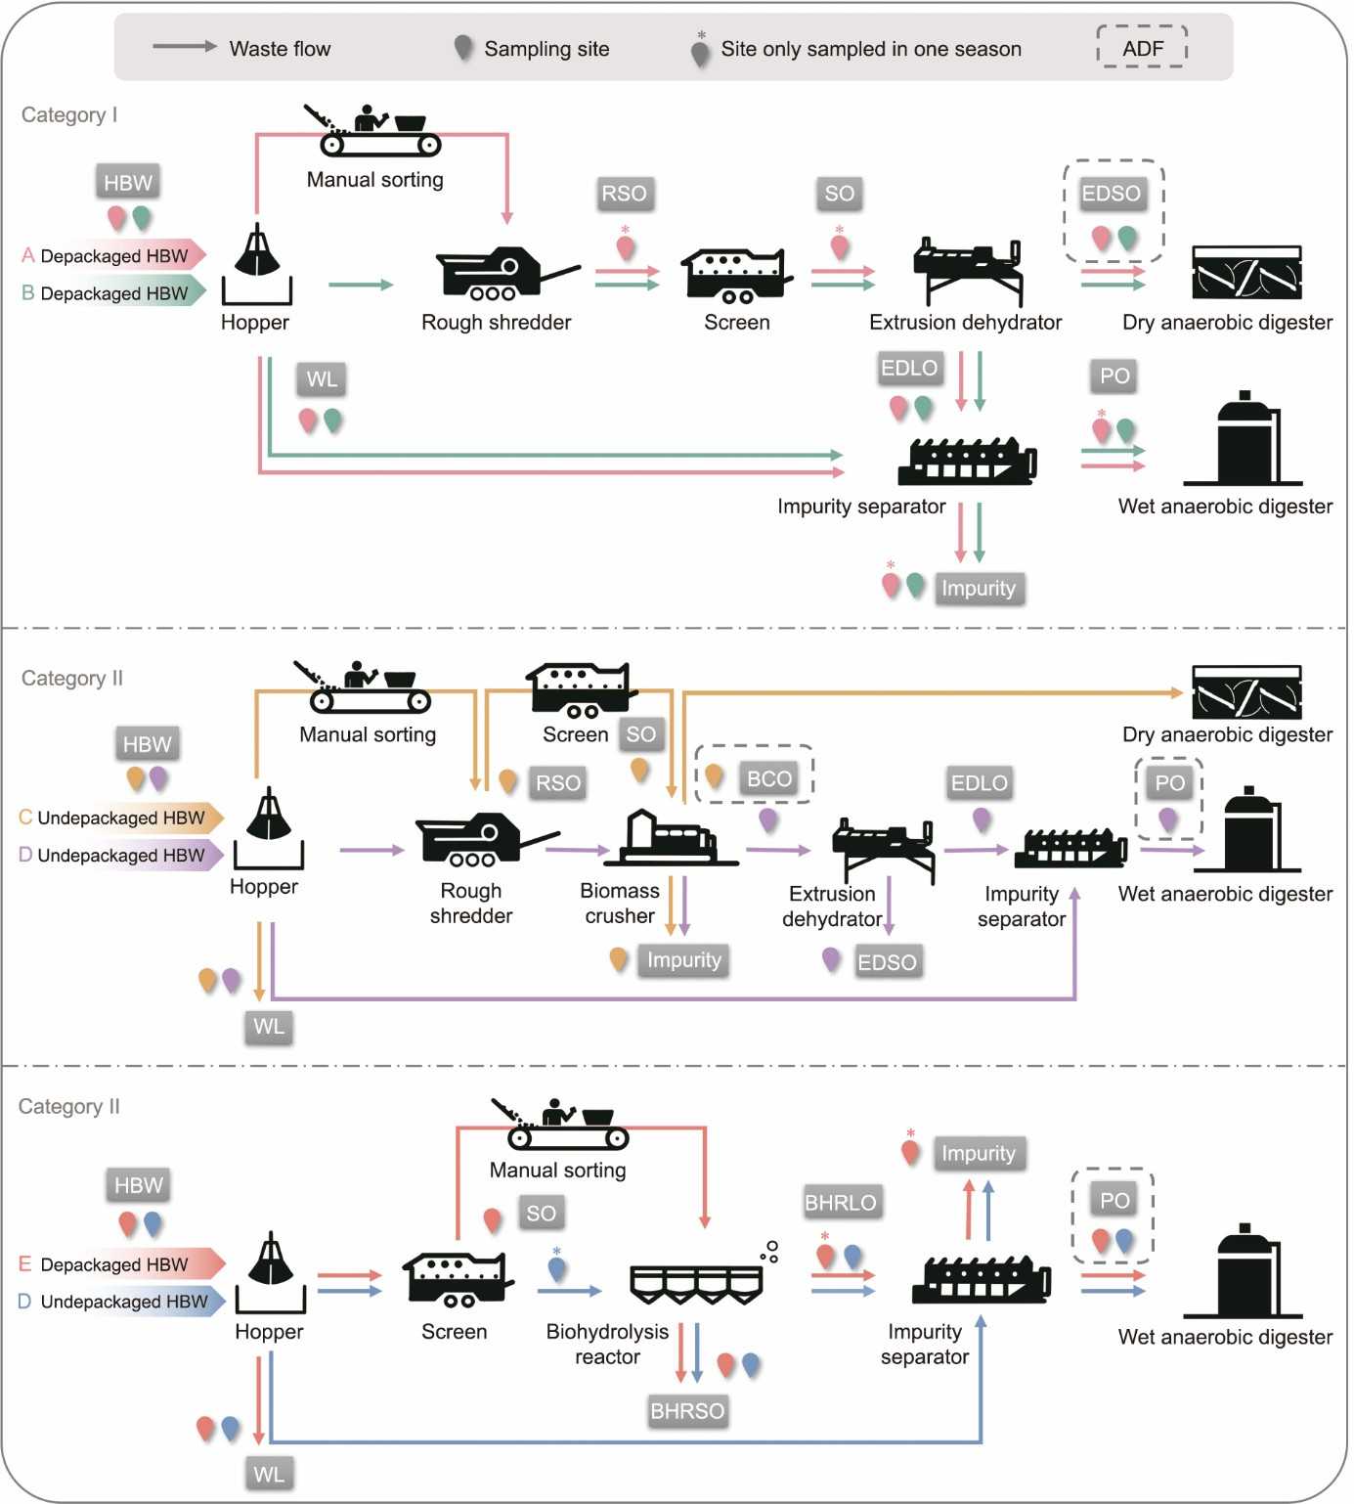

**Fig. 1.** Process flow diagrams and sampling sites. BCO: biomass crusher output; BHRLO: biohydrolysis reactor liquid output; BHRSO: biohydrolysis reactor solid output; EDLO: extrusion dehydrator liquid output; EDSO: extrusion dehydrator solid output; PO: purified output; RSO: rough shredder output; SO: screen output; WL: waste leachate. A balloon with a star means sites sampled during a single season.

* 1. *Extraction of plastic debris and MPs*

Without a standard MPs extraction process for HBW samples, certain modifications have been made based on a universal enzymatic purification protocol [24]. Briefly, sodium dodecyl sulfonate solution was used primarily to separate small particles and fat from MPs [25] and increase the contact surface for subsequent digestion [24,26]. To reduce costs, 30% H2O2 replaced enzymes to digest a large number of samples. Moreover, the conventional process of density fractionation was not applied owing to its limited success in separating organic-rich samples from plastic materials. This is because the density of organic matter is 1.0–1.4 g·cm−3, similarly to that of certain plastics, such as polyethylene terephthalate (PET) and nylon [27]. A diagram and description of the specific operation process are shown in the supplementary material (Fig. S2 and Text S1 in Appendix A).

* 1. *Identification of MPs*

MPs were observed on the filter membrane through the digital microscope (VHX-6000; Keyence, Japan) and pulled using tweezers. Particles exhibiting bright color, good uniformity, and excellent elasticity were considered MPs [18]. These suspected MPs were isolated and photographed, and their shape, color, and maximum dimension (length) were recorded. Particles were classified into fiber, fibrous cluster, film, flake, granule, and sphere, according to He et al. [28]. The particle

size was defined as the longest dimension, with five size ranges: 0.05–0.5, 0.5–1, 1–2, 2–5, and > 5 mm. Attenuated total reflection-Fourier transform infrared spectroscopy (ATR-FTIR; Nicolet iS20; Thermo Fisher Scientific, USA) was used to determine nonfiber particles larger than 1 mm. Micro-Fourier transform infrared spectroscopy (μ-FTIR) (Nicolet iS50; Thermo Fisher Scientific) was used to determine non-fiber particles with size 50 μm to 1 mm and all fibers. OMNIC software (Thermo Fisher Scientific) was used to process the spectrum, and the Hummel Polymer and Additives database (Thermo Fisher Scientific) was used to analyze the spectrum. The polymer type was determined when the degree of spectral matching exceeded 80%. The lower detection limit of MPs was set at 50 μm to ensure accuracy in detection owing to diffraction limitations [2,29]. To assess the impact of MPs on pollution degree and the requirement for multicountry standards, the root scanner (WinRHIZO *Arabidopsis*; Regent, Canada) and Fiji software [30] were used to measure the area of non-fiber MPs with a size of > 2 mm.



Kruskal–Wallis and Mann–Whitney tests were used to compare the differences in abundance of MPs among different samples. Statistical significance was determined using a *p*-value threshold of ≤ 0.05. ***, **, and * representing significance levels of 1%, 5%, and 10%, respectively. Cohen’s *f* values were employed to categorize effect sizes as small, medium, and large, with thresholds set at 0.1, 0.25, and 0.4, while Cohen’s *d* values determined effect sizes as small, medium, and large, with thresholds at 0.2, 0.5, and 0.8, respectively.

* 1. *Quality assurance and quality control*

To obtain reliable results, contamination control measures were implemented following Prata et al. [31]. Each sample was treated in triplicates. A blank control and recovery experiment were conducted using deionized water and quartz sand as reference materials. In the blank controlled experiment, only one or two cellophane fibers were found in either the liquid- or solid-phase samples, confirming that cellophane fibers were not identified as MPs herein. In the recovery experiment, 32 standard plastic particles with different shapes, sizes, and polymer compositions polystyrene (PS) sphere, PS granule, polyethylene (PE) granule, PE flake, polypropylene (PP) flake, PE film, PP fiber, and PET fibrous cluster were dispersed into a mixture of 30 g deionized water and 30 g quartz sand. In liquid- and solid-phase samples, recovery rates of standard plastic particles were (98.96% ± 1.80%) and (94.79% ± 1.80%), respectively.

# Results and discussion

* 1. *Quantities of plastic debris and MPs*
     1. *Abundance of MPs in waste before and after pretreatment*

Fig. 2 illustrates the abundance of MPs at the start and end of pretreatment systems during warm and cold seasons. The Mann–Whitney test indicated that MPs abundance did not differ significantly between warm and cold seasons (*p* = 0.464) (Fig. 2(a)). However, MPs abundance in systems receiving depackaged HBW was significantly different from those managing undepackaged HBW (*p* < 0.01 ***) (Fig. 2(b)). The Kruskal–Wallis test disclosed significant differences in MPs abundance among the three defined categories (*p* < 0.01 ***) and across the six distinct systems (*p* < 0.01 ***). Furthermore, the abundance of MPs can significantly vary within Category II (*p* < 0.01 ***) and Category III (*p* < 0.01 ***) (Fig. 2(c)), emphasizing that the characteristics of the HBW and pretreatment processes both have a significant impact on MPs abundance.

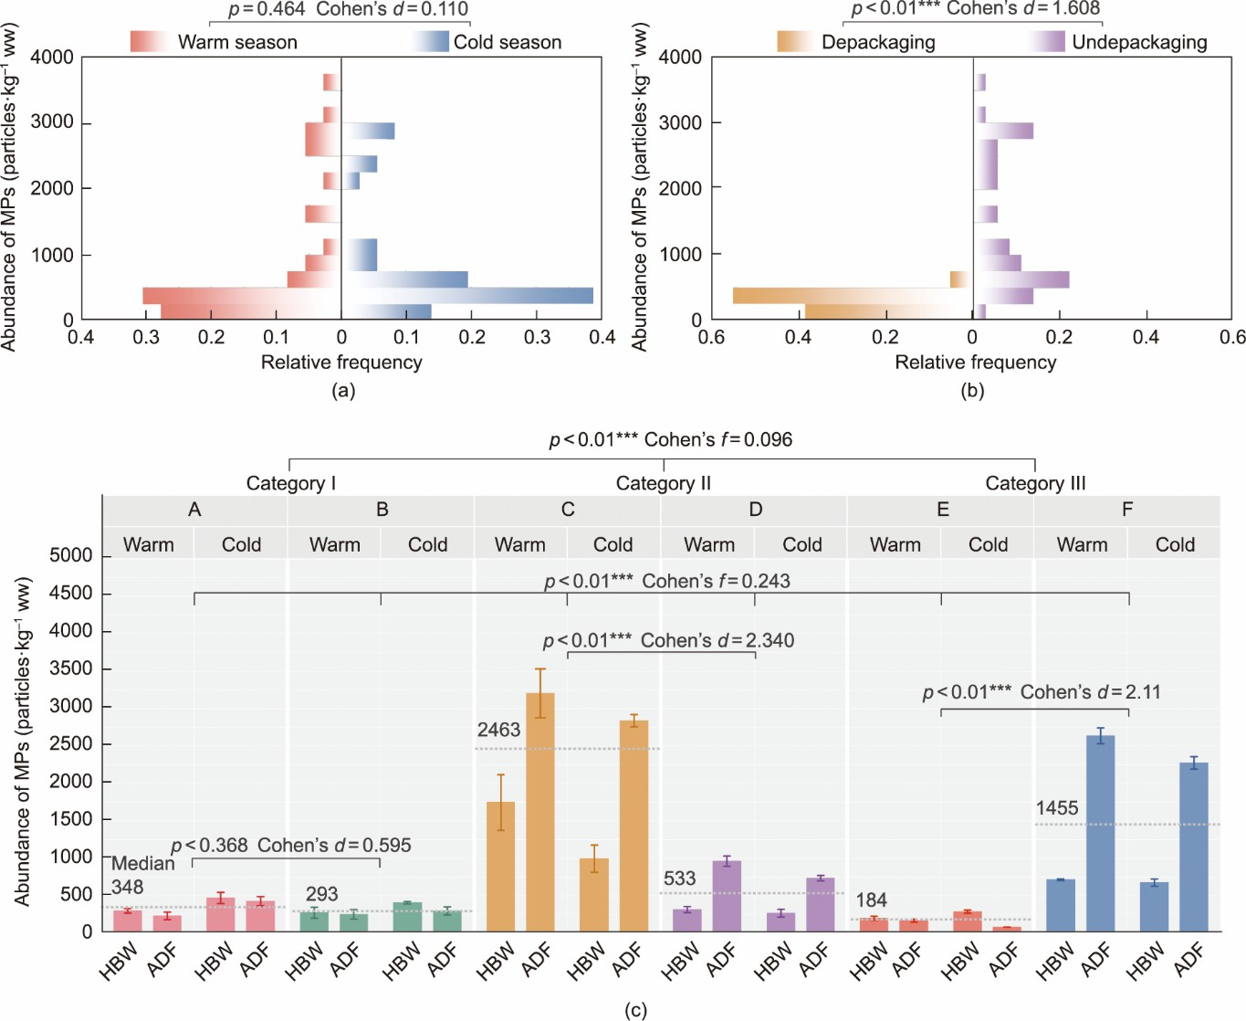

**Fig. 2.** MPs abundance in HBW and ADF. (a) Frequency histogram of MPs abundance in warm or cold seasons; (b) frequency histogram of MPs abundance in systems handling depackaged or undepackaged HBW; and (c) MPs’ abundances in the six pretreatment systems.

The quantities of MPs in HBW ranged from (199 ± 26) to (1744 ± 370) particles per kilogram of wet weight (particles·kg−1 ww) during the warm season. Among the pretreatment systems, Systems A, B, and E showed the lowest MPs abundance during the warm season, with values of (298 ± 30), (272 ± 74), and (199 ± 26) particles·kg−1 ww, respectively. System D recorded a slight increase in MPs content in HBW at (314 ± 40) particles·kg−1 ww, while Systems C and F had high levels at (1744 ± 370) and (714 ± 11) particles·kg−1 ww, respectively. Gui et al. [32] reported that MPs abundance in HBW collected from suburban areas without depackaging at the source and mixed with 30% other waste was (800 ± 200) particles·kg−1 ww in China. Tan et al. [19] found that MPs abundance in HBW collected from urban and suburban areas without depackaging at the source in China was between 5780 and 6330 particles·kg−1 ww. Thus, the findings of this study align with the range provided in the literature.

In the ADF, MPs pollution levels were similar to HBW pollution levels after a series of pretreatment steps. During the warm season, ADF in System A, B, and E displayed the lowest MPs abundance of (230 ± 51), (251 ± 64), and (167 ± 20) particles·kg−1 ww, respectively, representing a reduction of 23%, 8%, and 16%, respectively, compared with HBW. System D showed a slightly higher MPs abundance in ADF at (962 ± 68) particles·kg−1 ww, while Systems C and F had the highest levels at (3207 ± 328) and (2634 ± 106) particles·kg−1 ww, respectively, amounting to a considerable increase of 206%, 84%, and 269% compared with HBW, respectively. During the cold season, the MPs abundance in ADF of Systems A, B, and E was 9%, 27%, and 72% lower than that in HBW, whereas Systems C, D, and F exhibited increases of 185%, 176%, and 237%, respectively, compared with HBW.

The physical composition of the received HBW could explain the levels of MPs pollution in HBW and ADF (Table S3 in Appendix A). For example, during the warm season, in the HBW of Systems A, B, D, and E, plastic debris＞20 mm were substantially low at only 0.5 wt% to 2.61 wt%. Conversely, Systems C and F had a large quantity of plastic debris＞20 mm in their HBW, ranging from 7.12 wt% to 16.19 wt%.

The reduced plastic contamination in the HBW of Systems A, B, and E can be attributed to depackaging, where plastic

bags containing HBW and other missorted wastes were removed. In contrast, Systems C, D, and F do not require depackaging before disposal, with System D located in a suburban environment exhibiting a different pattern owing to the lower plastic usage compared to the urban systems. Therefore, this study demonstrates that depackaging HBW at the source can dramatically reduce the level of plastic contamination in HBW by 85%, leading to an 8%–72% reduction in MPs levels in ADF.



*3.1.2. Abundance of MPs during pretreatment processes*

Fig. 3 shows the average MPs abundance in two seasons throughout the pretreatment process. In this case, the pretreated output includes all the samples that have been processed throughout the pretreatment process, except for HBW. Systems A and B maintained stable MPs abundances between (218 ± 74) and (408 ± 27) particles·kg−1 ww throughout the observation period. In contrast, as a result of pretreatment, Systems C, D, and F exhibited maximum MPs levels in their pretreated output at (3021 ± 294), (1673 ± 279), and (3198 ± 263) particles·kg−1 ww, which were 119%, 473%, and 360% higher compared to HBW, respectively. Inferentially, pretreatment systems of Categories II and III, dominated by biomass crushers and biohydrolysis reactors, are likely to generate more MPs compared to Category I, which employs rough shredders.

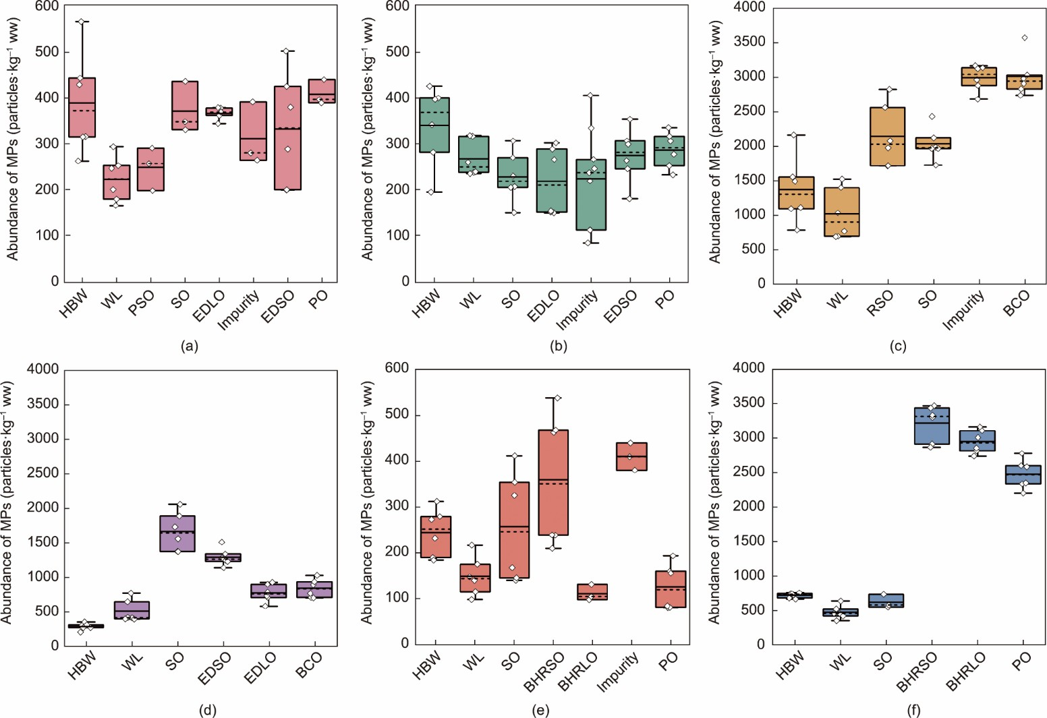

**Fig. 3.** Average MPs abundance in all samples across the warm and cold seasons in (a) System A, (b) System B, (c) System C, (d) System D, (e) System E, and (f) System F, respectively.

In Categories I and III, the main distinction between Systems A and B, E and F is the presence or absence of manual sorting. In Category I where both systems receive depackaged HBW, the MPs contamination levels remained consistently low between Systems A and B throughout the entire process, whereas in Category III, the MPs contamination levels were higher in System F which receives undepackaged HBW compared to System E which receives depackaged HBW. This suggests that, regardless of whether subsequent manual sorting occurs, depackaging is the key to reducing MPs contamination.

Category II includes two systems that mainly differ in the presence of manual sorting and screening at the beginning of the pretreatment process in System C compared with System D. In System C, the abundance of MPs increased from (1382 ± 481) particles·kg−1 ww in HBW to (3021 ± 294) particles·kg−1 ww in EDSO, with an increase factor of approximately 2.2. In contrast, in System D, MPs were produced after passing through the rough shredder and biomass crusher, which increased from (292 ± 48) particles·kg−1 ww in the HBW to (1673 ± 279) particles·kg−1 ww in the SO, indicating an increase factor of about 5.7. This indicated that, in Category II, the system with manual sorting and screening effectively removed plastic debris compared to the system without these processes. After passing through the extrusion dehydrator, the MPs in the SO of system D yielded two phases: solid ((1314 ± 125) particles·kg−1 ww) and liquid ((782 ± 129) particles·kg−1 ww) phase MPs. However, owing to the lack of an extrusion dehydrator at the end of the pretreatment process in System C, MPs cannot be separated into different phases, resulting in an enhanced MPs content entering the anaerobic digester.

* 1. *Secondary MPs formation potential in pretreatment procedure*

Comparing the abundance of MPs in the input and output of pretreatment equipment (Fig. 4) revealed that the output of the

biohydrolysis reactor, biomass crusher, and rough shredder exhibited significantly higher MPs abundance than the input, with ratios between 136%–529%, 136%–602%, and 143%–182%, respectively. This suggests a higher likelihood of secondary MPs formation in these stages. In contrast, MPs abundances in and out of the hopper and screen remained similar, suggesting an absence of observable secondary MPs formation. A slight decrease in MPs abundance was noted in the output of the impurity separator and extrusion dehydrator compared with the input; however, owing to the two-strand discharges, these processes may contribute to the formation of MPs and shunt effects on MPs. Solid waste treatments serve as vehicles and converters for MPs that can modify their characteristics and behavior [33]. Coker [34] reported that the rough shredder can remove a considerable amount of plastics from the HBW stream, but the force used in this separation can result in plastic fragmentation into small pieces. Similarly, other mechanical processes may introduce or contribute to existing levels of MPs in the waste stream, eventually affecting the finished digestate or compost.



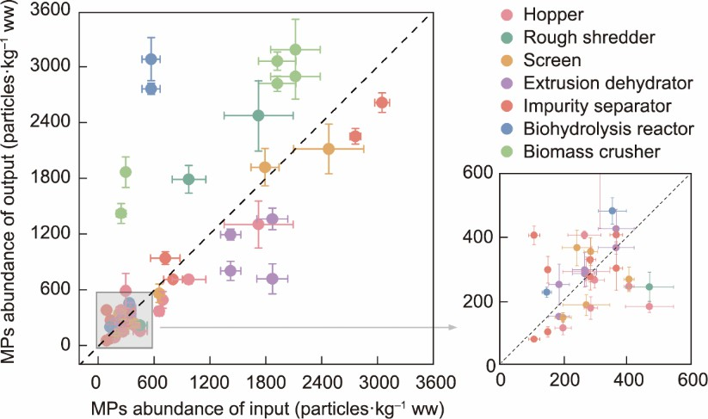

**Fig. 4.** MPs abundance in input and output of pretreatment equipment.

Fig. 5 illustrates the proportional distribution of shape and size across various sample types. Across all samples, fiber MPs accounted for the largest proportion (62%–82%), followed by flake MPs (11%–28%) and film MPs (0.6%–14%), while sphere, granule, and cluster MPs accounted for < 6%. Fiber MPs were also found to be the dominant plastic debris shape in raw digestate [18], suburban domestic waste compost [32], HBW, and their biologically treated products [19]. Most fiber MPs were 1–2 and 0.5–1 mm in size, accounting for 34%–55% and 25%–47% of the total, respectively, followed by 2–5 mm (11%– 30%), while the sum of smallest (0.05–0.5 mm) and largest sizes (> 5 mm) accounted for < 12%. It is estimated that 60% of the fibers in farmland soils have particle sizes between 1 and 3 mm, and the predominant size fraction in irrigation waters is between 0.5 and 2 mm [35]. Notably, the size distribution of fiber MPs remained consistent across all sample types, with minimal effect from different pretreatment devices. In contrast, nonfiber MPs exhibited different size distributions among sample types, and these differences increased as treatment progressed, suggesting fragmentation of plastic fragments during treatment [19]. Such variations in particle characteristics, including their shape and size, have been observed to affect the performance of stormwater retention structures in the removal of MPs [36], which is similar to pretreatment structures in that respect.

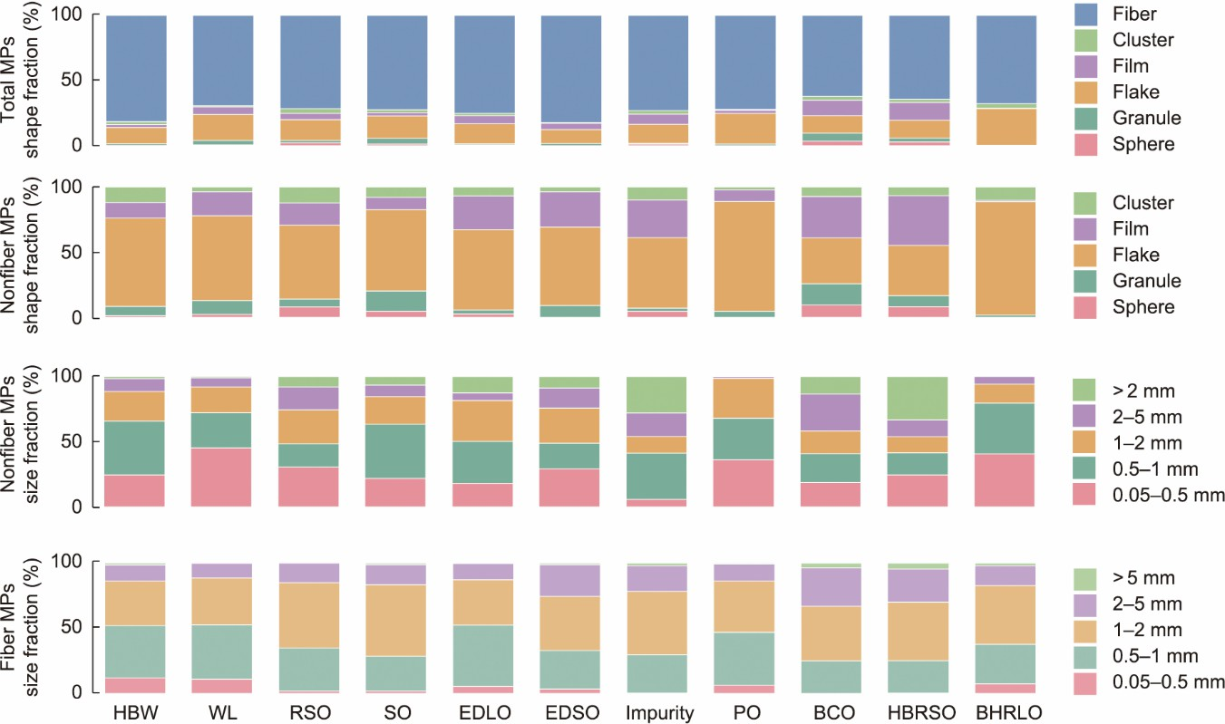

**Fig. 5.** Shape and size distributions of MPs in different samples.

The potential for secondary MPs formation through hoppers and screens from the perspective of MPs abundance appears low. However, these procedures involve the removal of certain types of MPs while generating new ones. In HBW, the predominant shape of MPs was fiber (82%), contributing to the highest fiber content among all material types. This was followed by flake (13%) and very small amounts of cluster, film, and granule (2%, 2%, and 1%, respectively). Most nonfiber and fiber were smaller than 2 mm, accounting for 89% and 86%, respectively. Compared with HBW, fiber MPs in the WL decreased by 13%, while film, flake, and granules increased by 4%, 7%, and 2%, respectively. The proportion of non-fiber and fiber MPs smaller than 2 mm increased by 4% and 2%, suggesting the effectiveness of the hopper in removing small- sized particles through WL. Furthermore, MPs may be generated when waste is transferred to the next pretreatment equipment. The SO exhibited a shape and size distribution similar to HBW, suggesting that the screen has a limited effect on MPs, which is attributed to the large mesh diameter, measuring 120 mm and beyond.

Most secondary MPs formation is observed in rough shredders, biomass crushers, and biohydrolysis reactors. Compared with HBW, fiber MPs in the RSO decreased by 10%, while all other shapes increased. The overall size of MPs increased, with the proportion of nonfiber MPs over 5 mm and those between 2 and 5 mm increasing by 6% and 8%, respectively. BCO exhibited the lowest proportion of fiber MPs (62%), whereas spheres and granules represent the highest proportions (4% and 6%, respectively). The proportion of nonfiber MPs larger than 5 mm and between 2 and 5 mm significantly increased by 11% and 18%, respectively, in the BCO compared with HBW. Compared with HBW, BHRSO produced fewer fiber MPs (decreased by 18%), whereas film MPs increased significantly by 12% and comprised 14% flake, 3% granules, 3% spheres, and 2% clusters. Furthermore, BHRSO has the highest percentage of nonfiber MPs larger than 5 mm, which is 33% (increasing by 31% compared with HBW). These results show that these processes produce nonfiber MPs of larger size (> 2 mm). In contrast to results observed in pretreatment systems involving shredding units that reduce particle size and facilitate the transfer of MPs to the substrate fraction [17,20], our results indicate that the pretreatment process with a shredding effect has a stronger impact on fragmenting nonfiber plastic debris into MPs than reducing MPs to even smaller sizes.

The extrusion dehydrator and impurity separator can separate MPs into solid or liquid phases. Notably, the percentage of fiber and nonfiber MPs larger than 2 mm is higher in EDSO (25% and 24%, respectively) than those in EDLO (12% and 19%, respectively). A similar pattern is observed in the impurity separator, where the percentage of fiber and nonfiber MPs larger than 2 mm is higher in the impurity output (22% and 46%, respectively) than those in the PO (14% and 1%, respectively). This trend replicates the extrusion dehydration of biohydrolysis reactors, where the liquid output from biohydrolysis reactors have a much smaller MPs size distribution, with fiber and nonfiber MPs larger than 2 mm accounting for 13% and 40% higher than those in the solid output. It was verified that equipment with an extrusion dehydration effect tends to trap large MPs (> 2 mm) in the solid phase, whereas small MPs tend to aggregate in the liquid phase. Similarly, Liu et al. [37] have noted the removal of MPs larger than 0.5 mm in wastewater treatment plants primarily through initial treatment processes designed to eliminate floatable and settleable impurities.

* 1. *Plastic debris and MPs stream in the pretreatment system*

Fig. 6 depicts plastic debris and MPs stream in six pretreatment systems **(**Text S2 in Appendix A**)**. An enhanced amount of plastic debris and MPs were found in Systems C and F during the pretreatment process and in the anaerobic digester, indicating

that the plastic content in HBW has the greatest impact on MPs content in ADF. Pretreatment systems of Category I proved the most effective at removing plastic contaminants and showed the lowest potential for secondary MPs formation as the plastic stream narrowed as the process progressed. In contrast, Categories II and III displayed varying levels of risk for secondary MPs formation, depending on the technologies used and their sequence in the process.

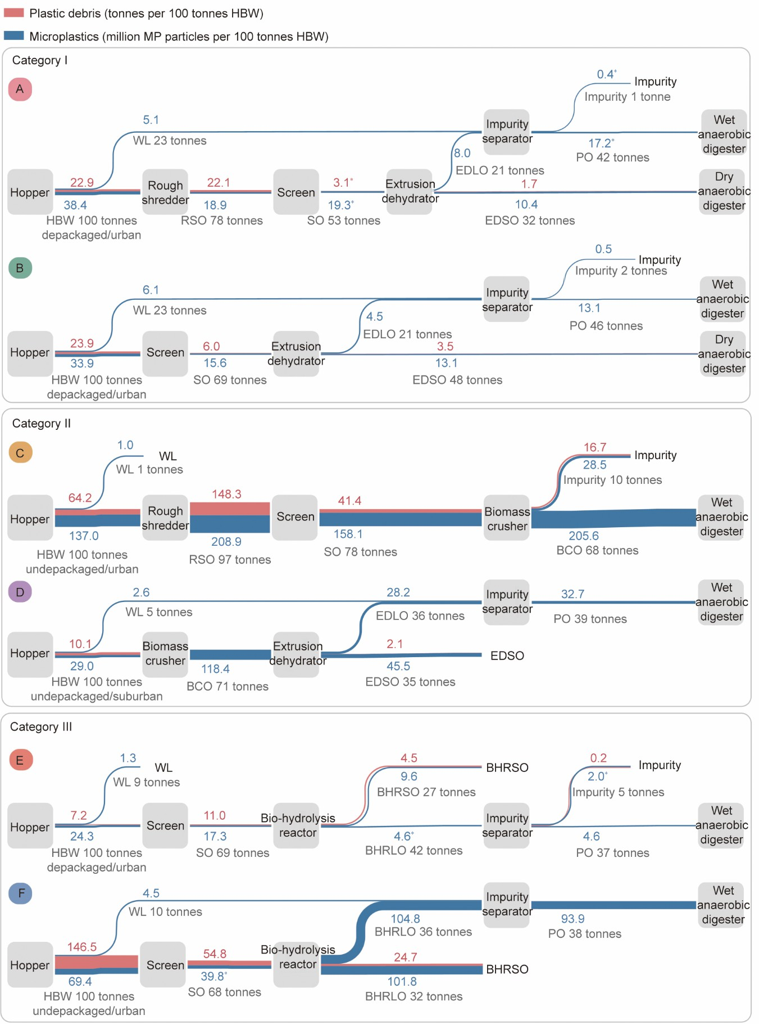

**Fig. 6.** Plastic debris and MPs flow in the waste stream. Data marked with a star represent data from only one season.

Comparing the width of tributaries reveals that the screen is the most efficient method for removing plastic debris, while the biohydrolysis reactor and biomass crusher are the most likely to form secondary MPs. At the design stage, the phase of feedstock entering the anaerobic digestion system should be considered, as MPs can often exist in solid or liquid phases after passing through an extrusion dehydrator and impurity separator. Notably, judging the extent of plastic pollution based solely on visible plastic debris is inaccurate, which may lead to an incorrect assessment of MPs pollution. With the size distribution

of MPs mentioned above, the detective size of plastics in organic fertilizer is mostly 2 mm at present, while MPs smaller than 2 mm are widely present in these materials, thereby suggesting a reconsideration of the pollution control effectiveness of these standards. To quantify plastics in compost, the threshold size must be lowered [38].



Given the variance in treatment capacity among the systems, the MPs loads also varied significantly across the systems. In pretreatment systems receiving depackaged HBW, Category I (receiving 600 tonnes of depackaged HBW daily) processes 10.4–17.2 million MP particles per 100 tonnes of HBW into anaerobic digesters. For Category III (receiving 100 tonnes of depackaged HBW daily), this figure drops to 4.6 million MP particles per 100 tonnes. In urban areas, pretreatment system receiving undepackaged HBW, Category II (receiving 200 tonnes of undepackaged HBW per day) processes an estimated

205.6 million MP particles per 100 tonnes of HBW into an anaerobic digester, whereas Category III (receiving 81 tonnes of undepackaged HBW per day) processes an estimated 93.9 million MP particles per 100 tonnes of HBW into anaerobic digester. In suburban areas, the pretreatment system (receiving 200 tonnes of undepackaged HBW daily) processes an estimated 32.7 million MP particles per 100 tonnes of HBW into anaerobic digestion. Moreover, impurities and other solid phases not digested in anaerobic digesters are sent to incineration plants, where MPs range from 0.4 to 101.8 million MP particles per 100 tonnes of HBW.

In urban cities of China, estimated MPs abundance in sewage effluent ranges from 0.20 to 1.73 particles·L−1 in Xiamen

[39] and (0.59 ± 0.22) particles·L−1 in Beijing [40]. The abundance of MPs in bottom ash ranges from 1.9 to 565 particles·kg−1 in China, implying that one tonne of municipal solid waste produces 360 to 102 000 MP particles in the bottom ash [41]. National data for municipal solid waste treatment in 2021 indicate that 180.20 million tonnes undergo incineration treatment annually, and 16.11 million tonnes are treated biologically [42]. In addition, wastewater treatment amounts to 61 189.56 million tonnes annually [43]. Based on these data, the annual production of MPs ranges from 741.11 to 33 124.22 billion MP particles in ADF, 64.44 to 16 401.00 billion particles in solids for incineration, 64.87 to 18 380.09 billion particles in bottom ash, and 12 237.91 to 105 857.94 billion particles in sewage effluent. Thus, the HBW pretreatment systems can release MPs in a similar manner to wastewater treatment and municipal solid waste incineration facilities.

* 1. *Polymer types in MPs and source apportionment*

During daily life, various physicochemical properties of plastics determine their intended applications, which in turn determine their distribution characteristics in different environmental conditions [44]. This study revealed that common plastic types in HBW encompass food packaging bags, plastic bags, lunch boxes, plastic bottles, foam boxes, and rope. Analyzing the shape, polymer type, color, and other physical and chemical characteristics of MPs and plastic waste could identify potential sources of MPs [32,45].

The findings indicate that fibers and fragments are the predominant shapes in solid organic waste and its biologically treated products [46], aligning with the results of this study. PET and PP are the majority constituents of fibers and clusters, comprising 61.1% and 6.4% of the total polymers, respectively (Fig. 7). PA and PAN are the only polymers identified in the fibers, accounting for 3.5% cumulatively of the total polymers. A similar result was observed in agricultural soils in the coastal plains of eastern China [35]. Fiber MPs in soil are typically derived from plastic rope used for tying and securing greenhouses [47]. In flakes, it is estimated that PE, PP, and resin constitute 9.4%, 3.2%, and 3.2% of the components, respectively. Almost all spheres are made of PS (1.9%), representing the material of almost all spheres, and most films are composed of PE (4.7%). Granules predominantly comprised PS, PP, and PE, accounting for 0.9%, 0.7%, and 0.6%, respectively.

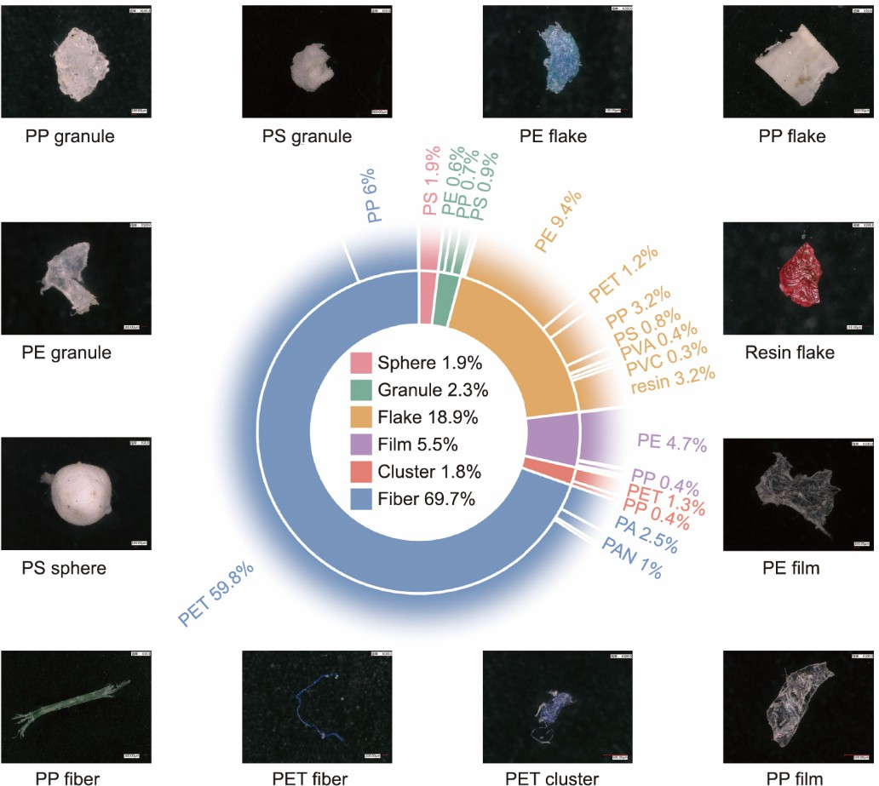

**Fig. 7.** Correlation between MPs shape and polymer type in MPs and examples of MPs found in the samples. PA: polyamide; PAN: polyacrylonitrile; PVA: polyvinyl alcohol; PVC: polyvinyl chloride.

HBW is predominantly contaminated with MPs, which stem from various sources such as plastic packaging, the degradation of unsorted plastic waste, and MPs within the food itself [15,27,48]. A recent study has shown that a Chinese consumer theoretically consumes 624–10 556 MP particles annually from single-use plastic containers [49]. Given that PS, PP, and PE are the most commonly used plastics in food packaging [50], these MPs may derive from these products. Plastic particles in food items may also introduce them into the HBW stream [16], as observed in items such as air, sugar, and honey, which primarily contain fragments and fibers [51]. Regardless of the food item consumed, the predominant MPs shapes were fibers and fragments, aligning with our findings.

Although entirely abandoning plastic food packaging or HBW pretreatment is unrealistic, this study suggests steps to reduce the risk of MPs formation. While depackaging at the source was designed to supervise waste segregation, it has somehow evolved into an effective means to control MPs pollution [18]. Using a screen and manual sorting process before performing other pretreatment processes can concurrently decrease plastic debris and the risk of MPs being released.

# Conclusions and environmental implication

Depackaging HBW at the source can greatly reduce the MPs content present in the ADF by 8%–72%, regardless of the pretreatment processes employed. As a result of pretreatment, the maximum MPs levels in the pretreated output can reach (1673 ± 279) to (3198 ± 263) particles·kg−1 ww, which is 119%–473% higher compared to the MPs levels in untreated HBW, especially for those undepackaged at the source. The equipment involved in the pretreatment process, such as biomass crusher, biohydrolysis reactor, and rough shredder, are most prone to secondary MPs formation, displaying significantly higher MPs abundance in the outputs compared to the inputs, with a ratio of 136%–529%, 136%–602%, and 143%–182%, respectively. Furthermore, equipment with an extrusion dehydration effect tends to trap large MPs (> 2 mm) in the solid phase, whereas small MPs tend to aggregate in the liquid phase. Consequently, MPs generated by pretreatment systems in anaerobic digesters range between 4.6 and 17.2 million per 100 tonnes of depackaged HBW and 32.7–205.6 million per 100 tonnes of undepackaged HBW. MPs are produced similarly to wastewater treatment plants [39,40] and municipal solid waste incineration facilities [41], with an annual average of 741.11–33 124.22 billion MP particles in ADF and 64.44–16 401.00 billion MP particles in solid output intended for incineration.

MPs present in the final products of HBW pose a global soil contamination threat. This study underscores the high risk of secondary MPs formation owing to the pretreatment of HBW, even when the primary purpose is plastic waste removal. Considering the massive global production of HBW and the indispensable application of mechanical pretreatment in biological and mechanical–biological plants, this can result in the dispersion of MPs throughout the entire waste treatment system and further into the environment. These findings emphasize the necessity of removing plastic packaging from waste at disposal and can serve as a guide for process selection and optimization in numerous pretreatment systems worldwide.



**Acknowledgments**

This work was financially supported by the National Natural Science Foundation of China (22276140), Shanghai Municipal Government State-Owned Assets Supervision and Administration Commission (2022028), and the Key Research and Development Project of Zhejiang Province, China (2021C03024).

# References

1. MacLeod M, Arp HPH, Tekman MB, Jahnke A. The global threat from plastic pollution. Science 2021;373(6550):61–65.
2. Ivleva NP. Chemical analysis of microplastics and nanoplastics: challenges, advanced methods, and perspectives. Chem Rev 2021;121(19):11886– 11936.
3. Rochman CM, Hoellein T. The global odyssey of plastic pollution. Science 2020;368(6496):1184–1185.
4. Li C, Gan Y, Zhang C, He H, Fang J, Wang L, et al. “Microplastic communities” in different environments: differences, links, and role of diversity index in source analysis. Water Res 2021;188:116574.
5. Golwala H, Zhang X, Iskander SM, Smith AL. Solid waste: an overlooked source of microplastics to the environment. Sci Total Environ 2021;769:144581.
6. Wright SL, Kelly FJ. Plastic and human health: a micro issue? Environ Sci Technol 2017;51(12):6634–6647.
7. Du C, Abdullah JJ, Greetham D, Fu D, Yu M, Ren L, et al. Valorization of food waste into biofertiliser and its field application. J Clean Prod 2018;187:273–284.
8. RedCorn R, Fatemi S, Engelberth AS. Comparing end-use potential for industrial food–waste sources. Engineering 2018;4(3):371–380.
9. Chen P, Anderson E, Addy M, Zhang R, Cheng Y, Peng P, et al. Breakthrough technologies for the biorefining of organic solid and liquid wastes. Engineering 2018;4(4):574–580.
10. Weithmann N, Möller JN, Löder MGJ, Piehl S, Laforsch C, Freitag R. Organic fertilizer as a vehicle for the entry of microplastic into the environment. Sci Adv 2018;4(4):eaap8060.
11. O’Connor J, Mickan BS, Siddique KHM, Rinklebe J, Kirkham MB, Bolan NS. Physical, chemical, and microbial contaminants in food waste management for soil application: a review. Environ Pollut 2022;300:118860.
12. Porterfield KK, Hobson SA, Neher DA, Niles MT, Roy ED. Microplastics in composts, digestates, and food wastes: a review. J Environ Qual 2023;52(2):225–240.
13. Porterfield KK, Scarborough MJ, Roy ED. Organics recycling tradeoffs: biogas potential and microplastic content of mechanically depackaged food waste. ACS Sustainable Chem Eng 2023;11(28):10422–10429.
14. Braun M, Mail M, Heyse R, Amelung W. Plastic in compost: prevalence and potential input into agricultural and horticultural soils. Sci Total Environ 2021;760:143335.
15. Shi Y, Chai J, Xu T, Ding L, Huang M, Gan F, et al. Microplastics contamination associated with low-value domestic source organic solid waste: a review. Sci Total Environ 2023;857:159679.
16. Kenny, S. Emerging issues in food waste management plastic contamination. Report. Washington: United States Environmental Protection Agency (EPA) Office of Research and Development; 2021 Aug. Report No.: EPA/600/R-21/116. Contract No.: 68HERC19D0003.
17. Lopes ADCP, Robra S, Muller W, Meirer M, Thumser F, Alessi A, et al. Comparison of two mechanical pre-treatment systems for impurities reduction of source-separated biowaste. Waste Manag 2019;100:66–74.
18. Yang Z, Lu F, Hu T, Xu X, Zhang H, Shao L, et al. Occurrence of macroplastics and microplastics in biogenic waste digestate: effects of depackaging at source and dewatering process. Waste Manag 2022;154:252–259.
19. Tan M, Sun Y, Gui J, Wang J, Chen X, Song W, et al. Distribution characteristics of microplastics in typical organic solid wastes and their biologically treated products. Sci Total Environ 2022;852:158440.
20. Alessi A, Lopes A, Muller W, Gerke F, Robra S, Bockreis A. Mechanical separation of impurities in biowaste: comparison of four different pretreatment systems. Waste Manag 2020;106:12–20.
21. Sholokhova A, Denafas G, Mykhaylenko V. Microplastics generation and concentration during mechanical–biological treatment of mixed municipal solid waste. Environ Res 2022;214:113815.
22. Rocha-Santos T, Duarte AC. A critical overview of the analytical approaches to the occurrence, the fate and the behavior of microplastics in the environment. Trends Analyt Chem 2015;65:47–53.
23. Rocha-Santos T, Rodrigues DF, Atkinson JD, Lin AYC, Blaney L. Emerging contaminants: JHM current and future trends. J Hazard Mater 2022;438:129496.
24. Löeder MGJ, Imhof HK, Ladehoff M, Löeschel LA, Lorenz C, Mintenig S, et al. Enzymatic purification of microplastics in environmental samples. Environ Sci Technol 2017;51(24):14283–14292.
25. Simon M, van Alst N, Vollertsen J. Quantification of microplastic mass and removal rates at wastewater treatment plants applying Focal Plane Array (FPA)-based Fourier Transform Infrared (FT-IR) imaging. Water Res 2018;142:1–9.
26. López Rosales A, Andrade JM, Grueiro-Noche G, Fernandez-Gonzalez V, Lopez-Mahia P, Muniategui-Lorenzo S. Development of a fast and efficient method to analyze microplastics in planktonic samples. Mar Pollut Bull 2021;168:112379.
27. Gala A, Guerrero M, Serra JM. Characterization of post-consumer plastic film waste from mixed MSW in Spain: a key point for the successful implementation of sustainable plastic waste management strategies. Waste Manag 2020;111:22–33.
28. He P, Chen L, Shao L, Zhang H, Lu F. Municipal solid waste (MSW) landfill: a source of microplastics?—Evidence of microplastics in landfill leachate. Water Res 2019;159:38–45.
29. Li Y, Ye Z, Yu Y, Li Y, Jiang J, Wang L, et al. A combined method for human health risk area identification of heavy metals in urban environments. J Hazard Mater 2023;449:131067.
30. Schindelin J, Arganda-Carreras I, Frise E, Kaynig V, Longair M, Pietzsch T, et al. Fiji: an open-source platform for biological-image analysis. Nat Methods 2012;9(7):676–682.
31. Prata JC, Reis V, da Costa JP, Mouneyrac C, Duarte AC, Rocha-Santos T. Contamination issues as a challenge in quality control and quality assurance in microplastics analytics. J Hazard Mater 2021;403:123660.
32. Gui J, Sun Y, Wang J, Chen X, Zhang S, Wu D. Microplastics in composting of rural domestic waste: abundance, characteristics, and release from the surface of macroplastics. Environ Pollut 2021;274:116553.
33. Liu R, Tan Z, Wu X, Liu Y, Chen Y, Fu J, et al. Modifications of microplastics in urban environmental management systems: a review. Water Res 2022;222:118843.
34. Coker C. Food waste depackaging systems [Internet]. Hong Kong: BioCycle; 2019 Jul 10 [cited 2023 Apr 5]. Available from: https:/[/www.biocycle.net/food-waste-depackaging-systems/.](http://www.biocycle.net/food-waste-depackaging-systems/)
35. Zhou B, Wang J, Zhang H, Shi H, Fei Y, Huang S, et al. Microplastics in agricultural soils on the coastal plain of Hangzhou Bay, east China: multiple sources other than plastic mulching film. J Hazard Mater 2020;388:121814.
36. Wang C, O’Connor D, Wang L, Wu WM, Luo J, Hou D. Microplastics in urban runoff: global occurrence and fate. Water Res 2022;225:119129.
37. Liu W, Zhang J, Liu H, Guo X, Zhang X, Yao X, et al. A review of the removal of microplastics in global wastewater treatment plants: characteristics

and mechanisms. Environ Int 2021;146:106277.



1. Ruggero F, Porter AE, Voulvoulis N, Carretti E, Lotti T, Lubello C, et al. A highly efficient multi-step methodology for the quantification of micro- (bio)plastics in sludge. Waste Manag Res 2021;39(7):956–965.
2. Long Z, Pan Z, Wang W, Ren J, Yu X, Lin L, et al. Microplastic abundance, characteristics, and removal in wastewater treatment plants in a coastal city of China. Water Res 2019;155:255–265.
3. Yang L, Li K, Cui S, Kang Y, An L, Lei K. Removal of microplastics in municipal sewage from China’s largest water reclamation plant. Water Res 2019;155:175–181.
4. Yang Z, Lu F, Zhang H, Wang W, Shao L, Ye J, et al. Is incineration the terminator of plastics and microplastics? J Hazard Mater 2021;401:123429.
5. National Bureau of Statistics. National data [Internet]. Beijing: National Bureau of Statistics of China; 2021 [cited 2023 August 26]. Available from: https://data.stats.gov.cn/.
6. Ministry of Housing and Urban-Rural Development of the People’s Republic of China. Urban-rural development statistical yearbook [Internet]. Beijing: Ministry of Housing and Urban-Rural Development of the People’s Republic of China; 2021Oct 21 [cited 2023 August 26]. Available from: https:/[/www.mohurd.gov.cn/.](http://www.mohurd.gov.cn/)
7. Wang C, Zhao J, Xing B. Environmental source, fate, and toxicity of microplastics. J Hazard Mater 2021;407:124357.
8. Yu H, Shao J, Jia H, Gang D, Ma B, Hu C. Characteristics and influencing factors of microplastics in snow in the inner Mongolia Plateau, China. Engineering. In press.
9. Zhou Y, Ren X, Tsui TH, Barcelo D, Wang Q, Zhang Z, et al. Microplastics as an underestimated emerging contaminant in solid organic waste and their biological products: occurrence, fate and ecological risks. J Hazard Mater 2023;445:130596.
10. Wang J, Li J, Liu S, Li H, Chen X, Peng C, et al. Distinct microplastic distributions in soils of different land-use types: a case study of Chinese farmlands. Environ Pollut 2021;269:116199.
11. Samanta P, Dey S, Kundu D, Dutta D, Jambulkar R, Mishra R, et al. An insight on sampling, identification, quantification and characteristics of microplastics in solid wastes. Trends Environ Anal 2022;36:e00181.
12. Du F, Cai H, Zhang Q, Chen Q, Shi H. Microplastics in take-out food containers. J Hazard Mater 2020;399:122969.
13. Li Y, Li X, Wang P, Su Y, Xie B. Size-dependent effects of polystyrene microplastics on anaerobic digestion performance of food waste: focusing on oxidative stress, microbial community, key metabolic functions. J Hazard Mater 2022;438:129493.
14. Cox KD, Covernton GA, Davies HL, Dower JF, Juanes F, Dudas SE. Human consumption of microplastics. Environ Sci Technol 2019;53(12):7068– 7074.

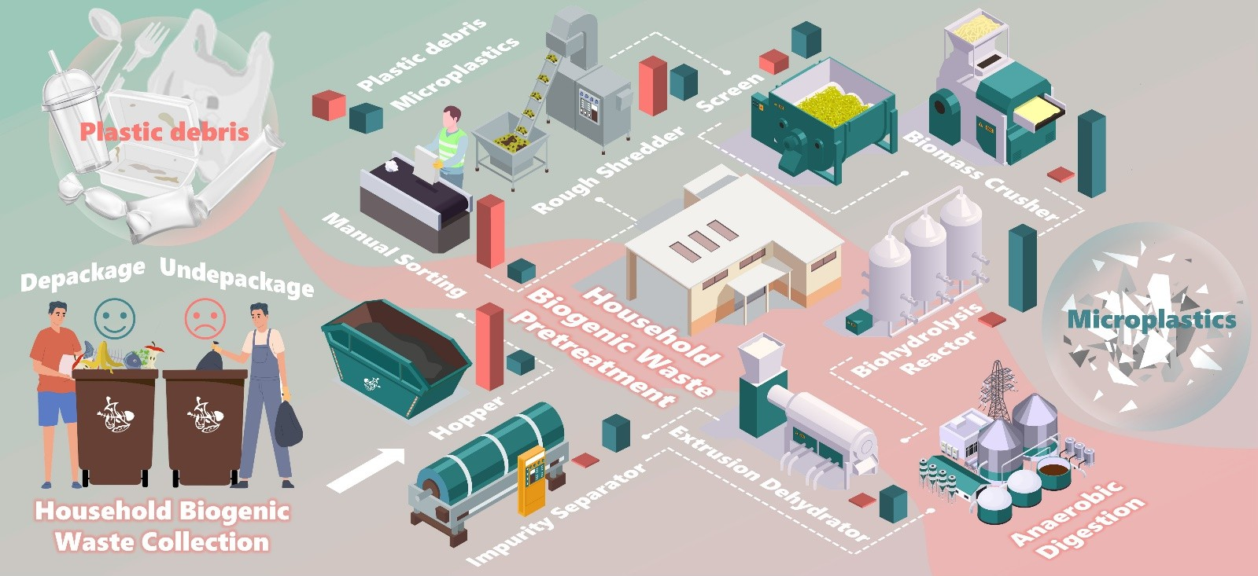

**Highlights**

* + Depackaging at the source is a useful measure to control microplastics secondary formation.
  + Microplatics secondary formation from pretreatment was intensified for waste undepackaged at the source.
  + Pretreated output may contain 473% more microplastics than input.
  + Each 100 tons of biogenic waste generated 4.6 million to 205.6 million microplastics.

**Declaration of interests**

☒ The authors declare that they have no known competing financial interests or personal relationships that

could have appeared to influence the work reported in this paper.

* The authors declare the following financial interests/personal relationships which may be considered as potential competing interests:

