

Electronic Notes in Theoretical Computer Science

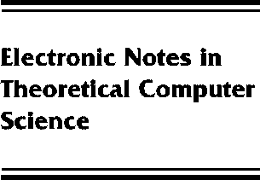[www.elsevier.com/locate/entcs](http://www.elsevier.com/locate/entcs)

Process Algebra and Information Flow

P.Y.A. Ryan

**Abstract**

Controlling information flows through a system is the fundamental issue in information security. It turns out that making precise the notion of information flow, and in particular the absence of information flow, is a remarkably subtle question. Many formalizations have been proposed, many inspired by the seminal ideas of Goguen and Meseguer with their notion of non-interference. Even now the security community has not reached a consensus on its definition. In this talk we show that casting the problem in a process algebraic framework sheds light on many of the sources of controversy. In particular we argue that non-interference reduces to characterizing the equivalence of processes, itself a rather controversial problem in the process algebra world.

1571-0661 *⃝*c Elsevier Ltd Open access under [CC BY-NC-ND license.](http://creativecommons.org/licenses/by-nc-nd/3.0/)

10.1016/S1571-0661(05)80063-5