[Engineering Science and Technology, an International Journal 48 (2023) 101583](https://doi.org/10.1016/j.jestch.2023.101583)

Contents lists available at [ScienceDirect](http://www.sciencedirect.com/science/journal/22150986)

Engineering Science and Technology, an International Journal

journal homepage: [www.elsevier.com/locate/jestch](https://www.elsevier.com/locate/jestch)

[](http://crossmark.crossref.org/dialog/?doi=10.1016/j.jestch.2023.101583&domain=pdf)Review

Review on the two-stage vapor injection heat pump with a flash tank

Havva Ceylan

*Dept. of Mechanical Engineering, Çorlu Engineering Faculty, Namık Kemal University, 59860 Çorlu, Tekirda*˘*g, Turkey*

A R T I C L E I N F O

*Keywords:* Vapor injection Flash tank

Optimum pressure Control strategy

A B S T R A C T

Refrigerant vapor injection technology is a reliable method to reduce the discharge temperature and improve the heating performance of air source heat pumps at low ambient temperatures. Compressor technology, injection configuration, and the state of injected refrigerant significantly affect system performance, complexity and initial investment. The flash tank injection system demonstrates a better system performance than the heat exchanger system, but the lack of an appropriate control strategy is a factor that hinders the widespread use of the flash tank system. To reveal the challenges of the system, this paper reviews the parameters affecting the system perfor- mance and the control strategies on two-stage vapor injected heat pumps with a flash tank. ESC, a model- independent real-time control strategy, is presented as a promising solution for optimal control of the FTC cycle. The performance of the system is influenced by factors such as de-superheating, subcooling, injection mass flow rate, injection pressure and variable speed. Injection pressure is the main factor. There exists an optimal injection pressure to maximize the COP of the system.

# Introduction

Building energy consumption is increasing in parallel with the increasing demands of people to have a high standard of living. Air- source heat pumps are widely used in buildings due to their low installation costs and ability to reduce energy consumption by using renewable energy. However, when they operate with a high-pressure ratio (low evaporation temperature or high condensation tempera- ture), the increased discharge temperature causes oil deterioration, limiting the safe operating envelope of the compressors. In addition, with the increase of compression irreversibility, volumetric efficiency and system performance decrease. For this reason, researchers are trying to increase the efficient operating limits of heat pumps.

In recent years, vapor injection systems have been the focus of attention as a solution to the problems caused by the large compression ratio. In two-stage compression with vapor injection, the vapor injected into the compressor at intermediate pressure produces an intercooling effect on the refrigerant leaving the low compression stage due to its low enthalpy. As a result, the operating temperature range is extended as the compressor discharge temperature is lower than in the conventional single-stage cycle. At the same time, heating performance and COP are improved [33,58].

In the past, these systems have been used in industry to reduce the discharge temperature [49], but in recent years they have become attractive for heat pump systems with the development of compressor

models with injection ports [42]. Huang [15] showed that a vapor- injected heat pump with R407C can meet the heating capacity of a family home and its operating costs are lower than those of currently used oil heating. Wang [66] tested the flash tank cycle in cooling and heating scenarios. He reported capacity and COP improvements of 14 %

and 4 %, respectively, at an ambient temperature of 46.1 ◦C, and 30 %

and 20 % at an ambient temperature of —17.8 ◦C. However, in some studies, it was indicated that vapor injection provides COP improvement only at low ambient temperatures (for heating) or high condenser temperatures (for cooling) [3,53,61,67]. At high evaporator tempera- tures and low condenser temperatures, the performance may be lower than a single stage system. Xu [53] reported that the cooling COP was

lower than that of the single-stage system at T0 = 5 ◦C and Tc = 40 ◦C.

Xue [61] and Yan [74] also pointed to the same result and reported that it is necessary to switch to the non-injection cycle at high ambient temperatures in order to achieve higher performance. Vapor injection has a greater effect on the condenser than on the evaporator. Therefore, vapor injection is more beneficial for heating applications than cooling applications [60].

Previous review studies [44,58,77] on refrigerant injection systems include various configurations. In this study, only flash tank systems were focused on for a more detailed review. The challenges of the system were revealed and the results were intended to be a reference for future studies.

This paper is structured as follows: Section 2 examines the injection mechanism, such as compressor technologies, injection cycle

*E-mail address:* [hceylan@nku.edu.tr](mailto:hceylan@nku.edu.tr).

<https://doi.org/10.1016/j.jestch.2023.101583>

Received 5 June 2023; Received in revised form 25 October 2023; Accepted 15 November 2023

Available online 24 November 2023

2215-0986/© 2023 Karabuk University. Publishing services by Elsevier B.V. This is an open access article under the CC BY-NC-ND license (<http://creativecommons.org/licenses/by-nc-nd/4.0/>).

**Nomenclature**

COP Coefficient of Performance FTVI Flash Tank Vapor Injection SCVI Subcooler Vapor Injection TXV Thermostatic Expansion Valve EV Electronic Expansion Valve SC Interstage subcooling

SCc Subcooling at the condenser outlet

*c*p,m Molar specific heat at constant pressure Pe Evaporator pressure

Pc Condenser pressure

Pm Optimum interstage pressure Te Evaporator temperature

Tc Condenser temperature

Tm Optimum interstage temperature

configurations, and the state of injection refrigerant. Section 3 evaluates the parameters that affect system performance and the relations used to estimate the optimum injection pressure. Section 4 presents control strategies and their effects on performance improvement. Recent studies on the vapor injection systems, which are beyond the scope of the cur- rent study, are included in Section 5. Finally, the conclusions from this study are presented in Section 6.

# Regulations in the intermediate stage

* 1. *Compressor technologies-two stage (TS)-quasi two stage (QTS)*

In conventional two-stage systems (TS), the fluid coming out of the first stage compressor is mixed with the injection stream in a mixing chamber at constant pressure and then compressed to the condenser pressure in the second compressor, as seen in Fig. 1(a). In this case, each compressor operates at lower compression ratios and closer to its opti- mum efficiency [50]**.** However, due to the high cost and large size of these compressors, the application of the two-stage cycle is limited to some large-scale applications [12]**.** Recently, studies on two-stage sys- tems using a single compressor with an injection port for compression have increased [70]. This system, called a quasi-two-stage compression heat pump (QTSHP), uses only one compressor as seen in Fig. 1(b), so it has advantages of simpler construction, better reliability, lower cost, and easier control [70,77]. The development of these compressors has allowed vapor injection to become economical for small-scale applica- tions [34]**.**

The most commonly used compressor for this technology is the scroll compressor [47,50]. Because the injection is relatively easy to incor- porate and the injection pressure can be adjusted by properly selecting the optimum port position [32]. Port position, which is an important design parameter for system performance, has been studied by some authors [8,21,62]. Scroll compressors also have some disadvantages. When operating conditions differ from the design compression ratio, optimum compression efficiency cannot be achieved due to the constant volume ratio. In addition, it is still difficult and expensive to design the scroll compressor with an injection port compatible with a heat pump system [58]. Therefore, other types of compressors such as rotary compressors [12,14,27,64,74] and twin-screw compressors [29,73] have also been investigated.

**Tello-Oquendo** [47] compared two-stage compression systems using a single scroll compressor with injection port (SCVI) and two reciprocating compressors in series (TSRC) in terms of compressor effi- ciency, volumetric efficiency, COP, and cooling capacity. R407C was used as refrigerant. From the results, it was seen that SCVI works more efficiently at points where the pressure ratio is lower than 7.5, while

TSRC works more efficiently at higher pressure ratios (Pr > 7.5). **Tello-**

**Oquendo** [50] compared two-stage compression systems with a single scroll compressor (SCVI) and two scroll compressors in series (TSSC) for R290. A two-stage compression reciprocating compressor (TSRC) was also included in the comparison. For pressure ratios above 5, the COP of the SCVI heat pump was lower than that of the other two compressors. **Yang** [75] proposed general analytical expressions to quickly calculate the upper limit of the COP improvement of the (quasi) two-stage cycle under specific working conditions with specific refrigerants. They compared the experimental results of quasi two-stage systems in the literature with the calculated upper limits.

* 1. *Intermediate configurations*

The most commonly used vapor injection cycles in two-stage cool- ing/heating systems are the vapor injection cycle with a flash tank (FTVI) and the vapor injection cycle with a sub-cooler (SCVI). The generation of the injected vapor is different for these two systems, shown in Fig. 2. *In the FTVI cycle,* the refrigerant from the condenser expands through the expansion valve-1, then enters the flash tank and separates into two phases, saturated liquid and saturated vapor. The saturated liquid at state (6) expands through the expansion valve-2 and enters the evaporator (7). The saturated vapor at state (5) is injected into the intermediate compression chamber. *In the SCVI cycle*, the fluid leaving the condenser (3) is divided into two branches, main stream and injection stream. The main stream is subcooled in the IHX (6), then it passes through the expansion valve and enters the evaporator (7). The injection stream evaporates by exchanging heat with the main stream in

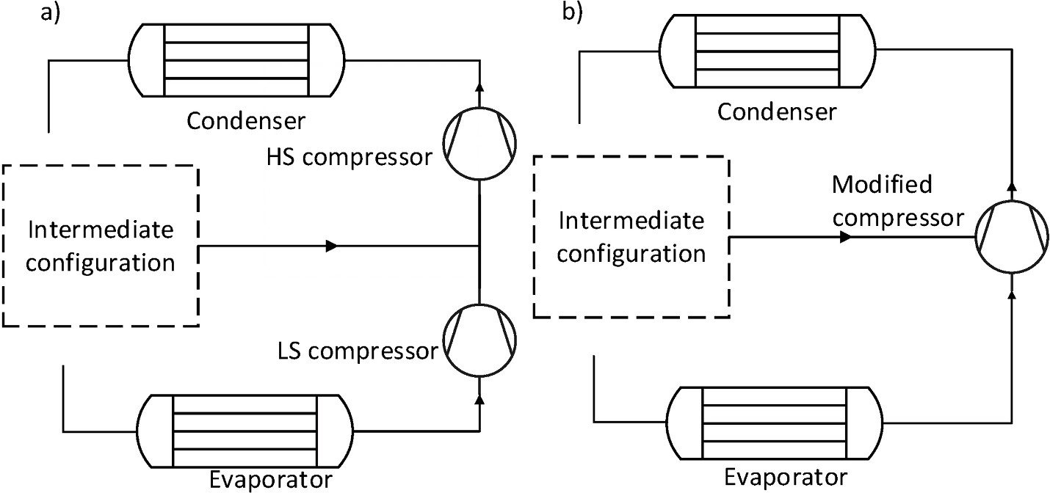

**Fig. 1.** Schematics of (a) (TS) system (b) (QTS) system [77].

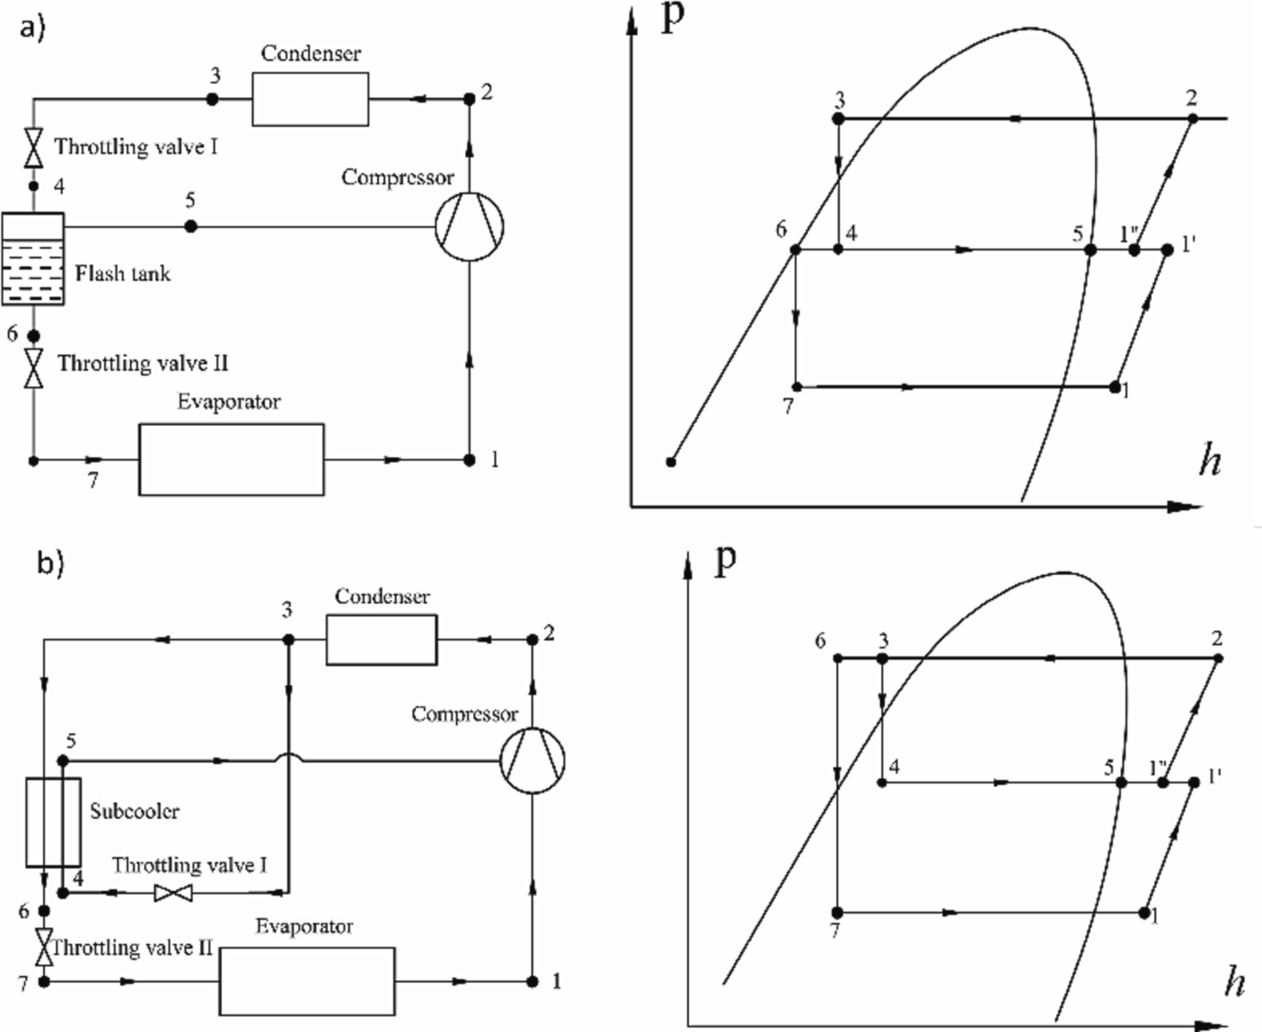

**Fig. 2.** The schematic and P-h diagram (a) FTVI system (b) SCVI system [36].

the IHX and is then injected into the intermediate compression chamber. In both intermediate configurations, compression work is saved as the injection stream bypasses the first compression stage, resulting in increased performance [13,77].

The advantages and disadvantages of vapor injection cycles with economizer (IHXC) and flash tank (FTC) are as follows:

* + - The IHXC has a single-stage expansion from condensing pressure to evaporating pressure. On the other hand, the FTC has a two-stage expansion. This feature has a significant impact on the FTC perfor- mance due to reduced throttling losses.
    - Due to the phase separation in the flash tank, the enthalpy of the

refrigerant at the evaporator inlet is less in the FTC and hence the evaporator capacity increases [68,65].

* + - In FTC, because of that the gas injected into the compressor is

saturated vapor, the intercooling effect is high and the compression is more efficient.

* + - The heat pump flash tank system has a significantly lower

compressor discharge temperature, which significantly extends its operating life [33,42].

* + - In FTC, the intermediate conditions are limited by the fact that the

refrigerant is the saturated liquid at the inlet of the low expansion valve and the saturated vapor at the inlet of the injection port. Whereas IHXC has the freedom to adjust the superheat of the injected refrigerant at the injection port. Therefore, the IHXC has a wider injection pressure operating range than that of the FTC [42,68]**.**

* + - The flash tank system is less complex, easier to construct, and less costly than a heat exchanger [56,57].

The two methods have been compared in terms of performance in some studies. **Ma and Zhao** [33] compared the performance of a vapor- injected two-stage system for FTVI and SCVI cycles. The heating ca-

pacity and COP of the FTVI cycle for a condenser temperature of 45 ◦C

and an evaporator temperature of —25 ◦C were 10.5 % and 4.3 % higher than those of the SCVI cycle, respectively. They also stated that the FTVI is more efficient and reliable than the SCVI at low ambient temperatures. **Heo** [13] experimentally compared the performance of various vapor injection heat pump cycles and reported that the FTVI cycle exhibited

14.4 % higher average heating capacity than the SCVI cycle. **Baek** [2] compared three vapor injection CO2 cycles based on heating perfor- mance. They determined that the heating capacity and COP of the optimized SCVI cycle were 12.1 % and 12.7 % higher, respectively, than

those of the optimized FTVI cycle at an outdoor temperature of —15 ◦C

and a compressor frequency of 55 Hz. **Wang** [68] experimentally compared the system performance of IHXC and FTC with the conven- tional system in both cooling and heating mode. The maximum COP

improvement of 23 % was obtained with the FTC system at an ambient temperature of —17.8 ◦C. **Dai** [9] developed four hybrid configurations for CO2 heat pump systems, which include vapor injection and dedicated mechanical subcooling. It is stated that the proposed hybrid technolo-

gies can increase the overall system performance.

It is seen that the FTVI system is advantageous in terms of perfor- mance compared to the system with heat exchanger. However, in

practice, SCVI systems are preferred to FTVI systems because there are some difficulties in the control of the FTVI [58,69].

* 1. *State of injection refrigerant (vapor or two phase)*

The refrigerant injected into the intermediate pressure location of the compressor can be in vapor phase or two phase. Two-phase injection provides a lower discharge temperature than vapor injection. It also affects the heating performance. However, its applications are limited due to wet compression [23]. Xu [55] proposed the vapor-injected flash tank heat pump system with injection subcooling, as seen in Fig. 3. They showed that when two-phase fluid is injected instead of vapor, re- frigerants with high discharge temperature such as R32 can operate at low ambient temperatures, but some COP loss occurs.

**Qv** [40] reached the same conclusion in their study and limited the two-phase injection time to 8-second intervals to avoid performance degradation and wet compression. **Lee** [26] applied the two-phase refrigerant injection technique to approach the saturation cycle. This cycle uses saturation compression and saturation expansion, which follow the saturated vapor and liquid lines, respectively. The P-h dia- gram for the 4-stage cycle is shown in Fig. 4**.** The mass flow rate of two- phase refrigerant injected is controlled with the degree of superheat. They determined that the COP of the four-stage saturation cycle was

22.42 % and 28.24 % higher than the single-stage cycle for the cooling mode and the heating mode, respectively. **Mathison** [34] developed a model to study the saturation cycle achievable with dual-phase refrig-

erant and continuous injection. For the vapor compression cycle with injection operating at an evaporating temperature of —20 ◦C and a condensing temperature of 50 ◦C, the upper limit of the COP develop- ment possible with continuous refrigerant injection is determined as 44

%, as seen in Fig. 5. They reported that one injection point increases the COP by 21 % while the four injection points improve the COP by 36 % over the single-stage vapor compression cycle.

# The parameters affecting system performance

It is expected from an efficient heat pump/refrigerator to operate safely at very low and high temperatures and to provide adequate heating/cooling with the highest efficiency. It is necessary to know which parameters affect the capacity and COP development of the FTVI system and their importance.

* 1. *De-superheating(inter-cooling) and interstage subcooling*

Vapor injection has two thermal effects: (1) de-superheating effect

(2) interstage subcooling effect. The injection of saturated vapor from

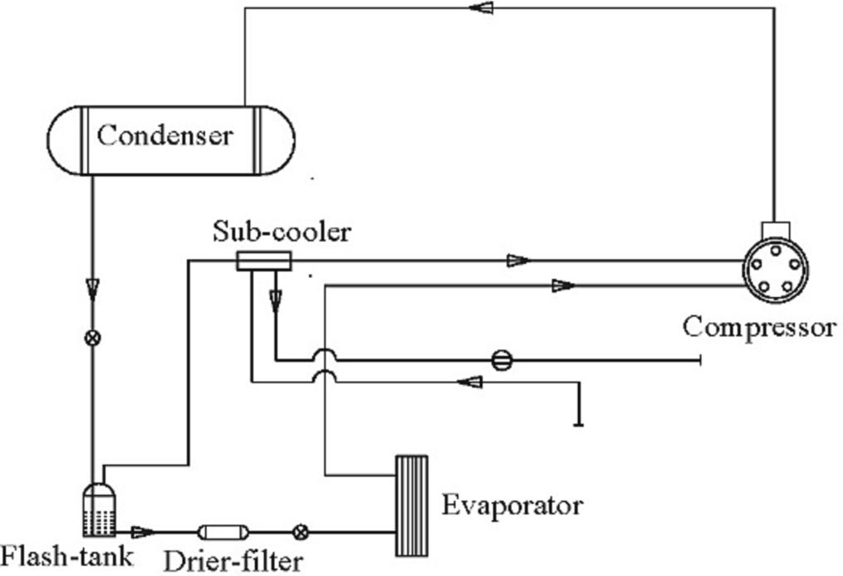

**Fig. 3.** Vapor injection with subcooling mode (VIS) [55].

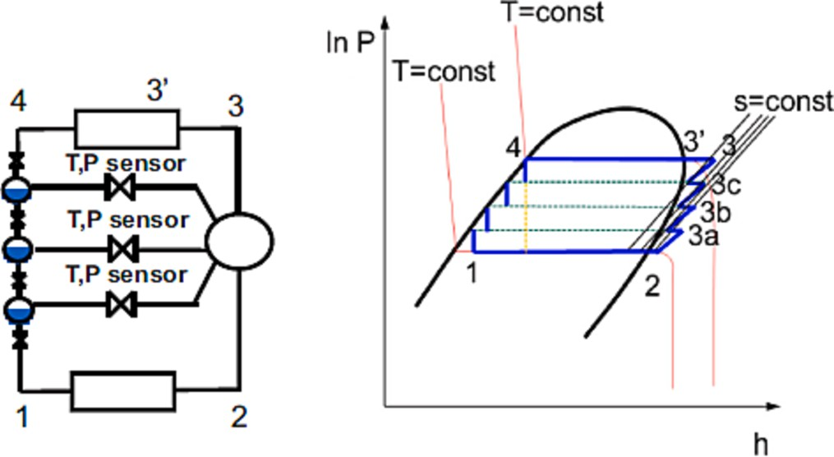

**Fig. 4.** The schematic and P-h diagram of four-stage cycle [26].

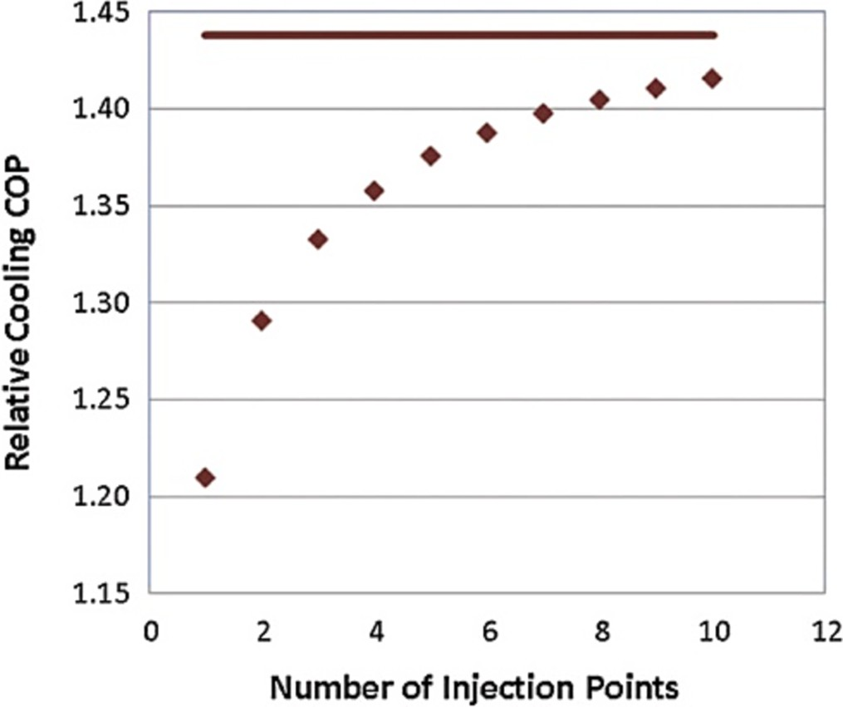

**Fig. 5.** Variation in relative COP with number of injection points [34].

the flash tank in the intermediate stage results in a reduction of tem- perature and specific volume at the inlet of the second compression stage. This event is called de-superheating. The first effect of de- superheating is the increase in the mass flow rate through the second stage compression and condenser, thus increasing compressor work and heating capacity. The second effect is that the enthalpy difference in the condenser decreases due to the decrease in discharge temperature and therefore the heating capacity decreases. The COP decreases or increases depending on the relative increase of compressor work and heating capacity affected by mass flow rate and intercooling. The effect of inter- stage subcooling is to decrease the specific enthalpy of the refrigerant entering the evaporator. Increasing the enthalpy difference increases the two-phase heat transfer area and evaporator capacity. These phenomena have been mentioned in many studies [13,19,52,77]**.**

**Torrella** [52] defined the interstage subcooling and de-superheating parameters in two-stage compressor systems and investigated the vari- ation of COP for R404A and R717 according to these parameters. **Jiang**

[17] showed that the effect of interstage subcooling on COP improve- ment is greater for refrigerants with large specific heat (cp). **Jiang** [19] examined the effect of these parameters on the heating COP for 33 fluids. They also revealed the connection of COP with cp, m. Further subcooling resulted in a higher COP for all fluids. However, the effect of the de-superheating factor on the COP was different according to the fluid. De-superheating improved the heating COP (COPh) when the cp, m of the refrigerant used was less than 60 J/mol K, whereas when cp,m was

greater than 70 J mol—1 K, de-superheating decreased COPh rather than

increasing it. Also, the improvement effect of subcooling on COPh is greater than that of de-superheating.

(C11) and the dew point temperature at the intermediate pressure (I)) to the AHRI polynomial **(Eq.3)** characterizing the compressor power input.

* 1. *Injection pressure and injection mass flow rate*

The use of vapor/liquid-phase separation for vapor injection in the FTC cycle reduces the number of variable parameters. Therefore, the COP of the FTVI system at a given condenser and evaporator tempera-

*W*˙ , *Q*˙, *m*˙*ref* = *C*1 + *C*2*S* + *C*3*D* + *C*4*S*2 + *C*5*SD* + *C*6*D*2 + *C*7*S*3

+*C*8*S*2*D* + *C*9*SD*2 + *C*10*D*3

*W*˙ = *C*1 + *C*2*S* + *C*3*D* + *C*4*S*2 + *C*5*SD* + *C*6*D*2 + *C*7*S*3 + *C*8*S*2*D*

+*C*9*SD*2 + *C*10*D*3 + *C*11*I*

(3)

(4)

ture depends on two design variables, the fluid and the injection pres-

*m*˙*inj*

*Pint*

sure [49]**.** There is a pressure difference between the injection pressure and the intermediate pressure for both the FT system and the IHX sys- tem. It is the driving force of the injection [22]**.** Due to the difficulty of measuring the intermediate pressure inside the compressor, most au- thors considered the injection pressure to be approximately the inter- mediate pressure in their studies [31,34,35].

An increase in the condensation temperature at a constant evapo- rator pressure, or vice versa, increases the intermediate pressure. However, the effect of the change in the evaporation temperature is greater than that of the condensation temperature. As the injection pressure increases, the injection mass flow rate and therefore the heating capacity and compressor work increase [20]**. Wang** [64] examined the change of system parameters according to ambient temperature, considering the flash tank heat pump system with new gas-injected ro- tary compressor**.** Fig. 6 shows that the mass flow rate increases with the ambient temperature as the evaporating temperature increases, but the injection ratio (minj/me), which is the mass flow rate of the injected gas divided by the refrigerant flowing through the evaporator, decreases.

*m*˙*e* = *A* + *B Pe* , *A* = — 0.383, *B* = 0.329 (5)

**Eq.** **(5)**is an intrinsic characteristic of each scroll compressor, regardless of how the injection is carried out. A and B are obtained by linear regression for single-speed compressors. This correlation was used by **Tello-Oquendo** [50] to determine the injection mass flow under the suction conditions in their experimental study. It was observed that the obtained values were in good agreement with the experimental results. **Lumpkin** [28] proposed two dimensionless correlations based on the Buckingham-PI theorem to predict the performance of a single-port in- jection scroll compressor **(Eq.** **(6) and (7)**. They validated the dimen- sionless correlations using 43 data points from their study for a single- speed R-407C scroll compressor and also 63 data points from Dard- enne [10] for a variable speed compressor. The results were compared with the Tello-Oquendo correlations **(Eq.** **(4) and (5)**and the AHRI- polynomial **(Eq.** **(3)**. In all cases, the injection ratio and compressor power input were most accurately matched with the dimensionless-PI correlation compared to the other correlations.

Because when the evaporation temperature decreases, the mass flow rate at the compressor suction decreases while the injection mass flow

simultaneously increases.

*m*˙*inj*

*m*˙*ref* = *o*

*C*

*fpower C*1 Δ*hinj*,*sh C*2 *Pinj C*3 *Tsuc C*4

*fno*min*al* Δ*hinj*,*fg Psuc Tamb*

( ) ( ) ( ) ( )

( ) ( ) ( ) ( ) ( )

(6)

The injection ratio is closely related to the injection pressure. Ac- cording to the mass and energy balance **(Eq.1)** written for the flash tank system in Fig. 2**(a)**, when the injection pressure increases, (h5-h4) in-

creases, (h4-h6) decreases and thus the injection ratio **(Eq.2)** decreases

*Pdis C*5 Δ*hsuc*,*sh C*6 *Pdis C*7 *Psuc C*8 *Tsuc C*9

*Psuc* Δ*hsuc*,*fg Pcrit Pcrit Tcrit*

*W*˙ ( *fpower* )*C*1 ( *m*˙*inj* )*C*2 ( *Pinj* )*C*3

[65]**.**

*Tdis* , *ηisen* , *ηv* , *fq* , *W*˙

= *Co*

*fno al*

*m*˙*ref*

*Psuc*

*max*

min

(7)

*m*˙*ch*4 = *m*˙*eh*6 + *m*˙*injh*5 (1)

( *Tsuc* )*C*4 (*Pdis* )*C*5 (Δ*hsuc*,*sh* )*C*6 (*Pdis* )*C*7 (*Psuc* )*C*8 (*Tsuc* )*C*9

*m*˙*inj* = *h*4 — *h*6

(2)

*Tamb*

*Psuc*

Δ*hsuc*,*fg*

*Pcrit*

*Pcrit*

*Tcrit*

*m*˙*e*

*h*5 — *h*4

**Xue** [61] showed that the injection ratio varies linearly with the

* 1. *Optimum injection pressure and relations*

pressure ratio (Pint/Pe)) which is the injected gas pressure divided by the evaporator pressure. **Tello-Oquendo** [48] analyzed the effect of inter- mediate pressure on the evaporator mass flow rate and the compressor power input, independent of the injection mechanism (flash tank or internal heat exchanger). Two correlations seen in **Eqs.** **(4) and (5)**were proposed for the characterization of the scroll compressor. **Eq.** **(4)**is obtained by adding a new term (the product of a regression coefficient

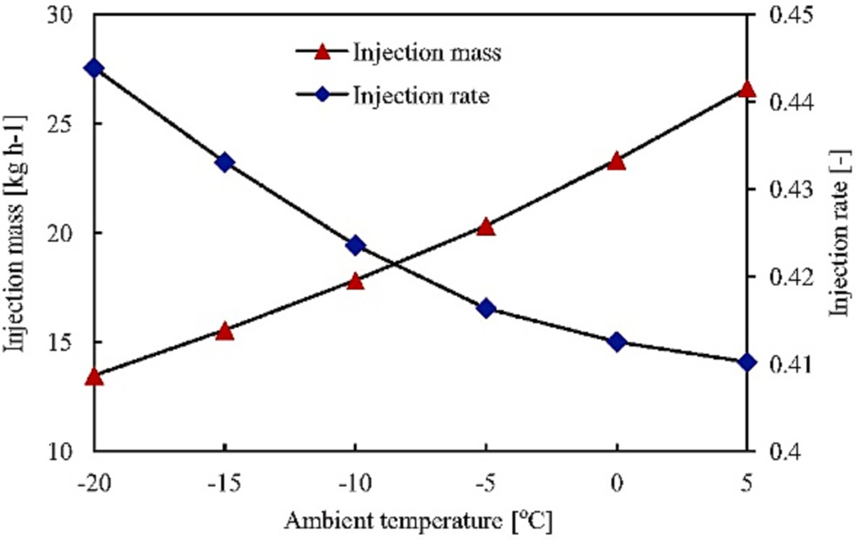

**Fig. 6.** Injection mass flowrate and injection rate [64].

Injection pressure must be considered in system design because of its significant impact on cycle performance [32,43,58]**. Xue** [61] experi- mentally investigated the effect of the pressure ratio on system perfor-

mance for a flash tank vapor injection (FTVI) system at constant room conditions of 20 ◦C and 60 % and an ambient temperature range of

—10 ◦C to 7 ◦C. At all ambient temperatures, as the pressure ratio in-

creases, the injection rate, heating capacity, and power input increase, and the discharge temperature decreases due to the intercooling effect. Heating COP, on the other hand, may have a different tendency ac- cording to the ambient temperature. While COP decreases with the decrease of the injection pressure ratio at ambient temperatures of 2 and

7 ◦C, it has an optimum point at lower temperatures as seen in Fig. 7. **Jin**

[20] obtained similar results. At Tc = 40 ◦C, the COP showed an opti- mum when the evaporator temperature was —15 ◦C and —30 ◦C, while the COP decreased with the increase of the intermediate pressure when the evaporator temperature was 0 ◦C. **Chabot** [4] investigated the op-

timum injection pressure in FTVI system for 167 refrigerants. They found that there is an injection pressure that maximizes COP for each fluid at Tc = 40 ◦C and Te = -15 ◦C conditions.

Many authors have attempted to estimate the intermediate pressure and temperature that maximizes performance. **Torrella** [51] presented a summary of the expressions used in the literature for the optimum intermediate pressure (Pm) and the optimum intermediate temperature (Tm). These are listed in Table 1. **Eq. 11**, known as the geometric mean

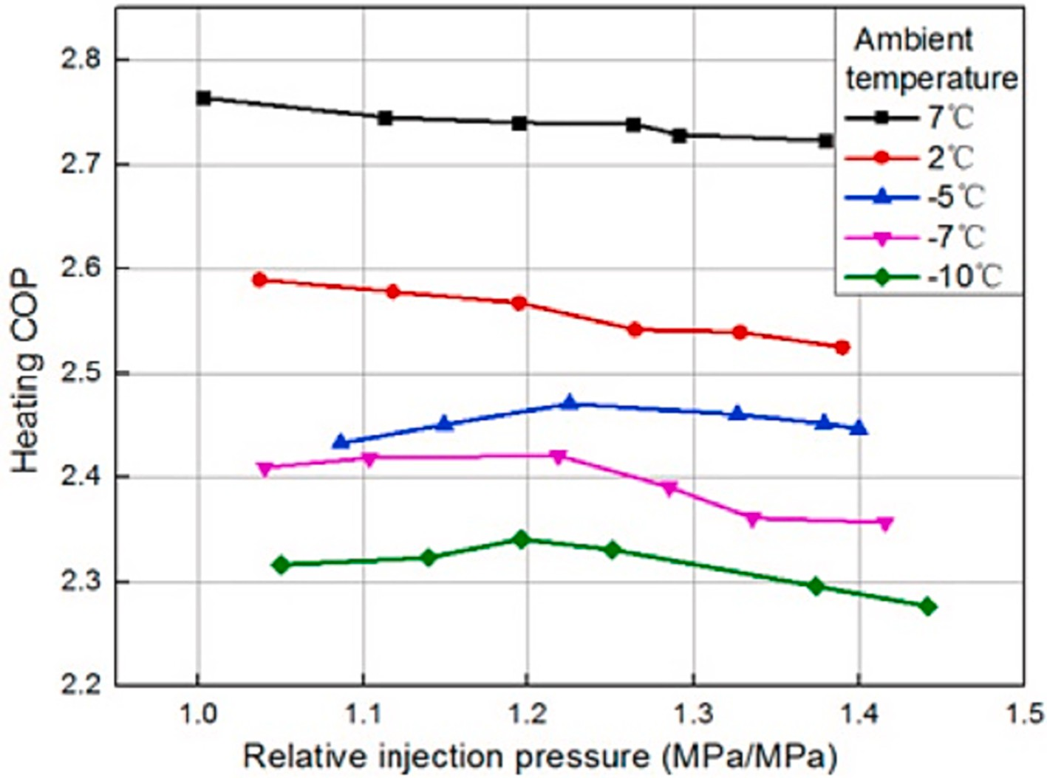

**Fig. 7.** Change of heating COP with relative injection pressure [61].

**Table 1**

Optimum pressure and temperature expression [51].

of intercooling (**Eqs.** **(15) and (16)**.

*Tint*,*d*,*opt* = 0.5(*Tc* + *Te*) + (*Tc* — *Te*)*f*1(*ε*, *Tc*,*r*, *Te*,*r*) (15)

Behringer (1928) *Tm* = *T*(*P* = *Pge* ) + 5 (8) *f* 2 2

Rasi (1955) *T*

= 0.4*T* + 0.6*T* + 3 (9)

1 (*ε*, *Tc*,*r* , *Te*,*r* ) = *a*1 *ε* + *a*2 *Tc*,*r* + *a*3 *Te*,*r* + *a*4 *ε* + *a*5 *Tc*,*r*

(16)

*m c e*

= √̅̅̅̅̅̅̅̅̅̅

√ 2

Czaplinski (1959) *Tm Tc Te*

Baumann and Blass (1961) *Pm* = √*P*̅̅̅*c*̅̅*P*̅̅̅*e***̅**

(10)

(11)

+*a*6 *Te*,*r* + *a*7 *εTc*,*r* + *a*8 *εTe*,*r* + *a*9 *Tc*,*r Te*,*r*

The intermediate pressure was also investigated using Eq.17,

De Lepeleire (1973) *Pm* =

*P*̅̅̅*c*̅̅*P*̅̅̅*e***̅** + 0.35(*bar*) (12)

referred to as the injection pressure ratio (PR

). **Heo** [12] showed the

Domanski (1995) *Tm* = 0.5(*Tc* + *Te* ) (13)

pressure (Pm,ge), is the most widely used optimum pressure expression in the literature. This approach is based on the perfect gas assumption where the suction of both compressors is at the same temperature.

In real conditions, the optimum injection pressure (Pm) may differ from Pm,ge. Many authors have used the dimensionless intermediate pressure seen in **Eq.14** in their optimization studies. It was called as the relative injection pressure (RIP) and was defined as the ratio of the in- jection pressure to the geometric mean pressure [32]. **Arora and**

**Kaushik** [1] stated that the optimum injection pressure maximizing the

inj

effect of ambient temperature and compressor frequency on PRinj. The injection pressure ratio increased with increasing ambient temperature and frequency. However, the effect of ambient temperature was greater. **Rad and Maddah** [41] used the entropy analysis method in the FTVI cycle. It was concluded that the optimum pressure determined at the point where the total entropy production is minimum is almost equal to the optimum pressure according to the first law. In addition, it has been determined that the optimum injection pressure ratio varies between

0.25 and 0.35 for six refrigerants in a wide range of condenser and evaporator temperatures.

COP and exergy efficiency in FTC is close to the saturation pressure corresponding to the geometric mean of condensation and evaporation temperatures. **Redon** [42] investigated the optimum intermediate pressure in the flash tank and economizer system for different fluids. It has been observed that the optimum RIP values are always greater than

one for all the refrigerants studied. **Xu** [54] investigated the thermal

*PR Pinj* — *Pe*

*Pc* — *Pe*

*inj* =

* 1. *Variable speed*

(17)

performance of R1234yf, R32 and their mixtures in the FTVI cycle. The optimum RIP is 1.2 at 0 ◦C ambient temperature and also between 1.15 and 1.35 for the evaporator temperature range of —20 ◦C to 5 ◦C. **Luo**

[29] found that the optimum intermediate pressure is approximately 26

% higher than the geometric mean pressure.

*Pinj*

**Heo** [12] investigated the effect of compressor speed, ambient temperature and EEV openings on the heating performance of flash tank vapor injection. The compressor used was a twin rotary compressor with two separate cylinders. The results showed that the effect of vapor in- jection is reduced at relatively high ambient temperatures and high

compressor frequencies. At ambient temperatures above 5 ◦C,

compressor frequencies higher than 90 Hz resulted in wet compression

*RIP* = √*P*̅̅̅*e*̅̅*P*̅̅̅*c***̅**

(14)

in the compressor and lower COP than that of the non-injection system.

**Jiang** [18] showed that the optimum Pm is between the arithmetic mean pressure (Pm,ari) corresponding to the arithmetic mean tempera- ture (*T*m,ari **(Eq. 13)**) and the geometric mean pressure*.* For R22, Pm was close to Pm,ari, while for ammonia the deviation from Pm,ge and Pm,ari was equal for FT cycles. They also revised *T*m,ari taking into account the effect

This frequency limit specified for compressor safety may vary depending on the flash tank size. **Yan** [74] examined the system performance and discharge temperature for injection and non-injection operation at

different compressor speeds. As a result of the tests carried out at —7◦C

ambient temperature, it has been observed that there is an optimum intermediate pressure according to the maximum COP at each frequency

value and that the optimum intermediate pressure increases as the compressor frequency decreases. **Ko** [24] examined an air-to-water heat pump system with an FTVI cycle using an inverter-driven two-stage rotary compressor. The system showed a 48 % increase in heating ca- pacity and a 36 % in COP over conventional air-to-water heat pump

system at an ambient temperature of —15 ◦C and a water temperature of

60 ◦C. **Kwon** [25] controlled the intermediate pressure by changing the frequency of the high stage compressor. In this way, a performance in- crease of 5.2 % was achieved at a heat source temperature of 30 ◦C. **Wang** [65] showed the effect of changing the compressor frequency on the COP in the ambient temperature range of —4 to —20 ◦C. As the frequency increased, the COP decreased. However, the decrease was less at low ambient temperatures. **Wei** [72] studied the COP increase of FTVI and SCVI using R1234ze(E) at different frequencies. They presented that the heating COP for FTVI increased by 3.5–7.4 % compared to the single-

stage mode without vapor injection when the compressor frequency

varied between 40 and 100 Hz.

# System control

The lack of an effective control strategy has limited the practical acceptance of the FTC. Therefore, the control strategy should be seri- ously considered in order to increase the applicability of the FTC in commercial products [59]. What is expected from a control method for an FTC-VI system is stable and safe operation, maintaining a reasonable liquid level range and achieving the achievable thermal performance

cost-effectively [69]**.** Improper control can reduce the efficiency of liq- uid–vapor separation in the flash tank, causing liquid to enter the compressor and reduce system performance [39]. In addition, the sys-

tem should be operated at the optimum injection pressure in terms of performance.

There are three control valves in the FTC injection system as seen in Fig. 8. The reliable operation of the system and the increase in perfor- mance are closely related to the control of these valves. The upper stage expansion valve controls the injection mass flow rate and the injection pressure. Increasing the upper stage expansion valve opening causes the injection pressure to increase. The lower stage expansion valve controls the mass flow rate of the evaporator and the low pressure of the system, usually using the evaporator outlet superheat. The third injection con- trol valve can be used to control the on/off of the vapor injection and also to ensure the safety of the compressor if the liquid level unexpect- edly increases [56]**.**

* 1. *Operating strategy using TXV or EXV*

IHX systems can be controlled with thermostatic expansion valves (TXV), which use the superheating degree as the control signal, at low cost, while TXV cannot be used in the flash tank system because the injected vapor is saturated. **Xu** [56] suggested giving positive heat to the fluid exiting the flash tank in order to use cost-effective TXV. He put forward the idea that a heat exchanger could be applied between the injected vapor and the liquid exiting the condenser for positive heat. In their experimental work, they used an electric heater to simulate the heat exchanger. As a result of the study, they stated that the heat exchanger cost is negligible compared to the system using complex and expensive electronic expansion valve (EEV) control, and if that the su- perheat can be controlled within 6 K, the performance decrease will be within 1 %.

It’s known that the response of an EEV is faster than a TXV, therefore, it’s more effective to implement an EEV for the upper stage expansion control. **Qiao** [37] performed the numerical modeling for start-up and

shut-down operations of a flash tank vapor injection heat pump system. **Qiao** [38] conducted an experimental study based on this numerical model and examined the changes in pressure and mass over time. The experimental results show that the opening of the upper stage EEV has a significant impact on system performance and the liquid level in the flash tank. **Xu** [57] proposed the control strategy using EEV coupled with a PID controller for the upper stage expansion of an R410A vapor injection flash tank heat pump system as seen in Fig. 8**.** The proposed method does not require a liquid level sensor which incurs an additional cost in potential industrial applications. An electric heater was used in the vapor injection line to provide superheat. As a result of the tests

performed at different superheat degrees by varying the heater power, a superheat degree of 4–6 ◦C was recommended for both system perfor- mance and appropriate flash tank liquid level.

**Wang** [63] proposed a hybrid flash tank that would provide super- heating to the injection vapor to control the expansion valve. As can be seen from Fig. 9**,** the hybrid tank takes advantage of the fact that the temperature of the fluid leaving the condenser is greater than the tem- perature of the vapor exiting the flash tank. The optimum injection pressure is reduced and the performance of the system is increased. Preliminary numerical experiments have shown that the system can increase the cooling capacity by 1.5 % to 3.5 %.

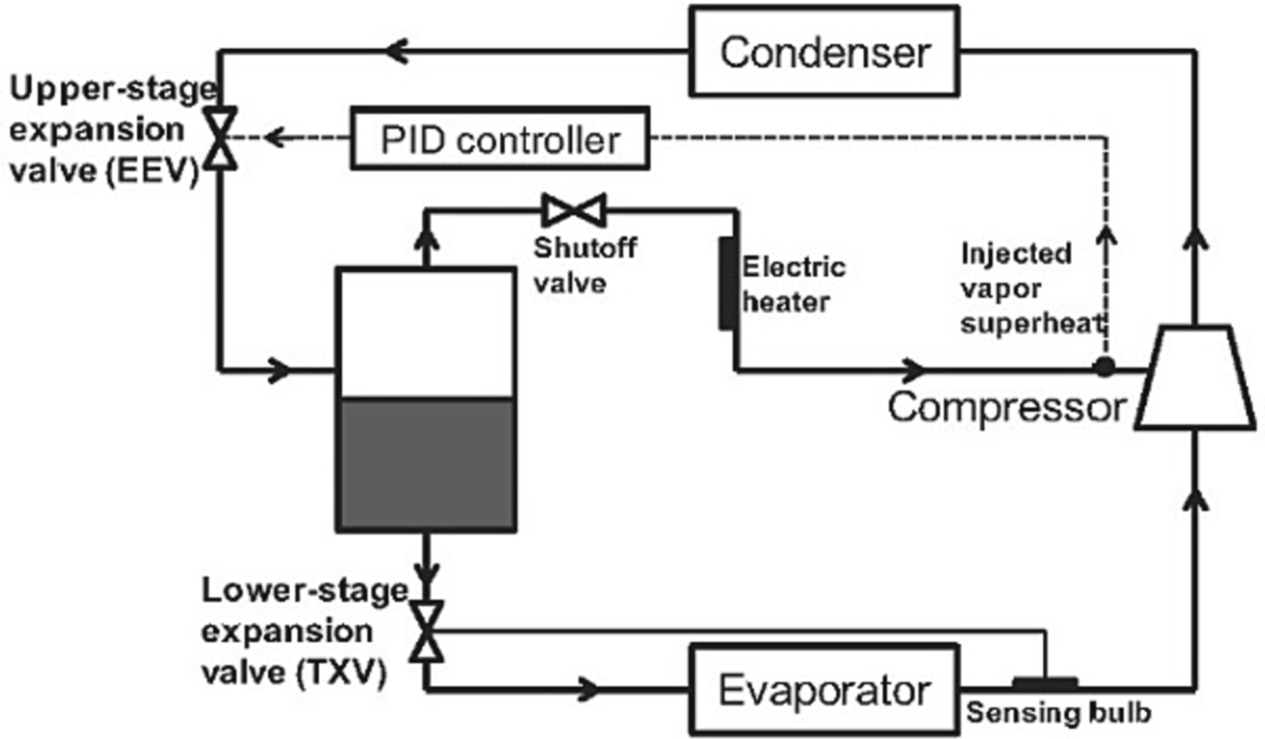

**Fig. 8.** Schematic of the control strategy for flash tank cycle [57].

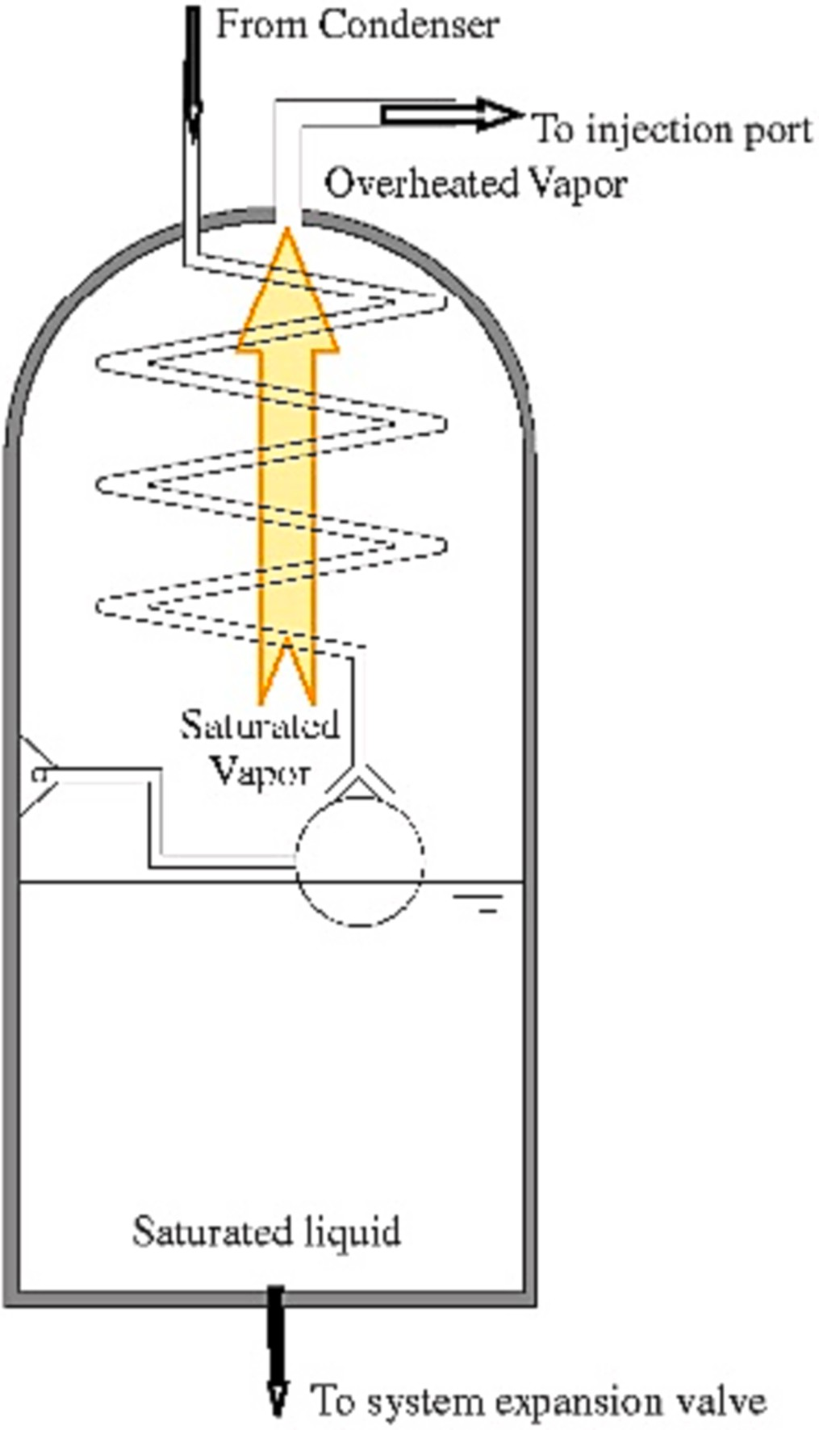

**Fig. 9.** Hybrid flash tank [63].

* 1. *Control strategy using liquid level - phase separation*

Ideally, the liquid and vapor separated in the flash tank are consid- ered to be a single phase when leaving the flash tank. However, the separation of liquid and vapor is not ideal in practice. Due to the dy- namic conditions in the FT, two-phase currents can often occur at the outputs of the FT and cause problems [58]**.** The liquid level in the flash tank must be high enough to prevent uncontrollable injection of liquid into the compressor. Therefore, the liquid level can be controlled to

effectively separate the vapor from the liquid–vapor mixture**.** If the

liquid level is above the appropriate limit, the vapor quality entering the flash tank should be increased by reducing the opening of the expansion valve, or vice versa [38,56]**. Jang** [16] proposed a reliability index using mass balance in the flash tank to predict the required liquid level. A reliability index above 1 means no liquid refrigerant enters the compressor and the system operates safely.

**Xu** [56] reported that, as a result of their experimental work, the liquid level in the flash tank should be maintained between 40 % and 60

% of the flash tank height to prevent liquid injection into the compressor. **Wang and Li** [69] stated that the same range is valid for safe operation as a result of their experimental study. Using the liquid level in the FT as the control parameter of the EEV requires a liquid level

sensor and corresponding transmitters, which significantly increase the overall system cost. Fig. 10 shows the schematic of a control strategy employing a liquid level sensor. The liquid level sensor is inserted to the flash tank in order to measure the liquid level inside the flash tank [59]. **Singer** [45] proposed a method to determine in situ both the heating capacity and the performance coefficient (COP) of already installed heat pumps. All measurements required are temperatures measured by con- tact temperature sensors installed on the pipe surfaces and also electric power intake. Using the data obtained, first the pressure and enthalpy values are determined, then the mass flow rates from the mass and en- ergy balances and finally the heating capacity and COP can be calcu- lated. Uncertainties caused by the possibility of two-phase refrigerant at points (the compressor inlet, injection port, and outlets of condenser and flash tank), that are considered to be single-phase and uncertainties due to sensor errors can cause errors in the COP calculation. According to the results, the relative error of the calculated COP is 5.3 % due to sensor uncertainties in the operating condition studied. In order for the error due to vapor quality to remain below 10 %, the compressor suction line vapor quality must be greater than 96 %, the condenser exit vapor quality must be less than 15 %, the FT liquid line vapor quality must be less than 48 % and the injection line vapor quality must be greater than

76 %.

In the FT cycle, there is a possibility of flooding in the compressor at high speeds. In such cases, the combined flash tank and subcooler (FTSC) cycle offered by **Heo** [13] could be used as a solution for precise control of the amount of fluid injected into the compressor **(**Fig. 11**).**

* 1. *Model based control strategies*

**Tello-Oquendo** [49] proposed a correlation (**Eq.** **(18)**that can be used for both flash tank and IHX cycles to determine the optimum in- termediate temperature. This correlation is formed by adding the parameter related to condenser subcooling (SCc) to the **Eq. 13** proposed by Domanski [11]**.** Here K1 and K2 are equal to 0.5, and K3 is obtained by linear regression. The optimum intermediate pressure is calculated by **Eq.** **(19)****.**

*Tint*,*d*,*opt* = *K*1 *Tc* + *K*2 *Te* + *K*3 *SCc* (18)

*Pint*,*opt* = *Psat* (*T* = *Tint*,*d*,*opt* ) (19)

They suggested the control method shown in Fig. 12 so that the system could be operated with the optimal subcooling. In this method, the optimum subcooling is controlled by varying the opening of the second expansion valve. Since the superheat at the evaporator outlet cannot be controlled in this case, a liquid receiver is used at the evap- orator outlet.

**Luo** [29] studied the control strategy for intermediate pressure of a two-stage vapor injection heat pump at variable condensing tempera- tures. The evaporation temperature was kept constant at 3 ◦C. Firstly the

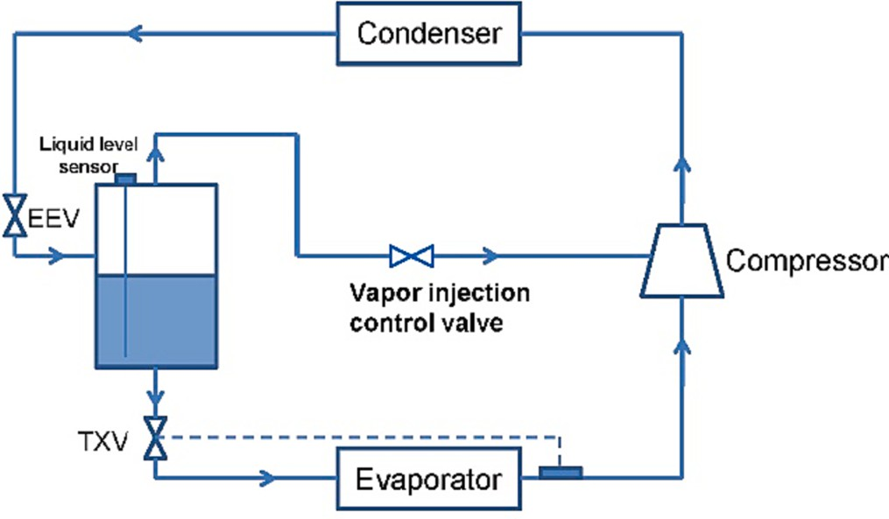

**Fig. 10.** Control strategy employing a liquid level sensor [59].

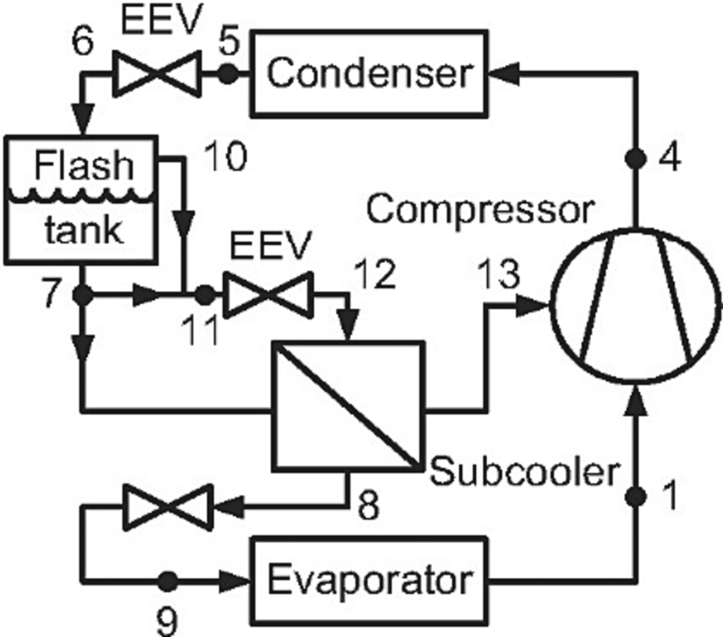

**Fig. 11.** Flash tank and sub-cooler vapor injection (FTSC) [13].

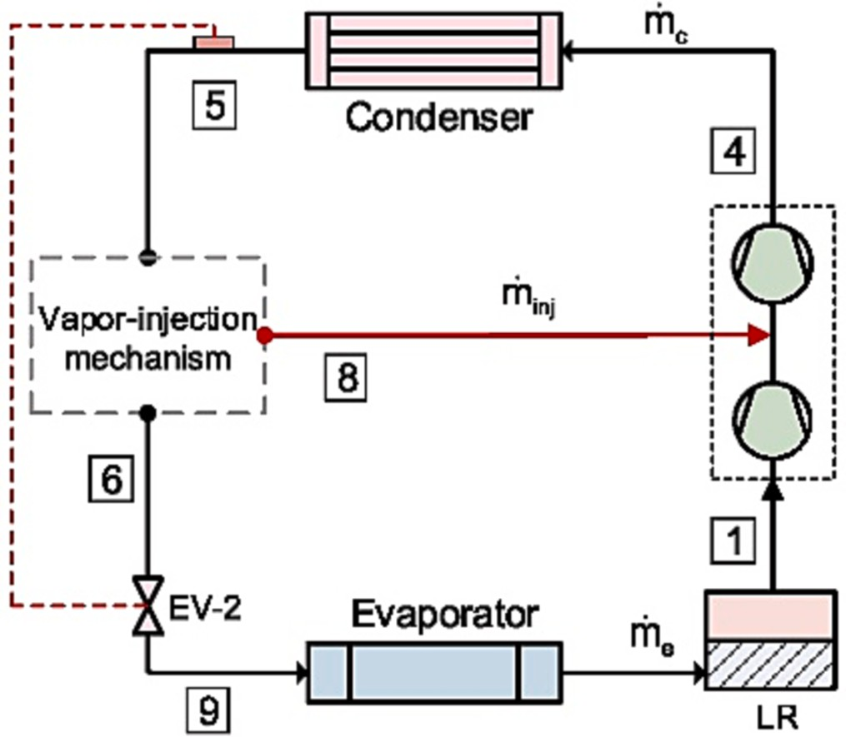

**Fig. 12.** Control of subcooling for two-stage vapor compression cycle with vapor- injection [49].

injection pressure, at which the maximum performance is achieved, was investigated. Then, the interstage subcooling degree, which is the dif- ference between the condenser temperature and the second evaporator inlet temperature at optimum pressure, was determined. The optimum intermediate pressures at each condensing temperature were about 26 % higher than the geometric mean pressure. Finally, for an intelligent control strategy, a regression equation **(Eq.** **(20)**was obtained for the relationship between subcooling degree (*Tsc*) and condensing temper- ature (*Tc*).

subcooling, as seen in Fig. 13. The calculated parameters are input to the mathematical control model and the two-way valve opening is auto- matically adjusted to achieve the specified subcooling degree. The experimental results are in agreement with the theoretical results within

the range of 10–20 %. In addition, the heating COP of the system can be

increased by 20 % with the automatic control method according to the constant injection pressure situation.

* 1. *Real-time optimization strategy*

**Wang and Li** [69] pointed out that model-based control strategies can be costly under highly variable ambient and load conditions and presented a control strategy which includes real-time optimization of system efficiency for an air source heat pump water heater with FTVI, as seen in Fig. 14. In this control strategy, the upper expansion valve opening is adjusted via the extremum seeking controller (ESC) which can search for an input setpoint to optimize performance. The manip- ulated input of the ESC is the intermediate pressure, and the feedback is the total power. Total power is obtained by adjusting compressor ca-

pacities via a PI controller to achieve a constant water temperature (55 ◦C) under constant water flow mass velocity. The superheat at the compressor inlet is controlled by the lower expansion valve using another PI controller. Optimized intermediate pressure setpoint based

on minimizing total power consumption is provided by the control of the upper stage expansion valve. In the proposed method, superheating is not required in the injection line, therefore, the loss of efficiency caused by the superheated vapor is eliminated.

**Wei** [70] studied a quasi-two-stage compression air source heat pump in a test rig in the region where the external design temperature for heating is —27.1 ◦C. In the experimental study, two-phase suction

was observed when the outdoor temperature dropped to —15 ◦C. The

authors proposed a method by which the amount of liquid can be controlled for the safe operation of the compressor. When the suction fluid contains some liquid, it will evaporate as it passes over the motor without going to the suction chamber and the compressor will be able to operate safely. If the liquid refrigerant is more than the amount that will evaporate with the motor heat, the excess liquid refrigerant falling into the oil pool due to gravity will evaporate and cause the oil temperature to drop. The control strategy is to adjust the amount of liquid refrigerant using the allowable oil temperature in the compressor’s oil pool.

*TSC* = 18.91922 — 0.53926*Tc* + 0.0058*T*2

*C*

(20)

**Luo** [30]**,** as a continuation of the study in **Luo** [29], proposed an automatic control method to achieve the best performance at different condensation temperatures. The condensing temperature and the refrigerant temperature at the inlet of the second expansion valve were detected by means of the sensors present in the system and transmitted to a programmable logic controller (PLC) to calculate the corresponding

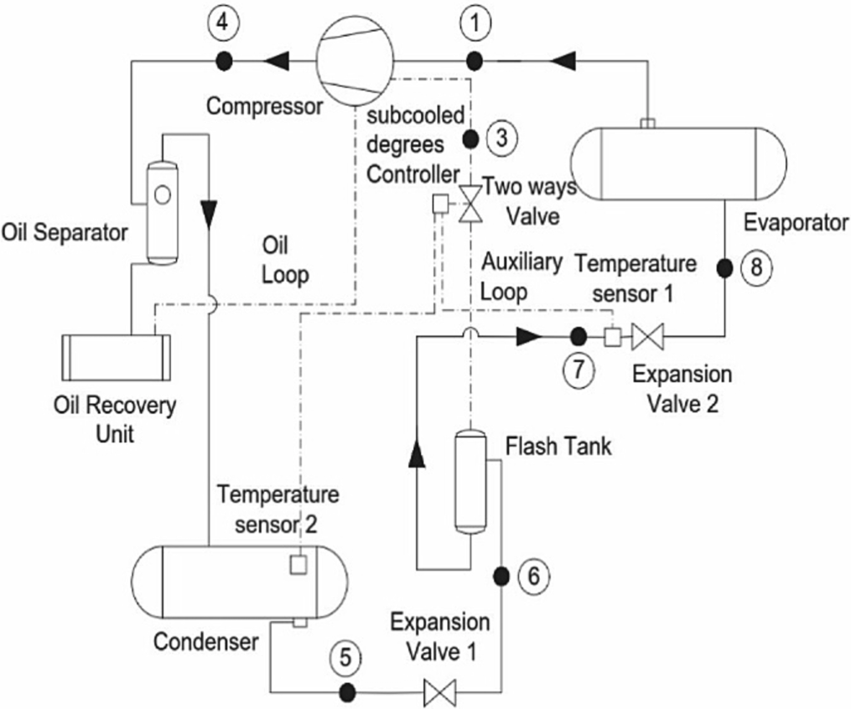**Fig. 13.** Automatic control method for FTVI heat pump [30].

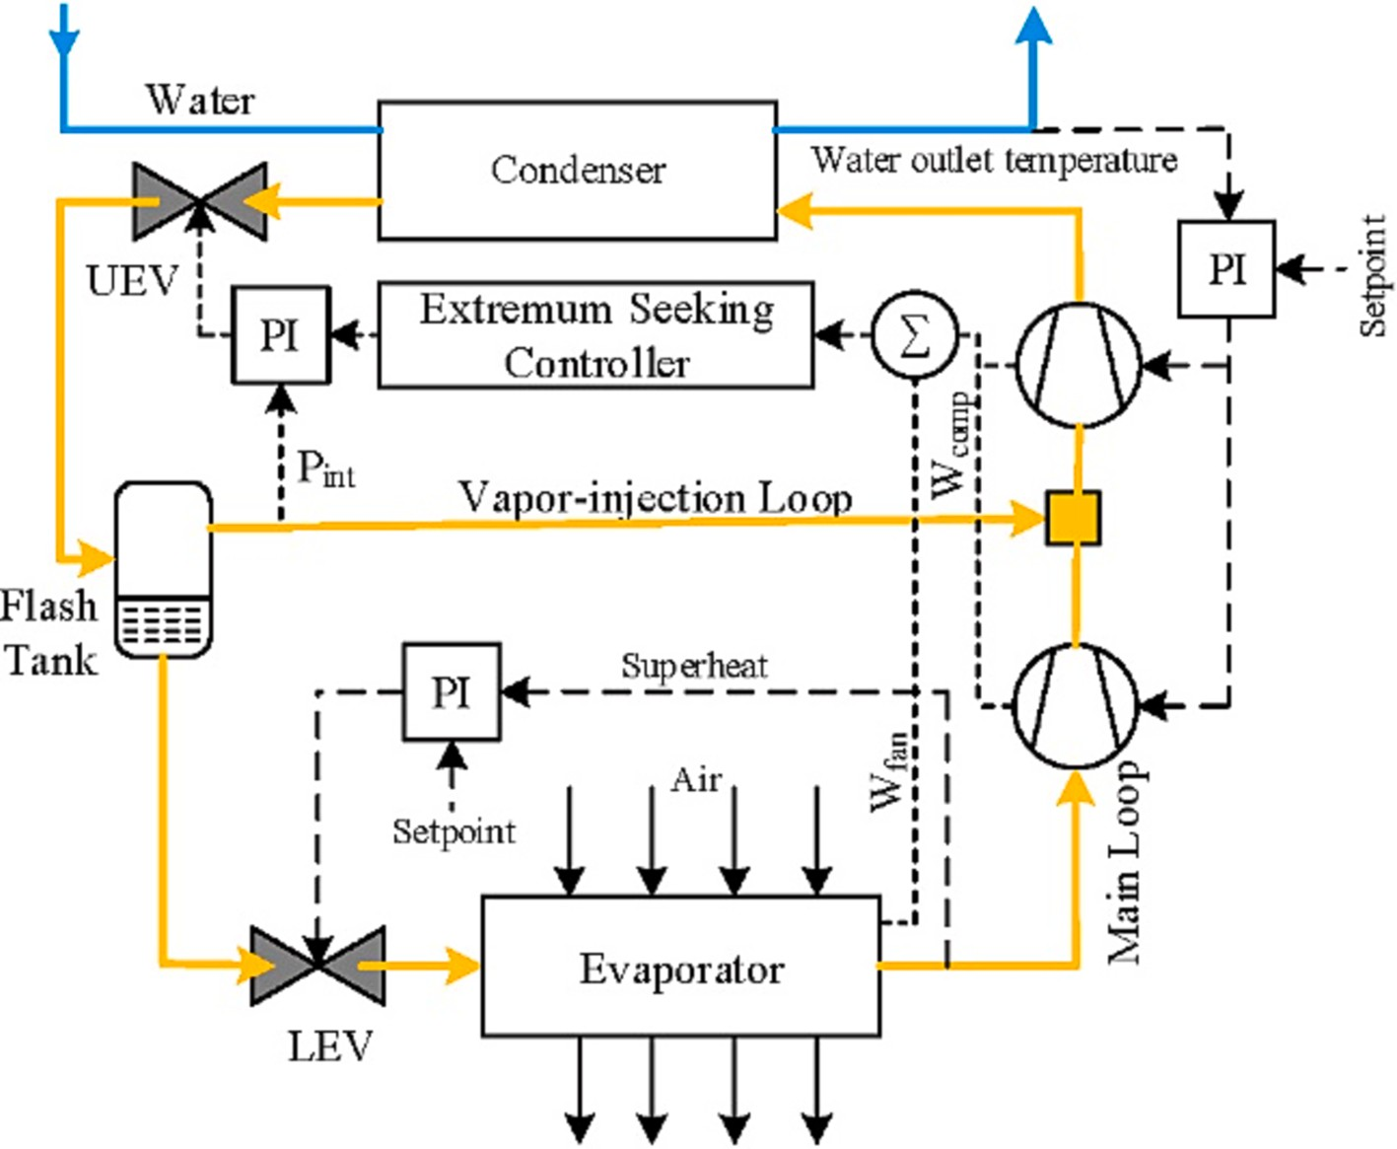

**Fig. 14.** Schematic diagram for the ESC based operation for FTVI two-stage ASHP [69].

# Topics covered in recent years

This section includes recent studies on vapor injection systems that are beyond the scope of the current study.

**Chen** [7] studied the effect of refrigerant leakage on the performance of a flash tank vapor injection heat pump. They concluded that a vapor injection heat pump is more sensitive to refrigerant leakage than a conventional heat pump. **Wei** [71] studied the frosting which causes the rise in the discharge temperature and the rapid decline in the coefficient of performance. They stated that vapor injection is beneficial to shorten the defrosting time. **Chen** [6] proposed a novel vapor injection auto- cascade heat pump to enhance the heating performance for high- temperature water heating applications. The proposed system improved the COP and heating capacity by an average of 51.8 % and

104.3 %, respectively, over the conventional autocascade system when the evaporating temperature ranged from 0 ◦C to 20 ◦C. **Chen** [5] presented a novel direct-expansion solar-assisted flash tank vapor in- jection heat pump for water heating, combining the solar energy utili- zation technique and vapor injection technique. **Dai** [9] developed the configuration of flash tank vapor injection combined with mechanical subcooling. This hybrid CO2 heat pump system can effectively solve the problems of energy efficiency deterioration at high return water tem- perature, as well as high compression ratio when it is used for space heating. In order for the model developed considering the steady state to be applicable in the case of variable temperature and heating capacity, a further dynamic simulation model should be developed. **Yang** [76] studied the effects of the opening of electronic expansion valves on CO2 vapor-injection heat pump system with a flash tank for electric vehicles. The optimal regulation strategy is presented for heating and cooling mode. Further examination of the effectiveness and reliability of the control strategy was left to future studies. **Tang** [46] developed a pro- totype of a vapor injection linear compressor. The results showed that the injection process interferes with the suction process and leads to a reduction of the suction mass flow rate as well as the cooling capacity. Therefore, the optimization of the check valve structure and the control strategy of the vapor injection linear compressor prototype are

presented as future considerations.

# Conclusions

The injection process can effectively improve the heating perfor- mance and reduce the discharge temperature. This paper focuses on vapor-injected two-stage cycles with a flash tank to provide a compre- hensive review. The following conclusions are summarized from the studies reviewed:

* The flash tank cycle and the internal heat exchanger cycle are the two major VI configurations. The FT cycle demonstrates better sys- tem performance. Its heating capacity and COP are higher than those of the IHX cycle. The lack of an effective control strategy makes the widespread use of the flash tank injection system difficult.
* A quasi-two-stage compression system using only one compressor has the advantages of a simpler system, better reliability, lower cost, and easier control. However, it cannot reach the efficiency of two- stage compression under extreme conditions. The widely used compressors for the refrigerant injection technique are scroll, rotary and screw types. For better performance, the studies are focused on the design of the injection ports for scroll compressors and on the back-flowing problem of injected refrigerant for rotary compressors.
* Two-phase injection heat pumps have energy-saving potential with reduced discharge temperature in extreme weather conditions. Since direct measurement of injection quality is extremely difficult in actual heat pumps, a direct control strategy is still not available for practical applications. For this reason, its application is limited due to wet compression.
* There is not yet a general expression for the optimum pressure that can be used for all conditions and fluids. For convenience, the re- searchers have related the optimum pressure to the geometric mean pressure. The relative injection pressure (RIP), defined as the ratio of the injection pressure to the geometric mean pressure, has been widely used in studies.
* There has been relatively limited research on control strategies for vapor injection systems with a flash tank. The model-based control strategies are valid for limited operating conditions. Whereas, model-free real-time control strategy such as ESC can well track the optimal operating under highly variable ambient and load conditions without elevating the superheat and without additional devices. The ESC strategy therefore promises to be a successful solution for a cost- effective, optimal control method for the FTC cycle.

It is hoped that this study will provide a fundamental reference for further research and application of two-stage refrigerant injection heat pumps with a flash tank.

# Declaration of competing interest

The authors declare that they have no known competing financial interests or personal relationships that could have appeared to influence the work reported in this paper.

# References

1. A. Arora, S.C. Kaushik, Energy and exergy analyses of a two-stage vapour compression refrigeration system, Int. J. Energy Res. 34 (2010) 907–923, [https://](https://doi.org/10.1002/er.1594) [doi.org/10.1002/er.1594](https://doi.org/10.1002/er.1594).
2. C. Baek, J. Heo, J. Jung, E. Lee, Effects of vapor injection techniques on the heating performance of a CO2 heat pump at low ambient, Int. J. Refrigeration. 43 (2014) 26–35, <https://doi.org/10.1016/j.ijrefrig.2014.03.009>.
3. Bertsch, S.S., Groll, E.A., Two-stage air-source heat pump for residential heating and cooling applications in northern U.S. climates. Int. J. Refrigeration, 31 (2008),1282-1292. https://doi.org/10.1016/j.ijrefrig.2008.01.006.
4. A. Chabot, F. Mathieu-Potvin, Numerical analysis of heat pumps: Selection of the

best fluids for maximizing the coefficient of performance, Int. J. Refrigeration 112 (2020) 281–302, <https://doi.org/10.1016/j.ijrefrig.2019.11.017>.

1. J. Chen, Z. Zhang, G. Zhang, D. Wang, Energy, exergy, economic and

environmental analysis of a novel direct-expansion solar-assisted flash tank vapor injection heat pump for water heater, Energy Conversion and Management 254 (2022), 115239, <https://doi.org/10.1016/j.enconman.2022.115239>.

1. J. Chen, Q. Chen, X. Qin, D. Wang, Energy, exergy, economic and environmental analyses and optimization of a novel vapor injection autocascade heat pump for high-temperature water heating, Energy Conversion and Management 267 (2022), 115909, <https://doi.org/10.1016/j.enconman.2022.115909>.
2. G. Chen, J. Fang, Z. Li, S. Zhang, Theoretical analysis of the impacts of refrigerant leakage on the performance of a flash tank vapor injection heat pump, Int. J. of

Refrigeration 147 (2023) 10–19. [https://www.sciencedirect.com/science/article/](https://www.sciencedirect.com/science/article/pii/S0140700722004303) [pii/S0140700722004303](https://www.sciencedirect.com/science/article/pii/S0140700722004303).

1. Y.U. Choi, M.S. Kim, G.T. Kim, et al., Performance analysis of vapor injection heat pump system for electric vehicle in cold startup condition, Int. J. Refrigeration 80

(2017) 24–36, <https://doi.org/10.1016/j.ijrefrig.2017.04.026>.

1. B. Dai, Y. Hao, S. Liu, D. Wang, R. Zhao, X. Wang, J. Liu, F. Zong, T. Zou, Hybrid CO2 air source heat pump system integrating with vapor injection and mechanical subcooling technology for space heating of global application: Life cycle techno- energy-enviro-economics assessment, Energy Conversion and Management 271 (2022), 116324, <https://doi.org/10.1016/j.enconman.2022.116324>.
2. L. Dardenne, E. Fraccari, A. Maggioni, L. Molinaroli, L. Proserpio, E. Winandy, Semi-empirical modelling of a variable speed scroll compressor with vapour

injection, Int. J. Refrigeration 54 (2015) 76–87, [https://doi.org/10.1016/j.](https://doi.org/10.1016/j.ijrefrig.2015.03.004) [ijrefrig.2015.03.004](https://doi.org/10.1016/j.ijrefrig.2015.03.004).

1. [P. Domanski, Theoretical evaluation of the vapor compression cycle with liquid-](http://refhub.elsevier.com/S2215-0986(23)00261-6/h0055) [line/suction-line heat exchanger, economizer, and ejector, National Institute of](http://refhub.elsevier.com/S2215-0986(23)00261-6/h0055) [Standards and Technology, 1995. NIST Interagency Report 5606.](http://refhub.elsevier.com/S2215-0986(23)00261-6/h0055)
2. J. Heo, M.W. Jeong, Y. Kim, Effects of flash tank vapor injection on the heating performance of an inverter-driven heat pump for cold regions, Int. J. Refrigeration

33 (2010) 848–855, <https://doi.org/10.1016/j.ijrefrig.2009.12.021>.

1. J. Heo, M.W. Jeong, C. Baek, Y. Kim, Comparison of the heating performance of

air-source heat pumps using various types of refrigerant injection, Int. J. Refrigeration 34 (2011) 444–453, <https://doi.org/10.1016/j.ijrefrig.2010.10.003>.

1. J. Heo, R. Yun, Y. Kim, Simulations on the performance of a vapor-injection

heatpump for different cylinder volume ratios of a twin rotary compressor, Int. J. Refrigeration 36 (2013) 730–744, <https://doi.org/10.1016/j.ijrefrig.2012.10.015>.

1. M.J. Huang N. Hewitt N. Minh Field testing of an economized vapor injection heat

pump 2007 https://pure.ulster.ac.uk/ws/portalfiles/portal/11791928/BJ_ming_ fullpaper_1%5B1%5D.pdf.

1. Jang, Y., Lee, E., Chin, S., Ha, S., Effects of flash and vapor injection on the air-to- air heat pump system. International Refrigeration and Air Conditioning Conference at Purdue, 2010. https://core.ac.uk/download/pdf/4955627.pdf.
2. S. Jiang, S. Wang, X. Jin, T. Zhang, A general model for two-stage vapor compression heat pump systems, Int. J. Refrigeration 51 (2015) 88–102, [https://](https://doi.org/10.1016/j.ijrefrig.2014.12.005) [doi.org/10.1016/j.ijrefrig.2014.12.005](https://doi.org/10.1016/j.ijrefrig.2014.12.005).
3. S. Jiang, S. Wang, X. Jin, Y. Yu, The role of optimum intermediate pressure in the

design of two-stage vapor compression systems: A further investigation, Int J Refrigeration. 70 (2016) 57–70, <https://doi.org/10.1016/j.ijrefrig.2016.06.024>.

1. S. Jiang, S. Wang, Y. Yu, Z. Ma, J. Wang, Further analysis of the influence of

interstage configurations on two-stage vapor compression heat pump systems, Appl. Therm. Eng. 184 (2021), 116050, [https://doi.org/10.1016/j.](https://doi.org/10.1016/j.applthermaleng.2020.116050) [applthermaleng.2020.116050](https://doi.org/10.1016/j.applthermaleng.2020.116050).

1. X. Jin, S. Wang, T. Zhang, F. Zu, Intermediate pressure of two-stage compression

system under different conditions based on compressor coupling model, Int. J. Refrigeration 35 (2012) 827–840, <https://doi.org/10.1016/j.ijrefrig.2012.02.001>.

1. J. Jung, Y. Jeon, H. Lee, Y. Kim, Numerical study of the effects of injection-port

design on the heating performance of an R134a heat pump with vapor injection used in electric vehicles, Appl. Therm. Eng. 127 (2017) 800–811, [https://doi.org/](https://doi.org/10.1016/j.applthermaleng.2017.08.098) [10.1016/j.applthermaleng.2017.08.098](https://doi.org/10.1016/j.applthermaleng.2017.08.098).

1. D. Kang, J. Jeong, B. Ryu, Heating performance of a VRF heat pump system

incorporating double vapor injection in scroll compressor, Int. J. Refrigeration 96 (2018) 50–62, <https://doi.org/10.1016/j.ijrefrig.2018.09.027>.

1. D. Kim, Y. Jeon, D.S. Jang, et al., Performance comparison among two-phase,

liquid, and vapor injection heat pumps with a scroll compressor using R410A, Appl. Therm. Eng. 137 (2018) 193–202, [https://doi.org/10.1016/j.](https://doi.org/10.1016/j.applthermaleng.2018.03.086) [applthermaleng.2018.03.086](https://doi.org/10.1016/j.applthermaleng.2018.03.086).

1. Y. Ko, S. Park, S. Jin, B. Kim, J. Jeong, The selection of volume ratio of two-stage rotary compressor and its effects on air-to-water heat pump with flash tank cycle,

Appl. Energy 104 (2013) 187–196, [https://doi.org/10.1016/j.](https://doi.org/10.1016/j.apenergy.2012.11.021) [apenergy.2012.11.021](https://doi.org/10.1016/j.apenergy.2012.11.021).

1. O. Kwon, D. Cha, C. Park, Performance evaluation of a two-stage compression heat pump system for district heating using waste energy, Energy 57 (2013) 375–381, <https://doi.org/10.1016/j.energy.2013.05.012>.
2. H. Lee, Y. Hwang, R. Radermacher, H.H. Chun, Potential benefits of saturation cycle with two-phase refrigerant injection, Appl. Therm. Eng. 56 (2013) 27–37, <https://doi.org/10.1016/j.applthermaleng.2013.03.030>.
3. X. Liu, B. Wang, W. Shi, P. Zhang, A novel vapor injection structure on the blade of a rotary compressor, Appl. Therm. Eng. 100 (2016) 1219–1228, [https://doi.org/](https://doi.org/10.1016/j.applthermaleng.2016.02.098) [10.1016/j.applthermaleng.2016.02.098](https://doi.org/10.1016/j.applthermaleng.2016.02.098).
4. D.R. Lumpkin, A.M. Bahman, E.A. Groll, Two-phase injected and vapor-injected

compression: experimental results and mapping correlation for a R-407c scroll compressor, Int. J. Refrigeration 86 (2018) 449–462, [https://doi.org/10.1016/j.](https://doi.org/10.1016/j.ijrefrig.2017.11.009) [ijrefrig.2017.11.009](https://doi.org/10.1016/j.ijrefrig.2017.11.009).

1. Luo, W. J., Lai, J. C., Hsieh, P. Y., Fasya F. R., Intelligent High-performance Dynamic Control for Two-stage Screw High-temperature Heat Pump System. Sensors and Materials, 30(2018), No.11(2), 2599-2614. https://doi.org/10.18494/ SAM.2018.2070.
2. W.J. Luo, J.C. Lai, M.C. Hsieh, I.H. Huang, Performance Analysis of High- temperature Two-stage Compression Heat Pump with Vapor Injection Dynamic

Control, Sensors and Materials 32 (2020) 4259–4275, [https://doi.org/10.18494/](https://doi.org/10.18494/SAM.2020.3107) [SAM.2020.3107](https://doi.org/10.18494/SAM.2020.3107).

1. G. Ma, Q. Chai, Characteristics of an improved heat pump cycle for cold regions, Applied Energy 77 (2004) 235–247, [https://doi.org/10.1016/S0306-2619(03)](https://doi.org/10.1016/S0306-2619(03)00123-5)

[00123-5](https://doi.org/10.1016/S0306-2619(03)00123-5).

1. G. Ma, X. Li, Exergetic optimization of a key design parameter in heat pump systems with economizer coupled with scroll compressor, Energy Convers. Manag.

48 (2007) 1150–1159, <https://doi.org/10.1016/j.enconman.2006.10.007>.

1. G. Ma, H. Zhao, Experimental study of a heat pump system with flash-tank coupled with scroll compressor, Energy and Buildings 40 (2008) 697–701, [https://doi.org/](https://doi.org/10.1016/j.enbuild.2007.05.003) [10.1016/j.enbuild.2007.05.003](https://doi.org/10.1016/j.enbuild.2007.05.003).
2. M. Mathison, J. Braun, E. Groll, Performance limit for economized cycles with continuous refrigerant injection, Int. J. Refrigeration 34 (2021) 234–242, [https://](https://doi.org/10.1016/j.ijrefrig.2010.09.006) [doi.org/10.1016/j.ijrefrig.2010.09.006](https://doi.org/10.1016/j.ijrefrig.2010.09.006).
3. E. Navarro, A. Redo´n, J. Gonza´lvez, I. Martinez, Characterization of a vapor

injection scroll compressor as a function of low, intermediate and high pressures and temperature conditions, Int. J. Refrigeration 36 (2013) 1821–1829, [https://](https://doi.org/10.1016/j.ijrefrig.2013.04.022) [doi.org/10.1016/j.ijrefrig.2013.04.022](https://doi.org/10.1016/j.ijrefrig.2013.04.022).

1. H. Qi, F. Liu, Y.u. Jianlin, J.,, Performance analysis of a novel hybrid vapor injection cycle with subcooler and flash tank for air-source heat pumps, Int. J. Refrigeration 74 (2017) 540–549, <https://doi.org/10.1016/j.ijrefrig.2016.11.024>.
2. H. Qiao, V. Aute, R. Radermacher, Transient modeling of a flash tank vapor

injection heat pump system - Part I: Model development, Int. J. Refrigeration 49 (2015) 169–182, <https://doi.org/10.1016/j.ijrefrig.2014.06.019>.

1. H. Qiao, X. Xu, V. Aute, R. Radermacher, Transient modeling of a flash tank vapor

injection heat pump system - Part II: Simulation results and experimental validation, Int. J. Refrigeration 49 (2015) 183–194, [https://doi.org/10.1016/j.](https://doi.org/10.1016/j.ijrefrig.2014.06.018) [ijrefrig.2014.06.018](https://doi.org/10.1016/j.ijrefrig.2014.06.018).

1. H. Qiao, V. Aute, R. Radermacher, Dynamic modeling and characteristic analysis of

a two-stage vapor injection heat pump system under frosting conditions, Int. J. Refrigeration 84 (2017) 181–197, <https://doi.org/10.1016/j.ijrefrig.2017.08.020>.

1. D. Qv, B. Dong, L. Cao, L. Ni, J. Wang, R. Shang, Y. Yao, An experimental and

theoretical study on an injection-assisted air-conditioner using R32 in the refrigeration cycle, Applied Energy 185 (2017) 791–804, [https://doi.org/10.1016/](https://doi.org/10.1016/j.apenergy.2016.10.100) [j.apenergy.2016.10.100](https://doi.org/10.1016/j.apenergy.2016.10.100).

1. E.A. Rad, S. Maddah, Entropic optimization of the economizer’s pressure in a heat pump cycle integrated with a flash-tank and vapor-injection system, Int. J. Refrigeration 97 (2019) 56–66, <https://doi.org/10.1016/j.ijrefrig.2018.09.018>.
2. A. Redon, E. Navarro-Peris, M. Pitarch, J. Gonz´alvez-Macia, J.M. Corber´an,

Analysis and optimization of subcritical two-stage vapor injection heat pump systems, Applied Energy 124 (2014) 231–240, [https://doi.org/10.1016/j.](https://doi.org/10.1016/j.apenergy.2014.02.066) [apenergy.2014.02.066](https://doi.org/10.1016/j.apenergy.2014.02.066).

1. C.W. Roh, M.S. Kim, Effects of intermediate pressure on the heating performance of

a heat pump system using R410A vapor-injection technique, Int. J. Refrigeration 34 (2011) 1911–1921, <https://doi.org/10.1016/j.ijrefrig.2011.07.011>.

1. C.W. Roh, J.W. Yoo, M.S. Kim, Vapor refrigerant injection techniques for heat

pump systems: the latest literature review and discussion, Int. J. Air-Cond. Refrig. 22 (2014) 1430002, <https://doi.org/10.1142/S201013251430002X>.

1. Singer, E., Tran, C.T., Rivie‘re, P., On-field measurement method of vapor injection heat pump system. Int. J. Refrigeration, 41(2014), 147-156. https://doi.org/ 10.1016/j.ijrefrig.2014.01.008.
2. Z. Tang, X. Li, H. Zou, M. Tang, C. Tian, Experimental performance of a heat pump driven by vapor injection linear compressor, Applied Thermal Engineering 225 (2023), 120197. [https://www.sciencedirect.com/science/article/pii/S13594311](https://www.sciencedirect.com/science/article/pii/S1359431123002260)

[23002260](https://www.sciencedirect.com/science/article/pii/S1359431123002260).

1. F.M. Tello Oquendo, E. Navarro Peris, J. Gonza´lvez Macia, J.M. Corber´an, Performance of a scroll compressor with vapor injection and two-stage reciprocating compressor operating under extreme conditions, Int. J. Refrigeration

63 (2016) 144–156, <https://doi.org/10.1016/j.ijrefrig.2015.10.035>.

1. F.M. Tello Oquendo, E. Navarro Peris, J. Gonza´lvez Macia, New characterization

methodology for vapor injection scroll compressors, Int. J. Refrigeration 74 (2017) 528–539, <https://doi.org/10.1016/j.ijrefrig.2016.11.019>.

1. F.M. Tello Oquendo, E. Navarro Peris, J. Gonz´alvez Macia, A comprehensive study

of two-stage vapor compression cycles with vapor-injection for heating applications, taking into account heat sink of finite capacity, Int. J. Refrigeration 93 (2018) 52–64, <https://doi.org/10.1016/j.ijrefrig.2018.05.039>.

1. F.M. Tello Oquendo, E. Navarro Peris, J. Gonza´lvez Macia, Comparison of the performance of a vapor-injection scroll compressor and a two-stage scroll compressor working with high pressure ratios, Appl. Therm. Eng. 160 (2019), 114023, <https://doi.org/10.1016/j.applthermaleng.2019.114023>.
2. E. Torella, R. Llopis, R. Cabello, Experimental evaluation of the inter-stage conditions of a two-stage refrigeration cycle using a compound compressor, Int. J.

Refrigeration 32 (2009) 307–315, <https://doi.org/10.1016/j.ijrefrig.2008.05.006>.

1. E. Torrella, J.A. Larumbe, R. Cabello, R. Llopis, D. Sanchez, A general methodology

for energy comparison of intermediate configurations in two-stage vapour compression refrigeration systems, Energy 36 (2011) 4119–4124, [https://doi.org/](https://doi.org/10.1016/j.energy.2011.04.034) [10.1016/j.energy.2011.04.034](https://doi.org/10.1016/j.energy.2011.04.034).

1. S. Xu, G. Ma, Q. Liu, Z. Liu, Experiment study of an enhanced vapor injection refrigeration/heat pump system using R32, Int. J. Therm. Sci. 68 (2013) 103–109, <https://doi.org/10.1016/j.ijthermalsci.2012.12.014>.
2. S. Xu, X. Fan, G. Ma, Experimental investigation on heating performance of gas-

injected scroll compressor using R32, R1234yf and their 20wt%/80wt% mixture under low ambient temperature, Int. J. Refrigeration 75 (2017) 286–292, [https://](https://doi.org/10.1016/j.ijrefrig.2017.01.010) [doi.org/10.1016/j.ijrefrig.2017.01.010](https://doi.org/10.1016/j.ijrefrig.2017.01.010).

1. S. Xu, J. Niu, Z. Cui, G. Ma, Experimental research on vapor-injected heat pump using injection subcooling, Appl. Therm. Eng. 136 (2018) 674–681, [https://doi.](https://doi.org/10.1016/j.applthermaleng.2018.03.028) [org/10.1016/j.applthermaleng.2018.03.028](https://doi.org/10.1016/j.applthermaleng.2018.03.028).
2. [X. Xu, Y. Hwang, R. Radermacher, H.M. Pham, Control strategy of vapor injection](http://refhub.elsevier.com/S2215-0986(23)00261-6/h0280) [cycle. International Refrigeration and Air Conditioning Conference at Purdue,](http://refhub.elsevier.com/S2215-0986(23)00261-6/h0280) [2010](http://refhub.elsevier.com/S2215-0986(23)00261-6/h0280).
3. X. Xu, Y. Hwang, Radermacher, Transient and steady-state experimental

investigation of flash tank vapor injection heat pump cycle control strategy, Int. J. Refrigeration 34 (2011) 1922–1933, [https://doi.org/10.1016/j.](https://doi.org/10.1016/j.ijrefrig.2011.08.003) [ijrefrig.2011.08.003](https://doi.org/10.1016/j.ijrefrig.2011.08.003).

1. X. Xu, Y. Hwang, R. Radermacher, Refrigerant injection for heat pumping/air conditioning systems: Literature review and challenges discussions, Int. J. Refrigeration 34 (2011) 402–415, <https://doi.org/10.1016/j.ijrefrig.2010.09.015>.
2. [X. Xu, Investigatıon of vapor injectıon heat pump system with a flash tank utilızing](http://refhub.elsevier.com/S2215-0986(23)00261-6/h0295) [R410a and low-gwp refrıgerant R32, Ph.D, University of Maryland College Park,](http://refhub.elsevier.com/S2215-0986(23)00261-6/h0295) [2012. Dissertation](http://refhub.elsevier.com/S2215-0986(23)00261-6/h0295).
3. X. Xu, Y. Hwang, Radermacher, Performance comparison of R410A and R32 in vapor injection cycles, Int. J. Refrigeration 36 (2013) 892–903, [https://doi.org/](https://doi.org/10.1016/j.ijrefrig.2012.12.010) [10.1016/j.ijrefrig.2012.12.010](https://doi.org/10.1016/j.ijrefrig.2012.12.010).
4. J. Xue, X. Guo, L. Xue, Experimental Study on Performance of Flash-tank Vapor Injection Air-Source Heat Pump System with Refrigerant R32, Energy Procedia 142

(2017) 950–956, <https://doi.org/10.1016/j.egypro.2017.12.152>.

1. B. Wang, W. Shi, X. Li, Numerical analysis on the effects of refrigerant injection on the scroll compressor, Appl. Therm. Eng. 29 (2009) 37–46, [https://doi.org/](https://doi.org/10.1016/j.applthermaleng.2008.01.025) [10.1016/j.applthermaleng.2008.01.025](https://doi.org/10.1016/j.applthermaleng.2008.01.025).
2. B. Wang, W. Shi, L. Han, X. Li, Optimization of refrigeration system with gas- injected scroll compressor, Int. J. Refrigeration 32 (2009) 1544–1554, [https://doi.](https://doi.org/10.1016/j.ijrefrig.2009.06.008) [org/10.1016/j.ijrefrig.2009.06.008](https://doi.org/10.1016/j.ijrefrig.2009.06.008).
3. B. Wang, X. Liu, W. Shi, Performance improvement of air source heat pump using

gas-injected rotary compressor through port on blade, Int. J. Refrigeration 73 (2017) 91–98, <https://doi.org/10.1016/j.ijrefrig.2016.09.017>.

1. J. Wang, D. Qv, Y. Yao, L. Ni, The difference between vapor injection cycle with

flash tank and intermediate heat exchanger for air source heat pump: An experimental and theoretical study, Energy 221 (2021), 119796, [https://doi.org/](https://doi.org/10.1016/j.energy.2021.119796) [10.1016/j.energy.2021.119796](https://doi.org/10.1016/j.energy.2021.119796).

1. [X. Wang, Performance investigation of two-stage heat pump system with vapor](http://refhub.elsevier.com/S2215-0986(23)00261-6/h0330) [injected scroll compressor, University of Maryland College Park, 2008. Ph.D.](http://refhub.elsevier.com/S2215-0986(23)00261-6/h0330) [Dissertation,](http://refhub.elsevier.com/S2215-0986(23)00261-6/h0330).
2. X. Wang, Y. Hwang, R. Radermacher, Performance investigation of refrigerant vapor-injection technique for residential heat pump systems, Refrigeration and Air- Conditioning Conference, Purdue (2008). [https://docs.lib.purdue.edu/cgi/viewc](https://docs.lib.purdue.edu/cgi/viewcontent.cgi?article=1900%26context%3Diracc) [ontent.cgi?article 1900&context iracc](https://docs.lib.purdue.edu/cgi/viewcontent.cgi?article=1900%26context%3Diracc).

[= =](https://docs.lib.purdue.edu/cgi/viewcontent.cgi?article=1900%26context%3Diracc)

1. X. Wang, Y. Hwang, R. Radermacher, Two-stage heat pump system with vapor-

injected scroll compressor using R410A as a refrigerant, Int. J. Refrigeration 32 (2009) 1442–1451, <https://doi.org/10.1016/j.ijrefrig.2009.03.004>.

1. W. Wang, Y. Li, Intermediate pressure optimization for two-stage air-source heat

pump with flash tank cycle vapor injection via extremum seeking, Appl. Energy 238 (2019) 612–626, <https://doi.org/10.1016/j.apenergy.2019.01.083>.

1. Wei, W., Ni, L., Zhou, C., Yao, Y., Xu, L., Yang, Y., Performance analysis of a quasi-

two stage compression air source heat pump in severe cold region with a new control strategy. Appl. Therm. Eng. 174(2020),115317. https://doi.org/10.1016/j. applthermaleng.2020.115317.

1. Wei, W., Ni, L., Dong, Q., Wang, W., Ye, J., Xu, L., Yang, Y., Yao, Y., Experimental investigation on improving defrosting performance of air source heat pump through vapor injection, Energy & Buildings 256(2022), 111696. [https://www.](http://www/) sciencedirect.com/science/article/pii/S0378778821009804.
2. F. Wei, B. Wang, Z. Cheng, M. Cui, Experimental research on vapor-injected water source heat pump using R1234ze(E), Appl. Therm. Eng. 229 (2023), 120595, <https://doi.org/10.1016/j.applthermaleng.2023.120595>.
3. H. Wu, K. Lin, H. Huang, B. Xiong, B. Zhang, Z. Xing, Research on Effects of Vapor

Injection on Twin-screw Compressor Performance, Int. J. Refrigeration 118 (2020) 483–490, <https://doi.org/10.1016/j.ijrefrig.2020.04.023>.

1. G. Yan, Q.L. Jia, T. Bai, Experimental investigation on vapor injection heat pump

with a newly designed twin rotary variable speed compressor for cold regions, Int.

J. Refrigeration 62 (2016) 232–241, [https://doi.org/10.1016/j.](https://doi.org/10.1016/j.ijrefrig.2015.10.024) [ijrefrig.2015.10.024](https://doi.org/10.1016/j.ijrefrig.2015.10.024).

1. X. Yang, B. Wang, Z. Cheng, W. Shi, Y. Yu, Upper-limit of performance improvement by using (quasi) two-stage vapor compression, Appl. Therm. Eng. 185 (2021), 116426, <https://doi.org/10.1016/j.applthermaleng.2020.116426>.
2. T. Yang, H. Zou, M. Tang, C. Tian, Y. Yan, Comprehensive study on EEVs regulation

characteristics of vapor-injection CO2 heat pump for electric vehicles, Int. J. of Refrigeration 149 (2023) 11–22. [https://www.sciencedirect.com/science/article/](https://www.sciencedirect.com/science/article/pii/S0140700722004753) [pii/S0140700722004753](https://www.sciencedirect.com/science/article/pii/S0140700722004753).

1. L. Zhang, Y. Jiang, J. Dong, Y. Yao, Advances in vapor compression air source heat pump system in cold regions: a review, Renew. Sustain. Energy Rev. 81 (2018) 353–365, <https://doi.org/10.1016/j.rser.2017.08.009>.