[Egyptian Journal of Basic and Applied Sciences 5 (2018) 138–144](https://doi.org/10.1016/j.ejbas.2018.05.003)



Contents lists available at [ScienceDirect](http://www.sciencedirect.com/science/journal/2314808X)

Egyptian Journal of Basic and Applied Sciences

journal homepage: [www.elsevier.com/locate/ejbas](http://www.elsevier.com/locate/ejbas)

Full Length Article

[](http://crossmark.crossref.org/dialog/?doi=10.1016/j.ejbas.2018.05.003&domain=pdf)Role of CdSe quantum dots in the structure and antibacterial activity of chitosan/poly e-caprolactone thin films

M.S. Meikhail a, A.M. Abdelghany b,⇑, W.M. Awad a

a *Physics Department, Faculty of Science, Mansoura University, 35516 Mansoura, Egypt*

b *Spectroscopy Department, Physics Division, National Research Center, 33 ElBehouth St., 12311 Dokki, Giza, Egypt*

## a r t i c l e i n f o

*Article history:*

Received 4 January 2018

Received in revised form 18 April 2018 Accepted 2 May 2018

Available online 12 May 2018

*Keywords:*

CdSe QDs Ch/PCL FTIR SEM

Antibacterial tests

## a b s t r a c t

Chitosan/polycaprolactone (Ch/PCL) semi-natural polymeric blend containing gradient concentrations of CdSe quantum dots (QDs) dopant were synthesized via hot injection method. Synthesized samples con- taining different concentration of CdSe QDs were characterized by X-ray diffraction and FTIR absorption spectroscopy. FTIR experimental data of synthesized samples shows the maintenance of characteristic vibrational band with a marginal variation in both intensity and position related to the increase in dopant concentration. XRD patterns reveal amorphous nature of prepared virgin blend and blend samples that contain small amount of QDs. Samples with higher QDs concentration, namely (0.008, 0.016) wt% show appearance of crystalline bands related to the (1 1 1) reflection plane and in agreement with JCPDS card no. 19-0191. Scanning electron microscopy (SEM) indicates that morphology of synthesized bio- composites is critically affected by addition of CdSe QDs.

Antibacterial tests reveals different inhibition zone related to increasing concentration of CdSe QDs and type of bacteria under investigation. Evaluation of The activity index % were also studied.

© 2018 Mansoura University. Production and hosting by Elsevier B.V. This is an open access article under

the CC BY-NC-ND license (<http://creativecommons.org/licenses/by-nc-nd/4.0/>).

1. Introduction

Chitosan is a natural polymer classified as polysaccharide that composed of a random distribution of b-(1-4)-linked D-glucosamine and N-acetyl-D-glucosamine with a chemical for- mula (C6H11O4N)n [1] which can be obtained from deacetylation process of chitin that considered as the second most abundant polysaccharide primarily extracted from exoskeleton of sea crea- tures [2–4]. Chitosan gained its cationic nature due to amino groups that grants biological activity at low pH values that results in a high capacity to interact with negatively charged compounds including proteins or anionic polysaccharides.

Poly e-caprolactone (PCL) is a hydrophobic synthetic semi- crystalline polyester with the chemical formula (C6H10O2)n that synthesized by ring opening polymerization of monomer (e-caprolactone) via cationic, anionic and co-ordination catalysts or by free radical ring-opening polymerization of 2-methylene-1- 3-dioxepane [5]. PCL usually characterized by slow degradation rate combined with high plasticity and ductility that can help counter balance the rapid degradation of natural polymers and

* Corresponding author.

*E-mail address:* [a.m_abdelghany@yahoo.com](mailto:a.m_abdelghany@yahoo.com) (A.M. Abdelghany).

increase the structural stability of the scaffolds obtained from their blends [6,7].

Blending of natural and synthetic polymers namely PCL with cellulose, starch and chitin may result in a new class of materials suitable with desired properties for bio-application as unique [8–12]. The hydrophobic character of PCL decreases the physico- chemical interactions with cells laying on its surface and their blends considered as a good candidate for the construction of 3D scaffolds results from slow degradation rate and its ability to main- tain its morphology and mechanical properties after implanted that enhance mechanical properties of chitosan based scaffolds especially in the wet state [13]. PCL/Ch blends have been used as scaffold materials in the controlled release of drugs like Ofloxacin

[14] and in nerve tissue reconstruction [15]. Ch/PCL ratio of 75/25 has higher hydrophilicity and better mechanical properties and cell adhesion and proliferation than PCL scaffolds.

Quantum dots (QDs) are spherical nano-sized crystals that may be formed of almost all semiconducting metals including CdSe, CdS, CdTe, PbS and ZnS while, alloys or any other metals may be used [16,17]. Cadmium selenide (CdSe) may be considered as an archetypal quantum dot with size range from 2 to 10 nm in diam- eter (10–50 atoms). Many types of quantum dot will emit light of specific frequencies if electricity or light is applied to them. These frequencies can be precisely tuned by changing the dot’s size, [18,19], giving rise to many applications. QDs were introduced to

<https://doi.org/10.1016/j.ejbas.2018.05.003>

2314-808X/© 2018 Mansoura University. Production and hosting by Elsevier B.V.

This is an open access article under the CC BY-NC-ND license (<http://creativecommons.org/licenses/by-nc-nd/4.0/>).

biological cell as alternative fluorescent probes in recent years. It uses in biological imaging, bio-sensing and intracellular detection and targeting, solar cells, quantum computing, transistors, LEDs and diode lasers [20]. Density function theory (DFT) is computa- tional quantum mechanical method utilized as a part of physical science, material science to research the electronic structure (the ground state) of numerous body system, specifically particles, and atoms. It is a standout amongst the most well-known and effective quantum mechanical ways to deal with matter.

The present work aims to introduce a routine characterization for a novel semi-natural polymeric blend containing gradient con- centration of CdSe QDs. FTIR, density functional theory (DFT) and XRD was employed to approve the reaction mechanisms between both constituents of organic matrix and that with inorganic dopant. In addition, the antimicrobial tests were performed to study the effect of CdSe QDs on different gram-positive, gram- negative and fungi.

1. Experiment and method
   1. *Materials*

Chitosan of molecular weight 6.0 × 105 [2-Amino-2-deoxy-(1- 4)glucopyranan] with the chemical formula (C8H11NO)n, supplied by Aldrich Co. Poly e-caprolactone of average molecular weight 45,000 with chemical formula (C6H10O2)n, supplied by Aldrich in

pellets form. Acetic acid, ethanol and other solvents of high purity were supplied by Sham Lab. Co.

* 1. *Sample preparation*

CdSe QDs were synthesized via ordinary hot injection route pre- viously reported [21,22]. In the synthesis route 0.8 mmol of CdO was added to about 20 mmol of stearic acid in a tri-neck flask with smooth heating (70–110 °C) in nitrogen atmosphere. The tempera-

ture was raised gradually to 180 °C after the formation of cadmium

stearate (colorless solution). One mmol of Se metal powder and 3 mL of trioctylphosphine (TOP) were injected to the flask. Six equal amount of reaction mixture were collected every 15 min to permit the QDs formation and growth. The samples were instantaneously cooled and diluted with toluene to discontinue CdSe particles growth. Obtained QDs were washed in methanol media and centrifuged.

Chitosan and poly e-caprolactone were dissolved in 0.2 M aque-

ous acetic acid and glacial acetic acid respectively. Ch/ PCL (75/25) poly blend was prepared using casting technique. Gradient concen- tration of the QDs were added to form thin film of desired concen- trations. Samples were kept in evacuated dissector until use. Table 1 lists the abbreviation and sample composition.

* 1. *Physical measurements*

Single beam (Nicolet *iS*10, USA) spectrophotometer was used to record the FTIR experiment data in the spectral range (4000–400)

Table 1

Sample notation and composition.

|  |  |  |  |
| --- | --- | --- | --- |
| Sample | Chitosan | PCL | CdSe |
|  | wt% |  |  |
| CdSe0 | 75 | 25 | 0.000 |
| CdSe1 | 75 | 25 | 0.001 |
| CdSe2 | 75 | 25 | 0.002 |
| CdSe4 | 75 | 25 | 0.004 |
| CdSe8 | 75 | 25 | 0.008 |
| CdSe16 | 75 | 25 | 0.016 |

cm—1 and with resolution of 2 cm—1 to study the vibrational mode of the specimens.

X-ray diffraction scans were obtained using PANalytical X’Pert PRO XRD system using Cu Ka target with secondary monochroma- tor (where, k = 1.540 Å, the tube operated at 45 kV–40 mA (Hol- land), the Bragg’s angle (2h) in the range of (5–80°). In this analysis, the peak locations (2h) in X-ray diffraction spectra are used to identify the different crystalline structures in the pure and doped films.

The morphology of the films was characterized by scanning electron microscope using SEM Model Quanta 250 FEG (Field Emis- sion Gun) with accelerating voltage 30 kV, magnification 14× up to

1,000,000 and resolution for Gun.1n). Size and shape of QDs deter- mined using HRTEM (JEOL-JEM-2100) with accelerating voltage 200 kV while UV/Vis. measurement was performed using JASCO V770 Spectrophotometer.

1. Results and discussions
   1. *Characterization of prepared QDs*

Fig. 1 revels UV UV/Vis optical absorption spectra of prepared CdSe QDs combined with high resolution transmission electron micrographs (HRTEM). Obtained micrograph shows that synthe- sized material are of spherical shape with size ranging from 4 to 5 nm. UV/Vis. optical absorption spectrum was found to be in agreement with that reported for the same sample previously reported [21,22].

* 1. *Fourier transform-infrared spectroscopy (FTIR)*

FTIR absorption experimental data of prepared pristine poly- meric matrices and their blend films shown in Fig. 2 reveals the maintenance of basic vibrational groups belong to the backbone matrices of both Ch and PCL. The absorption bands observed in

the chitosan spectra at 2951, 2872 cm—1 can be assigned to the

stretching vibrations of CH3, while bands at 1648, 1555 cm—1 may be attributed to (AC@O) secondary amide and (AC@O) proto- nated amine stretching respectively. Other bands located at 1165, 1025 cm—1 are assigned to (CAOAC) a symmetric and (CAOAC)

symmetric vibration respectively. The band at 3429, 1724, 1412 cm—1 is assigned to (OAH) overlapped to the (NAH) stretching vibrations, (C@O) carbonyl stretching and (CH3) symmetric defor-

mation. Same observation with marginal variation in peak position and/or intensity may be observed for PCL films. Fig. 3 also, shows

**2.2**

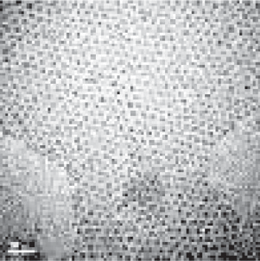

**2.0**

**1.8**

**1.6**

**1.4**

**Intensity**

**1.2**

**1.0**

**0.8**

**0.6**

**0.4**

**0.2**

**0.0**

**400 450 500 550 600 650**

**Wavelength(nm)**

Fig. 1. Revels UV UV/Vis optical absorption spectra of prepared CdSe QDs combined with high resolution transmission electron micrographs.

Table 2

**3429**

**2951**

**2872**

**1724**

**1555**

**1412**

**1165**

**1025**

FTIR spectral data of prepared polymeric matrices and their assignments [23–25].

**Absorbance**

|  |  |  |
| --- | --- | --- |
| Peak position (cm—1) | Band assignment | References |
| 3429 | (OAH) overlapped to the (NAH) stretching | 23 |
|  | vibrations |  |
| 2951 | (CH2) asymmetric stretching | 23 |
| 2872 | (CH2) symmetric stretching | 24 |
| 1724 | (C@O) carbonyl stretching | 24 |
| 1648 | (C@O) stretching | 23 |
| 1555 | (C@O) stretching protonated amine | 25 |
| 1412 | (CH3) symmetric deformation | 25 |
| 1165 | (CAOAC) symmetric stretching | 24 |
| 1025 | (CAOAC) a symmetric and (CAOAC) | 25 |
|  | symmetric vibration |  |

**4000 3500 3000 2500 2000 1500 1000 500**

**1648**

### Wavenumber cm-1

Fig. 2. FTIR absorption spectra of chitosan and PCL blend.

distinct changes in the blend spectrum indicating some type of interaction between individual blend constituents. Such interac- tion can be discussed using both experimental and theoretical approach discussed in the next sections. Fig. 3 shows FTIR spectra of prepared polymeric blend doped with different concentrations of the inorganic filler (CdSe QDs). Analysed data of synthesized samples can be shown in Table 2. An obvious change in intensity was observed with increasing CdSe dopant content. The peaks at

1025 and 1412 cm—1 appear sharp in blend and (CdSe1) then

become broad and increase in the broadness with increase concen- tration of filler up to 0.008 wt% then disappear in concentration of

0.016. The intensity of the peaks at 1555 cm—1 and 1724 cm—1

decrease with increasing filler until concentration 0.016 cm—1, peak is disappeared. FTIR spectra are used to investigate the incor- poration of PCL into chitosan biopolymer matrices by showing the absorption band positions and the vibrational modes.

* 1. *Density function theory (DFT)*

Density Functional Theory (DFT) a theoretical approach is employed to identify mechanism of interaction between the polymer matrices and measure the degree of agreement with

**Absorbance**

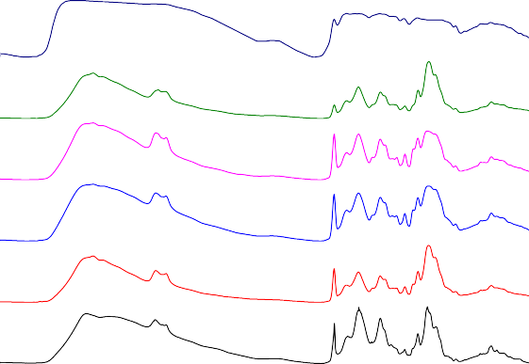

CdSe16

CdSe8 CdSe4 CdSe2

CdSe1

Blend

**4000 3500 3000 2500 2000 1500 1000 500**

### Wavenumber (cm-1)

Fig. 3. FTIR absorption spectra of chitosan and PCL blend with different concen- tration of CdSe QDs.

experimental data for complex interaction between both chitosan and Poly e-caprolactone.

All calculations were performed using Gaussian 03 programs

[26] within the DFT framework. Polymeric blend of (Ch/PCL) was optimized using the Becke’s three parameter hybrid functional, (B3LYP) correlation functional was also employed with the elec- tron core potential basis set WLANL2DZ [27,28].

Both experimental and theoretical FTIR spectrum of Ch/PCL bin- ary blend and polymer blend with dopant QDs are perceived to be in agreement with the suggested interaction and complexation between samples constituents shown in both Fig. 4a:d.

* 1. *X-ray diffraction analysis*

The X-ray diffraction analysis for both pure chitosan and pure PCL show a broad band corresponding to amorphous nature of chi- tosan and two characteristic peaks at angles 2h = 21.2° and 2h =

23.5°, corresponding to the (1 1 0) and (2 0 0) crystallographic

planes of semi crystalline nature of PCL biopolymer as shown in Fig. 5. XRD patterns of the Chitosan/PCL blend show that the two characteristic peaks of PCL were disappeared indicates the misci- bility among two biopolymers, which means that the incorporation of PCL did not significantly affect the amorphous structure of chi- tosan. From Fig. 6, we can observed that the XRD patterns of the Ch/PCL/CdSe QDs bio-composites still kept the amorphous struc- ture of Ch/PCL blend until the concentration of (0.008, 0.016) wt% of CdSe nanoparticles, two characteristic peaks of CdSe appear in concentration (0.008) wt% and make overlapping to form one peak in concentration (0.016) wt% which means that CdSe nanoparticles affect significantly on the amorphous structure of the blend.

* 1. *Scanning electron microscope (SEM)*

The SEM has been used to explore the surface morphology and structure of studied samples, Fig. 7(A, B) presents SEM the micro- graphs of pure chitosan and pure PCL which showed smooth appearance of the surface. The SEM of Ch/PCL blend as shown in Fig. 7(C), doesn’t show any new features.

Addition of CdSe, QDs, with different concentrations to the biopolymer blend, the surface of bio composites become rough and the grain size was formed and varied in their shape according to CdSe QDs concentration as shown in Fig. 6(D–H). It is clear that the grain size at high concentration (0.008, 0.016) of CdSe QDs takes a definite shape and the CdSe were dispersed well in the blend. That’s mean that the morphology of Ch/PCL/CdSe QDs bio- composites is critically affected by addition of CdSe QDs. This reveals compatibility between the SEM and X-ray response of the present Ch/PCL/CdSe system.

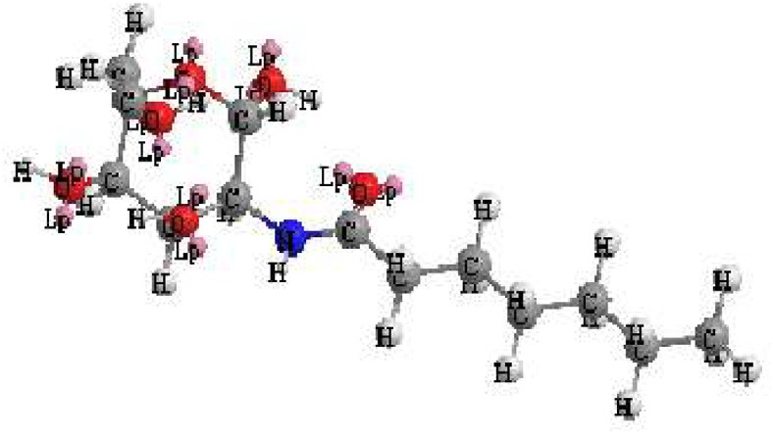**4000 3500 3000 2500 2000 1500 1000 500**

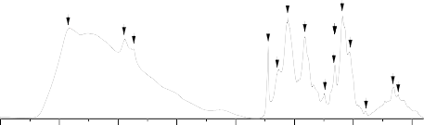

**Theoritical**

**Experimental**

**Normalized Absorbance**

**3425**

**2949**

**2866**

**2951**

**2866**

**1724**

**1729**

**1648**

**1557**

**1405**

**1253**

**1164**

**1412**

**1241 1164**

**1095**

**1024.8**

**891.4**

**892.3**

**662**

**617**

**605.4**

**Wavenumber (cm-1)**

# (a) (b)

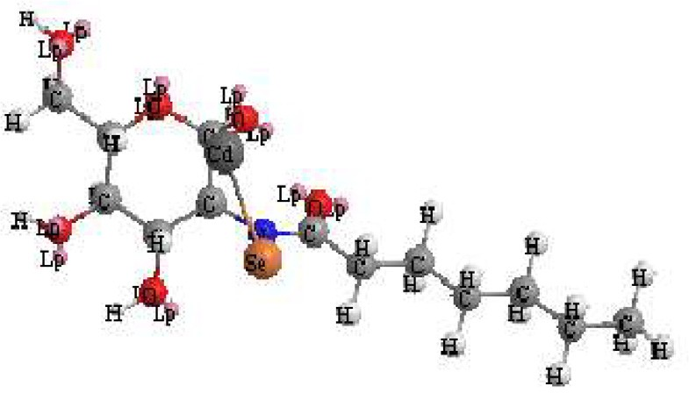**2.0**

**Theoritical**

**Experimental**

**1723**

**1672**

**1.5**

**Normalized Absorbance**

**2949**

**2868**

**1475**

**1424**

**1174**

**1024**

**921**

**1.0**

**2942**

**2866**

**1729**

**1157**

**1044**

**0.5**

**1660**

**1418**

**921**

**0.0**

**4000 3500 3000 2500 2000 1500 1000 500**

**Wavenumber (cm-1)**

# (c) (d)

Fig. 4. (a) Schematic diagram of optimized suggested interaction mechanism between Ch and PCL. (b) Theoretical and experimental FTIR data of prepared polymer blend. (c) Schematic diagram of optimized suggested interaction mechanism of polymer blend and Cdse QDs. (e) Theoretical and experimental FTIR data of prepared composite.

**110**

**200**

**10 20 30 40 50 60 70 80**

**Blend**

**PCL**

**Cs**

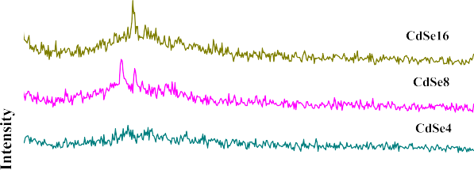

**Intensity**

**2** **(deg)**

Fig. 5. X-ray diffraction of pure chitosan, pure PCL and chitosan/PCL blend. Fig. 6. X-ray diffraction of Ch/PCL/CdSe QDs biocomposites.

* 1. *Antibacterial tests*

**1097**

During the last decade significant interest has aroused in the research on synthesis of Cadmium selenide (CdSe) QDs for biolog- ical, biomedical and pharmaceutical applications due to their known antimicrobial properties The Cadmium ion exhibits broad-spectrum biocidal activity towards many different bacteria, fungi, and viruses [29–31].

The antimicrobial activity of the synthesized of CdSe QDs doped with different concentration in polymer blend were tested. Thus the antimicrobial activity of the compounds was evaluated against two gram-positive (*Staphylococcus aureus*, *Bacillus subtilis*) and two gram-negative bacteria (*Pseudomonas aeruginosa* and *Escherichia coli*) as well as against the pathogenic fungus *Candida albicans* (*C. albicans*). The samples were seeded in petri dishes containing agar

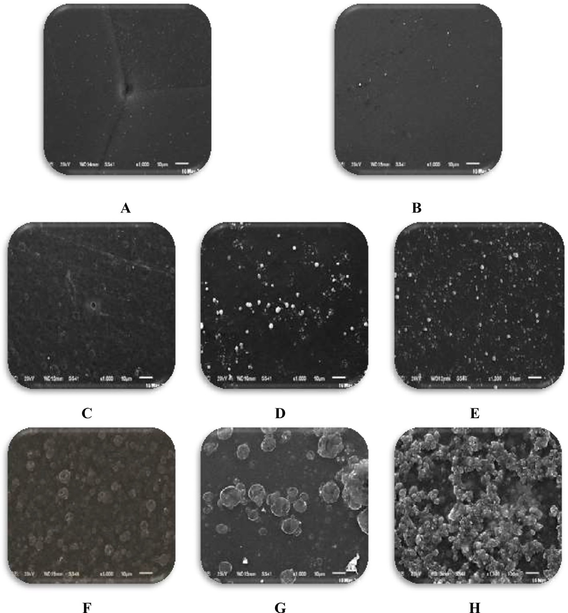

Fig. 7. A (Chitosan), B (PCL), C (Blend), D (CdSe1), E (CdSe2), F (CdSe4), G (CdSe8), H (CdSe16).

media (Agar 20 g + Beef extract 3 g + peptone 5 g) and the petri dishes were incubated at 36 °C. The inhibition zones were recorded after 24 h of incubation and summarized in Table 3. Each treat- ment was replicated three times.

Thus the antimicrobial activity percent (%) was evaluated from the relation:

*Zone of inhibition by test compound* (*diametre*)

Fig. 8 shows antibacterial test results of CdSe QDs doped in polymer blend at room temperatures (RT). It was found that the size of the inhibition zone was higher against *Bacillus subtilis* and *Staphylococcus aureus* at 0.001 wt% CdSe QDs. Antibacterial activities index were found against all test cultures (*Staphylococcus aureus*, *Bacillus subtilis*) to be 83.3 and 52.2 respectively. While the activity index for *Escherichia coli* and *Pseudomonas aeruginosa* were

%*Activity Index* =

*Zone of inhibition by standard* (*diametre*) × 100

50.0 and 82.6 respectively. Moreover, the activity index of Candida Fungi was 81.5 at concentration 0.002 wt% CdSe QDs.

Table 3

concentration of CdSe QDs against the diameter of inhibition zone and the activity index %.

|  |  |  |  |  |  |  |  |  |  |  |  |  |  |  |  |  |
| --- | --- | --- | --- | --- | --- | --- | --- | --- | --- | --- | --- | --- | --- | --- | --- | --- |
| No. | Compound | *E. coli*  (mg/ml) | *Pseudomonas aeruginosa*  (mg/ml) | | | | *S. aureus*  (mg/ml) | | *Bacillus subtilis*  (mg/ml) | | | *C. albicans*  (mg/ml) | | | | |
|  |  | D | A |  | D | A |  | D | A |  | D | A |  | D | A |  |
|  |  | (mm) | % |  | (mm) | % |  | (mm) | % |  | (mm) | % |  | (mm) | % |  |
| 1 | Chitosan | 17.0 | 65.4 |  | 21 | 91.3 |  | 22.0 | 91.7 |  | 13.0 | 56.5 |  | 18.0 | 66.7 |  |
| 2 | Blend | NA | – |  | 5 | 21.7 |  | 7.00 | 29.2 |  | 4.00 | 17.4 |  | 2.00 | 7.40 |  |
| 3 | CdSe(1) | 13.0 | 50.0 |  | 19 | 82.6 |  | 20.0 | 83.3 |  | 12.0 | 52.2 |  | 4.00 | 14.8 |  |
| 4 | CdSe(2) | 9.00 | 34.6 |  | 13 | 56.5 |  | 9.0 | 37.5 |  | 7.0 | 30.4 |  | 22.0 | 81.5 |  |
| 5 | CdSe(4) | 12.0 | 46.1 |  | 17 | 73.9 |  | 19.0 | 79.2 |  | 10.0 | 43.5 |  | 15.0 | 55.5 |  |
| 6 | CdSe(8) | NA | – |  | NA | – |  | 5.00 | 20.8 |  | NA | – |  | 5.00 | 18.5 |  |
| 7 | CdSe(16) | 7.00 | 26.9 |  | 9 | 39.1 |  | 12.0 | 50.0 |  | 8.00 | 34.8 |  | 3.00 | 11.1 |  |
| Ampicillin |  | 26.0 | 100 |  | 23.0 | 100 |  | 24.0 | 100 |  | 23.0 | – |  | NA | – |  |
| Clotrimazole | NA | | – | NA | | – | NA | | – | NA | | – | 27 | | 100 | |

D, Diameter of inhibition zone; A, Activity index and NA no observed action.

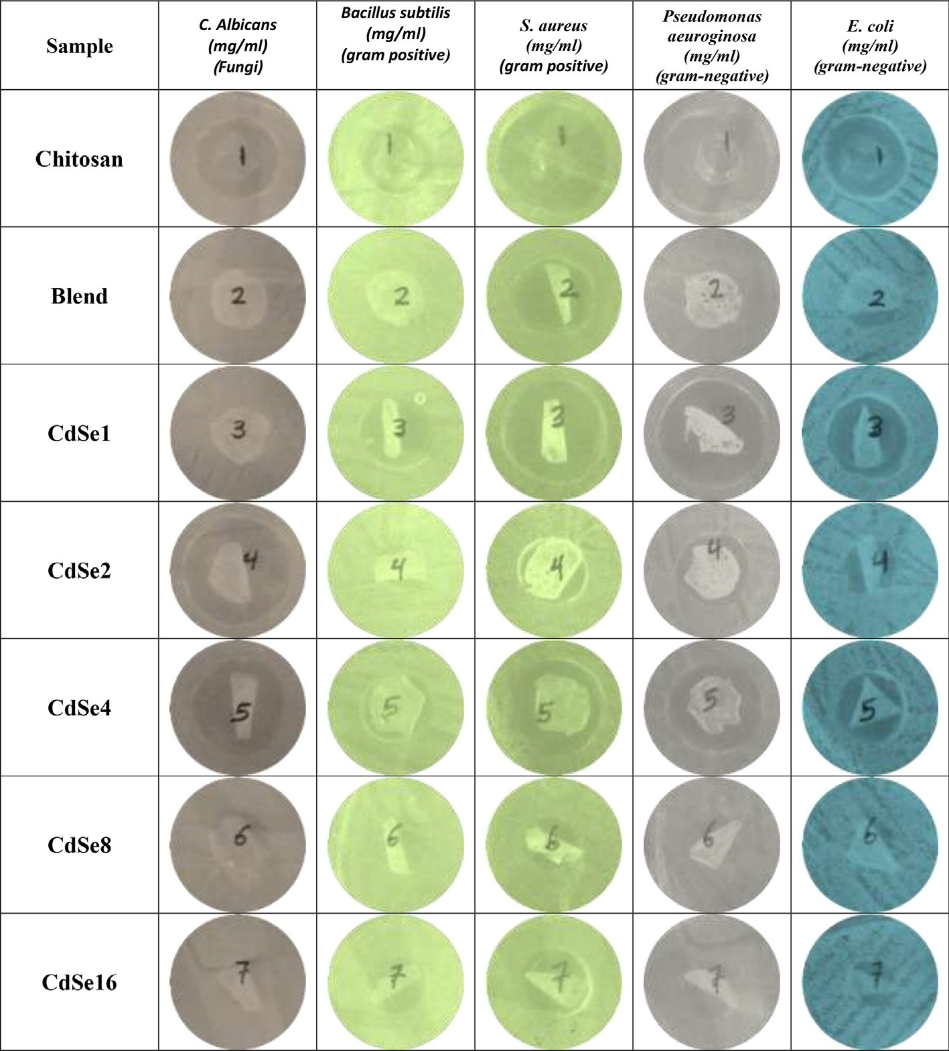

Fig. 8. The inhibition zone vs. the concentration of CdSe QDs.

No antibacterial activity was found at 0.008 wt% CdSe QDs except for *Staphylococcus aureus* and *Candida albicans* they show a moder- ate index activity and small inhibition zone. Among all, *Bacillus subtilis* exhibited maximum susceptibility, while *Pseudomonas aeruginosa* was found to be least susceptible to CdSe QDs. Increasing the synthesizing concentration of CdSe QDs resulted in significant reduction of antibacterial activity of CdSe may be due to increase in particle size of CdSe QDs. The difference of the sizes of zone of inhibition between the CdSe QDs synthesized at differ- ent concentration could be correlated to the difference in nanopar- ticles diffusion tendency in cells due to the difference in their sizes producing different amount of reactive oxygen species (ROS).

The size of inhibition zone was different according to the type of bacteria and the concentrations of CdSe QDs. Based on the results obtained from Fig. 8 and the diameter of inhibition zone for differ- ent bacteria, it can be concluded that the maximum inhibition activity happens for *Staphylococcus aureus*. Fig. 8 also, demon- strates the similar extended results for different concentrations of CdSe nanoparticles antibacterial activity and it can be seen that the same results obtained. The maximum diameter has happened for *S. aureus*. All numerical data can be tabulated as seen in Table 3.

1. Conclusion

Semi-natural biocomposite of Ch/PCL containing gradient concentrations of CdSe QDs were successfully synthesized and

characterized through X-ray diffraction and FTIR absorption spectroscopy. DFT approach was employed to investigate the reac- tion mechanisms of both polymer blend and samples that doped with the QDs filling material. Both FTIR experimental and experi- mental data shows the maintenance of characteristic vibrational band with a marginal variation in both intensity and position related to the increase in dopant concentration. XRD patterns reveal amorphous nature of prepared virgin blend and blend sam- ples that contain small amount of QDs. Samples with higher QDs concentration, namely CdSe8 and CdSe16 shows appearance of crystalline bands assigned to 111 reflection plane reported previ- ously and in agreement with JCPDS card no. 19-0191. Scanning electron microscopy (SEM) indicates that morphology of synthe- sized bio-composites is critically affected by addition of CdSe QDs. Antibacterial tests reveals different inhibition zone related to increasing concentration of CdSe QDs and sort of bacterial strain under investigation. Evaluation of The activity index % were also studied.

References

1. [Dash M, Chiellini F, Ottenbrite RM, Chiellini E. Chitosan-A versatile semi-](http://refhub.elsevier.com/S2314-808X(18)30007-1/h0005) [synthetic polymer in biomedical applications. Prog Polym Sci 2011;36](http://refhub.elsevier.com/S2314-808X(18)30007-1/h0005) [(8):981–1014](http://refhub.elsevier.com/S2314-808X(18)30007-1/h0005).
2. [Monier M, Abdel-Latif DA, Abou El-Reash YG. Ion-imprinted modified chitosan](http://refhub.elsevier.com/S2314-808X(18)30007-1/h0010) [resin for selective removal of Pd(II) ions. J Colloid Interface Sci](http://refhub.elsevier.com/S2314-808X(18)30007-1/h0010) [2016;469:344–54](http://refhub.elsevier.com/S2314-808X(18)30007-1/h0010).
3. [Liu J, Meng Cg, Liu S, Kan J, Jin Ch. Preparation and characterization of](http://refhub.elsevier.com/S2314-808X(18)30007-1/h0015) [protocatechuic acid grafted chitosan films with antioxidant activity. Food](http://refhub.elsevier.com/S2314-808X(18)30007-1/h0015) [Hydrocolloids 2017;63:457–66](http://refhub.elsevier.com/S2314-808X(18)30007-1/h0015).
4. [Lin YC, Wang HP, Gohar F, Ullah MH, Zhang X, Xie DF, et al. Preparation and](http://refhub.elsevier.com/S2314-808X(18)30007-1/h0020) [copper ions adsorption properties of thiosemicarbazide chitosan from squid](http://refhub.elsevier.com/S2314-808X(18)30007-1/h0020) [pens. Int J Biol Macromol 2017;95:476–83](http://refhub.elsevier.com/S2314-808X(18)30007-1/h0020).
5. [Pitt CG. Poly-e-caprolactone and its copolymers. In: Chasin M, Langer R,](http://refhub.elsevier.com/S2314-808X(18)30007-1/h0025) [editors. Biodegradable polymers as drug delivery systems. New York: Marcel](http://refhub.elsevier.com/S2314-808X(18)30007-1/h0025) [Dekker; 1990. p. 71–120](http://refhub.elsevier.com/S2314-808X(18)30007-1/h0025).
6. [Labet M, Thielemans W. Synthesis of polycaprolactone: a review. Chem Soc](http://refhub.elsevier.com/S2314-808X(18)30007-1/h0030) [Rev 2009;38:3484–504](http://refhub.elsevier.com/S2314-808X(18)30007-1/h0030).
7. [Li WJ, Cooper JA, Mauck RL, Tuan RS. Fabrication and characterization of six](http://refhub.elsevier.com/S2314-808X(18)30007-1/h0035) [electrospun poly(hydroxy ester)-based fibrous scaffolds for tissue engineering](http://refhub.elsevier.com/S2314-808X(18)30007-1/h0035) [applications. Acta Biomater 2006;2:377–85](http://refhub.elsevier.com/S2314-808X(18)30007-1/h0035).
8. [Yang K, Wang XL, Wang YZ. Progress in nanocomposite of biodegradable](http://refhub.elsevier.com/S2314-808X(18)30007-1/h0040) [polymer. J Ind Eng Chem 2007;13(4):485–500](http://refhub.elsevier.com/S2314-808X(18)30007-1/h0040).
9. [Hong S, Kim GH. Fabrication of electrospun polycaprolactone biocomposites](http://refhub.elsevier.com/S2314-808X(18)30007-1/h0045) [reinforced with chitosan for the proliferation of mesenchymal stem cells.](http://refhub.elsevier.com/S2314-808X(18)30007-1/h0045) [Carbohydr Polym 2011;83:940–6](http://refhub.elsevier.com/S2314-808X(18)30007-1/h0045).
10. [Ghorbani FM, Kaffashi B, Shokrollahi P. PCL/chitosan/Zn-doped nHA](http://refhub.elsevier.com/S2314-808X(18)30007-1/h0050) [electrospun nanocomposite scaffold promotes adipose derived stem cells](http://refhub.elsevier.com/S2314-808X(18)30007-1/h0050) [adhesion and proliferation. Carbohydr Polym 2015;118:133–42](http://refhub.elsevier.com/S2314-808X(18)30007-1/h0050).
11. [Sahoo S, Sasmal A, Sahoo D. Synthesis and characterization of chitosan–](http://refhub.elsevier.com/S2314-808X(18)30007-1/h0055) [polycaprolactone blended with organoclay for control release of doxycycline. J](http://refhub.elsevier.com/S2314-808X(18)30007-1/h0055) [Appl Polym Sci 2010;118:3167–75](http://refhub.elsevier.com/S2314-808X(18)30007-1/h0055).
12. [Abdolmohammadi S, Siyamak S, Ibrahim NA. Enhancement of mechanical and](http://refhub.elsevier.com/S2314-808X(18)30007-1/h0060) [thermal properties of polycaprolactone/chitosan blend by calcium carbonate](http://refhub.elsevier.com/S2314-808X(18)30007-1/h0060) [nano-particles. Int J Mol Sci 2012;13:4508–22](http://refhub.elsevier.com/S2314-808X(18)30007-1/h0060).
13. [Raftery RM. Development of a gene-activated scaffold platform for tissue](http://refhub.elsevier.com/S2314-808X(18)30007-1/h0065) [engineering applications using chitosan–pDNA nanoparticles on collagen-](http://refhub.elsevier.com/S2314-808X(18)30007-1/h0065) [based scaffolds. J Controlled Release 2015;210:84–94](http://refhub.elsevier.com/S2314-808X(18)30007-1/h0065).
14. [Sahoo S, Sasmal A, Nanda R. Synthesis of chitosan polycaprolactone blend for](http://refhub.elsevier.com/S2314-808X(18)30007-1/h0070) [control delivery of ofloxacin drug. Carbohydr Polym 2010;79:106–13](http://refhub.elsevier.com/S2314-808X(18)30007-1/h0070).
15. [Bolaina-Lorenzo E, Martínez-Ramos C, Monleón-Pradas M, Herrera-Kao W,](http://refhub.elsevier.com/S2314-808X(18)30007-1/h0075) [Cauich-Rodríguez JV, Cervantes-Uc JM. Electrospun polycaprolactone/chitosan](http://refhub.elsevier.com/S2314-808X(18)30007-1/h0075) [scaffolds for nerve tissue engineering: physicochemical characterization and](http://refhub.elsevier.com/S2314-808X(18)30007-1/h0075) [Schwann cell biocompatibility. Biomed Mater 2016;12(1):01500](http://refhub.elsevier.com/S2314-808X(18)30007-1/h0075).
16. [Baileyc RE, Nie S. Alloyed semiconductor quantum dots, tuning the optical](http://refhub.elsevier.com/S2314-808X(18)30007-1/h0080) [properties without changing the particle. J Am Chem Soc 2003;125:7100–6](http://refhub.elsevier.com/S2314-808X(18)30007-1/h0080).
17. [Sabaeian M, Nasab AK. Size-dependent intersubband optical properties of](http://refhub.elsevier.com/S2314-808X(18)30007-1/h0085) [dome-shaped InAs/GaAs quantum dots with wetting layer. Appl Opt 2012;51](http://refhub.elsevier.com/S2314-808X(18)30007-1/h0085) [(18):4176–85](http://refhub.elsevier.com/S2314-808X(18)30007-1/h0085).
18. [Nasab AK, Sabaeian M, Sahrai M, Fallahi Kerr V. Nonlinearity due to](http://refhub.elsevier.com/S2314-808X(18)30007-1/h0090) [intersubband transitions in a three-level InAs/GaAs quantum dot, the impact](http://refhub.elsevier.com/S2314-808X(18)30007-1/h0090) [of a wetting layer on dispersion curves. J Opt 2014;16(5):055004](http://refhub.elsevier.com/S2314-808X(18)30007-1/h0090).
19. [Ramírez H, Flórez YJ, Camacho AS. Efficient control of coulomb enhanced](http://refhub.elsevier.com/S2314-808X(18)30007-1/h0095) [second harmonic generation from excitonic transitions in quantum dot](http://refhub.elsevier.com/S2314-808X(18)30007-1/h0095) [ensembles. J Phys Chem Chem Phys 2015;17(37)](http://refhub.elsevier.com/S2314-808X(18)30007-1/h0095).
20. [Bruchez M, Moronne M, Gin P, Weiss S, Alivisatos AP. Semiconductor](http://refhub.elsevier.com/S2314-808X(18)30007-1/h0100) [nanocrystals as fluorescent biological labels. Science 1998;281(5385):2013–6](http://refhub.elsevier.com/S2314-808X(18)30007-1/h0100).
21. [Tananaev PN, Dorofeev SG, Vasil’ev RB, Kuznetsova TA. Preparation of copper-](http://refhub.elsevier.com/S2314-808X(18)30007-1/h0105) [doped CdSe nanocrystals. Inorg Mater 2009;45:347–51](http://refhub.elsevier.com/S2314-808X(18)30007-1/h0105).
22. [Hu MZ, Zhu T. Semiconductor nanocrystal quantum dot synthesis approaches](http://refhub.elsevier.com/S2314-808X(18)30007-1/h0110) [towards large-scale industrial production for energy applications. Nanoscale](http://refhub.elsevier.com/S2314-808X(18)30007-1/h0110) [Res Lett 2015;10(1):469–83](http://refhub.elsevier.com/S2314-808X(18)30007-1/h0110).
23. [Gautam S, Chou C, Dinda AK, Potdar PD, Mishra NC. Fabrication and](http://refhub.elsevier.com/S2314-808X(18)30007-1/h0115) [characterization of PCL/gelatin/chitosan ternary nanofibrous composite](http://refhub.elsevier.com/S2314-808X(18)30007-1/h0115) [scaffold for tissue engineering applications. J Mater Sci 2014;49:1076–89](http://refhub.elsevier.com/S2314-808X(18)30007-1/h0115).
24. [Elzubair A, Elias CN, Suarez JCM, Lopes HP, Vieira MVB. The physical](http://refhub.elsevier.com/S2314-808X(18)30007-1/h0120) [characterization of a thermoplastic polymer for endodontic obturation. J](http://refhub.elsevier.com/S2314-808X(18)30007-1/h0120) [Dent 2006;34:784–9](http://refhub.elsevier.com/S2314-808X(18)30007-1/h0120).
25. [Silva SML, Braga CRC, Fook MVL, Raposo CMO, Carvalho LH, Canedo EL.](http://refhub.elsevier.com/S2314-808X(18)30007-1/h0125) [Application of infrared spectroscopy to analysis of chitosan/clay](http://refhub.elsevier.com/S2314-808X(18)30007-1/h0125) [nanocomposites. Mater Sci Eng Technol 2012. ISBN 978-953-51-0537-4](http://refhub.elsevier.com/S2314-808X(18)30007-1/h0125).
26. [Frisch MJ, Trucks GW, Schlegel HB, Scuseria GE, Robb MA, et al. Gaussian 03,](http://refhub.elsevier.com/S2314-808X(18)30007-1/h0130) [Revision A.1. Pittsburgh PA: Gaussian Inc; 2003](http://refhub.elsevier.com/S2314-808X(18)30007-1/h0130).
27. [Hay PJ, Wadt WR. Ab initio effective core potentials for molecular calculations.](http://refhub.elsevier.com/S2314-808X(18)30007-1/h0135) [Potentials for the transition metal atoms Sc to Hg. J Chem Phys 1985;82:270](http://refhub.elsevier.com/S2314-808X(18)30007-1/h0135).
28. [Becke D. Density-functional thermochemistry. III. The role of exact exchange. J](http://refhub.elsevier.com/S2314-808X(18)30007-1/h0140) [Chem Phys 1993;98:5648](http://refhub.elsevier.com/S2314-808X(18)30007-1/h0140).
29. [Kloepfer JA, Mielke RE, Nadeau JL. Appl Environ Microb 2005;71:2548](http://refhub.elsevier.com/S2314-808X(18)30007-1/h0145).
30. [Wang L, Zheng H, Long Y, Gao M, Hao J, Du J, et al. Hazard J Mater](http://refhub.elsevier.com/S2314-808X(18)30007-1/h0150) [2010;177:1134](http://refhub.elsevier.com/S2314-808X(18)30007-1/h0150).
31. [Kim YG, Moon S, Kuritzkes DR, Demirci U. Biosens Bioelectron 2009;25:253](http://refhub.elsevier.com/S2314-808X(18)30007-1/h0155).