[Egyptian Journal of Basic and Applied Sciences 5 (2018) 210–219](https://doi.org/10.1016/j.ejbas.2018.05.008)

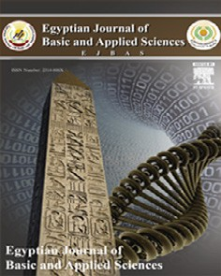

Contents lists available at [ScienceDirect](http://www.sciencedirect.com/science/journal/2314808X)

Egyptian Journal of Basic and Applied Sciences

journal homepage: [www.elsevier.com/locate/ejbas](http://www.elsevier.com/locate/ejbas)

Full Length Article

[](http://crossmark.crossref.org/dialog/?doi=10.1016/j.ejbas.2018.05.008&domain=pdf)Screening and identification of novel inhibitors against human 4-aminobutyrate-aminotransferase: A computational approach

S. Vijayakumar a,⇑, G. Kasthuri a, S. Prabhu b, P. Manogar a, N. Parameswari c

a *Computational Phytochemistry Lab, P.G. and Research Department of Botany and Microbiology, A.V.V.M. Sri Pushpam College (Autonomous), Poondi 613 503,*

*Thanjavur District, Tamil Nadu 613 503, India*

b *Department of Botany, Annai Vailankanni Arts and Science College (Bishop Sundaram Campus), Thanjavur-613 007, Tamil Nadu, India*

c *Department of Zoology, Arulmigu Palani Andavar College of Arts and Culture, Palani, Tamil Nadu, India*

a r t i c l e i n f o

*Article history:*

Received 28 January 2018

Received in revised form 6 May 2018 Accepted 27 May 2018

Available online 6 June 2018

*Keywords:*

4-Aminobutyrate aminotransferase (GABA) receptor

Homology modeling Molecular docking ADME

Phytocompounds

a b s t r a c t

4-Aminobutyrate aminotransferase (GABA) receptors are the key mediators of quick inhibitory synaptic transmission in the midpoint of the nervous system in mammalian. Dysfunction of GABA receptors con- tributes the genetic disorders and chronic neurological disorders include childhood absence epilepsy, juvenile myoclonic epilepsy, adolescent myoclonic epilepsy, and seizures. They get affected by mutations of GABA subunit genes from the brain. The neurological diseases of Huntington, Alzheimer, Epilepsy and Parkinsonism are affecting due to the mutation of GABA levels. Thus, this study has chosen 32 molecules from thirty-one medicinal plants, after which we executed significant computational approaches such as homology modeling, molecular docking and absorption, distribution, metabolism, and excretion (ADME). In the computational approaches, the analogue O-[(2E)-3-(4-hydroxyphenyl)-2-propenoyl]pentofurano syl-(1-3) pentopyranosyl-(1-4)pentose showed the superior docking scores of —9.336 with well binding affinities. Moreover, the natural molecules rosmarinic acid, curcumin and mangiferin were close to that of superior one. Based on this scrutinizes, we concluded that the top ranking molecules can be considered as a suitable drug candidate for GABA causing problems.

© 2018 Mansoura University. Production and hosting by Elsevier B.V. This is an open access article under

the CC BY-NC-ND license (<http://creativecommons.org/licenses/by-nc-nd/4.0/>).

Introduction

4-aminobutyrate aminotransferase (GABA) receptors are the key mediators of fast inhibitory synaptic transmission in the cen- tral nervous system of mammals [1]. Its dreadful conditions become involved in catalysis by aminobutyrate transaminase (ABAT, GABA transaminase) for the period of the early stage [2]. It is divided into the three kinds of receptors namely GABAA, GABAB, and GABAC [3–7]. These are all mainly affected by the mutations of GABA subunit genes from the nervous system.

Generally, the GABA has the capability to maintain lower blood pressure in rats and human beings as well [8–12]. Moreover, the deficiencies of GABA levels are causing various neuronal problems in central nervous system of mammalians. Especially, the epilepsy

is a most commonly causing neurological disease to the people which also originates due to the deficiencies of c-aminobutyric acid.

Epilepsy is one of the neurological disorders, which mainly affects the region of CNS (central nervous system). Inhibition of

* Corresponding author.

*E-mail address:* [svijaya_kumar2579@rediff.com](mailto:svijaya_kumar2579@rediff.com) (S. Vijayakumar).

GABA-mediated inhibitory neurotransmission or increase in excitation due to glutamatergic or cholinergic transmission has been reported to play a central role in development of epilepsy [13]. Nearly, 50 million people are affected by epilepsy worldwide which affects different age groups and sex [14]. Eighty percent of the burden of epilepsy is in the developing country, where 80–90% of people with epilepsy receive no treatment at all [15]. Currently, lots of drugs have available for seizure and its related problems which includes valproate, lamotrigine and topiramate. These drug molecules are identified to cause several side effects in shorter usage and they contain low bio accessibility [16]. For that reason, this study was seeking alternate drug molecule with good accessibility to the human for epilepsy.

The results of GABA on human health were the challenge of a huge quantity of interest in food mechanized. In the market, lots of GABA containing food items are available, which includes germinated brown rice, chocolate, wine, and other food products [17]. Natural plants and their products have been used against lots of disease and disorders around the world nearly hundreds of years. Recently, many ethnobotanical studies have been reported the potentiality of medicinal plants and their active molecules for diseases includes central nervous system,

<https://doi.org/10.1016/j.ejbas.2018.05.008>

2314-808X/© 2018 Mansoura University. Production and hosting by Elsevier B.V.

This is an open access article under the CC BY-NC-ND license (<http://creativecommons.org/licenses/by-nc-nd/4.0/>).

pathogenic diseases, etc [18]. The medicinal plant-derived secondary metabolites such as alkaloids, flavonoids, tannins, saponins, and other phytochemicals possess potential bio-actions when they are utilized [19].

Worldwide, 33% of the huge human population having devel- oped countries and above 80% of the human population and indus- trially developing countries has been used the herbal based products for maintaining human health and treat certain climate change, food and water related diseases like cold, fever, heart dis- eases, diabetes, etc [20–22].

Nowadays, most of the people are depend and believe the medicinal plants and their products, because those are contain good therapeutic abilities with well bio-availability. Therefore, we carried out the computational studies such as homology mod- eling, molecular docking, drug designing and ADME analysis, which we carried out for find a suitable drug molecule. Through this analysis, we found certain effective drug analogues from medicinal plants for epilepsy.

Materials and methods

*Software and hardware*

The computational analysis was carried in Maestro v10.2 of Schrodinger suite. The docking tools were complexly programmed in single software as Maestro v10.2 which includes prime applica- tion for homology modeling, Ligprep for ligand preparation, Site- map for validate the binding sites, grid generation for fix the target site and Glide Xtra Precision for docking purpose. Centos Linux was used as the operating system for computational examinations.

*Target*

Human 4-aminobutyrate aminotransferase (GABA) sequence (Accession No. P80404) was retrieved from the established data- base [23].

*Ligand molecules*

Totally thirty-two phytoconstituents were selected for docking with a target. The natural molecules were selected with the help of previous literature reports (Table 1) (Supplementary data). Those molecules were obtained from the established chemical database [24].

*Homology modeling and protein preparation*

Homology modeling was performed for predicting the tar- get by using prime application in Maestro v10.2 [25,26]. Dur- ing this structure prediction, we face some important steps such as find homolog’s, BLAST homology search and show sequence similarity and identity with already known template sequences. Finally, the target model was build which can be further used for docking purposes. The predicted target was then used in protein preparation by wizard tool of Schrodinger suite. During the process, the missing side chains and back bones were added, and update the missing residues also. The wizard tool has contain two important mechanisms namely, preparation and refinement. The X-ray crystallography structure of the target is closely associated with the water molecules. The water molecules occupied target is not eligible to take the further study, hence, it was eliminate. Finally, the optimization and minimization steps were performed on this process [25].

*Active site validation and grid generation*

The site validation was analyzed on the target inner and surface regions by using sitemap tool [27]. Site map analysis, showed pos- sible active binding sites and one binding site was selected to pro- ceed further. It was chosen based on their site values (site scores and size of site area). Then, the selected site was used for the grid generation. Grid box shape and values were generated in X: 5.3; Y:

3.71; Z:-20.86 coordination. Target site was explained with 10 A°C

radius around the ligand binding site [28].

*Ligand preparation*

The structures of the thirty-two ligand molecules were con- verted to 3D structure from 2D using ligprep tool [29]. The ligands were drawn geometry optimized via Optimized Potentials for Liq- uid Simulations 2005 (OPLS2005) force field [30]. All the ligand molecules were generated 3D structures from 1D (Smiles) and 2D (SDF) representation, probing for tautomers and steric isomers and geometry minimization of ligands [31].

*Molecular docking*

The molecular docking study was used to execute in Glide Xtra precision (XP) docking mode. It was used to predict the binding affinities between the target to ligand, ligand efficiency, and ligand inhibitory constant to the target. The complex of thirty-two ligands is docked with the active site of the target by using Glide Xtra pre- cision (XP) which docks ligands flexibly [32–34]. The energetic small molecules will have accessible poses that avoid these penal- ties and also get good docking scores. It reveals to have accurate hydrophobic contacts between targets to ligand.

*ADMET analysis*

This analysis was carried out by Quikprop tool of Masetro v10.2 [35]. All the ligand molecules were analyzed with the parameters of hydrogen bond donor, hydrogen bond acceptor, blood brain barrier and central nervous system followed by Katsila et al., [36].

Results and discussion

*Homology modeling*

The crystal structure of human 4-aminobutyrate aminotrans- ferase is not available from protein data bank. Therefore, this study predicted the target model with the template of porcine 4- aminobutyrate aminotransferase by homology modeling. During the structure prediction, the analysis represents the sequence sim- ilarity and identity between target and template. This structure has been predicted from the sequence of human 4-aminobutyrate aminotransferase. It shows the sequence identity and similarity with the template of pig 4-aminobutyrate aminotransferase. This study target was found together in the sequence of PDB ID: 1OHV (Fig. 1).

*Structure validation*

The structural validation was analyzed by Ramachandran plot, which shows the residues occurring regions. It also represents the accuracy and reliability of residues between template and target. In this validation, 87.3% of residues mostly occurred in the favor region, 11.7% of residues in additional region, 0.7% of residues in generously allowed region and the remaining 0.3% of the

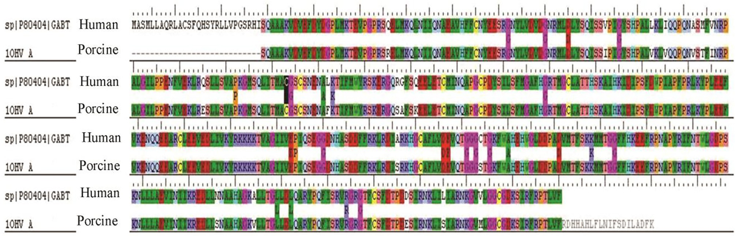

Fig. 1. Sequence alignment on human 4-aminobutyrate-aminotransferase with porcine 4-aminobutyrate-aminotransferase.

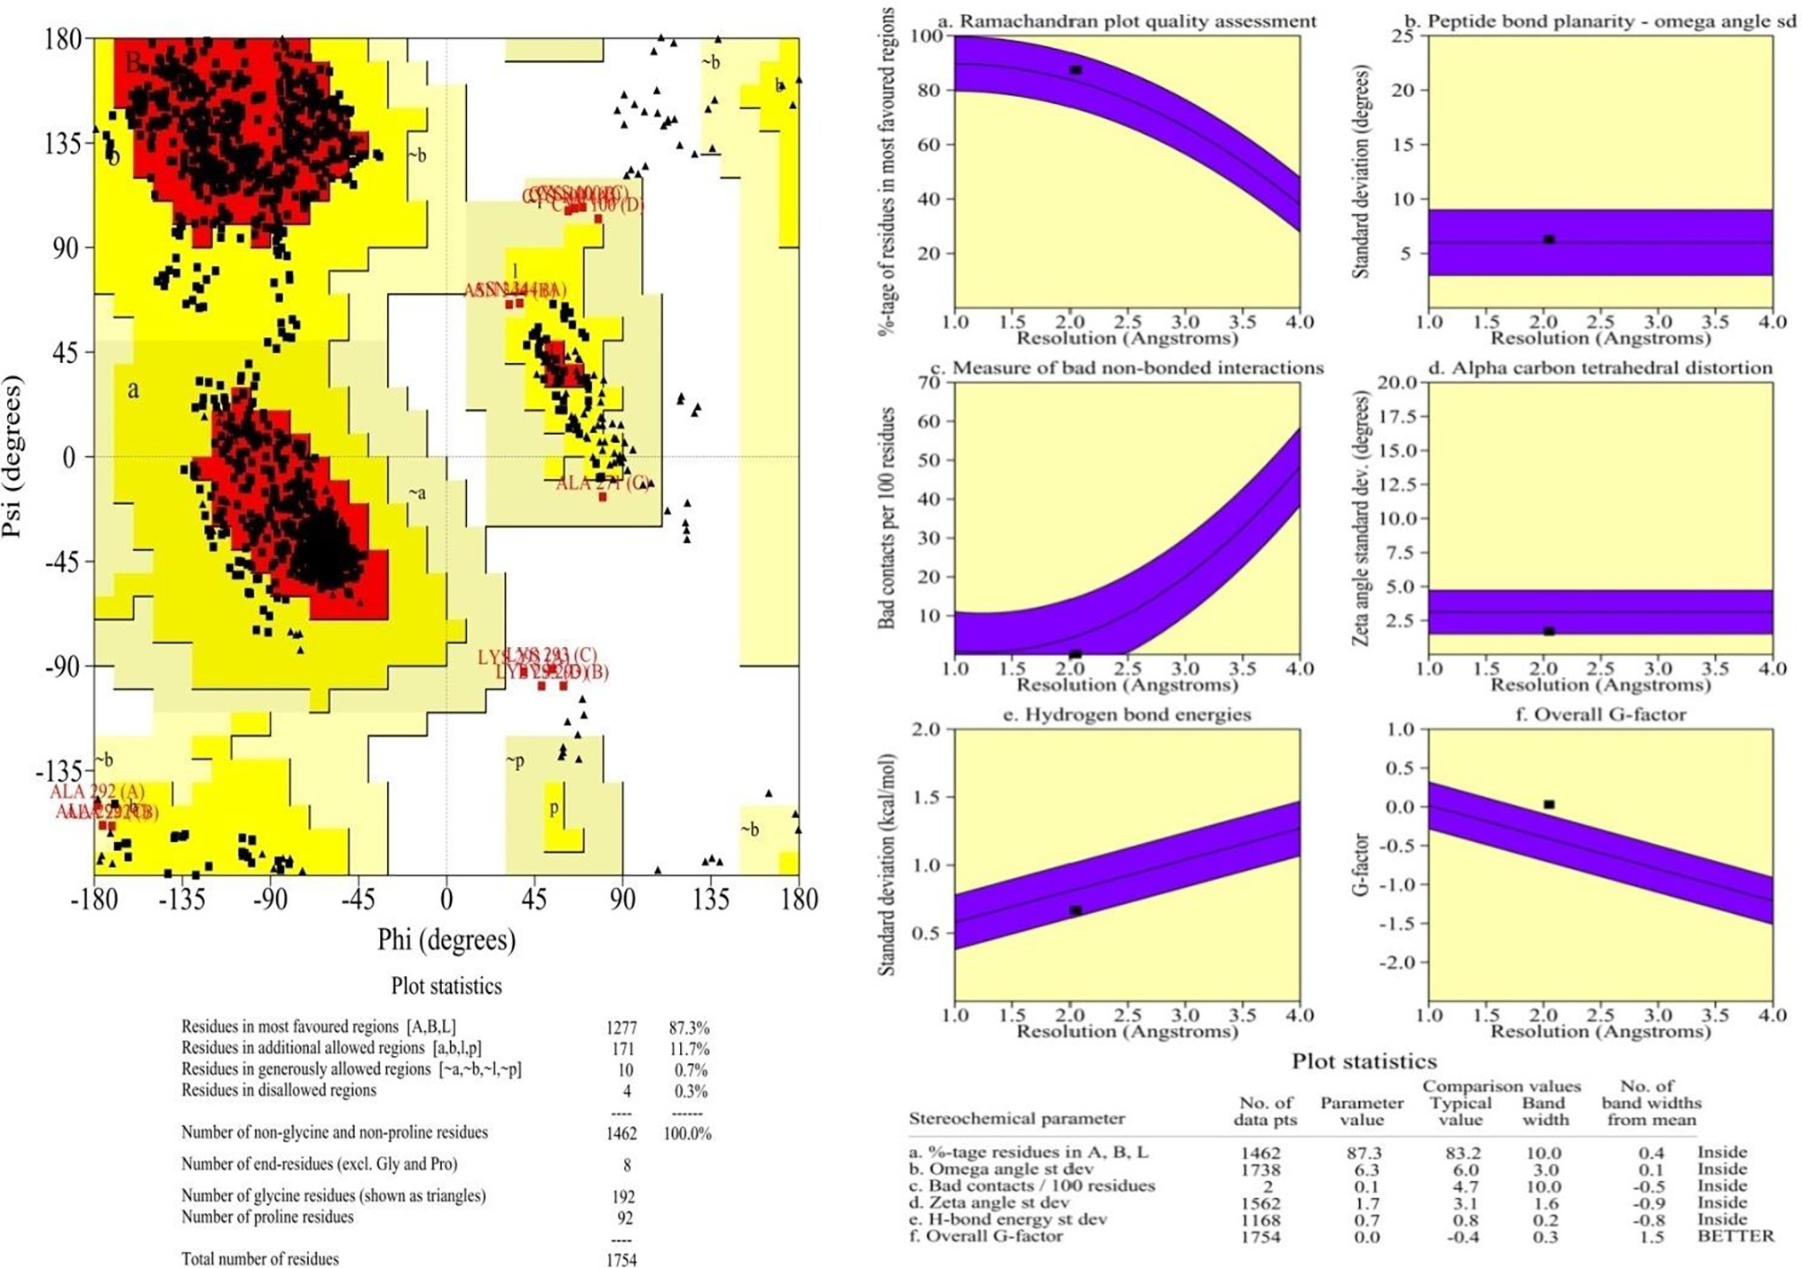

Fig. 2. Structural validation of modelled GABA of *Homo sapiens*. (a) Ram Phage shows the accuracy and reliability of sequence with the template of porcine 4-aminobutyrate- aminotransferase. The plot shows the 87.3% of residues mostly occurs in favoured region; (b) Main chain parameters validate by using Procheck.

residues were present in disallowed regions (Fig. 2a). Whereas, the main chain parameters in terms of conformation of the predicted model were checked for deviations from the template using Procheck tool. Previously, Iftikhar et al., [37] predicted the struc- ture of human 4-aminobutyrate transaminase with the template of 4-aminobutyrate-aminotransferase of pig. Through, the homol- ogy modelling, they have analyzed the sequence similarity and identity in same target and template. Also, they have reported that the Ramachandran plot for structure validation.

*Drugable site analysis*

In this study, the site analysis has produced five active drugable binding sites from the target. The site map shown their binding cavity residues were Gln267, Hip162, Glh231, Asp264, Val138, Tyr161, Arg164, Gly163, Gly134, Lys293, Ser133, Val75, Gly298, Pro300, Ala296, Asn132, Leu299, Ser302, Ile295, Gly235, Leu301

and Gln267 (Fig. 3). Similarly, Iftikhar et al., [37] have analyzed the ligand binding sites in 4-aminobutyrate aminotransferase for

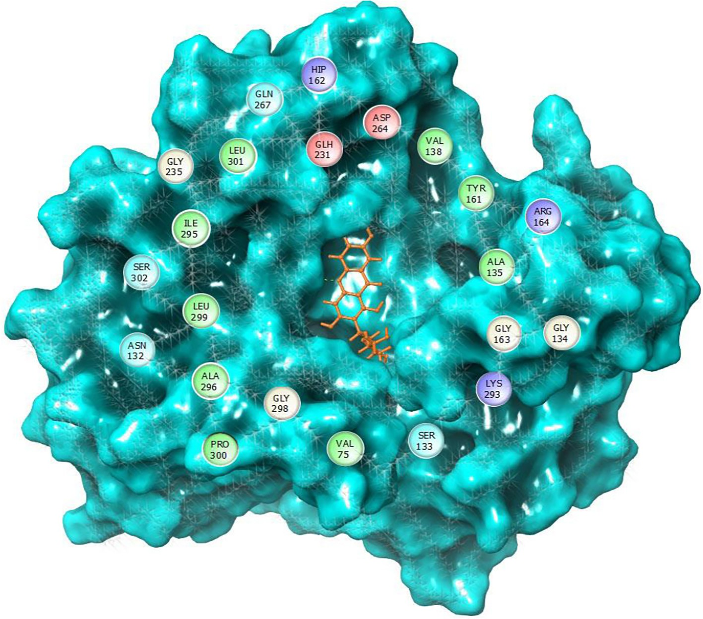

Fig. 3. Molecular structure represents the ligand binding cavity of GABA with active residues.

docking with known analogues. Recently, many computational studies have been carried out this binding site analysis method in many kinds of target molecules [38,39]. Moreover, Vijayakumar et al., [40] has described that the potentiality of the binding site analysis in Maestro v 10.2, Schrodinger suite. As a result of this analysis, the qualified binding site was taken for grid generation, which is help to fix the possible binding site in target [41].

*Molecular docking*

The molecular docking was performed in human 4- aminobutyrate aminotransferase molecule with experimentally reported and known bioactive molecules. Among them, 5-O-[(2E)-3-(4-Hydroxyphenyl)-2-propenoyl] pentofuranosyl-(1-3) pentopyranosyl-(1-4) pentose is placed superior docking scores of —9.336, when compared to other ligand molecules (Table 2). It also shows better binding affinities with a protein molecule. Fol- lowed by rosmarinic acid, curcumin and mangiferin shows the nearest docking scores when compared to the superior docking score placed bioactive molecule. Through molecular docking, we found that of the ligands four bioactive molecules have received the favorable docking score with the target of human 4- aminobutyrate aminotransferase. These ligands demonstrate favorable docking scores with target receptor, which are originated with the docking score of —8.224. Through the scatter plot, entire ligand molecules docking scores with their glide were represented in Fig. 4. In recent scenario, lots of computational researches have been done for finding out the effective drug molecules against cer- tain globally challenged micro-organisms and its diseases as well. The computational analysis provides us some important facts such as docking score, binding energy, binding affinities and also indi- cated the ligand potentiality. In general, binding affinities were shown particularly the ligand contribution and that flexibility with

the protein active site. Taken together, we found such kinds of docking parameters and binding affinities contact with ligands to target, which are mainly involved in the hydrogen bond side chain, back chain and Pi-Pi stacking contacts.

*5-O-[(2E)-3-(4-Hydroxyphenyl)-2-propenoyl] pentofuranosyl-(1-3) pentopyranosyl-(1-4)pentose*

This ligand molecule had the potent docking scores of —9.336. Table 2 shows the ligand docking score and their energy values. It has shown good countable binding affinities with the residues of human 4-aminobutyrate aminotransferase. At this point, so much of binding contacts were involved in the target residues. Some of the interactions depend on both specific interactions with the ligand binding site and non-specific forces to the outside of the target binding cavity. Different binding affinities contacts were involved between ligand to target. Precisely, hydrogen bond side chain, back chain and Pi-Pi stacking contacts were involved between both molecules. The complex of ligand and protein was investigated for analyzing their contacts formation. An examina- tion of the docked complex represents six bond formations between target to ligand. There, some active residues contacts with the ligand atoms were Gly134, Arg164, Tyr161, Leu299, Gln267 and Gly298 (Fig. 5a). Among the six residues, four residues con- tacts belong to hydrogen bond back chain such as Gly134 (OH), Arg164 (O), Leu299 (OH) and Gly298 (OH) (Fig. 5b). This molecule

interacts by forming a p-p stacking contacts. Gln267 (OH) by form-

ing a side chain contacts with the functional group of ligand. Here, the dotted blue straight line is indicated hydrogen bond side chain. The solid blue straight line is indicated hydrogen bond back chain. And, the dumbbell shaped green line is indicated the Pi-Pi stacking contact. Likewise, our previous computational study reported that the analogue has shown better docking scores with good binding contacts in Acetylcholinesterase (AChE) enzymes. AChE, which is

Table 2

Docking scores and glide energy values of ligand molecules received with the human 4-aminobutyrate-aminotransferase.

|  |  |  |  |  |  |
| --- | --- | --- | --- | --- | --- |
| S. No. | Phytoconstituents | Docking Scores | Glide energy | Lipophilic EvdW | Molecular formula |
| 1. | 5-O-[(2E)-3-(4-Hydroxyphenyl)-2-propenoyl] pentofuranosyl-(1-3) pentopyranosyl-(1-4)pentose | —9.336 | —58.733 | —3.671 | C24 H32O15 |
| 2. | (R)-(+)-rosmarinic acid | —8.687 | —59.972 | —4.001 | C18 H16 O8 |
| 3. | Curcumin | —8.427 | —47.631 | —4.35 | C21 H20 O6 |
| 4. | Mangiferin | —8.224 | —47.462 | —2.639 | C19 H18O11 |
| 5. | Ellagic acid | —6.35 | —35.284 | —2.266 | C14 H6 O8 |
| 6. | Azadirachtin | —6.211 | —50.992 | —3.764 | C35 H44O16 |
| 7. | (—)-Andrographolide | —5.756 | —29.584 | —2.56 | C20 H30 O5 |
| 8. | D-(+)-Catechin | —5.496 | —39.259 | —2.496 | C15 H14 O6 |
| 9. | Epicatechin | —5.438 | —41.206 | —3.01 | C15 H14 O6 |
| 10. | Bilobalide | —4.952 | —30.76 | —1.849 | C15 H18 O8 |
| 11. | Dimethylallyl diphosphate | —4.328 | —39.687 | —2.854 | C20 H36 O7 P2 |
| 12. | Rac 8-Prenylnaringenin | —4.276 | —39.628 | —3.718 | C20 H20 O5 |
| 13. | Syringic acid | —4.04 | —28.168 | —1.458 | C9 H10 O5 |
| 14. | Eugenol | —3.894 | —25.424 | —2.421 | C10 H12 O2 |
| 15. | Imperatorin | —3.868 | —35.178 | —2.866 | C16 H14 O4 |
| 16. | Carvacrol | —3.867 | —23.084 | —2.454 | C10 H14 O |
| 17. | Apigenin | —3.818 | —36.071 | —2.176 | C15 H10 O5 |
| 18. | Ginkgolide-B | —3.732 | —29.047 | —1.26 | C20 H24 O10 |
| 19. | Menthone | —3.438 | —16.169 | —1.989 | C10 H18 O |
| 20. | g-Tokoferol | —3.346 | —36.401 | —3.193 | C28 H48 O2 |
| 21. | (+)-L-Alliin | —3.307 | —24.253 | —1.13 | C6 H11 NO3 S |
| 22. | Trifluoromethanesulfonate | —3.106 | —19.239 | —1.083 | C2 H3 F3 O3 S |
| 23. | Oleanolic acid | —3.06 | —33.412 | —1.466 | C30 H48 O3 |
| 24. | L-(—)-Menthol | —2.909 | —13.814 | —1.583 | C10 H20 O |
| 25. | Caryophyllene oxide | —2.879 | —16.735 | —1.728 | C15 H24 O |
| 26. | (—)-Linalool | —2.753 | —20.642 | —2.443 | C10 H18 O |
| 27. | 2-cyclohexenol | —2.53 | —17.244 | —1.413 | C6 H10 O |
| 28. | Ursolic acid | —2.272 | —28.858 | —1.73 | C30 H48 O3 |
| 29. | (6E)-1,6-Octadien-3-ol | —1.954 | —21.703 | —1.709 | C8 H14 O |
| 30. | Berberine | —1.648 | —28.011 | —2.164 | C20 H18 N O4 |
| 31. | Allicin | —1.514 | —31.163 | —1.933 | C6 H10 O S2 |
| 32. | (E)-ajoene | —1.391 | —35.145 | —2.378 | C9 H14 O S3 |

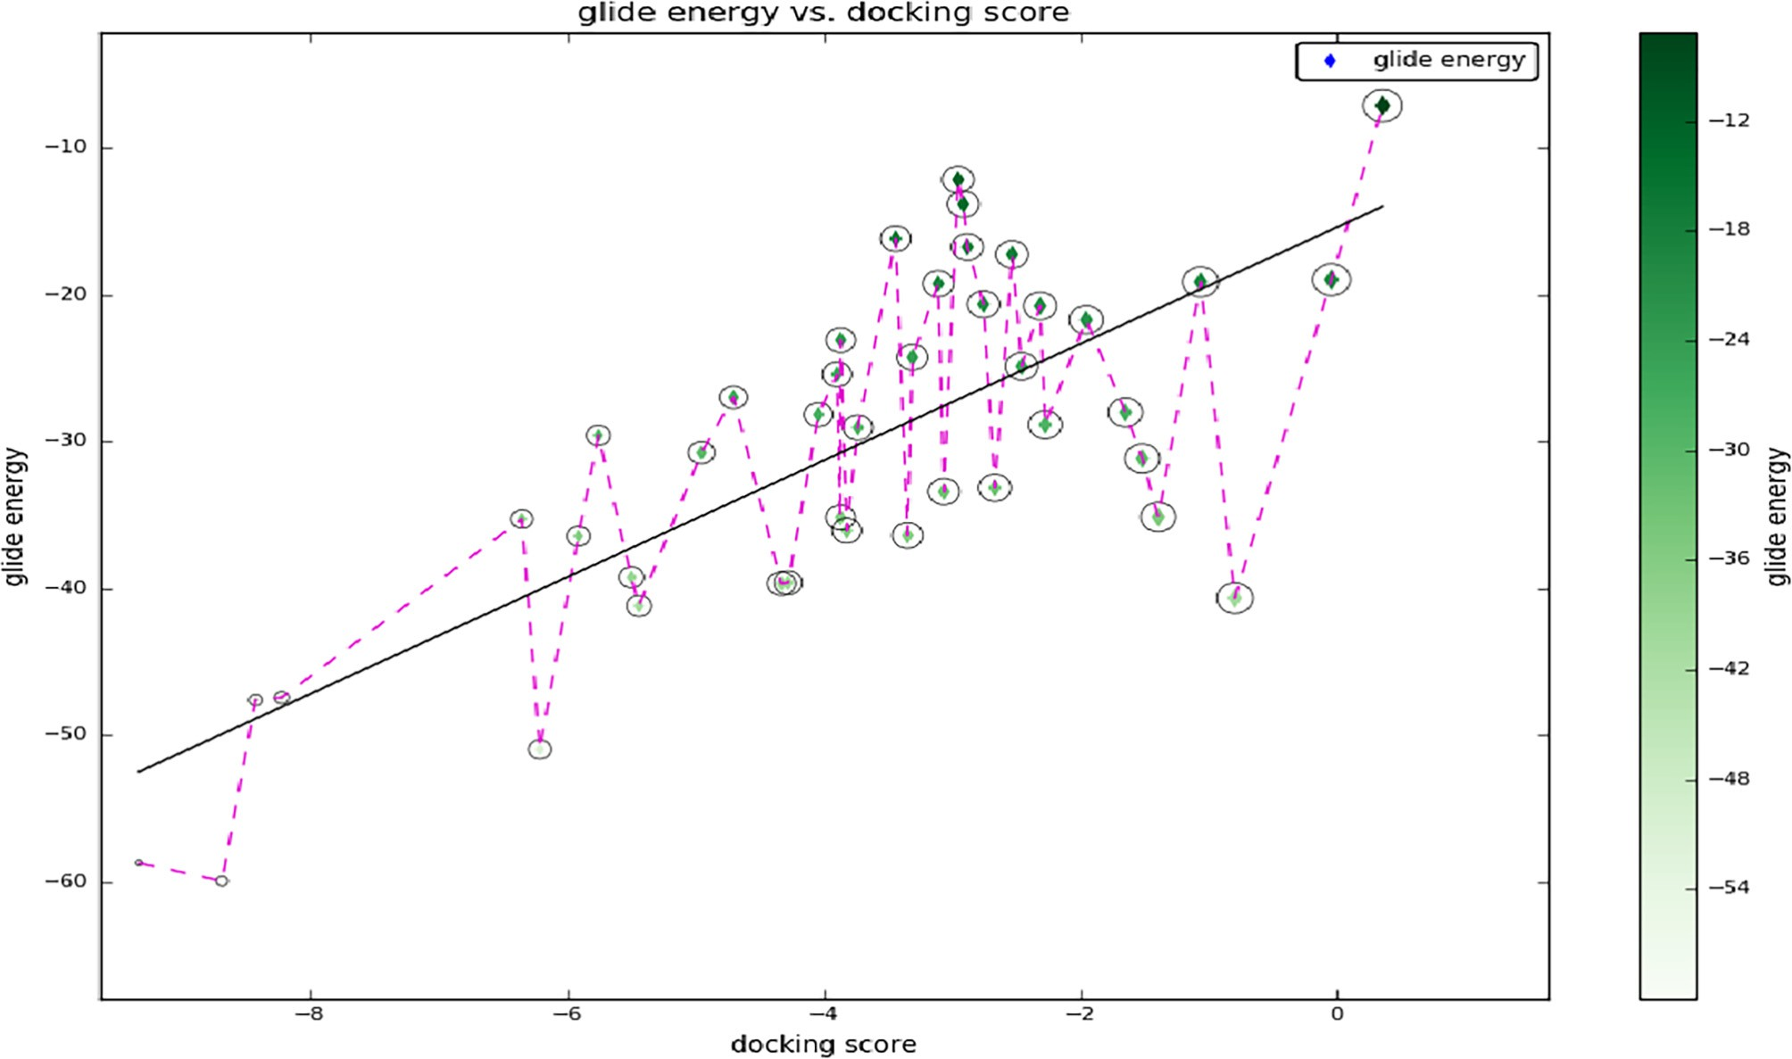

Fig. 4. Scatter plot shows the ligands docking scores and their energy values.

an organic substance and it, is contributing in the transfer of neu- ronal signals in the brain. AChE is a recognized enzyme that acting an essential function in the central nervous system (CNS). Already,

we reported that molecule 5-O-[(2E)-3-(4-Hydroxyphenyl)-2-pro penoyl] pentofuranosyl-(1-3) pentopyranosyl-(1-4) pentose has showed good docking scores with well contacts to AChE enzyme.

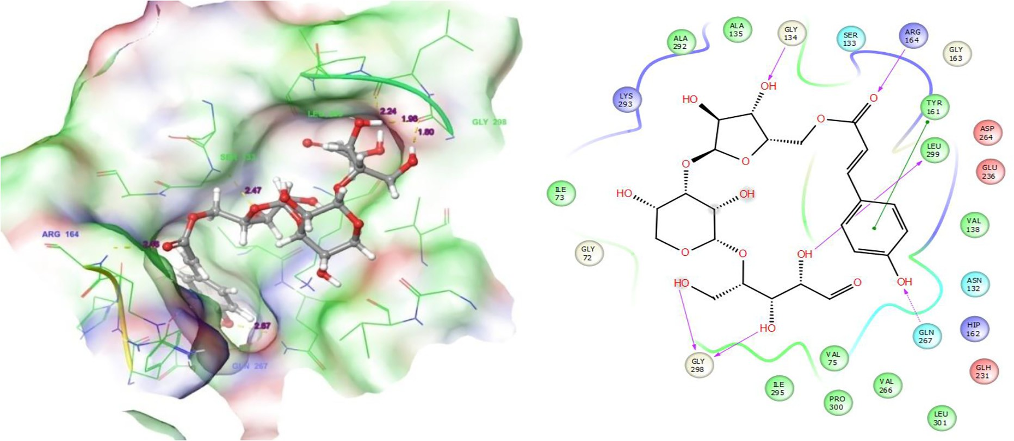

Fig. 5. Molecular interactions of Target with 5-O-[(2E)-3-(4-Hydroxyphenyl)-2-propenoyl] pentofuranosyl-(1-3) pentopyranosyl-(1-4)pentose: Residues and hydrogen bond contacts (yellow dotted line) with their distance values (pink values), and the 2D template representing the types of contacts formed between the ligand and target.

Hence, we suggested that the molecule could be containing good neuronal disorder inhibiting abilities [25].

*Rosmarinic acid*

Among the 32 ligands, rosmarinic acid had the second valuable docking scores (-8.687). Analysis of the docked complex demon- strates that the residue contacts were Gly298, Leu299, Gln267, Gln231, Asp264 and Tyr16. Fig. 6a shows the residue contacts and their distance values in pink color. Among the seven residue contacts, most of the residues were Gln267 (OH), Glh231 (OH), Asp264 (OH) and Tyr261 (O) formed in hydrogen bond side chain contacts with ligand. Gly298 (OH) and Leu299 (OH) were involved in the hydrogen back chain contacts with rosmarinic acid. Surpris-

ingly, the residue Tyr261 is involved in both side chain as well as the p-p stacking contacts with the ligand (Fig. 6b). Rosmarinic acid is a specific bioactive molecule in the plant species of *Salvia offici-*

*nalis* which also contains other medicinal plant species like *Prunella vulgaris* and *Melissa officinalis*. It reduces the number of harmful actions in induced by Ab, which include reactive oxygen species configuration, lipid peroxidation, DNA destruction, caspase-3 establishment and protein hyperphosphorylation [42]. Medicinal

plants that contain this molecule have been exploited as an effec- tive neurological activity. *Salvia officinalis* is treated eleven mild to moderate symptoms having Alzheimer disease patients, there it has significantly improved the cognitive functions [43]. This shows the favorable docking score with the human 4-aminobutyrate aminotransferase target (Table 3).

*Curcumin*

Curcumin had the third valuable docking score (-8.427). Inves- tigation of the docked complex demonstrates that the contacts were Leu299, Leu301, Ala135, Gln267, Arg164 and Tyr161. In which, the residues Leu299 (OH), Leu301 (O), Ala135 (O) and Arg164 (O) were involved in hydrogen bond back chain contacts

with the ligand. Gln267 by forming a hydrogen bond side chain contacts and the residue TYR161 is involved in p-p stacking con- tacts with Curcumin. Fig. 7a is shown the residue contacts and

their distance values are in pink color. Fig. 7b shows their binding contact types. Curcumin is mainly present in the medicinal species of *Curcuma longa*. The pharmacological action of turmeric has been recognized principally. The curcuminoids consists of curcumin and two associated molecules demethoxy curcumin (DMC) and

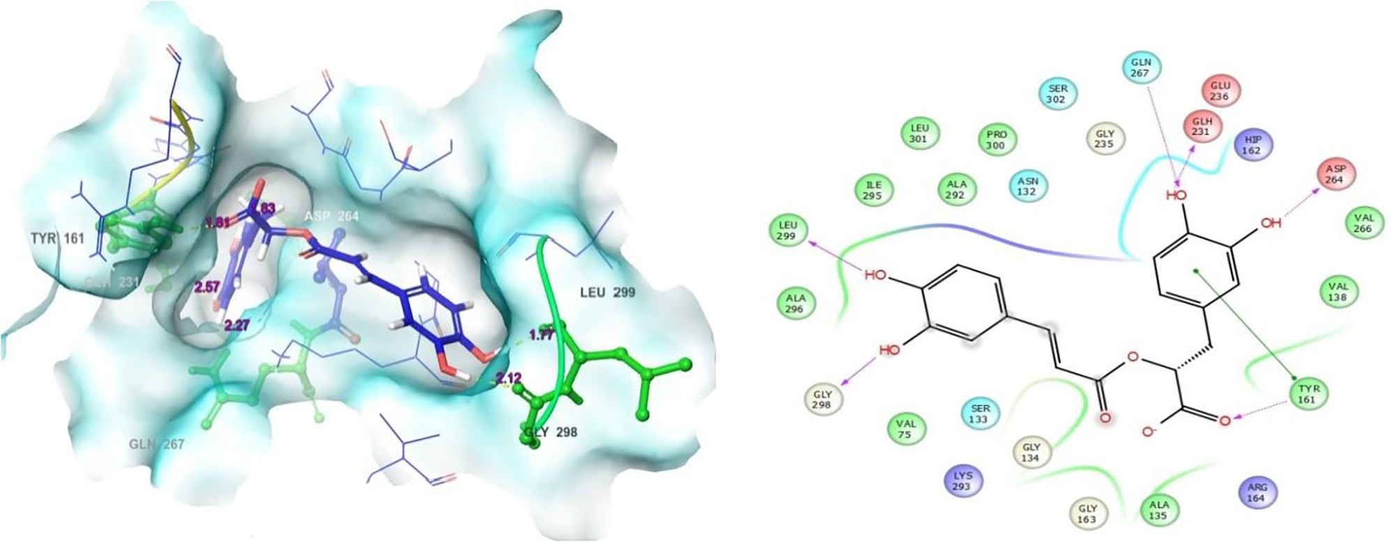

Fig. 6. Molecular interactions of target with (R)-(+)-rosmarinic acid: Residues and hydrogen bond contacts (yellow dotted line) with their distance values (pink values), and the 2D template representing the types of contacts formed between the ligand and target.

Table 3

Human 4-aminobutyrate-aminotransferase (GABA) residues interactions with tested molecules.

|  |  |  |  |  |
| --- | --- | --- | --- | --- |
| S. No. | Phytocompounds | Residues interactions and their distance values | Types of bond formation |  |
|  |  |  | H-bond back bone H-bond side chain |
| 1.  2. | 5-O-[(2E)-3-(4-Hydroxyphenyl)-2-propenoyl] pentofuranosyl-(1-3) pentopyranosyl-(1-4) pentose  (R)-(+)-rosmarinic acid | Gly134 (2.46), Arg164 (2.46), Tyr161,pi-pi stacking,  Leu299(2.23), Gly298 (1.97, 1.79), Gln 267(2.66)  Asp 264 (1.82), Gln267 (2.27), Gln 231(2.57), Tyr 161 | Gln 267 Gly 134, Arg 164, Tyr  161,Leu 299, Gly 298  Asp 264, Gln 267, Gly 298, Leu 299 |  |
| 3. | Curcumin | (1.81), Gly 298(2.12), Leu 299(2.67)  Gln 267(2.04), Arg 164(2.51), Leu 299(1.78), Leu 301 | Gln 231, Tyr 161,  Arg 164, Leu 299, Gln 267, |  |
| 4. | Mangiferin | (2.11), Ala 135(2.12)  Glu 236(2.16)Gly 134 (2.66), Lys 293,(2.24), Leu 299 | Leu 301, Ala 135  Gly 134, Leu 299, Glu 236, Arg 164 |  |
| 5. | Ellagic acid | covalent bond(2.16, 2.11), Leu 301(1.93), Arg 164(1.90)  Gly 134(2.14), Leu 301 (2.05), Leu 299 covalent bond | Lys 293, Leu 301  Gly 134, Leu 301, Lys 293 |  |
|  |  | (2.06), Lys 293(2.55) | Leu 299 |  |
| 6. | Azadirachtin | Tyr 161(1.96), Arg 164(1.74) | – Tyr 161, arg 164 |  |
| 7. | (—)-Andrographolide | Ala 135(2.06), Leu 301(2.20) | Ala 135, Leu 301 – |  |
| 8.  9. | D-(+)-Catechin  Epicatechin | Gln 267(2.42), Gln 231(2.93), Asp 264(1.77), Tyr 161, Ala  135(2.36), Lys 293(2.75)  Asp 264(1.63, 1.82), TYR 161 pi-pi stacking, Ala 135 | Asp 264, Tyr 161, Gln 267, Gln 231  Ala 135, Lys 293  Ala 135, Lys 293 Asp 264, |  |
| 10. | Bilobalide | (2.73), Lys 293(2.73)  Lys 293(2.19), asn 132(2.44), Gln 298(2.06) | Lys 293, Asp 132, – |  |
| 11. | Dimethylallyl diphosphate | Ala 135(1.90), Gly 134(1.94.), Lys 293(2.27) | Gln 298  Ala 135, Gly 134, – |  |
| 12. | Rac 8-Prenylnaringenin | Asp 264(1.86), Tyr 161(2.52) pi-pi stacking | Lys 293  – Asp 264 |  |
| 13. | Syringic acid | Gln 267(2.38), Ala 135(1.82), Tyr 161 pi-pi stacking | Ala 135 Gln 267 |  |
| 14. | Eugenol | Asp 264(1.93), Tyr 161 pi-pi stacking | Asp 264 – |  |
| 15.  16. | 9-[(3-Methyl-2-buten-1-yl)oxy]-7H-furo[3,2-g] chromen-7-one  Carvacrol | Gln 267(2.29), Tyr 161 pi-pi stacking  His 162(1.83), Tyr 161 pi-pi stacking | Gln 267 –  His 162 – |  |
| 17.  18. | Apigenin  (-)-Menthone | Gln 231(2.10), Asp264(1.76), Lys 293 salt bridge, Tyr 161 pi-pi stacking  Tyr 161(1.91) | Gln 231, Asp 264 –  – Tyr 161 |  |
| 19. | g-Tokoferol | Asp 264(1.71), Tyr 161 pi-pi stacking | – Asp 264 |  |
| 20.  21. | (+)-L-Alliin  Methyl trifluoromethanesulfonate | Asp264 (1.78), Tyr161 (1.17), LYS 293 salt bridge, Gln267  (1.82)  Leu301 (1.82), Lys 293 (1.95) | Tyr 161 Gln267, Asp 264  Leu 301, Lys 293 – |  |
| 22.  23. | Oleanolic acid  6-Methyl-2-cyclohexen-1-ol | Arg 164 (2.15), Tyr161 (1.51), Gln 298 (1.94)  His 162 (1.81) | Arg 164, Tyr161, Tyr 161  Gln 298  His 162 – |  |
| 24. | L-(—)-Menthol | Tyr 161 (1.95) | – Tyr 161 |  |
| 25. | 4,5-Epoxy-4,11,11-trimethyl-8-methylenebicyclo | Tyr 161 (2.11) | – Tyr 161 |  |
| 26. | (7.2.0)undecane  Linalool | Ala 135(2.02) | Ala 135 – |  |
| 27. | 2-cyclohexenol | Gln 231(2.22), Gln 267(2.43) | Gln 231, Gln 267 |  |
| 28. | Ursolic acid | Arg 164 salt bridge | – – |  |
| 29. | (6E)-1,6-Octadien-3-ol | Asp 264(2.20), gln 267(1.91) | Gln 267 Asp 264 |  |
| 30. | Berberine | – | – – |  |
| 31. | Allicin | – | – – |  |
| 32. | (E)-ajoene | Gln 267(2.36) | – Gln 267 |  |

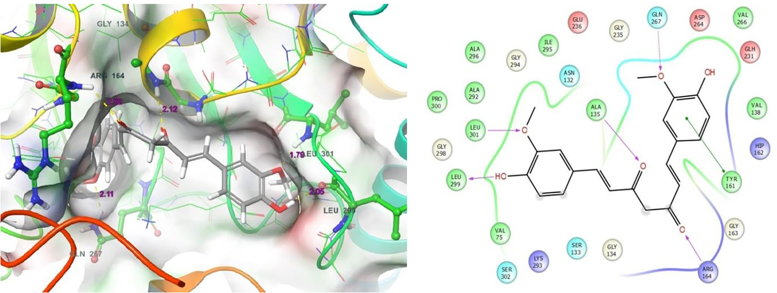

Fig. 7. Molecular interactions of target with Curcumin: Residues and hydrogen bond contacts (yellow dotted line) with their distance values (pink values), and the 2D template representing the types of contacts formed between the ligand and target.

bisdemethoxycurcumin [44,45]. It has effective antimicrobial properties against certain harmful pathogens. Curcumin has been consumed as many as human health complaints of both diseases and disorders. Curcumin, which suppress the type II diabetes and its associated symptoms, rheumatoid arthritis, multiple sclerosis (MS) and Alzheimer’s disease. It is inhibits human immunodefi- ciency, virus (HIV) replication, enhances wound healing properties,

protects from liver injury, increases bile secretion, which also pro- tects from cataract formation, protects from pulmonary toxicity and fibrosis. Besides, it has restrained anti-leishmaniasis and anti-atherosclerotic activities. Additionally, the wide range of liter- ature suggests that curcumin has contains effectual biological activities for the prevention and treatment of numerous health complaints [42]. Previously, Erfani et al., [46] stated that the effect

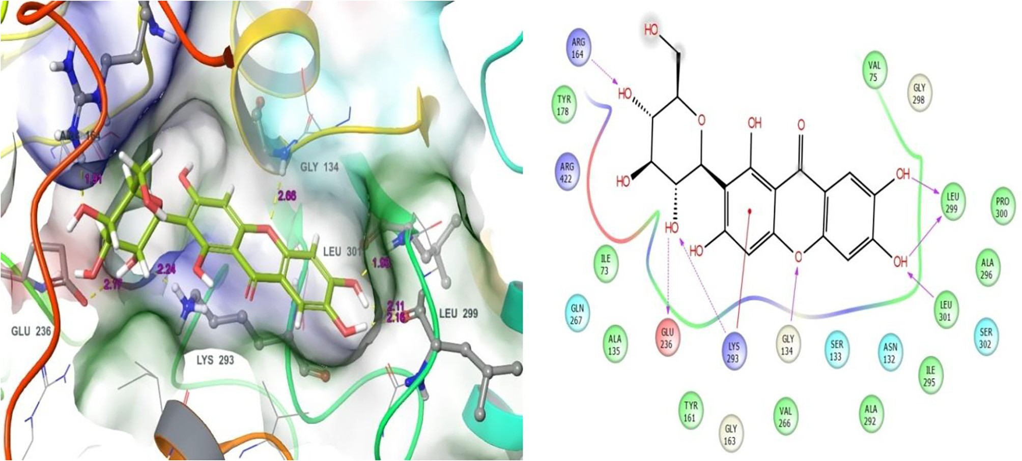

Fig. 8. Molecular interactions of target with Mangiferin: Residues and hydrogen bond contacts (yellow dotted line) with their distance values (pink values), and the 2D template representing the types of contacts formed between the ligand and target.

Table 4

Physico-chemical properties and biological function values of tested molecules analyzed by QuikProp.

|  |  |  |  |  |  |  |  |  |  |  |  |
| --- | --- | --- | --- | --- | --- | --- | --- | --- | --- | --- | --- |
| S. no. | Phytoconstituents | MW | SASA | FISA | IP | Donor H bond | Acceptor H bond | BBB | CNS | OA | Metabolism |
| 1. | 5-O-[(2E)-3-(4-Hydroxyphenyl)-2-propenoyl] | 560.508 | 767.581 | 410.315 | 9.224 | 7 | 22.45 | —4.673 | —2 | 1 | 8 |
| 2. | pentofuranosyl-(1-3) pentopyranosyl-(1-4)pentose  -(R)-(+)-rosmarinic acid | 360.32 | 661.858 | 336.413 | 8.898 | 5 | 7 | —3.743 | —2 | 1 | 6 |
| 3. | Curcumin | 368.385 | 674.36 | 153.896 | 8.847 | 2 | 7 | —1.758 | —2 | 3 | 5 |
| 4. | Mangiferin | 422.345 | 637.514 | 367.311 | 9.028 | 7 | 13 | —3.601 | —2 | 1 | 10 |
| 5. | Ellagic acid | 302.197 | 452.214 | 326.02 | 9.2 | 4 | 8 | —2.375 | —2 | 2 | 4 |
| 6. | Azadirachtin | 720.723 | 866.694 | 150.339 | 9.923 | 3 | 19.05 | —1.38 | —2 | 2 | 5 |
| 7. | Andrographolide | 350.454 | 560.058 | 161.781 | 10.115 | 3 | 8.1 | —1.206 | —2 | 3 | 6 |
| 8. | D-(+)-Catechin | 290.272 | 509.649 | 239.383 | 8.855 | 5 | 5.45 | —1.868 | —2 | 2 | 7 |
| 9. | epicatechin | 290.272 | 513.921 | 234.526 | 8.749 | 5 | 5.45 | —1.851 | —2 | 2 | 7 |
| 10. | Bilobalide | 326.302 | 425.57 | 206.112 | 11.386 | 2 | 11.45 | —0.995 | —1 | 2 | 3 |
| 11. | dimethylallyl diphosphate | 450.448 | 641.258 | 37.992 | 9.525 | 0 | 10 | —0.584 | —1 | 3 | 0 |
| 12. | rac 8-Prenylnaringenin | 340.375 | 622.17 | 167.764 | 9.013 | 2 | 4 | —1.378 | —2 | 3 | 8 |
| 13. | Syringic acid | 198.175 | 392.802 | 137.647 | 9.068 | 2 | 4.25 | —0.791 | —1 | 3 | 3 |
| 14. | Eugenol | 164.204 | 392.915 | 39.592 | 8.888 | 1 | 1.5 | —0.001 | 0 | 3 | 3 |
| 15. | -[(3-Methyl-2-buten-1-yl)oxy]-7H- | 270.284 | 523.616 | 66.104 | 8.965 | 0 | 3.75 | —0.223 | 0 | 3 | 5 |
| 16. | Carvacrol | 150.22 | 389.572 | 44.585 | 9.129 | 1 | 0.75 | 0.08 | 1 | 3 | 3 |
| 17. | Apigenin | 270.241 | 492.236 | 204.227 | 9.056 | 2 | 3.75 | —1.446 | —2 | 3 | 3 |
| 18. | 6,12,17-Trihydroxy-16-methyl-8-(2 | 424.404 | 494.879 | 218.086 | 10.915 | 2 | 12.9 | —1.146 | —2 | 2 | 4 |
| 19. | (—)-Menthone | 154.252 | 389.781 | 39.448 | 10.436 | 0 | 2 | 0.199 | 1 | 3 | 2 |
| 20. | g-Tokoferol | 416.686 | 834.983 | 45.643 | 8.388 | 1 | 1.5 | —0.72 | —1 | 1 | 4 |
| 21. | (+)-L-Alliin | 177.218 | 381.056 | 160.805 | 9.492 | 2 | 6 | —0.647 | —1 | 1 | 5 |
| 22. | Methyl trifluoromethanesulfonate | 164.099 | 293.78 | 101.269 | 12.152 | 0 | 4 | 0.01 | 1 | 3 | 0 |
| 23. | Oleanolic acid | 456.707 | 689.988 | 97.616 | 9.761 | 2 | 3.7 | —0.411 | —1 | 1 | 3 |
| 24. | 6-Methyl-2-cyclohexen-1-ol | 112.171 | 319.992 | 38.941 | 9.982 | 1 | 1.7 | 0.21 | 1 | 3 | 2 |
| 25. | L-(—)-Menthol | 156.267 | 400.546 | 40.738 | 10.926 | 1 | 1.7 | 0.121 | 1 | 3 | 1 |
| 26. | -4,5-Epoxy-4,11,11-trimethyl-8-met | 220.354 | 470.864 | 0 | 9.766 | 0 | 2 | 0.134 | 1 | 3 | 2 |
| 27. | 13849981-Linalool | 154.252 | 432.413 | 33.081 | 9.493 | 1 | 0.75 | —0.021 | 0 | 3 | 4 |
| 28. | -2-cyclohexenol | 98.144 | 296.281 | 49.281 | 9.799 | 1 | 1.7 | 0.135 | 1 | 3 | 2 |
| 29. | Ursolic acid | 456.707 | 658.555 | 95.593 | 9.149 | 2 | 3.7 | —0.366 | —1 | 1 | 3 |
| 30. | (6E)-1,6-Octadien-3-ol | 126.198 | 388.26 | 41.517 | 9.882 | 1 | 1.7 | —0.088 | 0 | 3 | 3 |
| 31. | Berberine |  |  |  |  |  |  |  |  |  |  |
| 32. | (E)-ajoene | 162.264 | 377.755 | 41.704 | 9.467 | 7 | 4 | 0.065 | 1 | 2 | 3 |

MW – Molecular weight, SASA – Solvent Accessible Surface Area, PSA – Polar surface area, BBB – Blood brain barrier, CNS – Central nervous system.

of curcumin on epilepsy. They are pointed out the effectiveness of curcumin at different concentration levels on various clinical experimentation namely Albino rat, Swiss mice and Zebra fish. Firstly, we found that the biological potential of curcumin for epi- lepsy, which has identified by molecular docking approach. In this study, the molecule curcumin is placed better docking scores with good binding affinities than mangiferin and other molecules.

*Mangiferin*

Mangiferin had the fourth valuable docking score (—8.224). It was also shown good binding affinities with target residues. This docked complex showed that the residue contacts between target as well as the Mangiferin. This examination shows that there are six binding affinities between ligand to target. There, the residues Arg164, Glu236, Lys293, Gly134, Leu299 and Leu301 were made different contacts formation with the small molecule of mangi- ferin. Particularly, the residues Arg164 (OH), Glu236 (OH) and Lys293 (OH) were involved in hydrogen bond side chain contacts. Whereas, following residues Gly134 (O), Leu299 (OH) and Leu301 (OH) were involved in hydrogen bond back chain contacts. But, the residue Leu299 was involved ionic binding with the ligand hydro- xyl group. Fig. 8a. represents the residues contacts and their resi- due distance values. Fig. 8b displayed the residue contacts in ligand atoms and their contacts types. In this study, all the tested compounds contacts were shown in Table 3. Mangiferin is mainly found in *Mangifera indica*. It has an effective pharmacological prop- erties, which also contain lots of health benefits includes immunoregulation, cardio protective, memory enhancement, antiviral, laxative and the list goes on. Important and potentiality of the *Mangifera indica* and their molecule mangiferin have been clearly reported in a previous finding [47].

*ADMET-analysis*

In the beginning stage of drug discovery physico-chemical indi- cators were used in order to find the vital properties affecting to the biological functions (ADME) Table 4. There are some important physico-chemical properties were measured such as permeability, solubility, lipophilicity, integrity and stability. But the concept of ADME has been expanded by the toxicity. Right from the beginning of drug discovery *in silico* method has been used to give an accurate prediction of pharmacokinetics properties for instant ADMET.

Conclusion

c-aminobutyric acid is an important neurotransmitter in the region of central nervous system of mammalian. Due to the defi- ciency of GABA levels the people are affected by certain neurolog- ical disorder and diseases especially epilepsy. But, these GABA enzymes are available more in germinated brown rice, chocolate, wine, etc. Based on the availability of GABA in medicinal plant parts the phytoconstituents were tested with GABA by using com- putational approaches. As a result of this computational finding some molecules such as 5-O-[(2E)-3-(4-Hydroxyphenyl)-2-prope noyl]pentofuranosyl-(1-3)pentopyranosyl-(1-4)pentose, (R)-(+)- rosmarinic acid, curcumin and mangiferin shows favorable docking scores and displayed good contacts to the target. In order to the computational outcome, we have revealed certain active novel drug analogues for the neurological disorder of epilepsy. Especially, 5-O-[(2E)-3-(4-Hydroxyphenyl)-2-propenoyl] pentofuranosyl-(1- 3)pentopyranosyl-(1-4)pentose has displayed effective computa- tional results than other superior three analogues. Based on the finding, we conclude that the above molecules could be suitable drug candidates for epilepsy. And also this study will be very helpful for new herbal drug discovery to the pharmaceutical sector.

Acknowledgement

The authors are grateful to the DST-SERB (SB/YS/LS-109/2014) for providing financial assistance in this project. We specially express our thanks to the management of A.V.V.M. Sri Pushpam College (Autonomous), Poondi, for providing them necessary facil- ities and support to carry out this work.

Appendix A. Supplementary data

Supplementary data associated with this article can be found, in the online version, at <https://doi.org/10.1016/j.ejbas.2018.05.008>.

References

1. [McGeer PL, Kawamata T, Walker DG, Akiyama HI, Tooyama McGeer EG.](http://refhub.elsevier.com/S2314-808X(18)30045-9/h0005) [Microglia in degenerative neurological disease. Glia 1993;7:84–92](http://refhub.elsevier.com/S2314-808X(18)30045-9/h0005).
2. [Medina-Kauwe LK, Tobin AJ, De Meirleir L, Jaeken J, Jakobs C, Nyhan WL, et al.](http://refhub.elsevier.com/S2314-808X(18)30045-9/h0010) [4-Aminobutyrate aminotransferase (4-aminobutyrate aminotransferase-](http://refhub.elsevier.com/S2314-808X(18)30045-9/h0010) [transaminase) deficiency. J Inherit Metab Dis 1999;22:414–27](http://refhub.elsevier.com/S2314-808X(18)30045-9/h0010).
3. [Sabeega Begum B, Subashini S, Hemalatha P, Archana P, Bharathi N, Nagarajan](http://refhub.elsevier.com/S2314-808X(18)30045-9/h0015) [P, et al. *In silico* screening of phytochemical compounds targeting childhood](http://refhub.elsevier.com/S2314-808X(18)30045-9/h0015) [absence epilepsy (CAE). Int J Pharm Pharm Sci 2014;6:430–3](http://refhub.elsevier.com/S2314-808X(18)30045-9/h0015).
4. [Gunne LM, Haggstrom JE, Sjoquist B. Association with persistent neuroleptic-](http://refhub.elsevier.com/S2314-808X(18)30045-9/h0020) [induced dyskinesia of regional changes in brain 4-aminobutyrate](http://refhub.elsevier.com/S2314-808X(18)30045-9/h0020) [aminotransferase synthesis. Nature 1984;309:347–59](http://refhub.elsevier.com/S2314-808X(18)30045-9/h0020).
5. [Butterworth J, Yates CM, Simpson J. Phosphate-activated glutaminase in](http://refhub.elsevier.com/S2314-808X(18)30045-9/h0025) [relation to Huntington’s disease and agonal state. J Neurochem](http://refhub.elsevier.com/S2314-808X(18)30045-9/h0025) [1983;41:440–7](http://refhub.elsevier.com/S2314-808X(18)30045-9/h0025).
6. [Yoshika S, Aso Y, Takeda Y. Statical evaluation of accelerated stability data](http://refhub.elsevier.com/S2314-808X(18)30045-9/h0030) [obtained at a single temperature. Effect of experimental errors in evaluation of](http://refhub.elsevier.com/S2314-808X(18)30045-9/h0030) [stability data. Chem Pharma Bullet 1990;38:1757–9](http://refhub.elsevier.com/S2314-808X(18)30045-9/h0030).
7. [Bakay RAE, Harris A. Neurotransmitter receptor and biochemical changes in](http://refhub.elsevier.com/S2314-808X(18)30045-9/h0035) [monkey cortical epileptic foci. Brain Res 1981;206. 387-04](http://refhub.elsevier.com/S2314-808X(18)30045-9/h0035).
8. [Nishino N, Fujiwara H, Noguchi-Kuno SA, Tanaka C. 4-Aminobutyrate](http://refhub.elsevier.com/S2314-808X(18)30045-9/h0040) [aminotransferase A receptor but not musculleric receptor density was](http://refhub.elsevier.com/S2314-808X(18)30045-9/h0040) [decreased in the brain of patients with Parkinson’s disease. Jap J Pharmacol](http://refhub.elsevier.com/S2314-808X(18)30045-9/h0040) [1988;48:331–9](http://refhub.elsevier.com/S2314-808X(18)30045-9/h0040).
9. [Elliott KAC, Hobbiger F. Gamma aminobutyric acid: circulatory and respiratory](http://refhub.elsevier.com/S2314-808X(18)30045-9/h0045) [effects in different species; re-investigation of the anti-strychnine action in](http://refhub.elsevier.com/S2314-808X(18)30045-9/h0045) [mice. J Physiol 1959;1:70–84](http://refhub.elsevier.com/S2314-808X(18)30045-9/h0045).
10. [Aoki Y, Saint-Germain N, Gyda M, Magner-Fink E, Lee YE, Credidio C, et al.](http://refhub.elsevier.com/S2314-808X(18)30045-9/h0050) [Sox10 regulates the development of neural crest-derived melanocytes in](http://refhub.elsevier.com/S2314-808X(18)30045-9/h0050) [Xenopus. Dev Biol 2003;259:33–9](http://refhub.elsevier.com/S2314-808X(18)30045-9/h0050).
11. [Inoue K, Shirai T, Ochiai H, Kasao M, Hayakawa K, Kimura M, et al. Blood-](http://refhub.elsevier.com/S2314-808X(18)30045-9/h0055) [pressure-lowering effect of a novel fermented milk containing gamma-](http://refhub.elsevier.com/S2314-808X(18)30045-9/h0055) [aminobutyric acid (4-aminobutyrate aminotransferase) in mild](http://refhub.elsevier.com/S2314-808X(18)30045-9/h0055) [hypertensives. Eur J Clin Nutr 2003;57:490–5](http://refhub.elsevier.com/S2314-808X(18)30045-9/h0055).
12. [Noguchi A, Matsumura S, Dezawa M, Tada M, Yanazawa T, Ito A, et al. Isolation](http://refhub.elsevier.com/S2314-808X(18)30045-9/h0060) [and characterization of patient-derived, toxic, high mass amyloid beta-protein](http://refhub.elsevier.com/S2314-808X(18)30045-9/h0060) [(Abeta) assembly from Alzheimer disease brains. J Biol Chem](http://refhub.elsevier.com/S2314-808X(18)30045-9/h0060) [2009;284:32895–905](http://refhub.elsevier.com/S2314-808X(18)30045-9/h0060).
13. [Snead OC. Basic mechanisms of generalized absence seizures. Ann Nuerol](http://refhub.elsevier.com/S2314-808X(18)30045-9/h0065) [1995;37:146–57](http://refhub.elsevier.com/S2314-808X(18)30045-9/h0065).
14. <http://www.who.int/mediacentre/news/releases/2007/pr04/en/>.
15. [Perucca E. The new generation of antiepileptic drugs: advantages and](http://refhub.elsevier.com/S2314-808X(18)30045-9/h0075) [disadvantages. Brit J Clin Pharmacol 1996;42:531–43](http://refhub.elsevier.com/S2314-808X(18)30045-9/h0075).
16. [Hill DS, Wlodarczyk BJ, Palacios AM, Finnell RH. Teratogenic effects of](http://refhub.elsevier.com/S2314-808X(18)30045-9/h0080) [antiepileptic drugs. Expert Rev Neurother 2010;10:943–59](http://refhub.elsevier.com/S2314-808X(18)30045-9/h0080).
17. [Akihiro Takashi, Koike Satoshi, Tani Ryoji, Tominaga Takehiro, Watanabe Shin,](http://refhub.elsevier.com/S2314-808X(18)30045-9/h0085) [Iijima Yoko, Aoki Koh, Shibata Daisuke, Ashihara Hiroshi, Matsukura Chiaki.](http://refhub.elsevier.com/S2314-808X(18)30045-9/h0085) [Biochemical mechanism on 4-aminobutyrate aminotransferase accumulation](http://refhub.elsevier.com/S2314-808X(18)30045-9/h0085) [during fruit development in tomato. Plant Cell Physiol 2008;49(9):1378–89](http://refhub.elsevier.com/S2314-808X(18)30045-9/h0085).
18. [Phani Kumar G, Khanum F. Neuroprotective potential of phytochemicals.](http://refhub.elsevier.com/S2314-808X(18)30045-9/h0090) [Pharmacogn Rev 2012;6:81–90](http://refhub.elsevier.com/S2314-808X(18)30045-9/h0090).
19. [Atanasov AG, Waltenberger B, Wenzig EMP, et al. Discovery and resupply of](http://refhub.elsevier.com/S2314-808X(18)30045-9/h0095) [pharmacologically active plant-derived natural products: a review. Biotechnol](http://refhub.elsevier.com/S2314-808X(18)30045-9/h0095) [Adv 2015;33. 1582-14](http://refhub.elsevier.com/S2314-808X(18)30045-9/h0095).
20. [Abdou AM, Higashiguchi S, Horie K, Kim M, Hatta H, Yokogoshi H, et al.](http://refhub.elsevier.com/S2314-808X(18)30045-9/h0100) [Relaxation and immunity enhancement effects of gamma-aminobutyric acid](http://refhub.elsevier.com/S2314-808X(18)30045-9/h0100) [(4-aminobutyrate aminotransferase) administration in humans. Biofact](http://refhub.elsevier.com/S2314-808X(18)30045-9/h0100) [2006;26:201–8](http://refhub.elsevier.com/S2314-808X(18)30045-9/h0100).
21. [Chintamunnee V, Mahomoodally MF. Herbal medicine commonly used against](http://refhub.elsevier.com/S2314-808X(18)30045-9/h0105) [infectious diseases in the tropical island of Mauritius. J Herb Med](http://refhub.elsevier.com/S2314-808X(18)30045-9/h0105) [2012;143:113–25](http://refhub.elsevier.com/S2314-808X(18)30045-9/h0105).
22. [Tahraoui J, El-Hilaly Z, Israili H, Lyoussi Z. Ethnopharmacological survey of](http://refhub.elsevier.com/S2314-808X(18)30045-9/h0110) [plants used in the traditional treatment of hypertension and diabetes in south-](http://refhub.elsevier.com/S2314-808X(18)30045-9/h0110) [eastern Morocco (Errachidia province). J Ethnopharmacol 2007;110:105–17](http://refhub.elsevier.com/S2314-808X(18)30045-9/h0110).
23. [www.uniprot.org](http://www.uniprot.org/).
24. [www.chemspider.com](http://www.chemspider.com/).
25. Prime 2011 version 2.1 Schrödinger, LLC, NewYork.
26. [Vyas VK, Ukawala RD, Ghate M, Chintha C. Homology modeling a fast tool for](http://refhub.elsevier.com/S2314-808X(18)30045-9/h0130) [drug discovery: current perspectives. Ind J Pharm Sci 2012;74:1–17](http://refhub.elsevier.com/S2314-808X(18)30045-9/h0130).
27. Site Map version 2.5 Schrodinger, LLC, New York, 2016.
28. [Ginalski K, Nick V, Grishin V, Godzik A, Rychlewski L. Practical](http://refhub.elsevier.com/S2314-808X(18)30045-9/h0140) [lessons from protein structure prediction. Nucleic Acid Res 2005;33:](http://refhub.elsevier.com/S2314-808X(18)30045-9/h0140) [1874–91](http://refhub.elsevier.com/S2314-808X(18)30045-9/h0140).
29. [Robertson JC, Hurley NC, Tortorici M, Ciossani G, Borrello MT, Vellore NT, et al.](http://refhub.elsevier.com/S2314-808X(18)30045-9/h0145) [Expanding the druggable space of the LSD1/CoREST epigenetic target: new](http://refhub.elsevier.com/S2314-808X(18)30045-9/h0145) [potential binding regions for drug-like molecules, peptides, protein partners,](http://refhub.elsevier.com/S2314-808X(18)30045-9/h0145) [and chromatin. J Compu Biol 2013;9:e1003158](http://refhub.elsevier.com/S2314-808X(18)30045-9/h0145).
30. LigPrep, 2011. Version 2.3 Schrödinger, LLC, NewYork.
31. [Tripathi SK, Muttineni R, Singh SK. Extra precision docking, free energy](http://refhub.elsevier.com/S2314-808X(18)30045-9/h0155) [calculation and molecular dynamics simulation studies of CDK2 inhibitors. J](http://refhub.elsevier.com/S2314-808X(18)30045-9/h0155) [Theor Biol 2013;334:87–100](http://refhub.elsevier.com/S2314-808X(18)30045-9/h0155).
32. [Kakarala KK, Kaiser J, Vinod D. Structure and putative signaling mechanism of](http://refhub.elsevier.com/S2314-808X(18)30045-9/h0160) [Protease activated receptor 2 (PAR2) – a promising target for breast cancer. J](http://refhub.elsevier.com/S2314-808X(18)30045-9/h0160) [Mol Graph Model 2014;54:179–99](http://refhub.elsevier.com/S2314-808X(18)30045-9/h0160).
33. Glide, 2011.version5.7, Schrödinger, LLC, NewYork.
34. [Elokely KM, Doerksen RJ. Docking challenge: protein sampling and molecular](http://refhub.elsevier.com/S2314-808X(18)30045-9/h0170) [docking performance. J Chem Inf Model 2013;53:1934–45](http://refhub.elsevier.com/S2314-808X(18)30045-9/h0170).
35. QikProp, version 4.3, Schrödinger, LLC, New York, NY, 2014.
36. [Katsila T, Spyroulias GA, Patrinos GP, Matsoukas GT. Computational](http://refhub.elsevier.com/S2314-808X(18)30045-9/h0180) [approaches in target identification and drug discovery. Comp Struct](http://refhub.elsevier.com/S2314-808X(18)30045-9/h0180) [Biotechnol 2016;14:177–84](http://refhub.elsevier.com/S2314-808X(18)30045-9/h0180).
37. [Iftikhar T, Batool S, Deep A, Narasimhan B, Sharma PC, Malhotra M, et al. *In*](http://refhub.elsevier.com/S2314-808X(18)30045-9/h0185)[*silico* analysis of the inhibitory activities of 4-aminobutyrate aminotransferase](http://refhub.elsevier.com/S2314-808X(18)30045-9/h0185) [derivatives on 4-aminobutyrate transaminase. Arab J Chem 2017;10:](http://refhub.elsevier.com/S2314-808X(18)30045-9/h0185) [1267–75](http://refhub.elsevier.com/S2314-808X(18)30045-9/h0185).
38. [Subhani S, Archana J, Jamil K. Homology modelling and molecular docking of](http://refhub.elsevier.com/S2314-808X(18)30045-9/h0190) [MDR1with chemotherapeutic agents in non-small cell lung cancer. Biomed](http://refhub.elsevier.com/S2314-808X(18)30045-9/h0190) [Pharmaco 2015;71:45](http://refhub.elsevier.com/S2314-808X(18)30045-9/h0190).
39. [Subhani S, Jamil K. Molecular docking of chemotherapeutic agents to CYP3A4](http://refhub.elsevier.com/S2314-808X(18)30045-9/h0195) [in non-small cell lung cancer. Biomed Pharmaco 2015;73:65–74](http://refhub.elsevier.com/S2314-808X(18)30045-9/h0195).
40. [Vijayakumar S, Manogar P, Prabhu S. Potential therapeutic targets and the role](http://refhub.elsevier.com/S2314-808X(18)30045-9/h0200) [of technology in developing novel cannabinoid drugs from cyanobacteria.](http://refhub.elsevier.com/S2314-808X(18)30045-9/h0200) [Biomed Pharmaco 2016;83:362–71](http://refhub.elsevier.com/S2314-808X(18)30045-9/h0200).
41. [Patschull AOM, Gooptu B, Ashford P, Daviter T, Nobeli I. *In silico* assessment of](http://refhub.elsevier.com/S2314-808X(18)30045-9/h0205) [potential druggable pockets on the surface of a1-antitrypsin conformers. PLoS](http://refhub.elsevier.com/S2314-808X(18)30045-9/h0205) [One 2012;7:e36612](http://refhub.elsevier.com/S2314-808X(18)30045-9/h0205).
42. [Liu T, Xu F, Du X, Lai D, Liu T, Zhao Y, et al. Establishment and characterization](http://refhub.elsevier.com/S2314-808X(18)30045-9/h0210) [of multi-drug resistant, prostate carcinoma-initiating stem-like cells from](http://refhub.elsevier.com/S2314-808X(18)30045-9/h0210) [human prostate cancer cell lines 22RV1. Mol Cell Biochem 2010;340:265–73](http://refhub.elsevier.com/S2314-808X(18)30045-9/h0210).
43. [Akhondzadeh S, Noroozian M, Mohammadi M, Ohadinia S, Jamshidi AH, Khani](http://refhub.elsevier.com/S2314-808X(18)30045-9/h0215) [M, et al. *Melissa officinalis* extract in the treatment of patients with mild to](http://refhub.elsevier.com/S2314-808X(18)30045-9/h0215) [moderate Alzheimer’s disease: a double blind, randomised, placebo controlled](http://refhub.elsevier.com/S2314-808X(18)30045-9/h0215) [trial. J Neurol Neurosurg Psychia 2003;74:863–6](http://refhub.elsevier.com/S2314-808X(18)30045-9/h0215).
44. [Aggarwal BB, Kumar A, Bharti AC. Anticancer potential of curcumin: preclinical](http://refhub.elsevier.com/S2314-808X(18)30045-9/h0220) [and clinical studies. Antican Res 2003;23:363–98](http://refhub.elsevier.com/S2314-808X(18)30045-9/h0220).
45. [Paramasivam M, Poi R, Banerjee H, Bandyopadhyay A. High-performance thin](http://refhub.elsevier.com/S2314-808X(18)30045-9/h0225) [layer chromatographic method for quantitative determination of](http://refhub.elsevier.com/S2314-808X(18)30045-9/h0225) [curcuminoids in *Curcuma longa* L germplasm. Food Chem 2009;113:640–4](http://refhub.elsevier.com/S2314-808X(18)30045-9/h0225).
46. [Erfani M, Arshrafzadeh F, Akhondian J, Rahimi H, Toosi MB, Kalat HL, et al. The](http://refhub.elsevier.com/S2314-808X(18)30045-9/h0230) [effect of curcumin on epilepsy: an experimental review. Rev Clinical Med](http://refhub.elsevier.com/S2314-808X(18)30045-9/h0230) [2017;4:131–5](http://refhub.elsevier.com/S2314-808X(18)30045-9/h0230).
47. [Masud Parvez GM. Current advances in pharmacological activity and toxic](http://refhub.elsevier.com/S2314-808X(18)30045-9/h0235) [effects of various capsicum species. J Pharmaco Phytochem 2017;3:1900–12](http://refhub.elsevier.com/S2314-808X(18)30045-9/h0235).