[Egyptian Journal of Basic and Applied Sciences 4 (2017) 9–14](http://dx.doi.org/10.1016/j.ejbas.2016.12.001)

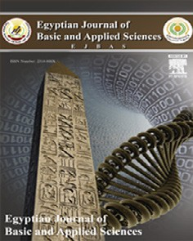

Contents lists available at [ScienceDirect](http://www.sciencedirect.com/science/journal/2314808X)

Egyptian Journal of Basic and Applied Sciences

journal homepage: [www.elsevier.com/locate/ejbas](http://www.elsevier.com/locate/ejbas)

Full Length Article

Serum level of vitamin D in patients with alopecia areata



Nora Mohamed Mostafa Darwish a, Hamdy Fouad Marzok a, Mohamed Ali Mohamed Gaballah a,⇑,

Hend Elsaudi Abdellatif b

a *Faculty of Medicine, Mansoura University, Egypt*

b *Mansoura University Student Hospital, Egypt*

# a r t i c l e i n f o

*Article history:*

Received 14 August 2016

Received in revised form 30 November 2016 Accepted 9 December 2016

Available online 18 December 2016

*Keywords:* Vitamin D Alopecia areata

# a b s t r a c t

*Purpose:* Alopecia areata (AA) is an autoimmune disease mediated by both CD4+ and CD8+ T-cells with cytokines playing an important role. Current study aimed at measuring serum 25 hydroxy vitamin D [25 (OH) D] level in patients with AA in comparison to controls in our locality.

*Subjects and methods:* The study recruited 50 subjects, 30AA patients and 20 controls. All patients were subjected to detailed history taking and examination to detect pattern, severity (SALT score) of AA. Blood samples were taken from all subjects to do complete blood count and to assess serum levels of 25(OH)D, parathyroid hormone, random blood sugar, and calcium.

*Results:* There was significant decrease in serum 25(OH)D level in AA patients in comparison to controls. Serum 25(OH)D level showed significant decrease in males than in females in patients. Levels of serum calcium were significantly lower in patient group compared to control group with. Regarding blood pic- ture; the only significant difference was in the count of RBCs which showed significant lower levels in AA group compared to control group. Positive linear correlation was found between serum vitamin D and serum calcium in the patients group. Strong positive correlation was found between SALT score and dura- tion of the disease. All patients with total scalp hair loss and body hair loss had duration of disease more than six months, while most of patients with duration of disease less than six months had low SALT scores.

*Conclusions:* Serum levels of 25(OH)D were significantly lower in patients than controls.

© 2016 Mansoura University. Production and hosting by Elsevier B.V. This is an open access article under the CC BY-NC-ND license (<http://creativecommons.org/licenses/by-nc-nd/4.0/>).

1. Introduction

Alopecia areata (AA) is a common chronic disease resulting in non-scarring hair loss. AA presents with different clinical patterns such as patches of hair loss; complete or near complete loss of facial and scalp hair (alopecia totalis, AT); or complete loss of all body and scalp hair (alopecia universalis, AU) [1].

Although many different causes were suggested, the exact underlying etiology of AA is problematic. However, immunological, environmental, psychological, and genetic factors are the most powerful explanations [2].

*Abbreviations:* 1,25(OH)2 D3, 1,25-dihydroxy vitamin D3; 25(OH)D, 25-hydroxy vitamin D; AA, alopecia areata; AT, alopecia totalis; AU, alopecia universalis; PTH, parathyroid hormone; VDR, vitamin D receptors.

* Corresponding author at: Department of Dermatology, Andrology & STDs,

Faculty of Medicine, Mansoura University, El-Gomhoria St., Mansoura, Egypt.

*E-mail addresses:* [dr.h.marzouk@hotmail.com](mailto:dr.h.marzouk@hotmail.com) (H.F. Marzok), [mohali212@yahoo.](mailto:mohali212@yahoo.com) [com](mailto:mohali212@yahoo.com) (M.A.M. Gaballah), [nonaelsha3nona@hotmail.com](mailto:nonaelsha3nona@hotmail.com) (H.E. Abdellatif).

Vitamin D is synthesized in the epidermal keratinocytes under effect of UV-B lights (290–315 nm) or ingested in diet and dietary supplements [3]. Vitamin D was found to have immune-regulatory effects. 1,25-Dihydroxy vitamin D3 (1,25(OH)2 D3) which is the active form of vitamin D, is one of the regulators of both innate and adaptive immune responses as it modulates immune functions and activities of both T-lymphocytes and B-lymphocytes [4].

1,25(OH)2 D3 has an important role in hair follicle biology. Vita- min D receptors (VDR) expression in epidermal keratinocytes and the mesenchymal dermal papilla cells were detected [5]*.* Expres- sion of the VDR in keratinocytes is necessary for preservation of the normal hair cycle [6]. Lack of the VDR is associated with reduced epidermal differentiation and hair follicle growth. In addi- tion, patients with 1,25(OH)2 D3-resistant rickets type II and VDR knockout mice exhibit phenotypes that include AT [7].

Evaluation of vitamin D status is not based on measurement of serum 1,25 (OH)2 D3 serum levels as they are relatively low and firmly regulated. Vitamin D status is assessed by measurement of 25-hydroxy vitamin D (25(OH)D), which is an indicator of supply

<http://dx.doi.org/10.1016/j.ejbas.2016.12.001>

2314-808X/© 2016 Mansoura University. Production and hosting by Elsevier B.V.

This is an open access article under the CC BY-NC-ND license (<http://creativecommons.org/licenses/by-nc-nd/4.0/>).

rather than function. It is the most stable and plentiful metabolite of vitamin D in human serum and has a half-life of about 3 weeks, making it the most suitable indicator of the vitamin D status [8].

Patients with AA showed significantly lower concentrations of both 25(OH)D and 1,25(OH)2 D3 with higher mean values of parathyroid hormone (PTH) than controls [5,9]*.* In addition, vita- min D supplementation might have a preventive role in human autoimmune diseases such as AA [10]. Furthermore, it was sug- gested that activation of regulatory T cells can explain the possible efficacy of vitamin D analogs in the treatment of AA [9].

The aim of the present work was to evaluate serum level of vitamin D in patients with different clinical types of AA in our locality.

1. Subjects and methods

This work was designed as prospective case control study and was approved by the ethical committee in the faculty of medicine, Mansoura University. This study included 50 subjects, 30 AA patients and 20 age- and sex matched healthy controls. They were selected from outpatient clinic of Dermatology, Andrology and STDs department in Mansoura University Hospital. Informed writ- ten consents were obtained from all participants. All participants were from Dakahlia Governorate.

* 1. *Subjects*

1. inclusion criteria:
   1. All patients with any type of AA not receiving any treat- ment for AA for at least 6 months before inclusion in the study
2. Exclusion criteria:
   1. Any patient taking vitamin D supplementation, iron prepa- rations, vitamin B, folic acid or calcium (Ca) supplementa- tions in the last 6 months.
   2. Patients treated with topical vitamin D3 analog.
   3. Patients known to have a state of vitamin D deficiency (to avoid the selection bias).
   4. Patients with any associated disease that alter the blood 25 (OH)D level as vitiligo, psoriasis, SLE, renal disease, liver disease, cancers and autoimmune diseases.

All participants in this study were subjected to the following:

1. Full history taking.
2. General examination to exclude associated systemic diseases that may affect the blood vitamin D level.
3. Dermatological examination including skin, hair, nail and oral mucosa.
4. Clinical assessment of the degree of AA:

The extent of scalp hair loss was determined by dividing the scalp into 4 quadrants (Fig. 1) and visually determining the per- centage of scalp hair loss in each quadrant then adding the num- bers together with a maximum score of 100%. This was determined according to the Severity of Alopecia Tool or SALT score [11]. It included assessment of scalp hair loss (S), Body hair loss (B) and Nail involvement (N) as follows:

S: Scalp hair loss S0 = no hair loss. S1 = <25% hair loss.

S2 = 25–49% hair loss. S3 = 50–74% hair loss. S4 = 75–99% hair loss.

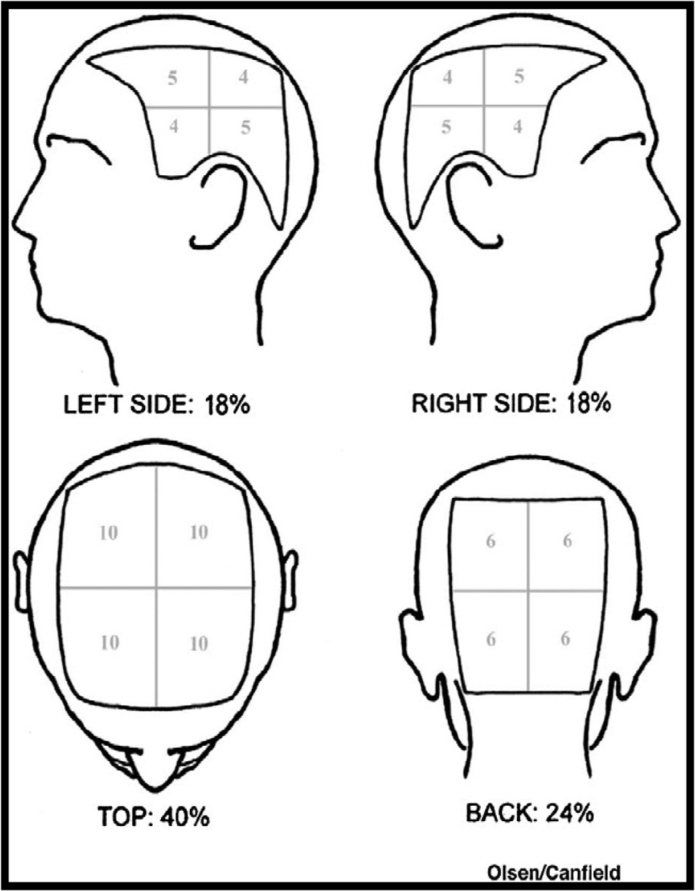

Fig. 1. Olsen/Canfield tool for determination of % scalp hair loss [11].

a = 75–95% hair loss.

b = 96–99% hair loss. S5 = 100% hair loss. B: Body hair loss

B0 = No body hair loss. B1 = Some body hair loss.

B2 = 100% body (excluding scalp) hair loss.

N: Nail involvement

N0 = No nail involvement N1 = Some nail involvement.

N2 = Twenty nail dystrophy involvement. Pattern of scalp hair loss:

* 1. patchy
  2. ophiasis
  3. totalis (100% scalp hair loss)
  4. Classifications of patients [12]:

Patients were classified according to the severity of AA into:

* Mild AA: patients who showed <25% hair loss according to SALT score, and they were 10 patients.
* Moderate AA: patients who showed 25–49% hair loss according to SALT score, and they were 7 patients.
* Sever AA: patients who showed >50% hair loss according to SALT score, and they were 13 patients.

Also, patients were classified according to duration of the dis- ease into patients within 6 months or more than 6 months.

* 1. Standardized photographs of the scalp in order to help assess- ment of the SALT score.
  2. *Methods*

A venous blood sample of 7 cm3 was withdrawn from each par- ticipant. One millilitre was collected in an EDTA tube for complete blood count (CBC) using automated blood count machine (Sysmex, BM Egypt Company). The rest of the sample was collected in a plain tube and left to clot. Serum was separated, and divided into 3 ali-

quots and stored at —20 °C until analysis:

1. One aliquot was used for random blood sugar (RBS) and Ca assay.
2. the second aliquot was used for PTH assay.
3. the last aliquot was used for 25 (OH) D assay.
   * 1. *Ca and RBS assay*

Colorimetric principle kits (bioMerieux, France) were used. The manufacture instructions of the commercially available kits were followed.

* + 1. *PTH assay*

An ELISA principle was used, in which; standards, controls, or patient samples were simultaneously incubated with the enzyme labeled antibody and a biotin coupled antibody in a streptavidin- coated microplate well. At the end of assay incubation, the microwells were washed to remove unbound components and the enzyme bound to the solid phase was incubated with the sub- strate, tetramethylbenzidine (TMB). An acidic stopping solution was then added to stop the reaction and converts the color to yel- low. The intensity of the yellow color was directly proportional to the concentration of intact PTH in the sample. A dose response curve of absorbance versus concentration was generated using results obtained from the calibrators. Concentrations of intact PTH present in the controls and patient samples were determined directly from this curve [13]. The kits were supplied from Cali- biotech Inc., Spring Valley.

* + 1. *3–25(OH)D*

Blood levels of 25(OH) D were assessed using ELISA kits (SunRedbio, Shanghai). 25 (OH) D was added to monoclonal anti- body enzyme wells which were coated with human 25 (OH) D antibodies labeled with biotin, and combined with streptavidin- HRP to form immune complex, then incubation and washing again to remove the uncombined enzyme. Chromogen solutions A, B, were added. The color of the liquid changed into the blue. When acid was added, the color finally became yellow. The chroma of color and concentration of 25(OH)D of sample were positively cor- related. Results were obtained after plotting the standard curve.

* 1. *Data interpretation and statistical analysis*

The statistical analysis was performed using the Statistical Package for Social Sciences (SPSS for Windows Package 20.0 Chi- cago, IL). Quantitative data were presented as mean ± standard deviation (SD) or median and range while qualitative data were presented as number (n) and percentage (%). The normality of data was tested using histograms, box-plots and Shapiro-Wilk test results. Normally distributed data were compared between the two groups using independent samples *t* test. Data which violated the normality assumptions were compared using Mann-Whitney

test. Chi square (v2) test was performed for comparing categorical

data.

Receiver operator characteristic (ROC) analysis was used to determine the optimum cutoff value. Correlation between various variables was done using Pearson and Spearman’s correlation coef- ficients. *P* values <0.05 was considered statistically significant.

1. Results

Table 1 shows the socio-demographic and clinical data of the studied groups. They were13 workers, 6 students and 11 house- wives. 20 patients were from rural areas and 10 from urban areas. Nine patients experienced prior history of AA. Four patients expe- rienced prior history of infection within 6 months before onset of hair loss. No patients had family history of AA.

Table 2 shows comparison between the patients and control groups regarding different blood tests done. The levels of serum vitamin D were significantly lower in AA group compared to con- trol group. ROC curve analysis revealed a value of 17.23 ng/mL as a cutoff value between the two groups with 100% sensitivity and 99% specificity, area under the curve 0.992 and *p* < 0.001 (Fig. 2).

Among the patients group, levels of vitamin D were significantly lower in males compared to females with *p* = 0.009 (Fig. 3), while in control group no significant difference was found between males and females with *p* = 0.45.

The levels of serum Ca were significantly lower in patient group compared to control group. Regarding blood picture; the only sig- nificant difference was in the count of RBCs which showed lower levels in AA group compared to control group with *p* < 0.001. Regarding SALT score, no difference was found between males and females in the severity of the disease (Table 3).

Positive linear correlation was found between serum vitamin D and serum calcium in the patients group (r = 0.445, p = 0.01) (Fig. 4). No significant correlation was found between SALT score and vitamin D. Strong positive correlation was found between SALT score and duration of the disease (r = 0.71, *p* < 0.0001). All patients with AU and AT had duration of disease more than six months; while most of patients with duration of disease less than six months had low SALT scores (Table 4). No significant correlation was found between SALT score and any of the other variables in the patients group. In the control group no significant correlation was found between vitamin D and other variables.

Discussion

Alopecia areata (AA) is autoimmune disease characterized by T- cell infiltrates and cytokine production around anagen-stage hair follicles [14]. CD8+T cells act as the effector cells with help from

Table 1

Demographic and clinical data of the studied groups.

|  |  |  |  |
| --- | --- | --- | --- |
| Variables | Patients (n = 30) | Controls (n = 20) | *P* value |
| *Age (years)* |  |  |  |
| Range  Mean ± SD | 7–44  28.67 ± 10 | 17–49  24.8 ± 6 | 0.12 |
| *Gender* |  |  |  |
| Males (n & %) | 13 (43.3%) | 10 (50%) | 0.25 |
| Females (n & %) | 17 (56.7%) | 10 (50%) |  |
| *Duration of disease* |  |  |  |
| <6 months (n & %) | 15 (50%) |  |  |
| >6 months (n & %) | 15 (50%) |  |  |
| *Pattern of hair loss* |  |  |  |
| Patchy AA (n & %) | 20 (66.7%) |  |  |
| AT&AU (n & %) | 10 (33.3%) |  |  |
| *SALT score* | *n (%)* |  |  |
| S1 | 10 (33.3%) |  |  |
| S2 | 7 (23.3%) |  |  |
| S3 | 4 (13.3%) |  |  |
| S4 | 3 (10%) |  |  |
| S5 | 1 (3.3%) |  |  |
| S4 B | 3 (10%) |  |  |
| S5 B | 2 (6.7) |  |  |

P significance when <0.05; n: number; SD: stander deviation.

Table 2

Comparison between the two groups regarding different blood tests done.

rheumatoid arthritis (RA), type I diabetes mellitus (DM), vitiligo, systemic lupus erythematosus (SLE), thyroiditis, pemphigus vul-

Item Patient group

Mean ± SD

|  |  |  |  |
| --- | --- | --- | --- |
| Serum Vitamin D (ng/mL) | 7.52 ± 6.24 | 31.70 ± 12.29 | <0.001 |
| Serum calcium (mg/dL) | 7.91 ± 1.30 | 9.23 ± 0.36 | <0.001 |
| Serum PTH (pg/mL) | 37.09 ± 28.53 | 48.52 ± 35.7 | 0.25 |
| RBS (mg/dL) | 92.63 ± 7 | 95 ± 6.8 | >0.05 |
| RBCs (×106/mL) | 4.21 ± 0.4 | 5 ± 0.4 | 0.001 |
| WBCs (×103/mL) | 8.33 ± 1.8 | 7.78 ± 2.1 | >0.05 |
| HB (g/dL) | 12.60 ± 1.4 | 13.46 ± 1.8 | >0.05 |
| PLT (×103/mL) | 223.83 ± 29.3 | 244.35 ± 60.5 | >0.05 |

Control group Mean ± SD

P value

garis (PV), pernicious anemia and celiac disease [16].

1,25(OH)2D3 is a modulator of both the innate and adaptive immune systems through its varied effects on T and B lympho- cytes, dendritic cells, and macrophages, all of them express VDRs. A connection between some autoimmune diseases, including type I DM, RA, SLE, vitiligo, psoriasis, multiple sclerosis (MS), inflamma- tory bowel disease (IBD), and vitamin D deficiency has been reported [17]. This finding suggests that vitamin D deficiency might be an environmental trigger for the induction of autoimmu-

P significance when <0.05; n: number; SD: stander deviation.

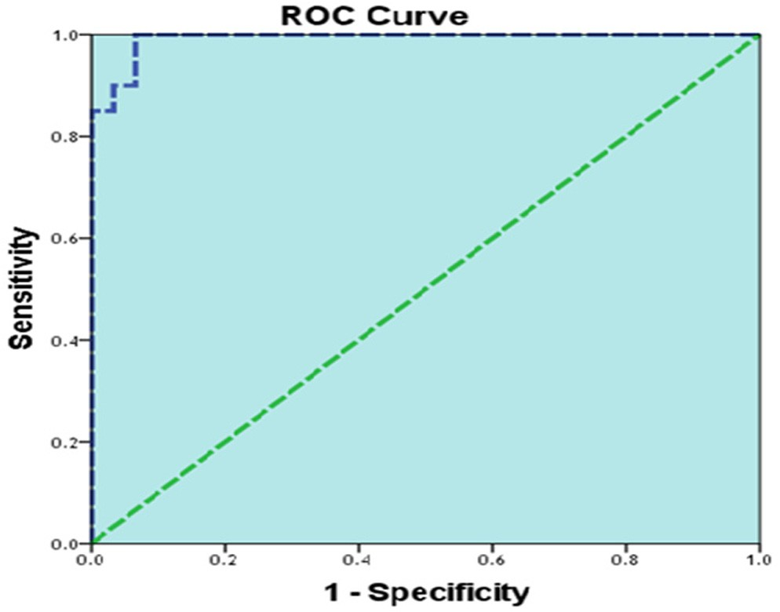

Fig. 2. ROC curve analysis for vitamin D level between the two groups.

CD4+T cells and a defect in regulatory/suppressor CD4+/CD25+ cells can explain the autoaggression of the disease [15]. The disease is known to occur with various autoimmune disorders, such as

nity [18].

Vitamin D inhibits the formation of dendritic cells which in turn reduces the activation of T-cells and the T-cells mediated immune response. Vitamin D, also acts on T-cells themselves, regulating the differentiation and activation of TH1 and TH2. It inhibits Th1 cells which produce interferon- and interleukin (IL)-2 and activates macrophages, and TH17 cells which produce IL17 and IL22 [19]. Vitamin D also increases the production of regulatory of CD4+ CD25+ regulatory T cells and enhances their inhibitory function which play a very important role in self-tolerance and therefore in prevention of autoimmunity [20]*.* Furthermore, therapeutic properties of vitamin D and its derivatives in psoriasis were noticed through its ability to inhibit the TH1 responses through inhibition of dendritic cells and activation of regulatory T cells [21]. In the current study, AA patients showed significant decrease of serum vitamin D level compared to controls. This is in agreement with other studies [5,9,22,23]. In the current study lower levels of vitamin D were more frequent in male patients in the study group. Similar to this, *d’Ovidio* et al. [9] showed that incidence of vitamin D deficiency was higher in males compared to females with AA. In contrary to our results, other studies reported that serum level of vitamin D were lower in female AA patients and controls, they explained this by the limited exposure of females to sunlight due to religious and social concerns [22,23]*.* Difference between our results and the aforementioned studies may be explained by small size of our sample and that samples were col- lected randomly throughout all year seasons, so the effect of sea-

sonal variation of vitamin D was not eliminated.

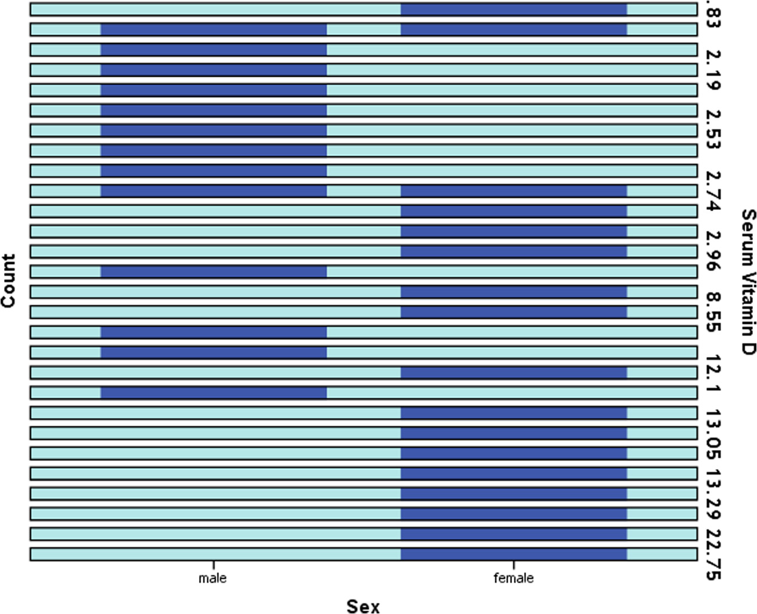

Fig. 3. Level of vitamin D in males and females of the study group.

Table 3

Distribution of SALT Score in males and females of the study group.

|  |  |  |  |  |  |  |  |  |  |  |
| --- | --- | --- | --- | --- | --- | --- | --- | --- | --- | --- |
|  | | | SALT Score |  |  |  |  |  |  | Total |
| S 1 | S 2 | S 3 | S 4 | S 5 | S 4, B | S5 B |  |
|  | Sex | Male | 3 | 4 | 1 | 2 | 1 | 0 | 2 | 13 |
|  |  | Female | 7 | 3 | 3 | 1 | 0 | 3 | 0 | 17 |
|  | Total |  | 10 | 7 | 4 | 3 | 1 | 3 | 2 | 30 |

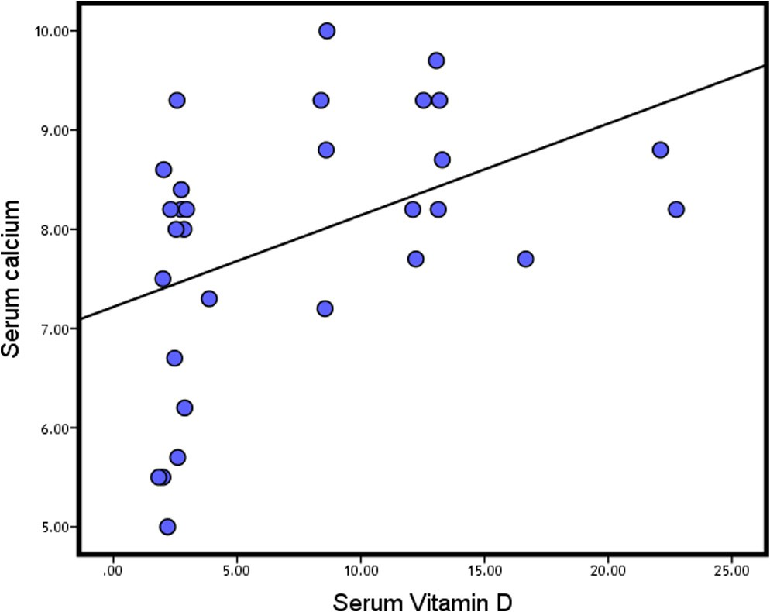

Fig. 4. Significant positive linear correlation between vitamin D levels and serum calcium levels in the study group.

Table 4

Distribution of SALT Score regarding duration of disease.

|  |  |  |  |
| --- | --- | --- | --- |
| SALT Score | Duration of disease |  | Total |
|  | Less than 6 months | More than 6 months |  |
| S 1 | 9 | 1 | 10 |
| S 2 | 5 | 2 | 7 |
| S 3 | 0 | 4 | 4 |
| S 4 | 1 | 2 | 3 |
| S 5 | 0 | 1 | 1 |
| S 4, B | 0 | 3 | 3 |
| S5 B | 0 | 2 | 2 |
|  | n = 15 | n = 15 | n = 30 |

In the present work, levels of serum Ca were significantly lower in patients compared to control group. In agreement with this, it was found that as a patient becomes vitamin D deficient, there is a decrease in intestinal Ca absorption which lowers Ca levels [24]. As regard PTH level, there was no significant difference between patient and control groups in the present work*.* Yilmaz et al. [5] found no significant difference between the AA patients and controls for PTH level. In addition, it was found that when serum 25(OH) D is low, serum PTH is relatively high, but often still in the normal range, and the increase of serum PTH is blunted in many patients as in the present study [25,26].

Regarding blood picture, the only significant difference between patients and controls was in the RBCs count which was signifi- cantly lower levels in patients. Yet, there was no significant differ- ence in serum hemoglobin concentrations between patients and controls. Regarding RBS, there was no significant difference between patient and control groups. In agreement with this *Sharma* et al. [27] *& Tan* et al. [28] stated that diabetes mellitus occur more frequently in relatives of patients with AA, rather than in AA patients themselves.

In the present study there was no significant correlation between serum vitamin D levels and either the duration or the severity of AA. Furthermore, no significant correlation was found between SALT score and vitamin D levels. This is supported by *Yil- maz* et al. [5] & *d’Ovidio* et al. [9] who found no correlation between the concentrations of 25(OH)-D, 1,25(OH)2D3 and various clinical parameters including extent of the hair loss, disease dura- tion and number of patches. Another study also found no signifi- cant differences among the patients with different patterns of hair loss and their serum concentrations of 25(OH) D [22]. In the contrary a recent study by *Cerman* et al. [23] found a significant inverse correlation between low 25(OH) D levels and severity of AA according to SALT scores.

There might be several explanations for this inconsistency between these studies. There may be methodological variations. Serum25 (OH) D exhibits great seasonal variation. The present research and that of *Yilmaz* et al. [5] were conducted on small number of cases and during summer while in *Cerman* et al. [23] study much more cases were enrolled and it was during the winter period. Second, most of the patients in the current study and that of *Yilmaz* et al. [5] consisted of patients with SALT scores <25%, making it statistically difficult to investigate the association with serum vitamin D levels.

Lastly, the number of studied patients was low. This may be due to the nature of the studied disease as the approximate prevalence of AA is 0.1% worldwide [29]. So, it is not so common disease and number of available cases coming to dermatology outpatient clinic at Mansoura University Hospital varies from time to time. In addi- tion, the selectivity of the studied group in the course of the dis- ease also decreased the number of cases. Due to strict inclusion and exclusion criteria of the study, many cases were not included. Furthermore, the high cost of the studied investigations made a limitation.

However, it is possible to extrapolate for larger group of cases. Although the study group was small; it is representative for the studied disease. It included mild, moderate and sever cases as well as different grades of scoring of AA were nearly represented in the patient group. In addition, a large group study is warranted with longer study duration, different modality of recruitment (e.g. in co-operation with other clinics), more funds and facilities as well as vigorous statistical methods.

There are some additional limitations to the present study. A subgroup with vitamin D supplementation to assess the implica- tion on disease severity and extension was not included. Finally, vitamin D levels were measured once, regardless of ethnicity, skin color or sun exposure, which may bias the results.

In conclusion, serum levels of 25(OH)D were significantly lower in patients than controls based on results of the present study on 30 AA patients in our locality. Possible efficacy of topical vitamin D analogs and systemic vitamin supplementation in the treatment of AA should be investigated thoroughly.

Conflicts of interest

We also declare that we have no conflicts of interest in connec- tion with this paper. This research did not receive any specific

grant from funding agencies in the public, commercial, or not-for- profit sectors.

References

1. [Alzolibani AA. Epidemiologic and genetic characteristics of alopecia areata](http://refhub.elsevier.com/S2314-808X(16)30186-5/h0005) [(part 1). Acta Dermatovenerol Alp Pannonica Adriat 2011;20(4):191–8](http://refhub.elsevier.com/S2314-808X(16)30186-5/h0005).
2. [Papadopoulos AJ, Schwartz RA, Janniger CK. Alopecia areata. Pathogenesis,](http://refhub.elsevier.com/S2314-808X(16)30186-5/h0010) [diagnosis, and therapy. Am J Clin Dermatol 2000;1(2):101–5](http://refhub.elsevier.com/S2314-808X(16)30186-5/h0010).
3. [Amor KT, Rashid RM, Mirmirani P. Does D matter? The role of vitamin D in hair](http://refhub.elsevier.com/S2314-808X(16)30186-5/h0015) [disorders and hair follicle cycling. Dermatol Online J 2010;16(2)](http://refhub.elsevier.com/S2314-808X(16)30186-5/h0015).
4. [Baeke F, Takiishi T, Korf H, Gysemans C, Mathieu C. Vitamin D: modulator of](http://refhub.elsevier.com/S2314-808X(16)30186-5/h0020) [the immune system. Curr Opin Pharmacol 2010;10(4):482–96](http://refhub.elsevier.com/S2314-808X(16)30186-5/h0020).
5. [Yilmaz N, Serarslan G, Gokce C. Vitamin D concentrations are decreased in](http://refhub.elsevier.com/S2314-808X(16)30186-5/h0025) [patients with alopecia areata. Vitamins Trace Elements 2012;01(03):1–4](http://refhub.elsevier.com/S2314-808X(16)30186-5/h0025).
6. [Chen CH, Sakai Y, Demay MB. Targeting expression of the human vitamin D](http://refhub.elsevier.com/S2314-808X(16)30186-5/h0030) [receptor to the keratinocytes of vitamin D receptor null mice prevents](http://refhub.elsevier.com/S2314-808X(16)30186-5/h0030) [alopecia. Endocrinology 2001;142(12):5386–9](http://refhub.elsevier.com/S2314-808X(16)30186-5/h0030).
7. [Akar A, Orkunoglu FE, Ozata M, Sengul A, Gur AR. Lack of association between](http://refhub.elsevier.com/S2314-808X(16)30186-5/h0035) [Vitamin D receptor FokI polymorphism and alopecia areata. Eur J Dermatol](http://refhub.elsevier.com/S2314-808X(16)30186-5/h0035) [2004;14(3):156–8](http://refhub.elsevier.com/S2314-808X(16)30186-5/h0035).
8. [Kennel KA, Drake MT, Hurley DL. Vitamin D deficiency in adults: when to test](http://refhub.elsevier.com/S2314-808X(16)30186-5/h0040) [and how to treat. Mayo Clin Proc 2010;85(8):752–7. quiz 757–758](http://refhub.elsevier.com/S2314-808X(16)30186-5/h0040).
9. [d’Ovidio R, Vessio M, d’Ovidio FD. Reduced level of 25-hydroxyvitamin D in](http://refhub.elsevier.com/S2314-808X(16)30186-5/h0045) [chronic/relapsing Alopecia Areata. Dermatoendocrinology 2013;5(2):271–3](http://refhub.elsevier.com/S2314-808X(16)30186-5/h0045).
10. [Antico A, Tampoia M, Tozzoli R, Bizzaro N. Can supplementation with vitamin](http://refhub.elsevier.com/S2314-808X(16)30186-5/h0050) [D reduce the risk or modify the course of autoimmune diseases? A systematic](http://refhub.elsevier.com/S2314-808X(16)30186-5/h0050) [review of the literature. Autoimmun Rev 2012;12(2):127–36](http://refhub.elsevier.com/S2314-808X(16)30186-5/h0050).
11. [Olsen EA, Hordinsky MK, Price VH, Roberts JL, Shapiro J, Canfield D, et al.](http://refhub.elsevier.com/S2314-808X(16)30186-5/h0055) [Alopecia areata investigational assessment guidelines–Part II. National](http://refhub.elsevier.com/S2314-808X(16)30186-5/h0055) [Alopecia Areata Foundation. J Am Acad Dermatol 2004;51(3):440–7](http://refhub.elsevier.com/S2314-808X(16)30186-5/h0055).
12. [Ahmed I, Nasreen S, Jehangir U, Wahid Z. Clinical spectrum of alopecia areata](http://refhub.elsevier.com/S2314-808X(16)30186-5/h0060) [and its association with thyroid dysfunction. J Pak Assoc Dermatol 2012;22](http://refhub.elsevier.com/S2314-808X(16)30186-5/h0060) [(3):207–12](http://refhub.elsevier.com/S2314-808X(16)30186-5/h0060).
13. [Mallette LE. The parathyroid polyhormones: new concepts in the spectrum of](http://refhub.elsevier.com/S2314-808X(16)30186-5/h0065) [peptide hormone action. Endocr Rev 1991;12(2):110–7](http://refhub.elsevier.com/S2314-808X(16)30186-5/h0065).
14. [Wang E, McElwee KJ. Etiopathogenesis of alopecia areata: Why do our patients](http://refhub.elsevier.com/S2314-808X(16)30186-5/h0070) [get it? Dermatol Ther 2011;24(3):337–47](http://refhub.elsevier.com/S2314-808X(16)30186-5/h0070).
15. [Freyschmidt-Paul P, Hoffmann R, McElwee KJ. Alopecia areata. In: Blume-](http://refhub.elsevier.com/S2314-808X(16)30186-5/h0075) [Peytavi U, Tosti A, Trüeb RM, editors. Hair growth and disorders. Berlin](http://refhub.elsevier.com/S2314-808X(16)30186-5/h0075) [Heidelberg: Springer; 2008. p. 311–32](http://refhub.elsevier.com/S2314-808X(16)30186-5/h0075).
16. [McElwee KJ, Gilhar A, Tobin DJ, Ramot Y, Sundberg JP, Nakamura M, et al. What](http://refhub.elsevier.com/S2314-808X(16)30186-5/h0080) [causes alopecia areata? Exp Dermatol 2013;22(9):609–26](http://refhub.elsevier.com/S2314-808X(16)30186-5/h0080).
17. [Hewison M. An update on vitamin D and human immunity. Clin Endocrinol](http://refhub.elsevier.com/S2314-808X(16)30186-5/h0085) [(Oxf) 2012;76(3):315–25](http://refhub.elsevier.com/S2314-808X(16)30186-5/h0085).
18. [Arnson Y, Amital H, Shoenfeld Y. Vitamin D and autoimmunity: new](http://refhub.elsevier.com/S2314-808X(16)30186-5/h0090) [aetiological and therapeutic considerations. Ann Rheum Dis 2007;66](http://refhub.elsevier.com/S2314-808X(16)30186-5/h0090) [(9):1137–42](http://refhub.elsevier.com/S2314-808X(16)30186-5/h0090).
19. [Oyoshi MK, He R, Kumar L, Yoon J, Geha RS. Cellular and molecular](http://refhub.elsevier.com/S2314-808X(16)30186-5/h0095) [mechanisms in atopic dermatitis. Adv Immunol 2009;102:135–226](http://refhub.elsevier.com/S2314-808X(16)30186-5/h0095).
20. [Gorman S, Kuritzky LA, Judge MA, Dixon KM, McGlade JP, Mason RS, et al.](http://refhub.elsevier.com/S2314-808X(16)30186-5/h0100) [Topically applied 1,25-dihydroxyvitamin D3 enhances the suppressive activity](http://refhub.elsevier.com/S2314-808X(16)30186-5/h0100) [of CD4+CD25+ cells in the draining lymph nodes. J Immunol 2007;179](http://refhub.elsevier.com/S2314-808X(16)30186-5/h0100) [(9):6273–83](http://refhub.elsevier.com/S2314-808X(16)30186-5/h0100).
21. [Penna G, Roncari A, Amuchastegui S, Daniel KC, Berti E, Colonna M, et al.](http://refhub.elsevier.com/S2314-808X(16)30186-5/h0105) [Expression of the inhibitory receptor ILT3 on dendritic cells is dispensable for](http://refhub.elsevier.com/S2314-808X(16)30186-5/h0105) [induction of CD4+Foxp3+ regulatory T cells by 1,25-dihydroxyvitamin D3.](http://refhub.elsevier.com/S2314-808X(16)30186-5/h0105) [Blood 2005;106(10):3490–7](http://refhub.elsevier.com/S2314-808X(16)30186-5/h0105).
22. [Nassiri S, Saffarian Z, Younespour S. Association of vitamin D level with](http://refhub.elsevier.com/S2314-808X(16)30186-5/h0110) [alopecia areata. Iran J Dermatol 2013;16(1):1–5](http://refhub.elsevier.com/S2314-808X(16)30186-5/h0110).
23. [Cerman AA, Solak SS, Altunay IK. Vitamin D deficiency in alopecia areata. Br J](http://refhub.elsevier.com/S2314-808X(16)30186-5/h0115) [Dermatol 2014;170(6):1299–304](http://refhub.elsevier.com/S2314-808X(16)30186-5/h0115).
24. [Holick MF. Vitamin D deficiency. N Engl J Med 2007;357(3):266–81](http://refhub.elsevier.com/S2314-808X(16)30186-5/h0120).
25. [Lips P. Relative value of 25(OH)D and 1,25(OH)2D measurements. J Bone Miner](http://refhub.elsevier.com/S2314-808X(16)30186-5/h0125) [Res 2007;22(11):1668–71](http://refhub.elsevier.com/S2314-808X(16)30186-5/h0125).
26. [Bouillon R, Van Schoor NM, Gielen E, Boonen S, Mathieu C, Vanderschueren D,](http://refhub.elsevier.com/S2314-808X(16)30186-5/h0130) [et al. Optimal vitamin D status: a critical analysis on the basis of evidence-](http://refhub.elsevier.com/S2314-808X(16)30186-5/h0130) [based medicine. J Clin Endocrinol Metabolism 2013;98(8):E1283–304](http://refhub.elsevier.com/S2314-808X(16)30186-5/h0130).
27. [Sharma VK, Dawn G, Kumar B. Profile of alopecia areata in Northern India. Int J](http://refhub.elsevier.com/S2314-808X(16)30186-5/h0135) [Dermatol 1996;35(1):22–7](http://refhub.elsevier.com/S2314-808X(16)30186-5/h0135).
28. [Tan E, Tay YK, Goh CL, Chin Giam Y. The pattern and profile of alopecia areata](http://refhub.elsevier.com/S2314-808X(16)30186-5/h0140) [in Singapore–a study of 219 Asians. Int J Dermatol 2002;41(11):748–53](http://refhub.elsevier.com/S2314-808X(16)30186-5/h0140).
29. [Jabbari A, Petukhova L, Cabral RM, Clynes R, Christiano AM. Genetic basis of](http://refhub.elsevier.com/S2314-808X(16)30186-5/h0145) [alopecia areata: a roadmap for translational research. Dermatol Clin 2013;31](http://refhub.elsevier.com/S2314-808X(16)30186-5/h0145) [(1):109–17](http://refhub.elsevier.com/S2314-808X(16)30186-5/h0145).