HOSTE D BY

Available online at [www.sciencedirect.com](http://www.sciencedirect.com/science/journal/2314808X)

ScienceDirect

journal homepage: <http://ees.elsevier.com/ejbas/default.asp>

[e g ypti an j o ur nal o f b a sic and a pp l i e d sci en c e s 2 ( 201 5 ) 229](http://dx.doi.org/10.1016/j.ejbas.2015.05.002) e[23](http://dx.doi.org/10.1016/j.ejbas.2015.05.002) 5



Full Length Article

Shifted Chebyshev wavelet-quasilinearization technique for MHD squeezing flow between two infinite plates and JefferyeHamel flows



*Muhammad Asad Iqbal, Umar Khan, Ayyaz Ali, Syed Tauseef Mohyud-Din*\*

*Department of Mathematics, Faculty of Sciences, HITEC University Taxila, Pakistan*

## a r t i c l e i n f o

*Article history:*

Received 13 November 2014 Received in revised form

9 April 2015

Accepted 4 May 2015

Available online 9 July 2015

*MSC:*

35Q79

42C15

39B9

*Keywords:*

MHD flow

Chebyshev wavelets method Quasilinearization technique JefferyeHamel flow Numerical solution

## a b s t r a c t

In this article, shifted Chebyshev wavelets method is merged with quasilinearization technique to tackle with the nonlinearity of physical problems. The accuracy of the pro- posed method is verified by the help of two nonlinear physical models, one MHD squeezing flow between two infinite plates and other JefferyeHamel flow that is obtained using proper similarity transforms. Numerical solution is also sought using RungeeKutta order 4 method. Results obtained for different iterations and different values of degree of poly- nomial are described in tables and graphs which verify the accuracy and stability of the proposed method.

Copyright 2015, Mansoura University. Production and hosting by Elsevier B.V. This is an open access article under the CC BY-NC-ND license ([http://creativecommons.org/licenses/](http://creativecommons.org/licenses/by-nc-nd/4.„0/)

[by-nc-nd/4.0/](http://creativecommons.org/licenses/by-nc-nd/4.„0/)).

# Introduction

After the pioneering works of Stefan [1], squeezing flows have been of much interest to the researchers due to their many practical and industrial applications. Many mechanical equipment work under the principle of moving pistons where

two plates exhibit squeezing moment normal to their own surfaces. Electric motors, engines and hydraulic lifters also have this squeezing flow in some of their parts. Its biological applications are also of equal importance. Flow inside sy- ringes and nasogastric tube is also a kind of squeezing flows. One can find more than enough literature on these flows in

* *Corresponding author*.

E-mail address: [syedtauseefs@hotmail.com](mailto:syedtauseefs@hotmail.com) (S.T. Mohyud-Din).

Peer review under responsibility of Mansoura University. <http://dx.doi.org/10.1016/j.ejbas.2015.05.002>

2314-808X/Copyright 2015, Mansoura University. Production and hosting by Elsevier B.V. This is an open access article under the CC BY- NC-ND license ([http://creativecommons.org/licenses/by-nc-nd/4.0/](http://creativecommons.org/licenses/by-nc-nd/4.„0/)).

230 [e gypti an j o ur nal o f b a sic and a p p l i ed sci e n c e s 2 ( 201 5 ) 229](http://dx.doi.org/10.1016/j.ejbas.2015.05.002) e[23](http://dx.doi.org/10.1016/j.ejbas.2015.05.002) 5

Refs. [2,3] and references therein. Electrically conducting flows are also very important as a slight change in magnetic field

r v*V* + (*V*$V)*V* = V$*T* — *f* , (2.2)

may cause to flow to disperse or often to go smoothly for some v*t B*

time. It was therefore essential to discuss the flow under the

influence of magnetic field to see how it affects the flow behavior. Refs. [4](#_bookmark26)e[6] studied the effects of magnetic field on squeezing flow for different geometries and pointed out some important aspects of these flows.

Flows through nonparallel walls gain importance in early 19th century after the pioneering works of Jeffery [7] and Hamel [8]. Since then, there are many studies available that discussed the different practical and industrial applications of these flows and reported that flow characteristics vary by changing the angle between two channels [9](#_bookmark29)e[11]. Flows through rivers and channels, different biological flows such as flow through arteries and veins are some practical applica- tions of these types of flows. Due to nonlinearity of the

where *V* is velocity vector, r density constant and *T* is the

Cauchy Stress tensor given by,

*T* = —r*I* + *A*1,

where *A*1 = (V*V*)+ (V*V*)T.

While *fB* is a source term arising due to applied magnetic

field, i.e., the so called magnetic or Lorentz force. This force is known to be a function of the imposed magnetic field *B*, the induced electric field *E* and the fluid velocity vector *V*, that is

*f B* = s(*E* + *V*\**V*)\**B*.

Detailed derivation of the considered model is discussed in

Ref. [23]. Using compatibility equation

problems involved in fluid mechanics, exact solutions are

2 3

J,

unlikely. Many numerical and analytical techniques are available to solve these problems [12](#_bookmark30)e[15].

*r*

v*t*

v(*r*, *z*)

*r*

m

Wavelet methods are also one of the relatively new tech-

1 v*E*2J v

r4 —

*E*2 J

*r*2

5 = *E*4J — s

*B*2 vJ

*r*

v*z*

, (2.3)

niques for obtaining approximate solutions of differential

0

equations. Commonly used wavelet schemes are Haar wave- lets, Legendre wavelets and Chebyshev wavelets. Islam et al. used Haar wavelet collocation method for obtaining the nu- merical solutions of boundary layer flow problem [17] and Hariharan applied Haar wavelet method for solving Sine- Gordon and KleineGordon equations [18]. Rawashdeh imple-

*r*2

mented Legendre wavelet method to obtain solution of frac-

where

v2 1 v v2

*E* = —  + = 0,

2

v*r*2 *r* v*r* v*z*2

from Eq. (2.3), after simplification we get

2v J, *E*2 J 3

0

m

4

*B*2 vJ

tional integro-differential equations [16]. Ali et al. used

—r4

v(*r*, *z*)

5 = *r E* J — s *r*

, (2.4)

v*z*

Chebyshev wavelets to obtain solutions for linear and

nonlinear boundary value problems [19]. Iqbal et al. obtained solutions for fractional delay differential equations using Chebyshev wavelets [20]. Since the models for which we are approximating solutions are of nonlinear in nature, so for better results we are also using quasilinearization technique. The quasilinearization technique was first introduced by Bellman and Kalaba [21] as a generalization of the New- toneRaphson method [22] to tackle the single or systems of

nonlinear ordinary or partial differential equations.

The proposed method formed by merging Chebyshev wavelets method with quasilinearization technique is fully

with associated auxiliary conditions

*z* = *H*, then *u* = 0, *w* = —*V*, (2.5a)

*z* = 0, then *w* = 0, v*u* = 0. (2.5b)

v*z*

We can now define stream function as

J(*r*, *z*)= *r*2*f* (*z*). (2.6)

Replacing value from Eq. (2.6) into Eq. (2.4) reduces Eq. (2.4)

into a nonlinear ordinary differential equation

compatible for solving such nonlinear physical models. To the best of our knowledge, this is the first article on Chebyshev

wavelet methods in fluid mechanics. Two non-linear prob-

*f* iv

2r

(*z*) +

m

*f* (*z*)*f*

'''

s*B*2

(*z*) — 0*f* (*z*)= 0. (2.7)

''

m*r*

lems are taken into account. A well-known numerical method RungeeKutta order 4 method is used to solve the same prob- lems. Comparison is made among the solutions to verify the accuracy of the proposed solutions.

Subject to the boundary conditions

*f* (0)= 0, *f* (0)= 0,

''

*V*

*f* (*H*)=

, *f* '(*H*)= 0. (2.8)

2

# Mathematical formulation

Nonlinear differential equation in Eq. (2.7) along with bound-

ary conditions in Eq. (2.8) can be made dimensionless by using the following non-dimensional parameters

### *MHD squeezing flow between two infinite plates*

The equations of motion for the flow are given by [23],

*f*

*F* = , *x* =

*V*/2

*z*

*H*, *Re* =

r*H*

m/*V*

, *M* =

s*HB*2

0, (2.9)

s ﬃﬃﬃﬃﬃﬃﬃﬃﬃﬃ**ﬃ**

m

V$*V* = 0, (2.1)

*F*iv(*x*)+ *Re F*(*x*)*F*''' (*x*)— *M*2*F*'' (*x*)= 0, (2.10)

with boundary conditions converted into the form

[e g ypti an j o ur nal o f b a sic and a pp l i e d sci en c e s 2 ( 201 5 ) 229](http://dx.doi.org/10.1016/j.ejbas.2015.05.002) e[23](http://dx.doi.org/10.1016/j.ejbas.2015.05.002) 5

231

*F*(0)= 0, *F*'' (0)= 0, *F*(1)= 1, *F*'(1)= 0.

### *Jeffery*e*Hamel flows*

For the flow of an incompressible viscous fluid due to either a source or a sink that is present at the intersection of two rigid, nonparallel plane walls; angle between walls is 2a as shown in Fig. A. Flow is assumed to be symmetric and purely radial. These assumptions mean that the velocity field is of the form

*V* = [*ur*, 0, 0], where m*r* is a function of both *r* and q.

From Eqs. (2.12) and (2.13) after eliminating pressure terms and using Eqs. (2.15) and (2.16), we get a nonlinear ordinary differential equation for normalized velocity profile *F*(*x*)

*F*''' (*x*) + 2a*ReF*(*x*)*F*'(*x*) + 4a2*F*'(*x*) = 0. (2.17)

Accordingly the boundary conditions (2.14) are

*F*(0)= 1, *F*'(0)= 0, *F*(1)= 0, (2.18)

where *Re* is Reynolds number given by

*Re* = *f*max = *U*max*r*a Divergent Channel : a > 0, *U*max > 0 ,

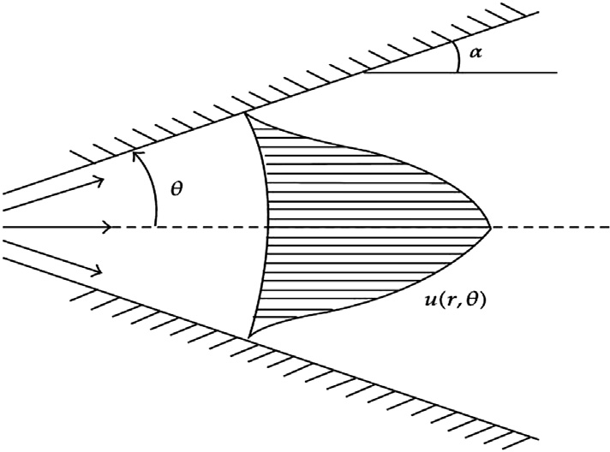*v v* Convergent Channel : a < 0, *U*max < 0

(2.19)

*U*max here is center line velocity.

# Shifted Chebyshev wavelets

In the present work, we use the shifted Chebyshev poly- nomials on [*a*,*b*], so the shifted Chebyshev nodes are

*x* = *b* — *a* cos (2*k* + 1)p + *a* + *b*, *k* = 0, 1, 2, …, *M* — 1,

Fig. A e Schematic diagram of the problem.

In polar coordinates equations of motion in the absence of body forces given in Ref. [24] are

1 v

*r* v*r* (*rur*)= 0, (2.11)

*k* 2 2*M* 2

where *a* and *b* are real numbers with *a* < *b*. The shifted Che- byshev polynomials *Tm*(*x*) of order *m* are defined on the in- terval [*a*,*b*] and are given by the following recurrence formulae,

2*x* — (*b* + *a*)

*T*0(*x*)= 1, *T*1(*x*)= *b* — *a* , *Tm*+1(*x*)

*r* + *v*

v*r*2 + *r*

v*r* + *r*2

vq2 — *r*2

, (2.12)

= 2

*Tm*(*x*)— *Tm*—1(*x*), *m* = 1, 2, 3, ….

v*ur*

*ur* =—

v*r* r v

*b* — *a*

1 v*p*

v2*ur*

1 v*ur*

1 v2*ur*

*ur*

2*x* — (*b* + *a*)

1 v*p* 2*v* v*ur*

— + = 0, (2.13)

The orthogonality conditions is

*pr* v*r r*2 vq

Z*b* 1

8>< 0, *m*s*n*;

where r, is constant density; m, is dynamic viscosity and *p* is

*a*

1 —

2*x*—(*b*+*a*)

*b*—*a*

2

pressure.

Boundary condition at the center line of the channel is

sﬃﬃﬃﬃﬃﬃﬃﬃﬃ ﬃﬃﬃﬃﬃﬃﬃﬃﬃﬃﬃﬃﬃﬃﬃﬃﬃﬃ ﬃﬃﬃ *Tm*(*x*)*Tn*(*x*)d*x* = >: *b* — *a* p, *m* = *n*.

8>><

j*n*,*m*(*x*)=

*k* sﬃﬃﬃﬃﬃﬃﬃﬃ4ﬃﬃﬃﬃﬃﬃﬃﬃﬃﬃ *k*

Shifted Chebyshev wavelets defined on the interval [*a*,*b*] as2

*n*b *n*b + 1

2

2

(3.1)

22 (*b* — *a*

)p

*Tm* 2 *x* — *n*b , *a* + (*b* — *a*)

*k* ≤ *x* ≤ *a* + (*b* — *a*) *k* ,

>>: 0, otherwise

v*ur* = 0, (2.14)

vq

and on the walls are *ur* = 0.

From continuity equation (2.11), we have

*k* = 1,2,3,…, is the level of resolution, *n* = 1,2,3,…,2*k*—1 is the translation parameter, *m* = 1,2,3,…,*M* — 1 is the order of the Chebyshev polynomials, *M* > 0. The solution obtained by

Chebyshev wavelets is of the form

*f* (q)= *rur*. (2.15) ∞ ∞

X X

For making equations dimensionless parameters are defined as

*y*(*x*)= *cn*,*m*j*n*,*m*(*x*),

*n*=1 *m*=0

where j*n*,*m*(*x*) is given by equation (3.1). We approximate *y*(*x*)

*f* (q)

*F*(*x*) =

*f*

max

q

, *x* = . (2.16)

a

by the truncated series

232 [e gypti an j o ur nal o f b a sic and a p p l i ed sci e n c e s 2 ( 201 5 ) 229](http://dx.doi.org/10.1016/j.ejbas.2015.05.002) e[23](http://dx.doi.org/10.1016/j.ejbas.2015.05.002) 5

2*k*—1 *M*—1

X X

*y*(*x*)= *cn*,*m*j*n*,*m* (*x*). (3.2)

*n*=1 *m*=0

Then a total number of conditions 2*k*—1*M* should exist for determination of 2*k*—1*M* coefficients *c*10, *c*11, …, *c*1*M*—1, *c*20, *c*21, …, *c*2*M*—1, …, *c*2*k*—10, *c*2*k*—11, …, *c*2*k*—1 *M*—1.

Some conditions are furnished by the initial or boundary

conditions, while for remaining conditions we replace *yK*,*M* in our differential equation to recover the unknown coefficients *cn*,*m*.

# Quasilinearization

The quasilinearization [25,26] approach is a generalized NewtoneRaphson technique for differential equations. The quasilinearization technique converges quadratically to the exact solution if there is convergence at all and it has mono- tone convergence.

Consider a nonlinear second order differential

*y* (*x*)= *f* (*y*(*x*), *x*) (4.1)

''

with the boundary conditions

### *Convergence of quasilinearization technique*

The convergence of quasilinearization technique is derived and discussed in Ref. [25] which shows that the convergence of quasilinearization technique is second order if there is convergence at all.

### *Convergence of Chebyshev wavelets method*

The convergence of Chebyshev wavelets method is derived in Ref. [20] which shows that the series solution by Chebyshev wavelets method converges to *y*(*x*) for differential equation of any order.

# Solution procedure

### *For MHD squeezing flow between two infinite plates*

Differential equation of MHD squeezing flow (2.10) after applying quasilineariztion technique becomes

d4 d3 d3

d*x*4 *Fn*+1(*x*)+ *ReFn*(*x*) d*x*3 *Fn*+1(*x*)+ *ReFn*+1(*x*) d*x*3 *Fn*(*x*)

*y*(*a*) = a and *y*(*b*) = b, *a* ≤ *x* ≤ *b*, (4.2)

where *f* may be a function of *x* or *y*(*x*). Let *y*0(*x*), be an initial

— *M*2

d2 d*x*2

*Fn*+1(*x*)= *ReFn*(*x*)

d3 d*x*3

*Fn*(*x*), (6.1)

approximation of the function *y*(*x*). The Taylor's series expansion of *f* about *y*0(*x*) is

with boundary conditions converted into the form

*f* (*y*(*x*), *x*)= *f y*0(*x*), *x* + *y*(*x*)— *y*0(*x*) *fy y*0(*x*), *x*

0

+ *O* *y*(*x*)— *y* (*x*) 2 . (4.3)

0

*Fn*+1(0)= 0,

d2

d*x*2 *Fn*+1(0)= 0, *Fn*+1(1)= 1,

d *F* (1)= 0.

d*x n*+1

Ignoring second and higher order terms and replacing in Eq. (4.1), we get

*y*'' (*x*)= *f y* (*x*), *x* + *y*(*x*)— *y* (*x*) *f y* (*x*), *x* (4.4) solving Eq. (4.4) and calling answer *y*1(*x*). Using *y*1(*x*) and again

0

0

*y*0

0

expanding Eq. (4.1) about *y*1(*x*), we have

For applying Chebyshev wavelets technique now substitute,

2*k*—1 *M*—1

X X

*Fn*+1(*x*)= *cn*,*m*j*n*,*m*(*x*)

*n*=1 *m*=0

Eq. (6.1) becomes (see Tables 1 and 2, Figs. 1 and 2),

'' ! !

*y* (*x*)= *f y*1(*x*), *x*

after simplification we get *y*2(*x*), second approximation to *y*(*x*).

*n*=1 *m*=0

*n*=1 *m*=0

+ *y*(*x*)— *y*1(*x*) *fy*1 *y*1(*x*), *x*

(4.5)

d4 2*k*—1 *M*—1

*c* j

X X

d*x*4

*n*,*m*

*n*,*m*

(*x*)

d3

+ *ReF* (*x*)

*n*

d*x*3

2*k*—1 *M*—1

*c* j

X X

*n*,*m*

*n*,*m*

(*x*)

Continuing this process we obtain the desired accuracy if the

X2*k*—1 *M*X—1 ! d3

d2 X2*k*—1 *M*X—1 ! d3

problem converges. Generally we can write the recurrence

relation in the following form

+ *Re*

*n*=1 *m*=0

*cn*,*m* j*n*,*m* (*x*)

d*x*3 *Fn*(*x*)

2

'' (*x*)= *f* *y* (*x*), *x* + *y*(*x*)— *y* (*x*) *f*

*y*

*n*+1

*n*

*n*

*yn*

*n*

*n*=1 *m*=0

*y* (*x*), *x* (4.6)

— *M* d*x*2

*cn*,*m* j*n*,*m* (*x*)

= *ReFn*(*x*) d*x*3 *Fn*(*x*).

in which *yn*(*x*) is known and after solving we get *yn*+1(*x*). The

*yn*+1(*a*)= a and *yn*+1(*b*)= b. Same procedure can be applied on boundary condition in (4.2) is also converted into the form other higher order nonlinear problems also.

### *For Jeffery*e*Hamel flow*

(6.2)

Eq. (2.17) representing JefferyeHamel flow after applying quasilinearization becomes,

1. Convergence analysis d3 d d

d*x*3 *Fn*+1(*x*)+ 2a*ReFn*+1(*x*) d*x Fn*(*x*)+ 2a*ReFn*(*x*) d*x Fn*+1(*x*)

(6.3)

Since we are using both quasilinearization technique and Chebyshev wavelets method so we discuss the convergence

+ 4a2 d *F*

d*x n*+1

d

(*x*) = 2a*ReFn*(*x*) d*x Fn*(*x*).

for both of these. Accordingly the boundary conditions are converted into

[e g ypti an j o ur nal o f b a sic and a pp l i e d sci en c e s 2 ( 201 5 ) 229](http://dx.doi.org/10.1016/j.ejbas.2015.05.002) e[23](http://dx.doi.org/10.1016/j.ejbas.2015.05.002) 5

233

|  |  |  |  |  |  |  |  |
| --- | --- | --- | --- | --- | --- | --- | --- |
| Table 1 e Comparison of solutions for MHD squeezing flow (6.2) for M ¼ 1 and Re ¼ 1, for different polynomial values of proposed method with RK-4. | | | | | | | |
| *x* | *ym*=5 | *ym*=10 | *ym*=15 | *y*RK-4 | Error at *ym*=5 | Error at *ym*=10 | Error at *ym*=15 |
| 0.0 | 0.000000 | 0.000000 | 0.000000 | 0.000000 | 8.8356E—10 | 2.0000E—13 | 2.0000E—17 |
| 0.1 | 0.179073 | 0.149529 | 0.150294 | 0.150294 | 2.8779E—02 | 7.6409E—04 | 9.7110E—07 |
| 0.2 | 0.350522 | 0.296018 | 0.297481 | 0.297481 | 5.3041E—02 | 1.4620E—03 | 1.0152E—06 |
| 0.3 | 0.508061 | 0.436441 | 0.438468 | 0.438468 | 6.9594E—02 | 2.0258E—03 | 1.5166E—06 |
| 0.4 | 0.646863 | 0.567797 | 0.570190 | 0.570190 | 7.6674E—02 | 2.3914E—03 | 2.0176E—06 |
| 0.5 | 0.763564 | 0.687121 | 0.689626 | 0.689626 | 7.3940E—02 | 2.5020E—03 | 2.2772E—06 |
| 0.6 | 0.856258 | 0.791478 | 0.793798 | 0.793798 | 6.2462E—02 | 2.3179E—03 | 2.4621E—06 |
| 0.7 | 0.924503 | 0.877942 | 0.879781 | 0.879781 | 4.4724E—02 | 1.8369E—03 | 2.7129E—06 |
| 0.8 | 0.969314 | 0.943567 | 0.944697 | 0.944697 | 2.4618E—02 | 1.1287E—03 | 1.6322E—06 |
| 0.9 | 0.993167 | 0.985322 | 0.985707 | 0.985707 | 7.4602E—03 | 3.8448E—04 | 5.7870E—07 |
| 1.0 | 1.000000 | 1.000000 | 1.000000 | 1.000000 | 1.0250E—06 | 2.3752E—10 | 6.7291E—13 |

|  |  |  |  |  |  |  |  |
| --- | --- | --- | --- | --- | --- | --- | --- |
| Table 2 e Comparison of solutions for MHD squeezing flow (6.2) when M ¼ 5 and Re ¼ 5, for different polynomial values of proposed method with RK-4. | | | | | | | |
| *x* | *ym*=5 | *ym*=10 | *ym*=20 | *y*RK-4 | Error at *ym*=5 | Error at *ym*=10 | Error at *ym*=20 |
| 0.0 | 0.000000 | 0.000000 | 0.000000 | 0.000000 | 1.5195E—12 | 3.0000E—14 | 2.0000E—17 |
| 0.1 | 0.139490 | 0.124266 | 0.131396 | 0.131398 | 8.0912E—03 | 7.1321E—04 | 2.5254E—06 |
| 0.2 | 0.277545 | 0.247984 | 0.261827 | 0.261830 | 1.5712E—02 | 2.3848E—03 | 5.5279E—06 |
| 0.3 | 0.412278 | 0.370508 | 0.390154 | 0.390153 | 2.2116E—02 | 5.9653E—03 | 7.6114E—06 |
| 0.4 | 0.541307 | 0.490960 | 0.514882 | 0.514878 | 2.6415E—02 | 2.3931E—02 | 9.0962E—05 |
| 0.5 | 0.661754 | 0.608014 | 0.633961 | 0.633959 | 2.7782E—02 | 2.5957E—02 | 1.0881E—05 |
| 0.6 | 0.770250 | 0.719551 | 0.744547 | 0.744549 | 2.5691E—02 | 5.5007E—03 | 1.1488E—05 |
| 0.7 | 0.862929 | 0.822111 | 0.842734 | 0.842736 | 2.0183E—02 | 3.0634E—03 | 1.1001E—05 |
| 0.8 | 0.935432 | 0.910033 | 0.923211 | 0.923213 | 1.2212E—02 | 2.3186E—03 | 8.5481E—06 |
| 0.9 | 0.982904 | 0.974168 | 0.978825 | 0.978827 | 4.0748E—03 | 4.6613E—04 | 4.7314E—06 |
| 1.0 | 0.999997 | 0.999999 | 1.000000 | 1.000000 | 3.0000E—06 | 1.0000E—06 | 3.0000E—09 |

*F* 0 1 d *F* 0

*n*+1( )= ,

d*x*

*n*+1( )= ,

0 *F* 1 0

*n*+1( )= .

d*x*3

d*x*

d3 X2*k*—1 *M*X—1

! X2*k*—1 *M*X—1 ! d

For applying Chebyshev wavelets technique now substitute,

*n*=1 *m*=0

*cn*,*m*j*n*,*m*(*x*)

+ 2a*Re*

*n*=1 *m*=0

*cn*,*m*j*n*,*m*(*x*)

*Fn*(*x*)

X X

+ 2a*ReFn*(*x*)

d X2*k*—1 *M*X—1

*cn*,*m* j*n*,*m* (*x*)!

2*k*—1 *M*—1

X X

d*x n*=1 *m*=0

*Fn*+1(*x*)= *cn*,*m*j*n*,*m* (*x*).

*n*=1 *m*=0

Eq. (6.3) becomes (see Tables 3 and 4, Figs. 3 and 4)

+ 4a2

d 2*k*—1 *M*—1

d*x n*=1 *m*=0

*cn*,*m*j*n*,*m*(*x*)!

= 2a*ReFn*(*x*)

d*x Fn*(*x*). d

(6.4)

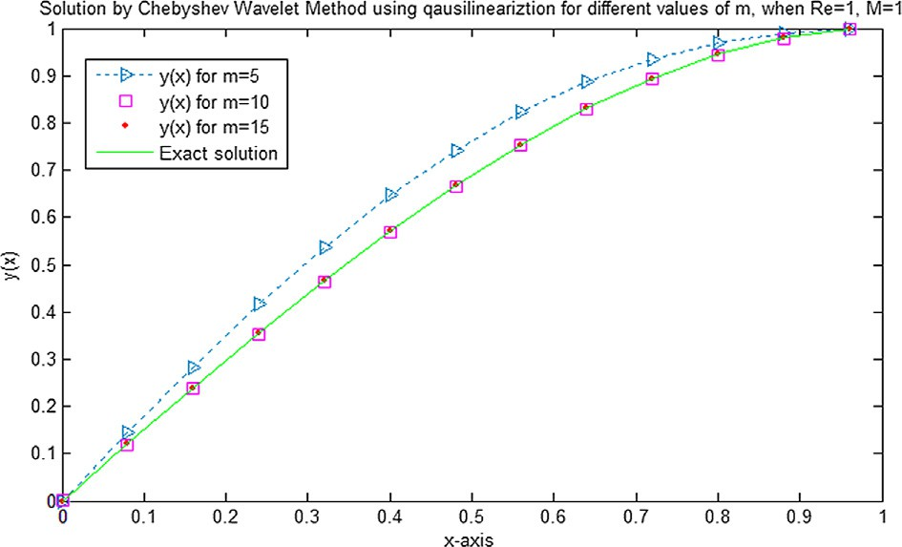 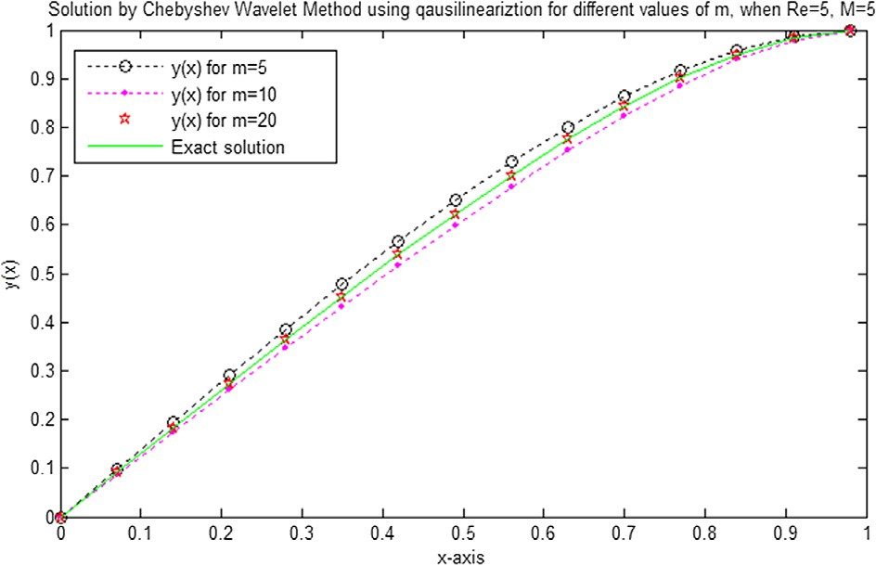

Fig. 1 e Comparison of MHD squeezing flow solutions when M ¼ 1 and Re ¼ 1 for different values of m for proposed method with RK-4.

Fig. 2 e Comparison of MHD squeezing flow solutions when M ¼ 1 and Re ¼ 1 for different values of m for proposed method with RK-4.

234 [e gypti an j o ur nal o f b a sic and a p p l i ed sci e n c e s 2 ( 201 5 ) 229](http://dx.doi.org/10.1016/j.ejbas.2015.05.002) e[23](http://dx.doi.org/10.1016/j.ejbas.2015.05.002) 5

|  |  |  |  |  |  |  |  |
| --- | --- | --- | --- | --- | --- | --- | --- |
| Table 3 e Comparison of solutions for JefferyeHamel flow (6.4) when a ¼ 3 and Re ¼ 10 (diverging channel), for different polynomial values of proposed method with RK-4. | | | | | | | |
| *x* | *ym*=5 | *ym*=10 | *ym*=15 | *y*RK-4 | Error at *ym*=5 | Error at *ym*=10 | Error at *ym*=15 |
| 0.0 | 1.00000000 | 1.00000000 | 1.00000000 | 1.000000 | 0.0000E+00 | 8.0000E—15 | 0.0000E+00 |
| 0.1 | 0.99157877 | 0.98926632 | 0.98927742 | 0.989277 | 2.3017E—03 | 1.0674E—05 | 4.2882E—07 |
| 0.2 | 0.96567510 | 0.95717777 | 0.95722187 | 0.957222 | 8.4531E—03 | 4.4222E—05 | 1.2284E—07 |
| 0.3 | 0.92129433 | 0.90406280 | 0.90416150 | 0.904162 | 1.7132E—02 | 9.9194E—05 | 4.9197E—07 |
| 0.4 | 0.85739549 | 0.83044063 | 0.83061596 | 0.830616 | 2.6779E—02 | 1.7536E—04 | 3.1634E—08 |
| 0.5 | 0.77289138 | 0.73698202 | 0.73725696 | 0.737257 | 3.5634E—02 | 2.7497E—04 | 3.5067E—08 |
| 0.6 | 0.66664851 | 0.62445984 | 0.62485587 | 0.624856 | 4.1792E—02 | 3.9615E—04 | 1.2573E—07 |
| 0.7 | 0.53748710 | 0.49369572 | 0.49422070 | 0.494221 | 4.3266E—02 | 5.2527E—04 | 2.9941E—07 |
| 0.8 | 0.38418113 | 0.34551120 | 0.34612473 | 0.346125 | 3.8056E—02 | 6.1379E—04 | 2.6389E—07 |
| 0.9 | 0.20545829 | 0.18069489 | 0.18122899 | 0.181229 | 2.4229E—02 | 5.3410E—04 | 2.0706E—09 |
| 1.0 | 0.00000000 | 0.00000000 | 0.00000000 | 0.000000 | 2.0797E—09 | 1.0512E—11 | 2.5103E—15 |

|  |  |  |  |  |  |  |  |
| --- | --- | --- | --- | --- | --- | --- | --- |
| Table 4 e Comparison of solutions for JefferyeHamel Flow (6.4) when a ¼ ¡15 and Re ¼ 50 (converging channel), for different polynomial values of proposed method with RK-4. | | | | | | | |
| *x* | *ym*=5 | *ym*=10 | *ym*=20 | *y*RK-4 | Error at *ym*=5 | Error at *ym*=10 | Error at *ym*=20 |
| 0.0 | 1.000000 | 1.000000 | 1.000000 | 1.00000 | 0.0000E+00 | 1.0000E—15 | 0.0000E+00 |
| 0.1 | 0.995146 | 0.994182 | 0.994204 | 0.994204 | 9.4273E—04 | 2.1705E—05 | 2.1293E—07 |
| 0.2 | 0.979819 | 0.976258 | 0.976335 | 0.976335 | 3.4846E—03 | 7.6169E—05 | 1.1514E—10 |
| 0.3 | 0.952012 | 0.944758 | 0.944924 | 0.944925 | 7.0877E—03 | 1.6684E—04 | 2.4876E—08 |
| 0.4 | 0.908579 | 0.897127 | 0.897461 | 0.898461 | 1.1118E—02 | 3.3309E—04 | 4.8795E—07 |
| 0.5 | 0.845234 | 0.829676 | 0.830308 | 0.830309 | 1.4925E—02 | 6.3271E—04 | 2.1740E—07 |
| 0.6 | 0.756551 | 0.737579 | 0.738653 | 0.738653 | 1.7898E—02 | 1.0734E—03 | 5.2853E—07 |
| 0.7 | 0.635962 | 0.615016 | 0.616549 | 0.616549 | 1.9413E—02 | 1.5325E—03 | 9.1173E—07 |
| 0.8 | 0.475762 | 0.455492 | 0.457191 | 0.457191 | 1.8571E—02 | 1.6981E—03 | 8.0688E—07 |
| 0.9 | 0.267103 | 0.252419 | 0.253604 | 0.253604 | 1.3500E—02 | 1.1832E—03 | 1.2011E—06 |
| 1.0 | 0.000000 | 0.000000 | 0.000000 | 0.000000 | 1.0000E—07 | 2.0000E—10 | 1.0000E—16 |

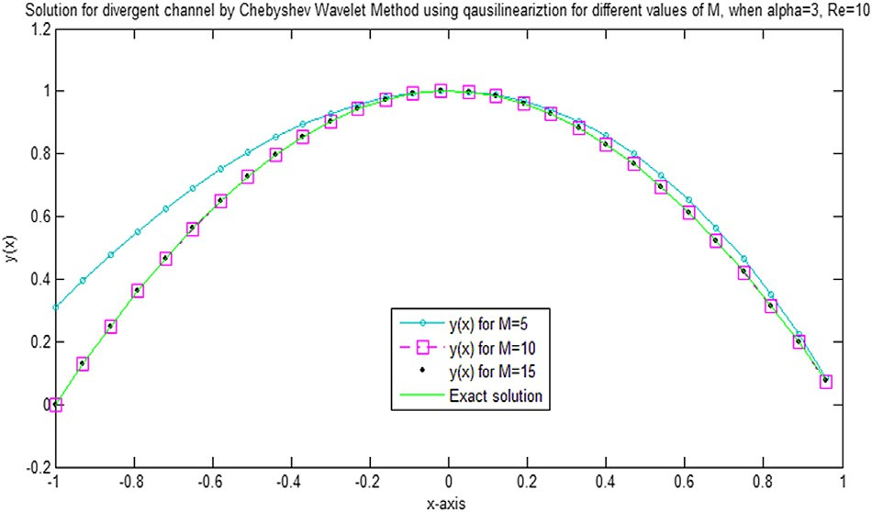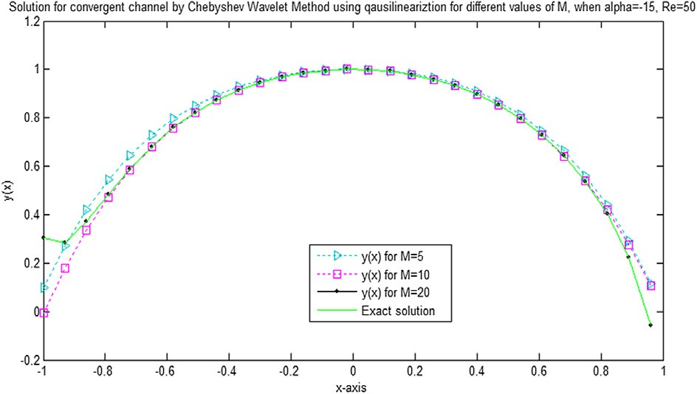

Fig. 3 e Comparison of JefferyeHamel flow when a ¼ 3 and Re ¼ 10 for different values of M for proposed method with RK-4.

Fig. 4 e Comparison of JefferyeHamel flow when a ¼ ¡15 and Re ¼ 50 for different values of M for proposed method with RK-4.

# 7. Conclusion

This article investigates the MHD flow between two parallel plates and JefferyeHamel flow. Shifted Chebyshev wavelets-

also sought out for the sake of comparison. It is clear from Figures and Tables that this method can be applied success- fully to different problems of physical nature.

## r e f e r e n c e s

quasilinearization technique is applied to solve the equations

of flow. In order to check the accuracy of the solution obtained

by shifted Chebyshev wavelets-quasilinearization technique at different values of polynomials figures and tables are drawn which shows that the accuracy of method is increased when we increase the order of the polynomial. Numerical solution is

1. [Stefan MJ. Versuch. Uber die scheinbareadhesion,](http://refhub.elsevier.com/S2314-808X(15)00026-3/sref1) [Sitzungsberichte der Akademie der Wissenschaften in Wien.](http://refhub.elsevier.com/S2314-808X(15)00026-3/sref1) [Math Naturwiss 1874;69:713](http://refhub.elsevier.com/S2314-808X(15)00026-3/sref1)e[21](http://refhub.elsevier.com/S2314-808X(15)00026-3/sref1).
2. [Archibald FR. Load capacity and time relations for squeeze](http://refhub.elsevier.com/S2314-808X(15)00026-3/sref2) [films. J Lubr Technol 1956;78:231](http://refhub.elsevier.com/S2314-808X(15)00026-3/sref2)e[45](http://refhub.elsevier.com/S2314-808X(15)00026-3/sref2).

[e g ypti an j o ur nal o f b a sic and a pp l i e d sci en c e s 2 ( 201 5 ) 229](http://dx.doi.org/10.1016/j.ejbas.2015.05.002) e[23](http://dx.doi.org/10.1016/j.ejbas.2015.05.002) 5

235

1. [Reynolds O. On the theory of lubrication and its application](http://refhub.elsevier.com/S2314-808X(15)00026-3/sref3) [to Mr. Beauchamp tower's experiments, including an](http://refhub.elsevier.com/S2314-808X(15)00026-3/sref3) [experimental determination of the viscosity of olive oil.](http://refhub.elsevier.com/S2314-808X(15)00026-3/sref3) [Philos Trans Roy Soc Lond 1886;177:157](http://refhub.elsevier.com/S2314-808X(15)00026-3/sref3)e[234](http://refhub.elsevier.com/S2314-808X(15)00026-3/sref3).
2. [Grimm RJ. Squeezing flows of Newtonian liquid films: an](http://refhub.elsevier.com/S2314-808X(15)00026-3/sref4) [analysis include the fluid inertia. Appl Sci Res](http://refhub.elsevier.com/S2314-808X(15)00026-3/sref4) [1976;32(2):149](http://refhub.elsevier.com/S2314-808X(15)00026-3/sref4)e[66](http://refhub.elsevier.com/S2314-808X(15)00026-3/sref4).
3. [Hussain A, Mohyud-din ST, Cheema TA. Analytical and](http://refhub.elsevier.com/S2314-808X(15)00026-3/sref5) [numerical approaches to squeezing flow and heat transfer](http://refhub.elsevier.com/S2314-808X(15)00026-3/sref5) [between two parallel disks with velocity slip and](http://refhub.elsevier.com/S2314-808X(15)00026-3/sref5) [temperature jump. Chin Phys Lett 2012;29:114705](http://refhub.elsevier.com/S2314-808X(15)00026-3/sref5).
4. [Khan U, Ahmed N, Zaidi ZA, Asadullah S, Mohyud-Din ST.](http://refhub.elsevier.com/S2314-808X(15)00026-3/sref6) [MHD squeezing flow between two infinite plates. Ain Shams](http://refhub.elsevier.com/S2314-808X(15)00026-3/sref6) [Eng J 2014;5:187](http://refhub.elsevier.com/S2314-808X(15)00026-3/sref6)e[92](http://refhub.elsevier.com/S2314-808X(15)00026-3/sref6).
5. [Jeffery GB. The two-dimensional steady motion of a viscous](http://refhub.elsevier.com/S2314-808X(15)00026-3/sref7) [fluid. Philos Mag 1915;6:455](http://refhub.elsevier.com/S2314-808X(15)00026-3/sref7)e[65](http://refhub.elsevier.com/S2314-808X(15)00026-3/sref7).
6. [Hamel G. Spiralf](http://refhub.elsevier.com/S2314-808X(15)00026-3/sref8)o€[rmige Bewgungen Z](http://refhub.elsevier.com/S2314-808X(15)00026-3/sref8)a€[her Flu¨ ssigkeiten.](http://refhub.elsevier.com/S2314-808X(15)00026-3/sref8)

[Jahresber Deutsch Math Verein 1916;25:34](http://refhub.elsevier.com/S2314-808X(15)00026-3/sref8)e[60](http://refhub.elsevier.com/S2314-808X(15)00026-3/sref8).

1. [Fraenkel LE. On the Jeffery](http://refhub.elsevier.com/S2314-808X(15)00026-3/sref9a)e[Hamel solutions for flow](http://refhub.elsevier.com/S2314-808X(15)00026-3/sref9a) [between plane walls. Proc Roy Soc A 1962;267:119](http://refhub.elsevier.com/S2314-808X(15)00026-3/sref9a)e[38](http://refhub.elsevier.com/S2314-808X(15)00026-3/sref9a).
2. [Rosenhead L. The steady two-dimensional radial flow of](http://refhub.elsevier.com/S2314-808X(15)00026-3/sref9) [viscous fluid between two inclined plane walls. Proc Roy Soc](http://refhub.elsevier.com/S2314-808X(15)00026-3/sref9) [A 1940;175:436](http://refhub.elsevier.com/S2314-808X(15)00026-3/sref9)e[67](http://refhub.elsevier.com/S2314-808X(15)00026-3/sref9).
3. [Ganji ZZ, Ganji DD, Esmaeilpour M. Study on nonlinear](http://refhub.elsevier.com/S2314-808X(15)00026-3/sref10) [Jeffery](http://refhub.elsevier.com/S2314-808X(15)00026-3/sref10)e[Hamel flow by He's semi-analytical methods and](http://refhub.elsevier.com/S2314-808X(15)00026-3/sref10) [comparison with numerical results. Comput Math Appl](http://refhub.elsevier.com/S2314-808X(15)00026-3/sref10) [2009;58:2107](http://refhub.elsevier.com/S2314-808X(15)00026-3/sref10)e[16](http://refhub.elsevier.com/S2314-808X(15)00026-3/sref10).
4. [He JH. Homotopy perturbation method: a new nonlinear](http://refhub.elsevier.com/S2314-808X(15)00026-3/sref11) [analytical technique. Appl Math Comput 2003;135:73](http://refhub.elsevier.com/S2314-808X(15)00026-3/sref11)e[9](http://refhub.elsevier.com/S2314-808X(15)00026-3/sref11).
5. [Liao SJ. Beyond perturbation: introduction to the homotopy](http://refhub.elsevier.com/S2314-808X(15)00026-3/sref12) [analysis method. Boca Raton: CRC Press; 2003. ChapHall](http://refhub.elsevier.com/S2314-808X(15)00026-3/sref12).
6. [Mohyud-Din ST, Hussain A, Yildirim A. Homotopy analysis](http://refhub.elsevier.com/S2314-808X(15)00026-3/sref13) [method for parametric differential equations. World Appl Sci](http://refhub.elsevier.com/S2314-808X(15)00026-3/sref13) [J 2010;11:851](http://refhub.elsevier.com/S2314-808X(15)00026-3/sref13)e[6](http://refhub.elsevier.com/S2314-808X(15)00026-3/sref13).
7. [Noor MA, Mohyud-Din ST. Homotopy perturbation method](http://refhub.elsevier.com/S2314-808X(15)00026-3/sref14) [for solving Thomas-Fermi equation using Pade](http://refhub.elsevier.com/S2314-808X(15)00026-3/sref14) [approximants. Int J Nonlin Sci 2009;8:27](http://refhub.elsevier.com/S2314-808X(15)00026-3/sref14)e[31](http://refhub.elsevier.com/S2314-808X(15)00026-3/sref14).
8. [Rawashdeh EA. Legendre wavelets method for fractional](http://refhub.elsevier.com/S2314-808X(15)00026-3/sref15) [integro-differential equations. Appl Math Sci 2011;5:2465](http://refhub.elsevier.com/S2314-808X(15)00026-3/sref15)e[74](http://refhub.elsevier.com/S2314-808X(15)00026-3/sref15).
9. [Islam S, Aziz I, Sarler B. The numerical solution of second-](http://refhub.elsevier.com/S2314-808X(15)00026-3/sref16) [order boundary-value problems by collocation method with](http://refhub.elsevier.com/S2314-808X(15)00026-3/sref16) [the Haar wavelets. Math Comput Model 2010;52:1577](http://refhub.elsevier.com/S2314-808X(15)00026-3/sref16)e[90](http://refhub.elsevier.com/S2314-808X(15)00026-3/sref16).
10. [Hariharan G. Haar Wavelet method for solving sine](http://refhub.elsevier.com/S2314-808X(15)00026-3/sref17)e[Gordon](http://refhub.elsevier.com/S2314-808X(15)00026-3/sref17) [and Klein](http://refhub.elsevier.com/S2314-808X(15)00026-3/sref17)e[Gordon equations. Int J Nonlin Sci 2010;9(2):1](http://refhub.elsevier.com/S2314-808X(15)00026-3/sref17)e[10](http://refhub.elsevier.com/S2314-808X(15)00026-3/sref17).
11. [Ali A, Iqbal MA, Mohyud-Din ST. Chebyshev wavelets](http://refhub.elsevier.com/S2314-808X(15)00026-3/sref18) [method for delay differential equations. Int J Mod Math Sci](http://refhub.elsevier.com/S2314-808X(15)00026-3/sref18) [2013;8(2):102](http://refhub.elsevier.com/S2314-808X(15)00026-3/sref18)e[10](http://refhub.elsevier.com/S2314-808X(15)00026-3/sref18).
12. [Iqbal MA, Ayyaz A, Mohyud-din ST. Chebyshev wavelets](http://refhub.elsevier.com/S2314-808X(15)00026-3/sref19) [method for fractional delay differential equations. Int J Mod](http://refhub.elsevier.com/S2314-808X(15)00026-3/sref19) [Appl Phys 2013;4(1):49](http://refhub.elsevier.com/S2314-808X(15)00026-3/sref19)e[61](http://refhub.elsevier.com/S2314-808X(15)00026-3/sref19).
13. [Bellman RE, Kalaba RE. Quasilinearization and nonlinear](http://refhub.elsevier.com/S2314-808X(15)00026-3/sref20) [boundary-value problems. New York: Elsevier Pub Comp;](http://refhub.elsevier.com/S2314-808X(15)00026-3/sref20) [1965](http://refhub.elsevier.com/S2314-808X(15)00026-3/sref20).
14. [Conte SD, Boor C de. Elementary numerical analysis.](http://refhub.elsevier.com/S2314-808X(15)00026-3/sref21) [McGraw-Hill Int. Edit.; 1981](http://refhub.elsevier.com/S2314-808X(15)00026-3/sref21).
15. [Khan U, Ahmed N, Zaidi ZA, Asadullah M, Mohyud-Din ST.](http://refhub.elsevier.com/S2314-808X(15)00026-3/sref22) [MHD squeezing flow between two infinite plates. Ain Shams](http://refhub.elsevier.com/S2314-808X(15)00026-3/sref22) [Eng J 2014;5:187](http://refhub.elsevier.com/S2314-808X(15)00026-3/sref22)e[92](http://refhub.elsevier.com/S2314-808X(15)00026-3/sref22).
16. [Joneidi AA, Domairry G, Babaelahi M. Three analytical](http://refhub.elsevier.com/S2314-808X(15)00026-3/sref23) [methods applied to Jeffery](http://refhub.elsevier.com/S2314-808X(15)00026-3/sref23)e[Hamel flow. Commun Nonlin Sci](http://refhub.elsevier.com/S2314-808X(15)00026-3/sref23) [Numer Simul 2010;15(11):3423](http://refhub.elsevier.com/S2314-808X(15)00026-3/sref23)e[34](http://refhub.elsevier.com/S2314-808X(15)00026-3/sref23).
17. [Lee ES. Quasilinearization and invariant imbedding. N. York](http://refhub.elsevier.com/S2314-808X(15)00026-3/sref24) [Lond.: Acad. Press; 1968](http://refhub.elsevier.com/S2314-808X(15)00026-3/sref24).
18. [Mandelzweig VB, Tabakin F. Quasilinearization approach to](http://refhub.elsevier.com/S2314-808X(15)00026-3/sref25) [nonlinear problems in physics with application to nonlinear](http://refhub.elsevier.com/S2314-808X(15)00026-3/sref25) [ODEs. Comput Phys Commun 2001;141:268](http://refhub.elsevier.com/S2314-808X(15)00026-3/sref25)e[81](http://refhub.elsevier.com/S2314-808X(15)00026-3/sref25).