[Egyptian Informatics Journal 23 (2022) 163–176](https://doi.org/10.1016/j.eij.2022.10.002)

Contents lists available at [ScienceDirect](http://www.sciencedirect.com/science/journal/11108665)

Egyptian Informatics Journal

journal homepage: [www.sciencedirect.com](http://www.sciencedirect.com/)

[](http://crossmark.crossref.org/dialog/?doi=10.1016/j.eij.2022.10.002&domain=pdf)Smart Traffic Scheduling for Crowded Cities Road Networks

Ahmad A.A. Alkhatib a, Khulood Abu Maria a, Shadi AlZu’bi b, Eman Abu Maria a

a *Computer Information System Department, Alzaytoonah University of Jordan, Airport Street, Amman, Jordan*

b *Computer Science Department, Alzaytoonah University of Jordan, Airport Street, Amman, Jordan*

a r t i c l e i n f o

*Article history:*

Received 17 June 2021

Revised 19 September 2022

Accepted 14 October 2022

Available online 16 November 2022

*Keywords:*

Smart road traffic control Smart cities

Road traffic network management UTC

Urban traffic control

a b s t r a c t

With the fast-expanding number of vehicles in smart cities, the management of road intersections and traffic congestion has grown to be major problems. Drivers often express their opinion that putting traffic lights on while taking traffic flows into account will have a significant impact on how traffic moves. This paper presents a smart Road traffic Control management system termed Urban Traffic Control (UTC) keeping real-time dynamic traffic flow in mind which helps in upgrading the level of road traffic network management. To provide an organized traffic arrangement, UTC presents methodologies such as vehicle counting, controlling process, and evaluation of lanes keeping status in mind, this whole procedure is implemented by taking the complete traffic network into an account instead of just considering intersec- tions. The primary goal of our system is to lessen traffic jams by cutting down on the trip and waiting times vehicles spend at crossings and intersections. We need to assign a plan for traffic flow that has the least amount of traffic congestion and vehicle waiting time, for this purpose some indicators and models are introduced in this study. Lane weight, traffic jam indicator, and vehicle priority are among these models. As this work is an improvement on the current Road Network without much changing, we integrate our system on normal traffic lights which allow each lane a chance to move and we also con- sidered the no-interference lane movement. To simulate our idea, we introduced a smart road traffic con- trol system consisting of multi-agents, by using a NetLogo stimulator. To compare the fixed cycle traffic light, several vehicles (150 in total) with random behaviour were generated and scattered over 25 differ- ent intersections for the time duration of 9 h. This setting was used to test our smart traffic control solu- tion on both lane flow and no interference movement flow. According to the obtained results, there was a 25.98% reduction in total average waiting time over simulation period for all vehicles and a reduction of 34.16% for no interference movement flow. These observations clearly state that suggested method is bet- ter suited for today’s complex traffic conditions where change in infrastructure is minimal.

© 2022 THE AUTHORS. Published by Elsevier BV on behalf of Faculty of Computers and Artificial Intel-

ligence, Cairo University. This is an open access article under the CC BY-NC-ND license ([http://creative-](http://creativecommons.org/licenses/by-nc-nd/4.0/)

[commons.org/licenses/by-nc-nd/4.0/](http://creativecommons.org/licenses/by-nc-nd/4.0/)).

1. Introduction

Speaking of the present millennium, the rate of the number of vehicles registered in the US has risen to 19 % (i.e., approximately 46 million vehicles) in the early 20 years [1]. Due to this sudden increase, the issues of traffic accidents, road congestion, and envi- ronmental pollution have become more serious. There are some

*E-mail address:* [Ahmad.Alkhatib@zuj.edu.jo](mailto:Ahmad.Alkhatib@zuj.edu.jo) (A.A.A. Alkhatib)

Peer review under responsibility of Faculty of Computers and Information, Cairo University.

**Production and hosting by Elsevier**

possible solutions to these issues, such as Intelligent Transporta- tion Systems (ITS) or smart traffic lights. These methods reduce the waiting time at traffic lights and enhance the quality of driving. In major cities, waiting time and traffic jams are critical, by scheduling traffic and enhancing junction traffic flow, smart cities may lessen congestion, trip times, and carbon dioxide emissions [2]. The traffic refinement process can involve (ITS) Intelligent traf- fic lights system, which can include Genetic Algorithm [3], Fuzzy Logic and Neural Network [4,5], PLC [6], Machine Learning and deep learning [7], or Virtual Traffic light (VTL) [8,9]. Different forms of these technologies were introduced in smart cities and Internet of Things (IoT) schemes Vehicle to Everything (V2X) [10].

Controller and light heads are components of traffic lights, the controller act as the brain that commands the lights to change in a predetermined sequence. The sequence may adhere to a specified time interval, automated vehicles, or Urban Traffic Control (UTC)

<https://doi.org/10.1016/j.eij.2022.10.002>

1110-8665/© 2022 THE AUTHORS. Published by Elsevier BV on behalf of Faculty of Computers and Artificial Intelligence, Cairo University. This is an open access article under the CC BY-NC-ND license (<http://creativecommons.org/licenses/by-nc-nd/4.0/>).

principles. Despite the current traffic situation, the fixed time tech- nique represented in the green light will be shown for the same period during each cycle and regardless of the direction of no inter- ference movement flow control, it is still employed on the lane flow control.

However, in highly congested locations or where there are no waiting automobiles, this approach may be ineffective. We place a detector along the side road or on the traffic signal lights to track the demands of the vehicles as the new technique takes into account the vehicle demands at each intersection in an automated manner. A vehicle needs to go through a phase-changing process where green status should be asserted as fast as possible. Depend- ing on other incoming vehicles or the number of cycles for a partic- ular intersection (either minimum or maximum), the phase might be detected and the green status might be extended.

Even though this automated approach is smarter than the con- ventional method of a fixed time, since it is not easy to calculate the maximum time limit for extremely crowded junctions, the automated method shows poor performance. In UTC, the status of current traffic flow impacts the timing measures and the net- work gathers data on a centralized computer to improve the flow of traffic [11].

UTC systems not only boost traffic flow, and vehicle trips and reduce emissions, it also offers a potential way as an alternative to address the demands of new infrastructure i.e., road expansion, new roads, tunnels, and bridges. An ideal traffic management sys- tem must be smart enough to manage traffic flow on roads effec- tively by taking input, priority of vehicles, affected output traffic, and volume of traffic into account. This research suggests a method that can practically be implemented to record incoming real-time differences in the flow of traffic. To minimize the overall time taken to travel and waiting time of vehicle, this technique inhibits multi-phase and can adjust itself with every update in status data. The remaining paper is further divided into the following man- ner: Section 2 deals with the relevant literature review on the topic of road traffic optimization. The suggested technique is mentioned in section 3. Section 4 contains the suggested methods of simula- tion for improving traffic light system. Section 5 consist the discus- sion and lastly, section 6 covers the conclusion and the anticipated

future work on this topic.

1. Related work

With the rapid increase in the number of vehicles, the conven- tional way of managing traffic by using system traffic lights is not much effective. Even if there are no vehicles in the other lanes, still the systems require moving vehicles to wait for a particular time limit, this is a genuine concern. To cope with these issues, several researchers have developed solutions that include Virtual traffic lights, a Genetic algorithm, and a neural network to improve traffic density in every lane at the junction. These techniques require instating a network and hardware either on both roads and traffic or on one of them. [9].

By applying image and video processing, Pandey et al gathered the traffic density at the intersection and put out a strategy for allocating the periods for traffic signals. The suggested approach is effective for traffic control [12].

Xu et al used a generative adversarial network to predict the state of road traffic in 202. According to them, accurate state pre- diction is crucial for intelligent transportation systems. Such pre- dictions help travellers and the government to execute good plans and strategies regarding traffic management, respectively. Their proposed framework consists of three models, i.e., 1) Gener- ator (G): Use historic traffic states to build a spatiotemporal matrix and generate future traffic states from it. (2) The Discriminator (D):

Used to calculate the difference between actual and generated data. (3) The Adversarial training: Make sure that a balance exists between (D) and (G). For traffic flows, a 5-minute traffic prediction is generated by using this framework [7].

Under the supervision of the US Department of Transportation, the Robust Net Research Group and Michigan Traffic Laboratory at Michigan University have created an intelligent traffic signalling system (I-SIG). This technology seeks to prevent collisions and les- sen traffic congestion. The system was set up and tested in several US states, including Tampa, Florida, AZ, CA, and NY. To assess traffic conditions and adjust traffic timing, the vehicles in I-SIG transmit their current position and speed to the nearby traffic signal. Unfor- tunately, they asserted that the I-SIG system’s sensors are unreli- able since they can easily be accessed by unauthorized sources [13].

It is a difficult task to remove traffic jams. Therefore, a lot of researchers hardly tried to reduce rush-hour traffic and the waste of ‘‘valuable” time. Traffic jams are caused by traffic lights, accord- ing to Avin et al. As a result, they suggested using wireless technol- ogy to provide a virtual traffic light and traffic light schedule broadcasting-based location of each vehicle. To assess the intersec- tion’s capacity and boost performance accuracy, they created a simulation. According to the observations, the percentage of vehi- cles increased by 5 %, and the wait time decreased by up to 50 %. Notably, they only took un-delayed vehicles into account [14].

For detecting traffic light states, Saini et al. introduced a convo- lutional neural network (CNN) in 2017, this CNN was based on the state recognition approach. Under various lighting setups and weather conditions, their technique proved reliable for driving evaluation [15].

Focusing on vehicle-to-vehicle (V-2-V) networking, Hagenauer et al studied the performance of self-organized traffic management algorithms. Instead of conventional ways of traffic light systems, this study incorporated virtual traffic light (VTL) on a leading vehi- cle. To carry out the election and traffic light computations in real- time vehicular networks, the researchers created an algorithm. They looked into the idea of using both synthetic and real-world cases to build an algorithm that enables arbitrary intersection arrangements. They concluded that VTL effectively uses all vehicu- lar system resources and enhances the experience of driving only under average network load [16].

When speaking of multi-intersection networks, it is suggested to use artificial intelligence to manage smart traffic flow. Arel et al experimented to reduce average waiting time, congestion, and the possibility of intersection cross-blocking, by using rein- forcement learning Neural networks (RL), they intended to control traffic light cycles effectively. They considered five intersections for this experiment, each one acted as an autonomous intelligent agent (either as a central or outbound agent). To find an approxi- mate value function, Q-learning was implemented with a feed- forward neural network. The results of this experiment show that for an isolated single intersection control under LFQ regulation, a multi-agent reinforcement learning-based control system is bene- ficial [17].

To communicate with traffic agents, Iyer et al. talked about syn- chronizing traffic flow by employing multi-agent fuzzy logic distri- bution and Q learning. They stated that the fuzzy system can manage the multiple input data levels provided by traffic lights. [18].

Teo et al used a simulation on a traffic light system to observe the impact of waiting vehicle lanes, amber time, and duration of green light. To ensure effective vehicle passing at the junction, they use a genetic algorithm to arrange the traffic light time cycling. Present queue length is fed to the Genetic algorithm as input and evaluated optimal green time for intersection, in this way, the algo- rithm can find an optimized solution. The speed of the genetic

algorithm depends on the length of data, hence to enhance the results further, the flow of incoming traffic is recorded even at times when the status is red [3].

A microscopic simulation was performed by Wang et al. They suggested an adaptive linear quadratic regulator (LQR) with incre- mental adjustments. A multi-agent simulation that produced 35 junction points was carried out. The observations collected from this simulation were then compared to regular traffic signals, an average of 29.9 s delay was recorded for a 20 s green cycle which was relatively less than the average traffic delay of normal lights. [19].

Siyal and Fathy applied edge detection and neural network algorithms to develop a process that improves traffic flow at the intersection. In this process, edge detection was used to identify vehicles and estimate their movement, whereas queue parameters were calculated using Neural networks. These neural networks were trained on different traffic flow records to develop a model with better accuracy as compared to conventional algorithms used for image processing [20].

Using CNN to collect and recognize features from visual camera pictures, John et al. introduced machine learning techniques based on computer vision for varying illumination environments. Here, the onboard GPS sensor is added to enhance identification accu- racy. The GPS pinpoints the area of interest for the traffic signal it contains. Utilizing data sets collected from various locations, the suggested technique was assessed and contrasted with the conventional traffic signal. In various illumination environments, they demonstrated impressive identification accuracy of their sug- gested approach [21].

To regulate traffic lights for a single junction, Zou et al. pre- sented an efficiently built fuzzy logic based on Wireless Sensor Network (WSN) [22]. According to this model, monitoring of traffic flow in nearby areas was done through single-axis magneto sen- sors that were supposed to be installed alongside roads. Based on the number of available vehicles, the fuzzy algorithm was utilized to alter the passing time for automobiles. In comparison with the traditional fixed cycle system, their research concluded that about a 22.7 % decrease in average waiting time and real-time control were obtained for the simulation period during the 80 s.

In a multi-intersection traffic network, Sanchez et al put for- ward an approach to improve traffic light cycles. They combined the Cellular Automata Simulator with Genetic Algorithms to carry out the improvement process and evaluated the model accord-

ingly. For simultaneous computation, the team used the Beowulf Cluster algorithm. After that, they performed experiments to eval- uate the suggested methodologies and confirmed their relevance for the traffic signal optimization task [23].

Several strategies were used by Biswas et al. to improve the traffic system. We targeted previous work done for enhancing intelligent traffic systems and carried out a detailed study to make comparisons among several different types of research on this topic. The study emphasized several contributions that appeared helpful for applying the smart traffic control system in developing countries [24].

Zaatouri and Ezzedine put out another real-time algorithm for managing traffic signals. They used computer vision and machine learning to assess the conflicting traffic flows at the road intersec- tion. ‘‘You Only Look Once” (YOLO) named object identification algorithm was used to maximize the performance of traffic lights. This algorithm is based on a deep CNN algorithm. This method is per the guidelines for waiting time and safely passing vehicles [25]. The latest developments in the approaches and algorithms for road traffic optimisation were systematically analysed by Ryd- zewski et al. Various potential types of simulation that may be used in this regard were examined by the researchers, for example

NetLogo, VANET, SUMO, AIMSUM and VISSIM [26].

Several researchers have examined the complicated task of syn- chronising traffic lights in the surrounding region. For instance, Tomar et al. analysed the system by dividing it into degrees of syn- chronisation [27]. A model for signal synchronisation was devel- oped by the researchers that was capable of operating with DSRC, sensors, image processing or any other technology reviewing traffic density at intersections. It was possible to scale the frame- work and include new junctions without any issues. The technique used by the authors was SUMO simulation, which brought about a decrease of 19 % in the average trip time in comparison to the fixed time as well as non-synchronised traffic regulation (See Fig. 1).

Actual maps and mobility data were considered by Nesmach- now et al. when developing a traffic light synchronisation parallel algorithm for Bus Rapid Transit systems. Here, a different priority for buses and other vehicles was allocated. According to the researchers, through this approach, the average speed of public transport improves by almost 15.3 % and that of other vehicles by 24.8 % [28].

URBC (Urban Traffic Balance Control) is a traffic control strategy formulated by Zhonghe et al. on the basis of state-feedback. In this

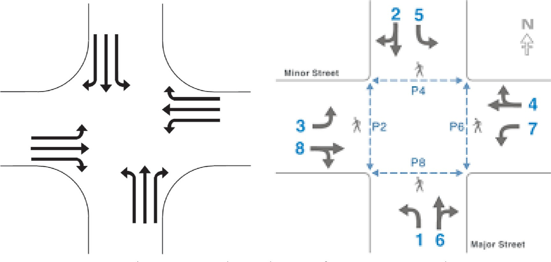

Fig. 1. Lane Flow and no Interference Movement Flow.

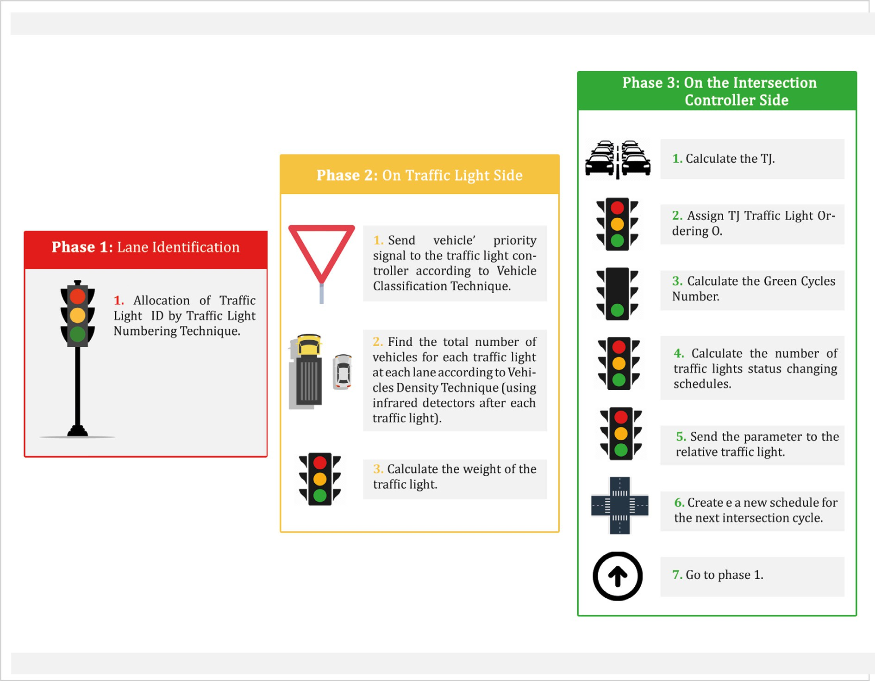

Fig. 2. The Proposed system phases.

method, VISSIM was used to simulate Wangjing (Beijing, China). There are 19 intersections and 56 links in the region, and it was observed that it was possible to decrease the delay time from 13 % to 20 % [29].

Road traffic conditions within a grid network were simulated by Burguillo et al. using NetLogo. To demonstrate how average wait- ing times were affected, varying numbers of self-organising inter- sections were used by the researchers. The findings of the study showed that the waiting time decreased in comparison to stan- dard, fixed-time traffic lights when the number of intelligent inter- sections were more than 50 % [30].

Simulation was carried out on a 4x4 traffic network grid for 1, 2 and 3 h by Ahmad et al. [31]. The results showed that when the proposed method was used, the average waiting time decreased by 18 %.

Vehicle waiting time was highlighted in the study by Patrascu et al. Jade framework, Java and SUMO were employed in their study, in addition to various kinds of agents. It was possible for the average waiting time to decline, and this would lead to a fuel reduction of 3.06 % and a speed increase of 9 % on average [32].

1. Methodology

The system presented here includes various processes that would be applied to traffic lights, without significantly modifying

the infrastructure. The objective of this system is to decrease vehi- cle average waiting time and enhance traffic flow. The system also receives consistently updated information regarding the traffic for the entire traffic network and not only the intersection. The exist- ing traffic status of the intersection and the key roads affected due to this situation reflect the indicators determined in this study. The decision will be taken by the intersection itself, taking into account the traffic volume and the vehicle priority of the preceding and ensuing intersections, organising the traffic flow such that the vehicle waiting time and traffic jam in the network is minimized. As can be seen in Fig. 2, there are three stages of the traffic light controlling system put forward.

* 1. *Phase 1: Lane identification*

It can be seen in Fig. 3 that there are ty-pically-four traffic lights at intersections, each of which has multiple lanes and two direc- tions (backwards and forwards). A technique is initially presented to allocate an IDx number for every lane on the traffic lights so that the lane, intersection and direction can be differentiated. The rele- vant lanes from all directions that can possibly be affected by the existing lane traffic can also be denoted by the ID.

Taking into account the lane flow technique, there are three numbers in the traffic light IDx which represent the following traf- fic light allocations:

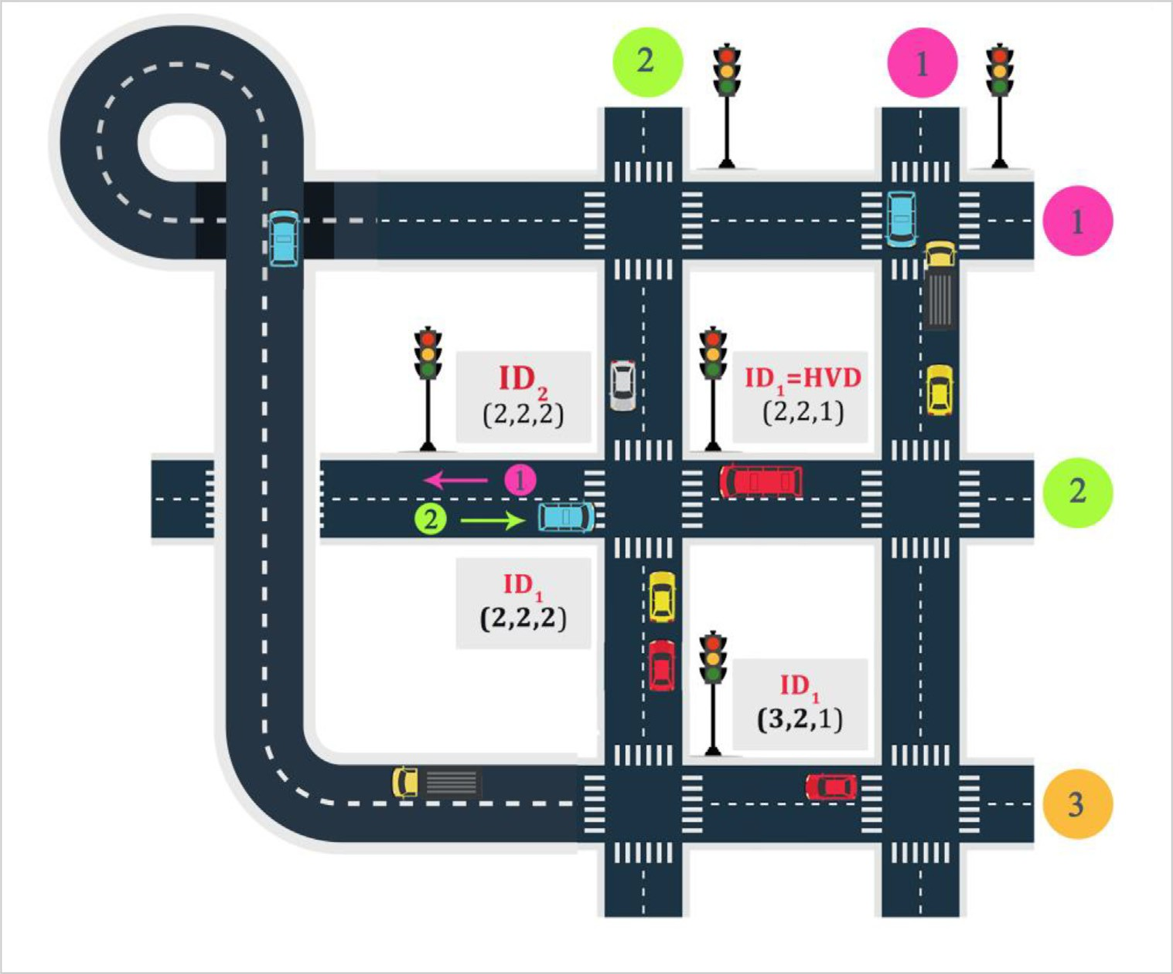

Fig. 3. Traffic light IDx assignment-lane flow technique.

* + - IDx = HVD (horizontal, vertical, direction)
    - A number will be assigned to each path (1, 2, 3, n). Hence, for every intersection, there will be a horizontal as well as a vertical

path number.

* + - There are two directions for every path (forward direction is denoted by 1 and backward direction by 2). For instance, the

ID of an HVD is (2,2,1). The first number signifies the second horizontal path, the second number represents the second ver- tical path, while the final number is representative of the direc- tion, which is the forward direction in this scenario.

x refers to the crossing edge, and is equivalent to 1, 2 or more.

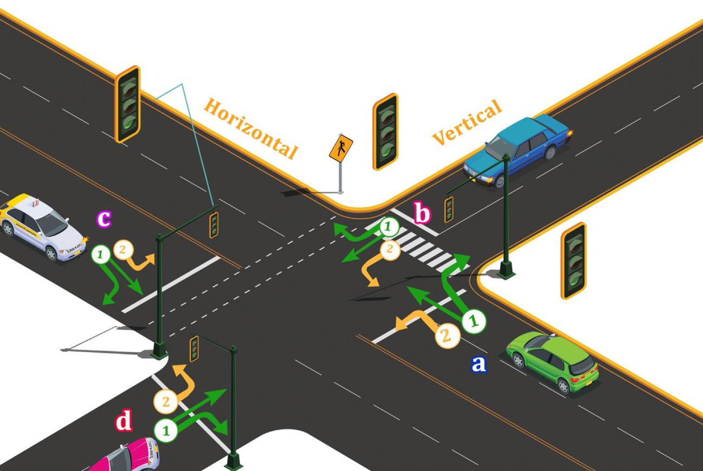

Fig. 4. No interference Movement.

The HVD can denote leading or affected lanes because all inter- section that have similar H or V index are believed to be affected.

On the other hand, IDx on no-interference movement flow will include the following:

* + - IDx = HVLD (horizontal, vertical, location, direction)
    - A number (1, 2, 3, n) will be assigned to each path. Therefore, there will be a horizontal and a vertical path number for every

intersection.

* + - There are four locations (a, b, c, d) in every intersection. Refer to Fig. 4 shown below.
    - There are four no-interference movement in every intersection. Refer to Table 1 below.
  1. *Phase 2: Traffic lights side*

In this phase, information will be gathered at every traffic light. The number of vehicles that use the method of traffic counting established earlier in [33] will be determined at every traffic light. The basis of the method is utilizing two infrared sensors and two sensors that are at a distance of 1 m from each other and are kept

Table 1

No Interference movements HVLD.

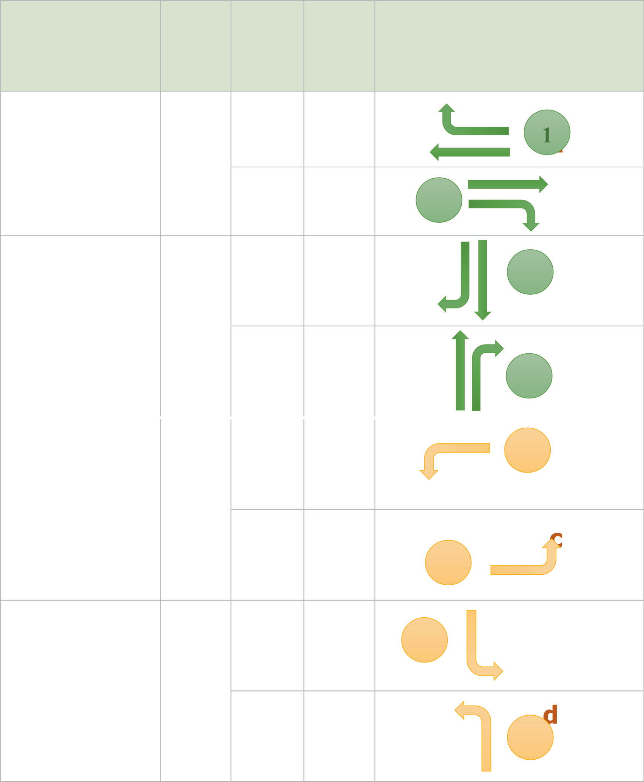

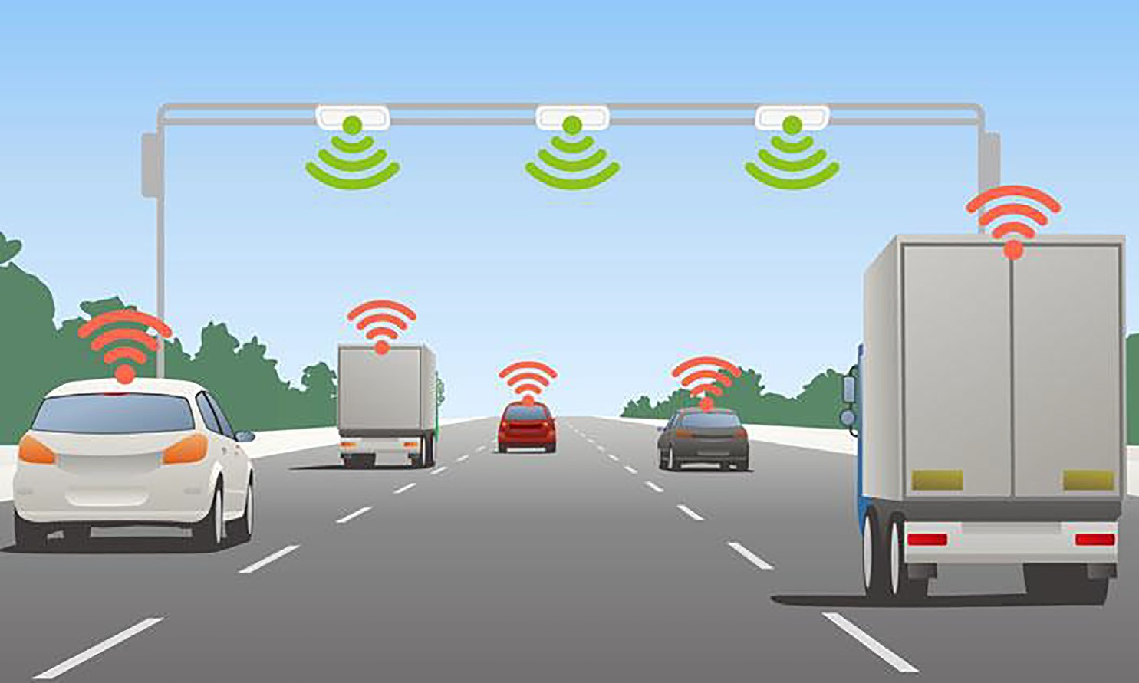

Fig. 5. Infrared Sensors for Vehicle Counting.

either at the start of every lane or right after the traffic light to ensure that vehicles are counted accurately, as shown in Fig. 5.

The perpetually (on) infrared transmitted dispatches infrared signals to the detector on the ground across a line-of-sight con- nection. No vehicles have moved past the beam throughout the duration the detector receives the infrared signal. In this case, the number of vehicles passing through will be determined by identifying the speed of vehicles and the length for traffic vol- ume because longer vehicles are more likely to cause greater traffic jam issues compared to normal length vehicles. Two timers will be triggered when the connection of the initial infra- red sensor is interrupted by the vehicle: (t-1 m) and (*t*-of broken connection).

To determine the vehicle speed, the time between the initial connection interruption and the subsequent connection interrup- tion (1 m apart) is determined by the T-1 m. The car length is deter- mined by the second timer, *T*-of broken connections, by counting the time from the point the second connection disruption occurs till the first connection reappears. On the basis of the car length, there will be an increase in the number of vehicles by (n) every time the *t*- of broken connection surpasses the time needed by a vehicle of nor- mal length, with speed remaining constant.

*car speed*(*m*/*s*) = 1*m* (1)

*t* — 1*meter*

*car speed*(*km*/*h*) = 1*meter* *t* — 1*meter* (2)

*k* = *t* — *of broken connection* * *car speed* (5)

The method for determining the number of crossing vehicles is

5

shown in Fig. 6.

A priority model is also presented in Table 2 that groups vehi- cles into three priority types that would be taken into account when calculating lane weights. It is assumed that emergency vehi- cles, school buses and public transportation can send a signal to the traffic light and can identify themselves through DSDR or RFID. Fol- lowing this, Equation (6) is used at each traffic light for computing weight. The intersection controller will receive the results, in addi- tion to the traffic light IDx (HVD).

*w*(IDx )= X*n* V*p*(*i*) (6)

*i*=1

Here, w refers to the Traffic light weight, n represents the num-

ber of vehicles and Vp indicates priority weight.

* 1. *Phase 3: Intersection controller*

In this phase, operations are carried out on the intersection con- troller side. The purpose of this is to create a table that distin- guishes every HVD schedule with respect to its traffic jam indicator, weight, number of green cycles, traffic light order, exist- ing status and time of subsequent status.

1000

3600

Tj (Traffic jam indicator) refers to the total of the previous i number of HVDs weights of those that are going to lead traffic to

When the car speed (km/h) is less than 5 km/h, the counter

changes just once as the car is moving at a very low speed. When the speed becomes more than 5 km/h, the equation given subse- quently is

used:.*t* — *ofbrokenconnection* = *thetimeneededforthecartofully*

*crossthefirstsensor*

# *car length* = *car speed* * *t* — *of broken connection* (3)

the path of the existing HVD, and the subsequent i number of HVDs of those that will be influenced by the existing HVD vehicle flow in all directions, horizontal as well as vertical (in this study, we choose i = 5). The suggested indicator can be indicative of the traf- fic status of different junctions. Equation (7) can be used to com- pute Tj.

*V*+*i H*+*i*

X X

There should be an increase in the counter for cars that are more than 5 m long so that the volume of the traffic can be inte- grated within the statistics. The equation given below can be used for this purpose.

*k* = *car length* (4)

# *normal car length*

*Tj* = *w*(IDx) (7)

*V*—*i H*—*i*

There will be higher order of traffic light with higher Tj. In nor-

mal cycles Arelet. It is also presumed that 30 s of the green cycle is nearly equivalent to the movement of p vehicles (approximately 10 cars on average). Therefore, Equation (8) for lane flow control is used to determine the number of normal green cycles needed for

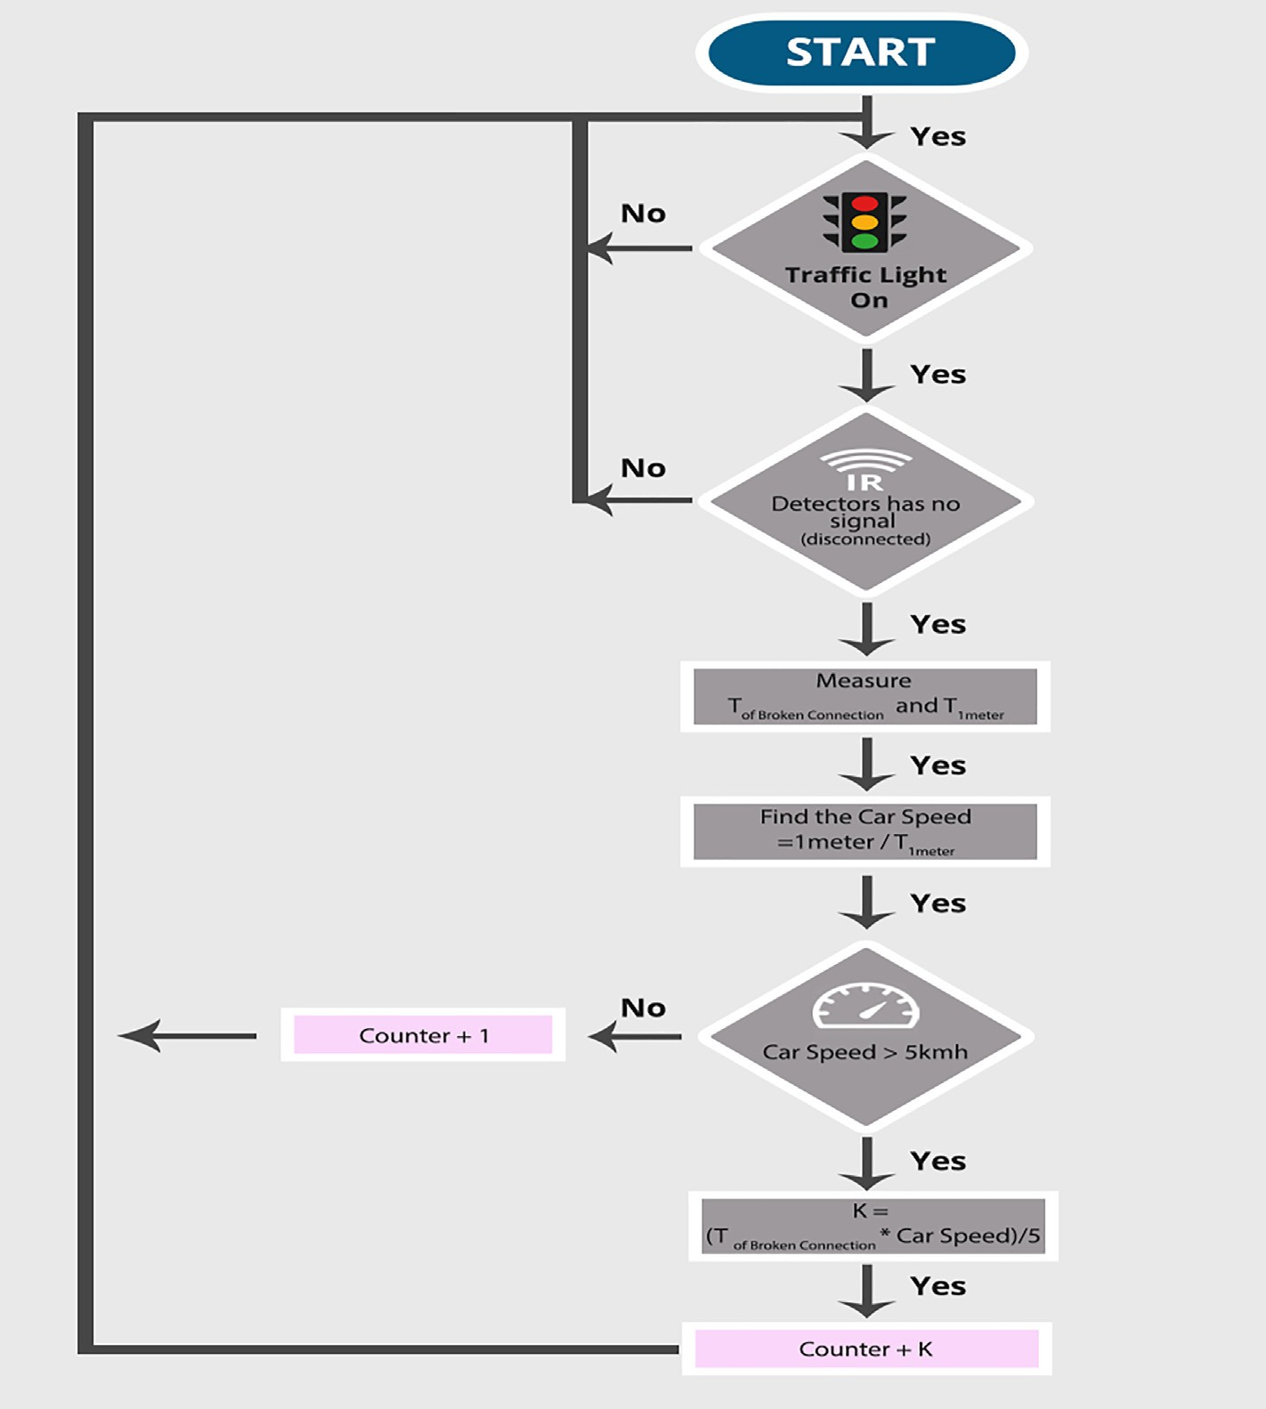

Fig. 6. Proposed algorithm for counting the number of crossing vehicles.

Table 2

Vehicle priority weight.

Vehicle Priority weight (Vp)

Emergency Vehicle 1.0

School & public Buses 0.5

Normal Vehicle 0.1

optimum number of vehicles to move across the junction, while Equation (9) is used to determine the time of the subsequent status.

# *number of car*

The computation is a little different when using the no- interference movement flow since the Traffic Jam indicator will be computed in accordance with the chosen movement:

Weight of Movement(1) = w(HVa1) + w(HVc1).

Weight of Movement(2) = w(HVb1) + w(HVd1).

(10)

Weight of Movement(3) = w(HVa2) + w(HVc2).

Weight of Movement(4) = w(HVb2) + w(HVd2).

The vehicle may be involved in distinct parameters for the sub-

sequent hop and the subsequent movement for an intersection lane of (i) cannot be predicted; therefore, we include the weight of the movement in the weight of all intersections in the given radius (i) to compute Tj as in equation (11).

# *number of green cycles* =

(8)

*V* +*i*

*H*+*i*

*p Tj* = Weight of Movement (index) + X X *w*(IDx), *i*

*N V* —*i H*—*i*

X

Time of next status = *time of green cycle for traffic light with*(*N*)

1

+ (*N* * 10)

(9)

= [1, 5] (11)

While, Index is the movement number.

# *number of green cycles of movement*(*index*)

*numberofcar*(*L*)

Here, N signifies Tj order of junction lanes and the 10 s as a =

safety for every change in traffic light status.

*p* (12)

Table 3

Lane Scheduling.

IDx Weight TJ N (TJ order) Num of green cycles Time of next status

*L* = max *number of cars* Lastly, Table 3 given below presents the intersection schedule:

*N*

Time of next status = *time of green cycle for traffic light with*(*N*)

X

1

+ (*N* * 10)

Table 4

Agent’s main attributes and methods.

(13)

1. Simulation

NetLogo [34,35] is used to construct a multi-agent urban traffic simulation model. We used 25 linked intersections from a given

Agent Type Attributes Behavior

Vehicle Agent ● Vehicle Id

Priority

Direction Current Lane Stopping-Time Waiting-Time Quit-Time

Traffic Light Agent ● Traffic-Light-Id

Intersection-Id

Traffic-Light-Direction Traffic-Light-Movement Total-Vehicles-No

Total-Weight

Intersection Controller Agent ● Intersection-Id Traffic-Light-Id

Travel-DirectionTraffic-Jam-Indicator (TJ)Traffic-Jan-index

(for movement flow) Selected-Traffic-Light

Green-Cycles-NumberYellow-Cycles-Number (10 s as a safety time)

Red-Cycles-Number Current-Status Time of Next Status

* Set-Id

Set-Priority

Send-Priority- Signal

* Set Traffic Id

Calculate Vehicle Density

Calculate Traffic Light Weight

* Calculate-Traffic-Jam-Indicator Assign-Traffic- Light-Order

Calculate- Green-Cycles Calculate-Red-Yellow-Cycles Determine- Next-Change

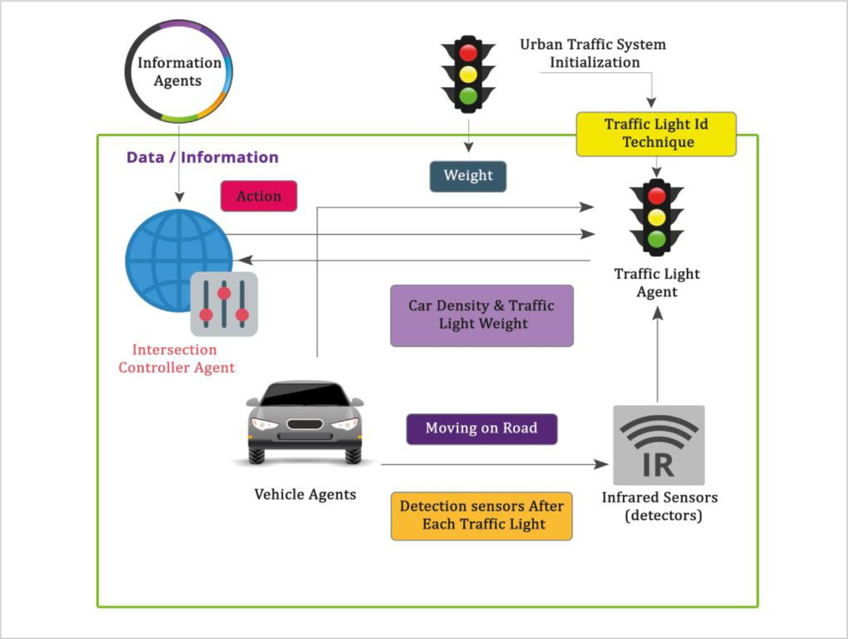

Fig. 7. Multi-Agent Urban Traffic System Components.

area with various lanes in all directions and 150 vehicles in a ran- dom behaviour. This simulator is specifically used to test three kinds of UTC systems, which are the proposed system, no interfer- ence movement and fixed time traffic control system.

Being a free open-source software, NetLogo is used for multi- agent programmable modelling environment. Scala and Java lan- guages are used to write the programme, which operates over Java Virtual Machines (JVM). There are four kinds of agents under which NetLogo can model the population growth: Patches, Links, Turtules and Observer (further details are provided in [34]). To determine the key attributes and techniques of each agent, a multi-agent-

based urban traffic mechanism is presented as a simulation model, as shown in Table 4. In this model, each traffic light, vehicle and controller are considered as a distinct agent and is spread out across a map of 25 intersections. The different types of agents of UTC are:

* Vehicle Agent:
* Traffic Light Agent.
* Intersection Controller Agent: The controlling unit to ensure that the diagnostic process is effective, which also provides

directives and modifications for traffic light units.

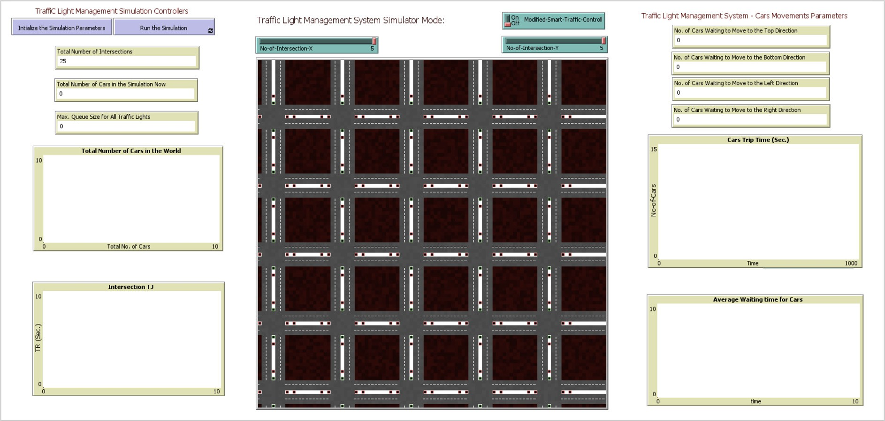

Fig. 8. Simulation Set Up.

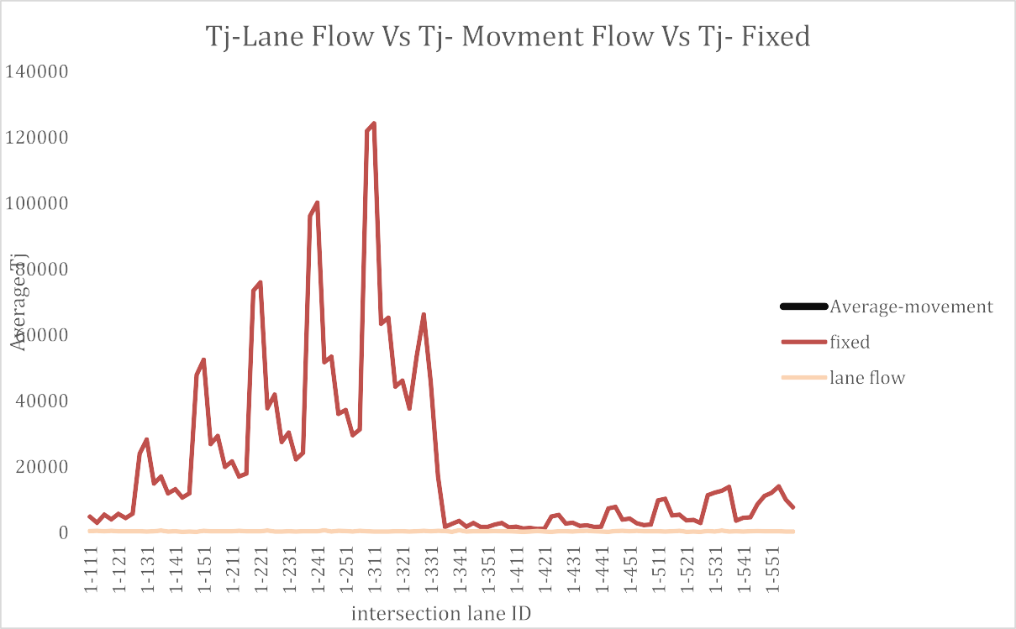

Fig. 9. Tj comparison for the three techniques.

An observer-oriented-decided-act method is used by every agent to manage all traffic lights at road junctions. Nevertheless, the existing status of the traffic at the crossing is consistently determined by the intersection control agent. The information obtained is then used to determine the behaviour of the agents. Fig. 7 shows the agent-based system components, while Fig. 8 pre- sents the screenshots of the simulation setups (NetLogo). For 150 randomly behaving vehicles that had the same average trip time, the average wiating times were recorded. The two systems were compared by concentrating on the average vehicle waiting time for all 150 vehicles across a simulation period of 9 h. The following have been used to carry out the proposed method: (1) controller agent: to obtain data and allocate schedules to HVDs and HVLDs,

(2) traffic light agent: to note down the number of vehicles and their weight for every HVD; and (3) vehicle agent: to declare their priority values in accordance with the lane flow and no- interference movement flow. In contrast, the following approach is used to carry out the fixed type on the traffic light agent: the green light shows for 30 s and red light for 90 s, and a safety time

of 10 s is included to account for the change in traffic light status. In this model, the controller is not utilized.

1. Results and discussion

ated in a map (network) of 5 × 5 intersections across a time frame For fixed control as well as smart control, the simulation oper- of 9 h. For all of the 150 cars, the average waiting time of the over-

all trip time and the Traffic Jam Indicator (TJ) for the 25 intersec- tions have been monitored. It was determined in the evaluation of the suggested method that TJ was a parameter that showed the extent to which the prevailing traffic is disturbed from the two directions (the paths move towards the present intersection and will receive traffic from the existing intersection). For the two systems (smart and fixed), a TJ record has been maintained to depict how the traffic flow will be affected by this indicator. A sample of TJ-smart lane flow control records is shown in Table 5 that provides the existing status of the intersection and the adja- cent region to the traffic light controller. The TJ-smart no interfer-

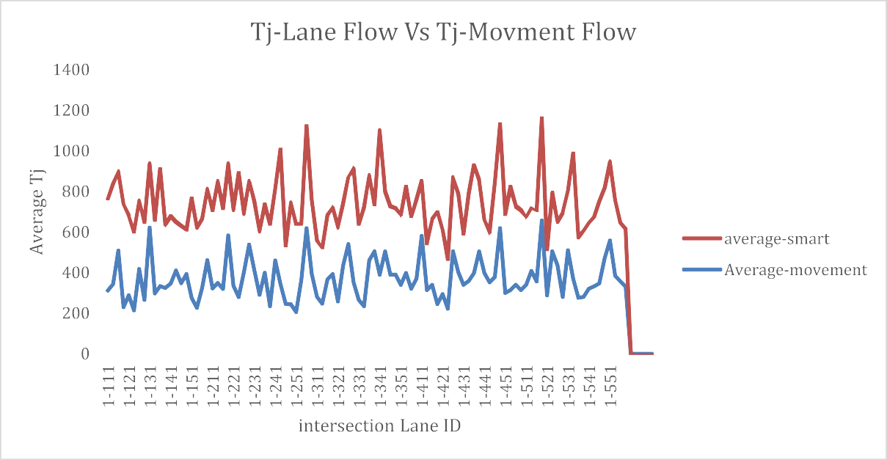

Fig. 10. Tj comparison for the lane flow and movement flow techniques.

Table 5

TJ-Smart Lane Flow Control.

|  |  |  |  |  |  |  |  |
| --- | --- | --- | --- | --- | --- | --- | --- |
| No | ID | TJ-1 | TJ-2 | TJ-3 | TJ-4 | TJ-n | Ave |
| 1 | 1-111 | 472.797 | 460.674 | 484.920 | 436.428 | 441.290 | 459.2218 |
| 2 | 1-112 | 517.803 | 504.526 | 531.080 | 477.972 | 467.122 | 499.7006 |
| 3 | 2-111 | 400.803 | 390.526 | 411.080 | 369.972 | 388.881 | 392.2524 |
| 4 | 2-112 | 517.803 | 504.526 | 531.080 | 477.972 | 523.904 | 511.057 |
| 5 | 1-121 | 400.803 | 390.526 | 411.080 | 369.972 | 406.131 | 395.7024 |
| 6 | 1-122 | 400.803 | 390.526 | 411.080 | 369.972 | 389.456 | 392.3674 |
| 7 | 2-121 | 348.270 | 339.340 | 357.200 | 321.480 | 333.598 | 339.9776 |
| 8 | 2-122 | 408.330 | 397.860 | 418.800 | 376.920 | 340.297 | 388.4414 |
| . | . | . | . | . | . | . | . |
| . | . | . | . | . | . | . | . |
| 96 | 2-542 | 347.509 | 362.037 | 338.569 | 362.037 | 331.822 | 348.3948 |
| 97 | 1-551 | 395.160 | 416.520 | 392.221 | 422.578 | 334.126 | 392.121 |
| 98 | 1-552 | 398.899 | 374.818 | 389.560 | 356.606 | 363.345 | 376.6456 |
| 99 | 2-551 | 293.805 | 286.578 | 312.100 | 281.975 | 279.221 | 290.7357 |
| 100 | 2-552 | 278.543 | 284.776 | 309.678 | 286.098 | 276.426 | 287.1042 |

ence movement flow records are depicted in Table 6, whereas the TJ-Fixed of the same intersections are shown in Table 7. For both the systems, the average TJ for every path ID has been determined so that the results can be compared not only across the intersec- tion, but throughout the network (25 intersections, each of which have 4 paths).

The findings of TJ-Smart Lane flow control and no interference movement control are more or less a uniform line on the lower part of the graph for the simulation period, whereas there are extremely variable incremental values of the TJ-Fixed, as can be seen in Fig. 9. This indicates that traffic jam can be managed by the proposed method to an acceptable range instead of the unpre-

Table 6

TJ-Smart Movement Flow Control- Sample.

|  |  |  |  |  |  |  |  |
| --- | --- | --- | --- | --- | --- | --- | --- |
| No | ID | TJ-1 | TJ-2 | TJ-3 | TJ-4 | TJ-5 | Ave |
| 1 | 1-111 | 300.662 | 316.914 | 320.874 | 312.586 | 306.471 | 311.501458 |
| 2 | 1-112 | 343.471 | 362.037 | 340.087 | 335.326 | 333.060 | 342.7962 |
| 3 | 2-111 | 491.471 | 518.037 | 488.822 | 523.058 | 516.554 | 507.5884 |
| 4 | 2-112 | 220.890 | 232.830 | 244.886 | 217.769 | 232.843 | 229.8436 |
| 5 | 1-121 | 278.980 | 294.060 | 277.456 | 290.644 | 301.856 | 288.5992 |
| 6 | 1-122 | 207.089 | 218.283 | 223.471 | 220.553 | 204.673 | 214.81384 |
| 7 | 2-121 | 392.089 | 413.283 | 431.438 | 429.341 | 416.773 | 416.5848 |
| 8 | 2-122 | 220.890 | 232.830 | 213.547 | 450.548 | 218.654 | 267.293824 |
| . | . | . | . | . | . | . | . |
| . | . | . | . | . | . | . | . |
| 96 | 2-542 | 455.972 | 466.166 | 471.808 | 483.231 | 479.667 | 471.3688 |
| 97 | 1-551 | 571.310 | 566.120 | 553.020 | 546.823 | 554.999 | 558.4544 |
| 98 | 1-552 | 414.910 | 398.773 | 384.591 | 359.122 | 363.905 | 384.2602 |
| 99 | 2-551 | 397.108 | 321.201 | 354.551 | 340.774 | 368.003 | 356.3274 |
| 100 | 2-552 | 332.968 | 325.065 | 344.411 | 331.389 | 321.442 | 331.055 |

Table 7

TJ-Fixed Control- Sample.

|  |  |  |  |  |  |  |  |
| --- | --- | --- | --- | --- | --- | --- | --- |
| No | ID | TJ-1 | TJ-2 | TJ-3 | TJ-4 | TJ-5 | Ave |
| 1 | 1-111 | 4662.000 | 4914.221 | 4923.750 | 4931.760 | 4536.009 | 4793.55 |
| 2 | 1-112 | 2904.500 | 3061.500 | 2923.000 | 3191.115 | 2826.760 | 2981.38 |
| 3 | 2-111 | 5235.500 | 5518.500 | 5605.321 | 5521.333 | 5094.725 | 5395.08 |
| 4 | 2-112 | 3872.667 | 4082.000 | 4111.586 | 4103.661 | 3767.965 | 3987.58 |
| 5 | 1-121 | 5426.667 | 5720.000 | 5789.991 | 5891.884 | 5280.881 | 5621.88 |
| 6 | 1-122 | 4356.750 | 4592.250 | 4363.522 | 4427.008 | 4239.043 | 4395.71 |
| 7 | 2-121 | 5522.250 | 5820.750 | 6041.611 | 5762.226 | 5373.766 | 5704.12 |
| 8 | 2-122 | 23236.000 | 24492.876 | 23469.770 | 25886.231 | 22608.799 | 23938.74 |
| . | . | . | . | . | . | . | . |
| . | . | . | . | . | . | . | . |
| 96 | 2-542 | 9313.250 | 10970.650 | 11115.670 | 11521.760 | 12660.330 | 11116.33 |
| 97 | 1-551 | 14314.000 | 10991.520 | 11630.330 | 12934.000 | 10313.330 | 12036.64 |
| 98 | 1-552 | 16150.990 | 12550.660 | 15810.000 | 12490.530 | 13210.990 | 14042.63 |
| 99 | 2-551 | 8424.560 | 9902.990 | 10826.760 | 9860.350 | 10929.410 | 9988.81 |
| 100 | 2-552 | 5454.510 | 7704.000 | 6721.000 | 8716.000 | 9932.280 | 7705.56 |

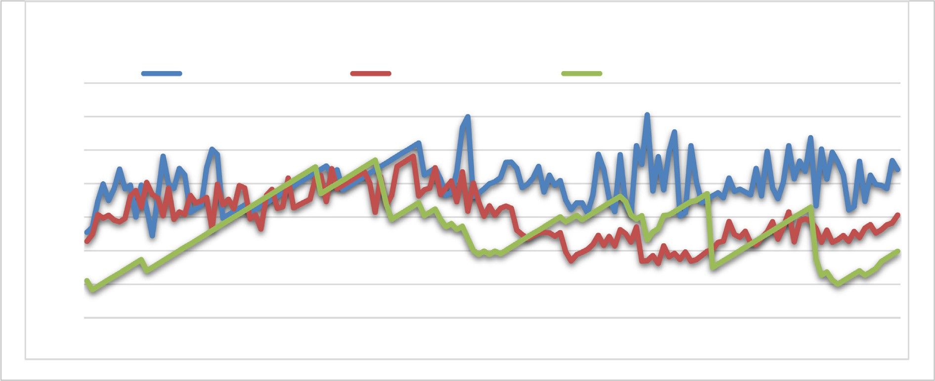

Fig. 11. The proposed algorithm in comparison of fixed cycle control according to total waiting time.

Table 8

Vehicles Trip Time and Average Waiting Time(AWT)- Sample.

|  |  |  |  |  |
| --- | --- | --- | --- | --- |
| Vehicle Id | Trip Time (*Sec*.) | AWT-Fixed (*Sec*.) | AWT-Smart (*Sec*.) | AWT-Movement (*Sec*) |
| 1 | 235 | 25.47 | 22.7 | 11.00 |
| 2 | 205 | 27.3 | 24.87 | 8.33 |
| 3 | 215 | 34.67 | 30.76 | 9.33 |
| 4 | 334 | 39.89 | 29.96 | 10.33 |
| 5 | 413 | 35.0 | 30.54 | 11.33 |
| 6 | 132 | 38.56 | 29.12 | 12.33 |
| 7 | 514 | 44.32 | 28.65 | 13.33 |
| . | . | . | . | . |
| . | . | . | . | . |
| 94 | 392 | 36.59 | 21.82 | 31.23 |
| 95 | 401 | 48.77 | 24.60 | 32.23 |
| 96 | 410 | 44.32 | 21.58 | 33.23 |
| . | . | . | . | . |
| . | . | . | . | . |
| 146 | 331 | 39.67 | 25.25 | 14.67 |
| 147 | 288 | 39.47 | 26.52 | 16.80 |
| 148 | 542 | 38.56 | 27.66 | 17.80 |
| 149 | 322 | 46.56 | 28.25 | 18.80 |
| 150 | 331 | 44.23 | 30.64 | 19.80 |

dictable or incremental behaviour for the network seen in fixed traffic control.

The lane flow and Movement flow appeared very close to each other, as movement control has small improvement than flow con- trol as shown in Fig. 10.

In contrast, the trip time and average waiting time were noted for all of the 150 vehicles for the two systems, as depicted in Table 8. As can be seen in Fig. 10, the suggested method brought about a decrease in the waiting time for every vehicle. According to the findings, the average waiting time computed for traditional fixed cycle control is 40.49 s for all of the 150 vehicles that had an average trip time of 335.44 s and 29.97 s for the suggested system of lane flow control and 26.66 s for the no-interference movement control, where the number of vehicles and the average trip time were the same (See Fig 11).

Consequently, the average waiting time on traffic lights was decreased by the suggested smart system by 25.98 % for lane flow control and 34.16 % for the movement control for the whole traffic in road network. These percentages are higher than other studies carried out with similar goals and environment. When the average waiting time is decreased, there is a decline in gas emission, new infrastructure requirements, time wastage, and so on.

1. Conclusion and future work

In this study, urban traffic-based intelligence approaches for traffic light scheduling are determined based on demand and fea- sibility of smart traffic optimisation so that vehicle waiting time is decreased and the existing infrastructure undergoes very few changes. Limited indicators and models are presented in this sys- tem to enhance the traffic flow for the entire network and decrease the mean waiting time of vehicles for the two methods by 34.16 % and 25.98 %, respectively. When such systems are adopted, the need for new infrastructure is decreased, as well as fuel consump- tion, drivers’ trip time, gas emission, mean waiting time and the environmental impact on flora, fauna and human health. The aim of future studies will be to prototype this system and implement the method on Virtual Traffic Light Technology (VT).

1. Data availability

Data available on request from the authors.

1. Funding statement

No funding to declare.

Declaration of Competing Interest

The authors declare that they have no known competing finan- cial interests or personal relationships that could have appeared to influence the work reported in this paper.

Acknowledgment

Authors would like to thank Alzaytoonah University of Jordan for their support.

References

1. U.S. Department of Transportation, Bureau of Transportation Statistics, Transportation Statistics Annual Report 2021(2021). *U.S. Department of Transportation.* [Online]. Available: [https://www.bts.gov/sites/](https://www.bts.gov/sites/bts.dot.gov/files/2022-01/TSAR_FULL%2520BOOK-12-31-2021.pdf2021) [bts.dot.gov/files/2022-01/TSAR_FULL%20BOOK-12-31-2021.pdf2021](https://www.bts.gov/sites/bts.dot.gov/files/2022-01/TSAR_FULL%2520BOOK-12-31-2021.pdf2021).
2. [Ferreira M, d’Orey PM. On the impact of virtual traffic lights on carbon](http://refhub.elsevier.com/S1110-8665(22)00068-8/h0010) [emissions mitigation. IEEE Trans Intell Transp Syst 2012;13(1):284–95](http://refhub.elsevier.com/S1110-8665(22)00068-8/h0010).
3. K. T. K. Teo, W. Y. Kow and Y. K. Chin, ‘‘Optimization of Traffic Flow within an Urban Traffic Light Intersection with Genetic Algorithm,” 2nd International Conference on Computational Intelligence, Modelling and Simulation, Bali, Indonesia, 2010, pp. 172–177.
4. [Khiang M, Khalid M, Yousef R. Intelligent traffic lights control by fuzzy logic.](http://refhub.elsevier.com/S1110-8665(22)00068-8/h0020) [Malaysian J Comput Sci 1997;9(2):29–35](http://refhub.elsevier.com/S1110-8665(22)00068-8/h0020).
5. K.H Chao, R.H Le and M.H Wang, ‘‘An intelligent traffic light control based on extension neural network,” *in International Conference on Knowledge-Based and Intelligent Information and Engineering Systems*, San Sebastián, Spain, 2008.
6. [Viraktamath S, Holkar P, Narayankar PV, Pujari J. Adaptive intelligent traffic](http://refhub.elsevier.com/S1110-8665(22)00068-8/h0030) [control system using plc. Int J Innovat Res Comput Commun Eng 2015;3](http://refhub.elsevier.com/S1110-8665(22)00068-8/h0030) [(6):287–90](http://refhub.elsevier.com/S1110-8665(22)00068-8/h0030).
7. [Xu D, Peng P, Wei C, He D, Xuan Q. Road traffic network state prediction based](http://refhub.elsevier.com/S1110-8665(22)00068-8/h0035) [on a generative adversarial network. IET Intel Transport Syst 2020;14](http://refhub.elsevier.com/S1110-8665(22)00068-8/h0035) [(10):1286–94](http://refhub.elsevier.com/S1110-8665(22)00068-8/h0035).
8. M.C.P. Ferreira, O. Tonguz, R.J. Fernandes, H.M.F. DaConceicao and W. Viriyasitavat: ‘‘Methods and systems for coordinating vehicular traffic using in-vehicle virtual traffic control signals enabled by vehicle-to-vehicle communications,” *Google Patents*, US Patent Pub. No.: US 2013/0116915 A1, 2015.
9. [Alkhatib AA, Sawalha T. Techniques for road traffic optimization: an overview.](http://refhub.elsevier.com/S1110-8665(22)00068-8/h0045) [Indian J Comput Sci Eng 2020;11(4):311–20](http://refhub.elsevier.com/S1110-8665(22)00068-8/h0045).
10. Y.Jaradat, M., Masoud, I., Jannoud, and D. Zeidan, ‘‘Genetic Algorithm Energy Optimization in 3D WSNs with Different Node Distributions,” *Intelligent Automation & Soft Computing*, vol.33, no., 2, pp. 791-808, 202.
11. H. Sanderson, ‘‘How do traffic signals work?,”, *Traffic Design*. [Online]. Available: [https://www.trafficsignaldesign.com/how_do_traffic_signals_work.](https://www.trafficsignaldesign.com/how_do_traffic_signals_work.htm) [htm](https://www.trafficsignaldesign.com/how_do_traffic_signals_work.htm).
12. K. Pandey and P. Jalan, ‘‘An approach for optimizing the average waiting time for vehicles at the traffic intersection,” *in 2018 Fifth International Conference on Parallel, Distributed and Grid Computing (PDGC*). Solan, India,

pp. 30–35, 2018.

1. Q.chen and Z. Mao, ‘‘Connected cars can lie, posing a new threat to smart cities,” *the conversation.* [Online]. Available: [https://theconversation.com/connectedcars-](https://theconversation.com/connectedcars-can-lie-posing-a-new-threat-to-smart-cities-95339) [can-lie-posing-a-new-threat-to-smart-cities-95339](https://theconversation.com/connectedcars-can-lie-posing-a-new-threat-to-smart-cities-95339).
2. C. Avin, M. Borokhovich, Y. Haddad and Z. Lotker, ‘‘Optimal virtual traffic light placement,” in *Proceedings of the 8th International Workshop on Foundations of Mobile Computing*. Madeira, Portugal, p.p. 1-10, 2012.
3. S. Saini , S.Nikhil, K.R. Konda, H.S. Bharadwaj and N. Ganeshan: ‘‘An efficient vision-based traffic light detection and state recognition for autonomous vehicles,” in *Intelligent Vehicles Symposium (IV)*, California, USA pp.606-611, 2017.
4. F. Hagenauer, P. Baldemaier, F. Dressler and C. Sommer, ‘‘Advanced leader election for virtual traffic lights,” *ZTE Communications*, *Special Issue on VANET*, vol.12, no. 1, pp. 11–16, 2014.
5. [Arel I, Liu C, Urbanik T, Kohls AG. Reinforcement learning-based multiagent](http://refhub.elsevier.com/S1110-8665(22)00068-8/h0085) [system for network traffic signal control. IET Intel Transport Syst 2010;4](http://refhub.elsevier.com/S1110-8665(22)00068-8/h0085) [(2):128–35](http://refhub.elsevier.com/S1110-8665(22)00068-8/h0085).
6. Iyer, V.; Jadhav, R.; Mavchi, U.; Abraham, J. ‘‘Intelligent traffic signal synchronization using fuzzy logic and Q-learning”. *In Proceedings of the 2016 International Conference on Computing, Analytics and Security Trends (CAST)*, Pune, India, 2016; pp. 156–161.
7. [Wang H, Zhu M, Hong W, Wang C, Tao G, Wang Y. Optimizing signal timing](http://refhub.elsevier.com/S1110-8665(22)00068-8/h0095) [control for large urban traffic networks using an adaptive linear quadratic](http://refhub.elsevier.com/S1110-8665(22)00068-8/h0095) [regulator control strategy. IEEE Trans Intell Transp Syst 2022;23(1):333–43](http://refhub.elsevier.com/S1110-8665(22)00068-8/h0095).
8. [Siyal MY, Fathy M. A neural-vision based approach to measure traffic queue](http://refhub.elsevier.com/S1110-8665(22)00068-8/h0100) [parameters in real-time. Pattern Recogn Lett 1999;20(8):761–70](http://refhub.elsevier.com/S1110-8665(22)00068-8/h0100).
9. V. John, K. Yoneda, B. Qi, Z. Liu and S. Mita, ‘‘Traffic light recognition in varying illumination using deep learning and saliency map,” in *17th International IEEE Conference on Intelligent Transportation Systems* (ITSC), Qingdao, China, pp. 2286–2291 ,2014.
10. F. Zou, B. Yang and Y. Cao: ‘‘Traffic light control for a single intersection based on wireless sensor network,” *in 9th International Conference on Electronic Measurement & Instruments*, Beijing, China, pp. 1–1040, 2009.
11. J.J. Sanchez, M. Galan and E. Rubio: ‘‘Genetic algorithms and cellular automata: A new architecture for traffic light cycles optimization,‘‘ *in the Congress on Evolutionary Computation*, Oregon, Portland, pp. 1668–1674, 2004.
12. S.P. Biswas, P. Roy, N. Patra, A. Mukherjee and N. Dey : ‘‘Intelligent traffic monitoring system,” *in Proceedings of the Second International Conference on Computer and Communication Technologi*es, Bengaluru, Karnataka, India, pp. 535–545, 2016.
13. K. Zaatouri and T.Ezzedine, ‘‘A self-adaptive traffic light control system based on yolo,” *in International Conference on Internet of Things, Embedded Systems and Communications* (IINTEC), Hammamet, Tunisia, pp. 16–19, 2018.
14. [Rydzewski A, Czarnul P. Recent advances in traffic optimisation: systematic](http://refhub.elsevier.com/S1110-8665(22)00068-8/h0130) [literature review of modern models, methods and algorithms. IET Intel](http://refhub.elsevier.com/S1110-8665(22)00068-8/h0130) [Transport Syst 2020;14(13):1740–58](http://refhub.elsevier.com/S1110-8665(22)00068-8/h0130).
15. [Tomar I, Sreedevi I, Pandey N. State-of-Art Review of Traffic Light](http://refhub.elsevier.com/S1110-8665(22)00068-8/h0135) [Synchronization for Intelligent Vehicles: Current Status, Challenges, and](http://refhub.elsevier.com/S1110-8665(22)00068-8/h0135) [Emerging Trends. Electronics 2022;11(4):pp](http://refhub.elsevier.com/S1110-8665(22)00068-8/h0135).
16. Nesmachnow, S.; Massobrio, R.; Arreche, E.; Mumford, C.; Olivera, A.C.; Vidal, P.J.; Tchernykh, A. ‘‘Traffic lights synchronization for Bus Rapid Transit using a parallel evolutionary algorithm”, *International Journal of Transportation Science and Technology,* vol. 8, no. 1pp.53–67. 2019.
17. H. Zhonghe, Z. Chi, W. Li, ‘‘Consensus feedback control for urban roadtraffic networks”. *54th Annual Conf. of the Society of Instrument and ControlEngineers of Japan*, Hangzhou, China, pp. 1413–1418, 2015.
18. P.S. Rodríguez-Hernández, J.C. Burguillo, E. Costa-Montenegro, et al.: ‘‘Astudy for self-adapting urban traffic control” *Ibero-American Conf. onArtificial Intelligence*, San José, Costa Rica, pp. 63–74, 2019.
19. [Ahmad Yousef KM, Shatnawi A, Latayfeh M. Intelligent traffic lightscheduling](http://refhub.elsevier.com/S1110-8665(22)00068-8/h0155) [technique using calendar-based history information. Future Gener Comput](http://refhub.elsevier.com/S1110-8665(22)00068-8/h0155) [Syst 2019:124–35](http://refhub.elsevier.com/S1110-8665(22)00068-8/h0155).
20. A. Ion, C. Berceanu, M. Patrascu, ‘‘Applying agent based simulation to the design of traffic control systems with respect to real-world urban complexity”, *Multi- Agent Systems and Agreement Technologies*, Athens, Greece,pp. 395–409, 2015.
21. [Alkhatib A. Proposed simple low cost system for road traffic counting. Int J Syst](http://refhub.elsevier.com/S1110-8665(22)00068-8/h0165) [Control Commun Inder 2020;11(4):334–45](http://refhub.elsevier.com/S1110-8665(22)00068-8/h0165).
22. NetLogoWeb. ‘netlogoweb.org. (n.d.)’. (, 2022. Availablefrom: [https://www.](https://www.netlogoweb.org/assets/modelslib/Sample%2520Models/Chemistry%2520%2520Physics/Ising.nlogo) [netlogoweb.org/assets/modelslib/Sample%20Models/Chemistry%20%](https://www.netlogoweb.org/assets/modelslib/Sample%2520Models/Chemistry%2520%2520Physics/Ising.nlogo) [20Physics/Ising.nlogo](https://www.netlogoweb.org/assets/modelslib/Sample%2520Models/Chemistry%2520%2520Physics/Ising.nlogo).
23. Tisue, S. and Wilensky, U. ‘‘Netlogo: Design and implementation of a multi- agent modeling environment,” *in Proceedings of agent*, USA, pp. 7–9 , 2004.