[Egyptian Informatics Journal 23 (2022) 225–238](https://doi.org/10.1016/j.eij.2021.12.005)

Contents lists available at [ScienceDirect](http://www.sciencedirect.com/science/journal/11108665)

Egyptian Informatics Journal

journal homepage: [www.sciencedirect.com](http://www.sciencedirect.com/)

Full length article

[](http://crossmark.crossref.org/dialog/?doi=10.1016/j.eij.2021.12.005&domain=pdf)Smart geographical routing protocol achieving high QoS and energy efficiency based for wireless multimedia sensor networks

Wael Ali Hussein ⇑, Borhanuddin M Ali, MFA Rasid ⇑, Fazirulhisyam Hashim

*Department of Computer and Communication Systems Engineering, Wireless and Photonics Research Centre (WiPNET); Faculty of Engineering, Universiti Putra Malaysia, 43400 UPM Serdang, Selangor, Malaysia*

a r t i c l e i n f o

*Article history:*

Received 13 September 2021

Accepted 1 December 2021

Available online 5 January 2022

*Keywords:*

Wireless multimedia sensor network Energy efficiency

Network lifetime

a b s t r a c t

Over the recent years, multimedia applications have begun to be used over wireless sensor networks (WSN), which hitherto has been primarily used to carry small amount of data. To meet the demand for higher throughput and real-time characteristics of multimedia contents, the routing protocol need to be simplified and optimized. In this paper, we present a routing algorithm that provides a low end-to- end packet delay and low packet loss, referred to as smart, greedy forwarding algorithm based on throughput and energy-awareness (SGFTEM). This algorithm routes multimedia packets across a WSN by choosing high- throughput paths rather than always choosing the shorter path to the sink. When it encounters network holes, a network void-bypass is applied, which enhances the reliability of the net- work. Energy management is also implemented to extend sensor node lifetime by way of reducing the radio transmission coverage to a suitable distance reachable by the sensor nodes The simulation results shows that, SGFTEM reduces the end-to-end delay by 40% and packet loss ratio by 35% and maintain energy consumption against other algorithms. With energy management, the residual energy of sensor nodes are made to be equally distributed across the entire network which results in load balancing. The performance of SGFTEM are also compared via simulation against AGEM, TPGF, GPSR, and AODV showing superior performance under similar scenarios i.e. low packet end-to-end delay, low packet loss and load balancing of routing paths.

© 2022 THE AUTHORS. Published by Elsevier B.V. on behalf of Faculty of Computers and Information,

Cairo University. This is an open access article under the CC BY-NC-ND license ([http://creativecommons.](http://creativecommons.org/licenses/by-nc-nd/4.0/)

[org/licenses/by-nc-nd/4.0/](http://creativecommons.org/licenses/by-nc-nd/4.0/)).

1. Introduction

It is well known that wireless sensor networks (WSN) have made many contributions in the area of monitoring, surveillance and object tracking, but they have generally been limited to simple monitoring and sensing applications such as for temperature, pres- sure, humidity and occasionally the presence and locations of objects [1,2]. For those types of applications, the bit rate is typically of the order of hundreds of bits per second, so the WSN has tradi- tionally been designed to handle these ranges of data rates. How- ever, in recent years, there has been increased interest in multimedia content such as audio and video streams, still images

* Corresponding authors.

Peer review under responsibility of Faculty of Computers and Information, Cairo University.

**Production and hosting by Elsevier**

and other content-rich multimedia be handled over WSN. This calls for a drastic adjustment to the traditional WSN specifications, which hitherto have been characterized as low-bandwidth and low-power networks, in order for the networks to be able to handle the higher-bandwidth and real time requirements of media-rich content [3–5]. WMSN is one of the technologies that shape the Internet of Things (IoT) research [6]. One aspect that needs to be enhanced to face the new challenges is the routing protocol; it must provide the quality of service (QoS) requirement of multime- dia content, and with optimal energy consumption [7]. WMSNs, as with the traditional WSN, consist of sensor nodes with one or a few sinks at the edges of the network, which can be in an indoor or out- door environment. Some example use-cases include building mon- itoring, factory management, livestock or wildlife monitoring and object tracking [8]. WMSN needs to be self-configured; thus, it pre- cludes a user interface for configuration of routing paths, energy management, sensing events, etc. WMSN needs to be highly reli- able, support high data rate, low-power computation ability and the sensor nodes to be portable; these gives rise to a sensitive trade-off between improving the reliability and minimizing energy

<https://doi.org/10.1016/j.eij.2021.12.005>

1110-8665/© 2022 THE AUTHORS. Published by Elsevier B.V. on behalf of Faculty of Computers and Information, Cairo University. This is an open access article under the CC BY-NC-ND license (<http://creativecommons.org/licenses/by-nc-nd/4.0/>).

consumption; between guaranteeing QoS and extending sensor lifetimes. The optimization of the trade-offs between WMSN parameters is difficult to achieve in the hardware components; however, optimization between energy consumption and QoS is possible in the routing protocol. The energy consumption of sensor nodes mainly occurs at the radio transceiver and, to a lesser degree, in the data computation and processing part, respectively. In net- work routing, QoS is an important metric which indicates the per- formance of a network in terms of transmission delay, packet loss, packet delivery at the sink node, etc [9]. Many surveys on WMSN have been performed over the last few years, addressing different aspects of the technology; surveys of sensor node architectures and components in [10], while reviews of routing protocols, technolo- gies and their challenges can be found in [11–13]. In this paper, we present SGFTEM, which is a location-based routing protocol that delivers high QoS with good energy performance compared against many other WSN protocols of the same category.

This paper is organized as follows: in Section 2, we review related works on WSN routing protocols particularly those based on geographical information, followed by a detailed description of our proposed SGFTEM protocol in Section 3. The simulation results and discussions are presented in Section 4, and finally the conclusion is made in Section 6.

1. Related Works

As high-lighted above, WMSN routing protocols focus more on QoS support when transmitting multimedia packets to meet end- to-end delay bounds, packet delivery and maintaining energy effi- ciency [14,15]. The routing protocols can be classified according to the mapping shown in Fig. 1. For a hole-bypassing geographical routing protocol, the protocol called greedy perimeter stateless routing for wireless networks (GPSR) which is in itself derived from the mobile ad hoc network (MANET), has been adopted in WSNs [16]. Based on the geographical positions of forwarder nodes, the protocol makes greedy-forwarding decisions using only the infor- mation from a router’s immediate neighbors in the network. GPSR works based on geographic location routing, described as follows:

1. Each node in GPSR knows its own location and its respective direct single-hop neighbor node’s geographic location;
2. GPSR includes the geographic location of destination nodes in each packet;
3. The sensor node sends the packets to the neighbor node that is closer to the destination, using the greedy forwarding technique;
4. If a packet encounters an energy hole, and the sensor node is not able to send the packets directly to a node that is closer to the destination using greedy forwarding, then GPSR will use perimeter forwarding;
5. Perimeter forwarding routes packets around the hole until it arrives at the node closest to the destination;
6. After perimeter forwarding, greedy forwarding takes over the routing again.

GPSR uses a simple method to route data from source to sink, but GPSR will have problem with holes, whether static or dynamic. When GPSR uses perimeter searching and cannot find a valid neighbor node, it will abort the search and therefore will not be able to complete the routing. However, GPSR uses the same routing path persistently due to the adoption of the shortest path routing algorithm until the node’s energy becomes exhausted and the path becomes broken. Then, GPSR will find another path, which may be longer, until routing becomes exhausted again eventually. Because of this shortcoming, GPSR is not able to maximize the lifetime of the network.

The ad hoc on-demand distance vector routing protocol (AODV)

[17] uses two techniques to perform routing: discovery route paths and path maintenance. It uses three types of control signals: route request (RREQ), route reply (RREP) and route error (RERR). The dis- covery route, which works when the source node starts sending data to the destination node, does not have a valid routing path. The source node will start route discovery steps by sending route request (RREQ) packets to its neighbors, which will be forwarded to their neighbors and so on until they reach the destination or find nodes that have fresh routing paths to the destination. Through the process of forwarding the RREQ, the intermediate nodes record in their routing tables the addresses of the neighbors from the first

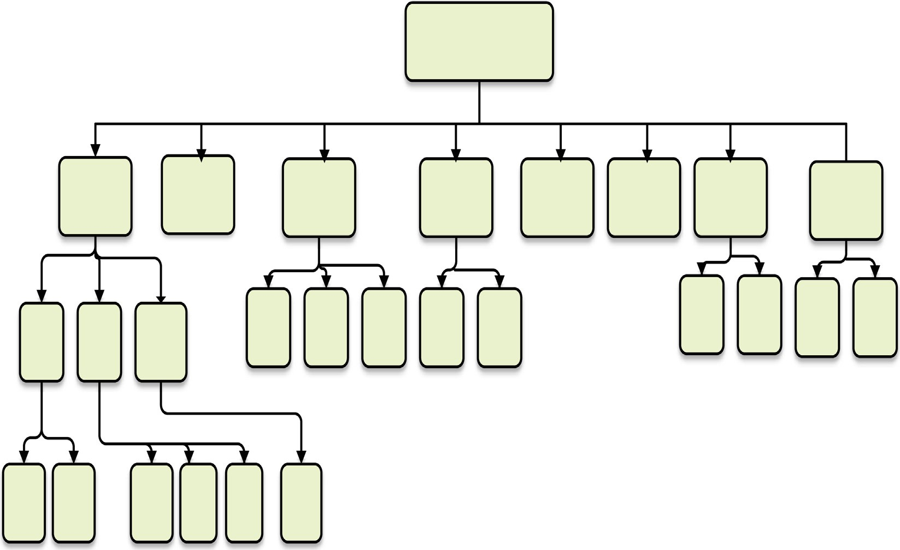

Fig. 1. Wireless multimedia sensor network (WMSN) routing protocol classification [18–20].

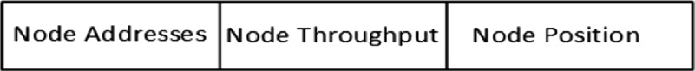

Fig. 2. Beacon message structure at the network layer.

copy of broadcast packets and establish a reverse path. The source node will ignore any RREQ packet received later. RREP packets are routed back using the reverse path, and the nodes in this path setup forward route entrances in their routing tables, which is started after the receipt of the RREP. The maintenance of routes in AODV employs RERR packets when connection links fail. The RERR starts from the instant a connection link to the corresponding routing source node fails; the source node will be informed about the failure of connection and the RREQ process will be initiated for the failure. AODV achieves high reliability because of the route- request–route-reply and route maintenance method, which is good for applications that need high reliability. However, the AODV method incurs high delay and is not beneficial for difficult delay- sensitive applications.

Two-phase greedy forwarding (TPGF) has been presented in [26,30]. The first step in this protocol explores the path by sending the packets to the next-hop node that has a shorter distance to the destination. In case the forwarder-node has no next-hop node, it sends data back to the sender node and blocks the forwarder- node. The forwarding-node searches for another forwarder node and selects it to reach the destination. In the second phase pf opti- mization, the destination will send back to the source through the same routing path packets labeled with the node number and path number to optimize the routing path and reduce the number of hops. TPGF solves greedy perimeter stateless routing for wireless network routing protocol (GPSR) problems to avoid failure if it can- not find the next-hop node in the forwarding mode. The drawbacks of TPGF are that if node in the same path have a blocked status, for- warding data in closed circle will take place and there will be a high possibility of losing the routing path.

For a static sensor network, another protocol called the adaptive greedy compass energy-aware using multi-path (AGEM) approach has been proposed in [24]. AGEM is based on greedy geographic routing together with angle-based greedy forwarding for next- hop node selection. It aims to extend the lifetime of the network and reduce the queue size in the network. AGEM works in two modes: first, it uses a smart greedy forwarding, in which if there is another neighbor node closer to the destination node than for- warder node, then the packet will be forwarded there. The other mode is called step-back forwarding, in which when there is no neighbor node closer to the destination than its forwarder node,

any of the neighbor nodes within an angular space (*a*) or an initial

node *a*0 can be chosen. The minimum neighbor node set must be found if *n* 6 2 while n is the number of neighbor nodes, and load balancing is performed. If *n* = 1, then load balancing cannot be achieved. If no nodes are found, then (*a*) is incremented by D*a*until it reaches *a* 180◦. If the next forwarding-node still cannot be found based on AGEM requirements, a hole in the forwarding path

=

( )

is considered to have occurred, and thus the step-back mode is entered. The forwarder node will inform its neighbors that it will no longer be used to forward packets to the sink. One of its neigh- bor nodes will then take responsibility of by-passing the hole. AGEM is suitable for transmitting multimedia traffic over a wire- less sensor networks because it meets the transmission constraints of WMSN and maximizes the network lifetime. Using the hole by- passing technique along with maximizing the network lifetime results in further energy consumption, because when the sensor node energy is low, the forwarding path will be changed to another path, making routing paths much longer. In this case, more nodes are used and extra delay is incurred. In critical real-time applica-

tions, reliability is more important than energy savings; thus, energy-saving becomes irrelevant in that situation. Furthermore, back-forwarding to avoid holes incurs further delay.

In multi-agent based context-aware information gathering for agriculture using Wireless Multimedia Sensor Networks [29], a hierarchical structure has been used. The network is divided into clusters and each cluster selects its respective cluster head. Sensor nodes are geographically distributed and gather the data such as; detect the disease-affected plants, recognize the growth of unwanted plants, check the fertility of the soil periodically, and detect fire in the field at the time of transmission from the sensor nodes. The collected data is then classified into various classes, based on a predetermined value. If the data lie out of a specific range, the node will become active and transmit the data to the cluster head, which will subsequently send to the sink node. In the sensor nodes, there are two kinds of the agent; sensor node agents and sink node agents. A possible use case is in the remote detection of plant conditions; SGFTEM extracts the plant data based on the content-based image retrieval (CBIR) method, where the health status of plants is extracted from the images and stored in the sensor node knowledge base. The protocol is event-driven and the data are transmitted to the sink node according to their classification. For example, data detecting a fire must reach the sink node without delay, while data relating to diseased plants could tolerate some delays. The sensor node must support CBIR with high-resolution cameras for image detection, which requires high processing power.

Table 1 summarizes and classifies relevant protocols.

1. The Proposed Protocol

In this section, we briefly describe the SGFTEM, which com- prises both the routing algorithm and energy management system.

* 1. *Smart Greedy Forwarding based on Throughput, Energy-Aware and Multi-Path Routing Algorithm (SGFTEM)*

The basic idea of our SGFTEM routing protocol is derived from the works of [31,16,32] and those presented in previous WSN works as depicted in Fig. 1. It considers various QoS parameters such as end-to-end delay, packet loss and energy balancing. The basic idea is to perform the load balancing of packet routing and reduce the queuing of packets in the most-used sensor nodes in the entire network. Two main problems that arise from a pure greedy-forwarding protocol arise; namely, the persistent routing of packets through the same path which is usually the shortest path, and secondly the process of avoiding holes and finding alter- native routes which can be complex. Using the same path results in energy exhaustion of the nodes involved and they will die early creating holes in the network. The objective of the algorithm pro- posed in this paper is to avoid using complex routing processes to minimize end-to-end delay of packet forwarding delays and energy consumption.

In SGFTEM, packets carrying video streams or images are for- warded via multiple paths to enhance their reliability and perform load balancing. At each forwarding node, the node decides how to forward packets to its neighbor node, taking into consideration the node’s throughput and distance to the destination. In establishing connections, forwarding nodes use beacons at the network layer to exchange information about neighbor nodes, including IP addresses (Id), throughput, residual energy, and node positions as in Fig. 2. In summary, SGFTEM is a geo-location-based routing pro- tocol in which nodes are aware of their respective geographical coordinates and their respective neighbors, and in which all previ- ous information is integrated and the information on nearby neigh-

Table 1

Routing protocol classification

|  |  |  |  |  |  |  |  |  |  |  |  |  |
| --- | --- | --- | --- | --- | --- | --- | --- | --- | --- | --- | --- | --- |
| Routing Protocol | Flat | Hierarchical | Multi- path | Latency | Energy Efficiency | Event | Query | No Priority | Static Priority | Differentiated priority | Hole bypassing | Location awareness |
| AMPMCR [21] |  | U | U | U | U |  | U |  |  | U | U | U |
| MMSPEED [22] | U |  | U | U | U |  | U |  |  | U | U | U |
| EA*QoS* [23] |  | U |  | U | U |  | U |  |  |  |  |  |
| AGEM [24] | U |  | U | U | U | U | U |  |  |  | U | U |
| RAP [25] | U |  |  | U |  | U | U |  |  | U |  | U |
| GPSR [16] | U |  |  |  |  |  |  | U |  |  |  |  |
| TPGF [26] | U |  | U | U | U |  |  | U |  |  | U | U |
| MPMP [27] | U |  | U | U | U |  |  |  | U |  | U | U |
| DGR [28] | U |  | U |  | U |  |  | U |  |  |  |  |
| AODV [17] | U |  | U | U |  |  |  | U |  |  |  |  |
| MCAIG [29] |  | U | U |  | U | U |  |  |  | U | U |  |

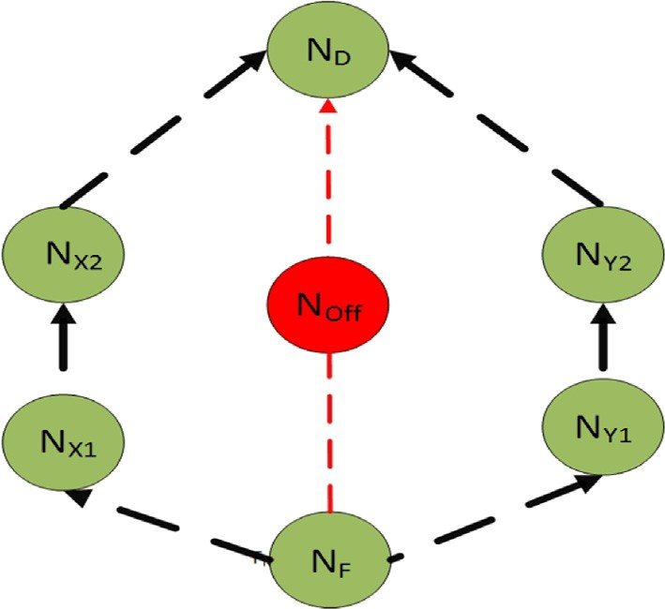bors is updated, resulting in successful packet forwarding. The fol- lowing factors are considered in SGFTEM.

1. The distance between the forwarding node and destination;
2. The throughput of forwarding nodes and their respective neighbors;
3. The residual energy level at each node;
4. The number of hops experienced by the packets;
5. The distance between neighbors and destinations;
6. The speed of sensor nodes in mobility cases.

The SGFTEM routing algorithm work as follows: it chooses the shortest path using the initial throughput, which is assumed to be equal for all nodes, which are at their minimum values. New throughputs is then calculated, and the initial values are replaced by the new values. This throughput information are shared with the neighbor nodes using beacon messages. Within a short time, the routing technique changes to a throughput-based routing tech- nique and is used in all the sensor nodes. First, a forwarding node checks if its neighbor’s distance to the destination is less than itself; if it is, it then checks the node’s throughput and takes it as the best value. The information on the node’s address, distance to destination and throughput are all stored in the sensor nodes, and this process continues with all the neighbor nodes. Finally, the node that has the highest throughput and a shorter distance to the destination than the forwarding node will be selected as the next-hop node. Beacon messages keep frequent updates of the sensor nodes’ throughput and the other information mentioned above. As a result, the forwarding node can now decide a locally optimal, greedy choice for a packet’s next hop.

In some cases, the forwarding node may not be able to find the next-hop node, which means that one or more holes have appeared in the routing path. Usually, holes are caused by two main prob- lems; the first type is the static type of holes, which is typically caused by shadowing when the nodes lie behind large objects like buildings or hills, which do not change dynamically; the other type is the dynamic holes, which is mainly caused by sensor nodes turn- ing off due to energy exhaustion. SGFTEM can handle holes if there are working nodes within the area, and it is able to establish a new routing path. When the forwarding node cannot find the next hop in the greedy forwarding mode due to holes, it chooses perimeter forwarding instead to bypass the hole. Fig. 3 shows the situation

Fig. 3. Perimeter forwarding.

This is illustrated in Fig. 4, the packets take a step back to the previous sender, the node shuts down NM2 and packets are subse- quently forwarded using the perimeter forwarding mode.

* + 1. *Throughput Calculation*

In SGFTEM, the throughput is initialized to 0, and the node then starts calculating the subsequent throughput using the following relationships:

*td* = *Simt* — *Stt* (1)

*Throughput* = *Nbits*/*td* (2)

where *td* is the duration of transmission, *Simt* is the simulation time, *Stt* is the startup time and *Nbits* is the number of bits. In Algorithm 1, all of the required information throughput (*Node throughput*), addresses (*Node adress* ) and simulation time (*Sim time*) is embed- ded in the beacon packet and forwarded to the neighbor nodes. The coordinates and simulation time of the nodes represent the address. The destination address is known at each node in the network. Geo- graphical positions of nodes can be obtained from any global posi- tioning system (GPS) service.

()

Algorithm 1: Sending Beacon Packet Function

that a forwarding node (NF) encounters a hole in its routing path,

and thus it uses perimeter forwarding for packets to *Nx*1 or *Ny*1 based on the condition of the nodes. The distance between *NF* and *ND* through *NOff* is shorter than *NF* to *ND* through *Nx*1 and *Nx*2

*NF* ?*NOff* ?*ND* < *NF* ?*Nx*1 ?*Nx*2, which describes how the perime-

ter forwarding works. If the perimeter forwarding is unable to find any forwarding node, SGFTEM will send the packet back to the pre- vious sender will look for another next-hop node using greedy for- warding or perimeter forwarding as described above.

1: *Set Throuput Value for node with L*3*Addr Simtime*

2: *Beacon* ← *Node adress*()

3: *Beacon* ← *Node Sim time*

4: *Beacon* ← *Node throughput*

5: *Network protocol Info* ← *SetDistnationAddr*

6: *Network protocol Info* ← *SetSourceAddr*

7: *Send UDP Packet*

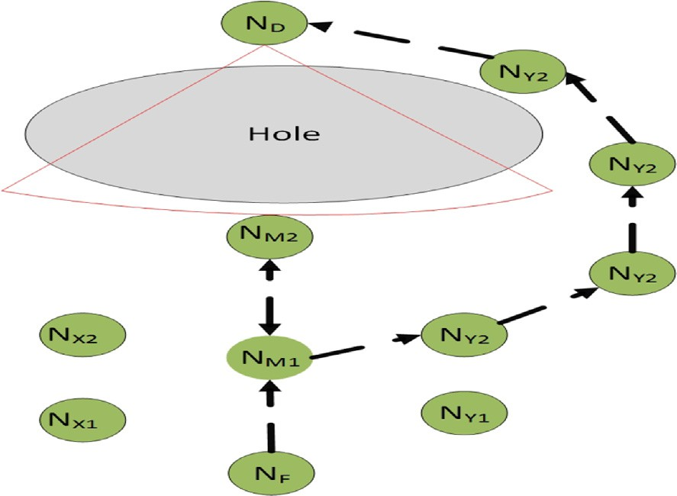

Fig. 4. Step-back mode.

* 1. *Coverage and Energy Management Model*

Several techniques for energy management have been applied to SGFTEM. The motivation for this paper arose from the need to transmit a large amount of content-rich multimedia data which extends the time of using radio transceivers at the nodes, and exhaust the battery faster.

* + 1. *Coverage and Network Lifetime*

In this paper, we focus on the method of extending sensor node lifetimes considering coverage techniques and extending the coverage area by way of dividing the sensing area into many small virtual grids. As illustrated in Fig. 5, consider any two adjacent grids e.g., grids A and B; all nodes in A can communi- cate with nodes in B and vice versa. The nodes in the grids have the same routing capability while inn reality, a node’s radio communications range is not symmetric or deterministic due to radio propagation effects such as multi-path propagation

and shadowing. However, for simplicity, in this paper we assume

Algorithm 2: Forwarding Mode of SGFTEM Algorithm Function

1: *Bst Neibrnod Throput*=0

2: for all *i* 6 *Total of Neibrnods* do

3: if *Neibrnod Dstanc i* 6 *Best NeibrnodDstnc* then

4: while *Neibrnod Throput* P *BestNeibrnod Throput* do

5: *Best Neibrnod Throput* ← *Neibrnod Throput*

6: *Best Neibrnod Neibrnod*

←

7: end while

that the radio range of all nodes is deterministic and symmetri- cal [34–36]. The virtual grid is a square with dimensions *r*in meters and a size assumed to be based on the radio range, R;

i.e the distance between two possible farthest nodes in two adja- cent grids must not be larger than radio range, R [37]. Therefore, we obtain

*r*2 + (2*r*)2 6 *R*2 (3)

*R*

8: end if

*r* 6 ,ﬃ5ﬃﬃ

(4)

9: end for

In step-back mode, the packets will be sent back to the previous sender address and the current sender node turn-off. as we can see on the following algorithm:

Algorithm 3: Backward Mode of SGFTEM Algorithm Function

From *r*, we can construct the network topology, and this will help us to cover each point in the sensing area and keep the net- work alive even when some of the neighbor sensor nodes are turned-off for charging.

* + 1. *Energy Management on SGFTEM*

Energy management helps to extend the lifetime of sensor

nodes. In the simulation model, solar charging has been applied

1: *NextHopNodeAddr* ← *PrvisSndrAdd*

2: *Check*& *Cast* < *SGFTEM Packet* > *toPrvisSndrAdd*

3: *NodeStatus* ← *ShutDown Status*

4: *Call* Algorithm 1

Thus, the SGFTEM routing algorithm is expected to be superior than that of the GPSR [16] and AGEM [31,33] as it uses a simple method to route packets with only a few parameters carried in beacon messages, and require no further calculation. When the packets encounter holes, SGFTEM uses the perimeter technique to get around them, and thereupon it continues to use the normal process, which is throughput-based.

to each node, which extends the battery life of the sensor nodes. Energy management includes sleep and wake-up modes and route-load balancing. The strategy for energy management is as follows,

1. Wake-Up and Sleep Mode
   1. Nodes goes to sleep mode at a low battery level: SGFTEM will turn-off any node when the energy of the battery reduces to 20% of the total capacity and switches it back on when the energy increases to 35%. This is done to keep the node alive at all times without any sudden turning-off incidents.

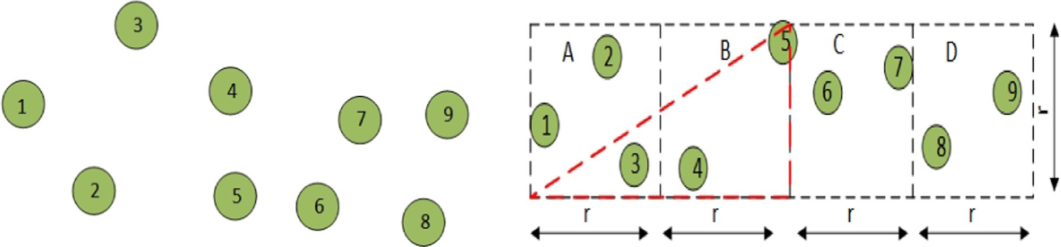



Fig. 5. Virtual grid in SGFTEM.

* 1. Nodes are turned-off based on the traffic situation: Any node with a throughput of less than 5% of the total calcu- lated throughput will go to sleep for a specific time. In this case, turning-off the node when it has no available band- width will save the energy of the node, and will allow the routing protocol to find another neighbor node as the forwarder.

1. Appropriate beacon interval time: Selecting a beacon interval time is important to avoid sensor nodes to be disconnected. Long intervals will cause incorrect or old information to be used regarding the forwarding node, which may result in a failure of forwarding the packets. On the other hand, a short beacon inter- val will consume large bandwidth over the entire network, causing increased packet collisions and subsequent re- transmissions, which consumes more energy. A short interval- time also implies having to send more beacons and thus causing more energy to be consumed. The challenge is to find the best beacon-interval time that gives the best QoS.
2. Throughput-based routing: This will keep transmitting pack- ets over nodes with low load, which extends the network lifetime.
3. Simulation Results and Discussions

In this section, we present the simulation of SGFTEM under many scenarios to present the performance of our contribution. First, we conducted extensive simulations to observe the delay, packet loss and energy efficiency performance. The simulation has been conducted for different network densities of 35, 55, 75 node. Secondly, we studied the performance of SGFTEM in network topology with voids, and we conducted simulations under the same network density of 35, 55, 75 nodes. Third, we studied net- work coverage extension and node’s lifetime extension. We simu- lated them against related works and compare the results. The structure of this section can be summarized as follows, based on the simulation results:

Evaluations, analysis and discussion of smart greedy forwarding working based on selection of routing paths with higher throughput and shorter distance to the destination, for a high QoS routing protocol;

●

Coverage extension, load balancing and energy efficiency tech- niques for SGFTEM.

●

To simulate and evaluate the performance of SGFTEM, Omnet++ 5 has been used, which is a discrete event simulator with the Inet

2.99.1 framework. A homogeneous network is used to send multi- media packets from source to sink. Three types of simulations have been performed:

1. Networks with static nodes,
2. Networks with static nodes having two voids,
3. SGFTEM with energy management.

This section describes the performance of SGFTEM routing algo- rithm in terms of the specified QoS. The routing algorithm is exam- ined with respect to the number of nodes, speed of sensor nodes and energy management. The simulations in this section measure three main performance parameters: end-to-end delay (E2ED), the packet loss ratio (PLR) and the residual energy of the sensor nodes. Simulations of SGFTEM in networks with static nodes were performed using the parameters listed in Table 2. The design parameters are the number of nodes, while the network size was set to 1500 m 500 m, which is considered as a typical radio range for sensor nodes in the field. The traffic rate is set as 5 packet/s of 512 bytes each to make it comparable with a real network [38]. .

×

The SGFTEM algorithm was simulated under three network density scenarios 35 nodes, 55 nodes and 75 nodes, under the same coverage area, to study the effect of network density. The perfor- mance of SGFTEM is then compared against AGEM [31], TPGF [26], AODV [17] and GPSR [16] routing protocols, all of which have been described in Section 2. A homogeneous network is used to send multimedia packets, with a data rate of 20 kbps, in an area of 1500 m 500 m, with one source node and one sink at the edges of the coverage area. The multi-path transmission scenario is shown in Fig. 6(a) and (b) shows a plain topology in which all the sensor nodes are working, while Fig. 6(b) shows the same net- work containing two holes. OMNET++ 5 with the Inet v3 frame- work [39]was used to simulate the algorithm.

* 1. *End-to-End Delay (E2ED)*

×

The network topology is used to examine the performance of SGFTEM, in both cases with a different number of sensor nodes. The simulation results of SGFTEM on a plain network topology with 35 nodes is presented in Fig. 7 and compared against AGEM, TPGF, AODV and GPSR. In the second scenario, which comprises of 55 nodes, AODV shows the highest end-to-end delay, followed by GPSR, TPGF, AGEM and SGFTEM. In the third scenario i.e., with 75 nodes, GPSR shows the highest end-to-end delay, followed by AGEM, AODV and SGFTEM. This observation can be summarized as follows:

1. SGFTEM is the fastest among the protocols examined; i.e., it has the smallest end-to-end -delay.
2. The end-to-end delay in GPSR, TPGF and AGEM increase when network density increase.
3. The end-to-end delay in AODV reduces remarkably when net- work density increase.
4. The end-to-end-delay in AGEM show the best performance among TPGF, AODV and GPSR for the plain network topology.

As has been described earlier, SGFTEM forwards packets to the neighbor nodes that have higher throughput and that are closer to the destination than the forwarding node; even though the nodes have information about their respective neighbors and store the geographic position of the destinations, they do not have any glo- bal information about the network status. The nodes with high throughput (higher available bandwidth) incur smaller E2ED, packet loss and reduced energy consumption by reducing the packet queuing and collisions. SGFTEM shows lower E2ED than TPGF and AGEM because TPGF and AGEM follows the shortest path, where the shortest-path routing may comprise of nodes with low throughput, which implies high packet queuing, resulting in high end-to-end delay and increased packet losses. Meanwhile, an increased number of sensor nodes on AGEM results in increased end-to-end delay and packet loss owing to the absence of global

Table 2

WMSN simulation parameters for static and mobile sensor nodes.

Parameter Value

Network Size 1500 × 500 *m*

Number of Sink Nodes 1

Number of Source Nodes 1

Number of Sensors 35,55,75

Packet Size 512B

Packet Rate 5 Packet/Sec

Run time 500s

Maximum Radio Range 200 meters

Transmit Power 2mW

Charging Power 3.6 W/h (for 8 h)

Battery Capacity 59500 J

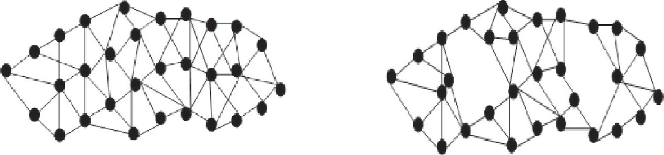



Fig. 6. Simulation topology of the wireless multimedia sensor network (WMSN) a) Plain topology, b) Plain topology with holes.

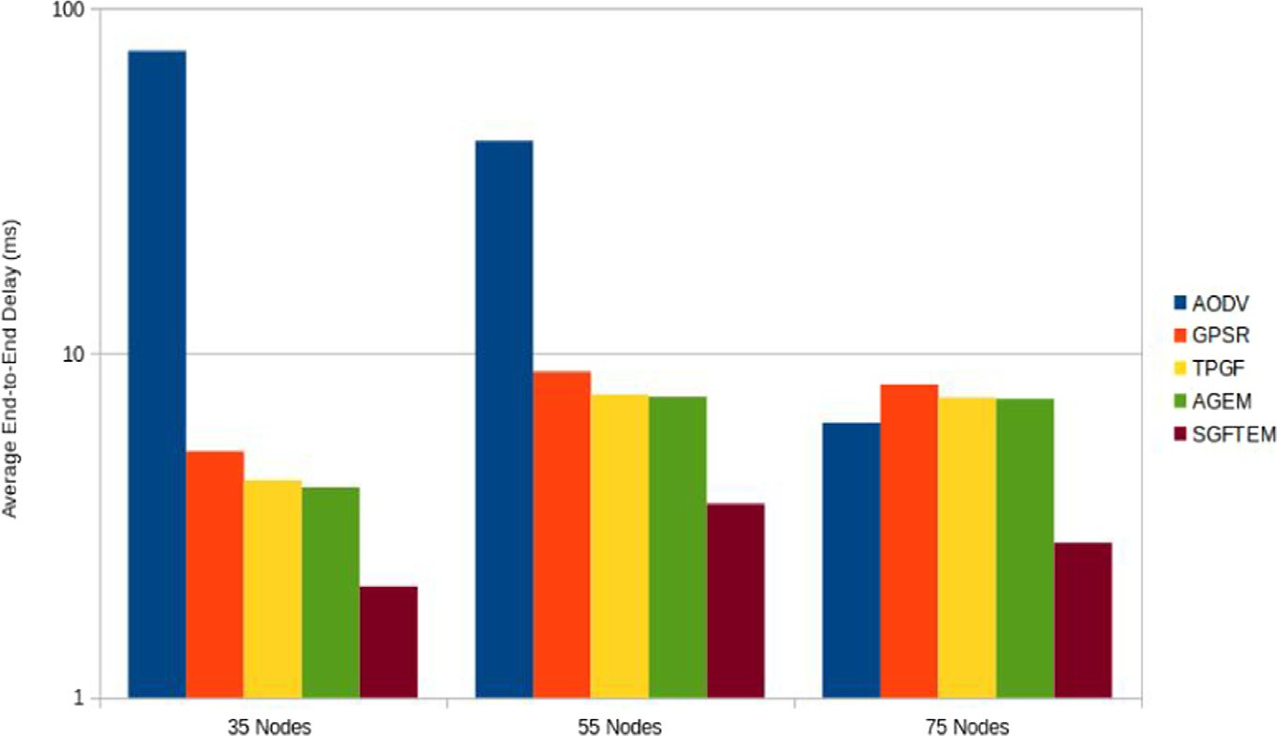

Fig. 7. Average end-to-end delay in the static nodes scenario (plain topology).

information on the sensor node; thus with a high sensor number, packet collisions increase, resulting in increased end-to-end delay and packet loss. AODV shows high delay in low-density networks as a result of route request and route reply mechanism adopted by the AODV protocol [40]. On the other hand, SGFTEM shows only a slight change in end-to-end delay with a high- density network because the routing of data follows the nodes with lower traffic load.

For the plain network topology with holes illustrated in Fig. 6 (b), the simulation result is presented in Fig. 8.. In the 35- node sce- nario, AODV shows the highest (worst) end-to-end delay; TPGF comes second; AGEM and GPSR are third and fourth, respectively; and SGFTEM achieves the lowest delay. In the 55-node scenario, the behavior follows the same order as the 35-node scenario. In the 75- node scenario, AGEM shows the highest delay compared to the others, with AODV the second highest followed by GPSR, while AGEM and SGFTEM exhibited the best performance. From these results, the following can be observed:

1. SGFTEM achieves the minimum (best) end-to-end delay;
2. AODV’s end-to-end delay reduces remarkably when the net- work density increases;
3. Geographic routing protocol performance decreases with increased network density.

To understand the simulation result of the network with holes, SGFTEM was slightly modified so that it can find the path with the same mechanism as GPSR and AGEM and keep following nodes

with low traffic load, which explains its low E2ED delay. In perime- ter mode routing, AGEM searches for the next node around a 30° angle and GPSR searches over 180°, which explains why AGEM

can reduce the number of possible next nodes. If the approach can- not find the next node in the first search, the angle of the search will be increased to 60°. The node searches again for the next node, and if it cannot find one, it increases the search angle further, and so on. Even though this can increase the path search time, which increases the E2ED, in return it increases the reliability of AGEM,

as demonstrated by its low packet loss. If AGEM cannot find the right node, it will take a step back, cancel the current forwarding node and search for other possible nodes. However, this will tend to increase the E2ED and in a high packet stream, this will result in increased packet loss. On the other hand, as has been described in Section 2, AODV works based on a route-request and route-reply protocol, and route maintenance. If there are breaks along the route, it will fix the path by going into route maintenance mode. In this mode, a global message is sent to every sensor node in the network to discover a new path and fix the breaks, resulting in two major issues: firstly, the flooding of the entire network with route messages consumes part of the available bandwidth and increase the packet collisions which subsequently result in higher delays and less reliability; and secondly, by flooding the messages in the network, the node’s radio transmitter sending time is increased, reducing the energy efficiency in the network. End-to- end delay, reliability and energy efficiency are the most common issues for transmitting multimedia data in WMSNs. In conclusion, the AODV method is reliable but costly in term of delay and energy.

* 1. *Packet Loss Ratio (PLR)*

This section presents the simulation result of the packet loss ratio (PLR) for the above protocols. The PLR has been evaluated based on six different scenarios, as shown in Fig. 9 and Fig. 10. They

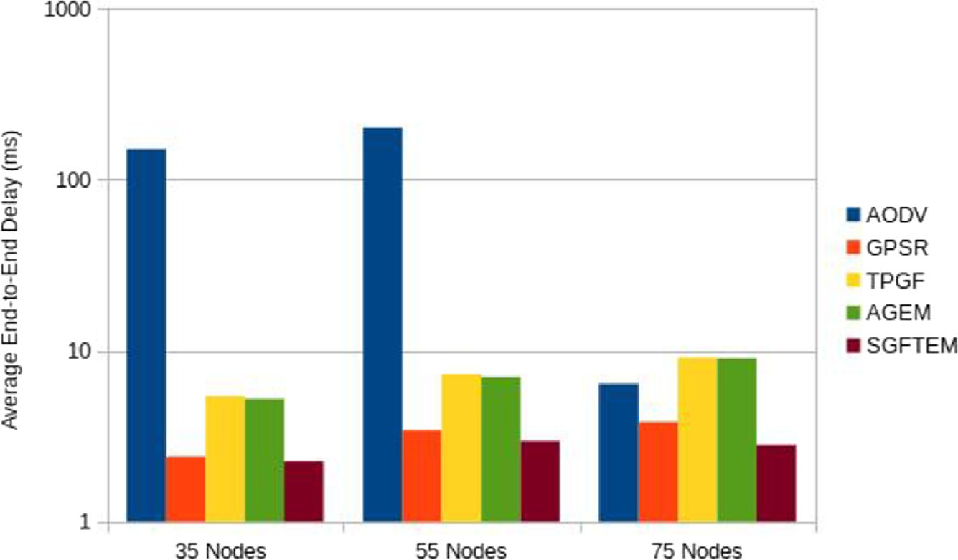

Fig. 8. Average end-to-end delay of the compared protocols for networks with two holes.

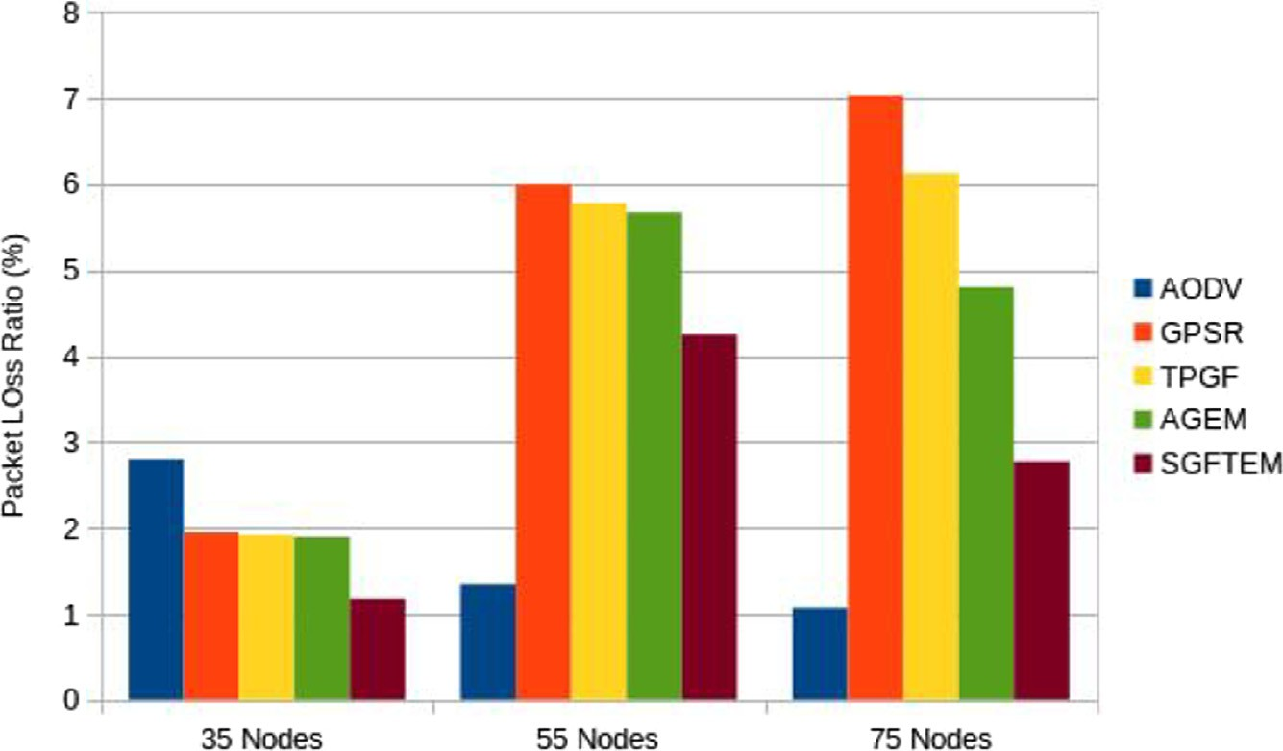

Fig. 9. Packet loss ratio in plain topology under three different network density scenarios.

are namely a plain topology and plain topology with holes and 35 nodes, 55 nodes and 75 nodes, respectively. In Fig. 9 plain topology is presented With 35 nodes, AODV suffers the highest PLR; GPSR and AGEM are slightly better performance, with the second and third-highest PLR, respectively; and the lowest PLR is achieved by SGFTEM. Thus, it could be observed that location-based protocol performs better in low network density such as with 35 nodes. For the 55-node scenario, GPSR suffers the highest PLR; AGEM and SGFTEM get the second and third-highest PLR, respectively; and AODV achieves the lowest PLR (i.e., the best result). Finally, in the 75-node scenario, the pattern is similar to the 55-node sce- nario. The following conclusions can be derived from the presented results:

1. In terms of reliability (smallest packet loss), AODV is better in high network density;
2. AGEM and TPGF exhibit better PLR performance than GPSR under different scenarios;
3. SGFTEM performs the best among the greedy routing protocols;
4. The PLR performance of greedy routing protocols suffers under high network density scenarios.

AODV PLR results is illustrated in Fig. 9, which is well known as a high reliability routing protocol, but the downside is its high end- to-end delay, as presented in the previous section. As shown,

AGEM is slightly more reliable than GPSR, because AGEM searches for routing paths and performs load balancing of multiple-paths. Finally, in SGFTEM, the routing path creation searches for paths with low traffic load, which minimizes packet loss. All greedy rout- ing protocols examined here suffer high packet loss at high net- work densities and only work best up to a certain network size, whereas AODV performs better under high network density net- work scenarios. This is because all greedy routing protocols studied here have neighbor node information only (local information) whereas AODV has global information. Dealing with local informa- tion only gives the advantage of low delay and reduces energy con- sumption in the nodes. In fact, AODV and SGFTEM belong to different categories of routing protocols, and they are compared here to examine the overall performance of the SGFTEM, as the best protocol among the greedy protocols studied here. .

The PLR of the compared protocols under the plain network topology with holes are presented in Fig. 10 for 35, 55 and 75- node scenarios, respectively. In the 35-node scenario, GPSR and TPGF together show the highest PLR (i.e., perform worst), followed by AODV, AGEM and SGFTEM. For the 55 and 75-node scenario, the pattern remain the same as with 35-node scenario described ear- lier even though the relative numbers are different; the PLR for GPSR and TPGF reduce a little, while the PLR for AODV and AGEM increase a little, while SGFTEM remain the same. In the 75-node scenario, AODV TPGF, AGEM and SGFTEM. In the 55-node scenario,

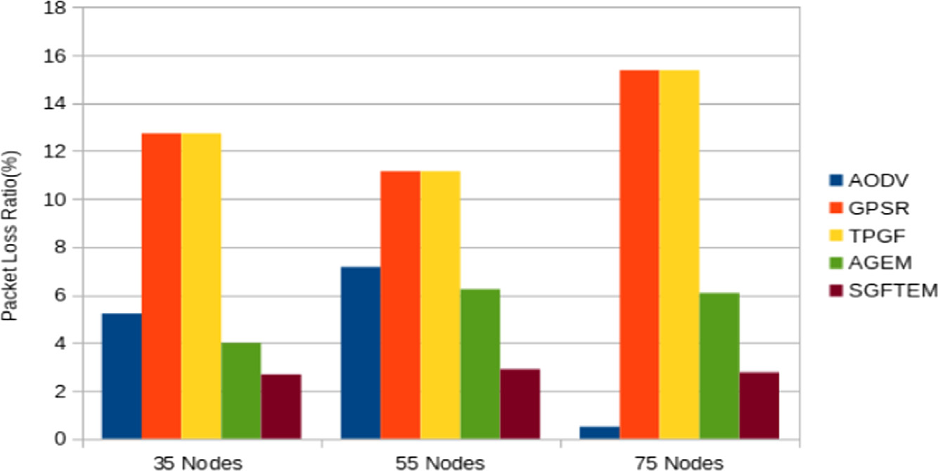

Fig. 10. Average packet loss ratio (PLR) in networks with a two–hole scenario.

similar behavior is seen in the 75-node scenario, a similar behavior to the 35-node scenario is observed, that show how increase the number of The packet loss in AODV dramatically reduces, showing the best performance among all the protocols examined nodes will not effect the performance of protocol. The observation here, SGFTEM shows the best performance among the protocols, reaf- firms the previous discussion on the performance of the protocols, showing the improved reliability of AGEM over GPSR.

* 1. *Residual Energy*

Residual energy is another performance parameter that has been studied in the SGFTEM protocol. The residual energy has been obtained after 500 s simulation time for a transmit power of 2 mW and a charging energy of 648 J. From the results shown in Fig. 11, it can be seen that, with a 500s simulation time, only a small amount of energy has been consumed for all the protocols. SGFTEM, under a plain topology network, retains the highest residual energy among all the protocols compared, followed by AGEM, TPGF and GPSR. The performance pattern of all the protocols remains consistent under all the three scenarios: SGFTEM performs best, followed by AODV, GPSR, TPGF and AGEM. This stems from the fact that SGFTEM routing performs load-balancing in the routing path, whereas GPSR, TPGF and AGEM always use the shortest path regardless of the situ- ation. The same wake-up and sleep scheduling strategy has been applied in this simulation because the simulation focuses on show- ing the energy consumption performance during routing.

The residual energy for the plain topology network with two holes is presented in Fig. 12 under the three network density sce- narios as has been applied with previous simulations. It can be seen that the behavior pattern is similar to the plain topology as the simulation time is equal, at 500s.

To examine the behavior of this routing protocol in further detail, the position of these nodes in the network are mapped as shown in Fig. 13 and the residual energy are color-coded accord- ingly to the respective nodes. As can be seen, the nodes around the sink node consume more energy than the others, while the rest of the nodes in the network maintain almost the same level of residual energy. This demonstrates that the SGFTEM succeeds in performing path load-balancing as the variation of the energy level among the nodes is only slight.

* 1. *Energy Consumption*

In this section, the energy consumption performance of the pro- tocols under the INET framework of the OMNET++ Simulation are presented, starting with a battery capacity of 59,500 J ( 5000 mAh for a 12 V battery, while a regular phone battery capacity is

≈

from 2500 to 5000 mAh). The use of energy-aware protocols will increase the lifetime of the sensor nodes and effectively the net- work. Fig. 17 illustrates the residual energy in the plain network topology for SGFTEM, AGEM, TPGF, GPSR and AODV. It shows that SGFTEM has the best performance in terms of energy efficiency. SGFTEM selects the next-hop node with a higher available band- width, reducing the packet queuing, transmitting time of the node, and resulting in better energy consumption.

From the simulation experiments described above, it can be said that, overall, SGFTEM has characteristics that can satisfy WMSN requirements, such as low end-to-end delay, low packet loss and excellent energy efficiency compared with the other pro- tocols analyzed in this paper. This stems from the techniques that have been used in SGFTEM; i.e., a data routing technique that keeps track of the nodes with higher throughput and that are closer to the destination. It uses knowledge already saved in sensor nodes and does not need to apply extra steps to find the best neighbor nodes. This helps to reduce packet end-to-end delay and save energy, while at the same time reducing packet loss.

* 1. *Energy Management*

To enhance the performance of SGFTEM in term of energy man- agement and load balancing, further simulations on a homoge- neous network have been performed. The sensor nodes are deployed based on radio transmitter coverage and the extent of the sensor lifetime method, throughout the sensing field. The sens- ing field is a rectangular area, and the size varies depending on the number of sensor nodes and their locations. In this simulation, the sensing areas chosen were 750 m 600 m for 35 nodes, 1000 m 600 m for 55 nodes and 1500 m 600 m for 75 nodes. The sink and source nodes are situated at fixed points at the edges of the sensing field. This scenario represents a monitoring use-case, in which the source node sends the data packet to the sink node, to be for- warded to the outside world.

×

× ×

* 1. *Coverage and Energy System Model*

The simulation parameters of the network model are calculated as follows:

*R*

*r* 6 pﬃ(ﬃ5) (5)

200

*r* 6 pﬃ(ﬃ5) (6)

*r* 6 89.5*m* (7)

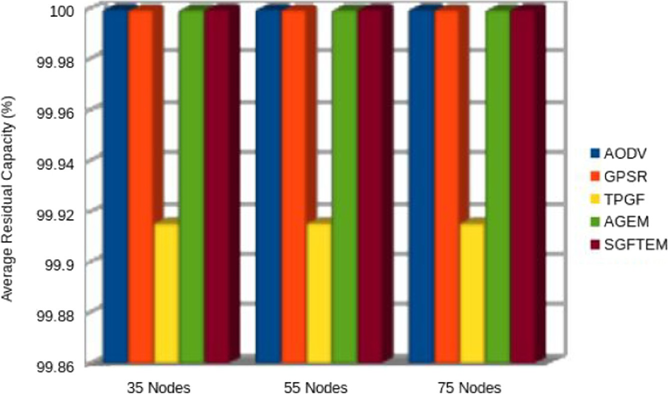

Fig. 11. Average of residual capacity in plain topology.

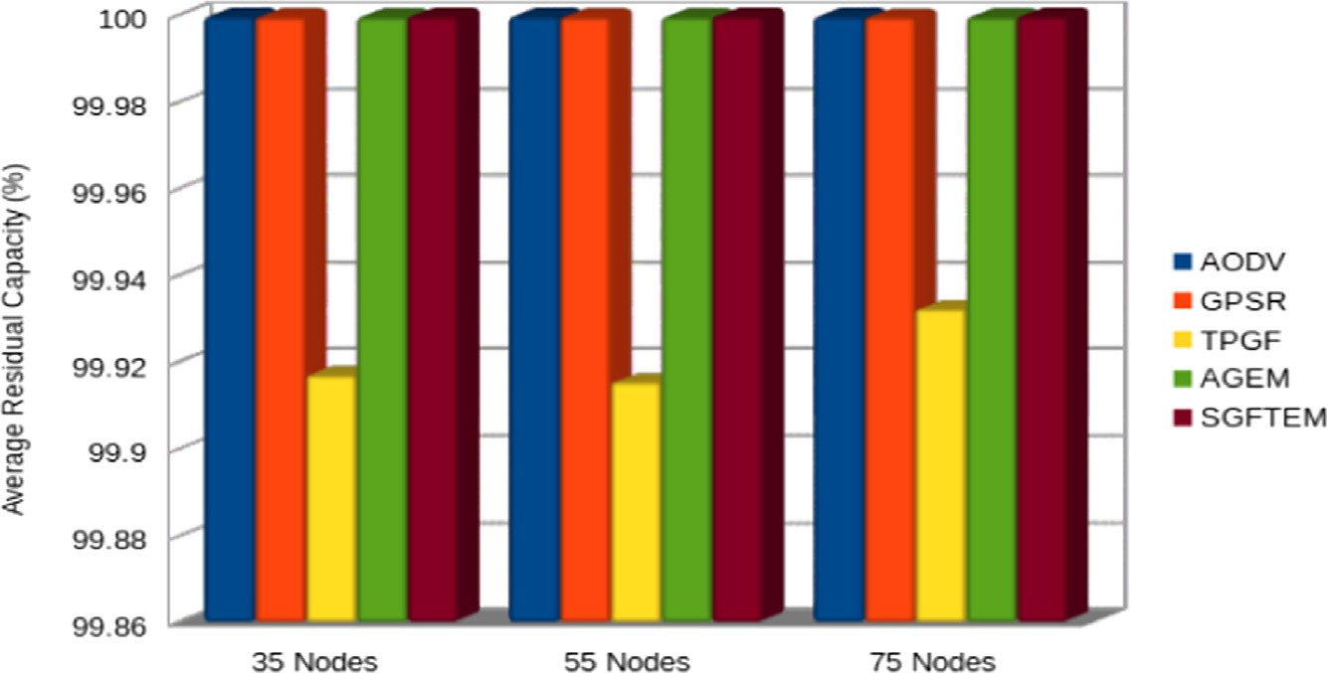

Fig. 12. Average of residual capacity in a plain network topology with two holes.

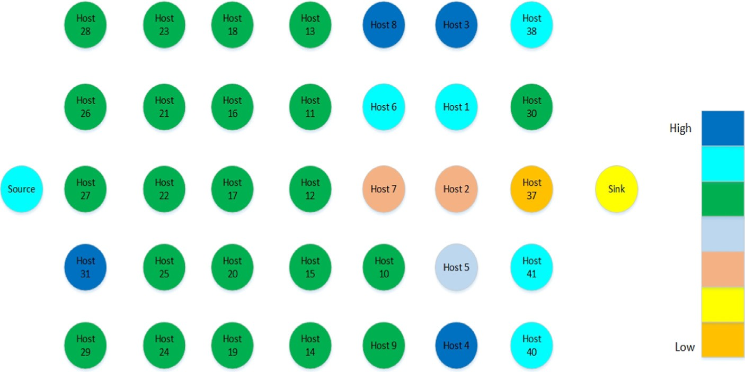

Fig. 13. SGFTEM average residual energy level of sensor nodes in a flat topology, with color coding showing the different amounts of residual energy among the nodes.

where *R* is the maximum radio range and r is the adjacent possible hop. To construct the network, the sensing area is divided into grids with rib lengths of 89.5 m to make sure that the radio range covers the whole area of the network, so if there are nodes that shut down during operation, routing shall continue. Besides, energy saving in

the radio transmitter is achieved by voiding sending data over long distances.

A simple energy management is applied; this is done by switch- ing nodes on and off, resulting in network reliability and energy savings with a solar energy charging system is applied, (Table 3).

Table 3

Energy management simulation parameters.

Parameter Value

Network Size Size varies according to number of Nodes Number of Sink Nodes 1

Number of Source Nodes 1

Number of Sensor nodes 35,55,75 Packet Size 512B

Packet Rate 5 Packet/Sec

Simulation time 12000s

Maximum Radio Range 200 meters Transmit Power 2mW

Charging Power 3.6 W/h

Battery Capacity 2000 J

The residual energy of each sensor node is illustrated in Fig. 14. The dark-colored bubble shows nodes with the highest residual energy, while the bright shade indicates nodes with minimal residual

energy. The distribution of energy consumption after 12,000s is considered equal for most of the nodes, except for nodes at the edges, such as nodes 1, 2, 12, 28 and 35. These are less active nodes because of their positions in the grid which are outside the main route. SGFTEM did not use these nodes because there were other nodes with better throughput and shorter distance to the destina- tion. Comparing Fig. 14 to Fig. 13 and ignoring the difference in battery capacity and run time, it can be seen that applying energy management to the sensor nodes can efficiently extend their life- times, and more nodes would be involved in routing packets so that other nodes can save their energy. Fig. 14 shows the average of the sensor nodes’ residual energy.

The end-to-end delay performance of the respective protocols is shown in Fig. 15 for the 3 network scenarios examined. Except for AODV, the other protocols show low end-to-end delay including SGFTEM. This low end-to- end delay stems from the arrangement of sensor nodes, where each node is placed 89 m from its respec- tive neighbor nodes to guarantee coverage of the whole sensing area. Selecting a forwarding node that has a low load with a shorter

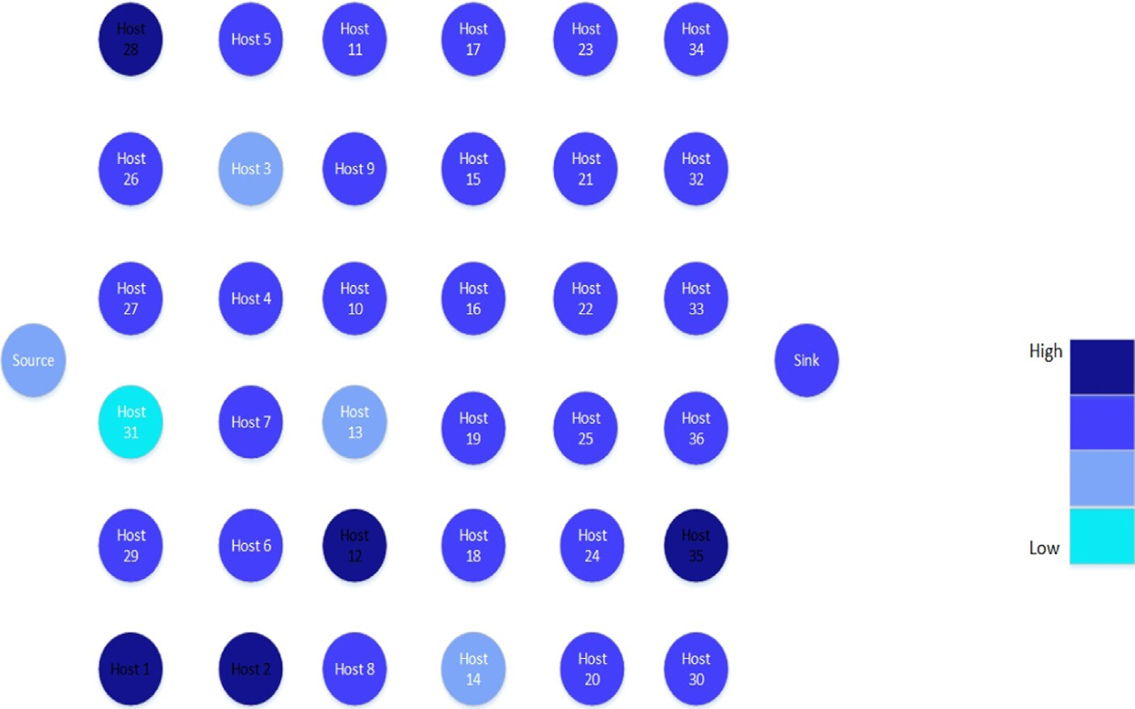

Fig. 14. SGFTEM residual energy level in nodes with energy management in the 35-node scenario.

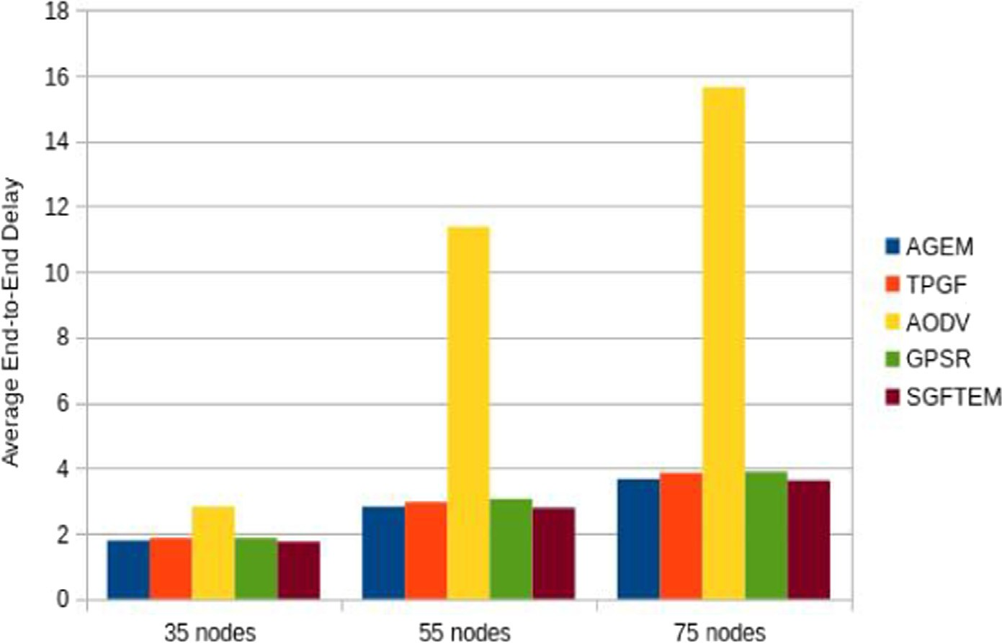

Fig. 15. End-To-End transmission delay with energy management for the various routing protocols at various network densities.

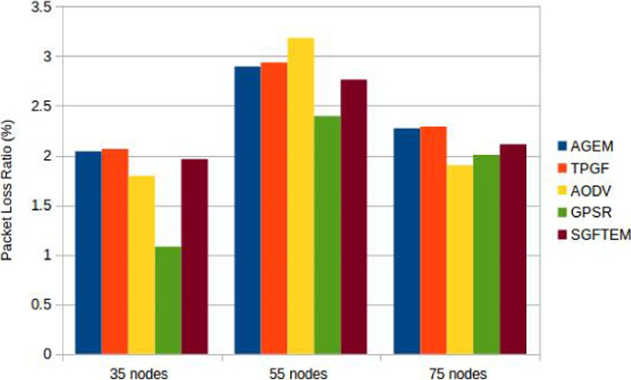

Fig. 16. Packet loss ratio with energy management.

Table 4

PLR Comparison,with and without Energy management

distance to the destination will result in a lower E2ED. A compar- ison between figure FIg. 7 and Fig. 15 demonstrates the difference

Number of Nodes

Routing Protocol

PLR without Energy Management%

PLR with Energy Management %

between the results of the two scenarios where the E2ED is smaller in Fig. 15 for different network densities with energy management.

AODV 2.8 1.8

GPSR 1.95 1.08

35 TPGF 1.92 2.06

AGEM 1.9 1.8

SGFTEM 1.71 1.96

AODV 1.35 3.18

GPSR 6 2.4

5 5 TPGF 5.78 2.93

AGEM 5.7 2.9

SGFTEM 4.2 2.76

AODV 1.07 1.9

GPSR 7.03 2

75 TPGF 6.13 2.3

AGEM 4.8 2.27

SGFTEM 2.77 2.11

The PLR performance, as illustrated in Fig. 16, shows superior performance in this case there are improvement of 50–100% com- pared with the results in Fig. 9. in addition, Table 4 show the per- centagechange in the performance.

The residual capacity is depend on the mechanism of the proto- col and the network density, SGFTEM shows equal residual energy under different network densities, similar to AGEM protocol; and that arises from the load balancing mechanism during packet rout- ing. AODV shows higher level residual energy in high network den- sity and low level residual energy in low network density. TPGF show better performance in low-density network while in high- density the energy level is lower. Lastly GPSR is performing better in higher density. The residual energy level of each protocol among

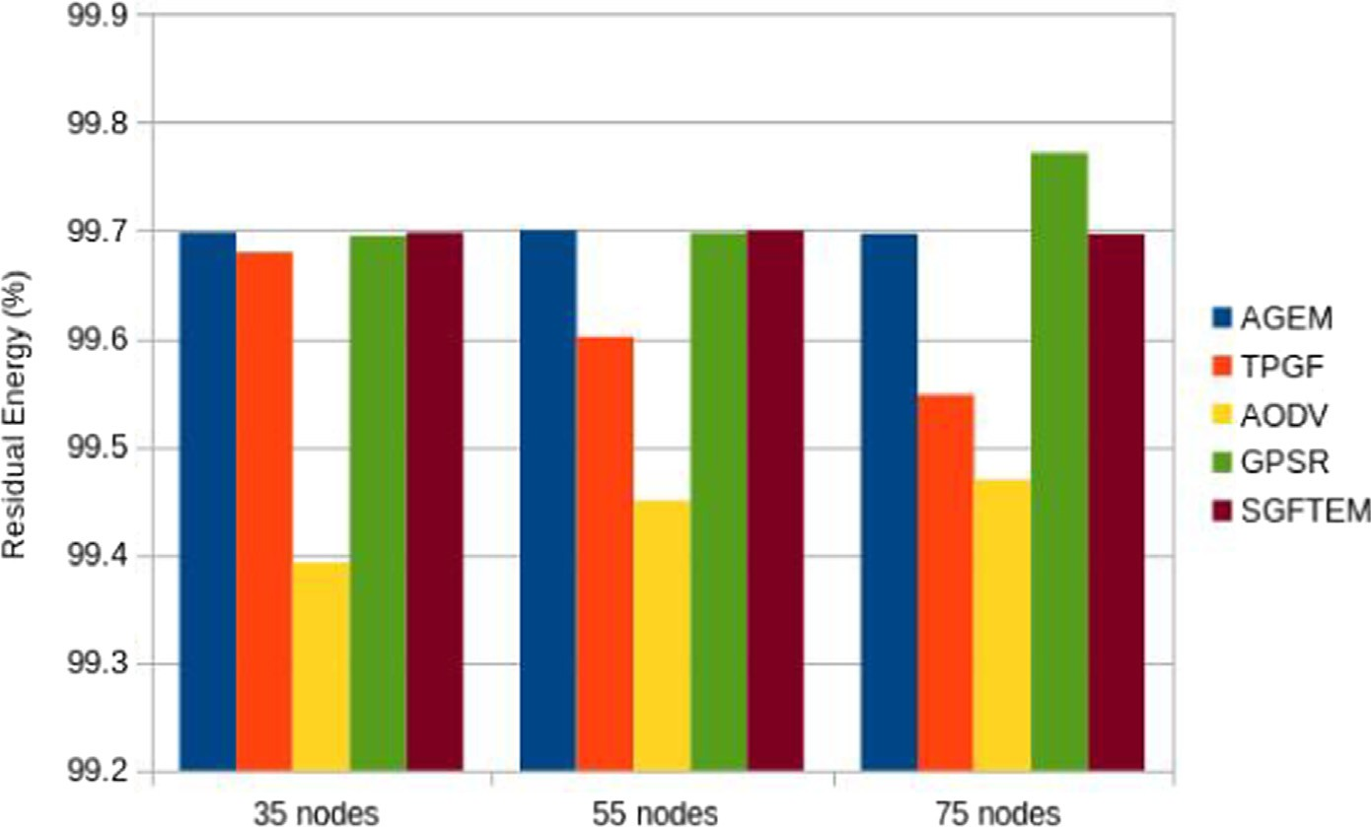

Fig. 17. Residual energy with energy management.

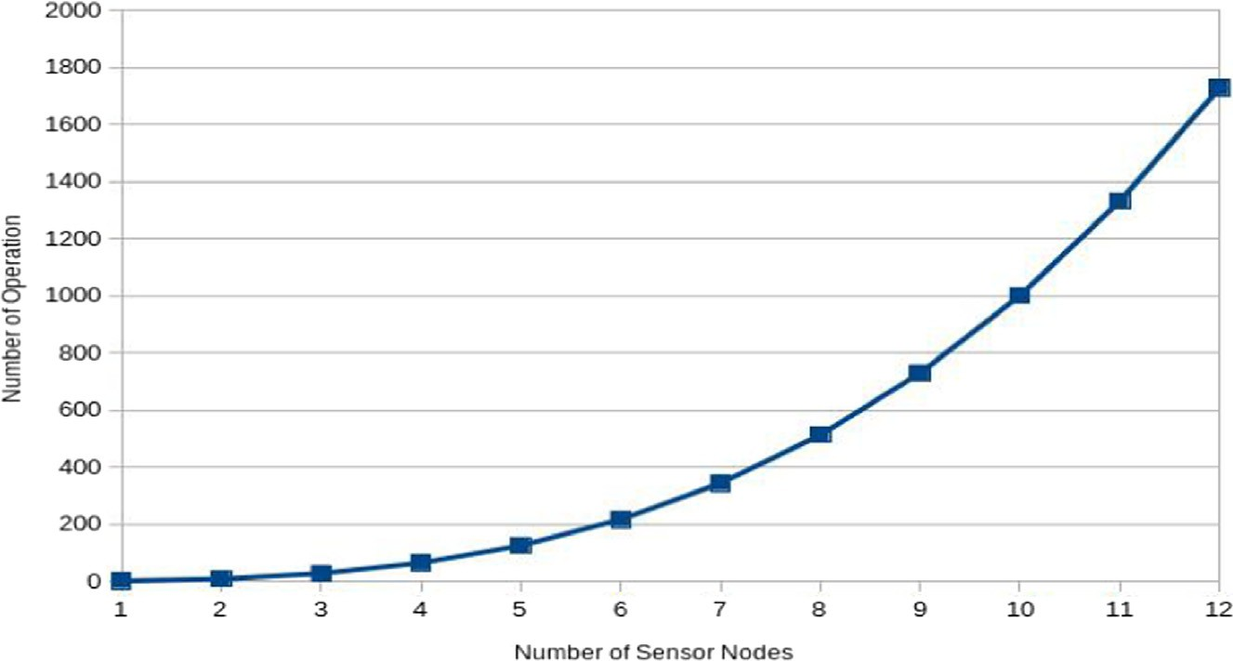

Fig. 18. Relationship between number of operation and number of neighbor sensor nodes.

different scenarios reflect the mechanism of packet routing behav- ior of the protocol. .

1. Complexity

In this section, we discuss the complexity of the SGFTEM routing algorithm to give an overview of its behavior in terms of time com- plexity [41].Big O notation has been used to study an algorithm’s efficiency as it is a simple method to evaluate an algorithm [42]. In this paper, we apply Big O notation on the pseudo-code written for the routing algorithm, which compares the distance and throughput between nodes and keeps forwarding packets to the best node selected based on the mentioned criteria. The comparison uses information stored in the memory. Writing the code using a fast read and write method with a suitable data container is key to reducing the code processing delay. In this paper, we use maps and vector data containers instead of arrays. Using maps allows us to use the same container for more than one type of data, which is not available in arrays. Applying vectors to maps allow us to store the location and throughput together and perform searching using the ”find” instruction instead of a ”for” loop. This dramatically reduces the time needed to search in the data container. In the fol- lowing pseudo code, we present the Big O notation and compute the complexity as follows: From Algorithm 4, which has been described in Section 3, the value of the Big O notation in the pseudo code is given as Algorithm 4, which has been described in Section 3,

Algorithm 4: Forwarding mode of the SGFTEM algorithm function.

1: *Bst Neibrnod Throput* = 0

2: for all *i* 6 *Total of Neibrnods* do

3: if *Neibrnod Dstanc i* 6 *Best NeibrnodDstnc* then

4: while *Neibrnod Throput* P *BestNeibrnod Throput* do

5: *Best Neibrnod Throput* ← *Neibrnod Throput*

6: *Best Neibrnod Neibrnod*

←

7: end while

8: end if

9: end for

The value of the Big O notation in the pseudo code is [43]

*T*(*n*)= *o*(1)+ *o*(*n*)* (*o*(*n* — 1)* (*o*(*n*)+ *o*(*logn*)+ *o*(*logn*))) (8)

*T*(*n*)= *o*(1)+ *o*(*n*)* ((*o*(*n*2 — *n*)+ *o*(*nlogn*)— *o*(*logn*)

+ *o*(*nlogn*)— *o*(*logn*)) (9)

*T*(*n*)= *o*(1)+ ((*o*(*n*3 — *n*2)+ *o*(*n*2*log*(*n*)— *o*(*n*)(*logn*)

+ *o*(*n logn*)— *o*(*nlogn*)) (10)

2

The above equations indicate that the result is a cubic equation, and therefore the running time needs a cubic number of neighbor nodes. We can simply apply n nodes and estimate the time needed to run the code by using the speed of the computer processor and the time needed for read and write operations to the random access memory (RAM). Fig. 18 shows the estimation of the opera- tions per second needed for n neighbor nodes. The running time shows the number of operations needed per second, which indi- cates the network’s scalability. Thus, when the number of neighbor nodes increases, a good multi-path routing opportunity is obtained, but it comes at the expense of increased processing time. Therefore, we need to maintain a balance between both requirements.

1. Conclusion

In this paper, the SGFTEM protocol has been presented and ana- lyzed using simulations. It has been compared against that of AGEM, TPGF, GPSR and AODV under different networks density scenarios with 35, 55 and 75 nodes for a plain network topology, and later. with two voids introduced. The protocol was also simu- lated under different networks density and simulated with extended coverage and energy management to analyse their load balancing and energy consumption efficiency. SGFTEM was shown to achieve lower end-to-end delays in all scenarios, which is proof that it can deliver multimedia data with minimal packet loss and a suitable energy consumption compared against the other routing protocols analyzed above. At the same time, the Big O analysis of the pseudo-code of the SGFTEM algorithm shows a reasonable level of complexity. Thus, we can conclude that SGFTEM matches the requirements for routing multimedia data with a strict delay deadline in a wireless sensor network.

Declaration of Competing Interest

The authors declare that they have no known competing finan- cial interests or personal relationships that could have appeared to influence the work reported in this paper.

References

1. [Shen H, Bai G. Routing in wireless multimedia sensor networks: A survey and](http://refhub.elsevier.com/S1110-8665(21)00080-3/h0005) [challenges ahead. Journal of Network and Computer Applications](http://refhub.elsevier.com/S1110-8665(21)00080-3/h0005) [2016;71:30–49](http://refhub.elsevier.com/S1110-8665(21)00080-3/h0005).
2. [Hasan K, Ahmed K, Biswas K, Islam M, Kayes A, Islam S, et al. Control plane](http://refhub.elsevier.com/S1110-8665(21)00080-3/h0010) [optimisation for an sdn-based wban framework to support healthcare](http://refhub.elsevier.com/S1110-8665(21)00080-3/h0010) [applications. Sensors 2020;20(15):4200](http://refhub.elsevier.com/S1110-8665(21)00080-3/h0010).
3. M.Z. Hasan, H. Al-Rizzo, F. Al-Turjman, A survey on multipath routing protocols for qos assurances in real-time wireless multimedia sensor networks, IEEE Communications Surveys & Tutorials.
4. [Silvestre-Blanes J, Sempere-Payá V, Albero-Albero T. Smart sensor](http://refhub.elsevier.com/S1110-8665(21)00080-3/h0020) [architectures for multimedia sensing in iomt. Sensors 2020;20(5):1400](http://refhub.elsevier.com/S1110-8665(21)00080-3/h0020).
5. [Bannour F, Souihi S, Mellouk A. Distributed sdn control: Survey, taxonomy, and](http://refhub.elsevier.com/S1110-8665(21)00080-3/h0025) [challenges. IEEE Communications Surveys & Tutorials 2018;20(1):333–54](http://refhub.elsevier.com/S1110-8665(21)00080-3/h0025).
6. [Basir R, Qaisar S, Ali M, Aldwairi M, Ashraf MI, Mahmood A, Gidlund M. Fog](http://refhub.elsevier.com/S1110-8665(21)00080-3/h0030) [computing enabling industrial internet of things: State-of-the-art and research](http://refhub.elsevier.com/S1110-8665(21)00080-3/h0030) [challenges. Sensors 2019;19(21):4807](http://refhub.elsevier.com/S1110-8665(21)00080-3/h0030).
7. [Lin S-C, Akyildiz IF, Wang P, Luo M. Qos-aware adaptive routing in multi-layer](http://refhub.elsevier.com/S1110-8665(21)00080-3/h0035) [hierarchical software defined networks: A reinforcement learning approach.](http://refhub.elsevier.com/S1110-8665(21)00080-3/h0035) [In: in: 2016 IEEE International Conference on Services Computing (SCC), IEEE.](http://refhub.elsevier.com/S1110-8665(21)00080-3/h0035)

[p. 25–33](http://refhub.elsevier.com/S1110-8665(21)00080-3/h0035).

1. [Ang L-M, Seng KP, Chew LW, Yeong LS, Chia WC. Wireless multimedia sensor](http://refhub.elsevier.com/S1110-8665(21)00080-3/h0040) [networks on reconfigurable hardware. Springer; 2013](http://refhub.elsevier.com/S1110-8665(21)00080-3/h0040).
2. [Asif M, Khan S, Ahmad R, Sohail M, Singh D. Quality of service of routing](http://refhub.elsevier.com/S1110-8665(21)00080-3/h0045) [protocols in wireless sensor networks: A review. IEEE Access 2017;5:1846–71](http://refhub.elsevier.com/S1110-8665(21)00080-3/h0045).
3. [Ali S, Ashraf A, Qaisar SB, Afridi MK, Saeed H, Rashid S, Felemban EA, Sheikh](http://refhub.elsevier.com/S1110-8665(21)00080-3/h0050)

[AA. Simplimote: A wireless sensor network monitoring platform for oil and gas](http://refhub.elsevier.com/S1110-8665(21)00080-3/h0050) [pipelines. IEEE Systems Journal 2016;12(1):778–89](http://refhub.elsevier.com/S1110-8665(21)00080-3/h0050).

1. X. He, Q. Hao, L. Zhao, Design and implementation of an intelligence wireless multimedia sensor networks node, in: Wireless Communications, Networking and Mobile Computing, 2009. WiCom’09. 5th International Conference on, IEEE, 2009, pp. 1–4.
2. [Amjad M, Afzal MK, Umer T, Kim B-S. Qos-aware and heterogeneously](http://refhub.elsevier.com/S1110-8665(21)00080-3/h0060) [clustered routing protocol for wireless sensor networks. IEEE Access](http://refhub.elsevier.com/S1110-8665(21)00080-3/h0060) [2017;5:10250–62](http://refhub.elsevier.com/S1110-8665(21)00080-3/h0060).
3. [Shah GA, Liang W, Akan OB. Cross-layer framework for qos support in wireless](http://refhub.elsevier.com/S1110-8665(21)00080-3/h0065) [multimedia sensor networks. IEEE Transactions on Multimedia 2012;14](http://refhub.elsevier.com/S1110-8665(21)00080-3/h0065) [(5):1442–55](http://refhub.elsevier.com/S1110-8665(21)00080-3/h0065).
4. [Mariño PP. Optimization of computer networks: modeling and algorithms: a](http://refhub.elsevier.com/S1110-8665(21)00080-3/h0070) [hands-on approach. John Wiley & Sons; 2016](http://refhub.elsevier.com/S1110-8665(21)00080-3/h0070).
5. [Akyildiz IF, Melodia T, Chowdhury KR. A survey on wireless multimedia sensor](http://refhub.elsevier.com/S1110-8665(21)00080-3/h0075) [networks. Computer networks 2007;51(4):921–60](http://refhub.elsevier.com/S1110-8665(21)00080-3/h0075).
6. B. Karp, H.-T. Kung, Gpsr: Greedy perimeter stateless routing for wireless networks, in: Proceedings of the 6th annual international conference on Mobile computing and networking, ACM, 2000, pp. 243–254.
7. [Perkins C, Belding-Royer E, Das S. Ad hoc on-demand distance vector (aodv)](http://refhub.elsevier.com/S1110-8665(21)00080-3/h0085) [routing. Tech. rep. 2003](http://refhub.elsevier.com/S1110-8665(21)00080-3/h0085).
8. [Ehsan S, Hamdaoui B. A survey on energy-efficient routing techniques with](http://refhub.elsevier.com/S1110-8665(21)00080-3/h0090) [qos assurances for wireless multimedia sensor networks. IEEE](http://refhub.elsevier.com/S1110-8665(21)00080-3/h0090) [Communications Surveys & Tutorials 2012;14(2):265–78](http://refhub.elsevier.com/S1110-8665(21)00080-3/h0090).
9. R.C. Carrano, D.G. Passos, L.C.S. Magalhães, N. Célio Vinicius, Survey and taxonomy of duty cycling mechanisms in wireless sensor networks., IEEE Communications Surveys and Tutorials 16 (1) (2014) 181–194.
10. [Tilak S, Abu-Ghazaleh NB, Heinzelman W. A taxonomy of wireless micro-](http://refhub.elsevier.com/S1110-8665(21)00080-3/h0100) [sensor network models. ACM SIGMOBILE Mobile Computing and](http://refhub.elsevier.com/S1110-8665(21)00080-3/h0100) [Communications Review 2002;6(2):28–36](http://refhub.elsevier.com/S1110-8665(21)00080-3/h0100).
11. [Jane YY, Xie LF, Zhang M, Chong PH. A performance comparison of flat and](http://refhub.elsevier.com/S1110-8665(21)00080-3/h0105) [cluster based routings in mobile ad hoc networks. International Journal of](http://refhub.elsevier.com/S1110-8665(21)00080-3/h0105) [Wireless Information Networks 2012;19(2):122–37](http://refhub.elsevier.com/S1110-8665(21)00080-3/h0105).
12. [Felemban E, Lee C-G, Ekici E. Mmspeed: multipath multi-speed protocol for](http://refhub.elsevier.com/S1110-8665(21)00080-3/h0110) [qos guarantee of reliability and. timeliness in wireless sensor networks. IEEE](http://refhub.elsevier.com/S1110-8665(21)00080-3/h0110) [transactions on mobile computing 2006;5(6):738–54](http://refhub.elsevier.com/S1110-8665(21)00080-3/h0110).
13. K. Akkaya, M. Younis, An energy-aware qos routing protocol for wireless sensor networks, in: Distributed Computing Systems Workshops, 2003. Proceedings. 23rd International Conference on, IEEE, 2003, pp. 710–715.
14. [Medjiah S, Ahmed T, Krief F. Agem: adaptive greedy-compass energy-aware](http://refhub.elsevier.com/S1110-8665(21)00080-3/h0120) [multipath routing protocol for wmsns. In: Consumer Communications and](http://refhub.elsevier.com/S1110-8665(21)00080-3/h0120) [Networking Conference (CCNC), 2010 7th IEEE. IEEE; 2010. p. 1–6](http://refhub.elsevier.com/S1110-8665(21)00080-3/h0120).
15. [Dey KC, Rayamajhi A, Chowdhury M, Bhavsar P, Martin J. Vehicle-to-vehicle](http://refhub.elsevier.com/S1110-8665(21)00080-3/h0125) [(v2v) and vehicle-to-infrastructure (v2i) communication in a heterogeneous](http://refhub.elsevier.com/S1110-8665(21)00080-3/h0125) [wireless network–performance evaluation. Transportation Research Part C:](http://refhub.elsevier.com/S1110-8665(21)00080-3/h0125) [Emerging Technologies 2016;68:168–84](http://refhub.elsevier.com/S1110-8665(21)00080-3/h0125).
16. [Shu L, Zhang Y, Yang LT, Wang Y, Hauswirth M, Xiong N. Tpgf: geographic](http://refhub.elsevier.com/S1110-8665(21)00080-3/h0130) [routing in wireless multimedia sensor networks. Telecommunication Systems](http://refhub.elsevier.com/S1110-8665(21)00080-3/h0130) [2010;44(1–2):79–95](http://refhub.elsevier.com/S1110-8665(21)00080-3/h0130).
17. [Shu L, Zhang Y, Yu Z, Yang LT, Hauswirth M, Xiong N. Context-aware cross-](http://refhub.elsevier.com/S1110-8665(21)00080-3/h0135) [layer optimized video streaming in wireless multimedia sensor networks. The](http://refhub.elsevier.com/S1110-8665(21)00080-3/h0135) [Journal of Supercomputing 2010;54(1):94–121](http://refhub.elsevier.com/S1110-8665(21)00080-3/h0135).
18. [Chen M, Leung VC, Mao S, Yuan Y. Directional geographical routing for real-](http://refhub.elsevier.com/S1110-8665(21)00080-3/h0140) [time video communications in wireless sensor networks. Computer](http://refhub.elsevier.com/S1110-8665(21)00080-3/h0140) [Communications 2007;30(17):3368–83](http://refhub.elsevier.com/S1110-8665(21)00080-3/h0140).
19. [Bhanu K, Reddy TB, Hanumanthappa M. Multi-agent based context aware](http://refhub.elsevier.com/S1110-8665(21)00080-3/h0145) [information gathering for agriculture using wireless multimedia sensor](http://refhub.elsevier.com/S1110-8665(21)00080-3/h0145) [networks. Egyptian Informatics Journal 2019;20(1):33–44](http://refhub.elsevier.com/S1110-8665(21)00080-3/h0145).
20. [He J-X, Jia L-Y. A novel video streams differentiated services multipath qos](http://refhub.elsevier.com/S1110-8665(21)00080-3/h0150) [routing algorithm for wireless multimedia sensor networks. Computing](http://refhub.elsevier.com/S1110-8665(21)00080-3/h0150) [Technology and Automation (1) 2016:15](http://refhub.elsevier.com/S1110-8665(21)00080-3/h0150).
21. [Medjiah S, Ahmed T, Asgari AH. Streaming multimedia over wmsns: an online](http://refhub.elsevier.com/S1110-8665(21)00080-3/h0155) [multipath routing protocol. International Journal of Sensor Networks 2012;11](http://refhub.elsevier.com/S1110-8665(21)00080-3/h0155) [(1):10–21](http://refhub.elsevier.com/S1110-8665(21)00080-3/h0155).
22. [De Couto DS, Aguayo D, Bicket J, Morris R. A high-throughput path metric for](http://refhub.elsevier.com/S1110-8665(21)00080-3/h0160) [multi-hop wireless routing. Wireless networks 2005;11(4):419–34](http://refhub.elsevier.com/S1110-8665(21)00080-3/h0160).
23. [Amgoth T, Jana PK. Energy-aware routing algorithm for wireless sensor](http://refhub.elsevier.com/S1110-8665(21)00080-3/h0165) [networks. Computers & Electrical Engineering 2015;41:357–67](http://refhub.elsevier.com/S1110-8665(21)00080-3/h0165).
24. [Tran T, An MK, Huynh DT. Symmetric connectivity in wireless sensor networks](http://refhub.elsevier.com/S1110-8665(21)00080-3/h0170) [with directional antennas. In: Communications (ICC), 2015 IEEE International](http://refhub.elsevier.com/S1110-8665(21)00080-3/h0170) [Conference on. IEEE; 2015. p. 6400–5](http://refhub.elsevier.com/S1110-8665(21)00080-3/h0170).
25. [Wan P-J, Yi C-W. Asymptotic critical transmission radius and critical neighbor](http://refhub.elsevier.com/S1110-8665(21)00080-3/h0175) [number for k-connectivity in wireless ad hoc networks, in. In: Proceedings of](http://refhub.elsevier.com/S1110-8665(21)00080-3/h0175) [the 5th ACM international symposium on Mobile ad hoc networking and](http://refhub.elsevier.com/S1110-8665(21)00080-3/h0175) [computing. ACM; 2004. p. 1–8](http://refhub.elsevier.com/S1110-8665(21)00080-3/h0175).
26. [Wang Y, Zhang Y, Liu J, Bhandari R. Coverage, connectivity, and deployment in](http://refhub.elsevier.com/S1110-8665(21)00080-3/h0180) [wireless sensor networks. In: Recent Development in Wireless Sensor and Ad-](http://refhub.elsevier.com/S1110-8665(21)00080-3/h0180) [hoc Networks. Springer; 2015. p. 25–44](http://refhub.elsevier.com/S1110-8665(21)00080-3/h0180).
27. [Xu Y, Heidemann J, Estrin D. Geography-informed energy conservation for ad](http://refhub.elsevier.com/S1110-8665(21)00080-3/h0185) [hoc routing, in. In: Proceedings of the 7th annual international conference on](http://refhub.elsevier.com/S1110-8665(21)00080-3/h0185) [Mobile computing and networking. IEEE; 2001. p. 70–84](http://refhub.elsevier.com/S1110-8665(21)00080-3/h0185).
28. [Abbas N, Yu F, Fan Y. Intelligent video surveillance platform for wireless](http://refhub.elsevier.com/S1110-8665(21)00080-3/h0190) [multimedia sensor networks. Applied Sciences 2018;8(3):348](http://refhub.elsevier.com/S1110-8665(21)00080-3/h0190).
29. A. Varga, Omnet++, in: Modeling and tools for network simulation, Springer, 2010, pp. 35–59.
30. [Mafirabadza C, Khatri P, Chauhan R. Comparative analysis of aodv and dsr](http://refhub.elsevier.com/S1110-8665(21)00080-3/h0200) [scalability in manet. In: Communication Networks (ICCN), 2015 International](http://refhub.elsevier.com/S1110-8665(21)00080-3/h0200) [Conference on. IEEE; 2015. p. 71–6](http://refhub.elsevier.com/S1110-8665(21)00080-3/h0200).
31. [Eiza MH, Owens T, Ni Q, Shi Q. Situation-aware qos routing algorithm for](http://refhub.elsevier.com/S1110-8665(21)00080-3/h0205) [vehicular ad hoc networks. IEEE Transactions on Vehicular Technology](http://refhub.elsevier.com/S1110-8665(21)00080-3/h0205) [2015;64(12):5520–35](http://refhub.elsevier.com/S1110-8665(21)00080-3/h0205).
32. P. Bartalos, Complexity analysis of routing algorithms in computer networks, in: IIT. SRC 2005: Student Research Conference, Citeseer, 2004, p. 69.
33. Azat Ibrakov, What are the complexity guarantees of the standard containers?, url:https://stackoverflow.com/questions/181693/what-are-the-complexity- guarantees-of-the-standard-containers/ (2018).