HOSTE D BY

Available online at [www.sciencedirect.com](http://www.sciencedirect.com/science/journal/2314808X)

ScienceDirect

journal homepage: <http://ees.elsevier.com/ejbas/default.asp>

[e g ypti an j o ur nal o f b a sic and a pp l i e d sci en c e s 2 ( 201 5 ) 39](http://dx.doi.org/10.1016/j.ejbas.2014.11.001) e[49](http://dx.doi.org/10.1016/j.ejbas.2014.11.001)



Full length article

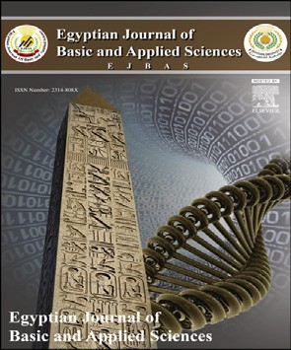Spectroscopic and rock magnetic studies on some ancient Indian pottery samples



*C. Manoharan* *a**, P. Sutharsan* *b**,*\**, R. Venkatachalapathy* *c**, S. Vasanthi* *d**,*

*S. Dhanapandian* *a**, K. Veeramuthu* *e*

a *Department of Physics, Annamalai University, Annamalainagar 608 002, India*

b *Arulmigu Meenakshi Amman College of Engineering, Vadamavandal (near Kanchipuram),*

*Thiruvannamalai 604 410, India*

c *Faculty of Marine Sciences, Annamalai University, Parangipettai 608 502, India*

d *State Archaeological Department, Tamilnadu, India*

e *Thiru Kolanjiappar Government Arts College, Virudhachalam, Cuddalore 606 001, India*

## a r t i c l e i n f o

*Article history:*

Received 9 April 2014 Received in revised form 16 November 2014

Accepted 24 November 2014

Available online 7 December 2014

*Keywords:*

FTIR XRD

Mo€ssbauer

Magnetic properties Pottery shreds

## a b s t r a c t

In this study, the ancient potteries from Tamilnadu (Nedungur: Lat.10◦ 57'N; Long.77◦51'E) were collected and investigated for their chemical and mineralogical characteristics to estimate their firing temperature and firing atmosphere. The physical and chemical state of iron (Fe2+/Fe3+) and iron oxide phases obtained using Mo€ssbauer spectra were used to establish the temperature and atmosphere of firing. The clay mineral type and its struc- tural deformation due to firing were established using X-Ray Diffraction (XRD), X-Ray Fluorescence (XRF) and Fourier Transform Infrared (FTIR) Spectroscopy. The data collected

from these techniques show that quartz was the predominant mineral, followed by traces of albite, orthoclase and Fe-bearing minerals (hematite and magnetite) and suggested that the firing temperature of potteries lies in the range of 600e800 ◦C in oxidizing atmosphere. The mineral types and domain states of the constituent magnetic fine particles were elucidated using the variation of susceptibility at various frequencies and temperature

under low field. An attempt has also been made to correlate the magnetic parameters from the percentage of Fe2+/Fe3+ and iron oxides. The information obtained paves a way for a better understanding of the technological development that took place in the ancient past and also the suitability of the samples for the determination of reliable ancient geomag- netic field intensity values.

Copyright 2014, Mansoura University. Production and hosting by Elsevier B.V. This is an open access article under the CC BY-NC-ND license ([http://creativecommons.org/licenses/](http://creativecommons.org/licenses/by-nc-nd/3.„0/)

[by-nc-nd/3.0/](http://creativecommons.org/licenses/by-nc-nd/3.„0/)).

* *Corresponding author*.

E-mail address: [suthar.san282@gmail.com](mailto:suthar.san282@gmail.com) (P. Sutharsan).

Peer review under responsibility of Mansoura University. <http://dx.doi.org/10.1016/j.ejbas.2014.11.001>

2314-808X/Copyright 2014, Mansoura University. Production and hosting by Elsevier B.V. This is an open access article under the CC BY- NC-ND license ([http://creativecommons.org/licenses/by-nc-nd/3.0/](http://creativecommons.org/licenses/by-nc-nd/3.„0/)).

40 [e gypti an j o ur nal o f b a sic and a pp l i ed sci e n c e s 2 ( 201 5 ) 39](http://dx.doi.org/10.1016/j.ejbas.2014.11.001) e[49](http://dx.doi.org/10.1016/j.ejbas.2014.11.001)

# Introduction

Ceramics represent one of the earliest and most significant innovations of mankind. Their first appearance marks the beginning of a new period in man's evolution during which important technological developments rapidly succeeded one another. Pottery is considered to be the prime important fac- tor of archaeology [1,2].

Providing rich data for an understanding of the past cul- ture, it is a source for the study of ancient society and history, it occupies a unique position by its distinguishing and char- acteristic features as well as by its distribution in different areas and different periods. Since pottery differs in style, size, color, etc., and changes from region to region and age to age, it serves as an important criterion for identifying cultures pos- sessing different traits and tracing extraneous influences.

Clay, the chief ingredient used in pottery, is a fine grained material that develops some ductile behavior when mixed with water. On firing clay to get the final products, clay min- erals undergo a sequence of chemical and structural modifi- cations (dehydration, oxidation, dehydroxylation, decomposition and formation of new phases) that generally improve mechanical strength, durability, etc. The tempera- ture at which changes occur depends on the chemical and mineralogical compositions of the original clay, duration of heating and the atmosphere under which heating has been

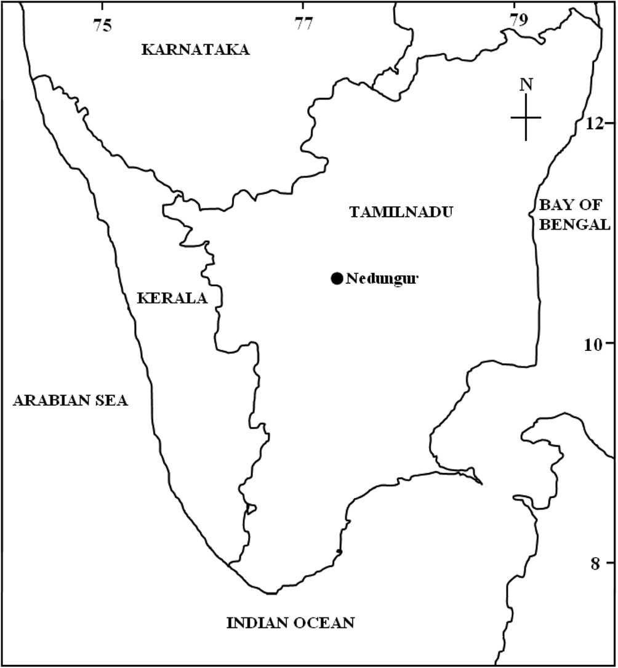Fig. 1 e Schematic map showing the archeological site of recent excavation in Tamilnadu sampled in this study. Full dot corresponds to sampling site.

carried out. Various spectroscopic techniques have been

adopted by researchers to establish the type of clay used, firing temperature and firing atmosphere. Venkatachalapathy et al. [3,4]; Manoharan et al. [5,6]; Dhanapandian et al. [7] have carried out extensive studies on Indian archaeological artefacts.

The place chosen for the present (Fig. 1) study is Nedungur [Lat. 10◦ 57'N; Long. 77◦57'E], situated on the ancient trade route, i.e. Kongu Peruvazhi, in the present Aravakkuruchi

taluk of Karur District and located about 15 km from Karur town. This ancient trade route passed from Kerala, through Palaghat pass, via., Vellaur, Sulur, Kangeyam, Karur, Uraiyur and led to Kaveripumpattinam on the eastern coast. Today though it is a small sleepy village, based on the style, shape, texture, color of the pottery and other archaeological remains from the habitation, archaeologists of Tamilnadu state have assigned two periods that is 3rd century BC and 4th century AD. Approximately a variety of 18 pottery specimens were collected. Based on their macroscopic features (color and fabric), 9 sherds were selected from both periods for miner- alogical, chemical and rock magnetic studies. The character- istics of all the above mentioned potsherds are given in Table 1.

In the present study, attention has been focused on the

characterization of pottery samples collected from Nedungur by using Fourier Transform Infrared (FTIR) spectra, X-ray Diffraction (XRD), Mo€ssbauer and Rock magnetic studies.

Bricks and potteries are the baked clay. When the kiln is hot, the particles of oxidized iron present in the clay freely oriented themselves and get frozen in particular position, along the ambient geomagnetic field, when they get cooled. They have not responded to the subsequent variation of the earth magnetic field, both in magnitude and direction.

Therefore, they can be considered to be the best fossilized magnetic record of the state of the magnetic field of the earth in the past. The remanent magnetization is characteristic of baked clays. The fossil magnetism in the archaeological sample possessing remanent magnetization is proportional to the intensity of the ambient geomagnetic field [e.g., [8,9]]. Archaeomagnetic study is primarily based on the thermo- remanent magnetization acquired by the baked clay materials at the time and in the place of its last firing. Main limitation of archaeomagnetic studies is the fact that most of burned archaeological artefacts are displaced and thus no primary geomagnetic directions may be retrieved. However, archae- ointensity studies have the great advantage that no oriented material is required. The type of magnetic minerals and their concentration and domain states are important factors in determining the reliability of the results possessed by the ar- tefacts. To establish the above, the samples have been sub- jected to rock magnetic studies.

# Experimental details

The FTIR absorption spectra were recorded in the frequency region of 4000e400 cm—1 using model paragon 500, Per- kineElmer spectrophotometer with 16 scan mode by using standard KBr pellet technique. The room temperature Mo€ssbauer measurements have been performed with a con-

ventional constant acceleration spectrometer (M/s. WISSEL, Germany) equipped with a 57Co (Rh) source. The spectra have been fitted on a PC with the least squares minimization pro- cedure assuming Lorentzian line shapes. XRD spectra have

[e g ypti an j o ur nal o f b a sic and a pp l i e d sci en c e s 2 ( 201 5 ) 39](http://dx.doi.org/10.1016/j.ejbas.2014.11.001) e[49](http://dx.doi.org/10.1016/j.ejbas.2014.11.001) 41

been recorded on X-pert MPD from Philips using CuKa radiation in the 2q range from 10◦ to 70◦ in steps of 0.02◦. X-ray fluores-

|  |  |  |  |
| --- | --- | --- | --- |
| Table 1 e Description of potsherds collected from Nedungur, Tamilnadu, India. | | | |
| Sample ID | Historical age | Type of pot materials | Description |
| NDR-1 | 3rd Century BC | Bowl | Black and red ware with slightly inverted and simple rim with medium |
|  |  |  | grained |
| NDR-3 | 3rd Century BC | Basin | Red ware with slightly inverted and beaked rim with fine grained |
| NDR-4 | 3rd Century BC | Vessel | Black and red ware with externally projecting e short beaked rim with |
|  |  |  | medium coarse grained |
| NDR-6 | 3rd Century BC | Pot sherd | Black and red ware with externally projecting rim |
| NDR-10 | 4th Century AD | Basin | Black and red ware with fine medium grained |
| NDR-11 | 4th Century AD | Rimless bowl | Red slipped ware with medium fabric |
| NDR-16 | 4th Century AD | Plate | Brown and black ware bearing traces of slip on the outer surface with |
|  |  |  | medium coarse grained |
| NDR-17 | 4th Century AD | Pot sherd | Red ware with medium grained |
| NDR-18 | 4th Century AD | Rimless bowl | Black and red ware with fine medium grained |

cence spectrometry (Bruker model S4 Pioneer sequential wavelength-dispersive X-ray spectrometer) was performed to determine chemical composition by pressed pellet technique. Mass-specific magnetic susceptibility is measured with the

Bartington MS2B dual frequency meter at two frequencies (cLF at 0.47 kHz and cHF at 4.7 kHz) for specimen of disk shaped (2.2 cm in diameter) were cut from each selected sample. Per- centage frequency-dependent magnetic susceptibility

cFD%=(cLF — cHF) × 100/cLF as well as mass specific frequency

dependent susceptibility cFD = cLF — cHF are then calculated.

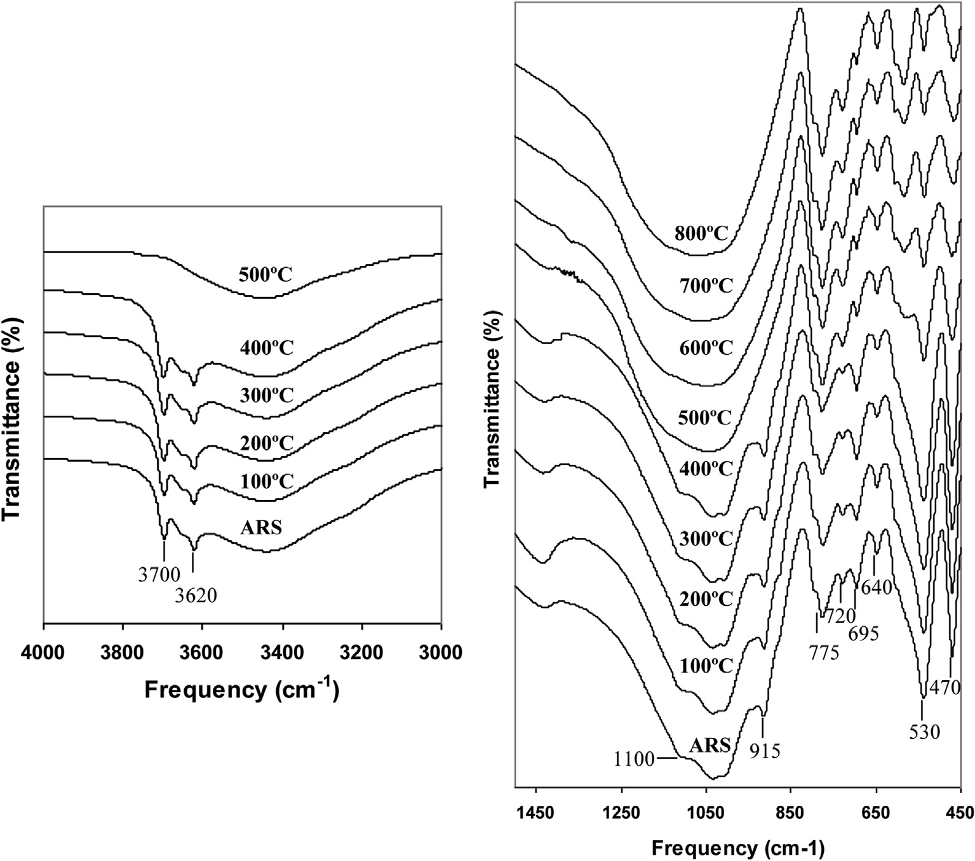

Fig. 2 e FTIR absorption spectra of Nedungur clay (NDR-clay). The figure on the left side shows the enlarged image of the spectra in the 4000e3000 cm¡1 region. On the right side figure presents the spectra of four samples in the region 1450e450 cm¡1. In these figures, the observed peaks at 3700, 3620, 1100 and 915 cm¡1 dictate the presence of disorder kaolinite. After firing the clay to 500 ◦C, because of destruction of clay structure these bands are completely disappeared. The presence of quartz can be confirmed by the observed peaks at 775, 795 and 695 cm¡1. After heating to 500 ◦C, the goethite (530 cm¡1) is diminished. Formation of iron oxides (hematite and magnetite) is confirmed above 600 ◦C by two new

peaks observed at 540 and 580 cm¡1.

42 [e gypti an j o ur nal o f b a sic and a pp l i ed sci e n c e s 2 ( 201 5 ) 39](http://dx.doi.org/10.1016/j.ejbas.2014.11.001) e[49](http://dx.doi.org/10.1016/j.ejbas.2014.11.001)

Temperature dependence of magnetic susceptibility ce*T* (in air atmosphere) is then measured using Bartington MS2WFB with high temperature furnace by heating samples up to 700 ◦C and

cooling down to 100 ◦C in steps of 5 ◦C.

# Results and discussion

#### *FT-IR analysis*

Infrared spectroscopy is a sensitive technique to monitor dehydroxylation and dehydration of clay minerals. In the present study the FTIR spectra were recorded for the local clay (NDR-Clay) in as received state (ARS) and fired to higher temperatures in steps of 100e800 ◦C in laboratory conditions

are shown in Fig. 2. Kaolinite with mostly Al in the octahedral positions has four absorption bands at 3700, 3670, 3655, and 3622 cm—1 in the OH stretching region [10]. In the disordered

kaolinite structure, the two weak bands 3670 and 3655 are replaced by a single band at 3655. In NDR-clay, the distinct band at 3700 and 3620 cm—1 along with weak shoulder at

3650 cm—1 in as received state indicates that the kaolinite is of

disordered type. No peaks of kaolinite at 3700 cm—1 region were identified at and above 500 ◦C since it decomposes at 500e550 ◦C [11]. The presence of broad bands at 3440 cm—1 and 1640 cm—1 are attributed to adsorbed water molecules that should disappear on firing clay above 100 ◦C [12,3].

The ARS spectrum of clay shows a broad band centered around 1030 cm—1 with asymmetry around 1100, 935 and 915 cm—1 which are attributed to SieOeSi, [AleOe(OH)]6, OeH deformation and AleOH, respectively. On firing the clay, in- tensity of the band 1100, 935 and 915 cm—1 decreases and disappears above 500 ◦C, due to dehydroxylation. Above 600 ◦C, a broad symmetry band is observed at 1030 cm—1, due to the destruction of octahedral sheet structure. The broad band observed at 1030 cm—1 reveals that the type of clay is red [13]. The 1030 cm—1 absorption band in the range of asym- metric silicate tetrahedral vibrations are broadened and become less intensive at 800 ◦C [11].

The sharp bands appeared at 795 and 775 cm—1 along with

695 cm—1 are due to quartz [3]. The band at 640 cm—1 is attrib- uted to AleO co-ordinate vibration. The SieOeAl bending vi- bration observed at 530 cm—1 is the most sensitive band to the presence of residual Al in the octahedral sheet [14,15]. On firing,

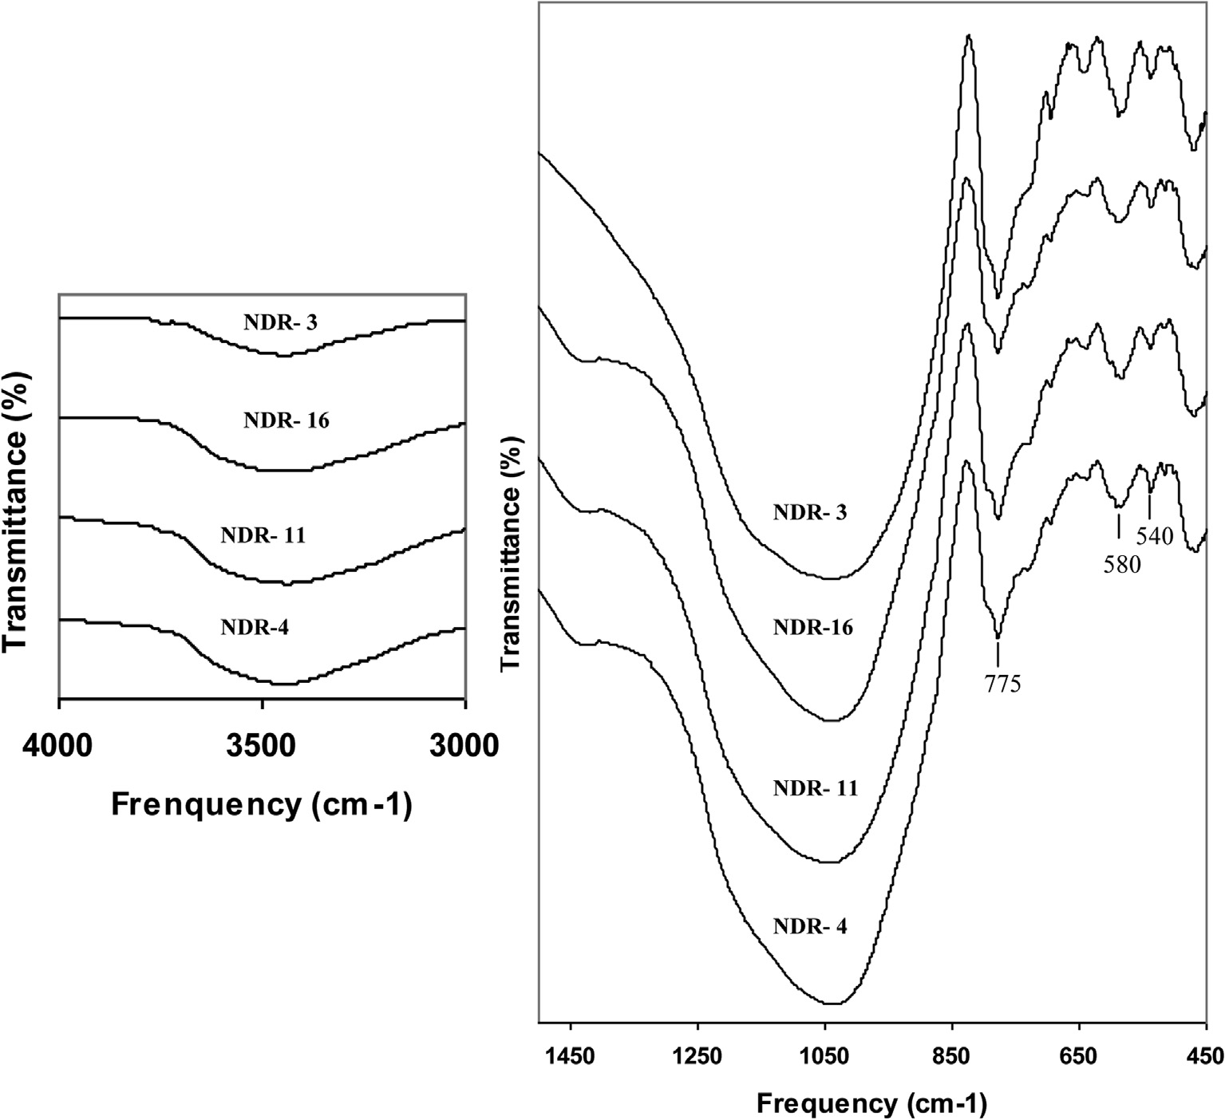

Fig. 3 e FTIR absorption spectra of Nedungur pottery sherds in as received state. The figure on the left side shows the enlarged image of the spectra in the 4000e3000 cm¡1 region. In the figure, there is no evidence for presence of kaolonite (clay) and clearly indicates that the potteries were fired above 600 ◦C. On the right side figure presents the spectra of four samples in the region 1450e450 cm¡1. Due to the presence of hematite (540 cm¡1) and magnetite (580 cm¡1), the potteries might have been fired around 650e700 ◦C. In addition, presence of quartz can be confirmed by the observed peaks at 775,

795 and 695 cm¡1.

[e g ypti an j o ur nal o f b a sic and a pp l i e d sci en c e s 2 ( 201 5 ) 39](http://dx.doi.org/10.1016/j.ejbas.2014.11.001) e[49](http://dx.doi.org/10.1016/j.ejbas.2014.11.001) 43

no perceptible changes are observed in this region upto 500 ◦C and above this temperature as iron replaces aluminum, the intensity of the band at 530 cm—1 decreases with appearance of the band at 540 cm—1 along with weak shoulder at 580 cm—1 attributed to iron oxides. Above 500 ◦C, the intensity of the band at 540 and 580 cm—1 increases with further oxidation and the

formation of crystalline hematite [16,17]. The band at 470 cm—1 due to SieOeSi bending is free from any temperature effects. From the above details, it is concluded that the local clay is of disordered kaolinite type and structural changes due to tem- perature effects are well established.

The absence of hydroxyl bands (SieOeSi) in the region 3700 cm—1 and the presence of a broad symmetry band centered around 1030 cm—1 in the spectra of samples NDR-1, 3, 4, 11, 16 and 18 indicate that all the samples have been fired above 600 ◦C and are made up of red clay [13,18,6,11]. The well resolved and distinct peaks at 540 and 580 cm—1 in the spectra of all samples reveal the presence of iron oxides [16,17], which also confirms the firing temperature as above 600 ◦C. The sharp and increased intensity of the absorption peak 580 cm—1 along with 540 cm—1 is due to the formation of crystalline iron oxides, which forms normally above 700 ◦C [19]. From the above statements, one can conclude that samples NDR-3, 10 and 17 might have been fired above 700 ◦C and other samples in between 600 and 700 ◦C. While establishing the firing

temperature of the samples, the spectra were compared with the spectra of clay samples fired to different temperatures. The FTIR spectra of representative samples recorded in ARS and the region of interest are shown in Fig. 3.

#### *XRD and Mo*€*ssbauer analysis*

The effect of X-ray diffraction by mineral structure constitutes the basis for identifying minerals and their crystalline sub- stances. For the present investigation, the XRD spectra have been recorded at room temperature and the minerals associ- ated with the samples are identified using JCPDS file [20]. From the XRD pattern of the samples, the minerals like quartz (3.33, 4.23, 1.81, 1.53 and 2.27 Å), albite (3.19, 4.03, and 3.21 Å),

orthoclase (3.31, 3.77 and 2.99 Å), hematite (2.69 and 2.51 Å) and magnetite (2.53 and 2.96 Å) are identified.

XRD reflection spectra for the representative samples are shown in Fig. 4. Quartz is predominant, might have been added to make the clay self tempered. Information like firing temperature and atmosphere can be obtained from Mo€ssbauer parameters, viz., isomer shift, quadrupole splitting

and magnetic hyperfine interaction which specify the pres- ence of Fe2+/Fe3+ and iron oxides [21]. Mo€ssbauer spectra of Nedungur pottery samples have been recorded and the representative sample spectra are shown in Fig. 5 and the Mo€ssbauer parameters derived from the peak position are

given in Table 2. From the presence or absence of para- magnetic Fe2+ and Fe3+, the firing condition, firing tempera- ture and coloring mechanisms of the archaeological potteries have been deduced. The decrease or disappearance of Fe2+ ion indicates that oxygen is rich in original firing atmosphere. The

pottery fired under oxidizing atmosphere, at temperatures above 500 ◦C show no Fe2+ in their Mo€ssbauer spectrum. Coey

[22] pointed out that the isomer shift (d) value ranging from 0.8 to 1.5 mm/s and quadrupole splitting (D) value from 1 to

3.5 mm/s are attributed to Fe2+. The isomer shift value from

0.2 to 0.6 mm/s and quadrupole splitting value from 0 to

1.8 mm/s are attributed to Fe3+. From Table 1, it is evident that Mo€ssbauer parameters for magnetite and hematite are in good agreement with the reported values [23,19,3,11].

On firing sample under reducing atmosphere, the reduc- tion of Fe3+ in clay begins at 400 ◦C and the Fe2+ content raises until on firing about 800 ◦C. A small amount of Fe3+ is left between 600 and 650 ◦C under reducing condition [19]. The above notification leads to conclude that the samples NDR-1,

4, 6, 11, 16 and 18 have been fired under reduced atmo- sphere above 400 ◦C, but the presence of Fe3+ indicates that the sample is not fired under strong reduced atmosphere upto 800 ◦C or the sample is fired under reduced atmosphere and air is admitted during cooling which might have enabled the conversion of Fe2+ to Fe3+. Admission of air during cooling is

either to achieve the red color of the ceramics, or due to the fact they inadvertently open the kiln before it has cooled sufficiently.

The structural Fe2+ in the clay begins to be oxidized to Fe3+,

a process that is concluded at about 450 ◦C, hence Fe2+ is ab- sent in the case of clay fired under oxidizing atmosphere above this temperature. The presence of Fe2+ and Fe3+ in the case of samples NDR-1, 4, 6, 11, 16 and 18 reveals that samples are fired under changing conditions established from two different colors of the materials [19].

Whenpreviously reducedmaterial isheatedagain inair atan increasing temperature, the Fe2+ is reoxidized to Fe3+ between about 450 and 600 ◦C. Since Fe3+ formed during reoxidation is no

longer structural iron in dehydroxylated sheet silicates but mainly superparamagnetic hematite, one does not observe the high quadrupole splitting of non magnetic Fe3+ as observed when fresh clays are fired in air. The presence of more

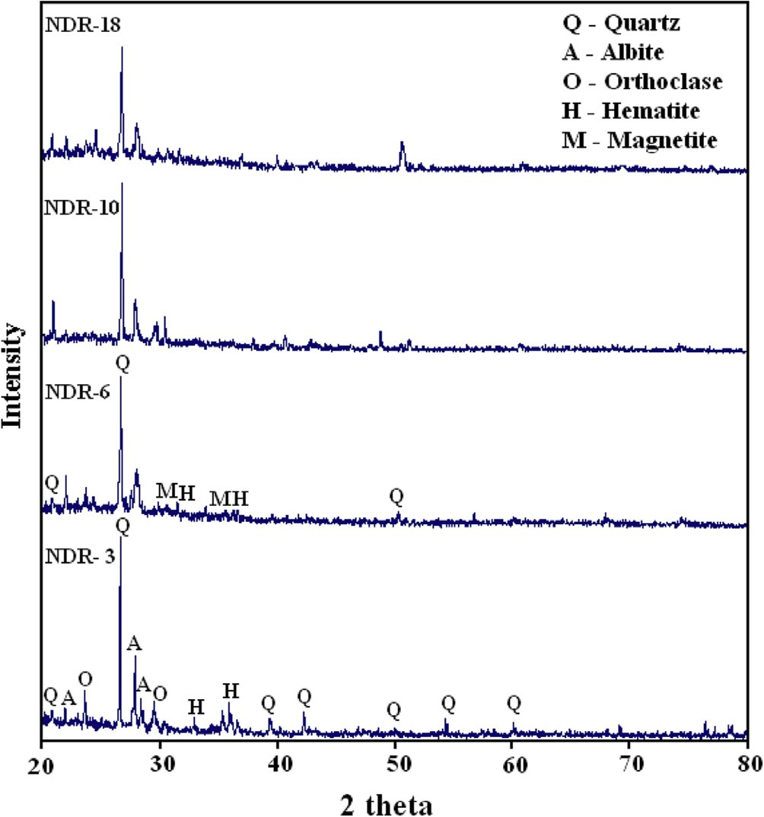

Fig. 4 e XRD patterns for pottery sherds samples NDR-3, NDR-6, NDR-10, and NDR-18.

44 [e gypti an j o ur nal o f b a sic and a pp l i ed sci e n c e s 2 ( 201 5 ) 39](http://dx.doi.org/10.1016/j.ejbas.2014.11.001) e[49](http://dx.doi.org/10.1016/j.ejbas.2014.11.001)

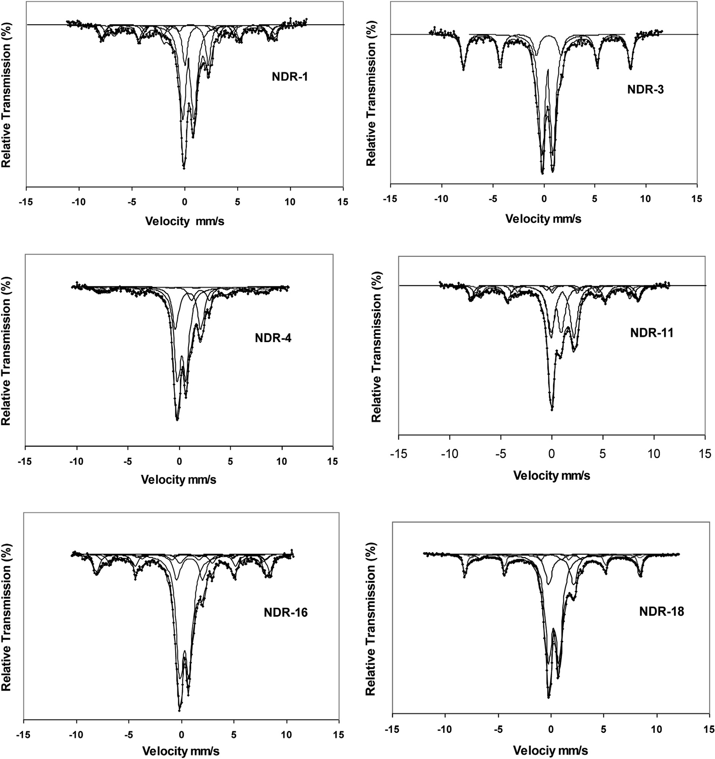

Fig. 5 e Room temperature 57Fe Mo€ssbauer spectrum of Nedungur pottery sherds in the as received state. The doublet with quadrupole splitting distribution fitted to both Fe2+ and Fe3+ contributions. The sextet with large magnetic splitting is due to hematite. Note: solid dots e experimental data; solid lines e fitted curves (sextets and doublets).

percentage of non paramagnetic Fe2+ and Fe3+ indicates that well ordered iron oxides are not formed, i.e., the samples are not fired to higher temperature or iron oxide particles are less than 100 nm. Itleadstothebehaviorassuperparamagnetic(SP) which blocks the formation of well ordered sextet in the spectra [21].

In the present study, the absence of well ordered sextet in the spectra indicates that the samples are not fired to higher temperature also due to the presence of SP grains. The pres- ence of poor sextet is due to the presence of grains with sizes greater than SP like SD/PSD. The above conclusions are also confirmed through rock magnetic studies of the above sam- ples. From the above notion it can be concluded that the

samples NDR-1, 4, 6, 11, 16 and 18 are fired under changing conditions (reduced followed by oxidation). The red outer surface and inner black core also confirm the changing at- mosphere followed by artisans during manufacturing of the artifacts in the archaeological past.

The Mo€ssbauer spectra of the pottery sample NDR-3, 10, and 17 show the presence of paramagnetic Fe3+ and iron oxide, namely, hematite. The absence of Fe2+ indicates that the sample is fired in a strong oxidizing atmosphere. The larger percentage of non magnetic Fe3+ and the presence of poor crystalline hematite in the spectra reveal that the sample is not fired above 900 ◦C (at which the entire structural iron

[e g ypti an j o ur nal o f b a sic and a pp l i e d sci en c e s 2 ( 201 5 ) 39](http://dx.doi.org/10.1016/j.ejbas.2014.11.001) e[49](http://dx.doi.org/10.1016/j.ejbas.2014.11.001) 45

|  |  |  |  |  |  |  |  |  |  |  |
| --- | --- | --- | --- | --- | --- | --- | --- | --- | --- | --- |
| Table 2 e Mo€ssbauer parameters of Nedungur pottery samples in the as-received state. | | | | | | | | | | |
| S. no | Sample location | Natural of material | Color | Sample ID |  | I.S.  (mm/s) | Q.S.  (mm/s) | H  (kOe) | *I*redl  (%) | Assignment |
| 1 | Nedungur | Pottery | Black-and-red ware | NDR-1 | S1 | 0.38 | —0.22 | 508 | 17.24 | Hematite |
|  |  |  |  |  | S2 | 0.28 | 0.12 | 488 | 8.58 | Magnetite |
|  |  |  |  |  | S3 | 0.75 | 0.14 | 467 |  |  |
|  |  |  |  |  | D1 | 0.34 | 1.02 | e | 56.65 | Fe3+ |
|  |  |  |  |  | D2 | 1.10 | 2.21 | e | 17.53 | Fe2+ |
| 2 | Nedungur | Pottery | Red ware | NDR-3 | S1 | 0.42 | —0.21 | 506 | 36.81 | Hematite |
|  |  |  |  |  | D1 | 0.35 | 1.28 | e | 63.19 | Fe3+ |
| 3 | Nedungur | Pottery | Black-and-red ware | NDR-4 | S1 | 0.39 | —0.23 | 495 | 4.8 | Hematite |
|  |  |  |  |  | S2 | 0.30 | 0.17 | 488 | 9.9 | Magnetite |
|  |  |  |  |  | S3 | 0.57 | 0.15 | 462 |  |  |
|  |  |  |  |  | D1 | 0.40 | 0.94 | e | 51.1 | Fe3+ |
|  |  |  |  |  | D2 | 0.99 | 2.47 | e | 34.2 | Fe2+ |
| 4 | Nedungur | Pottery | Black-and-red ware | NDR-6 | S1 | 0.51 | —0.39 | 508 | 14.52 | Hematite |
|  |  |  |  |  | S2 | 0.25 | 0.15 | 484 | 13.28 | Magnetite |
|  |  |  |  |  | S3 | 0.55 | 0.09 | 460 |  |  |
|  |  |  |  |  | D1 | 0.41 | 1.02 | e | 32.60 | Fe3+ |
|  |  |  |  |  | D2 | 1.15 | 2.39 | e | 39.40 | Fe2+ |
| 5 | Nedungur | Pottery | Red ware | NDR-10 | S1 | 0.43 | —0.20 | 505 | 55 | Hematite |
|  |  |  |  |  | D1 | 0.38 | 0.99 | e | 45 | Fe3+ |
| 6 | Nedungur | Pottery | Red slipped ware | NDR-11 | S1 | 0.37 | —0.23 | 496 | 16.02 | Hematite |
|  |  |  |  |  | S2 | 0.30 | 0.13 | 485 | 12.81 | Magnetite |
|  |  |  |  |  | S3 | 0.62 | 0.05 | 456 |  |  |
|  |  |  |  |  | D1 | 0.43 | 0.97 | e | 34.60 | Fe3+ |
|  |  |  |  |  | D2 | 1.04 | 2.23 | e | 36.57 | Fe2+ |
| 7 | Nedungur | Pottery | Brown-and-black ware | NDR-16 | S1 | 0.37 | —0.20 | 512 | 16 | Hematite |
|  |  |  |  |  | S2 | 0.40 | 0.16 | 480 | 12 | Magnetite |
|  |  |  |  |  | S3 | 0.71 | 0.03 | 461 |  |  |
|  |  |  |  |  | D1 | 0.42 | 0.88 | e | 54.1 | Fe3+ |
|  |  |  |  |  | D2 | 0.92 | 2.47 | e | 17.4 | Fe2+ |
| 8 | Nedungur | Pottery | Red ware | NDR-17 | S1 | 0.61 | —0.39 | 507 | 72 | Hematite |
|  |  |  |  |  | D1 | 0.44 | 1.14 | e | 28 | Fe3+ |
| 9 | Nedungur | Pottery | Black-and-red ware | NDR-18 | S1 | 0.39 | —0.23 | 496 | 4.7 | Hematite |
|  |  |  |  |  | S2 | 0.38 | 0.17 | 486 | 11.7 | Magnetite |
|  |  |  |  |  | S3 | 0.64 | 0.08 | 463 |  |  |
|  |  |  |  |  | D1 | 0.40 | 0.88 | e | 60.3 | Fe3+ |
|  |  |  |  |  | D2 | 1.01 | 2.44 | e | 14.4 | Fe2+ |
| I.S. e isomer shift; Q.S e quadrupole splitting; S e sextet; D e doublet; H e magnetic hyperfine field; *I*red e relative spectral area. | | | | | | | | | | |

forms hematite also due to the smaller grain size (super- paramagnetic hematite particles)). For this above reason, it may be concluded that the samples are fired under oxidizing atmosphere, the same is also revealed from the reddish brown color of the outer surface. The light brown color may be due to carbon deposition. The observed quadrupole splitting value of

Fe 3+ (1.28 mm/s) confirms the firing temperature of this

sample as around 700 ◦C during manufacturing [19].

Poor oxygen diffusion can be noticed from the presence of Fe2+ percentage which is higher in the case of samples NDR-4, 6 and 11 [24]. Presence of Fe2+ in the case of samples NDR-1, 4, 6, 11, 16 and 18 shows the changing atmosphere followed

during manufacturing. The black-and-red and brown-and- black ware of the samples also reveal the changing condi- tions adopted during firing cycle. The black color corresponds to carbon formed from dense smoke during reduced atmo- spheric firing using charcoal and wood. The outer red color of the sherds is due to the blow of air at higher temperatures during the end of the firing cycle (during cooling). The admission of air at lower temperature during cooling leads to gray (or) brown outer surface and inner black color. Red slip is

prepared from ochre and the application of slip and robbing process completely change the appearance of the pot and fill up the minute cavities [1]. The presence of hematite in the case of red slipped ware NDR-11 is confirmed through chem- ical and Mossbauer analyses.

The above discussion reveals that all the samples have been fired under changing conditions except NDR-3, 10 and 17, which is fired under oxidizing condition.

#### *Chemical analysis*

The physico-chemical properties of ceramic materials depend mainly on the raw clay composition and firing features, indicative of the local technology available at that time [25]. Firing techniques have been assessed through FTIR and Mossbauer analysis. Chemical analysis has been carried out to measure the composition of clay and baked clay. Table 3 gives the chemical composition of archaeological pottery sherds collected from Nedungur. It is noticed that the pottery sherds present a typical composition and they are constituted mainly by silica and alumina and minor contents of Ca, K, Mg, Ti and

46 [e gypti an j o ur nal o f b a sic and a pp l i ed sci e n c e s 2 ( 201 5 ) 39](http://dx.doi.org/10.1016/j.ejbas.2014.11.001) e[49](http://dx.doi.org/10.1016/j.ejbas.2014.11.001)

|  |  |  |  |  |  |  |  |  |  |  |
| --- | --- | --- | --- | --- | --- | --- | --- | --- | --- | --- |
| Table 3 e Chemical composition of archaeological pottery sherds of Nedungur site by XRF (wt.%). | | | | | | | | | | |
| Chemical constituents | NDR-clay | NDR-1 | NDR -3 | NDR -4 | NDR -6 | NDR -10 | NDR -11 | NDR -16 | NDR -17 | NDR -18 |
| SiO2 | 49.23 | 49.66 | 50.14 | 55.28 | 49.68 | 48.43 | 50.02 | 53.81 | 51.92 | 59.02 |
| Al2O3 | 23.70 | 18.55 | 19.33 | 17.65 | 18.82 | 19.16 | 17.54 | 16.62 | 16.72 | 16.47 |
| Fe2O3 | 8.46 | 6.71 | 9.93 | 1.30 | 4.62 | 8.75 | 7.27 | 4.81 | 9.31 | 1.29 |
| K2O | 2.62 | 2.03 | 2.15 | 1.85 | 3.52 | 3.67 | 1.98 | 2.11 | 1.68 | 2.02 |
| CaO | 3.96 | 5.44 | 3.08 | 4.10 | 5.52 | 3.19 | 5.11 | 4.95 | 4.26 | 3.22 |
| MgO | 2.35 | 1.75 | 1.81 | 2.16 | 3.18 | 2.36 | 2.91 | 1.03 | 0.95 | 1.63 |
| TiO2 | 0.92 | 0.85 | 0. 54 | 0. 91 | 0.39 | 1.17 | 1.04 | 0.96 | 0.93 | 0.75 |
| Na2O | 2.58 | 1.70 | 2.66 | 1.93 | 2.23 | 2.32 | 1.85 | 1.65 | 2.33 | 1.21 |
| Fe3O4 | e | 5.14 | 1.4 | 6.11 | 3.47 | 1.79 | 4.05 | 7.01 | 2.04 | 6.83 |
| LOI | 6.38 | 8.21 | 9.55 | 9.51 | 8.49 | 8.86 | 8.27 | 9. 75 | 10. 68 | 7.33 |
| LOI e loss on ignition.  The clay and potteries have comparable chemical composition. The concentration of silica (SiO2) is more both in clay and potteries. Apart from silica, the most abundant impurity elements are alumina (Al2O3) and fluxes (K2O, Fe2O3, CaO, MgO and TiO2). The percentage of CaO ranges from  3.08 to 5.44% in both clay and potteries indicate that non-calcareous type clay materials were used by the potters at the time of manufacturing. They have loss on ignition in the range of 6.38e10.68%. | | | | | | | | | | |

Na oxides. The significant amounts of Fe2O3 and Fe3O4 are responsible for the reddish and black color of the pottery sherds respectively [26](#_bookmark33)e[28]. In the present study, the CaO content in the above samples is less than 6% indicative of the non-calcareous clay used for the production of pottery [29]. The loss on ignition (6e10%) obtained for the pottery sherds is within the usual range and is associated mainly with volatile components and organic matter. These results are in agree- ment with Mossbauer and XRD results. Especially the pres- ence of iron oxides established in chemical analysis is in good agreement with the presence of sextets belonging to hematite and magnetite.

#### *Mineral magnetic studies*

Magnetic susceptibility (c) describes the magnetic response of a sample when exposed to a (generally weak) magnetic field and c is mainly a function of the concentration and miner- alogy of the ferrimagnetic (magnetite, maghemite, Fe- sulphides) minerals present, but it can also depend on the

strength of the applied magnetic field and the particle size distribution of the magnetic grains. In the absence of ferri- magnetic minerals, c can be found due to antiferromagnetic, paramagnetic and diamagnetic minerals. Magnetic suscepti- bility c is also dependent on sample size. Therefore, it is customary to present susceptibility as mass or volume normalized susceptibility c [30].

Magnetic susceptibility and its frequency dependence are widely used in studying magnetic enhancement and are also useful in the detection of fine magnetite/maghemite grains [31]. The frequency dependent susceptibility is a non- destructive indicator to decipher the nature of magnetic car- riers that are very much suitable for archaeomagnetic studies. Kostadinova and Kovacheva (2008) [32] have reported that burnt clay samples with cFD% > 4 have detectable concentra-

tion of superparamagnetic (SP) grains and this indicates that

magnetite grains in superparamagnetic boundary. Frequency dependent magnetic susceptibility of Nedungur pottery sam- ples is shown in Fig. 6. The magnetic susceptibility cLF of pottery samples is more evenly spread over a wide interval

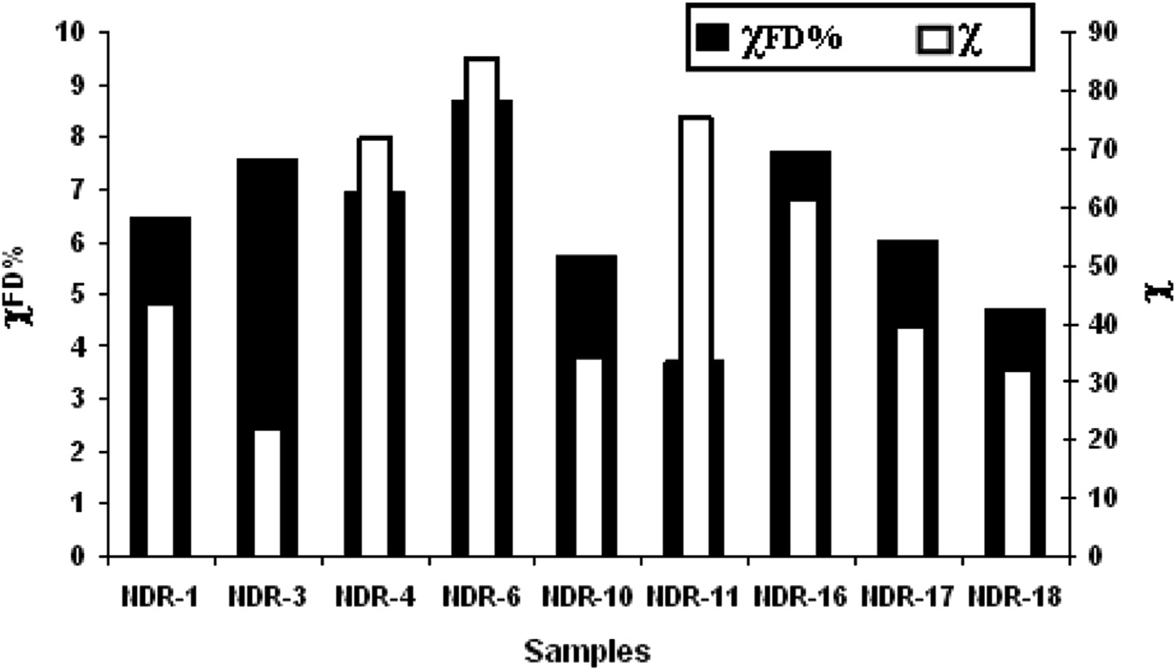

Fig. 6 e Frequency dependent magnetic susceptibility of Nedungur pottery samples.

[e g ypti an j o ur nal o f b a sic and a pp l i e d sci en c e s 2 ( 201 5 ) 39](http://dx.doi.org/10.1016/j.ejbas.2014.11.001) e[49](http://dx.doi.org/10.1016/j.ejbas.2014.11.001) 47

1.0

0.8

**Normalized χ**

0.6

0.4

0.2

0.0

**NDR-1**

### Heating

**Cooling**

1.0

0.8

**Normalizied χ**

0.6

0.4

0.2

0.0

**NDR-3**

### Heating Cooling

0 100 200 300 400 500 600 700

**Temperature (°C)**

0 100 200 300 400 500 600 700

**Temperature (°C)**

1.0

0.8

**Normalized χ**

0.6

0.4

0.2

0.0

**NDR-6**

### Heating Cooling

1.0

0.8

**Normalized χ**

0.6

0.4

0.2

0.0

### NDR-16

### Heating

**Cooling**

0 100 200 300 400 500 600 700

**Temperature (°C)**

0 100 200 300 400 500 600 700

### Temperature (°C)

Fig. 7 e Temperature dependent magnetic susceptibility of Nedungur pottery. NDR-1, NDR-6 and NDR-16 show heating and cooling curves are almost reversible. Particularly, NDR-3 shows the irreversible heating and cooling curves, and exhibits two curie temperatures at approximately 580 ◦C and 625 ◦C, indicating two magnetic mineral phases. This shows that the pottery was not fired to higher temperature (600 ◦C) during firing. The other samples were fired above 600 ◦C during firing and reflect the same Curie temperature. Note: thick line e heating curve, thin line e cooling curve.

(22e85 × 10—7 m3/kg) pointing to higher magnetic enhance- ment. High values of cFD% indicate the presence of very fine grained metastable magnetic grains spanning the super- paramagnetic (SP)estable single domain (SSD) boundary [33]. All the samples show cFD% >2 but most of the samples fall in between 4 and 10% suggesting the presence of significant

amount of the superparamagnetic magnetite grains. Dearing et al. [34] have reported that addition of increasing amount of MD e magnetite to soil containing predominately SP magne-

tite grains (cFD% = 10.5) causes cFD% to decrease to >2, while

cLF increases with concentration. In the present study, the absence of multi domain nature of magnetite (cFD > 2) reveals the suitability of the sample for archaeomagnetic studies also.

The results suggest that the pottery samples under investi- gation are magnetically enhanced materials in terms of con- centration and degree of crystallinity of magnetite. Higher values of susceptibility are obtained for samples with larger

curves of all the NDR samples (except NDR-3) reveal that there is no distinct mineralogical changes and that magnetite, the main magnetic mineral; with Curie temperature around 580e590 ◦C is found. The NDR-3 in (Fig. 7) samples has irre- versible behavior during heating and cooling due to mineral- ogical alteration and these samples are not suitable for

archaeointensity measurements. The irreversibility behavior of sample may be due to alteration of lower curie phase mineral maghaemite to magnetite curie phase during labo- ratory heating [36]. Thermomagnetic curves are useful in- dicators for the thermal stability of magnetic minerals upon temperature in baked materials [37]. The reversibility between the heating and cooling susceptibility curves used here for testing the stability of the magnetic mineralogy upon tem- perature. The above observations are coinciding well with the chemical and Mossbauer analysis.

percentage of ferrous ion or Fe2+/Fe3+ ratio. Similar results

have been obtained for ancient Quatari pottery samples by Ref. [35]. The temperatureesusceptibility measurements are to monitor the variations of the susceptibility in order to determine the Curie temperature and to identify magnetic minerals which are responsible for acquiring ancient geomagnetic field and nature of mineral transformation, if any. The temperature dependent susceptibility curves for four representative samples are shown in Fig. 7. In the present investigation, the reversibility of the heating and cooling

# Conclusion

FTIR results indicate that the shreds are fired above 600 ◦C under changing atmospheric conditions to achieve different coloration. The ratio of Fe2+/Fe3+ and iron oxides using

Mo€ssbauer spectra helps to understand the probable firing temperature and firing atmosphere in supportive of the FTIR studies. XRF analysis confirms that the samples are rich in fluxes more significantly the amount of iron contents

48 [e gypti an j o ur nal o f b a sic and a pp l i ed sci e n c e s 2 ( 201 5 ) 39](http://dx.doi.org/10.1016/j.ejbas.2014.11.001) e[49](http://dx.doi.org/10.1016/j.ejbas.2014.11.001)

hematite and magnetite. It is obvious that the iron oxides are the main colorants. The artisans of Nedungur have used only non-calcareous clays for their household utilities. Higher mass specific susceptibility obtained using magnetic studies reveals the possibility of either the iron from the parent unbaked clay (or) due to higher firing temperature during

baking. The susceptibility values are found to be higher with a higher percentage of Fe2+. The mineral magnetic studies reveal that ferrimagnetic mineral magnetite is the main contributor with superparamagnetic/single domain in na-

ture and hence it is suitable for archaeointensity measure- ments except NDR-3. The present investigation also gives the clue that the people, who lived in between the 3rd BC century to 3rd century AD in Nedungur, India were well aware of producing single and multi colored pottery for different do- mestic uses like storing food grains, water and cooking purposes.

# Acknowledgment

The authors are grateful to The Director, State Archaeological Department, Tamilnadu, for providing sufficient samples for this study. The authors gratefully acknowledged. Dr. T. Rathakrishna, Scientist G and Head, Geosciences Division, National Centre for Earth Science Studies (NCEES), Kerala for giving permission to carry out the magnetic measurements and his valuable discussions. The authors wish to extend their sincere thanks to the Director, Dr. Dipankar Dass (Scientist) IUC, Calcutta for recording Mo€ssbauer spectra and for their fruitful discussion. Finally, corresponding author of the manuscript is highly indebted to the anonyms reviewer for giving useful comments and suggestions.

## references

1. [Gurumurthy S. Ceramic Traditions in South India. University](http://refhub.elsevier.com/S2314-808X(14)00045-1/sref1) [of Madras; 1981. p. 155](http://refhub.elsevier.com/S2314-808X(14)00045-1/sref1).
2. [Maniatis Y, Simopoulos A, Kostikas A. An investigation of](http://refhub.elsevier.com/S2314-808X(14)00045-1/sref2) [ancient ceramic technologies by M](http://refhub.elsevier.com/S2314-808X(14)00045-1/sref2)o€[ssbauer spectroscopy. In:](http://refhub.elsevier.com/S2314-808X(14)00045-1/sref2) [Olin JS, Franklin AD, editors. Archaeological ceramics, vol. 1.](http://refhub.elsevier.com/S2314-808X(14)00045-1/sref2) [Washington, DC: Smithsonian Institution Press; 1982.](http://refhub.elsevier.com/S2314-808X(14)00045-1/sref2)

[p. 97](http://refhub.elsevier.com/S2314-808X(14)00045-1/sref2)e[108](http://refhub.elsevier.com/S2314-808X(14)00045-1/sref2).

1. [Venkatachalapathy R, Sridharan T, Dhanapandian S,](http://refhub.elsevier.com/S2314-808X(14)00045-1/sref3) [Manoharan C. Determination of firing temperature of](http://refhub.elsevier.com/S2314-808X(14)00045-1/sref3) [ancient potteries by means of infrared and Mossbauer](http://refhub.elsevier.com/S2314-808X(14)00045-1/sref3) [studies. Spectrosc Lett 2002;35(6):769](http://refhub.elsevier.com/S2314-808X(14)00045-1/sref3)e[79](http://refhub.elsevier.com/S2314-808X(14)00045-1/sref3).
2. [Venkatachalapathy R, Bakas T, Basavaiah N,](http://refhub.elsevier.com/S2314-808X(14)00045-1/sref4) [Deenadayalan K. M](http://refhub.elsevier.com/S2314-808X(14)00045-1/sref4)o€[ssbauer and mineral magnetic studies](http://refhub.elsevier.com/S2314-808X(14)00045-1/sref4) [on archaeological potteries from Adhichanalur Tamilnadu,](http://refhub.elsevier.com/S2314-808X(14)00045-1/sref4) [India. Hyperfine Interact 2008;186:89](http://refhub.elsevier.com/S2314-808X(14)00045-1/sref4)e[98](http://refhub.elsevier.com/S2314-808X(14)00045-1/sref4).
3. [Manoharan C, Venkatachalapathy R, Dhanapandian S,](http://refhub.elsevier.com/S2314-808X(14)00045-1/sref5) [Deenadayalanm K. FTIR and M](http://refhub.elsevier.com/S2314-808X(14)00045-1/sref5)o€[ssbauer spectroscopy](http://refhub.elsevier.com/S2314-808X(14)00045-1/sref5) [applied to study of archaeological artifacts from](http://refhub.elsevier.com/S2314-808X(14)00045-1/sref5) [Maligaimedu, Tamil Nadu, India. Indian J Pure Appl Phys](http://refhub.elsevier.com/S2314-808X(14)00045-1/sref5) [2007;45:860](http://refhub.elsevier.com/S2314-808X(14)00045-1/sref5)e[5](http://refhub.elsevier.com/S2314-808X(14)00045-1/sref5).
4. [Manoharan C, Veeramuthu K, Venkatachalapathy R,](http://refhub.elsevier.com/S2314-808X(14)00045-1/sref6) [Radhakrishna T, Ilango R. Spectroscopic and ancient](http://refhub.elsevier.com/S2314-808X(14)00045-1/sref6) [geomagnetic field intensity studies on archaeological](http://refhub.elsevier.com/S2314-808X(14)00045-1/sref6)

[pottery samples, India. Lithunian J Phys](http://refhub.elsevier.com/S2314-808X(14)00045-1/sref6) [2008;48(2):195](http://refhub.elsevier.com/S2314-808X(14)00045-1/sref6)e[202](http://refhub.elsevier.com/S2314-808X(14)00045-1/sref6).

1. [Dhanapandian S, Manoharan C, Sutharsan P. Applications of](http://refhub.elsevier.com/S2314-808X(14)00045-1/sref7) FTIR and [57Fe M](http://refhub.elsevier.com/S2314-808X(14)00045-1/sref7)o€[ssbauer techniques in studies of recently](http://refhub.elsevier.com/S2314-808X(14)00045-1/sref7) [excavated Indian archaeological pottery. Acta Phys Pol A](http://refhub.elsevier.com/S2314-808X(14)00045-1/sref7) [2012;121:592](http://refhub.elsevier.com/S2314-808X(14)00045-1/sref7)e[8](http://refhub.elsevier.com/S2314-808X(14)00045-1/sref7).
2. [Jordanova N, Petrovsky E, Kovacheva M, Jordanova D. Factors](http://refhub.elsevier.com/S2314-808X(14)00045-1/sref8) [determining magnetic enhancement of burnt clay from](http://refhub.elsevier.com/S2314-808X(14)00045-1/sref8) [archaeological sites. J Archaeol Sci 2001;28:1137](http://refhub.elsevier.com/S2314-808X(14)00045-1/sref8)e[48](http://refhub.elsevier.com/S2314-808X(14)00045-1/sref8).
3. [Kovacheva M, Jordanova N, Karloukovski V. Geomagnetic](http://refhub.elsevier.com/S2314-808X(14)00045-1/sref9) [field variations as determined from Bulgarian](http://refhub.elsevier.com/S2314-808X(14)00045-1/sref9) [archaeomagnetic data. Part II: the last 8000 years. Surv](http://refhub.elsevier.com/S2314-808X(14)00045-1/sref9) [Geophys 1998;19:431](http://refhub.elsevier.com/S2314-808X(14)00045-1/sref9)e[60](http://refhub.elsevier.com/S2314-808X(14)00045-1/sref9).
4. [Bantignies JL, Cartier Dit Moulin C, Dexpert H. Wettability](http://refhub.elsevier.com/S2314-808X(14)00045-1/sref10) [contrasts in kaolinite and illite clays: characterization by](http://refhub.elsevier.com/S2314-808X(14)00045-1/sref10) [infrared and X-ray absorption spectroscopies. Clays Clay](http://refhub.elsevier.com/S2314-808X(14)00045-1/sref10) [Miner 1997;45(2):184](http://refhub.elsevier.com/S2314-808X(14)00045-1/sref10)e[93](http://refhub.elsevier.com/S2314-808X(14)00045-1/sref10).
5. [Valanciene V, Siauciunas R, Baltusnikaite J. The influence of](http://refhub.elsevier.com/S2314-808X(14)00045-1/sref11) [mineralogical compositions on the colour of clay body. J Eur](http://refhub.elsevier.com/S2314-808X(14)00045-1/sref11) [Ceram Soc 2010;30:1609](http://refhub.elsevier.com/S2314-808X(14)00045-1/sref11)e[17](http://refhub.elsevier.com/S2314-808X(14)00045-1/sref11).
6. [Wolff RG. Infrared absorption patterns (OH region) of several](http://refhub.elsevier.com/S2314-808X(14)00045-1/sref12) [clay minerals. Am Mineral 1965;50:240](http://refhub.elsevier.com/S2314-808X(14)00045-1/sref12)e[4](http://refhub.elsevier.com/S2314-808X(14)00045-1/sref12).
7. [Ghosh SN. Infra-red spectra of some selected minerals, rocks](http://refhub.elsevier.com/S2314-808X(14)00045-1/sref13) [and products. J Mater Sci 1978;13. 1877](http://refhub.elsevier.com/S2314-808X(14)00045-1/sref13)e[1866](http://refhub.elsevier.com/S2314-808X(14)00045-1/sref13).
8. [Komadel P. Chemically modified smectites. Clay Miner](http://refhub.elsevier.com/S2314-808X(14)00045-1/sref14) [2003;38:127](http://refhub.elsevier.com/S2314-808X(14)00045-1/sref14)e[38](http://refhub.elsevier.com/S2314-808X(14)00045-1/sref14).
9. [Madejova J. FTIR techniques in clay mineral studies. Vib](http://refhub.elsevier.com/S2314-808X(14)00045-1/sref15) [Spectrosc 2003;31:1](http://refhub.elsevier.com/S2314-808X(14)00045-1/sref15)e[10](http://refhub.elsevier.com/S2314-808X(14)00045-1/sref15).
10. [Kostikas A, Simopoulos A, Gangas NH. M](http://refhub.elsevier.com/S2314-808X(14)00045-1/sref16)o€[ssbauer study of](http://refhub.elsevier.com/S2314-808X(14)00045-1/sref16)

[ancient pottery. J Phys Colloq 1974;35:107](http://refhub.elsevier.com/S2314-808X(14)00045-1/sref16)e[15](http://refhub.elsevier.com/S2314-808X(14)00045-1/sref16).

1. [Wagner U, Gebhard R, Grosse G, Hutzelmann T, Murad E,](http://refhub.elsevier.com/S2314-808X(14)00045-1/sref17) [Riederer J, et al. Clay: an important raw material for](http://refhub.elsevier.com/S2314-808X(14)00045-1/sref17) [prehisteric man. Hyperfine Interact 1998;17(7):325](http://refhub.elsevier.com/S2314-808X(14)00045-1/sref17)e[35](http://refhub.elsevier.com/S2314-808X(14)00045-1/sref17).
2. [Venkatachalapathy R, Gournis D, Manoharan C,](http://refhub.elsevier.com/S2314-808X(14)00045-1/sref18) [Dhanapandian S, Deenadayalan K. FTIR and M](http://refhub.elsevier.com/S2314-808X(14)00045-1/sref18)o€[ssbauer](http://refhub.elsevier.com/S2314-808X(14)00045-1/sref18) [spectroscopic studies of archaeological potteries from](http://refhub.elsevier.com/S2314-808X(14)00045-1/sref18) [Nathikudi Tamilnadu. Indian J Phys 2004;78(12):1371](http://refhub.elsevier.com/S2314-808X(14)00045-1/sref18)e[5](http://refhub.elsevier.com/S2314-808X(14)00045-1/sref18).
3. [Wagner U, Wagner FE, Hausler W, Shimada I. The use of](http://refhub.elsevier.com/S2314-808X(14)00045-1/sref19) [M](http://refhub.elsevier.com/S2314-808X(14)00045-1/sref19)o€[ssbauer spectroscopy in studies of archaeological](http://refhub.elsevier.com/S2314-808X(14)00045-1/sref19) [ceramics. In: Creagh DC, Bradley DA, editors. Radiation in Art](http://refhub.elsevier.com/S2314-808X(14)00045-1/sref19) [and Archaeometry; 2000. p. 417](http://refhub.elsevier.com/S2314-808X(14)00045-1/sref19)e[43](http://refhub.elsevier.com/S2314-808X(14)00045-1/sref19).
4. [JCPDS. Joint Committee on Powder Diffraction Standards,](http://refhub.elsevier.com/S2314-808X(14)00045-1/sref20) [Mineral Powder Diffraction File. 1999](http://refhub.elsevier.com/S2314-808X(14)00045-1/sref20).
5. [Wagner FE, Wagner U. M](http://refhub.elsevier.com/S2314-808X(14)00045-1/sref21)o€[ssbauer spectra of clays and](http://refhub.elsevier.com/S2314-808X(14)00045-1/sref21)

[ceramics. Hyperfine Interact 2004;154:35](http://refhub.elsevier.com/S2314-808X(14)00045-1/sref21)e[82](http://refhub.elsevier.com/S2314-808X(14)00045-1/sref21).

1. [Coey JMD. Clay minerals and their transformations studied](http://refhub.elsevier.com/S2314-808X(14)00045-1/sref22) [with nuclear techniques. At Energy Rev 1980;18:73](http://refhub.elsevier.com/S2314-808X(14)00045-1/sref22)e[124](http://refhub.elsevier.com/S2314-808X(14)00045-1/sref22).
2. [Tominga T, Takeda M, Mabuchi JF, Palqcios J.](http://refhub.elsevier.com/S2314-808X(14)00045-1/sref23) Characterization of ancient Japanese roofing tiles by [57Fe](http://refhub.elsevier.com/S2314-808X(14)00045-1/sref23) [M](http://refhub.elsevier.com/S2314-808X(14)00045-1/sref23)o€[ssbauer spectroscopy. Archaeometry 1978;20:135](http://refhub.elsevier.com/S2314-808X(14)00045-1/sref23)e[46](http://refhub.elsevier.com/S2314-808X(14)00045-1/sref23).
3. [Nodari L, Maritan L, Mazzoli C, Russo U. Sandwich structures](http://refhub.elsevier.com/S2314-808X(14)00045-1/sref24) [in the Etruscan-Paden type pottery. Appl Clay Sci](http://refhub.elsevier.com/S2314-808X(14)00045-1/sref24) [2004;27:119](http://refhub.elsevier.com/S2314-808X(14)00045-1/sref24)e[28](http://refhub.elsevier.com/S2314-808X(14)00045-1/sref24).
4. [Tudisca V, Casieri C, Demma F, Diaz M, Pinol L, Terenzi C,](http://refhub.elsevier.com/S2314-808X(14)00045-1/sref25) [et al. Firing technique characterization of black-slipped](http://refhub.elsevier.com/S2314-808X(14)00045-1/sref25) [pottery in Prasnesete by low field 2D NMR relaxometry. J](http://refhub.elsevier.com/S2314-808X(14)00045-1/sref25) [Archaeol Sci 2011;38:352](http://refhub.elsevier.com/S2314-808X(14)00045-1/sref25)e[9](http://refhub.elsevier.com/S2314-808X(14)00045-1/sref25).
5. [De Benedetto GE, Laviano R, Sabbatini L, Zambonin PG.](http://refhub.elsevier.com/S2314-808X(14)00045-1/sref26) [Infrared spectroscopy in the mineralogical characterization](http://refhub.elsevier.com/S2314-808X(14)00045-1/sref26) [of ancient pottery. J Cult Herit 2002;3(3):177](http://refhub.elsevier.com/S2314-808X(14)00045-1/sref26)e[86](http://refhub.elsevier.com/S2314-808X(14)00045-1/sref26).
6. [Monterio SN, Vieira CMF, Ribeiro MM, Silva FAN. Red ceramic](http://refhub.elsevier.com/S2314-808X(14)00045-1/sref27) [industrial products incorporated with oily wastes. Constr](http://refhub.elsevier.com/S2314-808X(14)00045-1/sref27) [Build Mater 2007;21(11):2007](http://refhub.elsevier.com/S2314-808X(14)00045-1/sref27)e[11](http://refhub.elsevier.com/S2314-808X(14)00045-1/sref27).
7. [Manoharan C, Sutharsan P, Dhanapandian S,](http://refhub.elsevier.com/S2314-808X(14)00045-1/sref28) [Venkatachalapathy R, Mohamed Asanulla R. Analysis of](http://refhub.elsevier.com/S2314-808X(14)00045-1/sref28) [temperature effect on ceramic brick production from](http://refhub.elsevier.com/S2314-808X(14)00045-1/sref28) [alluvial deposits, Tamilnadu, India. Appl Clay Sci](http://refhub.elsevier.com/S2314-808X(14)00045-1/sref28) [2011;54:20](http://refhub.elsevier.com/S2314-808X(14)00045-1/sref28)e[5](http://refhub.elsevier.com/S2314-808X(14)00045-1/sref28).

[e g ypti an j o ur nal o f b a sic and a pp l i e d sci en c e s 2 ( 201 5 ) 39](http://dx.doi.org/10.1016/j.ejbas.2014.11.001) e[49](http://dx.doi.org/10.1016/j.ejbas.2014.11.001) 49

1. [Maniatis Y, Tite MS. Technological examination of](http://refhub.elsevier.com/S2314-808X(14)00045-1/sref29) [Neolithic](http://refhub.elsevier.com/S2314-808X(14)00045-1/sref29)e[Bronze age pottery from Central and Southeast](http://refhub.elsevier.com/S2314-808X(14)00045-1/sref29) [Europe and from the Near East. J Archaeol Sci](http://refhub.elsevier.com/S2314-808X(14)00045-1/sref29) [1981;8:59](http://refhub.elsevier.com/S2314-808X(14)00045-1/sref29)e[76](http://refhub.elsevier.com/S2314-808X(14)00045-1/sref29).
2. [Mooney SD, Geiss C, Smith MA. The use of mineral magnetic](http://refhub.elsevier.com/S2314-808X(14)00045-1/sref30) [parameters to characterize archaeological ores. J Archaeol](http://refhub.elsevier.com/S2314-808X(14)00045-1/sref30) [Sci 2003;30(5):511](http://refhub.elsevier.com/S2314-808X(14)00045-1/sref30)e[23](http://refhub.elsevier.com/S2314-808X(14)00045-1/sref30).
3. [Mullins C, Tite M. Magnetic viscosity, quadrature](http://refhub.elsevier.com/S2314-808X(14)00045-1/sref31) [susceptibility, and frequency dependence of susceptibility in](http://refhub.elsevier.com/S2314-808X(14)00045-1/sref31) [single-domain Assemblies of magnetite and maghemite. J](http://refhub.elsevier.com/S2314-808X(14)00045-1/sref31) [Geophys Res 1973;78:804](http://refhub.elsevier.com/S2314-808X(14)00045-1/sref31)e[9](http://refhub.elsevier.com/S2314-808X(14)00045-1/sref31).
4. [Kostadinova M, Kovacheva M. Case study of the Bulgarian](http://refhub.elsevier.com/S2314-808X(14)00045-1/sref32) [Neolithic archaeological site of Piperkov Chiflik and its](http://refhub.elsevier.com/S2314-808X(14)00045-1/sref32) [archaeomagnetic dating. Phys Chem Earth 2008;33:511](http://refhub.elsevier.com/S2314-808X(14)00045-1/sref32)e[22](http://refhub.elsevier.com/S2314-808X(14)00045-1/sref32).
5. [Eyre J. Frequency dependence of magnetic susceptibility for](http://refhub.elsevier.com/S2314-808X(14)00045-1/sref33) [populations of single-domain-grain. Geophys J Int](http://refhub.elsevier.com/S2314-808X(14)00045-1/sref33) [1997;129:209](http://refhub.elsevier.com/S2314-808X(14)00045-1/sref33)e[11](http://refhub.elsevier.com/S2314-808X(14)00045-1/sref33).
6. [Dearing JA, Bird PM, Dann RJL, Benjamin SF. Secondary](http://refhub.elsevier.com/S2314-808X(14)00045-1/sref34) [ferrimagnetic minerals in Welsh soils: a comparison of](http://refhub.elsevier.com/S2314-808X(14)00045-1/sref34) [mineral magnetic detection methods and implications for](http://refhub.elsevier.com/S2314-808X(14)00045-1/sref34) [mineral formation. Geophys J Int 1997;130:727](http://refhub.elsevier.com/S2314-808X(14)00045-1/sref34)e[36](http://refhub.elsevier.com/S2314-808X(14)00045-1/sref34).
7. [Eissa NA, Sallam HA, Sanad AM, Mira AF. M](http://refhub.elsevier.com/S2314-808X(14)00045-1/sref35)o€[ssbauer effect](http://refhub.elsevier.com/S2314-808X(14)00045-1/sref35) [study of the origin of ancient Qatari potter. Indian J. Pure](http://refhub.elsevier.com/S2314-808X(14)00045-1/sref35) [Appl. Phys. 1979;17:731](http://refhub.elsevier.com/S2314-808X(14)00045-1/sref35)e[3](http://refhub.elsevier.com/S2314-808X(14)00045-1/sref35).
8. [Alva-Valdivia LM. Comprehensive paleomagnetic study of](http://refhub.elsevier.com/S2314-808X(14)00045-1/sref36) [a succession of Holocene olivine-basalt flow: Xitle](http://refhub.elsevier.com/S2314-808X(14)00045-1/sref36) [Volcano (Mexico) revisited. Earth Planets Space](http://refhub.elsevier.com/S2314-808X(14)00045-1/sref36) [2005;57:839](http://refhub.elsevier.com/S2314-808X(14)00045-1/sref36)e[53](http://refhub.elsevier.com/S2314-808X(14)00045-1/sref36).
9. [Spassov S, Hus J. Estimating baking temperatures in a Roman](http://refhub.elsevier.com/S2314-808X(14)00045-1/sref37) [pottery kiln by rock magnetic properties: implications of](http://refhub.elsevier.com/S2314-808X(14)00045-1/sref37) [thermochemical alteration for archaeointensity](http://refhub.elsevier.com/S2314-808X(14)00045-1/sref37) [determinations. Geophys J Int 2006;167:592](http://refhub.elsevier.com/S2314-808X(14)00045-1/sref37)e[604](http://refhub.elsevier.com/S2314-808X(14)00045-1/sref37).