

Electronic Notes in Theoretical Computer Science 252 (2009) 143–156

[www.elsevier.com/locate/entcs](http://www.elsevier.com/locate/entcs)

Stochastic Cellular Automata in Dynamic Environmental Modeling: Practical Applications

# Jan Podrouzek1

*CIDEAS Research Center, Faculty of Civil Engineering Brno University of Technology*

*Brno, Czech Republic*

Abstract

This article presents the key aspects of an intuitive programming approach based on a Cellular automata technique providing an effective, easy to understand tool to describe some real processes. Although for many years most physical effects have been described by the language of differential equations, it may be beneficial in this era of cheap computing power to deploy a new descriptive apparatus based on very simple programs rather than mathematical equations, which are not always capable of capturing nature’s most essential mechanisms, including the randomness in physics. Based on these assumptions, the term ’intuitive programming’ is used to refer to a system of simple programs with transparent yet complex behavior. The effectiveness of the proposed methodology is demonstrated in a case study of a deteriorating bridge within a dynamic environment with several approaches to stochastic effects.

*Keywords:* Cellular Automata, Stochastic Effects, Concrete Deterioration, Dynamic Environment.

# Introduction

The performance of large structures (concrete bridges) generally decreases over time and when a certain performance threshold is reached the structure may no longer be used according to governing regulations. In the process of design and during oper- ation, environmental stressors should be considered as one of various performance- reducing factors. Environmental loading is always connected with uncertainties. Two major groups may be distinguished: data-based and knowledge-based uncer- tainty. It is not always possible to reduce data-based uncertainty, although a vari- ety of models may be used for the evaluation of available data, thus reducing the knowledge-based uncertainty group.

1 Email: [podrouzek.j@fce.vutbr.cz](mailto:podrouzek.j@fce.vutbr.cz)

1571-0661 © 2009 Elsevier B.V. Open access under [CC BY-NC-ND license.](http://creativecommons.org/licenses/by-nc-nd/3.0/)

doi:10.1016/j.entcs.2009.09.019

This work focuses on the nontraditional numerical representation of selected processes relevant to the assessment of environmental exposure, using a cellular au- tomata (CA) technique with several stochastic modifications. The numerical mod- els presented were constructed with respect to the data available and completed by heuristic estimation within a project concerning a degrading bridge in South Tyrol. Before the bridge was dismantled samples were taken for further chemical analysis to obtain the spatial properties of the concrete at various depths, in particular the chloride concentration.

An introduction to the CA approach was published in (Wolfram 1994), its ap- plication to the diffusion process was detailed in (Biondini 2004), and the problems involved in proper boundary interpretation, the time dependent chloride-feed and the dynamic diffusion coefficient were discussed in (Podrouzek 2008).

The material we are interested in, concrete, is generally effective in protecting embedded steel from corrosion. However, the protective environment is destroyed when the chloride concentration reaches a certain level: the so-called critical level (CEB 1992). The explicit quantification of environmental stressors such as de-icing salts is essential for a category of tasks which include performance based design (Teply 2006) and the prediction of the service life of reinforced concrete structures.

CA may effectively serve for such purposes, being faster and more transparent when compared to conventional approaches such as FEM.

Regarding the CA simulation, two major updating mechanisms may be distin- guished, synchronous and asynchronous updating. Different concepts of updating mechanisms are demonstrated using simple examples.

The standard synchronous updating mechanism with stochastic modification of evolutionary coefficients was published in (Podrouzek 2007). The concept of an asynchronous updating mechanism is demonstrated on a detail of a cross section of a continuous beam with a crack due to negative bending moments.

The desired stochastic effects should exhibit natural heterogeneity within the simulation as observed in the real world by introducing several modifications of the updating mechanism. The visualization of the simulation state within a certain time period offers a visual comparison of the resulting concentration (*Cact*) patterns for the different methods. When formulated by a simple numerical condition (1), crucial information on the critical concentration (*Ccr*) region, i.e. areas with possible corrosion of steel reinforcement, is provided.

1. *Cact* ≥ *Ccr*

# Dynamic environmental modeling

During their life cycle, constructions undergo a number of events of which a few have a critical effect on their structural health. In this article an existing bridge has been chosen to demonstrate some of the key features of diffusion-based cellular automata simulation. Regarding the bridges, seasonal de-icing salt application may be considered in certain areas noting that diffusion also takes place inside the con- crete structure even when there is no external chloride feed, e.g. in summer. During

the event of rain the exposed surface regions may have their chloride concentration reduced due to the wash-out effect. Different diffusion components may also be considered, such as carbon dioxide or water. Another example could be the effect of UV rays or temperature. All of the above-mentioned factors would have an instant effect on the local material and diffusive properties of the structure. It is clear that such a system would be relatively easy to create in terms of cellular programming but would require a large amount of field data together with theoretical knowledge of individual phenomena and their interactions. Note that the presented case study is based on a single-parameter cell system.

It should also be noted here that constructing a cellular automata-based compu- tational model is not a difficult task from the standpoint of programming difficulty. The basic idea behind CA simulation is that a system of rather primitive cells (sim- ple rules and interactions) provides behavior much more complex than the level of complexity of individual cells. The behavior of the decentralized system is very transparent and easy to describe in the language of arbitrary programming code. Implementation of the desired stochastic effects is also a matter of simple algo- rithms, where there is lot of space for intuition-based experimentation; the same could be stated for boundary behavior definition. What makes it a task is that one has to describe the CA model one has created in terms of mathematical equations in order to be able to compare the results with conventional analytical models and to define the units of input/output. Often, the most difficult task is to relate the simulation time to conventional time as the results will most probably be compared with experimental results. The calibration of such simulations according to avail- able data is easily feasible as an automated process, finding e.g. the best matching surface concentration.

In the following section some of the above-mentioned features will be briefly demonstrated using the language of the selected application example - the case study of a deteriorating bridge. The underlying mechanisms have been described earlier by the author and will not be expanded upon here.

# The case study

Maintaining the proper safety level of concrete bridges under gradual degradation due to traffic and environmental actions during their service life is an expensive and problematic task. Chloride ion ingress is an important aspect of durability design and maintenance, especially in regions where winter salt application for traffic safety is common, e.g. for highways. This case study utilizes the proposed CA approach to analyze possible chloride-induced deterioration using the example of a real highway bridge. The presented numerical simulation, which as we should recall is yet an imaginary concept outside time and space, serves as an illustrative rather than an application example. However, future utilizations may enable the engineer to focus on the modeling or prognosis of reinforcement corrosion in most jeopardized locations, namely to assess the initiation time, i.e. the durability limit state; and thus support decision making in the design process or maintenance planning.

In the following sections selected features of stochastic CA in environmental modeling will be discussed using easy to understand examples, all related to the problem of our selected case study - the bridge in South Tyrol.

* 1. *General notes*

The structure is for our purposes represented by a 2D grid of cells. Each cell has its own state value representing the component concentration (e.g. the chloride ions). The process of chloride ingress in the unlikely event of homogenous isotropic media would be governed by a local rule in which the evolutionary coefficients Φ*i* (*i* = 1,2,3,4,5) assign the level of chloride concentration redistribution within the cell’s neighbourhood (von Neumann, radius 1):

1. *Xt*+1 = Φ1*Xt* + Φ2*Nt* + Φ3*Et* + Φ4*St* + Φ5*Wt*

where the discrete variables *Xt, Nt, Et, St, Wt* represent the concentration of the

component in the given cell at time *t*. This paper introduces several stochastic modifications of this updating mechanism, having in common only one aspect, which is that the values of evolutionary coefficients Φ*i* must verify the following normality

rule:

1. Σ Φ*i* =1

as required by the mass conservation law. For isotropic media the symmetry

conditions Φ2*,*3*,*4*,*5 = 0.125 and Φ1 = 0.5 must be adopted in order to avoid direc- tionality effects. The relationship between the cell size Δ*x*, time step Δ*t*, diffusion coefficient *D* and chloride evolutionary coefficient Φ1 (governing) is usually manda- tory for the whole grid of cells within a time step:

1. *D* = Φ1Δ*x*2Δ*t*−1

unless the asynchronous updating mechanism is adopted. Generally, if the syn-

chronous updating mechanisms are used, all cells get updated within a time step and the concept of the time step may be related to (4) while the local rule (2) may be affected by any number of neighboring cells and corresponding evolutionary coefficients respecting the normality rule (3). In the case of an asynchronous up- dating mechanism the concept of the time step has to be defined by other means, as discussed in the following chapters.

* 1. *The South Tyrol bridge*

The three-span bridge was designed in 1969 as a highway crossover located in South Tyrol, see Fig. 1. Inspections showed that there was a serious degradation of the piles and beams in the junctions of the prestressed V beams. These weak zones were mainly caused by the insufficient sealing of the pavement in the region of the expansion joints over the piles. The bridge was demolished in spring 2008, concrete samples were drilled and chemical analysis was performed. Chloride concentrations were measured and localized serving as an input for the CA simulation (with help of heuristic expert judgment).

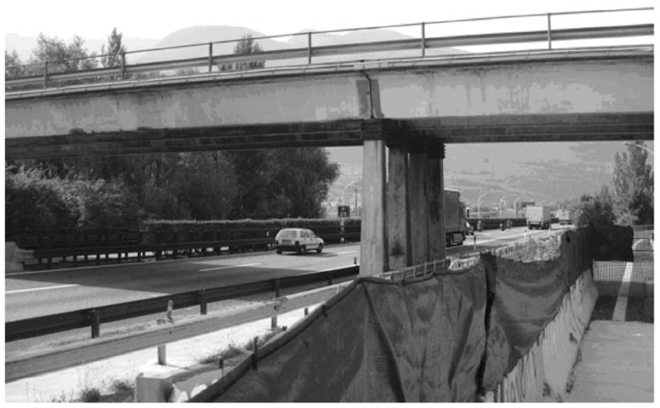

Fig. 1. The South Tyrol bridge

* 1. *Longitudinal cut*

Figure 2 shows the estimated initial distribution of de-icing salt concentrations (half of the bridge), the maximal surface chloride concentration being 0.2 % *Cl*− per cement content. Note that the distribution of the initial concentration along the bottom part of the bridge was estimated from the location of stiffeners and supports (leakage through joints), where higher ”localized” degradation was detected. A prediction of chloride concentrations for 30 years is shown in Fig. 3. The light tone represents the cells less saturated with chlorides in contrast to the darker tone representing the cells more saturated with chlorides, i.e. the degrading state. Black regions represent parts where the critical concentration has been reached (1) (here 0.4 % *Cl*− per cement content).

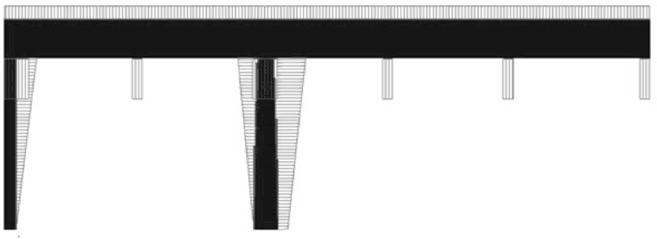

Fig. 2. Distribution of initial concentrations of aggressive agents as considered in the 2D model.

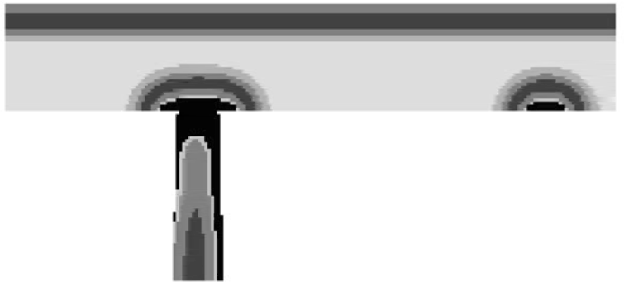

Fig. 3. Predictions of chloride concentration development for 30 years - detail around the supporting pier with a critical concentration region (black).

* 1. *Transverse cut*

The simulations in this section have been accomplished on a transverse segment cross section affected by airborne chloride ions. The South Tyrol bridge was a highway crossover; and the heavy two-lane traffic under the bridge in one direction caused air turbulence between the V segments which lifted deicing salt chlorides from the highway surface. Logically, the traffic-bound side of each V segment was more exposed (Fig. 5). Based on this presupposition the chloride-loading pattern was estimated - see Fig. 4, which shows one segment. For the sake of simplicity the CA simulation was elaborated only for this part of the bridge cross section. It is believed that in all V segments the chloride effect would be similar except for in the peripheral ones.

Two approaches concerning the prescription of environmental action and the interface behavior were used. Due to the seasonal rotation in South Tyrol, the deicing salts were applied for 40% of two months annually according to obtained data. The first approach (A1; see fig. 6) does not directly prescribe the seasonal salt application - it presumes that a certain average chloride feed occurs over the whole simulation period during which the chlorides enter and/or leave the cross section according to the current governing concentration gradient. The second approach (B2; see fig. 7) does directly prescribe a current chloride feed to each time step; the chlorides may only enter the cross section according to the governing gradient. Both approaches, A1 and B2, suggest that the basic stochastic modification (2) (normal

distribution, mean 0, std. dev. 0.5) and the diffusion coefficient (2 × 10−12 *m*2*/s*)

are constant over the simulation period and the cross section. The size of a cell

is 7 mm (the dimensions of the cross section are circa 2.4 x 1.3 m ) as a typical fraction in concrete and the time step duration length is 35 days.

Overview of methods:

A: indirect definition - constant chloride feed B: direct definition - seasonal chloride feed 1: absorbing boundaries

2: reflecting boundaries

Note that numerical experiments with combination B1 proved that there would be no critical concentration region growth over time if the same surface concentra- tions were used. In contrast, combination A2 would logically lead to unrealistically high concentrations. This is the explanation why only A1 and B2 combinations were presented here. Generally, the expansion of such approaches would lead to an interesting concept of balanced systems searching for an equilibrium state within a dynamic environment.



Fig. 4. Traffic-induced air turbulence scheme (arrows point in the Innsbruck direction).

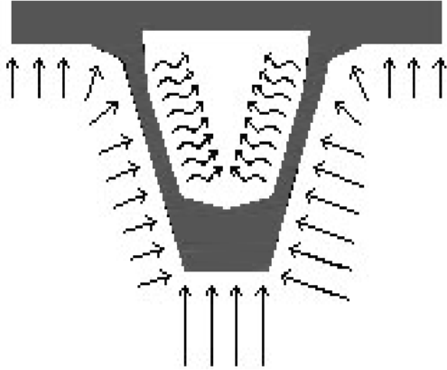

Fig. 5. External Chloride feed; exposed surface *Cl*− concentrations varied from 1 to 2 % [content by weight of concrete]; absorbing boundaries effect (V segment core).



Fig. 6. Critical concentration region development for the A1 setup (*C*cr ≥ 0*.*4% [content by weight of concrete]) for ages 5, 15, 30 and 80 years (black to shaded tones); chlorides in the thin side walls are ”absorbed” by the hollow core (absorbing boundaries) causing almost no increment in the critical depth over time in contrast with the lower part where the distance between the two surfaces eliminates the effect of absorbing boundaries and thus the critical depth time increment is obvious.

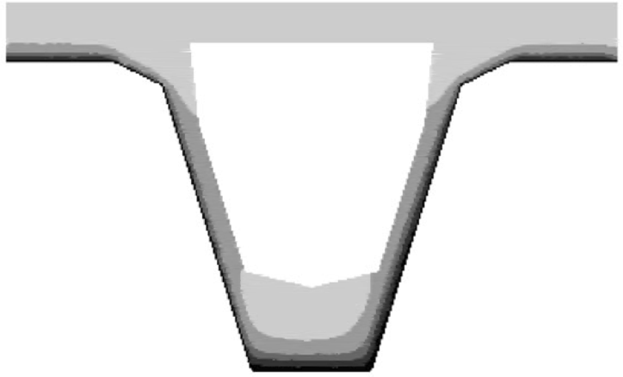

Fig. 7. Critical concentration region development for the B2 setup (*C*cr ≥ 0*.*4% [content by weight of concrete]) for ages 5, 15, 30 and 80 years (black to shaded tones).

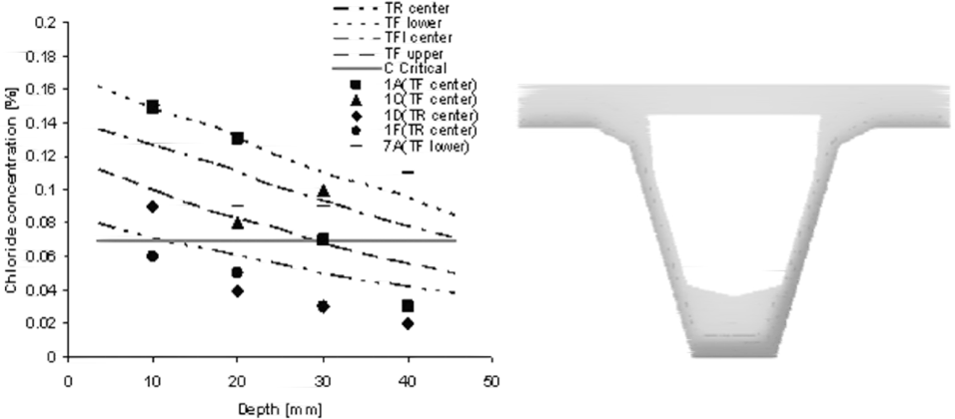

Fig. 8. Chloride concentration comparison: chemical analysis (points) vs. numerical simulation (lines, 38 years) and b - visualization of the chloride concentration pattern for a simulated time of 38 years; the dark tones represent concrete saturated with chloride ions from external feed (Fig. 5).

* 1. *Local modeling*

All methods presented here are demonstrated on a simple example designated to exhibit the nature of the proposed methods. These are named A, B and C in the fol- lowing paragraphs and represent three major approaches to asynchronous updating (using discrete random numbers) according to the author’s experience. Combin- ing these methods, many other derivatives may be described; however, combining stochastic methods in CA usually does not provide more complex or different con- centration distribution patterns. The basic stochastic modification (5) of evolution coefficients Φ*i* is based on generating a random real number increment Ψ according to the given probability density function (usually a normal distribution with a mean value of 0) for every cell within the given neighborhood,

1. *φi* = Φ*i*(1 + Ψ)

satisfying the mass conservation law (6) with a simple modification (for details

see (Biondini 2004, Podrouzek 2008). Unlike the above, the methods presented here

adopt exclusively faster discrete rectangular randomness.

1. Σ *φi* =1

The applied example consists of a CA lattice representing a detail of a cross

section of a continuous beam (reinforced bridge deck) with a crack due to negative bending moments. The crack is located near the middle support, on the surface subjected to traffic loading. By means of deicing salt application, the chloride ions penetrated into the system via a salty solution which partially filled the crack. The simulated system is a conceptional cut-out from the beam, so absorbing boundaries are used to simulate the continuation of the concrete cross section (Fig. 9, left). The top surface of the beam is considered to be ideally insulated, therefore reflecting boundaries are used on the top surface, with the exception of the crack-opening. The crack itself is modeled by two types of cells: cells of constant chloride feed action are used in the region where the crack is filled with the salty diffusion, while

the remaining cells are absorbing. The initial *Cl*− concentration is considered as 0; the CA system is activated only by the crack. The parameters of the simulation

are: cell size 5mm, time step duration length 18 days, diffusion coefficient 2 ×

10−12 *m*2*/s*. Two monitors are located in the system in order to record the *Cl*−

concentration time history. Let us assume that these monitors are reinforcing bars at a specific location (Fig.9). Then, the resulting plot (Fig. 10) may be interpreted as a time to corrosion initiation curve where the depassivation occurs when the concentration reaches the critical value (dashed line). The growth of the critical concentration region (Fig. 9, right) is limited due to the absorbing features of certain boundary cells, so any position outside this region should be corrosion free regardless of the simulation time. The *Cl*− distribution patterns for the proposed methods are visualized in Fig. 11, 12 and 13, where the black and white gradient represents the level of saturation of chloride ions (% by weight of the concrete).

* + 1. *The A method*

This method assumes that the transformation of each individual cell X is a func- tion that randomly uses any possible combination of neighboring cells; the possible states may then be (i) the full neighborhood of 4 cells (N,S,E,W), (ii) trios (4 com- binations), (iii) couples (6 combinations) or (iv) singles (4 combinations), which total 15 combinations according to table 1. To satisfy the mass conservation law, evolutionary coefficients must be modified according to the generated combination of cells used for updating. In the case that all 4 neighboring cells are used, the value of the evolutionary coefficients is 0.5/4 = 0.125. If 3 neighboring cells are taken into account, the evolutionary coefficient would be 0.5/3, which is similar for the couples and singles. Note that this method exhibits the same behavior with synchronous or asynchronous updating, saving significant system resources during the calcula- tion when only one matrix is used within a time step (asynchronous updating) in contrast with synchronous updating when two matrices are necessary: the original values in one matrix and the new updated values in the second matrix.

Table 1

Combination of neighboring cells (North, South, West and East); those marked with X are used in the transitional formula with relevant evolution coefficients.

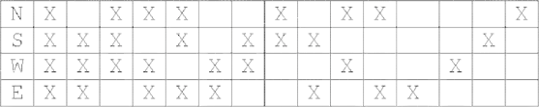

* + 1. *The B method*

Utilizes the discrete random generator before each individual cell transformation to determine whether the cell will be updated or not. Both synchronous and asyn- chronous updating mechanisms are possible; however, asynchronous updating may exhibit certain signs of directionality effects due to the updating sequence for the specific configuration. The B method represents a fast method with rather uniform stochastic noise.

* + 1. *The C method*

Proved to have identical patterns to the B method although the implementation is rather different. Random coordinates are generated in a sequence of individual transformations, determining which cell will get updated. This is a fully asyn- chronous method, where the simulation duration may not be described by the time step duration length as in the previous (parallel) methods. One possible means of time interpretation offers the definition of the number of updates (serial) per time unit.

From the numerous relevant combinations of simulation setup several random resulting states are presented here. The nature of the simulation is predetermined by (i) the selection of boundary interaction (cases with or without upper deck insulation), (ii) stochastic modification of the transformation rule and (iii) by the type of chloride feed (constant for all presented examples). Within the course of the simulation the current state is affected by the stochastic modification, which may lead to a very complex pattern of chloride distribution, yet the simulation’s initial setup is transparent and simple.

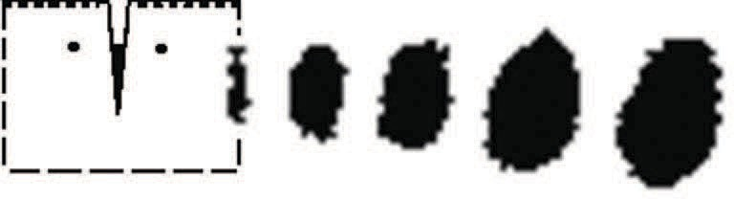

Fig. 9. Left: Geometry of the solved region with upper deck insulation and two symmetrical monitors; Right: Critical concentration region evolution in method A; from left to right the number of time steps is 10, 250, 500, 1000 and 2500; time step duration length is 18 days; the maximum width of the region is approximately 10 cm at *t*=125 years. Note that the growth of the region is not proportional to the growing number of time steps for the reason that after a certain time the system reaches its balanced state when

the chlorides have spread over the cross section and the *Cl*− increment within the time step is balanced by the absorbing boundaries (see also Fig. 10).

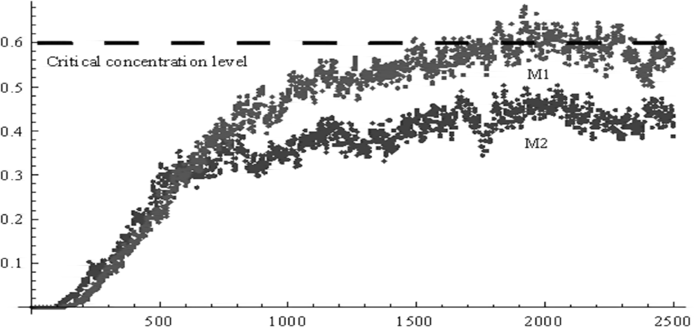

Fig. 10. Method A with upper deck insulation: Output from monitors M1 and M2; the horizontal axis represents time steps, the vertical axis represents the Cl- concentration (% by weight of concrete). After a certain time, the concentration from monitor 1 reaches the critical value and the concentration growth stops due to the effect of the absorbing boundaries.

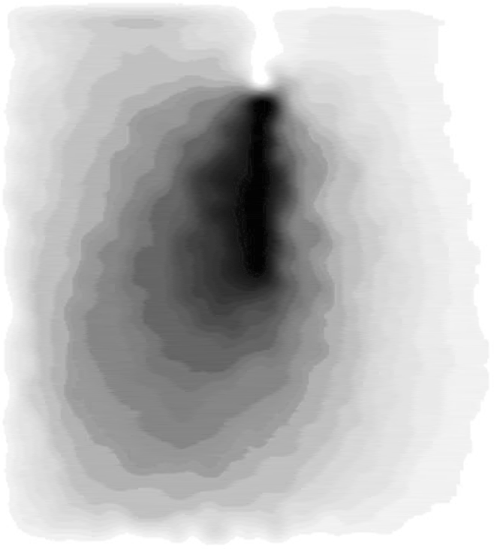

Fig. 11. Method A with upper deck insulation: Visualization of the simulation state at 2500 time steps (corresponds to 125 years), see the corresponding critical concentration region in Fig. 9. Note the strong irregularities when compared to the next figure, Fig. 12.

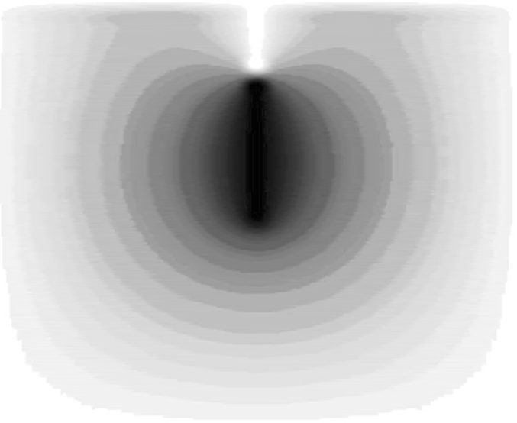

Fig. 12. Method B with upper deck insulation: Visualization of the simulation state at 2500 time steps (corresponds to 125 years); almost no stochastic noise is perceivable.

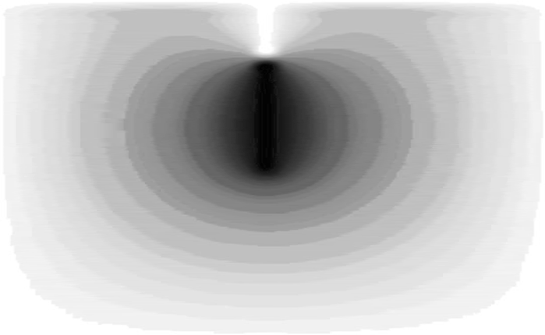

Fig. 13. Fully asynchronous Method C with upper deck insulation: Visualization of the simulation state at 4E6 individual transformations (corresponds to 2500 time steps, i.e. 125 years), indistinguishable by visual inspection from the previous state (Fig. 12.). The same *Cl*− concentration pattern would result from a

fully deterministic synchronous CA simulation. In this regard it was not necessary to implement the two modifications - method B and C - simply because their effect on the resulting pattern is minor on this scale.

# Conclusion

Randomness in physics can be modeled by mechanisms of simple programs, as demonstrated on the proposed stochastic modifications of cellular automaton. In the local modeling section method A exhibits not only stochastic noise, but also an irregular trend without any implicit definition of irregularities. From this point of view the proposed methodology brings the CA concept closer to the diffusion pro- cesses observed in reality. Such irregularities may emerge due to e.g. the concrete casting and/or curing procedure. The resulting estimation of the chloride concen- tration pattern in time may be useful while estimating the service life based on time to initiation reinforcement corrosion caused by the presence of chloride ions.

# Acknowledgement

This outcome has been achieved with the financial support of the Ministry of Ed- ucation of the Czech Republic, project No. 1M0579, within the activities of the CIDEAS research centre and within research project No. GA103/07/0760.

# References

1. Biondini, F., F. Bontempi, D. M. Frangopol, and P. G. Malerba, *Cellular Automata Approach to Durability Analysis of Concrete Structures in Aggressive Environments*, Journal of Structural Engineering Asce, Vol. 130, No. 11, 2004, Pp. 1724-1737.
2. Wolfram, S., “Cellular Automata And Complexity - Collected Papers,” URL:

[http://www.stephenwolfram.com](http://www.stephenwolfram.com/) .

1. “CEB, Comit Euro-International du Bton,” Durable Concrete Structures - Design Guide, Thomas Telford, London, 1992.
2. Podrouzek, J., D. Novak, B.Teply and D. Vorechovska, *Modeling of Environmental Effects on Bridge Components: Possibilities of Cellular Programming*, Lecture Notes in Computer Science, Cellular Automata, Vol. 5191 (2008), Pp. 379-384.
3. Tepl, B., M. Chrom, D. Matesov and M. Rovnank, “FREET- D Deterioration Module Program Documentation, Brno/Cervenka Consulting, 2006.
4. Marsaglia, G. and W. Wan *The Ziggurat Method for Generating Random Variables*, Tsang, Journal of Statistical Software, Vol. 05, Issue 08
5. Vorechovska, D., J. Podrouzek, M. Chroma, P. Rovnanikova and B. Teply, *Modeling of Chloride Concentration Effect on Reinforcement Corrosion*, Computer-Aided Civil and Infrastructure Engineering, Vol. 24, Issue 09.