Electronic Notes in Theoretical Computer Science 46 (2001)

URL: <http://www.elsevier.nl/locate/entcs/volume46.html> 12 pages

Strongly Normal Sets of Tiles in *N* Dimensions

Punam K. Saha 1

*Medical Image Processing Group University of Pennsylvania Philadelphia, PA 19104-6021, U.S.A.*

T. Yung Kong 2*,*3

*Department of Computer and Information Sciences Temple University*

*Philadelphia, PA 19122-6094, U.S.A.*

Azriel Rosenfeld 4

*Center for Automation Research University of Maryland*

*College Park, MD 20742-3275, U.S.A.*

**Abstract**

The first and third authors and others [2,8,9,10,11,12] have studied sets of “tiles” (a generalization of pixels or voxels) in two and three dimensions that have a property called *strong normality* (SN): For any tile *P* , only finitely many tiles intersect *P* , and any nonempty intersection of these tiles must also intersect *P* . This paper presents extensions of the basic results about SN sets of tiles to *n* dimensions. One of our results is that if SN holds for every *n* + 1 or fewer tiles in a locally finite set of tiles in **R***n*, then the entire set of tiles is SN. Other results are that SN is equivalent to hereditary local contractibility, that simpleness of a tile in an SN set of tiles is equivalent to contractibility of its shared subset, and that deletion of a simple tile in an SN set of tiles preserves the homotopy type of the union of all the tiles.

1 Email: [saha@mipg.upenn.edu](mailto:saha@mipg.upenn.edu)

2 Email: [ykong@cs.qc.edu](mailto:ykong@cs.qc.edu)

3 Present address: Computer Science Dept., Queens College, Flushing, NY 11367, U.S.A.

4 Email: [ar@cfar.umd.edu](mailto:ar@cfar.umd.edu)

*◯*c *2001 Published by Elsevier Science B. V.* Open access under [CC BY-NC-ND license.](http://creativecommons.org/licenses/by-nc-nd/3.0/)

# Introduction

In [8] two of the authors and Majumder studied sets of (not necessarily reg- ular) tetrahedra, and showed that the neighborhood of any tetrahedron (the union of the tetrahedra that intersect it) is contractible if the tetrahedra have a property called *strong normality* (SN): For any tetrahedron *T* , only finitely many tetrahedra intersect *T* , and any nonempty intersection of these tetrahe- dra also intersects *T* . In [9] the first and third authors showed that this is also true for sets of convex polygonal or polyhedral “tiles” in the plane or 3-space, and that the converse is also true: Contractibility of neighborhoods implies SN. In [2] Brass showed that in the plane these results remain true for tiles that are contractible and whose pairwise intersections are connected; he also showed that if SN holds for all triples of tiles in a set of tiles, then it holds for the entire set. In [10] the first and third authors showed by example that in 3-space it is not sufficient for the tiles and their nonempty pairwise inter- sections to be contractible, but that the results of [9] remain true for convex tiles. They also showed that if SN holds for all triples and quadruples of a locally finite set of convex tiles in 3-space, then it holds for the entire set.

As in previous papers by the first and third authors, we say that a tile is *simple* if deleting it does not change the homotopy type of its neighborhood. The first and third authors showed in [10] that, for any SN set of tiles in 3- space, simpleness of a tile is equivalent to contractibility of its *shared subset*, which is the set of all points of the tile that also lie on at least one other tile. (In the special case where the tiles are the polyhedra in a tessellation of **R***n*, the shared subset of a tile has been called its *attachment set* in the second author’s work [3,4,5].)

In [11] the first and third authors gave efficient methods of identifying simple tiles and computing the local topological changes when a non-simple tile is deleted, if the tiles are polygons in the plane or polyhedra in 3-space and the set of tiles is SN. They also showed in [12] that, in an SN set of tiles, deletion of a simple tile preserves the homotopy type of the union of all the tiles, but this need not be true if the set of tiles is not SN.

The purpose of this paper is to present extensions of some of these results to *n* dimensions. (Images of dimensionality greater than 3 arise in many real-world situations; time-varying three-dimensional medical images are an example.) In particular, the main result in Section 2 is that if SN holds for all collections of *n* + 1 or fewer tiles in a locally finite set of tiles in **R***n*, then the entire set of tiles is SN. In Section 4, the main results are that in an SN set of tiles the neighborhood of any tile is contractible, and, conversely, if in every subcollection of a locally finite set of tiles the neighborhood of each tile is contractible, then the set of tiles is SN. The main results in Section 5 are that, in any SN set of tiles, simpleness of a tile is equivalent to contractibility of its shared subset, and deletion of a simple tile preserves the homotopy type of the union of all the tiles.

The results in this paper are stated for tiles that are convex polytopes. (A *convex polytope* is a set that is the convex hull of a finite set of points.) It is easy to deduce that our results are also valid for any set of compact (i.e., closed and bounded) tiles for which there is a homeomorphism (i.e., a topology-preserving map) of **R***n* to itself that maps each tile onto a convex polytope.

# Local finiteness and strong normality

In the rest of this paper a *tile* is a convex polytope in **R***n*. Let *P* be any set of tiles. 5 The union of all the elements of *P* will be denoted by *U* (*P*). Note that the tiles may overlap, and they may not cover **R***n*. However, any tessellation of **R***n* by convex polytopes provides an example of a set *P* of tiles.

A collection of sets in **R***n* is said to be *locally finite* if no bounded region in **R***n* intersects infinitely many of the sets in the collection. (A related concept was called *normal* in some papers by the first and third authors.)

We now define the principal concept of this paper:

**Definition 2.1** A collection of tiles *P* is *strongly normal* (SN) if *P* is locally finite and, for all *P, P*1*,..., Pm ∈ P* (*m ≥* 1), if each *Pi* intersects *P* and *I* = *P*1 *∩· · ·∩ Pm* is nonempty, then *I* intersects *P* .

The following proposition is an easy consequence of the definition of SN. Assertion (ii) says that strong normality is *hereditary*: Any subcollection of an SN collection of tiles is itself SN.

**Proposition 2.2** *Let P be an SN set of tiles. Then:*

* 1. *P ∪ {∅} is also SN.*
  2. *P' is SN for all P' ⊆ P.*

The *neighborhood* of *P* in *P*, denoted by *NP*(*P* ), is the union of all *Q ∈P* that intersect *P* (including *P* itself). Theorems 4.1 and 4.2 in Section 4 show that a locally finite set of tiles *P* is SN iff, for every *P' ⊆P* and every *P ∈ P'*, *NP'* (*P* ) is contractible; thus SN is equivalent to hereditary local contractibil- ity. (A set is said to be *contractible* if it is, loosely speaking, “continuously deformable over itself to a point”. We will say more about this concept in Section 3 below.)

Local contractibility is a property of most “real” shapes: If *Bδ*(*p*) denotes the open ball with radius *δ* centered at *p*, then for any point *p* in most real shapes *S* the set *Bδ*(*p*) *∩ S* is contractible for all sufficiently small *δ*. (By a “real” shape we mean a subset of **R***n* that is used to model something in the physical world.) Since the intended purpose of our sets of tiles *P* is to provide quantized representations of real shapes, the property that any *P' ⊆ P* is locally contractible at each tile is a good property of SN sets of tiles.

5 The “tiles” correspond to voxels in **R**3 or to pixels in **R**2.

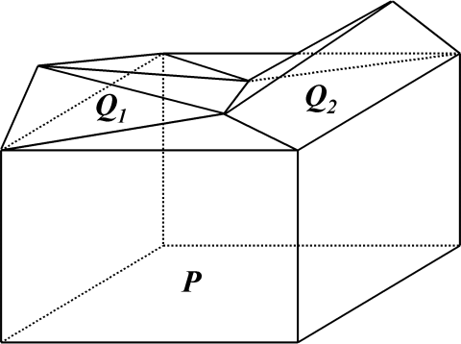

Fig. 1. A non-SN set of three tiles. *P, Q*1, and *Q*2 form a tunnel.

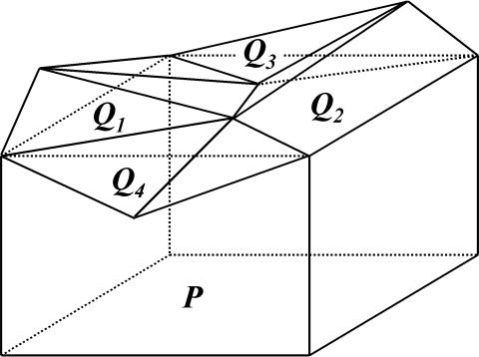

Fig. 2. A non-SN set of five tiles. *P, Q*1*, Q*2*, Q*3, and *Q*4 surround a cavity.

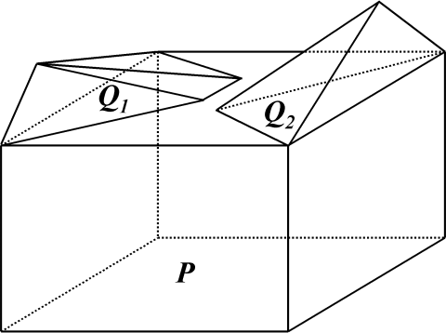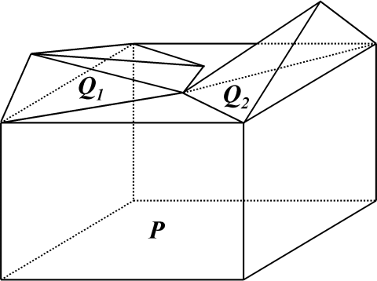

(a) (b)

Fig. 3. Two sets of three tiles which demonstrate the need to know how the neighbors of *P* intersect among themselves to determine the “topological effect” of deleting

*P* . The intersection of the cubical tile *P* with its neighbors is the same in (a) and

(b) (two edges of the cube in each case), but *NP* (*P* ) in (a) is contractible while *NP* (*P* ) in (b) has a tunnel. In (a), deletion of *P* breaks one object into two; in (b), it eliminates a tunnel. (a) is SN but (b) is not.

Figures 1 and 2 show examples in which SN is violated. In Figure 1, the neighborhood *P ∪ Q*1 *∪ Q*2 of *P* forms a tunnel; in Figure 2, the neighborhood *P ∪Q*1*∪Q*2*∪Q*3*∪Q*4 surrounds a cavity. It should be noted that in such cases it is not sufficient to know how the neighbors of *P* intersect with *P* if we wish to determine the “topological effect” of deleting *P* ; one must also know how the neighbors of *P* intersect among themselves. This is illustrated in Figures 3(a) and (b): Although the intersection of the tile *P* with its neighbors is the same in both cases, *NP*(*P* ) is contractible in (a) but forms a tunnel in (b). In Figure 3(a), deletion of *P* breaks one object into two, while in (b) it breaks a tunnel.

Our first main result (Theorem 2.6 below) is that if *P* is a locally finite collection of tiles in **R***n*, and all subsets of *n* + 1 or fewer tiles of *P* are SN, then *P* is SN.

Our proof of this depends on the following concepts: *P* will be called *k- strongly normal* (SN*k*) if every subcollection of *k* or fewer tiles of *P* is SN. *P* will be said to have the *(2,k) intersection property* (notation: *I*2*→k*) if whenever *P'* is a set of *k* or fewer tiles of *P* every pair of which intersect, the intersection of all the tiles in *P'* is nonempty. It is not difficult to verify the following:

**Lemma 2.3** *A set of tiles satisfies SNk if and only if it satisfies I*2*→k.*

Here the “if” part is a straightforward consequence of the definitions of *SNk* and *I*2*→k*. The “only if” part can be proved by induction on *k*. From this lemma we obtain the following characterization of strong normality:

**Corollary 2.4** *A locally finite collection of tiles P is SN if and only if P*

*satisfies I*2*→k for all integers k >* 2*.*

The condition “*I*2*→k* for all integers *k >* 2” says that whenever *P'* is a finite set of tiles of *P* every pair of which intersect, the intersection of all the tiles in *P'* is nonempty. From this characterization of SN it is easy to deduce the following result, which we will use later.

**Corollary 2.5** *Let P and S be sets of tiles such that each member of S is an intersection of (one or more of the) tiles in P. Then S is SN if P is SN.*

In Corollary 2.5, note that if *P* is SN then any nonempty intersection of tiles of *P* must be a finite intersection, since *P* is locally finite. Note also that it is in fact unnecessary to assume that the members of *S* are tiles (i.e., convex polytopes), since this is implied by the fact that each member of *S* is an intersection of one or more of the tiles in *P*. (It is well known that the intersection of any finite collection of convex polytopes is a convex polytope.) Helly’s theorem [14] states that if a collection of convex sets in **R***n* has the property that every *n* + 1 members of the collection have nonempty in- tersection, then every finite subcollection of those convex sets has nonempty intersection. Thus, in **R***n*, *I*2*→n*+1 implies *I*2*→k* for all integers *k >* 2. As an

immediate consequence of this, Lemma 2.3 and Corollary 2.4 we have:

**Theorem 2.6** *Let P be a locally finite set of tiles in* **R***n. Then P is SN if and only if P is SNn*+1*.*

# Some concepts and facts

This section presents certain concepts and facts which are used in our proofs of the results stated in subsequent sections. Our arguments do not depend on any knowledge of topology other than what is presented in this section and Facts 4.3 – 4.6 in Section 4.

In this paper, a *polyhedron* is a union of a finite number of convex polytopes. It follows that the union and the intersection of any two polyhedra are also polyhedra.

Every union of a finite (or locally finite) collection of closed sets is a closed set. Moreover, every convex polytope is a closed set. It follows that every polyhedron is a closed set.

Two subsets of **R***n* are said to have the same *homotopy type* if they belong to the same equivalence class of the *homotopy equivalence* relation. Homotopy equivalence can be regarded as a weaker version of the equivalence relation of being topologically equivalent: For example, a line segment, a closed disk and an open disk all have the same homotopy type as a set consisting of a single point, though no two of these four sets are topologically equivalent. Two sets with the same homotopy type must have the same number of connected components; in the plane **R**2 they must also have the same number of “holes”, and in 3-space the same number of “holes” or “tunnels” and the same number of “cavities”. In the plane, two nonempty connected polyhedra have the same homotopy type if and only if they have the same number of “holes”.

A set is said to be *contractible* if it has the same homotopy type as a one- point set. Thus a contractible set is nonempty and connected. A contractible set in the plane also has no holes. A contractible set in 3-space has no holes or tunnels, and no cavities. For a polyhedron in the plane or 3-space, these necessary conditions are also sufficient for the polyhedron to be contractible: It can be shown that a polyhedron in the plane or in 3-space is contractible if and only if it is nonempty and connected, has no holes or tunnels, and, in the 3D case, also has no cavities. However, the only facts about contractible sets that we will need in this paper are stated below. The first of these facts is:

**Fact 3.1** *Nonempty convex sets are contractible.*

Two other facts we will need about contractible sets are stated at the end of this section.

If *X ⊆ Y* , and *Y* can be continuously deformed over itself onto *X* in such a way that the points in *X* remain fixed throughout the deformation process, then *X* is said to be a *strong deformation retract* of *Y* ; the map *r* : *Y → X* such that *r*(*y*) is the point in *X* to which *y* is ultimately moved by the deformation process is called a *strong deformation retraction*. We will need the following

elementary properties of strong deformation retraction, which follow easily from the formal definition of the concept in texts on topology (e.g., [1]).

**Fact 3.2** *If X is a strong deformation retract of Y , then X and Y have the same homotopy type.*

**Fact 3.3** *If X is a strong deformation retract of Y , and Y is a strong defor- mation retract of Z, then X is a strong deformation retract of Z.*

Our arguments in Sections 4 and 5 depend on the following somewhat surprising fact, which is proved in Chapter 1 of [13]:

**Fact 3.4** *Let A and B be contractible polyhedra such that B ⊆ A. Then B is a strong deformation retract of A.*

A consequence 6 of Fact 3.4 that we will use is:

**Fact 3.5** *Let C be a closed set and let X be a contractible polyhedron such that X ∩ C is also a contractible polyhedron. Then C is a strong deformation retract of C ∪ X.*

# A collection of tiles is strongly normal if and only if the neighborhood of every tile in every subcollection is contractible

The result stated in the title of this section is precisely formulated in the following two theorems:

**Theorem 4.1** *Let P be an SN set of tiles and let P be any tile of P. Then the neighborhood NP*(*P* ) *of P is contractible.*

**Theorem 4.2** *Let P be a locally finite collection of tiles such that, for all P' and P satisfying P ∈ P' ⊆ P, the neighborhood NP'* (*P* ) *is contractible. Then P is SN.*

Note that since every subcollection of an SN collection of tiles is itself SN, Theorem 4.1 implies the converse of Theorem 4.2: If *P'* is any subcollection of the SN collection *P*, then *NP'* (*P* ) is contractible for each *P* in *P'*.

Our proof of Theorem 4.1 proceeds by induction on the number of tiles in *P* that intersect *P* . The induction step is based on Fact 3.5 and the fact that if *P*1 is any tile of *P \ {P}* that intersects *P* , then *P*1 *∩ NP−{P*1*}*(*P* ) is contractible. We prove the latter fact by considering the collection of tiles *S* = *{P*1 *∩ P}∪ {P*1 *∩ Pi |* 2 *≤ i ≤ m}*, where *{P*1*, P*2*,..., Pm}* is the set of all the tiles of *P \ {P}* that intersect the tile *P* . The point is that *S* is SN (by

6 On putting *A* = *X* and *B* = *X ∩ C* in Fact 3.4, we deduce that *X ∩ C* is a strong deformation retract of *X*. But if *r* : *X → X ∩ C* is the corresponding strong deformation retraction, then we can extend *r* to a retraction of *C∪X* to *C* simply by defining *r*(*y*) = *y* for all *y ∈ C \ X*, and it is straightforward to verify that this retraction is a strong deformation retraction of *C ∪ X* onto *C*.

Corollary 2.5), and, since *P* is SN, *P*1 *∩ NP−{P*1*}*(*P* )= *NS* (*P*1 *∩ P* ), which is contractible by the induction hypothesis.

Our proof of Theorem 4.2 uses properties of Euler numbers of polyhedra. For any polyhedron *P* , we write *χ*(*P* ) to denote the Euler number (or Euler characteristic) of *P* . Here are the elementary facts we need about *χ*(*P* ), all of which are easily deduced from the definition of the Euler number and its well-known properties (see, e.g., [1]):

**Fact 4.3** *χ*(*∅*)= 0*.*

**Fact 4.4** *If P is a contractible polyhedron, then χ*(*P* )= 1*.*

**Fact 4.5** *For any polyhedra P*1 *and P*2*, χ*(*P*1*∪P*2)= *χ*(*P*1)+*χ*(*P*2)*−χ*(*P*1*∩P*2)*.*

Fact 4.5 is the case *k* = 2 of the following “inclusion-exclusion principle”, which can be deduced from Fact 4.5 by induction on *k*:

**Fact 4.6** *For any polyhedra P*1*, P*2*,..., Pk,*

*k*

*χ*( *Pi*)= Σ (*−*1)*|S|−*1*χ*( *Pi*)

*i*=1

*S⊆{*1*,*2*,...,k},S/*=*∅*

*i∈S*

By rearranging the sum on the right-hand side, Fact 4.6 can be rewritten as follows:

(1)

*χ*( *Pi*)= *χ*(*Pk*)+ Σ

(*−*1)*|S|*(*χ*(*Pk ∩* *Pi*) *− χ*( *Pi*))

*i*=1

*k*

*S⊆{*1*,*2*,...,k−*1*},S/*=*∅*

*i∈S*

*i∈S*

Now suppose the hypotheses of Theorem 4.2 hold, and *P∗* = *{P*1*,..., Pm}* is a minimal subset of *P\ {P}* that violates SN with *P* (i.e, a minimal subset of *P \ {P}* for which the condition stated in Definition 2.1 fails to hold). On

putting *k* = *m* + 1 and *Pk* = *P* we deduce from (1) (and Facts 3.1 and 4.3 –

4.4) that *χ*(*NP∗∪{P}*(*P* )) = *χ*( *k Pi*)= *χ*(*Pk*)+ (*−*1)*m*(*−*1) = 0 or 2, and so

*i*=1

*NP∗∪{P}*(*P* ) is not contractible. This contradiction proves Theorem 4.2.

Say that a collection *P* of tiles is *hereditarily locally contractible* if, for all *P'* and *P* satisfying *P ∈ P' ⊆ P*, the neighborhood *NP'* (*P* ) is contractible. Then as an immediate consequence of Theorems 4.1 and 4.2 (and Proposition 2.2) we have:

**Theorem 4.7** *For locally finite sets of tiles, strong normality is equivalent to hereditary local contractibility.*

# In a strongly normal set of tiles, if deletion of a tile preserves the homotopy type of its neighborhood, it preserves the homotopy type of the union of all the tiles, and the shared subset of the tile is contractible

If *P* is a set of tiles then, as in previous papers by the first and third authors, we will say that a tile *P ∈ P* is *simple* in *P* if deleting *P* from *P* does not

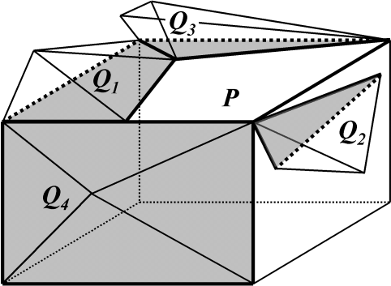 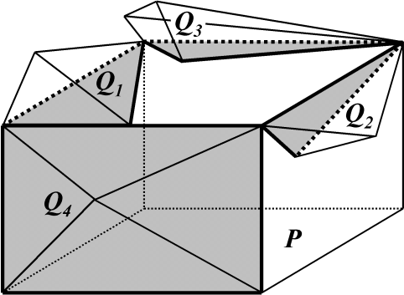

(a) (b)

Fig. 4. Two examples of the shared subset of a tile. Vertices and lines within a shared subset are shown bold while faces are shown gray. In (a), the shared subset is contractible and the tile *P* is simple. In (b), the shared subset is not contractible and *P* is not simple.

change the homotopy type of *NP*(*P* ). To state this definition more precisely we first define *N∗* (*P* ), the *excluded neighborhood* of *P* in *P*, as the union of all *Q ∈ P*, excluding *P* itself, that intersect *P* ; thus *NP*(*P* )= *N∗* (*P* ) *∪ P* . Then *P ∈P* is *simple* in *P* iff *NP*(*P* ) and *N∗* (*P* ) have the same homotopy type.

*P*

*P*

*P*

If *P* is SN then, by Theorem 4.1, *NP*(*P* ) is contractible, and so *P* is simple if and only if *N∗* (*P* ) is contractible.

*P*

We mention that when *P* is non-simple the Betti numbers of *N∗* (*P* ) provide useful information on the local topological changes that result from deletion of *P* , if *P* is SN.

*P*

Define *Ns* (*P* ), the *shared subset* of *P* in *P*, as the set *N∗* (*P* ) *∩ P* . Thus,

*P P*

*Ns* (*P* ) is the subset of *P* that is shared by its neighbors. As our definition

*P*

of a collection of tiles places no restrictions on how two tiles intersect with each other, *Ns* (*P* ) may even be the whole of *P* . Figures 4(a) and (b) illustrate shared subsets of tiles. It may be noted that, in Figure 4(a), the shared subset is contractible and the tile *P* is simple. On the other hand, in Figure 4(b) the shared subset has a “tunnel” and therefore is not contractible, and *P* is not simple. These are examples of the following general result:

*P*

**Theorem 5.1** *Let P be an SN set of tiles and let P ∈ P. Then P is simple in P if and only if Ns* (*P* ) *is contractible.*

*P*

Our proof of this theorem depends on the following lemma, which gives a sufficient condition for *A ∪* (*P ∩ P '*) to be a strong deformation retract of *A ∪ P '* (where *A*, *P* , and *P '* are arbitrary polyhedra). This lemma follows from Fact 3.5 on putting *C* = *A ∪* (*P ∩ P '*) and *X* = *P '*.

**Lemma 5.2** *Let P, P ' and A be polyhedra such that P ' and P ' ∩* (*A ∪ P* ) *are contractible. Then A ∪* (*P ∩ P '*) *is a strong deformation retract of A ∪ P '.*

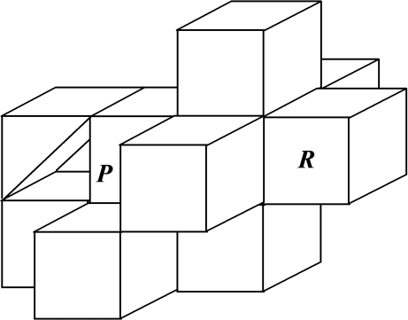

Fig. 5. If *P* is not SN, the homotopy type of *U* (*P*) may change even when a simple tile *P* is deleted. (In this example one of the tiles is a triangular prism, not a cube, and there is no tile between *P* and *R*.)

To deduce Theorem 5.1 from this, let *{P*1*, P*2*,..., Pm}* be the set of all the tiles of *P \ {P}* that intersect the tile *P* . For 1 *≤ k ≤ m*, let *Sk* =

*{Pk ∩P}∪{Pk ∩Pi |* 1 *≤ i ≤ k −* 1*}*. The fact that *P* is SN implies ( *k−*1(*Pk ∩ Pi*)) *∪* (*Pk ∩ P* )= *NSk* (*Pk ∩ P* ), and this is contractible by Theorem 4.1 (as *Sk* is SN, by Corollary 2.5). So it follows from the preceding lemma (on putting

*i*=1

*A* = ( *k−*1 *Pi*) *∪* *m* (*P ∩Pi*) and *P '* = *Pk*) that ( *k−*1 *Pi*) *∪* *m* (*P ∩Pi*) is

*i*=1

*i*=*k*+1

*i*=1

*i*=*k*

a strong deformation retract of ( *k Pi*) *∪* *m* (*P ∩ Pi*). This and Fact 3.3

evidently imply that *Ns*

*m*

*i*=1 *∩*

*i*=*k*+1

*∗*  *m*

of *NP* (*P* )=

*P* (*P* ) =

*i*=1(*P*

*Pi*) is a strong deformation retract

It is shown in [10] that this theorem, in the case of the 3D cubic tessellation, leads to the characterization of simpleness that is given in [6,7].

*i*=1 *Pi*, which proves Theorem 5.1.

Our final theorem implies that deletion of a simple tile from an SN collec- tion of tiles does not change the homotopy type of the union of the tiles (as stated in the title of this section).

**Theorem 5.3** *Let P be an SN set of tiles and let P be a simple tile in P. Then U* (*P \ {P}*) *is a strong deformation retract of U* (*P*)*.*

**Proof.** Let *C* = *U* (*P \ {P}*) and let *X* = *NP*(*P* ). Then *C* is closed (as it is a union of a locally finite collection of closed sets), *X* is contractible (by Theorem 4.1), and *C ∩ X* = *N∗* (*P* ) is contractible (as *P* is simple). So, by Fact 3.5, *C* is a strong deformation retract of *C ∪ X* = *U* (*P*). *✷*

*P*

If *P* is not SN, the homotopy type of *U* (*P*) may change when a tile *P* is deleted from *P* even if *P* is simple. An example is shown in Figure 5; note that tile *R* is not in *NP*(*P* ). Here *P* is simple (*NP*(*P* ) and *N∗* (*P* ) have the same homotopy type) but the homotopy type of *U* (*P*) changes when *P* is deleted: Before deletion of *P* , *U* (*P*) has one component, one tunnel, and one cavity, because there is no tile between *P* and *R*; after deletion of *P* , *U* (*P*) has one component but no tunnels or cavities.

*P*

# Concluding remarks

Extensions of the basic results of [2,8,9,10,12] to SN sets of tiles in *n* dimen- sions have been presented. We have not attempted to extend the results of [11] to *n* dimensions, because the complexity of computing the topological changes when a non-simple tile is deleted grows rapidly with *n* even in the standard hy- percubic tessellations. However, it may be worth investigating computational aspects of the problem of determining whether a tile is simple, and the more general problem of determining the local topological changes that occur when a tile is deleted, in low-dimensional (e.g., 4D or 5D) hypercubic tessellations. Images based on such tessellations are used in temporal image analysis. We are currently working on this problem in 4D.

# References

1. M. A. Armstrong, *Basic Topology*, Springer-Verlag, 1983.
2. P. Brass, On strongly normal tessellations, *Pattern Recognition Letters* **20**, 1999, 957–960.
3. C. J. Gau and T. Y. Kong, Minimal non-simple sets of voxels in binary images on a face-centered cubic grid, *International Journal of Pattern Recognition and Artificial Intelligence* **13**, 1999, 485–502.
4. T. Y. Kong, On topology preservation in 2-d and 3-d thinning, *International Journal of Pattern Recognition and Artificial Intelligence* **9**, 1995, 813–844.
5. T. Y. Kong, Topology preserving deletion of 1’s in 2-, 3- and 4-dimensional binary images, in E. Ahronovitz and C. Fiorio, Ed., *Proceedings of the 7th International Workshop on Discrete Geometry for Computer Imagery* (DGCI ’97, Montpellier, France, December 1997), Springer-Verlag, 1997, 3–18.
6. P. K. Saha, B. Chanda and D. Dutta Majumder, Principles and Algorithms for 2D and 3D Shrinking, TR KBCS/2/91, N.C.K.B.C.S. Library, Indian Statistical Institute, Calcutta, India, 1991.
7. P. K. Saha and B. B. Chaudhuri, Detection of 3D simple points for topology preserving transformation with applications to thinning, *IEEE Transactions on Pattern Analysis and Machine Intelligence*, **16**, pp. 1028–1032, 1989.
8. P. K. Saha, D. Dutta Majumder and A. Rosenfeld, Local topological parameters in a tetrahedral representation. *Graphical Models and Image Processing* **60**, 1998, 423–436.
9. P. K. Saha and A. Rosenfeld, Strongly normal sets of convex polygons or polyhedra, *Pattern Recognition Letters* **19**, 1998, 1119–1124.
10. P. K. Saha and A. Rosenfeld, The digital topology of sets of convex voxels,

*Graphical Models* **62**, 2000, 343–352.

1. P. K. Saha and A. Rosenfeld, Determining simplicity and computing topological change in strongly normal partial tilings of *R*2 or *R*3, *Pattern Recognition* **33**, 2000, 105–118.
2. P. K. Saha and A. Rosenfeld, Local and global topology preservation in locally finite sets of tiles, *Information Sciences* **137**, 2001, 303–311.
3. E. H. Spanier, *Algebraic Topology*, McGraw Hill, 1966.
4. R. Webster, *Convexity*, Oxford University Press, 1994.