HOSTE D BY

Available online at [www.sciencedirect.com](http://www.sciencedirect.com/science/journal/2314808X)

ScienceDirect

journal homepage: <http://ees.elsevier.com/ejbas/default.asp>

[e g ypti an j o ur nal o f b a sic and a pp l i e d sci en c e s 2 ( 201 5 ) 1 5 9](http://dx.doi.org/10.1016/j.ejbas.2015.04.004) e[166](http://dx.doi.org/10.1016/j.ejbas.2015.04.004)



Full Length Article

Structural and functional analysis of ocular regions of five marine teleost fishes (*Hippocampus hippocampus*, *Sardina pilchardus*, *Gobius niger*, *Mullus barbatus* & *Solea solea*)



*Samah T. Darwish* *a**, Mahmoud E. Mohalal* *b**, Menna M. Helal* *a**,*

*Hassan I.H. El-Sayyad* *c**,*\*

a *Zoology Department, Al-Arish Faculty of Science, Suez Canal University, Egypt*

b *Zoology Department, Faculty of Science, Suez Canal University, Egypt*

c *Zoology Department, Faculty of Science, Mansoura University, Egypt*

## a r t i c l e i n f o

*Article history:*

Received 30 January 2015 Received in revised form 14 March 2015

Accepted 3 April 2015

Available online 5 May 2015

*Keywords:*

Retina Lens

Scanning electron microscopy Protein & isoenzyme electrophoresis Marine teleost

## a b s t r a c t

Five marine teleost fishes inhabiting different marine depths namely *Hippocampus hippo- campus* (Linnaeus, 1758), *Sardina pilchardus* (Walbaum, 1792), *Gobius niger* (Linnaeus, 1758), *Mullus barbatus barbatus* (Linnaeus, 1758) and *Solea solea* (Linnaeus, 1758) were used in the present study. Their retinae and lenses were subjected for histological, scanning electron microscopy, SDS-PAGE and isoenzyme electrophoresis of alkaline phosphatase, malate and glucose-6-phosphate dehydrogenase. The present findings showed variant histological structures with characteristic photoreceptors mainly of either rods for *H. hippocampus*, *M. barbatus* and *S. solea* or cones in *S. pilchardus*. Mixed photoreceptors are identified in *G. niger*. The fishes exhibited diversity in protein band expression coincides with change of pattern orientation in lens fibers arrangement and histological structures of retina. Isoenzyme electrophoresis of estimated isoenzyme showed differences between lens and retina of fishes especially *H. hippocampus*.

It can be concluded that the retina and lens of the studied teleost fishes showed apparent varying structure reflecting the isoenzyme characteristic for preserving func- tional characteristic of vision according to the marine habitat depths.

Copyright 2015, Mansoura University. Production and hosting by Elsevier B.V. This is an open access article under the CC BY-NC-ND license ([http://creativecommons.org/licenses/](http://creativecommons.org/licenses/by-nc-nd/4.„0/)

[by-nc-nd/4.0/](http://creativecommons.org/licenses/by-nc-nd/4.„0/)).

* *Corresponding author*. Tel.: +20 01003179778; fax: +20 050 2246254. E-mail address: [elsayyad@mans.edu.eg](mailto:elsayyad@mans.edu.eg) (H.I.H. El-Sayyad).

Peer review under responsibility of Mansoura University. <http://dx.doi.org/10.1016/j.ejbas.2015.04.004>

2314-808X/Copyright 2015, Mansoura University. Production and hosting by Elsevier B.V. This is an open access article under the CC BY- NC-ND license ([http://creativecommons.org/licenses/by-nc-nd/4.0/](http://creativecommons.org/licenses/by-nc-nd/4.„0/)).

160 [e gypti an j o ur nal o f b a sic and a p p l i ed sci e n c e s 2 ( 201 5 ) 1 5 9](http://dx.doi.org/10.1016/j.ejbas.2015.04.004) e[166](http://dx.doi.org/10.1016/j.ejbas.2015.04.004)

# Introduction

Vision is an important sense organ. Similar to other land vertebrates, fishes have oval lens and retina with charac- teristics rod and/or cone photoreceptors (ectopic or photopic vision) [1](#_bookmark8)e[3]. Fish vision is markedly adapted to their aquatic environment especially at deep sea where eyes suited to its dark level [4]. Aquatic marine environment absorb light which is gradually decrease with increasing depth become blue at 50 m [5]. Marine teleost fishes inhabiting different depths of marine environment displayed varying optometric

[6] and retinal structures [7,8].

In poor light at deep surfaces, teleost fishes used monofocal lens beside monochromatic retina such as the South American cichlid fish *Aequidens pulcher* (blue acara) which showed adap- tive changes of lens during day and night [9] as well as exhibited retinomotor movements [10,11]. Multifocal lenses were observed in diurnal and nocturnal coral reef fishes. The prop- erties of the lens seemed to be specifically adapted to the visual needs of each species [12]. Also, the retina of deep sea living fishes showed adapted retina with more than visual pigments such as stomiid dragonfishes, which uniquely produce far red bioluminescence from suborbital photophores [13].

The distribution of lens protein and the refractive indices of fishes attracted the attention of many authors. Pierscionek and Augusteyn [14] mentioned that a high content of gamma- crystallins is found in lenses which have refractive index gradients. SDS-PAGE profiles of soluble lens nuclear proteins of *Clarias batrachus* (Linn.) revealed the presence of eight distinct polymorphs along the western region of Uttar Pra- desh, India. b- and g-crystallins were identified according to their molecular weights and isoelectric points [15].

The present study aimed to evaluate the diversity of retinal and lenticular structure and function in five marine teleost fishes inhabiting different marine depths.

# Materials & methods

Selected teleost fishes were collected from Mediterranean sea regions around Port Said in the Northeast of Egypt. The captured fishes collected were of almost relatively similar sizes. The investigated fishes are:

1. *Hippocampus hippocampus* (Linnaeus, 1758), Order Syn- gnathiformes, Family Syngnathidae. It lives at depth range of 14e40 m [16].
2. *Sardina pilchardus* (Walbaum, 1792), Order Clupeiformes, Family: Clupeidae. The fish lives at depth range of 25e55 m depth [17].
3. *Gobius niger* (Linnaeus, 1758), Order Perciformes, Family Gobiidae. It lives at depth range from 1 to 75 m [18],
4. *Mullus barbatus barbatus* (Linnaeus, 1758), Order: Perci- formes, Family: Mullidae. It lives at depth up to 100 m [19].
5. *Solea solea* (Linnaeus, 1758), Order: Pleuronectiformes, Family: Soleidae. It lives at depth around 0e150 m [20].

The eyes of the selected fishes were dissected and inves- tigated as follows:

### *Morphometric assessments*

Retinal thickness and their layers were measured in investi- gated fishes by linear ocular micrometers. The ratio relation- ship between outer and inner nuclear layer were investigated according to Wang et al. [21] to determine the nocturnal or diurnal pattern of the fish. Also, the relationship between ganglion layer and inner nuclear layer was also investigated according to Gu et al. [22] to illustrate the visual acuity.

### *Histological investigations*

The retinae of the investigated fishes were separated from their lens and immediately fixed in 10% phosphate buffered formalin (pH 7.4). They were then dehydrated in ascending grades of ethyl alcohol, cleared in xylene and mounted in molten paraplast at 58e62 ◦C. Serial 5 mm sagittal histological sections were cut, stained with Haematoxylin and eosin and examined under bright-field light microscopy.

### *Scanning electron microscopic investigation*

Lenses of the examined fishes were separated and immedi- ately fixed in 2.5% glutaraldehyde in 0.1 M cacodylate buffer at (pH 7.4) and dehydrated in ascending grades of ethyl alcohol. The specimens were dried in a carbon dioxide critical point drying apparatus, mounted in stubs and coated with a thin layer of gold by low voltage DC sputtering and investigated under scanning electron microscope JOEL5300 JSM (musa- shino 3-chome akishima Tokyo 196-8558, Japan).

### *Sodium dodecyl sulfate polyacrylamide-gel* electrophoresis (SDS-PAGE) protein analysis of retina and lens

Lenses and retina of the investigated fishes were separated and stored frozen at —20 ◦C until use. Extraction of protein was carried out and protein content was determined by the method of Lowry et al. [23] using crystalline bovine serum albumin as standard. Protein extracts were subjected to so- dium dodecyl sulfate polyacrylamide gel electrophoresis (SDS-PAGE) according to Laemmli [24]. Electrophoresis was carried out at a constant 200 V. The separated proteins were placed on polyacrylamide gels stained with Coomassie blue R- 250 (60 mg/l) in an acidic medium for the generation of an electrostatic attraction between the dye molecules and the amino groups of proteins [25].

### *Isoenzyme electrophoresis of acid phosphatase,* malate dehydrogenase and glucose-6-phosphate dehydrogenase

Lens and retina samples were collected, cleaned and homog- enized using 0.1 M TriseHCl (pH 7.5) containing 20% sucrose. Protein content was determined according to Lowry et al. [23] and electrophoresis by the method of Laemmli [24]. For visu- alization of the tested enzymes, the tissue samples were incubated in medium containing the selected substrate of the tested enzyme and visualized materials as follows:

[e g ypti an j o ur nal o f b a sic and a pp l i e d sci en c e s 2 ( 201 5 ) 1 5 9](http://dx.doi.org/10.1016/j.ejbas.2015.04.004) e[166](http://dx.doi.org/10.1016/j.ejbas.2015.04.004) 161

Acid phosphatase isoenzymes: Staining was carried out using 30 mg naphthol-AS-MX-phosphate as substrate and 50 ml incubation buffer, 0.25 ml 0.1 M MgCl2, 0.25 ml MnCl2 10%, 5 ml NaCl 20%, and 30 mg fast blue [26].

Malic dehydrogenase isoenzymes: Staining solution was carried out by mixing 50 mN TriseHCl (pH 8.5) 50 ml, nicotinamide adenine dinucleotide (NAD) 10 mg, maleic acid 1 ml (after neutralized with NaOH), nitro blue tetra- zolium chloride (NBT) 10 mg and phenazine methosul- phate (PMS) 2 mg [27].

Glucose-6-phosphate dehydrogenase: Staining solution was prepared by mixing 50 ml 0.2 M TriseHCl (pH 8.0),50 ml, 10 mg NADP, 10 mg MTT, nicotinamide adenine dinucleotide (NAD), 5 mg and phenazine methosulphate (PMS), 200 mg MgCl2, and 100 mg glucose-6-phosphate [28].

Isoenzyme patterns were recorded on the basis of number and the rate of flow (Rf) values of the isoenzyme bands. The Rf value is the mobility of each isoenzyme band that traveled from the origin divided by the distance traveled by the front tracking dye. The presence or absence of a certain isoenzy- matic band was considered as a differentiating feature. Zy- mograms were drawn to scale and relative mobility values were calculated for each band.

### *Statistical analysis*

Data are presented as mean ± standard error. The statistical analysis was performed with multi-variant analysis of vari- ance (MANOVA) using SPSS (version 13) software package for Windows of comparing the multivariations between each investigated fishes in relation with *H. hippocampus* and considered statistically significant at P < 0.05.

# Results

### *Scanning electron microscopy of lens*

The lens of the fishes under consideration exhibited circular shape except that of *H. hippocampus* which showed elliptical- shape. The lens ensheathed by a thin acellular sheet of collagen fibers. The lens fibers are more organized and consist of densely packed fibers interconnected by ball and socket structures on short edges. There is a relative absence of ball and sockets on their superficial fibers which allowing lens movement. The lens fibers of the studied teleost fishes varied from each other and categorized in three forms. The lens fi- bers of *G. niger*, *M. barbatus* and *S. solea* revealed that the lens fibers arranged in concentric layers of densely packed lens fibers representing the superficial and deep cortical fibers. At the center of the lens, a group of straight fibers were passing along the antero-posterior axis representing the embryonic nucleus. Fibers appeared as tightly joined parallel ribbon-like structures with minimal intercellular spaces in between spe- cies. Each fiber had the shape of a polygon or hexagon with two wide parallel sides and four other smaller ones. The *G. niger* showed the least organization of the lens fibers comparing with *M. barbatus* & *S. solea*. However, SP revealed the grouping of fibers forming club-shaped regularly oriented

in parallel rows bearing ball adjoining to socket of the another one. On the other hand *H. hippocampus* showed irregular pattern distribution of short and long lens fibers having balls with alternating socket of the another ones. In all the speci- mens, the structure of the lens fibers appeared hexagonal with two wide parallel sides and four other smaller ones. The lens fibers interconnect into planar sheets with interconnecting ball and socket structures on short edges. Also, there is a relative absence of ball and sockets on planar side of super- ficial fibers allowing planar movement (Fig. 1).

### *Morphometric observations*

The retinae of the selected marine fishes, were composed of ten layers namely, pigment epithelial layer (PE), photoreceptor layer (PL), outer limiting membrane (OLM), outer nuclear layer (ONL), outer plexiform layer (OPL), inner nuclear layer (INL), inner plexiform layer (IPL), ganglion cell layer (GCL), nerve fiber layer (NFL), inner limiting membrane (ILM). There is a considerable variation between the whole retinal thickness as well as their retinal layers. Comparing with *H. hippocampus*, *S. pilchardus* showed non-significant increase of whole retinal

thickness and apparent thickened retina in *S. solea* > *G. niger* > *M. barbatus*. The pigmented epithelium and outer plexiform layer reached a considerable thickness in *S. solea* and being become more reduced in *G. niger* and *M. barbatus*. The photoreceptor layer becomes markedly increased in *G. niger*. The outer and inner nuclear layer varied markedly be- tween species. *G. niger* showed increased thickness of ganglionic and inner nuclear layer, meanwhile *M. barbatus* possessed increased thickness of outer nuclear layer. The RPE is narrow composed of a single raw of hexagonal cells, enclosed with dark-brown melanosomes, being more intense

in *S. solea* and *G. niger* comparing with the other examined fishes. The pigmented epithelium showed characteristic dig- itiform processes between photoreceptor cells. Following as- sessments of the ONL/INL ration, *S. pilchardus* and *G. niger* showed the least average ratio manifesting diurnal mean- while the average increased in *H. hippocampus*, *M. barbatus* and

*S. solea* which is correlated with nocturnal habits. Also, the average GL/INL was markedly increased in *S. pilchardus* reflecting increase visual acuity comparing with the other studied fishes (Table 1, Fig. 2).

### *Histological observations of retina*

The cones and rods showed varying degrees of intensities throughout the photoreceptor layer in contact with the pig- mented epithelium. In *S. pilchardus*, the photoreceptors composed mainly of single and double cones, meanwhile mixed rods and cones are distinguished in *G. niger*. On the other hand, teleost fishes *H. hippocampus*, *M. barbatus* and *S. solea* showed photoreceptor layer composed mainly of single, double and triple rods. The outer nuclear layer represents the nuclei of the photoreceptor cells and appeared more dense in

*S. solea* and *S. pilchardus*, less dens in *G. niger* and *M. barbatus* as well as finely distributed in *H. hippocampus* and most of them aligned at the peripheral margin of photoreceptors. There is a marked-related changes in the retinae of the studied teleost species. The ganglion and nerve fibers showed regular

162 [e gypti an j o ur nal o f b a sic and a p p l i ed sci e n c e s 2 ( 201 5 ) 1 5 9](http://dx.doi.org/10.1016/j.ejbas.2015.04.004) e[166](http://dx.doi.org/10.1016/j.ejbas.2015.04.004)

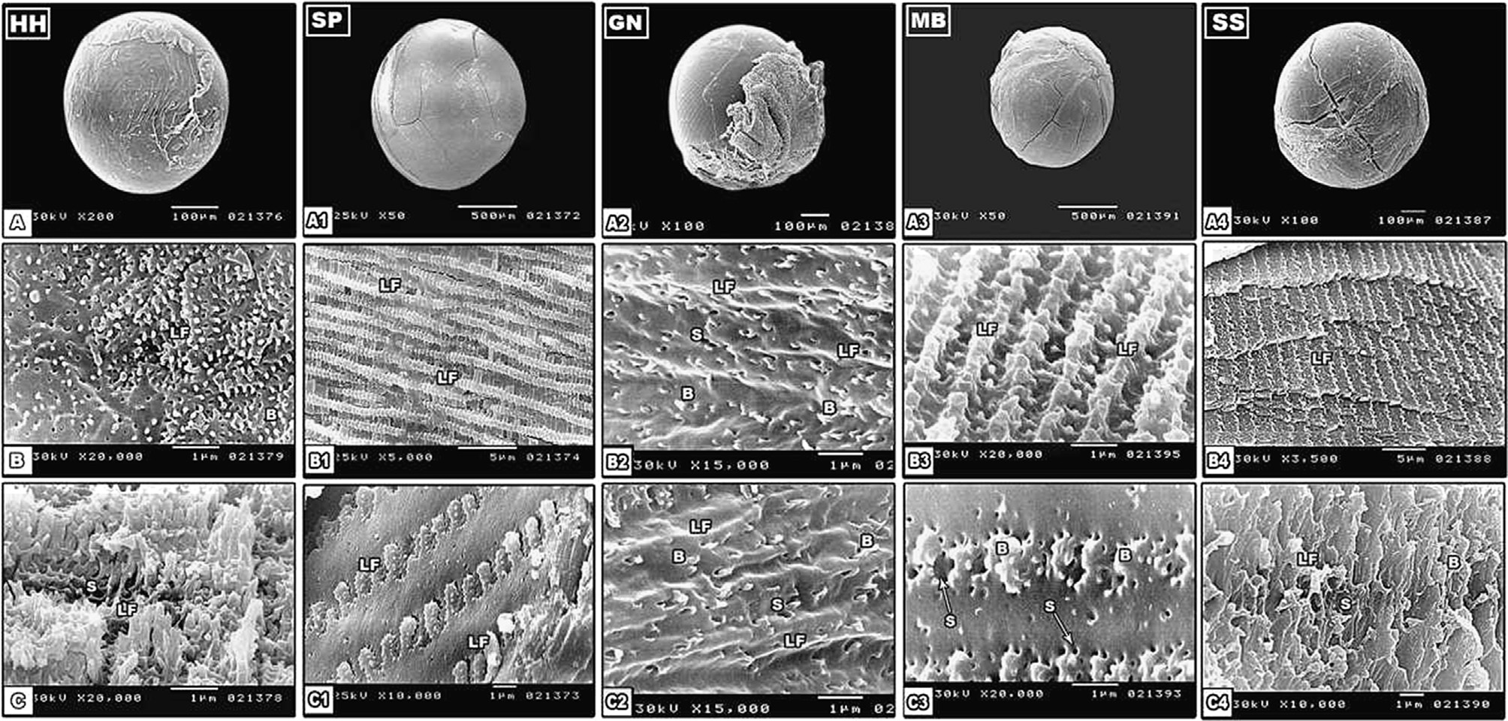

Fig. 1 e Scanning electron micrographs of lens of marine teleost fishes *Hippocampus hippocampus* (AeC), *Sardina pilchardus*

(A1eC1), *Gobius niger* (A2eC2), *Mullus barbatus* (A3eB3) and *Solea solea* (A4eC4).

arrangement of ganglion cells, being more abundant in *S. solea* species (Fig. 2).

### *Retina* & *lens SDS-SPAGE protein electrophoresis*

Examining protein electrophoresis in lens and retina revealed that the examining fishes exhibited similar band expression at 200, 172 and 116 kD. A striking feature of double band expression in retina of *M. barbatus* at equal to 140 kD. At 97.4, 45 and 21 kD, both lens and retina of the studied fishes varied markedly (Fig. 3).

### *Lens and retina isoenzyme electrophoresis*

Concerning lens, Acid phosphatase isoenzymes electropho- resis showed similarities between *S. pilchardus* and *G. niger* and is quite different from the *H. hippocampus*, *M. barbatus barbatus* and *S. solea* which are quiet similar. Malate dehydrogenase isoenzymes showed almost similar rate of flow in the teleost fishes *H. hippocampus*, *S. pilchardus*, *G. niger* and *M. barbatus barbatus*, however, *S. solea* exhibited variant expression of the isoenzyme fractions. In glucose-6-phosphate dehydrogenase,

four isoenzymes are expressed in *G. niger* and *M. barbatus barbatus*. Their rate of flow is almost closely similar. However

*H. hippocampus* and *S. pilchardus* expressed three isoenzymes. In the studied fishes, the percentages of band intensities of the estimated isoenzymes are quite different between each others (Fig. 4).

In retina, acid phosphatase expressed three isoenzyme fractions in the investigated fishes. The isoenzymes I and II are closely similar, however isoenzyme III showed variant degrees of mobility. Concerning glucose 6-phosphate dehy- drogenase showed variants expression of the isoenzymes expression. *H. hippocampus*, *S. pilchardus* and *S. solea* expressed three isoenzymes with almost similar pattern of the iso- enzymes 1 & 11. However isoenzyme 111 varying in its degree of mobility. On the other hand, *G. niger* and *M. barbatus* expressed four isoenzymes which are different of their flow rate. Malate dehydrogenase expressed four isoenzymes. *H. hippocampus*, *S. pilchardus* and *G. niger* showed almost similar isoenzymes expression 1 & 11, meanwhile isoenzyme 111 differed in flow rate. However, *M. barbatus* expressed five isoenzymes and *S. solea* expressed four isoenzymes but of variant intensities and flow rate (Fig. 4).

|  |  |  |  |  |  |  |  |  |  |  |  |  |
| --- | --- | --- | --- | --- | --- | --- | --- | --- | --- | --- | --- | --- |
| Table 1 e Retinal thickness of selected marine fishes. | | | | | | | | | | | | |
|  | WR | PE | PL | ONL | OPL | INL | IPL | GL |  | NFL/IPL | % | ONL/INL |
| *Hippocampus hippocampus* | 176.1 ± 12. 2  181.7 ± 13.9*  242.8 ± 11.1**  219.3 ± 6.1**  252.2 ± 13.6** | 28.1 ± 0.6  45.9 ± 1.5  46.4 ± 1.5  58.1 ± 1.8  65.6 ± 3.8 | 30.4 ± 1.7  35.5 ± 3.1  55.5 ± 4.1  37.1 ± 2.1  27.2 ± 2.8 | 41.7 ± 1.7  37.6 ± 2.2  33 ± 0.8  42.2 ± 1.3  66.1 ± 4.8 | 4.6 ± 0.7  7.6 ± 1.6  10 ± 0.8  4.5 ± 2.6  12.7 ± 0.8 | 33.8 ± 2.8  36.8 ± 2.3  42 ± 1.5  26.1 ± 2.8  32.2 ± 3.5 | 33.1 ± 4.4  6.5 ± 1.7  41.3 ± 3.8  40.6 ± 2.8  37.3 ± 5.4 | 4.4 ±  12.3 ±  14.6 ±  10.7 ±  11.2 ± | 0.8 | 13 | 1.2 | |
| *Sardina pilchardus* | 0.8 | 189 | 0.8 | |
| *Gobius niger* | 2.1 | 24 | 0.7 | |
| *Mullus barbatus* | 0.8 | 26 | 1.6 | |
| *Solea solea* | 1.3 | 30 | 2 | |
| Data are represented by the Mean ± SE (n ¼ 5). Comparing with *Hippocampus hippocampus*. *Means non-significant at P < 0.05. **Means significant. Abbreviations; WR, whole retina; PE, pigmented epithelium; PL, photoreceptor layer; ONL, outer nuclear layer; OPL, outer plexiform layer; INl, inner plexiform layer; INL, inner nuclear layer; Gl, ganglion layer; NFL, nerve fiber layer. | | | | | | | | | | | | |

[e g ypti an j o ur nal o f b a sic and a pp l i e d sci en c e s 2 ( 201 5 ) 1 5 9](http://dx.doi.org/10.1016/j.ejbas.2015.04.004) e[166](http://dx.doi.org/10.1016/j.ejbas.2015.04.004) 163

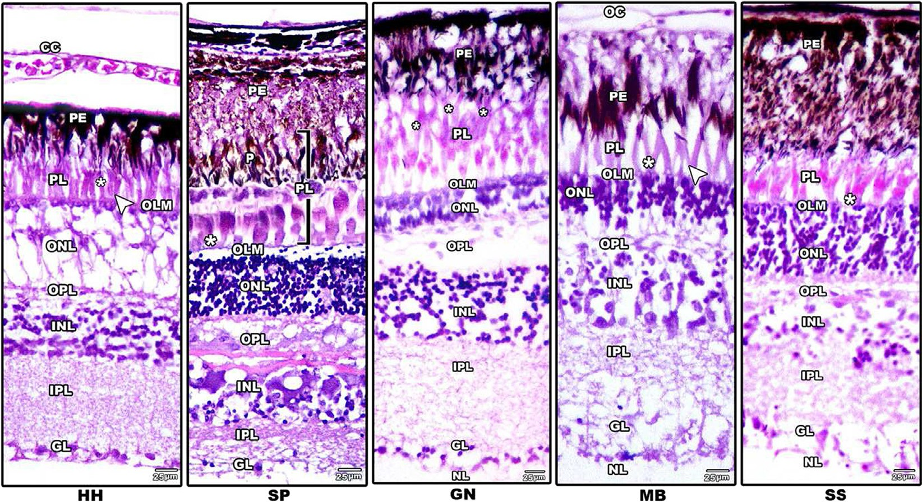

Fig. 2 e Photomicrographs of transverse histological sections of retina of marine teleost fishes *Hippocampus hippocampus* (HH), *Sardina pilchardus* (SP), *Gobius niger* (GN), *Mullus barbatus* (MB) and *Solea solea* (SS). Note variation of retinal layers between species. The photoreceptors of HH, MB & SS are mainly single and double rods, meanwhile SP is cones and GN of mixed rods and cones. HX-E.

# Discussion

Vision required functional integrity of retinal neural circuits of different cell types. The outer and the inner plexiform layers form synaptic relationships between photoreceptors and other bipolar and horizontal cells [29]. Teleost species may have different visual demands that arise from differences in the light environment and levels of inter- and intra-specific competition. Teleost fish eyes accommodate with the aquatic environment by a set of novel adaptations in the growth and development of the eye [30].

Our findings revealed varying retinal thickness in the studied teleost species. Comparing with the other studied

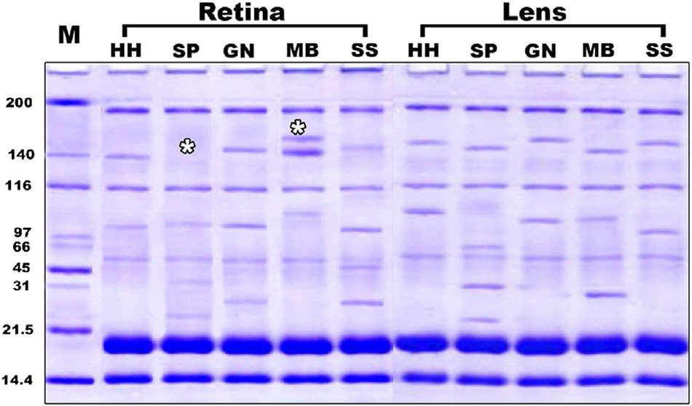

Fig. 3 e SDS-PAGE of protein electrophoresis of retina and lens of marine teleost fishes *Hippocampus hippocampus* (HH), *Sardina pilchardus* (SP), *Gobius niger* (GN), *Mullus barbatus* (MB) and *Solea solea* (SS). Note variants expression of protein expression between species at 31, 97 and

140 kD.

fishes, *S. solea* showed marked retinal thickness and their peculiar diameter of PE and ONL. The PE appeared enclosed with dense dark-brown melanosomes, being more intense in

*S. solea* more than other fishes. On the other hand, *H. hippo- campus* showed the least thickened ones. *H. hippocampus* and

*S. solea* showed the least thickness of inner plexiform and inner nuclear layer. The mentioned species as well as *M. barbatus* showed photoreceptor layer composed mainly of single, double and triple rods. The average ratio of ONL/INL increased in *H. hippocampus*, *M. barbatus* and *S. solea* suggested nocturnal habits which reflected the structural pattern of photoreceptors. At the same time their visual acuity calcu- lated by GL/INL revealed apparently decreased as a result of their dim vision.

Unlike *S. solea* and *M. barbatus* which are teleost fishes fa- voring the living at more deeping levels of sea water, *H. hip- pocampus* is detected in either coastal lagoons with strong oceanic influences [31], or found on soft bottoms amongst rocks and algae [32]. Besides, many authors reported that Hippocampus species feed actively at night (nocturnal) [33].

Furthermore, *S. pilchard* exhibited the presence of single and double cone photoreceptors comparing with mixing structure of both rods and cones in *G. niger*. According to Munz and McFarland [34] *S. pilchardus* and *G. niger* showed the least average of ONL/INL as well as apparently higher visual acuity in *S. pilchardus*.

The retinal pigment epithelium (RPE) and photoreceptors of fishes were found to exhibit retinomotor movements in response to diurnal changes in lighting conditions. In dark- ness, the pigment granules of the RPE migrate to the scleral base and cone photoreceptors elongate. In the light these movements are reversed; pigment granules disperse into the long apical projections of the RPE cell and cones contract [35].

164 [e gypti an j o ur nal o f b a sic and a p p l i ed sci e n c e s 2 ( 201 5 ) 1 5 9](http://dx.doi.org/10.1016/j.ejbas.2015.04.004) e[166](http://dx.doi.org/10.1016/j.ejbas.2015.04.004)

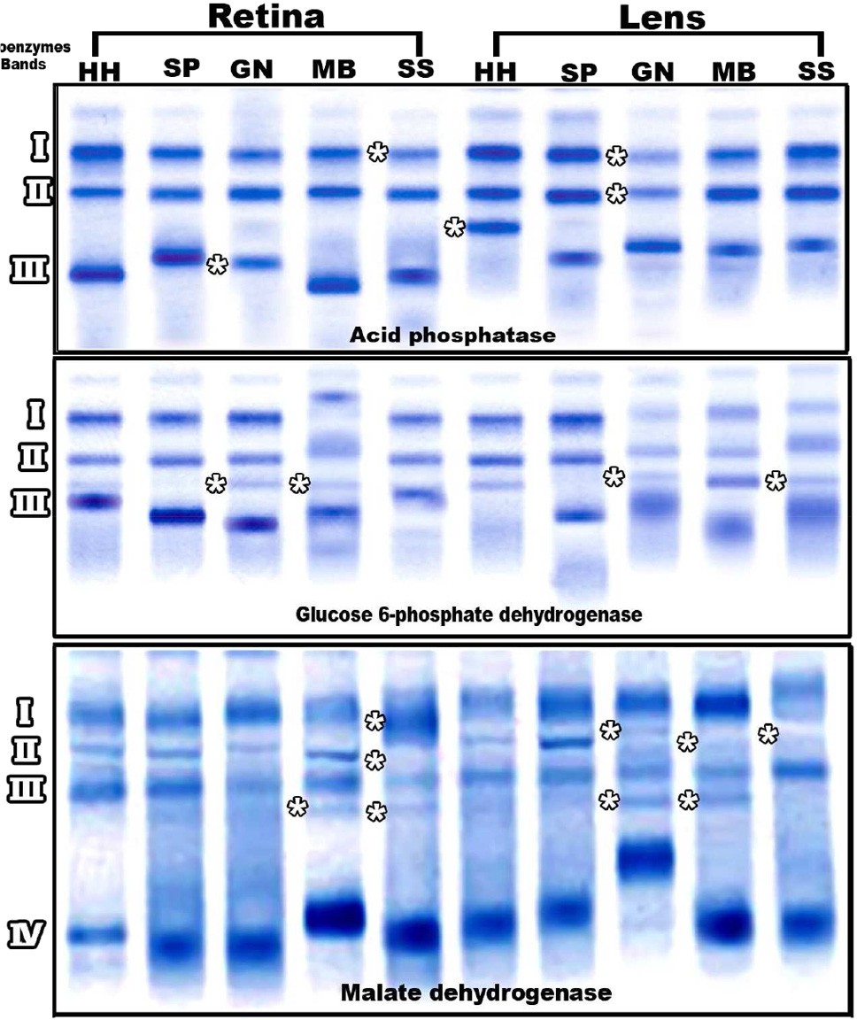

Fig. 4 e Acid phosphatase, glucose 6-phosphate dehydrogenase and malate dehydrogenase of marine teleost fishes *Hippocampus hippocampus* (HH), *Sardina pilchardus* (SP), *Gobius niger* (GN), *Mullus barbatus* (MB) and *Solea solea* (SS). Note variant expression of band densities. Concerning acid phosphatase, *Gobius* niger shows faint expression of isoenzyme I &II. Isoenzyme III shows variant mobility between species in retina and lens (*).

Extra expression of bands appear in retina of GN and MB as well as in lens of GN, MB and SS. Glucose-6-phosphatase and Malate dehydrogenase show extra expression of bands in retina of *Gobius niger* and *Mullus barbatus* as well as in lens of *Gobius niger* and *Mullus barbatus* and *Solea solea*.

polyunsaturated lipids that are degraded by RPE phospholi- pases [41] and acid lipases [42] releasing fatty acids that are recycled to photoreceptors for use in POS renewal [43]. Kunz and Ennis [44] also mentioned that the RPE showed active shedding of the tips of the light-sensitive photoreceptor outer segments and subsequent phagocytosis beside its reti- nomotor movements of pigment-epithelium in co-ordination with rods and cones.

Investigating 15 species of cardinal fish (Apogonidae), including both nocturnal and diurnal forms, revealed that the nocturnal forms possessed larger eye and retina compared with the other diurnal forms. The diurnal fishes have cones which form a mosaic structure of four double with central single one. The curvature of the retina reflects flattening of the images and neural mechanisms can correct for image distor- tions without loss of information [45].

Also, our findings revealed that there is a marked increase of thickness and density of the outer nuclear cells in *S. solea* comparing with the other selected teleost fishes. These may reflect the abundant increase of photoreceptors which re- flected bioactivation of the vision and consequently accumu- lated of lipid materials from the photoreceptors as a result of renewal their tips in the pigmented epithelium which become dense dark-brown.

Decreased GCL-IPL thickness (<fifth percentile) can discriminate between children with and without vision loss from their OPG. Ganglion cell layereinner plexiform layer thickness could be used as a surrogate marker of vision in children with OPGs [22].

Furthermore our findings revealed that the studied fishes showed marked variations of SDS-PAGE protein analysis in their lenses and retinae. This diversity reflects structural variations in the arrangement of lens fibers which categorized the studied teleost fishes in three categories according to their lens fibers distribution. Also, the fishes possessed structural variations of retinal structures and supported these findings. In addition, the observed increased intensities of acid phos- phatase isoenzymes in *S. solea*, *S. pilchardus* and *H. hippocam- pus* is correlated with increased intensities of melanosomes in

these investigated fishes comparing with less activities and

decreased melanosomes in *G. niger* and *M. barbatus*. Similar findings of detecting highest acid phosphatase activity among

The apparent increase thickened RPE of *S. solea* as well as presence of their densely grouping melanosomes widespread in between lysosomes. Abundance distribution of melano- somes facilitated digestion the apical tips of outer segment photoreceptors. Increased retinal pigmented epithelium was also reported in some deep fishes [36] and Moray eels [21]. Hyperpigmentation was also served to absorb stray light, minimizing light scattering and scavenging free radicals and toxins [37]. Melanosomes are also known to be lysosome- related organelles [38]. In fish and amphibians, the melano- somes of the PE exhibited a redistribution from the cell body into the apical processes upon the onset of light, which is reversed in the dark. Melanosomes in the PE of mammals are generally thought not to move with the light cycle [39]. Me- lanosomes was found to contain high incorporation of acid phosphatase [40].

The unique relationship between the photoreceptors and

the PE extends to the POS membranes which contains the

eye tissues were reported by Kigasawa et al. [46]. Couet and Blest [47] reported acid phosphatase levels in retinae of crabs allowed to experience lights-off at the normal time and in those of crabs held in continuous light over the same period follow identical courses. Melanosomes were found to show a positive in acid phosphatase reaction, indicating that mela- nosomes are commonly incorporated into the lysosomal system of the RPE. The observation of acid phosphatase ac- tivity within melanosomes indicates that they may continue to be synthesized at a low rate in retina of adult eyes [48]. The detecting lysosomes within PE which may contain an impressive array of nearly 40 hydrolytic enzymes that have been identified by a variety of biochemical and histochemical techniques [49].

Concerning glucose-6-phosphate dehydrogenase, the

teleost fishes showed varying intensities of their isoenzymes.

*H. hippocampus* and *S. pilchardus* showed similar rate of flow and expressed three isoenzymes varying from the other

[e g ypti an j o ur nal o f b a sic and a pp l i e d sci en c e s 2 ( 201 5 ) 1 5 9](http://dx.doi.org/10.1016/j.ejbas.2015.04.004) e[166](http://dx.doi.org/10.1016/j.ejbas.2015.04.004) 165

teleost fishes which expressed four isoenzymes. These may reflect the high energy demand for vision which required high G6PD isoenzymes activities.

Malate dehydrogenase isoenzymes showed marked varia- tions of the rate of flow and the percentages of band intensities of the isoenzymes between the studied teleost fishes. *H. hip- pocampus* expressed variant expression of the isoenzymes pattern from the other teleost fishes. Malate dehydrogenase (MDH), is an aerobic krebs cycle enzyme involved in the malate-aspartate mechanism. The enzyme distributed in retinal layers especially in the photoreceptor inner segments, containing a high density of mitochondria, and in the outer plexiform layer (OPL), containing photoreceptor terminals and bipolar and horizontal cell processes. It is involved in retinal energy metabolism and support neurosynaptic-transmission [50]. The enzyme is involved in gluconeogenesis, the synthe- sis of glucose from smaller molecules. In the cytosol, the ma- late is oxidized to oxaloacetate by cytosolic malate dehydrogenase and then to phosphoenolpyruvate [51]. Also, glucose-6-phosphate dehydrogenase is present in mitochon- drial matrix and their outer membrane. It may be used in glycolysis to produce energy in the form of adenosine triphosphate and reduced nicotinamide adenine dinucleotide (NADH) or by the pentose phosphate pathway. Glucose oxidation and synthesis of mitochondrial ATP is of its main target [52](#_bookmark55)e[54]. At the same time the presence of malate de- hydrogenase with it activity in catalyzing the NAD/NADH- dependent inter-conversion in the mitochondrial membrane, and mitochondrial matrix [51] (Mina´rik et al., 2002) gives ideal combination with glucose-6 phosphate dehydrogenase in biological activities of the photoreceptors. Glucose-6-phos- phate and malate dehydrogenase are important mitochondrial enzymes promoting the metabolic pathway of photoreceptors to accomodate vision in their aquatic environment especially at deep sea levels.

Finally the authors concluded that the retina and lens of the studied teleost fishes showed apparent varying structure reflecting the isoenzyme characteristic for preserving func- tional characteristic of vision according to the marine habitat depth.

# Funding

There are no funding sources to declare.

## referen c es

1. [Al-Adhami MA, Qar J, AlKhdour M. Ultrastructure of the](http://refhub.elsevier.com/S2314-808X(15)00023-8/sref1) [outer retina in the killifish, *Aphanius sirhani*](http://refhub.elsevier.com/S2314-808X(15)00023-8/sref1)[(Cyprinodontidae, Teleostei). An Biol 2010;32:39](http://refhub.elsevier.com/S2314-808X(15)00023-8/sref1)e[44](http://refhub.elsevier.com/S2314-808X(15)00023-8/sref1).
2. [Sattari A, Asli M, Mansoori FS, Kheirandish R, Yavari H.](http://refhub.elsevier.com/S2314-808X(15)00023-8/sref2) [Histological study of middle layer of rabbit fish eye (*Siganus*](http://refhub.elsevier.com/S2314-808X(15)00023-8/sref2)[*javus*). Asian Pac J Trop Biomed 2012:S1086](http://refhub.elsevier.com/S2314-808X(15)00023-8/sref2)e[9](http://refhub.elsevier.com/S2314-808X(15)00023-8/sref2).
3. [Begum A, Goswami UC, Dey S. Ultramicroscopic structure of](http://refhub.elsevier.com/S2314-808X(15)00023-8/sref3) [the lens of *Anabas testudineus* and its significance. Clarion](http://refhub.elsevier.com/S2314-808X(15)00023-8/sref3) [2013;2(1):52](http://refhub.elsevier.com/S2314-808X(15)00023-8/sref3)e[5](http://refhub.elsevier.com/S2314-808X(15)00023-8/sref3).
4. [Bone Q, Moore RH. Biology of fishes. 3rd ed. Abingdon, U.K.:](http://refhub.elsevier.com/S2314-808X(15)00023-8/sref4) [Taylor](http://refhub.elsevier.com/S2314-808X(15)00023-8/sref4) & [Francis; 2008. p. 310](http://refhub.elsevier.com/S2314-808X(15)00023-8/sref4)e[26. 409](http://refhub.elsevier.com/S2314-808X(15)00023-8/sref4)e[436](http://refhub.elsevier.com/S2314-808X(15)00023-8/sref4).
5. [Lythgoe JN. The ecology of vision. Oxford: Clarendon Press;](http://refhub.elsevier.com/S2314-808X(15)00023-8/sref5) [1979](http://refhub.elsevier.com/S2314-808X(15)00023-8/sref5).
6. [Schartau JM, Sjogreen B, Gagnon YL, Kroger RHH. Optical](http://refhub.elsevier.com/S2314-808X(15)00023-8/sref6) [plasticity in the crystalline lenses of the cichlid fish *Aequidens*](http://refhub.elsevier.com/S2314-808X(15)00023-8/sref6)[*pulcher*. Curr Biol 2009;19:122](http://refhub.elsevier.com/S2314-808X(15)00023-8/sref6)e[6](http://refhub.elsevier.com/S2314-808X(15)00023-8/sref6).
7. [Frohlich E, Wagner HJ. Rod outer segment renewal in the](http://refhub.elsevier.com/S2314-808X(15)00023-8/sref7) [retinae of deep-sea fish. Vis Res 1996;36(19):3183](http://refhub.elsevier.com/S2314-808X(15)00023-8/sref7)e[94](http://refhub.elsevier.com/S2314-808X(15)00023-8/sref7).
8. [He BM. Triple cones in the retinae of three anchovy species:](http://refhub.elsevier.com/S2314-808X(15)00023-8/sref8) [*Engraulis encrasicolus*, *Cetengraulis mysticetus* and *Anchovia*](http://refhub.elsevier.com/S2314-808X(15)00023-8/sref8)[*macrolepidota* (Engraulididae, Teleostei). Vis Res](http://refhub.elsevier.com/S2314-808X(15)00023-8/sref8) [2009;49:1569](http://refhub.elsevier.com/S2314-808X(15)00023-8/sref8)e[82](http://refhub.elsevier.com/S2314-808X(15)00023-8/sref8).
9. [Malkki PE, Kroger RHH. Visualization of chromatic correction](http://refhub.elsevier.com/S2314-808X(15)00023-8/sref9) [of fish lenses by multiple focal lengths. J Opt A Pure Appl Opt](http://refhub.elsevier.com/S2314-808X(15)00023-8/sref9) [2005;7:691](http://refhub.elsevier.com/S2314-808X(15)00023-8/sref9)e[700](http://refhub.elsevier.com/S2314-808X(15)00023-8/sref9).
10. [Kirsch M, Wagner HJ, Douglas RH. Rods trigger light adaptive](http://refhub.elsevier.com/S2314-808X(15)00023-8/sref10) [retinomotor movements in all spectral cone types of a](http://refhub.elsevier.com/S2314-808X(15)00023-8/sref10) [teleost fish. Vis Res 1989;29(4):389](http://refhub.elsevier.com/S2314-808X(15)00023-8/sref10)e[96](http://refhub.elsevier.com/S2314-808X(15)00023-8/sref10).
11. [Donatti L, Fanta E. Retinomotor movements in the Antarctic fish](http://refhub.elsevier.com/S2314-808X(15)00023-8/sref11) [*Trematomus newnesi* Boulenger submitted to different](http://refhub.elsevier.com/S2314-808X(15)00023-8/sref11) [environmental lightconditions. RevBras Zool 2007;24(2). SciELO](http://refhub.elsevier.com/S2314-808X(15)00023-8/sref11).
12. [Karpestam B, Gustafsson J, Shashar N, Katzir G, Kr](http://refhub.elsevier.com/S2314-808X(15)00023-8/sref12)o€[ger RHH.](http://refhub.elsevier.com/S2314-808X(15)00023-8/sref12) [Multifocal lenses in coral reef fishes. J Exp Biol](http://refhub.elsevier.com/S2314-808X(15)00023-8/sref12) [2007;210:2923](http://refhub.elsevier.com/S2314-808X(15)00023-8/sref12)e[31](http://refhub.elsevier.com/S2314-808X(15)00023-8/sref12).
13. [Douglas RH, Partridge JC, Marshall NJ. The eyes of deep-sea](http://refhub.elsevier.com/S2314-808X(15)00023-8/sref13) [fish: lens pigmentation, tapeta and visual pigments. Prog Ret](http://refhub.elsevier.com/S2314-808X(15)00023-8/sref13) [Eye Res 1998;17(4):597](http://refhub.elsevier.com/S2314-808X(15)00023-8/sref13)e[636](http://refhub.elsevier.com/S2314-808X(15)00023-8/sref13).
14. [Pierscionek B, Augusteyn R. Refractive index and protein](http://refhub.elsevier.com/S2314-808X(15)00023-8/sref14) [distributions in the blue eye trevally lens. J Am Optom Assoc](http://refhub.elsevier.com/S2314-808X(15)00023-8/sref14) [1995;66:739](http://refhub.elsevier.com/S2314-808X(15)00023-8/sref14)e[43](http://refhub.elsevier.com/S2314-808X(15)00023-8/sref14).
15. [Ahmad R, Pandey RB, Arif SH, Nabi N, Jabeen M, Hasnain A.](http://refhub.elsevier.com/S2314-808X(15)00023-8/sref15) [Polymorphic b and g lens crystallins demonstrate latitudinal](http://refhub.elsevier.com/S2314-808X(15)00023-8/sref15) [distribution of threatened walking catfish *Clarias batrachus*](http://refhub.elsevier.com/S2314-808X(15)00023-8/sref15)[(Linn.) Populations in North-western India. J Biol Sci](http://refhub.elsevier.com/S2314-808X(15)00023-8/sref15) [2012;12:98](http://refhub.elsevier.com/S2314-808X(15)00023-8/sref15)e[104](http://refhub.elsevier.com/S2314-808X(15)00023-8/sref15).
16. [Garrick-maidment N, Trewhella S, Hatcher J, Collins KJ,](http://refhub.elsevier.com/S2314-808X(15)00023-8/sref16) [Mallinson JJ. Seahorse tagging project, Etudland Bay, Dorset,](http://refhub.elsevier.com/S2314-808X(15)00023-8/sref16) [UK. Mar Biodivers Rec 2010;3(e73):1](http://refhub.elsevier.com/S2314-808X(15)00023-8/sref16)e[4](http://refhub.elsevier.com/S2314-808X(15)00023-8/sref16).
17. [Brito A. Catalogo de los pesces de las Islas Canarias. la](http://refhub.elsevier.com/S2314-808X(15)00023-8/sref17) [Laguna: Francisco Lemus; 1991. p. 230](http://refhub.elsevier.com/S2314-808X(15)00023-8/sref17).
18. [Miller PJ. Gobiidae. In: Whitehead, et al., editors. Fishes of the](http://refhub.elsevier.com/S2314-808X(15)00023-8/sref18) [Northern-eastern Atlantic and the Mediterranean. Paris:](http://refhub.elsevier.com/S2314-808X(15)00023-8/sref18) [UNESCO; 1986. p. 1019](http://refhub.elsevier.com/S2314-808X(15)00023-8/sref18)e[85](http://refhub.elsevier.com/S2314-808X(15)00023-8/sref18).
19. [Mytilineou C, Politou CY, Papaconstantinou C, Kavadas S,](http://refhub.elsevier.com/S2314-808X(15)00023-8/sref19) [Donghia G, Sion L. Deep](http://refhub.elsevier.com/S2314-808X(15)00023-8/sref19)e[water fish fauna in the Eastern](http://refhub.elsevier.com/S2314-808X(15)00023-8/sref19) [Ionian Sea. Belg J Zool 2005;135(2):229](http://refhub.elsevier.com/S2314-808X(15)00023-8/sref19)e[33](http://refhub.elsevier.com/S2314-808X(15)00023-8/sref19).
20. [Muus BJ, Nielsen JG. Sea fish. Scandinavian fishing year book.](http://refhub.elsevier.com/S2314-808X(15)00023-8/sref20) [Denmark: Hedehusene; 1999. p. 340](http://refhub.elsevier.com/S2314-808X(15)00023-8/sref20).
21. [Wang FY, Tang MY, Yan HY. A comparative study on the](http://refhub.elsevier.com/S2314-808X(15)00023-8/sref21) [visual adaptations of four species of moray eel. Vis Res](http://refhub.elsevier.com/S2314-808X(15)00023-8/sref21) [2011;51:1099](http://refhub.elsevier.com/S2314-808X(15)00023-8/sref21)e[108](http://refhub.elsevier.com/S2314-808X(15)00023-8/sref21).
22. [Gu S, Glaug N, Cnaan A, Packer RJ, Avery RA. Ganglion cell](http://refhub.elsevier.com/S2314-808X(15)00023-8/sref22) [layer](http://refhub.elsevier.com/S2314-808X(15)00023-8/sref22)e[inner plexiform layer thickness and vision loss in](http://refhub.elsevier.com/S2314-808X(15)00023-8/sref22) [young children with optic pathway gliomas. Investig](http://refhub.elsevier.com/S2314-808X(15)00023-8/sref22) [Ophthalmol Vis Sci 2014;55(3):1402](http://refhub.elsevier.com/S2314-808X(15)00023-8/sref22)e[8](http://refhub.elsevier.com/S2314-808X(15)00023-8/sref22).
23. [Lowry OH, Rosebrough NJ, Farr AL, Randall RJ. Protein](http://refhub.elsevier.com/S2314-808X(15)00023-8/sref23) [measurement with the Folin phenol reagent. J Biol Chem](http://refhub.elsevier.com/S2314-808X(15)00023-8/sref23) [1951;193:265](http://refhub.elsevier.com/S2314-808X(15)00023-8/sref23)e[75](http://refhub.elsevier.com/S2314-808X(15)00023-8/sref23).
24. [Laemmli UK. Cleavage of structural proteins during the](http://refhub.elsevier.com/S2314-808X(15)00023-8/sref24) [assembly of the head of bacteriophage T4. Nature](http://refhub.elsevier.com/S2314-808X(15)00023-8/sref24) [1970;227:680](http://refhub.elsevier.com/S2314-808X(15)00023-8/sref24)e[5](http://refhub.elsevier.com/S2314-808X(15)00023-8/sref24).
25. [Andrews AT. Electrophoresis: theory, techniques, and](http://refhub.elsevier.com/S2314-808X(15)00023-8/sref25) [biochemical and clinical applications. 2nd ed. Oxford: Oxford](http://refhub.elsevier.com/S2314-808X(15)00023-8/sref25) [University Press; 1986](http://refhub.elsevier.com/S2314-808X(15)00023-8/sref25).
26. [Franz](http://refhub.elsevier.com/S2314-808X(15)00023-8/sref26)e´[n A, Hasselgren G. Electrophoretic separation of](http://refhub.elsevier.com/S2314-808X(15)00023-8/sref26)

[alkaline and acid phosphatase isoenzymes from the pulp of](http://refhub.elsevier.com/S2314-808X(15)00023-8/sref26) [monkey teeth. Acta Odontol Scand 1978;36(6):371](http://refhub.elsevier.com/S2314-808X(15)00023-8/sref26)e[5](http://refhub.elsevier.com/S2314-808X(15)00023-8/sref26).

166 [e gypti an j o ur nal o f b a sic and a p p l i ed sci e n c e s 2 ( 201 5 ) 1 5 9](http://dx.doi.org/10.1016/j.ejbas.2015.04.004) e[166](http://dx.doi.org/10.1016/j.ejbas.2015.04.004)

1. [Atzpodienj W, Gancedow M, Duntze W, Holzer H.](http://refhub.elsevier.com/S2314-808X(15)00023-8/sref27) [Isoenzymes of malate dehydrogenase in *Saccharomyces*](http://refhub.elsevier.com/S2314-808X(15)00023-8/sref27)[*cerevisiae*. Eur J Biochem 1968;7:58](http://refhub.elsevier.com/S2314-808X(15)00023-8/sref27)e[62](http://refhub.elsevier.com/S2314-808X(15)00023-8/sref27).
2. [Nie CX, Tong ST, Chen DX. Determination of glucose-6-](http://refhub.elsevier.com/S2314-808X(15)00023-8/sref28) [phosphate dehydrogenase isoenzymes of human](http://refhub.elsevier.com/S2314-808X(15)00023-8/sref28) [erythrocytes by a thin-layer PAG-IEF procedure. J Biochem](http://refhub.elsevier.com/S2314-808X(15)00023-8/sref28) [Biophys Methods 1989;19(4):309](http://refhub.elsevier.com/S2314-808X(15)00023-8/sref28)e[18](http://refhub.elsevier.com/S2314-808X(15)00023-8/sref28).
3. [Fuerst PG, Bruce F, Tian M, Wei W, Elstrott J, Feller MB, et al.](http://refhub.elsevier.com/S2314-808X(15)00023-8/sref29) [DSCAM and DSCAML1 function in self-avoidance in multiple](http://refhub.elsevier.com/S2314-808X(15)00023-8/sref29) [cell types in the developing mouse retina. Neuron](http://refhub.elsevier.com/S2314-808X(15)00023-8/sref29) [2009;64:484](http://refhub.elsevier.com/S2314-808X(15)00023-8/sref29)e[97](http://refhub.elsevier.com/S2314-808X(15)00023-8/sref29).
4. [Fernald RD. Teleost vision: seeing while growing. J Exp Zool](http://refhub.elsevier.com/S2314-808X(15)00023-8/sref30) [Suppl 1990;5:167](http://refhub.elsevier.com/S2314-808X(15)00023-8/sref30)e[80](http://refhub.elsevier.com/S2314-808X(15)00023-8/sref30).
5. [Foster SJ, Vincent ACJ. Life history and ecology of seahorses:](http://refhub.elsevier.com/S2314-808X(15)00023-8/sref31) [implications for conservation and management. J Fish Biol](http://refhub.elsevier.com/S2314-808X(15)00023-8/sref31) [2004;2004(65):1](http://refhub.elsevier.com/S2314-808X(15)00023-8/sref31)e[61](http://refhub.elsevier.com/S2314-808X(15)00023-8/sref31).
6. [Dawson CE. Syngnathidae. In: Whitehead PJP, Bauchot M-L,](http://refhub.elsevier.com/S2314-808X(15)00023-8/sref32) [Hureau J-C, Nielsen J, Tortonese E, editors. Fishes of the](http://refhub.elsevier.com/S2314-808X(15)00023-8/sref32) [North-eastern Atlantic and the Mediterranean, vol. 2. Paris:](http://refhub.elsevier.com/S2314-808X(15)00023-8/sref32) [UNESCO; 1986. p. 628](http://refhub.elsevier.com/S2314-808X(15)00023-8/sref32)e[39](http://refhub.elsevier.com/S2314-808X(15)00023-8/sref32).
7. [Hoang DH, Sy TS, Hoa HT. Feeding behaviour and food of](http://refhub.elsevier.com/S2314-808X(15)00023-8/sref33) [seahorses in Vietnam. Mar Biol South China 1998:458](http://refhub.elsevier.com/S2314-808X(15)00023-8/sref33)e[64](http://refhub.elsevier.com/S2314-808X(15)00023-8/sref33).
8. [Munz FW, McFarland WN. The significance of spectral](http://refhub.elsevier.com/S2314-808X(15)00023-8/sref34) [position in the rhodopsins of tropical marine fishes. Vis Res](http://refhub.elsevier.com/S2314-808X(15)00023-8/sref34) [1973;13(10):1829](http://refhub.elsevier.com/S2314-808X(15)00023-8/sref34)e[74](http://refhub.elsevier.com/S2314-808X(15)00023-8/sref34).
9. [Burnside B, Basingert S. Retinomotor pigment migration in](http://refhub.elsevier.com/S2314-808X(15)00023-8/sref35) [the teleost retinal pigment epithelium. 11. Cyclic-3](http://refhub.elsevier.com/S2314-808X(15)00023-8/sref35)0[, 5](http://refhub.elsevier.com/S2314-808X(15)00023-8/sref35)0[-](http://refhub.elsevier.com/S2314-808X(15)00023-8/sref35) [adenosine monophosphate induction of dark-adaptive](http://refhub.elsevier.com/S2314-808X(15)00023-8/sref35) [movement in vitro. Invest Ophthalmol Vis Sci 1983;24:16](http://refhub.elsevier.com/S2314-808X(15)00023-8/sref35)e[23](http://refhub.elsevier.com/S2314-808X(15)00023-8/sref35).
10. [Munk O. Ocular degeneration in some deep-sea fishes.](http://refhub.elsevier.com/S2314-808X(15)00023-8/sref36) [Galathea-Reprod 1965;8:21](http://refhub.elsevier.com/S2314-808X(15)00023-8/sref36)e[31](http://refhub.elsevier.com/S2314-808X(15)00023-8/sref36).
11. [Futter CE, Ramalho JS, Jaissle GB, Seeliger MW, Miguel C,](http://refhub.elsevier.com/S2314-808X(15)00023-8/sref37) [Seabra MC. The role of Rab27a in the regulation of](http://refhub.elsevier.com/S2314-808X(15)00023-8/sref37) [melanosome distribution within retinal pigment epithelial](http://refhub.elsevier.com/S2314-808X(15)00023-8/sref37) [cells. Mol Biol Cell 2004;15:2264](http://refhub.elsevier.com/S2314-808X(15)00023-8/sref37)e[75](http://refhub.elsevier.com/S2314-808X(15)00023-8/sref37).
12. [Raposo G, Marks MS. Melanosomes](http://refhub.elsevier.com/S2314-808X(15)00023-8/sref38) e [dark organelles](http://refhub.elsevier.com/S2314-808X(15)00023-8/sref38) [enlighten endosomal membrane transport. Nat Rev Mol Cell](http://refhub.elsevier.com/S2314-808X(15)00023-8/sref38) [Biol 2007;8(10):786](http://refhub.elsevier.com/S2314-808X(15)00023-8/sref38)e[97](http://refhub.elsevier.com/S2314-808X(15)00023-8/sref38).
13. [Burnside B, Laties AM. Pigment movement and cellular](http://refhub.elsevier.com/S2314-808X(15)00023-8/sref39) [contractility in the retinal pigment epithelium. In: Zinn KM,](http://refhub.elsevier.com/S2314-808X(15)00023-8/sref39) [Marmor MF, editors. The retinal pigment epithelium.](http://refhub.elsevier.com/S2314-808X(15)00023-8/sref39) [Cambridge, MA: Harvard University Press; 1979. p. 175](http://refhub.elsevier.com/S2314-808X(15)00023-8/sref39)e[91](http://refhub.elsevier.com/S2314-808X(15)00023-8/sref39).
14. [Nakagawa H, Rhodes AR, Fitzpatrick TB, Hori Y. Acid](http://refhub.elsevier.com/S2314-808X(15)00023-8/sref40) [phosphatase in melanosome formation: a cytochemical](http://refhub.elsevier.com/S2314-808X(15)00023-8/sref40) [study in normal human melanocytes. J Invest Dermatol](http://refhub.elsevier.com/S2314-808X(15)00023-8/sref40) [1984;83:140](http://refhub.elsevier.com/S2314-808X(15)00023-8/sref40)e[4](http://refhub.elsevier.com/S2314-808X(15)00023-8/sref40).
15. [Zimmerman WF, Godchaux III W, Belkin M. The relative](http://refhub.elsevier.com/S2314-808X(15)00023-8/sref41) [proportions of lysosomal enzyme activities in bovine retinal](http://refhub.elsevier.com/S2314-808X(15)00023-8/sref41) [pigment epithelium. Exp Eye Res 1983;36:151](http://refhub.elsevier.com/S2314-808X(15)00023-8/sref41)e[8](http://refhub.elsevier.com/S2314-808X(15)00023-8/sref41).
16. [Hayasaka S, Hara S, Mizuno K, Aizu S. In vitro degradation of](http://refhub.elsevier.com/S2314-808X(15)00023-8/sref42) [rod outer segment lipid by acid lipase. Jpn J Ophthalmol](http://refhub.elsevier.com/S2314-808X(15)00023-8/sref42) [1977;21:342](http://refhub.elsevier.com/S2314-808X(15)00023-8/sref42)e[7](http://refhub.elsevier.com/S2314-808X(15)00023-8/sref42).
17. [Gordon WC, Bazan NG. Visualization of [3H]docasahexaenoic](http://refhub.elsevier.com/S2314-808X(15)00023-8/sref43) [acid trafficking through photoreceptors and retinal pigment](http://refhub.elsevier.com/S2314-808X(15)00023-8/sref43) [epithelium by electron microscopic autoradiography. Invest](http://refhub.elsevier.com/S2314-808X(15)00023-8/sref43) [Ophthalmol Vis Sci 1993;34:2402](http://refhub.elsevier.com/S2314-808X(15)00023-8/sref43)e[11](http://refhub.elsevier.com/S2314-808X(15)00023-8/sref43).
18. [Kunz YW, Ennis S. Ultrastructural diurnal changes of the](http://refhub.elsevier.com/S2314-808X(15)00023-8/sref44) [retinal photoreceptors in the embryo of a viviparous teleost](http://refhub.elsevier.com/S2314-808X(15)00023-8/sref44) [(*Poecilia reticulata* P.). Cell Differ 1983;13(2):115](http://refhub.elsevier.com/S2314-808X(15)00023-8/sref44)e[23](http://refhub.elsevier.com/S2314-808X(15)00023-8/sref44).
19. [Fishelson L, Ayalon G, Zverdling A, Holzman R. Comparative](http://refhub.elsevier.com/S2314-808X(15)00023-8/sref45) [morphology of the eye (with particular attention to the](http://refhub.elsevier.com/S2314-808X(15)00023-8/sref45) [retina) in various species of cardinal fish (Apogonidae,](http://refhub.elsevier.com/S2314-808X(15)00023-8/sref45) [Teleostei). Anat Rec A Discov Mol Cell Evol Biol 2004;277(2):](http://refhub.elsevier.com/S2314-808X(15)00023-8/sref45) [249](http://refhub.elsevier.com/S2314-808X(15)00023-8/sref45)e[61](http://refhub.elsevier.com/S2314-808X(15)00023-8/sref45).
20. [Kigasawa K, Kim IT, Choi JB. Melanosomes of retinal pigment](http://refhub.elsevier.com/S2314-808X(15)00023-8/sref46) [epithelium](http://refhub.elsevier.com/S2314-808X(15)00023-8/sref46) e [distribution, shape, and acid phosphatase](http://refhub.elsevier.com/S2314-808X(15)00023-8/sref46) [activity. Korean J Ophthalmol 1998;12(2):85](http://refhub.elsevier.com/S2314-808X(15)00023-8/sref46)e[91](http://refhub.elsevier.com/S2314-808X(15)00023-8/sref46).
21. [Couet HG, Blest AD. The retinal acid phosphatase of a crab,](http://refhub.elsevier.com/S2314-808X(15)00023-8/sref47) [*Leptograpsus*: characterisation, and relation to the cyclical](http://refhub.elsevier.com/S2314-808X(15)00023-8/sref47) [turnover of photoreceptor membrane. J Comp Physiol](http://refhub.elsevier.com/S2314-808X(15)00023-8/sref47) [1982;149(3):353](http://refhub.elsevier.com/S2314-808X(15)00023-8/sref47)e[62](http://refhub.elsevier.com/S2314-808X(15)00023-8/sref47).
22. [Kim IT, Choi JB. Melanosomes of retinal pigment epithelium](http://refhub.elsevier.com/S2314-808X(15)00023-8/sref48) e [distribution, shape, and acid phosphatase activity. Korean](http://refhub.elsevier.com/S2314-808X(15)00023-8/sref48) [J Ophthalmol 1998;12(2):85](http://refhub.elsevier.com/S2314-808X(15)00023-8/sref48)e[91](http://refhub.elsevier.com/S2314-808X(15)00023-8/sref48).
23. [Boulton ME, Docchio F, Dayhaw-Barker P, Ramponi R,](http://refhub.elsevier.com/S2314-808X(15)00023-8/sref49) [Cubeddu R. Age related changes in the morphology,](http://refhub.elsevier.com/S2314-808X(15)00023-8/sref49) [absorption and fluorescence of melanosomes and lipofuscin](http://refhub.elsevier.com/S2314-808X(15)00023-8/sref49) [granules of the retinal pigment epithelium. Vis Res](http://refhub.elsevier.com/S2314-808X(15)00023-8/sref49) [1990;30:1291](http://refhub.elsevier.com/S2314-808X(15)00023-8/sref49)e[303](http://refhub.elsevier.com/S2314-808X(15)00023-8/sref49).
24. [Ross CD, Godfrey DA. Distributions of aspartate](http://refhub.elsevier.com/S2314-808X(15)00023-8/sref50) [aminotransferase and malate dehydrogenase activities](http://refhub.elsevier.com/S2314-808X(15)00023-8/sref50) [in rat retinal layers. J Histochem Cytochem 1985;33(7):](http://refhub.elsevier.com/S2314-808X(15)00023-8/sref50) [624](http://refhub.elsevier.com/S2314-808X(15)00023-8/sref50)e[30](http://refhub.elsevier.com/S2314-808X(15)00023-8/sref50).
25. [Min](http://refhub.elsevier.com/S2314-808X(15)00023-8/sref51)a´[rik P, Tom](http://refhub.elsevier.com/S2314-808X(15)00023-8/sref51)a´[skov](http://refhub.elsevier.com/S2314-808X(15)00023-8/sref51)a´ [N, Koll](http://refhub.elsevier.com/S2314-808X(15)00023-8/sref51)a´[rov](http://refhub.elsevier.com/S2314-808X(15)00023-8/sref51)a´ [M, Antal´ık M. Malate](http://refhub.elsevier.com/S2314-808X(15)00023-8/sref51) [dehydrogenases](http://refhub.elsevier.com/S2314-808X(15)00023-8/sref51)d[structure and function. Gen Physiol](http://refhub.elsevier.com/S2314-808X(15)00023-8/sref51) [Biophys 2002;21(3):257](http://refhub.elsevier.com/S2314-808X(15)00023-8/sref51)e[65](http://refhub.elsevier.com/S2314-808X(15)00023-8/sref51).
26. [Campbell WH, Bernofsky C. Mitochondrial glucose-6-](http://refhub.elsevier.com/S2314-808X(15)00023-8/sref52) [phosphate dehydrogenase from *Saccharomyces cerevisiae*. Mol](http://refhub.elsevier.com/S2314-808X(15)00023-8/sref52) [Cell Biochem 1979;25(1):33](http://refhub.elsevier.com/S2314-808X(15)00023-8/sref52)e[42](http://refhub.elsevier.com/S2314-808X(15)00023-8/sref52).
27. [Mailloux RJ, Harper ME. Glucose regulates enzymatic sources](http://refhub.elsevier.com/S2314-808X(15)00023-8/sref53) [of mitochondrial NADPH in skeletal muscle cells; a novel role](http://refhub.elsevier.com/S2314-808X(15)00023-8/sref53) [for glucose-6-phosphate dehydrogenase. FASEB J](http://refhub.elsevier.com/S2314-808X(15)00023-8/sref53) [2010;24(7):2495](http://refhub.elsevier.com/S2314-808X(15)00023-8/sref53)e[506](http://refhub.elsevier.com/S2314-808X(15)00023-8/sref53).
28. [Hsieh YT, Lin MH, Ho HY, Chen LC, Chen CC, Shu JC.](http://refhub.elsevier.com/S2314-808X(15)00023-8/sref54) [Glucose-6-phosphate dehydrogenase (G6PD)-deficient](http://refhub.elsevier.com/S2314-808X(15)00023-8/sref54) [epithelial cells are less tolerant to infection by *Staphylococcus*](http://refhub.elsevier.com/S2314-808X(15)00023-8/sref54)[*aureus*. PLoS One 2013:e79566](http://refhub.elsevier.com/S2314-808X(15)00023-8/sref54).