HOSTE D BY

Available online at [www.sciencedirect.com](http://www.sciencedirect.com/science/journal/2314808X)

**ScienceDirect**

journal homepage: [http://ees.elsevier.com/ejbas/default.asp](http://http//ees.elsevier.com/ejbas/default.asp)

egyptian journal of basic and applied sciences 3 (2016) 314–321



**Full Length Article**

**Temperature dependent current–voltage and photovoltaic properties of chemically prepared (p)Si/(n)Bi2S3 heterojunction**



***Amir Hussain*** ***\****

*Department of Physics, Gauhati University, Guwahati, Assam 781014, India*

A R T I C L E I N F O A B S T R A C T

*Article history:*

Received 4 October 2015 Received in revised form 18 June 2016

Accepted 21 June 2016

Available online 1 July 2016

*Keywords:* Nanocrystalline Heterojunction Silicon

Series resistance Photovoltaic

Ni-doped nanocrystalline Bi2S3 thin film is deposited on boron doped single crystal (p)-Si substrate by chemical bath deposition to form (p)Si/(n)Bi2S3 heterojunction structure. The electrical characterization of the (p)Si/(n)Bi2S3 heterojunction is carried out in the tempera- ture range of 300 K–340 K and capacitance–voltage characteristics is measured at a frequency of 1 KHz at 300 K. Various junction parameters are calculated from the I–V characteristics. The ideality factor is found to be greater than unity with high series resistance. The ideal- ity factor and series resistance decreases, whereas the saturation current density increases with increase in temperature. The J–V characteristics under illumination showed poor pho- tovoltaic effect of the junction. The existence of higher value of ideality factor and large number of interface states in (p)Si/(n) Bi2S3 heterojunction reduced the photovoltaic con- version efficiency.

© 2016 Mansoura University. Production and hosting by Elsevier B.V. This is an open access article under the CC BY-NC-ND license (<http://creativecommons.org/licenses/by->

nc-nd/4.0/).

# Introduction

Bismuth Sulphide is a member of V–VI semiconductor com- pounds whose band gap energy 1.7 eV lies in the visible range of the solar energy spectrum, which makes it very useful for solar energy conversion devices [1–3]. Bohr exciton radius of bulk Bi2S3 is 28.9 nm [4], which implies that significant quantum confinement effect can be observed at relatively large Bi2S3 nanoparticles. Bi2S3 is one of the earliest materials known to exhibit photoconducting properties [5]. Due to its significant thermoelectric effect, this material is important in view of its thermoelectric application as well [6]. It is widely used in

optoelectronics, photoelectrochemical devices, thermoelec- tric cooler, electrical switching, solar selective coatings, and decorative coatings [5,7]. Nanostructures of Bi2S3 have poten- tial applications in electrochemical hydrogen storage, hydrogen sensors, X-ray computed tomography imaging, biomolecule de- tection and photoresponsive materials [8].

Much research have been carried out on the preparation, characterization and applications of Bi2S3 thin films by em- ploying several deposition techniques such as chemical deposition [9–16], vacuum evaporation [17–20], cathodic elec- trodeposition [21], anodic electrodeposition [22], hot-wall method [23], solution gas interface [24], spray deposition [7,25–28], ul-

trasonic methods [29,30], microwave irradiation [31,32],

* *E-mail address:* [hussainmakak@gmail.com](mailto:hussainmakak@gmail.com). <http://dx.doi.org/10.1016/j.ejbas.2016.06.003>

2314-808X/© 2016 Mansoura University. Production and hosting by Elsevier B.V. This is an open access article under the CC BY-NC-ND license ([http://creativecommons.org/licenses/by-nc-nd/4.0/).](http://creativecommons.org/licenses/by-nc-nd/4.0/))

egyptian journal of basic and applied sciences 3 (2016) 314–321

**315**

hydrothermal synthesis [33–35], and solvothermal decompo- sition [36] etc.

There are limited literature pertaining to the preparation

efficiency of 1.6% for 860 nm PbS QDs and over 1% for 1300 nm PbS QDs.

and characterization of heterojunctions based on Bi2S3. Pineda

et al. [37] fabricated hybrid solar cells of the configuration ITO/ Bi2S3/P3OT/Au [(P3OT) is poly3-octylthiophene polymer]. They investigated the photovoltaic performance of the solar cell and reported that the cell using a Bi2S3 film of thickness 50 nm had the highest open-circuit voltage of 440 mV and short- circuit current density of 0.022 mA/cm2. Recently, Martinez et al.

[38] fabricated hybrid heterojunctions by using Bi2S3, NCs and P3HT poly (3-hexylthiophene) polymer with a power conver- sion efficiency of 1%. Becerra et al. [39] have analysed the feasibility of combining p-Si with an n-Bi2S3 thin film to form thin film solar cell using evaporated (n)Bi2S3 on (p)Si. They reported short-circuit current density of 3 mA/cm2, open- circuit voltage of 360 mV, and efficiency of 0.5%, which improved to 7.2 mA/cm2, 485 mV and 1.7%, respectively, after heating the cell in forming gas. Moreno-Garcia et al. [40] have fabri- cated (n)Bi2S3/(p)PbS solar cell by chemical CBD method. They carried out an extensive study to explore the relevance of each thin film component and suggested ways to improve the cell parameters. Their best (n)Bi2S3/(p)PbS solar cell junctions pro- duced open-circuit voltage of 280 mV and short-circuit current density of 6 mA/cm2 and energy conversion efficiency of 0.5%. The same research group [41] extended their work on (n)Bi2S3/ (p)PbS solar cells by introducing CdS and ZnS window layers in their solar cell structure and reported an improvement of the various junction parameters. Kachari et al. [42] reported the fabrication of Al/(p)Bi2S3 Schottky barrier junction by vacuum evaporation method. They have evaluated the various junc- tion parameters from the I–V characteristics of the junction. Further, they investigated the photovoltaic performance of the junction. Bao et al. [43] reported the formation of Schottky contact between Bi2S3 nanowires and gold (Au) electrode. The photo-switchable conductivity of individual Bi2S3 nanowires was studied, indicating possible applications in optoelec- tronic nano-devices. Bessekhouad et al. [44] prepared (n)Bi2S3/ (n)TiO2 heterojunctions by direct mixture of both constituents and by precipitation of the Bi2S3 with commercial TiO2 at dif- ferent concentrations. They have analysed (n)Bi2S3/(n)TiO2 junction by UV-Vis spectroscopy and established that the junc- tions were able to absorb the light up to 800 nm. Moreno- García et al. [45] fabricated CdS/(n)Bi2S3/(p)PbS solar cell and reported open-circuit voltage of 250 mV and short-circuit current density of 3.45 mA/cm2. Bi2S3 film was introduced basically to secure stability for the CdS/ PbS junction. Wang et al. [46] syn- thesized Bi2S3 nanorods and nanowires. Further they fabricated bulk hybrid heterojunction solar cells by blending the Bi2S3 nanorods or nanowires with MDMO-PPV polymer (poly [2- methoxy-5-(3′,7′-dimethyloctyloxy)-1,4-phenylenevinylene]).

Ladhe et al. [47] have chemically prepared (n)Bi2S3 and (p)CuSCN

layers to fabricate (n)Bi2S3/(p)CuSCN heterojunction on fluo- rine doped tin oxide (FTO) coated glass substrates. They successfully employed the heterojunction as a Liquefied Pe- troleum Gas (LPG) sensor at room temperature. Rath et al. [48] reported the first solution-processed heterojunction solar cells based on p-type PbS quantum dots and n-type Bi2S3 nanocrystals. In this solar cell nanostructured n-type Bi2S3 was used as electron acceptor. They reported a power conversion

# Preparation of (p)Si/(n)Bi2S3 heterojunction

The (p)Si/(n)Bi2S3 heterojunctions are prepared by depositing

1.5 wt% Ni-doped Bi2S3 thin films on boron doped p-type silicon wafer by chemical bath deposition technique. The silicon wafers use for the fabrication of the heterojunction structure is mirror

like p-type (100) orientation with resistivity 1–10 Ωcm and

350 ± 25 μm thickness. For the deposition of Ni-doped Bi2S3 film on silicon wafer, 5 ml of 0.5 M Bi(NO3)3 dissolved in 2 ml of Tri- ethanolamine (TEA) and 4 ml of 1 M CH3CS.NH2 are mixed

together and 1.wt% of Ni(NO3)3 as Ni3+ sources is added to the resultant solution. The resultant solution is stirred for 20 min

at room temperature to get uniform mixture solution. Finally, 39 ml of distilled water is added to the resultant solution to obtain a total volume of 50 ml. The silicon substrates are im- mersed vertically into the solution supported by the wall of the beaker and heated at 318 K for 20 min. The resultant so- lution changes from brown to dark brown colour, which indicates the initiation of Bi2S3 film formation. The solution is kept at room temperature for 2 h for further deposition. After deposition, the Si substrates coated with nanocrystalline Ni- doped Bi2S3 film are taken out and washed with distilled water and dried in open air. The films deposited on the polished surface of the Si substrates are removed with the help of dilute nitric acid and again washed with distilled water. Thickness of the Bi2S3 film deposited on the Si substrate is measured by Tolansky method as discussed in our earlier published paper [49]. The aluminium ‘Al’ electrodes are deposited onto the back surface of silicon wafers by vacuum evaporation for ohmic contact. The metal aluminium ‘Al’ electrodes, which acts as upper electrodes, are vacuum deposited on the Bi2S3 thin film through a suitable mask for ohmic contact to form the struc- ture Al/(p)Si/(n) Bi2S3/Al as shown in Fig. 1. Thus, nine heterojunctions each of equal area of 0.04 cm2 are obtained. Surface morphology of the film deposited on the Si substrate is studied using JEOL-JSM 6360 operating at 20 kV. Keithley

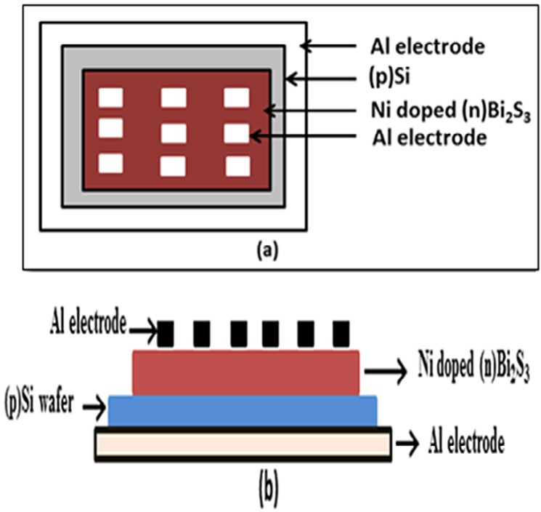

### Fig. 1 – Schematic diagram of Al/(p)Si/(n)Bi2S3/Al structure:

**(a) view from above, (b) lateral view.**

**316** egyptian journal of basic and applied sciences 3 (2016) 314–321

|  |  |  |  |
| --- | --- | --- | --- |
| **Table 1 – Details of a typical (p)Si/(n)Bi2S3 junction preparation.** | | | |
| Thickness of the (p)Si wafer (μm) | Thickness of (n)  Bi2S3 (nm) | Concentration (Na) 1016/cm3 | Concentration (Nd) 1016/cm3 |
| 350 ± 25 | 228 | 5.6 | 2.622 |

Electrometer (6514) and Rishabh multimeter (14S) are used for measuring I–V characteristics of the (p)Si/(n)Bi2S3 heterojunction and C–V characteristics by using Systronics LCR-Q meter (928). The film deposited on the Si substrate is found to be n-type as determined by the hot probe method. The temperature on the sample surface is measured by Instron (In-303) digital tem- perature controller using PT-100 sensor. For forward bias, the positive and negative terminals of the voltage source are con- nected to upper and lower ‘Al’ electrodes. The details of the

### Fig. 2 – SEM photographs of nanoparticles Bi2S3.

sample prepared are given in Table 1.

# Results and discussions

## *Reaction mechanism*

The deposition process of Bi2S3 film is based on the slow release of Bi3+ and S2− ions in the solution, which then condense ion by ion or cluster by cluster on the surface of the boron doped p-Si substrate. The concentration of Bi3+ and S2− ions in the so-

lution controls the rate of Bi2S3 formation. The rate of Bi3+ ions is controlled by TEA, which forms a complex Bi[(TEA)n]3+ with Bi3+. Ni-doped Bi2S3 films are prepared by adding 1.5 wt% of nickel nitrate Ni(NO3)2 to the following procedure and the re-

action mechanism are given as

cluster. Agglomeration of small crystallites in the film is also evident from the photograph. Such agglomeration makes it dif- ficult to evaluate the grain size from SEM image. It is also clear from this image that there is a common characteristic of the grains in their spherical shape.

## *Current–voltage characteristics of (p)Si/(n)Bi2S3* heterojunctions

The current–voltage characteristics of a typical (p)Si/(n)Bi2S3 junction in dark and under illumination (1100 Lux) are shown in Fig. 3. The junction is found to exhibit rectifying character- istics with small reverse current, indicating the existence of a barrier between the Si wafer and Bi2S3 film. The tempera- ture dependence of the current–voltage characteristics of the

*Bi* *NO*  .5*H O*  *TEA*  *Bi* *TEA*3  5*H O*  *NO*

(1)

prepared junction has been studied in the dark within

3 3 2

*Bi* *TEA*3  *Bi*3  *TEA*

2 3

(2)

temperature range from 300 K to 340 K. The temperature de- pendence of current–voltage characteristics for forward bias has been shown in Fig. 4. At higher bias voltage, the current

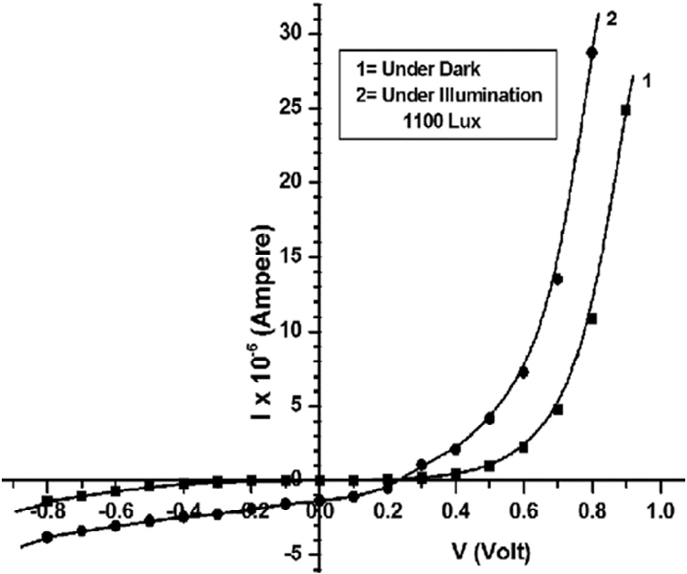*CH*3*CSNH*2  *OH*  *CH*3*CONH*2  *SH* (3)

*SH*  *OH*  *S*2  *H*2*O*

(4)

*Ni* *NO*3 2  *Ni*2  *NO* (5)

3

Then the overall chemical reaction is as follows

*Bi*3  *Ni*2  *S*2  *Bi*2*xNixS*3 (6)

## *Surface morphology studies*

The surface morphology of the Ni-doped Bi2S3 film deposited on the silicon substrate has been investigated by scanning elec- tron microscope (SEM) operating with an accelerating voltage 20 kV as shown in Fig. 2. It is seen that the surface is well covered without any void or pin hole with irregularly shaped grains of random size. These irregularly shaped grains of random size are interconnected with each other to form a

### Fig. 3 – I–V characteristics of a typical (p)Si/(n)Bi2S3 junction in the dark and under illumination.

egyptian journal of basic and applied sciences 3 (2016) 314–321

**317**

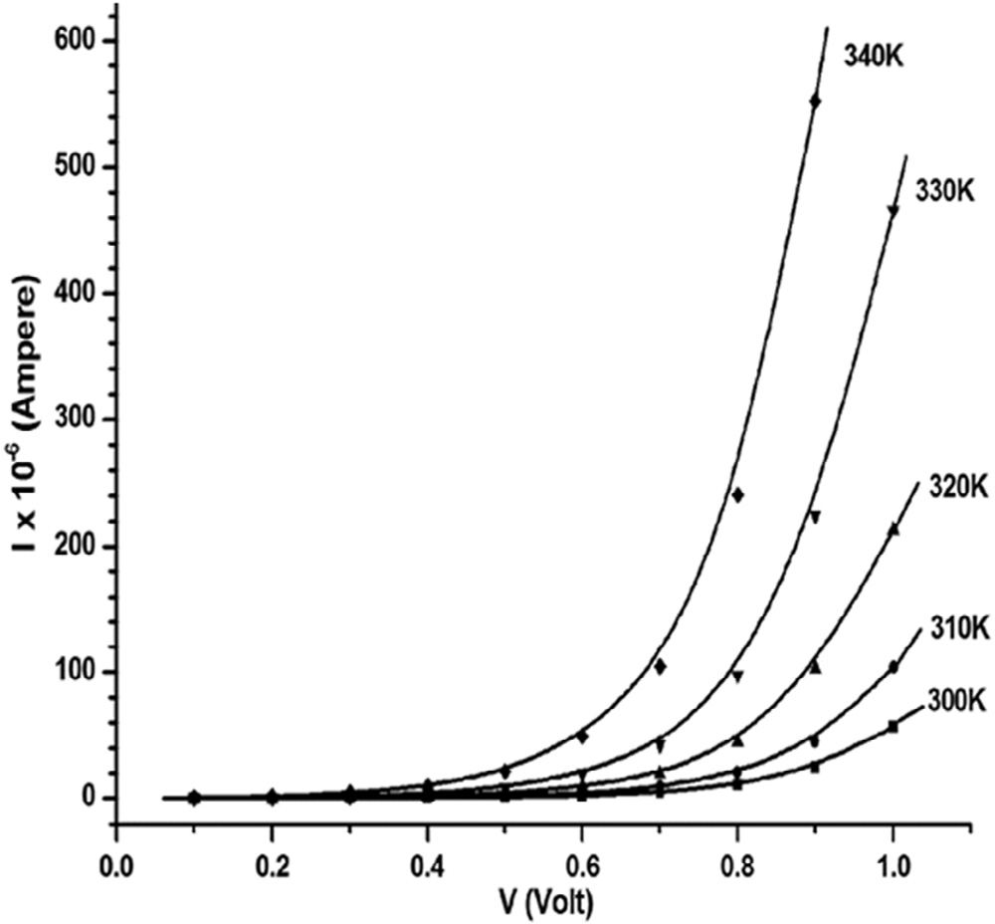has been observed to increase more rapidly as the tempera- ture is increased. At low temperature, the carriers do not have sufficient energy to surmount the high barrier but they are able to surmount the lower barriers. Consequently, current will flow through patches of the lower Schottky barrier height [50]. With raising temperature, more and more electrons have enough energy to cross the higher barrier. As a result, the current trans- port is dominated by the current that flows over the higher barrier. Therefore the dominant barrier height increases with temperature [51].

Fig. 5 shows lnJ vs V plots for a typical (p)Si/(n)Bi2S3 heterojunction in the dark at different temperatures. The straight fitting of lnJ vs V shows that current, carrying mecha- nism over the heterojunction barrier, is dominated by the thermionic mechanism, current density–voltage relation is given by the relation [52]

J  J exp qV 

s  

nkT

(7)

### Fig. 4 – I–V characteristics of a typical (p)Si/(n)Bi2S3 heterojunction at different temperatures in the dark.

where V is the applied voltage and Js is the saturation current density given as

Js  qA*TVbi exp  qVbi 

(8)

k  kT 

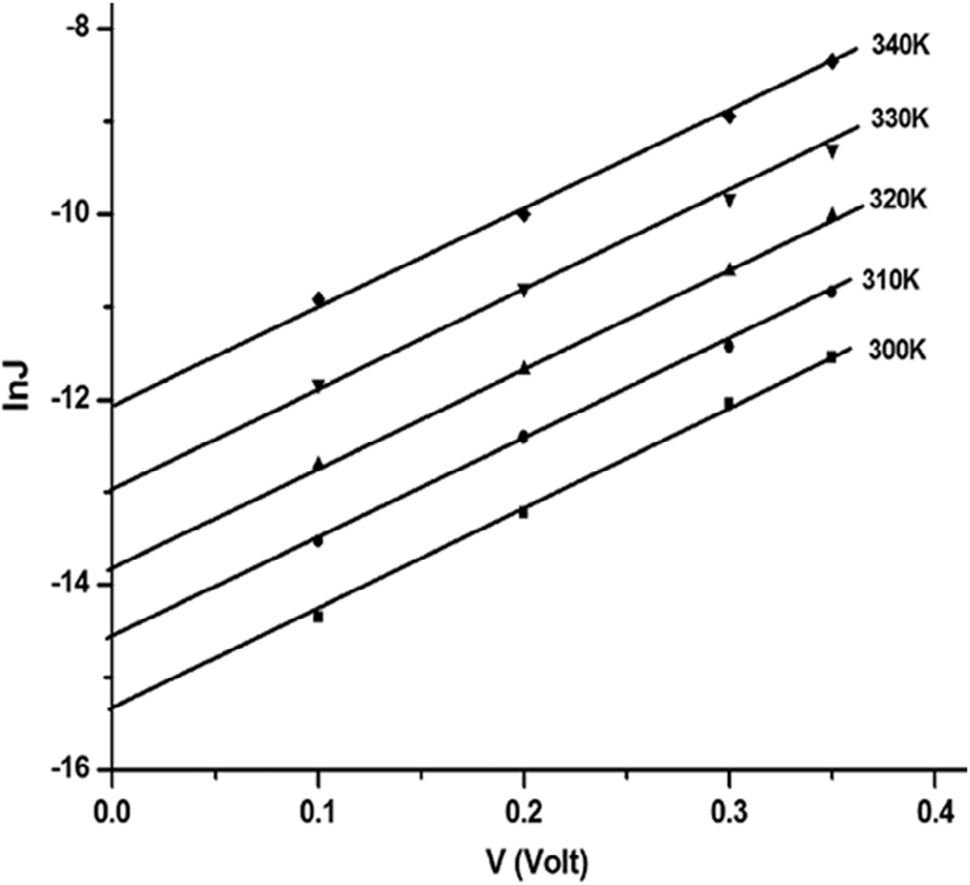

### Fig. 5 – ln J vs V plot of a typical (p)Si/(n)Bi2S3 heterojunction.

where A* is the Richardson constant, Vbi is the built-in poten- tial, k is the Boltzmann’s constant and T is the temperature. The ideality factors (n) and saturation current density (Js) are calculated from the slopes and intercepts of these plots respectively. The estimated values of diode ideality factors and saturation current densities at different temperatures of the typical (p)Si/(n)Bi2S3 heterojunction are given in Table 2. The saturation current density Js and ideality factor (n) are depen- dent on temperature. The greater value of ideality factor than unity is attributed to factors such as presence of interfacial layer, image force lowering of built-in potential, recombination of elec- trons and holes in depletion region, tunnelling effect and barrier

height inhomogeneity [53–55].

From the measured values of Js at different temperatures,

a plot of ln(Js/T) versus T−1 has been drawn as shown in Fig. 6. The plot is almost a straight line, which indicates that the

current transport process follows the relation (7) as dis- cussed above. From the slope of the plot, the built-in potential Vbi of the junction is calculated and values are given in Table 2. The ideality factor ‘n’ and saturation current density ‘Js’ of the junction at different temperatures are estimated from the slopes and intercepts of lnJ vs V plot (Fig. 5) respectively. The calcu- lated values are tabulated in Table 2. From the estimated values

|  |  |  |  |  |  |
| --- | --- | --- | --- | --- | --- |
| **Table 2 – Junction parameters of a typical (P)Si/(n)Bi2S3 heterojunction.** | | | | | |
| Temperature (K) | Ideality factor (n) | Saturation current density Js (10−6 Acm-2) | Built-in potential (from C–V) Vbi (eV) | Built-in potential (from I–V) Vbi (eV) | Series resistance (Ω) Dark |
| 300 | 3.6 | 0.22 | 0.69 | 0.66 | 2447 |
| 310 | 3.5 | 0.47 |  |  | 932 |
| 320 | 3.4 | 0.98 |  |  | 446 |
| 330 | 3.3 | 2.34 |  |  | 260 |
| 340 | 3.2 | 5.69 |  |  | 83 |

**318** egyptian journal of basic and applied sciences 3 (2016) 314–321

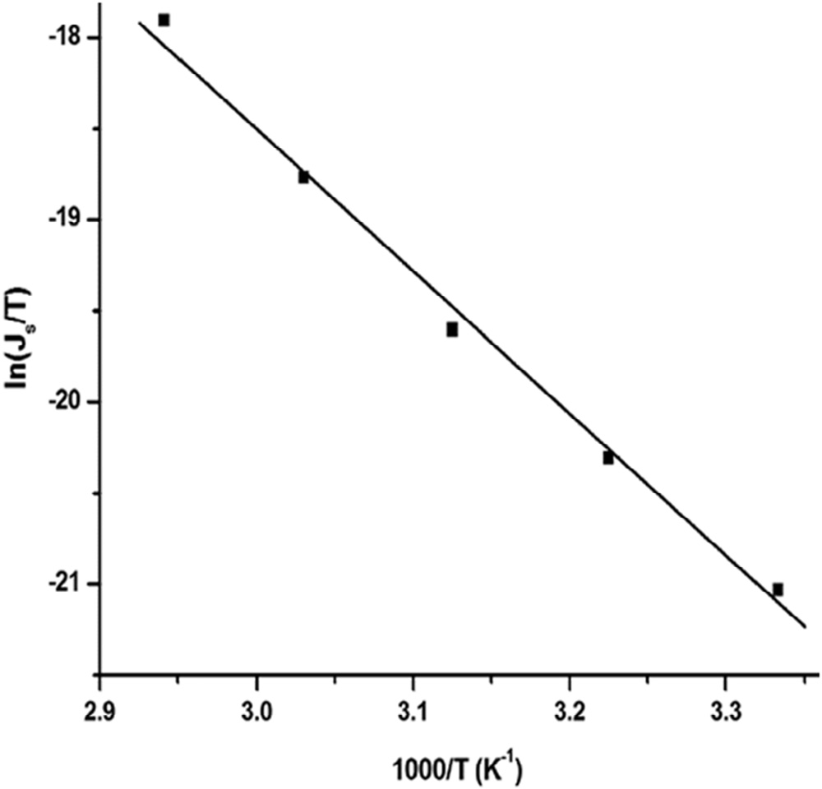

### Fig. 6 – ln (Js/T) versus T−1 plots of a typical (p)Si/(n)Bi2S3 heterojunction.

of Js for different temperatures, lnJs/T vs T−1 graph is plotted for the junction as shown in Fig. 6. The built-in potential Vbi

of the junction is calculated from the slope of the plot and the value is given in Table 2.

## *Effect of series resistance on I–V characteristics of* the (p)Si/(n)Bi2S3 heterojunction

As depicted in Fig. 7 for higher voltages, the lnI vs V plots of the junctions have been observed to deviate from linearity. This deviation gives an indication of the presence of series resis-

tance Rs associated with the neutral region of the junction. The series resistance are estimated from I vs ΔV plots of the junc- tion. Fig. 8 represents the I vs Vplots of a typical (p)Si/ (n)Bi2S3 junction at 300 K in the dark, where ΔV is the voltage due to series resistance. The value of Rs of a typical (p)Si/

(n)Bi2S3 junction at different temperatures are found to be in the range 2447–83 Ω as given in Table 2. The series resistance of the (p)Si/(n)Bi2S3 junction is found to decrease with an in-

crease in temperature. With increasing temperature, the number of free charge carriers is also increased due to either their bond breaking or by the de-trapping mechanism [56]. As a result, the series resistance of the (p)Si/(n)Bi2S3 junction decreases with an increase in temperature.

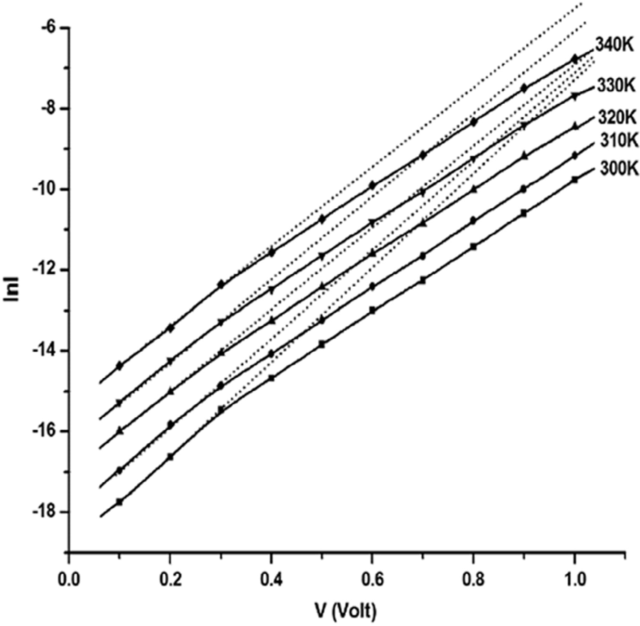

### Fig. 7 – lnI vs V plots of a typical (p)Si/(n)Bi2S3 heterojunction.

egyptian journal of basic and applied sciences 3 (2016) 314–321

**319**

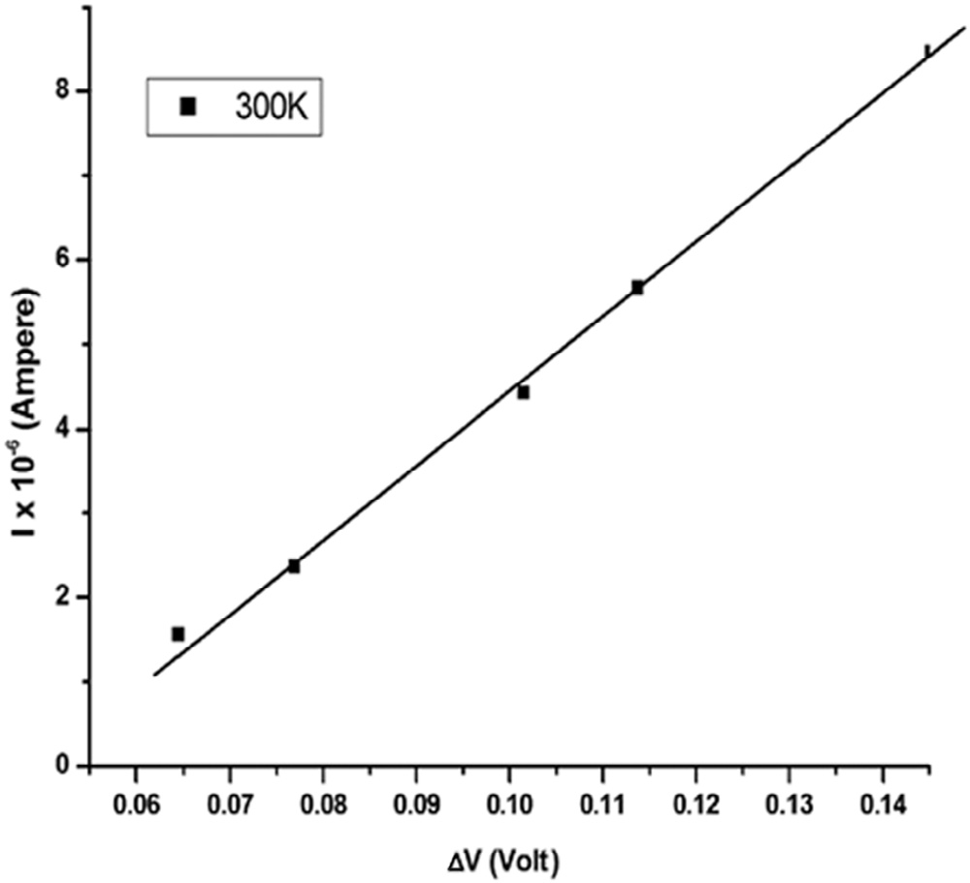

### Fig. 8 – Plot of I vs ΔV of a typical (p)Si/(n)Bi2S3 heterojunction.

by image force in the I–V characteristics and the barrier height inhomogeneities [59,60].

## *3.6. Photovoltaic measurements of (p)Si/(n)Bi2S3* heterojunction

The photovoltaic performance of the (p)Si/(n)Bi2S3 junction is investigated under different light intensities. Fig. 10 shows J–V curves for a typical (p)Si/(n)Bi2S3 junction under different light intensities, which reveals poor photovoltaic effect of the junc- tions. Under illumination, electron–hole pairs are created inside the depletion region and are separated by built-in electric field with holes and electrons are drifting to the Si and Bi2S3layers respectively. When the device terminals are short-circuited, excess holes in the Si flow through the external circuit to re- combine with the excess electrons in the Bi2S3 side and this represents the photocurrent. Calculated photovoltaic param- eters of the junctions are given in Table 3. The open-circuit voltage and short-circuit current are strongly dependent on the series resistance (Rs) as well as the junction ideality factor (n) as per the known equations [61].

ISC  I0 exp qV  IRS   1  I

(9)

## *Capacitance–voltage characteristics of a* (p)Si/(n)Bi2S3 junction

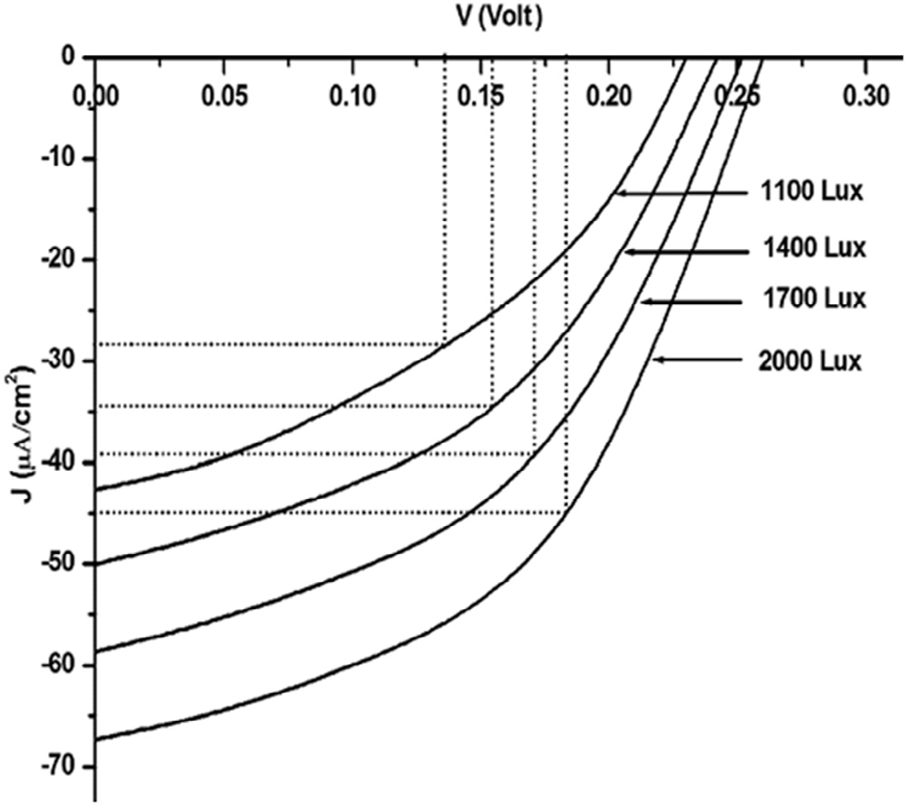The capacitance–voltage characteristics of (p)Si/(n)Bi2S3 junc- tion is measured at 1 KHz frequency under reverse bias condition at room temperature (300 K). Fig. 9 shows C−2–V plot

of a typical (p)Si/(n)Bi2S3 junction. The built-in potential Vbi mea-

sured from this plot is found to be 0.69 eV, which is higher than the value obtained from current–voltage characteristics as given in Table 2. This divergence is ascribed to the existence of ca- pacitance at the interfacial layer containing defects [57,58]. Other factors for this divergence are lowering of the barrier height

  kT  

### Fig. 9 – C−2–V plot of (p)Si/(n)Bi2S3 heterojunction measured at 300 K.

**Fig. 10 – J–V plots of a typical (p)Si/(n)Bi2S3 junction at different light intensities.**

|  |  |  |  |  |
| --- | --- | --- | --- | --- |
| **Table 3 – Photovoltaic parameters of a typical (p)Si/ (n)Bi2S3 heterojunction.** | | | | |
| Intensity of light (Lux) | Short-circuit current  (Jsc μA/cm2) | Open-circuit voltage  Voc (Volt) | Fill factor (FF) | Efficiency (%) |
| 1100 | 42.623 | 0.232 | 0.390 | 0.385 |
| 1400 | 50.03 | 0.242 | 0.436 | 0.414 |
| 1700 | 58.67 | 0.252 | 0.452 | 0.432 |
| 2000 | 67.31 | 0.200 | 0.605 | 0.447 |

**320** egyptian journal of basic and applied sciences 3 (2016) 314–321

VOC  nkT ln  ISC  1

q  I 

o

(10)

1. [Jana A, Bhattacharya C, Sinha S, Datta J. J Solid State](http://refhub.elsevier.com/S2314-808X(16)30017-3/sr0065) [Electrochem 2009;13:1339–50.](http://refhub.elsevier.com/S2314-808X(16)30017-3/sr0065)
2. [Ahire RR, Sharma RP. Indian J Eng Mater Sci 2006;13:140–4.](http://refhub.elsevier.com/S2314-808X(16)30017-3/sr0070)
3. [Mane RS, Shankapal BR, Lokhande CD. Mater Res Bull](http://refhub.elsevier.com/S2314-808X(16)30017-3/sr0075)

where, I is the total output current and Io is the saturation current. The open-circuit voltage (Voc), short-circuit current density (Jsc) and fill factor of these junctions are tabulated in Table 3. It is observed that the junction exhibits poor photovoltaic performance with low fill factor and low efficiency. In the poly- crystalline films, the grain boundary potential may affect the series resistance and open-circuit voltage of solar cell [62]. Re- combination of electron–hole pairs photo-generated takes place at grain boundary and hence the short-circuit current is reduced [63]. Besides, there are many factors responsible for the poor pho- tovoltaic performance, such as presence of interfacial layer and low doping concentration. As the light intensity increases there is increase in excitation and separation of electrons from their atoms, which leads to the creation of more electron–hole pairs. This may be the reason for the increase of photovoltaic perfor- mance of the junctions with increasing light intensity.

# Conclusions

In this paper, we investigated the temperature dependent elec- trical and photovoltaic properties of (p)Si/(n)Bi2S3 heterojunction fabricated by chemical bath deposition (CBD) technique. The rectifying nature of the junction shows the formation of barrier at the interface of the two semiconductors. The ideality factor and series resistance decreases, whereas the potential barrier height increases with increase in temperature. Photovoltaic con- version efficiency of the junction is found low with low value of fill factor due to the presence of the interfacial and barrier height inhomogeneity.

# Acknowledgement

We express our gratefulness to the Department of Physics, Manipur University, Manipur, for providing the SEM facilities.

R E F E R E N C E S

1. [Novoselova AB, editor. Physical and chemical properties of](http://refhub.elsevier.com/S2314-808X(16)30017-3/sr0010) [semiconductors handbook. Moscow: Nauka; 1978. p. 97.](http://refhub.elsevier.com/S2314-808X(16)30017-3/sr0010)
2. [Pari N, Nayak BB, Acharya BS. Thin Solid Films 1995;254:47.](http://refhub.elsevier.com/S2314-808X(16)30017-3/sr0015)
3. [Chapnik IM. Phys Status Solidi 1986;137B:95.](http://refhub.elsevier.com/S2314-808X(16)30017-3/sr0020)
4. [Li Y, Wei F, Ma Y, Zhang H, Gao Z, Dai L, et al.](http://refhub.elsevier.com/S2314-808X(16)30017-3/sr0025) [CrystEngComm 2013;15:6611–16.](http://refhub.elsevier.com/S2314-808X(16)30017-3/sr0025)
5. [Bube RH. Photoconductivity in solids. New York: Wiley; 1960.](http://refhub.elsevier.com/S2314-808X(16)30017-3/sr0030)
6. [Mizogushi H, Hosono H, Ueda N, Kawazoe K. J Appl Phys](http://refhub.elsevier.com/S2314-808X(16)30017-3/sr0035) [1995;78:1376.](http://refhub.elsevier.com/S2314-808X(16)30017-3/sr0035)
7. [Martiny JM, Hernandezy JL, Adellyz L, Rodriguezy A, Lopez F.](http://refhub.elsevier.com/S2314-808X(16)30017-3/sr0040) [Semicond Sci Technol 1996;11:1740–4.](http://refhub.elsevier.com/S2314-808X(16)30017-3/sr0040)
8. [Song L, Chen C, Zhang S. Power Technol 2011;207:170–4.](http://refhub.elsevier.com/S2314-808X(16)30017-3/sr0045)
9. [Pejova B, Grozdanov I. Mater Chem Phys 2006;99:39.](http://refhub.elsevier.com/S2314-808X(16)30017-3/sr0050)
10. [Killerdar VV, Lokhande CD, Bhosale CH. Thin Solid Films](http://refhub.elsevier.com/S2314-808X(16)30017-3/sr0055) [1996;289:14–16.](http://refhub.elsevier.com/S2314-808X(16)30017-3/sr0055)
11. [Ubale AU. Mater Chem Phys 2010;121:555–60.](http://refhub.elsevier.com/S2314-808X(16)30017-3/sr0060)

[2000;35:587–601.](http://refhub.elsevier.com/S2314-808X(16)30017-3/sr0075)

1. [Lokhande CD, Ubale AU, Patil PS. Thin Solid Films](http://refhub.elsevier.com/S2314-808X(16)30017-3/sr0080) [1997;302:1–4.](http://refhub.elsevier.com/S2314-808X(16)30017-3/sr0080)
2. [Desai JD, Lokhande CD. Mater Chem Phys 1995;41:98–103.](http://refhub.elsevier.com/S2314-808X(16)30017-3/sr0085)
3. [Lukose J, Pradeep B. Solid State Commun 1991;78:535–8.](http://refhub.elsevier.com/S2314-808X(16)30017-3/sr0090)
4. [Mahmoud S, Sharaf F. Fizika 1996;A5:205–13.](http://refhub.elsevier.com/S2314-808X(16)30017-3/sr0095)
5. [Mageshwari K, Sathyamoorthy R, Sudhagar P, Kang YS. Appl](http://refhub.elsevier.com/S2314-808X(16)30017-3/sr0100) [Surf Sci 2011;257:7245–53.](http://refhub.elsevier.com/S2314-808X(16)30017-3/sr0100)
6. [Mageshwari K, Sathyamoorthy R. Vacuum 2012;86:2029–34.](http://refhub.elsevier.com/S2314-808X(16)30017-3/sr0105)
7. [Lokhande CD, Bhosale CH. Bull Electrochem 1990;6:622.](http://refhub.elsevier.com/S2314-808X(16)30017-3/sr0110)
8. [Miller B, Menzes S, Heller A. J Electroanal Chem 1978;94:85–](http://refhub.elsevier.com/S2314-808X(16)30017-3/sr0115) [9.](http://refhub.elsevier.com/S2314-808X(16)30017-3/sr0115)
9. [Krishnamoorthy PA, Shivkumar GK. Thin Solid Films](http://refhub.elsevier.com/S2314-808X(16)30017-3/sr0120) [1984;121:151.](http://refhub.elsevier.com/S2314-808X(16)30017-3/sr0120)
10. [Pawar SH, Bhosale PN, Uplane MD, Tamhankar SP. Thin Solid](http://refhub.elsevier.com/S2314-808X(16)30017-3/sr0125) [Films 1983;110:165–70.](http://refhub.elsevier.com/S2314-808X(16)30017-3/sr0125)
11. [Pawar SH, Tamhankar SP, Lokhande CD. Mater Chem Phys](http://refhub.elsevier.com/S2314-808X(16)30017-3/sr0130) [1984;11:401–12.](http://refhub.elsevier.com/S2314-808X(16)30017-3/sr0130)
12. [Mahmoud SA. Physica B 2001;301:310–17.](http://refhub.elsevier.com/S2314-808X(16)30017-3/sr0135)
13. [Benramdane N, Latreche M, Tabet H, Boukhalfa M, Kebbab Z,](http://refhub.elsevier.com/S2314-808X(16)30017-3/sr0140) [Bouzidi A. Mater Sci Eng B 1999;64:84–7.](http://refhub.elsevier.com/S2314-808X(16)30017-3/sr0140)
14. [Medles M, Benramdane N, Bouzidi A, Nakrela A, Tabet-](http://refhub.elsevier.com/S2314-808X(16)30017-3/sr0145) [Derraz H, Kebbab Z, et al. Thin Solid Films 2006;497:58–64.](http://refhub.elsevier.com/S2314-808X(16)30017-3/sr0145)
15. [Wang SY, Du YW. J Cryst Growth 2002;236:627–34.](http://refhub.elsevier.com/S2314-808X(16)30017-3/sr0150)
16. [Wang H, Zhu JJ, Zhu JM, Chen HY. J Phys Chem B](http://refhub.elsevier.com/S2314-808X(16)30017-3/sr0155) [2002;106:3848–54.](http://refhub.elsevier.com/S2314-808X(16)30017-3/sr0155)
17. [Liao XH, Wang H, Zhu JJ, Chen HY. Mater Res Bull](http://refhub.elsevier.com/S2314-808X(16)30017-3/sr0160) [2001;36:2339–46.](http://refhub.elsevier.com/S2314-808X(16)30017-3/sr0160)
18. [Liao XH, Zhu JJ, Chen HY. Mater Sci Eng B 2001;85:85–9.](http://refhub.elsevier.com/S2314-808X(16)30017-3/sr0165)
19. [Shao MW, Mo MS, Cui Y, Chen G, Qian YT. J Cryst Growth](http://refhub.elsevier.com/S2314-808X(16)30017-3/sr0170) [2001;233:799–802.](http://refhub.elsevier.com/S2314-808X(16)30017-3/sr0170)
20. [Zhang W, Yang Z, Huang X, Zhang S, Yu W, Qian Y, et al.](http://refhub.elsevier.com/S2314-808X(16)30017-3/sr0175) [Solid State Commun 2001;119:143.](http://refhub.elsevier.com/S2314-808X(16)30017-3/sr0175)
21. [Yu SH, Yang J, Wu YS, Han ZH, Xie Y, Qian YT. Mater Res Bull](http://refhub.elsevier.com/S2314-808X(16)30017-3/sr0180) [1998;33:1661–6.](http://refhub.elsevier.com/S2314-808X(16)30017-3/sr0180)
22. [Yu SH, Shu L, Yang JA, Han ZH, Qian YT, Zhang YH. J Mater](http://refhub.elsevier.com/S2314-808X(16)30017-3/sr0185) [Res 1999;14:4157.](http://refhub.elsevier.com/S2314-808X(16)30017-3/sr0185)
23. [Pineda E, Nicho ME, Nair PK, Hu H. Sol Energy 2012;86:1017–](http://refhub.elsevier.com/S2314-808X(16)30017-3/sr0190) [22.](http://refhub.elsevier.com/S2314-808X(16)30017-3/sr0190)
24. [Martinez L, Stavrinadis A, Higuchi S, Diedenhofen SL,](http://refhub.elsevier.com/S2314-808X(16)30017-3/sr0195) [Bernechea M, Tajimab K, et al. Phys Chem Chem Phys](http://refhub.elsevier.com/S2314-808X(16)30017-3/sr0195) [2013;15:5482–7.](http://refhub.elsevier.com/S2314-808X(16)30017-3/sr0195)
25. [Becerra D, Nair MTS, Nair PK. J Electrochem Soc](http://refhub.elsevier.com/S2314-808X(16)30017-3/sr0200) [2011;158:H741–9.](http://refhub.elsevier.com/S2314-808X(16)30017-3/sr0200)
26. [Moreno-Garcia H, Nair MTS, Nair PK. Thin Solid Films](http://refhub.elsevier.com/S2314-808X(16)30017-3/sr0205) [2011;519:2287–95.](http://refhub.elsevier.com/S2314-808X(16)30017-3/sr0205)
27. [Moreno-García H, Nair MTS, Nair PK. Thin Solid Films](http://refhub.elsevier.com/S2314-808X(16)30017-3/sr0210) [2011;519:7364–8.](http://refhub.elsevier.com/S2314-808X(16)30017-3/sr0210)
28. [Kachari T, Wary G, Rahman A. AIP Conf Proc 2010;1249:202–](http://refhub.elsevier.com/S2314-808X(16)30017-3/sr0215) [5.](http://refhub.elsevier.com/S2314-808X(16)30017-3/sr0215)
29. [Bao HF, Cui XQ, Li CM, Gan Y, Zhang J, Guo J. J Phys Chem](http://refhub.elsevier.com/S2314-808X(16)30017-3/sr0220) [2007;C.111:12279–83.](http://refhub.elsevier.com/S2314-808X(16)30017-3/sr0220)
30. [Bessekhouad Y, Robert D, Weber JV. J Photoch Photobio A](http://refhub.elsevier.com/S2314-808X(16)30017-3/sr0225) [2004;163:569–80.](http://refhub.elsevier.com/S2314-808X(16)30017-3/sr0225)
31. [Moreno-García H, Gomez-Daza O, Campos J, Nair MTS, Nair](http://refhub.elsevier.com/S2314-808X(16)30017-3/sr0230) [PK. Mater Res Soc Symp Proc 2007;1012:451.](http://refhub.elsevier.com/S2314-808X(16)30017-3/sr0230)
32. [Wang ZJ, Qu SC, Xu Y, Chen YH, Zeng XB, Liu JP, et al. Adv](http://refhub.elsevier.com/S2314-808X(16)30017-3/sr0235) [Mater Res 2007;26–28:601–7.](http://refhub.elsevier.com/S2314-808X(16)30017-3/sr0235)
33. [Ladhe RD, Baviskar PK, Tan WW, Zhang JB, Lokhande CD,](http://refhub.elsevier.com/S2314-808X(16)30017-3/sr0240) [Sankapal BR. J Phys D Appl Phys 2010;43(1–6):245302.](http://refhub.elsevier.com/S2314-808X(16)30017-3/sr0240)
34. [Rath AK, Bernechea M, Martinez L, Konstantatos G. Adv](http://refhub.elsevier.com/S2314-808X(16)30017-3/sr0245) [Mater 2011;23:3712–17.](http://refhub.elsevier.com/S2314-808X(16)30017-3/sr0245)
35. [Hussain A, Begum A, Rahman A. Indian J Phys](http://refhub.elsevier.com/S2314-808X(16)30017-3/sr0250) [2012;86(8):697–701.](http://refhub.elsevier.com/S2314-808X(16)30017-3/sr0250)

egyptian journal of basic and applied sciences 3 (2016) 314–321

**321**

1. [Hussain A, Rahman A. Mater Sci Semicon Proc 2013;16:1918–](http://refhub.elsevier.com/S2314-808X(16)30017-3/sr0255) [24.](http://refhub.elsevier.com/S2314-808X(16)30017-3/sr0255)
2. [Reddy NNK, Reddy VR. Bull Mater Sci 2012;35(1):53–61.](http://refhub.elsevier.com/S2314-808X(16)30017-3/sr0260)
3. [Sze SM. Physics of semiconductor and devices. 2nd ed. New](http://refhub.elsevier.com/S2314-808X(16)30017-3/sr0265) [Delhi: Willy Eastern Ltd.; 1983. p. 126–46.](http://refhub.elsevier.com/S2314-808X(16)30017-3/sr0265)
4. [Rhoderick EH, Williams RH, editors. Metal-semiconductor](http://refhub.elsevier.com/S2314-808X(16)30017-3/sr0270) [contacts. Second ed. Oxford: Clarendon Press; 1988.](http://refhub.elsevier.com/S2314-808X(16)30017-3/sr0270)
5. [Werner JH, Ploog K, Queisser HJ. Phys Rev Lett 1986;57:1080–3.](http://refhub.elsevier.com/S2314-808X(16)30017-3/sr0275)
6. [Werner JH, Gutter HH. J Appl Phys 1991;69:1522–33.](http://refhub.elsevier.com/S2314-808X(16)30017-3/sr0280)
7. [Janardhanam V, Lee H-K, Shim K-H, Hong H-B, Lee S-H, Ahn](http://refhub.elsevier.com/S2314-808X(16)30017-3/sr0285) [K-S, et al. J Alloy Compd 2010;504:146–50.](http://refhub.elsevier.com/S2314-808X(16)30017-3/sr0285)
8. [Van Zeghbroeck B. Principles of electronic devices. 1996;](http://refhub.elsevier.com/S2314-808X(16)30017-3/sr0290) [Electronic Book.](http://refhub.elsevier.com/S2314-808X(16)30017-3/sr0290)
9. [Peta KR, Park B-G, Lee S-T, Kim M-D, Oh J-E, Kim T-G, et al.](http://refhub.elsevier.com/S2314-808X(16)30017-3/sr0295) [Thin Solid Films 2013;534:603–8.](http://refhub.elsevier.com/S2314-808X(16)30017-3/sr0295)
10. [Card HC, Rhoderick EH. J Phys D Appl Phys 1971;4:1589–601.](http://refhub.elsevier.com/S2314-808X(16)30017-3/sr0300)
11. [Cakar M, Onganer Y, Turut A. Synth Met 2002;126:213–18.](http://refhub.elsevier.com/S2314-808X(16)30017-3/sr0305)
12. [Wary G, Kachari T, Rahman A. Int J Thermophys 2006;27:332–](http://refhub.elsevier.com/S2314-808X(16)30017-3/sr0310) [46.](http://refhub.elsevier.com/S2314-808X(16)30017-3/sr0310)
13. [Chu TL, Chu SS. Solid-State Electron 1995;38:533–49.](http://refhub.elsevier.com/S2314-808X(16)30017-3/sr0315)
14. [Dutta J, Bhattacharyya D, Chaudhuri S, Pal AK. Sol Energ Mat](http://refhub.elsevier.com/S2314-808X(16)30017-3/sr0320) [Sol C 1995;36:357–68.](http://refhub.elsevier.com/S2314-808X(16)30017-3/sr0320)