[Egyptian Journal of Basic and Applied Sciences 5 (2018) 220–227](https://doi.org/10.1016/j.ejbas.2018.05.006)

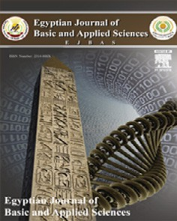

Contents lists available at [ScienceDirect](http://www.sciencedirect.com/science/journal/2314808X)

Egyptian Journal of Basic and Applied Sciences

journal homepage: [www.elsevier.com/locate/ejbas](http://www.elsevier.com/locate/ejbas)

Full Length Article

[](http://crossmark.crossref.org/dialog/?doi=10.1016/j.ejbas.2018.05.006&domain=pdf)The aqueous extract of *Ocimum gratissimum* leaves ameliorates acetic acid-induced colitis via improving antioxidant status and hematological parameters in male Wistar rats

Kehinde P. Olamilosoye a, Rufus O. Akomolafe a, Olumide S. Akinsomisoye a, Modinat A. Adefisayo b,

Quadri K. Alabi a,c,⇑

a *Department of Physiological Sciences, Faculty of Basic Medical Sciences, Obafemi Awolowo University, Ile-Ife, Osun State, Nigeria*

b *Department of Physiology, Faculty of Basic Medical Sciences, University of Medical Sciences, Ondo State, Nigeria*

c *Department of Hematology and Blood Transfusion, Faculty of Basic Medical Sciences, College of Medicine, Afe Babalola University, Ado Ekiti, Ekiti State, Nigeria*

# a r t i c l e i n f o

*Article history:*

Received 2 January 2018

Received in revised form 14 May 2018 Accepted 26 May 2018

Available online 5 June 2018

*Keywords:* Antioxidant Colitis

Hematological parameters

*Ocimum gratissimum*

Rats

# a b s t r a c t

The beneficial effects of *Ocimum gratissimum*, have been attributed mainly to its antioxidant and anti- inflammatory properties. This study investigated the protective effects of aqueous extract of *Ocimum gratissimum* leaves (AEOGL) on acetic acid induced colitis in male rats. Twenty male Wistar rats, 100– 180 g were divided into four groups as follows: Group 1 (control) (n = 5) received 2 ml/kg of distilled water for 21 consecutive days. Group 2 (n = 5) received 2 ml of 6% acetic acid solution once intra rectally for induction of colitis. Group 3 and 4 (n = 5 each) were treated as group 2 and thereafter received AEOGL orally at 200 and 400 mg/kg/day respectively for 20 consecutive days. All the animals from each group were sacrificed 24 h after the induction of colitis and administration of AEOGL. The diarrhea score, ulcer score, hematological parameters, nitric oxide (NO), myeloperoxidase (MPO), superoxide dismutase (SOD), reduced glutathione (GSH) markers and histopathological alteration were evaluated. Acetic acid-induced colitis significantly caused alteration in diarrhea score, ulcer score, hematological parameters, MPO and SOD activities, NO and GSH levels (p < 0.05). It induced significant inflammation of the colonic tissue. AEOGL administration significantly decreased diarrhea score and ulcer score to normal (p < 0.05). It pre- vented alteration effect of acetic acid on hematological parameters and significant decreases the activities of MPO, SOD, NO and increase GSH levels (p < 0.05) in colitis rats. In conclusion, *Ocimum gratissimum* leaves possesses ameliorative effects against acetic acid-induced colitis as a consequence of its anti- inflammatory and anti-oxidative properties.

© 2018 Mansoura University. Production and hosting by Elsevier B.V. This is an open access article under

the CC BY-NC-ND license (<http://creativecommons.org/licenses/by-nc-nd/4.0/>).

Introduction

Ulcerative colitis (UC) is an idiopathic inflammatory bowel dis- ease that affects the colonic mucosa and is clinically characterized by diarrhea, abdominal pain and hematochezia. The prevalence of inflammatory bowel diseases, including ulcerative colitis, is gener- ally higher, with an estimated of 250 cases per 100,000 individuals in western countries but is becoming common in rest of the world due to the adoption of western lifestyle [1,2]. The etiology of inflammatory bowel diseases is still not fully understood but it is widely acknowledged that they result from complex interplay

* Corresponding author at: Department of Physiological Sciences, Obafemi Awolowo University, PMB 013 Ile-Ife, Osun State, Nigeria.

*E-mail address:* [alabikunlequadri@gmail.com](mailto:alabikunlequadri@gmail.com) (Q.K. Alabi).

among genetic, environmental, microbial and immune factors [3]. Worsen and inappropriate mucosal immune response mediated by mucosal T cells triggers the release of several pro- inflammatory mediators, including reactive oxygen and nitrogen species, neutrophil infiltration and overproduction of pro- and anti-inflammatory cytokines [3]. All these factors can cause tissue damage and are thought to be critical events in the pathogenesis of ulcerative colitis.

Inflammatory bowel diseases disorders are multifactorial with no therapeutic agents available to control both inflammatory immune response and oxidative stress effectively [1]. However, the available drugs, such as 5-amino salicylic acid (5-ASA) deriva-

tives, monoclonal antibiotics, steroids (glucocorticoid), anti-tumor necrosis factor (TNF)-a (infliximab) and immunosuppressive agents, have exhibited beneficial effects in the treatment of

<https://doi.org/10.1016/j.ejbas.2018.05.006>

2314-808X/© 2018 Mansoura University. Production and hosting by Elsevier B.V.

This is an open access article under the CC BY-NC-ND license (<http://creativecommons.org/licenses/by-nc-nd/4.0/>).

inflammatory bowel disease [4]. Indeed, most of these drugs bring serious side effects with low results and many patients do not respond to these treatment [5]. Based on the dissatisfaction with the current pharmacology treatments, focus has been increased on complementary medicine approaches, including medicinal plant extract or natural active compound extract from the plants [6]. There is a great need to identify effective chemopreventive agents that might improve colitis with fewer or no side effects.

*Ocimum gratissimum* (OG) is an herbaceous plant which belongs to the Labiatae family. The plant is indigenous to tropical areas especially India and West Africa. In Nigeria, it is found in the Savannah and coastal areas [7]. It is known by various names in different parts of the world. In India it is known by its several ver- nacular names, the most commonly used ones being Vriddhutulsi (Sanskrit), Ram tulsi (Hindi), Nimmatulasi (Kannada) [8]. In Nige- ria, the plant is called ‘‘effinrin-nla” by the Yoruba speaking tribe, ‘‘Ahuji” by the Igbos, and ‘‘Daidoya” by the Hausas [7]. It is com- monly used in folk medicine to cure many diseases due to its potent bioactive principles including tannins, saponins, flavonoids, phenols and anthraquinone glycosides [9]. Antioxidant vitamins; alpha-tocopherol and ascorbic acid have been detected in its leaves extracts [9]. The flowers and the leaves of this plant are rich in essential oils so it is used in preparation of teas and infusion [10]. *Ocimum gratissimum* is used in Nigeria in the management of baby’s cord, to keep the wound surfaces sterile and also used extensively in the treatment of fungal infections, fever, cold and catarrh [11]. Its pharmacological potencies such as anti- inflammatory, antibacterial, antimicrobial, anti-oxidative and anti- malarial have also been documented [12–14,10]. Recent evidence has emerged that early initiating time of polyphenol rich extract of OG had pharmacological important against colitis [15]. Despite the vast therapeutic benefit of *Ocimum gratissimum* in various experimental models, its effect on drugs induced colitis are scarce. This study was therefore designed to examine the beneficial effects of aqueous extract of *Ocimum gratissimum* leaves on acetic acid- induced colitis in male Wistar rats. Furthermore, we studied macroscopic and histological parameters and analyzed some hematological parameters, oxidative stress markers and inflamma- tory markers such as NO level and MPO activity.

Materials and methods

*Drugs and chemicals*

Acetic acid (Manufactured by Eastman Chemical Company lim- ited) a chemical reagent, often produced by fermentation and sub- sequent oxidation of ethanol. Ketamine hydrochloride (50 mg/10 ml) injection was purchased from Popular Pharmaceuticals LTD. No. 164, Tongi, Industrial Area, Gazipur-1711, Bangladesh. All other reagents were of analytical grade and purchased from Sigma (St. Luis, USA).

*Plant extraction*

The *Ocimum gratissimum* leaves were collected, washed, air dried under shade and grounded into fine powder using a blender. The aqueous extract was prepared by extracting the powdered leaves (520 g) with 5.2 L of distilled water in an electric shaker for 48 h. The extract was filtered through Whatmann No. 1 (What-

mann International Ltd, Maidstone, UK) paper and evaporated under reduced pressure at 40 °C using a rotary evaporator. The resulting concentrate was freeze dried with the aid of a lyophilizer. The residue (52.80 g) was kept in petri dishes with a tight fitting cover until it was needed for the study.

## Extraction yield in % = 52.80/520 * 100 = 10.2%

*Preliminary phytochemical test*

Preliminary phytochemical properties of the aqueous extract of *Ocimum gratissimum* leaves were tested using the following chem- icals and reagents: flavonoids (NaCl and HCl), alkaloids (Mayer and Dragendorff’s reagents), saponins (frothing test), tannins (FeCl3), cardiac glycosides (Salkowski test), terpenoids (Borntrager’s reac- tion), phenols [FeCl3 and K3Fe(CN6)] [16].

*Determination of total phenolics*

The total phenol contents in the aqueous extract of *Ocimum gratissimum* leaves extracts were determined by the method of Sin- gleton and Rossi [17] and as described by Gulcin et al. [18]. Briefly, an aliquot of the extract (1 ml) was mixed with 4 ml of Folin–Cio- calteu’s phenol reagent which already being diluted with distilled water (1:10 v/v). The resulting mixture was voltexed. After 5 min of standing, 3 ml of 7% (w/w) sodium carbonate (Na2CO3) solution was added and thereafter incubated for 90 min at room tempera- ture for color development. Using an ultraviolet (UV)–Vis spec- trophotometer (Beckman, DU 7400, USA), the absorbance was read at a wavelength of 765 nm against a negative control contain- ing 1 ml of distilled water. Extracts were evaluated at a final con- centration of 1 mg/ml. Total phenolic content was expressed as mg/g gallic acid equivalent using the equation obtained from a cal- ibration curve of gallic acid.

*Determination of total flavonoids*

Total flavonoids content of the leaves extract was determined using aluminum chloride colorimetric assay method according to Zhilen et al. [19] and as described by Miliauskas et al. [20]. Briefly, to 0.6 ml of distilled water and 0.3 ml of 4% sodium nitrate solution were added to 0.4 ml of the extract samples. After 5 min, 0.5 ml of 10% aluminum chloride and 0.9 ml of sodium hydroxide solutions were added to the resulting mixture. Against blank, the absor- bance, at a wavelength of 430 nm, was read using a UV–Vis spec- trophotometer (Beckman, DU 7400, USA). The development of yellow color was taking as indication of the presence of flavonoids. Extract samples were evaluated at final concentration of 1.5 mg/ ml. Total flavonoid content was calculated as quercetin equivalent (mg/g) using the equation obtained from the calibration curve. Quercetin with varying concentrations 0.1, 0.2, 0.3, 0.4 and 0.5 mg/ml was used as standard in comparison to the extract sample.

*Animals*

Twenty adult male Wistar rats weighing 100–180 g were used in this study. They were obtained from the Animal House of the College of Health Sciences, Obafemi Awolowo University, Ile-Ife. They were housed in a plastic cages and allowed to acclimatize in the laboratory for two weeks before the commencement of the study. The animals were kept under normal environmental condi- tions with a 12 h light/dark cycle and had free access to standard rodent diet and water. The animal experimental procedures were conducted in accordance with the National Institutes of Health guide for the care and use of laboratory animals (NIH Publications No. 8023, revised 1978) and approved by Institutional Research Committee.

*Experimental design*

Twenty male Wistar rats were divided into four groups as fol- lows; Group 1 (control group) consisted of 5 rats, received distilled water for 21 days. Groups 2–4 consisted of 5 rats each. Group 2 received 2 ml of 6% acetic acid solution once intra-rectally for the induction of colitis. Groups 3 and 4 were pre-treated with the acetic acid solution to induced colitis and subsequently treated

with 200 and 400 mg/kg/day (p.o) of AEOGL respectively for 20 days. Twenty-four hours after the end of the experiment, the ani- mals were sacrificed under ketamine hydrochloride anesthetic (10 mg/kg/b.w via intramuscular route). The Blood samples from all the rats were drawn via cardiac puncture and collected into EDTA tubes for hematological analysis. The rectum and the descending colon of the rats were removed for antioxidant status, neutrophil infiltration status and histological study using hema- toxylin and eosin stain.

*Measurement of body weight gain*

Weekly body weight of the rats for all groups were measured with the aid of a digital weighing balance (Hanson, China) to assess weekly weight gain or weight loss.

*Measurement of colonic ulcer score (colon mucosa damage index (CMDI)*

After sacrificing the animals through ketamine hydrochloride anesthetic, the entire rectum and the descending part of the colon were removed and opened longitudinally, and washed with normal saline to remove luminal content, the visible damages were exam- ined with the aid of magnifying lens and score on a 0–5 scale by method of Davies et al. [21]; Zheng et al. [22].

The ulcer score method includes;

for 15 min. at —4 °C. The supernatant was collected for the estima- tion of superoxide dismutase (SOD) and was assayed by the method described by Misra and Fridovich [24]. Briefly, to 200 lL of the lysate, 2.5 ml of buffer, 30 mM EDTA and 300 lL of 2 mM of pyrogallol was added. An increase in absorbance was recorded

at 420 nm for 3 min by spectrophotometer. One unit of enzyme activity is 50% inhibition of the rate of autooxidation of pyrogallol as determined by change in absorbance/min at 420 nm. The activ- ity of SOD was expressed as mg/mg protein.

Reduced glutathione (GSH) was determined using the method

described by Beutler et al. [25]. Briefly, 1 ml of the supernatant, obtained above, was added to 0.5 ml of Ellman’s reagent (10 mM). 2 ml of phosphate buffer was, thereafter, added. The yellow colour developed was read at 412 nm against blank containing

3.5 ml of phosphate buffer. A series of standards were also treated similarly and the amount of GSH was expressed in mg/mg protein. Nitric oxide (NO) was measured by the method of Grisham et al.

[26]. 500 ll sample was mixed with 500 lL TCA in 1.5 ml tube to

deprotein the sample. 100 lL was of each sample was separated in labeled eppendorf tubes and 0.1 ml of 1% sulphanilamide in 5% phosphoric acid was added and incubated at RT for 10 min, followed by addition of 0.1 ml of 0.1% NED (N-1- napthylethylenediamine dihydrochloride) and incubate for 10 min at 60%. The absorbance of the chromophore formed was mea-

sured at 546 nm. The standard curve is prepared using sodium nitrite (100 lm). The amount of NO in the sample is extrapolated

from the standard curve.

Score Observation

1. no damage
2. localized hyperemia with no ulcers
3. linear ulcer with no significant inflammation
4. linear ulcer with inflammation at one site
5. linear ulcer with inflammation, the size of ulcer <1 cm
6. multiple inflammations and ulcers, the size of ulcer >1 cm

*Measurement of colonic macroscopic damage*

After sacrificing the animals through ketamine hydrochloride anesthetic, the distal colon, (8 cm) was removed and opened longi- tudinally, and washed to remove luminal contents with normal saline, the weight of the colon was measured with the aid of a sen- sitive weighing balance and the length of the excised part of the colon was also measured using a meter ruler [22,23]. The Colon Macroscopic Damage was calculated using this formula;

## CMD = Weight of the colon (mg)

Length of the colon (cm)

*Measurement haematological indices*

The haematocrit (HCT), haemoglobin (HB) concentration, red blood cell (RBC), mean Corpuscular volume (MCV), mean corpuscu- lar haemoglobin concentrated (MCHC), white blood cell (WBC), granulocyte (GRAN), monocytes (MON),neutrophil (NEU), lympho- cytes (LYMP) and platelet (PL) counts were measured using an auto-analyzer machine (SFRI blood cell Counter, H18 light, France).

*Biochemical assays*

The colon samples of the rats were homogenized in 50 mM Tris–HCl buffer (pH 7.4) containing 1.15% potassium chloride and the homogenate was centrifuged at 10,000 revolution per minutes

Myeloperoxidase (MPO) as marker of inflammation and colon injury was measured according to the method of Xia and Zweier [27]. To 2 ml of O-dianisidine mixture (16.7 mg of O-dianisidine,

100 ml of 0.05 M potassium phosphate buffer and 50 lL of diluted

H2O2) into the cuvette, 70 lL of PMF was added. The increase in absorbance was monitored every 30 s for 1 min. The absorbance was read at 350 nm. One unit of MPO activity can be defined as the quantity of enzyme able to convert/degrade 1 lmol of H2O2

to water in 1 min at room temperature.

*Histological analysis*

The colon tissues biopsies of the rats were fixed in 10% formalin, dehydrated in graded alcohol, cleared in xylene and embedded in paraffin wax. The tissues were then cut into 2–3 lm thick sections

by a microtome, fixed on the slides and stained with hematoxylin- eosin (H&E). The slides were examined under a light microscope (Olympus CH; Olympus, Tokyo, Japan) and photomicrographs were

taken with a Leica DM 750 Camera at ×100 and 400 magnification.

*Statistical analysis*

The results obtained were expressed as mean ± SEM. Data were analyzed using One-way analysis of variance (ANOVA) followed by post-hoc test using Student-Newman-Keuls and *P* value less than

0.05 was considered statistically significant. The statistical analysis was performed with the aid of Graph Pad Prism 5.03.

Results

*Phytochemicals screening of aqueous extract of Ocimum gratissimum leaves*

Quantitative phytochemical analysis of the extract showed the presence of alkaloids, flavonoid, tannins, saponin, cardiac glycoside and terpenoid (Table 1).

Table 1

Phytochemical ingredients of aqueous extract of *Ocimum gratissimum* leaves.

|  |  |  |
| --- | --- | --- |
| Phytochemical constituents | mg/g | Percentage (%) composition |
| Alkaloids | 3.54 ± 0.34 | 0.45 |
| Tannins | 12.05 ± 1.05 | 1.11 |
| Saponins | 20.56 ± 0.03 | 2.05 |
| Flavonoid | 25.06 ± 0.03 | 2.10 |
| Cardiac Glycoside | 9.02 ± 0.90 | 1.00 |
| Terpenoids | 10.05 ± 0.56 | 1.10 |

Total phenolic (gallic acid equivalent) (mg/100 g) and total flavonoid content (quercetin equivalent) (mg/100 g)

Total phenolic content 90.03 ± 0.60

Total flavonoid content 50.04 ± 0.45

Values were expressed per g of plant extract and are means of triplicate (n = 3) determination ± standard deviation.

*Total phenolic and flavonoid contents*

The results of the total phenol and flavonoid contents of the aqueous extract of *Ocimum gratissimum* leaves are presented in Table 1. The total phenol content reported as gallic acid equivalent was 90.03 mg GAE/100 g, while the total flavonoid content reported as quercetin equivalent was 50.04 mg QUE/100 g.

*Body weight change*

The body weight change is show in the Fig. 1.

The group 2 (AA) had a significantly lower (p < 0.05) body weight change when compared the Group 1 (control). There was a significantly lower (p < 0.05) body weight change in Group 2 when compared with Groups 3 and 4 respectively. However, Groups 3 and 4 showed no significant different in body weight change when compared with the control.

*Effects on diarrhea score and ulcer parameters*

*Hematological parameters*

The mean values of hematological parameters in rats treated with AEOGL are presented in Table 2. Acetic acid induced colitis significantly increased white blood cell (WBC) count, neutrophil count (NEU) and granulocyte count. However, administration of AEOGL significantly lower (p < 0.05) white blood cell (WBC) count, neutrophil count (NEU), lymphocyte count (LYM), and granulocyte counts when compared with colitis control group. Acetic acid treatment significantly lower (p < 0.05) lymphocyte count (LYM), red blood cell (RBC) count and hemoglobin (Hb) concentration when compared with AEOGL treated groups. Table 3.

*Effects on nitric oxide (NO) and MPO*

The mean values of nitric oxide level and MPO activity in rats treated with AEOGL are presented in Figs. 2 and 3 respectively. The induction of colitis with AA was accompanied with significant increase in the plasma nitric oxide system in rats. The NO level in the plasma increased significantly in the rats treated with acetic acid (colitis control group) compared with normal control animals. AEOGL treatment prevented the increased in the NO level and maintained its normalcy in acetic acid-exposed rats. Ulcerative col- itis group (AA) had a significantly higher MPO in the colonic tissue compared with the control. However, AEOGL had no significant dif- ferent in MPO when compared with the control. AEOGL groups had a lower MPO activity when compared with the colitis group (AA). Thus, AEOGL prevented increased in MPO in the colon mucosa.

*Colitis-induced colon oxidative stress*

The induction of colitis was accompanied with significant depletion of colon mucosa antioxidant system in rats. The SOD

Table 2

Effects of AEOGL on diarrhea score and ulcer parameters of rats induced colitis by acetic acid.

The diarrhea score, colon mucosa damage index and colon macroscopic damage of the rats treated with AA (Group 2) was sig-

Groups Diarrhea

score

CMDI

(mg/cm)

Ulcer score (units)

nificantly higher (p < 0.05) when compared with AEOGL treated groups (groups 3 and 4). There was a significantly lower of colon mucosa damage index in Group 4 when compared with Group 3. Thus, AEOGL prevent or reduce the increased in diarrhea score, colon mucosa damage index and colon macroscopic damage induced by acetic acid treatment (Table 1).

Group 1 – – –

Group 2 (Acetic Acid) 4.40 ± 0.10 3.80 ± 0.20 5.40 ± 0.10

Group 3 (AA + 200 mg/kg AEOGL) 2.00 ± 0.20a 2.40 ± 0.25a 3.00 ± 0.20a

Group 4 (AA + 400 mg/kg AEOGL) 2.00 ± 0.01a 1.00 ± 0.32ab 2.00 ± 0.10a

Values are given as Mean ± SEM (n = 5). a = significantly different from Group 2 (acetic acid group) (p < 0.05); b = significantly different from Group 3 (p < 0.05).

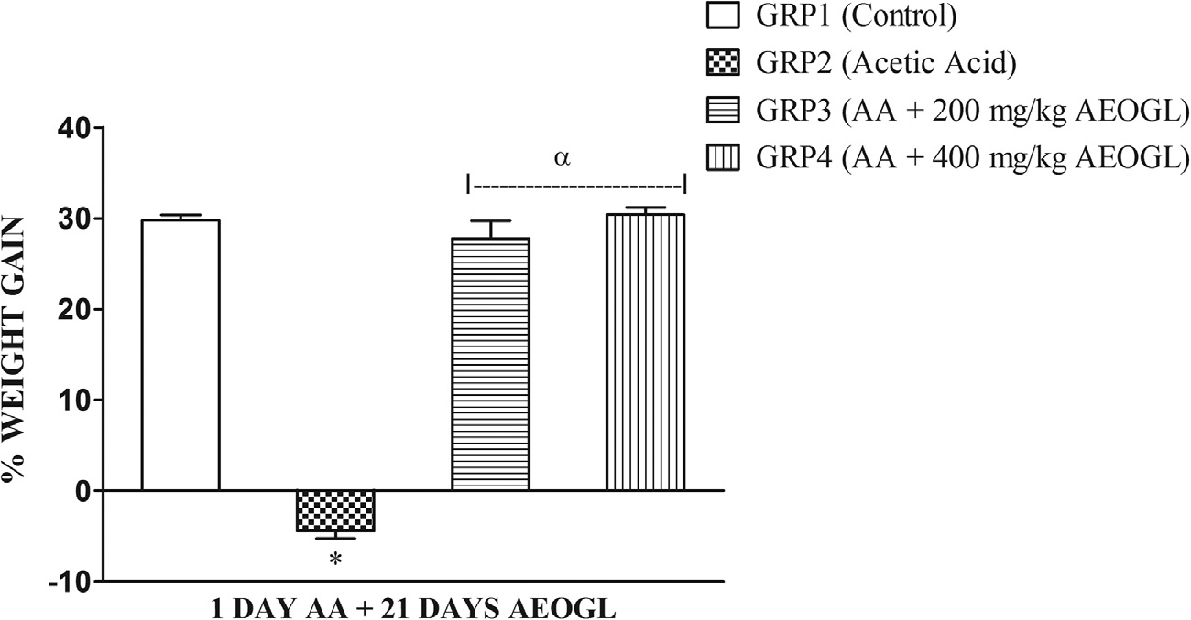

Fig. 1. Effects of AEOGL on percentage weight gain of rats induced colitis by acetic acid. Values are given as Mean ± SEM (n = 5) * = significantly different from control group (p < 0.05); a = significantly different from acetic acid group (AA) (p < 0.05).

Table 3

Effects of AEOGL on hematological parameters of rats induced colitis by acetic acid.

|  |  |  |  |  |
| --- | --- | --- | --- | --- |
| Parameters | Group 1 (Control) | Group 2 (Colitis Control) | Group 3 (AA + 200 mg/kg AEOGL) | Group 4 (AA + 400 mg/kg AEOGL) |
| WBC (×103) (/mL) | 6.80 ± 0.374 | 10.20 ± 0.837* | 7.00 ± 0.758a | 6.80 ± 0.335 a |
| NEU (×103) (/mL) | 2.50 ± 0.000 | 5.10 ± 0.001* | 4.21 ± 0.010* | 3.61 ± 0.141b |
| LYM (×103) (/mL) | 7.40 ± 0.400 | 2.80 ± 0.490* | 5.00 ± 0.100*a | 5.20 ± 0.490*a |
| GRAN (×103) | 2.00 ± 0.316 | 3.90 ± 0.120* | 2.10 ± 0.245a | 2.00 ± 0.100a |
| RBC (×106) (/mL) | 7.80 ± 0.200 | 6.08 ± 0.200* | 7.01 ± 0.245*a | 7.00 ± 0.050*a |
| HB (g/dl) | 16.90 ± 0.510 | 14.04 ± 0.245* | 15.70 ± 0.045*a | 15.60 ± 0.145*a |
| PLT (×103) (/mL) | 641.00 ± 39.657 | 559.80 ± 22.557 | 567.40 ± 10.717 | 543.00 ± 25.03 |

Values are given as Mean ± SEM (n = 5).

* = significantly different from Group 1 (control group) (p < 0.05); a = significantly different from Group 2 (acetic acid group) (p < 0.05).

b = significantly different from Group 3 (AA + 200 mg/kg AEOGL) group (p < 0.05). WBC = White blood cell, NEU = Neutrophil, LYM = Lymphocyte, GRAN = Granulocyte, RBC

= Red blood cell, HB = Hemoglobin, PLT = Platelet Count.

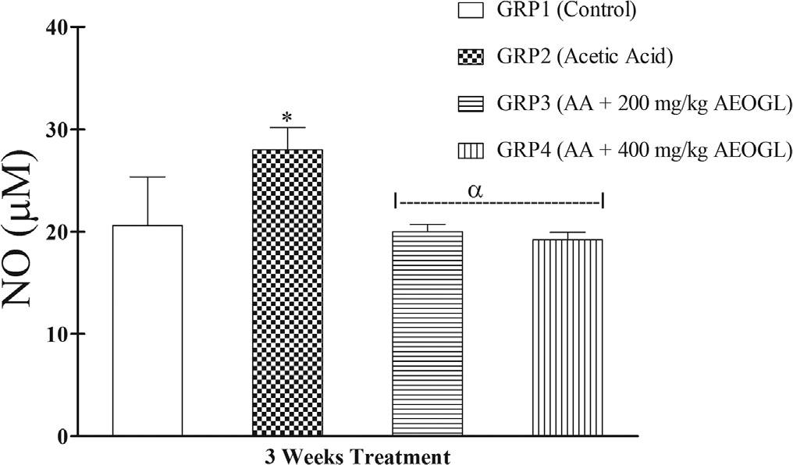

Fig. 2. Effects of AEOGL on nitric oxide (NO) of rats induced colitis by acetic acid.

Values are given as Mean ± SEM (n = 5); * = significantly different from control (p < 0.05); a = significantly different from acetic acid group (AA).

activity in the colon tissue increased significantly while the GSH level decreased significantly in the rats treated with acetic acid (colitis control group) compared with normal control animals (Fig. 4 & 5). AEOGL treatment prevented the increased in the SOD activity and decreased GSH level and maintained their normalcy in acetic acid-exposed rats (Figs. 4 & 5).

*Histological observations*

The representative photomicrographs of colon sections of con- trol and treated rats are shown in Fig. 6. The histology of the colon sections of the control rats was structurally normal having the nor- mal epithelial architecture and laminal propria, submucosa and muscularis propria. In contrast, treatment with acetic acid alone

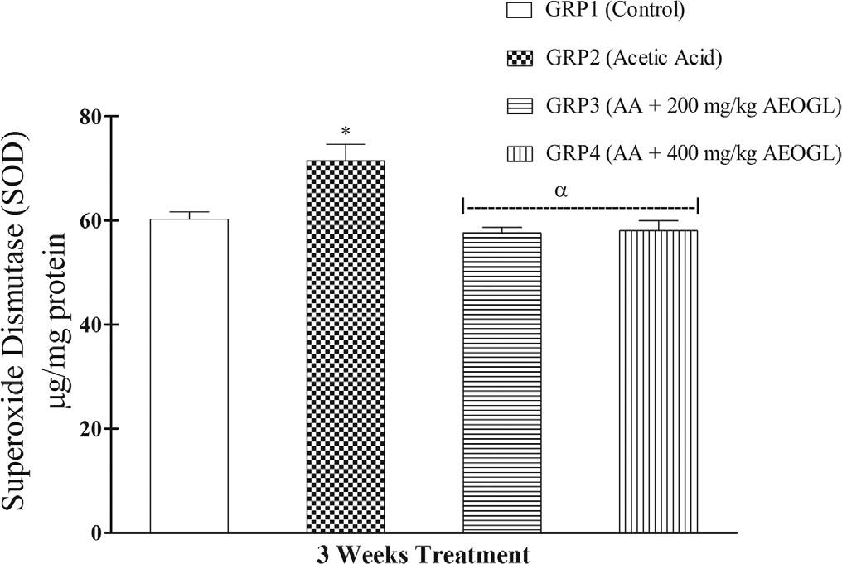Fig. 4. Effects of AEOGL on superoxide dismutase (SOD) of rats induced colitis by acetic acid. Values are given as Mean ± SEM (n = 5); * = significantly different from control (p < 0.05); a = significantly different from acetic acid group (AA) (p < 0.05).

resulted in severe epithelial erosion, necrotic and distorted cryptic glands accompanied by marked cellular infiltration by mononu- clear cells, degenerative changes in the regions of the colon. The morphological characteristics of the colon of rats treated with AEOGL showed significant amelioration of acetic acid-induced col- itis and were comparable to those in control group.

Discussion

Induction of colitis in rats using acetic acid is a classical and well-established method to produce an experimental model of col- itis similar to human colitis [28,29]. The biochemical changes are

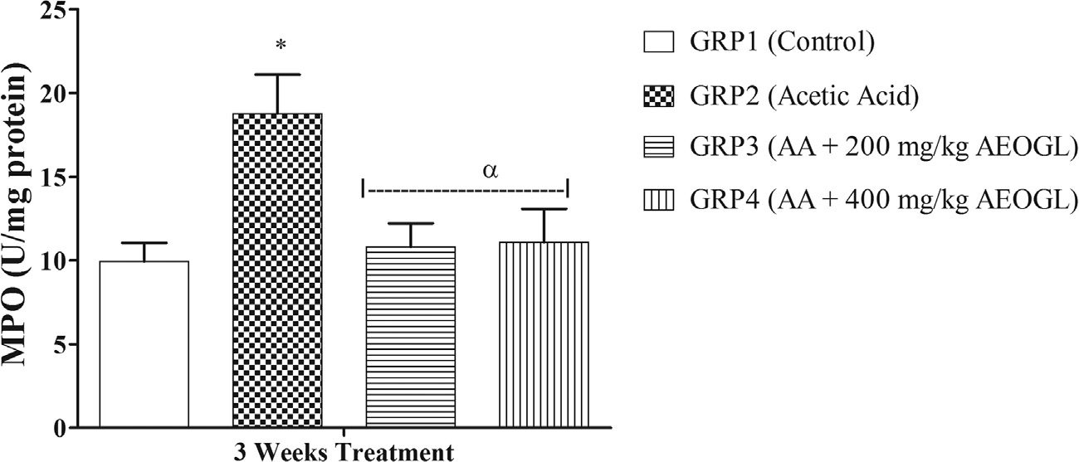

Fig. 3. Effects of AEOGL on myeloperoxidase (MPO) of rats induced colitis by acetic acid. Values are given as Mean ± SEM (n = 5); * = significantly different from control (p < 0.05); a = significantly different from acetic acid group (AA) (p < 0.05).

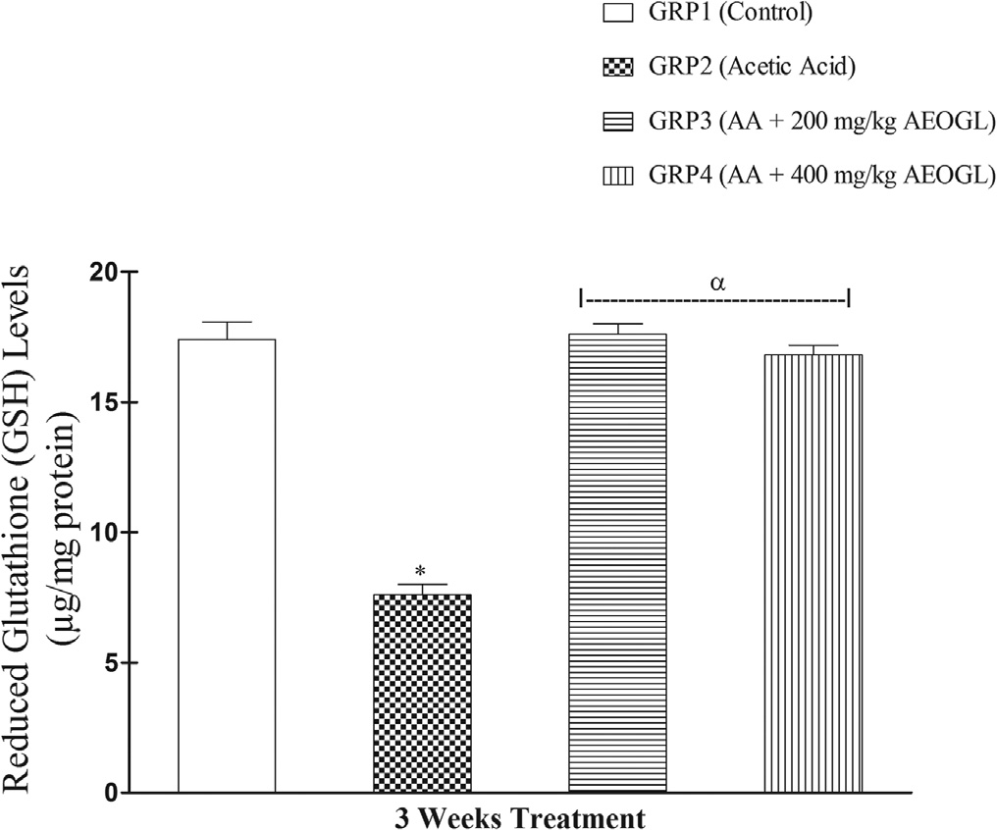

Fig. 5. Effects of AEOGL on reduced glutathione (GSH) of rats induced colitis by acetic acid. Values are given as Mean ± SEM (n = 5); * = significantly different from control (p < 0.05); a = significantly different from acetic acid group (1 day AA) (p < 0.05).

mainly excessive production of reactive oxygen and nitrogen metabolites, neutrophil infiltration, increasing local oxidative stress that aggravate tissue injury in inflammatory diseases, weight loss and diarrhea [28,29].

Weight loss and excessive bleeding of the colonic mucosal wall are one of the major symptoms of colitis. In the present study, ani- mals that were induced with acetic acid (AA) showed a decreased in body weight gain when compared with the control group. In

addition, the diarrhea scoring of rats treated with AA was signifi- cantly higher when compared with the control group. Compared with the AA group, rats treated with AEOGL at 200 and 400 mg/ kg showed an accelerated weight gain toward control group. In this study, AEOGL increase body weight by preventing the fistulae in the gastrointestinal tract e.g. diarrhea. It reduced the inflammation of the large intestine and excessive nutrient losses through diar- rhea. Study has shown that administration of AEOGL in rats caused significant histological changes in the intestines, revealing the presence of increased villi and larger goblets cells [30]. The increase in the numbers of villi in the intestine facilitates increase nutrient absorption due to increase in the surface area of the intes- tine [31]. Furthermore, AEOGL enhances anti-diarrhea effect by inhibiting intestinal motility, partly via muscarinic receptor inhibi- tion [32], thereby facilitating nutrient absorption in the intestine. The significant increase in body weight and decrease in diarrhea scores that were observed in AEOGL groups, may be as a result of AEOGL inhibited the intestinal motility, by increasing number of villi and larger goblets cells of the intestine, which favor rapid absorption of nutrient from the gastro-intestinal tract and subse- quently prevented diarrhea.

Alteration in hematological parameters due to tissue damage is an important clinical manifestation of inflammatory bowel dis- eases. Thus, an assessment of hematological parameters can be used to determine the degree of disease state of colitis [33].

Decrease in red blood cell count (RBC) could reveal an imbal- ance between its production and loss [34]. The results obtained in this study revealed that AA induced colitis caused significant reduction in red blood cell counts (RBC) with subsequent decline in hemoglobin (HB) concentration. The observed decrease in the number of RBCs, accompanied by a decreased HB, seems to confirm that colitis probably caused excessive blood loss as a result of seri- ous gastrointestinal tract bleeding, hemolysis of red blood cell and

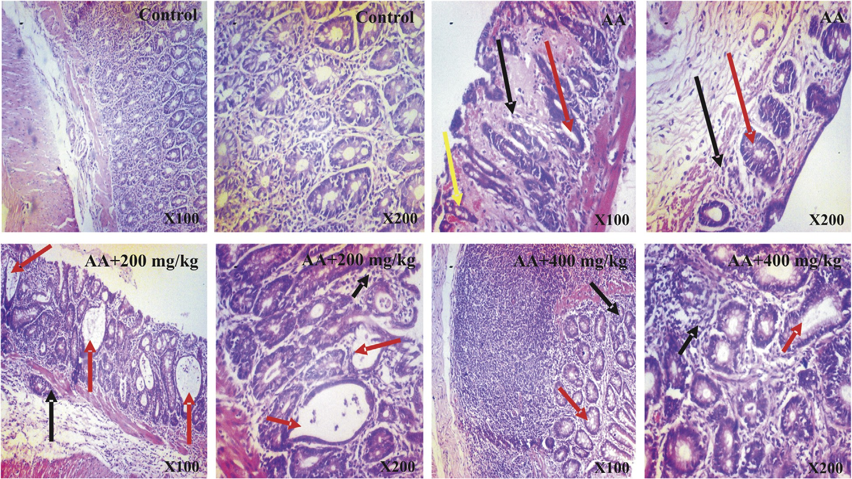

Fig. 6. Photomicrographs of colon tissues showing the effects of AEOGL administration following acetic acid-induced colitis. Photomicrograph of the colon of Control (CN), Acetic Acid (AA), AA + 200 mg/kg and AA + 400 mg/kg. CN shows presence of intact T-lymphocytes and intraepithelial lymphocytes. Abundant or proportionate goblet cells and absorptive cells. In contrast, AA shows severe mucosal atrophy, hyperchromatic nuclei (black arrow), loss of goblet cells, crypts distortions and abscesses (red arrow), hyperemia and tissue hemorrhage (yellow arrow). 200 and 400 mg/kg (Groups 3 and 4) AEOGL treated group showed greater signs of improvement, revealing higher/greater numbers of crypts/glands. They showed high glandular/mucosal height (black arrow), prominent intraepithelial lymphocytes, signs of crypt distortions and abscesses (red

arrow). (H & E Stain; ×100 & 400).

poor absorption of iron in the intestine. The results of this study showed that, the aqueous extract of *Ocimum gratissimum* leaves administered at the dosages used and for the duration of the exper- iment appeared to improve the red blood cells and HB counts in rats toward control. However, there was a significant decrease in RBC count and HB concentrations in rats treated with AEOGL when compared with the control. The reduction in the RBCs and HB count in the experimental groups, as compared with the control is an indication that AEOGL failed to completely inhibit the effect of acetic acid on colonic blood loss.

In this study, the rats induced with colitis showed a significant increase in white blood cell counts (WBC), neutrophil (NEU), monocyte (MON) and granulocyte (GRAN) counts when compared with the control group, but the lymphocyte counts significantly decrease when compared with the control group. The observed decrease in lymphocyte counts may be as a result of the immuno- suppressive effects of colitis on the bone marrow through the inhi- bition of T cell activity. The administration of 200 and 400 mg/kg doses of the AEOGL significantly normalized the white blood cells, lymphocyte, monocyte and granulocyte counts. It is possible that the extract contained agents that stimulated the bone marrow to produce leucocyte and release them into the blood. Leucocyte are activated when the body is invaded by bacteria and they provide the first line of defense against invading microorganisms [35]. The granules of the granulocytes, particularly neutrophil contain many enzymes, which makes it a powerful and effective defensive agent and hence, deficiency of neutrophils in the body leads to myriad defects, including conditions such as colitis [35]. However, administration of AEOGL significantly ameliorated the hematolog- ical parameters of the colitis rats toward control.

In this study, acute exposure to acetic acid significantly increased the colonic tissue nitric oxide (NO) concentration in the rats when compared with the control. Under normal physiolog- ical conditions, NO produces an anti-inflammatory effect. How- ever, it is considered as a proinflammatory mediator that induces inflammation due to overproduction by inducible nitric oxide syn- thase (iNOS) in abnormal situations [36]. The elevated concentra-

tion of NO in AA-exposed rats observed in this study could lead to NO reaction with superoxide anion (O—) to form potent oxidant peroxynitrite (ONOO–) and impair the colonic mucosa. The present study showed that administration of AEOGL significantly inhibited

2

NO production which prevented peroxynitrite formation from inflammatory cells and countered inflammation. The apparent sup- pression in AA-mediated increase in NO concentration by AEOGL suggests its ability to prevent neutrophil infiltration and inflamma- tion in the colon [37,38] as it was also seen in the photomicrograph of groups treated with AEOGL.

Myeloperoxidase (MPO) is found primarily in the azurophilic granules of neutrophils [39]. The assay of this enzyme has been widely used as an index of severity of digestive inflammation [39]. Accumulation of granulocytes in the colon could contribute to granulocyte-mediated mucosal tissue damage, breakdown of the mucosal barrier and subsequent inflammatory response [40]. Relative to the normal control group, there was marked elevation in the activities of MPO in the acetic acid treated group. The observed increase in the colonic MPO activity indicates colonic inflammation damage as a result of neutrophil infiltration into the colons of AA-treated rats. However, the results of the rats post-treated with AEOGL showed marked reduction in the activi- ties of MPO and histopathological changes induced by acetic acid only showed less colonic mucosal injury with less infiltration of leucocytes and cellular changes in AEOGL treated rats.

Superoxide dismutase (SOD) is an enzyme existing in mito- chondria as well as cytosol which is responsible for the mainte- nance of redox balance in the tissue [41,42]. The increased level of reactive oxygen species caused deregulation of cellular redox

balance [42]. Superoxide dismutase (SOD) reduces superoxide to water (O2– to H2O) thus playing a pivotal role in scavenging of oxidative free radicals [43]. In this study, SOD was found to be higher in the acetic acid treated group when compared with the control group. The increased in SOD in AA-induced colitis reflects uncontrolled oxidative stress. Aqueous extract of *Ocimum gratissi- mum* leaves treatment brought back SOD activities to normal, thus restoring oxidative balance in the colonic mucosa.

Reduced glutathione (GSH) is an important intracellular antiox- idant agent in mammalian gut and involved in the repair mecha- nism of mucosal damage by free radicals. It plays an important role in protecting the intestinal cells and act as a defense mecha- nism against inflammation [44]. During inflammation, GSH level decreases resulting in severe colon mucosal injury. In this study, acetic acid treatment resulted to reduction of colonic tissue GSH level. However, treatment with AEOGL significantly normalized the colonic tissue GSH level. The improvement of GSH showed that AEOGL might have depleted ROS level, relieved the inhibition of the antioxidant enzymes and/or might have triggered their synthe- sis which in turn attenuated the oxidative damage in AA-treated rats.

The aqueous extract of *Ocimum gratissimum* leaves are rich in flavonoids and phenolic compounds (Table 1). Previous studies have reported the protective action of flavonoids and phenols against oxidative stress induced cellular damage [45,46]. Flavo- noids and phenols can exert their anti-inflammatory and anti- oxidative activities by various mechanisms, e.g. by scavenging or quenching free radicals, by chelating metal ions, or by inhibiting enzymatic systems responsible for free radical generation [47]. The anti-inflammatory and anti-oxidative properties of AEOGL can also be due to the presence of saponin, terpenoids, glycoside and alkaloids present in this plant [48]. In this study, AEOGL inter- vention shows restoration of oxidant and/or antioxidant balance and this may be suggests that the phytochemical components of the extract have favorable effects on the antioxidant defense sys- tems and hematological parameters. These resultant mechanisms explained the involvement of the extract in colonic tissue integrity preservation observed in this study. Thus, AEOGL treatment effec- tively ameliorated the induction of oxidative stress, inflammatory cells infiltration, hematological alteration and histological damage in the AA-treated rats. Overall, the findings of this study show the efficacy of AEOGL to prevent AA-induced colonic mucosa injury. The anti-colitis effect of AEOGL is related to its anti- inflammatory and anti-oxidative properties. However, it can be suggested that the therapeutic effect of AEOGL can also be associ- ated with improved blood supply to the mucosa and the whole intestinal wall under the influence of the extract and other effects. Hence more studies has to been done to ascertain the mechanism behind anti-colitis effect of *Ocimum gratissimum* leaves.

Conflict of interest

The authors of this manuscript declare no conflict of interest.

References

1. [Loftus Jr EV. Clinical epidemiology of inflammatory bowel disease: Incidence,](http://refhub.elsevier.com/S2314-808X(18)30004-6/h0005) [prevalence, and environmental influences. Gastroenterology](http://refhub.elsevier.com/S2314-808X(18)30004-6/h0005) [2004;126:1504–17](http://refhub.elsevier.com/S2314-808X(18)30004-6/h0005).
2. [Baumgart DC, Sandborn WJ. Inflammatory bowel disease: clinical aspects and](http://refhub.elsevier.com/S2314-808X(18)30004-6/h0010) [established and evolving therapies. Lancet 2007;369:1641–57](http://refhub.elsevier.com/S2314-808X(18)30004-6/h0010).
3. [Kaser A, Zeissig S, Blumberg RS. Inflammatory bowel disease. Ann Rev](http://refhub.elsevier.com/S2314-808X(18)30004-6/h0015) [Immunol 2010;28:573–621](http://refhub.elsevier.com/S2314-808X(18)30004-6/h0015).
4. [Yukitake H, Kimura H, Suzuki H, Tajima Y, Sato Y, Imaeda T, et al. BTZO-15, an](http://refhub.elsevier.com/S2314-808X(18)30004-6/h0020) [ARE-Activator Ameliorates DSS- and TNBS-Induced colitis in rats. PLoS One](http://refhub.elsevier.com/S2314-808X(18)30004-6/h0020) [2011;6(8):e23256](http://refhub.elsevier.com/S2314-808X(18)30004-6/h0020).
5. [Podolsky DK. Inflammatory bowel disease. N Engl J Med 2002;347:417–29](http://refhub.elsevier.com/S2314-808X(18)30004-6/h0025).
6. [Kong SC, Hurlstone DP, Pocock CY, Walkington LA, Farquharson NR, Bramble](http://refhub.elsevier.com/S2314-808X(18)30004-6/h0030) [MG, et al. The incidence of self-prescribed oral complementary and alternative](http://refhub.elsevier.com/S2314-808X(18)30004-6/h0030) [medicine use by patients with gastrointestinal diseases. J Clin Gastroenterol](http://refhub.elsevier.com/S2314-808X(18)30004-6/h0030) [2005;39:138–41](http://refhub.elsevier.com/S2314-808X(18)30004-6/h0030).
7. [Effraim KD, Jacks TW, Sodipo OA. Histopathological studies on the toxicity of](http://refhub.elsevier.com/S2314-808X(18)30004-6/h0035) [Ocimum gratissimum leave extract on some organs of rabbit. Afr J Biomed Res](http://refhub.elsevier.com/S2314-808X(18)30004-6/h0035) [2003;6:21–5](http://refhub.elsevier.com/S2314-808X(18)30004-6/h0035).
8. [Nadkarni KM. Indian materia medica. third ed. India: Popular Prakashan Pvt](http://refhub.elsevier.com/S2314-808X(18)30004-6/h0040) [Ltd; 1999](http://refhub.elsevier.com/S2314-808X(18)30004-6/h0040).
9. [Akinmoladun AC, Ibukun EO, Emmanuel A, Obuotor EM, Farombi EO.](http://refhub.elsevier.com/S2314-808X(18)30004-6/h0045) [Phytochemical constituent and antioxidant activity of extract from the](http://refhub.elsevier.com/S2314-808X(18)30004-6/h0045) [leaves of Ocimum gratissimum. Sci Res Essays 2007:163–6](http://refhub.elsevier.com/S2314-808X(18)30004-6/h0045).
10. [Rabelo M, Souza EP, Soares PMG, Miranda AV, Matos FJA, Criddle DN.](http://refhub.elsevier.com/S2314-808X(18)30004-6/h0050) [Antinociceptive properties of the essential oil of Ocimum gratissimum L.](http://refhub.elsevier.com/S2314-808X(18)30004-6/h0050) [(Labiatae) in mice. Braz J Med Biol Res 2003;36:521–4](http://refhub.elsevier.com/S2314-808X(18)30004-6/h0050).
11. [Ijeh II, Omodamiro OD, Nwanna IJ. Antimicrobial effects of aqueous and](http://refhub.elsevier.com/S2314-808X(18)30004-6/h0055) [ethanolic fractions of two spices, Ocimum gratissimum and Xylopia](http://refhub.elsevier.com/S2314-808X(18)30004-6/h0055) [aethiopica. Afr J Biotechnol 2005;4:953–6](http://refhub.elsevier.com/S2314-808X(18)30004-6/h0055).
12. [Sahouo GB, Tonzibo ZF, Boti B, Chopard C, Mahy JP, N’guessan YT. Anti-](http://refhub.elsevier.com/S2314-808X(18)30004-6/h0060) [inflammatory and analgesic activities: Chemical constituents of essential oils](http://refhub.elsevier.com/S2314-808X(18)30004-6/h0060) [of Ocimum gratissimum, Eucalyptus citriodora and Cymbopogon giganteus](http://refhub.elsevier.com/S2314-808X(18)30004-6/h0060) [inhibited lipoxygenase L-*1*](http://refhub.elsevier.com/S2314-808X(18)30004-6/h0060)[and cyclooxygenase of PGHS. Bull Chem Soc Ethiop](http://refhub.elsevier.com/S2314-808X(18)30004-6/h0060) [2003;17(2):191–7](http://refhub.elsevier.com/S2314-808X(18)30004-6/h0060).
13. [Adebolu TT, Salau AO. Antimicrobial activity of extracts of Ocimum gratissium](http://refhub.elsevier.com/S2314-808X(18)30004-6/h0065) [on selected diarrhea causing bacteria in southwestern Nigeria. Afr J Biotechnol](http://refhub.elsevier.com/S2314-808X(18)30004-6/h0065) [2005;4(7):682–4](http://refhub.elsevier.com/S2314-808X(18)30004-6/h0065).
14. [Orafidiya LO, Adesina SK, Igbeneghu O, Akinkunmi EO, Adetogun GE, Salau AO.](http://refhub.elsevier.com/S2314-808X(18)30004-6/h0070) [The effect of honey and surfactant type on the antibacterial properties of the](http://refhub.elsevier.com/S2314-808X(18)30004-6/h0070) [leaf essential oil of Ocimum gratissmum Linn. Against common wound-](http://refhub.elsevier.com/S2314-808X(18)30004-6/h0070) [infecting organisms. Int J Aromather 2006;16:57–62](http://refhub.elsevier.com/S2314-808X(18)30004-6/h0070).
15. [Alabi QK, Akomolafe RO, Omole JG, Adefisayo MA, Ogundipe OL, Aturamu A,](http://refhub.elsevier.com/S2314-808X(18)30004-6/h0075) [et al. Polyphenol rich extract of Ocimum gratissimum leaves ameliorates](http://refhub.elsevier.com/S2314-808X(18)30004-6/h0075) [colitis via attenuating colonic mucosa injury and regulating pro-inflammatory](http://refhub.elsevier.com/S2314-808X(18)30004-6/h0075) [cytokines production and oxidative stress in rats. Biomed Pharmacother](http://refhub.elsevier.com/S2314-808X(18)30004-6/h0075) [2018;103:812–22](http://refhub.elsevier.com/S2314-808X(18)30004-6/h0075).
16. [Trease GE, Evans WC. Pharmacognosy. London: Ballière Tindall Press; 1983](http://refhub.elsevier.com/S2314-808X(18)30004-6/h0080).
17. [Singleton VL, Rossi JA. Colorimetry of total phenolics with phosphomolybdic](http://refhub.elsevier.com/S2314-808X(18)30004-6/h0085) [phosphotungstic acid reagents. Am J Enol Viticult 1965;16:144–58](http://refhub.elsevier.com/S2314-808X(18)30004-6/h0085).
18. [Gulcin I, Oktay M, Kirecci E, Kufrevioglu OI. Screening of antioxidant and](http://refhub.elsevier.com/S2314-808X(18)30004-6/h0090) [antimicrobial activities of anise (Pimpinella anisum L.) seed extracts. Food](http://refhub.elsevier.com/S2314-808X(18)30004-6/h0090) [Chem 2003;83:371–82](http://refhub.elsevier.com/S2314-808X(18)30004-6/h0090).
19. [Zhilen J, Mengeheng T, Jianming W. The determination of flavonoids contents](http://refhub.elsevier.com/S2314-808X(18)30004-6/h0095) [in mulberry and their scavenging effects on superoxide radicals. Food Chem](http://refhub.elsevier.com/S2314-808X(18)30004-6/h0095) [1999;64:555–9](http://refhub.elsevier.com/S2314-808X(18)30004-6/h0095).
20. [Miliauskas G, Venskutonis PR, van Beek TA. Screening of radical scavenging](http://refhub.elsevier.com/S2314-808X(18)30004-6/h0100) [activity of some medicinal and aromatic plant extracts. Food Chem](http://refhub.elsevier.com/S2314-808X(18)30004-6/h0100) [2004;85:231–7](http://refhub.elsevier.com/S2314-808X(18)30004-6/h0100).
21. [Davies RP, Morrow WEM, Miller DC, Deen J. Epidemiologic study of decubital](http://refhub.elsevier.com/S2314-808X(18)30004-6/h0105) [ulcer in sow. J Am Vet Med Assoc 1996;208(7):1058–62](http://refhub.elsevier.com/S2314-808X(18)30004-6/h0105).
22. [Zheng L, Gao Z, Wang S. Chronic ulcerative colitis model in rats. World J](http://refhub.elsevier.com/S2314-808X(18)30004-6/h0110) [Gastroenterol 2000;6(1):150–2](http://refhub.elsevier.com/S2314-808X(18)30004-6/h0110).
23. [Dong WG, Liu SP, Yu BP, Wu DF, Luo HS, Yu JP. Ameliorative effects of sodium](http://refhub.elsevier.com/S2314-808X(18)30004-6/h0115) [ferulate on experimental colitis and their mechanisms in rats. World J](http://refhub.elsevier.com/S2314-808X(18)30004-6/h0115) [Gastroenterol 2003;9(11):2533–8](http://refhub.elsevier.com/S2314-808X(18)30004-6/h0115).
24. [Misra HP, Fridovich I. The role of superoxide anion in the autooxidation of](http://refhub.elsevier.com/S2314-808X(18)30004-6/h0120) [epinephrine and a simple assay for superoxide dismutase. J Biol Chem](http://refhub.elsevier.com/S2314-808X(18)30004-6/h0120) [1972;247:3170–5](http://refhub.elsevier.com/S2314-808X(18)30004-6/h0120).
25. [Beutler E, Durgun O, Kelly BM. Improved method for the determination of](http://refhub.elsevier.com/S2314-808X(18)30004-6/h0125) [blood glutathione. J Lab Clin Med 1963;51:882–8](http://refhub.elsevier.com/S2314-808X(18)30004-6/h0125).
26. [Grisham MB, Johnson GG, Lancaster Jr JR. Quantitation of nitrite and nitrite in](http://refhub.elsevier.com/S2314-808X(18)30004-6/h0130) [extracellular fluids. Methods Enzymol 1996;268:237–46](http://refhub.elsevier.com/S2314-808X(18)30004-6/h0130).
27. [Xia Y, Zweier JL. Measurement of myeloperoxidase in leukocyte-containing](http://refhub.elsevier.com/S2314-808X(18)30004-6/h0135) [tissues. Anal Biochem 1997;245:93–6](http://refhub.elsevier.com/S2314-808X(18)30004-6/h0135).
28. [Fabia R, Willen R, A’rRajab A, Andersson R, Ahren B, Bengmark S. Acetic acid-](http://refhub.elsevier.com/S2314-808X(18)30004-6/h0140) [induced colitis in the rat: a reproducible experimental model for acute](http://refhub.elsevier.com/S2314-808X(18)30004-6/h0140) [ulcerative colitis. Eur Surg Res 1992;24(4):211–25](http://refhub.elsevier.com/S2314-808X(18)30004-6/h0140).
29. [Kojima R, Hamamoto S, Moriwaki M, Iwadate K, Ohwaki T. The new](http://refhub.elsevier.com/S2314-808X(18)30004-6/h0145) [experimental ulcerative colits model in rats induced by subserosal injection](http://refhub.elsevier.com/S2314-808X(18)30004-6/h0145) [of acetic acid. Nihon Yakurigaku Zasshi 2001;118(2):123–30](http://refhub.elsevier.com/S2314-808X(18)30004-6/h0145).
30. [Iweala EEJ, Obidoa O. Studies on some biochemical and histological changes](http://refhub.elsevier.com/S2314-808X(18)30004-6/h0150) [associated with long term consumption of leaves of *Ocimum gratissimum* L. in](http://refhub.elsevier.com/S2314-808X(18)30004-6/h0150) [male rats. Am J Food Technol 2010;5:376–84](http://refhub.elsevier.com/S2314-808X(18)30004-6/h0150).
31. [Pappenheimer JP. Intestinal absorption of hexoses and amino acids: from](http://refhub.elsevier.com/S2314-808X(18)30004-6/h0155) [apical cytosol to villus capillaries. J Membr Biol 2001;184:233](http://refhub.elsevier.com/S2314-808X(18)30004-6/h0155).
32. [Offiah VN, Chikwendu UA. Antidiarrhoeal effects of Ocimum gratissimum leaf](http://refhub.elsevier.com/S2314-808X(18)30004-6/h0160) [extract in experimental animals. J Ethnopharmacol 1999;68:327–30](http://refhub.elsevier.com/S2314-808X(18)30004-6/h0160).
33. [Jagtap AG, Niphadkar PV, Phadke AS. Protective effect of aqueous extract of](http://refhub.elsevier.com/S2314-808X(18)30004-6/h0165) [Bombax malabaricum DC on experimental models of inflammatory bowel](http://refhub.elsevier.com/S2314-808X(18)30004-6/h0165) [disease in rats and mice. Indian J Exp Biol 2011;49:343–51](http://refhub.elsevier.com/S2314-808X(18)30004-6/h0165).
34. [Alabi QK, Akomolafe RO, Olukiran OS, Nafiu AO, Omole JG, Adefisayo AM, et al.](http://refhub.elsevier.com/S2314-808X(18)30004-6/h0170) [Assessment of haematological and biochemical effects of Kolaviron in Male](http://refhub.elsevier.com/S2314-808X(18)30004-6/h0170) [Wistar Rats. Br J Pharm Res 2017;16(3):1–14](http://refhub.elsevier.com/S2314-808X(18)30004-6/h0170).
35. [Ganong WF. Review of medical physiology. 22nd ed. Singapore: McGraw Hill;](http://refhub.elsevier.com/S2314-808X(18)30004-6/h0175) [2005. p. 515–7](http://refhub.elsevier.com/S2314-808X(18)30004-6/h0175).
36. [Cross RK, Wilson KT. Nitric oxide in inflammatory bowel disease. Inflamm](http://refhub.elsevier.com/S2314-808X(18)30004-6/h0180) [Bowel Dis 2003;9:179–89](http://refhub.elsevier.com/S2314-808X(18)30004-6/h0180).
37. [Gillberg L, Varsanyi M, Sjostrom M, Lordal M, Lindholm J, Hellstrom PM. Nitric](http://refhub.elsevier.com/S2314-808X(18)30004-6/h0185) [oxide pathway-related gene alterations in inflammatory bowel disease. Scand](http://refhub.elsevier.com/S2314-808X(18)30004-6/h0185) [J Gastroenterol 2012;2012(47):1283–97](http://refhub.elsevier.com/S2314-808X(18)30004-6/h0185).
38. [Wadie W, Abdel-Aziz H, Zaki HF, Kelber O, Weiser D, Khayyal MT. STW 5 is](http://refhub.elsevier.com/S2314-808X(18)30004-6/h0190) [effective in dextran sulfate sodium-induced colitis in rats. Int J Colorectal Dis](http://refhub.elsevier.com/S2314-808X(18)30004-6/h0190) [2012;27:144–53](http://refhub.elsevier.com/S2314-808X(18)30004-6/h0190).
39. [Klebanoff SJ. Myeloperoxidase: friend and foe. J Leukoc Biol 2005;77](http://refhub.elsevier.com/S2314-808X(18)30004-6/h0195) [(5):598–625](http://refhub.elsevier.com/S2314-808X(18)30004-6/h0195).
40. [Mantovani A, Muzio M, Garlanda C, Sozzani S, Allavena P. Macrophage control](http://refhub.elsevier.com/S2314-808X(18)30004-6/h0200) [of inflammation: negative pathways of regulation of inflammatory cytokines.](http://refhub.elsevier.com/S2314-808X(18)30004-6/h0200) [Novartis Found Symp 2010;234:120–31](http://refhub.elsevier.com/S2314-808X(18)30004-6/h0200).
41. [Abreu MT. The pathogenesis of inflammatory bowel disease: translational](http://refhub.elsevier.com/S2314-808X(18)30004-6/h0205) [implications for clinicians. Curr Gastroenterol Rep 2002;4:481–9](http://refhub.elsevier.com/S2314-808X(18)30004-6/h0205).
42. [Kandhare AD, Raygude KS, Ghosh P, Ghule AE, Gosavi TP, Badole SL, et al. Effect](http://refhub.elsevier.com/S2314-808X(18)30004-6/h0210) [of hydroalcoholic extract of Hibiscus rosa sinensis Linn. leaves in experimental](http://refhub.elsevier.com/S2314-808X(18)30004-6/h0210) [colitis in rats. Asian Pac J Trop Biomed 2012;5:337–44](http://refhub.elsevier.com/S2314-808X(18)30004-6/h0210).
43. [Kruidenier L, Kuiper I, Van Duijn W, Mieremet-Ooms MA, van Hogezand RA,](http://refhub.elsevier.com/S2314-808X(18)30004-6/h0215) [Lamers CB, et al. Imbalanced secondary mucosal antioxidant response in](http://refhub.elsevier.com/S2314-808X(18)30004-6/h0215) [inflammatory bowel disease. J Pathol 2003;201:17–27](http://refhub.elsevier.com/S2314-808X(18)30004-6/h0215).
44. [Chavan S, Sava L, Saxena V, Pillai S, Sontakke A, Ingole D. Reduced glutathione:](http://refhub.elsevier.com/S2314-808X(18)30004-6/h0220) [importance of specimen collection. Indian J Clin Biochem 2005;20:150–2](http://refhub.elsevier.com/S2314-808X(18)30004-6/h0220).
45. [Sharma V, Rajani GP. Evaluation of Caesalpinia pulcherrima Linn. for anti-](http://refhub.elsevier.com/S2314-808X(18)30004-6/h0225) [inflammatory and antiulcer activities. Indian J Pharmacol 2011;43(2):168–71](http://refhub.elsevier.com/S2314-808X(18)30004-6/h0225).
46. Alabi QK, Olukiran OS, Adefisayo MA, Fadeyi BA. Effects of treatment with Nauclea latifolia root decoction on sexual behavior and reproductive functions in male rabbits. J Dietary Suppl 2017. doi: [https://doi.org/10.1080/](https://doi.org/10.1080/19390211.2017.1380105) [19390211.2017.1380105](https://doi.org/10.1080/19390211.2017.1380105).
47. [Lukacinova A, Mojzis J, Benacka R, Keller J, Maguth T, Kurila P. Preventive](http://refhub.elsevier.com/S2314-808X(18)30004-6/h0235) [effects of flavonoids on alloxan-induced diabetes mellitus in rats. Acta Vet](http://refhub.elsevier.com/S2314-808X(18)30004-6/h0235) [2008;77:175–82](http://refhub.elsevier.com/S2314-808X(18)30004-6/h0235).
48. Mishra J, Srivastava RK, Shukla SV, Raghav CS. Antioxidants in aromatic & medicinal plants. Science Tech entrepreneur; 2007.