

[Egyptian Informatics Journal (2015) 16, 113–119](http://dx.doi.org/10.1016/j.eij.2015.02.001)

Cairo University

Egyptian Informatics Journal

[www.elsevier.com/locate/eij](http://www.elsevier.com/locate/eij) [www.sciencedirect.com](http://www.sciencedirect.com/science/journal/11108665)

ORIGINAL ARTICLE

The effect of location errors on location based routing protocols in wireless sensor networks



Mohsen Kadi *, Iyad Alkhayat

*Network and Operating Systems Department, Information Technology Engineering Faculty, Damascus University, Syrian Arab Republic*

Received 6 July 2014; revised 22 January 2015; accepted 8 February 2015

Available online 2 March 2015

Abstract Location-based routing protocols use position information for making packet forward- ing decisions, assuming perfect location information. Unlike topological routing algorithms, they do not need to exchange and maintain routing information. They work nearly stateless. However, in practice there could be significant errors in obtaining location estimates.

In this paper, the impact of location errors on power consumption of these protocols will be analyzed via developing a mathematical model represents the location errors that may occur in real deployment. Then a simulation of the power consumption of two location-based routing protocols, Geographic Random Forwarding (GeRaf) and Minimum Energy Consumption Forwarding (MECF), is carried out to evaluate the mathematical model.

KEYWORDS

WSN;

GeRaf; MECF;

Location error

Both the obtained simulation results and the developed mathematical model show that this type of routing protocols suffers from substantial performance degradation in terms of power consumption in presence of location errors.

© 2015 Production and hosting by Elsevier B.V. on behalf of Faculty of Computers and Information, Cairo University. This is an open access article under the CC BY-NC-ND license (ht[tp://creativecommons.](http://creativecommons.org/licenses/by-nc-nd/4.0/)

or[g/licenses/by-nc-nd/4.0/).](http://creativecommons.org/licenses/by-nc-nd/4.0/)

1. Introduction

A wireless sensor network (WSN) is an infrastructure com- prised of sensing (measuring), computing, and communication elements that give an administrator the ability to instrument, observe, and react to events and phenomena in a specified

* Corresponding author.

Peer review under responsibility of Faculty of Computers and Information, Cairo University.

**Production and hosting by Elsevier**

environment. WSN subjects to a unique set of resource con- straints such as finite battery power and limited bandwidth. In a typical sensor network, each sensor node has a micropro- cessor, a small amount of memory, one or more sensing devices, and ability to communicate wirelessly with other nodes within its radio range. Usually a WSN consists of large number of sensors that are deployed randomly, and it has self- configuring ability that allows formation of connections and copes with the resultant nodal distribution. These inherent characteristics make routing in WSN very challenging, and push toward designing new routing protocols to optimize resource usage, especially power efficiency. This is because power is the key constraint, as sensors have to work unattend- ed, sometimes for a long period of time once they are placed.

<http://dx.doi.org/10.1016/j.eij.2015.02.001>

1110-8665 © 2015 Production and hosting by Elsevier B.V. on behalf of Faculty of Computers and Information, Cairo University.

This is an open access article under the CC BY-NC-ND license [(http://creativecommons.org/licenses/by-nc-nd/4.0/).](http://creativecommons.org/licenses/by-nc-nd/4.0/)

114 M. Kadi, I. Alkhayat

Routing protocols in wireless sensor networks are classified in the following basic four categories.

* 1. *Data-centric protocols*

In data-centric protocols, each source sensor that has the appropriate data responds by sending its data to the sink independently of all other sensors [1].

* 1. *Hierarchical protocols*

WSN is divided to multiple clusters, and each cluster is man- aged by a special node, called cluster head, which is responsible for coordinating the data transmission activities of all sensors in its cluster [2].

* 1. *Location-based protocols*

In location-based protocols, sensor nodes are addressed by means of their locations. They use locations information for making packet forwarding decisions [3].

* 1. *QoS-based protocols*

It is also important to consider quality of service (QoS) requirements in terms of delay, reliability, and fault tolerance in routing in WSNs [6]. QoS based routing protocols try to find a balance between energy consumption and QoS requirements. Location based routing protocols determine the path to send the traffic through by using the position information of the source, the direct neighbors of the source and the destina- tion. As a result, very little routing information is needed and no energy is spent on route discovery, queries or replies. Node memory and computation requirements are decreased as well as the routing protocol’s traffic overhead. In location-based routing, the process is localized and distributed so that all

nodes are involved in the routing process [7].

In this paper, the power consumption of two routing proto- cols will be investigated. The first one is GeRaf, which is one of the location based routing protocols [4]. It is designed for wire- less ad-hoc and sensor networks. In this protocol, at any hop, the sender node chooses the neighbor that is closest to the des- tination as next relay. While in the second protocol, MECF [5], at any hop, the sender node chooses the neighbor that is closest

to it as next relay.

protocol. Another study [9] developed an analytical method for examining node’s location error in multihop networks. The method depends on Cram´er Rao bound (CRB) to com- pute the accuracy of localization. This study does not clarify the error’s impact on location based routing protocols. On the other hand [10], evaluates localization algorithms used in WSN depending on traditional metrics, and introduces new metrics that can distinguish better among alternative localiza- tion algorithms without showing the effect of these localization errors on the routing protocols.

In this paper, a new mathematical model for localization errors in wireless sensor networks will be developed. This mod- el is based on Gaussian distribution to comprise all the sources of location errors in WSN. Using this model, the impact of localization errors on the power consumption of location based routing protocols will be investigated. Finally, the model will be verified by simulating the power consumption of two location based routing protocols.

In summary, compared with the study in [8], Gaussian dis- tributed location errors are introduced on node coordinates to study the effect of location errors on location based routing in general, not just for a specific protocol description. Compared with [9,10], this study investigates the effect of location errors on the power consumption of the location based routing protocols.

3. Mathematical model

There are many sources of location errors in the localization process. One of them is inaccurate measurement of distance or bearing due to sensing technology limitations or environ- ment noise. Also, localization algorithms may cause errors due to the resource limitation of the sensors [11]. There are many other factors that contribute to the final error in the localization process such as network density, uncertainties in anchor locations and anchor density. Therefore, a Gaussian distribution is more appropriate to model location errors due to the many uncertainties involved in localization process. In this study, it will be assumed that we have large number of sen- sors deployed randomly in Euclidean plane. The location error at each node is modeled by a Gaussian distribution [12], with zero mean and finite standard deviation. The zero mean assumption follows the law of large numbers:

1 X*n*

lim

*n*→∞ *n k*—1

*xk* = 0 (1)

1. Related work

Location based routing protocols assume that the obtained location information is perfect. However, in reality there are errors in the location information. These errors are produced by the localization process. Many researches focused on this fact. [8] Introduces an analysis of the errors impact on location based routing in wireless ad hoc networks. This analysis is based on the assumption that the localization algorithm has an error characteristic that is circularly symmetric, i.e., the localization algorithm would localize a node anywhere within a disk around its actual position. The researchers analyzed and simulated only specific protocol description and observe the packet delivery ratio and the power consumption of that

where *n* is the number of sensor in network, *xk* is the location error at sensor *k* on one of the axes, *k* is an integer.

It will be assumed that the location errors for all nodes in a network are independent and the variance of Gaussian error on *x*-axis and *y*-axis for each individual node is equal.

Fig. 1 shows two sensors, *Pi* and *Pj*, with real location *Pi*(*Xi*, *Yi*), *Pj*(*Xj*, *Yj*), and measured location *P* '(*xi*; *yi*), *P* '(*xj*; *yj*), respectively (to simplify Fig. 1 we put *Pi* at the

*i*

*j*

origin, with no errors i.e. *Pi* = *P* ', in the simulation every node has errors). According to our assumptions

*i*

*Xi* = *xi* + *wi* (2)

*Yi* = *yi* + *wi* (3)

The effect of location errors on location based routing protocols 115

where g*ij* is the distance between the two measured locations

g = q(ﬃﬃ*x*ﬃﬃﬃ*i*ﬃﬃ—ﬃﬃﬃﬃﬃ*x*ﬃﬃﬃ*j*ﬃ)ﬃﬃ2ﬃﬃ+ﬃﬃﬃﬃﬃ(ﬃﬃ*y*ﬃﬃﬃﬃﬃ—ﬃﬃﬃﬃ*y*ﬃﬃﬃﬃ)ﬃﬃ2**ﬃ**

*ij*

*i*

*j*

(13)

And h is the angle between —*o*→*x* and *P* '

*j*

*r* = q(ﬃﬃgﬃﬃﬃﬃﬃcﬃﬃﬃoﬃﬃsﬃﬃﬃhﬃﬃﬃ+ﬃﬃﬃﬃﬃ*w*ﬃﬃﬃ)ﬃﬃ2ﬃﬃﬃ+ﬃﬃﬃﬃﬃ(ﬃﬃgﬃﬃﬃﬃﬃsﬃﬃiﬃnﬃﬃﬃhﬃﬃﬃﬃ+ﬃﬃﬃﬃﬃ*w*ﬃﬃﬃ)ﬃﬃ2**ﬃ**

*ij*

*ij*

(14)

*a* = g*ij* cos h + *w* is a Gaussian random variable with standard

deviation r2 = r2 + r2 and mean l = g*ij* cos h [13], and

*a i j*

*b* = g*ij* sin h + *w* is a Gaussian random variable with standard

deviation r2 = r2 + r2 and mean l = g*ij* sin h

*a i j*

*a* ~ *N*(g*ij* cos h; r2 + r2) (15)

*i j*

*b* ~ *N*(g*ij* sin h; r2 + r2) (16)

Figure 1 The difference between real and measured location.

*i j*

*r* = p*a*ﬃﬃﬃ2ﬃﬃﬃ+ﬃﬃﬃﬃﬃ*b*ﬃﬃ2**ﬃ**

(17)

*Xj* = *xj* + *wj* (4)

*r* is a random variable that follows Rician distribution, because *a* ~ *N*(g*ij* cos h; r2 + r2) and *b* ~ *N*(g*ij* sin h; r2 + r2) are two

*i j i j*

*Yj* = *yj* + *wj* (5)

where *w* ~ *N*(0; r2) and *w* ~ *N*(0; r2) are Gaussian random

independent normal random variables with non-zero mean, so the square root of the sum of their square follows Rician distribution [13]. The probability density function is:

*i i j j*

variables with zero mean and standard deviation r*i* and r*j*

(18)

respectively.

In our study, Euclidean distance will be used to measure

*r*2 +g2

*ij*

—

*f*(*r*) =

2r2 *I*0

*r*

r2

*e*

*r*g*ij*

r2

distance between two points, that is given by the following

law for two points *P* '(*xi*; *yi*); *P* '(*xj*; *yj*):

where *I*0 is the modified Bessel function of the first kind and zero order.

*i j*

*D* = q(ﬃﬃ*x*ﬃﬃﬃ*i*ﬃﬃ—ﬃﬃﬃﬃﬃ*x*ﬃﬃﬃ*j*ﬃ)ﬃﬃ2ﬃﬃ+ﬃﬃﬃﬃﬃ(ﬃﬃ*y*ﬃﬃﬃﬃﬃ—ﬃﬃﬃﬃ*y*ﬃﬃﬃﬃ)ﬃﬃ2**ﬃ**

(6) Z p

*I*0(*x*) =

The error in a sensor location can be defined as the distance

*i*

*j*

*ex* cos h*dx* (19)

between the real and measured location of the sensor, so it is given by

*i*

*j*

0

And r is the standard deviation given by

qﬃﬃﬃﬃﬃﬃﬃﬃﬃﬃﬃﬃﬃﬃﬃﬃﬃﬃﬃﬃﬃﬃﬃﬃﬃﬃﬃﬃﬃﬃﬃﬃﬃﬃﬃﬃﬃﬃﬃﬃﬃﬃﬃﬃﬃ

(*X* — *x* )2 + (*Y* — *y* )2 =

*i*

*E* =

*i*

*i*

*i*

*i*

qﬃﬃﬃﬃﬃﬃﬃﬃﬃﬃﬃﬃﬃﬃﬃﬃ

*i*

*i*

r2 = r2 + r2

(20)

This follows a Rayleigh distribution, because *wi* ~ *N*(0; r2) and *wi* ~ *N*(0; r2) are two independent normal random variables with zero mean, so the square root of the sum of their square follows Rayleigh distribution [13]. The probability density function is

*i*

*i*

*w*2 + *w*2 = *z* (7)

*3.1. Transmission failure*

A transmission failure happens when the destination is out of the transmission range of the sender. Location based routing protocols assume that the transmission range of each node is

*z f*(*z*) = 2

r

*i*

—*z*2 2r2

*i*

*e*

(8)

perfectly circular. In real deployment, sensors have irregular radio patterns that affect the network topology [15]. Moreover, transmission range heterogeneity appears in sensor

The probability density function for the real distance

between the two sensors *Pi* and *Pj* is

*r* = q(ﬃﬃ*X*ﬃﬃﬃﬃﬃﬃ—ﬃﬃﬃﬃﬃ*X*ﬃﬃﬃﬃ)ﬃﬃ2ﬃﬃﬃ+ﬃﬃﬃﬃﬃ(ﬃﬃ*Y*ﬃﬃﬃﬃﬃ—ﬃﬃﬃﬃﬃ*Y*ﬃﬃﬃﬃﬃ)ﬃﬃ2ﬃ

*i*

*j*

*i*

*j*

networks after awhile of network deployment due to inequality of power consumption.

Assume that sensor *Pi* has a packet to transmit and sensor

*Pj* is the chosen sensor as next node. The probability that a

*r* = q(ﬃﬃ*x*ﬃﬃﬃﬃﬃ—ﬃﬃﬃﬃﬃ*x*ﬃﬃﬃﬃﬃ+ﬃﬃﬃﬃﬃ*w*ﬃﬃﬃﬃﬃ—ﬃﬃﬃﬃﬃ*w*ﬃﬃﬃﬃ)ﬃﬃ2ﬃﬃﬃ+ﬃﬃﬃﬃﬃ(ﬃﬃ*y*ﬃﬃﬃﬃ—ﬃﬃﬃﬃﬃ*y*ﬃﬃﬃﬃ+ﬃﬃﬃﬃﬃ*w*ﬃﬃﬃﬃﬃﬃ—ﬃﬃﬃﬃ*w*ﬃﬃﬃﬃﬃ)ﬃ2ﬃﬃ

(9)

*i*

*j*

*i*

*j*

*i*

*j*

*i*

*j*

*w* = *wi* — *wj* is a Gaussian random variable with zero mean and standard deviation r2 = r2 + r2 [14]

packet transmission from sensor *Pi* to sensor *Pj* fails is Pr{*transmissionfailuretosensor Pj*}= *P*{*R* > *ri*} (21)

*i j* where *r* is the transmission range for sensor *P* and *R* is the real

qﬃﬃﬃﬃﬃﬃﬃﬃﬃﬃﬃﬃﬃﬃﬃﬃﬃﬃﬃﬃﬃﬃﬃﬃﬃﬃﬃﬃﬃﬃﬃﬃﬃﬃﬃﬃﬃﬃﬃﬃﬃﬃﬃﬃﬃﬃﬃﬃﬃﬃﬃﬃﬃﬃﬃﬃﬃﬃﬃﬃﬃ *i* *i*

*r* =

(*xi* — *xj* + *w*)2 + (*y* — *y* + *w*)2

(10)

distance between the two sensors. The transmission failure

*i j*

From Fig. 1, we have

occurs if the real distance between the sender *Pi* and the recei- ver *Pj* is greater than the transmission range of the sender. As

*xi* — *xj* = g*ij*

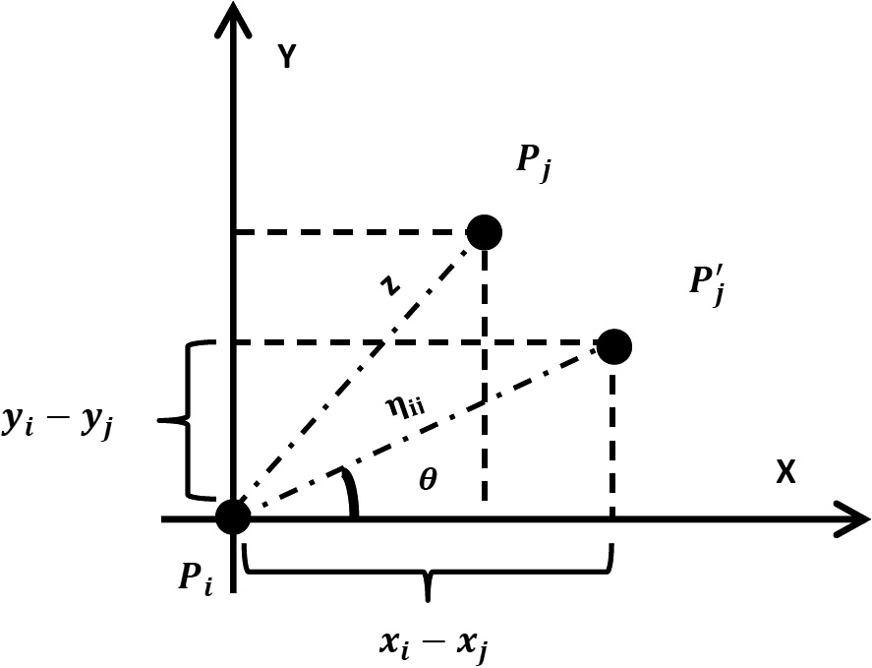

*yi* — *yj* = g*ij*

cos h (11)

sin h (12)

the real distance between the two sensors follows Rician distri- bution, the transmission failure probability is given as integral for the probability density function of Rician distribution as follows:

116 M. Kadi, I. Alkhayat

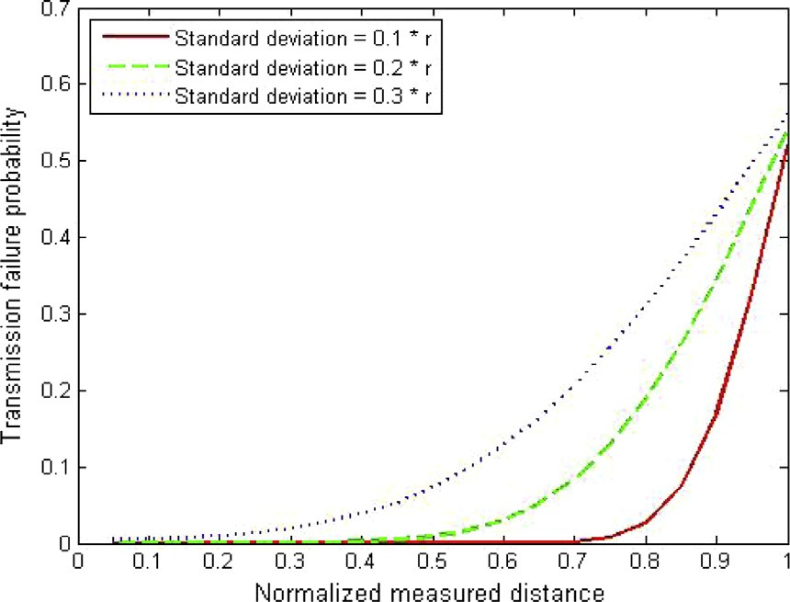

*P* = *f*(*r*)*dr*

Z ∞

*ri*

Z

(22)

∞ *r*

*P* =

*r*2 +g2

*ij*

—

*e* 2r2 *I*0

*r* g*ij* *dr*

*r* r2 r2

*i*

By applying the transformation *r* = r*x*, thus *x* = *r*

r

and

*dx* = *dr*

Z ∞

*P* =

*xe*

g2

—

*I*

0

*x*

*dx*

*P* = *Q* g*ij* ; *ri*

*ri*

r

1

2

*x*2 + *ij*

r2

g*ij* r

(23)

1

r

r

which is a Marcum’s function with *m* = 1 as defined in [13]. According to Marcum’s function with *m* = 1 properties, the transmission failure increases by the increase of standard deviation of the error for the distance between the two sensors. In case the standard deviation of error for the distance between the two sensors is constant, the probability of transmission failure increases, if the chosen destination is closer to the edge of the sender’s transmission range.

1. Impact of location error on location based routing

Location based routing protocols that use greedy forwarding technique are vulnerable to transmission failure. In this technique, the sender sensor selects the closest neighbor to the destination as next relay, which is more likely to be close to the edge of a transmission range than any other neighbors. As Eq. (22) indicates, the transmission failure probability is given by Marcum function with *m* = 1 , Fig. 2 shows the relationship between the transmission failure probability (Marcum’s function value) and the standard deviation of the location error for three different values of the measured dis- tance between the two nodes. The figure shows that the trans- mission failure increases when the destination gets closer to the sender’s transmission range edge *ri*. While Fig. 3 shows the relationship between the transmission failure probability and the measured distance between the two nodes for three differ- ent values of the standard deviation of the location error. We can see that the transmission failure increases by increasing the

standard deviation of the location error.

Figure 3 Transmission failure against the measured distance between two sensors.

1. Simulation

To evaluate the power consumption of location based routing protocols, we simulate two protocols GeRaf and *MECF* using matlab in two cases. First, the power consumption of the two protocols in case there are no locations errors will be com- pared, and then the power consumption of them when location errors exist will be compared as well. It is worth pointing out that GeRaF is an integrated MAC/routing protocol. It is a receiver initiated protocol in which nodes nominate themselves as potential relays, depending on their location. Since our study focuses on power consumption of routing protocols, we omit the complex mechanism associated with MAC layer and only present the routing operation in a GeRaF. In this study, we monitor only power consumption and its relation with location errors, and other performance metrics (such as packet delivery ration, delay, throughput) may be included in future work.

The network used in the simulation is 100 m by 100 m field, consists of statics sensors (not mobile), placed randomly. The source and destination sensors are fixed at the points (0, 0) and (100, 100) in order, and the network consists of homogenous sensors with maximum transmission range equal to 20 m. The energy consumed by electronics to send and receive each bit is e*elec* = 50 nJ/bit, and b = 100 pJ/bit/m2 as in [16]. The traffic flow generated at source is 2 Mbps.

Figure 2 Transmission failure against standard deviation of location errors.

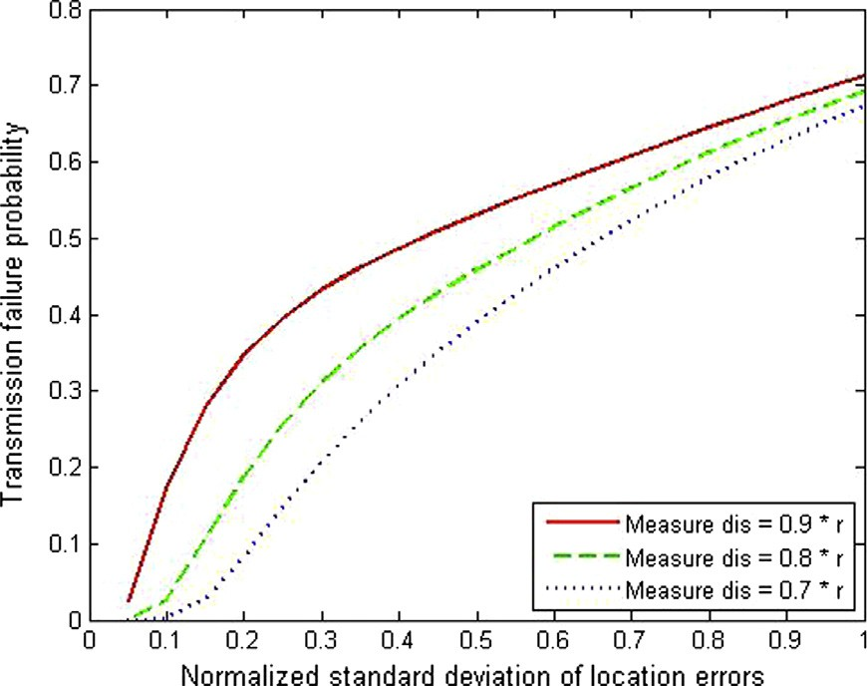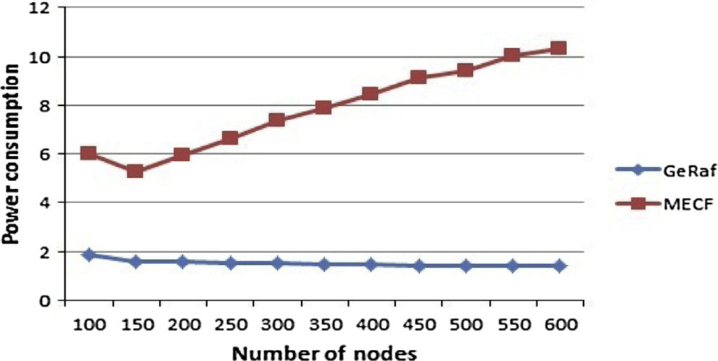

Figure 4 Power consumption against Number of nodes in the network, no location errors.

The effect of location errors on location based routing protocols 117

Figure 5 Number of hops against number of nodes in the network, no location errors.

Figure 7 MECF’s Power consumption against number of nodes for different values of the standard deviation of location errors.

* 1. *First case: there are no location errors*

In this case, GeRaf power consumption is relatively high when node density is low, and decreases by increasing the number of nodes, because GeRaf chose the next node that is closer to the destination. On the other hand MECF chooses the next relay node that is closer to the sender and makes advancement toward the destination, therefore its power consumption increases by increasing the number of nodes as in Fig. 4. Fig. 5 shows that MECF’s number of hops increases almost linearly with the number of nodes while GeRaf’s number of hops decreases by increasing the number of nodes.

* 1. *Second case: there are location errors*

Figure 6 GeRaf’s Power consumption against number of nodes for different values of the standard deviation of location error.

In this case, location errors will be introduced to the node’s real location coordinates. These errors are randomly generated

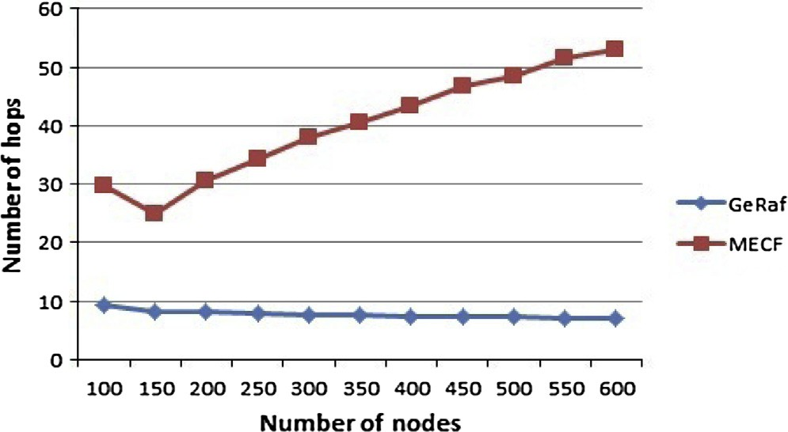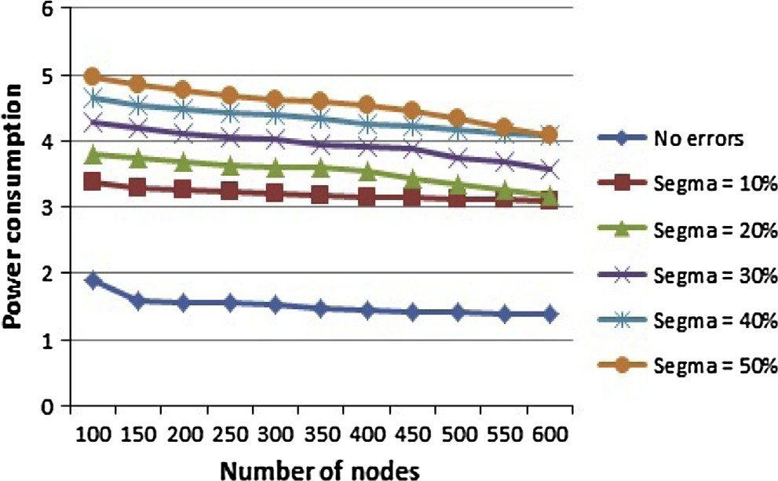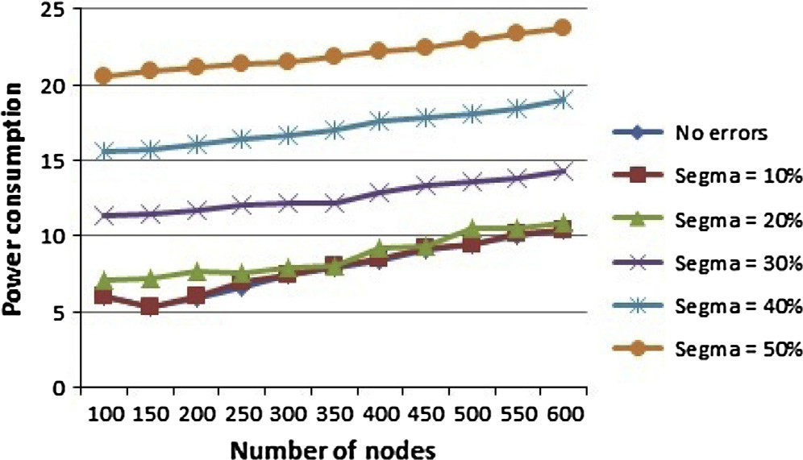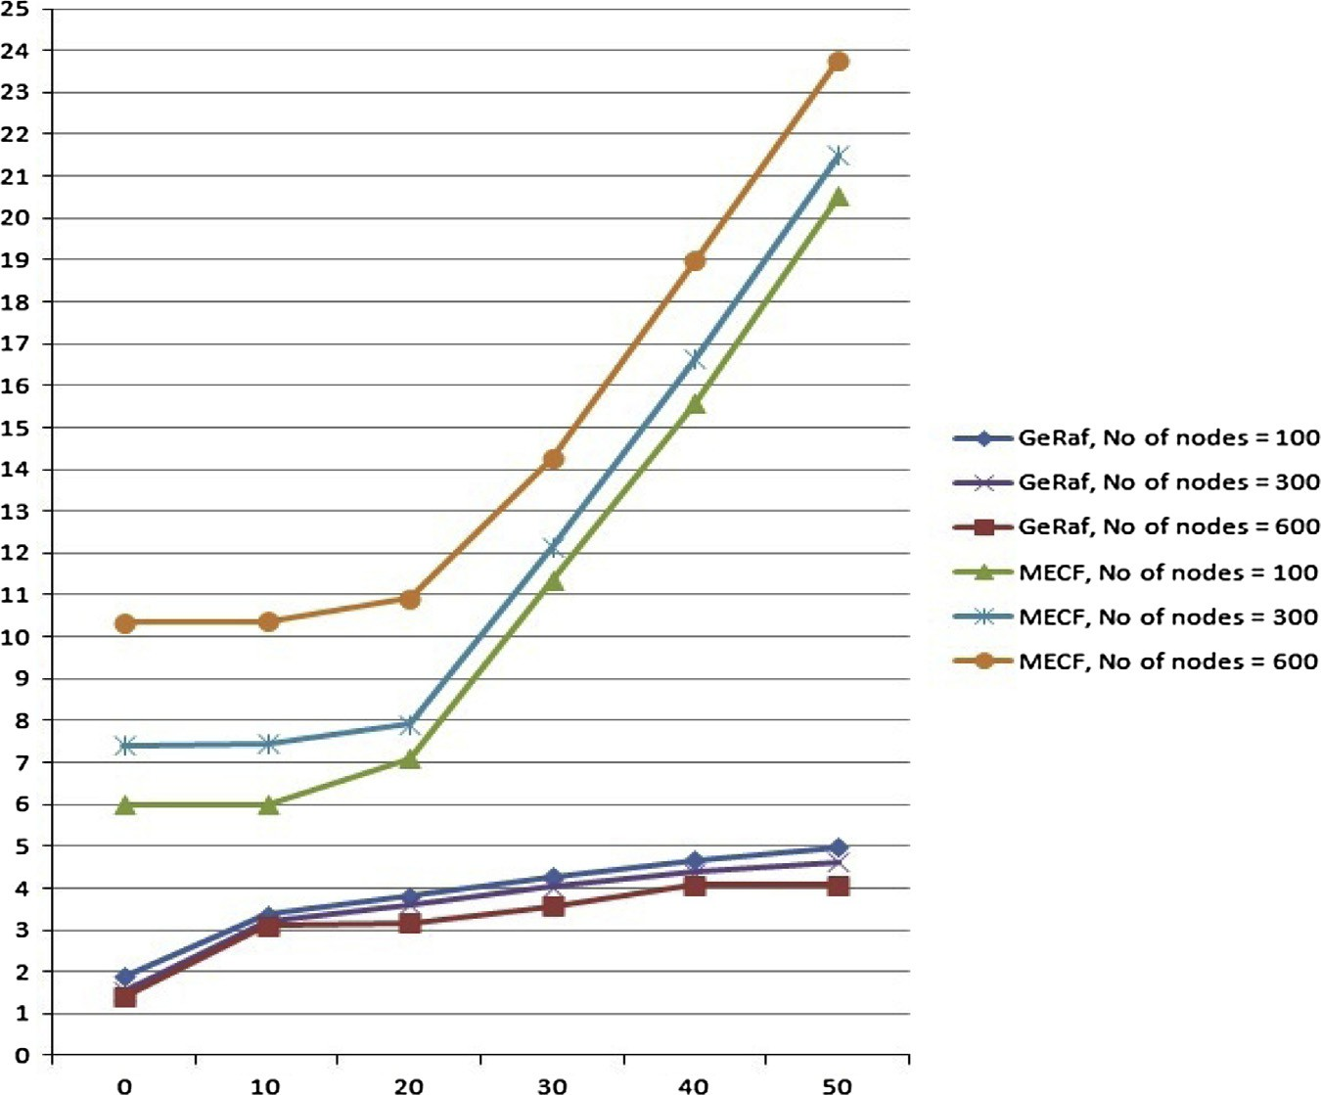

Figure 8 Power consumption against the standard deviation of location errors.

118 M. Kadi, I. Alkhayat

in Gaussian random variables with zero mean and specific standard deviation r, and are normalized to the node’s trans- mission range (r ,the standard deviation of location errors, is expressed as percentage of the transmission range).

Fig. 6 shows GeRaf power consumption in presence of location errors, for different values of the standard deviation of the location errors. The power consumption increases by increasing the standard deviation of location errors. GeRaf chooses the next relay node that is closer to the destination, which mostly located at the sender’s edge of the transmission range, so it experiences high probability of transmission fail- ure, and it consumes more power. These results agree with developed mathematical model which indicates that the power consumption increases by increasing the standard deviation of location errors and by choosing next relay that is closer to the sender’s transmission range.

In Fig. 7, it can be seen that MECF almost consumes the same power when the standard deviation of error is between zero and 20% of the node transmission range, because it chooses the next relay node that is closer to the sender. Although MECF shows immunity against small location errors, but when the standard deviation of location error exceeds 20% of the node transmission range, it consumes more power as the mathematical model indicates.

Fig. 8 shows the power consumption against the standard deviation of location errors for different network’s density for both the algorithms. It can be seen that GeRaf has a high sensitivity against localization errors, and these errors dupli- cate power consumption of GeRaf even though their standard deviation is less than 10% of the node’s transmission range. Small localization errors, that are up to 20% of the node’s transmission rang, have no effect on power consumption of MECF while large localization errors increase power con- sumption in MECF rapidly. On average, we can see that GeRaf outperforms MECF in terms of power consumption in case there are localization errors or not.

1. Conclusion

Location-based routing protocols use position information for making packet forwarding decisions by assuming perfect loca- tion information. In real deployment of WSN, the errors in loca- tion information, resulted from the localization technique and environment conditions, cannot be avoided. This paper intro- duces a mathematical model that evaluates location errors effect on location based routing in WSN. Then this model is evaluated by simulating two location based routing protocols GeRaf and MECF. Both the proposed mathematical model and simulation results show that the power consumption of this type of routing protocols is increased in case there are localization errors. The simulation results show that GeRaf has a high sensitivity again- st localization errors, and small localization errors cause dupli- cation in power consumption. While MECF is tolerated to small localization errors that have standard deviation up to 20% of node’s transmission range, it suffers from high power consump- tion when the localization errors’ standard deviation is greater than 20% of node’s transmission range. In this paper, only pow- er consumption metric has been analyzed. Other WSN metrics such as packet delivery ratio and delay may also be studied to provide a comprehensive view of the effect of location errors on location based routing protocols.



References

1. [Mondal Raj Kumar, Sarddar Debabrata. Data-centric routing](http://refhub.elsevier.com/S1110-8665(15)00005-5/h0005) [protocols in wireless sensor networks: a survey. Int J Adv Comput](http://refhub.elsevier.com/S1110-8665(15)00005-5/h0005) [Technol 2014;3](http://refhub.elsevier.com/S1110-8665(15)00005-5/h0005).
2. [Patel Kinjal, Arora Himanshu, Jha Pradeep. Hierarchical routing](http://refhub.elsevier.com/S1110-8665(15)00005-5/h0010) [protocol in wireless sensor networks. Int J Adv Technol Eng Res](http://refhub.elsevier.com/S1110-8665(15)00005-5/h0010) [2014;4](http://refhub.elsevier.com/S1110-8665(15)00005-5/h0010).
3. [Wang Jin, Yang Xiaoqin, Zhang Zhongqi, Wang Yuxiang, Kim](http://refhub.elsevier.com/S1110-8665(15)00005-5/h0015) [Jeong-Uk. A survey about location-based routing protocols for](http://refhub.elsevier.com/S1110-8665(15)00005-5/h0015) [wireless sensor network. Adv Sci Technol Lett 2014;48:51–5](http://refhub.elsevier.com/S1110-8665(15)00005-5/h0015).
4. [Zorzi Michele, Rao Ramesh R. Geographic random forwarding](http://refhub.elsevier.com/S1110-8665(15)00005-5/h0020) [(GeRaF) for ad-hoc and sensor networks: multihop performance.](http://refhub.elsevier.com/S1110-8665(15)00005-5/h0020) [IEEE Trans. Mob. Comput. 2003;2](http://refhub.elsevier.com/S1110-8665(15)00005-5/h0020).
5. Bighnaraj Panigrahi, Swades De, Jean-Daniel Lan Sun Luk. A greedy minimum energy consumption forwarding protocol for wireless sensor networks, communication systems and networks and workshops 2009, COMSNETS 2009, First International; January 2009. p. 1–6.
6. [Singh Shio Kumar, Singh MP, Singh DK. Routing protocols in](http://refhub.elsevier.com/S1110-8665(15)00005-5/h0030) [wireless sensor networks – a survey. Int J Comput Sci Eng Surv](http://refhub.elsevier.com/S1110-8665(15)00005-5/h0030) [(IJCSES) 2010;1(2):63–83](http://refhub.elsevier.com/S1110-8665(15)00005-5/h0030).
7. [Popescua Ana Maria, Tudorachea Ion Gabriel, Pengb Bo, Kempa](http://refhub.elsevier.com/S1110-8665(15)00005-5/h0035) [AH. Surveying position based routing protocols for wireless](http://refhub.elsevier.com/S1110-8665(15)00005-5/h0035) [sensor and ad-hoc networks. Int J Commun Netw Inf Secur](http://refhub.elsevier.com/S1110-8665(15)00005-5/h0035) [(IJCNIS) 2012;4(1):41–67](http://refhub.elsevier.com/S1110-8665(15)00005-5/h0035).
8. [Shah RC, Wolisz A, Rabaey JM. On the performance of](http://refhub.elsevier.com/S1110-8665(15)00005-5/h0040) [geographical routing in the presence of localization errors. IEEE](http://refhub.elsevier.com/S1110-8665(15)00005-5/h0040) [Int Conf 2005;5:2979–85](http://refhub.elsevier.com/S1110-8665(15)00005-5/h0040).
9. [Savvides A, Garber WL, Moses RL, Srivastava MB. An analysis](http://refhub.elsevier.com/S1110-8665(15)00005-5/h0045) [of error inducing parameters in multihop sensor node localization.](http://refhub.elsevier.com/S1110-8665(15)00005-5/h0045) [IEEE Trans Mob Comput 2005;4:567–77](http://refhub.elsevier.com/S1110-8665(15)00005-5/h0045).
10. [Aksu Hidayet, Aksoy Demet, Korpeoglu Ibrahim. A study of](http://refhub.elsevier.com/S1110-8665(15)00005-5/h0050) [localization metrics: evaluation of position errors in wireless](http://refhub.elsevier.com/S1110-8665(15)00005-5/h0050) [sensor networks. Comput. Netw. 2011;55:3562–77](http://refhub.elsevier.com/S1110-8665(15)00005-5/h0050).
11. [Wan Jiangwen, Ning Yu, Feng Renjian, Yinfeng Wu, Changming](http://refhub.elsevier.com/S1110-8665(15)00005-5/h0055) [Su. Localization refinement for wireless sensor networks. Comput.](http://refhub.elsevier.com/S1110-8665(15)00005-5/h0055) [Commun. 2009;32:1515–24](http://refhub.elsevier.com/S1110-8665(15)00005-5/h0055).
12. [Zorzi M, Rao R. Geographic random forwarding (GeRaF) for ad](http://refhub.elsevier.com/S1110-8665(15)00005-5/h0060) [hoc and sensor networks: multihop performance. IEEE Trans.](http://refhub.elsevier.com/S1110-8665(15)00005-5/h0060) [Mob. Comput. 2003;2:337–48](http://refhub.elsevier.com/S1110-8665(15)00005-5/h0060).
13. [Papoulis A, Pillai SU. Probability, random variables and stochas-](http://refhub.elsevier.com/S1110-8665(15)00005-5/h0065) [tic processes. McGraw-Hill; 2002](http://refhub.elsevier.com/S1110-8665(15)00005-5/h0065).
14. [Durrett R. Probability – theory and examples. Duxbury Press;](http://refhub.elsevier.com/S1110-8665(15)00005-5/h0070) [1996](http://refhub.elsevier.com/S1110-8665(15)00005-5/h0070).
15. [He Tian, Huang Chengdu, Blum Brian M, Stankovic JohnA,](http://refhub.elsevier.com/S1110-8665(15)00005-5/h0075) [Abdelzaher Tarek. Range-free localization schemes for large scale](http://refhub.elsevier.com/S1110-8665(15)00005-5/h0075) [sensor networks. ACM Trans Embed Comput Syst 2005;4:](http://refhub.elsevier.com/S1110-8665(15)00005-5/h0075) [877–906](http://refhub.elsevier.com/S1110-8665(15)00005-5/h0075).
16. [Wendi B, Chandrakasan Anantha P, Balakrishnan Hari. An](http://refhub.elsevier.com/S1110-8665(15)00005-5/h0080) [application-specific protocol architecture for wireless microsensor](http://refhub.elsevier.com/S1110-8665(15)00005-5/h0080) [networks. IEEE Trans. Wireless Commun. 2002;1:660–70](http://refhub.elsevier.com/S1110-8665(15)00005-5/h0080).

Mohsen Kadi is a master student at Informa- tion Technology Engineering Faculty, Damascue University. He holds Bachelor degree in networks and operating system from Information Technology Engineering Faculty at Aleppo University in Syria 2010. He is a senior Net developer and Linux system administrator.



The effect of location errors on location based routing protocols

119

Iyad Alkhayat completed his PhD at Univer-

sity of Louisville, USA, and he is currently an assistant professor at Network Department at the University of Damascus. His research interests are wireless and mobile systems, routing in heterogeneous network, adhoc and sensor networks, seamless mobile computing environments.