[Egyptian Journal of Basic and Applied Sciences 4 (2017) 107–111](http://dx.doi.org/10.1016/j.ejbas.2017.04.002)

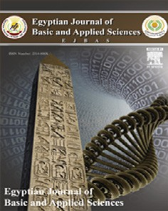

Contents lists available at [ScienceDirect](http://www.sciencedirect.com/science/journal/2314808X)

Egyptian Journal of Basic and Applied Sciences

journal homepage: [www.elsevier.com/locate/ejbas](http://www.elsevier.com/locate/ejbas)

Full Length Article

The essential oil of rosemary and its effect on the human image and numerical short-term memory



O.V. Filiptsova ⇑, L.V. Gazzavi-Rogozina, I.A. Timoshyna, O.I. Naboka, Ye.V. Dyomina, A.V. Ochkur

*National University of Pharmacy, 53, Pushkinska Str., Kharkiv 61002, Ukraine*

# a r t i c l e i n f o

*Article history:*

Received 15 December 2016

Received in revised form 7 March 2017 Accepted 18 April 2017

Available online 8 May 2017

*Keywords:*

Rosemary essential oil Short-term memory Ukraine

# a b s t r a c t

The research results of the effect of essential oil of rosemary on the human short-term image and numer- ical memory have been described. The study involved 53 secondary school students (24 boys and 29 girls) aged 13–15 years, residents of the Ukrainian metropolis. Participants were divided into the control group and ‘‘Rosemary” group, in which the rosemary essential oil was sprayed. The statistically significant dif- ferences in productivity of the short-term memory of the participants of these two groups have been found, while sex differences in uniform groups were absent. Therefore, the essential oil of rosemary has significantly increased the image memory compared to the control. Inhalation of the rosemary essen- tial oil increased the memorization of numbers as well.

© 2017 Mansoura University. Production and hosting by Elsevier B.V. This is an open access article under

the CC BY-NC-ND license (<http://creativecommons.org/licenses/by-nc-nd/4.0/>).

1. Introduction

In today’s world there are many factors that adversely affect the human mental health. The number of children with the attention deficit hyperactivity disorder has increased, and among adults the cases of Alzheimer’s disease have become more frequent. Therefore, not only identification of risk groups by such important characteristics as memory, attention and the response rate, but also the study of the possibilities of their correction are relevant. It is desirable to use natural compounds with a decreased risk of side effects compared to synthetic components of drugs. Consider- ing the current methods of alternative medicine aromatherapy is highly popular and reasonably trustworthy among the profession- als. The topicality of studying the effects of essential oils is induced by a number of advantageous points, namely, the relatively high rate of their impact, ease of use, safety and relatively low costs. Essential oils are used for various purposes: skin cleansing and skin tonicity, hair wetting and hair nourishment, wellness massage and psychophysiological effects [1].

The knowledge of the biological effects of many essential oils was passed on from generation to generation mainly through just observations without scientific evidence. For example, it is consid- ered to be traditional that the essential oils of rosemary and pep- permint have the stimulating effect on the central nervous system, and the essential oils of ylang ylang and lavender, vice versa, exhibit the sedative effect. The current studies, which allow

* Corresponding author.

*E-mail address:* [philiptsova@yahoo.com](mailto:philiptsova@yahoo.com) (O.V. Filiptsova).

selecting specific combinations of essential oils, are able to explain their biological activity previously perceived *a priori*. Thus, the rosemary essential oil is used in aromatherapy for a relatively long time; however, its effects on the human body, particularly on the nervous system, have not been sufficiently studied. In one study involving 20 healthy volunteers who inhaled the rosemary essen- tial oil the subjective feelings of the participants and objective indi- cators of the autonomic nervous system (the body temperature, the heart rate, the rate of respiration and blood pressure) were assessed. The electroencephalogram was also taken in the partici- pants of the study. The measurements were performed before, dur- ing, and after inhalation of the essential oil. The results demonstrated a significant increase in blood pressure, the heart rate and the rate of respiration after aromatherapy. The volunteers noted that they felt more refreshed. Analysis of EEG also showed the stimulating effects of the rosemary essential oil on the brain wave activity [2].

The effects of aromatherapy were studied in the elderly, some of them suffered from Alzheimer’s disease. The aromatherapy lasted for 28 days. For the experiment the essential oils of rose- mary and lemon were used in the morning, while the essential oils of lavender and orange were used in the evening. The results of the study showed a positive effect of the aromatherapy on cognitive indices of the participants of the study [3]. The studies were con- ducted to assess the effect of 1,8-cineole containing in the rose- mary essential oil on the cognitive performance and mood of a person. The study involved 20 healthy volunteers. Before and after the experiment the cognitive indices and the mood change were assessed in points. At the end of the experiment the subjects were

<http://dx.doi.org/10.1016/j.ejbas.2017.04.002>

2314-808X/© 2017 Mansoura University. Production and hosting by Elsevier B.V.

This is an open access article under the CC BY-NC-ND license (<http://creativecommons.org/licenses/by-nc-nd/4.0/>).

taken the venous blood for determining 1,8-cineole in the serum. The results obtained showed that the concentration of 1,8- cineole absorbed into the bloodstream by inhalation of the rose- mary essential oil was positively associated with the effectiveness of the tasks proposed. It was also shown that the rosemary essen- tial oil contributed to improvement of the speed and accuracy of task performance. The effect of the essential oil on mood was not particularly noticeable [4].

Not only the inhalation of essential oils can have a positive impact on memory in human and animals. It was shown in rats that the subchronic administration of the rosemary extract of *Ros- marinus officinalis* L. *per os* in the dose of 200 mg/kg improved the long-term memory in rodents on the background of introduction of scopolamine alkaloid. The hypothetic mechanism of action, which was the basis of the memory improvement, was the inhibition of acetylcholinesterase in the rat’s brain [5]. In another work the effects of different doses of the rosemary extract introduced to male rats of Wistar line (50, 100 and 200 mg/kg/day) within 12 weeks on learning and the spatial memory, as well as on the survival of neurons in the hippocampus (the region of the brain being responsible for transition of the short-term memory into the long-term one, or the so-called consolidation), were studied. According to the results of the study the extract of rosemary in the dose of 100 mg/kg contributed to restoration of the informa- tion retrieval from the memory. The effect of the plant extract in higher doses was less pronounced [6]. In the elderly at the age of 75 at the beginning of the study the use of the powder from rose- mary dry leaves in different doses affected the memory rate in var- ious ways. The rosemary powder had a positive effect in the lowest dose (750 mg), and it had a negative impact on this process in the highest dose (6000 mg). The conclusion about the positive effects of small chronic doses of rosemary, which were similar to those used in cooking, was made [7]. It is expected that diterpenes con- tained in rosemary inhibit the death of neurons induced by a num- ber of factors *in vitro* and *in vivo*, thus presenting the therapeutic potential when treating Alzheimer’s disease [8].

There is evidence that preferences to essential oils may be related to gender and ethnicity. Thus, in one study the attractive- ness of the essential oil among Hispanic and white secondary school students was assessed. The results of the study demon- strated that inhalation of the essential oil of orange was associated with happiness in girls. In addition, Hispanic girls considered the odor of the essential oil of orange to be soothing more often than white girls. On the other hand, Latin American males described the odor of peppermint as ‘‘energetic” more often than white stu- dents [9].

Ukraine is a multiethnic state [10–14]. As shown by our previ- ous studies, the Ukrainian population is polymorphic by the taste sensitivity [15] and is characterized by a peculiar sexual dimor- phism and unique distribution of a number of behavioral charac- teristics [16,17]. It is expedient to study the possible effects of different factors, in particular the effect of essential oils, on cogni- tive features of the Ukrainian population previously unstudied in this respect. The aim of the present study was to analyze the effect of the essential oil of rosemary on characteristics of short-term image and numerical memory of secondary school students living in the modern Ukrainian cities.

1. Materials and methods

The study involved 53 secondary school students (24 boys and 29 girls) aged 13–15 years. The volunteers were natives of the city of Kharkiv – the second largest metropolis of Ukraine. All partici- pants of the experiment were divided into two groups in a random manner. The first group was the control group where the students were not exposed to any essential oils. In the second group (‘‘Rose- mary”) the rosemary essential oil was sprayed (the Latin name of appropriate plant used is *Rosmarinus officinalis* L.). The control group included 31 individual (12 males and 19 females) and the experimental group included 22 individuals (12 males and 10 females). The participants of the study were not informed about the presence of aromas of the essential oil in the room. The collec- tion of information was conducted taking into account the ethical principles when dealing with a person in accordance with the Dec- laration of Helsinki. All participants of the experiment gave the written consent to participate in the study, completed the ques- tionnaire, which included a list of issues of the demographic nat- ure, and their cognitive features were tested.

* 1. *Characteristics of the methods for cognitive studies*
     1. *The ‘‘memory for images*” *method*

The method is developed by P.I. Zinchenko and intended to study the short-term image memory. The essence of the method lies in the fact that the subject was shown a table with 16 images for 20 s. The images should be remembered, they should be repro- duced in the form for 1 min. The task was to remember as many images as possible for 20 s. In 20 s the table was removed, and the subjects should record the images that they remembered. The test results were assessed by the number of the images cor- rectly reproduced [18].

* + 1. *The ‘‘memory for numbers*” *method*

The method is developed by P.I. Zinchenko and intended to assess the short-term visual memory, its volume and accuracy. The task was as follows. For 20 s a person was presented a table with 12 double-digited numbers, which should be remembered, and after the table was removed, the numbers should be recorded in the form. As many numbers as possible should be remembered for 20 s. The short-term visual memory was assessed by the quan- tity of the numbers correctly reproduced [18].

The following statistical tests were used in the research: the Shapiro-Wilk test (W), the Kolmogorov-Smirnov test (D), the Mann-Whitney test (U), the chi square test (v2) b the Student *t*- test. The mean and median values, minimal and maximal values, standard deviation, lower and upper quartiles were also calculated. The database was formed in the *Microsoft Excel* program. The calcu- lations were made in the *Statistica 6.1* program.

1. Results and discussion

The age of participants of the control and experimental groups was checked for a distribution pattern. The analysis has demon- strated that the age did not correspond to the normal distribution

Table 1

The age characteristics of the sample under study.

|  |  |  |  |  |  |  |  |  |  |
| --- | --- | --- | --- | --- | --- | --- | --- | --- | --- |
| Group | *n* | *X*¯ | d | min | max | *W* | *p* | *D* | *p* |
| Control | 31 | 13.8 | 0.7 | 13 | 15 | 0.79 | <0.001 | 0.28 | <0.01 |
| Rosemary | 22 | 14.1 | 0.5 | 13 | 15 | 0.70 | <0.001 | 0.39 | <0.01 |

*Notes. n* – number of participants, *X*¯ – mean, d – standard deviation, min – minimal value, max – maximal value, *W* – the Shapiro-Wilk test, *D* – the Kolmogorov-Smirnov test,

*p* – significance level.

in both groups (Table 1). This was confirmed by the Shapiro-Wilk test and Kolmogorov-Smirnov test values.

As the age did not correspond to the normal distribution, the Mann-Whitney test was used to compare the control and experi- mental groups for this non-parametric character. Its value was equal to *U* = 251 (*p* > 0.05). This indicated that as a whole the con- trol group and the group with rosemary essential oil use were com- patible by age.

The checking of both groups for sex uniformity was performed by means of v2 test. The selection of this test was due to the fact, that this character resides in the category of qualitative traits. As

Table 2

Sex of participants of the study.

|  |  |  |  |
| --- | --- | --- | --- |
| Group | Males, *n* (%) | Females, *n* (%) | Total |
| Control | 12 (38.7) | 19 (61.3) | 31 |
| Rosemary | 12 (54.6) | 10 (45.5) | 22 |
| Total | 24 | 29 | 53 |

v2 (with Yates’ correction) = 0.74, *p* > 0.05.

*Notes. n* – number of participants, v2 – the chi square test, *p* – significance level.

the statistical analysis has shown, the control and experimental groups were compatible by sex (*p* > 0.05, Table.2).

After analysis of groups in relation to age and sex the calcula- tion of basic statistical parameters of short-term memory charac- teristics was performed. The results are presented in Table 3 and in Figs. 1 and 2.

The analysis has shown that the distribution of correctly repro- ducible images and numbers corresponded to the normal one. This was confirmed by the Shapiro-Wilk test and Kolmogorov-Smirnov test values: for correctly reproducible images – *W* = 0.98 (*p* > 0.05), *D* = 0.11 (*p* > 0.05) and for correctly reproducible numbers – *W* = 0.96 (*p* > 0.05), *D* = 0.13 (*p* > 0.05) in the control group, for cor- rectly reproducible images – *W* = 0.95 (*p* > 0.05), *D* = 0.16 (*p* > 0.05) and for correctly reproducible numbers – *W* = 0.96 (*p* > 0.05), *D* = 0.12 (*p* > 0.05) in the experimental group. On this base it was appropriate to use parametric instruments of statistics in a further comparison, in particular the Student *t*-test (Table 4).

The results of analysis has revealed no sex differences in the control and experimental groups in relation to short-term memory characteristics (Table 5).

The results obtained clearly indicate that the essential oil of rosemary has a positive effect on the human short-term memory

Table 3

Basic statistical parameters of correctly reproducible images and numbers as indicators of short-term memory.

Group *n X*¯ *Correctly reproducible images*

|  |  |  |  |  |  |  |  |  |  |
| --- | --- | --- | --- | --- | --- | --- | --- | --- | --- |
| Control | 31 | 7.2 | 0.4 | 2.3 | 2 | 12 | 5 | 7 | 9 |
| Rosemary | 22 | 9.4 | 0.5 | 2.3 | 5 | 13 | 8 | 9.5 | 11 |
| *Correctly reproducible numbers* | | | | | | | | | |
| Control | 31 | 5.8 | 0.3 | 1.8 | 2 | 9 | 4 | 6 | 7 |
| Rosemary | 22 | 7.1 | 0.4 | 1.9 | 4 | 11 | 6 | 7 | 9 |

*sX* d min max Q1 Me Q3

*Notes. n* – number of participants, *X*¯ – mean, *sX* – standard error, d – standard deviation, min – minimal value, max – maximal value, Q1 – lower quartile, Me – median value, Q3 – upper quartile.

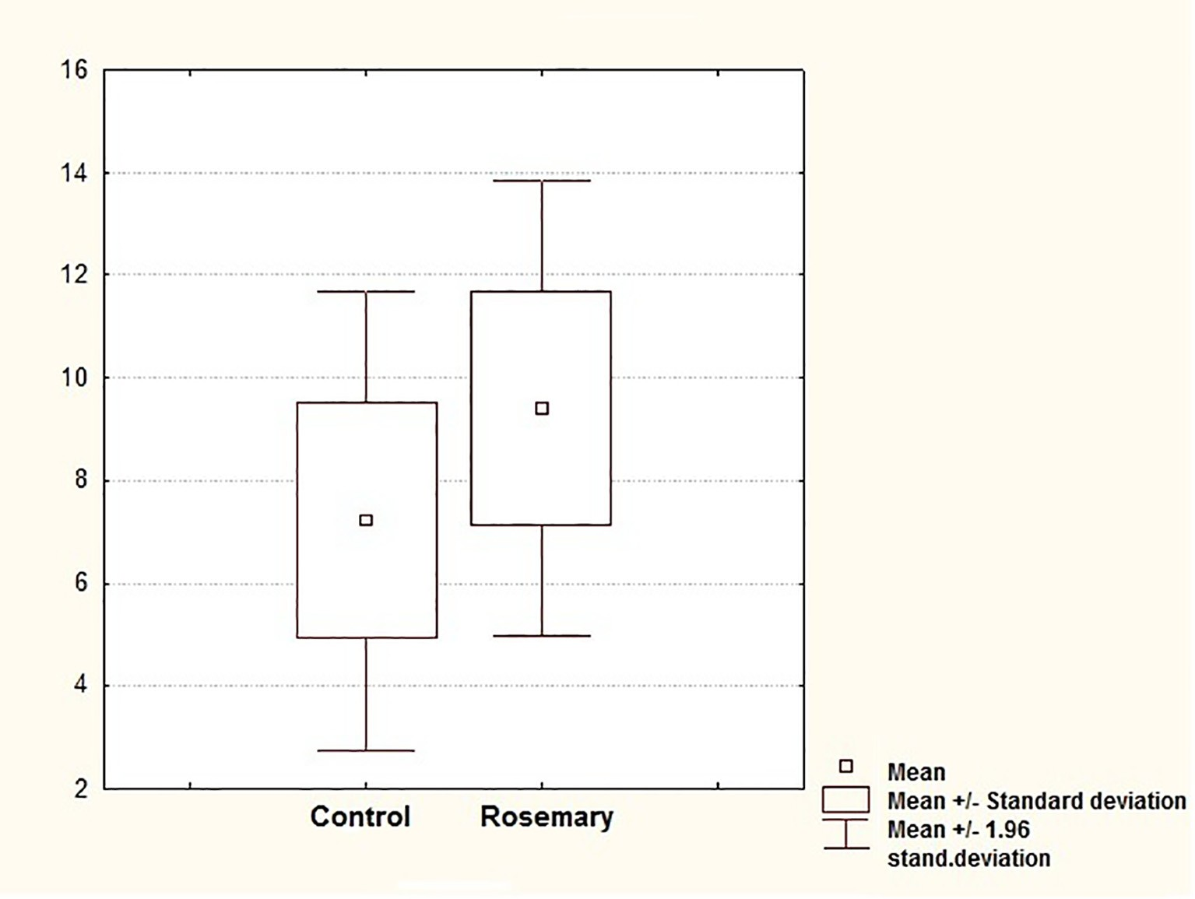

Fig. 1. Categorized distribution diagrams of correctly reproducible images.

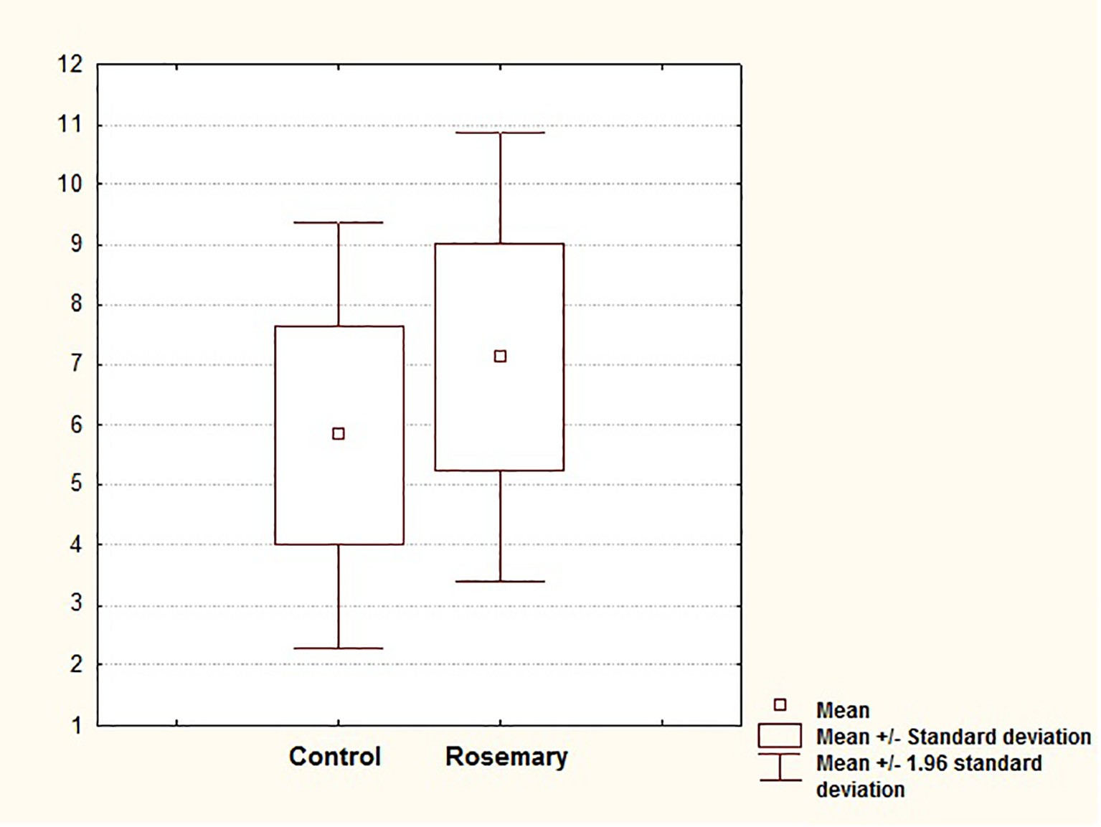

Fig. 2. Categorized distribution diagrams of correctly reproducible numbers.

Table 4

The results of comparative analysis of correctly reproducible images and numbers in the combined control and experimental groups.

|  |  |  |  |  |  |
| --- | --- | --- | --- | --- | --- |
| Group | *n* | *X*¯ | d | *t* | *p* |
| *Correctly reproducible images* |  |  |  |  |  |
| Control | 31 | 7.2 | 2.3 | 3.45 | <0.01 |
| Rosemary | 22 | 9.4 | 2.3 |  |  |
| *Correctly reproducible numbers* |  |  |  |  |  |
| Control | 31 | 5.8 | 1.8 | 2.51 | <0.05 |
| Rosemary | 22 | 7.1 | 1.9 |  |  |

*Notes. n* – number of participants, *X*¯ – mean, d – standard deviation, *t* – the Student *t*-test, *p* – significance level.

Table 5

The results of comparative analysis of correctly reproducible images and numbers between males and females in the control and experimental groups.

Group *n X*¯ *Correctly reproducible images, control*

|  |  |  |  |  |  |
| --- | --- | --- | --- | --- | --- |
| Males | 12 | 7.1 | 2.5 | 0.27 | >0.05 |
| Females | 19 | 7.3 | 2.2 |  |  |
| *Correctly reproducible images, rosemary* | | | | | |
| Males | 12 | 9.0 | 2.4 | 0.93 | >0.05 |
| Females | 10 | 9.9 | 2.0 |  |  |
| *Correctly reproducible numbers, control* | | | | | |
| Males | 12 | 5.8 | 2.5 | 0.01 | >0.05 |
| Females | 19 | 5.8 | 1.3 |  |  |
| *Correctly reproducible numbers, rosemary* | | | | | |
| Males | 12 | 6.4 | 2.1 | 2.08 | >0.05 |
| Females | 10 | 8.0 | 1.2 |  |  |

d *t p*

*Notes. n* – number of participants, *X*¯ – mean, d – standard deviation, *t* – Student *t*-test, *p* – significance level.

in relation to images and numbers, with absence of sex differences in the uniform groups. In the study by other authors the effect of the aromatherapy with ylang ylang (sedative) and peppermint (stimulant) on memory was anticipated as well: inhalation of the

essential oil of peppermint improved memory; ylang-ylang wors- ened it, and in addition, contributed to the increase in time of pro- cessing the information. At the same time, in relation to subjective feelings the essential oil of peppermint increased the alert state of

the body, while the essential oil of ylang ylang decreased it, as well as led to a pronounced sense of calm [19].

However, it should be noted that effects of essential oils on the human behavior may be rather unexpected. For example, it was shown that in the presence of the sprayed lavender essential oil the level of trust of a person toward other people increased. In con- trast, when inhaling the essential oil of peppermint people became less trusting, and in a role play they were willing to entrust money to strangers less readily. Such studies are important for the poten- tial impact on the consumer behavior, negotiations, and conclusion of transactions [20]. In regards to the effect of essential oils on the cognitive abilities, and, in particular, on memory, the currently existing scientific data can be also supplemented in the near future.

1. Conclusions

Despite the fact that in the world literature the fragmentary research of the relationship of essential oils with the characteris- tics of the human behavior is known the population of Ukraine remains unstudied up to the present moment. The results obtained complete the information about the effects of essential oils on the human short-term memory and contribute to the study of possibil- ities for correction of the short-term image and numerical mem- ory. Tests identifying the effect of the essential oil of rosemary on the cognitive features of students and the results obtained in our study have demonstrated that there are statistically significant differences between the values of the short-term memory of the participants of different groups, namely: the essential oil of rose- mary has a statistically significant increase of the image and numeric memory of the participants of the study compared to the control. The results of our studies complete the currently known information concerning the effect of essential oils on the expression of the human cognitive functions.

Acknowledgments

The research is supported by Ministry of Education and Science of Ukraine grant ‘‘Biological threats and challenges arising from migration and invasion: population and genetic approach”.

References

1. [Babar A, Al-Wabel NA, Shams S, Ahamad A, Khan SA, Anwar F. Essential oils](http://refhub.elsevier.com/S2314-808X(16)30189-0/h0005) [used in aromatherapy: a systemic review. Asian Pac J Trop Biomed 2015;5](http://refhub.elsevier.com/S2314-808X(16)30189-0/h0005) [(8):601–11](http://refhub.elsevier.com/S2314-808X(16)30189-0/h0005).
2. [Sayorwan W, Siripornpanich V, Piriyapunyaporn T, Hongratanaworakit T,](http://refhub.elsevier.com/S2314-808X(16)30189-0/h0010) [Kotchabhakdi N, Ruangrungsi N. The effects of lavender oil inhalation on](http://refhub.elsevier.com/S2314-808X(16)30189-0/h0010) [emotional states, autonomic nervous system, and brain electrical activity. J](http://refhub.elsevier.com/S2314-808X(16)30189-0/h0010) [Med Assoc Thai 2012;95(4):598–606](http://refhub.elsevier.com/S2314-808X(16)30189-0/h0010).
3. [Jimbo D, Kimura Y, Taniguchi M, Inoue M, Urakami K. Effect of aromatherapy](http://refhub.elsevier.com/S2314-808X(16)30189-0/h0015) [on patients with Alzheimer’s disease. Psychogeriatrics 2009;9(4):173–9](http://refhub.elsevier.com/S2314-808X(16)30189-0/h0015).
4. [Moss M, Oliver L. Plasma 1,8-cineole correlates with cognitive performance](http://refhub.elsevier.com/S2314-808X(16)30189-0/h0020) [following exposure to rosemary essential oil aroma. Ther Adv](http://refhub.elsevier.com/S2314-808X(16)30189-0/h0020) [Psychopharmacol 2012;2:103–13](http://refhub.elsevier.com/S2314-808X(16)30189-0/h0020).
5. [Ozarowski M, Mikolajczak PL, Bogacz A, Gryszczynska A, Kujawska M, Jodynis-](http://refhub.elsevier.com/S2314-808X(16)30189-0/h0025) [Liebert J, et al. *Rosmarinus officinalis* L. leaf extract improves memory](http://refhub.elsevier.com/S2314-808X(16)30189-0/h0025) [impairment and affects acetylcholinesterase and butyrylcholinesterase](http://refhub.elsevier.com/S2314-808X(16)30189-0/h0025) [activities in rat brain. Fitoterapia 2013;91:261–71](http://refhub.elsevier.com/S2314-808X(16)30189-0/h0025).
6. [Rasoolijazi H, Mehdizadeh M, Soleimani M, Nikbakhte F, Farsani ME,](http://refhub.elsevier.com/S2314-808X(16)30189-0/h0030) [Ababzadeh S. The effect of rosemary extract on spatial memory, learning and](http://refhub.elsevier.com/S2314-808X(16)30189-0/h0030) [antioxidant enzymes activities in the hippocampus of middle-aged rats. Med J](http://refhub.elsevier.com/S2314-808X(16)30189-0/h0030) [Islam Repub Iran 2015;29:187](http://refhub.elsevier.com/S2314-808X(16)30189-0/h0030).
7. [Pengelly A, Snow J, Mills SY, Scholey A, Wesnes K, Butler LR. Short-term study](http://refhub.elsevier.com/S2314-808X(16)30189-0/h0035) [on the effects of rosemary on cognitive function in an elderly population. J Med](http://refhub.elsevier.com/S2314-808X(16)30189-0/h0035) [Food 2012;15(1):10–7](http://refhub.elsevier.com/S2314-808X(16)30189-0/h0035).
8. [Habtemariam S. The therapeutic potential of rosemary (*Rosmarinus officinalis*)](http://refhub.elsevier.com/S2314-808X(16)30189-0/h0040) [diterpenes for Alzheimer’s disease. Evid Based Complement Alternat Med](http://refhub.elsevier.com/S2314-808X(16)30189-0/h0040) [2016;2016:2680409](http://refhub.elsevier.com/S2314-808X(16)30189-0/h0040).
9. [Fitzgerald M, Culbert T, Finkelstein M, Green M, Johnson A, Chen S. The effect of](http://refhub.elsevier.com/S2314-808X(16)30189-0/h0045) [gender and ethnicity on children’s attitudes and preferences for essential oils:](http://refhub.elsevier.com/S2314-808X(16)30189-0/h0045) [a pilot study. Explore (NY) 2007;3(4):378–85](http://refhub.elsevier.com/S2314-808X(16)30189-0/h0045).
10. [Atramentova LA, Filiptsova OV. Genetic Demographic Processes in Ukrainian](http://refhub.elsevier.com/S2314-808X(16)30189-0/h0050) [Urban Populations in 1990s: the Marriage Structure of the Poltava Population.](http://refhub.elsevier.com/S2314-808X(16)30189-0/h0050) [Russ. J. Genet 1999;35(12):1464–70](http://refhub.elsevier.com/S2314-808X(16)30189-0/h0050).
11. [Atramentova LA, Filiptsova OV, Mukhin VN, SIu Osipenko. Genetic](http://refhub.elsevier.com/S2314-808X(16)30189-0/h0055) [demographic data of Ukrainian urban populations in the 1990s: ethno-](http://refhub.elsevier.com/S2314-808X(16)30189-0/h0055) [geographic characteristics of migrants in the Donetsk region. Genetika](http://refhub.elsevier.com/S2314-808X(16)30189-0/h0055) [2002;38(10):1402–8](http://refhub.elsevier.com/S2314-808X(16)30189-0/h0055).
12. [Atramentova LA, Filiptsova OV, SIu Osipenko. Genetic demography of](http://refhub.elsevier.com/S2314-808X(16)30189-0/h0060) [Ukrainian urban populations in the 1990s: the ethnic composition of the](http://refhub.elsevier.com/S2314-808X(16)30189-0/h0060) [migration flow in the Kharkov population. Genetika 2002;38(7):972–9](http://refhub.elsevier.com/S2314-808X(16)30189-0/h0060).
13. [Atramentova LA, Filiptsova OV, Osipenko SYu. Genetic demography of](http://refhub.elsevier.com/S2314-808X(16)30189-0/h0065) [Ukrainian Urban Populations in the 1990s: ethnicity and birthplaces of](http://refhub.elsevier.com/S2314-808X(16)30189-0/h0065) [migrants to the Poltava population. Russ J Genet 2002;38(9):1082–7](http://refhub.elsevier.com/S2314-808X(16)30189-0/h0065).
14. [Atramentova LA, Meshcheriakova IP, Filiptsova OV. Characteristics of](http://refhub.elsevier.com/S2314-808X(16)30189-0/h0070) [migration in the population of Yevpatoria (Crimea). Genetika 2014;50](http://refhub.elsevier.com/S2314-808X(16)30189-0/h0070) [(9):1124–32](http://refhub.elsevier.com/S2314-808X(16)30189-0/h0070).
15. [Filiptsova OV, Timoshyna IA, Kobets YuN, Kobets MN, Burlaka IS, Hurko IA. The](http://refhub.elsevier.com/S2314-808X(16)30189-0/h0075) [population structure of Ukraine in relation to the phenylthiocarbamide](http://refhub.elsevier.com/S2314-808X(16)30189-0/h0075) [sensitivity. Egypt. J. Med. Hum. Genet 2015;16(2):135–9](http://refhub.elsevier.com/S2314-808X(16)30189-0/h0075).
16. [Atramentova LA, Luchko EN. Aggression and empathy as genetic](http://refhub.elsevier.com/S2314-808X(16)30189-0/h0080) [differentiation factors of urban population. Russ. J. Genet 2016;52(6):615–21](http://refhub.elsevier.com/S2314-808X(16)30189-0/h0080).
17. [Filiptsova OV, Kobets YuN, Kobets MN, Timoshyna IA. Population Study of](http://refhub.elsevier.com/S2314-808X(16)30189-0/h0085) [Fears in Two Generations of Ukrainians. Indian J Psychol Med 2015;37](http://refhub.elsevier.com/S2314-808X(16)30189-0/h0085) [(3):305–10](http://refhub.elsevier.com/S2314-808X(16)30189-0/h0085).
18. Gparnbryv go o,oeq, 'rcgepbveynakmyoq b gpbrkalyoq gcbxokoub: yxe,y.

goco,be/[cocnad. B.L. <akby, B.R. Uaqla, B.R. Uep,axedcmrbq b lp.,; gol pel. A.

A. Rpskoda, C.A. Maybxeda]. - CG,: Bpl-do «Gbnep», 2000. – 560 c. (In Russian).

1. [Moss M, Hewitt S, Moss L, Wesnes K. Modulation of cognitive performance and](http://refhub.elsevier.com/S2314-808X(16)30189-0/h0095) [mood by aromas of peppermint and ylang-ylang. Int J Neurosci 2008;118](http://refhub.elsevier.com/S2314-808X(16)30189-0/h0095) [(1):59–77](http://refhub.elsevier.com/S2314-808X(16)30189-0/h0095).
2. [Sellaro R, van Dijk WW, Paccani CR, Hommel B, Colzato LS. A question of scent:](http://refhub.elsevier.com/S2314-808X(16)30189-0/h0100) [lavender aroma promotes interpersonal trust. Front Psychol 2014;5:1486](http://refhub.elsevier.com/S2314-808X(16)30189-0/h0100).