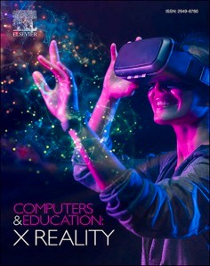[Computers & Education: X Reality 3 (2023) 100042](https://doi.org/10.1016/j.cexr.2023.100042)

Contents lists available at [ScienceDirect](http://www.sciencedirect.com/science/journal/29496780)

Computers & Education: X Reality

journal homepage: [www.journals.elsevier.com/computers-and-education-x-reality](https://www.journals.elsevier.com/computers-and-education-x-reality)

The impact of mixed reality serious games on mortise and tenon learning in [](http://crossmark.crossref.org/dialog/?doi=10.1016/j.cexr.2023.100042&domain=pdf) college students

Yongxin Hang 1, Huiqing Wang 2, Zihan Sang 2, Rong Huang, Li Ye *

*School of Architecture & Design, China University of Mining and Technology, Xuzhou, Jiangsu, PR China*

A R T I C L E I N F O

*Keywords:*

Games

Improving classroom teaching Media in education Teaching/learning strategies

A B S T R A C T

As an intangible cultural heritage, traditional handicrafts are significant in artistic education. Due to limited approaches to communicating traditional handicrafts and appreciating content, it cannot be easy to carry out effective skill inheritance in an art education situation in a modern teaching environment. This study uses mixed reality technology to develop a serious game for learning traditional handicrafts. The objective is to improve

students’ attitudes by promoting a digital teaching environment. This research uses traditional Chinese mortise and tenon joints for the case study. The effects of serious games using MR technology and traditional teaching

methods were compared through quasi-experiments on students’ academic performance, learning motivation and situational interest. The results show that serious games can have advantages in acquiring and retaining knowledge, stimulating students’ learning motivation and situational interest. This study aims to support cultural heritage education methods.

# Introduction

Cultural heritage education has a range of positive impacts on the protection and dissemination of cultural heritage. In recent years, many countries have begun to realize the importance of strengthening cultural heritage education for teenagers. China has also adopted corresponding educational policies to promote the study of cultural heritage among college students (Underhill & Salazar, 2016). Mortise and tenon joints are the core of traditional Chinese timber buildings (Chun, Meng, & Han, 2017), containing significant historical and cultural information as well as educational dissemination significance that cannot be ignored. This study explores the mortise and tenon joints in traditional Chinese furniture, which come in various types and even within the same type, there are different structural forms. This complexity adds to the diffi- culty of learning and identifying mortise and tenon structures. Furthermore, some of these joints have extremely intricate structures, making it challenging for students to visually comprehend the internal structure of the joints through traditional learning methods, resulting in a lack of interest in learning among students.

There is now evidence from related research that video games can be used for teaching, aiming to engage students deeply through the

attraction of games (Mortara et al., 2014). This kind of game, which incorporate educational themes and educational goals, is believed to have the potential to make learning learner-centered and make the learning process more accessible, fun, and effective (Papastergiou, 2009). The video games used in education are called serious games. Some research results also show that serious games can improve stu- dents’ motivation (Manero et al., 2015; Tüzün et al., 2009) and can

further improve students’ academic performance (Srisawasdi & Pan-

jaburee, 2019). At present, most serious games for cultural heritage education are two-dimensional games operated by computers, tablet, phones, or other devices (Djaouti et al., 2009; Gabellone et al., 2017). In this way, it is difficult to observe the object structure in an all-around way and study the three-dimensional material heritage well, such as building sites and utensil structures. Some games try to use virtual re- ality (VR), augmented reality (AR), and other technologies that aim to immerse players in the game and learn about historical events and related information (Bruno et al., 2018; Ferdani et al., 2020). At present,

based on VR and AR, a new technology, “mixed reality (MR)”, has emerged. MR combines the characteristics of VR and AR (Beyoglu et al.,

2020), which can not only observe objects in all directions but also bring for a better interactive experience. MR has become essential technical

* Corresponding author.

*E-mail address:* [3858@cumt.edu.cn](mailto:3858@cumt.edu.cn) (L. Ye).

1 The author’s permanent address is School of Architecture & Design, China University of Mining and Technology.

2 Co-second authors.

<https://doi.org/10.1016/j.cexr.2023.100042>

Received 30 October 2022; Received in revised form 30 September 2023; Accepted 7 October 2023

Available online 6 November 2023

2949-6780/© 2023 The Authors. Published by Elsevier Ltd. This is an open access article under the CC BY-NC-ND license ([http://creativecommons.org/licenses/by-](http://creativecommons.org/licenses/by-nc-nd/4.0/) [nc-nd/4.0/](http://creativecommons.org/licenses/by-nc-nd/4.0/)).

support for creating a real learning environment (Chang et al., 2010), creating an immersive and interesting learning environment (Yusoff & Zaman, 2009), where students can independently control the learning process according to their situation (Guo, 2015; Müller et al., 2007).

However, it is still worth further exploring how to apply MR in the teaching of cultural heritage and what learning effects this teaching method will produce. Therefore, this study investigates the use of MR technology to learn mortise and tenon through serious games, and compares it with conventional teaching methods. The study examines the effects of MR-based serious games on knowledge retention, learning motivation, and situational interest in the learning of mortise and tenon. By analyzing academic performance and learning motivation data, this study aims to provide a comprehensive understanding of the impact of

serious MR-based games on college students’ learning of cultural heritage.

# Literature review

* 1. *Mortise and tenon joint*

Current cultural heritage research pays more attention to intangible cultural heritage (Del Barrio et al., 2012), and material heritage is mainly focused on exploring sites and architectural heritage (Abulnour, 2013; Yin & Antonio, 2020). Mortise and tenon joints are the core of traditional Chinese timber buildings (Chun, Meng, & Han, 2017). The joints are a joinery method used to connect two pieces of wood. The tenon refers to the projection at the end of a piece of wood, and the mortise to the hole carved in a counterpart piece of wood. The mortise and tenon usually fit exactly so that the joint is strong enough to carry the intended load (Wu et al., 2019). The components of the mortise and tenon joint are formed by combining convex and concave structures. The protruding part is called the tenon, and the concave part is called the mortise. Mortise and tenon have been invented and used for six or seven thousand years. It is the primary structural method of ancient Chinese architecture, furniture, and other wooden artefacts. Structures using mortise and tenon joints are not prone to cracks, and the assembly method is also faster and more convenient for transportation and disassembly. However, there are many types of mortise and tenon, and they may vary depending on a specific application in architecture, furniture, or other genres. This paper mainly studies the mortise and tenon in conventional Chinese furniture, where the joint generally comprises two or more components. The same mortise and tenon also have a variety of structural forms (Fig. 1). For example, the mortise and tenon in furniture can make classical furniture very strong, with a long service life and the internal wooden components more solid. Furniture of Mortise and tenon construction is convenient for assembly, installa- tion and disassembly, which structure is relatively simple to maintain; it has a high internal quality.

As a structural approach for effectively connecting ancient wooden

architecture and furniture in China, these joints are close to the inter- locking approaches utilised in foreign countries. Mortise and tenon joints contain historical information and have an educational signifi- cance which should not be ignored. However, due to its complex structure and the numerous types of mortise and tenon joints, it can be problematic to disseminate information effectively and for the varied approaches to be embraced appropriately by learners.

* 1. *Serious games in cultural heritage*

Modern theories of effective learning suggest that it is most effective when active, experiential, situational and problem-based, with imme- diate feedback (Connolly et al., 2012). Serious games have the necessary conditions to be an effective learning medium (Erhel & Jamet, 2013). Serious games are widely used in teaching, and the learning environ-

ment presented in games supports the player’s learning experience, allowing users to accumulate learning in the process of game interaction

(Johnson and Wen-hai, 2008; Pannese & Carlesi, 2007). Serious games make the learning process enjoyable and relaxing (Gee, 2003; Prensky, 2003). A feature of serious games is the feedback mechanism, which allows learners to immediately understand their learning performance (Gao, Gonzalez, & Yiu, 2019), thus helping students achieve their learning goals.

ICURA is a 3D adventure game that aims to spread Japan’s culture and etiquette (Froschauer et al., 2010). Travel in Europe（TiE） is an online treasure hunt serious game which aims to promote and spread the

cultural heritage of European cities (Bellotti et al., 2013). Fort Ross Virtual Warehouse (FRVW) is a serious game that disseminates Amer- ican history and culture, aiming to explore a new method of archiving, disseminating, and teaching historical information (Lercari et al., 2013). The development of projects has shown serious games’ potential to

achieve cultural heritage educational goals. There are various types of

games, and combining appropriate game modes with learning content can effectively improve students’ entertainment and participation (Melero & Herna´ndez-Leo, 2014). Different serious games can be

adopted depending on the cultural heritage category (Mortara et al., 2014). For example, many architectural heritages use adventure games to recognize buildings and understand their artistic values (Bellotti et al., 2003; De Paolis et al., 2011). Historical heritage mainly uses role-playing games to understand the causes and development of his- torical events by reconstructing the historical environment (Christo- poulos et al., 2011; Gaitatzes et al., 2005). These research results show that people can learn relevant cultural heritage knowledge through serious games, which proves that serious games have a certain potential in cultural heritage education.

* 1. *Mixed reality*
     1. *The advantages of MR application in teaching*

In recent years, MR has been used as an educational tool in appli- cations such as earth sciences, mechanical engineering, and medical imaging (Pan et al., 2006; Strangman & Hall, 2003). One of the main reasons for using MR in education and training is that it supports high interactivity and can present a virtual environment similar to the real world. MR-based solutions can be an excellent alternative to traditional classes, notably in medicine, anatomy, organic chemistry, and biochemistry (especially 3D molecular structures), in both remote and traditional in-person teaching modalities (Pregowska et al., 2022). Scholars already use virtual reality in museum displays (Carrozzino et al., 2019) or augmented reality for archaeology in virtual architec- tural heritage sites (Narciso, Pa´dua, Ada˜o, Peres, & MagalhEs, 2015). In the field of education, MR has been applied to guide safety management education and primary and secondary (K-12) (Pellas et al., 2020). Research shows that MR simulation is more beneficial to the

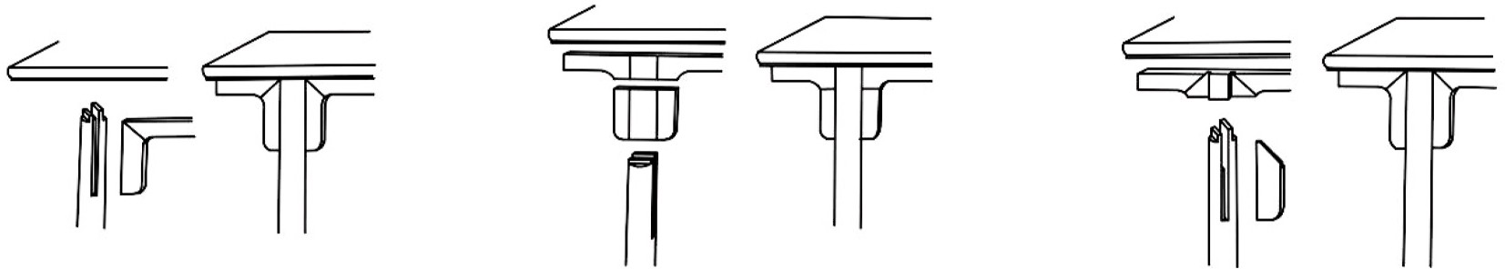

**Fig. 1.** Three structures of Elongated bridle tenon.

participants’ motivation.

In addition to teaching methods, many studies have shown that students’ motivation and interests also impact academic performance (Carreira, 2011; Yu et al., 2019). Students’ interest in learning is actively

promoted through inquiry-based interaction and problem-solving

(Antonietti & Cantoia, 2000; Price & Rogers, 2004). MR has been suc- cessfully integrated into learning and training programs to create authentic learning experiences within simulated virtual learning envi- ronments that facilitate tacit knowledge acquisition and workplace expertise development (Wu, Hartless, et al., 2019). Research has been shown that students feel more engaged when interacting with an MR interface, which leads to better performance (Dalim et al., 2016). If the system fails to interact, students will feel disengaged (Chen & Duh, 2018). In the mixed reality environment, people can interact with vir- tual objects. With an automatic speech recognition module, students can have verbal conversational interaction with a virtual personal assistant using spoken natural language, while the assistant not only verifies the students’ location, but also provides safety warnings and informs the

next steps to be taken (Zhu et al., 2014). Using serious games for

learning can effectively improve students’ learning motivation and in- terest (Manero et al., 2015; Rosas et al., 2003). However, we have not

yet understood how serious games based on MR technology affect stu- dents’ motivation and interest. Therefore, the second research purpose of this study is to find out how the teaching style of MR serious games will affect the students’ learning interest and motivation.

* + 1. *MR in learn culture learning*

MR is conducive to improving learners’ ability to analyze problems, explore new concepts, and effectively improve students’ learning effect. However, compared with the subject knowledge, culture is more ab-

stract, which also makes culture in education have certain difficulties. A well-established trend worldwide, using augmented, virtual, and mixed- reality technologies in cultural heritage enhances accessibility, knowl- edge diffusion, and user-centered experiences. Bekele et al. (2018) provide a comprehensive review, identifies application areas, suggests appropriate technologies, and predicts future research directions. Peteva et al. (2019) present the conceptual framework of a project that utilizes mixed reality to train and promote cultural heritage, high- lighting the benefits of virtual and augmented reality in engaging users and fostering regional development through cultural tourism. Plecher et al. (2019) present mixed reality approaches for engaging students in ancient Greek culture, including the use of augmented reality in mu- seums and a new VR-streaming solution. The application allows users to visualize 3D scans of cultural heritage in their original environment, providing a unique way to experience the past. Gonzalez Vargas et al. (2020) examine the application of augmented reality (AR) in cultural heritage (CH) education and its effect on students’ motivation to learn

about CH topics. This study analyzed various databases and specific

journals. And identifies potential areas for future improvement in this field. The study by Bekele et al. (2021) confirmed that the integration of collaborative and multi-modal interaction methods with mixed reality technology effectively enhances cultural learning in virtual heritage, as demonstrated in the evaluation at the Western Australian Shipwrecks Museum. Bekele (2021) explores the design and implementation of a cloud-based collaborative and multi-modal mixed reality application in the virtual heritage domain, aiming to enhance cultural learning.

However, there is still a need for further exploration on the appli- cation of Mixed Reality (MR) in the learning of cultural heritage and the potential learning outcomes it can produce. Therefore, this study aims to investigate the efficacy of using MR technology in the learning of cul- tural heritage, specifically focusing on the teaching method of serious games. By comparing this method with conventional teaching methods, the study seeks to determine whether learning through mixed reality games can yield better outcomes for college students.

# Research purpose

Mortise and tenon contain rich cultural connotations and artistic values, but it is difficult for the public to understand due to its diversity and complex structure. Under the global trend of attaching importance to the teaching of cultural heritage and promoting the dissemination of knowledge associated to cultural heritage, can the serious game solve the dilemma that mortise and tenon joints are difficult to promote? The question drives us to study this. This study developed a mixed reality-

based pair matching puzzle game called “Looking for mortise and tenon joint”, which is used to improve learning attitude, learning per- formance and motivation. The main objectives of the research are as

follows:

1. The impact of MR serious games and traditional teacher teaching on students’ learning and knowledge retention.
2. The influence of MR serious game and traditional teacher teaching

on students’ learning motivation and situational interest.

# Method

In this study, the experimental group learned mortise and tenon knowledge through the MR game, and researchers taught the control group. The two groups of students learnt the same content, such as mortise and tenon structures and related concepts, in different teaching methods. The researchers compiled the study materials for both groups to ensure that the two teaching methods covered the same content to minimize differences in outcomes due to different learning content. Research materials are compiled with the advice of experts to ensure the accuracy of the knowledge contained in the materials. Finally, the test was used to evaluate the knowledge learning and retention of the two groups of participants. The situational interest and motivation scale were also used to measure and evaluate the state of the experimental participants after learning.

* 1. *Serious game design*

The pair matching puzzle game used in this study requires the players to match the same two pictures, select, and eliminate them. In the process of finding the images, the player is reminded of the content of the image. A mortise can be divided into two or more parts, and the player chooses the different structural parts to eliminate. Players will carefully observe the mortise and tenon joint structure, distinguish the difference between each structure, and deepen their memory of the mortise and tenon joint in this process. So, we adapted the pair matching puzzle connected game mode and modified the game to make it suitable for teaching.

Chinese furniture structure has a long and fine tradition. After continuous improvement and development in various dynasties, the organic combination of various parts is simple and clear, in line with the mechanical principles, and the structural connection benefits from the support of various mortise and tenon joints. Based on this characteristic, the researchers designed a “mortise and tenon” game based on the rules

of puzzle games. When players compare different mortise and tenon

structures and look for matching parts, they unconsciously learn about each mortise and tenon and its components. In this game, because the components of mortise and tenon are not the same, the number is different, and the structure is similar overall, the subtleties are different, increasing the difficulty of the game. Therefore, players in the game need to understand the structural characteristics of each mortise and tenon joint, and carefully observe, to complete the correct match. In the game process, MR can realize the interaction between people and ob- jects in the environment and has certain operation functions. In the MR environment, players can rotate, zoom in and out of each model at will, and observe the subtleties of each structure through a 360-degree rotation. Zooming in and out also allows players to repeatedly

compare the similarities and differences of each structure (Fig. 2). In this interactive process, the player can deeply understand and memorize the mortise and tenon components. After the game design is completed, it is submitted to the tutor for verification and modification. The tutor is an expert on the history and structure of Ming and Qing Dynasty furniture with more than a decade of teaching experience, so the game content is considered professional and reliable.

The game called “Looking for mortise and tenon joint” was designed by researchers according to the rules of the pair matching puzzle game.

Players are required to compare different mortise and tenon structures to find the parts that match each other. The matching process requires careful identification of each object so that the two objects fit into one, forming a complete mortise and tenon. The game interface is littered with many structural models, and players must find a successful match between different structural models until all the structural models in the interface are mortise and tenon. Completing the stage enables progres- sion to the next level of the game (Fig. 3). The whole game is divided

into three levels based on the book’s classification of mortise and tenon. Shixiang Wang, a master of classical furniture research in China,

divided furniture structure into four categories in his book “Research on Ming Style Furniture”, namely, basic combination, a combination of legs and feet with upper members, a combination of legs and feet with lower

members, and additional tenon pins. Based on this, this study divides mortise and tenon joints into three types, foundation member, leg member and comprehensive member, based on their stress direction and position in furniture. The complexity of mortise and tenon structure involved in these three types of joints becomes even larger. In turn, the number of components increases, and the styles change. The game is also divided into three levels according to these three categories. First, the lattice shoulder tenon in the foundation member is selected; in the second pass, the shoulder tenon in the leg member is selected; in the third pass, the selection of integrated components in the reed corner tenon. These three mortises and tenon joints, each containing two or more different components, meet the requirements of the game content in the experiment.

Take the first level as an example, which is divided into two parts. The first part introduces the basic concept of the tenon joint, including the source introduction, joint style, and detailed joint explanation, to help the player understand the mortise and tenon. There are three kinds of shoulder tenon, and there are only slight differences in the joint, which requires the player to use the function of MR and careful obser- vation. In this section, the player can review at any time and control the learning progress according to their own level of acceptance. Then the second part is the matching puzzle game, which explains all the mortise and tenon joints included in this part. The three-lattice shoulder tenon is composed of two components. Each mortise and tenon component are decomposed, disassembled, randomly placed, and divided into two rows of options. Players need to combine the learning content of the above part, carefully observe the similarities and differences of each joint, and drag the correct option into the black box on the right side. Finally, the

system determines if it has found the correct structure, and the correct one will hear the correct feedback tone, and the wrong one will hear the wrong feedback tone.

In order to help players better complete the game, scaffolding is set up in the game. When the player finds the accurate mortise and tenon structure, the system will judge the success and show the complete mortise and tenon joint pattern, further deepening the player’s memory.

Suppose the player makes the wrong choice, and the game fails. In that

case, the system automatically pops up a message to help the player understand and identify each mortise and tenon structure in order to help the player finish the game. When all three mortises and tenon are correctly matched at this level, the system automatically displays the complete mortise and tenon patterns, allowing the player to compare them again from a holistic perspective. The second and third passes have the same process except for the different mortise and tenon styles and complexity, which will not be repeated here. The game process is shown in Fig. 3, along with screenshots of the game interface.

In the early stage, the mortise and tenon joints are screened ac- cording to the classification of mortise and tenon joints, and the mortise and tenon structures suitable for games are selected. Depending on the complexity of the mortise and tenon structure, the game level is iden- tified as easy or difficult. After the general framework of the game was determined, we first created each mortise and tenon model in 3D Studio Max and drew the auxiliary information in the game interface. Then, with the help of experts, we developed the game in unity3D and finally integrated all the game contents into the Hololens2 device. Once the

game was made, the team’s researchers wore Hololens2 helmets and played the game directly. In the process, we found flaws in the game and

improved it to make it perfect.

Hololens2 is the first virtual headset that can be used wirelessly, greatly improving the user’s game experience. At the same time, the Holelens2 module is flexible. HoloLens2 can be worn with glasses,

making it more popular with users.

* 1. *Traditional teaching*

In the experiment, compared with the MR group using serious game teaching, the traditional teaching group was set as the control group, using the teaching method taught by the researcher. Before the experi- ment, students in the control group would watch the same mortise and tenon video as students in the experimental group. Researchers taught the control group the knowledge of mortise and tenon joints with the PowerPoint software. The content taught in the PowerPoint is the same as that in the MR game, except that the mortise and tenon structures are in two-dimensional picture form, not interactive. The researcher also explained in full accordance with the text in the PowerPoint to ensure that the learning content of the two groups was consistent. Appropriate time will be reserved for each mortise and tenon joint to ensure the students’ learning effect in the control group, so the students can better

understand the structure of the mortise and tenon joints from the

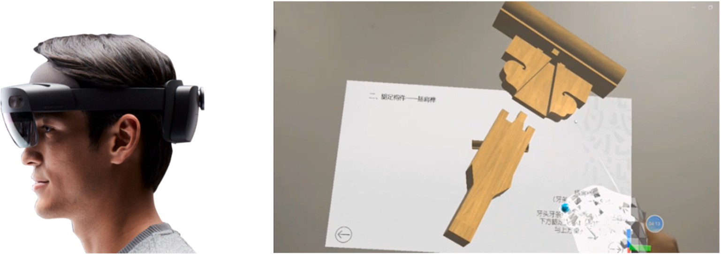

**Fig. 2.** MR wearing image and game image from the player’s perspective.

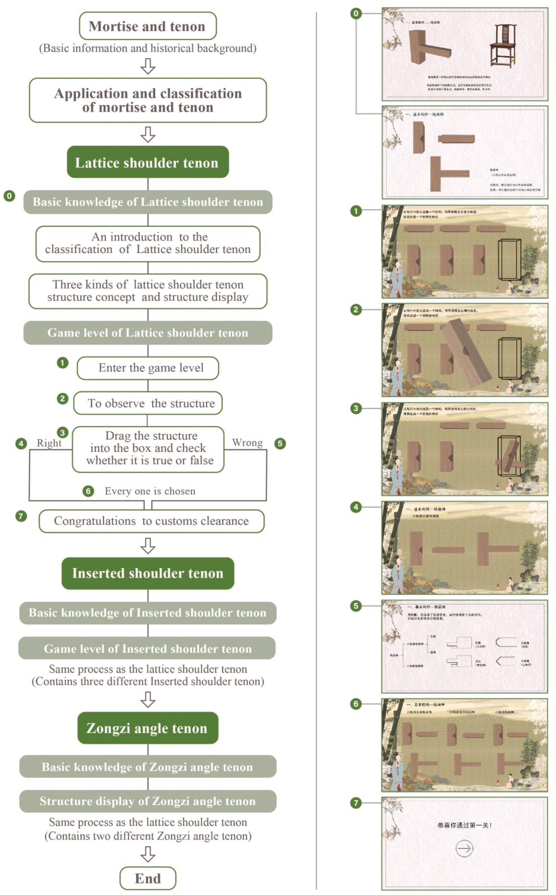

**Fig. 3.** Game flow and related interface screenshots.

pictures (Fig. 4).

* 1. *Achievement test*

To explore whether the use of MR serious games for mortise and tenon joint teaching can improve students’ learning effect, the

researchers designed a test to evaluate the performance of two groups of students. First, the researchers formulated the test questions about mortise and tenon joints and invited relevant experts to review the test questions. The researchers modified and improved the test content ac- cording to experts’ suggestions so the test was professional and effective.

The test will be used for the post-test after the study and the memory test

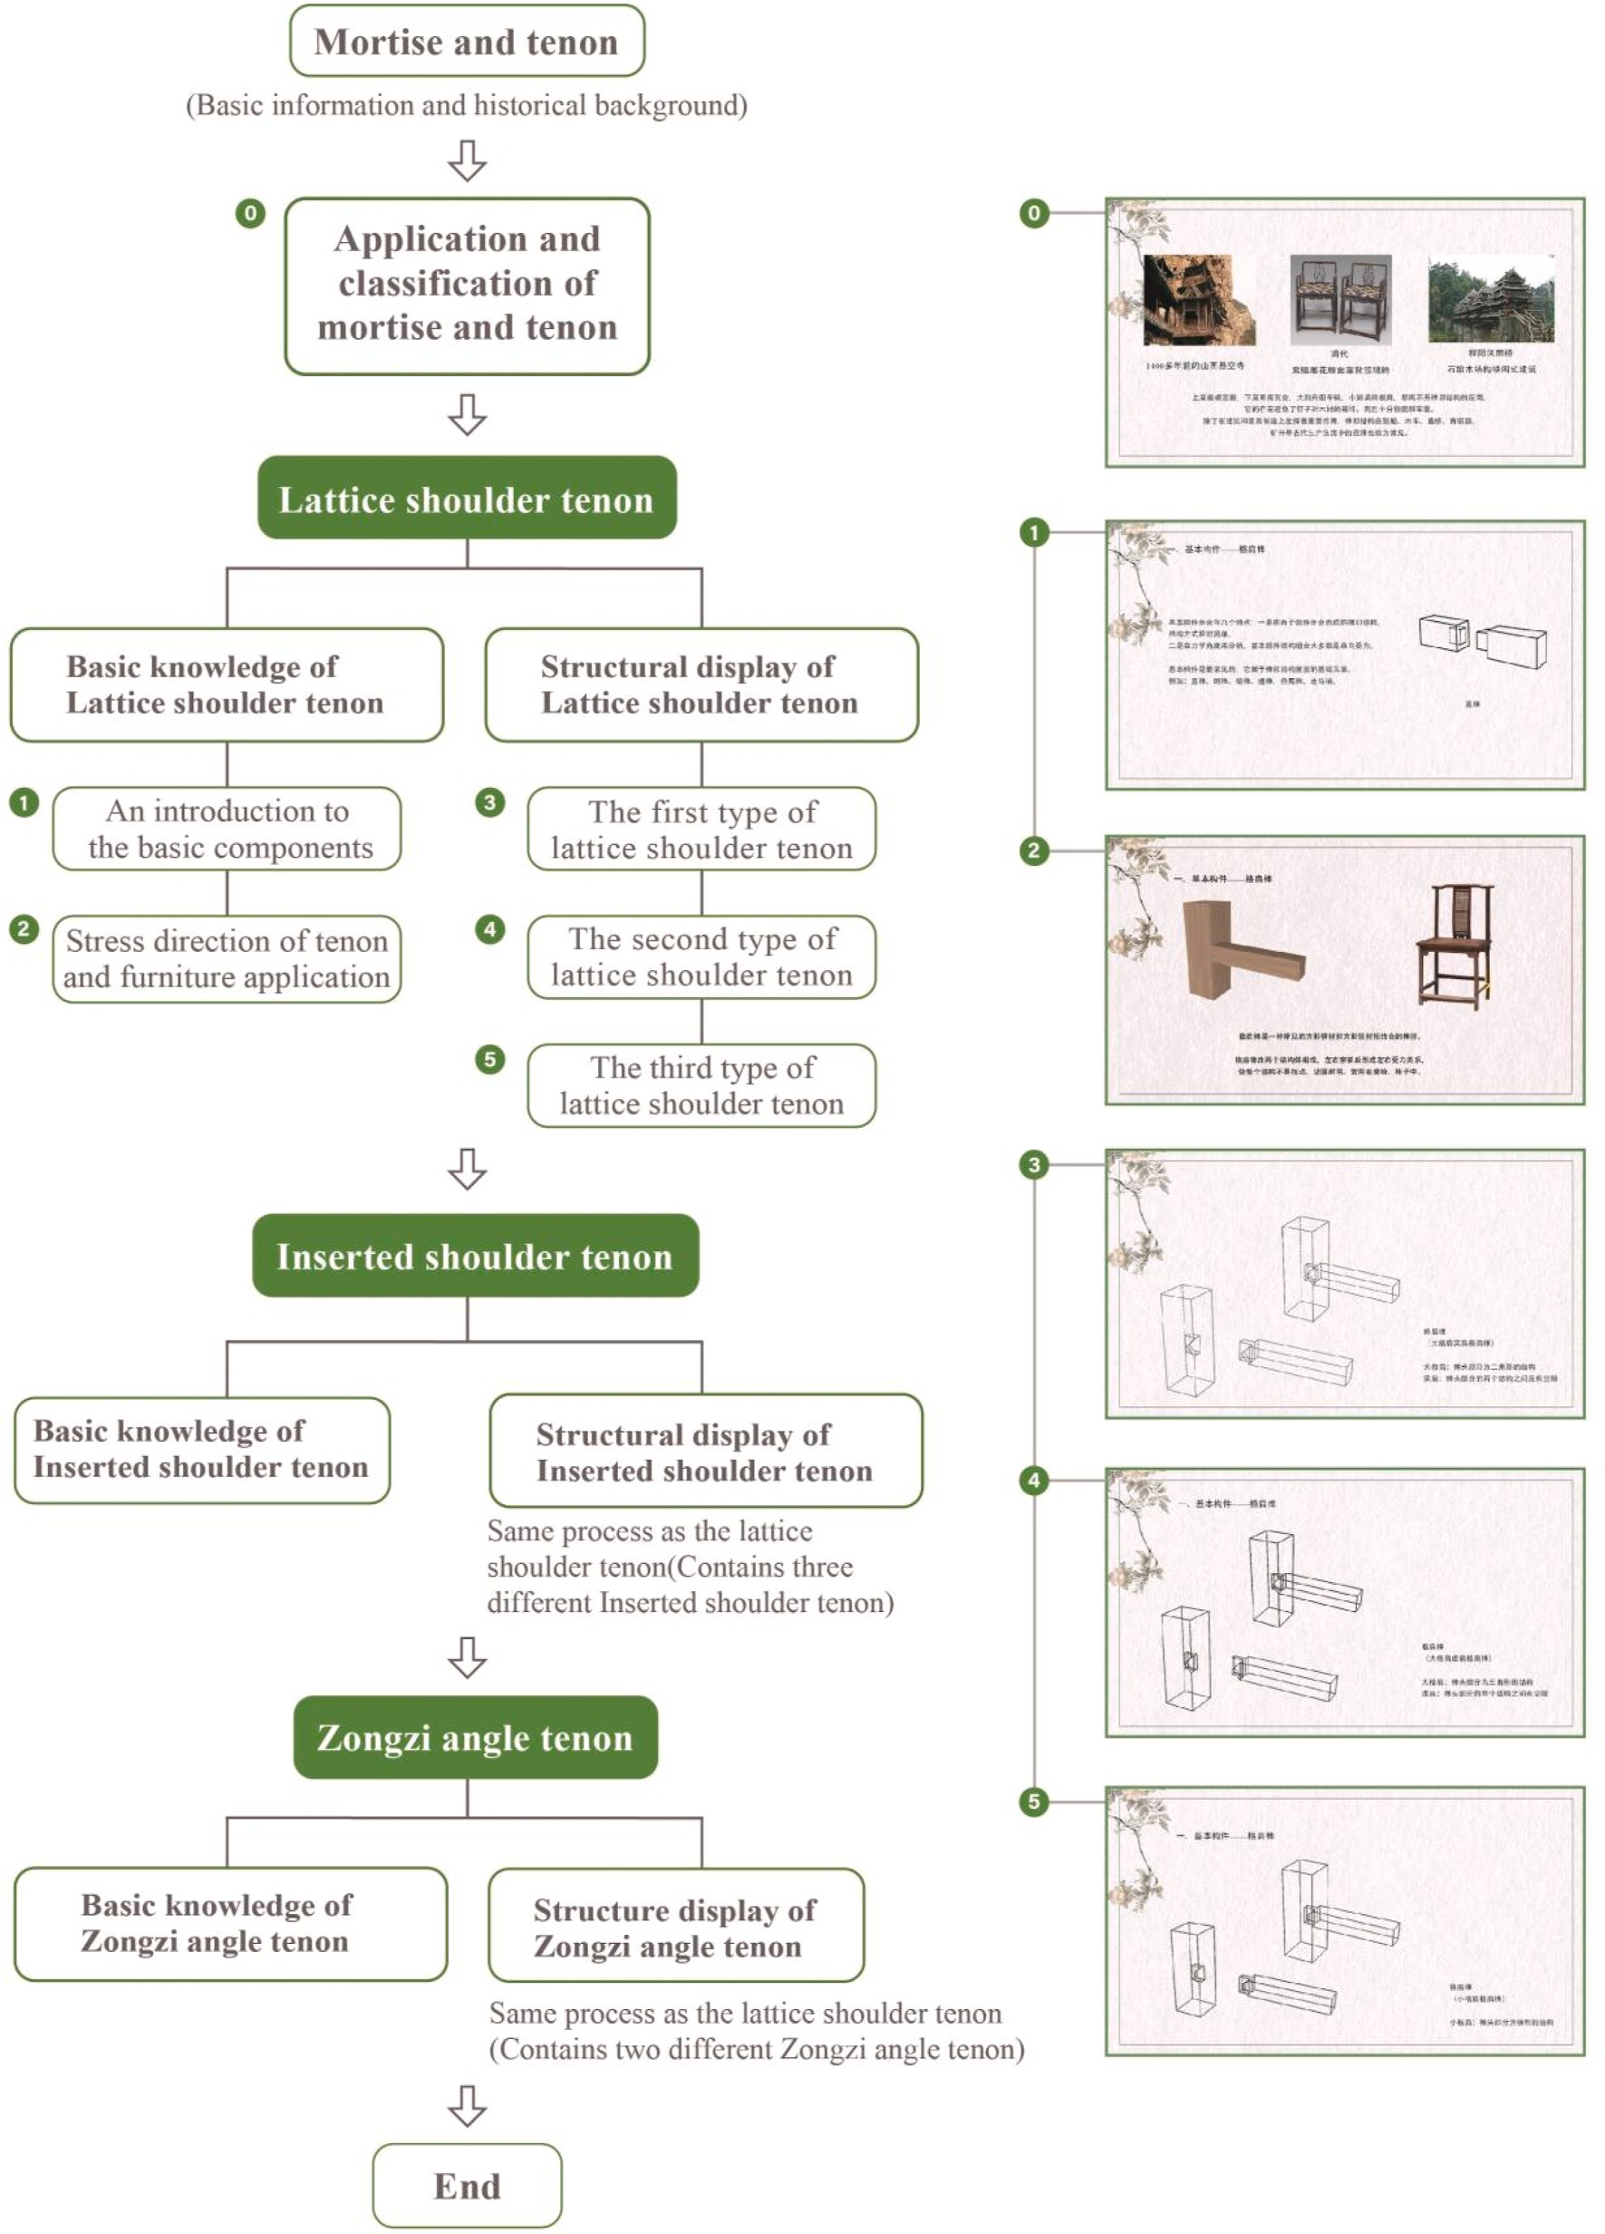

**Fig. 4.** Video learning flow and related screenshots.

after one week.

The test evaluates participants’ learning effect from three aspects: knowledge acquisition, knowledge transfer and knowledge application.

The knowledge acquisition part consists of questions 1 to 5, which investigate basic knowledge. Corresponding knowledge points exam- ined are directly presented in the teaching content. Questions 6 and 7 relate to the knowledge transfer part of the test, which tests whether the participants can flexibly use the knowledge of mortise and tenon joint knowledge. Questions 8 to 10 link with the knowledge application part, which examines the application of the three mortise and tenon joints included in the teaching content in furniture. The questionnaire consists of 10 questions, each of which is 1 point. The achievement test had exactly the same questions as the memory test.

* 1. *Measurement of students’ motivational change*

The content of the motivation scale in this paper is modified based on the motivation questionnaire proposed in Paul R. Pintrich’ s classroom learning research. Internal consistency reliability analysis of the moti- vation questionnaire showed Cronbach’s alpha coefficients were 0.86 and 0.87, respectively. A five-point Likert scale was used to measure students’ learning motivation before and after the experiment. Students were asked to choose the appropriate number from strongly disagree (1

point) to agree strongly (5 points). The scale includes two dimensions, self-efficacy and intrinsic value. Intrinsic value is used to assess partic- ipants’ attitudes towards mortise and tenon courses, and self-efficacy is

used to assess participants’ confidence in their abilities. The whole

motivation consists of seven questions. All questions in the scale are accurately translated into Chinese to ensure participants can understand the questions and answers correctly. The motivation scale was tested

before and after the experiment to analyze the change in students’ learning motivation through the difference between the two scores.

* 1. *Measurements of students’ situational interest*

In educational research, interests are conceptualized as personal and situational interests (Krapp et al., 1992). Contextual claims refer to in- terests activated by the environment (Hidi, 2006; Schraw & Lehman, 2001; Sun & Rueda, 2012). Numerous studies have shown that situa- tional interest can significantly improve student engagement, perfor- mance, and effort (Alexander et al., 1995; Harp & Mayer, 1997; Rotgans & Schmidt, 2014). The content of the situational interest scale in this

paper comes from the scale proposed in Paul W. Darst’s research on sports situational interest. The scale comprises six dimensions: explor-

atory imagery, pleasure, novelty, attention needs, challenge, and overall interest. The internal consistency reliability analysis of the whole questionnaire showed that Cronbach’s alpha coefficient was 0.79. Par-

ticipants’ situational interest was assessed using a five-point Likert scale.

The learning interest scale contains 6 questions, one for each dimension. The influence of MR reality games on students’ learning interests is analyzed through the score difference between the two groups of

students.

# Process

We recruited 66 students from a university in Jiangsu, China and randomly divided them into two groups, with 33 students in each group. Before the experiment, we conducted interviews and prior knowledge tests on all participants to measure students’ understanding of MR and

mortise and tenon through some questions. In the course of talking with

the students, we learned that none of the participants had experience with MR and Hololens2. The questionnaire of knowledge pre-test investigated the basic understanding of mortise and tenon, and the re- sults showed that most students had no knowledge of mortise and tenon. However, three students had higher scores on the prior test and had a certain understanding of mortise and tenon. These three students were

excluded from the experiment to avoid the influence of prior knowledge on the final results. The final number of participants in the research was 63, including 32 in the traditional group (TRD), with an average age of

20.8 years (SD = 1.3), and 31 in the MR group, with an average age of

21.1 years (SD = 1.4). For all students involved in this research, new knowledge needs to be learnt in the experiment. Each participant was in a closed office with no distractions during the experiment. At the same time, to avoid the John Henry effect of the control group and the Hawthorne effect of the experimental group, the students in both groups were not informed of the purpose of the experiment and kept students in a natural learning state.

Before the experiment began, the MR group was required to watch an informal popular science video about mortise and tenon joints, intro- ducing basic information and testing students’ motivation before

learning. The researchers then introduced the rules of the game and

HoloLens2 manipulation to the MR group. The goal is to ensure that participants feel relaxed and comfortable during the process. At the end of the game, they completed tests and questionnaires and a memory test a week later. Participants in the TRD group were also asked to watch the same popular science videos as those in the MR group before the experiment began. The researchers then used PowerPoint to teach the same content. After the PowerPoint presentation, participants in the TRD group were also asked to complete tests and questionnaires and a memory test a week later.

# Results and discussion

* 1. *Learning and knowledge retention*

The achievement test results were used to compare the learning of participants in the TRD and MR groups. There are 10 questions in the test, with 1 point for each question, 10 points out of 10. Fig. 5 shows the scores of the two groups in each question. Table 1 shows the results of the T-test.

The data showed that the test scores of the MR group were better than those of the TRD group (t = 7.545, P < 0.01). There were signifi- cant differences in the basal part (T = 7.503, P < 0.01) and migration part (P < 0.01) between the two groups. According to Fig. 6, in the

knowledge acquisition part, the performance of the MR group was

significantly better than that of the TRD group in the examination of mortise and tenon structures. Both groups of students had high accuracy in answering simple questions. With the more complex mortise and tenon structure, the accuracy of the two groups declined. However, the decreasing trend of the MR group was relatively slow, and the difference between the two groups gradually widened. This indicates that learning mortise and tenon structures by using MR can help students clearly understand mortise and tenon structures, while the traditional teaching method of showing structures by two-dimensional pictures cannot play a great role in helping students learn mortise and tenon structures. The transfer part is the application of basic knowledge, which requires stu- dents to choose on the basis of understanding mortise and tenon struc- ture knowledge. In this part, students in the MR group scored better, which further reflected that students in the MR group had a clearer understanding of mortise and tenon structure. There was no significant difference between the two groups in the application part (P > 0.05). In

the teaching process of both TRD and MR groups, this knowledge was

displayed with pictures and described with words. Therefore, we believe that in this part, the teaching content and teaching methods of the two groups are the same, so there is no significant difference between the two groups. The overall test results show that both the traditional teaching method and the teaching method using MR serious game can effectively impart knowledge, but for the explanation of the three- dimensional structure, MR shows its advantages. Students can observe the mortise and tenon structure from multiple angles in the process of the MR game. In addition, game-based learning is enhanced by an interactive model suitable for legacy content (Hong et al., 2012).

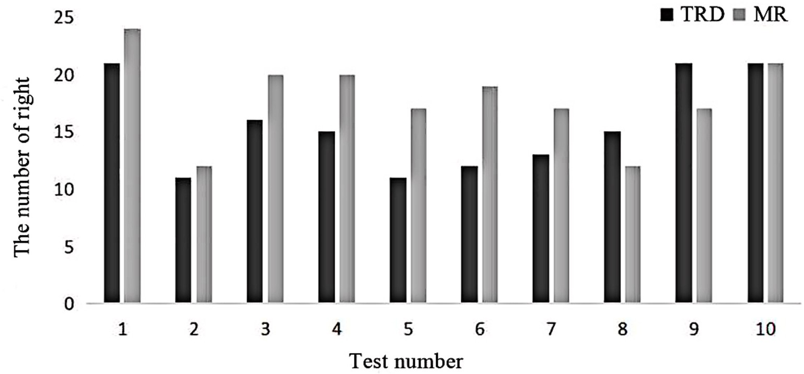

**Fig. 5.** Scores of TRD group and MR group in achievement test.

**Table 1**

T-test of achievement test in TRD group and MR group Comparison of mortise and tenon learning results between TRD group and MR group.

TR group - MR group Paired difference t Df sig. (2-tailed) cohen’s d Mortise and tenon test content Mean Mean difference Std. error difference 95％ Confidence interval of the

difference

|  |  |  |  |  |  |  |  |  |  |  |
| --- | --- | --- | --- | --- | --- | --- | --- | --- | --- | --- |
|  | TRD | MR |  |  | Lower | Upper |  | | | |
| The entire test | 4.73 | 6.63 | 1.886 | .252 | 1.380 | 2.391 | 7.47 | 54 | .00*\*\** | 2.033 |
| Knowledge acquisition | 2.24 | 3.44 | 1.209 | .162 | .884 | 1.535 | 7.44 | 56 | .00*\*\** | 1.988 |
| Knowledge transfer | 0.76 | 1.33 | .565 | .131 | .304 | .826 | 4.33 | 60 | .00*\*\** | 1.118 |
| Knowledge application | 1.73 | 1.85 | .111 | .146 | .180 | .403 | 0.77 | 57 | .44 | .204 |

*Note:* *p < 0.05; **p < 0.01.

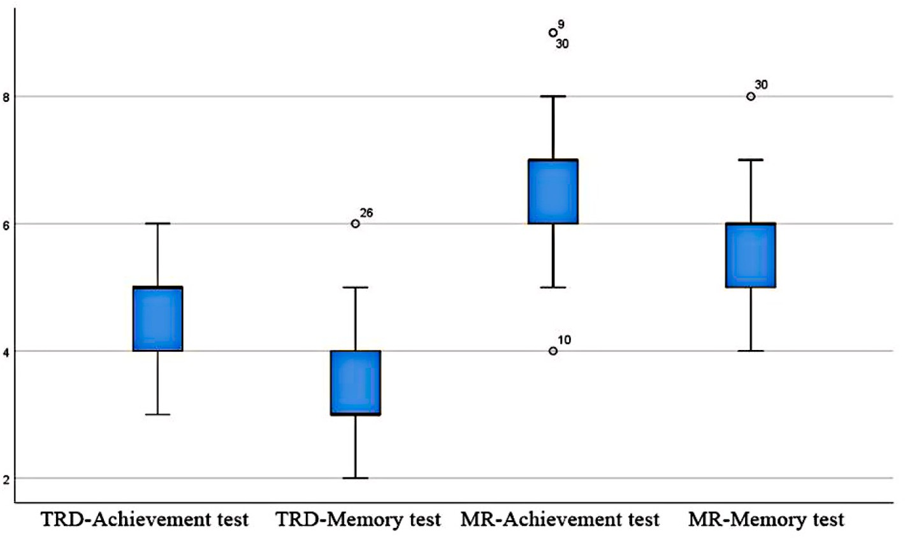

**Fig. 6.** Memory test results of TRD group and MR group.

A memory test was performed one week after the experiment. When the papers were collected, four students in the MR group scored higher on the memory test than on the achievement test. After a follow-up visit, the researchers learned that the four students searched relevant mate- rials and reviewed what they had learned. This phenomenon also shows that MR serious games can stimulate students’ interest in learning

mortise and tenon. To ensure the accuracy and authenticity of the data

analysis of memory retention rate, the data of these four students in the memory test were excluded. The final memory test part included 32

students in the TRD group and 27 students in the MR group. Fig. 6 shows the scores of the two groups of students on the achievement test and memory test, and the T-test was used to compare the differences in memory between the two groups of participants. The analysis results are shown in Table 2.

The results showed that the scores of the MR group in the basic part were higher than those of the TRD group (p < 0.01). The structures examined in the basics section are displayed in the game. Participants repeatedly observed and compared several mortises and tenon joint

Test of memory test in TRD group and MR group, Comparison of mortise and tenon learning results between TRD group and MR group.

TR group -MR group Paired difference t Df sig. (2-tailed) cohen’s d Mortise and tenon test content Mean Mean difference Std. error difference 95％ Confidence interval of the

difference

|  |  |  |  |  |  |  |  |  |  |  |
| --- | --- | --- | --- | --- | --- | --- | --- | --- | --- | --- |
|  | TRD | MR |  |  | Lower | Upper |  |  |  |  |
| The entire test | 3.36 | 5.52 | —.128 | .032 | —.192 | —.064 | —4.01 | 53 | .00** | 2.033 |
| Knowledge acquisition | 1.33 | 3.07 | —.304 | .051 | —.407 | —.201 | —5.92 | 53 | .00*\*\** | 1.988 |
| Knowledge transfer | 0.57 | 1.11 | —.259 | .119 | —.497 | —.021 | —2.18 | 58 | .03 | 1.118 |
| Knowledge application | 1.45 | 1.33 | —.076 | .068 | —.059 | —.211 | 1.12 | 55 | .27 | .204 |

*Note:* *p < 0.05; **p < 0.01.

structures during the game, which deepened the students’ memory of the structures. With the help of appropriate scaffolding in the game,

participants will pay more attention to the difference in mortise and tenon joint structure. Although the score difference was not large be- tween the two groups in the transfer part, the score of the MR group (M

= 0.76) was still higher than that of the TRD group (M = 0.50). In the transfer part, the performance difference was not significant (p > 0.05), which further proved that the two teaching methods did not produce significant differences in the two-dimensional picture-style content as analyzed in the achievement test. Different from the previous one, the score of the MR group (M = 0.78) was lower than that of the TRD group (M = 0.85) in this part, probably because the stereoscopic model in MR attracted more attention from the participants while ignoring the pic- tures. The content in the picture caused the students in the MR group to be less impressed by the content in the picture.

* 1. *Changes in motivation before and after the experiment*

The researchers tested the motivation of the two groups of partici- pants before and after the experiment. All data was effective and included in the analysis. Internal consistency reliability analysis of the motivation questionnaire showed that Cronbach’s alpha coefficients

were 0.86 and 0.87, respectively. Table 3 shows the paired sample T-test

results for the two groups of student motivation data. The data shows that the student’s learning motivation in the TRD group did not change significantly (t = 0.00, p > 0.05) after learning. In contrast, the student’s

learning motivation in the MR group was significantly improved (t =

—11.09, p < 0.01). The result indicates that teaching with MR serious games can improve students’ learning motivation in the learning pro- cess. According to the interviews with the subjects before the experi-

ment, MR, a new virtual technology, has not been widely used in Chinese colleges and universities, and serious games are rarely used in class. Hence, students are full of curiosity about the new technology. Based on this, we believe new technology and learning styles can improve students’ motivation to learn.

* 1. *Learning interest*

The internal consistency reliability analysis of the whole question- naire showed that Cronbach’s alpha coefficient was 0.79. Table 4 shows a significant difference in situational interest between the TRD and MR

group (p < 0.01). Data shows that, compared with the traditional teaching method, the MR serious game teaching method can improve

learners’ situational interest. Moreover, we conducted a Pearson cor- relation coefficient analysis on situational interest and performance to

explore whether the performance is affected by situational interest. The results showed that there was a significant positive correlation between the two (R = 0.59, P < 0.01), and the score did increase with the increase of situational interest (Table 5).

# Conclusion

In quasi-experimental research, comparing the differences between the TRD group and the MR group confirmed the significance of serious games using MR technology in promoting traditional handicraft edu- cation. MR mainly provides an interactive game environment for players. In this game environment, the player can shrink and enlarge the structural model, as well as rotate the model to facilitate the player’s

observation of the model. This MR game environment allows players to

view objects more clearly and easily than traditional 2D game graphics. The focus of this article is to show the internal structure of the sample and the spine so that students can learn the knowledge of mortise and tenon. Although two-dimensional images can show the external struc- ture of the spine, it is difficult to show the internal structure of the spine and how the various structures are integrated, which is also the focus of MR game teaching. At the same time, the rod structure is similar, and the player needs to carefully compare the subtle differences between each structure. Hence, the three-dimensional game environment is more convenient. The use of the MR design of mortise and tenon game, based on the form of levels, let students step by step in-depth understanding of mortise and tenon. Spread mortise and tenon knowledge in the form of games. Compared with the teaching group of traditional teachers, the teaching group using MR game learned more knowledge of mortise and tenon. At the same time, students in the MR play group achieved greater gains in learning motivation and situational interest. In recent years, digital technology has been widely used in education and communica- tion to improve learners’ knowledge acquisition and attitude. VR, AR

and other virtual technologies have been widely used in cultural heri-

tage education, but few studies involve the teaching application of traditional handicrafts. This study takes traditional mortise and tenon joint from China as a teaching case, combines the latest MR technology to enhance immersion and interaction in serious games, and compares its advantages with the traditional teaching mode. The interaction of MR and the characteristics of 360◦ surround are combined with mortise and tenon joints to solve the problem that mortise and tenon joints cannot be observed well in traditional teaching methods (Tüzün et al., 2009;

**Table 3**

T-test of motivation changes in TRD group and MR group. Comparison of learning motivation changes between TRD group and MR group.

|  |  |  |  |  |  |  |  |  |  |  |  |
| --- | --- | --- | --- | --- | --- | --- | --- | --- | --- | --- | --- |
|  | |  | Paired difference | |  | | | t | Df | sig. (2-tailed) | cohen’s d |
|  |  |  |  |  |  |  |  |  |  |
|  |  |  |  |  |  |  |  |  |  |
|  |  |  |  |  |  |  |  |  |  |  |  |
|  |  |  |  |  |  |  |  |  |  |  |  |

|  |  |  |  |  |  |  |  |  |  |  |  |
| --- | --- | --- | --- | --- | --- | --- | --- | --- | --- | --- | --- |
|  | |  | Paired difference | |  | | | t | Df | sig. (2-tailed) | cohen’s d |
|  |  |  |  |  |  |  |  |  |  |
|  |  |  |  |  |  |  |  |  |  |
|  |  |  |  |  |  |  |  |  |  |  |  |
|  |  |  |  |  |  |  |  |  |  |  |  |

*Note:* *p < 0.05; **p < 0.01.

**Table 4**

T-test of situational interest in TRD group and MR group. Comparison of situational interest between TRD group and MR group.

|  |  |  |  |  |  |  |  |  |
| --- | --- | --- | --- | --- | --- | --- | --- | --- |
|  | Paired difference |  |  |  | t | df | sig. (2-tailed) | cohen’s d |
| Mean | Mean difference | Std. error difference | 95％ Confidence interval of the difference |  |  |  |  |
| TRD MR |  |  | Lower Upper |  |  |  |  |
|  | 4.76 6.61 | —6.363 | .548 | —7.457 —5.268 | —11.6 | 62 | .00** | —2.95 |

*Note:* *p < 0.05; **p < 0.01.

**Table 5**

Correlation test between learning achievement and situational interest, Corre- lation analysis between learning achievement and situational interest.

|  |  |  |
| --- | --- | --- |
| achievement and situational interest | Pearson Correlation | sig. (2-tailed) |
| situational interest | .595 | .00** |

*Note:* *p < 0.05; **p < 0.01.

Manero et al., 2015; Srisawasdi & Panjaburee, 2019). Through the game, the knowledge of mortise and tenon is refined and integrated so that players can master the knowledge more easily in the game. This research effectively expands the serious game design method with cul- tural heritage education. Furthermore, it explores the effectiveness of the serious game teaching method based on mixed reality technology. With a traditional teaching method, it is not easy to show three-dimensional structures through words and pictures, but this is the advantage of MR technology. The modes of pair matching puzzle game enable players to recognize the structure during the game and differ- entiate between structures of the same mortise and tenon joints. Through interaction, players are guided to interact with the content of cultural relics to improve their attitude toward learn about cultural heritage and make them more actively participate in cultural relic learning activities. (Gil-Fuentetaja & Economou, 2019).

Mortise and tenon joints and their production techniques are important material cultural heritage in China. Using MR serious games to spread mortise and tenon knowledge can attract more people to pay attention to understanding mortise, and realizing the inheriting of mortise and tenon culture. On the other hand, learning the mortise and tenon structure through games can give students great flexibility in the following mortise and tenon model or traditional Chinese furniture making.

This study also has certain limitations. First of all, there are few mortises and tenon joints involved in the experiment, and only one mortise and tenon joint case is selected for each type of mortise and tenon joint. In future research, we will conduct more comprehensive developments and integrate more content and elements. Second, the data shows that the information in the picture part of the MR game is not well conveyed, which also needs to be further analyzed in the following research. Finally, this paper fails to determine which aspects of MR

serious games affect students’ learning motivation and situational in- terests and how the results will guide us to design games more effec-

tively, which will also be our next research direction.

# Statements on open data and ethics

In this study, the participants in the experiment were voluntary and their personal information was strictly protected. The data can be ob- tained by sending emails to the corresponding author. The authors declare that the data in this paper has not been plagiarized, is original, and meets academic standards.

# Author contributions

Yongxin Hang: Conceptualization, methodology, writing, criticism, experiment. Huiqing Wang: Methodology, game production, writing, experiment, data analysis, editing. Zihan Sang: Experiment, comment,

edit. Rong Huang: Game production, writing, experimentation. Li Ye: Methodology, commentary, editing.

# Funding

This work was supported by the Teaching and academic research independent key topics of China University of Mining and Technology (grant number: 2022DLZD07); and the 14th Five-Year Plan of Educa- tional Science in Jiangsu Province, China (grant number: T-b/2021/06).

Funding sources were not involved in the study.

# Declaration of competing interest

The authors declare that they have no known competing financial interests or personal relationships that could have appeared to influence the work reported in this paper.

# Acknowledgements

We would like to thank the 3 experts 63 participants of college stu- dents in our trials and reviewers’ valuable suggestions. Additionally, we would like to thank David Bramston, who provided suggestions for ex-

periments and language proof for the article.

# References

Abulnour, A. M. H. (2013). *Protecting the Egyptian monuments: Fundamentals of proficiency*. <https://doi.org/10.1016/j.aej.2013.09.003>

Alexander, P. A., Jetton, T. L., & Kulikowich, J. M. (1995). Interrelationship of knowledge, interest, and recall. *Assessing A Model of Domain Learning, 87*(4), 559. <https://doi.org/10.1037/0022-0663.87.4.559>

Antonietti, A., & Cantoia, M. (2000). To see a painting versus to walk in a painting: An experiment on sense-making through virtual reality. *Computers & Education, 34*(3–4), 213–223. <https://doi.org/10.1016/S0360-1315(99)00046-9>

[Bekele, M. K. (2021). Clouds-based collaborative and multi-modal mixed reality for](http://refhub.elsevier.com/S2949-6780(23)00036-3/sref6)

[virtual heritage. *Heritage, 4*(3), 1447–1459](http://refhub.elsevier.com/S2949-6780(23)00036-3/sref6).

[Bekele, M. K., Champion, E., McMeekin, D. A., & Rahaman, H. (2021). The influence of](http://refhub.elsevier.com/S2949-6780(23)00036-3/sref7) [collaborative and multi-modal mixed reality: Cultural learning in virtual heritage.](http://refhub.elsevier.com/S2949-6780(23)00036-3/sref7) [*Multimodal Technologies and Interaction, 5*(12), 79](http://refhub.elsevier.com/S2949-6780(23)00036-3/sref7).

[Bekele, M. K., Pierdicca, R., Frontoni, E., Malinverni, E. S., & Gain, J. (2018). A survey of](http://refhub.elsevier.com/S2949-6780(23)00036-3/sref8) [augmented, virtual, and mixed reality for cultural heritage. *Journal on Computing and*](http://refhub.elsevier.com/S2949-6780(23)00036-3/sref8)

[*Cultural Heritage (JOCCH), 11*(2), 1–36](http://refhub.elsevier.com/S2949-6780(23)00036-3/sref8).

Bellotti, F., Berta, R., De Gloria, A., D’ursi, A., & Fiore, V. (2013). A serious game model for cultural heritage. *Journal on Computing and Cultural Heritage (JOCCH), 5*(4),

1–27. <https://doi.org/10.1145/2399180.2399185>

Bellotti, F., Berta, R., De Gloria, A., Ferretti, E., & Margarone, M. (2003). VeGame: Exploring art and history in Venice. *Computer, 36*(9), 48–55. [https://doi.org/](https://doi.org/10.1109/MC.2003.1231194) [10.1109/MC.2003.1231194](https://doi.org/10.1109/MC.2003.1231194)

Beyoglu, D., Hursen, C., & Nasiboglu, A. (2020). Use of mixed reality applications in teaching of science. *Education and Information Technologies, 25*(5), 4271–4286. <https://link.springer.com/article/10.1007/s10639-020-10166-8>.

Bruno, F., Barbieri, L., Lagudi, A., Cozza, M., Cozza, A., Peluso, R., & Muzzupappa, M. (2018). Virtual dives into the underwater archaeological treasures of South Italy.

*Virtual Reality, 22*(2), 91–102. [https://link.springer.com/article/10.1007/s10055-0](https://link.springer.com/article/10.1007/s10055-017-0318-z) [17-0318-z](https://link.springer.com/article/10.1007/s10055-017-0318-z).

Carreira, J. M. (2011). Relationship between motivation for learning EFL and intrinsic motivation for learning in general among Japanese elementary school students.

*System, 39*(1), 90–102. <https://doi.org/10.1016/j.system.2011.01.009> [Carrozzino, M., Voinea, G. D., Dugulean, M., Boboc, R. G., & Bergamasco, M. (2019).](http://refhub.elsevier.com/S2949-6780(23)00036-3/sref16)

[*Comparing innovative xr systems in cultural heritage. a case study*](http://refhub.elsevier.com/S2949-6780(23)00036-3/sref16).

Chang, C. W., Lee, J. H., Wang, C. Y., & Chen, G. D. (2010). Improving the authentic learning experience by integrating robots into the mixed-reality environment.

*Computers & Education, 55*(4), 1572–1578. [https://doi.org/10.1016/j.](https://doi.org/10.1016/j.compedu.2010.06.023) [compedu.2010.06.023](https://doi.org/10.1016/j.compedu.2010.06.023)

[Chen, S. S. C., & Duh, H. B. L. (2018). Mixed reality in education: Recent developments](http://refhub.elsevier.com/S2949-6780(23)00036-3/sref19) [and future trends. In *2018 IEEE 18TH international conference on advanced learning*](http://refhub.elsevier.com/S2949-6780(23)00036-3/sref19)[*technologies (ICALT 2018)*](http://refhub.elsevier.com/S2949-6780(23)00036-3/sref19).

Christopoulos, D., Mavridis, P., Andreadis, A., & Karigiannis, J. N. (2011). Using virtual environments to tell the story: “The Battle of Thermopylae”. In *2011 third international conference on games and virtual worlds for serious applications* (pp. 84–91).

IEEE. <https://doi.org/10.1109/VS-GAMES.2011.18>

[Chun, Q., Meng, Z., & Han, Y. (2017). Research on Mechanical Properties of Main Joints](http://refhub.elsevier.com/S2949-6780(23)00036-3/sref21) [of Chinese Traditional Timber Buildings with the Type of Post-and-Lintel](http://refhub.elsevier.com/S2949-6780(23)00036-3/sref21) [Construction. *Journal of Renewable Materials, 247-260*, 2017.01.a4](http://refhub.elsevier.com/S2949-6780(23)00036-3/sref21).

Connolly, T. M., Boyle, E. A., MacArthur, E., Hainey, T., & Boyle, J. M. (2012).

A systematic literature review of empirical evidence on computer games and serious games. *Computers & Education, 59*(2), 661–686. [https://doi.org/10.1016/j.](https://doi.org/10.1016/j.compedu.2012.03.004) [compedu.2012.03.004](https://doi.org/10.1016/j.compedu.2012.03.004)

[Dalim, C. S. C., Dey, A., Piumsomboon, T., Billinghurst, M., & Sunar, S. (2016). TeachAR:](http://refhub.elsevier.com/S2949-6780(23)00036-3/sref23) [An interactive augmented reality tool for teaching basic English to non-native](http://refhub.elsevier.com/S2949-6780(23)00036-3/sref23) [children. In *Adjunct proceedings of the 2016 IEEE international symposium on mixed and*](http://refhub.elsevier.com/S2949-6780(23)00036-3/sref23)[*augmented reality (ISMAR-ADJUNCT)*](http://refhub.elsevier.com/S2949-6780(23)00036-3/sref23).

De Paolis, L. T., Aloisio, G., Celentano, M. G., Oliva, L., & Vecchio, P. (2011). MediaEvo project: A serious game for the edutainment. In *2011 3rd International conference on*

*computer research and development* (Vol. 4, pp. 524–529). IEEE. [https://doi.org/](https://doi.org/10.1109/ICCRD.2011.5763914) [10.1109/ICCRD.2011.5763914](https://doi.org/10.1109/ICCRD.2011.5763914)

Del Barrio, M. J., Devesa, M., & Herrero, L. C. (2012). Evaluating intangible cultural heritage: The case of cultural festivals. *City, Culture and Society, 3*(4), 235–244. <https://doi.org/10.1016/j.ccs.2012.09.002>

Djaouti, D., Alvarez, J., Rampnoux, O., Charvillat, V., & Jessel, J. P. (2009). Serious games & cultural heritage: A case study of prehistoric caves. In *2009 15th*

*international conference on virtual systems and multimedia* (pp. 221–226). IEEE. <https://doi.org/10.1109/VSMM.2009.40>

Erhel, S., & Jamet, E. (2013). Digital game-based learning: Impact of instructions and

feedback on motivation and learning effectiveness. *Computers & Education, 67*, 156–167. <https://doi.org/10.1016/j.compedu.2013.02.019>

Ferdani, D., Fanini, B., Piccioli, M. C., Carboni, F., & Vigliarolo, P. (2020). 3D

reconstruction and validation of historical background for immersive VR applications and games: The case study of the Forum of Augustus in Rome. *Journal of Cultural Heritage, 43*, 129–143. <https://doi.org/10.1016/j.culher.2019.12.004>

Froschauer, J., Seidel, I., G¨artner, M., Berger, H., & Merkl, D. (2010). Design and

evaluation of a serious game for immersive cultural training. In *2010 16th international conference on virtual systems and multimedia* (pp. 253–260). IEEE. <https://doi.org/10.1109/VSMM.2010.5665978>

Gabellone, F., Lanorte, A., Masini, N., & Lasaponara, R. (2017). From remote sensing to a serious game: Digital reconstruction of an abandoned medieval village in Southern

Italy. *Journal of Cultural Heritage, 23*, 63–70. [https://doi.org/10.1016/j.](https://doi.org/10.1016/j.culher.2016.01.012) [culher.2016.01.012](https://doi.org/10.1016/j.culher.2016.01.012)

[Gaitatzes, A., Christopoulos, D., & Papaioannou, G. (2005). Virtual reality systems and](http://refhub.elsevier.com/S2949-6780(23)00036-3/sref34) [applications: The ancient olympic games. In *Panhellenic conference on informatics* (pp.](http://refhub.elsevier.com/S2949-6780(23)00036-3/sref34)

[155–165). Berlin, Heidelberg: Springer](http://refhub.elsevier.com/S2949-6780(23)00036-3/sref34).

Gao, Y., Gonzalez, V. A., & Yiu, T. W. (2019). The effectiveness of traditional tools and computer-aided technologies for health and safety training in the construction

sector: A systematic review. *Computers & Education, 138*, 101–115. [https://doi.org/](https://doi.org/10.1016/j.compedu.2019.05.003) [10.1016/j.compedu.2019.05.003](https://doi.org/10.1016/j.compedu.2019.05.003)

Gee, J. P. (2003). What video games have to teach us about learning and literacy.

*Computer Entertainment (CIE), 1*(1). <https://doi.org/10.1145/950566.950595>, 20-

20.

Gil-Fuentetaja, I., & Economou, M. (2019). Communicating museum collections information online: Analysis of the philosophy of communication extending the

constructivist approach. *Journal on Computing and Cultural Heritage (JOCCH), 12*(1), 1–16. <https://doi.org/10.1145/3283253>

[Gonzalez Vargas, J. C., Fabregat, R., Carrillo-Ramos, A., & Jov´e, T. (2020). Survey: Using](http://refhub.elsevier.com/S2949-6780(23)00036-3/sref38)

[augmented reality to improve learning motivation in cultural heritage studies.](http://refhub.elsevier.com/S2949-6780(23)00036-3/sref38)

[*Applied Sciences, 10*(3), 897](http://refhub.elsevier.com/S2949-6780(23)00036-3/sref38).

Guo, Q. (2015). Learning in a mixed reality system in the context of industry 4.0. *Journal of Technical Education (JOTED), 3*(2). <https://doi.org/10.48513/joted.v3i2.60>

Harp, S. F., & Mayer, R. E. (1997). The role of interest in learning from scientific text and illustrations: On the distinction between emotional interest and cognitive interest. *Journal of Educational Psychology, 89*(1), 92. [https://doi.org/10.1037/0022-](https://doi.org/10.1037/0022-0663.89.1.92) [0663.89.1.92](https://doi.org/10.1037/0022-0663.89.1.92)

Hidi, S. (2006). Interest: A unique motivational variable. *Educational Research Review, 1*

(2), 69–82. <https://doi.org/10.1016/j.edurev.2006.09.001>

Hong, J. C., Hwang, M. Y., Tam, K. P., Lai, Y. H., & Liu, L. C. (2012). Effects of cognitive style on digital jigsaw puzzle performance: A GridWare analysis. *Computers in Human*

*Behavior, 28*(3), 920–928. <https://doi.org/10.1016/j.chb.2011.12.012> [Johnson, T. E., & Wen-hai, D. H. (2008). Complex skills development for today’s](http://refhub.elsevier.com/S2949-6780(23)00036-3/sref45)

[workforce. In *Understanding models for learning and instruction* (pp. 305–325). Boston,](http://refhub.elsevier.com/S2949-6780(23)00036-3/sref45) [MA: Springer](http://refhub.elsevier.com/S2949-6780(23)00036-3/sref45).

Krapp, A., Hidi, S., & Renninger, K. A. (1992). Interest, learning, and development. *Kress*. <https://doi.org/10.1108/00197850610646061>

[Lercari, N., Mortara, M., & Forte, M. (2013). Unveiling California history through serious](http://refhub.elsevier.com/S2949-6780(23)00036-3/sref48)

[games: Fort Ross virtual warehouse. In *International conference on games and learning*](http://refhub.elsevier.com/S2949-6780(23)00036-3/sref48)[*alliance* (pp. 236–251). Cham: Springer](http://refhub.elsevier.com/S2949-6780(23)00036-3/sref48).

Manero, B., Torrente, J., Serrano, A´., Martínez-Ortiz, I., & Fern´andez-Manjo´n, B. (2015).

Can educational video games increase high school students’ interest in theatre? *Computers & Education, 87*, 182–191. [https://doi.org/10.1016/j.](https://doi.org/10.1016/j.compedu.2015.06.006) [compedu.2015.06.006](https://doi.org/10.1016/j.compedu.2015.06.006)

[Melero, J., & Hern´andez-Leo, D. (2014). A model for the design of puzzle-based games](http://refhub.elsevier.com/S2949-6780(23)00036-3/sref52) [including virtual and physical objects. *Journal of Educational Technology & Society, 17*](http://refhub.elsevier.com/S2949-6780(23)00036-3/sref52)

[(3), 192–207](http://refhub.elsevier.com/S2949-6780(23)00036-3/sref52).

Mortara, M., Catalano, C. E., Bellotti, F., Fiucci, G., Houry-Panchetti, M., & Petridis, P. (2014). Learning cultural heritage by serious games. *Journal of Cultural Heritage, 15*

(3), 318–325. <https://doi.org/10.1016/j.culher.2013.04.004>

[Müller, D., Bruns, F. W., Erbe, H. H., Robben, B., & Yoo, Y. H. (2007). Mixed reality](http://refhub.elsevier.com/S2949-6780(23)00036-3/sref54) [learning spaces for collaborative experimentation: A challenge for engineering](http://refhub.elsevier.com/S2949-6780(23)00036-3/sref54) [education and training. *International Journal of Online Engineering (iJOE), 3*(4),](http://refhub.elsevier.com/S2949-6780(23)00036-3/sref54)

[15–19](http://refhub.elsevier.com/S2949-6780(23)00036-3/sref54).

[Narciso, D., P´adua, L., Ad˜ao, T., Peres, E., & MagalhEs, L. (2015). Mixar mobile](http://refhub.elsevier.com/S2949-6780(23)00036-3/sref55)

[prototype: Visualizing virtually reconstructed ancient structures in situ. *Procedia*](http://refhub.elsevier.com/S2949-6780(23)00036-3/sref55)[*Computer Science, 64*, 852–861, 2015](http://refhub.elsevier.com/S2949-6780(23)00036-3/sref55).

Pan, Z., Cheok, A. D., Yang, H., Zhu, J., & Shi, J. (2006). Virtual reality and mixed reality

for virtual learning environments. *Computers & Graphics, 30*(1), 20–28. [https://doi.](https://doi.org/10.1016/j.cag.2005.10.004) [org/10.1016/j.cag.2005.10.004](https://doi.org/10.1016/j.cag.2005.10.004)

Pannese, L., & Carlesi, M. (2007). Games and learning come together to maximise effectiveness: The challenge of bridging the gap. *British Journal of Educational Technology, 38*(3), 438–454. <https://doi.org/10.1111/j.1467-8535.2007.00708.x>

Papastergiou, M. (2009). Digital game-based learning in high school computer science education: Impact on educational effectiveness and student motivation. *Computers &*

*Education, 52*(1), 1–12. <https://doi.org/10.1016/j.compedu.2008.06.004>

[Pellas, N., Kazanidis, I., & Palaigeorgiou, G. (2020). A systematic literature review of](http://refhub.elsevier.com/S2949-6780(23)00036-3/sref60) [mixed reality environments in K-12 education. *Education and Information*](http://refhub.elsevier.com/S2949-6780(23)00036-3/sref60)[*Technologies*](http://refhub.elsevier.com/S2949-6780(23)00036-3/sref60).

[Peteva, I., Denchev, S., & Trenchev, I. (2019). Mixed reality as new opportunity in the](http://refhub.elsevier.com/S2949-6780(23)00036-3/sref61) [preservation and promotion of the cultural and historical heritage. In *EDULEARN19*](http://refhub.elsevier.com/S2949-6780(23)00036-3/sref61)

[*Proceedings* (pp. 2451–2456)](http://refhub.elsevier.com/S2949-6780(23)00036-3/sref61).

[Plecher, D. A., Wandinger, M., & Klinker, G. (2019). Mixed reality for cultural heritage.](http://refhub.elsevier.com/S2949-6780(23)00036-3/sref62) [In *2019 IEEE conference on virtual reality and 3D user interfaces (VR)* (pp. 1618–1622)](http://refhub.elsevier.com/S2949-6780(23)00036-3/sref62).

Prensky, M. (2003). Digital game-based learning. *Computer Entertainment (CIE), 1*(1).

<https://doi.org/10.1145/950566.950596>, 21-21.

Price, S., & Rogers, Y. (2004). Let’s get physical: The learning benefits of interacting in digitally augmented physical spaces. *Computers & Education, 43*(1–2), 137–151. <https://doi.org/10.1016/j.compedu.2003.12.009>

Rosas, R., Nussbaum, M., Cumsille, P., Marianov, V., Correa, M., Flores, P., … Salinas, M. (2003). Beyond nintendo: Design and assessment of educational video games for first and second grade students. *Computers & Education, 40*(1), 71–94. [https://doi.org/](https://doi.org/10.1016/S0360-1315(02)00099-4) [10.1016/S0360-1315(02)00099-4](https://doi.org/10.1016/S0360-1315(02)00099-4)

Rotgans, J. I., & Schmidt, H. G. (2014). Situational interest and learning: Thirst for knowledge. *Learning and Instruction, 32*, 37–50. [https://doi.org/10.1016/j.](https://doi.org/10.1016/j.learninstruc.2014.01.002) [learninstruc.2014.01.002](https://doi.org/10.1016/j.learninstruc.2014.01.002)

Schraw, G., & Lehman, S. (2001). Situational interest: A review of the literature and directions for future research. *Educational Psychology Review, 13*(1), 23–52. https:// doi.org/10.1023/A:1009004801455

Srisawasdi, N., & Panjaburee, P. (2019). Implementation of game-transformed inquiry- based learning to promote the understanding of and motivation to learn chemistry.

*Journal of Science Education and Technology, 28*(2), 152–164. [https://linkspri](https://linkspringer.53yu.com/article/10.1007/s10956-018-9754-0) [nger.53yu.com/article/10.1007/s10956-018-9754-0](https://linkspringer.53yu.com/article/10.1007/s10956-018-9754-0).

[Strangman, N., & Hall, T. (2003). *Virtual reality/simulations*. Wakefield: National Center](http://refhub.elsevier.com/S2949-6780(23)00036-3/sref71) [on Accessing the General Curriculum](http://refhub.elsevier.com/S2949-6780(23)00036-3/sref71).

Sun, J. C. Y., & Rueda, R. (2012). Situational interest, computer self-efficacy and self- regulation: Their impact on student engagement in distance education. *British*

*Journal of Educational Technology, 43*(2), 191–204. [https://doi.org/10.1111/j.1467-](https://doi.org/10.1111/j.1467-8535.2010.01157.x) [8535.2010.01157.x](https://doi.org/10.1111/j.1467-8535.2010.01157.x)

Tüzün, H., Yılmaz-Soylu, M., Karakus¸, T., Inal, Y., & Kızılkaya, G. (2009). The effects of computer games on primary school students’ achievement and motivation in geography learning. *Computers & Education, 52*(1), 68–77. [https://doi.org/10.1016/](https://doi.org/10.1016/j.compedu.2008.06.008)

[j.compedu.2008.06.008](https://doi.org/10.1016/j.compedu.2008.06.008)

[Underhill, A. P., & Salazar, L. C. (Eds.). (2016). *Finding solutions for protecting and sharing*](http://refhub.elsevier.com/S2949-6780(23)00036-3/sref75)[*archaeological heritage resources*. Springer International Publishing](http://refhub.elsevier.com/S2949-6780(23)00036-3/sref75).

[Wu, G., Zhong, Y., Gong, Y., & Ren, H. (2019). Application of modern wood product](http://refhub.elsevier.com/S2949-6780(23)00036-3/sref77) [Glulam in timber frame with Tenon-Mortise joints and its structural behavior.](http://refhub.elsevier.com/S2949-6780(23)00036-3/sref77)

[*Journal of Renewable Materials, 09*(5), 451–461](http://refhub.elsevier.com/S2949-6780(23)00036-3/sref77).

[Wu, W., Hartless, J., Tesei, A., Gunji, V., Ayer, S., & London, J. (2019). Design assessment](http://refhub.elsevier.com/S2949-6780(23)00036-3/sref76) [in virtual and mixed reality environments: Comparison of novices and experts.](http://refhub.elsevier.com/S2949-6780(23)00036-3/sref76)

[*Journal of Construction Engineering and Management*, (9), 04019049.1–04019049.14](http://refhub.elsevier.com/S2949-6780(23)00036-3/sref76).

Yin, Y., & Antonio, J. (2020). Application of 3D laser scanning technology for image data processing in the protection of ancient building sites through deep learning. *Image and Vision Computing, 102*, 103969. <https://doi.org/10.1016/j.imavis.2020.103969>

[Yusoff, R. C. M., & Zaman, H. B. (2009). Mixed reality book: A visualization tool. In](http://refhub.elsevier.com/S2949-6780(23)00036-3/sref80)

[*International visual informatics conference* (pp. 326–336). Berlin, Heidelberg: Springer](http://refhub.elsevier.com/S2949-6780(23)00036-3/sref80).

Yu, S. J., Sun, J. C. Y., & Chen, O. T. C. (2019). Effect of AR-based online wearable guides on university students’ situational interest and learning performance. *Universal Access in the Information Society, 18*(2), 287–299. [https://doi.org/10.1007/s10209-](https://doi.org/10.1007/s10209-017-0591-3)

[017-0591-3](https://doi.org/10.1007/s10209-017-0591-3)

[Zhu, Z. W., Branzoi, V., Wolverton, M., Murray, G., Vitovitch, N., Yarnall, L., Acharya, G.,](http://refhub.elsevier.com/S2949-6780(23)00036-3/sref82) [Samarasekera, S., & Kumar, R. (2014). AR-Mentor: Augmented reality based](http://refhub.elsevier.com/S2949-6780(23)00036-3/sref82) [mentoring system. In *2014 IEEE international symposium on mixed and augmented*](http://refhub.elsevier.com/S2949-6780(23)00036-3/sref82)[*reality (ISMAR) - science and technology*](http://refhub.elsevier.com/S2949-6780(23)00036-3/sref82).

[Pregowska, A., Osial, M., Dolega-Dolegowski, D., Kolecki, R., & Proniewska, K. (2022).](http://refhub.elsevier.com/S2949-6780(23)00036-3/sref63)

[Information and communication technologies combined with mixed reality as](http://refhub.elsevier.com/S2949-6780(23)00036-3/sref63) [supporting tools in medical education. *Electronics, 11*(22), 37–78](http://refhub.elsevier.com/S2949-6780(23)00036-3/sref63).