[Egyptian Journal of Basic and Applied Sciences 4 (2017) 160–167](http://dx.doi.org/10.1016/j.ejbas.2017.07.002)

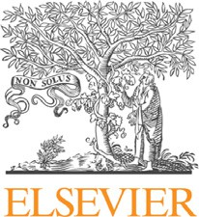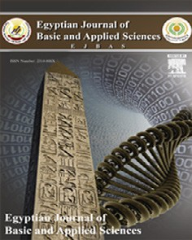

Contents lists available at [ScienceDirect](http://www.sciencedirect.com/science/journal/2314808X)

Egyptian Journal of Basic and Applied Sciences

journal homepage: [www.elsevier.com/locate/ejbas](http://www.elsevier.com/locate/ejbas)

Full Length Article

The role of thymoquinone as a potent antioxidant in ameliorating the neurotoxic effect of sodium arsenate in female rat



Rami B. Kassab, Rehab E. El-Hennamy ⇑

*Zoology Department, Faculty of Science, Helwan University, Cairo, Egypt*

# a r t i c l e i n f o

*Article history:*

Received 22 May 2017

Received in revised form 1 July 2017 Accepted 3 July 2017

Available online 14 July 2017

*Keywords:* Arsenic TQ

Antioxidants Neurotoxicity Brain

# a b s t r a c t

Arsenic is a neurotoxic substance that makes the brain susceptible to free radicals. Thymoquinone (TQ) is a potent antioxidant extracted from *Nigella sativa* seeds. It scavenges free radicals and prevents the cell damage resulted from oxidative substances. In this study, the ameliorative effect of TQ in arsenic-induced neurotoxicity was investigated. Rats were treated for 21 days with: distilled water, 20 mg/kg sodium arsenate, 10 mg/kg TQ, and arsenate followed by TQ. Cerebral cortex, cerebellum and brain stem were removed for the measurements of different physiological parameters. Cerebelli were prepared for histopathological studies. Arsenate treatment caused a decrease in the levels of norepinephrine (NE), dopamine (DA), acetylcholine esterase (AChE) and Na+-K+-ATPase activities in cerebral cortex, cerebel- lum, and brain stem of rats. Similarly, the levels of glutathione (GSH), glutathione peroxidase (GPx), glu- tathione reductase (GR), superoxide dismutase (SOD), catalase (CAT) were declined. In contrast, serotonin

(5-HT), lipid peroxidation (MDA), nitrite/nitrate (NO), and tumour necrosis factor (TNF-a) levels were

increased after arsenate treatment. The presence of degenerated Purkinje cells in cerebellum was noticed. Results revealed that, post-treatment with TQ suppressed the arsenate-induced neurotoxic effects as it decreased the levels of 5-HT, MAD, NO, TNF-a and increased the levels of NE, DA, GH, GPx, GR, SOD,

and CAT, in the cerebral cortex, cerebellum, and brain stem. Likewise, AChE and Na+-K+-ATPase activities were increased after TQ post-treatment. In conclusion, TQ ameliorated the neurotoxic effect of arsenate and suppressed the oxidative stress induced in the nervous system through its antioxidant mechanism.

© 2017 Mansoura University. Production and hosting by Elsevier B.V. This is an open access article under

the CC BY-NC-ND license (<http://creativecommons.org/licenses/by-nc-nd/4.0/>).

1. Introduction

Thymoquinone (TQ) is the main constituent of the volatile oil derived from *N. sativa* seeds. It has different pharmacological prop- erties such as anticonvulsant [1], antitussive [2], and anti-tumour

[3] as well as anti-inflammatory and antioxidant activities [4]. TQ crosses the blood brain barrier and exerts neuromodulatory activ- ities. It has a neuroprotective effect and improves brain injuries resulting from Parkinson’s disease [5] and status epilepticus [6]. It is also useful in the treatment of glial tumours by inducing apop- tosis of glial tumour cells [7]. Several studies reported the protec- tive role of TQ against neurotoxicty induced by heavy metals and radiation. It reduces the cerebral oxidative injuries induced by lead and ionizing radiation [7]. In addition it has a nephroprotective role against lead [8] and cadmium toxicity [9].

* Corresponding author at: Department of Zoology and Entomology, Faculty of Science, Helwan University, Ain Helwan, Cairo 11790, Egypt.

*E-mail addresses:* [rami.kassap@yahoo.com](mailto:rami.kassap@yahoo.com) (R.B. Kassab), [rhennamy@hotmail.](mailto:rhennamy@hotmail.com) [com](mailto:rhennamy@hotmail.com) (R.E. El-Hennamy).

Neurotoxicity is caused by the exposure to certain chemicals that affect the nervous system. It results from the degeneration of the neuronal cells [10]. Symptoms of neurotoxicity may include brain damage, dementia oramnesia, anxiety, depression, limb weakness and blurred vision [11]. Neurotoxicity occurs upon the exposure to natural or synthetic toxic substances, called neurotox- ins. Neurotoxins such as: aluminum, mercury, copper, arsenic, lead and manganese are characterized by their abilities to alter the nor- mal activity of the nervous system causing neuronal damage [12,13].

Arsenic is an environmental contaminant found naturally in ground water [14]. Other less common sources of arsenic exposure are incineration of arsenic preserved wood products, inhalation of indoor air polluted with coal combustion, consumption of tainted foods, ingestion of kitchen dust, and tobacco smoke [15]. It is ranked the first among toxicants posing significant potential threats to human health [16]. Arsenic exposure makes the brain tissue of rat vulnerable to free radical attack resulting in abnormal apoptosis of neural cells [17]. It could pass through the blood-brain barrier, invade the brain parenchyma and induce brain toxicity. Brain toxicity includes, altered cholinergic and monoaminergic

<http://dx.doi.org/10.1016/j.ejbas.2017.07.002>

2314-808X/© 2017 Mansoura University. Production and hosting by Elsevier B.V.

This is an open access article under the CC BY-NC-ND license (<http://creativecommons.org/licenses/by-nc-nd/4.0/>).

signalling. Behavioural deficits including learning, memory, and locomotion also results after arsenic exposure [18].

Therefore, the present study aimed to evaluate the effect of sodium arsenate on different brain areas (cerebral cortex, cerebel- lum, and brain stem) then to examine the role of TQ in ameliorat- ing neurotoxic effects of arsenate.

1. Material and methods
   1. *Chemicals*

Sodium arsenate (E.C. No. 231-547-5) and TQ (EC No. 207-721- 1) were purchased from Sigma (St. Louis, MO, USA). TQ was first dissolved in DMSO then was diluted with normal saline to a final DMSO concentration of 0.1%. The solution was then given orally.

All other chemicals and reagents were of analytical grade. Dou- ble distilled water was used as the solvent.

* 1. *Experimental animals*

Fourty Wistar female adult (4 month old) rats weighing 180– 200 g were obtained from the Holding Company for Biological Products and Vaccines (VACSERA, Giza, Egypt). Animals were sub- jected to an adaptation period of 10 days in the animal facility before experiments, they were housed in wire bottomed cages in

a room under standard conditions of illumination with a (12– 12 h) light-dark cycle at 25 ± 1 °C. They were provided with water and a balanced diet *ad libitum*. All animals received care in compli- ance with the Egyptian rules for animal protection.

* 1. *Experimental protocol*

Rats were classified randomly into four groups (n = 10) and treated orally for 21 consecutive days with:

* distilled water (control group).
* arsenic as sodium arsenate (20 mg/kg body weight/day) accord- ing to Yadav et al. [19] (As group).
* thymoquinone (10 mg/kg body weight/day) according to Gilho- tra and Dhingra [20] (TQ group).
* sodium arsenate (20 mg/kg body weight/day) then, after one hour they have received TQ (10 mg/kg body weight/day) (As.TQ).

At the end of the experiment, rats of all groups were sacrificed by fast decapitation; brains were removed, and dissected. Cerebelli were removed and fixed for histopathological studies. Cerebral cor-

tex, cerebellum and brain stem were stored in —70 °C until the per-

formance of the physiological measurements.

* 1. *Histopathological study*

Cerebelli were fixed in 10% formalin, dehydrated, cleared in xylene, embedded in paraffin wax, then sectioned, hydrated, stained with hematoxylin and eosin, and mounted in DPX [21].

* 1. *Physiological measurments*

The tested monoamines were estimated by high performance liquid chromatography (HPLC) according to Pagel et al. [22].

* + 1. *AChE assay*

C. No. 3.1.1.7), forms a yellow color with 5,5'-dithiobis (2- Thiocholine, produced by the action of acetylcholinesterase (E. nitrobenzoic acid). The intensity of the produced color, measured

at 412 nm, proportionate to the enzyme activity in the sample [23].

* + 1. *Na+/K+ ATPase assay*

The enzyme activity was determined by measuring the amount of inorganic phosphate (Pi) liberated from ATP during the incuba- tion of cerebrum, cerebellum and brain stem aliquots. Before, the

slices were incubated with Meth (0.05, 0.1, 0.5 and 1 lM) at differ-

ent times (5 or 15 min). Then, the reaction mixture containing 95 mM NaCl, 15 mM KCl, 1.0 mM ATP (disodium salt), 38 mM Tris–HCl buffer (pH 7.4) was added to aliquot of homogenized

slices (50 lg of protein) in a final volume of 0.3 mL. After a 5-

min pre-incubation at 37 °C in the presence of 0.1 mM ouabain to specifically inhibit Na+/K+-ATPase (E.C. No. 3.6.3.9), the reaction was initiated by addition of ATP and terminated after 15 min of incubation by addition of 1 mL of color reagent (Ammonium Molybdate 2%, Triton X 5% solubilized in H2SO4 1.8 M). The released inorganic phosphate was measured spectrophotometri- cally at k = 405 nm. Na+/K+-ATPase activity was calculated from the difference between amounts of inorganic phosphate found after incubation in the absence and presence of 1.5 M ouabain [24].

* + 1. *Measurment of lipid peroxidation*

Lipid peroxidation in brain homogenate were determined according to the method of Ohkawa et al. [25] using 1 mL of tri- chloroacetic acid 10% and 1 mL of thiobarbituric acid 0.67%, fol- lowed by heating in a boiling water bath for 30 min. Thiobarbituric acid reactive substances were determined by the absorbance at 535 nm and expressed as malondialdehyde (MDA) equivalents formed.

* + 1. *Measurement of Nitrite/Nitrate level*

The assay of nitrite/nitrate (NO) in brain homogenate was done according to the method of Berkels et al. [26]. In acid medium and in the presence of nitrite the formed nitrous acid diazotises sul- phanilamide, which is coupled with N-(1-naphthyl) ethylenedi- amine. The resulting azo dye has a bright reddish-purple color, which was measured at 540 nm.

* + 1. *Estimation of glutathione*

Glutathione (GSH) of brain was determined by the methods of

(5,5' dithiobis, 2-nitrobenzoic acid) with GSH to produce a yellow Ellman [27]. The method based on the reduction of Ellman’s reagent compound. The reduced chromogen directly proportional to GSH

concentration and its absorbance were measured at 405 nm.

The enzymatic antioxidants, GPx (E.C. no. 1.1.1.9), GR (E.C. 1.8.1.7), CAT (E.C. no. 1.11.1.6), and SOD (E.C. no. 1.15.1.1) were

determined according to the manufacturer instructions and pur- chased from Cayman chemical, Ann Arbor, Michigan, USA.

TNF-a (E.C. no. 1272/2008) was determined by quantitative

ELISA kits purchased from R&D Systems Inc (Minneapolis, USA).

* 1. *Statistical analysis*

The recorded data were presented as mean ± standard error. One way ANOVA was carried out, and the statistical comparisons among the groups were performed with Duncan’s test using a sta-

tistical package program (SPSS version 17.0). P ≤ 0.05 was consid-

ered as significant for all statistical analysis.

1. Results
   1. *Physiological observations*

The data recorded in Fig. 1a showed the effect of As and the post-treatment with TQ on the content of NE in the selected brain areas. The level of NE was decreased significantly (*P* < 0.05) in cere- bral cortex, cerebellum and brain stem in As-treated group when

compared with control values. After the treatment with TQ, a sig- nificant increase in the level of NE in all the tested brain homoge- nate was observed as compared with As-treated group. Similarly, the concentration of DA declined significantly (*P* < 0.05) in As- treated group as compared with the control group in all studied brain areas. The greatest decrease was found in brain stem. The

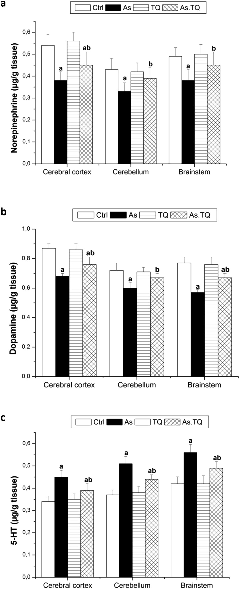

Fig. 1. Levels of the neurotransmitters, norepinephrine (a), dopamine (b), and serotonin (c) in cerebral cortex, cerebellum, and brain stem after the treatment with As and TQ. a: Significance at (P < 0.05) as compared to control group, b significance at (P < 0.05) as compared to arsenic group.

treated group with As and TQ showed that the levels of DA restored near to the normal values (Fig. 1b). In addition, the oral administra- tion of As significantly (*P* < 0.05) elevated 5-HT levels in cerebral cortex, cerebellum and brain stem compared with control group. Meanwhile, the post-tretment with TQ was found to decrease sig- nificantly (P < 0.05) the increament in 5-HT content (Fig. 1c).

The treated rats with As showed a significant depletion (*P* < 0.05) in the activity of AChE in cerebral cortex and brain stem when compared with those treated with distilled water as a con- trol. This value was elevated significantly (*P* < 0.05) after the treat- ment with TQ (Fig. 2a). Moreover, daily treatment with As for 21 days produced a significant (*P* < 0.05) depletion in the activity of Na+-K+-ATPase in all examined brain homogenates compared with the control group. Post treatment with TQ increased the activ- ity of Na+-K+-ATPase significantly (*P* < 0.05) compared with As group (Fig. 2b).

Levels of MDA was elevated significantly (*P* < 0.05) in As group compared with the control values in all investigated brain areas (Fig. 3a). However, the co-administered group with TQ showed a significant reduction in the level of MDA in the studied brain areas as compared with As group. By the same manner, the As-treated rats showed a significant (*P* < 0.05) increment in the levels of NO in cerebral cortex, cerebellum and brain stem as compared to the control group, meanwhile, the orally treated group with As and TQ induced a significant decrement in the levels of NO in the experimented brain areas when compared with As group (Fig. 3b). In contrast, levels of GSH were decreased significantly (*P* < 0.05) in As-group when compared to the control group. The post-treatment with TQ elevated the values of GSH significantly as compared to As treated rats (Fig. 3c).

The present study also estimated the enzymatic antioxidant system in the cerebral cortex, cerebellum and brain stem. The data presented in Fig. 4 showed that, the exposure to As caused a signif- icant decline (*P* < 0.05) in the concentration of CAT, SOD, GPx, and GR as compared with the control group, however, the treatment with TQ elevated these values significantly (*P* < 0.05) in the studied brain areas as compared to As-treated rats.

The influence of As and TQ on cytokines was also evaluated. It is clear from Fig. 5 that the administration of As for 21 days increased the production of TNF-a significantly in all the studied brain areas when compared with the control values, the maximum elevation

was marked in brain stem and cerebral cortex, however, the com- bined treatment with As and TQ showed a significant decrease (*P* < 0.05) in the production of TNF-a as compared to As-treated group.

* 1. *Histological observations of cerebellum*

Histological sections of the cerebellum of control rats showed normal architecture with distinct cortical layers: outer molecular, inner granular cell layer, between which is the single layer of large neurons called Purkinje cells. The granular cell layer was very pop- ulated with cells (Fig.6a). Rats treated with arsenate have cerebelli contained shrinked and degenerated Purkinje cells with condensed cytoplasm. Some of them lose their axons. The number of Purkinje cells, granular cells, and molecular cells were decreased (Fig.6b). The cerebellum of rats post treated with TQ (As+ TQ group) showed both normal and degenerated Purkinje cells (Fig.6c). The number of molecular cells and granular cells were slightly increased.

1. Discussion

Arsenic affects many transporter systems including the monoamines, DA, 5-HT and NE. It also induces overproduction of reactive oxygen species (ROS) and reactive nitrogen species (RNS)

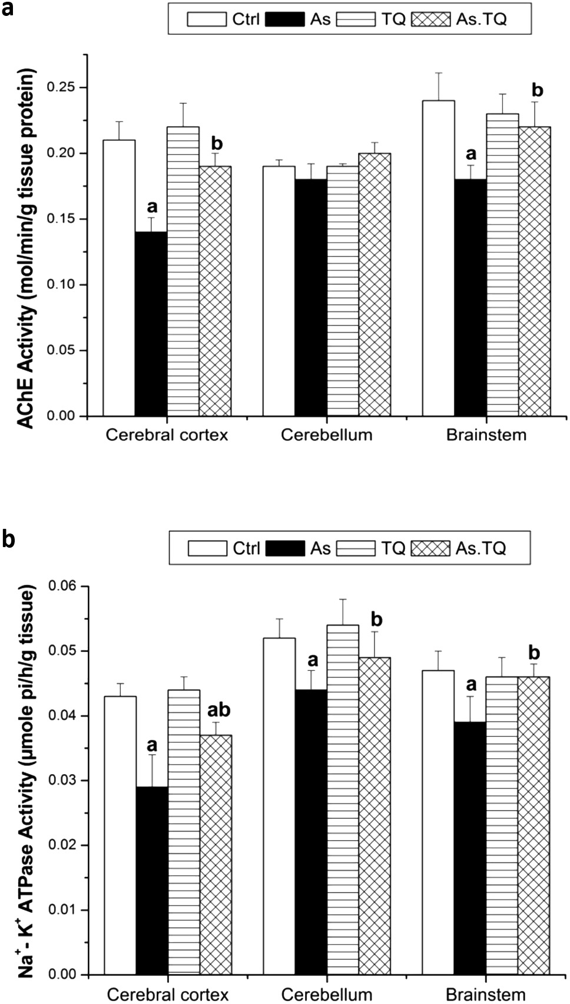

Fig. 2. Acetyl choline esterase activity (a) and Na+-K+ ATPase activity (b) in cerebral cortex, cerebellum, and brain stem after the treatment with As and TQ. a: Significance at (P < 0.05) as compared to control group, b significance at (P < 0.05) as compared to arsenic group.

in the body resulting in nucleic acid damage of the nerve cells [28]. In the present study, treatment of female rats with 20 mg/kg arse- nate for 21 days induced a decline in DA and NE and an elevation in 5-HT in cerebral cortex, cerebellum, and brain stem. This result agrees in part with Mejia et al. [29] who studied the effect of arsenic on discrete brain regions of rats. The study revealed a decrease in norepinephrine levels and an increase in levels of dopa- mine, serotonin, and their metabolites. In another study, exposure to moderate levels of arsenic (1, 2, and 4 mg/L) for 60 days reduced the levels of NE, DA, and 5-HT in both the cerebrum and cerebel- lum of 7-weeks old mice. Similarly, mRNA levels of monoamine synthetases (including dopamine b-hydroxylase, tyrosine hydroxy- lase, and tryptophan hydroxylase) were reduced after arsenic exposure [30]. High levels of arsenic cause insufficiency of dopaminergic and serotonergic signaling in the corpus striatum, hippocampus, and frontal cortex [19,31]. It could be concluded from those previous studies and the present result that the levels

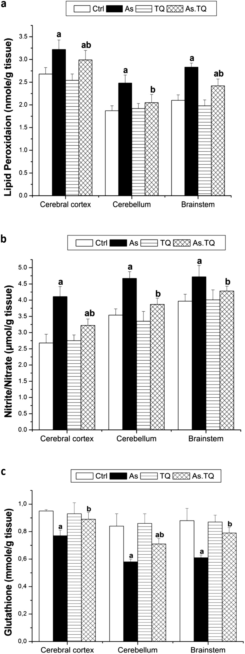Fig. 3. Lipid peroxidation level (a), nitrite/nitrate level (b), and Glutathione levels

(C) in cerebral cortex, cerebellum, and brain stem after the treatment with As and TQ. a: Significance at (P < 0.05) as compared to control group, b significance at (P < 0.05) as compared to arsenic group.

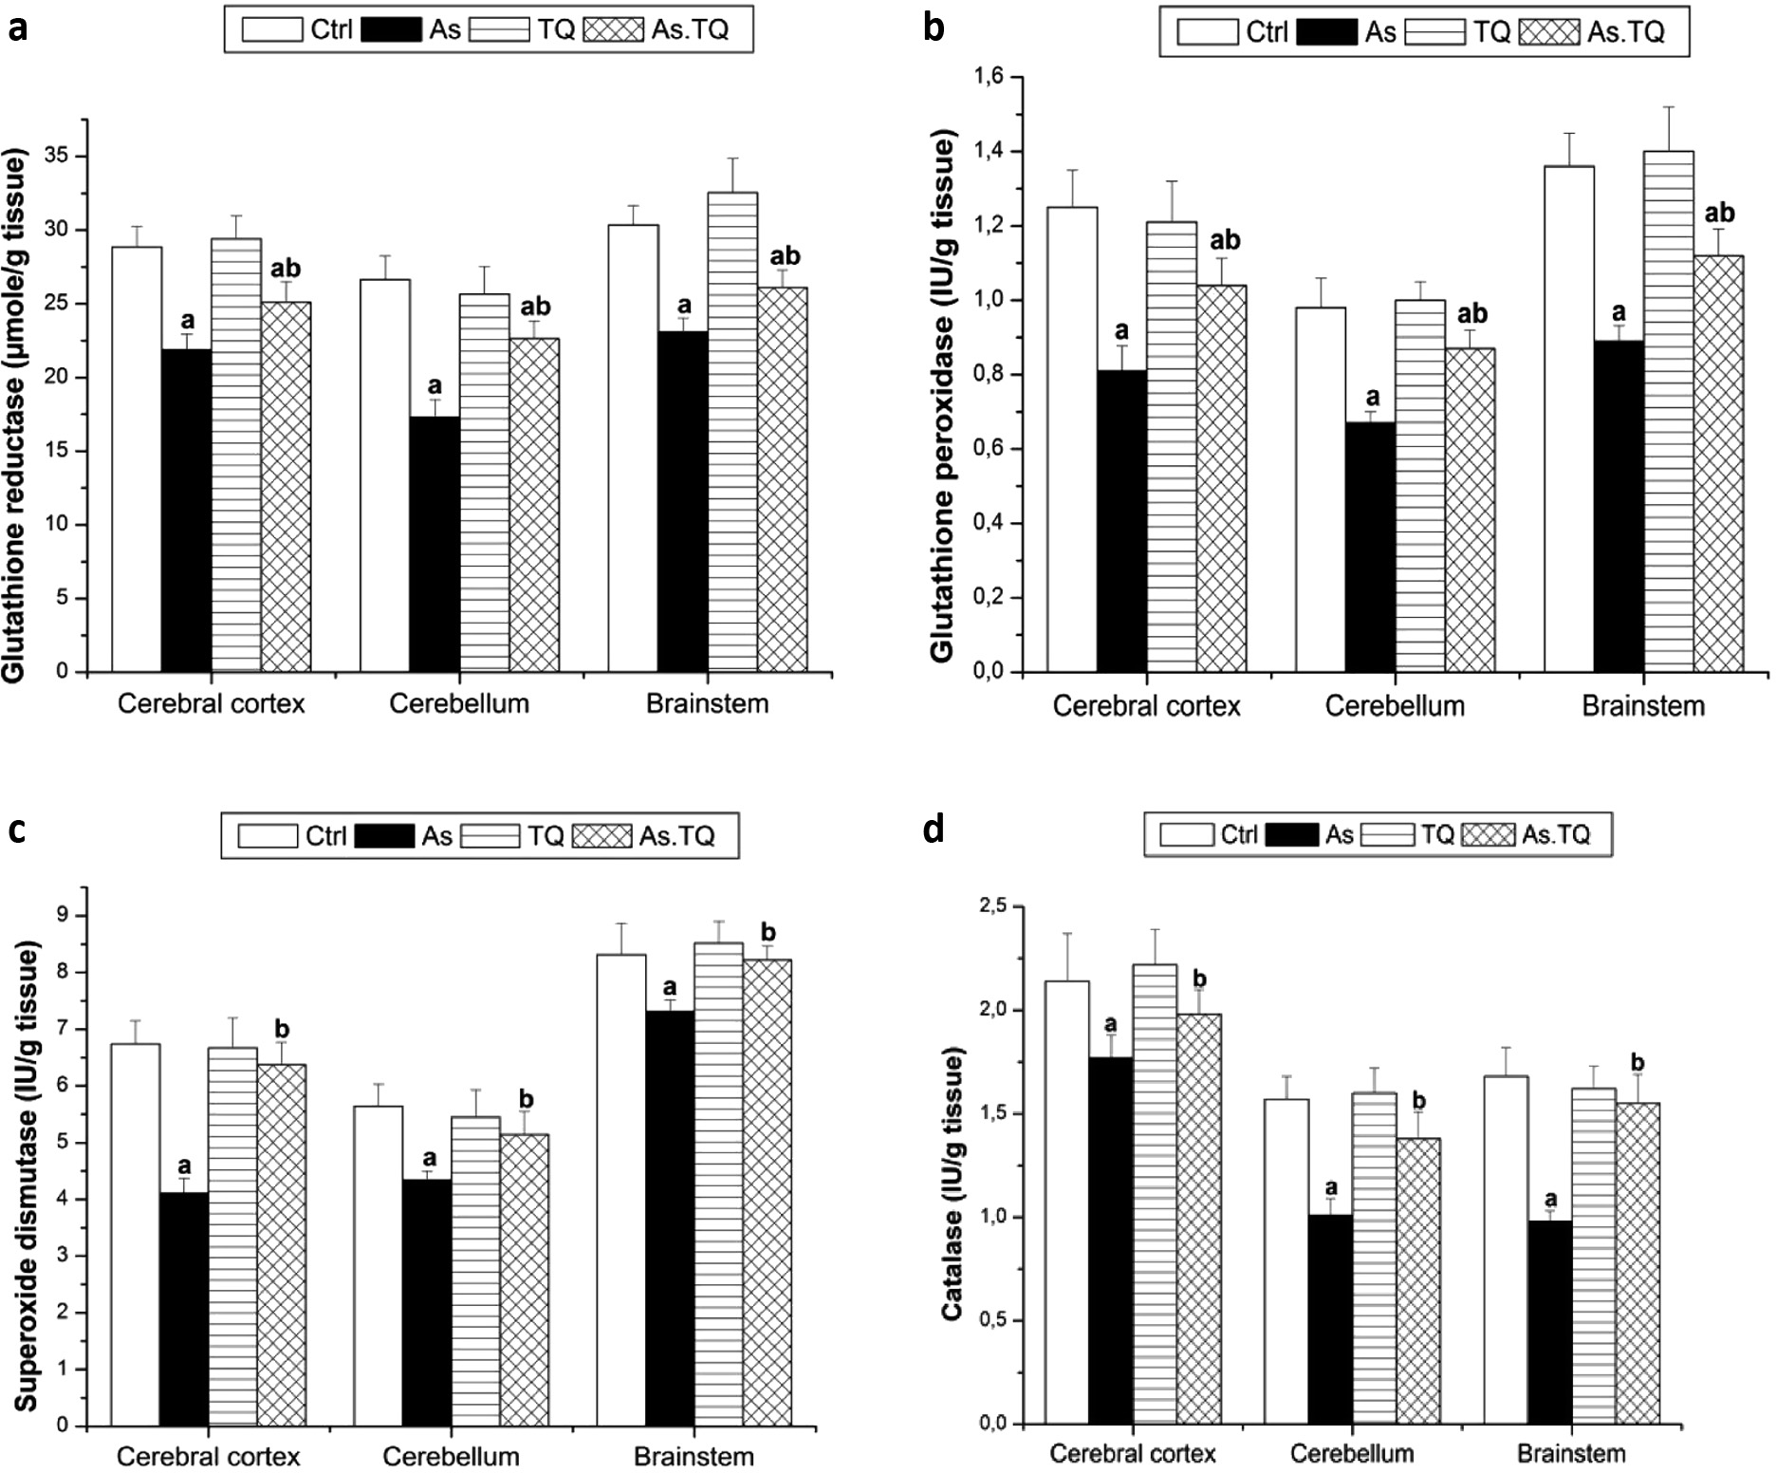

Fig. 4. Glutathione reductase (a), glutathione peroxidase (b), superoxide dismutase (c), and catalase (d) levels in cerebral cortex, cerebellum, and brain stem after the treatment with As and TQ. a: Significance at (P < 0.05) as compared to control group, b significance at (P < 0.05) as compared to arsenic group.

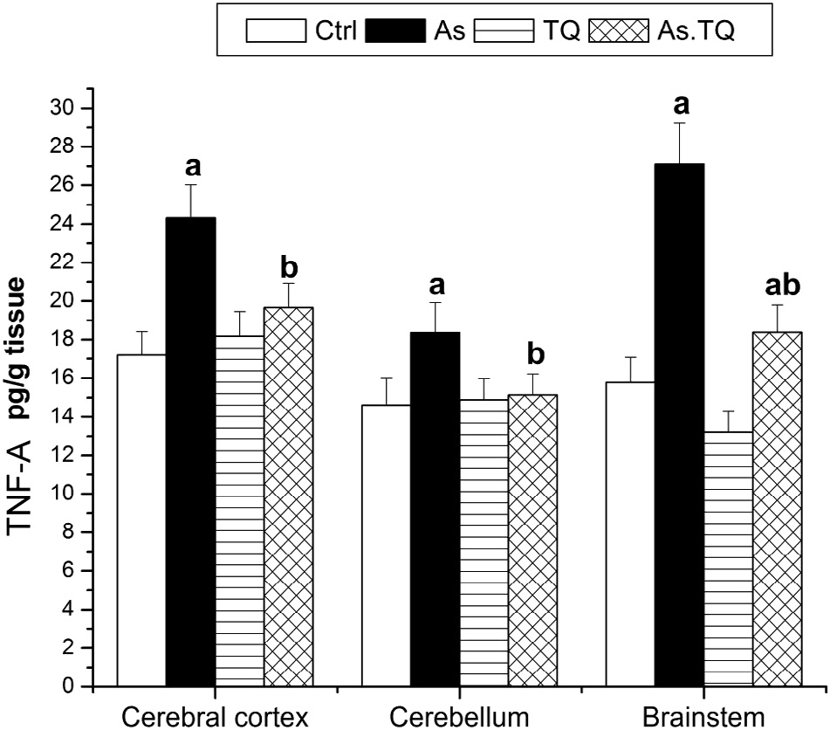

Fig. 5. Levels of TNF-a in cerebral cortex, cerebellum, and brain stem after the treatment with As and TQ. a: Significance at (P < 0.05) as compared to control group, b significance at (P < 0.05) as compared to arsenic group.

of monoamines after arsenic exposure increases or decreases in a dose dependant manner, age, and the exposed brain area.

Oxidative stress may play a role in the metalloid’s neurotoxicity [32]. It is well known that the CNS is armed with an endogenous antioxidant defence mechanism consisting of antioxidant enzymes that produced upon exposure to ROS via a mechanism regulated at the transcriptional level [33,34]. Reduced glutathione is the major thiol present in the brain tissue, which has an essential role in the protection against oxidative injury due to ROS [35]. Reduction of glutathione and glutathione peroxidase reduces the capacity of an organism to defend itself from the damage caused by ROS [36]. Rodriguez et al. [37] reported an alteration in mRNA of several antioxidant genes including superoxide dismutase (SOD) upon arsenic exposure which depend on the dose and the region of the brain (nucleus accumbens, prefrontal cortex, or striatum).

The present study revealed a decrease in GSH, and the antioxi- dant enzyme system GPx, GR, SOD, and CAT in all brain areas stud- ied of the female rat after arsenate treatment as well as an increase in lipid peroxidation levels. GSH is converted into its oxidized form (GSSG) in the reaction catalyzed by GPx, then it can be reduced back to GSH by GR [8]. Consequently, the decrease of GSH may be due to deficiency of the antioxidant enzyme system GPx and GR that may result from alteration in their genes. In agreement

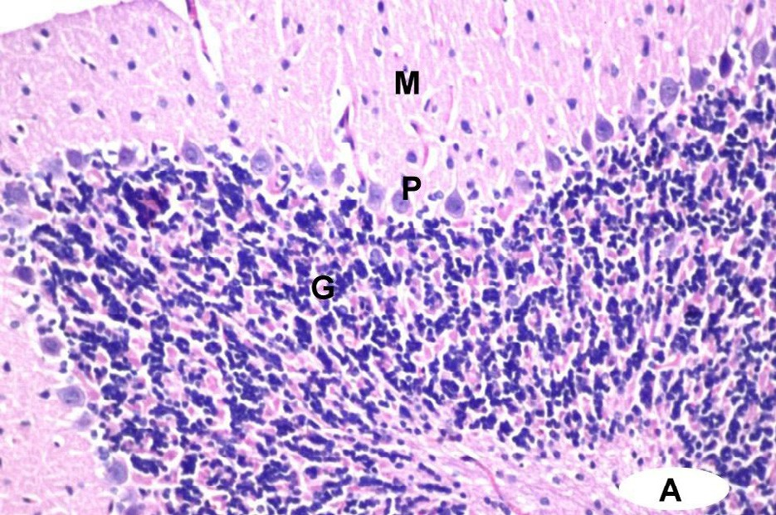

**a**

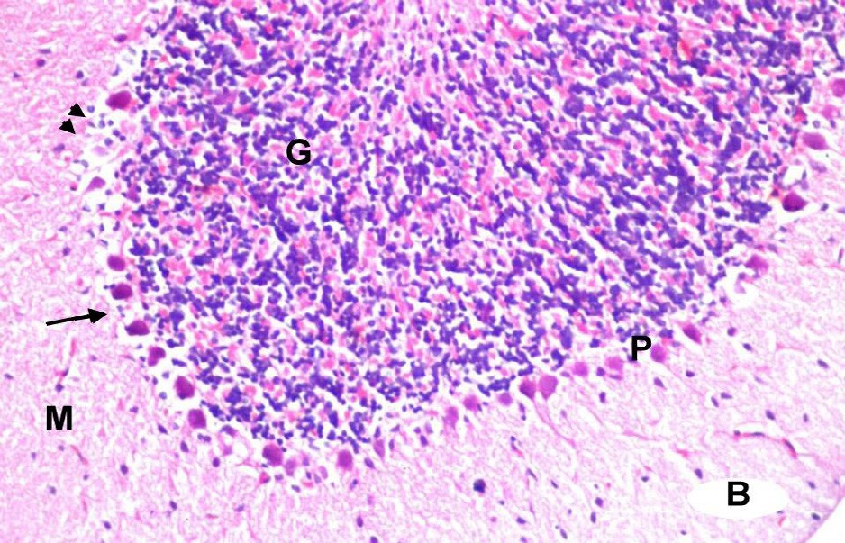

**b**

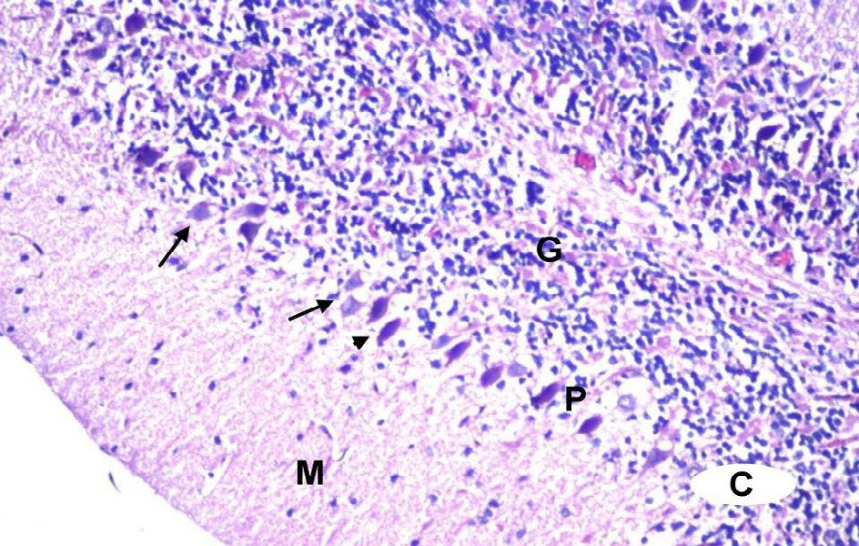

**c**

Fig. 6. Photomicrographs of rat cerebellum. (a) A section from control group showing the normal histological structure of cerebellum which consists of the outer molecular layer (M), middle Purkinje cell layer (P), and inner granular layer (G). (b) A section from arsenate treated group. The Purkinje cells are degenerated; some cells lose axons and shrinked (arrows). Their numbers are decreased and some areas are depleted from Purkinje cells (arrow heads). (c) A section from cerebellum treated with TQ after arsenate showing normal Purkinje cells (arrows) and other

shrinked cells (arrow heads). (400×, H&E stain).

with this study, Chaudhuri et al. [38] found an increase in the level

of lipid peroxidation and a decrease in GSH level, superoxide dis- mutase and glutathione reductase activities in the brain of rat after permissible dose (50 mg/L, the national standard in Bangladesh) of arsenic. Similarly, sodium arsenite in drinking water led to the gen- eration of ROS and subsequent lipid peroxidation in the brains of developing rat pups. In addition, the pups’ levels of the antioxidant GSH as well as the activity of the antioxidant enzyme GPx were decreased after arsenic exposure [36]. This decrease in the antiox- idant system indicates a free radical-mediated cellular degeneration.

Thymoqinone (TQ), the active component of *Nigella sativa* (NS) seeds, has broad and versatile pharmacological effects that include strong antioxidant activity against free radical-generating agents

[39]. Treatment of rats with TQ after exposure to arsenate in the present study, decreased the elevated levels of 5-HT, MAD and increased the lowered levels of NE, DA, and GSH. The enzymatic antioxidant system, GPx, GR, SOD, and CAT were also increased in the cerebral cortex, cerebellum, and brain stem. Similarly, Safhi

[40] found that oral administration of TQ after treatment of chlor- promazine reduced the levels of lipid peroxidation, increased levels of antioxidant enzymes i.e., reduced glutathione, GPx, GR, CAT, and glutathione-S-transferase in the brain of rat.

Thymoquinone has been proved experimentally to be an anti- inflammatory substance [41]. In this study, it reduced the elevated levels of NO and TNF-a in the cerebral cortex, cerebellum and brain

stem of female rats after arsenate treatment. El-Mahmoudy et al.

[42] investigated the effect of TQ on NO production by macro- phages after lipopolysaccharide stimulation. They found that TQ suppressed NO production by macrophage. It mediates its inhibi- tory effect on NO production via reduction of iNOS mRNA and pro- tein expression which might be important in ameliorating the inflammatory and autoimmune conditions. Likewise, TQ decreased

IL-6, TNF-a, MDA and NO metabolites and increased thiol content,

SOD and CAT in the brain of rats treated with lipopolysaccharides [43]. Moreover, Umar et al. [44] found a significant reduction in the levels of pro-inflammatory mediators {IL-1b, IL-6, TNF-a, IFN-c and

PGE (2)} and an increase in the level of IL-10 in arthritic rats after TQ treatment.

Locomotion is affected by arsenic exposure in rodent models. Early studies demonstrated impaired motor coordination and delayed spontaneous alteration in rats administered with arsenic (36 mg/L) for four months [8]. Low levels of arsenic seem to induce hyperactivity in male mice, while high levels induce hypo-activity [37,45]. In the present study, female rats were hypoactive after arsenate treatment.

Altered motor coordination and locomotion could arise from abnormality in cholinergic functioning. In this study, AChE activity declined in cerebral cortex, cerebellum, and brain stem of female rats treated with arsenate, which may be the reason of the hypo- activity observed in rats. The study of Yadav et al. [46] performed on female rats exposed to 20 mg/kg arsenic showed a reduction in AChE activity and ChAT labeling in the hippocampus and frontal cortex. Exposure to less arsenic (5 mg/kg body weight) also inhib- ited AChE activity in the brain and was associated with poorer per- formance in operant learning [47]. Another study demonstrated that AChE activity decreased with increasing arsenic concentra- tions in male rats after five days of exposure [48]. Administration of TQ after arsenate exposure in the current study, increased the AChE activity in all the brain areas studied, indicating the amelio- rative effect of TQ on locomotion and motor coordination. Like- wise, TQ improved the muscle coordination and spontaneous locomotor activity of rats pretreated with chlorpromazine [40].

Neurons are also susceptible to arsenic toxicity. In the present study arsenate caused a decrease in neuronal cell number of cere- bellum and shrinkage of Purkinje cells with a loss of their axons. It is well known that Purkinje cell regulates and coordinates motor movements. These results are in agreement with other studies of rats [49,50] and mice [51]. Sodium arsenate reduced cerebellar neuron viability and induced DNA degradation and nuclear frag- mentation in cultures of rat cerebellar neurons [50]. In cultured mouse neuronal cells, sodium arsenate led to neuronal apoptosis, necrosis, and inhibited neurite growth in a dose-dependent man- ner [51].

Arsenite like any other metal toxins, such as lead, cadmium and mercury, can affect mitochondrial oxidative enzymes. It is possible that this toxin interferes with energy coupling process by altering the redox states of cytochrome C enzyme. The resultant ROS formed will in turn induce peroxidation of membranes and loss of its ion channels. Other studies also show that the sodium and

potassium channels are either depressed or down regulated in this toxicity process [52]. In this study arsenate decreased the activity of Na+-K+ ATPase which indicated changes in electro-activity of the brain of rat.

TQ protects slightly cerebellar neurons from degeneration and increase the activity of Na+-K+ ATPase after arsenate treatment in the present study. In the same manner Ullah et al. [53] revealed an ameliorative effect of tymoquinone from the apoptosis trig- gered by ethanol in rat during early development. The mechanism involved the down regulation of caspase-3, cytochrome-c, cleaved caspase-9 and upregulation of Bcl-2. Bcl-2 protein family plays an important role in apoptotic signal transduction by regulating mito- chondrial function [54]. This finding implied that TQ potentially prevents apoptosis by regulating the mitochondrial path way [53].

1. Conclusion

In general, previously published reports showed that TQ mainly functions through its antioxidant mechanism, and it has been used as a protective agent in multiple toxicity models. As well, this study showed that TQ attenuated the neurotoxic effect and the oxidative stress resulting from the exposure to arsenic through its powerful antioxidant effect.

Acknowledgment

Research was performed in the laboratories of Zoology and Entomology Department, Faculty of science, Helwan University, Egypt.

References

1. [Hosseinzadeh H, Parvardeh S. Anticonvulsant effects of thymoquinone, the](http://refhub.elsevier.com/S2314-808X(17)30231-2/h0005) [major constituent of *Nigella sativa* seeds, in mice. Phytomedicine](http://refhub.elsevier.com/S2314-808X(17)30231-2/h0005) [2004;11:56–64](http://refhub.elsevier.com/S2314-808X(17)30231-2/h0005).
2. [Hosseinzadeh H, Eskandari M, Ziaee T. Antitussive effect of thymoquinone, a](http://refhub.elsevier.com/S2314-808X(17)30231-2/h0010) [constituent of *Nigella sativa* seeds, in guinea pigs. Pharmacol Online](http://refhub.elsevier.com/S2314-808X(17)30231-2/h0010) [2008;2:480–4](http://refhub.elsevier.com/S2314-808X(17)30231-2/h0010).
3. [Attoub S, Sperandio O, Raza H, Arafat K, Al-Salam S, Al Sultan MA, et al.](http://refhub.elsevier.com/S2314-808X(17)30231-2/h0015) [Thymoquinone as an anticancer agent: evidence from inhibition of cancer cells](http://refhub.elsevier.com/S2314-808X(17)30231-2/h0015) [viability and invasion *in vitro* and tumor growth *in vivo*. Fundam Clinl](http://refhub.elsevier.com/S2314-808X(17)30231-2/h0015) [Pharmacol 2013;27:557–69](http://refhub.elsevier.com/S2314-808X(17)30231-2/h0015).
4. [Woo CC, Kumar AP, Sethi G, Tan KHB. Thymoquinone: potential cure for](http://refhub.elsevier.com/S2314-808X(17)30231-2/h0020) [inflammatory disorders and cancer. Biochem Pharmacol 2012;83:443–51](http://refhub.elsevier.com/S2314-808X(17)30231-2/h0020).
5. [Ebrahimi SS, Oryan S, Izadpanah E, Hassanzadeh K. Thymoquinone exerts](http://refhub.elsevier.com/S2314-808X(17)30231-2/h0025) [neuroprotective effect in animal model of Parkinson’s disease. Toxicol Lett](http://refhub.elsevier.com/S2314-808X(17)30231-2/h0025) [2017;276:108–14](http://refhub.elsevier.com/S2314-808X(17)30231-2/h0025).
6. [Shao YY, Li B, Huang YM, Luo Q, Xie YM, Chen YH. Thymoquinone attenuates](http://refhub.elsevier.com/S2314-808X(17)30231-2/h0030) [brain injury via an anti-oxidative pathway in a status epilepticus rat model.](http://refhub.elsevier.com/S2314-808X(17)30231-2/h0030) [Transl Neurosci 2017;8:9–14](http://refhub.elsevier.com/S2314-808X(17)30231-2/h0030).
7. [Elmaci I, Altinoz MA. Thymoquinone: an edible redox-active quinone for the](http://refhub.elsevier.com/S2314-808X(17)30231-2/h0035) [pharmacotherapy of neurodegenerative conditions and glial brain tumors.](http://refhub.elsevier.com/S2314-808X(17)30231-2/h0035) [Biomed Pharmacother 2016;83:635–40](http://refhub.elsevier.com/S2314-808X(17)30231-2/h0035).
8. [Mabrouk A, Ben Cheikh H. Thymoquinone ameliorates lead-induced](http://refhub.elsevier.com/S2314-808X(17)30231-2/h0040) [suppression of the antioxidant system in rat kidneys. Libyan J Med](http://refhub.elsevier.com/S2314-808X(17)30231-2/h0040) [2016;11:31018](http://refhub.elsevier.com/S2314-808X(17)30231-2/h0040).
9. [Erboga M, Kanter M, Aktas C, Sener U, Fidanol Erboga Z, Bozdemir Donmez Y,](http://refhub.elsevier.com/S2314-808X(17)30231-2/h0045) [et al. Thymoquinone ameliorates cadmium-induced nephrotoxicity, apoptosis,](http://refhub.elsevier.com/S2314-808X(17)30231-2/h0045) [and oxidative stress in rats is based on its anti-apoptotic and anti-oxidant](http://refhub.elsevier.com/S2314-808X(17)30231-2/h0045) [properties. Biol Trace Elem Res 2016;170:165–72](http://refhub.elsevier.com/S2314-808X(17)30231-2/h0045).
10. [Troshin VV. Pathogenesis and classification of chronic encephalopathy due](http://refhub.elsevier.com/S2314-808X(17)30231-2/h0050) [neurotoxic chemicals. Med Tr Prom Ekol 2009;7:21–6](http://refhub.elsevier.com/S2314-808X(17)30231-2/h0050).
11. [Asada K, Toyota K, Nishimura T, Ikeda J, Hori K. Accumulation and mobility of](http://refhub.elsevier.com/S2314-808X(17)30231-2/h0055) [zinc in soil amended with different levels of pig-manure compost. J Environ Sci](http://refhub.elsevier.com/S2314-808X(17)30231-2/h0055) [Health B 2010;45:285–92](http://refhub.elsevier.com/S2314-808X(17)30231-2/h0055).
12. [Belyaeva EA, Sokolova TV, Emelyanova LV, Zakharova IO. Mitochondrial](http://refhub.elsevier.com/S2314-808X(17)30231-2/h0060) [electron transport chain in heavy metal-induced neurotoxicity: effects of](http://refhub.elsevier.com/S2314-808X(17)30231-2/h0060) [cadmium, mercury, and copper. Sci World J 2012:136063](http://refhub.elsevier.com/S2314-808X(17)30231-2/h0060).
13. [Pohl HR, Roney N, Abadin HG. Metal ions affecting the neurological system.](http://refhub.elsevier.com/S2314-808X(17)30231-2/h0065) [Met Ions Life Sci 2011;8:247–62](http://refhub.elsevier.com/S2314-808X(17)30231-2/h0065).
14. [Tchounwou PB, Wilson B, Ishague A. Important considerations in the](http://refhub.elsevier.com/S2314-808X(17)30231-2/h0070) [development of public health advisories for arsenic and arsenic containing](http://refhub.elsevier.com/S2314-808X(17)30231-2/h0070) [compounds in drinking water. Rev Environ Health 1999;14:211–29](http://refhub.elsevier.com/S2314-808X(17)30231-2/h0070).
15. [Kapaj S, Peterson H, Liber K, Bhattacharya P. Human health effects from](http://refhub.elsevier.com/S2314-808X(17)30231-2/h0075) [chronic arsenic poisoning—a review. J Environ Sci Health 2006;41:2399–428](http://refhub.elsevier.com/S2314-808X(17)30231-2/h0075).
16. [Hughes MF et al. Arsenic exposure and toxicology: a historical perspective.](http://refhub.elsevier.com/S2314-808X(17)30231-2/h0080) [Toxicol Sci 2011;123:305–32](http://refhub.elsevier.com/S2314-808X(17)30231-2/h0080).
17. [Rodriguez VM, Carrizales L, Mendoza MS, Fajardo OR, Giordano M. Effects of](http://refhub.elsevier.com/S2314-808X(17)30231-2/h0085) [sodium arsenite exposure on development and behavior in the rat.](http://refhub.elsevier.com/S2314-808X(17)30231-2/h0085) [Neurotoxicol Teratol 2002;24:743–50](http://refhub.elsevier.com/S2314-808X(17)30231-2/h0085).
18. [Tyler CR, Allan AM. The effects of arsenic exposure on neurological and](http://refhub.elsevier.com/S2314-808X(17)30231-2/h0090) [cognitive dysfunction in human and rodent studies: a review. Curr Environ](http://refhub.elsevier.com/S2314-808X(17)30231-2/h0090) [Health Report 2014;1:132–47](http://refhub.elsevier.com/S2314-808X(17)30231-2/h0090).
19. [Yadav RS et al. Attenuation of arsenic neurotoxicity by curcumin in rats.](http://refhub.elsevier.com/S2314-808X(17)30231-2/h0095) [Toxicol Appl Pharmacol 2009;240:367–76](http://refhub.elsevier.com/S2314-808X(17)30231-2/h0095).
20. [Gilhotra N, Dhingra D. Thymoquinone produced antianxiety-like effects in](http://refhub.elsevier.com/S2314-808X(17)30231-2/h0100) [mice through modulation of GABA and NO levels. Pharmacological Rep](http://refhub.elsevier.com/S2314-808X(17)30231-2/h0100) [2011;63:660–9](http://refhub.elsevier.com/S2314-808X(17)30231-2/h0100).
21. [Delafield F. Haematoxylin and Eosin for General Staining. Staining of the](http://refhub.elsevier.com/S2314-808X(17)30231-2/h0105) [Animal Tissues Practical and Theoretical. London: Oxford University Press;](http://refhub.elsevier.com/S2314-808X(17)30231-2/h0105) [1984](http://refhub.elsevier.com/S2314-808X(17)30231-2/h0105).
22. [Pagel P, Blome J, Wolf HU. High-performance liquid chromatographic](http://refhub.elsevier.com/S2314-808X(17)30231-2/h0110) [separation and measurement of various biogenic compounds possibly](http://refhub.elsevier.com/S2314-808X(17)30231-2/h0110) [involved in the pathomechanism of Parkinson’s disease. J Chromatogr B](http://refhub.elsevier.com/S2314-808X(17)30231-2/h0110) [2000;746:297–304](http://refhub.elsevier.com/S2314-808X(17)30231-2/h0110).
23. [Gorun V, Proinov I, Baltescu V, Balaban G, Barzu O. Modified Ellman procedure](http://refhub.elsevier.com/S2314-808X(17)30231-2/h0115) [for assay of cholinesterase in crude enzymatic preparation. Anal Biochem](http://refhub.elsevier.com/S2314-808X(17)30231-2/h0115) [1978;86:324–6](http://refhub.elsevier.com/S2314-808X(17)30231-2/h0115).
24. [Muszbek LA. Highly sensitive method for the measurement of the ATP-ase](http://refhub.elsevier.com/S2314-808X(17)30231-2/h0120) [activity. Anal Biochem 1997;77:286–8](http://refhub.elsevier.com/S2314-808X(17)30231-2/h0120).
25. [Ohkawa H, Ohishi N, Yagi K. Assay for lipid peroxides in animal tissues by](http://refhub.elsevier.com/S2314-808X(17)30231-2/h0125) [thiobarbituric acid reaction. Anal Biochem 1979;95:351–8](http://refhub.elsevier.com/S2314-808X(17)30231-2/h0125).
26. [Berkels R, Purol-Schnabel S, Roesen R. Measurement of nitric oxide by](http://refhub.elsevier.com/S2314-808X(17)30231-2/h0130) [reconversion of nitrate/nitrite to no. Methods Mol Biol 2004;279:1–8](http://refhub.elsevier.com/S2314-808X(17)30231-2/h0130).
27. [Ellman GL. Tissue sulfhydryl groups. Arch Biochem Biophys 1959;82:70–7](http://refhub.elsevier.com/S2314-808X(17)30231-2/h0135).
28. [Mishra D, Flora SJ. Differential oxidative stress and DNA damage in rat brain](http://refhub.elsevier.com/S2314-808X(17)30231-2/h0140) [regions and blood following chronic arsenic exposure. Toxicol Ind Health](http://refhub.elsevier.com/S2314-808X(17)30231-2/h0140) [2008;24:247–56](http://refhub.elsevier.com/S2314-808X(17)30231-2/h0140).
29. [Mejia JJ, Diaz-Barriga F, Calderon J, Rios C, Jimenez-Capdeville ME. Effects of](http://refhub.elsevier.com/S2314-808X(17)30231-2/h0145) [lead-arsenic combined exposure on central monoaminergic systems.](http://refhub.elsevier.com/S2314-808X(17)30231-2/h0145) [Neurotoxicol Teratol 1997;19:489–97](http://refhub.elsevier.com/S2314-808X(17)30231-2/h0145).
30. [Liu X, Piao F, Li Y. Protective effect of taurine on the decreased biogenic amine](http://refhub.elsevier.com/S2314-808X(17)30231-2/h0150) [neurotransmitter levels in the brain of mice exposed to arsenic. Adv Exp Med](http://refhub.elsevier.com/S2314-808X(17)30231-2/h0150) [Biol 2013;776:277–87](http://refhub.elsevier.com/S2314-808X(17)30231-2/h0150).
31. [Yadav RS et al. Neuroprotective effect of curcumin in arsenic-induced](http://refhub.elsevier.com/S2314-808X(17)30231-2/h0155) [neurotoxicity in rats. Neurotoxicol 2010;31:533–9](http://refhub.elsevier.com/S2314-808X(17)30231-2/h0155).
32. [Rai A, Maurya S, Khare P, Srivastava A, Bandyopadhyay S. Characterization](http://refhub.elsevier.com/S2314-808X(17)30231-2/h0160) [of developmental neurotoxicity of As, Cd, and Pb mixture: synergistic action](http://refhub.elsevier.com/S2314-808X(17)30231-2/h0160) [of metal mixture in glial and neuronal functions. Toxicol Sci](http://refhub.elsevier.com/S2314-808X(17)30231-2/h0160) [2010;118:586–601](http://refhub.elsevier.com/S2314-808X(17)30231-2/h0160).
33. [Motohashi H, Yamamoto M. Nrf2-Keap1 defines a physiologically important](http://refhub.elsevier.com/S2314-808X(17)30231-2/h0165) [stress response mechanism. Trends Mol Med 2004;10:549–57](http://refhub.elsevier.com/S2314-808X(17)30231-2/h0165).
34. [Itoh K, Tong KI, Yamamoto M. Molecular mechanism activating Nrf2-Keap1](http://refhub.elsevier.com/S2314-808X(17)30231-2/h0170) [pathway in regulation of adaptive response to electrophiles. Free Radic Biol](http://refhub.elsevier.com/S2314-808X(17)30231-2/h0170) [Med 2004;36:1208–13](http://refhub.elsevier.com/S2314-808X(17)30231-2/h0170).
35. [Wang W, Ballatori N. Endogenous glutathione conjugates: occurrence and](http://refhub.elsevier.com/S2314-808X(17)30231-2/h0175) [biological functions. Pharmacol Rev 1998;50:335–56](http://refhub.elsevier.com/S2314-808X(17)30231-2/h0175).
36. [Xi S, Guo L, Sun W, Jin Y, Sun G. Prenatal and early life arsenic exposure](http://refhub.elsevier.com/S2314-808X(17)30231-2/h0180) [induced oxidative damage and altered activities and mRNA expressions of](http://refhub.elsevier.com/S2314-808X(17)30231-2/h0180) [neurotransmitter metabolic enzymes in offspring rat brain. J Biochem Mol](http://refhub.elsevier.com/S2314-808X(17)30231-2/h0180) [Toxicol 2010;24:368–78](http://refhub.elsevier.com/S2314-808X(17)30231-2/h0180).
37. [Rodriguez VM et al. Chronic exposure to low levels of inorganic arsenic causes](http://refhub.elsevier.com/S2314-808X(17)30231-2/h0185) [alterations in locomotor activity and in the expression of dopaminergic and](http://refhub.elsevier.com/S2314-808X(17)30231-2/h0185) [antioxidant systems in the albino rat. Neurotoxicol Teratol 2010;32:640–7](http://refhub.elsevier.com/S2314-808X(17)30231-2/h0185).
38. [Chaudhuri AN, Basu S, Chattopadhyay S, Das Gupta S. Effect of high arsenic](http://refhub.elsevier.com/S2314-808X(17)30231-2/h0190) [content in drinking water on rat brain. Indian J Biochem Biophys](http://refhub.elsevier.com/S2314-808X(17)30231-2/h0190) [1999;36:51–4](http://refhub.elsevier.com/S2314-808X(17)30231-2/h0190).
39. [Houghton PJ, Zarka R, de las Heras B, Hoult JR. Fixed oil of nigella sativa and](http://refhub.elsevier.com/S2314-808X(17)30231-2/h0195) [derived thymoquinone inhibit eicosanoid generation in leukocytes and](http://refhub.elsevier.com/S2314-808X(17)30231-2/h0195) [membrane lipid peroxidation. Planta Med 1995;611:33–6](http://refhub.elsevier.com/S2314-808X(17)30231-2/h0195).
40. [Safhi MM. Neuromodulatory effects of thymoquinone in extenuating oxidative](http://refhub.elsevier.com/S2314-808X(17)30231-2/h0200) [stress in chlorpromazine treated rats. Acta Pol Pharm 2016;73:529–35](http://refhub.elsevier.com/S2314-808X(17)30231-2/h0200).
41. [Chehl N, Chipitsyna G, Gong Q, Yeo CJ, Arafat HA. Anti-inflammatory effects of](http://refhub.elsevier.com/S2314-808X(17)30231-2/h0205) [the *Nigella sativa* seed extract, thymoquinone, in pancreatic cancer cells. HPB](http://refhub.elsevier.com/S2314-808X(17)30231-2/h0205) [(Oxford) 2009;11:373–81](http://refhub.elsevier.com/S2314-808X(17)30231-2/h0205).
42. [El-Mahmoudy A, Matsuyama H, Borgan MA, Shimizu Y, El-Sayed MG,](http://refhub.elsevier.com/S2314-808X(17)30231-2/h0210) [Minamoto N, et al. Thymoquinone suppresses expression of inducible nitric](http://refhub.elsevier.com/S2314-808X(17)30231-2/h0210) [oxide synthase in rat macrophages. Int Immunopharmacol 2002;2:1603–11](http://refhub.elsevier.com/S2314-808X(17)30231-2/h0210).
43. [Bargi R, Asgharzadeh F, Beheshti F, Hosseini M, Sadeghnia HR, Khazaei M. The](http://refhub.elsevier.com/S2314-808X(17)30231-2/h0215) [effects of thymoquinone on hippocampal cytokine level, brain oxidative stress](http://refhub.elsevier.com/S2314-808X(17)30231-2/h0215) [status and memory deficits induced by lipopolysaccharide in rats. Cytokine](http://refhub.elsevier.com/S2314-808X(17)30231-2/h0215) [2017;96:173–84](http://refhub.elsevier.com/S2314-808X(17)30231-2/h0215).
44. [Umar S, Zargan J, Umar K, Ahmad S, Katiyar CK, Khan HA. Modulation of the](http://refhub.elsevier.com/S2314-808X(17)30231-2/h0220) [oxidative stress and inflammatory cytokine response by thymoquinone in the](http://refhub.elsevier.com/S2314-808X(17)30231-2/h0220) [collagen induced arthritis in Wistar rats. Chem Biol Interact 2012;197:40–6](http://refhub.elsevier.com/S2314-808X(17)30231-2/h0220).
45. [Bardullas U et al. Chronic low-level arsenic exposure causes gender-specific](http://refhub.elsevier.com/S2314-808X(17)30231-2/h0225) [alterations in locomotor activity, dopaminergic systems, and thioredoxin](http://refhub.elsevier.com/S2314-808X(17)30231-2/h0225) [expression in mice. Toxicol Appl Pharmacol 2009;239:169–77](http://refhub.elsevier.com/S2314-808X(17)30231-2/h0225).
46. [Yadav RS et al. Neuroprotective efficacy of curcumin in arsenic induced](http://refhub.elsevier.com/S2314-808X(17)30231-2/h0230) [cholinergic dysfunctions in rats. Neurotoxicol 2011;32:760–8](http://refhub.elsevier.com/S2314-808X(17)30231-2/h0230).
47. [Nagaraja TN, Desiraju T. Effects on operant learning and brain acetylcholine](http://refhub.elsevier.com/S2314-808X(17)30231-2/h0235) [esterase activity in rats following chronic inorganic arsenic intake. Hum Exp](http://refhub.elsevier.com/S2314-808X(17)30231-2/h0235) [Toxicol 1994;13:353–6](http://refhub.elsevier.com/S2314-808X(17)30231-2/h0235).
48. [Patlolla AK, Tchounwou PB. Serum acetyl cholinesterase as a biomarker of](http://refhub.elsevier.com/S2314-808X(17)30231-2/h0240) [arsenic induced neurotoxicity in sprague-dawley rats. Int J Environ Res Public](http://refhub.elsevier.com/S2314-808X(17)30231-2/h0240) [Health 2005;2:80e3](http://refhub.elsevier.com/S2314-808X(17)30231-2/h0240).
49. [Luo JH, Qiu ZQ, Shu WQ, Zhang YY, Zhang L, Chen JA. Effects of arsenic](http://refhub.elsevier.com/S2314-808X(17)30231-2/h0245) [exposure from drinking water on spatial memory, ultra structures and NMDAR](http://refhub.elsevier.com/S2314-808X(17)30231-2/h0245) [gene expression of hippocampus in rats. Toxicol Lett 2009;184:121–5](http://refhub.elsevier.com/S2314-808X(17)30231-2/h0245).
50. [Namgung U, Xia Z. Arsenic induced apoptosis in rat cerebellar neurons via](http://refhub.elsevier.com/S2314-808X(17)30231-2/h0250) [activation of JNK3 and p38 MAP kinases. Toxicol Appl Pharmacol](http://refhub.elsevier.com/S2314-808X(17)30231-2/h0250) [2001;174:130e8](http://refhub.elsevier.com/S2314-808X(17)30231-2/h0250).
51. [Aung KH, Kurihara R, Nakashima S, et al. Inhibition of neurite outgrowth and](http://refhub.elsevier.com/S2314-808X(17)30231-2/h0255) [alteration of cytoskeletal gene expression by sodium arsenite. Neurotoxicol](http://refhub.elsevier.com/S2314-808X(17)30231-2/h0255) [2012;34:226e35](http://refhub.elsevier.com/S2314-808X(17)30231-2/h0255).
52. [Shaya D, Kreir M, Robbins RA, Wong S, Hammon J, Brüggemann A, et al.](http://refhub.elsevier.com/S2314-808X(17)30231-2/h0260) [Voltage-gated sodium channel (NaV) protein dissection creates a set of](http://refhub.elsevier.com/S2314-808X(17)30231-2/h0260) [functional pore-only proteins. Proc Natl Acad Sci USA 2011;108:12313–8](http://refhub.elsevier.com/S2314-808X(17)30231-2/h0260).
53. [Ullah I, Ullah N, Naseer MI, Lee HY, Kim MO. Neuroprotection with metformin](http://refhub.elsevier.com/S2314-808X(17)30231-2/h0265) [and TQ against ethanol-induced apoptotic neurodegeneration in prenatal rat](http://refhub.elsevier.com/S2314-808X(17)30231-2/h0265) [cortical neurons. BMC Neuroscience 2012;13:11](http://refhub.elsevier.com/S2314-808X(17)30231-2/h0265).
54. [Shy Y. A structural view of mitochondria-mediated apoptosis. Nat Struct Biol](http://refhub.elsevier.com/S2314-808X(17)30231-2/h0270) [2001;8:394–401](http://refhub.elsevier.com/S2314-808X(17)30231-2/h0270).