[Egyptian Informatics Journal 20 (2019) 143–150](https://doi.org/10.1016/j.eij.2019.02.001)

Contents lists available at [ScienceDirect](http://www.sciencedirect.com/science/journal/11108665)

Egyptian Informatics Journal

journal homepage: [www.sciencedirect.com](http://www.sciencedirect.com/)

[](http://crossmark.crossref.org/dialog/?doi=10.1016/j.eij.2019.02.001&domain=pdf)Using a two-level structural equation model to study the determinants of reproductive behaviour in Giza Governorate

Esmail Hassneen ⇑, Abdel-Hameed El-Abbasi, Mona Khalifa, Farouk Shoaeb

*Department of Biostatistics and Demography, Institute of Statistical Studies and Research, Cairo University, Egypt*

# a r t i c l e i n f o

*Article history:*

Received 31 October 2018

Revised 1 January 2019

Accepted 22 February 2019

Available online 28 February 2019

*Keywords:*

Structural equation modelling (SEM) Multi-level model

Total fertility rate (TFR) Slums

# a b s t r a c t

The purpose of this paper was to measure the quality of concordance of one- and two-level structural equation models by testing the two following statistical hypotheses: first, the structure of the two- level model is more efficient than that of the one-level model; second, economic and social determinants and intermediate variables have a significant effect on current and future fertility in Giza Governorate. A two-tier bicameral model (women, geographical area) was built on 1500 families divided equally into three districts (urban, rural, and slum). The districts were divided into 294 convergent communities

according to the standard of living. M—Plus 8.0 was used to estimate the numbers of four models. The

first estimated structural relationships between the determinants of fertility within the layers; the sec-

ond estimated relationships between the second and third strata; the third estimated structural equa- tions at the second level; and the fourth included the constants and a random slope in the model. The results show that the estimated parameters of the models corresponded well to the model and the multi-level model, whose indicators are proposed within acceptable limits. The final proposed model and the significance of its coefficients were tested to ensure the quality of the compatibility of the final model. The results show that the overall quality of the proposed compatibility is very high and that the indicators are within the accepted limits. The compatibility quality index is 0.99, the correlation quality is corrected by 0.98, and the CI index of significance is 0.00. Therefore, we can say that the proposed multi- level structural model (based on the indicators of total compatibility quality) is more efficient than the one-level model, supporting the first hypothesis. The second hypothesis is that economic and social determinants and intermediate variables have a significant impact on current and future fertility.

© 2019 Production and hosting by Elsevier B.V. on behalf of Faculty of Computers and Information, Cairo

University. This is an open access article under the CC BY-NC-ND license ([http://creativecommons.org/](http://creativecommons.org/licenses/by-nc-nd/4.0/)

[licenses/by-nc-nd/4.0/](http://creativecommons.org/licenses/by-nc-nd/4.0/)).

1. Introduction

Most studies contain variables measured at different levels. When examining multi-level data, the need for multi-level models is important because first-level data do not meet the independence condition since they belong to the same layer and are thus homo- geneous with data in different layers. The absence of this condition cannot be neglected since it can lead to invalid statistical conclu-

* Corresponding author.

*E-mail address:* [esmail.hassneen@pg.cu.edu.eg](mailto:esmail.hassneen@pg.cu.edu.eg) (E. Hassneen).

Peer review under responsibility of Faculty of Computers and Information, Cairo University.

**Production and hosting by Elsevier**

sions. The main aim of multi-level analysis is to allow appropriate modifications with random errors to arrive at valid statistical con- clusions. In addition, multi-level models test the relationships between variables at different levels in their hierarchical structure. Structural equations are an extension of the general linear model – the second generation - and allow the simultaneous anal- ysis of a set of regression equations to determine the relationships between latent and measured variables. Structural equations are characterized by a multi-stage system that includes path analysis, confirmatory factor analysis (CFA), multi-linear regression analysis (MLR) and an integrated model, and analysis of a moment struc-

tures (AMOS) [1].

Structural equations are also characterized by their ability to place associated variables in a single latent variable to create groups of related variables. Thus, structural equations address fewer latent variables. The interpretation of the latent variables is clearer and more accurate than that of the measured variables. The smaller the number of variables, the smaller the number of

<https://doi.org/10.1016/j.eij.2019.02.001>

1110-8665/© 2019 Production and hosting by Elsevier B.V. on behalf of Faculty of Computers and Information, Cairo University. This is an open access article under the CC BY-NC-ND license (<http://creativecommons.org/licenses/by-nc-nd/4.0/>).

measured variables, the greater the advantages of using structural equations over multiple regression models [2].

* 1. *Multi-level structural equation models (MSEMs) can be divided into two parts*

Part I: Multivariate analysis and covariance; this method is based on dividing the heterogeneity into two levels. A set of fixed parameters is estimated at the first level, and some of the fixed parameters are estimated at the second level.

Part II: Structural equations with a random slope; this method assumes that the effects of the first level come from effects that allow the parameters of the first level to differ from one layer to another. The random effects in the model are then determined to represent the potential difference in the first-level parameters as well as the variations and variations associated with the random tendency. The first method based on the orthogonal design of the covariance matrix is still used more in research because the second method is more complex in estimations [3].

Population growth is one of the greatest issues facing the Arab Republic of Egypt. The issue is that population growth rates are higher than economic growth rates. Among the problems faced by many developing countries is the problem of slums and their social and economic repercussions, as well as the population explosion. The 2012 report of the state of the population in Egypt affirmed that the most serious challenges facing Egypt are popula- tion growth and the spread of slum communities.

1. Literature review

A prior study [4] used MSEMs as an extension of structural equations for the analysis of random data. The study relied on data from the International Social Survey in 27 countries. The results at the individual level were quite stable even when small samples were used at the individual level. The parameters and random errors were affected at the group level according to the sample size. The most important result of this study was that the use of different sample sizes at the individual level had an irregular effect on the estimation of parameters and random errors at the group level. The results also confirmed that the statistical inference of MSEMs at the individual level is very good even with the small number of groups. The study concluded that MSEMs are a powerful tool for studying and estimating models that deal with overlapping data and will become more widely used in complex multi-level modelling.

Another previous study [5] analysed longitudinal data to exam- ine changes in time-dependent public health and biomedical science variables. MSEMs were used to analyse quantitative and continuous data. The first level measured the overlapping time points of individuals to investigate the properties that changed over time, and the second level measured properties that did not vary over time. The proposed model used the fixed and non- linear common variables for the latent variables and the missing data. The maximum potential method was used to estimate the parameters of the model, and the results of the study indicate that the estimates were satisfactory.

Additionally, researchers [6] have examined the interaction of independent variables, especially after the methods of estimating and interpreting the interactions between the latent variables inherent in the structural equations became available using the modified LAM method. The potential benefit of this method is lim- ited by the absence of traditional model quality parameters (goodness-of-fit indicators), standard parameters and the magni- tude of the effect of the latent interaction.

Therefore, this study investigated scientific methods for evalu- ating the latent moderated structural equation (LMS) method. Two steps were used to evaluate the overall model quality. The first step was to measure the quality of the initial model using quality assays (CFI, TLI, RMSE, v2). The second step was to use the log likelihood test to determine the relative suitability of the interaction-free model versus the alternative model based on the interaction estimation.

In a previous study, [2] multi-level tests within and across levels of analysis were conducted using MSEMs to clarify problems in current methods, such as mixed effects across levels of analysis and bias resulting from the use of group averages, and to overcome those problems using LMSs. The appropriate results can be explained by a multi-level analysis.

In another study, [7] LMS were used to test hypotheses related to intermediate and modified variables in a single step. The research presented several models of the intermediate and modi- fied variables and the equations related to each model. The research relied on simulation data to illustrate the use of latent interaction models to test modified and intermediate variables. The methods used to combine modified and intermediate variables were based on regression. Structural equations are characterized by the fact that they allow the integration of measurement error in the analysis and improve the quality of the results.

1. Modelling framework

To build a SEM model four models must be estimated as follows

1. The first estimated structural relationships between the determinants of fertility within the clusters.
2. The second estimated relationships between the second and third cluster.
3. The third estimated structural equations at the second level.
4. The fourth model was also used to estimate the model of two-level structural equations with constants and a random inclination.

The general formula of the two–level SEM model with random intercepts is as follows;

*yij* = (*yij* — *y*¯*j*)+ *y*¯*j*

*yT* = *yW* — *yB*

where

*j* = 1, 2 ... , *J* is the index for the cluster.

*i* = 1, 2 .. . , *nj* is the index for the units within the cluster,

*y*¯*j* is the mean of the cluster number *j*,

*yB* is the units between the cluster,

*yW* is the units within the cluster.

We find that, the both components are treated as unmeasured (latent) variables and the two parts are orthogonal and additive; one of the parts can be zero.

For the population level the total covariance can be divided into:

X X X

*Cov*(*yi*,*yj*)= = +

*T W B*

The main idea of the two-level SEM is specifying a model for each level. For the two–level Confirmatory Factor Analysis (CFA) model, we can use the following normal equations;

X *w* = K*w*W*w*K' + h*w*

*w*

'

X *B* = K*B*W*B*K + h*B*

*B*

For the previous natural equations, we note the;

* If we add a structural (regression) part, we add the (*I* — *B*)—1

term to the matrix formulation (as in regular SEM)

* No mean structure is needed for the within part (as the level one variables are centered about the cluster).
* A mean structure l*B* can be added for the between part of the model.
* In addition, in level two covariance *zj* to the model.

1. study problem

Measuring the quality of reconciling MSEMs across all levels is subject to several problems, including the inability to determine the level responsible for the poor quality of conciliation, as well as the quality of the adjustment of the upper levels by the small size of the sample. Therefore, in this work, each level was studied separately to obtain the statistical tests for each level before esti- mating the MSEM and the MSEM with constants and a random slope. This study examined fertility determinants due to the high rate of reproduction at the level of the Arab Republic of Egypt of up to 3.5 children per woman compared with the total fertility rate (TFR) of 3 births per woman in 2008 (Demographic Health Survey- DHS, 2014). There is increasing evidence indicating the effect of slum communities on these rates; thus, three areas, rural, urban and random geographical areas, in Giza Governorate were consid- ered [8].

1. Study objective

This study sought to assess the quality of the two-level SEM and the two-level SEM with random constants and a random slope and to compare them with the quality of conciliation for each level separately.

* 1. *Study sub-objectives*
     + Measure the quality of concordance of the one- and two- level SEMs.
     + Test the relative appropriateness of the MSEM.
     + Test the relative relevance of the MSEM with constants and a random slope.

1. Hypothesis

* The two-level structural model is more efficient than the one-level model.
* The economic and social determinants and the intermediate variables have a significant impact on current and future

fertility.

1. Data sources

The data of the study sample were collected in a study monitor- ing the demographic and health indicators in Giza Governorate, Egypt, conducted by the Institute of Statistical Studies and Research, Cairo University, in 2016 in cooperation with the National Population Council. The study sample includes data from three geographic regions in Giza Governorate: Manawat (rural), Abu Qatada (slum) and Ajouza (urban); a random sample of 1500

1. Background characteristics

Table 1 indicates that the number of households in the sample is 1500 divided equally over the three areas of the sample: Agouza, Manawat, and Aboqatada. The average number of persons in a fam- ily (average household size) is five in Manawat, the rural area, while the average age at marriage is 18 in Manawat due to the early marriage phenomenon. Accordingly, there is a high rate (inci- dence) of live births due to the long reproductive life of the women who married early. The percentage of education enrolment is 95.6% in Agouza and 81% in Manawat. This difference was attributed to higher dropout rates in rural areas. Aboqatada showed the highest rate of chronic disease at 7.5%. Regarding the wealth index, approx- imately 69% of the sampled population from Manawat are very poor (lowest wealth index) while 3.4% are very rich/wealthy (high- est wealth index); in contrast, 85.6% in Agouza are very rich. Regarding the level of violence against females (female violence), Agouza came first at a rate of 43.2%. The rate of violence against females is proportionally correlated to the wealth index in the sample, because violence rates have increased in recent years in the Egyptian society, especially violence between couples, which is a warning bell and needs intensive social and psychological stud- ies to find out the causes and treatment.

Lastly, the total fertility rate (TFR) is defined as a useful measure for examining the overall level of fertility. It can be interpreted as the number of children a woman would have by the end of her childbearing years if she were to pass through those years bearing children at the currently observed rates. The TFR calculated by summing the age-specific fertility rates (ASFR) for the woman at age 15–49. While TFR rates in the sample study, Manawat came first at a rate of 4.77 per woman. This reflects the high level of rural fertility in general, due to intensive agricultural activity and the need for many labours, and children are considered an investment in rural to support parents in old age. Agouza and Abu Qatada rate of about three per woman, overall, the fertility level in Giza gover- norate is consistent with Egypt’s fertility level of about 3.5 per woman [8].

Fig. 1 shows a population pyramid that illustrates the age and sex structure of Giza Governorate population and may provide insights about political and social stability, as well as economic development. The population is distributed along the horizontal axis, with females shown on the right and males on the left. The female and male populations are broken down into 5-year age groups represented as horizontal bars along the vertical axis, with the oldest age groups at the top and the youngest at the bottom. The shape of the population pyramid gradually evolved over time based on Totally Population Dynamics including (fertility, mortal- ity Rates, and international migration trends).

It is noticed in the population pyramid that there is a gap in the last age groups of females due mainly to the fact that the sample is a Purposive sample, 95% of the families are of a small size pattern, and the age of women falls in the category of 15–49 year.

1. analysis methodology

The layer in the MSEM is a random sample of the stratified communities, and the cases (the women) are randomly sampled from within each stratum. The layers are independent of each other at the second level, and the cases at the first level are independent of each other within each layer. The data are divided into two main levels, between layers and within layers, as shown in Eq. (1):

household divided into 500 households for each study area was included.

*yij*

= l + *yBj*

+ *ywij*

(1)

Table 1

|  |  |  |  |  |
| --- | --- | --- | --- | --- |
| Sample characteristics. |  | | | |
| Indicator/Region | Manawat | Aboqatada | Agouza | Total |
| Number of households in sample | 500 | 500 | 500 | 1500 |
| Sample population size | 2304 | 2277 | 2193 | 6774 |
| Family Size average | 5.02 | 4.92 | 4.79 | 4.91 |
| Median age at first marriage | 18 | 22 | 20 | 20 |
| Average live births | 3.09 | 2.77 | 2.7 | 2.86 |
| Total Fertility Rate (TFR) | 4.77 | 3.2 | 3 | 3.5 |
| Percentage of population enrolled in school | 80.9 | 84.7 | 95.6 | 87.1 |
| Chronic disease | 4.3 | 7.5 | 6.3 | 6.0 |
| Disability | 0.9 | 1.0 | 1.2 | 1.0 |
| Very poor people | 69.1 | 25.3 | 3.7 | 21.0 |
| Very rich people | 3.4 | 11.4 | 85.6 | 20.0 |
| Violence against females | 10.0 | 36.2 | 43.2 | 24.8 |

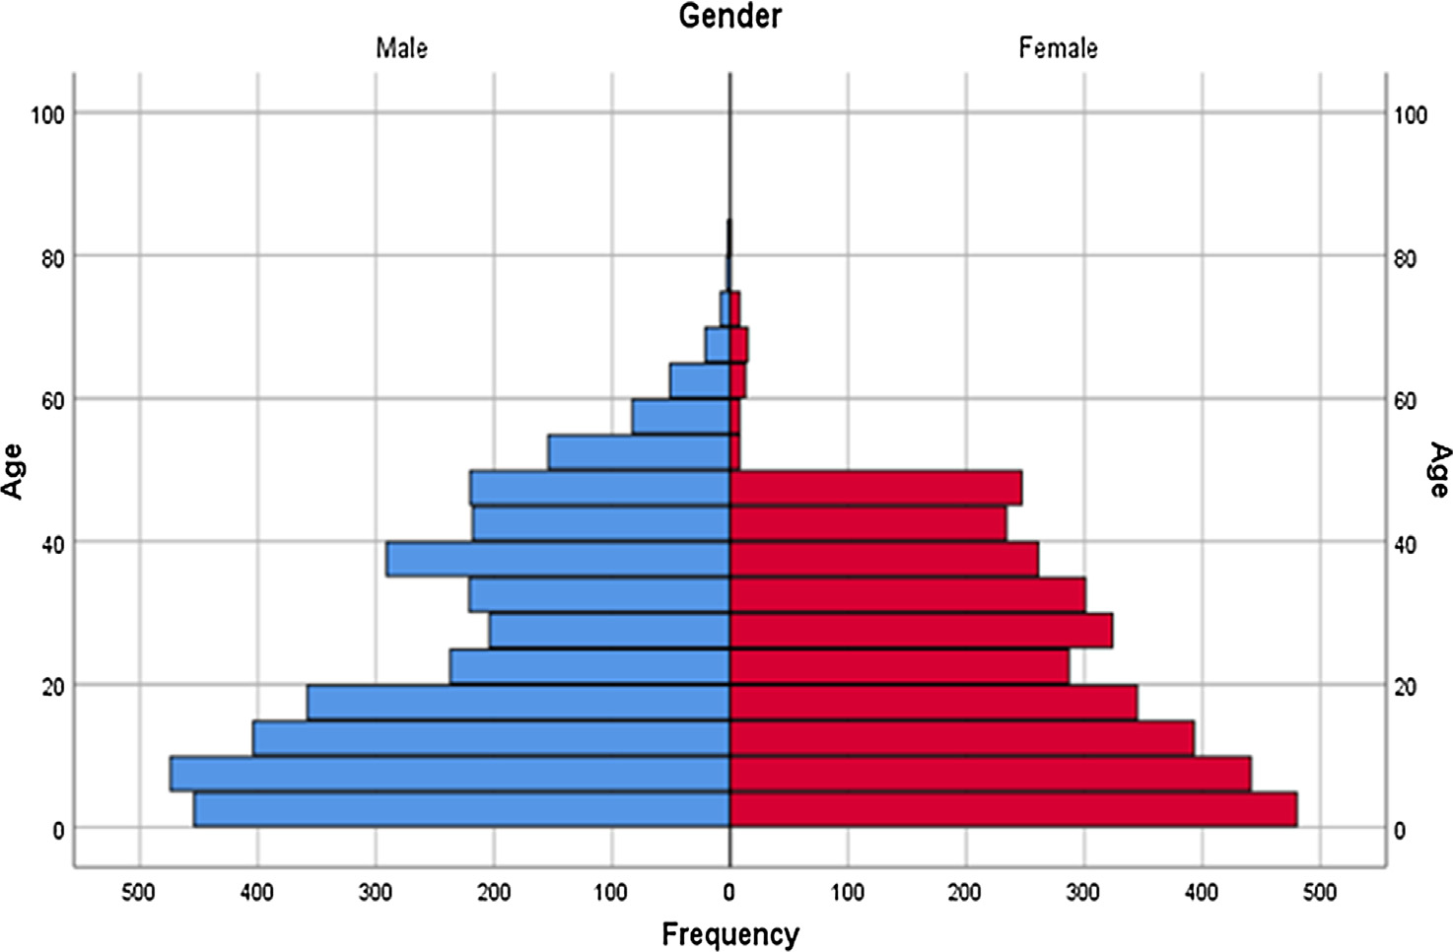

Fig. 1. Population pyramid (Giza-Egypt).

where *yij* is the vector of person *i* in layer j, and *yBj* an d *yWij* are ran- domized latent components reflecting changes between and within layers in order, with

*E* *yBj* = *E* *ywij* = 0

*E* *yij* = 0

Assuming that the data follow a normal distribution, the maxi- mum likelihood method is used, and the model is tested according to Eq. (3):

" X—1 !#

X

*FML* = *J* log R*gi*(h) + *tr*

"

*gi*

(h)*SBi*

—1 !#

The covariance was analysed according to the first- and second- level heterogeneity, as shown in Eq. (2):

+ (*N* — *J*) *log*|R*W* (h)| + *tr* (h)*SWj*

*W*

(3)

*Cov* *yij* = *Cov* *yBj* + *Cov* *ywij*

R*y* = R*B* + R*w* (2)

Depending on the following assumptions

1. Non-correlation of the random component of the first level and the second level.

*Cov yBj*,*ywij* = 0

1. Homogeneity of the heterogeneity of the first level across

layers.

R*wj* = R*w* forallj

The first part of Eq. (3) reflects the heterogeneity of the second level, and the second part reflects the variance of the first level.

Evaluation criteria for the goodness of fit of the SEM (single level):

1. Specific conciliation test) TML): This test is used to determine the validity of the following hypothesis:

H0: R*B* = R*B*(h)

R*W* = R*W* (h)

the population, respectively, and R*W* (h) and R*B*(h) is the covariance where R*W* and R*B* is the covariance of the first and second levels of

of the proposed model at the first and second levels, respectively. The conciliation is determined using the maximum likelihood pro- portion of the saturated model and the proposed model, as shown in Eq. (4):

1. Study factors

First factor: economic determinants (Y1) X3 = Women work

T F ^h F h^ 4 ●

ML =

ML( )— ML

*s*

( )

* X5 = Husband work
* X6 = Governorate of birth

where the first limit is the value of the function of the maximum likelihood of the proposed model, and the second part is the value of the function of the maximum likelihood of the saturated model. TML follows a normal distribution in degrees of freedom equal to the difference between the number of parameters of the proposed model and the saturated model.

Confirmatory fit index (CFI): This indicator measures the quality of the default model compared to the original model. The indepen- dent model is the model in which the variance is estimated with- out any constraints, with the covariance fixed at zero; this model is called the baseline model.

The parameters in the default form are compared with param- eters in the independent form using Eq. (5):

k*Hypothesized*

* X7 = Family size
* X8 = Wealth index

Second factor: social determinants (Y2)

* X1 = Women age
* X2 = Women education
* X4 = Current husband education

Third Factor: fertility determinants (Y3):

* Z1 = Number of children with contraceptive use
* Z2 = Ideal number of children
* Z3 = Birth interval

## D = 1 —

(5)

k*Baseline*

* Z4 = Fertility preference
* Z5 = Intention to use contraception in the future

The closer the value of D is to the correct value, the more likely it is to reconcile the positive model with the independent model.

Root mean square error of approximation (RMSEA):

This indicator estimates the model error in a population aside from the estimation error due to sampling error. This is done after reducing the bias of the function of the conciliation method (ML), as shown in Eq. (6):

*df*

Fourth factor: Intermediate determinants (Y4)

* V1 = Age at first marriage
* V2 = Previous contraceptive use
* V3 = Current contraceptive use
* V4 = Number of months of breastfeeding for the newborn
* V5 = Infant mortality

*F*^0 = *F*^*ML* —

(*N* — 1)

(6)

Fifth Factor: Current and future fertility determinants (Y5)

The RMSEA is then calculated as a measure of the degree of low conciliation quality in the population, as shown in Eq. (7):

* Y1 = Desire for children
* Y2 = Children ever born and living (CEB)

## RMSEA

sﬃ*F*^ﬃﬃ0ﬃﬃ

s*M*ﬃﬃﬃﬃﬃ*a*ﬃﬃ*x*ﬃﬃﬃ ﬃﬃ ﬃﬃﬃﬃﬃﬃﬃﬃﬃ*x*ﬃﬃﬃ2ﬃﬃ*d*ﬃﬃ*f*ﬃﬃﬃﬃﬃﬃﬃﬃ ﬃﬃﬃﬃﬃﬃ0ﬃﬃﬃ ﬃﬃ 7

= *df* =

*df* (*N* — 1) ,

( )

1. results and discussion

Estimation of model reconciliation at each level: (partial satu- rated model)

One research group [9] proposed the idea of using partially sat- urated models to estimate model reconciliation at each level. Another group [10] developed tools for testing this metric at each level, which is known as the specific quality (RMSEAs, CFIs).

In this method, if the first-level model is saturated, it can be used to measure the model’s conciliation at the second level (par- tial saturated between; PS_B). If the second level is saturated, it will be used to set the adjustment at the first level (partial saturated between PS_w). To test the quality of the model, some metrics will be used to judge the suitability of the single-level structural equa-

tion model, including the CFI, TLI, RMSEA, v2. To measure the rela-

tive appropriateness of the MSEM, the comparison is performed using the likelihood ratio test (LR test); in this way, whether the analysis or the structural equations of one level or the MSEM can better represent the data can be determined. The LR test is calcu- lated using the following equation:

*D* = —2[log — likelihood for model (0)

— log likelihood for model (1)]

where D follows the distribution of v2 , and the degrees of freedom

are calculated by subtracting the number of coefficients of the one- level model from the number of the multi-level model.

The method of structural equations was used, and the details of the variables and determinants used are as follows:

Overpopulation is from the biggest problem that faces Egypt nowadays, the most important priorities on the agenda of succes- sive governments in the modern era, are divided into three main dimensions that are listed as follows:

1. The first dimension: the rapid population increase in the rate of total reproduction.
2. Second dimension: low population characteristics of educa- tion, health, services and spread of slums, and this dimension is interested in the study of the famous triad (the dynamics of poverty, ignorance and disease).
3. The third dimension is the poor distribution of the popula- tion, so that the population in Egypt does not spread over the whole of Egyptian geography but is congested in the capital and in the narrow strip around the Nile River. This is a terri- ble pressure on resources and infrastructure. The rest of Egypt is not exploited in development. What the government is trying to remedy now is a very expensive solution because of its delay.

The rapid and huge increase in the number of population indi- cates the continuation of the phenomenon of overpopulation, which the government is trying to confront and to stop and curb the negative effects that affect the achievement of sustainable development in all its social, economic and environmental dimensions.

Within this framework, most population studies agreed on a set of factors that represent risk factors as a direct result of the increase in population are as follows:

1. Increased unemployment, high poverty line and number of poor.
2. Unbalanced economic growth with population growth and low standard of living.
3. The Increase of street children phenomenon, high rates of crime and corruption.
4. The spread of illiteracy and ignorance due to the increase in the number of poor.
5. High maternal mortality due to recurrent pregnancy.
6. Increase traffic congestion.
7. The state’s lack of support and health insurance.
8. Increasing the volume of government spending on the ser- vices item.
9. Low levels of wages and lack of absorption of many young people in the field of work.
10. Increase pressure on public utilities.

This section presents the results of the SEM for the levels within and between the two-level structural equations with the existence of constants and a random slope using observational research data. The data include three areas and reflect the characteristics of 1500 households divided into 500 families for each area of study, amounting to 294 (cluster) groups.

The model shown in Fig. 2 represents the default relationship of fertility determinants with current and future fertility levels.

Fertility determinants include economic determinants (Y1), public and reproductive health determinants (Y2), social and envi- ronmental determinants (Y3) and intermediate determinants determined by a set of variables based on factor analysis.

In the two-level analysis, the variables at the first level are treated as a two-sided variable, while the same variable at the second level is a continuous variable that measures the avail- ability of services by clustering. Relationships of variable at the first level with other variables of fertility determinants rep- resent the difference in the fertility of families at the second level by group. Relationships at the second level are relation- ships between the groups and the cumulative level of fertility determinants.

Four models were estimated. The first model is shown in Fig. 1, and the fourth model is shown in Fig. 3. In the first model, the

structural relationships between the determinants of fertility at the first level were estimated (within). In the second model, the structural relationships were estimated at the second level (between). The third model was a two-level structural equation that was estimated based on the output from the program. For the fourth model, was also used to estimate the model of two- level structural equations with constants and a random slope.

Table 2 shows the quality tests of model reconciliation obtained using the maximum likelihood. The results showed that the quality of conciliation was better in both the third and fourth models. Table 3 presents the parameters of the maximum likelihood and the standard errors of the four models. Notably, the results of the third and fourth models were similar, even with the lower stan- dard errors in the fourth model. In addition, the standard method yielded unreasonable results for the fertility determinants, and the concordance quality tests of the second and third models were largely identical.

The measurement model was built along with models of one- and two-level structural equations. Table 2 shows the estimation of the parameters of the models, and the parameters confirm that the results correspond to the specific model. Thus, the researchers were able to estimate the single-level structural equation model. These results are shown in Table 3, as well as the results of the two-level structural equation model. The results show the signifi- cance of the likelihood ratio test (LR) test at a significance level of 5%.

The proposed model was estimated using the method of struc- tural equations to test the path coefficients in the proposed model, with a focus on measurement errors and indirect relationships. While we cannot confirm the significance of these coefficients to ensure the quality of the compatibility of the overall model, the results confirm that the quality of the overall compatibility of the model is very high, according to the following indicators of quality: the CFI, adjusted goodness-of-fit index (AGFI), and RMSEA. Thus, we can say that the proposed model interprets the relationship to a high degree and can be relied upon to explain the relationships in the model.

The importance of the multi-level structural equation method lies in not only dividing the effect of variables into two parts, i.e., between levels and within levels, but also in the possibility of mea- suring the dependent variable at the second level by adding ran- dom coefficients to the traditional structural equations and then treating a portion of the coefficients as random, changing across layers [11].

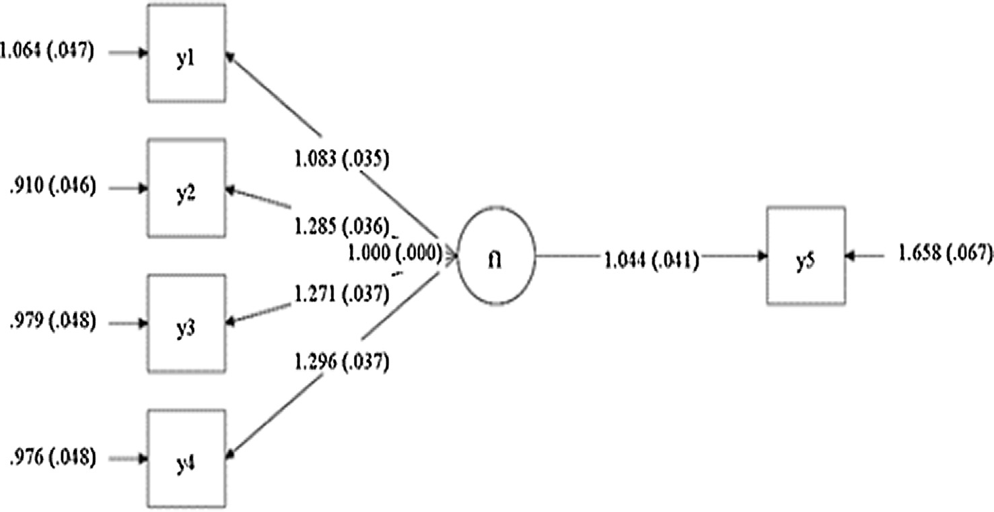

Fig. 2. The initial model of one level.

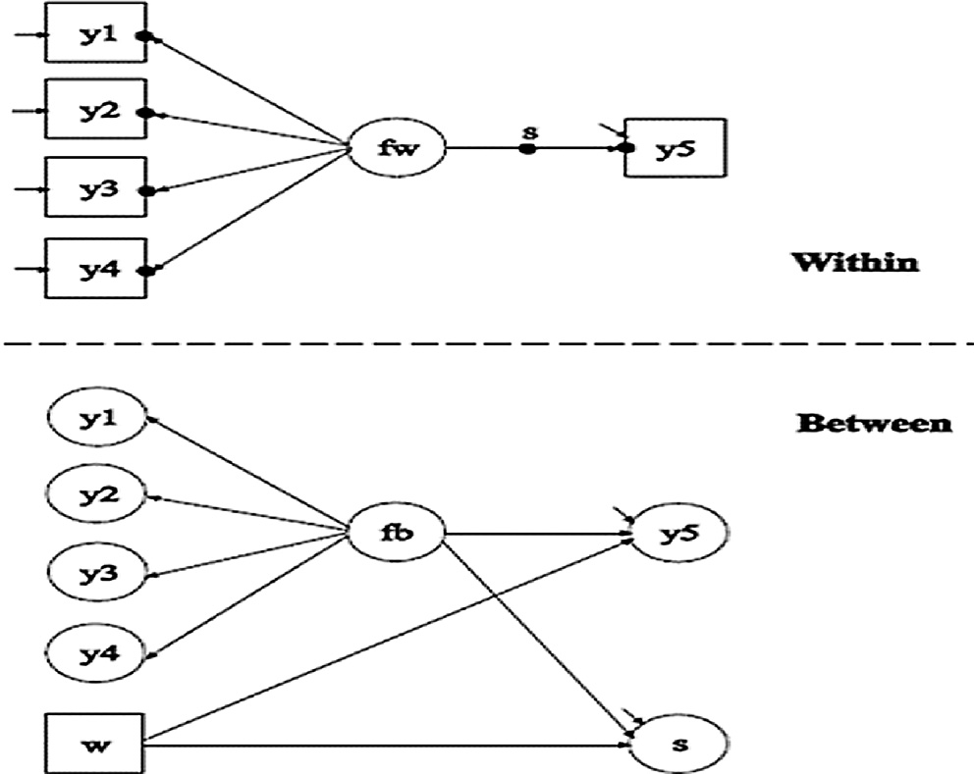

Fig. 3. The initial model of two levels.

Fig. 3 shows the two-level (within and between) structural equation model. The circles at the end of the arrows from fw are y1, y2, y3, and y4, and the end-filled circuit from fw to y5 are the random intercepts at the within level. Thus, the random inter- cepts are represented at the level between the circuits as continu- ous latent variables changing across layers. The circles filled in the middle of the arrow represent the random slope, which is referred to as the symbol (S). The random slope is represented at the between level as a continuous latent variable that varies across layers.

The two-level model is estimated with random constants and a random slope using the maximum likelihood method with strong standard errors using numerical integration. The fw is measured by y1, y2, y3, and y4, and the factor scale is automatically deter- mined by determining the first load factor using a default value of 1. The residual variance is then estimated by the factor indica- tors, and the residues are not linked as a dummy number [12].

In the within part of the model, the random slope variables are defined in the linear regression model of the dependent variable y5 on the fw factor. The error variation at the y5 level is estimated as the default value.

At the between level of the model, it is measured by random constant operations y1, y2, y3, and y4 and is set to measure the fac- tor automatically by the program via specification of the first load factor with one value. The remaining differences in factor indica- tors are corrected at zero. The variance of the factor is estimated as the default, the linear regression of the random constant y5, and the random slope S, and the mean SEM is estimated using the continuous factor indicators shown in the figure above. In the within level of the model, the circles filled at the end of the fw are represented by y1, y2, y3, and y4, the full-end-of-the-arrow

Table 3

Goodness-of-fit indicators for the proposed models.

|  |  |  |
| --- | --- | --- |
| Structural Paths | MSEM | MSEM with constants and a random slope |
| *Level one* |  |  |
| fw y1 | 1 (0.000) | 1 (0.000) |
| fw y2 | 1.328 (0.074) | 1.29 (0.07) |
| fw y3 | 1.243 (0.058) | 1.201 (0.055) |
| fw y4 | 1.307 (0.057) | 1.269 (0.056) |
| fw y5 | 1.299 (0.074) | () |
| *Level two* |  |  |
| fB y1 | 1 (0.000) | 1 (0.000) |
| fB y2 | 0.94 (0.06) | 0.952 (0.057) |
| fB y3 | 1.039 (0.056) | 1.066 (0.052) |
| fB y4 | 0.994 (0.067) | 1.019 (0.073) |
| fB y5 | 0.419 (0.077) | 0.422 (0.084) |
| fB S | – | —0.040 (0.111) |
| W y5 | 0.616 (0.039) | 0.646 (0.043) |
| W S | – | 0.407 (0.062) |

parameters from fw to y5, and random parameters of y1, y2, y3, and y4. The filled circle on the stock represents fw to y5 with a ran- domly slope S and heterogeneity at the level of group W.

The proposed multi-level model has its indicators set at accept- able limits, and the final proposed model and the significance of its coefficients have been tested to ensure the goodness of fit.

The results show that the overall compatibility quality of the proposed model is very high and that the indicators are acceptable; the CFI was 0.98, and the v2 (P-value) index was significant at 0.00. Therefore, we can say that the proposed multi-level structural

model (based on the overall quality indicators of compatibility) interprets the relationship better than the one-level model, and therefore, we accept the first hypothesis. The second hypothesis is that socioeconomic determinants and intermediate variables have a significant impact on current and future fertility.

12. Recommendations

The study consisted of two parts: the measurement model and the SEM.

The coefficients of the two models and the v2 test are presented

in Table 2. The results confirm that the model, represented the data well, thus moving the researchers to the next step. The SEM and the results of the SEM are presented in Table 3. The results are sig- nificant for the LR test at a 5% significance level for the two-level model. Building a good model is an important step in the application of multi-level structural equations, and the ability of the one-level method to determine the quality of such models enables researchers to evaluate multi-level structural models.

There are some Recommendations for policy and decision- makers, which are:

Education is one of the most important factors associated with fertility. The length of the female education period greatly limits

Table 2

Coefficients of the proposed Multi-level SEM.

|  |  |  |  |  |
| --- | --- | --- | --- | --- |
|  | Within model | Between model | Two-level model | Random-slope model |
| Log-likelihood | —12517.03 | —12335.61 | —12179.67 | —12045.45 |
| AIC | 25064.07 | 24703.23 | 24411.34 | 24140.9 |
| BIC | 25143.77 | 24788.24 | 24549.48 | 24273.79 |
| Adjusted BIC | 250960.12 | 24737.41 | 24466.89 | 24194.32 |
| v2 (P-value) | 11.95 (0.035) | 22.26 (0.008) | 46.15 (0.000) |  |
| RMSEA | 0.030 | 0.031 | 0.039 |  |
| CFI | 0.998 | 0.996 | 0.993 |  |
| TLI | 0.996 | 0.994 | 0.987 |  |
| v2 (P-value) (Baseline model) | 3165.62 (0.00) | 3560.83 (0.000) | 4540.37 (0.000) |  |
| SRMR (Standardized root mean square residual) | 0.010 | 0.020 | Value for within = 0.012 Value for between = 0.044 |  |

their total fertility and protects them from the risk of early mar- riage and subsequent pregnancy, early childbearing and age of danger.

1. A law that bans marriage under the age of 18 for girls has been introduced to aggravate and reduce the phenomenon, since it increases the period of pregnancy and raises the overall fertility rate.
2. The development and control of informal settlements, because they combine tripartite anti-development (poverty, ignorance, disease), it is difficult to convince their citizens on a subject such as family planning.
3. The area of Abu Qatada, which is a slum area, also is a geo- graphical area that is adjacent to Cairo University and its sit- uation is gradually improving due to the university’s existence and the effectiveness of some of its community activities. Therefore, it is recommended to carry out a study to measure the impact of universities and intellectual insti- tutions and their surroundings.

13. conclusion

This paper reviews and compares the models of one- and two- level structural equations. These models represent the second gen- eration after traditional linear regression models. They can identify and measure the relationships between latent and measured vari- ables, which arise from the need for statistical models that can explain the more complex problems of the past, which traditional regression methods have failed to resolve and interpret. The pre- sent works show a preference for the two-level structural model over the one-level model according to the overall compatibility quality indicators of both models.

The Two-level structural equations model (the woman level and area level), useful to study the current and future fertility by Total Fertility Rate (TFR). because that fit the empirical data.In addition, used for identifying of priorities slums development, which resulted in the main findings that the study based on real Data by Survey in the area should be at both the individual level

(women level) and the community level (area level). This is neces- sary to discover the Background characteristics of a community that affects the Growth of population because of the most of social phenomena and concepts are complex and multi-dimensions.

Acknowledgements

I would like to thank my teacher, mentor and big brother, (the late) Prof. Dr. Abdel-Hameed El-Abbasi, for providing great support and continuing to teach until the end of his life. In addition, I would like to thank Prof. Dr. Mona A. Khalifa for supporting me in my work on this subject.

References

1. [Ryu E. The role of centering for interaction of level 1 variables in multilevel](http://refhub.elsevier.com/S1110-8665(18)30235-4/h0005) [structural equation models. Struct Equation Model 2015;22(4):617–30](http://refhub.elsevier.com/S1110-8665(18)30235-4/h0005).
2. [Preacher KJ, Zhang Z, Zyphur MJ. Multilevel structural equation models for](http://refhub.elsevier.com/S1110-8665(18)30235-4/h0010) [assessing moderation within and across levels of analysis. Psychol Methods](http://refhub.elsevier.com/S1110-8665(18)30235-4/h0010) [2016;21(2):189](http://refhub.elsevier.com/S1110-8665(18)30235-4/h0010).
3. [Bollen KA, Bauer DJ, Christ SL, Edwards MC. Overview of structural equation](http://refhub.elsevier.com/S1110-8665(18)30235-4/h0015) [models and recent extensions. Stat Soc Sci 2010:37–79](http://refhub.elsevier.com/S1110-8665(18)30235-4/h0015).
4. [Cheung MWL, Au K. Applications of multilevel structural equation modeling to](http://refhub.elsevier.com/S1110-8665(18)30235-4/h0020) [cross-cultural research. Struct Equation Model 2005;12(4):598–619](http://refhub.elsevier.com/S1110-8665(18)30235-4/h0020).
5. [Song XY, Lee SY, Hser YI. A two-level structural equation model approach for](http://refhub.elsevier.com/S1110-8665(18)30235-4/h0025) [analyzing multivariate longitudinal responses. Stat Med 2008;27](http://refhub.elsevier.com/S1110-8665(18)30235-4/h0025) [(16):3017–41](http://refhub.elsevier.com/S1110-8665(18)30235-4/h0025).
6. [Maslowsky J, Jager J, Hemken D. Estimating and interpreting latent variable](http://refhub.elsevier.com/S1110-8665(18)30235-4/h0030) [interactions: a tutorial for applying the latent moderated structural equations](http://refhub.elsevier.com/S1110-8665(18)30235-4/h0030) [method. Int J Behav Dev 2015;39(1):87–96](http://refhub.elsevier.com/S1110-8665(18)30235-4/h0030).
7. [Sardeshmukh SR, Vanderburg RJ. Integrating moderation and mediation: a](http://refhub.elsevier.com/S1110-8665(18)30235-4/h0035) [structural equation modeling approach. Org Res Methods 2017;20(4):721–45](http://refhub.elsevier.com/S1110-8665(18)30235-4/h0035).
8. [El-Zanaty and Associates and ICF International. Egypt Demographic and Health](http://refhub.elsevier.com/S1110-8665(18)30235-4/h0040) [Survey. Cairo, Egypt and Rockville, Maryland, USA: Ministry of Health and](http://refhub.elsevier.com/S1110-8665(18)30235-4/h0040) [Population [Egypt]; 2014](http://refhub.elsevier.com/S1110-8665(18)30235-4/h0040).
9. [Hox JJ, Moerbeek M, van de Schoot R. Multilevel analysis: techniques and](http://refhub.elsevier.com/S1110-8665(18)30235-4/h0045) [applications. New York: Routledge; 2017](http://refhub.elsevier.com/S1110-8665(18)30235-4/h0045).
10. [Ryu E. Model fit evaluation in multilevel structural equation models. Front](http://refhub.elsevier.com/S1110-8665(18)30235-4/h0050) [Psychol 2014;5:81](http://refhub.elsevier.com/S1110-8665(18)30235-4/h0050).
11. [Marsh HW, Muthén B, Asparouhov T, Lüdtke O, Robitzsch A, Morin AJS,](http://refhub.elsevier.com/S1110-8665(18)30235-4/h0055) [Trautwein U. Exploratory structural equation modeling, integrating CFA and](http://refhub.elsevier.com/S1110-8665(18)30235-4/h0055) [EFA: application to students’ evaluations of university teaching. Struct](http://refhub.elsevier.com/S1110-8665(18)30235-4/h0055) [Equation Model 2009;16(3):439–76](http://refhub.elsevier.com/S1110-8665(18)30235-4/h0055).
12. [Mehta PD. Virtual levels and role models: N-level structural equations model](http://refhub.elsevier.com/S1110-8665(18)30235-4/h0060) [of reciprocal ratings data. Multivar Behav Res 2018;53(3):315–34](http://refhub.elsevier.com/S1110-8665(18)30235-4/h0060).