[Computers](https://doi.org/10.1016/j.cexr.2023.100029) & [Education: X Reality 3 (2023) 100029](https://doi.org/10.1016/j.cexr.2023.100029)

 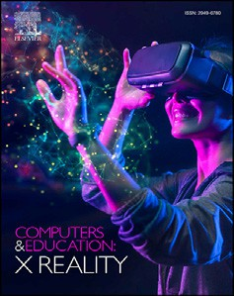

Contents lists available at [ScienceDirect](http://www.sciencedirect.com/science/journal/29496780)

Computers & Education: X Reality

journal homepage: [www.journals.elsevier.com/computers-and-education-x-reality](http://www.journals.elsevier.com/computers-and-education-x-reality)

[](http://crossmark.crossref.org/dialog/?doi=10.1016/j.cexr.2023.100029&domain=pdf)VR training program for fire escape: Learning progress predicted by the perception of fire presence, VR operational frustration, and gameplay self-efficacy

Jon-Chao Hong a, Hsun-Yu Chan b,*, Yun-Hsuang Teng c, Kai-Hsin Tai d,e, Chang-Zhen Lin f

a *Institute for Research Excellence in Learning Sciences, National Taiwan Normal University, Taiwan*

b *Department of Industrial Education, National Taiwan Normal University 162, Sec 2, Ho-Ping E Rd, Taipei City 106, Taiwan*

c *Department of Industrial Education, National Taiwan Normal University, Taiwan*

d *Institute for Research Excellence in Learning Sciences, National Taiwan Normal University, Taiwan*

e *Global Program in Interdisciplinary Studies, Soochow University, Taiwan*

f *New Taipei Municipal Taishan Senior High School, Taiwan*

A R T I C L E I N F O

*Keywords:* Virtual reality Frustration Fire presence

Gameplay self-efficacy Fire safety

A B S T R A C T

Most VR fire escape training programs only task learners to observe the procedure of fire escape in different simulated fire scenes. To improve the effectiveness of such training programs for everyone, we tested a “fire escape virtual reality training program” which takes advantage of the feedback on the action to help individuals to learn the necessary and correct steps of fire escape. The virtual program emulates a real fire scene by providing realistic visual and auditory stimuli. A single-group quasi-experimental study was carried out to measure the effectiveness of the program, and a total of 173 seventh- and eighth-grade students from a high school in New Taipei City participated. The results of structural equation modeling showed that 1) gameplay self-efficacy was negatively predicted by frustration, 2) fire presence positively predicted gameplay self-efficacy, and 3) gameplay self-efficacy positively predicted learning progress. The findings suggested that critical life-saving skills such as fire escape skills can be readily acquired and trained through individual virtual reality training programs.

1. Introduction

The stimulus–organism–response (S–O–R) model posits that envi- ronmental stimuli trigger individuals to subsequently respond (Mehra- bian & Russell, 1974). In educational settings, the model points out that creating a particular type of stimulus can lead to desired responses, and individuals can learn from such a process (Lin & Kuo, 2016; Mpinganjira, 2016). However, it is not always easy to offer real stimuli in educational environments when potential risks and dangers with limited resources outweigh the necessity of implementing certain education and training programs, such as learning essential fire-escape knowledge and skills without proper and adequate equipment. Migrating such training pro- grams into immersive virtual reality (VR) systems would be one of the ideal alternatives and might open up another way to understand the S–O–R process to improve the effectiveness of VR programs (Kour- outhanassis et al., 2015; Lopatina et al., 2020). Eventually, when the device becomes more affordable, VR objects have the potential to be

integrated into virtual programs for users to interact and learn knowledge in a virtual world (Hwang & Chien, 2022; Jaung, 2022).

VR technology is a popular medium that enables immersive envi- ronments to be used in a multitude of learning domains (Collins et al., 2021; Goedicke et al., 2018). Moreover, by integrating VR into training programs that teach how to cope with life-threatening incidents (e.g., fires), learners can practice repeatedly to master required knowledge and skills without the risk of incurring costs or triggering accidents that often occur in real-life situations (Song et al., 2021). Furthermore, the S–O–R theory helps researchers model the psychological process and outcomes of learning the knowledge and skills of fire escape via a VR system.

A variety of key indicators have been used to assess users' experience of immersive technology, including presence (Cummings & Bailenson, 2016), engagement (Boyle et al., 2012), and enjoyment (Dey et al., 2018). The achievement emotion theory (Pekrun, 2006) and Makransky et al. (2017, 2020) further conceptualized that learning outcomes in VR settings stem from the simulated presence of stimuli and feedback

* Corresponding author.

*E-mail addresses:* [tcdahong@gmail.com](mailto:tcdahong@gmail.com) (J.-C. Hong), [hsunyuchan@ntnu.edu.tw](mailto:hsunyuchan@ntnu.edu.tw) (H.-Y. Chan), [roxzero2760@gmail.com](mailto:roxzero2760@gmail.com) (Y.-H. Teng), [khtai@scu.edu.tw](mailto:khtai@scu.edu.tw) (K.-H. Tai), [unique487@tssh.ntpc.edu.tw](mailto:unique487@tssh.ntpc.edu.tw) (C.-Z. Lin).

<https://doi.org/10.1016/j.cexr.2023.100029>

Received 30 January 2023; Received in revised form 4 June 2023; Accepted 5 June 2023

2949-6780/© 2023 The Authors. Published by Elsevier Ltd. This is an open access article under the CC BY-NC-ND license ([http://creativecommons.org/licenses/by-](http://creativecommons.org/licenses/by-nc-nd/4.0/) [nc-nd/4.0/](http://creativecommons.org/licenses/by-nc-nd/4.0/)).

embedded in the VR program along with affective factors, and are mediated by cognitive factors (e.g., self-efficacy). Thus, it is necessary to measure the sense of presence and motion frustration, and further eval- uate their impact on user performance (Menin et al., 2022). Accordingly, in the present study, we asked: *How are frustration and the presence of fire influence the learning progress in a VR Fire-Escape program, and how does self-efficacy of game play mediate the aforementioned relationship?*

1. Theoretical background
   1. *Gameplay self-efficacy*

Self-efficacy refers to a belief in one’s ability to successfully resolve problems and accomplish tasks in a specific domain (Bandura, 1977). Researchers have identified self-efficacy as a critical precursor of learning outcomes and achievement (Høigaard et al., 2015; Wang & Degol, 2013), including in technology-mediated training programs (Saville & Foster, 2021). Therefore, cultivating learners' self-efficacy should be treated as a core learning objective in educational programs. In addition to retaining learners' attention and concentration, VR further enhances the effec- tiveness of on-site practice (Tai et al., 2022). In the context of VR modes that vary in terms of their technological sophistication, gameplay self-efficacy in the context of VR may play an important role in improving performance in real-life situations. Thus, we investigated how gameplay self-efficacy (GPSE) when playing VR Fire-Escape was related to the learning outcomes in this study.

* 1. *Fire presence*

Virtual presence determines the user’s feeling that the mediated environment is either real or virtual through the user’s sensations and actions responsive to their sense of presence (Fox et al., 2009). Presence is defined as “... a human reaction to immersion. Given the same immersive system, different people may experience different levels of presence, and different immersive systems may give rise to the same level presence in different people” (Slater, 2014, p. 2). Furthermore, Steuer (1992) described the concept of virtual presence as “a sense of being physically present with visual, auditory, or force displays generated by a computer” (p. 78). In a virtual environment, presence is a psychological state in which individuals feel or experience *being there*, as if the VR experience was real (Nichols et al., 2000). Successful interactions be- tween individuals and the virtual world largely depend on the conscious experience of the spatial presence (Denzer et al., 2022). Particularly, when users put on a VR headset, they are blocked from stimuli from the outside world. In the current study, the virtual stimuli arguably gener- ated a sense of presence in fire evacuation (Kwegyir-Afful, 2022).

Presence in VR is a technology-induced subjective experience when the individuals are placed in a simulated environment but gain similar experience to interacting with real objects. Individuals experience an increased sense of presence while using VR for training that could cause an increase in their learning efficacy (Ding et al., 2020). Students who are engaged in a high-presence VR environment were found to show more confidence in using VR (Song et al., 2021). It is thus important to study the roles of presence in virtual environment that can vary in different disciplinary contexts (Lim & Richardson, 2022). As such, the present study explored the role of fire presence in VR after players experienced interaction with the VR Fire-Escape program.

* 1. *Frustration when playing VR fire-escape*

Navigation largely relates to wayfinding and travel in virtual envi- ronments (Bowman et al., 2001). The former involves planning and following a route, whereas the latter refers to movement from one point to another. In VR, navigation is transformed into the movements that players perform using a designed interface, which also allows them to change their viewpoints and directions, creating a sense of walking (Hale

& Stanney, 2014). Nevertheless, if users find it hard to self-propel their movement through the vergence of their eyes, it will affect their inter- action performance and may lead to increased visual fatigue and frus- tration (Iskander et al., 2019). Essentially, this type of frustration affects the cognitive processing of the environmental features and observable behaviors (Maranges et al., 2017). Moreover, other frustration in VR may arise when the experience is not in accordance with the user’s daily habits. Therefore, such interaction requires greater mental demand and physical effort (Wu et al., 2021).

According to Lombard and Ditton (1997), frustration stems from the extent to which users cannot manipulate attributes of media, such as a mismatch between users' input and the type of corresponding response or no response at all. In the present study, we treated frustration as an emotional state that can be triggered by VR programs, which in turn may lead to an inaccurate perception, failed operation of technology, and a decreasing self-efficacy in game-play (Pence, 2022; Puente-Díaz & Cavazos-Arroyo, 2016). Previous studies indicated that interacting with objects via VR is complicated; for example, when it is hard to use VR properly to pick up objects virtually, frustration ensues (Calvert & Aba- dia, 2020). In the task of navigation, it is easy to feel frustrated with the thought that “I was arriving more slowly than expected” (Kim & Rhiu, 2021; Reeves et al., 2021). Similarly, in an empirical study, nursing professionals found VR training programs fun, challenging, and engaging, but they were frustrated with technical issues (e.g., object pick-up; Breitkreuz et al., 2021). However, since most existing literature focus on frustration in training programs, the degree to which players feel frustration when using VR (hereafter, frustration) to learn survival skills in a simulated life-threatening environment, such as fire-escape, has not been discussed; thus, the present study explored the relationship between frustration evoked by our design of VR fire escape program and gameplay self-efficacy.

* 1. *Learning progress*

VR is found to facilitate learning (Wu et al., 2020), but the effec- tiveness of VR programs may vary by subject matter (Villena-Taranilla et al., 2022). In their review, di Natale et al. (2020) revealed that the usage of VR programs positively influences students' performance and learning motivation, whereas Yang and Goh (2022) found that VR simulation improves motivation for learning, but not the knowledge or perceived effectiveness of the lesson. However, VR can facilitate learning progress (i.e., making sufficient progress that will ensure the culmination of completing the program) if the VR practice increases over time (Buentello-Montoya et al., 2021; Villena-Taranilla et al., 2022; Yang & Goh, 2022). If users can practice repeatedly, their procedural perfor- mance can be anchored; thus, VR may allow users to successfully anchor their procedure correctly in virtual contexts (Andreatta & Pauli, 2021). In the context of VR Fire-Escape, how participants used VR as a tool to repeatedly practice to promote their learning progress was explored.

1. Research model and hypothesis
   1. *Research model*

In the present study, we considered both affective (i.e., frustration) and cognitive factors (i.e., gameplay self-efficacy) that influence learning outcomes in VR programs by following Makransky et al.’s (2019) find- ings. From a motivational perspective (Ryan & Deci, 2017), the two factors can be addressed by providing goals and process feedback (Mouratidis et al., 2013). That is, VR Fire-Escape provides feedback as a procedural response for players to achieve learning effectiveness. This study therefore presented a conceptual framework to explore the corre- lates between their emotions including frustration when using VR, and the sense of fire presence that affected participants' learning progress through GPSE (see Fig. 1).

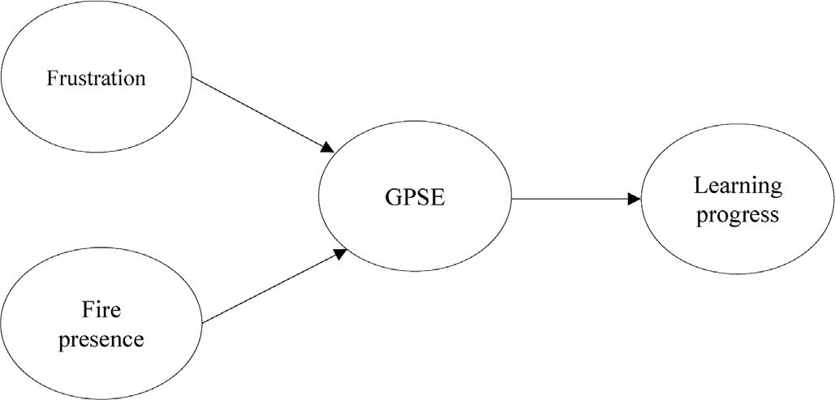

* 1. *Hypotheses*

Fig. 1. Conceptual model diagram.

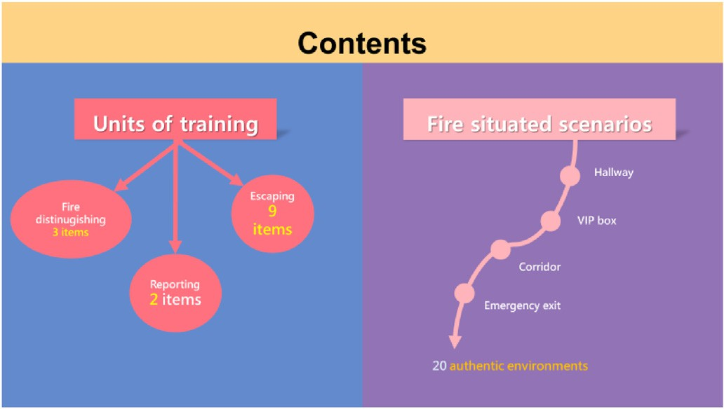Fig. 2. Content of the unit-based and situated training sections.

We followed the Cognitive-Affective Theory of Learning with Media (CATLM; Moreno, 2006) to chart the hypothesized paths in the current research. CATLM posits that multimedia can regulate learners' cognitive and affective processes that influence learning outcomes. Also, following Makransky et al. (2017), cognitive factors (e.g., self-efficacy) can be influenced by affective factors (e.g., frustration). Whereas self-efficacy supports individuals' interactions with virtual environments (Mabry et al., 2020), when individuals operate in environments or contexts where challenges routinely exceed their abilities, frustration may rise and further compromise self-efficacy. Moreover, playing in virtual worlds with learning materials may increase the user’s sense of presence and enhance the simulation efficacy (Zuniga Gonzalez et al., 2021). Finally, existing literature indicates that in a learning environment, self-efficacy mediates the relationship between academic performance and learning environment-related perception and affective responses of the learning environment (Høigaard et al., 2015; Llorca et al., 2017). In short, in VR training programs, perceived frustration and presence may cast opposite effects on the learning progress, and such effects may be mediated by gameplay self-efficacy. Therefore, we aimed to explore the relationships between the constructs inherent in VR experience as opposed to the effect of the VR program. We proposed four hypotheses as followed:

1. Frustration when using VR is negatively related to GPSE,
2. Fire presence is positively related to GPSE,
3. GPSE is positively related to learning progress, and
4. Frustration and fire presence are negatively related to learning progress mediated by GPSE.
5. VR Fire-Escape program

The VR Fire-Escape program designed in this study focuses on pre- evacuation and evacuation behavior in a fire scene, covering three ac- tions: turning on the fire alarm, distinguishing fire in the pre-evacuation stage, and escaping from the fire scene. The program includes a training mode and an assessment mode. In the training mode, the training content included unit-based training and situated training (see Fig. 2). In the unit- based training part, learners can choose one of the 14 units to master the procedure of 14 different fire responses. In the situated learning section, content from the 14 units were integrated in the 20 situated scenarios for learners to practice. The scene of fire escape was set in a karaoke, since such places are highly popular among high school students in Taiwan for after-school leisure. The training program was considered a game because of the game-like features, such as the rule-governed manipula- tions, the use of cognitive reasoning under time pressure, and a score- board for the ranking of performance that may trigger users to try more practice to top other users (Gomila & Calvo, 2008). An example scenario is shown in Fig. 3. Fig. 4 shows an example of automated feedback if users do not move for a while.

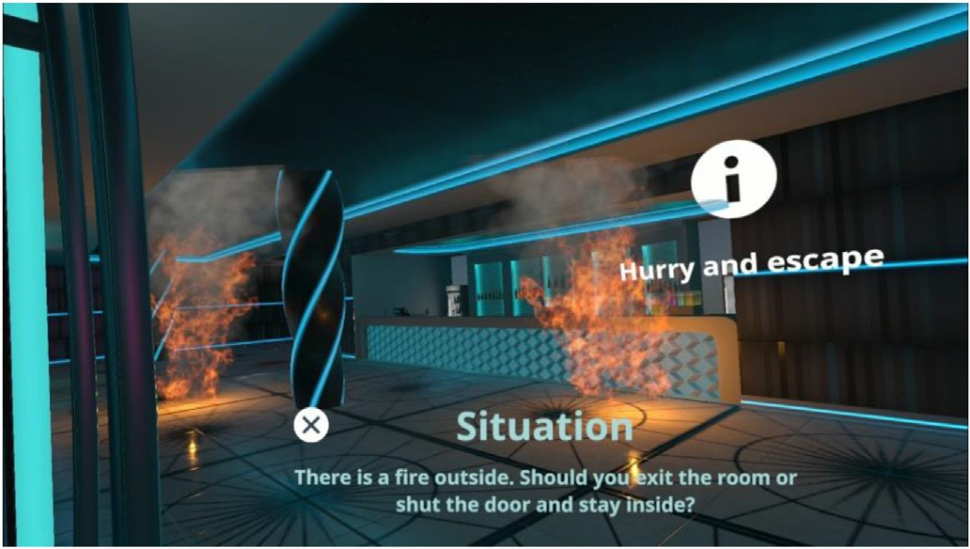

Fig. 3. A screenshot of a fire situation. *Note*: In the assessment mode, flame bursts out of a cabinet inside a karaoke room and the user has to run away. The program prompts a series of description of the scene and the user has to choose the right move. If the users got the wrong answer, they will lose some hit points (HP) and would “die” when using up all the HP.

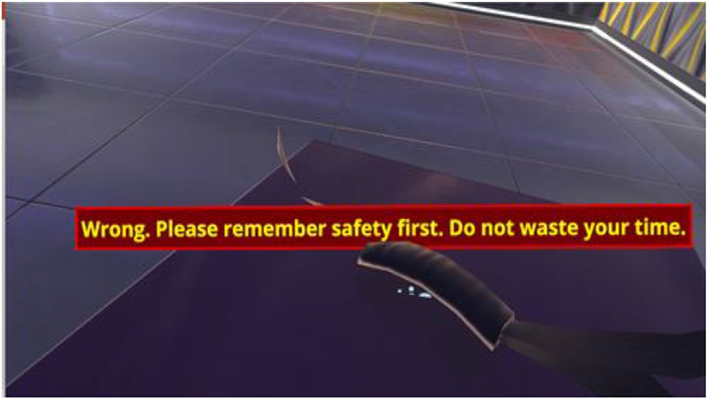

Fig. 4. Feedback on the action. *Description of the scene*: You have already run away from the fire, but should you return to the room to pick up something you left in the cabinet? If the users choose to return, the message above will pop out to warn them.

1. Methods
   1. *Procedure and participants*

To avoid the Hawthorne effect, a quasi-experimental single group study was adopted in this study. This research course was conducted over a period of 4 weeks. Each participant turned in a completed informed consent signed by one parent or guardian before participation in the study, indicating that participants and at least one of the parents/

guardians were aware that they were taking part in an experimental study and that the data they provided were anonymous. The study was approved by the Research Ethics Committee of National Taiwan Normal University (No. 201812HS020).

Purposive sampling was adopted in this study, and 160 participants from a high school in Northern Taipei provided the data. The sample comprised 150 (93.75%) boys and 10 (6.3%) girls. As for grade level, 117 (73.0%) were from the first year of senior high, 24 (15.0%) were from the second year, and 19 (12%) were from the third year. High school stu- dents were chosen as the target population because high school students are more familiar with the karaoke environment to ensure a high level of presence. The spatial presence of life-threatening scene is also more manageable for adolescents than younger children (Baumgartner et al., 2006). In addition, whereas most high school students in Taiwan have learned the fundamentals of fire escape in elementary school, they may had forgotten the related knowledge and skills. A quick review in an immersive mode may help revive the essential knowledge and skills that are deemed necessary for protecting themselves (see below for the effect on re-learning the knowledge and skills of fire escape).

After the study was approved by the research ethics review board, we received the signed informed consent form from one parent or guardian of each participant. Afterward, we adopted the following three-phase protocol to complete the study (see Fig. 5 for the flowchart):

Phase 1: When the program starts, the participants completed a tutorial that familiarizes them with the features and control of VR.

Phase 2: In three weeks, the participants completed the unit-based and situated training in the VR program for 20 minutes every day.

Phase 3: After completion, all participants filled out the survey questionnaire to measure the perceived frustration, presence, GPSE, and the knowledge of fire escape.

* 1. *Instrument*
     1. *Questionnaire*

We consulted relevant literature when developing the survey ques- tionnaire. Three experts were invited to validate the accuracy of the translation of items. Afterward, we conducted cognitive interviews with

10 students to ensure face validity. All items were measured by a 5-point Likert-type scale (1 ¼ *strongly disagree*, 5 ¼ *strongly agree*). The psycho- metric properties and sample items of each scale measurement are

described below:

* + - 1. *Gameplay self-efficacy (GPSE).* Self-efficacy is a judgment of one’s confidence in the domain-specific ability to successfully complete a task (Bandura, 1977). The gameplay self-efficacy scale used in this study was modified from Hong et al.’s (2023) gameplay self-efficacy scale. Six items were designed. Example items are: “I was good at moving the VR device smoothly,” “It was easy to learn, and I quickly became proficient in using VR,” and “I took a short time to physically master the VR



Fig. 5. Flowchart of the experiment.

interface.”

* + - 1. *Frustration.* If motion-based navigation interfaces have been improperly designed, it can negatively impact the VR experience due to frustration (Kim & Rhiu, 2021); thus, to assess participants' negative experience of frustration when using VR to play VR Fire-Escape, six items were designed. Example items are “I felt frustrated with the interface because I was arriving more slowly than expected,” “It took a long time to operate precisely,” and “I felt frustrated that I could not move virtual objects naturally.”
      2. *Fire presence.* Presence is conceptualized as the feeling of *being there* and is a psychological state in which individuals feel as if the VR experience is real (Nichols et al., 2000). In line with VR environmental presence that contributes to cognitive performance (Makransky et al., 2017), for this study, we designed six items to test participants' Fire escape VR presence. Example items include “When I was involved in playing VR Fire-Escape,” “I felt I was in a real KTV environment,” “I felt the fire scenarios were lifelike when I played VR Fire-Escape,” and “I felt those objects (e.g., hose) were similar to real objects.”
    1. *Pre-and post-test of learning progress*

The difference between participants' test scores in the first and sixth sessions was used as the learning progress (Hong et al., 2020). In this study, we consulted the municipal fire department’s handbook and developed a test of fire scene knowledge. The test was further validated by three domain experts to form the test items. Pre- and post-test example items are:

1. When you encounter a fire outbreak on the stairs, you should:
   1. Run downstairs
   2. Run upstairs
   3. Don’t move.
2. When you are in a smoky room, if you want to escape you should:
   1. Not use a wet towel, just run out of the room.
   2. Use a wet towel to cover your nose to escape.
   3. Use a plastic bag to cover your head and run out of the room.
3. Please rearrange the sequence of fire extinguisher usage: (A) Sweep the fire from left to right in a back-and-forth manner, (B) Aim at the bottom parts of the fire, (C) Pull out the safety latch, (D) Squeeze the handle to push out the chemical agent.
   1. *Plan of analysis*

We first examined the psychometric properties of the scales as out- lined above. Second, we applied the structural equation modeling (SEM) framework and estimated an SEM model to answer the research ques- tions. The measurement part of SEM retains the latent structure of the constructs and the structural part delineates the paths between the var- iables. If the model did not fit the data well, we consulted the modifi- cation indices to revise the model. After achieving a good model fit, we then focused on the magnitude of the path coefficients and the effect sizes in terms of R2.

1. Results
   1. *Psychometric properties of the scales*

We first checked the internal validity of the scales by conducting a one-level confirmatory factor analysis (CFA). We adopted the following cutoff values of various indices when evaluating our model: the chi- square statistics should be statistically non-significant, RMSEA smaller than 0.10, GFI and AGFI greater than 0.80, and factor loadings should be greater than 0.50. Items may be omitted when the model or item does not meet the criteria. As a result, two items in each of the fire presence,

frustration, and GPSE scales were omitted.

Second, we examined the item discriminability by contrasting par- ticipants who scored in the top against lower 27% of each item, and conducted *t*-tests to explore whether the two groups significantly differed in the value of each item. Following Hankins’s (2007) suggestion, items were determined to have good discrimination if the *t*-value was greater than 3 with a corresponding *p*-value smaller than 0.001. Consequently, the *t*-values across items were between 26.96 and 52.02, indicating that all items had good item discrimination. See Table 1 for details.

Third, for the scales of fire presence, frustration, and GPSE, we computed Cronbach α to examine the internal consistency and the composite reliability (CR) to test external consistency. We adopted Emerson’s (2019) recommendations that a scale has good internal and external consistency with a Cronbach α and CR value greater than 0.70. For the convergent validity of each scale, Hair et al. (2019) suggested that factor loadings (FL) and average variance extracted (AVE) should be higher than 0.50. Across scales, the Cronbach α values ranged between

0.89 and 0.95, CR between 0.89 and 0.94, FLs between 0.89 and 0.94, and AVE between 0.76 and 0.88. We thus considered that all three scales had acceptable internal and external consistency and convergent validity (see Tables 2 and 3). Finally, to test the divergent validity, Ro€nkko€ and Cho (2022) suggested that the square root of AVE should be higher than the absolute value of the Pearson correlation coefficient between con- structs. As shown in Table 3, construct discriminative validity was acceptable.

* 1. *Learning progress*

The participants completed one test before the fire escape programs (i.e., pre-test) and five follow-up tests on the content knowledge covered

in the fire escape program as the participants completed the modules. A paired-sample *t*-test showed a significant difference (*t* = —7.65, *p* < 0.001) between the pre-test (*M* = 10.96, *SD* = 2.18) and the fifth follow- up test (i.e., post-test; *M* = 16.08, *SD* = 2.06; see Table 4).

* 1. *Path model*

Table 2

Reliability and validity analysis.

|  |  |  |  |  |  |  |
| --- | --- | --- | --- | --- | --- | --- |
| Constructs | *M* | *SD* | Cronbach’s α | CR | FL | AVE |
| Fire presence | 3.45 | 0.86 | 0.89 | 0.93 | 0.87 | 0.76 |
| frustration | 2.44 | 0.98 | 0.92 | 0.94 | 0.89 | 0.80 |
| GPSE | 3.83 | 0.89 | 0.95 | 0.97 | 0.94 | 0.88 |

Table 3

Construct discriminative validity.

|  |  |  |  |
| --- | --- | --- | --- |
| Constructs | 1 | 2 | 3 |
| 1. Self-efficacy | (0.93) |  |  |
| 2. Frustration | 0.26 | (0.89) |  |
| 3. Fire presence | 0.23 | 0.13 | (0.87) |

*Note*. Divergent validity is presented on the diagonal.

Table 4

Comparative analysis of learning performance.

|  |  |  |  |  |
| --- | --- | --- | --- | --- |
| No. of times | *M* | *SD* | *t*-value | *d* |
| Pre-test | 10.96 | 2.18 | —7.65*** | 0.61 |
| Post-test | 16.08 | 2.06 |  |  |

We adopted the same cutoff values of model fit indices as we did in

CFA (Hair et al., 2019), and the results revealed that the model fit the data (χ2*/df* = 1.71, RMSEA = 0.07, GFI = 0.91, AGFI = 0.87, NFI = 0.94, NNFI = 0.96, CFI = 0.97, IFI = 0.97, RFI = 0.92, PNFI = 0.74, PGFI =

0.77). All fit indices met the thresholds suggested by Hair et al. (2019).

As summarized in Fig. 5, frustration was negatively related to GPSE (β = —0.28, *t* = —3.71, *p* < 0.001), whereas fire presence was positively

1. Discussion

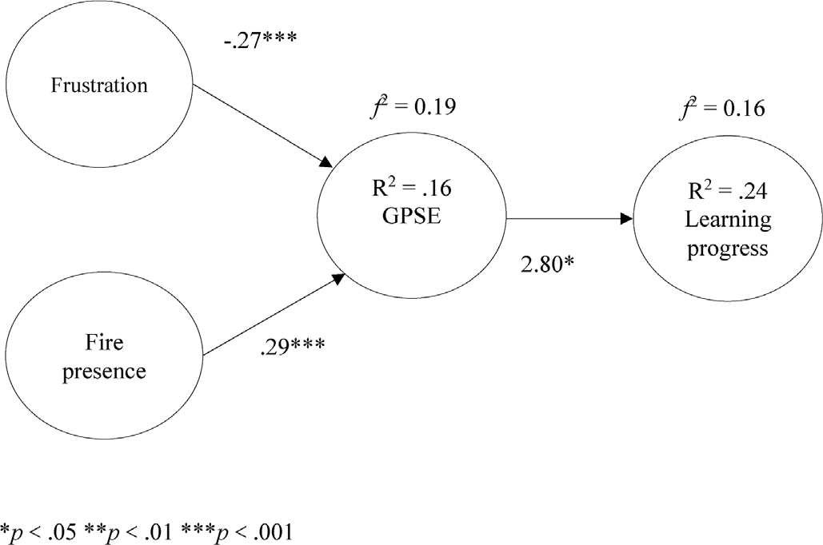Fig. 6. Summary of the path model.

related to GPSE (β = 0.36, *t* = 4.48, *p* < 0.001). In turn, GPSE was positively related to learning progress (β = 0.16, *t* = 2.07, *p* < 0.05; see

Fig. 6). The indirect path from frustration to learning progress through GPSE was statistically significant and negative (β = —0.43, *p* < 0.001). In addition, the indirect path from fire presence to learning progress through GPSE was statistically significant and positive (β = 0.48, *p* < 0.001).

In terms of effect sizes, we calculated explanative power between

constructs R2 and effect size by Cohen’s *f*2. The results demonstrated a moderate effect size of frustration and fire presence on GPSE (R2 = 0.16, *f2* = 0.19) and GPSE on learning progress (R2 = 0.24, *f2* = 0.16; Cohen

et al., 2007).

This study highlights the important role of game-play self-efficacy that may maximize the potential of VR programs to help learners immerse in a controlled, danger-free virtual world to gain new life-saving knowledge and skills (Yang & Goh, 2022). Given our findings, first, frustration slows down learning progress by lowering individuals' gameplay self-efficacy. When fundamental physical functioning can only be carried out through controllers, and when visual stimuli deviate from previous real-life experience (Calvert & Abadia, 2020; Wu et al., 2021), individuals waste cognitive resources on learning the use of gadgets and familiarizing themselves with the virtually constructed sight. Instead of paying due attention to the authentic learning task, frustration with VR

Table 1

Summary of the first-order CFA.

|  |  |  |  |  |  |  |  |  |
| --- | --- | --- | --- | --- | --- | --- | --- | --- |
| Fit index χ2 *df* | | | *p*-value of χ2 | RMSEA | GFI | AGFI | FL | *t-*value |
| Cutoff | – | – | >0.05 | <0.08 | >0.95 | >0.95 | >0.50 | >3.00 |
| Fire presence | 3.60 | 2 | 0.17 | 0.07 | 0.99 | 0.95 | 0.84–0.90 | 38.58–48.52 |
| frustration | 2.30 | 2 | 0.32 | 0.03 | 0.99 | 0.96 | 0.86–0.92 | 26.96–27.89 |
| GPSE | 1.54 | 2 | 0.46 | 0.01 | 0.99 | 0.98 | 0.92–0.95 | 49.67–52.04 |

programs grow because of the gap between real-life and simulated perceptual experience (Iskander et al., 2019), and we found that such emotional reaction is in turn related to a lower self-efficacy (Pence, 2022). Despite the numerous strengths of VR educational programs for promoting positive learning outcomes (Coban et al., 2022), difficulties with the operation of VR appear to present unnecessary hurdles and lower the learning outcomes (Song et al., 2021). Given the importance of GPSE in VR programs, VR-related frustration as a representation of risks should be reduced to cultivate GPSE.

Second, beyond replicating the S–O-R model (Mehrabian & Russell, 1974) and the importance of virtual presence in VR programs (Nichols et al., 2000; Song et al., 2021; Steuer, 1992), our findings demonstrate that a realistic representation of the environment is necessary for a higher level of gameplay self-efficacy and learning outcomes. Presence in VR is a technology-induced experience that is a subjective property of a person. Students who are engaged in a high-presence VR environment were found to show more confidence in using VR (Song et al., 2021). Some may be worried that a realistic fire scene may trigger aversive reaction (Fu et al., 2021), although there is in fact no real threat. It is likely that, at least for high school students, learners can suppress their aversive emotional reactions to the fire scene when they know that the threat is not real. Indeed, psychophysiological evidence has shown that adoles- cents tend to experience a lower level of spatial presence in VR than before (Baumgartner et al., 2006); subsequently, a lower spatial presence may be related to a milder emotional arousal (Lee et al., 2023; Pavic et al., 2023). As such, VR programs should provide a more authentic presence vis-`a-vis users' age and developmental stage to ensure a proper level of emotional arousal and, in turn, better gameplay self-efficacy and eventually a better learning outcome.

Third, resonating with existing literature (Meyer et al., 2019; Saville & Foster, 2021), we also highlighted the pivotal role of GPSE in pro- moting learning outcomes. In educational settings, self-efficacy is conceptualized as students' personal judgement of their ability to accomplish learning tasks or achieve specific goals (Han et al., 2020; Schunk & Pajares, 2009). In this study, gameplay self-efficacy is related to students' ability to handle VR equipment and interact with contents of fire escape. In turn, the sense of self-efficacy has been found to be closely related to learning performance (Zakariya et al., 2022). A heightened gameplay self-efficacy is particularly important in simulated tasks since a high level of self-efficacy helps ensure transfer so that learners can apply the knowledge and skills acquired in VR programs to actual problems and environments (Coban et al., 2022; Song et al., 2021; Tai et al., 2022).

Our findings further demonstrate that a vivid visual and audio rep- resentation of the authentic task (i.e., presence) and a lower level of frustration are both essential for building higher gameplay self-efficacy, even for life-threatening stimuli that may influence participants' deep learning. The affective and perceptual experience appear to have distinctive relationship to GPSE that educators and VR program de- velopers have to deal with both of the constructs to facilitate meaningful learning.

* 1. *Implications*

Based on the findings, our research highlights the value of VR pro- grams for training adolescents to cope with stressful and life-threatening incidents, the necessity of realistic presence in fire scenes, and the importance of reducing technological barriers for learners. VR remains a useful tool for training adolescents about the knowledge and skillset necessary for fire safety and escape. With potential risks, danger, and other limitations of providing drill-type courses, VR programs appear to be a safe and effective alternative (Yang & Goh, 2022). Second, with such an understanding, our findings imply that a more authentic presence when using VR may lead to better gameplay self-efficacy and eventually a better learning outcome. VR program developers should construct a realistic environment in the VR programs to facilitate self-efficacy and mastery of life-saving skills. In this sense, program developers should

work with content experts and designers to build a virtual world in which students are able to learn essential knowledge and skills to survive a fire scene.

Third, VR program developers should minimize technological bar- riers that may obstruct students' flow during the learning experience. In this context, effective VR programs in which users can practice by encountering dangerous fire situations should be designed (Çakirog˘lu & Go€kog˘lu, 2019). As such, paying more attention to user experience to facilitate smooth human-computer interaction is highly necessary (Petersen et al., 2022). Particularly, when trapped in a fire scene, people may underestimate the danger (e.g., smoke) or misunderstand the physical environment (e.g., it is bright because of the presence of fire) and take a risky route when evacuating (Fu et al., 2021). Our VR design allows individuals to practice repeatedly to form conditional responses as it integrates training into the virtual environment. This positively con- tributes to the development of fire evacuative skills. Finally, despite its rocky inception, we anticipate that the program will be further integrated into the virtual technology in which learners are able to collaborate in skills training in an immersive environment and to better prepare learners for group fire escape drills (Hwang & Chien, 2022).

* 1. *Limitations and future study*

The findings should be interpreted with caution. First, our quasi- experimental design does not support a causal relationship between using the VR Fire-Escape program, gameplay self-efficacy, and mastery of content knowledge and skills because of the lack of a control group. As a result, the findings should be interpreted as correlational. Researchers should conduct a similar study in the future but with a randomized control trial to justify the causal relationships. Second, the effect size of GPSE on learning progress was small, indicating that other variables are at play. It is possible that the effect size is small because the content is too simple for high school students since students may have already learned the fundamentals earlier. Researchers can further identify salient pre- dictors of learning outcomes that can also be promoted by VR programs besides self-efficacy or when the VR programs serve as a review of pre- viously learned content. Third, we did not compare who has not prac- ticed the VR Fire-Escape program to those of practiced, in terms of learning effectiveness in performance. Finally, the results can only be generalized to high school students. More research should be conducted with individuals of different ages to verify the effect of the VR Fire-Escape program.

1. Conclusion

VR programs provide a safe alternative for training students in the essential skills to cope with emergencies. In the current study, we documented that for high school-aged individuals, the vivid presence of the source of the risk—fire in this study—is positively related to game- play self-efficacy, which in turn is related to students' knowledge and skills of coping (i.e., fire escape). However, frustration with control over VR programs is negatively related to gameplay self-efficacy. Our path model clearly delineates that gameplay-related self-efficacy, which can be cultivated by well-designed visual and auditory effects in VR pro- grams, plays a pivotal role in facilitating learning outcomes for adoles- cents. Moreover, VR program designers and programmers should adopt intuitive control systems and modules to lower negative emotional re- action to VR programs.

Statements on open data and ethics

The participants were protected by hiding their personal information in this study. They were voluntary and understood that they could withdraw from the experiment at any time. The data can be provided upon requests by contacting the corresponding author.

Declaration of competing interest

The authors declare that they have no known competing financial interests or personal relationships that could have appeared to influence the work reported in this paper

Acknowledgement

This work was financially supported by the “Institute for Research Excellence in Learning Sciences” of National Taiwan Normal University (NTNU) from The Featured Areas Research Center Program within the framework of the Higher Education Sprout Project by the Ministry of Education (MOE) in Taiwan. Correspondence should be addressed to Hsun-Yu Chan, Department of Industrial Education, National Taiwan Normal University. Email: [hsunyuchan@ntnu.edu.tw](mailto:hsunyuchan@ntnu.edu.tw).

References

Andreatta, M., & Pauli, P. (2021). Contextual modulation of conditioned responses in humans: A review on virtual reality studies. *Clinical Psychology Review, 90*, Article 102095. <https://doi.org/10.1016/j.cpr.2021.102095>

Bandura, A. (1977). Self-efficacy: Toward a unifying theory of behavioral change.

*Psychological Review, 84*(2), 191–215. <https://doi.org/10.1037/0033-295x.84.2.191> Baumgartner, T., Valko, L., Esslen, M., & J€ancke, L. (2006). Neural correlate of spatial

presence in an arousing and noninteractive virtual reality: An EEG and psychophysiology study. *CyberPsychology and Behavior, 9*(1), 30–45. [https://doi.org/](https://doi.org/10.1089/cpb.2006.9.30) [10.1089/cpb.2006.9.30](https://doi.org/10.1089/cpb.2006.9.30)

Bowman, D. A., Kruijff, E., LaViola, J. J., Jr., & Poupyrev, I. (2001). An introduction to 3- D user interface design. *Presence: Teleoperators and Virtual Environments, 10*(1),

96–108. <https://doi.org/10.1162/105474601750182342>

Boyle, E. A., Connolly, T. M., Hainey, T., & Boyle, J. M. (2012). Engagement in digital entertainment games: A systematic review. *Computers in Human Behavior, 28*(3), 771–780. <https://doi.org/10.1016/j.chb.2011.11.020>

Breitkreuz, K. R., Kardong-Edgren, S., Gilbert, G. E., Anderson, P., DeBlieck, C., Maske, M., Hallock, C., Lanzara, S., Parrish, K., Rossler, K., Turkelson, C., &

Ellertson, A. (2021). Nursing faculty perceptions of a virtual reality catheter insertion game: A multisite international study. *Clinical Simulation in Nursing, 53*, 49–58. <https://doi.org/10.1016/j.ecns.2020.10.003>

Buentello-Montoya, D. A., Lomelí-Plascencia, M. G., & Medina-Herrera, L. M. (2021). The role of reality enhancing technologies in teaching and learning of mathematics.

*Computers* & *Electrical Engineering, 94*, Article 107287. [https://doi.org/10.1016/](https://doi.org/10.1016/j.compeleceng.2021.107287) [j.compeleceng.2021.107287](https://doi.org/10.1016/j.compeleceng.2021.107287)

Çakirog˘lu, Ü., & Go€kog˘lu, S. (2019). Development of fire safety behavioral skills via

virtual reality. *Computers* & *Education, 133*, 56–68. [https://doi.org/10.1016/](https://doi.org/10.1016/j.compedu.2019.01.014) [j.compedu.2019.01.014](https://doi.org/10.1016/j.compedu.2019.01.014)

Calvert, J., & Abadia, R. (2020). Impact of immersing university and high school students in educational linear narratives using virtual reality technology. *Computers* & *Education, 159*, Article 104005. <https://doi.org/10.1016/j.compedu.2020.104005>

Coban, M., Bolat, Y. I., & Goksu, I. (2022). The potential of immersive virtual reality to enhance learning: A meta-analysis. *Educational Research Review, 36*, Article 100452. <https://doi.org/10.1016/j.edurev.2022.100452>

[Cohen, L., Manion, L., & Morrison, K. (2007). In *Research methods in education* (6th ed.).](http://refhub.elsevier.com/S2949-6780(23)00023-5/sref11)

[Taylor](http://refhub.elsevier.com/S2949-6780(23)00023-5/sref11) & [Francis](http://refhub.elsevier.com/S2949-6780(23)00023-5/sref11).

Collins, J., Regenbrecht, H., & Langlotz, T. (2021). Expertise and experience in VR- supported learning: Achieving a deep non-verbal comprehension of four-dimensional space. *International Journal of Human-Computer Studies, 152*, Article 102649. [https://](https://doi.org/10.1016/j.ijhcs.2021.102649) [doi.org/10.1016/j.ijhcs.2021.102649](https://doi.org/10.1016/j.ijhcs.2021.102649)

Cummings, J. J., & Bailenson, J. N. (2016). How immersive is enough? A meta-analysis of the effect of immersive technology on user presence. *Media Psychology, 19*(2),

272–309. <https://doi.org/10.1080/15213269.2015.1015740>

Denzer, S., Diezig, S., Achermann, P., Koenig, T., & Mast, F. W. (2022). BizarreVR: Dream- like bizarreness in immersive virtual reality induced changes in conscious experience of reality while leaving spatial presence intact. *Consciousness and Cognition, 99*, Article 103283. <https://doi.org/10.1016/j.concog.2022.103283>

Dey, A., Billinghurst, M., Lindeman, R. W., & Swan, J. (2018). A systematic review of 10 years of augmented reality usability studies: 2005 to 2014. *Frontiers in Robotics and* *AI, 5*, 37. <https://doi.org/10.3389/frobt.2018.00037>

Di Natale, A. F., Repetto, C., Riva, G., & Villani, D. (2020). Immersive virtual reality in K- 12 and higher education: A 10-year systematic review of empirical research. *British Journal of Educational Technology, 51*(6), 2006–2033. [https://doi.org/10.1111/](https://doi.org/10.1111/bjet.13030) [bjet.13030](https://doi.org/10.1111/bjet.13030)

Ding, D., Brinkman, W. P., & Neerincx, M. A. (2020). Simulated thoughts in virtual reality for negotiation training enhance self-efficacy and knowledge. *International Journal of Human-Computer Studies, 139*, Article 102400. [https://doi.org/10.1016/](https://doi.org/10.1016/j.ijhcs.2020.102400) [j.ijhcs.2020.102400](https://doi.org/10.1016/j.ijhcs.2020.102400)

Emerson, R. W. (2019). Cronbach’s alpha explained. *Journal of Visual Impairment* &

*Blindness, 113*(3), 327. <https://doi.org/10.1177/0145482X19858866>

Fox, J., Arena, D., & Bailenson, J. N. (2009). Virtual reality: A survival guide for the social scientist. *Journal of Media Psychology, 21*(3), 95–113. [https://doi.org/10.1027/1864-](https://doi.org/10.1027/1864-1105.21.3.95) [1105.21.3.95](https://doi.org/10.1027/1864-1105.21.3.95)

Fu, M., Liu, R., & Zhang, Y. (2021). Why do people make risky decisions during a fire evacuation? Study on the effect of smoke level, individual risk preference, and neighbor behavior. *Safety Science, 140*, Article 105245. [https://doi.org/10.1016/](https://doi.org/10.1016/j.ssci.2021.105245) [j.ssci.2021.105245](https://doi.org/10.1016/j.ssci.2021.105245)

Goedicke, D., Li, J., Evers, V., & Ju, W. (2018). VR-OOM: Virtual Reality On-rOad driving simulation. In *CHI '18: Proceedings of the 2018 CHI conference on human factors in* *computing systems*. <https://doi.org/10.1145/3173574.3173739>

Gomila, T., & Calvo, P. (2008). In P. Calvo, & T. Gomila (Eds.), *Handbook of cognitive science: An embodied approachDirections for an embodied cognitive science: Toward an integrated approach* (pp. 1–25). Elsevier. [https://doi.org/10.1016/b978-0-08-046616-](https://doi.org/10.1016/b978-0-08-046616-3.00001-3) [3.00001-3](https://doi.org/10.1016/b978-0-08-046616-3.00001-3).

Hair, J. F., Risher, J. J., Sarstedt, M., & Ringle, C. M. (2019). When to use and how to report the results of PLS-SEM. *European Business Review, 31*(1), 2–24. [https://doi.org/](https://doi.org/10.1108/EBR-11-2018-0203) [10.1108/EBR-11-2018-0203](https://doi.org/10.1108/EBR-11-2018-0203)

[Hale, K. S., & Stanney, K. M. (2014). *Handbook of virtual environments: Design,*](http://refhub.elsevier.com/S2949-6780(23)00023-5/sref24)[*implementation, and applications*. CRC Press](http://refhub.elsevier.com/S2949-6780(23)00023-5/sref24).

Hankins, M. (2007). Questionnaire discrimination: (re)-introducing coefficient. *MBC* *Medical Research Methodology, 7*, 19. <https://doi.org/10.1186/1471-2288-7-19>

Han, F., Pardo, A., & Ellis, R. A. (2020). Students' self-report and observed learning orientations in blended university course design: How are they related to each other and to academic performance? *Journal of Computer Assisted Learning, 36*(6), 969–980. <https://doi.org/10.1111/jcal.12453>

Høigaard, R., Kovaˇc, V. B., Øverby, N. C., & Haugen, T. (2015). Academic self-efficacy mediates the effects of school psychological climate on academic achievement. *School Psychology Quarterly, 30*(1), 64–74. <https://doi.org/10.1037/spq0000056>

Hong, J. C., Hwang, M. Y., & Tai, K. S. (2023). Gestalt perception: A game designed to explore players' gameplay self-efficacy and anxiety reflected in their learning effects. *Journal of Research on Technology in Education, 55*(3), 441–458. [https://doi.org/](https://doi.org/10.1080/15391523.2021.1967819) [10.1080/15391523.2021.1967819](https://doi.org/10.1080/15391523.2021.1967819)

Hong, J. C., Hwang, M. Y., Tai, K. H., Lin, P. H., & Lin, P. C. (2020). Learning progress in a Chinese order of stroke game: The effects of intrinsic cognitive load and gameplay interest mediated by flow experience. *Journal of Educational Computing Research, 58*(4), 842–862. <https://doi.org/10.1080/09588221.2019.1614068>

Hwang, G.-J., & Chien, S.-Y. (2022). Definition, roles, and potential research issues of the metaverse in education: An artificial intelligence perspective. *Computers and Education: Artificial Intelligence, 3*, Article 100082. [https://doi.org/10.1016/](https://doi.org/10.1016/j.caeai.2022.100082) [j.caeai.2022.100082](https://doi.org/10.1016/j.caeai.2022.100082)

Iskander, J., Hossny, M., & Nahavandi, S. (2019). Using biomechanics to investigate the effect of VR on eye vergence system. *Applied Ergonomics, 81*. [https://doi.org/](https://doi.org/10.1016/j.apergo.2019.102883) [10.1016/j.apergo.2019.102883](https://doi.org/10.1016/j.apergo.2019.102883)

Jaung, W. (2022). Digital forest recreation in the metaverse: Opportunities and challenges. *Technological Forecasting and Social Change, 185*, Article 122090. [https://](https://doi.org/10.1016/j.techfore.2022.122090) [doi.org/10.1016/j.techfore.2022.122090](https://doi.org/10.1016/j.techfore.2022.122090)

Kim, Y. M., & Rhiu, I. (2021). A comparative study of navigation interfaces in virtual reality environments: A mixed-method approach. *Applied Ergonomics, 96*, Article 103482. <https://doi.org/10.1016/j.apergo.2021.103482>

Kourouthanassis, P., Boletsis, C., Bardaki, C., & Chasanidou, D. (2015). Tourists responses to mobile augmented reality travel guides: The role of emotions on adoption behavior. *Pervasive and Mobile Computing, 18*, 71–87. [https://doi.org/10.1016/](https://doi.org/10.1016/j.pmcj.2014.08.009) [j.pmcj.2014.08.009](https://doi.org/10.1016/j.pmcj.2014.08.009)

Kwegyir-Afful, E. (2022). Effects of an engaging maintenance task on fire evacuation delays and presence in virtual reality. *International Journal of Disaster Risk Reduction,* *67*, Article 102681. <https://doi.org/10.1016/j.ijdrr.2021.102681>

Lee, J., Kang, D., & Kim, J. (2023). The auxiliary role of virtual reality in enhancing the effects of disaster news on empathy and fear: The mediating role of presence.

*Cyberpsychology, Behavior, and Social Networking, 26*(4), 273–278. [https://doi.org/](https://doi.org/10.1089/cyber.2022.0243) [10.1089/cyber.2022.0243](https://doi.org/10.1089/cyber.2022.0243)

Lim, J., & Richardson, J. C. (2022). Considering how disciplinary differences matter for successful online learning through the Community of Inquiry lens. *Computers* & *Education, 187*, Article 104551. <https://doi.org/10.1016/j.compedu.2022.104551>

Lin, C. H., & Kuo, B. Z. L. (2016). The behavioral consequences of tourist experience.

*Tourism Management Perspectives, 18*, 84–91. [https://doi.org/10.1016/](https://doi.org/10.1016/j.tmp.2015.12.017) [j.tmp.2015.12.017](https://doi.org/10.1016/j.tmp.2015.12.017)

Llorca, A., Richaud, M. C., & Malonda, E. (2017). Parenting, peer relationships, academic self-efficacy, and academic achievement: Direct and mediating effects. *Frontiers in Psychology, 8*. <https://doi.org/10.3389/fpsyg.2017.02120>

Lombard, M., & Ditton, T. (1997). At the heart of it all: The concept of presence. *Journal of Computer-Mediated Communication, 3*(2). [https://doi.org/10.1111/j.1083-](https://doi.org/10.1111/j.1083-6101.1997.tb00072.x) [6101.1997.tb00072.x](https://doi.org/10.1111/j.1083-6101.1997.tb00072.x)

Lopatina, O. L., Morgun, A. V., Gorina, Y. V., Salmin, V. V., & Salmina, A. B. (2020). Current approaches to modeling the virtual reality in rodents for the assessment of brain plasticity and behavior. *Journal of Neuroscience Methods, 335*, Article 108616. <https://doi.org/10.1016/j.jneumeth.2020.108616>

Mabry, J., Lee, E., Roberts, T., & Garrett, R. (2020). Virtual simulation to increase self- efficacy through deliberate practice. *Nurse Educator, 45*(4), 202–205. [https://doi.org/](https://doi.org/10.1097/NNE.0000000000000758) [10.1097/NNE.0000000000000758](https://doi.org/10.1097/NNE.0000000000000758)

Makransky, G., Lilleholt, L., & Aaby, A. (2017). Development and validation of the multimodal presence scale for virtual reality environments: A confirmatory factor analysis and item response theory approach. *Computers in Human Behavior, 72*, 276–285. <https://doi.org/10.1016/j.chb.2017.02.066>

Makransky, G., Petersen, G. B., & Klingenberg, S. (2020). Can an immersive virtual reality simulation increase students' interest and career aspirations in science? *British Journal* *of Educational Technology, 51*(6), 2079–2097. <https://doi.org/10.1111/bjet.12954>

Makransky, G., Terkildsen, T. S., & Mayer, R. E. (2019). Adding immersive virtual reality to a science lab simulation causes more presence but less learning. *Learning and Instruction, 60*, 225–236. <https://doi.org/10.1016/j.learninstruc.2017.12.007>

Maranges, H. M., Schmeichel, B. J., & Baumeister, R. F. (2017). Comparing cognitive load and self-regulatory depletion: Effects on emotions and cognitions. *Learning and* *Instruction, 51*, 74–84. <https://doi.org/10.1016/j.learninstruc.2016.10.010>

[Mehrabian, A., & Russell, J. A. (1974). *An approach to environmental psychology*. MIT Press](http://refhub.elsevier.com/S2949-6780(23)00023-5/sref47). Menin, A., Torchelsen, R., & Nedel, L. (2022). The effects of VR in training simulators: Exploring perception and knowledge gain. *Computers* & *Graphics, 102*, 402–412.

<https://doi.org/10.1016/j.cag.2021.09.015>

Meyer, O. A., Omdahl, M. K., & Makransky, G. (2019). Investigating the effect of pre- training when learning through immersive virtual reality and video: A media and methods experiment. *Computers* & *Education, 140*. [https://doi.org/10.1016/](https://doi.org/10.1016/j.compedu.2019.103603) [j.compedu.2019.103603](https://doi.org/10.1016/j.compedu.2019.103603)

Moreno, R. (2006). Does the modality principle hold for different media? A test of the method-affects-learning hypothesis. *Journal of Computer Assisted Learning, 22*,

149–158. <https://doi.org/10.1111/j.1365-2729.2006.00170.x>

Mouratidis, A., Vansteenkiste, M., Michou, A., & Lens, W. (2013). Perceived structure and achievement goals as predictors of students'' self-regulated learning and affect and the mediating role of competence need satisfaction. *Learning and Individual Differences,* *23*, 179–186. <https://doi.org/10.1016/j.lindif.2012.09.001>

Mpinganjira, M. (2016). Environmental stimuli and user experience in online customer communities: A focus on flow and behavioural response. *Management Dynamics,* *25*(2), 2–16. <https://doi.org/10.10520/EJC194638>

Nichols, S., Haldane, C., & Wilson, J. R. (2000). Measurement of presence and its consequences in virtual environments. *International Journal of Human-Computer Studies, 52*, 471–491. <https://doi.org/10.1006/ijhc.1999.0343>

Pavic, K., Chaby, L., Gricourt, T., & Vergilino-Perez, D. (2023). Feeling virtually present makes me happier: The influence of immersion, sense of presence, and video contents on positive emotion induction. *Cyberpsychology, Behavior, and Social Networking, 26*(4), 238–245. <https://doi.org/10.1089/cyber.2022.0245>

Pekrun, R. (2006). The Control-Value Theory of Achievement Emotions: Assumptions, corollaries, and implications for educational research and practice. *Educational Psychology Review, 18*(4), 315–341. <https://doi.org/10.1007/s10648-006-9029-9>

Pence, P. L. (2022). Student satisfaction and self-confidence in learning with virtual simulations. *Teaching and Learning in Nursing, 17*, 31–35. [https://doi.org/10.1016/](https://doi.org/10.1016/j.teln.2021.07.008) [j.teln.2021.07.008](https://doi.org/10.1016/j.teln.2021.07.008)

Petersen, G. B., Petkakis, G., & Makransky, G. (2022). A study of how immersion and interactivity drive VR learning. *Computers* & *Education, 179*, Article 104429. [https://](https://doi.org/10.1016/j.compedu.2021.104429) [doi.org/10.1016/j.compedu.2021.104429](https://doi.org/10.1016/j.compedu.2021.104429)

Puente-Díaz, R., & Cavazos-Arroyo, J. (2016). An exploration of some antecedents and consequences of creative self-efficacy among college students. *Journal of Creative* *Behavior, 52*, 256–266. <https://doi.org/10.1002/jocb.149>

Reeves, S. M., Crippen, K. J., & McCray, E. D. (2021). The varied experience of undergraduate students learning chemistry in virtual reality laboratories. *Computers* & *Education, 175*, Article 104320. <https://doi.org/10.1016/j.compedu.2021.104320>

Ro€nkko€, M., & Cho, E. (2022). An updated guideline for assessing discriminant validity.

*Organizational Research Methods, 25*(1), 6–47. [https://doi.org/10.1016/10.1177/](https://doi.org/10.1016/10.1177/1094428120968614)

[1094428120968614](https://doi.org/10.1016/10.1177/1094428120968614)

[Ryan, R., & Deci, E. (2017). *Self-determination theory: Basic psychological needs in*](http://refhub.elsevier.com/S2949-6780(23)00023-5/sref61)[*motivation, development, and wellness*. Guilford Press](http://refhub.elsevier.com/S2949-6780(23)00023-5/sref61).

Saville, J. D., & Foster, L. L. (2021). Does technology self-efficacy influence the effect of training presentation mode on training self-efficacy? *Computers in Human Behavior* *Reports, 4*, Article 100124. <https://doi.org/10.1016/j.chbr.2021.100124>

[Schunk, D. H., & Pajares, F. (2009). In K. R. Wentzel, & D. B. Miele (Eds.), *Handbook of*](http://refhub.elsevier.com/S2949-6780(23)00023-5/sref63)[*motivation at schoolSelf-efficacy theory* (pp. 35](http://refhub.elsevier.com/S2949-6780(23)00023-5/sref63)–[53). Routledge](http://refhub.elsevier.com/S2949-6780(23)00023-5/sref63).

Slater, M. (2014). A note on presence terminology. *Presence Connect, 3*(3). [http](http://publicationslist.org/melslater)

[://publicationslist.org/melslater](http://publicationslist.org/melslater).

Song, H., Kim, T., Kim, J., Ahn, D., & Kang, Y. (2021). Effectiveness of VR crane training with head-mounted display: Double mediation of presence and perceived usefulness. *Automation in Construction, 122*, Article 103506. [https://doi.org/10.1016/](https://doi.org/10.1016/j.autcon.2020.103506) [j.autcon.2020.103506](https://doi.org/10.1016/j.autcon.2020.103506)

Steuer, J. (1992). Defining virtual reality: Dimensions determining telepresence. *Journal of Communication, 42*(4), 73–93. [https://doi.org/10.1111/j.1460-](https://doi.org/10.1111/j.1460-2466.1992.tb00812.x) [2466.1992.tb00812.x](https://doi.org/10.1111/j.1460-2466.1992.tb00812.x)

Tai, K. H., Hong, J. C., Tsai, C. R., Lin, C. J., & Hwang, M. Y. (2022). Virtual reality for car- detailing skill development: Learning outcomes of procedural accuracy and performance quality predicted by VR self-efficacy, VR using anxiety, VR learning interest and flow experience. *Computers* & *Education, 182*, Article 104458. [https://](https://doi.org/10.1016/j.compedu.2022.104458) [doi.org/10.1016/j.compedu.2022.104458](https://doi.org/10.1016/j.compedu.2022.104458)

Villena-Taranilla, R., Tirado-Olivares, S., Cozar-Gutierrez, R., & Gonzalez-Calero, J. A. (2022). Effects of virtual reality on learning outcomes in K-6 education: A meta- analysis. *Educational Research Review, 35*, Article 100434. [https://doi.org/10.1016/](https://doi.org/10.1016/j.edurev.2022.100434) [j.edurev.2022.100434](https://doi.org/10.1016/j.edurev.2022.100434)

Wang, M.-T., & Degol, J. (2013). Motivational pathways to STEM career choices: Using expectancy–value perspective to understand individual and gender differences in STEM fields. *Developmental Review, 33*(4), 304–340. [https://doi.org/10.1016/](https://doi.org/10.1016/j.dr.2013.08.001) [j.dr.2013.08.001](https://doi.org/10.1016/j.dr.2013.08.001)

Wu, H., Deng, Y., Pan, J., Han, T., Hu, Y., Huang, K., & Zhang, X. (2021). User capabilities in eyes-free spatial target acquisition in immersive virtual reality environments.

*Applied Ergonomics, 94*, Article 103400. [https://doi.org/10.1016/](https://doi.org/10.1016/j.apergo.2021.103400) [j.apergo.2021.103400](https://doi.org/10.1016/j.apergo.2021.103400)

Wu, B., Yu, X., & Gu, X. (2020). Effectiveness of immersive virtual reality using head- mounted displays on learning performance: A meta-analysis. *British Journal of Educational Technology, 51*(6), 1991–2005. <https://doi.org/10.1111/bjet.13023>

Yang, F., & Goh, Y. M. (2022). VR and MR technology for safety management education: An authentic learning approach. *Safety Science, 148*, Article 105645. [https://doi.org/](https://doi.org/10.1016/j.ssci.2021.105645) [10.1016/j.ssci.2021.105645](https://doi.org/10.1016/j.ssci.2021.105645)

Zakariya, Y. F., Nilsen, H. K., Goodchild, S., & Bjørkestøl, K. (2022). Self-efficacy and approaches to learning mathematics among engineering students: Empirical evidence for potential causal relations. *International Journal of Mathematical Education in Science* & *Technology, 53*(4), 827–841. <https://doi.org/10.1080/0020739x.2020.1783006>

Zuniga Gonzalez, D. A., Richards, D., & Bilgin, A. A. (2021). Making it real: A study of augmented virtuality on presence and enhanced benefits of study stress reduction sessions. *International Journal of Human-Computer Studies, 147*, Article 102579. <https://doi.org/10.1016/j.ijhcs.2020.102579>