HOSTE D BY

Available online at [www.sciencedirect.com](http://www.sciencedirect.com/science/journal/2314808X)

**ScienceDirect**

journal homepage: [http://ees.elsevier.com/ejbas/default.asp](http://http//ees.elsevier.com/ejbas/default.asp)

egyptian journal of basic and applied sciences 3 (2016) 1 7 2–186



**Full Length Article**

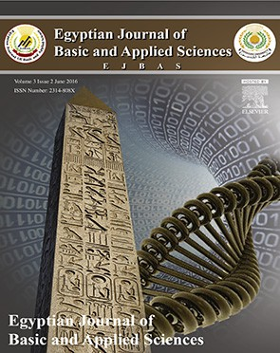**Vegetation structure and soil characteristics of five common geophytes in desert of Egypt**



***Y.A. El-Amier*** ***\****

*Department of Botany, Faculty of Science, University of Mansoura, El-Mansoura, Egypt*

A R T I C L E I N F O A B S T R A C T

*Article history:*

Received 20 October 2015 Received in revised form 1 March 2016

Accepted 1 March 2016

Available online 17 March 2016

*Keywords:* Vegetation Biodiversity Soil factors Geophytes Desert

Geophytes are kind of plants having the capability to survive under arid environmental con- ditions; parts of their bodies are dormant fleshy underground as bulbs, corms, tubers or rhizomes. The present study was designed to throw light on the ecological features of five representative geophytes, namely, *Cyperus capitatus, Cyperus conglomeratus*, *Elymus farctus*, *Lasiurus scindicus* and *Panicum turgidum*. The soil characteristics and the associated species of these geophytes are described in their natural habitats of coastal desert (Deltaic Medi- terranean coast) and inland desert (Cairo-Suez desert road). A total of 119 species (65 perennials, 3 biennials and 51 annuals) belonging to 97 genera and 28 families constituted their floristic composition. Asteraceae, Poaceae, Fabaceae and Chenopodiaceae are the largest families. Therophytes and chamaephytes are the most abundant life forms. The chorological analysis of the study area revealed that 63.02% and 47.33% belong to Saharo-Arabian and Mediterranean taxa, respectively. The highest species richness value (1.42 species stand–1) is recorded in the coastal desert. The application of TWINSPAN analysis yielded six dis- tinct vegetation groups (A, B, C1, C2, D1 and D2); each is linked to one or more of the studied geophyte plants. The main soil factors affecting the study geophytes are electrical conduc- tivity, organic carbon, sulphates, chlorides and bicarbonates as well as its silt composite.

© 2016 Mansoura University. Production and hosting by Elsevier B.V. This is an open

access article under the CC BY-NC-ND license (<http://creativecommons.org/licenses/by->

nc-nd/4.0/).

# Introduction

Geophytes are plants with underground storage organs (bulbs, corms, tubers or rhizomes) that appeared as promising raw ma- terials for various economic uses [1]. The leaves of these plants die annually. No evergreen plants are considered to be geo- phytes [2]. These geophytes have high diversity in the Mediterranean-type ecosystems, where they are considered as most common in seasonal climates [3,4].

The economic value of these species is attributed to col- lection and exporting their natural bulbs as ornamental plants. In addition, geophytes are used in medicine and food indus- try [5].

The Mediterranean desert coastline is an area of rela- tively high bio-diversity; 10% of the world’s higher plants can be found in this area, which represents only 1.6% of the Earth’s surface [6]. The northern Mediterranean coast of Egypt is char- acterized by highly diverse edaphic, topographic and climatic characteristics and as a consequence, by different vegetation

* Tel.: +01017229120-01280288892.

*E-mail address:* [yasran@mans.edu.eg](mailto:yasran@mans.edu.eg). <http://dx.doi.org/10.1016/j.ejbas.2016.03.001>

2314-808X/© 2016 Mansoura University. Production and hosting by Elsevier B.V. This is an open access article under the CC BY-NC-ND license ([http://creativecommons.org/licenses/by-nc-nd/4.0/).](http://creativecommons.org/licenses/by-nc-nd/4.0/))

egyptian journal of basic and applied sciences 3 (2016) 1 7 2–186

**173**

groups [7]. During relatively high rainfall periods; most of species are annuals that flourish during the rainy season. However, during the longer dry periods, the characteristic woody shrubs and perennial herbs constitute the scrub vegetation, scat- tered sparsely in parts and grouped in denser distinct patches [8,9]. On the other hand, the plant life in the Eastern Desert is much richer than that of the Western Desert. The flora of wadis and mountains of the north Eastern Desert has strong relations with that of the Sinai Peninsula [10].

Cyperaceae are the third largest monocotyledonous family

[11] and constitute a specialized group of plants, particularly in relation to their generative structure [12]. *Cyperus* is a large genus with about 600 species, which are distributed through- out all continents in both tropical and temperate regions. *Cyperus capitatus* and *Cyperus conglomeratus* are distributed in the coastal region of Egypt. These species are able to survive extreme climatic conditions [13].

*C. capitatus* is a perennial creeping sedge that occurs in coastal sandy habitats and mobile dunes of southern Europe and the Mediterranean coast of Egypt [13,14]. This species pro- duces extensive rhizomes, and it is one of the earliest species to colonize newly deposited dunes contributing to the initial stabilization of sand dunes in arid and semiarid coastal areas [15]. *C. conglomeratus* is a creeping yellowish-green, drought- resistant perennial wild species with short and branched rhizomes that are covered with acute brown scales. It grows in widely distributed in arid regions from Senegal to Paki- stan. In Egypt, it is growing in the coastal and inland sand dune habitats [13].

Poaceae are also one of the most ecologically and economi- cally important plant families with about 670 genera, 10,000 species and are distributed worldwide [13,16]. *Elymus farctus* (sand couch-grass) is a perennial rhizomatous grass with erect, rigid 60–90 cm long culms. It is a facultative halophyte and has the ability to fix sand, therefore, it is considered as the pioneer of the psammosere [17,18]. *Lasiurus* is a genus of Asian and African plants in the grass family, found primarily in arid regions. *Lasiurus scindicus* is a perennial herb with culms often woody below, up to 90 cm in length, erect from a thick woody rhizome that occurs in sandy, stony and rocky soils [13]. *Panicum turgidum* is a glaucous perennial wild species, widely distrib- uted in all phytogeographical regions of Egypt except the western Mediterranean coastal desert [19,20]. It is also con- sidered to have tolerant drought and soil salinity levels, and is an effective sand binding xerophyte and could be used to fix sand dunes [9,21].

This study was designed to throw light on the ecological features of the abovementioned five geophytes growing in the Mediterranean coast and Cairo-Suez road through studying their associated plant species and edaphic factors controlling their richness and distribution in the study area.

180 km, and a width in a N-S direction for about 15 km from the coast**.** On the other hand, Cairo-Suez desert road is about 130 km in length, located in the northern section of the Eastern Desert of Egypt (The Galalah Desert), which extends east of the Nile Delta. It represents the natural xeric habitat mainly in- habited by xerophytic vegetation. The gravel habitat is one of the most characteristic features of this road [9].

The study area is located in some Governorates in the north- ern part of the Nile Delta and Eastern Desert regions of Egypt, which comprises different habitats (Fig. 1). These include: Deltaic Mediterranean coast and inland desert habitat (Cairo-Suez desert road and Wadi Hagul).

According to the map of the world distribution of the arid regions [22], the climatic conditions of the Deltaic Mediterra- nean coast of Egypt is rather arid to semi-arid, where the rate of evaporation exceeds many times the rate of precipitation [23]. On the other hand, the Cairo-Suez desert road belongs to arid mesothermal type of Thornthwaite [24] and the arid or extreme arid climate of Walter [25]. Meteorological data of the studied area are presented in Table 1.

## *Vegetation analysis*

After a reconnaissance survey that was conducted between 2014 and 2015, 95 sample stands (10 m × 10 m) were randomly se- lected to represent a wide range of physiographic and environmental variation in the studied deserts. Specimens of the selected geophyte plants as well as the other associated species were collected from the Deltaic Mediterranean coastal strip and Cairo-Suez desert road. The studied geophyte species were *Cyperus capitatus* Vand., *Cyperus conglomeratus* Rottb., *Elymus farctus* (Viv.) Ranemark ex. Melderis., *Lasiurus scindicus* Henrard. and *Panicum turgidum* Forssk.

The relative density and cover of each species have been estimated in the studied stands [27,28]. Relative values of density and cover as well as importance value (IV = 200) for each

plant species in each stand were calculated. A floristic count

list was taken from the 95 sites to represent the five geo- phyte plants in the study sites: 80 from the Deltaic Mediterranean coast and 15 from Cairo-Suez desert road. Taxo- nomic nomenclature and analysis of phytogeographic ranges were used according to Zohary [29], Tackholm [20] and Boulos [30].

## *Soil analysis*

Each of the 95 study sites was represented by three soil samples that were collected at depths of 0–20, 20–35 and 35–50 cm. The samples were mixed together to form a single composite sample, which was then spread over sheets of paper and left to dry in the air. Soil texture, water holding capacity (WHC), organic carbon and sulphate were determined according to Piper

[31]. Calcium carbonate content was determined by titration

# Materials and methods

## *Study area*

The middle section of the Mediterranean coastal land of Egypt (Deltaic coast) extends from Abu-Quir (in the west, Long. 32°19′ E) to Port-Said (in the east Long. 31°19′ E) with a length of about

against 1N NaOH and expressed as a percentage [32]. Deter- mination of electrical conductivity and pH was determined in soil–water (1:5) suspension by the method adopted by Jackson [32]. Carbonates and bicarbonates were determined by titra- tion using 0.1 N HCl [33]. Sodium and potassium were determined by flame photometry, while calcium and magne- sium were estimated using atomic absorption spectrometer [34].

**174** egyptian journal of basic and applied sciences 3 (2016) 1 7 2–186

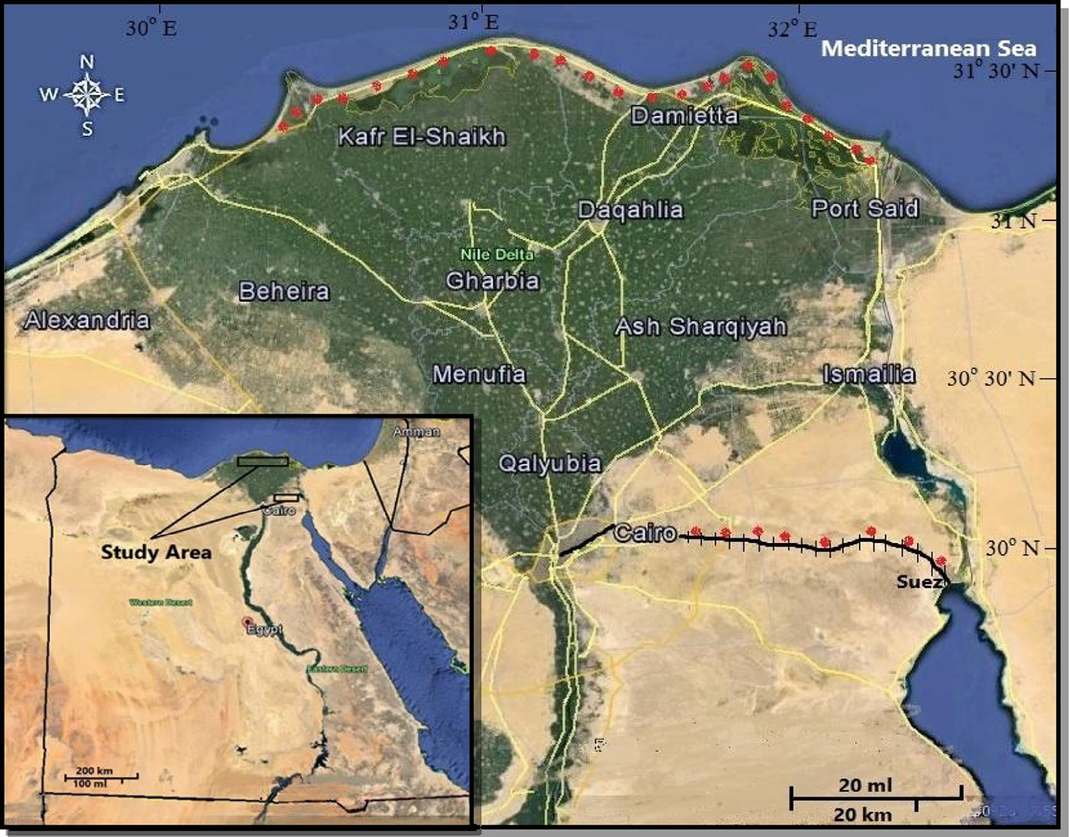

**Fig. 1 – Map of Egypt showing the location of study area.**

## *Data analysis*

Classification and ordination of the associated vegetation of the studied geophytes were performed using TWINSPAN analy- sis by the Community Analysis Package (CAP) computer

calculated from the formula H = –*Pi* ln *Pi* where, H is Shannon– Wiener diversity index and *Pi* is the relative presence value of the *i*th species [38].

program, version 2.3 [35]. For ordination, the indirect gradi-

ent analysis was undertaken using detrended correspondence analysis (DCA) [36]. The relation between the vegetation and soil gradients was assessed using Canonical Correspondence Analysis (CCA) [37].

Linear correlations coefficient (r) was calculated for assess- ing the relationship between the estimated soil variables and the studied geophytes. The vegetation groups produced from cluster analysis were then subjected to one-way analysis of vari- ance (ANOVA, SPSS 16 for Windows) testing, based on soil variables, to find out whether there were any significant varia- tions among groups.

Species richness (SR) is referred to here as the total number of species per site. The Shannon–Wiener diversity index was

# Results

## *Floristic composition*

A total of 119 species (65 perennials, 3 biennials and 51 annuals) constituted the floristic composition, belonging to 97 genera and 28 families (Appendix). The largest families were Asteraceae, Poaceae and Fabaceae (24, 18 and 11 species, respectively), Brassicaceae and Chenopodiaceae (8 species each), and Caryophyllaceae (7 species). They constituted 63.87% of the re- corded species, and represent most of the floristic structure in the study area, while the other 10 families shared 26.05% of the species and 12 families were monospecific.

|  |  |  |  |  |  |  |  |  |
| --- | --- | --- | --- | --- | --- | --- | --- | --- |
| **Table 1 – Long-term averages (≥20 years) of the climatic records at four stations in northern sector of the Nile Delta and Galalah Desert** **[26]****.** | | | | | | | | |
| Meteorological variable | Baltim  31° 33′ N, 31°  Range | 05′ E  Mean | Damietta  31° 25′ N, 31° 48′ E  Range Mean | | Cairo  30° 03′ N, 31° 15′E  Range Mean | | Suez  30° 70′ N, 32°  Range | 34′ E  Mean |
| Minimum air temperature (°C) | 11.2–23.6 | 17.3 | 8.4–21.4 | 15.4 | 8.8–21.8 | 15.6 | 10.4–24.1 | 17.6 |
| Maximum air temperature (°C) | 17.4–29.7 | 24.0 | 18.3–31.0 | 24.9 | 19.0–34.9 | 28.0 | 19.2–34.6 | 27.6 |
| Mean air temperature (°C) | 14.4–26.5 | 20.5 | 12.8–25.7 | 19.6 | 13.6–27.7 | 21.4 | 14.7–28.9 | 15.8 |
| Relative humidity (%) | 65.0–73.0 | 69.0 | 68–76 | 72 | 42–61 | 53 | 42–56 | 51 |
| Evaporation (mm/day) | 3.3–5.6 | 4.6 | 2.8–5.4 | 4.1 | 7.4–17 | 11.8 | 7.4–15.4 | 11.5 |
| Rainfall (mm/month) | 0.0–46.6 | – | 0.0–25.5 | – | 0.0–6.6 | – | 0.0–6.2 | |

egyptian journal of basic and applied sciences 3 (2016) 1 7 2–186

**175**

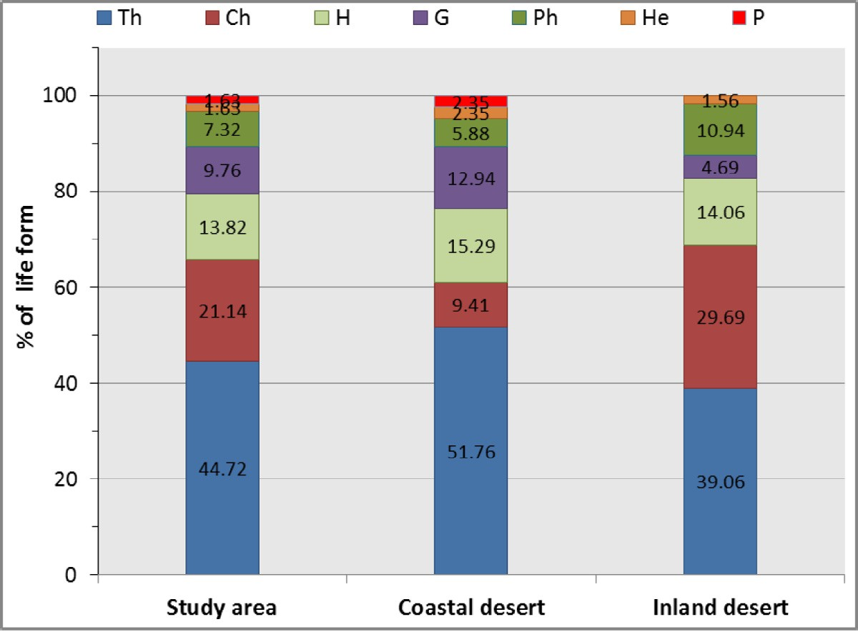

### Fig. 2 – Plant life form spectra in the different habitats of the study area. For life form abbreviations, see Appendix.

The largest genera are arranged in the following sequence: Asteraceae > Poaceae > Brassicaceae > Chenopodiaceae > Boraginaceae and Fabaceae. The total number of recorded species was 80 (38 perennials, 1 biennials and 41 annuals) and

66 (40 perennials, 2 biennials and 24 annuals) for coastal and inland desert, respectively.

The most common perennial species associated with the studied geophytes (*C. capitatus*, *C. conglomeratus* and *E. farctus*) in the costal desert were *Atractylis carduus, Calligonum polygonoides, C. capitatus, Echinops spinosus, E. farctus, Launaea mucronata, Silene succulent* and *Stipagrostis lanata*. On the other hand, the perennial species recorded in the inland desert which associated with studied geophytes (*Lasiurus scindicus* and *P. turgidum*) were *Artemisia judiaca, Diplotaxis harra, Launaea nudicaulis*, *Haloxylon salicornicum, Ochradenus baccatus*, *Zilla spinosa* and *Zygophyllum coccineum.* Each of these species attained a maximum importance value (IV).

Therophytes were the most abundant life form and con- stituted 44.72% of the total species. Chamaephytes ranked second (21.14%), followed by Hemicryptophytes (13.82%), Geo- phytes (9.76%), Phanerophytes (7.32%), Helophytes (1.63%), and *Cistanche phelypaea* as well as *Orobanche crenata* were the only recorded parasites. Life forms of the associated species with studied geophytes in coastal and inland desert are shown in Fig. 2.

## *Chorological affinities of the associated vegetation*

The chorological spectrum of the recorded plant species was illustrated in Fig. 3. The Cosmopolitan and Neotropical species constituted 7 species (5.88% of the total flora, Table 1). The flo- ristic data indicated the abundance of the Saharo-Arabian chorotype (mono-, bi- and pluriregional) within the major growth forms comprised 75 species (63.02%) of the total re-

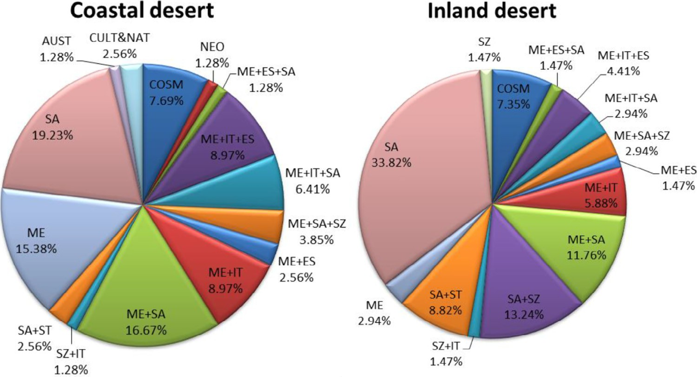

### Fig. 3 – Chorotype spectrum diagram of the coastal and inland desert. For chorotype abbreviations, see Appendex.

**176** egyptian journal of basic and applied sciences 3 (2016) 1 7 2–186

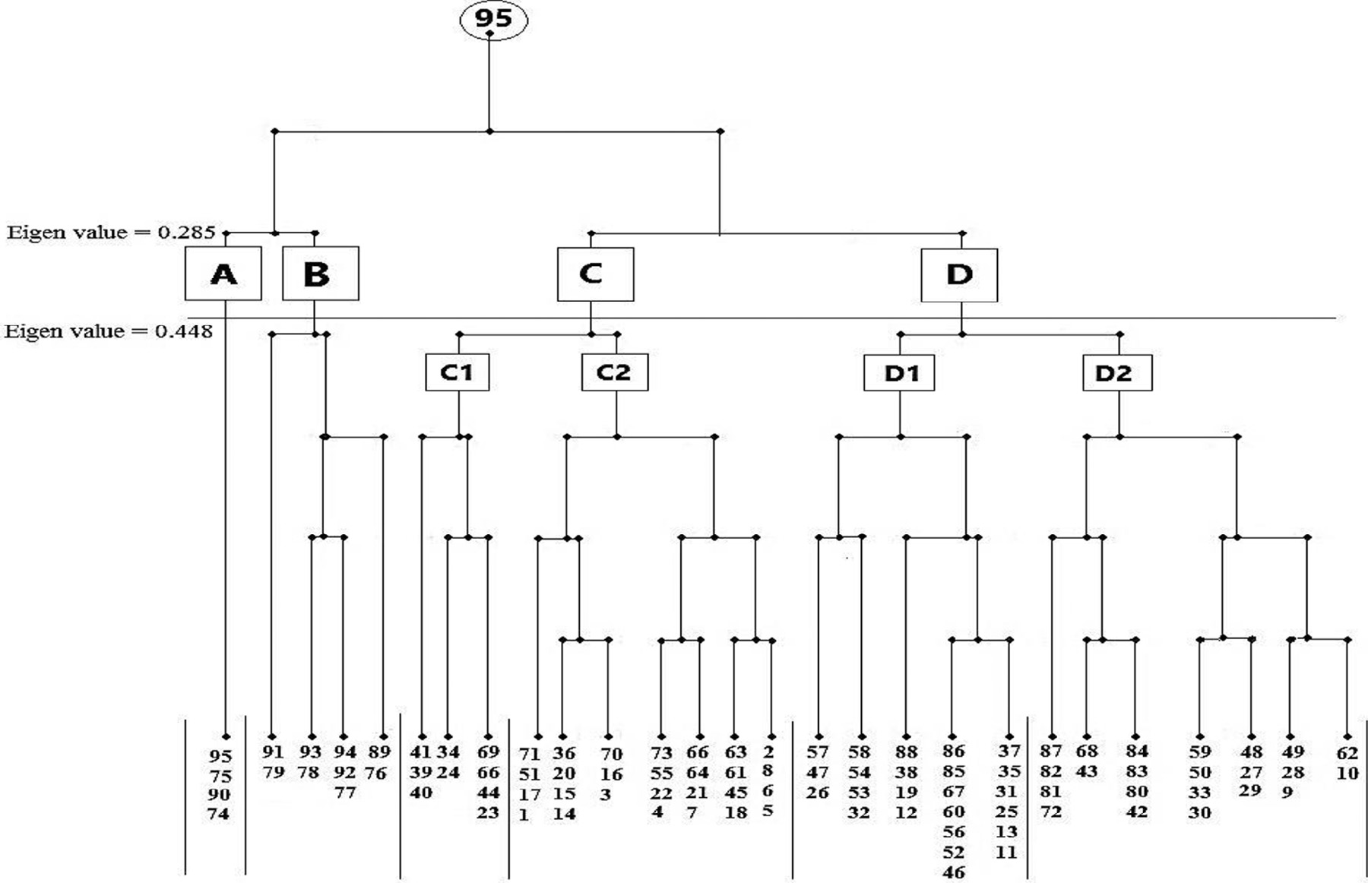

### Fig. 4 – Dendrogram showing cluster analysis of the studied 95 stands, with the 6 vegetation groups (A-D2) separated.

corded flora. The chorological analysis of the present study showed that the Mediterranean taxa were represented by 59 species (47.33%) of the total flora. These taxa were either Pluriregional, Bioregional or Monoregional.

## *Classification of the vegetation*

Application of TWINSPAN analysis techniques produced 4 major vegetation groups at the 2nd level of classification, and yielded six subgroups at the 3rd level. The total number of species varied from one subgroup to another (Fig. 4 and Table 2). Each of the identified vegetation group was named after the dominant species (i.e., highest importance value). Each is linked to one or more of the studied geophyte plants. Notably, two of the re- corded species were determined to have a wide ecological range of distribution and occurred in all the identified vegetation groups: *Erodium lacinatum* and *Hordium murinum*.

Group A is dominated by *O. baccatus* (4 sites and 33 species); the four sites in this group were sampled only from the north- ern part of the Eastern Desert (Cairo-Suez road and Wadi Hagul) and was the least diversified (33 species) among the recog-

nized groups with average species richness of 0.87 ± 0.32 species/ sample and Shannon–Wiener diversity index of 2.87 ± 0.65. This

group is linked to *L. scindicus* and *P. turgidum*. Among the common associates, *Z. spinosa, Lavandula coronopifolia, Cynodon dactylon, Z. coccineum, L. nudicaulis* occurred. *Tamarix aphylla* is the only tree found, while *Centaurea aegyptiaca* and *Launaea capitata* were the only biennial species in this group (Table 2). Group A has the lowest share of annuals, with only *Trigonella stellata, H. murinum, Volutaria lippii* and *Zygophyllum simplex* re- corded. Stands of this group were found on soil rich in fine sand

and clay, CaCO3, HCO3 and lowest sand, electrical conductiv- ity, chloride and cations (Table 3).

Vegetation group B consisted of 47 species (9 sites) that were codominated by *P. turgidum* and *Z. spinosa* representing the two

locations in the Wadi Hagul and Deltaic Mediterranean coastal strip with average species richness of 0.82 ± 0.24 species/

sample and Shannon–Wiener diversity index of 3.18 ± 0.55.

*P. turgidum* (P = 13.68%) and *L. scindicus* (P = 7.37%) are linked to this group. Common desert perennials are *Z. coccineum, Deverra*

*tortuosus, Launaea spinosa, Retama raetam, Zygophyllum decumbens*, *Cleome droserifolia* and *L. nudicaulis*. Apart from *Tamarix nilotica*, the only tree found, *C. aegyptiaca* is the only biennial species in this group (Table 2). The associated annual species,

*E. lacinatum, H. murinum, Reichardia tingitana, Senecio glaucus,*

*T. stellata* and *V. lippii*, have been recorded in this group. The

sites were characterized by high percentages of HCO3, CaCO3, electric conductivity, and moderate contents of Cl−, SO42− and cations (Table 3).

Group C1 is codominated by *Limonium pruinosum* and *Halocnemum strobilaceum* (44 species) inhabiting 9 sites studied in the Deltaic Mediterranean coastal strip; it is linked to

*C. capitatus* and *E. farctus* with average species richness of

0.96 ± 0.35 species/sample and Shannon–Wiener diversity index of 3.52 ± 0.34. Besides these dominant species, *T. nilotica, Calligonum comosum, Zygophllum album, Sporobolus spicatus* and *Salsola kali* were present. Twenty-eight annual species, includ- ing *E. lacinatum, H. murinum*, *Cakile maritima, Ifloga spicata, Poa annua* and *Rumex pictus*, were recorded in this group (Table 2). The stands were found to have the highest levels of fine sand and clay, electric conductivity, Cl−, SO 2− and cations as well as

4

moderate contents of HCO3, CaCO3 (Table 3).

egyptian journal of basic and applied sciences 3 (2016) 1 7 2–186

**177**

|  |  |  |  |  |  |  |  |  |  |  |  |  |
| --- | --- | --- | --- | --- | --- | --- | --- | --- | --- | --- | --- | --- |
| **Table 2 – Species composition of the obtained 6 vegetation groups in 95 sites in the two phytogeographical regions. Species in bold are the geophyte plants.** | | | | | | | | | | | | |
| Vegetation groups  Size of groups |  | A  4 |  | B  9 |  | C1  9 |  | C2  27 |  | D1  24 |  | D2  22 |
| Total number of species |  | 33 |  | 47 |  | 44 |  | 57 |  | 61 |  | 50 |
| Species present in 6 groups  *Erodium laciniatum* (Cav.) Wild. |  | 1.82 |  | 4.34 |  | 10.88 |  | 6.89 |  | 8.27 |  | 8.49 |
| *Hordium murinum* L. |  | 10.82 |  | 9.20 |  | 8.70 |  | 2.81 |  | 0.71 |  | 1.55 |
| Species present in 5 groups | | | | | | | | | | | | |
| *Atractylis carduus* (Forssk.) C.Chr | 0.66 | | – | | 2.18 | | 1.41 | | 0.72 | | 3.44 | |
| *Cakile maritima* Scop. | – | | 0.93 | | 1.41 | | 3.08 | | 3.36 | | 4.81 | |
| *Echinops spinosus* L. | 1.10 | | 4.75 | | – | | 7.86 | | 20.40 | | 16.65 | |
| *Ifloga spicata* (Forssk.) Sch. Bip. | – | | 12.26 | | 8.68 | | 16.76 | | 6.04 | | 6.03 | |
| *Poa annua* L. | – | | 2.89 | | 2.23 | | 1.03 | | 2.76 | | 0.74 | |
| *Reichardia tingitana* (L.) Roth | – | | 5.43 | | 0.54 | | 2.78 | | 5.06 | | 0.33 | |
| *Rumex pictus* Forssk. | – | | 1.34 | | 8.77 | | 16.28 | | 14.91 | | 12.78 | |
| *Salsola kali* L. | – | | 0.58 | | 1.04 | | 0.91 | | 1.01 | | 1.13 | |
| *Senecio glaucus* L. | – | | 2.09 | | 10.35 | | 12.01 | | 10.19 | | 13.75 | |
| *Mesembryanthemum nodiflorum* L. | – | | 1.68 | | 1.75 | | 0.31 | | 1.17 | | 0.08 | |
| *Mesembryanthemum crystallinum* L. | – | | 1.28 | | 4.13 | | 0.46 | | 2.74 | | 0.18 | |
| *Tamarix nilotica* (Ehrenb.) Bunge Species present in 4 groups  *Aegilops kotschyi* Boiss. | –  – | | 2.51  – | | 6.87  7.27 | | 2.27  1.64 | | 6.14  3.81 | | 5.64  0.50 | |
| *Bassia indica* (Wight) Scott. | – | | 1.26 | | – | | 0.71 | | 0.20 | | 1.89 | |
| *Bromus diandrus* Roth | – | | – | | 5.41 | | 2.35 | | 3.04 | | 1.61 | |
| *Carthamus tenuis* (Boiss & Blanche) Bornm. | – | | – | | 0.92 | | 0.84 | | 1.11 | | 1.30 | |
| *Cutandia memphitica* (Spreng.) Benth. | – | | – | | 2.72 | | 8.06 | | 1.37 | | 4.41 | |
| *Calligonum polygonoides* L. subsp. comosum (L’ Her.) Soskov | – | | – | | 9.51 | | 21.60 | | 3.06 | | 17.44 | |
| ***Cyperus capitatus* Vand.** | – | | – | | 13.65 | | 0.95 | | 13.49 | | 7.96 | |
| *Daucus litoralis* Sm. | – | | – | | 2.69 | | 7.53 | | 1.15 | | 0.58 | |
| ***Elymus farctus* (Viv.) Runem. ex Melderis** | – | | – | | 5.45 | | 20.02 | | 11.40 | | 3.11 | |
| *Launaea mucronata* (Forssk.) Muschl. | – | | – | | 0.58 | | 3.30 | | 5.20 | | 6.69 | |
| *Pancratium maritimum* L. | – | | – | | 2.33 | | 1.55 | | 0.97 | | 1.26 | |
| *Lotus halophilus* Boiss. | – | | – | | 5.48 | | 7.46 | | 0.12 | | 4.58 | |
| *Zygophllum album* L. | – | | – | | 5.49 | | 7.73 | | 1.42 | |  | |
| *Zygophyllum aegyptium* Hosny | – | | – | | 2.28 | | 0.97 | | 0.11 | | 6.25 | |
| *Phragmites australis* (Cav.) Trin. ex Steud. | – | | – | | 4.67 | | 0.40 | | 1.46 | | 0.32 | |
| Species present in 3 groups |  |  |  |  |  |  |  |  |  |  |  |  |
| *Aegilops bicornis* (Forssk.) Jaub. & Spach | – | | – | | 4.89 | | 0.75 | | 8.99 | | – | |
| *Alhagi graecorum* Boiss. | – | | – | |  | | 0.49 | | 9.60 | | 1.40 | |
| *Anchusa humilis* (Desf.) I.M. Johnst. | – | | – | | 0.80 | | 1.35 | | 0.71 | | – | |
| *Brassica tournefortii* Gouan. | – | | – | | 4.18 | | 0.84 | | 1.78 | | – | |
| *Chenopodium murale* L. | – | | – | |  | | 0.26 | | 0.15 | | 0.24 | |
| *Halocnemum strobilaceum* (Pall.) M. Bieb. | – | | – | | 16.52 | | 0.55 | | – | | 7.45 | |
| *Cyondon dactylon* (L.) Pers. | 15.65 | | – | | – | | – | | 10.66 | | 2.15 | |
| *Ononis serrata* Forssk. | – | | – | | – | | 0.65 | | 2.37 | | 2.44 | |
| *Silene succulenta* Forssk. | – | | – | | – | | 0.11 | | 1.32 | | 8.12 | |
| *Silene vivianii* Steud. | – | | – | | – | | 2.35 | | 0.36 | | 1.76 | |
| ***Panicum turgidum* Forssk.** | 1.65 | | 23.88 | | – | | 3.15 | | – | | – | |
| *Paronychia arabica* (L.) DC. | – | | – | | – | | 3.20 | | 0.08 | | 0.15 | |
| *Stipagrostis lanata* (Forssk) De Winter | – | | – | | – | | 8.03 | | 8.61 | | 6.34 | |
| *Zygophyllum coccineum* L. | 12.56 | | 7.35 | | 5.05 | | – | | – | | – | |
| *Retama raetam* (Forssk.)Webb & Berthel. | – | | 5.71 | | – | | – | | 2.24 | | 0.37 | |
| Species present in 2 groups |  |  |  |  |  |  |  |  |  |  |  |  |
| *Artemisia judiaca* L. | 3.12 | | 3.73 | | – | | – | | – | | – | |
| *Astragalus fruticosus* Forssk. | – | | – | | – | | – | | 0.28 | | 1.58 | |
| *Astragalus peregrinus* Vahl | – | | – | | 0.61 | |  | | 0.70 | | – | |
| *Atriplex semibaccata* R.Br. | – | | – | | – | | 0.49 | | 0.25 | | – | |
| *Bassia muricata* (L.) Asch. | – | | – | | – | | – | | 0.24 | | 0.60 | |
| *Carduus getulus* Pomel. | – | | – | | – | | 2.03 | | 4.12 | | – | |
| *Carduus pycnocephalus* L. | – | | – | | – | | 0.26 | | 1.03 | | – | |
| *Centaurea aegyptiaca* L. | 11.46 | | 4.69 | | – | | – | | – | | – | |
| *Cistanche phelypaea* (L.) Cout. | – | | – | | – | | 0.13 | | 0.44 | | – | |
| *Cressa cretica* L. | – | | – | | – | | – | | 0.24 | | 0.20 | |
| *Deverra tortuosa* (Desf.) DC. | 2.69 | | 8.70 | | – | | – | | – | | – | |
| *Diplotaxis harra* (Forssk.) Boiss. | 5.05 | | – | | – | | – | | – | | – | |

(*continued on next page*)

**178** egyptian journal of basic and applied sciences 3 (2016) 1 7 2–186

|  |  |  |  |  |  |  |
| --- | --- | --- | --- | --- | --- | --- |
| **Table 2 –** (*continued*) | | | | | | |
| Vegetation groups Size of groups  Total number of species | A 4  33 | B 9  47 | C1 9  44 | C2 27  57 | D1 24  61 | D2 22  50 |
| *Echium angustifolium* Mill. | – | – | 1.08 | 0.36 | – | – |
| *Emex spinosa* (L.) Campd. | – | – | – | – | 0.47 | 0.30 |
| *Euphorbia retusa* Forssk. | 3.24 | 1.16 | – | – | – | – |
| *Farsetia aegyptia* Turra. | 1.77 | 3.27 | – | – | – | – |
| *Francoeuria crispa* (Forssk.) Cass. | 3.70 | 3.85 | – | – | – | – |
| *Gypsophila capillaris* (Forssk.) C.Chr | 2.61 | 2.05 | – | – | – | – |
| *Iphiona mucronata* (Forssk.)Asch. & Schweinf. | 3.93 | 0.90 | – | – | – | – |
| *Lactuca serriola* L. | – | – | – | 0.33 | 0.77 | – |
| ***Lasiurus scindicus* Henrard.** | 11.20 | 3.66 | – | – | – | – |
| *Launaea nudicaulis* (L.) Hook.f. | 8.30 | 7.52 | – | – | – | – |
| *Launaea spinosa* (Forssk.) Sch.Bip. ex Kuntze. | 2.40 | 8.03 | – | – | – | – |
| *Limbarda crithmoide*s (L.) Dumort. | – | – | 1.24 | 0.52 | – | – |
| *Limonium pruinosum* (L.) Chaz. | – | – | 14.82 | 4.28 | – | – |
| *Lolium perenne* L. | – | – |  |  | 3.59 | 11.14 |
| *Lotus polyphllos* E.D.Clarke | – | – | 1.17 | 1.34 | – | – |
| *Lycium shawii* Roem. & Schult. | 1.32 | 2.21 | – | – | – | – |
| *Nauplius graveolens* (Forssk.) Wilklund | 1.74 | 1.52 | – | – | – | – |
| *Parapholis incurve* (L) C.E.Hubb | – | – | 1.07 | – | 0.29 | – |
| *Phoenix dactylifera* L. | – | – | 2.92 | 1.60 | – | – |
| *Picris asplenioides* L. | – | – | 4.46 | 6.38 | – | – |
| *Plantago squarrosa* Murray | – | – | 4.38 | – | 4.00 | – |
| *Sonchus oleraceus* L. | – | – | – | 0.31 | – | 0.05 |
| *Tamarix tetragyna* Ehrenb. | – | – | 3.60 | 0.73 | – | – |
| *Trigonella stellata* Forssk. | 12.24 | 6.23 | – | – | – | – |
| *Urospermum picroides* (L.) F.W.Schmidt | – | – | – | – | 0.31 | 0.51 |
| *Volutaria lippii* (L.) DC. | 1.80 | 5.40 | – | – | – | – |
| *Zilla spinosa* (L.) Prantl. | 5.56 | 21.15 | – | – | – | – |
| *Zygophyllum decumbens* Delile | 3.26 | 4.22 | – | – | – | – |
| *Zygophyllum simplex* L. | 7.59 | 1.54 | – | – | – | – |
| Species present in one group |  |  |  |  |  |  |
| *Alkanna lehmanii* (Tin.) A.DC. | – | 0.33 | – | – | – | – |
| *Astragalus spinosus* (Forssk.) Muschl. | – | – | – | – | 0.30 | – |
| *Cleome droserifolia* (Forssk.) Delile | – | 4.40 | – | – | – | – |
| *Cynanchum acutum* L. | – | – | – | – | 3.57 | – |
| ***Cyperus conglomeratus* Rottb.** | – | – | – | – | – | 5.86 |
| *Fagonia mollis* Delile | 2.77 | – | – | – | – | – |
| *Haloxylon salicornicum* (Moq.)Bunge ex Boiss. | – | 2.53 | – | – | – | – |
| *Heliotropium curassavicum* L. | – | – | – | – | 0.36 | – |
| *Herniaria hemistemon* J.Gay | – | 1.71 | – | – | – | – |
| *Juncus bufonius* L. | – |  | – | 0.22 | – | – |
| *Kickxia aegyptiaca* (L.)Nα´ belek. | – | 1.06 | – | – | – | – |
| *Launaea capitata* (Spreng) Dandy | 2.75 | – | – | – | – | – |
| *Lavandula coronopifolia* Poir. | 5.83 | – | – | – | – | – |
| *Lobularia arabica* (Boiss.) Muschl. | – | – | – | – | 0.27 | – |
| *Lotus creticus* L. | – | – | – | – | 0.25 | – |
| *Lotus glinoides* Delile | – | 2.02 | – | – | – | – |
| *Matthiola longipetala* (Vent.) DC. | – | 1.52 | – | – | – | – |
| *Moltkiopsis ciliata* (Forssk.) I. M. Johnst. | – | – | – | – | – | 7.94 |
| *Ochradenus baccatus* Delile | 44.76 | – | – | – | – | – |
| *Orobanche crenata* Forssk. | – | 1.26 | – | – | – |  |
| *Phalaris minor* Retz. | – | – | – | – | – | 0.39 |
| *Pulicaria undulata* (L.) C.A.Mey. | 3.73 | – | – | – | – | – |
| *Reseda decursiva* Forssk. | – | 0.72 | – | – | – | – |
| *Ricinus communis* L. | – |  | – | – | – | 1.71 |
| *Rumex vesicarius* L. | – | 0.41 | – | – | – | – |
| *Sisymbrium irio* L. | – | – | – | 0.30 | – | – |
| *Spergularia marina* (L.) Griseb. | – | – | 2.01 | – | – | – |
| *Spergularia rubra* (L.) J. & C.Presl. | – | 0.58 | – | – | – | – |
| *Sphenopus divaricatus* (Gouan) Rchb. | – | – | – | – | 0.26 | – |
| *Sporobolus spicatus* (Vahl) Kunth | – | – | 6.01 | – | – | – |
| *Stipagrostis scoparia* (Trin. & Rupr.) De Winter | – | – | – | – | – | 2.83 |
| *Suaeda monoica* Forssk. | – | 0.55 | – | – | – | – |
| *Tamarix aphylla* (L.) H. Karst. | 1.00 | – | – | – | – | – |
| *Trichodesma africanum* (L.) R.Br. | 1.95 | – | – | – | – | – |

egyptian journal of basic and applied sciences 3 (2016) 1 7 2–186

**179**

|  |  |  |  |  |  |  |  |  |  |
| --- | --- | --- | --- | --- | --- | --- | --- | --- | --- |
| **Table 3 – Mean values, standard error (±SE) and ANOVA values of the soil variables in the vegetation groups (A-D2) of the study area. EC = Electrical conductivity, OC = Organic carbon, ns = not significant at P < 0.05. *: Values are significant at**  **P < 0.05, **: Values are significant at P < 0.01, ***: Values are significant at P < 0.001.** | | | | | | | | | |
| Soil | variables | Mean | A | B | TWINSPAN vegetation groups  C1 C2 D1 | | | D2 | F-ratio |
| pH | | 8.11 ± 0.19 | 8.45 ± 0.20 | 7.95 ± 0.10 | 8.35 ± 0.26 | 7.96 ± 0.07 | 7.96 ± 0.11 | 7.99 ± 0.11 | 1.0ns |
| EC mS.cm−1 | | 1.39 ± 0.20 | 0.28 ± 0.07 | 0.71 ± 0.20 | 1.83 ± 0.35 | 0.66 ± 0.12 | 0.81 ± 0.12 | 0.70 ± 0.15 | 1.87** |
| Sand % | | 74.05 ± 1.25 | 72.03 ± 4.12 | 92.08 ± 1.54 | 90.48 ± 0.58 | 91.90 ± 0.36 | 91.80 ± 0.45 | 92.17 ± 0.45 | 0.22ns |
| Silt | | 10.10 ± 1.46 | 7.75 ± 4.08 | 4.60 ± 1.36 | 5.20 ± 0.56 | 4.69 ± 0.30 | 4.73 ± 0.42 | 4.29 ± 0.37 | 0.15ns |
| Clay | | 3.66 ± 0.22 | 4.27 ± 0.16 | 3.37 ± 0.22 | 4.31 ± 0.61 | 3.41 ± 0.17 | 3.47 ± 0.14 | 3.54 ± 0.14 | 0.59ns |
| WHC | | 28.80 ± 2.25 | 31.03 ± 2.52 | 31.33 ± 1.18 | 34.54 ± 2.23 | 33.63 ± 0.96 | 42.87 ± 7.74 | 33.30 ± 1.04 | 1.87ns |
| CaCO3 | | 5.42 ± 0.91 | 6.42 ± 2.62 | 5.24 ± 1.00 | 3.88 ± 0.50 | 3.55 ± 0.15 | 4.97 ± 1.00 | 4.00 ± 0.44 | 0.63* |
| OC | | 0.46 ± 0.10 | 0.33 ± 0.07 | 0.30 ± 0.03 | 0.66 ± 0.10 | 0.48 ± 0.02 | 0.46 ± 0.03 | 0.52 ± 0.05 | 3.31* |
| Cl− | | 1.32 ± 0.23 | 0.81 ± 0.57 | 0.53 ± 0.21 | 1.80 ± 0.19 | 1.71 ± 0.10 | 1.59 ± 0.15 | 1.46 ± 0.16 | 2.33** |
| SO42− | | 0.91 ± 0.14 | 0.55 ± 0.39 | 0.32 ± 0.09 | 1.23 ± 0.13 | 1.17 ± 0.07 | 1.14 ± 0.09 | 1.06 ± 0.10 | 2.27* |
| HCO3− | | 0.26 ± 0.09 | 0.30 ± 0.18 | 0.38 ± 0.12 | 0.19 ± 0.06 | 0.08 ± 0.01 | 0.25 ± 0.08 | 0.37 ± 0.12 | 0.71** |
| Na+ | mg/100g dry soil | 92.66 ± 23.92 | 30.66 ± 4.28 | 59.62 ± 14.06 | 187.05 ± 66.37 | 61.76 ± 9.05 | 111.36 ± 21.42 | 105.50 ± 28.32 | 2.14*** |
| K+ | | 12.99 ± 3.31 | 4.52 ± 0.50 | 8.88 ± 1.88 | 26.30 ± 10.32 | 7.93 ± 1.09 | 16.36 ± 2.78 | 13.96 ± 3.27 | 1.64** |
| Ca2+ | | 24.01 ± 6.92 | 6.36 ± 1.35 | 14.31 ± 3.95 | 47.41 ± 17.44 | 14.32 ± 2.29 | 33.34 ± 8.29 | 28.30 ± 8.20 | 1.60** |
| Mg2+ | | 10.22 ± 2.42 | 3.94 ± 0.63 | 6.68 ± 1.39 | 17.19 ± 4.79 | 6.77 ± 0.90 | 13.99 ± 3.44 | 12.73 ± 3.39 | 1.63** |
| Species richness | | 1.02 ± 0. | 0.87 ± 0.32 | 0.82 ± 0.24 | 0.96 ± 0.35 | 1.17 ± 0.74 | 1.42 ± 0.52 | 0.89 ± 0.34 | 3.03* |
| Shannon–Wiener index | | 3.19 ± | 2.87 ± 0.65 | 3.18 ± 0.55 | 3.52 ± 0.34 | 3.87 ± 0.22 | 3.20 ± 0.61 | 3.23 ± 0.33 | 0.84ns |

Group C2 is codominated by *C. comosum* and *E. farctus* (57 species) inhabiting 27 sites in the Deltaic Mediterranean coast that are revealed to have the moderate values of many mea- sured soil variables, excluding electric conductivity, chloride and sulphates (Table 3). This group is linked to *C. capitatus* and

*E. farctus* with average species richness of 1.17 ± 0.74 species/ sample and Shannon–Wiener diversity index of 3.87 ± 0.22.

Other associated perennial species include *A. carduus, E. spinosus,*

*L. pruinosum* and *S. lanata* (Table 2). Thirty-seven annual species that were recorded in this group with remarkable presence in- cluded *Carduus getulus*, *I. spicata, R. pictus, Picris asplenioides* and

*P. annua*.

Floristic group D1 consisted of 61 species that were domi- nated by *E. spinosus* representing the costal desert vegetation and was the most diversified (61 species) among the recog- nized groups with average species richness of 1.42 ± 0.52 species/ sample and Shannon–Wiener diversity index of 3.20 ± 0.61. This group is linked to *C. capitatus* and *E. farctus*. Other common as- sociates imcluded *Cynanchum acutum, S. kali, S. lanata, T. nilotica,*

*Z. album* and *Z. aegyptium* (Table 2)*.* Group D1 has the highest share of annuals (46 species), which included *C. maritima,*

*I. spicata, Mesembryanthemum nodiflorum, M. crystallinum, Aegilops kotschyi*, etc. Most of the examined soil variables (sand, clay,

Na+, K+, Ca2+, Mg2+, Cl− and SO42−) attained their highest levels in the stands of this group (Table 3).

Group D2 is codominated by *C. comosum* and *E. spinosus* (50 species) inhabiting 22 sites in the Deltaic Mediterranean coast that are revealed to have the highest values of many mea- sured soil variables (sand, EC, Cl−, SO 2−, CaCO , Na+ and Ca2+) (Table 3). This group is linked to *C. capitatus*, *E. farctus* and

4 3

*C. conglomeratus* with average species richness of 0.89 ± 0.34 species/sample and Shannon–Wiener diversity index of

3.23 ± 0.33. Other associated perennial species included

*Moltikopsis cillata, T. nilotica, L. mucronata, Zygophyllum aegyptium,*

*H. strobilaceum, S. lanata* and *S. succulent* (Table 2). Thirty annual species were recorded in this group that included the

remarkable presence of *Erodium laciniatum, C. maritima, I. spicata,*

*R. pictus, S. glaucus, Lolium perenne,* etc.

## *Ordination of sampling sites*

The application of DCA on 95 stands along axes 1 and 2 (ei- genvalues 0.618 and 0.303, respectively) indicated that the vegetation groups produced by the classification technique of the studied sites were generally interconnected, where the six vegetation groups were obtained (Fig. 5). Stands of groups A and B were segregated at lower side, which was clearly sepa- rated along the two axes of DCA. Groups C1 and C2 were separated at most upper left side. On the other hand, stands of group D1 separated at right side and group D2 demon- strated an intermediate position.

## *Soil–vegetation relationships*

The relationship between the vegetation and soil variables was studied using Canonical Correspondence Analysis (CCA). Fig. 6 shows the CCA ordination biplot with vegetation groups (A- D2) and the examined soil variables. It is clear that the electrical conductivity, silt, organic carbon, sulphates, chlorides and bi- carbonates were the most effective soil variables that have high significant correlations with the first and second axes.

In the upper right side of the CCA diagram, *O. baccatus*, which was dominant species in group A, codominated species (*P. turgidum* and *Z. spinosa*) in group B and common species (*Z. spinosa, L. coronopifolia, Z. coccineum, L. nudicaulis* and *D. tortuosus*) in group A and B collectively showed close rela- tionships with carbonate, bicarbonate, calcium carbonate and soil fractions (clay and silt). In the upper left side of the diagram,

*L. pruinosum* and *H. strobilaceum*, which were codominant species in group C1, *Calligonium polygnoides*, which was codominant species in group C2 and common species (*A. carduus* and *T. nilotica*) in groups C1, C2 and D1 showed a close relation-

**180** egyptian journal of basic and applied sciences 3 (2016) 1 7 2–186

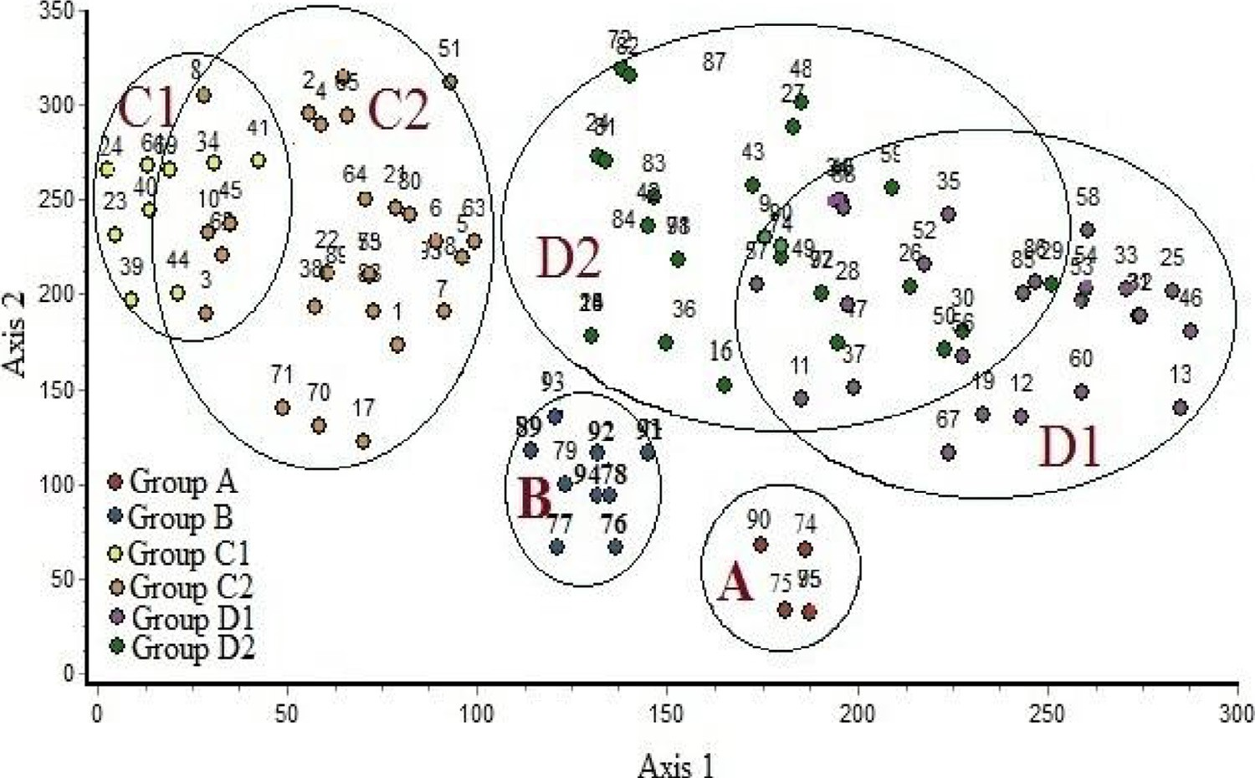

### Fig. 5 – DCA ordination diagram of the 95 sites on axes 1 and 2 within vegetation groups (A-D2).

ships with electrical conductivity, organic carbon and sulphates*.* On the other hand, in the lower left side, *E. spinosus*, which was dominant species in group D1 and codominant in group D2,

*E. farctus*, which was codominant species in group C2 and common species (*S. lanata* and *S. succulent*) in groups C2, D1 and D2 collectively showed close relationships with sulphates, chlo- ride and cations.

The simple linear correlation coefficient between some soil

variables and studied geophytes indicated that *C. capitatus* was positively significant (r = 0.240, 0.298, 0.280, 0.334 and 0.336) with CaCO3, Na+, K+, Ca2+ and Mg2+, respectively (Table 4).

*C. conglomeratus* had positively significant (r = 0.386), while

*E. farctus* had negatively significant correlation with HCO3. In contrast, *L. scindicus* had a negatively significant correlation with Cl− and SO 2− (r = −0.223 and r = −0.301, respectively). *P. turgidum* was negatively significant with organic carbon (r = −0.300), Cl− (r = −364) and SO 2− (r = −0.418).

# Discussion

Geophytes are a kind of plant having the capability to survive arid environmental conditions and part of their annual life cycle

4

4

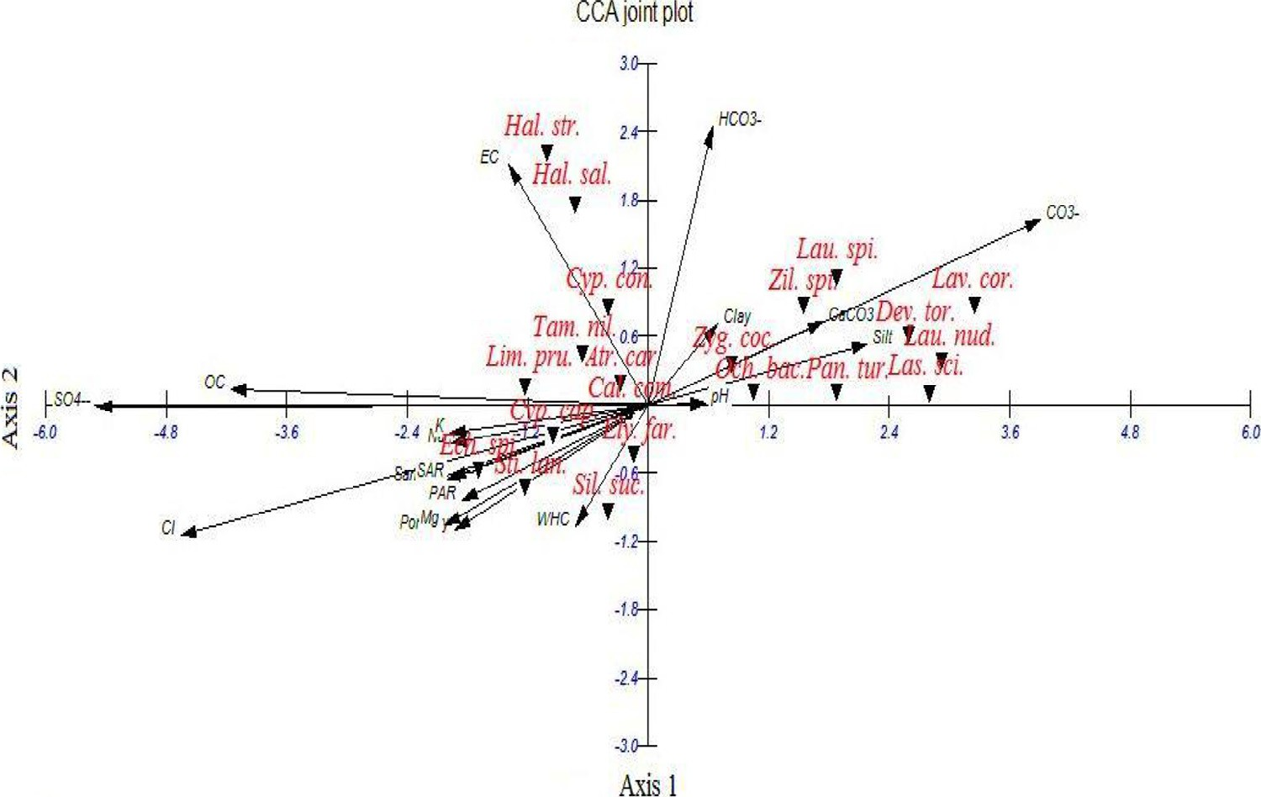

### Fig. 6 – CCA ordination diagram of the first two axes showing the distribution of the plant species with soil variables in the study area.

egyptian journal of basic and applied sciences 3 (2016) 1 7 2–186

**181**

as a dormant fleshy underground structure. The present field study indicated that geophytes were recorded along the Medi- terranean coast on sandy habitats (coastal dunes and sand flats). This agrees with Maswada and Elzaawely [39], who reported that the most distributed geophytes (*C. capitatus, C. conglomeratus, E. farctus*, *Pancratium maritimum, Sporobolus pungens* and *S. lanata*) were recorded in the Deltaic Mediterranean coast in stabi- lized, partially stabilized dunes and sand flats. Zahran and Willis [9] reported that *L. scindicus* and *P. turgidum* are found in the inland part of the Eastern Desert within the channel of wadis.

**Table 4 – Simple linear correlation coefficients between studied geophytes and soil variable**. **EC = Electrical conductivity, OC = Organic carbon. *: Values are significant at P < 0.05, **: Values are significant at P < 0.01.**

Na+

0.298*\*\**

−0.103

−0.129

−0.1

−0.135

K+

0.280*\*\**

−0.102

−0.144

−0.097

−0.133

Ca2+

0.334*\*\**

−0.1

−0.147

−0.097

−0.133

Mg2+

0.336*\*\**

−0.095

−0.152

−0.106

−0.133

The floristic diversity of the study area included 119 species, through 95 sites in two localities, representing 97 genera and 28 families. More than 60% (76 species) of the recorded species belong to 6 families; these are the species-rich families: Asteraceae, Poaceae, Fabaceae, Brassicaceae, Chenopodiaceae and Caryophyllaceae. These families represent the most common in the Mediterranean North African flora [40,41]. In the present study, Asteraceae is the largest family and also the most widespread of the flowering plants in the world [40,42], but is not the only largest family in the Flora of Egypt [20,43,44]. The largest genera arranged in the following sequence:

Cl−

0.048

0.021

0.131

−0.223*\**

−0.364*\*\**

SO4−

0.114

0.062

0.119

−0.301*\*\**

−0.418*\*\**

HCO3

0.161

0.386*\*\**

−0.219*\**

0.035

0.033

Asteraceae > Poaceae > Brassicaceae > Chenopodiaceae >

Boraginaceae > Fabaceae. These findings were in line with those of El-Amier et al. [45] in the Eastern Desert, Abd El-Ghani and

Edaphic factors

EC

0.144

−0.016

−0.069

−0.047

−0.068

Amer [46] in south Sinai, and Salama et al. [47] along the western Mediterranean coast.

Comparing the results of floristic diversity in coastal desert (80 species; 38 perennials, 1 biennial and 41 annuals) with that in the inland desert (66 species; 40 perennials, 2 biennials and 24 annuals) in the present study is more or less similar due to time of field trip in March to May. On the other hand, decreased numbers of annuals in the northern part of the Eastern Desert can be attributed to the environ- mental aridity which plays an important role in reducing floral diversity [48].

CaCO3

0.240*\**

−0.081

−0.168

0.006

0.083

OC

−0.009

0.000

−0.035

−0.177

−0.300*\*\**

pH

0.087

−0.031

−0.065

−0.026

−0.038

The dominant perennial species provide the permanent character of the plant cover in each habitat. This may be cred- ited to the rather short rainfall, which is not adequate for the appearance of many annuals. On the other hand, the rainy season provides a better opportunity for the appearance of a considerable number of annuals [49–53].

Porosity

0.072

−0.13

−0.014

−0.061

−0.124

WHC

0.093

−0.052

−0.042

−0.068

−0.057

Since the early 1960s, vast areas in the Egyptian deserts (Western, Eastern and Sinai) were subjected to land reclama- tion due to population growth and increased congestion in the old lands in the Nile Valley and the Delta. Not surprisingly, 61% of the priority reclaimable land through the Nile waters is located on the borders of the Valley and Delta regions where soil is loamy in nature and cultivation can be relatively suc- cessful [43,54]. In the study area, urban and agricultural processes were practiced in the deltaic parts. The land recla- mation processes entail an almost complete change in the environmental factors. Therefore, the reclaimed areas of this study can be considered as transitional areas of the succes- sion process between the old cultivated lands and that of the desert [43,55].

Sand

0.019

0.087

0.046

0.081

−0.009

Silt

0.001

−0.11

−0.033

−0.115

0.054

Clay

−0.062

0.041

−0.052

0.071

−0.126

*Cyperus capitatus Cyperus conglomeratus Elymus farctus Lasiurus scindicus Panicum turgidum*

In this study, the dominance of therophytes (44.72%), chamaephytes (21.14%) and hemicryptophytes (13.82%) over other life forms seems to be a response to the hot dry climate, topographical variations as well as human and animal inter-

Species

**182** egyptian journal of basic and applied sciences 3 (2016) 1 7 2–186

ferences [47,56]. Therophytes are adapted to the dryness of the region and shortage of rainfall, because they spend their veg- etative period in the form of seed [57,58]. These results are congruent with the spectra of vegetation in the desert habi- tats in other parts of the Middle East [59–61].

Egypt is the meeting point of floristic elements belonging to at least four phytogeographical regions: the African Sudano- Zambesian, the Asiatic Irano-Turanian, the Afro-Asiatic Sahro- Sindian and the Euro-Afro-Asiatic Mediterranean [62]. The whole country lies within the Saharo-Arabian belt of the Holarctic floristic realm [63]. The chorological analysis of the present study indicated the abundance of the Saharo- Arabian chorotype (63.02% of the total recorded flora) and Mediterranean taxa (47.33% of the total recorded species) within the major growth forms. This may be attributed to the fact that plants of the Saharo-Arabian species are good indicators for harsh desert environmental conditions, while Mediterranean species signal to a more mesic environment [58,63,64]. The high percentages of Saharo-Sindian and Medi- terranean elements in the study area may be attributed to their capability to penetrate this region and to the influence of man in the study area.

The classification and ordination analyses revealed that the vegetation of the study area can be divided into six major veg- etation groups (plant communities). Each is linked to one or more of the studied geophyte plants. It can be noted that certain vegetation groups characterized one or more of the studied lo- calities: group (A) in northern part of the Eastern Desert (Cairo- Suez road and Wadi Hagul), group (B) was distributed in Wadi Hagul and Deltaic Mediterranean coastal strip, and groups (C1), (C2), (D1) and (D2) were restricted in the Deltaic Mediterra- nean coastal strip.

Group A was the least diversified (33 species) among the recognized groups. This group is linked to *L. scindicus* and

*P**. turgidum*. Zahran and Willis [9] reported that *L. scindicus* and

*P. turgidum* are found in the channel wadis of Cairo-Suez desert road associated with *Anabasis articulata, Hammada elegans*, *Pituranthos tortuosus* and *D. harra*. This group is consistent with studies indicating that the vegetation of Eastern Desert is domi- nated by many herbs, shrubs and some trees and, therefore, has high species richness and plant cover [45,63,65]. On the other hand, vegetation group B is less distinct because it is char- acterized by mixed communities of Wadi Hagul and Deltaic Mediterranean coastal strip. In Egyptian desert, Salama et al. [66], Salama et al. [67], El-Amier et al. [68], Abd El-Ghani et al.

[69] and El-Amier and Abdulkader [59] recognized several plant associations, some of which are comparable to those of the present study.

The most diverse groups (C1, C2, D1 and D2) have things in common, such as inhabiting the Deltaic Mediterranean coast and being characterized by some halophytes (*L. pruinosum*, *H. strobilaceum, Stipagrostis scoparia, T. nilotica,* and *Z. album*) and psammophytes (*C. comosum*, *C. capitatus*, *C. conglomeratus, E. farctus*, *R. pictus* and *S. spicatus*), which could be related to higher concentration of salinity and soil mineral contents, perhaps due to animal grazing, rainfall, and floods [70]. Similar conclusions were made by other authors [68,71–74]. It can be noted that the salt-tolerant plant *T. nilotica* characterized veg- etation groups inhabiting the Deltaic Mediterranean coastal strip*. Tamarix* has been identified as a major cause of salt ac- cumulation on the soil surface [75].

Vegetationally, *C. capitatus* and *E. farctus* are codominant or indicator species in the study area whereas *C. conglomeratus* is not. This may be due to *C. capitatus* and *E. farctus* being Medi- terranean taxa, while *C. conglomeratus* is of Saharo-Sindian taxon.

The application of DCA on sampled stands indicated that groups A and B were clearly separated along the two axes of DCA, which represent xerophytic vegetation associated with the studied geophytes in inland desert. Groups C1, C2, D1 and D2 are superimposed; this is due to the similarity between these vegetation groups, which represent psammophytic and halo- phytic vegetation in the coastal desert. Analysis of the vegetation–soil relationships using CCA indicated that the dis- tribution of vegetation associated with investigated geophytes in the study area was mainly controlled by electrical conduc- tivity, silt, organic carbon, sulphates, chlorides and bicarbonates. This agrees more or less with the findings of Shaltout et al. [73], Maswada and Elzaawely [39] in the Mediterranean region of the Nile Delta, Salama et al. [66] in the inland wadi ecosys- tem of central Eastern Desert as well as El-Amier and Abdulkader [59] in the Northern Sector of Eastern Desert.

# Conclusion

The present study provides an analysis of vegetation struc- ture and soil characteristics of five common geophytes in Desert of Egypt to help in ecological management and conservation of these natural resources. Geophytes have high diversity in the desert ecosystems and are used as raw materials for various economic ornamental plants, medicine and food. Therefore, the conservation of natural habitats of this desert is of vital importance as well as the need for judicious utilization and sustainable development.

egyptian journal of basic and applied sciences 3 (2016) 1 7 2–186

**183**

# Appendix

***Enumerated list of geophyte plants in Egypt, together with their families, growth forms, chorotypes, and habitats in the different phytogeographic regions of Egypt. Life forms: Th = Therophytes; G = Geophytes, H = Hemicryptophytes;***

***Ch = Chamaephytes; He = Helophytes; Nph = Nanophanerophytes; MMPh = Meso & Megaphanerophytes; P = Parasitic;***

***Chorotypes: ME = Mediterranean, SA = Saharo-Arabian, SZ = Sudano-Zambezian, ES = Euro-Siberian, IT = Irano-Turanian, Cult. = Cultivated.***

|  |  |  |  |  |  |  |
| --- | --- | --- | --- | --- | --- | --- |
| Family | Species | Phytogeographical regions  Coastal desert Inland desert | Duration | Life | Chorotype | P% |
| Aizoaceae | *Mesembryanthemum nodiflorum* L. | + − | Annual | Th | ME+ES+SA | 13.68 |
|  | *Mesembryanthemum crystallinum* L. | + − | Annual | Th | ME+ES | 16.84 |
| Amaryllidaceae | *Pancratium maritimum* L. | + − | Perennial | G | ME | 10.53 |
| Apiaceae | *Daucus litoralis* Sm. | + − | Annual | Th | ME | 13.68 |
|  | *Deverra tortuosa* (Desf.) DC. | − + | Perennial | Ch | SA | 7.37 |
| Arecaceae | *Phoenix dactylifera* L. | + − | Perennial | MMPh | Cult. | 3.16 |
| Asclepiadaceae | *Cynanchum acutum* L. | + + | Perennial | H | ME+IT | 4.21 |
| Asteraceae | *Artemisia judiaca* L. | − + | Perennial | Ch | SA | 3.16 |
|  | *Atractylis carduus* (Forssk.) C.Chr. | + + | Perennial | H | ME+ SA | 25.26 |
|  | *Carduus getulus* Pomel. | + − | Annual | Th | SA | 13.68 |
|  | *Carduus pycnocephalus* L. | + − | Annual | Th | SA | 4.21 |
|  | *Carthamus tenui*s (Boiss & Blanche) Bornm. | + − | Annual | Th | ME | 10.53 |
|  | *Centaurea aegyptiaca* L. | − + | Biennial | Th | SA | 11.58 |
|  | *Echinops spinosus* L. | + + | Perennial | H | ME+SA | 52.63 |
|  | *Francoeuria crispa* (Forssk.) Cass. | − + | Perennial | Ch | SA+SZ | 2.11 |
|  | *Ifloga spicata* (Forssk.) Sch.Bip. | + + | Annual | Th | SA | 53.68 |
|  | *Iphiona mucronata* (Forssk.) Asch. & Schweinf. | − + | Perennial | Ch | SA | 3.16 |
|  | *Lactuca serriola* L. | + + | Annual | Th | ME+IT+ES | 3.16 |
|  | *Launaea capitata* (Spreng) Dandy | − + | Biennial | Th | SA+ SZ | 1.05 |
|  | *Launaea mucronata* (Forssk.) Muschl. | + + | Perennial | H | ME+SA | 31.58 |
|  | *Launaea nudicaulis* (L.) Hook.f. | + + | Perennial | H | SA | 12.63 |
|  | *Launaea spinosa* (Forssk.) Sch.Bip. ex Kuntze. | − + | Perennial | Ch | SA | 6.32 |
|  | *Limbarda crithmoide*s (L.) Dumort. | + − | Perennial | Ch | ME+ES+SA | 2.11 |
|  | *Nauplius graveolens* (Forssk.) Wilklund | − + | Perennial | Ch | SA | 2.11 |
|  | *Picris asplenioides* L. | + − | Annual | Th | ME+IT | 7.37 |
|  | *Pulicaria undulata* (L.) C.A.Mey. | − + | Perennial | Ch | SA | 1.05 |
|  | *Reichardia tingitana* (L.) Roth. | + + | Annual | Th | ME+IT | 29.47 |
|  | *Senecio glaucus* L. | + + | Annual | Th | ME+IT+SA | 74.74 |
|  | *Sonchus oleraceus* L. | + − | Annual | Th. | COSM | 2.11 |
|  | *Urospermum picroides* (L.) F.W.Schmidt | + − | Annual | Th | ME+IT | 2.11 |
|  | *Volutaria lippii* (L.) DC. | + | Annual | Th | SA | 6.32 |
| Boraginaceae | *Alkanna lehmanii* (Tin.) A.DC. | − + | Perennial | H | ME | 1.05 |
|  | *Anchusa humilis* (Desf.) I.M. Johnst. | + + | Annual | Th | ME+ SA | 8.42 |
|  | *Echium angustifolium* Mill. | + − | Perennial | H | ME | 2.11 |
|  | *Heliotropium curassavicum* L. | + − | Perennial | Ch | NEO | 1.05 |
|  | *Moltkiopsis ciliata* (Forssk.) I. M. Johnst. | + − | Perennial | Ch | ME+SA+SZ | 9.47 |
|  | *Trichodesma africanum* (L.) R.Br. | − + | Perennial | H | SA+ SZ | 2.11 |
| Brassicaceae | *Brassica tournefortii* Gouan. | + + | Annual | Th | ME+IT+SA | 5.26 |
|  | *Cakile maritima* Scop. | + − | Annual | Th | ME+ES | 21.05 |
|  | *Diplotaxis harra* (Forssk.) Boiss. | − + | Perennial | Ch | ME+ SA | 3.16 |
|  | *Farsetia aegyptia* Turra. | − + | Perennial | Ch | SA+ SZ | 4.21 |
|  | *Lobularia arabica* (Boiss.) Muschl. | + − | Annual | Th | SA | 1.05 |
|  | *Matthiola longipetala* (Vent.) DC. | − + | Annual | Th | ME+IT | 2.11 |
|  | *Sisymbrium irio* L. | + − | Annual | Th | ME+IT+ES | 1.05 |
|  | *Zilla spinosa* (L.) Prantl. | − + | Perennial | Ch | SA | 8.42 |
| Caryophyllaceae | *Gypsophila capillaris* (Forssk.) C.Chr | − + | Perennial | H | SA+IT | 3.16 |
|  | *Herniaria hemistemon* J.Gay | − + | Annual | Th | ME+ SA | 3.16 |
|  | *Paronychia arabica* (L.) DC. | + − | Annual | Th | ME+SA +SZ | 9.47 |
|  | *Silene succulenta* Forssk. | + − | Perennial | H | ME | 25.26 |
|  | *Silene vivianii* Steud. | + − | Annual | Th | SA | 20.00 |
|  | *Spergularia marina* (L.) Griseb. | + − | Biennial | Th | ME+IT+ ES | 2.11 |
|  | *Spergularia rubra* (L.) J. & C.Presl. | − + | Annual | Th | ME+ES | 3.16 |
| Chenopodiaceae | *Atriplex semibaccata* R.Br. | + − | Perennial | H | AUST | 2.11 |
|  | *Bassia indica* (Wight) Scott. | + + | Annual | Th | SZ+IT | 8.42 |
|  | *Bassia muricata* (L.) Asch. | + + | Annual | Th | SA+ IT | 2.11 |
|  | *Chenopodium murale* L. | + + | Annual | Th | COSM | 3.16 |
|  | *Halocnemum strobilaceum* (Pall.) M. Bieb. | + − | Perennial | Ch | ME+IT+SA | 7.37 |

forms

(*continued on next page*)

**184** egyptian journal of basic and applied sciences 3 (2016) 1 7 2–186

|  |  |  |  |  |  |  |
| --- | --- | --- | --- | --- | --- | --- |
| Family | Species | Phytogeographical regions  Coastal desert Inland desert | Duration | Life | Chorotype | P% |
|  | *Haloxylon salicornicum* (Moq.) Bunge ex Boiss. | − + | Perennial | Ch | SA | 1.05 |
|  | *Salsola kali* L. | + − | Annual | Th | COSM | 12.63 |
|  | *Suaeda monoica* Forssk. | − + | Perennial | Ch | ME+SA | 2.11 |
| Cleomaceae | *Cleome droserifolia* (Forssk.) Delile | − + | Perennial | Ch | SA + IT | 2.11 |
| Convolvulaceae | *Cressa cretica* L. | + − | Perennial | H | ME+IT | 2.11 |
| Cyperaceae | ***Cyperus capitatus* Vand.** | + − | Perennial | G | ME | 41.05 |
|  | ***Cyperus conglomeratus* Rottb.** | + − | Perennial | G | SA+SZ | 12.63 |
| Euphorbiaceae | *Euphorbia retusa* Forssk. | − + | Perennial | H | SA | 5.26 |
|  | *Ricinus communis* L. | + − | Perennial | Nph | Cult. & Nat. | 2.11 |
| Fabaceae | *Alhagi graecorum* Boiss. | + − | Perennial | H | ME+IT | 22.11 |
|  | *Astragalus fruticosus* Forssk. | + − | Perennial | Ch | SA | 4.21 |
|  | *Astragalus peregrinus* Vahl | + − | Annual | Th | SA | 3.16 |
|  | *Astragalus spinosus* (Forssk.) Muschl. | − + | Perennial | Ch | SA + IT | 1.05 |
|  | *Lotus creticus* L. | + − | Perennial | H | Me | 1.05 |
|  | *Lotus halophilus* Boiss. | + − | Annual | Th | ME+SA | 36.84 |
|  | *Lotus polyphllos* E.D.Clarke | + − | Perennial |  | ME | 5.26 |
|  | *Lotus glinoides* Delile | − + | Annual | Th | SZ | 4.21 |
|  | *Ononis serrata* Forssk. | + − | Annual | Th | ME+SA | 15.79 |
|  | *Retama raetam* (Forssk.) Webb & Berthel. | + + | Perennial | Nph | SA | 6.32 |
|  | *Trigonella stellata* Forssk. | − + | Annual | Th | SA+IT | 7.37 |
| Geraniaceae | *Erodium laciniatum* (Cav.) Wild. | + + | Annual | Th | ME | 47.37 |
| Juncaceae | *Juncus bufonius* L. | + − | Annual | Th | ME+IT+ES | 1.05 |
| Lamiaceae | *Lavandula coronopifolia* Poir. | − + | Perennial | Ch | SA | 1.05 |
| Orobanchaceae | *Cistanche phelypaea* (L.) Cout. | + − | Perennial | P, G | ME+SA | 2.11 |
|  | *Orobanche crenata* Forssk. | − + | Annual | Th, P | ME+IT | 3.16 |
| Plantaginaceae | *Plantago squarrosa* Murray | + − | Annual | Th | ME+SA | 12.63 |
| Plumbaginaceae | *Limonium pruinosum* (L.) Chaz. | + − | Perennial | G, He | SA | 6.32 |
| Poaceae | *Aegilops bicornis* (Forssk.) Jaub. & Spach | + − | Annual | Th | ME+ SA | 14.74 |
|  | *Aegilops kotschyi* Boiss. | + − | Annual | Th | SA+ IT | 8.42 |
|  | *Bromus diandrus* Roth. | + − | Annual | Th | ME | 14.74 |
|  | *Cutandia memphitica* (Spreng.) Benth. | + − | Annual | Th | ME+IT+SA | 27.37 |
|  | *Cyondon dactylon* (L.) Pers. | + + | Perennial | G | COSM | 16.84 |
|  | ***Elymus farctus* (Viv.) Runem. ex Melderis** | + − | Perennial | G | ME | 46.32 |
|  | *Hordeum murinum* L. | + + | Annual | Th | ME+IT+ES | 23.16 |
|  | ***Lasiurus scindicus* Henrard**. | − + | Perennial | G | SA+SZ | 7.37 |
|  | *Lolium perenne* L. | + − | Perennial | Th | ER-SR+ME+IT | 14.74 |
|  | ***Panicum turgidum* Forssk.** | + + | Perennial | H | SA | 13.68 |
|  | *Parapholis incurva* (L.) C.E. Hubb. | + + | Annual | Th | ME+IT+ES | 3.16 |
|  | *Phalaris minor* Retz. | + − | Annual | Th | ME+IT | 1.05 |
|  | *Phragmites australis* (Cav.) Trin.ex Steud. | + + | Perennial | G, He | COSM | 8.42 |
|  | *Poa annua* L. | + + | Annual | Th | COSM | 11.58 |
|  | *Sphenopus divaricatus* (Gouan) Rchb. | + − | Annual | Th | ME+IT+SA | 1.05 |
|  | *Sporobolus spicatus* (Vahl) Kunth | + + | Perennial | G | ME+SA+SZ | 2.11 |
|  | *Stipagrostis lanata* (Forssk.) | + − | Perennial | G | SA | 37.89 |
|  | *Stipagrostis scoparia* (Trin. & Rupr.) De Winter | + − | Perennial | G | SA | 3.16 |
| Polygonaceae | *Calligonum polygonoides* L. | + + | Perennial | Nph | SA+ IT | 35.79 |
|  | *Emex spinosa* (L.) Campd. | + + | Annual | Th | ME+SA | 2.11 |
|  | *Rumex pictus* Forssk. | + − | Annual | Th | ME+SA | 68.42 |
|  | *Rumex vesicarius* L. | − + | Annual | Th | ME+SA+SZ | 1.05 |
| Resedaceae | *Ochradenus baccatus* Delile | − + | Perennial | Nph | SA | 4.21 |
|  | *Reseda decursiva* Forssk. | − + | Annual | Th | SA | 1.05 |
| Scrophulariaceae | *Kickxia aegyptiaca* (L.) Nα´ belek. | − + | Perennial | Ch | ME+SA | 3.16 |
| Solanaceae | *Lycium shawii* Roem. & Schult. | − + | Perennial | Nph | SA+SZ | 3.16 |
| Tamaricaceae | *Tamarix nilotica* (Ehrenb.) Bunge. | + + | Perennial | Nph | SA | 17.89 |
|  | *Tamarix tetragyna* Ehrenb. | − + | Perennial | Nph | SA+SZ | 2.11 |
|  | *Tamarix aphylla* (L.) H. Karst. | − + | Perennial | Nph | SA+SZ | 1.05 |
| Zygophyllaceae | *Fagonia mollis* Delile | − + | Perennial | Ch | SA | 2.11 |
|  | *Zygophyllum album* L. | + − | Perennial | Ch | ME+SA | 15.79 |
|  | *Zygophyllum coccineum* L. | + + | Perennial | Ch | SA | 12.63 |
|  | *Zygophyllum aegyptium* Hosny | + − | Perennial | Ch | ME | 9.47 |
|  | *Zygophyllum decumbens* Delile | − + | Perennial | Ch | SA | 5.26 |
|  | *Zygophyllum simplex* L. | − + | Annual | Th | SA | 6.32 |

**Appendix –** (*continued*)

forms

egyptian journal of basic and applied sciences 3 (2016) 1 7 2–186

**185**

R E F E R E N C E S

1. [Rundel PW. Mediterranean-climate ecosystems: defining](http://refhub.elsevier.com/S2314-808X(16)30001-X/sr0010) [their extent and community dominance. In: Arianoutsou M,](http://refhub.elsevier.com/S2314-808X(16)30001-X/sr0010) [Panastasis VP, editors. Ecology, conservation and](http://refhub.elsevier.com/S2314-808X(16)30001-X/sr0010) [management of Mediterranean climate ecosystems.](http://refhub.elsevier.com/S2314-808X(16)30001-X/sr0010) [Rotterdam, The Netherlands: Millpress; 2004. p. 1–12.](http://refhub.elsevier.com/S2314-808X(16)30001-X/sr0010)
2. [Parsons RF. Monocotyledonous geophytes: comparison of](http://refhub.elsevier.com/S2314-808X(16)30001-X/sr0015) [California with Victoria, Australia. Aust J Bot 2000;48:39–43.](http://refhub.elsevier.com/S2314-808X(16)30001-X/sr0015)
3. [Esler KJ, Rundel PW, Vorster P. Biogeography of prostrate-](http://refhub.elsevier.com/S2314-808X(16)30001-X/sr0020) [leaved geophytes in semi-arid South Africa: hypothesis on](http://refhub.elsevier.com/S2314-808X(16)30001-X/sr0020) [functionality. Plant Ecol 1999;142:105–20.](http://refhub.elsevier.com/S2314-808X(16)30001-X/sr0020)
4. [Rossa B, von Willert DJ. Physiological characteristics of](http://refhub.elsevier.com/S2314-808X(16)30001-X/sr0025) [geophytes in semi-arid Namaqualand, South Africa. Plant](http://refhub.elsevier.com/S2314-808X(16)30001-X/sr0025) [Ecol 1999;142:121–32.](http://refhub.elsevier.com/S2314-808X(16)30001-X/sr0025)
5. [Alam A, Sharma V. Text book of economic botany. Jaipur,](http://refhub.elsevier.com/S2314-808X(16)30001-X/sr0030) [India: Pointer Publishers; 2012.](http://refhub.elsevier.com/S2314-808X(16)30001-X/sr0030)
6. [Medail F, Qúezel P. Biodiversity hotspots in the](http://refhub.elsevier.com/S2314-808X(16)30001-X/sr0035) [Mediterranean Basin. Conserv Biol 1999;13:1510–13.](http://refhub.elsevier.com/S2314-808X(16)30001-X/sr0035)
7. [El-Ghonemy AA, Wallace A, Romney EM. Nutrient](http://refhub.elsevier.com/S2314-808X(16)30001-X/sr0040) [concentrations in the natural vegetation of the Mojave](http://refhub.elsevier.com/S2314-808X(16)30001-X/sr0040) [Desert. Soil Sci 1978;126:219–29.](http://refhub.elsevier.com/S2314-808X(16)30001-X/sr0040)
8. [El-Shaer HM, El-Morsy MH. Potentiality of salt marshes in](http://refhub.elsevier.com/S2314-808X(16)30001-X/sr0045) [Mediterranean coastal zone of Egypt. In: Abdelly C, Öztürk](http://refhub.elsevier.com/S2314-808X(16)30001-X/sr0045) [M, Ashraf M, Grignon C, editors. Biosaline agriculture and](http://refhub.elsevier.com/S2314-808X(16)30001-X/sr0045) [high salinity tolerance. Basel, Boston, Berlin: Birkhäuser;](http://refhub.elsevier.com/S2314-808X(16)30001-X/sr0045) [2008.](http://refhub.elsevier.com/S2314-808X(16)30001-X/sr0045)
9. [Zahran MA, Willis AJ. The vegetation of Egypt. 2nd ed. The](http://refhub.elsevier.com/S2314-808X(16)30001-X/sr0050) [Netherlands: Springer; 2009.](http://refhub.elsevier.com/S2314-808X(16)30001-X/sr0050)
10. [Boulos L. Flora and vegetation of the deserts of Egypt. Flora](http://refhub.elsevier.com/S2314-808X(16)30001-X/sr0055) [Mediterran. 2008;1:341–59.](http://refhub.elsevier.com/S2314-808X(16)30001-X/sr0055)
11. [Muasya AM, Simpson DA, Chase MW, Culham A. An](http://refhub.elsevier.com/S2314-808X(16)30001-X/sr0060) [assessment of the suprageneric phylogeny in Cyperaceae](http://refhub.elsevier.com/S2314-808X(16)30001-X/sr0060) [using rbcL DNA sequences. Plant Syst Evol 1998;211:257–71.](http://refhub.elsevier.com/S2314-808X(16)30001-X/sr0060)
12. [Kukkonen I. Definition of descriptive terms for the](http://refhub.elsevier.com/S2314-808X(16)30001-X/sr0065) [Cyperaceae. Ann Bot Fenn 1994;31:37–43.](http://refhub.elsevier.com/S2314-808X(16)30001-X/sr0065)
13. [Boulos L. Flora of Egypt. Cairo: Al Hadara Publishing; 2005.](http://refhub.elsevier.com/S2314-808X(16)30001-X/sr0070)
14. [Castroviejo S. Cyperus. In: Castroviejo S, Laínz M, López](http://refhub.elsevier.com/S2314-808X(16)30001-X/sr0075) [González G, Montserrat P, Muñoz Garmendia F, Paiva J, et al.,](http://refhub.elsevier.com/S2314-808X(16)30001-X/sr0075) [editors. Flora Iberica: Plantas Vasculares de la Península](http://refhub.elsevier.com/S2314-808X(16)30001-X/sr0075) [Ibérica e Islas Baleares in Real Jardín Botánico CSIC. Madrid:](http://refhub.elsevier.com/S2314-808X(16)30001-X/sr0075) [1990. p. 8–22.](http://refhub.elsevier.com/S2314-808X(16)30001-X/sr0075)
15. [Galal TM, Fawzy M. Sand dune vegetation in the coast of](http://refhub.elsevier.com/S2314-808X(16)30001-X/sr0080) [Nile Delta, Egypt. Global J Environ Res 2007;1:74–85.](http://refhub.elsevier.com/S2314-808X(16)30001-X/sr0080)
16. [Watson L, Dallwitz MJ. The grass genera of the world.](http://refhub.elsevier.com/S2314-808X(16)30001-X/sr0085) [Wallingford: CAB International; 1992 1038 pp.](http://refhub.elsevier.com/S2314-808X(16)30001-X/sr0085)
17. [Rozema JP, Bijwaard G, Prast R, Bruekman M.](http://refhub.elsevier.com/S2314-808X(16)30001-X/sr0090) [Ecophysiological adaptations of coastal halophytes from](http://refhub.elsevier.com/S2314-808X(16)30001-X/sr0090) [foredunes and salt marshes. Vegetation 1985;62:499–521.](http://refhub.elsevier.com/S2314-808X(16)30001-X/sr0090)
18. [El-Ghareeb R, Rezk RM. A preliminary study on the](http://refhub.elsevier.com/S2314-808X(16)30001-X/sr0095) [vegetation of the coastal land at Bousseli (Egypt). Kuwait](http://refhub.elsevier.com/S2314-808X(16)30001-X/sr0095) [Univ (Sci) 1989;16:115–27.](http://refhub.elsevier.com/S2314-808X(16)30001-X/sr0095)
19. [Ismail AMA, Seed MT. Some aspects of autecology of](http://refhub.elsevier.com/S2314-808X(16)30001-X/sr0100)

[*Panicum turgidum* Forssk, Qatar Univ Sciet Bull 1983;3:91–101.](http://refhub.elsevier.com/S2314-808X(16)30001-X/sr0100)

1. [Tackholm V. Students’ flora of Egypt. 2nd ed. Cairo](http://refhub.elsevier.com/S2314-808X(16)30001-X/sr0105) [University Press; 1974.](http://refhub.elsevier.com/S2314-808X(16)30001-X/sr0105)
2. [Heneidy SZ, Waseem M. Rehabilitation of degraded coastal](http://refhub.elsevier.com/S2314-808X(16)30001-X/sr0110) [Mediterranean rangelands using *Panicum turgidum* Forssk.](http://refhub.elsevier.com/S2314-808X(16)30001-X/sr0110) [Acta Bot Croat 2007;66:161–76.](http://refhub.elsevier.com/S2314-808X(16)30001-X/sr0110)
3. [UNESCO, Map of the world distribution of arid regions, MAB](http://refhub.elsevier.com/S2314-808X(16)30001-X/sr0115) [Technical Notes, 7; 1977.](http://refhub.elsevier.com/S2314-808X(16)30001-X/sr0115)
4. [Ayyad MA, Abdel-Razik M, Mehanna A. Climatic and](http://refhub.elsevier.com/S2314-808X(16)30001-X/sr0120) [vegetational gradients in the Mediterranean desert of Egypt.](http://refhub.elsevier.com/S2314-808X(16)30001-X/sr0120) [In: Pre-report of the Mediterranean Bioclimatology](http://refhub.elsevier.com/S2314-808X(16)30001-X/sr0120) [Symposium. France: Montpellier; 1983.](http://refhub.elsevier.com/S2314-808X(16)30001-X/sr0120)
5. [Thornthwaite CW. An approach towards a national](http://refhub.elsevier.com/S2314-808X(16)30001-X/sr0125) [classification of climate. Geogr Rev 1948;38:55–94.](http://refhub.elsevier.com/S2314-808X(16)30001-X/sr0125)
6. [Walter H. Die Klima-Diagramme als Mittel zur Beurteilung](http://refhub.elsevier.com/S2314-808X(16)30001-X/sr0130) [der Klimaverhäntnisse fur Okologische,](http://refhub.elsevier.com/S2314-808X(16)30001-X/sr0130) [Vegetationskundliche und Landwirtschaftliche Zwecke. Ber](http://refhub.elsevier.com/S2314-808X(16)30001-X/sr0130) [Deut Bot Ges 1955;68:321–44.](http://refhub.elsevier.com/S2314-808X(16)30001-X/sr0130)
7. [Anonymous. Climatic normals for the Arab Republic of Egypt](http://refhub.elsevier.com/S2314-808X(16)30001-X/sr0135) [up to 1975. Ministry of Civil Aviation: Meteorological](http://refhub.elsevier.com/S2314-808X(16)30001-X/sr0135) [Authority. Cairo: General Organization for Governmental](http://refhub.elsevier.com/S2314-808X(16)30001-X/sr0135) [Printing Offices; 1980.](http://refhub.elsevier.com/S2314-808X(16)30001-X/sr0135)
8. [Canfield R. Application of the line interception method in](http://refhub.elsevier.com/S2314-808X(16)30001-X/sr0140) [sampling range vegetation. J For 1941;39:288–394.](http://refhub.elsevier.com/S2314-808X(16)30001-X/sr0140)
9. [Shukla RS, Chandel PS. Plant ecology and soil science. New](http://refhub.elsevier.com/S2314-808X(16)30001-X/sr0145) [Delhi, India: S. Chand & Company LTD. Ram Nagar;](http://refhub.elsevier.com/S2314-808X(16)30001-X/sr0145)

[1989.](http://refhub.elsevier.com/S2314-808X(16)30001-X/sr0145)

1. [Zohary M. Plant life of palestine. New York: Ronald Press;](http://refhub.elsevier.com/S2314-808X(16)30001-X/sr0150) [1962.](http://refhub.elsevier.com/S2314-808X(16)30001-X/sr0150)
2. [Boulos L. Flora of Egypt. Cairo: Al Hadara Publishing; 1999,](http://refhub.elsevier.com/S2314-808X(16)30001-X/sr0155) [2000, 2002&2005.](http://refhub.elsevier.com/S2314-808X(16)30001-X/sr0155)
3. [Piper CS. Soil and plant analysis. New York: Interscience](http://refhub.elsevier.com/S2314-808X(16)30001-X/sr0160) [Publishers Inc; 1947.](http://refhub.elsevier.com/S2314-808X(16)30001-X/sr0160)
4. [Jackson ML. Soil chemical analysis. International Institute](http://refhub.elsevier.com/S2314-808X(16)30001-X/sr0165) [for Tropical Agriculture (IITA); 1962.](http://refhub.elsevier.com/S2314-808X(16)30001-X/sr0165)
5. [Pierce WC, Haenisch EL, Sawyer DT. Quantitative analysis.](http://refhub.elsevier.com/S2314-808X(16)30001-X/sr0170) [Tokyo: Wiley Toppen; 1958.](http://refhub.elsevier.com/S2314-808X(16)30001-X/sr0170)
6. [Allen SE, Grimshaw HM, Parkinson JA, Quarmby C, Roberts](http://refhub.elsevier.com/S2314-808X(16)30001-X/sr0175) [JD. Chemical analysis of ecological materials. Osney, Oxford,](http://refhub.elsevier.com/S2314-808X(16)30001-X/sr0175) [London: Blackwell Scientific Publications; 1974.](http://refhub.elsevier.com/S2314-808X(16)30001-X/sr0175)
7. [Henderson PA, Seaby RMH. Population stability of the sea](http://refhub.elsevier.com/S2314-808X(16)30001-X/sr0180) [snail at the southern edge of its range. J Fish Biol](http://refhub.elsevier.com/S2314-808X(16)30001-X/sr0180) [1999;54:1161–76.](http://refhub.elsevier.com/S2314-808X(16)30001-X/sr0180)
8. [Whittaker RH. Gradient analysis of vegetation. Biol Rev](http://refhub.elsevier.com/S2314-808X(16)30001-X/sr0185) [1967;49:207–64.](http://refhub.elsevier.com/S2314-808X(16)30001-X/sr0185)
9. [ter Braak CJ. The analysis of vegetation-environment](http://refhub.elsevier.com/S2314-808X(16)30001-X/sr0190) [relationship by canonical correspondence analysis.](http://refhub.elsevier.com/S2314-808X(16)30001-X/sr0190) [Vegetation 1987;69:69–77.](http://refhub.elsevier.com/S2314-808X(16)30001-X/sr0190)
10. [Pielou EC. Ecological diversity. New York: Wiley Interscience;](http://refhub.elsevier.com/S2314-808X(16)30001-X/sr0195) [1975.](http://refhub.elsevier.com/S2314-808X(16)30001-X/sr0195)
11. [Maswada HF, Elzaawely AA. Ecological investigation of three](http://refhub.elsevier.com/S2314-808X(16)30001-X/sr0200) [geophytes in the Deltaic Mediterranean coast of Egypt. Pak J](http://refhub.elsevier.com/S2314-808X(16)30001-X/sr0200) [Biol Sci 2013;16:1662–74.](http://refhub.elsevier.com/S2314-808X(16)30001-X/sr0200)
12. [Funk VA, Susanna A, Stuessy T, Bayer R. Systematics,](http://refhub.elsevier.com/S2314-808X(16)30001-X/sr0205) [evolution, and biogeography of the Compositae. Vienna:](http://refhub.elsevier.com/S2314-808X(16)30001-X/sr0205) [IAPT; 2009.](http://refhub.elsevier.com/S2314-808X(16)30001-X/sr0205)
13. [Quezel P. Analysis of the flora of Mediterranean and](http://refhub.elsevier.com/S2314-808X(16)30001-X/sr0210) [Saharan Africa: phytogeography of Africa. Ann Mo Bot Gard](http://refhub.elsevier.com/S2314-808X(16)30001-X/sr0210) [1978;65:479–534.](http://refhub.elsevier.com/S2314-808X(16)30001-X/sr0210)
14. [Walters DR, Keil DJ. Vascular plant taxonomy. 4th ed.](http://refhub.elsevier.com/S2314-808X(16)30001-X/sr0215) [Dubuque, Iowa: Kendall/Hunt Publishing Co.; 1996.](http://refhub.elsevier.com/S2314-808X(16)30001-X/sr0215)
15. [Abd El–Ghani MM, Salama FM, El-Tayeh N. Desert roadside](http://refhub.elsevier.com/S2314-808X(16)30001-X/sr0220) [vegetation in Eastern Egypt and environmental](http://refhub.elsevier.com/S2314-808X(16)30001-X/sr0220) [determinants for its distribution. Phytol Balc Bulgaria](http://refhub.elsevier.com/S2314-808X(16)30001-X/sr0220) [2013;19:233–42.](http://refhub.elsevier.com/S2314-808X(16)30001-X/sr0220)
16. [Boulos L. Flora of Egypt. Cairo: Al Hadara Publishing; 2002.](http://refhub.elsevier.com/S2314-808X(16)30001-X/sr0225)
17. [El-Amier YA, Haroun SA, El-Shehaby OA, Abdulkader OM.](http://refhub.elsevier.com/S2314-808X(16)30001-X/sr0230) [Floristic features of Northern sector of the Eastern](http://refhub.elsevier.com/S2314-808X(16)30001-X/sr0230)

[Desert, Egypt. J Environ Sci Mansoura Univ 2015;44:387–401.](http://refhub.elsevier.com/S2314-808X(16)30001-X/sr0230)

1. [Abd El-Ghani MM, Amer WM. Soil-vegetation relationship in](http://refhub.elsevier.com/S2314-808X(16)30001-X/sr0235) [a coastal desert plain of southern Sinai, Egypt. J Arid Environ](http://refhub.elsevier.com/S2314-808X(16)30001-X/sr0235) [2003;55:607–28.](http://refhub.elsevier.com/S2314-808X(16)30001-X/sr0235)
2. [Salama FM, Abd El-Ghani MM, El-Naggar SM, Baayo KA.](http://refhub.elsevier.com/S2314-808X(16)30001-X/sr0240) [Floristic composition and chorological analysis of the](http://refhub.elsevier.com/S2314-808X(16)30001-X/sr0240) [Sallum area, west Mediterranean, Egypt. J Union Arab Biol](http://refhub.elsevier.com/S2314-808X(16)30001-X/sr0240) [Cairo 2003;13(B):27–47.](http://refhub.elsevier.com/S2314-808X(16)30001-X/sr0240)
3. [Abd El-Ghani MM. Environmental correlates of species](http://refhub.elsevier.com/S2314-808X(16)30001-X/sr0245) [distribution in arid desert ecosystems of East Egypt. J Arid](http://refhub.elsevier.com/S2314-808X(16)30001-X/sr0245) [Environ 1998;38:297–313.](http://refhub.elsevier.com/S2314-808X(16)30001-X/sr0245)
4. [Abdel Khalik K, El-Sheikh M, El-Aidarous A. Floristic](http://refhub.elsevier.com/S2314-808X(16)30001-X/sr0250) [diversity and vegetation analysis of Wadi Al-Noman, Mecca,](http://refhub.elsevier.com/S2314-808X(16)30001-X/sr0250) [Saudi Arabia. Turk J Bot 2013;37:894–907.](http://refhub.elsevier.com/S2314-808X(16)30001-X/sr0250)

**186** egyptian journal of basic and applied sciences 3 (2016) 1 7 2–186

1. [Alatar A, El-Sheikh MA, Thomas J. Vegetation analysis of](http://refhub.elsevier.com/S2314-808X(16)30001-X/sr0255) [Wadi Al-Jufair, a hyper-arid region in Najd, Saudi Arabia.](http://refhub.elsevier.com/S2314-808X(16)30001-X/sr0255) [Saudi J Biol Sci 2012;19:357–68.](http://refhub.elsevier.com/S2314-808X(16)30001-X/sr0255)
2. [Hosni HA, Hegazy AK. Contribution to the flora of Asir, Saudi](http://refhub.elsevier.com/S2314-808X(16)30001-X/sr0260) [Arabia. Candollea 1996;51:169–202.](http://refhub.elsevier.com/S2314-808X(16)30001-X/sr0260)
3. [Shaltout KH, Mady M. Analysis of raudhas vegetation in](http://refhub.elsevier.com/S2314-808X(16)30001-X/sr0265) [Central Saudi Arabia Biodiversity and Conservation, 1996; 5](http://refhub.elsevier.com/S2314-808X(16)30001-X/sr0265) [27–36.](http://refhub.elsevier.com/S2314-808X(16)30001-X/sr0265)
4. [Shaltout KH, Sheded MG, Salem AM. Vegetation spatial](http://refhub.elsevier.com/S2314-808X(16)30001-X/sr0270) [heterogeneity in a hyper arid biosphere reserve area in](http://refhub.elsevier.com/S2314-808X(16)30001-X/sr0270) [North Africa. Acta Bot Croat 2010;69(1):31–46.](http://refhub.elsevier.com/S2314-808X(16)30001-X/sr0270)
5. [Biswas AK. Land resources for sustainable agricultural](http://refhub.elsevier.com/S2314-808X(16)30001-X/sr0275) [development in Egypt. Ambio 1993;22:556–60.](http://refhub.elsevier.com/S2314-808X(16)30001-X/sr0275)
6. [Sheded MG, Radwan UA, Taher MA, Springuel I. Spatial](http://refhub.elsevier.com/S2314-808X(16)30001-X/sr0280) [heterogeneity in hyper-arid vegetation of the South Western](http://refhub.elsevier.com/S2314-808X(16)30001-X/sr0280) [Desert, Egypt. Feddes Repert 2012;122:351–66.](http://refhub.elsevier.com/S2314-808X(16)30001-X/sr0280)
7. [Abd El-Ghani MM, Abdel-Khalik KN. Floristic diversity and](http://refhub.elsevier.com/S2314-808X(16)30001-X/sr0285) [phytogeography of Gebel Elba National Park, south-east](http://refhub.elsevier.com/S2314-808X(16)30001-X/sr0285) [Egypt. Turk J Bot 2006;30:121–36.](http://refhub.elsevier.com/S2314-808X(16)30001-X/sr0285)
8. [Asri Y. Plant diversity in Touran Biosphere Reservoir. Tehran:](http://refhub.elsevier.com/S2314-808X(16)30001-X/sr0290) [Publishing Research Institute of Forests and Rangeland;](http://refhub.elsevier.com/S2314-808X(16)30001-X/sr0290) [2003.](http://refhub.elsevier.com/S2314-808X(16)30001-X/sr0290)
9. [El-Husseini N, El-Ghani MMA, El-Naggar SM. Biogeography](http://refhub.elsevier.com/S2314-808X(16)30001-X/sr0295) [and diversity of the tubiflorae in Egypt. Pol Bot J 2008;53:105–](http://refhub.elsevier.com/S2314-808X(16)30001-X/sr0295) [24.](http://refhub.elsevier.com/S2314-808X(16)30001-X/sr0295)
10. [El-Amier YA, Abdulkader OM. Vegetation and species](http://refhub.elsevier.com/S2314-808X(16)30001-X/sr0300) [diversity in the northern sector of Eastern Desert, Egypt.](http://refhub.elsevier.com/S2314-808X(16)30001-X/sr0300) [West Afr J Appl Ecol 2015;23:75–99.](http://refhub.elsevier.com/S2314-808X(16)30001-X/sr0300)
11. [El-Bana MI, Al-Mathnani A. Vegetation-soil relationships in](http://refhub.elsevier.com/S2314-808X(16)30001-X/sr0305) [the Wadi Al-Hayat area of the Libyan Sahara. Aust J Basic](http://refhub.elsevier.com/S2314-808X(16)30001-X/sr0305) [Appl Sci 2009;3:740–7.](http://refhub.elsevier.com/S2314-808X(16)30001-X/sr0305)
12. [Danin A, Orchan AG. The distribution of Raunkiaer life](http://refhub.elsevier.com/S2314-808X(16)30001-X/sr0310) [forms in Israel in relation to environment. J Veg Sci](http://refhub.elsevier.com/S2314-808X(16)30001-X/sr0310) [1990;1:41–8.](http://refhub.elsevier.com/S2314-808X(16)30001-X/sr0310)
13. [El-Hadidi MN. A historical flora of Egypt: a preliminary](http://refhub.elsevier.com/S2314-808X(16)30001-X/sr0315) [survey. In: Davis WV, Walker R, editors. Biological](http://refhub.elsevier.com/S2314-808X(16)30001-X/sr0315) [anthropology and the study of ancient Egypt. London:](http://refhub.elsevier.com/S2314-808X(16)30001-X/sr0315) [British Museum Press; 1993.](http://refhub.elsevier.com/S2314-808X(16)30001-X/sr0315)
14. [Abd El-Ghani MM, Abo El-Kheir M, Abdel-Dayem M, Abd El-](http://refhub.elsevier.com/S2314-808X(16)30001-X/sr0320) [Hamid M. Vegetation analysis and soil characteristics of five](http://refhub.elsevier.com/S2314-808X(16)30001-X/sr0320) [common desert climbing plants in Egypt. Turk J Bot](http://refhub.elsevier.com/S2314-808X(16)30001-X/sr0320) [2011;35:561–80.](http://refhub.elsevier.com/S2314-808X(16)30001-X/sr0320)
15. [El-Demerdash MA, Hegazy AK, Zilay AM. Distribution of](http://refhub.elsevier.com/S2314-808X(16)30001-X/sr0325) [plant communities in Tihamah coastal plains of Jizan](http://refhub.elsevier.com/S2314-808X(16)30001-X/sr0325) [Region, Saudi Arabia. Vegetation 1994;112:141–51.](http://refhub.elsevier.com/S2314-808X(16)30001-X/sr0325)
16. [Salama F, Abd El-Ghani MM, Gadallah M, El-Naggar SM,](http://refhub.elsevier.com/S2314-808X(16)30001-X/sr0330) [Amro A. Variations in vegetation structure, species](http://refhub.elsevier.com/S2314-808X(16)30001-X/sr0330) [dominance and plant communities in south of the Eastern](http://refhub.elsevier.com/S2314-808X(16)30001-X/sr0330) [Desert-Egypt. Not Sci Biol 2014;6(1):41–58.](http://refhub.elsevier.com/S2314-808X(16)30001-X/sr0330)
17. [Salama FM, Abd El-Ghani MM, El-Tayeh NA. Vegetation and](http://refhub.elsevier.com/S2314-808X(16)30001-X/sr0335) [soil relationships in the inland wadi ecosystem of central](http://refhub.elsevier.com/S2314-808X(16)30001-X/sr0335) [Eastern Desert, Egypt. Turk J Bot 2013;37:489–98.](http://refhub.elsevier.com/S2314-808X(16)30001-X/sr0335)
18. [Salama FM, Ahmed MK, El-Tayeh NA, Hammad SA.](http://refhub.elsevier.com/S2314-808X(16)30001-X/sr0340) [Vegetation analysis, phenological patterns and chorological](http://refhub.elsevier.com/S2314-808X(16)30001-X/sr0340) [affinities in Wadi Qena, Eastern Desert, Egypt. Afr J Ecol](http://refhub.elsevier.com/S2314-808X(16)30001-X/sr0340) [2012;50(2):193–204.](http://refhub.elsevier.com/S2314-808X(16)30001-X/sr0340)
19. [El-Amier YA, El-Halawany EF, Abdullah TJ. Composition and](http://refhub.elsevier.com/S2314-808X(16)30001-X/sr0345) [diversity of plant communities in sand formations along the](http://refhub.elsevier.com/S2314-808X(16)30001-X/sr0345) [northern coast of the Nile Delta in Egypt. Res J Pharm Biol](http://refhub.elsevier.com/S2314-808X(16)30001-X/sr0345) [Chem Sci 2014;5:826–47.](http://refhub.elsevier.com/S2314-808X(16)30001-X/sr0345)
20. [Abd El-Ghani MM, Soliman A, Abd El-Fattah R. Spatial](http://refhub.elsevier.com/S2314-808X(16)30001-X/sr0350) [distribution and soil characteristics of the vegetation](http://refhub.elsevier.com/S2314-808X(16)30001-X/sr0350) [associated with common succulent plants in Egypt. Turk J](http://refhub.elsevier.com/S2314-808X(16)30001-X/sr0350) [Bot 2014;38:550–65.](http://refhub.elsevier.com/S2314-808X(16)30001-X/sr0350)
21. [Pulford ID, Murphy KJ, Dickinson G, Briggs JA, Springuel I.](http://refhub.elsevier.com/S2314-808X(16)30001-X/sr0355)

[Ecological resources for conservation and](http://refhub.elsevier.com/S2314-808X(16)30001-X/sr0355) [development in Wadi Allaqi, Egypt. Bot J Linn Soc](http://refhub.elsevier.com/S2314-808X(16)30001-X/sr0355) [1992;108:131–41.](http://refhub.elsevier.com/S2314-808X(16)30001-X/sr0355)

1. [El-Halawany EF. Vegetation changes in North Nile Delta](http://refhub.elsevier.com/S2314-808X(16)30001-X/sr0360) [within two decades. J Environ Sci Mansoura Univ](http://refhub.elsevier.com/S2314-808X(16)30001-X/sr0360) [2003;26:153–80.](http://refhub.elsevier.com/S2314-808X(16)30001-X/sr0360)
2. [Omar GM. Plant life of the different habitats in the North](http://refhub.elsevier.com/S2314-808X(16)30001-X/sr0365) [Nile Delta of Egypt: ecology and fodder potentialities. Egypt:](http://refhub.elsevier.com/S2314-808X(16)30001-X/sr0365) [Fac. Sci., Mansoura University; 2006.](http://refhub.elsevier.com/S2314-808X(16)30001-X/sr0365)
3. [Shaltout KH, El-Kady HF, Al-Sodany YM. Vegetation analysis](http://refhub.elsevier.com/S2314-808X(16)30001-X/sr0370) [of the Mediterranean region of Nile Delta. Vegetation](http://refhub.elsevier.com/S2314-808X(16)30001-X/sr0370) [1995;116:73–83.](http://refhub.elsevier.com/S2314-808X(16)30001-X/sr0370)
4. [Zahran MA, El-Demerdash MA, Mashaly IA. Vegetation types](http://refhub.elsevier.com/S2314-808X(16)30001-X/sr0375) [of the deltaic Mediterranean coast of Egypt and their](http://refhub.elsevier.com/S2314-808X(16)30001-X/sr0375) [environment. J Veg Sci 1990;1:305–10.](http://refhub.elsevier.com/S2314-808X(16)30001-X/sr0375)
5. [Springuel I, Ali MM. Impact of Lake Nasser on desert](http://refhub.elsevier.com/S2314-808X(16)30001-X/sr0380) [vegetation in desert development. In: Proc 2 International](http://refhub.elsevier.com/S2314-808X(16)30001-X/sr0380) [Desert Development Conference. Cairo: 1990.](http://refhub.elsevier.com/S2314-808X(16)30001-X/sr0380)

[p. 557–68.](http://refhub.elsevier.com/S2314-808X(16)30001-X/sr0380)