[Egyptian Informatics Journal 18 (2017) 161–170](https://doi.org/10.1016/j.eij.2016.12.002)

Contents lists available at [ScienceDirect](http://www.sciencedirect.com/science/journal/11108665)

Egyptian Informatics Journal

journal homepage: [www.sciencedirect.com](http://www.sciencedirect.com/)

Full length article

Virtual machine consolidation enhancement using hybrid regression algorithms



Amany Abdelsamea a,⇑, Ali A. El-Moursy b,a, Elsayed E. Hemayed c, Hesham Eldeeb a

a *Computers and Systems Department, Electronics Research Institute, Giza, Egypt*

b *Electrical and Computer Engineering Department, University of Sharjah, Sharjah, UAE*

c *Computer Engineering Department, Cairo University Faculty of Engineering, Giza, Egypt*

a r t i c l e i n f o

*Article history:*

Received 5 April 2016

Revised 2 October 2016

Accepted 19 December 2016

Available online 9 January 2017

*Keywords:*

VM consolidation

Host overload detection Multiple regression Single factors

Multiple factors

a b s t r a c t

Cloud computing data centers are growing rapidly in both number and capacity to meet the increasing demands for highly-responsive computing and massive storage. Such data centers consume enormous amounts of electrical energy resulting in high operating costs and carbon dioxide emissions. The reason for this extremely high energy consumption is not just the quantity of computing resources and the power inefficiency of hardware, but rather lies in the inefficient usage of these resources. VM consolidation involves live migration of VMs hence the capability of transferring a VM between physical servers with a close to zero down time. It is an effective way to improve the utilization of resources and increase energy efficiency in cloud data centers. VM consolidation consists of host overload/underload detection, VM selec- tion and VM placement. Most of the current VM consolidation approaches apply either heuristic-based techniques, such as static utilization thresholds, decision-making based on statistical analysis of historical data; or simply periodic adaptation of the VM allocation. Most of those algorithms rely on CPU utilization only for host overload detection. In this paper we propose using hybrid factors to enhance VM consolida- tion. Specifically we developed a multiple regression algorithm that uses CPU utilization, memory utiliza- tion and bandwidth utilization for host overload detection. The proposed algorithm, Multiple Regression Host Overload Detection (MRHOD), significantly reduces energy consumption while ensuring a high level of adherence to Service Level Agreements (SLA) since it gives a real indication of host utilization based on three parameters (CPU, Memory, Bandwidth) utilizations instead of one parameter only (CPU utilization). Through simulations we show that our approach reduces power consumption by 6 times compared to sin- gle factor algorithms using random workload. Also using PlanetLab workload traces we show that MRHOD improves the ESV metric by about 24% better than other single factor regression algorithms (LR and LRR). Also we developed Hybrid Local Regression Host Overload Detection algorithm (HLRHOD) that is based on local regression using hybrid factors. It outperforms the single factor algorithms.

© 2017 Production and hosting by Elsevier B.V. on behalf of Faculty of Computers and Information, Cairo

University. This is an open access article under the CC BY-NC-ND license ([http://creativecommons.org/](http://creativecommons.org/licenses/by-nc-nd/4.0/)

[licenses/by-nc-nd/4.0/](http://creativecommons.org/licenses/by-nc-nd/4.0/)).

1. Introduction

Cloud computing can be considered as a computing paradigm with many exciting features like on-demand computing resources,

* Corresponding author.

*E-mail addresses:* [amany@eri.sci.eg](mailto:amany@eri.sci.eg) (A. Abdelsamea), [aelmoursy@sharjah.ac.ae](mailto:aelmoursy@sharjah.ac.ae) (A.A. El-Moursy), [hemayed@ieee.org](mailto:hemayed@ieee.org) (E.E. Hemayed), [heldeeb@eri.sci.eg](mailto:heldeeb@eri.sci.eg) (H. Eldeeb).

Peer review under responsibility of Faculty of Computers and Information, Cairo University.

**Production and hosting by Elsevier**

elastic scaling, elimination of up-front capital and operational expenses, and establishing a pay-as-you-go business model for computing and information technology services [1]. Cloud com- puting data centers consume enormous amounts of electrical energy resulting in high operating costs and carbon dioxide emissions. The reason for high energy consumption is not just the quantity of computing resources and the power inefficiency of hardware, but rather lies in the inefficient usage of these resources. One way to address the energy inefficiency is to leverage the capabilities of the virtualization technology. The reduction in energy consumption can be achieved by switching idle nodes to low-power modes (i.e., sleep, hibernation), thus eliminating the idle power consumption. Moreover, by using live migration the VMs can be dynamically consolidated to the minimal

<http://dx.doi.org/10.1016/j.eij.2016.12.002>

1110-8665/© 2017 Production and hosting by Elsevier B.V. on behalf of Faculty of Computers and Information, Cairo University. This is an open access article under the CC BY-NC-ND license (<http://creativecommons.org/licenses/by-nc-nd/4.0/>).

number of physical nodes according to their current resource requirements.

Most of current researches migrates VMs based on CPU utiliza- tion since there is a relationship between the total power con- sumption by a server and its CPU utilization [2]. Basically their model proposes that power consumption by a server grows lin- early with the growth of the CPU utilization. CPU utilization based models are able to provide an accurate prediction for CPU- intensive applications; however they tend to be inaccurate for other types of applications like network, I/O and memory intensive applications [2]. The purpose of this work is:

* Develop Multiple Regression Host Overload Detection algo- rithm (MRHOD).
* Develop Hybrid Local Regression Host Overload Detection algo- rithm (HLRHOD).
* Compare different host overload detection algorithms.

The paper is organized as follows: Section 2 explains dynamic

virtual machine consolidation. Section 3 presents the virtual machine selection. Section 4 discusses the related work. Section 5 discusses the Multiple Regression Host Overload Detection (MRHOD) algorithm. Section 6 discusses the Hybrid Local Regres- sion Host Overload Detection. Section 7 discusses the evaluation methodology. Section 8 simulation results and analysis. Finally, the conclusion and future work is discussed in Section 9.

1. Dynamic virtual machine consolidation

All Dynamic Virtual Machine (VM) consolidation is a promising approach for reducing energy consumption by dynamically adjust- ing the number of active machines to match resource demands. To address this problem, most of the current approaches apply Regression based algorithms that is based on estimation of future CPU utilization. The limitation of these approaches is that they lead to sub-optimal results and do not allow the administrator to explicitly set a QoS goal. Comparison between types of Host Over- load Detection Algorithms [3] is shown in Table 1.

The static utilization threshold is a simple method since it is based on a fixed CPU utilization threshold but it is unsuitable for dynamic environment. Adaptive utilization based algorithms are suitable for dynamic environment but give poor prediction of host overloading. Regression based algorithms give better predictions of host overloading since they are based on estimation of future CPU utilization but they are complex. Once a host overload is detected, the next step is to select VMs to offload the host to avoid performance degradation. Once a host overload is detected, the next step is to select VMs to offload the host to avoid performance degradation.

1. Virtual machine selection

Once a host overload is detected, the next step is to select VMs to offload the host to avoid performance degradation. After a selec- tion of a VM to migrate, the host is checked again for being over-

Table 1

Types of host overload detection algorithms.

loaded. If it is still considered as being overloaded, the VM selection policy is applied again to select another VM to migrate from the host. This is repeated until the host is considered as being not overloaded. This section presents three policies for VM selection.

* 1. *Minimum migration time (MMT)*

The Minimum Migration Time policy migrates a VM that requires the minimum time to complete a migration relative to the other VMs allocated to the same host. The migration time is estimated as the amount of RAM utilized by the VM divided by the spare network bandwidth available for the host [6].

* 1. *Random choice (RC)*

Random choice policy is another simple method to select VMs from overloading hosts. It randomly selects a VM to be migrated from the host according to a uniformly distributed discrete random variable [6]. If it is still overloaded, repeat the step until the host considered being not overloaded.

* 1. *Maximum correlation*

The idea behind the Maximum Correlation (MC) policy is that the higher the correlation between the resource usages by applica- tions running on an oversubscribed server is the higher the proba- bility of the server overloading will be. According to this idea, we select those VMs to be migrated that have the highest correlation of the CPU utilization with other VMs. To estimate the correlation between CPU utilizations multiple correlation coefficients is applied. It is used in multiple regression analysis to assess the qual- ity of the prediction of the dependent variable. The multiple corre- lation coefficients correspond to the squared correlation between the predicted and the actual values of the dependent variable [6].

1. Related work

Prior approaches to energy efficient dynamic VM consolidation can be broadly divided into three categories: periodic adaptation of the VM placement (no overload detection), threshold-based heuristics, and decision-making based on statistical analysis of his- torical data. All categories enjoyed significant attention from the research community, so we focus here only on a certain subset of the most relevant work.

* 1. *Periodic adaptation of VM placement*

Lots of work has been proposed for energy efficiency and man- agement on cloud data centers. In some approaches, VM consolida- tion has been formulated as an optimization problem with the objective to find a near optimal solution since an optimization problem is associated with constraints, such as data center capa- city and SLA. Farahnakian et al. [8] presented distributed system architecture to perform dynamic VM consolidation to improve

Type Static utilization threshold based algorithms Adaptive utilization based algorithms Regression based algorithms

Explanation Based on fixed CPU utilization

threshold

Based on statistical analysis of historical data of VM Based on estimation of future CPU utilization

Pros Simple Suitable for dynamic environment (robust) Better predictions of host overloading Cons Unsuitable for dynamic environment Poor prediction of host overloading Complex

Examples THR (Averaging threshold-based algorithm) [4]

MAD (Median Absolute Deviation) [5], IQR (Inter Quartile Range) [6]

LR (Local Regression) [7],

LRR (Robust local Regression) [7]

resource utilizations of PMs and to reduce their energy consump- tion. The authors proposed a dynamic VM consolidation approach that uses a highly adaptive online optimization meta-heuristic algorithm called Ant Colony System (ACS) to optimize VM place- ment. The proposed ACS-based VM Consolidation (ACS-VMC) approach uses artificial ants to consolidate VMs into a reduced number of active PMs according to the current resource require- ments. These ants work in parallel to build VM migration plans based on a specified objective function. The authors plan to further improve the proposed system model by clustering PMs and assign- ing them to the respective consolidation managers and also they intend to evaluate the performance of other heuristic methods for VM consolidation.

Ghribi et al. [9] presented two algorithms for energy efficient scheduling of virtual machines (VMs) in cloud data centers. Model- ing of energy aware allocation and consolidation to minimize over- all energy consumption leads us to the combination of an optimal allocation algorithm with a consolidation algorithm relying on migration of VMs at service departures. The optimal allocation algorithm is solved as a bin packing problem with a minimum power consumption objective. It is compared with an energy aware best fit algorithm. The exact migration algorithm results from a linear and integer formulation of VM migration to adapt placement when resources are released. The results show the ben- efits of combining the allocation and migration algorithms and demonstrate their ability to achieve significant energy savings while maintaining feasible convergence times when compared with the best fit heuristic. This approach is achieved at the virtual machine (VM) level (or IaaS level) and hence it is better to be achieved at the task level to be able to fit the Platform or Software as a Service (PaaS, SaaS) levels.

* 1. *Threshold-based heuristics*

Zhu et al. [10] studied the dynamic VM consolidation problem and applied a heuristic of setting a static CPU utilization threshold of 85% to determine when a host is overloaded. The host is assumed to be overloaded when the threshold is exceeded. How- ever, this approach is not suitable for an IaaS environment serving different kinds of applications, as the threshold values have to be tuned for each workload type to allow the consolidation controller to perform efficiently.

Zhou et al. [11] proposed a virtual machine deployment algo- rithm called Three-threshold Energy Saving Algorithm (TESA), which is based on the linear relation between the energy consump- tion and (processor) resource utilization. In TESA, according to load, hosts in data centers are divided into four classes, host with light load, host with proper load, host with middle load and host with heavy load by setting three thresholds. Based on TESA, five kinds of VM selection policies (minimization of migrations policy based on TESA (MIMT), maximization of migrations policy based on (MAMT), highest potential growth policy based on TESA (HPGT), lowest potential growth policy based on TESA (LPGT) and random choice policy based on TESA (RCT) are presented. In real workload it is not practical to determine the actual value of the three thresh- olds. Fortunately, it is likely to obtain optimal intervals between each two thresholds. Its disadvantage is that the host overload detection is based on setting three fixed thresholds which is not suitable for the dynamic nature of cloud. Also it doesn’t consider multiple factors when determining the host utilization.

* 1. *Decision making based on statistical analysis of historical data*

Fixed values of utilization thresholds are unsuitable for an envi- ronment with dynamic and unpredictable workloads, in which dif- ferent types of applications can share a physical resource. The

system should be able to automatically adjust its behavior depend- ing on the workload patterns exhibited by the applications.

Beloglazov and Buyya [6] presented a heuristics for dynamic consolidation of VMs based on an analysis of historical data from the resource usage by VMs. To calculate the upper CPU utilization threshold a statistical methods (Median absolute deviation and Interquartile range) are used. Also Regression based algorithms (Local regression and Local robust regression) that are based on estimation of future CPU utilization are used. These statistical methods and policies to select a VM to be migrated are combined to form various strategies. These approaches do not consider hybrid parameters for host utilization calculation on contrary they depend on CPU only.

Monil and Rahman [12] proposed a new host overload detection algorithm based on mean, median and standard deviation (MMSD) of utilization of VMs. Also a fuzzy VM selection method is proposed which takes intelligent decision to select a VM to be migrated from one host to the other. The disadvantage of the host overload detec- tion algorithm is that they still use mean and standard deviation that are very much influenced by terminal/outlier values.

Shidik et al. [13] presented a VM selection model in dynamic VM consolidation to improve the energy efficiency in cloud data center based on Fuzzy Markov Normal Algorithm. Fuzzy logic has been used for categorizing the attributes of VM candidates then deciding to which category VM should be migrated. The proposed VM selection model has been evaluated using various VM instance conditions (homogeneous or heterogeneous). Its disadvantage is that it does not consider hybrid factors.

Beloglazov and Buyya [4] presented OpenStack Neat to provide an extensible framework for dynamic consolidation of VMs based on the OpenStack platform. The functionality covered by this pro- ject will be implemented in the form of services separate from the core OpenStack services. The services of this project will interact with the core OpenStack services using their public APIs. Now OpenStack Neat is used as the Terracotta [14] code base at the very early stage. Terracotta is an extension to OpenStack implementing dynamic consolidation of resources, e.g. Virtual Machines (VMs) using live migration. Since Terracotta is at its early stage and the devices to measure power are not on our premise we use an authenticated simulator.

Most of the above work relies on one parameter only for calcu- lating the host utilization while this paper proposes the enhance- ment of host overload detection based on multiple regression and hybrid factors (CPU utilization, memory utilization and band- width utilization). None of the previous works use multiple regres- sion technique for enhancement of host overload detection.

1. Multiple regression host overload detection (MRHOD)
   1. *Multiple regression*

Multiple regression [15] is an extension of simple linear regres- sion. It is used to assist the prediction of the value of a variable based on the value of two or more other variables. The variable we want to predict is called the dependent variable (or sometimes, the outcome, target or criterion variable). The variables we are using to predict the value of the dependent variable are called the independent variables (or sometimes, the predictor, explana- tory or regressor variables). The design requirements of multiple regression are [16]:

* one dependent variable (criterion),
* Two or more independent variables (predictor variables),
* Sample data: at least 10 times as many cases as independent variables.
  + 1. *Multiple regression assumptions*

Multiple regression is based on independence, normality, homoscedasticity and linearity assumptions [17].

* + 1. *Multiple regression model*

A regression model that contains more than one regressor vari- able is called a multiple regression model [16] as shown in Eq. (1).

*Yi* = b0 + b1*X*1*i* + b2*X*2*i* + ... + b*kXki* + e (1)

where

Yi is the dependent variable,

Xij are the independent variables,

Bi is the slope (regression) coefficients which are partial deriva-

* 1. *Host overload detection using multiple regression*

In order to host a VM, a physical machine must provide all resources the VM requires, including CPU, memory, storage and network bandwidth. It is obvious that different goals (CPU, RAM and BW) may have different scales or measures. It is not possible to calculate the host utilization based on (CPU, RAM and BW) by summed them up directly. Therefore, there must be an existing for- mula to calculate the host utilization. In this paper we use the for- mula developed in [18] to calculate the host utilization based on hybrid factors by using a metric that captures the combined CPU-network-memory load of virtual and physical servers. The volume of a physical or virtual server is defined as the product of its CPU, network and memory loads as shown in Eq. (9):

tives of Y with respect to X variable,

e is that nonsystematic part of Y not linearly related to any of the X’s.

*Volnode*

where

x1 x2 x3

= 1 — *cpu* * 1 — *memory* * 1 — *netnode*

(9)

The key assumptions in this model are that the dependent vari-

able Y is linearly related to the X’s also there are no exact linear dependencies among the regressors. The independence assump- tion is shown in Eq. (2):

*E*(e|*X*1; *X*2 ... *Xk*)= 0 (2)

This assumption of a zero conditional mean for the error pro-

cess implies that it does not systematically vary with the X’s nor with any linear combination of the X’s. The coefficients of the mul- tiple regression models are estimated using sample data with k independent variables. To calculate these coefficients we must cre- ate k normal equations then solve these equations together to obtain the multiple regression coefficients. Eq. (3) consider the k- variable model. The estimated Ordinary Least Square (OLS) equa- tion contains the parameters of interest:

*y*^ = *b*0 + *b*1*x*1 + *b*2*x*2 + .. . + *bkxk* (3)

The ordinary least squares criterion can be defined in terms of

the OLS residuals, calculated from a sample of size n, from Eq. (4):

min *S* = X(*yi* — *b*0 — *b*1*xi*1 — *b*2*xi*2 — ... — *bkxik*)2 (4)

*n*

*i*=1

The minimization of this expression is performed with respect to

each of the k parameters b0, b1, b2.. . bk. We have a sample larger than the number of parameters to be estimated. The minimization is carried out by differentiating the scalar S with respect to each

of the b’s in turn, and setting the resulting first order condition to zero. This gives rise to (k + 1) simultaneous equations in (k + 1) unknowns, the regression parameters, that are known as the least squares normal equations. For the ‘‘k-variable” regression model, we can write out the normal equations as shown in Eqs. (5)–(8):

X *y* = *nb*0 + *b*1 X *x*1 + *b*2 X *x*2 + *b*3 X *x*3 (5) X *x*1*y* = *b*0 X *x*1 + *b*1 X *x*2 + *b*2 X *x*1*x*2 + *b*3 X *x*1*x*3 (6) X *x*2*y* = *b*0 X *x*2 + *b*1 X *x*1*x*2 + *b*2 X *x*2 + *b*3 X *x*2*x*3 (7)

1

2

.

.

X *xky* = *b*0 X *xk* + *b*1 X *x*1*xk* + *b*2 X *x*2*xk* + .. . + *bk* X *x*2 (8)

*k*

These equations may be uniquely solved, by normal algebraic

techniques or linear algebra, for the estimated least square param- eters. The solution to the normal Equations are the least squares estimators of the regression coefficient. In next section we discuss how multiple regression is used in host overload detection.

xi: The weight of CPU, memory and network load,

cpu: The physical host CPU utilization, memory: The physical host memory utilization,

netnode: The physical host network port utilization.

In this paper we propose Multiple Regression Host Overload Detection algorithm (MRHOD) to enhance VM consolidation using hybrid factors. The pseudo code for the Multiple Regression Host Overload Detection (MRHOD) algorithm is presented in Algorithm 1. Algorithm 1. multiple regression host overload detection algo-

rithm (MRHOD)

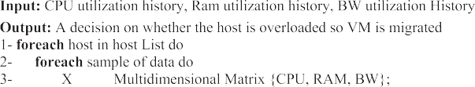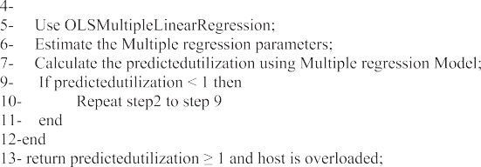

First, the host CPU utilization, RAM utilization and BW utiliza- tion for each host are calculated as the average utilization of the VMs in a host divided by the maximum host utilization. Then the inputs to the multiple regression algorithm are two matrices:

* The first one is two dimensional array named X with size of rows equal to the length of Data and column size equal to the

number of independent parameters which are three in this algorithm (CPU utilization, RAM utilization and BW utilization).

* The second input is one dimension array named Y which

includes a sample of data of host utilization calculated from

Equation (9).

The multiple regression is complicated since we need to obtain the coefficients of the regression model by solving the normal equations. We use Ordinary Least Square Multiple Regression func- tion (OLSMultipleRegression function) [16,17] to calculate the regression coefficients (parameters) of the multiple regression model. The regression coefficients are calculated once per host. Once the regression coefficients are calculated the predictedhostu- tilization equation can be formed as shown in Eq. (10):

predictedUtilization = b0 + (b1 * CPUutilization) + (b2

* Ramutilization)

+ (b3 * Bwutilization) (10)

By substituting values of CPU utilization and RAM utilization

and BW utilization in the equation we obtain the predictedUtiliza- tion. The triggering point of the algorithm is that if pre- dictedUtilization is greater than or equal 1 then the host is considered to be overloaded so we select a VM to be migrated from the overloaded host.

1. Hybrid local regression host overload detection method (HLRHOD)

Local regression [7] is used to model a relation between a pre- dictor variable and response variable. Local regression model is based on the form:

niques allow the test of experiments with various workload blend and resource performance scenarios on simulated systems for elaborating, examining versatile application provisioning methods. The CloudSim toolkit [20] has been chosen as a simulation plat- form, as it is a modern simulation framework aimed at Cloud com- puting environments. We use CloudSim toolkit to simulate all combinations of the following host overload detection algorithms

[6] (THR, IQR, MAD, LR, LLR, MMSD and MRHOD and HLRHOD)

with three VM selection algorithms (MMT, RC, MC) to detect the host overload based on hybrid factors.

*7.2. Power model*

Power consumption by computing nodes in data centers is mostly determined by the CPU, memory, disk storage, power sup- plies and cooling systems [21]. This fact combined with the diffi- culty of modeling power consumption by modern multi-core

*Y* = *f* (*x* )+∈

# (11)

CPUs makes building precise analytical models a complex research

*i i* *i*

where

f(x) is an unknown function,

єi is an error term, representing random errors in the observa- tions or variability from sources not included in the xi.

The main idea of the method of local regression is fitting simple models to localized subsets of data to build up a curve that approx- imates the original data. The proposed method is based on the Loess’s method [7] proposed by Cleveland [19]. Local regression host overload detection algorithm presented in [6] is based on the estimation of the future CPU utilization. They outperform the threshold-based and adaptive-threshold based algorithms because of their better prediction of host overloading but it depends on singe factor (CPU utilization) for host overload detection.

We use the formula developed in [18] to calculate the host uti- lization based on hybrid factors by using a metric that captures the combined CPU-network-memory load of virtual and physical ser- vers. After calculating the host utilization from the above formula, we use the Local Regression (LR) host overload detection algorithm proposed in [6].

1. Evaluation methodology
   1. *Experimental setup*

Since cloud computing is purely an internet based technology it suffers from a major problem which is the monetary cost involved in ensuring that the internet is always accessible. Additionally it is exceedingly hard to direct repeatable large scale experiments on a real system, which is needed to make an evaluation and compar- ison to the recommended heuristics. Additionally for assurance of the repeatability of experiments, simulations are picked as an approach to highlight the enhancement of recommended algo- rithms. Simulation tools have important benefits: no capital cost presented, provide enhanced results as using such tools help to change inputs and other parameters also in an easier way which result in better and efficient outputs. Simulation tools are also easy to learn since while working with such simulation tools user needs to have only programming abilities [20]. Simulation-based tech-

problem. Therefore, we utilize real data on power consumption provided by the results of the SPECpower benchmark [6] instead of using an analytical model of power consumption by a server. We have simulated a data center that comprises 50 hosts and 50 VMs using random workload traces. The host overload is fre- quently evaluated according to the scheduling interval which is set to 300 s [5]. The host types are:

HP ProLiant ML110 G4 (Intel Xeon 3040, 2 cores 1860 MHz, 4 GB), and HP ProLiant ML110G5 (Intel Xeon 3075, (2 cores 2660 MHz, 4 GB). The configuration and power consumption char- acteristics [5] of the selected servers are shown in Table 2.

*7.3. Performance metrics*

In order to compare the efficiency of the algorithms we use sev- eral metrics to evaluate their performance. The following metrics are used:

Total energy consumption (E) is defined as the sum of energy consumed by the physical resources of a data center as a result of application workloads. Energy consumption is calculated according to the model defined in [10].

Number of VM migrations: For dynamic VM consolidation once the overloaded or under-loaded hosts are found, the VMs are then selected for migration. The minimization of the VM migration time is the most important constraint in migra- tion step and it is achieved by the reduction of the total number of VM migrations.

SLA (Service Level Agreement): It can be determined in terms of such characteristics as minimum throughput or maximum response time delivered by the deployed system. As these char- acteristics can vary for different applications, it is necessary to use workload independent metric that can be used to evaluate SLA delivered to any VM deployed in an IaaS. SLAs are delivered

when 100\% of the performance requested by applications in a

VM is provided at any time bounded only by the parameters of

the VM [10].

We use two metrics for measuring the level of SLA violations [9] in an IaaS environment which are defined as: The first metric is the

Table 2

Power consumption by the selected servers at different load levels in Watts [5].

|  |  |  |  |  |  |  |  |  |  |  |  |
| --- | --- | --- | --- | --- | --- | --- | --- | --- | --- | --- | --- |
| Server | 0% | 10% | 20% | 30% | 40% | 50% | 60% | 70% | 80% | 90% | 100% |
| HP ProLiant G4 | 86 | 89.4 | 92.6 | 96 | 99.5 | 102 | 106 | 108 | 112 | 114 | 117 |
| HP ProLiant G5 | 93.7 | 97 | 101 | 105 | 110 | 116 | 121 | 125 | 129 | 133 | 135 |

the CPU utilization of 100\%, SLA violation Time per Active Host percentage of time, during which active hosts have experienced (SLATAH) as shown in Eq. (12):

The percentage of time, during which active hosts have experi- enced the CPU utilization of 100%, SLA violation Time per Active Host (SLATAH)

N

Energy consumption by physical nodes and SLAV are negatively correlated as energy can usually be decreased by the cost of the increased level of SLA violations. The objective of the resource management system is to minimize both energy and SLA viola- tions. Therefore, a combined metric denoted by Energy and SLA Violations (ESV) captures both energy consumption and the level

of SLA violations is proposed in [6]. For the ESV metric lower is bet-

# SLATAH = 1 X *Tsi*

N i=1 *Tai*

where

N is the number of hosts,

# (12)

ter since it indicates that energy saving is higher than SLA violations.

# ESV = E * SLAV (15)

Tsi is the total time during which the host i has, experienced the utilization of 100% leading to an SLA violation,

Tai is the total of the host i being in the active state (serving VMs).

The second metric is the overall performance degradation by VMs due to migrations, Performance Degradation due to Migra- tions (PDM) as shown in Eq. (13):

M

1. Simulation results and analysis

We have simulated all combinations of the following host over- load detection algorithms (THR, IQR, MAD, MMSD, LR and LLR and MRHOD and HLRHOD) with three VM selection algorithms (MMT, RC and MC) to detect the host overload based on hybrid parame- ters. For host overload detection based on three factors (CPU,

RAM and BW) utilizations we use Multiple Regression Host Over-

PDM = 1 X *Cdj*

M j=1 *Crj*

where

M is the number of VMs,

# (13)

load Detection algorithm (MRHOD) and (HLRHOD).

* 1. *VM selection policy evaluation*

Cdj is the estimate of the performance degradation of the VM j caused by migrations,

Crj is the total CPU capacity requested by the VM j during its lifetime.

Both the SLATAH and PDM metrics are independently and with equal importance characterize the level of SLA violations by the infrastructure. A combined metric that encompasses both perfor- mance degradation due to host overloading and performance degradation due to VM migrations is shown in Eq. (14). They denote the combined metric SLA Violation (SLAV) [6] which takes place when a VM cannot get the promised Quality of Service (QoS).

# SLAV = SLATAH * P*DM* (14)

Initially we start by evaluating MMT across different algorithms (THR, MAD, IQR, LR, and LRR) using random workload traces since it is the easiest type of workload to start our experiments with it since there are no large real world data files, no sensitive data and easily modified without affecting operation. There is more sav- ing in energy consumption, Number of VM migrations and SLA metric when using hybrid factors compared to the results obtained from single factor host utilization overload detection as shown in Fig. 1.

Energy consumption is reduced by about 15 times in case of hybrid factors (THR and IQR) than single factor and by about 5 times in case of hybrid factors (MAD, LR and LRR) than single fac- tor. Number of VM ESV is increased by about 10 times in case of hybrid factors (THR, IQR, LR and LRR) than single factors. Since

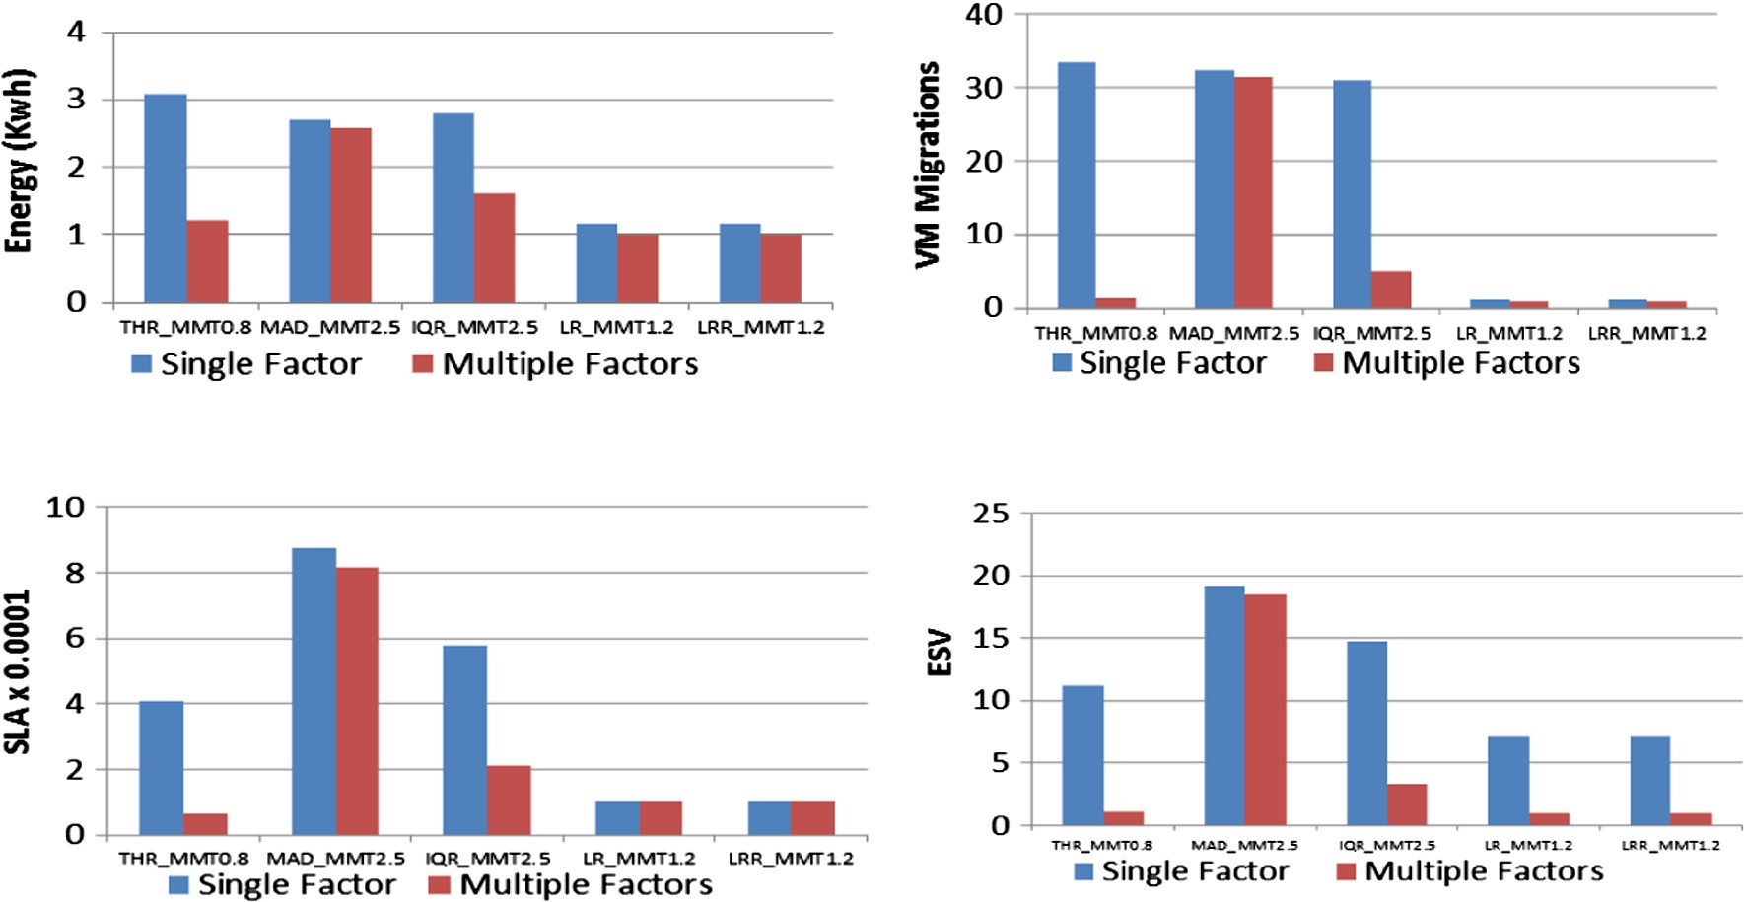

(a) Energy Consumption

(b) Number of VM migrations

(c) SLA metric (d) ESV metric

Figure 1. Algorithm combinations comparing multiple factors and single factors.

the results obtained from hybrid factors is better than the results from single factor so the VM behavior is rarely a function in one variable it should be a function of multiple factors. Regression based algorithms outperform the threshold-based and adaptive- threshold based algorithms using hybrid factors as well as using single factors since the Energy Service level agreement Violation metric (ESV) in case of LR-MMT and LRR-MMT is reduced com- pared to MAD-MMT, IQR-MMT and THR-MMT in both cases.

Next we perform similar evaluation for Random choice VM selection across the same set of algorithms (THR, MAD, IQR, LR and LRR). Energy consumption by physical nodes and SLAV are negatively correlated. As the energy consumption increase the SLAV decrease and vice versa. ESV metric is used to compare between algorithms as shown in Fig. 2. MAD_RS is the highest algorithm in term of ESV. LR_RS is the lowest algorithm in term of ESV so it is preferred to be used.

In Fig. 3 we compare between MMT, RS and MC VM selection algorithms. MMT gives poor results in term of ESV in adaptive- threshold based algorithms (MAD, IQR) compared to RS and MC. MC gives high value of ESV in case of MAD compared to MMC and MC. In case of regression algorithms they nearly give the same performance as shown in Fig. 3.

* 1. *Sensitivity analysis*
     1. *Safety parameter*

In this experiment we study the effect of changing the safety parameter on MRHOD to determine the best value of safety param- eter that gives best performance. MRHOD gives the best values in term of energy consumption, ESV metric when safety parameter is 1.5 as shown in Table 3.

We study also the effect of changing the safety parameter on HLRHOD algorithm. HLRHOD gives the best values in term of energy consumption and ESV metric when safety parameter is

1.4 as shown in Table 4.

* + 1. *Number of VMs*

Our sensitivity analysis is based on changing the number of vir- tual machines while keeping the number of hosts constant (100 host) and scheduling interval equals to 300 using random work- load traces. We study the effect of varying the number of VMs on energy consumption and ESV metric for different algorithms and the proposed HLRHOD algorithm and MRHOD algorithm as shown in Tables 5 and 6 respectively.

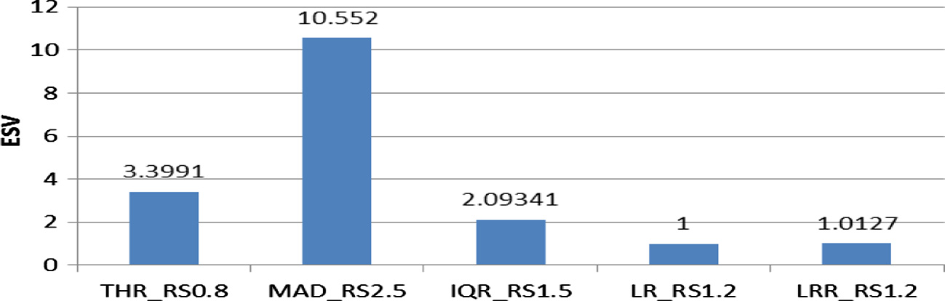

Figure 2. ESV for RS with different host overload detection algorithms.

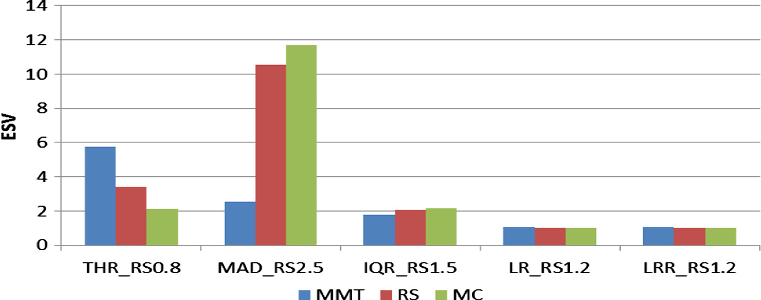

Figure 3. ESV comparison for RS vs. MMT vs. MC.

Table 3

Safety parameter for MRHOD.

|  |  |  |  |  |  |  |  |  |  |  |
| --- | --- | --- | --- | --- | --- | --- | --- | --- | --- | --- |
| Safety parameter | 0.8 | 0.9 | 1 | 1.1 | 1.2 | 1.3 | 1.4 | 1.5 | 1.6 | 1.7 |
| Energy (kW h) | 16.06 | 16.01 | 15.23 | 15.58 | 15.56 | 15.46 | 13.53 | 13.48 | 15.72 | 15.74 |
| VM Migrations (total no. of VM migrations) | 349 | 386 | 348 | 282 | 274 | 216 | 145 | 120 | 119 | 116 |
| SLA (100\% of the application perf. done at any time) | 0.011 | 0.014 | 0.016 | 0.01 | 0.0125 | 0.009 | 0.007 | 0.006 | 0.005 | 0.004 |
| PDM (estimated Perf. degradation/requested capacity) | 0.02 | 0.02 | 0.02 | 0.02 | 0.02 | 0.01 | 0.01 | 0.01 | 0.01 | 0.01 |
| SLATAH (Ratio) | 75.14 | 75.61 | 80.93 | 81.93 | 80.52 | 83.31 | 82.05 | 80.42 | 83.27 | 83.71 |
| SLAV | 1.502 | 1.51 | 1.618 | 1.63 | 1.6104 | 0.833 | 0.8205 | 0.8042 | 0.8327 | 0.8371 |
| ESV | 24.13 | 24.21 | 24.65 | 25.52 | 25.058 | 12.87 | 11.1 | 10.841 | 13.09 | 13.17 |

Table 4

Safety parameter for HLRHOD.

|  |  |  |  |  |  |  |  |  |  |  |
| --- | --- | --- | --- | --- | --- | --- | --- | --- | --- | --- |
| Safety parameter | 0.8 | 0.9 | 1 | 1.1 | 1.2 | 1.3 | 1.4 | 1.5 | 1.6 | 1.7 |
| Energy (kW h) | 16.06 | 16.22 | 15.65 | 15.56 | 15.55 | 15.46 | 13.53 | 15.66 | 15.72 | 15.74 |
| VM Migrations (total no. of VM migration) | 337 | 351 | 317 | 260 | 270 | 216 | 145 | 120 | 119 | 116 |
| SLA (100\ % of the application perf. done at any time) | 0.011 | 0.013 | 0.014 | 0.011 | 0.0126 | 0.00962 | 0.00744 | 0.00479 | 0.00539 | 0.004 |
| PDM (estimated Perf. degradation/requested capacity) | 0.01 | 0.02 | 0.02 | 0.01 | 0.02 | 0.01 | 0.01 | 0.01 | 0.01 | 0.01 |
| SLATAH (ratio) | 75.71 | 75.22 | 79.6 | 78.74 | 81.13 | 83.31 | 82.05 | 83.84 | 83.27 | 83.71 |
| SLAV | 0.757 | 1.504 | 1.592 | 0.7874 | 1.6226 | 0.8331 | 0.8205 | 0.8384 | 0.8327 | 0.837 |
| ESV | 12.1 | 24.401 | 24.915 | 12.252 | 25.231 | 12.878 | 11.101 | 13.129 | 13.09 | 13.17 |

Table 5

Energy consumption vs. number of VMs.

|  |  |  |  |  |  |  |  |  |  |
| --- | --- | --- | --- | --- | --- | --- | --- | --- | --- |
| Algorithm | 30 | 50 | 70 | 90 | 110 | 130 | 150 | 170 | 190 |
| THR_MMT-0.8 | 2.759 | 3.139 | 2.953 | 2.693 | 2.477 | 2.433 | 2.346 | 2.208 | 2.344 |
| IQR-MMT-1.5 | 2.406 | 2.6579 | 2.41 | 2.251 | 2.06 | 2.025 | 2.104 | 1.958 | 2.109 |
| MAD-MMT-2.5 | 2.371 | 2.632 | 2.409 | 2.184 | 2.042 | 1.998 | 2.055 | 1.959 | 2.096 |
| MMSD-MMT-2.5 | 2.301 | 2.554 | 2.38 | 2.148 | 1.962 | 1.935 | 1.981 | 1.912 | 2.031 |
| LRR-MMT-1.2 | 1.367 | 1.458 | 1.328 | 1.147 | 1.101 | 1.062 | 1.154 | 1.139 | 1.1717 |
| LR-MMT-1.2 | 1.367 | 1.458 | 1.328 | 1.147 | 1.101 | 1.062 | 1.154 | 1.139 | 1.1717 |
| HLRHOD-1.4 | 1.009 | 1.172 | 1.103 | 1.022 | 1.015 | 1.035 | 1.014 | 1.004 | 1.049 |

Table 6

ESV metric vs. number of VMs.

|  |  |  |  |  |  |  |  |  |  |
| --- | --- | --- | --- | --- | --- | --- | --- | --- | --- |
| Algorithm | 30 | 50 | 70 | 90 | 110 | 130 | 150 | 170 | 190 |
| THR_MMT-0.8 | 9.5 | 10.822 | 9.717 | 8.916 | 8.137 | 7.837 | 9.73 | 12.065 | 15.22 |
| IQR-MMT-1.5 | 15.292 | 18.977 | 19.797 | 18.277 | 18.255 | 20.286 | 21.093 | 21.756 | 24.82 |
| MAD-MMT-2.5 | 14.491 | 19.259 | 18.662 | 19.275 | 19.324 | 21.398 | 22.224 | 22.665 | 24.811 |
| MMSD-MMT-2.5 | 15.023 | 20.807 | 21.764 | 20.599 | 20.172 | 22.289 | 22.82 | 23.683 | 27.109 |
| LRR-MMT-1.2 | 4.321 | 6.008 | 6.12 | 5.793 | 5.549 | 5.537 | 6.71 | 6.51 | 6.66 |
| LR-MMT-1.2 | 4.321 | 6.008 | 6.12 | 5.793 | 5.549 | 5.537 | 6.71 | 6.51 | 6.66 |
| HLRHOD-MMT-1.4 | 0.976 | 1.183 | 1.108 | 1.029 | 1.022 | 1.016 | 0.999 | 1.002 | 1.008 |

We normalize the results with respect to MRHOD-MMT1.5. MRHOD and HLRHOD algorithms save more energy than all algo- rithms when we run random workload traces. MRHOD gives better results than MMSD since it is a regression based algorithm which is based on estimation of future CPU utilization which represents a better prediction of host overloading but MMSD is based on statis- tical analysis of historical data using mean, median and standard deviations which are sensitive to outliers. As number of VMs (30, 50, and 70) increases, the energy saving of MRHOD and HLRHOD algorithms gets higher than LR and LRR algorithms. For high num- ber of VMs, the improvement in MRHOD and HLRHOD is reduced compared to LR and LRR however they are still the best marginally.

* + 1. *Scheduling interval*

In this experiment we study the effect of changing the schedul- ing interval on the energy consumption and ESV metric for differ- ent algorithms beside the proposed MRHOD algorithm. We change the scheduling interval while keep the number of hosts constant (50 host) and the number of VMs constant (50) as shown in Table 7.

We normalize the results with respect to MRHOD-MMT1.5. As the scheduling interval increases, the ESV decreases across all algorithms.

* 1. *Algorithms comparative analysis*
     1. *Random workload*

Comparison between different single factor algorithms and Multiple Regression Host Overload Detection (MRHOD) is shown in Table 8. In Table 8, each algorithm name is followed by a number represents the value of the safety factor used while running the algorithm. Safety factor is a parameter of the method that indicates how aggressively the system consolidates VMs. It allows the adjustment of the safety of the method, the lower the safety parameter, the less the energy consumption, but the higher the level of SLA violations caused by the consolidation. For Table 8 we have selected for each algorithm a different safety parameter since not all of them perform the best with the same safety param- eter hence the results shown are for the best performing safety

Table 7

ESV metric vs. scheduling interval.

|  |  |  |  |  |  |  |  |
| --- | --- | --- | --- | --- | --- | --- | --- |
| Algorithm | 300 | 400 | 500 | 600 | 700 | 800 | 900 |
| THR_MMT | 11.523 | 7.874 | 5.273 | 4.174 | 3.218 | 2.673 | 2.338 |
| IQR-MMT | 19.169 | 13.078 | 9.735 | 7.583 | 6.751 | 5.397 | 4.838 |
| MAD-MMT | 18.95 | 21.133 | 10.179 | 7.834 | 6.374 | 5.389 | 4.909 |
| MMSD-MMT | 20.817 | 14.42 | 10.699 | 8.441 | 6.947 | 6.068 | 4.996 |
| LRR-MMT | 5.845 | 5.296 | 4.796 | 4.369 | 4.008 | 3.656 | 3.415 |
| LR-MMT | 5.845 | 5.296 | 4.796 | 4.369 | 4.008 | 3.656 | 3.415 |
| HLRHOD-MMT | 1.156 | 1.112 | 1.068 | 1.025 | 0.986 | 0.948 | 0.942 |

Table 8

Simulation result of host overload detection algorithms.

|  |  |  |  |  |  |  |  |
| --- | --- | --- | --- | --- | --- | --- | --- |
| Policy | Energy Consumption | Number Of Vm Migrations | SLA | PDM | SLATAH | SLAV | ESV |
| THR_MMT0.8 | 41.81 | 4839 | 0.03048 | 0.23 | 12.99 | 2.987 | 124.917 |
| IQR-MMT1.5 | 36.4 | 4685 | 0.06521 | 0.27 | 20.85 | 5.629 | 204.914 |
| MAD-MMT2.5 | 37.84 | 4490 | 0.04304 | 0.25 | 17.34 | 4.335 | 164.036 |
| MMSD_MMT2.5 | 34.57 | 1613 | 0.01921 | 0.09 | 20.45 | 1.841 | 63.626 |
| LRR-MMT1.2 | 19.7 | 167 | 0.00765 | 0.031 | 99.12 | 3.001 | 59.12 |
| LR-MMT1.2 | 19.7 | 167 | 0.00765 | 0.031 | 99.12 | 3.001 | 59.12 |
| HLRHOD-1.4 | 13.53 | 145 | 0.00744 | 0.01 | 82.05 | 0.82 | 11.101 |
| MRHOD-MMT1.5 | 13.48 | 120 | 0.0066 | 0.01 | 67.67 | 0.804 | 10.8406 |

parameter for each algorithm. For recently proposed algorithms (THR, IQR, MAD, LRR, and LR) we used the recommended safety parameters provided in [6]. Single factor Local regression based algorithms outperform single factor THR, IQR and MAD and MMSD due to better predictions of host overloading, and therefore decreased SLA violations due to host overloading (SLATAH) and the number of VM migrations. Across different metrics for power/performance and QOS Multiple Regression Host Overload Detection (MRHOD) algorithm outperforms all other algorithms that use single factor in host overload since ESV metric is improved 6 times compared to other single factor regression algorithms (LR, and LRR) and more than 10 times (an order of magnitude) com- pared to MAD, MMSD, IQR and THR.

* + 1. *PlanetLab workload*

In previous section we use random workload traces to compare between the literatures algorithms (THR, MAD, MMSD, IQR, LR, LRR) and the proposed algorithms (HLRHOD and MRHOD). But to

make a simulation based evaluation applicable, it is important to conduct experiments using workload traces from a real system. For our experiments we have used data provided as a part of the CoMon project, a monitoring infrastructure for PlanetLab [6]. We use PlanetLab workload (Number of hosts is 800) and (Number of virtual machines is 1033). Comparison between different single factor algorithms and Multiple factor Host Overload Detection algorithms are shown in Fig. 4.

Across different metrics for power/performance and QOS Multi- ple Regression Host Overload Detection (MRHOD) algorithm out- performs all other techniques that utilize single factor in host overload detection since the energy consumption is minimized by about 20% than LR and LRR algorithms. SLAV is minimized in LRR and LR than other multiple factor algorithms because the energy and SLAV are negatively correlated. So we use ESV metric to decide if the host is the best in predicting of node overloading. For MRHOD the ESV metric is improved by about 24% compared to other single factor regression algorithms (LR, and LRR) and more

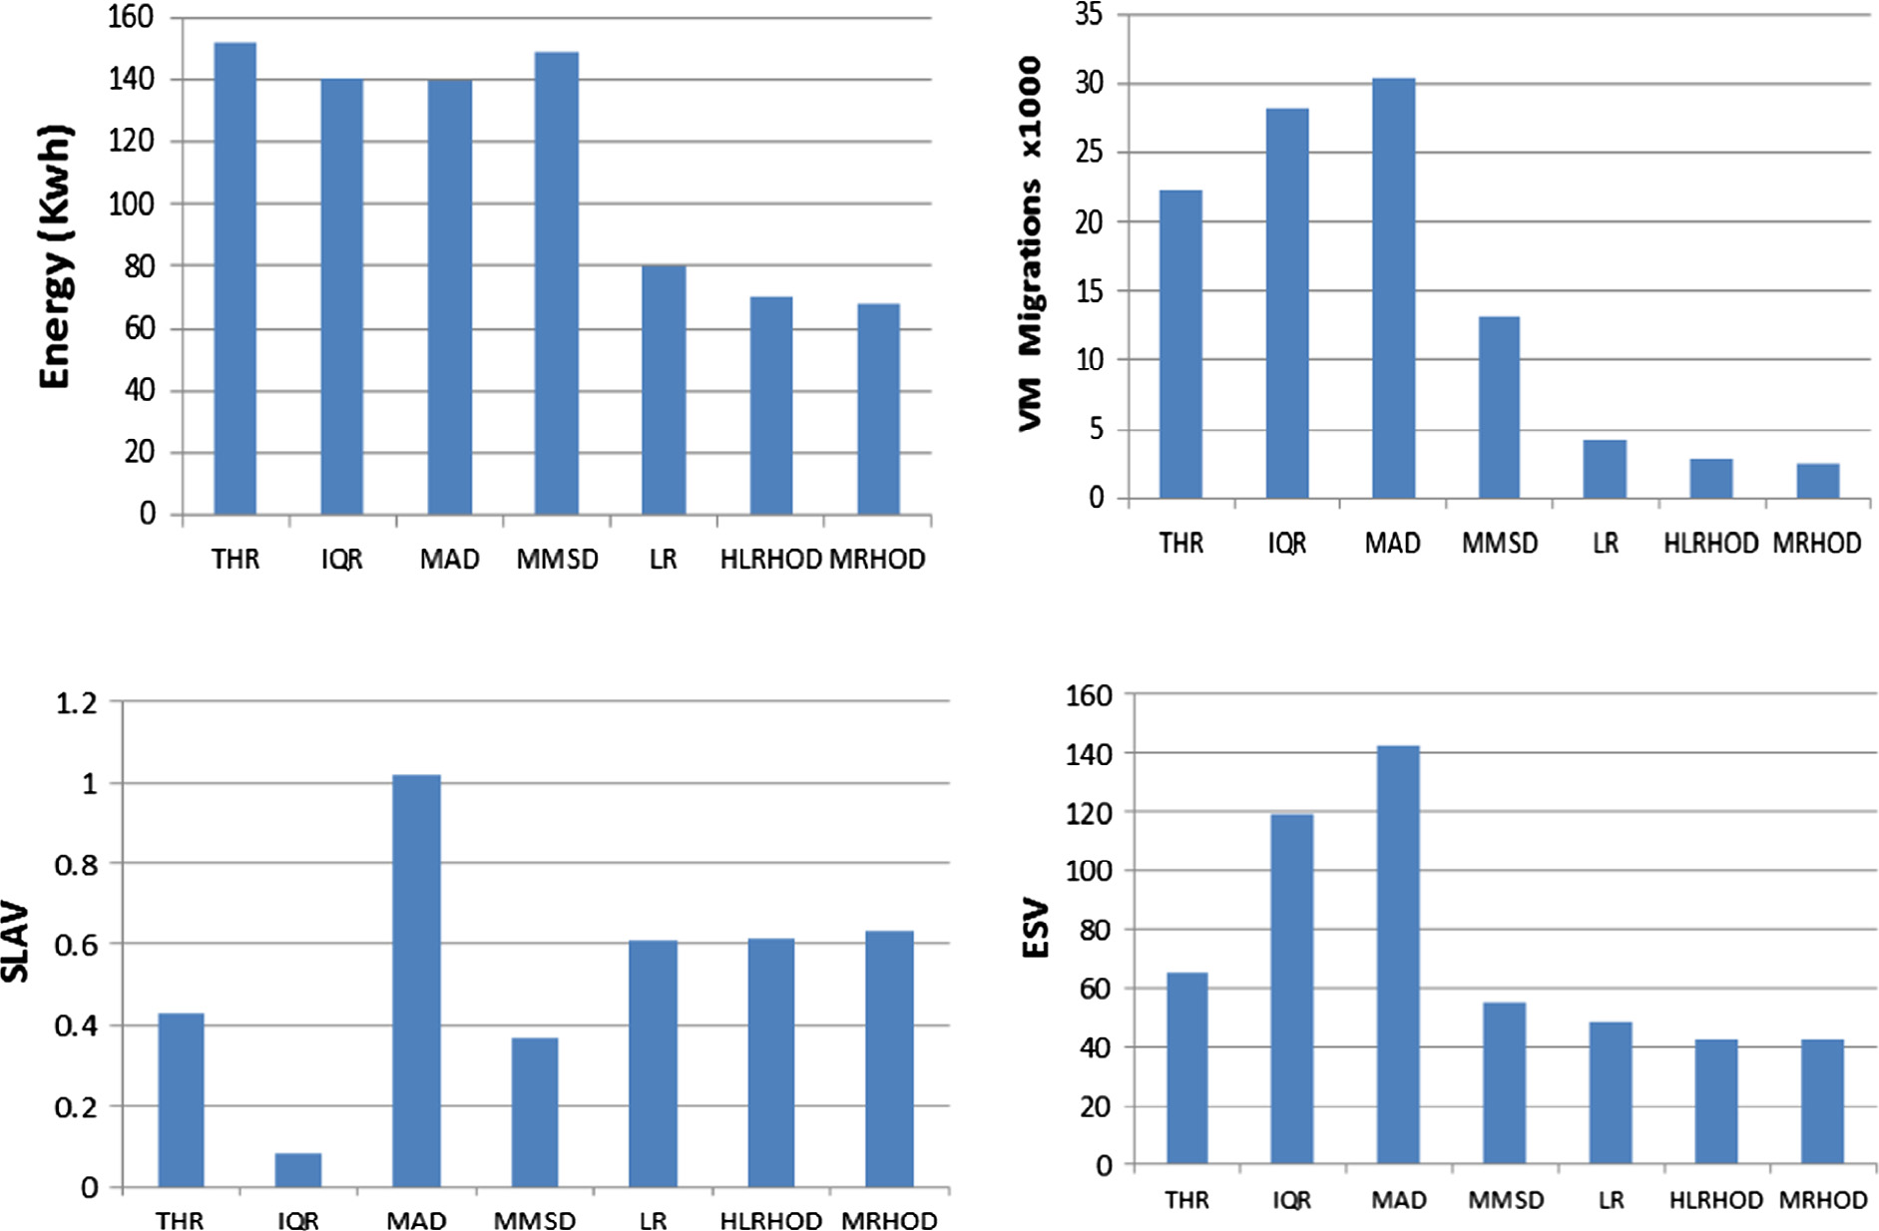(a) Energy Consumption (b) Number of VM migrations

* + - 1. SLAV metric
      2. ESV metric

Figure 4. Algorithms comparative comparison using PlanetLab workload.

Table 9

Multiple Regression significance test output.

|  |  |  |  |  |  |  |
| --- | --- | --- | --- | --- | --- | --- |
|  | Coefficients | Standard Error | t Stat | P-value | Lower 95% | Upper 95% |
| Intercept | —0.15522808 | 0.017376925 | —8.933000704 | 2.10386E—09 | —0.19094686 | —0.1195093 |
| CPU | 0.38366454 | 0.081251539 | 4.721935656 | 7.00234E—05 | 0.216649609 | 0.55067947 |
| RAM | 0.307722279 | 0.10047659 | 3.062626633 | 0.005052632 | 0.101189692 | 0.514254867 |
| BW | —0.061809984 | 0.227545473 | —0.271637942 | 0.78804571 | —0.529536402 | 0.405916434 |

than 40% compared to THR, MAD, and IQR. Multiple factor regres- sion algorithms give enhanced results than all other single factor algorithms due to improved predictions of host overload detection, and thus minimized the number of migrations of VM which cause a minimization in SLAV. Number of VM migration is very high in MAD and IQR algorithms.

* 1. *Multiple regression significance test using Anova*

We perform multiple regression significance test using Anova and data analysis tool in excel [22]. R-square is a statistical mea- sure of how close the data are to the fitted regression line. In our experiment adjusted R square is 0.91 which means the model greatly fits the data.

We test the significance of the independent factors (CPU, RAM, BW) on the independent factor (host utilization) using Anova. We obtain the following results presented in Table 9.

From table 9 it is clear that the p value of CPU and RAM is smal- ler than 0.05 so CPU and RAM values are significant. While the p value for BW is larger than 0.05 so it is insignificant. Although the BW is insignificant but it is very important when considering host utilization because for many applications, the performance does not rely only on CPU utilization. For applications that require communication among services, the communication cost can also influence the overall performance. Furthermore, there are applica- tions require a huge amount of memory hence; memory utilization can also influence the overall performance. So the CPU, RAM and BW are very important parameters for applications so they are used in our proposed multiple regression algorithms.

1. Conclusion

Multiple Regression is an effective way to solve virtual machine consolidation challenges. It is an extension to Linear Regression which produces better results for host overload detection since it is based on the prediction of host utilization which is suitable for the dynamic nature of the cloud. The predicted host utilization in multiple regression depends on multiple factors (CPU, Memory, Bandwidth) so it gives a real indication of host utilization. MRHOD and HLRHOD algorithms outperform the other algorithms that are based on only single factor in term of energy consumption. How- ever MRHOD and HLRHOD give poor results in term of SLAV since energy and SLAV are negatively correlated, it outperforms other algorithms in term of ESV metric by about 6 times compared to other single factor regression algorithms (LR, and LRR). The most effective method for virtual machine consolidation is MRHOD algo- rithm then HLRHOD algorithm while both are multiple factors host overload detection algorithms. As a future work, we can apply Mul- tiple Regression Host overload Detection algorithm (MRHOD) on real cloud rather than simulation. Studying how to develop a new formula for calculation of host utilization using normalization to achieve better results is another interesting direction for the future work. We plan also to extend the hybrid concept to different management tasks of cloud controllers.

Acknowledgements

The authors send their acknowledge to STDF for their financial grant of the cloud computing center of excellence (number 5220). This research was supported in part by the Distributed and Net- worked Systems Research Group Operating Grant number 150410, University of Sharjah.

References

1. [Mohan A, Shine. Survey on live vm migration techniques. Int J Adv Res Comput](http://refhub.elsevier.com/S1110-8665(16)30092-5/h0005) [Eng Technol 2013;2:60–74](http://refhub.elsevier.com/S1110-8665(16)30092-5/h0005).
2. [Dhiman G, Mihic K, Rosing T. A system for online power prediction in](http://refhub.elsevier.com/S1110-8665(16)30092-5/h0010) [virtualized environments using Gaussian mixture models. In: Proceedings of](http://refhub.elsevier.com/S1110-8665(16)30092-5/h0010) [the 47th ACM/IEEE DAC. p. 807–12](http://refhub.elsevier.com/S1110-8665(16)30092-5/h0010).
3. [Abdelsamea A, Hemayed EE, Eldeeb H, Elazhary H. Virtual machine](http://refhub.elsevier.com/S1110-8665(16)30092-5/h0015) [consolidation challenges: a review. Int J Innovation Appl Stud](http://refhub.elsevier.com/S1110-8665(16)30092-5/h0015) [2014;8:1504–16](http://refhub.elsevier.com/S1110-8665(16)30092-5/h0015).
4. [Beloglazov A, Buyya R. Openstack neat: a framework for dynamic and energy-](http://refhub.elsevier.com/S1110-8665(16)30092-5/h0020) [efficient consolidation of virtual machines in openstack clouds. Concurrency](http://refhub.elsevier.com/S1110-8665(16)30092-5/h0020) [Comput: Practice Exp (CCPE) 2015;27:1310–33](http://refhub.elsevier.com/S1110-8665(16)30092-5/h0020).
5. [Beloglazov A, Buyya R. Managing overloaded hosts for dynamic consolidation](http://refhub.elsevier.com/S1110-8665(16)30092-5/h0025) [of virtual machines in cloud data centers under quality of service constraints.](http://refhub.elsevier.com/S1110-8665(16)30092-5/h0025) [IEEE Trans Parallel Distributed Syst (TPDS) 2013;24:1366–79](http://refhub.elsevier.com/S1110-8665(16)30092-5/h0025).
6. [Beloglazov A, Buyya R. Optimal online deterministic algorithms and adaptive](http://refhub.elsevier.com/S1110-8665(16)30092-5/h0030) [heuristics for energy and performance efficient dynamic consolidation of](http://refhub.elsevier.com/S1110-8665(16)30092-5/h0030) [virtual machines in cloud data centers. Concurrency Comput: Practice Exp](http://refhub.elsevier.com/S1110-8665(16)30092-5/h0030) [(CCPE) 2012;24:1397–420](http://refhub.elsevier.com/S1110-8665(16)30092-5/h0030).
7. [Cleveland W, Loader C. Smoothing by local regression: principles and methods.](http://refhub.elsevier.com/S1110-8665(16)30092-5/h0035) [Stat Theory Comput Aspects Smoothing 1996](http://refhub.elsevier.com/S1110-8665(16)30092-5/h0035).
8. [Farahnakian F, Ashraf A, Pahikkala T, Liljeberg P, Plosila J, Porres I, et al. Using](http://refhub.elsevier.com/S1110-8665(16)30092-5/h0040) [ant colony system to consolidate vms for green cloud computing. IEEE Trans](http://refhub.elsevier.com/S1110-8665(16)30092-5/h0040) [Serv Comput 2015;8:187–98](http://refhub.elsevier.com/S1110-8665(16)30092-5/h0040).
9. [Ghribi C, Hadji M, Zeghlache D. Energy efficient vm scheduling for cloud data](http://refhub.elsevier.com/S1110-8665(16)30092-5/h0045) [centers: exact allocation and migration algorithms. In: 13th IEEE/ACM](http://refhub.elsevier.com/S1110-8665(16)30092-5/h0045) [international symposium on cluster, cloud and grid computing (CCGrid). p.](http://refhub.elsevier.com/S1110-8665(16)30092-5/h0045) [671–8](http://refhub.elsevier.com/S1110-8665(16)30092-5/h0045).
10. [Zhu F, Li H, Lu J. A service level agreement framework of cloud computing](http://refhub.elsevier.com/S1110-8665(16)30092-5/h0050) [based on the cloud bank model. Comput Sci Automation Eng (CSAE), IEEE](http://refhub.elsevier.com/S1110-8665(16)30092-5/h0050) [2012;1:255–9](http://refhub.elsevier.com/S1110-8665(16)30092-5/h0050).
11. [Zhou Z, Hu Z, Song T, Yu J. A novel virtual machine deployment algorithm with](http://refhub.elsevier.com/S1110-8665(16)30092-5/h0055) [energy efficiency in cloud computing. J Central South Univ 2015;22:94–983](http://refhub.elsevier.com/S1110-8665(16)30092-5/h0055).
12. [Monil MAH, Rahman RM. Vm consolidation approach based on heuristics,](http://refhub.elsevier.com/S1110-8665(16)30092-5/h0060) [fuzzy logic, and migration control. J Cloud Comput 2015;5(1):1–18](http://refhub.elsevier.com/S1110-8665(16)30092-5/h0060).
13. [Shidik G, Azhari A, Mustofa K. Improvement of energy efficiency at cloud data](http://refhub.elsevier.com/S1110-8665(16)30092-5/h0065) [center based on fuzzy markov normal algorithm vm selection in dynamic vm](http://refhub.elsevier.com/S1110-8665(16)30092-5/h0065) [consolidation. Int Rev Comput Software (IRECOS) 2016;11:511–20](http://refhub.elsevier.com/S1110-8665(16)30092-5/h0065).
14. Terracotta project. Home Page. <[http://terracotta.readthedocs.io/en/latest/](http://terracotta.readthedocs.io/en/latest/project_info.html) [project_info.html](http://terracotta.readthedocs.io/en/latest/project_info.html)>.
15. Abdelsamea A, El-Moursy AA, Hemayed EE, Eldeeb H. Multiple regression host overload detection, Sensors to Cloud Architectures Workshop (SCAW2016) held in conjunction with HPCA-22.
16. [Wooldridge MJ. Introductory econometrics: a modern approach. 5th ed. South](http://refhub.elsevier.com/S1110-8665(16)30092-5/h0080) [Western Cengage Learning; 2013](http://refhub.elsevier.com/S1110-8665(16)30092-5/h0080).
17. Bowerman B, O’Connell R, Murphree E, Business statistics in practice, 7th ed.; 2013.
18. Chen J, Liu W, Song J. Network performance-aware virtual machine migration in data centers. The Third International Conference on Cloud Computing, GRIDs, and Virtualization (CLOUD COMPUTING 2012); 2012. p. 65–78.
19. [Cleveland W. Robust locally weighted regression and smoothing scatterplots. J](http://refhub.elsevier.com/S1110-8665(16)30092-5/h0095) [Am Stat Assoc 1979:829–36](http://refhub.elsevier.com/S1110-8665(16)30092-5/h0095).
20. [Rodrigo C, Rajiv R. Cloudsim: a toolkit for modeling and simulation of cloud](http://refhub.elsevier.com/S1110-8665(16)30092-5/h0100) [computing environments and evaluation of resource provisioning](http://refhub.elsevier.com/S1110-8665(16)30092-5/h0100) [algorithms. New York, USA: Wiley Press; 2011. p. 23–50](http://refhub.elsevier.com/S1110-8665(16)30092-5/h0100).
21. [Beloglazov A, Abawajy J, Buyya R. Energy-aware resource allocation heuristics](http://refhub.elsevier.com/S1110-8665(16)30092-5/h0105) [for efficient management of data centers for cloud computing. Future](http://refhub.elsevier.com/S1110-8665(16)30092-5/h0105) [Generation Comput Syst 2012:755–68](http://refhub.elsevier.com/S1110-8665(16)30092-5/h0105).
22. [Anderson M, Braak CT. Permutation tests for multi-factorial analysis of](http://refhub.elsevier.com/S1110-8665(16)30092-5/h0110) [variance. J Stat Comput Simul 2003:85–113](http://refhub.elsevier.com/S1110-8665(16)30092-5/h0110).