Available online at [www.sciencedirect.com](http://www.sciencedirect.com/)

**ScienceDirect**

AASRI Procedia 4 (2013) 31 – 36

2013 AASRI Conference on Intelligent Systems and Control

A Hyper-Solution Framework for SVM Classification: Improving Damage Detection on Helicopter Fuselage Panels

Antonio Candelieria*, Raul Sormania, Gaia Arosiob, Ilaria Giordanib, Francesco Archettia,b

*aDepartment of Computer Science, Systems and Communications, University of Milano Bicocca, Italy*

*bConsorzio Milano Ricerche, Italy*

**Abstract**

The on-line assessment of structural health of aircraft fuselage panels and their remaining useful life is crucial both in military and civilian settings. This paper presents an application of a Support Vector Machines (SVM) classification framework aimed at improving the diagnosis task based on the strain values acquired through a monitoring sensor network deployed on the helicopter fuselage panels. More in details, diagnosis is usually defined as detecting a damage, identifying the specific component affected (i.e., bay or stringer) and then characterizing the damage in terms of center and size. Here, the first two steps are performed through the SVM classification framework while the last one is based on an Artificial Neural Network (ANN) hierarchy already presented in a previous authors’ work.

The training dataset was built through Finite Elements Method (FEM) based simulation, able to simulate the behavior of any type of panel and damage according to specific parameters to set up; the result of FE simulation consists of the strain fields on different locations. As results, the proposed SVM classification framework permits to improve reliability of detection and characterization tasks respect to the previous approach entirely based on ANN hierarchies.

Finally, the remaining useful life is estimated by using another ANN, different for damage on bay and stringer, able to predict the values of two parameters of the NASGRO equation which is used to estimate the damage propagation.

© 2013 The Authors. Published by Elsevier B.V. Open access under [CC BY-NC-ND license.](http://creativecommons.org/licenses/by-nc-nd/3.0/)

© 2013 Antonio Candelieri, Raul Sormani, Gaia Arosio, Ilaria Giordani, Francesco Archetti. Published by Elsevier B.V.

Selection and/or peer review under responsibility of American Applied Science Research Institute

Selection and/or peer review under responsibility of American Applied Science Research Institute

* Corresponding author. Tel.: +39-02-6448-2184 E-mail address: [antonio.candelieri@unimib.it](mailto:antonio.candelieri@unimib.it)

2212-6716 © 2013 The Authors. Published by Elsevier B.V. Open access under [CC BY-NC-ND license.](http://creativecommons.org/licenses/by-nc-nd/3.0/) Selection and/or peer review under responsibility of American Applied Science Research Institute doi:10.1016/j.aasri.2013.10.006

*Keywords*: structural health assessment; machine learning; support vector machines; artificial neural networks

# Introduction

Frequent and accurate maintenance is relevant for helicopters structure as well as particularly challenging. Finite Element Method (FEM) has been proposed to model the direct relation between damage and strain (Katsikeros and Labeas, 2009; Zienkiewicz, Taylor and Zhu, 2005), while the inverse relation is usually more difficult but in really simple cases. Respect to this, estimation of center and size of a damage on an helicopter fuselage panel, according to the strain acquired through a monitoring sensor network, is a really complex and usually ill posed task (Maniatty and Park, 2005; Song and Gu, 2008).

Recently, the application of machine learning approaches to the identification of a possible reliable relation from strain to damage characteristics have gained new interest. The most commonly adopted techniques are related to the Artificial Neural Network (ANN) learning paradigm, in particular aiming at estimating damage features as well as how it affects the remaining useful life (Sbarufatti et al. 2011a,b, Guez and Ahmad, 1988; Hoole, 1993); a sufficiently wide review on the adoption of ANN for structural health assessment in helicopters can be found in Trivailo et al., 2006. The authors of this paper have also presented in Candelieri et al, 2013 an extended approach based on hierarchies of ANN to provide decision support in structural health assessment, in particular *diagnosis* – consisting of *i)* detecting a possible damage, *ii)* identifying the affected component (i.e., bay or stringer) and *iii)* estimating the damage centre and size – and *prognosis* – estimation of the remaining useful life according to the estimation of damage propagation.

In this paper the adoption of a Support Vector Machines (SVM) classification framework, based on meta- heuristic techniques, is investigated with the aim to improve performances of the diagnosis task, in particular the detection of the damage and the identification of the affected component. The adopted SVM classification framework has been proposed by Candelieri and Conforti, 2011 and has been already successfully applied in the health domain (Candelieri and Conforti 2010).

The rest of the paper is organized as follows: section 2 presents the data preparation and pre-processing, tasks, section 3 provides a general overview of the SVM classification framework, section 4 reports results and compare them with the performances obtained by the previous results presented in Candelieri et al. 2013. Finally, some conclusions and planned future works are reported.

# Dataset preparation and pre-processing

The available dataset consists of strain measurements (features) in correspondence of different monitoring points on a helicopter fuselage panel. The reference structure is an aluminum panel and damage can affect both the main components of the panel,that are bay or the stringer. A stringer is a metal component, similar to an “L”, fixed to panel by several rivets and holding together two adjacent bays, while a bay is a sheet between two stringers. Each panel consists of 3 bays and 4 stringers and its overall size is 50x60 cm.

A FE simulation software is the most effective and efficient solution to generate a wide set of instances without the excessive costs related to a real world damage data acquisition campaign. The FE simulation software used in this study (Katsikeros and Labeas, 2009) was developed by a research group that is partner in the HECTOR project [(http://hector.mecc.polimi.it/).](http://hector.mecc.polimi.it/)) This tool is able to model any type of panel and damage and provide strain values by setting up a number of parameters (i.e., material of the panel, damaged component, damage centre, tensions applied to the panel). Moreover, a dataset containing real measurements acquired by a set of sensing devices, namely Fibre Bragg Gratings (FBG) (Hideki et al., 2006; Heredero et al., 2008; Chandler et al., 2008; Fernandez-Lopez et al., 2008) installed on a real panel subjected to a load applied

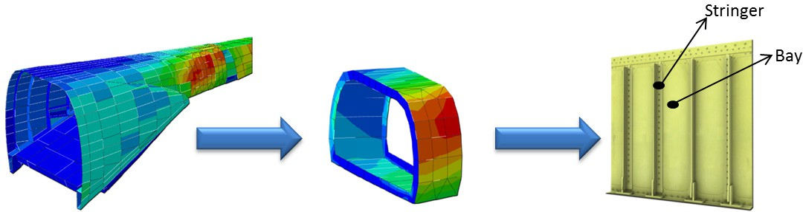by a mechanical tool – Upper Gripping system – has been taken into account. Damages centers and sizes have been generated by sampling from the same uniform distribution in order to be independent among them (i.i.d. samples). The following figure depicts the fuselage and the panel of an helicopter, as represented in the FE simulation software as well as it is in the real world.

Fig. 1 – A portion of the fuselage of a helicopter (left) and a smaller portion related to the more stressed area (centre) with the strain values as obtained by FE simulation and, finally, a real panel of an helicopter fuselage with stringers and bays indicated (right)

Dataset was built by setting 7 different vertical lines of sensors in the FE simulation software: 3 on bays and 4 on the correspondent stringers. On each vertical line, strains are measured at 201 equidistant points, therefore 7x201=1407 overall strain measurements on each panel have been considered.

The following Table 1 summarizes characteristics of the dataset.

Table 1 – Characteristics of dataset built through FE simulation (all the instances have 1407 features related to the strain at the monitoring points).

Type Number Further Available Information

No damage

1 instance from FE simulation;

This instance is duplicated by adding Gaussian noise (5%) in order to obtain a comparable number of instances with respect to the other class (damage on bay and damage on stringer)

* Coordinates (x and y) of the damage centre;

Crack on bay 3570

* + Damage size (mm);
  + *KLEFT* and *KRIGHT* : strain intensity factors used to estimated the horizontal evolution of the damage via NASGRO equation (Forman and Mettu, 2009);
  + Coordinates (x and y) of the damage centre;

Crack on stringer

8098

* + Damage size (mm);
  + *KLEFT* and *KRIGHT*: strain intensity factors used to estimated the horizontal evolution of the damage via NASGRO equation Forman and Mettu, 2009);

According to the technical requirements successively identified in the HECTOR project, the suitable number of real sensors has been set to 20, corresponding to 4 vertical lines (only on stringers) with 5 sensors for each line. A pre-processing step has been performed to create a mapping between the positions of the real- world sensors network and the locations previously considered into the FE simulation model.

A second pre-processing step has regarded data normalization: all tension values *ki* were transformed as follows



where *ki* is the *i*-th strain value and *M* is the overall number of strain measurements. Normalization is needed to remove the effect of the load in order to compare strain fields with respect to the damage and not to the load applied, as already suggested in Katsikeros and Labeas, 2009 and Sbarufatti et al, 2011. The two pre- processing steps have to be performed anytime sensors network is reconfigured.

# SVM Classification Framework and overall study design

Two strategies are usually applied for real world classification problem: searching for the most performing configuration of a single classification learning strategy (*Model Selection*) or combining different classifiers trained on the same dataset (*Ensemble Learning*) through Simple or Weighted Voting System (Valentini and Masulli, 2002). Respect to kernel-based learning strategies (e.g., SVM classification), another crucial issue consists in selecting a suitable combination of basic kernels (typically linear combination): this task represents an extension of *Model Selection* and is usually known as *Multiple Kernel Learning.* Candelieri and Conforti, 2010 and 2011 proposed a high-level classification learning framework based on SVM and meta-heuristics aimed at searching for the most reliable classifier that may be obtained through Model Selection, Multiple Kernel Learning and Ensemble Learning at the same time. Wider is the number of configurations to be tested, higher is the probability to obtain a reliable decision model, however higher is the computational time. Adopting meta-heuristics avoids bad-performing configurations by “moving” through promising classifiers and in Candelieri and Conforti 2010 and 2011 the best choice proved to be the use of Genetic Algorithms.

Respect to the previous work of Candelieri et al. 2013, related to hierarchies of ANNs to realize diagnosis and prognosis tasks in structural health assessment of helicopter fuselage panels, the tasks of damage detection and identification of the involved components are here performed through the SVM classification framework, as depicted in the following Fig. 2.

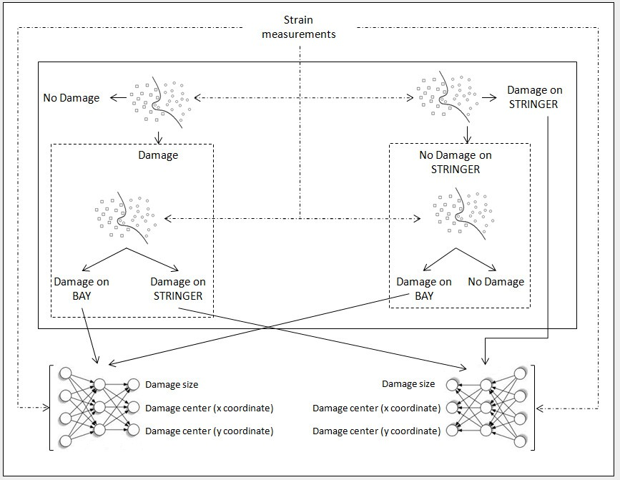

Fig. 2 – Diagnosis task performed by using SVM classification framework to detect a possible damage and identify the involved component (bay or stringer). At the bottom two ANNs, one for damage on bay and one for damage on stringer respectively, devoted to

the further characterization of the damage (i.e., centre and size), as already presented in the previous work of Candelieri et al. 2013

In detail, detection of a possible damage and identification of affected component have been developed according to two different strategies. In the first (left side of the Fig. 2) a SVM is used to discriminate between “damage” and “no damage” and another SVM is then used – if a damage have been detected – to differentiate between “damage on stringer” and “damage on bay”. In the second strategy (right side of the Fig. 2) a SVM is used to discriminate between “damage on stringer” and “no damage on stringer” and a second SVM is then used – if no damages are detected on stringer – to differentiate between “damage on bay” and “no damage”. The last strategy resulted the most reliable in the previous work of Candelieri et al, 2013.

# Results

The following Table 2 summarizes results obtained by the application of the SVM classification framework for the detection of possible damage and the identification of the affected component, according to the two different approaches proposed and depicted in the previous Fig. 2. In table 2 results obtained by the ANN hierarchies based system (Candelieri et al. 2013) are also reported, for a comparison. Respect to the previous authors’ work, in this case the discrimination between first approach resulted the most promising and reliable.

Table 2 – Results: comparison with previous study.

Task

Best Accuracy

(on 3 folds cross validation)

Best Accuracy

(on three folds cross validation) Previous Study: ANN hierarchies

|  |  |  |
| --- | --- | --- |
| First Approach  Damage/No Damage | 99.92% | 80.02% |
| Damage on Bay/Damage on Stringer | 99.97% | 79.53% |
| Second Approach  Damage on Stringer/No Damage | 93.40% | 84.86% |
| Damage on Bay/No Damage | 99.73% | 93.05% |

# Discussions and future works

This paper reviews a previous decision support system for the assessment of structural health of the helicopter fuselage panels based on hierarchies of ANNs (Candelieri et al. 2013). Although that system proved to be sufficiently reliable, authors have investigated the potential benefits offered by the adoption of a SVM classification framework to perform two specific tasks of the diagnosis process, in particular the detection of a possible damage and the identification of the affected component (bay or stringer).

The approach provided relevant improvements in terms of reliability on both tasks, offering overall average performances higher than 99% and an increase between 6% and 20% respect to the previous results.

As future works authors plan to extend the SVM classification framework to regression tasks, in order to improve also the other steps of the diagnosis and prognosis currently performed through ANN hierarchies, that are the estimation of damage centre and size (damage characterization) and the prediction of the damage evolution over time.

# Acknowledgements

This paper stems from the research project HECTOR (HEliCopter fuselage Crack moniToring and prognosis through on-board sensOR network) sponsored by the European Defence Agency (EDA).

# References

1. Katsikeros CE, Labeas GN. Development and Validation of a Strain-based Structural Health Monitoring System, Mechanical Systems and Signal Processing 2009; 23:372–383.
2. Zienkiewicz OC, Taylor RL, Zhu JZ. The finite Element Method: Its Basis and Fundamentals. 6th Ed. Butterworth-Heinemann; 2005.
3. Maniatty AM, Park E. Finite Element approach to inverse problems in dynamic elastography, Proceedings of the 5th International Conference on Inverse Problems in Engineering: Theory and Practice; 2005.
4. Song J, Gu RJ. A Finite Element Based Methodology for Inverse Problem of Determining Contact Forces Using Measured Displacements, Proceedings of International Conference on Engineering Optimization; 2008.
5. Sbarufatti C, Manes A, Giglio M. Advanced stochastic FEM-based artificial neural network for crack damage detection, Proceedings of Forth International Conference on Computational Methods for Coupled Problems in Sciences and Engineering, Coupled Problems 2011; 2011.
6. Sbarufatti C, Manes A, Giglio M. ANN based Bayesian hierarchical model for crack detection and localization over helicopter fuselage panels’, Advances in Safety, Reliability and Risk Management, ESREL 2011; 378–385.
7. Guez A, Ahmad Z. Solution to the inverse kinematics problem in robotics by neural networks’, Proceedings of IEEE International Conference on Neural Networks; 1988;2:2617-624.
8. Hoole SRH. Artificial neural networks in the solution of inverse electromagnetic field problems, Magnetics, IEEE Transactions on , 1993; 29(2):1931-1934.
9. Trivailo PM, Dulikravich GS, Sgarioto D, Gilbert T. Inverse problem of aircraft structural parameter estimation: application of neural networks, Inverse Problems in Science Engineering, 2006;14(4):351-363.
10. Candelieri A, Sormani R, Arosio G, Giordani I, Archetti F. Assessing Structural Health of Helicopter Fuselage Panels through Artificial Neural Networks Hierarchies, International Journal of Reliability and Safety, 2013 (in press).
11. Candelieri A, Conforti D. A Hyper-solution Framework for Classification Problems via Metaheuristic Approaches. 4OR: A Quarterly Journal of Operations Research. Springer Berlin/Heidelberg. 2011; 9(4):425- 428.
12. Candelieri A, Conforti D. A Hyper-Solution Framework for SVM Classification: Application for Predicting Destabilizations in Chronic Heart Failure Patients. The Open Medical Informatics Journal. 2010;4:135-139.
13. Hideki S, Shin-Etsu F, Tomonaga O, Nobuo T, Toshimitsu Jr Y. Structural health monitoring of cracked aircraft panels repaired with bonded patches using fiber bragg grating sensors, Applied Composite Materials, 2006; 13(2):87 – 98.
14. Heredero RL, Frövel M, Belenguer T, Barrera-Vilar D, Quirós FG, Garcia-Olcina R, Vague J, Sales S. Demonstration of the use of Fiber Bragg Grating for optical sensing (FIBOS) during an aerospace mission, Proceedings of the 4th European Workshop on Structural Health Monitoring, 2008; 833-839.
15. Chandler K, Ferguson S, Graver T, Csipkes A, Mendez A. On-line structural health and fire monitoring of a composite personal aircraft using an FBG sensing system, Proceedings of SPIE - The International Society for Optical Engineering - Smart Sensor Phenomena, Technology, Networks, and Systems 2008; 6933.
16. Fernández-López A, Güemes A, Gonzalez-Requena I, De Miguel-Giraldo C, Menéndez JM. Damage detection in composite repair patches using embedded optical sensors’, Proceedings of the 4th European Workshop on Structural Health Monitoring, 2008;818-824.
17. Forman, R.G., and Mettu, S.R. (1992) ’Behavior of Surface and Corner Cracks Subjected to Tensile and Bending Loads in Ti-6A1-4V Alloy’, Fracture Mechanics, Twenty-second Symposium, Vol. 1, ASTM STP 1131, H. A. Ernst, A. Saxena, and D. L. McDowell, eds., American Society for Testing and Materials, Philadelphia, 1992, pp. 519-546.
18. Valentini G, Masulli F. Ensemble methods, in Neural Nets. 2486 of lecture notes in computer science, 2002; 3–20.