Available online at [www.sciencedirect.com](http://www.sciencedirect.com/)



AASRI Procedia 1 (2012) 394 – 399

AASRI

Procedia

[www.elsevier.com/locate/procedia](http://www.elsevier.com/locate/procedia)

2012 AASRI Conference on Computational Intelligence and Bioinformatics

# A Local Fiscal Health Index Model Based on Extended Matter- Element Evaluation

YiFei Chena,b, DongSheng Liua,b, JiCheng Wuc , Lan Sunc

*aCollege of Computer Science & Information Engineering*

*bCenter for Studies of Modern Business ,Zhejiang Gongshang University ,HangZhou,China* [*chenyifei_linda@163.com*](mailto:chenyifei_linda@163.com)

*cSunyard System Engineering Co., Ltd* [*lhy@sunyard.com*](mailto:lhy@sunyard.com)

**Abstract**

Due to the influence of the fiscal crisis, the health of the local finance operation has been paid more and more attention. As a result, this essay puts forward a local fiscal health index model according to the problem of the operation of the local fiscal healthy operation. By describing the related concepts and application mechanism of the extenics and matter-element model, the extended matter-element evaluation model will be constructed, which will be used as the evaluation method of local fiscal health index model. With expert investigation and entropy weight method, the essay selects indicators from all kinds of indicator selections which affect the local fiscal health of the operation, establishing the local fiscal health index model, and use the extended matter-element evaluation model to evaluate the local financial. Results demonstrate that the local fiscal health index model, which is based on the extended matter-element evaluation, is a practical model.

2012 Published by Elsevier B.V. Selection and/or peer review under responsibility of American Applied Science Research Institute Open access under [CC BY-NC-ND license.](http://creativecommons.org/licenses/by-nc-nd/3.0/)

*Keywords:* The local finance; The extended matter-element evaluation model; Health index model

## Introduction

As an important part of the national finance, the local finance plays an important role in the rapid and stable development of the country's economy. Local fiscal health run is influenced by various economic and social factors, therefore, existence of potential risks to the future operation effect. Nowadays, many models or

2212-6716 © 2012 Published by Elsevier Ltd. Open access under [CC BY-NC-ND license.](http://creativecommons.org/licenses/by-nc-nd/3.0/)

doi:10.1016/j.aasri.2012.06.061

system can only reflect the past or current local fiscal conditions, which do not reflect the future direction of the local finance. It gets a lot of restrictions in the practical application. Therefore, the practical local fiscal health index model will analysis and monitor the operation of the local financial accurately, which makes a difference in the stable and rapid development of economy.

At present, with the construction of local fiscal index model, there are many widely applied methods, such as expert research method, data mining and so on. Hana Polackova (1998) established the famous fiscal risk matrix--Polackova matrix[1], in which proposes the concept of direct debt, contingent debt, dominant debt, implicit debt. It is an effective tool to analyze and evaluate the local government debt. Lifeng Liu(2001) adopted some internal factors and external factors indicators to evaluate the sustainability and fiscal risk degree of the national debt policy[2]. However, these indicators on reflection of fiscal risk is partial and scattered, which have the certain capriciousness.

Therefore, combining with the extenics and matter-element evaluation theory, the essay constructs the local fiscal health index model based on extended matter-element evaluation, which provides new basis of monitoring the health of the local finance operation.

## The local fiscal health index model based on extended matter-element evaluation

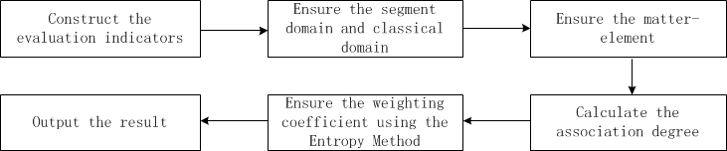This essay uses the extended matter-element model to build the local fiscal health index model. The basic thought is that using the extended matter-element method as a evaluation model of local financial health index model, then selecting all the indicators of local fiscal health index model, ensuring the practicability and validity of the model, reducing the complexity of the influence factors in the financial operation process and making the model can monitor the health of the local finance operation through the way of combining the data and the index model. The specific steps of local fiscal health index model based on extended matter-element evaluation are shown in Figure 1.

Fig.1. Structure of the local fiscal index model

* 1. *The local fiscal indicators at all levels*

The indicators selection in this article will center on three key factors that affect the local financial health operation - income, expenditure and debt. After taking experts investigation, the local financial risk comprehensive evaluation can be made of 14 indicators in all. The details are shown in Figure 2.

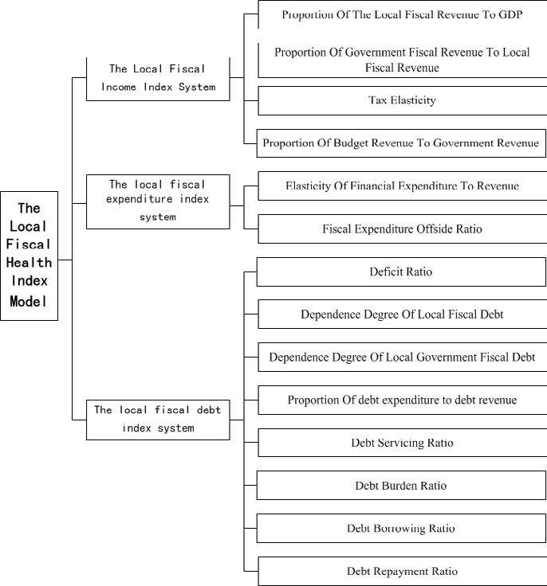

Fig.2. The local fiscal indicators at all levels

* + 1. Proportion Of The Local Fiscal Revenue To GDP C1, C1 = local fiscal income/GDP. (2) Proportion Of Government Fiscal Revenue To Local Fiscal Revenue C2, C2 = government fiscal revenue/local fiscal revenue.

(3) Tax Elasticity C3, C3 = percentage increase in tax/percentage increase in GDP. (4) Proportion Of Budget Revenue To Government Revenue C4, C4 = budget revenue/government revenue. (5) Elasticity Of Financial Expenditure To Revenue C5, C5 = growth rate of fiscal expenditure/growth rate of financial income. (6) Fiscal Expenditure Offside Ratio C6, C6 = fiscal offside expenditure/fiscal total expenditure. (7) Deficit Ratio C7, C7

= annual fiscal deficit/annual GDP. (8) Dependence Degree Of Local Fiscal Debt C8, C8 = debt the same year/local fiscal expenditure. (9) Dependence Degree Of Local Government Fiscal Debt C9, C9 = debt the same year/government fiscal expenditure. (10) Proportion Of debt expenditure to debt revenue C10, C10 = debt service the same year/ debt revenue the same year. (11) Debt Servicing Ratio C11, C11 = debt service the same year/ fiscal revenue the same year. (12) Debt Burden Ratio C12, C12 = debt/GDP the same year. (13) Debt Borrowing Ratio C13, C13= debt occurred in the same year/ GDP that year. (14) Debt Repayment Ratio C14, C14 = the interest amount of the maturity debt /GDP.

* 1. *The determination of segment domain and classical domain*

Nj expresses the jth dipartite risk evaluation level, when j = 1, 2, 3, 4, Nj are respectively {risk level},

{warning level}, {conservative level} and {sefety level}; Ci expresses the ith evaluation indicator. Vji = (aji, bji) is quantity value range of Nj about Ci , that is, data area classical domain of all items about their corresponding evaluation indicators. When j = 1, 2, 3, 4, the quantity value range is respectively (70, 100), (50.70), (20, 50), (0, 20). Besides, Np expresses all items, vpi is the quantity value rage of Np about Ci, which is the segment domain Np.

Now analysis a local fiscal situation, establish classical domain matter-element matrix R1, R2, R3, R4, segment domain matter-element matrix Rp and the matter-element matrix R:

{risk level}

{warming level}{conservative level}

{safety level}

4

|  |  |  |  |  |  |
| --- | --- | --- | --- | --- | --- |
| *N* 1 *C* 1 | (70,100) |  | *N* 2 | *C* 1 | (50,70) |
| *C* 2 | (70,100) |  |  | *C* 2 | (50,70) |
| *C* 3 | (70,100) |  |  | *C* 3 | (50,70) |
| *C* 4 | (70,100) |  |  | *C* 4 | (50,70) |
| *C* 5 | (70,100) |  |  | *C* 5 | (50,70) |
| *C* 6 | (70,100) |  |  | *C* 6 | (50,70) |

|  |  |  |  |  |  |  |  |  |  |  |  |  |  |  |
| --- | --- | --- | --- | --- | --- | --- | --- | --- | --- | --- | --- | --- | --- | --- |
|  |  |  |  |  |  |  |  |  |  |  |  |  |  |  |
| *N* 3 | *C* 1  *C* 2 | (20,50)  (20,50) |  | *N* 4 | *C* 1  *C* 2 | (0,20)  (0,20) |  | *Np* | *C* 1  *C* 2 | (0,100)  (0,100) |  | *N* 0 | *C* 1  *C* 2 | 40  43.6 |
|  | *C* 3 | (20,50) |  |  | *C* 3 | (0,20) |  |  | *C* 3 | (0,100) |  |  | *C* 3 | 22 |
|  | *C* 4 | (20,50) |  |  | *C* 4 | (0,20) |  |  | *C* | (0,100) |  |  | *C* 4 | 26.5 |
|  | *C* 5 | (20,50) |  |  | *C* 5 | (0,20) |  |  | *C* 5 | (0,100) |  |  | *C* 5 | 21.2 |
|  | *C* 6  *C* 7 | (20,50)  (20,50) |  |  | *C* 6  *C* 7 | (0,20)  (0,20) |  |  | *C* 6  *C* 7 | (0,100)  (0,100) | *R*  |  | *C* 6  *C* 7 | 22  35.3 |

*R* 1 

*C* 7 (70,100)

*C* 8 (70,100)

*C* 9 (70,100)

*R* 2 

*C* 7 (50,70)

*C* 8 (50,70)

*C* 9 (50,70)

*R* 3 

*C* 8 (20,50)

*C* 9 (20,50)

*R* 4 

*C* 8 (0,20)

*C* 9 (0,20)

*Rp* 

0

*C* 8 (0,100)

*C* 9 (0,100)

*C* 8 58.4

*C* 9 45.2

*C* 10

*C* 11

*C* 12

*C* 13

*C* 14

(70,100)

(70,100)

(70,100)

(70,100)

(70,100)

*C* 10

*C* 11

*C* 12

*C* 13

*C* 14

(50,70)

(50,70)

(50,70)

(50,70)

(50,70)

*C* 10 (20,50)

*C* 11 (20,50)

*C* 12 (20,50)

*C* 13 (20,50)

*C* 14 (20,50)

*C* 10

*C* 11

*C* 12

*C* 13

*C* 14

(0,20)

(0,20)

(0,20)

(0,20)

(0,20)

*C* 10

*C* 11

*C* 12

*C* 13

*C* 14

(0,100)

(0,100)

(0,100)

(0,100)

(0,100)

*C* 10

*C* 11

*C* 12

*C* 13

*C* 14

26

34.8

24.3

30.5

32.1

* 1. *The association degree calculation of the matter-element about the various evaluation rank*

T (xi, vji) expresses the distance between point xi and classical domain interval vji. T (xi, vpi) expresses the distance between point xi and segment domain interval vpi. The association degree Kj(xi) expresses the

membership degree of all indicators of matter-element about all the evaluation rank j. If Kj (xi) = Max Kj (xi), j < (1, 2,..., m), the evaluation indicator xi belongs to rank j.

 *T*(*xi*,*vji*) ,(*x*  *v* )

*vji*

 *i ji*

*Kj*(*xi* )  

*(1)*

 *T*(*xi*,*vji*)



 *T*(*xi*,*vpi*)  *T*(*xi*,*vji*)

,(*xi*

 *vji* )

*T*(*xi*,*vji* ) 

*xi*  1 (*aji*  *bji* )  1 (*bji*  *aji* )

*(2)*

2 2

*T*(*xi*,*vpi* ) 

*xi*  1 (*aji*  *bji* )  1 (*bpi*  *api* )

*(3)*

2 2

*vji*

 *bji*  *api* ,(*i*

 1,2,… ,*n*;*j*

 1,2,… ,*m* )

*(4)*

Calculating matter-element according to formulas (1)-(4) calculation can work out Kj (xi), in which i = 1, 2,... , 14; j = 1, 2,... ,4.The result is as shown in Table 1.

Table 1. The result of association degree calculation

|  |  |  |  |  |  |  |
| --- | --- | --- | --- | --- | --- | --- |
| Kj(xi) | K1 | K2 | K3 | K4 | maxKj(xi) | Conclusion |
| x1 | —0.429 | —0.200 | 0.333 | —0.333 | 0.333 | conservative level |
| x2 | —0.377 | —0.128 | 0.172 | —0.351 | 0.172 | conservative level |
| x3 | —0.686 | —0.560 | 0.100 | —0.083 | 0.100 | conservative level |

|  |  |  |  |  |  |  |
| --- | --- | --- | --- | --- | --- | --- |
| x4 | —0.479 | —0.270 | 0.587 | —0.311 | 0.587 | conservative level |
| x5 | —0.411 | —0.176 | 0.272 | —0.340 | 0.272 | conservative level |
| x6 | —0.686 | —0.560 | 0.100 | —0.083 | 0.100 | conservative level |
| x7 | —0.496 | —0.294 | 0.714 | —0.302 | 0.714 | conservative level |
| x8 | —0.218 | 0.253 | —0.168 | —0.480 | 0.253 | warning level |
| x9 | —0.354 | —0.096 | 0.119 | —0.358 | 0.119 | conservative level |
| x10 | —0.629 | —0.480 | 0.300 | —0.188 | 0.300 | conservative level |
| x11 | —0.503 | —0.304 | 0.740 | —0.298 | 0.740 | conservative level |
| x12 | —0.653 | —0.514 | 0.215 | —0.150 | 0.215 | conservative level |
| x13 | —0.564 | —0.390 | 0.525 | —0.256 | 0.525 | conservative level |
| x14 | —0.541 | —0.358 | 0.605 | —0.274 | 0.605 | conservative level |

* 1. *The determination of the weighting coefficients by Entropy Method*

The information entropy can be used to evaluate the degree of system information order and its utility. the judgment matrix consists of evaluation indicators determine the weighting coefficient of indicators. The calculation procedure is as follows:

* + 1. Construct judgment matrix R of m things and n evaluation indications: *Rmn*  (*xij*)*mn*(*i*  1,2,…,*n*;*j*  1,2,…*m*)
    2. Normalize the judgment matrix and use the following formula to get normalized judgment matrix B:

*bij*

 (*xij*  min *xi* )(max *xij*  min *xi*)

*(5)*

In the formula: maxxij is the most satisfied one and minxi is the most unsatisfied one among the different things with the same evaluation indicator.

* + 1. According to the definition of entropy, the entropy of n evaluation things and m evaluation indicators is as follows:

*m*

*H*   *fij* ln(*fij*) ln(*m*)(*i*  1,2,3,…,*n*;*j*

*j* 1

 1,2,3,…,*m*) where

*fij*

*m*

 (1  *bij* ) (1  *bij* )

*j* 1

*(6)*

* + 1. Calculate the evaluate indicator entropy weight:

*W*  (*wi* )*i*  *n*;*wi*

*n*

 (1  *Hi* ) (*n*   *Hi* ),*where*

*i* 1

*n*

 *wi*  1

*i* 1

*(7)*

Calculate entropy weight of evaluation indicators Wi according to the formulas (5)-(7):

Wi =(0.087010707 , 0.087010707 , 0.015625817 , 0.033454935 , 0.033454935 , 0.015625817 ,

0.087010707,0.054178356,0.033454935,0.033454935,0.054178356,0.194610695,0.135464545,

0.135464545)T (i=1,2,⋯,14)

* 1. *The determination of the weighting coefficients by Entropy Method*

The comprehensive association degree of matter-element about level j:

*n*

*Kj*(*po* )   *aiKj*(*vi* ),(*i*

*i* 1

 1,2,3,… ,*n*;*j*

 1,2,3,… ,*m* )

*(8)*

In the formula: Kj (p0) is the comprehensive association degree of matter-element about level j. Kj (vi) is

the association degree of matter-element about level j. wi is the weighting coefficient of every evaluation indicators. If Kj (p0) = maxKj (p0), j < (1, 2, 3,..., m), the evaluation indicator vi belongs to level j.

According to the formula (8), K1 (p0) = 0.513219348, K2 (p0) = 0.309932985, K3 (p0) = 0.376313759, K4

(p0) = 0.275210922. Because Max Kj (p0) = K3 (p0) = 0.376313759 belongs to the conservative level, although it don't have much risk, it's still far away from security level, it is necessary to pay more attention to the development of the local fiscal health K3 (p0).

## Peroration

The essay puts forward local fiscal health index model based on extended matter-element evaluation to ensure segment domain and classical domain through of indicators at all levels through the extended matter- element evaluation, calculating the weighting coefficient of indicators at all levels through entropy method, analyzing the association degree and finally arrive at the situation of local finance operation. Experiment shows that the local fiscal health index model constructed by extenics theory can make the complex uncertainty questions be abstracted as formalized model. It has clear concepts, simple calculation and high resolution of evaluation results.

## Acknowledgements

This research is supported by National Natural Science Foundation of China (Grant No. 71071140), Technology Plan Project of Hangzhou(Grand No. 20102011A22) as well as Research on healthy index model facing the local finance (NO.1130XJ1711228) and Modern business centre of Zhejiang GongShang University. We would like to thank the anonymous reviewers for their insightful comments and constructive suggestions provided during the review process, which have greatly contributed to improve the quality of the original manuscript.

## References

1. HANA POLACKOVA BRIXI. Contingent Government Liabilities: A Hidden Risk for Fiscal Stability, Policy Working Paper No.1989, The World Bank,1998.1-53.
2. Li-feng Liu. Review: National Debt Sustainability and Financial Risk Policy Conference. Macroeconomics, 2001,(5):49-50.
3. Tie-jun Qou, Hai-xing Zhang, Local Government Debt Risk Assessment and Warning System, Finance Forum, 2004.
4. Yu-qing Guo, Construction of Local Financial Risk Warning Index System, Western Finance and

Accounting, 2003.

1. Guan-cen Wu, You-zhao Liu, Guang-hui Fu, Social Benefit Evaluation of Land Reconsolidation Projects Based on Entropy-Weighted Extentic Matter-Element Model, China Land Science, 2008.
2. Wen-hui Xun, You-zhao Liu, Yu-qing Wang, Sustainable Utilization of Cultivated Land Based on Information Entropy and Matter-element Model—A Case Study of Jiangsu Province, Research of Agricultural Modernization, 2006.
3. Zhi-yong Zhu, Yin Wu, An Analysis Framework of Fiscal Risk with Endogenous Institutional Factors: Model and Empirical Studies, The Study of Finance and Economics, 2005,(2): 5-13.