Available online at [www.sciencedirect.com](http://www.sciencedirect.com/)

**ScienceDirect**

AASRI Procedia 5 (2013) 200 – 208

2013 AASRI Conference on Parallel and Distributed Computing and Systems

A Mobile Chinese Calligraphic Training System Using Virtual Reality Technology

Yingfei Wua,*, Zhenming Yuana, Dibin Zhoua, Yizhou Caib

*aHangzhou Normal Univerisity, No. 16, Lane Xuelin, Hangzhou,310036, China*

*aHangzhou Shengli Primary School, No. 199, Fuchunjiang Road, Hangzhou,310016, China*

**Abstract**

Traditional method to learn Chinese calligraphy needs long hour’s practice and the practice process often makes learners feel boring. And learners cannot get instant evaluation result during training. In this paper we introduce a new mobile Chinese Calligraphic training system based on virtual reality. The system is inspired by the way of tradition way to learn calligraphy which includes three main steps: a) learning stroke order of character; b) copying writing; c) real writing. Firstly the system demonstrates the right stroke order of calligraphic character with 2D and 3D mode. Secondly learner can write on iPad screen to practice copying writing. Meanwhile the leaner’s writing track will be captured and evaluated according the similarity. The result of user studies shows that our system can successfully guide learners to improve their writing skills and motive them to learn calligraphy.

© 2013 The Authors. Published by Elsevier B.V. Open access under [CC BY-NC-ND license.](http://creativecommons.org/licenses/by-nc-nd/3.0/)

© 2013 Published by Elsevier B.V. Selection and/or peer review [under responsi](http://creativecommons.org/licenses/by-nc-nd/3.0/)bility of American Applied Science Research Institute

Selection and/or peer review under responsibility of American Applied Science Research Institute

*Keywords:* Chinese calligraphy, Animation, Virtual reality, Computer aided education

# Introduction

Chinese calligraphy is the gems of ancient Chinese art and was listed as a UNESCO intangible Cultural

* Corresponding author. Tel.: 0086-139-581-774-05; fax: 0086-571-288-653-55.

*E-mail address:* [hardwyf@hotmail.com.](mailto:hardwyf@hotmail.com)

2212-6716 © 2013 The Authors. Published by Elsevier B.V. Open access under [CC BY-NC-ND license.](http://creativecommons.org/licenses/by-nc-nd/3.0/) Selection and/or peer review under responsibility of American Applied Science Research Institute doi:10.1016/j.aasri.2013.10.079

Heritage in 2009. Now more and more people start to learn calligraphy for its beauty and happiness it brings during the writing process. But the study process for beginner is hard because Chinese characters have lots of different font styles and some characters have different stroke order with different font style. Traditional method of learning calligraphy includes three main steps: a) learning the stoke order of character; b) copying writing; c) writing by memory. There are mainly two ways to learn calligraphic writing. The first way is to attend calligraphic lessons in which a guider shows the right writing stroke order, demonstrates the writing process, points out the mistakes of the students, and give suggestions to improve. It is the most effective way but some learners do not have time to attend lessons and teachers are not available. Another reason is that these lessons often cost lots of money. The second way is self-leaning by watching demonstration video such that learners can learn stroke order and method of using brush with different pressure. However students may still feel difficult to completely master writing stroke order and perform correctly. And the pressure between pen and paper is hardly for guider to demonstrate and explain clearly. It also suffers the shortage as watching video, i.e., lack of instant feedback.

Now much research work focused on helping learner to practice with help of computer virtual technology. Kamen Kanev introduced a tangible kanji representations attempting to bring flat written kanji back to the tangible 3D world where learners can get proper touch and feel of them (Kamen Kanev et al., 2012). A dancing training system by which user can imitate the motion demonstrated by a virtual teacher projected on the wall screen and mistake is given according student’s motion captured is introduced (Jacky C.P. Chan, 2011). Nathan outlines the relationship of spatial abilities, computer graphics education, and a methodology for pilot testing. A working prototype of a virtual reality-based version of spatial abilities assessment instrument is introduced (Nathan W. Hartman et al., 2006). Virtual reality is widely used in computer education and the effect to decrease learning process is confirmed (Elinda Ai-Lim Lee et al., 2010). Commercial 3D engine such as Unity3D is widely used in virtual system for it integrates creating and editing 3D objects in a one platform and can export to source code for Android and iOS. A virtual education system (Kari L. Clase et al., 2009) and methodology for the development of dynamic virtual reality applications based on 3D engine is introduced (Nikolaos Papastamatiou et al., 2010).

Also there are many interesting research work done in the field of computed aided calligraphic education. Ip proposed a model to simulate the real writing (Sam T.S. Wong et al., 2005). A remote haptic calligraphy system in which an operator controls a slave manipulator with a calligraphy brush by using a haptic interface device is introduced (Yutaka Ishibashi et al., 2007). By this system a teacher can instruct a student at a remote location to use a calligraphy brush. Some augmented calligraphy education systems that aim at supporting leaner's self-training are introduced (Takahiro Shichinohe et al., 2011). To summarize these researches are not appropriate for training purposes because of the following limitations: 1) the training process could not be practiced anywhere and anytime; 2) during the training period teacher should be on line; 3) the three main steps of learning calligraphy could not be fully covered.

In this paper we introduce a calligraphic virtual education system which covers the three main steps of learning calligraphy. Learner can use an App running on iPad to learn basic stroke order, practice copying writing and virtual writing everywhere and every time as client.

This paper is organized as follows. Firstly the objective of our system and the system structure are described. Secondly main functions and algorithms of the client App are described. Thirdly, experimental result is presented. Finally the conclusion is described.

# Our Objective: A Mobile Calligraphic Training System

Our objective is to give a whole technical solution to help people learn calligraphy in a virtual way. It needs to include calligraphic image pre-process to extract stroke order and stroke thickness. With the final



Fig. 1. Basic steps of calligraphic image preprocessing module

iPad 11:59 75%

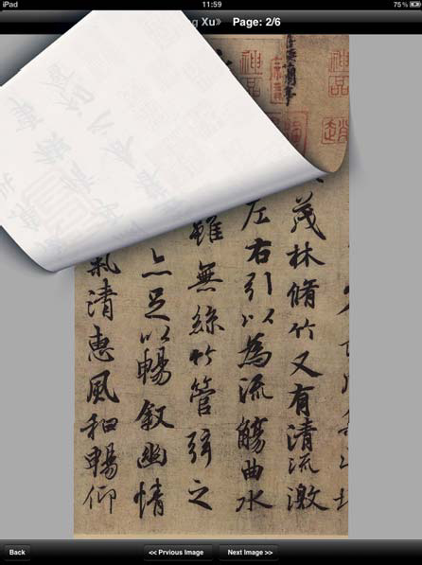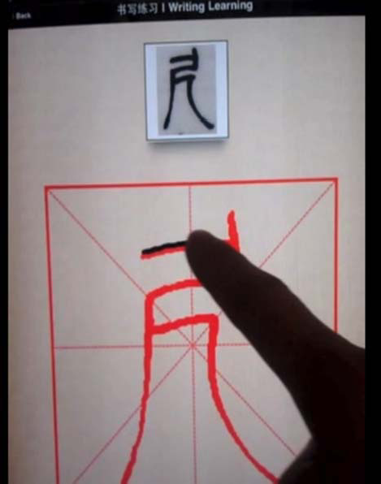

<<Previous Image

Xu>> Page:2/6

Back Writing Learning

Back

Next Image>>

(a) (b)

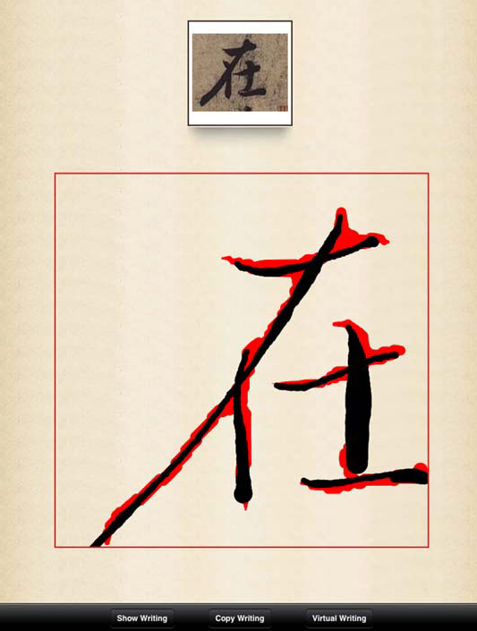

Show Writing

Copy Writing

Virtual Writing

(c)

Fig. 2. (a) preview of the product; (b) copying writing process; (c) copying writing result

extraction result users can use iPad as a terminal to learn right stroke order, practice copying writing, virtual which are the three leaning steps of traditional method of learning calligraphy. To meet the need of study everywhere, the application should be run on mobile platform without internet connection.

The whole system includes two parts: 1) the calligraphic image preprocessing module; 2) the client application as shown in Fig.1. The preprocessing module aims at extracting stroke thickness and stroke order from the skeleton of image using the thinning algorithm. It includes the process to check and remove spurious vertex and spurious cluster points from skeleton to avoid wrong stroke order extraction. Algorithm of stroke thickness extraction and stroke order extraction can be found in our previous research work (Ying-fei Wu et al., 2007). The second part is an App running on iOS. The App is organized with a whole calligraphic product and has functions such as 2D and 3D writing process recurring, copying writing and virtual writing. Other function such as previewing whole product is also supported as shown in Fig.2. (a).

# Client App

* 1. *2D writing process recurring*

2D writing process recurring is used to demonstrate writing process by 2D animation method. It is helpful for learner to master the right stroke order. In tradition way, showing the writing process is often given by teacher face to face. The shortcoming of traditional way is that the writing process demonstrated by teacher cannot cover all the characters in calligraphic class and if someone wants to see the demonstration more times it will make teacher boring.

The recurring process is applied by showing the writing process along the stroke order extracted in preprocessing module dot by dot (each pixel along the stroke). And each dot is showed with the feature of current stroke thickness which is also extracted during the preprocessing module.

* 1. *Copying writing*

Copying writing is a traditional method to learn how to use tip of a writing brush to write different shape at the start point, at the corner or at the end of a stroke. The evaluation rule of copying writing is that more similar with the original image is better. As writing brush is made of soft material and it can easily change shape and stroke thickness with different direction and pressure during the writing process. But in our App it is difficult to achieve as iPad screen is without pressure sensor. To simulate stroke thickness change, we use the writing speed as an import factor which will affect stroke thickness. An assumption is made that the writing speed and stroke width have an inverse relationship. The following formula presents the detail between stroke width and writing speed:

*t i* 1

*t i* 1, *t i* 1



*t i*



*r*, *st i* 1  *v*

*st i* 1  *v*

*r*, *st i* _1  *v*

*(1)*

where *t ri* means the stoke thickness of user writing process at time t when user write to the ith pixel of

skeleton, is a standard increment of stroke width. Fig.2. (b) and (c) show the copy wring process and

copying writing result using stroke thickness simulation method. We can choose different value for *r* to simulate different materials of brush hair, such as weasel hair or goat hair which are commonly used.

* 1. *Demonstration of 3D writing recurring*

The aim of developing 3D writing recurring is to let the user have more choice and interest to learn the stroke order. Fig. 3 is some key frames snap of the 3D writing process.

The 3D engine adopted in our project is Unity3D for it’s a powerful engine fully integrated with a set of intuitive tools and rapid workflows to create interactive 3D object. The main reasons of the choice of Unity3D for our system are: 1) 3D object and different kinds of lights can easily be edited; 2) user interaction is well supported by widely used script language such as JavaScript, C# and so on; 3) the 3D scene created in Unity3D can be exported as an iOS project in the code level. We embed the Unity3D scene into our App project in code level. In the 3D scene the movement of brush is along to the stroke order extracted from original calligraphic image by pre-processing module. The main app scene passes stroke order to 3D scene by “PlayerPrefs”.

# Evaluation

Based on the above research result, we implement four Apple Apps using three famous classical calligraphic products. These Apps can download from App Store with “CADAL” or “Chinese Calligraphy” as keywords. To evaluate the performance of our system, we totally invited 80 pupils to attend our calligraphic learning test for 5 times. During each test all the students are randomly selected into a tradition learning group and another group using our training system. The objective is to investigate the system performance from the following perspectives:

 Mastering stroke order: To test if the students master the right stroke order more efficiently using the system.

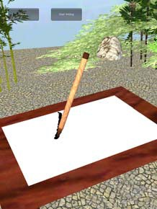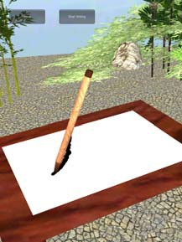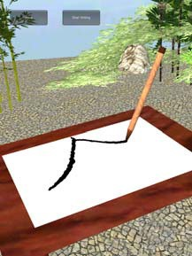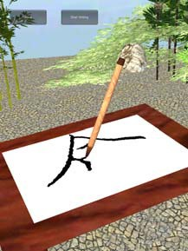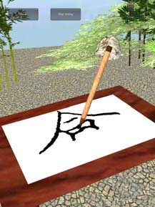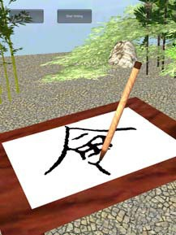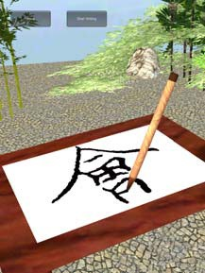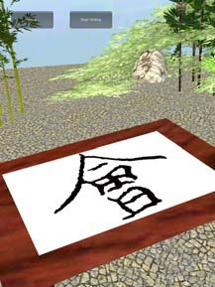

Fig. 3. Some key frames of writing process recurring

Table 1. Comparison of accuracy of mastering stroke order between two methods

|  |  |  |  |  |  |
| --- | --- | --- | --- | --- | --- |
|  | Normal Font | Lishu | Cursive Handwriting | Seal Character | Small Seal Character |
| Traditional method | 63.2% | 32.3% | 48.2% | 31% | 29% |
| Method using system | 66% | 72% | 79% | 75% | 73% |

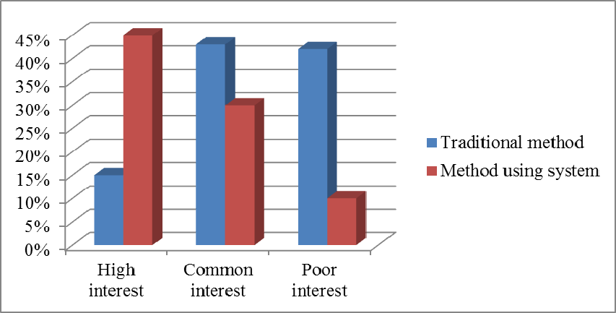

Fig. 4. Comparison of interest between two methods

 Comparing with the traditional training method: To test if our system is prior to the traditional method and if the system can motivate students more eager to learn calligraphy?

Table 2. Sales data of different markets

Markets Units

China 13241

USA 889

Taiwan 431

Hong Kong 282

Canada 189

Australia 146

Japan 138

Singapore 118

UK 102

Malaysia 81

* 1. *Mastering stroke order*

In each test every student was assigned to learn 10 calligraphic characters in 40 minutes. The five tests used different font types: Normal font, Lishu, Cursive Handwriting, Seal Character and Small Seal Character. After 40 minutes learning each student was required to virtual write on the iPad to check. Table 1. shows the difference of the two groups. With the help of the system students can master stroke order more quickly. We find that for Normal Fonts the difference between traditional method and method using the system is small. The reason for the small difference is that Normal Font calligraphic character is now still used in daily writing thus few mistakes are made. However for the other three fonts the difference between two groups is obvious for these font types are nearly new to most of the students.

*4.2. Comparing with the traditional training method*

Our system is evaluated to check if it can raise learner’s interest by some surveys. The survey has three options such as you have high interests, common interests or poor interest in calligraphy. The comparison result between two groups is shown in Fig. 4. It shows that our system effectively raise the learner interest in learning calligraphy. For further reason of the difference, we find by personal interview that the learner’s using the system can master calligraphy quickly and they are also pleased to use new science technology which make them happy during the training period.

# Conclusion

In this paper we discuss some key algorithms of Chinese calligraphic writing process recurring and stroke width simulation. Based on these ideas, we implement a virtual Chinese calligraphy training system based on iOS that can help people enjoy the writing beauty of calligraphy character and set good writing examples for users to follow in 2D and 3D mode. The learners’ real-time writing track can be captured and evaluated according similarity. These Apps can help learner master the right writing method faster than traditional method and motivate learner’s interest of learning calligraphy.

These Apps have been online in App Store for about 9 months. By the end of Feb, 2013, the sales data of global markets are shown in Table 2. The total of download units is more than 15,000. Download is from many countries and most is from China as now more and more people start to learn calligraphy.

# Acknowledgements

This project is supported by the 211 Key Project of Chinese Ministry of Education: CADAL (201003009), the National Science Foundation for Young Scholars of China (61103171), Zhejiang Provincial Natural Science Foundation of China (Grant No. Z12F020027) and Soft Science Project of Hangzhou (20120834M33).

# References

1. Kamen Kanev, Itaru Oido, Rentaro Yoshioka, Nikolay Mirenkov. Employment of 3D Printing for Enhanced Kanji Learning. HCCE '12 Proceedings of the 2012 Joint International Conference on Human- Centered Computer Environments, pp. 165-170, 2012.
2. Jacky C.P. Chan, Howard Leung, Jeff K.T. Tang, Taku Komura. A Virtual Reality Dance Training System Using Motion Capture Technology. IEEE TRANSACTIONS ON LEARNING TECHNOLOGIES, VOL. 4, NO. 2, APRIL-JUNE 2011.
3. Nathan W. Hartman, Patrick E. Connolly, Jeffrey W. Gilger,Gary R. Bertoline, Justin Heisler.Virtual Reality-based Spatial Skills Assessment and its Role in Computer Graphics Education. ACM SIGGRAPH 2006 Educators Program:International Conference on Computer Graphics and Interactive Techniques,2006
4. Elinda Ai-Lim Lee, Kok Wai Wong, Chun Che Fung. Learning with Virtual Reality: its Effects on Students with Different Learning Styles. Transactions on Edutainment IV, pp. 79 – 90, Jan. 2010.
5. Kari L. Clase, Nicoletta Adamo-Villani, S. Lee Gooding, Aman Yadav, Jeffrey D. Karpicke, Marcia Gentry. Enhancing Creativity in Synthetic Biology with Interactive Virtual Environments. Proceedings of the 39th IEEE International Conference on Frontiers in Education Conference, 2009.
6. Nikolaos Papastamatiou, Theofanis Alexandridis, Konstantinos Tsergoulas, Alex Michopoulos, Nikolaos

V. Karadimas. Virtual Reality Applications with User Interface for Dynamic Content Development. Proceedings of the 4th WSEAS international Conference on Computer Engineering and Applications, 2010.

1. Sam T.S. Wong, Howard Leung, Horace H.S. Ip. Model-based Analysis of Chinese Calligraphy Images, 9th Intl. Conf. on Information Visualization (IV05), London, England, July 2005.
2. Yutaka Ishibashi, Toshio Asano. Media Synchronization Control with Prediction in a Remote Haptic Calligraphy System. ACE '07 Proceedings of the International Conference on Advances in Computer Entertainment Technology, pp.79 – 86, 2007.
3. Takahiro Shichinohe, Tetsuo Yamabe, Takahiro Iwata, Tatsuo Nakajima. Augmented Calligraphy: Experimental Feedback Design for Writing Skill Development. Proceedings of Tangible and Embedded Interaction, pp.301-302, 2011.
4. Ying-fei Wu, Yue-ting Zhuang, Yun-he Pan, Jiang-qin Wu, Fei Wu. Research of 3D Chinese Calligraphic Handwriting Recur System and Its Key Algorithm, MIRAGE 2007, LNCS 4418, pp. 105–116, 2007.