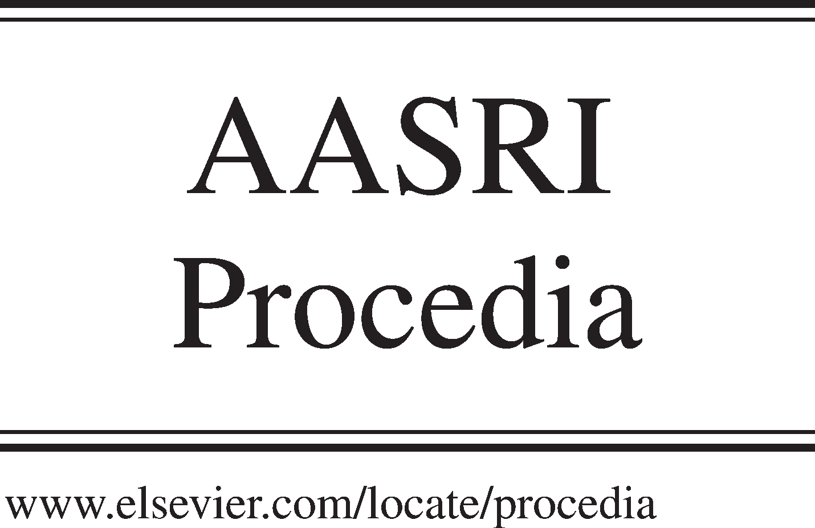Available online at [www.sciencedirect.com](http://www.sciencedirect.com/)

**ScienceDirect**

AASRI Procedia 5 (2013) 40 – 47

2013 AASRI Conference on Parallel and Distributed Computing and Systems

A Mode Shifting Resource Allocation Scheme for Device-to- Device Underlaying Cellular Network

Junshu Gao, Xuewen Liao, Jianguo Deng, Pinyi Ren

*Electrical Engineering and Computer Science The School of Electronic and Information Engineering*

*Xi’an Jiaotong University Xi’an, People’s Republic of China*

**Abstract**

Device-to-Device (D2D) communication underlaying a cellular network is a promising technique, and it has recently been proposed for booming local services, which will greatly improve system capacity by sharing the same resource blocks of cellular users at the same time. However, the mutual interference brought by inappropriate resource reuse will deteriorate the performance of the whole system. In this paper, a mode shifting resource allocation scheme is presented without channel state information (CSI) of D2D link and D2D user to cellular user link. D2D pair traditionally shares resource block of cellular user with the best channel to reduce the relative interference to cellular link. While in the other way, for the same purpose, the D2D user can also reuse the resource block over which its transmitter has the worst channel between itself and base station (BS), in addition a simple strategy is put up to select the reusing mode that provides larger capacity. Numerical results show that our proposed scheme performs significantly better than reference scheme in terms of system capacity and outage probability of cellular link, besides the scheme will not cause any extra complexity.

© 2013 The Authors. Published by Elsevier B.V. Open access under [CC BY-NC-ND license.](http://creativecommons.org/licenses/by-nc-nd/3.0/)

© 2013 Junshu Gao, Xuewen Liao, Jianguo Deng, Pinyi Ren[. Published by](http://creativecommons.org/licenses/by-nc-nd/3.0/) Elsevier B.V. Selection and/or peer review under responsibility of American Applied Science Research Institute

Selection and/or peer review under responsibility of American Applied Science Research Institute

*Keywords*: Device-to-device (D2D) communication, resource allocation mode shifting;

2212-6716 © 2013 The Authors. Published by Elsevier B.V. Open access under [CC BY-NC-ND license.](http://creativecommons.org/licenses/by-nc-nd/3.0/) Selection and/or peer review under responsibility of American Applied Science Research Institute doi:10.1016/j.aasri.2013.10.056

## Section 1. Introduction

In recent a couple of years, the scarcity of spectrum have drawn much attention from companies and research institutes, and to provide some additional technique for local service may be a practical way to solve this problem. A researcher from Nokia and his team have firstly brought the conception of device-to-device (D2D) communication mode into LTE cellular network [1]. Different from other techniques based on the infrastructure of cellular network, D2D pair can set up a link and communicate directly as Fig. 1 shows. In cellular network, when D2D users share the same spectral resource blocks (RBs) with some cellular users, the spectral efficiency will be improved. Meanwhile the cellular user will be influenced by the interference from D2D transmitter. To better control the interference, BS will be still in charge of assigning the sharing RBs to D2D devices. Due to its higher spectral efficiency and simple signaling, D2D communication may be an efficient part of future network as a supplement communication. Already existing research mainly contains two parts: power allocation and transmission mode selection. In [2-6], satisfactory results have been obtained in different scenarios on power control and communication mode selection.

Fig.1. LTE network with D2D link

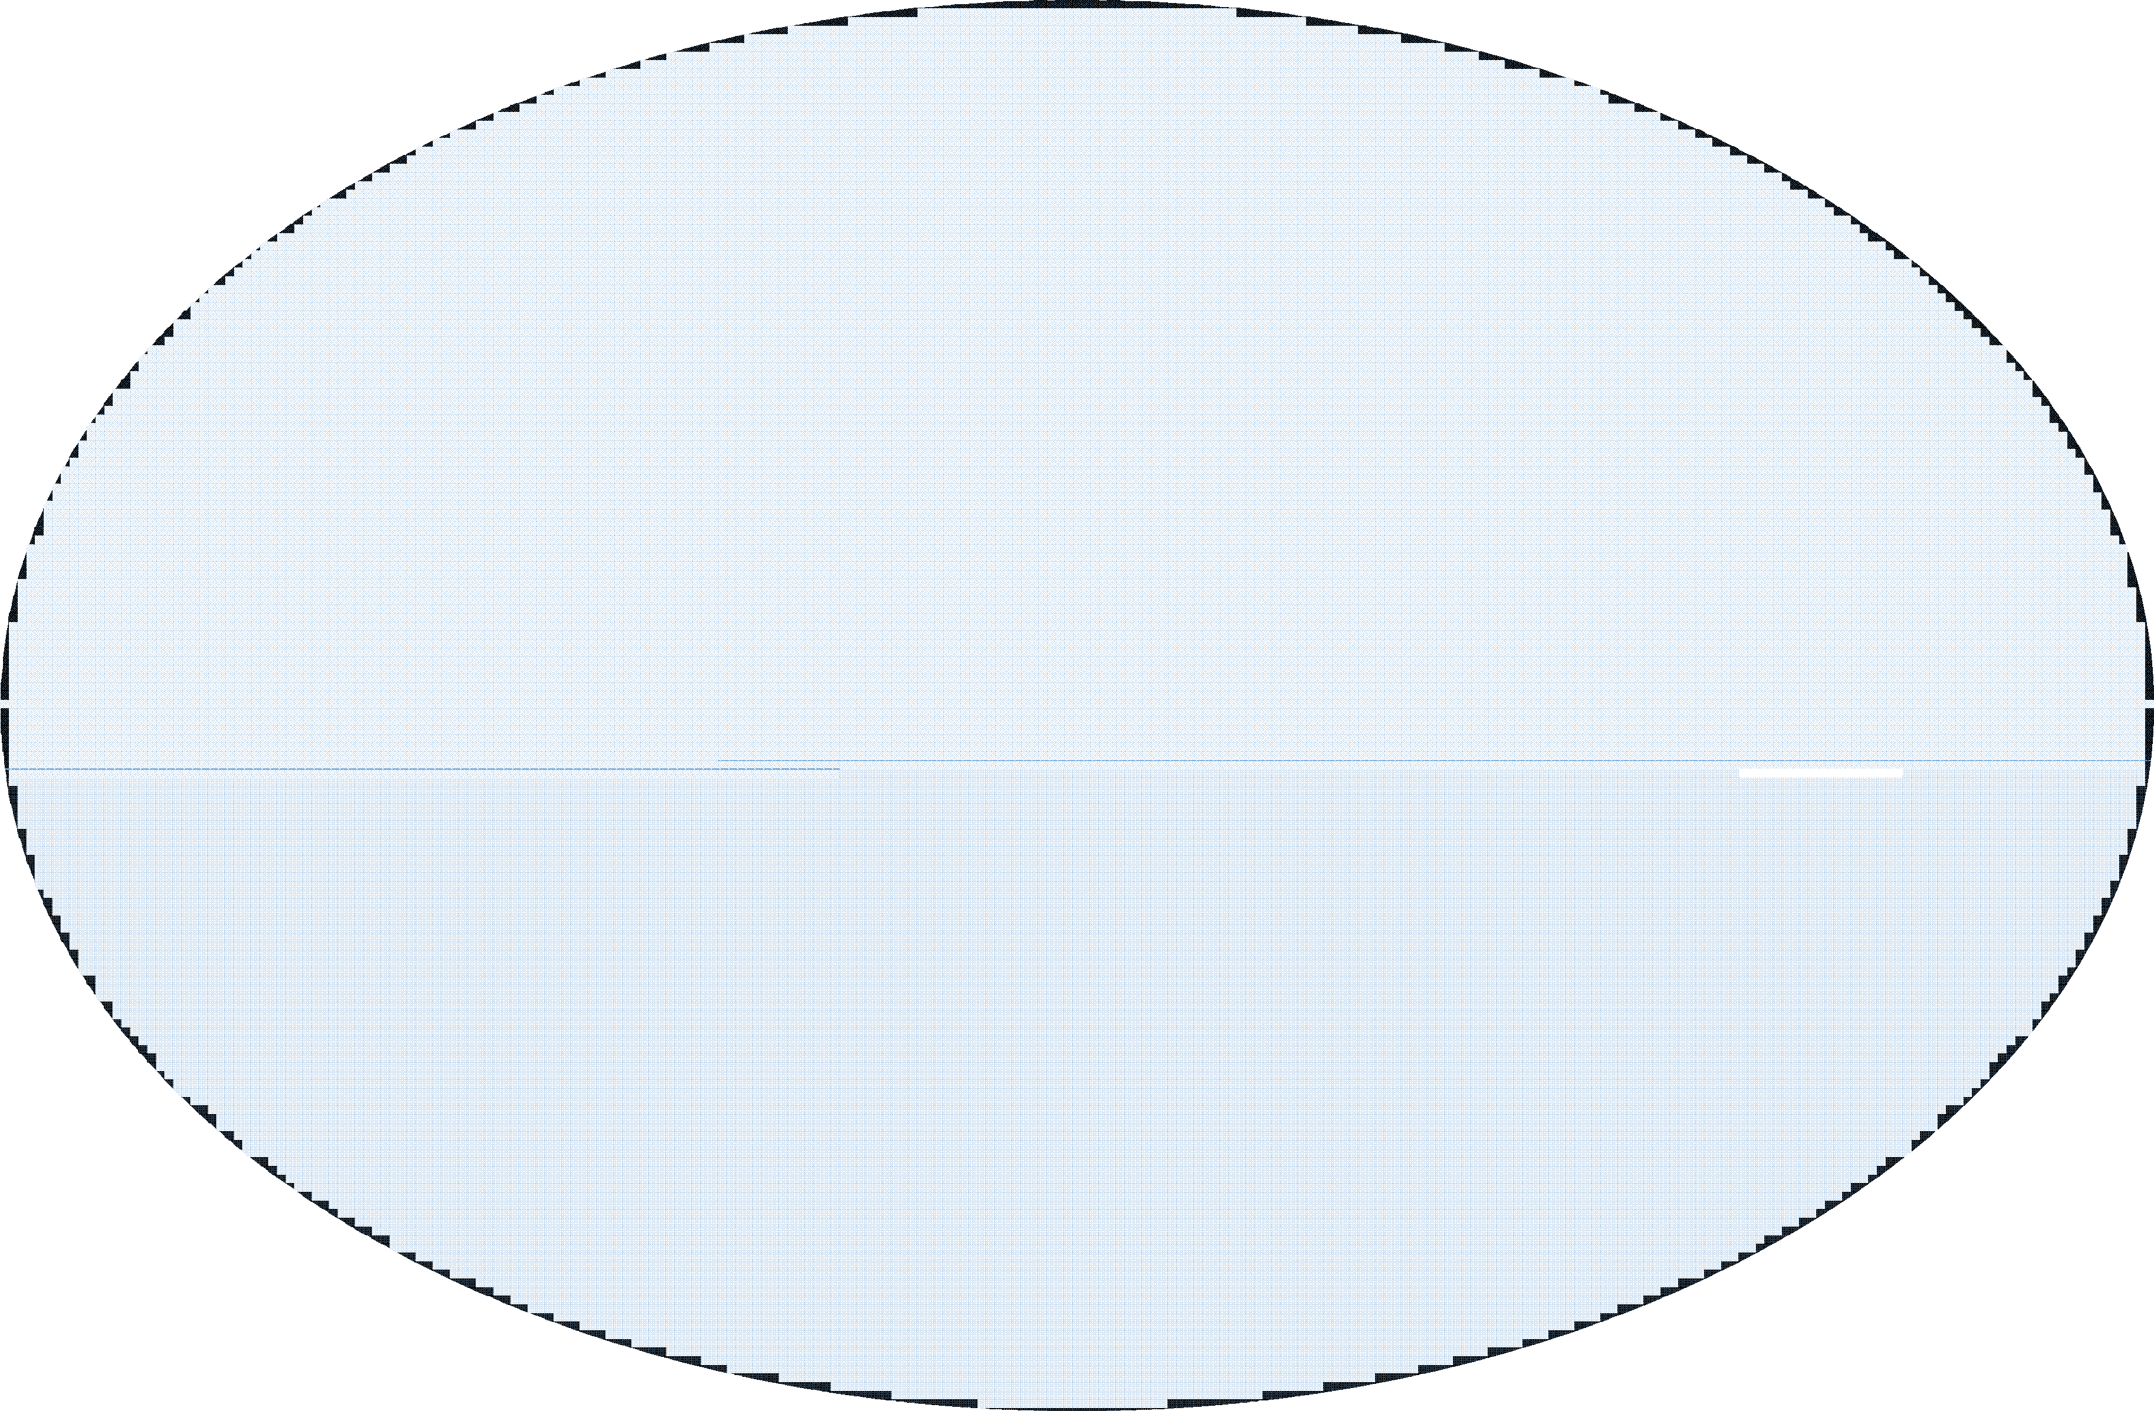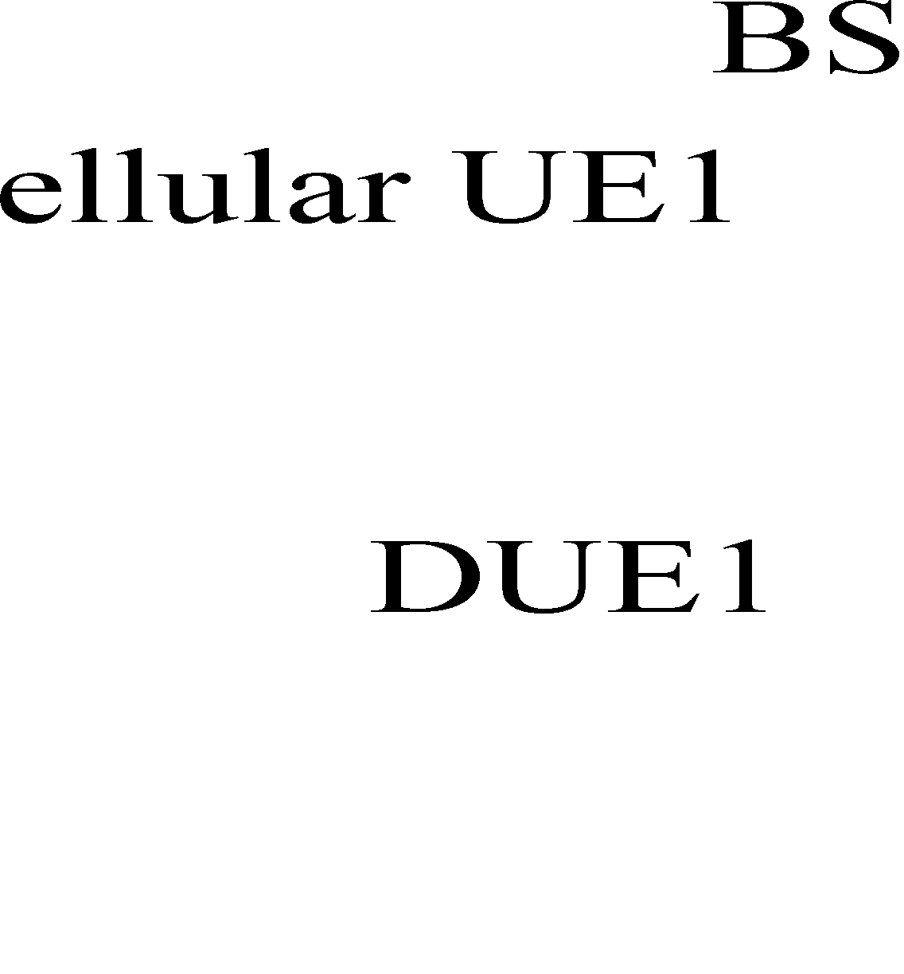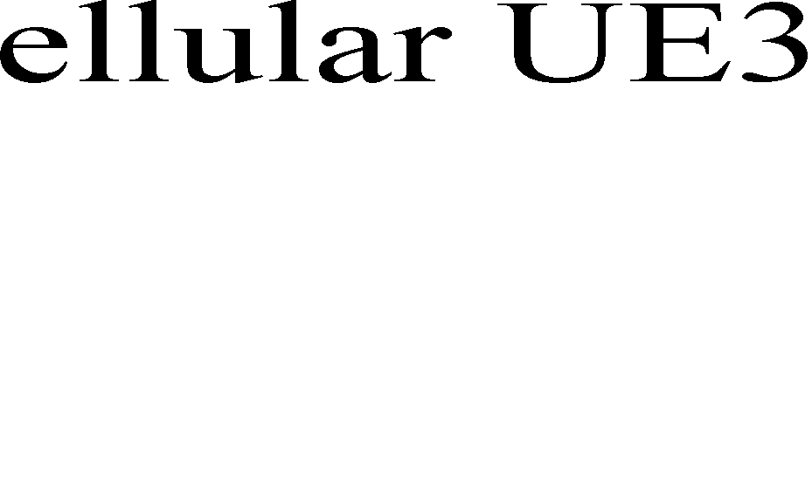

Fig.2. System model of D2D link and one cellular user sharing the same RB.

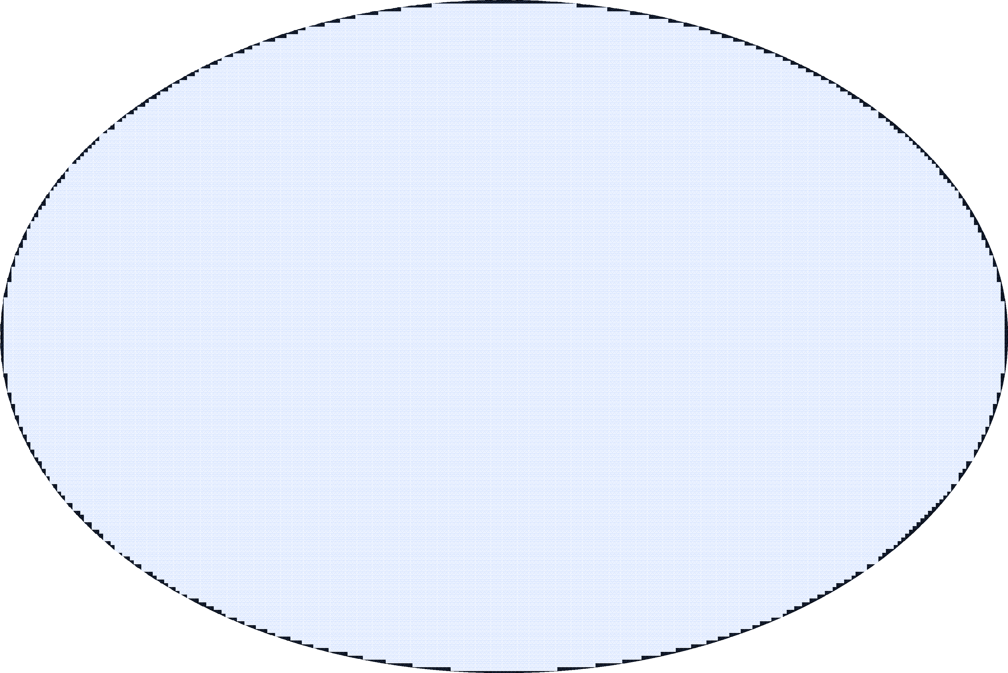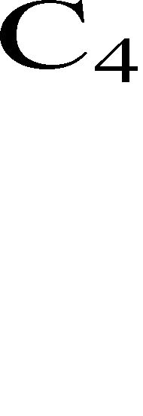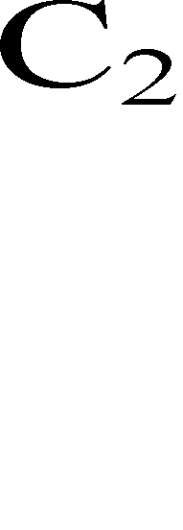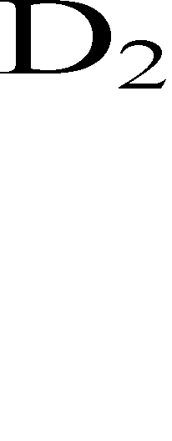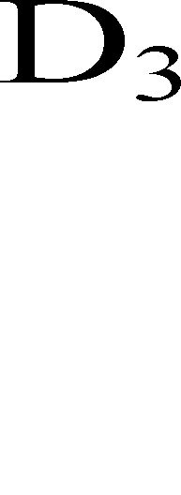

Yu *et al*. proposes a simple power control scheme for D2D transmitters on the condition that signal-to- interference-plus-noise-ratio (SINR) distribution could be derived by statistical methods. So the system can set a certain threshold to control the interference from D2D users [2]. Also, their advanced research includes another power allocation scheme, in which BS dynamically coordinates the interference between the cellular link and D2D link without suspending the cellular link service [3]. What’s more, Hakola describes the system throughput by equations to analyze the performance of the system in the cellular network with D2D communication mode [4]. In [5], a mode selection procedure has been concluded which takes into account the link quality and the situation of D2D pair, when D2D users share either cellular uplink or downlink resource, and the working mode of D2D user depends on the values of the two parameters. Furthermore, a more detailed power control scheme for D2D devices is proposed, which changes the D2D transmitter power in dynamic tuning step [6]. In fact, research in field of resource allocation also improves the performance of whole system significantly, and a resource allocation scheme is proposed which allocates appropriate resource for D2D users according to the lowest data rate of cellular user as needed to ensure the QoS of cellular user [7]. All the research requires that the original power allocation and signaling protocols in LTE network need to be changed, and this will affect the compatibility of the algorithm with the original system. Especially when BS needs to know the CSI of those links which are not linked to it directly, the system will pay a lot more for signaling overhead.

In this paper, no power allocation or other relevant protocols in original LTE network will be changed, and we are chiefly concerned with how to exploit the difference of channel state information (CSI) when D2D transmitter occupies different RBs, and then propose a resource allocation scheme that enhances the signal or reduces the interference separately. According to the CSI of cellular users and the CSI of D2D transmitters to BS, the system will properly select out the resource allocation mode with larger capacity. The rest of this paper is structured as follows. Section 2 describes the basic model when D2D communication exists in LTE networks. The detailed proposed resource allocation mechanism is given in Section 3, and Section 4 presents some convincing numerical results. The last section comes to the conclusion.

## Section 2. System Model

Suppose the resource allocation process of cellular users has been complete, then the BS collects the CSI of cellular user and D2D transmitter. BS allocates proper resource to D2D users according to the channel information linked to it and maximizes the system capacity. In order to achieve higher throughput, we formulate the problem as an optimization process of allocating appropriate RBs to D2D users. Users in a D2D link enabled network can communicate with each other directly as shown in Fig. 2. *C1, C2, C3* and *C4* represent cellular users. Moreover, *D1, D2, D3* and *D4* are D2D users. The SINR of D2D pair *d* and the cellular user *c* are calculated as *d* and *c* :

# *d P g*

 *c c d dd*

*(1)*

*d*



*N*

0 *c*

*Pc gcB*



*N*

0

*d*

*c d dB*

*d P g*

*c*

*d*

*c c cd*

*P g*

*(2)*



The problem comes out to be an optimising problem as below:

*Maximize*

*D C C*

*d n C * *n C (3)*

*c c d c c*

*d c c*



*s*.*t*. *P g*

*t* arg *et* (*N*

*d P g* ),

*(4)*

1. *cB c*

0 *d c d dB*

# *d P g*

*t* arg *et* (*N*

*d P g* );

*(5)*

*c c d dd d* 0 *c c c cd*



*c*

*d * 1;



*c*

1. *c*

*d * 1;

*(6)*

**Nomenclature**

*d c*

an indicator variable that

*d c*

1 when D2D pair *d* shares RB(s) with cellular user *c* , otherwise

*d c*

0

*gcd*

*Pd*

the channel gain between cellular user *c* and receiver of D2D pair *d*

the transmitting power of D2D pairs

*Pc*

*gdd*

*gcB*

*N*0

the transmitting power of cellular users the channel gain between D2D pair

the channel gain between BS and cellular user *c* .

the power spectral density of AWGN

Formula (3) is the optimization objective. Conditions in (4) and (5) guarantee the lowest SINR of the cellular link and D2D link, and the constraint in (6) ensures that different cellular users will occupy different RBs and each RB can only be reused by one D2D pair at most. In order to integrate the D2D communication in to LTE network smoothly, the uplink power control has been applied to cellular users and D2D transmitters [8], so here we can ignore the impact of different distances to BS and the receiving power of cellular user and D2D user are equal at BS. However, solving the aforementioned problem seems still impossible within such a short time delay in LTE networks.

## Section 3. Proposed resource allocation scheme

In the model described previously, we can find that the problem comes out to be a MINLP one, and an exhaustive searching scheme could get a solution under the condition that when we simplify some constraints of the problem, however, even so the complexity of exhaustive searching scheme is exponential, and it goes beyond the range that the system can support when the numbers of cellular users and D2D pairs become large. Thus some simple heuristic algorithms are needed.

* 1. *Reference scheme*

In literature [9], the authors have proposed a resource allocation algorithm that improves network

performance in terms of the system capacity. The proposed scheme selects out the best several resource blocks of cellular users, and then assigns to D2D pairs in a decreasing order. Through careful observation of the expression of *c* , we can see that higher channel gain ( *gcB* ) from cellular user *c* to BS could obtain higher *c* . Thus, any cellular user with high channel coefficient can share RBs with the D2D pairs. For each RB selected out, the D2D pair whose channel gain between its transmitter and BS is lowest will reuse it, and that is to make the maximum in expression (7):

*Ccelluar*

*C*

 *B* log2 (1 *c* )

*c*

*(7)*

* 1. *Proposed scheme*

In our proposed scheme, we not only follow the scheme that assigns the best RBs for cellular users, but also focuses on the worst resource block for D2D users in the links between D2D transmitters and BS separately to control the interference source. This would be a perfect supplement to the reference scheme without any extra complexity. The scheme can be divided into three steps.

Step 1: BS selects out several best resource blocks, as the process has been shown in Algorithm 1, and BS

*c*

will finally get a resource allocation matrix

*d* (1) .Then BS computes the whole capacity under this condition.

*C*(1)

*D C C*

*d* (1)*n C * *n C (8)*

*c c d c c*

*d c c*

Step 2: BS selects out the resource blocks according to the CSI of one particular D2D pair on each RB that could be reused. If the worst resource block for each D2D pair is different, then BS will update the resource allocation matrix at once. Otherwise the D2D pair that has the lowest channel gain will share resource block, other D2D pairs continue to check its second worst resource block, until each D2D pair has one particular resource block to share as shown in Algorithm 2. Then BS computes the whole capacity as (9):

*C*(2)

*D C C*

*d* (2)*n C * *n C (9)*

*c c d c c*

*d c c*

Step 3: BS compares the capacity of algorithm 1 and algorithm 2, and then it chooses the one that has a larger capacity during the time slot.

*C * max(*C* (1),*C* (2)) *(10)*

Repeat the process in every time slot. Actually, the feature of our proposed scheme is considering either the CSI of cellular users first or D2D pair first. In addition, we can figure out that the complexities of the two algorithms are the same. Our scheme is the combination of the two algorithms, so the complexity of our proposed scheme is the same magnitude as the reference one.

Table 1. Algorithm 1 and algorithm 2



**1*.*** *C* : list of Sorting the CSI for users in decreasing order

*D :* List of D2D pairs to reuse RBs

**2.** *Gd* : list of sorting the CSI of D2D pair *d* on each RB in increasing order.

*D* : List of D2D pairs to reuse RBs

**begin**

***c*=1;**

**while** *D* and *c C* do

*N*: set of RBs that can be reused

**begin**

d=1;

Pick RBs with *c * largest value Choose the D2D transmitter *d* of which

channel gain *gdB* is minimum

*Pc gcB*

*c*

**while** *N*

and *D*

do

*N*

Choose RBs with smallest *gdB* from *Gd*

For different D2D pairs, smaller *gdB* will share the RB

*Pc gcB*

*c*

0

*d c d dB*

*d P g*

*N*

0

*d c d dB*

*d P g*

*c c d dd*

*d P g*

*c c d dd*

*d P g*

*d*

*N*

0 *c c c cd*

*d P g*

*d*

*N*

0

*c c c cd*

*d P g*

**if**

*c*

*c*

*t* arg*et* and

*d*

*t* arg *et d*

**if**

*c*

*c*

*t* arg*et* and

*d*

*t* arg *et d*

share RBs with D2D pair *d*

*D D* {*d*}; *c c* 1;

**else** do not share RBs with D2D pai*d*r

**end**

share RBs with D2D pair *d*

*D D* {*d*}; *d d* 1

**else** do not share RBs with D2D pair *d*

**end**

**end end**

## Section 4. Simulation and results analysis

In this section, we provide the numerical results for our proposed scheme. We suppose that the RBs that each cellular user occupy have the same channel gain for simplicity. In a single cell with ten cellular users and several D2D pairs distributed uniformly, we obtain the capacity of relevant cellular users and D2D pairs, and

the outage probability of the cellular user will be given out as well. The pass loss model is *P*(*d* )  *cd * , where

*P*(*d* ) is the receive power at distance *d*. *c* is transmit power and  is the pass loss exponent, and the values of other parameters are set the same as those in [9].

104

0 2 4 6 8 10 12 14 16 18 20

Proposed scheme Reference scheme Exhaustive searching scheme

Capacity kbps

SNR  dB 

Fig. 3(a) The capacity one D2D pair

105

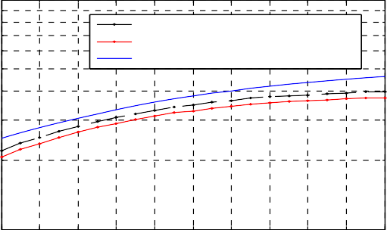

Proposed scheme Reference scheme Exhaustive searching scheme

104

Capacity (kbps)

0 2 4 6 8 10 12 14 16 18 20

SNR(dB)

Fig. 3(b)The capacity of four D2D pairs

100

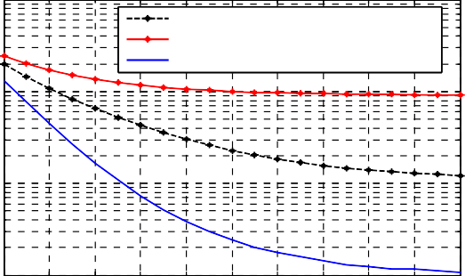

Proposed scheme Reference scheme Exhaustive searching scheme

10-1

Outage

10-2

10-3

0 2 4 6 8 10 12 14 16 18 20

SNR  dB 

Fig. 4 The outage probability of cellular user

Fig. 3(a) (b) illustrate that when one D2D pair or more D2D pairs are set in the cell randomly. As Fig.5 shows, our proposed scheme performs much better compared with the reference scheme in terms of the system capacity at the same level complexity. Fig. 4 shows the outage probability of the particular cellular user whose resource block is reused. The outage probability of our proposed scheme is only one tenth of the reference one when the SNR is 20dB and the threshold rate is 1bps/Hz. Finally, we analyze the impact of number of D2D pair on the gain that our proposed scheme obtains. It can be seen clearly that the gap between the exhaustive searching scheme and our proposed scheme becomes wider when the number of D2D pair increases. For the number of D2D pair increases, BS will select out more resource blocks. However, among the selected resource blocks to be reused, we have not yet aimed at the optimal allocation scheme that provides maximum capacity under this condition, and we only allocate the resource blocks selected based on some simple rules (i.e. the D2D transmitter with lower channel gain will reuse the RB) without increasing the algorithm complexity. The simple allocation principles will influence the performance of the system more significantly when the number of D2D pair becomes larger.

## Section 5. Conclusion

In this paper, we study the problem of resource allocation in a D2D link enabled network, where D2D users can share the resource blocks with cellular users. Taking full advantage of CSI known at BS, we

proposed a modified resource allocation scheme based on some existing research results, while the complexity remains unchanged. In terms of the average capacity and outage probability, the simulation results show that our proposed scheme performs better than the reference scheme.

## Acknowledgements

This work is supported by National Science and Technology Major Project (2010ZX03003-004-01), Science and Technology Program of Shaanxi Province No.2011K06-10)

## References

1. K. Doppler, M. P. Rinne, C. Wijting, C. B. Ribeiro, and K. Hugl, “Device-to-device communication as an underlay to LTE-advanced networks,” IEEE Commun. Mag., vol. 47, no. 12, pp. 42–29, Dec. 2009.
2. C. H. Yu, O. Tirkkonen, K. Doppler, and C. Ribeiro, “On the performance of device-to-device underlay communication with simple power control,” in Proc. IEEE VTC 2009-Spring, pp. 1-5, Apr. 2009.
3. Chia-Hao,Yu, O. Tirkkonen, “Power optimization of device-to-device communication underlaying cellular communication,” Communications. 2009,ICC ’09. IEEE International Conference on, pp.1-5 , 2009.

[4]S. Hakola, Tao Chen, Lehtomaki, Koskela,“Device-to-Device (D2D) Communication in Cellular Network- Performance Analysis of Optimum and Practical Communication Mode Selection,” Wireless Communication and Networking Conference (WCNC), 2010 IEEE

[5]K. Doppler, C. H. Yu, C. Ribeiro and P. Janis “Mode selection for Device-to-Device Communication underlaying an LTE-Advanced Network ” Wireless Communication and Networking Conference (WCNC), 2010 IEEE,April 2010.

1. Hongnian Xing, and Sami Hakola, “The Investigation of Power Control Schemes for a Device–to-Device Communication integrated into OFDMA Cellular System”, Personal Indoor and Mobile Radio Communications (PIMRC), 2010 IEEE 21st International Symposium on ,pp.1775-1780, Sep.2010
2. Xiaoyue Zhu and Si Wen, “QoS-based Resource Allocation Scheme for Device-to-Device (D2D) Radio Underlaying Cellular Networks”, in IEEE International Conference on Telecommunications, 2012 [8]Stefania Sesia, Issam Toufik and Matthew Baker. LTE-The UMTS Long Term Evolution: From Theory to Practice; 2009; ISBN: 978-0-470-69716-0.

[9]M.Zulhasnine and C.Huang “Efficient Resource Allocation for Device-to-Device Communication Underlaying LTE Network”, in IEEE Wireless Communication and Network Conference(WCNC), Sydney, Australia,April,2010