Available online at [www.sciencedirect.com](http://www.sciencedirect.com/)



AASRI Procedia 2 (2012) 50 – 55

AASRI

Procedia

[www.elsevier.com/locate/procedia](http://www.elsevier.com/locate/procedia)

2012 AASRI Conference on Power and Energy Systems

# A New Technique for High Resistance Fault Detection during Power Swing for Distance Relay

Nor Zulaily Mohamada, Ahmad Farid Abidinb*

*Universiti Teknologi MARA, Centre for Electrical Power Engineering Studies, 40450 Shah Alam, Selangor, Malaysia*

Abstract

Contingencies in power system caused oscillation in rotor angle which leads to power swing. In the case of power swing, distance relay is designed to block the operation to avoid wrong operation of relay. However, this blocking scheme proves to vulnerable as it could block the trip signals when a fault occurs during power swing. Hence, it is desired to develop the proper fault detection technique to avoid such circumstances. This paper presents a new fault detection technique during power swing based on S-Transform. To ascertain validity of the proposed scheme, it was verified with the IEEE 14 bus test system and simulations results show that the proposed technique can detect fault occurring during power swing.

© 2012 Published by Elsevier B.V. Selection and/or peer review under responsibility of American Applied Science Research Institute

© 2012 Published by Elsevier B.V. Selection and/or peer review under responsibility of American Applied Science Research Institute

© 2012 The Authors. Published by Elsevier B.V.

Selection and/or peer review under responsibility of American Applied Science Research Institute

Open access under [CC BY-NC-ND license.](http://creativecommons.org/licenses/by-nc-nd/3.0/)

*Keywords:* Distance protection; Power swing; Fault; S-Transform

1. Introduction

Cascading blackouts can be initiated due to many reasons and one of the major prominent causes is false tripping of distance relays due to power swing [1]-[2]. During power swing, the apparent impedance is fluctuating, so it will enter the relay tripping zones leading to undesired relay operation. Modern distance relay design is equipped with power swing blocking (PSB) scheme function to prevent the false tripping during

* Corresponding author. Tel.: +6019 4581985.

*E-mail address:* [norzulailymohamad@yahoo.com.](mailto:norzulailymohamad@yahoo.com)

2212-6716 © 2012 Published by Elsevier B.V. Selection and/or peer review under responsibility of American Applied Science Research Institute

Open access under [CC BY-NC-ND license.](http://creativecommons.org/licenses/by-nc-nd/3.0/) doi:10.1016/j.aasri.2012.09.013

power swing. Literature surveys up to recent years show PSB has lead to new security issue for distance relay operation.

Benmouyal *et al*. [3] and Su *et al.* [4] have tracked the power swing voltage center (PSCV) to detect a symmetrical fault during power swing. However, these methods require longer time delay thus might cause blocking relay would not reset. Mecharoui and Thomas in [5] developed the technique that can detect fault during fast power swing based on phase angle. However the technique proved to be problematical for high resistance fault. The work carried out in [6] has focused on detecting high resistance fault during power swing, but the symmetrical fault is not being considered in their studies.

A simple approach based on Fast Fourier Transform (FFT) analysis on DC component of current is used in

[7] to detect fault quickly during power swing and it works for phase earth fault, two-phase earth fault and even three-phase earth fault. Another approach based on Fast Fourier Transform (FFT) is developed by Mahamedi [8]. Unfortunately both techniques required proper selection of threshold value especially for detecting high resistance fault.

Time-frequency analysis using wavelet transform (WT) has been introduced in [9] and [10] for identification of the power swing and symmetrical faults during power swings. However the additional tools need to be developed to find the proper wavelet coefficient. Abidin *et al.* [2] introduced the use of S- Transform to characterize the features of fault and power swing. This technique found to be problematical for detection of faults with resistance more than 50 Ω.

All of the techniques which have been reported are not able to operate properly during high resistance faults and/or symmetrical fault. In order to overcome such drawbacks, the new fault detection technique during power swing based on S-Transform features of bus voltage has been proposed. In order to ascertain validity of the proposed scheme, evaluation and simulation are conducted under IEEE 14 bus test system.

1. System Description

The system used to simulate all study cases presented in this paper is IEEE 14 bus test system as illustrated in Fig. 1, extracted from [12]. It consists of 5 generators, 3 transformers, 11 loads and 20 transmission lines. The simulation model of the test system is set up by using PSCAD/EMTDC tools.

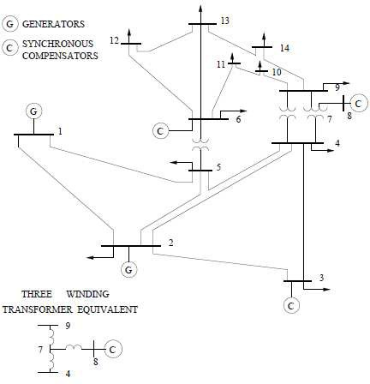

Fig. 1. Single line diagram of IEEE 14 bus test system.

1. S-Transform Theory

S-Transform is a variable window of Short Time Fourier Transform (STFT) [14]. A key feature of the S- Transform is its time-frequency domain representation. One of the methods of achieving the derivation the S- Transform is by manipulating Gaussian window function which can be defines as,

◎

*S* (** , *ƒ* )   *h*(*t*)



| *ƒ* |

(** *t* )2 *ƒ* 2

*e* 2

2**

*e* *j* 2*ƒt dt*

*(1)*

The relations between S-Transform and Fourier Transform can also be written as,

◎

*S* (** , *ƒ* )   *H* (**  *ƒ* )*e*



− 2** 2** 2

*ƒ* 2

*e j* 2** *d*

*(2)*

From equation (2), the discrete time series of S-Transform corresponding to h(t) is shown in following equation by letting τ -› k/T, f -› n/NT , and a -› m/NT,

 *n*  *N*1 *m*  *n*

− 2** 2*m*2

*n*2

*S kT* ,  *H* ( )*e*

*j* 2*mk*

*e N*

*(3)*

 *NT* 

*m*0 *NT*

where j, m, and n = 0, 1, …, N-1, T and N denote sampling interval and total of sampling point respectively.

Equation (3) can be further simplified as,

*N* 1

*m*2 *mk*

*S* *kT* , *n*   *H* ( *m*  *n* )** ( *n*2 ) ** ( *N* )

*(4)*

 *NT* 

*m*0 *NT*

where p =*e*-2π2 and 22µ=*e*j2π.

1. Proposed Scheme

The scheme proposed in this paper used S-Transform to extract the features between power swing and fault occurring during power swing based on bus voltage. The feature to detect fault is derived from the S- Transform and is given by,

*N* 1

*m*2 *mk*

*V* 



*m*0

*Vbus*

( *m*  *n* ).** ( *n*2 ) .** ( *N* )

*NT*

*(5)*

Based on equation (5), the smallest value of each of column in the matrix of δ is defined by using following equation,

*V* 

*N* 1

*m*0



*Vbus*

( min(*m*)  *n* ).** (

*NT*

(min(*m*))2

*n*2

) ( (min(*m*))*k* )

.** *N*

*(6)*

From equation (6), a row of vector of length *n*, filled with smallest value of each of column in matrix of δ is obtained. Once the smallest value of each of column in matrix of δ is obtained, the largest value of elements in array can be further obtained. The two key parameters in the proposed fault detection scheme are symbolized by *kref* and *kf*, where *kref* represent the largest value in array of when no fault occurs, and *kf* represents the largest value in array of in the event of fault occurs. Then, the criterion for the fault detection is defined as,

*k*  *k f*

*e k*

*(7)*

*ref*

The fault detection criterion is defined as, if *ke* > 1 the fault occurs, whereas if *ke* ≤ 1 there is no fault occurs.

1. Test Results
   1. *Simulation of Power Swing*

A three phase fault is triggered at different locations of the test system in order to create different cases of power swing. For example, a three phase fault for the duration of 350ms is created at line 3-4 at t=1.0s. The distance relay located near bus-5 at line 2-5 is considered in this study. Fig. 2(a) shows the typical power swing voltage waveform measured by the distance relay located near bus-5. Once the power swing has been simulated, the three-phase fault effect on the power swig can be further simulated. To perform this, a three phase fault is created at line 4-5 at t=2.5s for duration of 200ms while it is experiencing power swing. Fig. 2(b) illustrates the voltage waveform after three phase fault occurring during power swing.

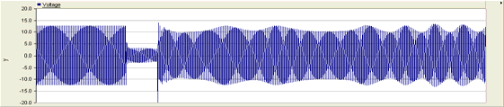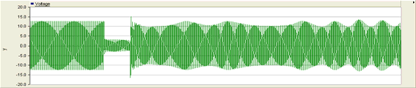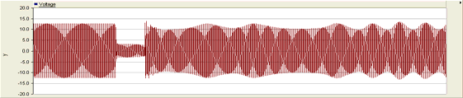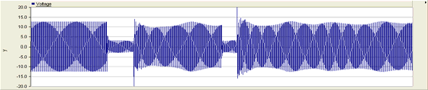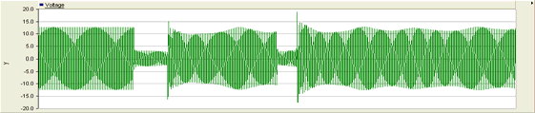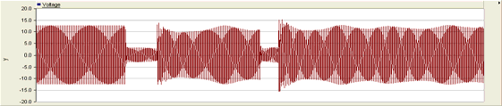

(a) (b)

Fig. 2. (a) Typical voltage waveform (from top, Phase A, B and C) during power swing; (b) Typical voltage waveform (from top, Phase A, B and C) during power swing and after three phase fault occurring at t=2.5s.

* 1. *Example Cases*

In this part, some case results are illustrated to test the effectiveness of the proposed fault detection technique during power swing. Fig. 3 shows the typical voltage waveform generated by the test system when a three phase fault occurred during power swing and the absolute S-Transform output. It is clearly observed there is significant feature between power swing and a three phase fault occurred during power swing.

20

10

Voltage (kV)

0

-10

-20

2.5 3

Original Signal

Time (s)

3.5 4

0.01

0.005

v

0

2.5 3

S-Transform Output

Time (s)

3.5 4

Fig. 3. Original and S- Transform output on voltage waveform when three phase fault occurs during power swing.

This paper used criterion of *ke* to detect fault during power swing. The value of criterion *ke* is depending on the *kf* which represent the highest level of S-Transform output. The values of *kf* around the fault point are shown in Fig. 4. In this case, there is at least one point that *ke* > 1, which means a fault occurred during power swing.

x 10-4

2

1

v

0

2.4 2.42 2.44 2.46 2.48 2.5 2.52 2.54 2.56 2.58 2.6

Time (s)

Fig. 4. Value of factor *kf* around the fault point.

Table I shows the performance of proposed scheme to detect fault during power swing with fault resistance varies from 10 Ω up to 200 Ω. In order to ascertain the effectiveness of proposed scheme, the cases of three phase to ground fault (Fault ABC-G), single phase to ground fault (Fault A-G), and double phase fault (Fault AB) has been carefully studied.

Table 1. Simulation cases for different fault resistance under power swing condition

Value of *ke*

Fault Resistance (Ω)

|  |  |  |  |
| --- | --- | --- | --- |
|  | Fault ABC-G | Fault A-G | Fault AB |
| 10 | 69.61 | 427.23 | 8.71 |
| 50 | 26.75 | 190.49 | 3.31 |
| 100 | 13.13 | 159.31 | 2.79 |
| 200 | 6.46 | 82.24 | 1.42 |

Based on all the results shown, it is clearly proven that the new proposed detection technique can detect genuine fault under all circumstances includes symmetrical and asymmetrical faults, as well as variety of fault resistance from low resistance up to high resistance.

1. Conclusion

A new fault detection technique for the distance relay during power swing has been presented in this paper. It make use of the utilization of S-Transform processing tool to process the distance relay input signals based on bus voltage to detect fault occurs during power swing. This technique is proven to detect different type of fault with different value of fault resistance.

References

1. Kundur, P.; Paserba, J.; Ajjarapu, V.; Andersson, G.; Bose, A.; Canizares, C.; Hatziargyriou, N.; Hill, D.; Stankovic, A.; Taylor, C.; Van Cutsem, T.; Vittal, V., “Definition and Classification of Power System Stability”, *IEEE Transaction on Power System*, Vol. 19, No. 2, May 2004.
2. Farid bin Abidin, Ahmad, *Adaptive Distance Protection to Prevent False Relay Tripping during Voltage Collapse and Power Swing*, PHD Thesis, 2010.
3. Benmouyal , D. Hou and D. Tziouvaras, *Zero-Setting Power-Swing Blocking Protection*, [online]

Available: <http://www.selinc.com/techpprs/6172_ZeroSetting_20050302.pdf>

1. Su, B., Dong, X.Z., Bo, Z.Q., Sun, Y.Z., Caunce, B.R.J., Tholomier, D., and Apostolov, A., “Fast Detector of Symmetrcial Fault during Power Swing for Distance Relay”, *IEEE Power Engineering Society General Meeting*, 2005.
2. Mechraoui, A. and Thomas, D.W.P., “A New Blocking Principle with Phase and Earth Fault Detection during Fast Power Swings for Distance Protection”, *IEEE Transactions on Power Delivery*, Vol. 10, No.3, July 1995.
3. Mechraoui, A. and Thomas, D.W.P., “A New Principle for High Resistance Earth Fault Detection during Fast Power Swings for Distance Protection”, *IEEE Transactions on Power Delivery*, Vol. 12, No. 4, 1997.
4. Karegar, H. K., and Mohamedi, B., “A New Method for Fault Detection during Power Swing in Distance Protection”, *6th International Conference on Electrical Engineering/Electronics, Computer, Telecommunications and Information Technology*, 2009.
5. Mahamedi, B., “A Very Fast Unblocking Scheme for Distance Protection to Detect Symmetrical Faults during Power Swing”, *Conference Proceedings IPEC*, 2010.
6. Brahma, S.M., “Distance Relay with Out-of-Step Blocking Function using Wavelet Transform”,

*IEEE Transactions on Power Delivery*, Vol. 22, No. 3, 2007.

1. Chengzong Pang, and Kezunovic, M., “Fast Distance Relay Scheme for Detecting Symmetrical Fault during Power Swing*”, IEEE Transactions on Power Delivery,* Vol. 25, No. 4, 2010.
2. Xiangning Lin, Zhengtian Li, Shuohao Ke, and Yan Gao, “Theoretical Fundamentals and Implementation of Novel Self-Adaptive Distance Protection Resistance to Power Swings, *IEEE Transactions on Power Delivery*, Vol. 25, No. 3, July 2010.
3. N. Mithulananthan, C. A. Ca˜nizares, and J. Reeve. “Indices to Detect Hopf Bifurcation in Power Systems”, *NAPS-2000*, Oct 2000.
4. Sameh K. M. Kodsi, *Accounting for the Effects of Power System Controllers and Stability on Power Dispatch and Electricity Market Prices*, PhD Thesis, 2005.
5. Yu-Hsiang Wang, *The Tutorial: S-Transform*, [online] Available:

<http://djj.ee.ntu.edu.tw/S%20transform.pdf>