Available online at [www.sciencedirect.com](http://www.sciencedirect.com/)



AASRI Procedia 2 (2012) 112 – 120

AASRI

Procedia

[www.elsevier.com/locate/procedia](http://www.elsevier.com/locate/procedia)

2012 AASRI Conference on Power and Energy Systems

# A Novel Implicit Correlation for the Operative Temperature of a PV Panel

Valerio Lo Branoa*, Giuseppina Ciullaa, Vincenzo Franzittaa, Alessia Violaa

*aDipartimento dell'Energia, Università di Palermo (Italy), edificio 9, 90128 Palermo (Italy)*

Abstract

The operating temperature of a commercial PV panel strongly affects the electric power output of the devices. The prediction of the operating temperature therefore plays a central role in the economic and energy assessment of PV systems. The authors propose a new implicit correlation that takes into account the standard weather variables but also the regimen of PV panel in terms of the proximity to the maximum power points. Data coming from an experimental set-up were processed by using the least squares technique. To validate the reliability of the correlation, a comparison between expected values and data from other common correlations were done. The results show that the regimen of the panel is strongly correlated with the operating temperature and the quality of the new correlation is generally very good.

© 2012 Published by Elsevier B.V. Selection and/or peer review under responsibility of American Applied Science Research Institute

© 2012 Published by Elsevier B.V. Selection and/or peer review under responsibility of American Applied Science Research Institute

© 2012 Valerio Lo Brano, Giuseppina Ciulla, Vincenzo Franzitta, Alessia Viola. Published by Elsevier B.V. Selection and/or peer review under responsibility of American Applied Science Research Institute

Open access under [CC BY-NC-ND license.](http://creativecommons.org/licenses/by-nc-nd/3.0/)

*Keywords*: PV cell temperature; least squares techinque; experimental data; solar cell.

1. Introduction

The need to reduce energy requirements and greenhouse gases emissions due to buildings has recently driven scientific community to the concept of Net Zero Energy Buildings (NZEBs) [1], [2]. Accurate analyses

* Corresponding author: Tel.: +39-091-23861918; fax: +39-091-484925.

*E-mail address:* [lobrano@dream.unipa.it.](mailto:lobrano@dream.unipa.it)

2212-6716 © 2012 Published by Elsevier B.V. Selection and/or peer review under responsibility of American Applied Science Research Institute

Open access under [CC BY-NC-ND license.](http://creativecommons.org/licenses/by-nc-nd/3.0/) doi:10.1016/j.aasri.2012.09.022

show that while the quality of building envelope is crucial to obtain good thermal performances, [3, 4] the use of renewable energy source such as PV systems, should permit to reach a nearly net zero energy balance [5].

This technology is founded on the photovoltaic (PV) effect, that exploits the properties of some semiconductor materials to convert solar radiation into electric energy. When sun light enters the PV cell, a part of the energy of the photons is absorbed by the semiconductor's atoms, which release electrons from the negative layer of the cell. By flowing through an external circuit, these electrons reach the positive layer and produce electricity. The power efficiency of PV is related to its “peak power”, which is the maximum power that the PV module is able to generate. The peak power of a PV cell is conventionally evaluated in the following “standard conditions”: irradiation of 1000 W/m2 (*Gref*) and cell temperature of 25°C (*Tref*). The typical power curve of a commercial PV module has always a single maximum and, in the above defined standard conditions, only about 15% of the incident solar energy is converted into electricity; the remaining part of the solar radiation is transformed into heat.

The operating temperature of the cell *Tc* is one of the most important parameter to determine the energy conversion efficiency of a PV panel; indeed, the efficiency of a PV device is a decreasing function of the *Tc* temperature. Obviously the performance of a PV module largely also depends on many other physical parameters such as the site latitude, the typical weather conditions, the panel tilt and azimuth angles, the air temperature, the wind speed, the temperature of the surrounding surfaces, the obstruction and shadow effects, the electrical load, etc. [6, 7].

To better evaluate the energy performance of a PV element it is necessary to know the thermal behaviour of the system to estimate accurately the heat flux across it; the heat transfer between the PV panel and the surrounding environment is driven by a global heat transfer coefficient, which describes the radiative and the convective exchange processes. In literature are available some empirical correlations to obtain the PV panel operating temperature. These correlations have been developed for common geometries and standard weather variables to facilitate the modelling design process of PV devices. From the mathematical point of view, the correlations for the PV operating temperature are either explicit in form, thus giving *Tc* directly, or in implicit form, i.e. they involve variables which themselves depend on *Tc*. In this last case, an iteration procedure is necessary for the relevant calculation. Most of the correlations usually include a reference state and the corresponding values of the pertinent variables [8, 9].

In practice, to evaluate the real electrical performance of a PV system, it is necessary to assess the heat exchange in actual condition, when the photovoltaic elements is working and producing electrical energy. In this paper the authors investigate a novel experimental correlation that takes into account not only the standard weather variables and common reference properties of the panel but also of the actual operating conditions as function of the electrical load.

Nomenclature

G Solar irradiation [W/m2]

G*ref* Solar irradiation at standard conditions [W/m2] MAE Mean Absolute Error

RL Electrical load [Ω]

Ta Air Temperature [°C]

Tc Celle temperature [°C]

Tref Celle temperature at standard conditions[°C] Vmmp Maximum power point voltage [V]

Voc

W

Open circuit voltage [V]

Wind speed [m/s]

1. Generalities on the PV panel behaviour

The electrical power produced by a PV devices is linked to the solar radiations on the panel but also depends on the connected electrical load *RL* as shown in Fig. 1.

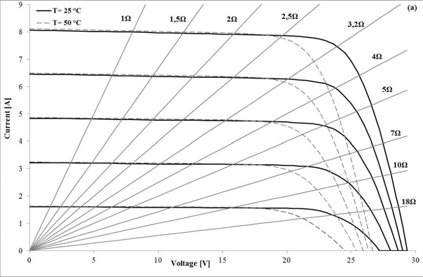

Fig. 1. Working point of a generic PV panel on I-V characteristics varying irradiation (from 1000 to 200 W/m2) and cell temperature.

Indeed, the load defines the operating point on the *I*–*V* characteristic. For given values of irradiance, temperature and electrical load, the operating point can be identified by drawing on the *I*–*V* characteristic the lines of the different *RL*. In the Fig.1 it is possible to observe how the intersection of load line and the PV characteristic corresponds to the working point; with the same graphical method it is possible to identify the working point in terms of electric power (Fig.2).

Therefore, in correspondence with a generic costant load connected to a photovoltaic panel, the working point will move along the load curve under the effect of temperature variations and irradiation during the day.

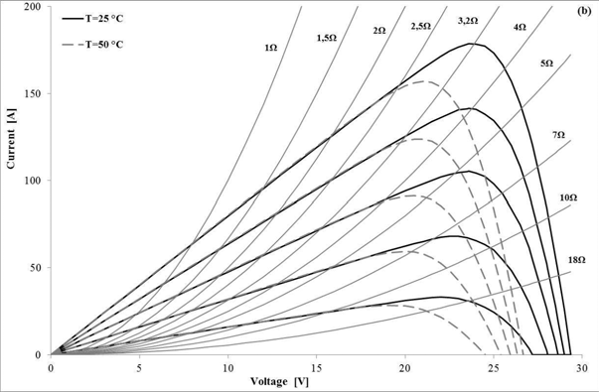

Fig. 2. Working point of a generic PV panel on I-V power characteristic, varying the irradiation (from 1000 to 200 W/m2) and cell temperature

* 1. *Identification of maximum power point*

In previous works [6, 7] the variation of open circuit voltage *Voc* at constant temperaure as function of solar radiation was related in the following form.

 *G* 

*Voc*  *Voc*,*ref*  *k* ln  *G* 

*(1)*

 *ref* 

As can be seen from Fig. 3 and Fig. 4 the points of maximum power of a generic PV panel can be well approximated by a more simple linear relation. If we take account of effects due to temperature, even the voltage pertaining the points of maximum power *Vmpp* can be derived with a linear relationship.

*Vmmp* (*G*,*Tc* )  *Vmmp* (*Gref* ,*Tref* )  *a* *Gref*  *G*   *b* *Tc*  *Tref* 

*(2)*

It is possible to immediately recognize as the electrical behavior of a generic PV panel can be represented in three modes or regimens:

1. when the ratio between the working voltage *V* and the voltage of maximum power *Vmpp* at given irradiation and temperature is less than 0.95, the characteristic *I-V* is practically almost horizontal and the power is proportional to the incident solar radiation;
2. when the ratio *V/Vmpp* for a given irradiation and temperature is greater than 1.05, the *I-V* characteristics of the panel decreases much more rapidly and the influence of irradiation becomes less significant (saturation conditions);
3. the regimen identified by a ratio 0.95 <*V/Vmpp* <1.05, characterizes the state of a PV panel connected to a maximum power point tracking system (*MPPT*) in which the load dynamically adapts to generate the maximum power.

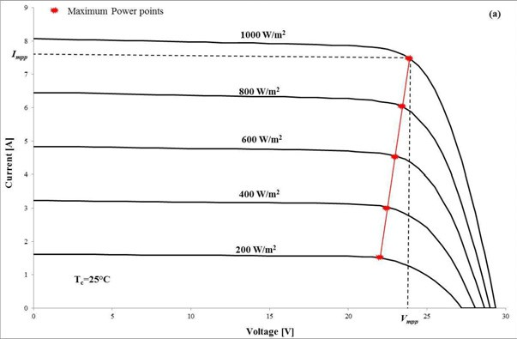

Fig. 3. Maximum power point of a generic PV panel on I-V characteristics varying irradiation (from 1000 to 200 W/m2) and cell temperature

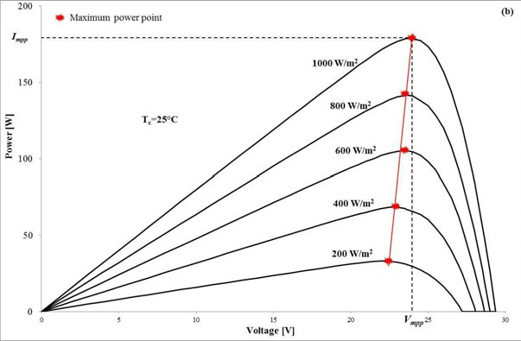

Fig. 4. Maximum power point of a generic PV panel on power characteristics varying irradiation (from 1000 to 200 W/m2) and cell temperature

The authors therefore hypothesized, in the presence of the *MPPT* systems, a strong correlation between *V/Vmpp* and the thermoelectric operating conditions of the panel. In order to verify this presumed correlation the authors used data monitored in the field by two different photovoltaic panels.

1. Experimental system

The experimental system was made up and situated on the top of the Department of Energy of Palermo University (Fig.5). It consists of two different silicon PV panels, a precision resistances set, a multimeter Fluke189/FVF2 and a Delta Ohm pyranometer mod. LP PYRA 02 AV, linked to an Advantech ADAM 6024 data acquisition module. A Davis Vantage PRO2 Plus Weather station was used to collect the measurements of air temperature and relative humidity, wind speed and direction, horizontal global solar irradiance and atmospheric pressure. The different values of *RL* were obtained by the parallel and/or series compositions of 3, 4 and 10 Ω precision resistances (Vishay RH250) with a tolerance of ±1% and a temperature coefficient of

±50 ppm/°C. Since the resistances never exceeded a temperature of 150°C, their nominal values were considered known within the precision of ±1.625%.

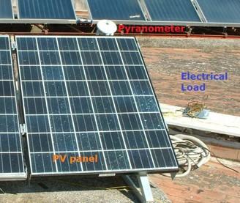

Fig. 5. The experimental PV system

In detail were installed two different panels: a 175 W poly-crystalline PV panel with a total area of 1.277 m2 (panel A) and a 180 W mono-crystalline PV panel with a total area of 1.16 m2 (panel B). The silicon temperature was measured using three thermocouples (type T, copper-constantan) installed into little holes

made in the PET (Polyethylene terephthalate) rear film of the panels, in order to improve the thermal contact with the cell silicon back face; averaged values of temperatures were used. All data were collected every 10 minutes and stored for the further calculations and comparisons. More details about the acquisition procedure is described in [7]. At different value of *RL* we recorded the values of:

* Air temperature *Ta* [°C],
* Cell temperature *Tc* [°C],
* Global irradiation *I* [W/m2];
* Ratio of working voltage *V* and *Vmpp*[A];
* Wind speed *W* [m/s].

1. Experimental system

From the database of data monitoring were extracted individual records characterized by a 0.95<*V/Vmpp*<1.05 from *panel A*. The correlation analysis between all data have confirmed the initial hypothesis, highlighting a strong correlation among the temperature reached by the panel during operation and the voltages ratio (Table.1).

Table 1.

Matrix Correlation Ta Tc G V W Power RL Vmpp V/Vmpp

|  |  |  |  |  |  |  |  |  |
| --- | --- | --- | --- | --- | --- | --- | --- | --- |
| Ta 1 |  |  |  |  |  | | | |
| Tc 0.586293 | 1 |  |  |  |
| G 0.322123 | 0.835285 | 1 |  |  |
| V -0.44558 | -0.52589 | -0.22179 | 1 |  |
| W -0.49066 | -0.52067 | -0.29138 | 0.772326 | 1 |
| Power 0.34581 | 0.200247 | 0.196357 | -0.03007 | 0.004259 | 1 |  |  |  |
| RL 0.325911 | 0.792753 | 0.973959 | -0.219 | -0.40693 | 0.159163 | 1 |  |  |
| Vmpp 0.318981 | 0.838861 | 0.998711 | -0.22084 | -0.26343 | 0.203286 | 0.961196 | 1 |  |
| V/Vmpp -0.65938 | -0.85506 | -0.42913 | 0.65476 | 0.580572 | -0.14379 | -0.38381 | -0.4362 | 1 |

* 1. *Cell temperature correlation*

The authors speculated then that among the operating temperature of the panel, the outside weather conditions and the thermoelectric regimen of the panel there is a mathematical correlation:

*T*  *T*

* *G* 

  *V* 

*(3)*

*c a a*  *bW*

*c* ln 1 *V*

(*G*,*T* ) 

 *mpp c* 

where *W* is the wind speed and the numerical values of *a, b* and *c* parameters must be evaluated.

Using a large amount of data monitored on two different panels, the values of previous parameters were calculated using the least squares technique. The values that best fit the Eqn. 3 to experimental data are:

*T*  *T*

* *G*  4.51228

  *V* 

*(4)*

*c a* 50.07311.23149 *W*

ln 1 *V*

(*G*,*T* ) 

 *mpp c* 

In Fig.6 it is possible to see the graph of expected value of *Tc* versus the value obtained from the above correlation for the *panel A*. To better assess the reliability of the new proposed correlation, we compared also the monitored *Tc* values of the *panel B*, values that were not used to obtain the *a, b* and *c* parameters (Fig.7).

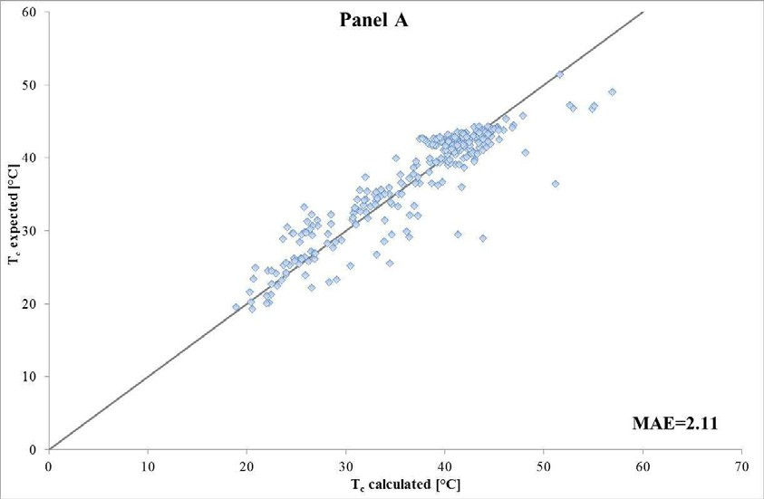

Fig. 6. Expected value of measured *Tc* versus *Tc* obtained by the correlation for *panel A*

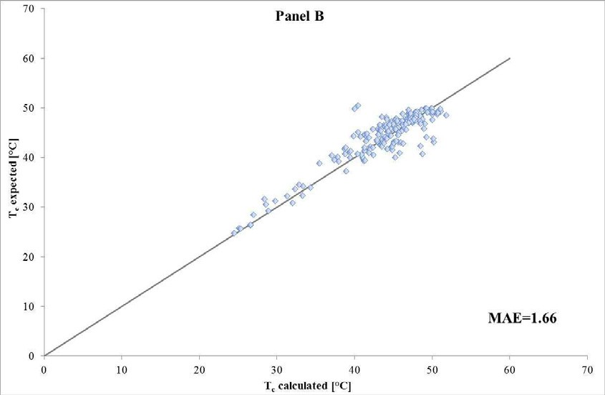

Fig. 7. Expected value of measured *Tc* versus *Tc* obtained by the correlation for *panel B*

The authors also applied other implicit correlations available in literature [8] for *Tc* ; in the following Table 2 results in terms of mean absolute error (*MAE*) for the two panels are reported:

1 *N*

 *N*  

*MAE Tc*, *expected Tc*, *calculated i i*1

*(5)*

where *N* is the number of available samples.

Table 2.

Correlation Panel A

MAE

Panel B MAE

Note

*Tc*  *Ta*  *G* 1 *Ta* 1 *W* 11.053** 

*Tc*  *Ta*  *G* ** / *U* 1  ** / ** 

*Tc*  *Ta*  *G* ** **  / *U*

4.51 4.06 W=1 m/s, a=0.0138, β=0.031, γ=0.042

15.22 14.35 τa/U taken as constant, used in TRNSYS type170

15.86 16.24 τa/U determined experimentally

*Tc*  *Ta*  *G* / *a*  *bW*   *c* ln 1 *V* / *Vmpp* (*G*,*Tc* ) 2.11 1.66 a= 50.0731, b=1.23149, c=4.51228

The results in Table 2 show that the new proposed correlation is characterized by a better MAE value respect other correlations already published in literature; in detail for the panel A the MAE is 2.11 and for panel B is 1.66. Probably the better results obtained by the proposed correlation are due to the classification of the operating regimens of the solar panel illustrated by the ratio V/Vmpp, which represents a novelty in the field.

1. Conclusions

Authors presented a novel implicit correlation to obtain the cell temperature from standard weather variables and working point of a PV panel. Assuming a linear relationship between the irradiation, the temperature and the relative voltage at maximum power, has been possible to characterize the operating regimen of the panel by the ratio of *V/Vmpp (G, Tc).* Following these hypotheses authors used a large database of monitored data coming from a two different PV systems to evaluate the parameters of a new implicit correlation depending of the ratio of *V/Vmpp (G, Tc).*

The value of the parameters used in the correlation were obtained by applying the technique of least squares. To assess the performance of the new procedure other correlations, widely used and available in the literature, were tested. The comparison of the results on two different panels were assessed by means of the MAE evaluated on several days data, The new correlation presents a significant improvement in terms of Mean Absolute Error respect other common correlations largely used.

Acknowledgment

This work was funded in part by "IMPETUS" program of Italian "Ministero dell'ambiente"

References

1. Cellura, M., Campanella, L., Ciulla, G., Guarino, F., Lo Brano, V., Cesarini, D. N., Orioli, A. The

redesign of an Italian building to reach net zero energy performances: A case study of the SHC Task 40 - ECBCS Annex 52 2011; 117-2:331-339.

1. Franzitta, V., Rizzo, G.. Renewable energy sources: A Mediterranean perspective ICBEE 2010 - 2nd International Conference on Chemical, Biological and Environmental Engineering, Proceedings : 48.
2. Beccali, G., Cellura, M., Lo Brano, V., Orioli, A. Single thermal zone balance solved by transfer function method. Energy and Buildings 2005;37 (12):1268-1277.
3. Beccali, G., Cellura, M., Lo Brano, V., Orioli, A. Is the transfer function method reliable in a European building context? A theoretical analysis and a case study in the south of Italy. Applied Thermal Engineering 2005;25 (2-3):341-357.
4. Franzitta, V., La Gennusa, M., Peri, G., Rizzo, G., Scaccianoce, G. Toward a European Eco-label brand for residential buildings: Holistic or by-components approaches? Energy 2011,36 (4):1884-1892.
5. Lo Brano, V., Orioli, A., Ciulla, G., Di Gangi, A. An improved five-parameter model for photovoltaic modules. Solar Energy Materials and Solar Cells 2010;94 (8):1358-1370.
6. Lo Brano, V., Orioli, A., Ciulla, G. On the experimental validation of an improved five-parameter model for silicon photovoltaic modules. Solar Energy Materials and Solar Cells 2012;105 :27-3.
7. Skoplaki, E., Palyvos, J.A. Operating temperature of photovoltaic modules: A survey of pertinent correlations. Renewable Energy 2009;34 (1):23-29.
8. Koehl, M., Heck, M., Wiesmeier, S., Wirth, J. Modelling of the nominal operating cell temperature based on outdoor weathering. Solar Energy Materials and Solar Cells 2011;95 (7):1638-1646.