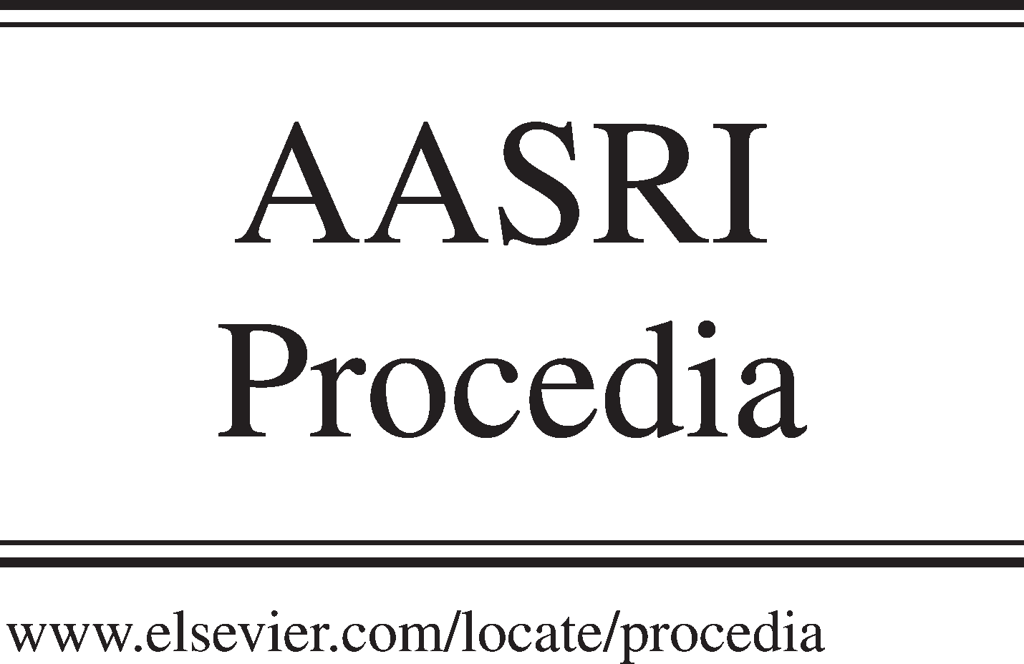Available online at [www.sciencedirect.com](http://www.sciencedirect.com/)

**ScienceDirect**

AASRI Procedia 4 (2013) 154 – 159

2013 AASRI Conference on Intelligent Systems and Control

A Parametric Study on Performance of Semi Active Suspension System with Variable Damping Coefficient Limit

Abroon Jamal Qazia Afzal Khanb, M. Tahir Khanb, Sahar Noorb

*Department of Mechanical Engineering, Sarhad University of Science and Information Technology, Peshawar, Pakistan*

*bDepartment of Mechanical Engineering, University of Engineering and Technology, Peshawar, Pakistan*

**Abstract**

The research paper involves modeling of semi active suspension system using quarter car model in Simulink environment. In order to modulate the damping coefficient value, fuzzy logic controller is modeled using Fuzzy Tool Box. Three different damping coefficient limits are selected for analyzing the response of system in terms of ride comfort. Road disturbance profile comprising a combination of two sinusoidal curves is modeled and the three semi active suspension systems are simulated. Suspension displacement and velocity parameters are selected as the indicators of ride comfort. The results manifest supremacy of the system having damping coefficient limit of 4000 N s/m. The optimized system performs well fulfilling the requirements of minimum percentage overshoot and rapid stabilizing time.

© 2013 The Authors. Published by Elsevier B.V. Open access under [CC BY-NC-ND license.](http://creativecommons.org/licenses/by-nc-nd/3.0/)

© 201 Published by Elsevier B.V.

Selection and/or peer review under responsibility of American Applied Science Research Institute

Selection and/or peer review under responsibility of American Applied Science Research Institute

*Keywords:* semi active suspension; damping coefficient; fuzzy logic controller; ride comfort

# Introduction

Suspension systems are classified into three categories namely passive, semi active and active suspensions. A passive system comprises a damper and a spring having fixed characteristics. A semi active system has the

* Corresponding author. Tel.: +923455420132

*E mail address:* [abroon.mech@suit.edu.pk](mailto:abroon.mech@suit.edu.pk)

2212-6716 © 2013 The Authors. Published by Elsevier B.V. Open access under [CC BY-NC-ND license.](http://creativecommons.org/licenses/by-nc-nd/3.0/) Selection and/or peer review under responsibility of American Applied Science Research Institute doi:10.1016/j.aasri.2013.10.024

ability to modulate the damping coefficient of damper but the direction of damping force is dependent on the relative velocity across the sprung and unsprung masses. In case of an active suspension, an actuator is incorporated that provides force without being influenced by relative velocity.

A semi-active suspension system performs better in improving the ride comfort and road handling keeping the complexity and cost at minimum. The system incorporates a damper that can modulate its damping coefficient. Semi-active systems are classified as systems where the characteristics can be changed rapidly (typically in less than 100 milliseconds) [1]. These systems can still store energy (springs) or dissipate energy (dampers). Adjustment of the orifice area in the damper regulates the damping force that ultimately alters the fluid flow resistance. The development of electrorheological (ER) and magnetorheological (MR) fluids has boosted research in the field of semi-active suspensions [1]. Nowadays, the mentioned conflicting requirements cannot be met with passive suspension systems; therefore, the application of active and semi- active suspensions is mandatory [2].

It was in early 1970s that active vehicle suspension systems were developed focusing on the optimization of tradeoff between ride quality and road handling [3]. Published research reveals significant improvements have been made in terms of ride quality and road handling using prototype active suspensions compared to passive suspension systems. The active suspension systems are complex, bulky and expensive and therefore, they are not commonly used in commercial vehicles. Issues related to the design and control aspects in active suspension systems appear to be the real challenges. An excessive power is required that results in heavy loads on the engine.

Semi-active suspension is a better choice than active suspension at the cost of ride comfort and road handling but there is not a significant degradation of the performance [3]. Semi-active suspensions need a damper and few sensors for adequate performance. The damping force can easily be varied instantaneously with the introduction of MR fluid dampers. Semi-active technology can materialize the variation of damping between the softer and harder limits in accordance with the situation as compared to the passive system [4].

The paper describes modeling of semi-active suspension systems based on variable damping coefficient limit. The models are designed in Simulink while the fuzzy logic controller is incorporated through Fuzzy Tool Box. Section 2 describes the modeling of systems and road disturbance profile. Section 3 explicates the design scheme of fuzzy logic controller. Section 4 describes the simulation and results. A parametric analysis is presented based on the statistics. Conclusion is elaborated in Section 5.

# Modeling of Systems

For simulation purpose, quarter car parameters have been taken from reference data [5]. Road disturbance profile comprises combination of two sinusoidal inputs. The Simulink model is depicted in Fig. 1.

* 1. *Modeling of Semi-Active Suspension Systems*

For a semi-active suspension Simulink model, the damping coefficient needs to be varied. In order to incorporate the varying capability of damping coefficient, a fuzzy logic controller in added in the Simulink model as shown in Fig. 2. Three fuzzy based systems are designed on the basis of different damping coefficient limits of 3000, 4000 and 5000 N s/m.



In Out

else { }

Disturbance

In

Out

if { }

Merge

Clock

If { }

0

Constant

In

Out

Road disturbance

Merge

elseif { }

In Out

elseif { }

In Out

Constant

else { }

In Out

f(u)

if(u1<=3.5)

u1 elseif(u1>=3.75)

else

if(u1<=1) u1 elseif(u1>=1.25)

else

Fig. 1. Modeling of road disturbance profile



-

-

-

1/Ms

1/s

1/s

+

-

Fuzzy Logic

*Ms : Sprung Mass (240 kg)*

Controller

x

+

-

*Mu : Unsprung Mass (36 kg)*

*cs : Damping Coefficient (1000 N s/m) ks : Sprung Mass Stiffness (16000 N/m) kt : Tire Stiffness (160000 N/m)*

*1/s : Integrator*

-

cs

ks

+

-

+

+

+

-

1/Mu

1/s

1/s

+

kt

Fig. 2. Semi-active quarter car suspension model in simulink



Input +

e

Output

Fuzzification Defuzzification

-

Decision Making Logic (Control Rules)

Sensor

Process

Fuzzy Knowledge Base (Fuzzy Inference)

Fig. 3. Fuzzy logic control system

# Design of Fuzzy Logic Controller

Fuzzy logic control system is depicted in Fig. 3. Error signal is fed into the fuzzy logic controller. Fuzzification converts the crisp values into fuzzy variables. Fuzzy inference system besides control rules process the fuzzy values and finally the fuzzy variables are transformed back to crisp values through defuzzification [6]. The fuzzy logic controller designed in this research comprises two inputs of relative displacement and relative velocity across the suspension and an output of damping coefficient.

# Simulation Results and Discussion

This section describes the simulation and analyzes the results in detail. The simulation results of suspension displacement are displayed in Fig. 4 for different values of maximum damping coefficient limit. System having damping coefficient limit of 4000 N s/m exhibits best performance for having no overshoot and fastest stabilizing time. System having damping coefficient value of 3000 N s/m performs the worst.

0.1

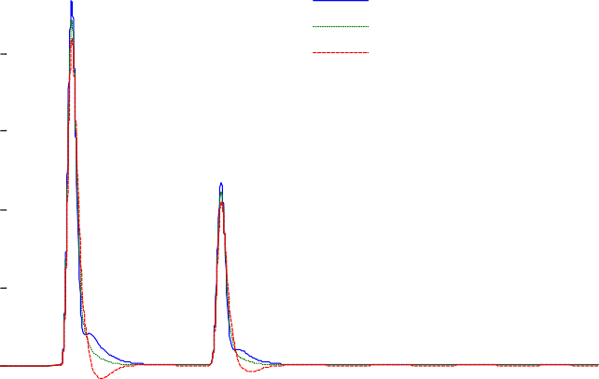

Damping Coefficient=5000 Damping Coefficient=4000 Damping Coefficient=3000

0.08

0.06

Suspension Displacement (m)

0.04

0.02

0

-0.02

0 1 2 3 4 5 6 7 8 9 10

Time (sec)

Fig. 4. Suspension displacement of semi-active systems

The simulation results of suspension velocity are displayed in Fig. 5 for different values of maximum damping coefficient limit. System having damping coefficient limit of 4000 N s/m exhibits best performance for having no overshoot and fastest stabilizing time. System having damping coefficient value of 5000 N s/m performs the worst.

1

Damping Coefficient=5000 Damping Coefficient=4000 Damping Coefficient=3000

0.8

0.6

0.4

Suspension Velocity (m/s)

0.2

0

-0.2

-0.4

-0.6

-0.8

0 1 2 3 4 5 6 7 8 9 10

Time (sec)

Fig. 5. Suspension velocity of semi-active systems

Parametric analysis of suspension displacement response of semi-active suspension with respect to variable damping coefficient limit is depicted in Fig. 6. The graph clearly indicates that system with maximum damping coefficient value of 4000 N s/m stabilizes at the earliest with no overshoot.

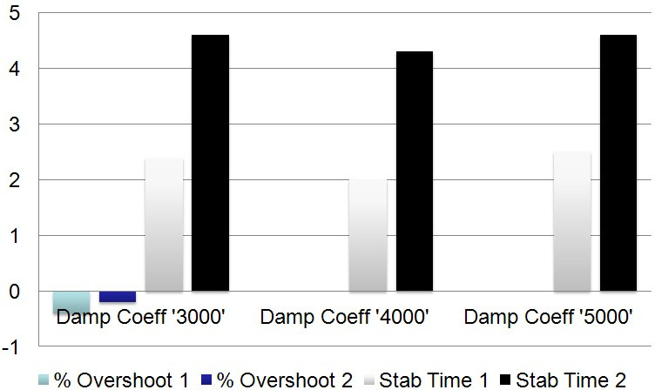

Fig. 6. Parametric analysis of suspension displacement response in relation to variable damping coefficient limit

Parametric analysis of suspension velocity response of semi-active suspension with respect to variable damping coefficient limit is depicted in Fig. 7. The graph clearly indicates that system with maximum damping coefficient value of 4000 N s/m stabilizes at the earliest with no overshoot.

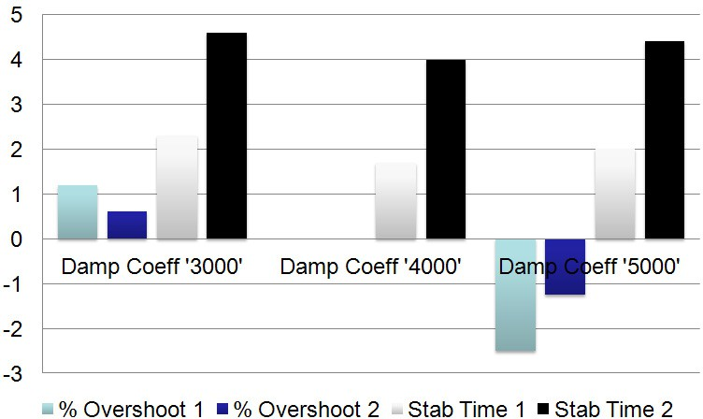

Fig. 7. Parametric analysis of suspension velocity response in relation to variable damping coefficient limit

# Conclusion

Semi-active suspension systems have been designed based on variable damping coefficient limit. The system having damping coefficient limit of 4000 N s/m performs the best in terms of ride comfort. The optimized system manifests its better performance owing to minimum stabilizing time and zero percentage overshoot. The system is validated for its performance in relation to a combination of two different disturbance inputs. Future work may include prototyping of the quarter car suspension model for subsequent testing in the loop.

# Acknowledgements

The authors would like to express gratitude to Prof Dr. Riaz Akbar and Dr. Ali Kamran for their valuable guidance and support.

# References

1. Guglielmino E, Sireteanu T, Stammers C W, Ghita G and Giuclea M. Semi-active suspension control : improved vehicle ride and road friendliness. Springer, London, 2008.
2. Martins I, Esteves M, Pina da Silva F, Verdelho P. Electromagnetic hybrid active-passive vehicle suspension system. Proceedings of 49th IEEE Vehicular Technology Conference, Houston, USA, 1999, 3: 2273-2277.
3. Dixit R. Sliding mode observation and control for semiactive vehicle suspensions [Thesis], Nov 2001. [Online]. Available: [http://repository.lib.ncsu.edu/ir/handle/1840.16/1543.](http://repository.lib.ncsu.edu/ir/handle/1840.16/1543) (Accessed on 28 October, 2012)
4. Ericksen E O and Faramarz G. A magnetorheological fluid shock absorber for an off-road motorcycle. International Journal of Vehicle Design, 2003, 33(1): 139-152.
5. Abu-Khudhair A, Muresan R and Yang S X. Fuzzy control of semi-active automotive suspensions. IEEE International Conference on Mechatronics and Automation, Changchun, China, Aug 2009, 2118-2122.
6. MathWorks Inc., 2012. [Online].

Available: [http://www.mathworks.com/help/pdf_doc/fuzzy/fuzzy.pdf.](http://www.mathworks.com/help/pdf_doc/fuzzy/fuzzy.pdf) (Accessed on 12 October, 2012)