[Artificial Intelligence in Agriculture 6 (2022) 167–175](https://doi.org/10.1016/j.aiia.2022.09.001)

Contents lists available at [ScienceDirect](http://www.sciencedirect.com/science/journal/)

Artificial Intelligence in Agriculture

journal homepage: [http://www.keaipublishing.com/en/journa ls/artificial- intelligence- in-agriculture/](http://www.keaipublishing.com/en/journals/artificial-intelligence-in-agriculture/)

[](http://crossmark.crossref.org/dialog/?doi=10.1016/j.aiia.2022.09.001&domain=pdf)A comparative analysis of paddy crop biotic stress classification using pre-trained deep neural networks

Naveen N. Malvade a,e,⁎, Rajesh Yakkundimath b,e, Girish Saunshi b,e,

Mahantesh C. Elemmi c,e, Parashuram Baraki d,e

a *Department of Information Science and Engineering, Smt. Kamala and Sri. Venkappa M. Agadi College of Engineering and Technology, Lakshmeshwar, 582116, Karnataka, India*

b *Department of Computer Science and Engineering, K. L. E. Institute of Technology, Hubballi, 580030, Karnataka, India*

c *Department of Computer Science and Engineering, Navkis College of Engineering, Hassan, 573217, Karnataka, India*

d *Department of Computer Science and Engineering, Smt. Kamala and Sri. Venkappa M. Agadi College of Engineering and Technology, Lakshmeshwar, 582116, Karnataka, India*

e *Visvesvaraya Technological University, Belagavi 590018, Karnataka, India*

# a r t i c l e i n f o

*Article history:*

Received 8 March 2022

Received in revised form 8 September 2022 Accepted 8 September 2022

Available online 16 September 2022

*Keywords:*

Paddy crop

Stress classification Biotic stress PlantVillage ImageNet

Pre-trained CNN models

# a b s t r a c t

The agriculture sector is no exception to the widespread usage of deep learning tools and techniques. In this paper, an automated detection method on the basis of pre-trained Convolutional Neural Network (CNN) models is proposed to identify and classify paddy crop biotic stresses from the field images. The proposed work also pro- vides the empirical comparison among the leading CNN models with transfer learning from the ImageNet weights namely, Inception-V3, VGG-16, ResNet-50, DenseNet-121 and MobileNet-28. Brown spot, hispa, and leaf blast, three of the most common and destructive paddy crop biotic stresses that occur during the flowering and ripening growth stages are considered for the experimentation. The experimental results reveal that the ResNet-50 model achieves the highest average paddy crop stress classification accuracy of 92.61% outperforming the other considered CNN models. The study explores the feasibility of CNN models for the paddy crop stress identification as well as the applicability of automated methods to non-experts.

© 2022 The Authors. Publishing services by Elsevier B.V. on behalf of KeAi Communications Co., Ltd. This is an open access article under the CC BY-NC-ND license (<http://creativecommons.org/licenses/by-nc-nd/4.0/>).

1. Introduction

India is a rice-growing country with a wide range of rice varieties adapted to wide spectrum of agro-climatic conditions. As a result, the crop has become a host for a variety of biotic and abiotic stresses, all of which have a negative impact on crop productivity and survival. Realizing the economic losses caused by them, efforts have been made to comprehend the importance of integrated and automated paddy crop management for the timely intervention and mitigation of the stresses. Furthermore, experts and politicians are also concerned about improving paddy production and yield. The agricultural experts identify the stress categories by the visual inspection of individual paddy plant leaf which is subjective and tedious in nature. The paddy

* Corresponding author at: Associate Professor, Dept. of Information Science and Engineering, Smt. Kamala and Sri. Venkappa M. Agadi College of Engineering and Technology, Lakshmeshwar, 582116, Karnataka, India

*E-mail addresses:* [naveen.malvade@gmail.com](mailto:naveen.malvade@gmail.com) (N.N. Malvade), [rajeshymath@gmail.com](mailto:rajeshymath@gmail.com) (R. Yakkundimath), [girishsaunshi@gmail.com](mailto:girishsaunshi@gmail.com) (G. Saunshi), [mc_elemmi2004@rediffmail.com](mailto:mc_elemmi2004@rediffmail.com) (M.C. Elemmi), [parashuram.baraki@gmail.com](mailto:parashuram.baraki@gmail.com)

(P. Baraki).

crop stresses have a complicated composition, and their presentation in different paddy crop varieties is very similar, making classification challenging. The goal of quickly identifying crop stress has various advantages for potential farmers and agriculture science researchers. Crop yields can be effectively increased by intervening early and miti- gating stress-related issues using suitable crop management strategies that take advantage of technology. This necessitates ongoing study in agriculture science and technological adoption.

In agriculture, emerging technologies such as Big Data, Machine Learning, and the Internet of Things have been widely used to improve all parts of rice production processes, ushering in a new era of smart farming. Significant gains in agricultural tasks have been noticed as a result of innovations in AI-based deep convolutional neural networks. Plant disease recognition, crop/weed separation, fruit grading, and land stat classification are just a few examples of agricultural applica- tions where CNNs achieve human-level accuracy. Several improve- ments have been made in the architecture of CNN with the gradual increase in the number of layers to make CNN scalable to multiclass problems. The most popular CNN models are GoogLeNet, AlexNet, Inception-V3, VGG-16, DenseNet-128, and ResNet-50. One of the appli- cations under consideration in this work is the processing of images of

<https://doi.org/10.1016/j.aiia.2022.09.001>

2589-7217/© 2022 The Authors. Publishing services by Elsevier B.V. on behalf of KeAi Communications Co., Ltd. This is an open access article under the CC BY-NC-ND license ([http://](http://creativecommons.org/licenses/by-nc-nd/4.0/) [creativecommons.org/licenses/by-nc-nd/4.0/](http://creativecommons.org/licenses/by-nc-nd/4.0/)).

paddy plant leaves using the various leading transfer learning CNN models. Literature searches have been conducted in this regard to learn about recent deep learning applications in the core topic of the current research.

A pre-trained VGG-16 model is deployed for automatic recognition and categorization of diverse paddy crop biotic and abiotic stresses using field images. To illustrate the technological viability of applying the deep learning method, researchers have used 30,000 field images from five different paddy crop varieties with 12 different stress classifi- cations. An average classification accuracy of 92.89% is achieved (Anami et al., 2020b). An upgraded VGG-19 model which was pre-trained on ImageNet public image dataset is deployed for the classification of five categories of paddy crop stresses using leaf images. The augmented image dataset is used in the experimentation. An average accuracy of 92% is obtained (Chen et al., 2020). Different CNN models are employed for the identification and classification of plant diseases. The VGG-16, Inception-V4, ResNet, and DenseNet models have deployed to experi- ment on the PlantVillage image dataset which includes 38 different categories of diseased and healthy leaf images from 14 different plants. It is reported that DenseNet provides a better classification accuracy score of 99.75%, outperforming the other architectures (Yakkundimath et al., 2022). Four prominent CNN models are used to construct an auto- mated wheat disease diagnosis system. There are 50,000 labeled images of healthy and afflicted wheat crop leaves in the image dataset. The greatest average recognition accuracy of the VGG-16 model is 97.95% (Lu et al., 2017a). The LeNet-5 and AlexNet models are employed for paddy crop disease identification using an image dataset containing 500 images of stable and diseased rice leaves and stems. An average identification accuracy of 95.48% is achieved using the AlexNet model. The work has also showed that the stochastic pooling technique improves the CNN model's generalization ability and avoids over- fitting (Lu et al., 2017b). The field images are used to identify 12 categories of biotic and abiotic paddy crop stresses using conventional image classifiers such as Back Propagation Neural Network (BPNN), Support Vector Machine (SVM), and k-Nearest Neighbor (*k*−NN). The maximum average classification accuracy achieved by the BPNN classi- fier was 89.12% (Anami et al., 2020a).

The usefulness of pre-trained deep learning CNN models for constructing non-destructive and cost-effective systems to automate the identification and classification of rice crop diseases can be seen with a literature review. Using traditional image processing techniques, significant attempts have been made to automatically identify and clas- sify paddy crop diseases from individual leaf images (Huang et al., 2015; Mohan et al., 2016; Mohanty et al., 2016; Orillo et al., 2014; Pugoy and Mariano, 2011; Phadikar et al., 2012; Phadikar et al., 2013; Sethy et al., 2020). The literature survey reveals the potential of pre-trained deep learning CNN models in the recognition and classification of paddy

crop diseases from the public image datasets (Hughes and Salathé, 2015; Saleem et al., 2020; Yakkundimath et al., 2022). This has stimulated interest in developing a sophisticated paddy crop stress rec- ognition system for use in developing crop management strategies.

There are four sections to the paper. The proposed methodology is presented in Section 2. The classification results of the considered CNN models are described in Section 3. The work's conclusion is presented in Section 4.

1. Proposed methodology

The overall methodology for the study is depicted in Fig. 1. The first step is to select an image dataset that depicts various biotic diseases on rice crop leaves. The next step is to label or annotate the training dataset. The learned CNN models' performance is then assessed on the testing image dataset. The hyper parameters are adjusted to improve the CNN models' performance. Finally, the different CNN models' classification performance is compared.

* 1. *Image dataset*

For dataset preparation, five popular paddy crop varieties, namely, Jaya, Abhilasha, Mugad Suganda, Mugad 101, and Mugad Siri are considered. The images were captured in the field under natural light condition near solar noon which is the period with the most consistent illumination using a Nikon D3300 Digital SLR camera having a resolu- tion of 60 megapixels. Some of the stressed paddy crop images are imported from PlantVillage image dataset. The PlantVillage is an openly and publicly available dataset that includes 54,306 images and 26 dis- eases affecting 14 different plants. The image dataset comprises a total of 3355 images, among which 523 images of Brown Spot symptom, 565 images of Hispa pests, and 779 images of Leaf Blast symptoms. The remaining 1488 images are from a healthy paddy crops. Fig. 2 shows some images of paddy crops that are affected by various stresses. The original image dataset comprising a total of 3355 paddy crop im- ages are enhanced to 26,840 using various classical image augmentation techniques such as translation, arbitrary rotations, shearing, scaling and flipping. The images collected from the dataset are of different sizes. The image size is reduced to 400 × 400 pixels for minimizing the computa- tional time required for further processing and their storage on the medium. The dataset is partitioned into three sub-datasets: 70% for training (18,788 images), 20% for validation (5368 images), and 10% for testing (2684 images). The details of the final image dataset used in the work are depicted in Table 1. The images collected from the dataset are of different sizes. The image size is reduced to 400 × 400 pixels for minimizing the computational time required for further

processing and their storage on the medium.

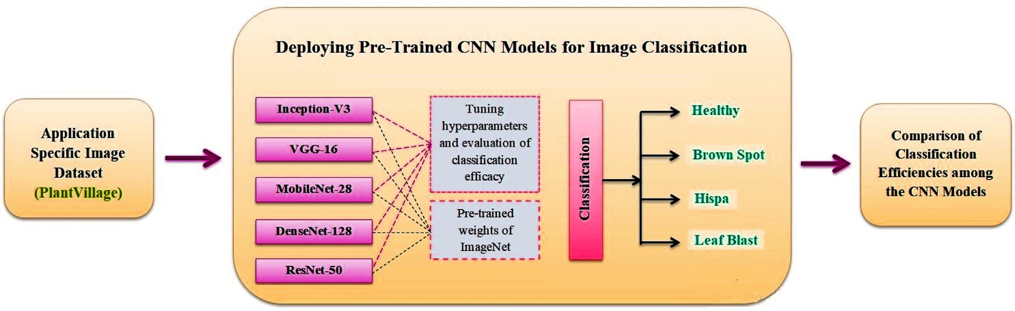

Fig. 1. Block diagram of the proposed methodology.

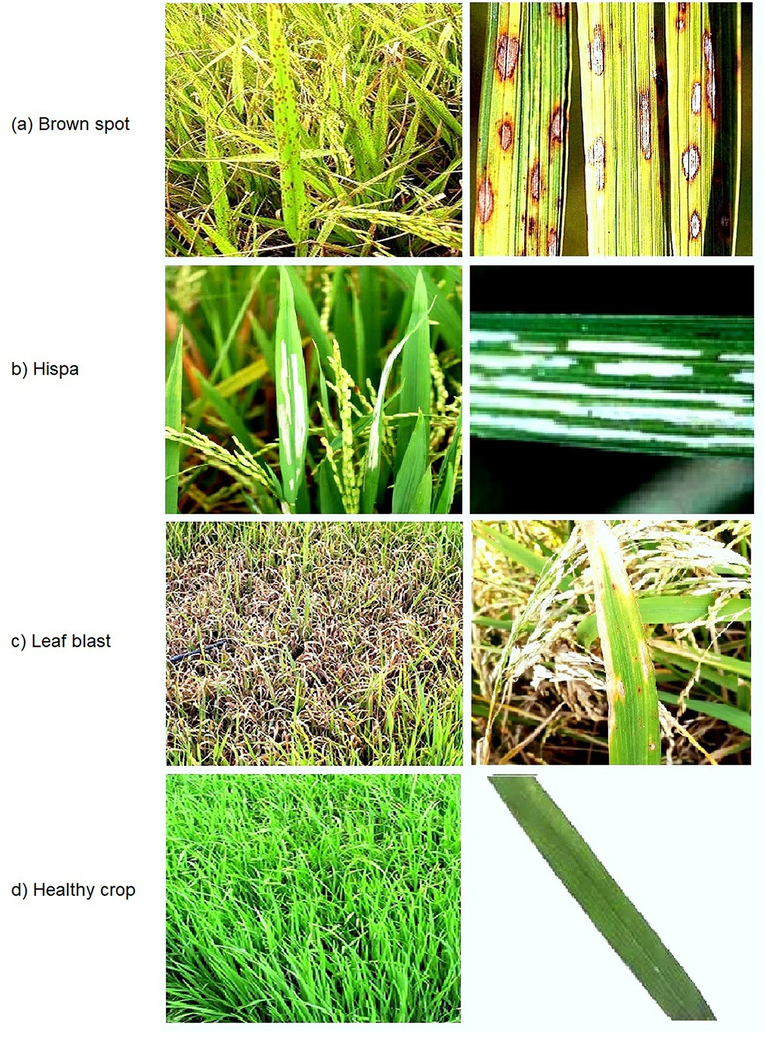

Fig. 2. Images of paddy crops affected by biotic stresses.

* 1. *CNN classifiers*

The present work has considered five high potential and commonly used transfer learning models namely, VGG-16, Inception-V3 (Szegedy et al. 2016), ResNet-50 (He et al. 2016), DenseNet-128 (Huang et al., 2017), and MobileNet-28 (Howard et al., 2017) which are pre-trained on ImageNet dataset (Simonyan and Zisserman, 2014; He et al., 2019). The description of transfer learning mechanism is available in literature (Yakkundimath et al., 2022). The descriptions of individual CNN models are available in literature (Too et al., 2019). There are around 1.2 million images and 1000 class categories in the ImageNet dataset. The steps

involved in training the considered CNN models on the prepared dataset are given in Algorithm 1.

Algorithm 1. Training and testing pre-trained CNN models on paddy crop stress image dataset.

Step 1. Use the augmented paddy crop stress image dataset. Step 2. Generate training and testing image datasets in batches.

Step 3. Load the base CNN model and customize only the final layer.

Step 4. Compile and fit the base CNN model with different values of dropout, and different optimizers and activation functions.

Step 5. End

Table 1

Summary of paddy crop stress image dataset.

training are graphically shown in Figs. 3–7. Fig. 8 shows the confusion matrices for the considered CNN models when evaluated with the test

Sl.

Paddy crop

Number of images

image dataset. The performance comparison of all the CNN models is

no.

biotic stress classes

Paddy crop specific

After augmentation

Training images

Validation images

Testing images

accomplished based on the evaluation metrics such as precision, recall and F1 scores derived from the confusion matrices. The evaluation met-

Total Number of Images

|  |  |  |  |  |  |  |  |
| --- | --- | --- | --- | --- | --- | --- | --- |
|  | | images |  |  |  |  | ric scores and its computation time per epoch obtained by all the con- |
| 1 | Brown Spot | 523 | 4184 | 2929 | 837 | 418 | sidered CNN models for the four classes of paddy crop images are |
| 2 | Hispa | 565 | 4520 | 3164 | 904 | 452 | tabulated in Table 2. Table 2 shows that the ResNet-50 model has the |
| 3 | Leaf Blast | 779 | 6232 | 4362 | 1246 | 624 | best performance, followed by the DenseNet-128, MobileNet, |
| 4 | Healthy | 1488 | 11,904 | 8333 | 2381 | 1190 | Inception-V3, and VGG-16 models in that order. The ResNet-50 model |

3355 26,840 18,788 5368 2684

has yielded the highest evaluation metrics as well as the maximum val- idation and testing accuracies of 96.65% and 92.61%, respectively and reasonable computing time to attain best in classification performance.

1. Experimental results and discussion

The paddy crop biotic stress classification experiments are con- ducted using the Deep Learning Toolbox provided by MATLAB 2021b programming platform. The considered pre-trained CNN models are imported and prepared them for transfer learning by editing suitable layer properties using Deep Network Designer application. In all the models, the last learnable layer and output or classification layer are re- placed to match the classes in newly constructed paddy crop biotic stress image dataset. All the CNN model training and testing operations are performed on a single workstation running on Windows 10 operat- ing system, configured with Intel Core i7–11,700 processor, 16 GB of RAM, and NVIDIA GPU with 12 GB memory. To get control over model training, the significant training options such as initial learn rate, valida- tion frequency, number of epochs, and mini-batch size are initialized to 0.0001, 10, 30, and 32 respectively. All hidden layers are activated using the ‘ReLu’ function, while the output layer is activated with the ‘softmax’ function. The network is fine-tuned using a stochastic gradient descent (SGD) algorithm with a categorical cross-entropy logarithmic loss func- tion. Batch normalization is applied to improve overall accuracy and faster learning.

The customized CNN models are trained and validated using the augmented image dataset as depicted in Table 1. The individual CNN model training progress, validation accuracy, loss, and other details of

The performance comparison results of all the considered pre-trained CNN models are graphically shown in Fig. 9.

1. Conclusions

The effectiveness of contemporary transfer learning models such as Inception V3, VGGNet with 16 layers, ResNet with 50 layers, DenseNet with 121 layers and MobileNet with 28 layers in the classification of paddy crop biotic stresses on five paddy crop varieties is explored in the present work. Fine-tuning and evaluation of state-of-the-art deep convolutional neural network models are utilized to determine the best model. In the classification of four categories of paddy crop stresses, including the healthy crop category, the RestNet-50 model outperformed all other models with the highest average classification accuracy of 92.61% by learning over 26,840 images. The ResNet-50 and DenseNet-128 models have nearly identical classification results. How- ever, when training and testing times are taken into account, the ResNet-50 model is effective. Since the work considers a larger number of CNN models for the task of image-based paddy crop biotic stresses classification, the results are promising. But, work needs to be carried out as future research is in improving the computational time. In the present work, there is a scope for adding new stress categories as well as enhancement of existing dataset with significant number of stressed paddy crop images. The work can be empowered with the sensor

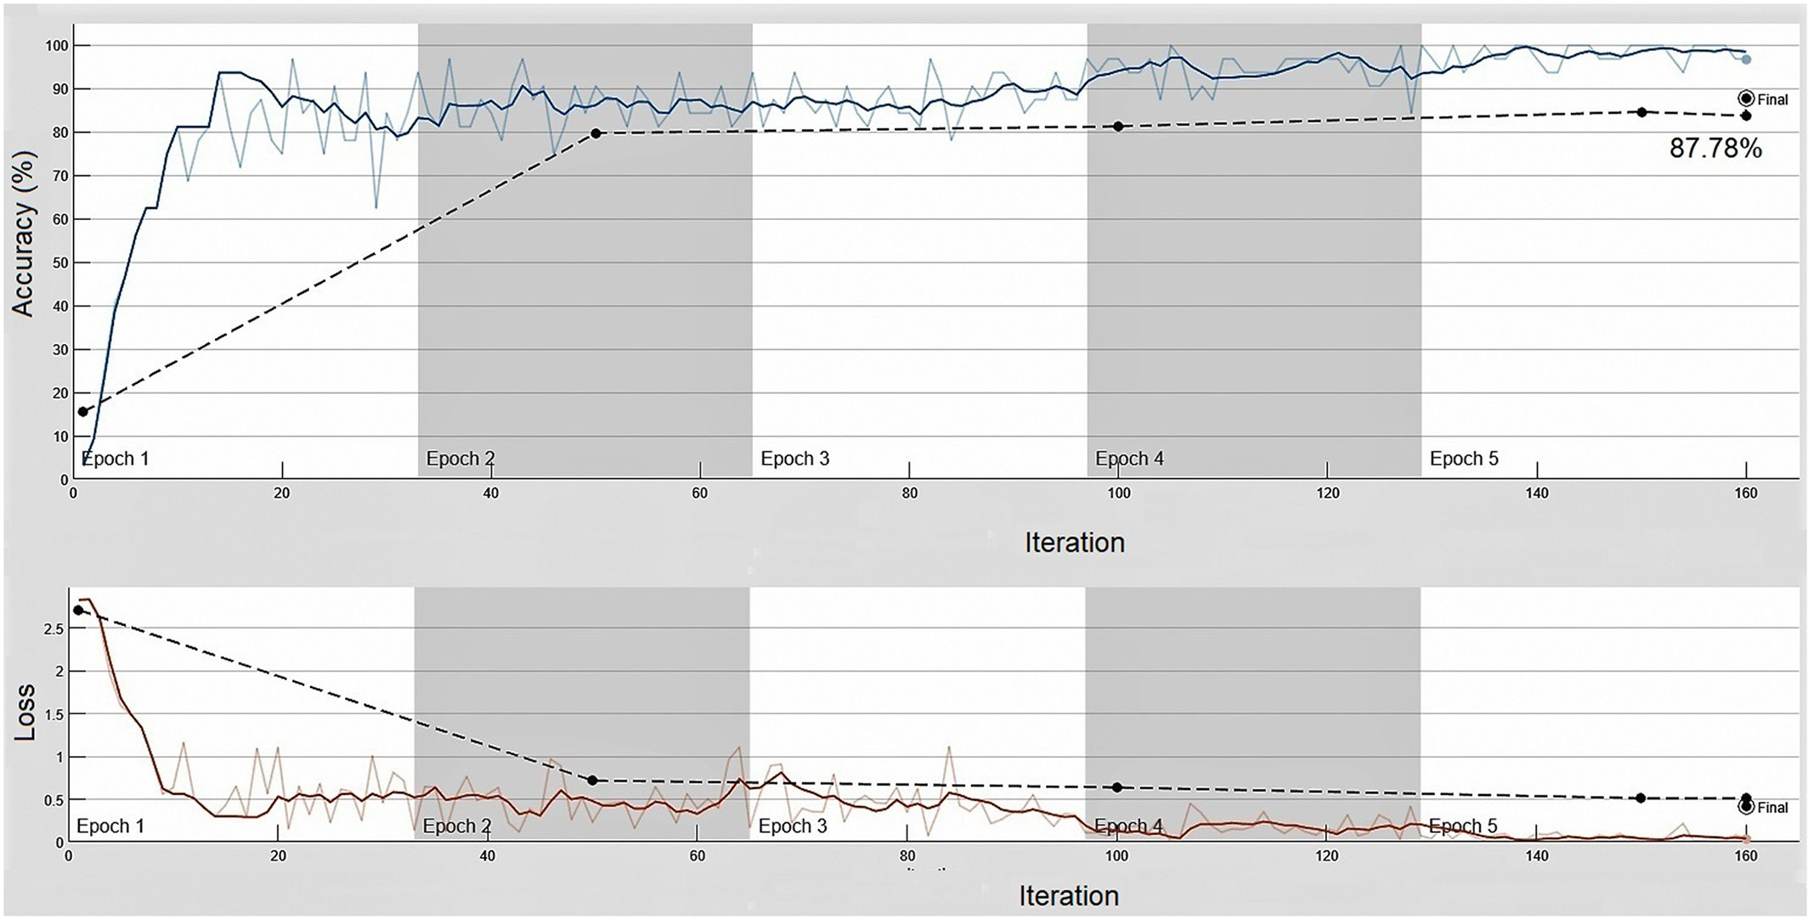

Fig. 3. Plot of validation accuracy and loss graph while training VGG-16 CNN model.

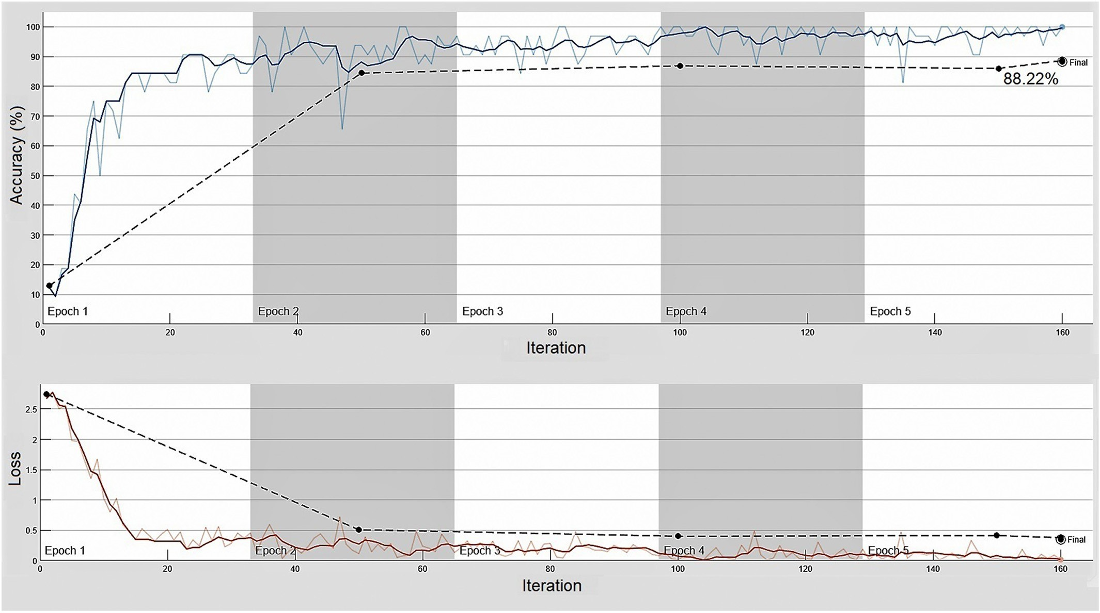

Fig. 4. Plot of validation accuracy and loss graph while training Inception-V3 CNN model.

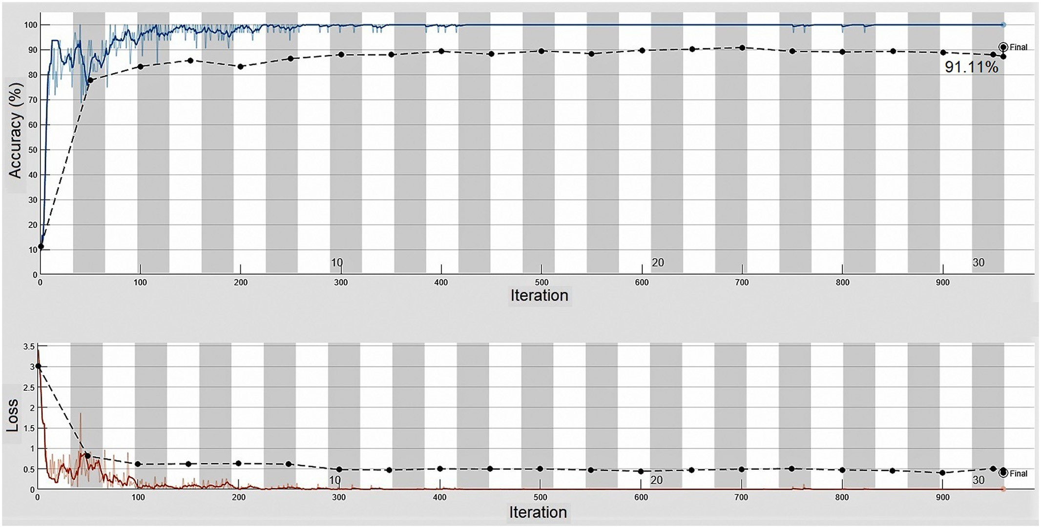

Fig. 5. Plot of validation accuracy and loss graph while training MobileNet CNN model.

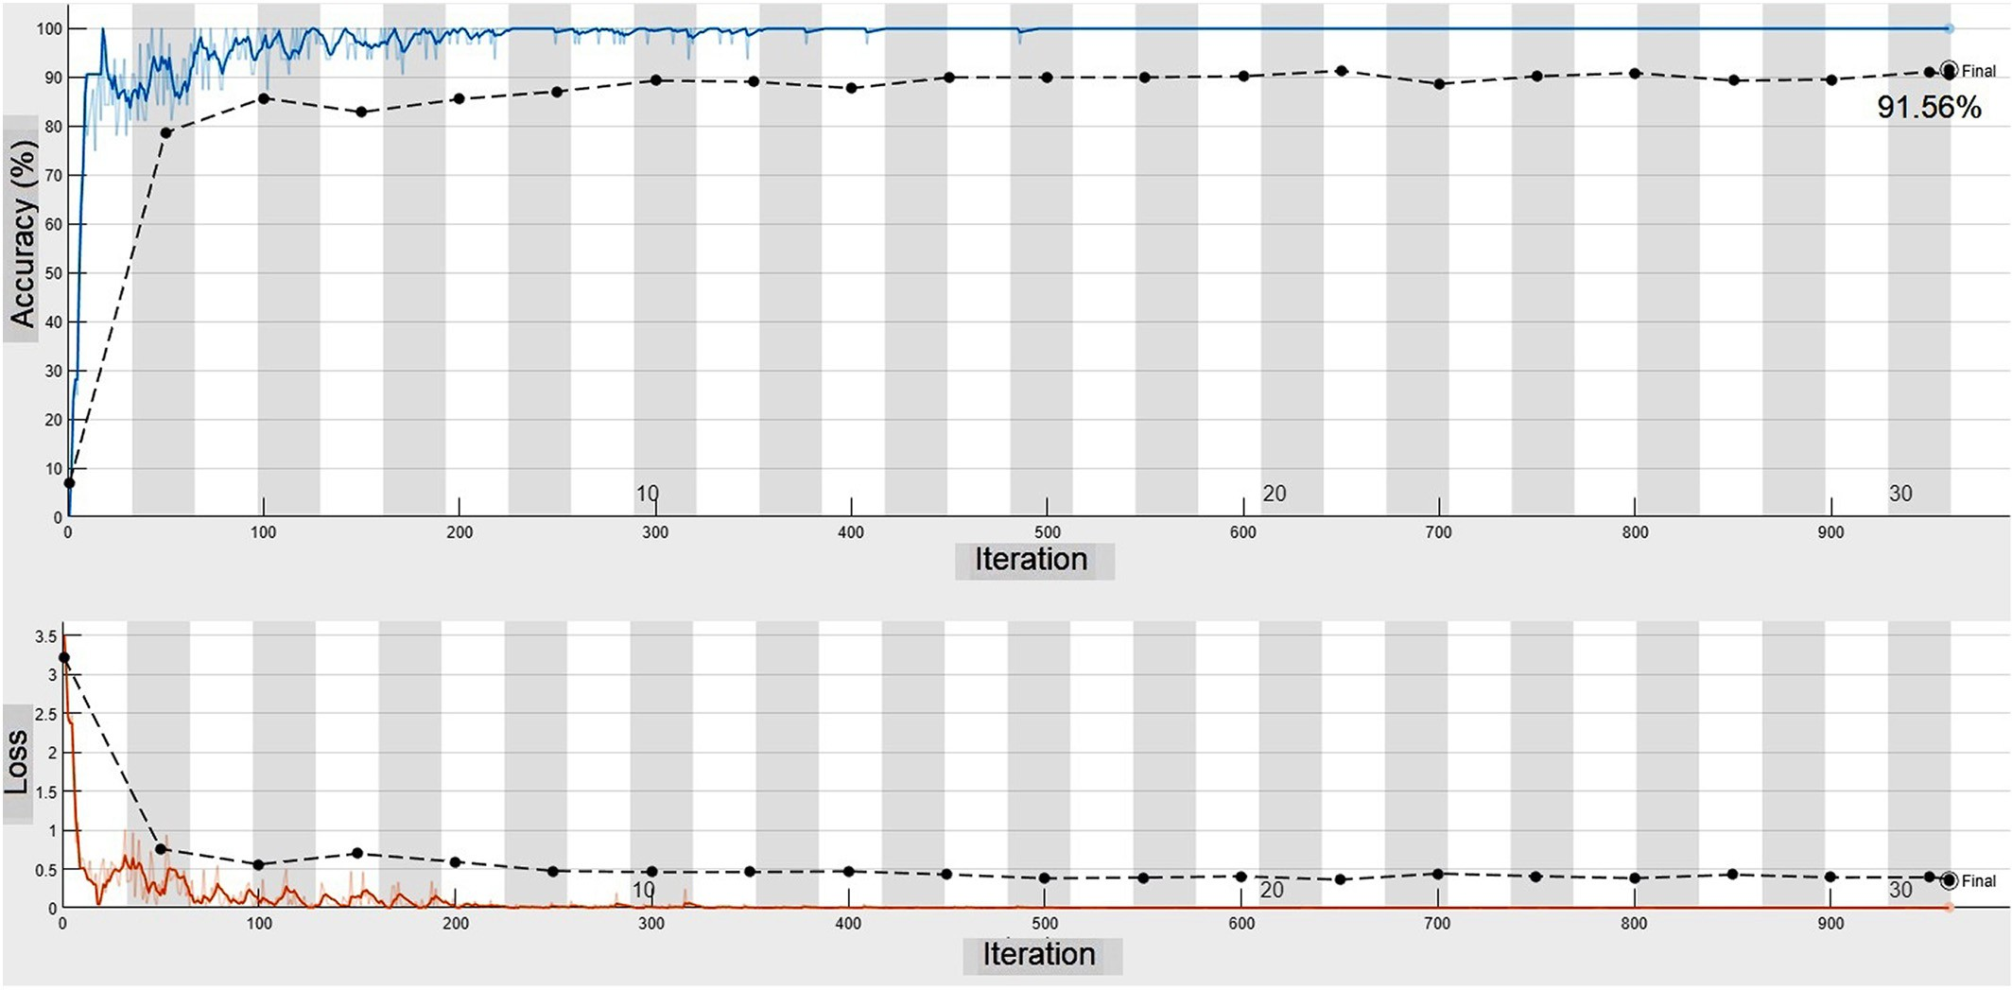

Fig. 6. Plot of validation accuracy and loss graph while training DenseNet-128 CNN model.

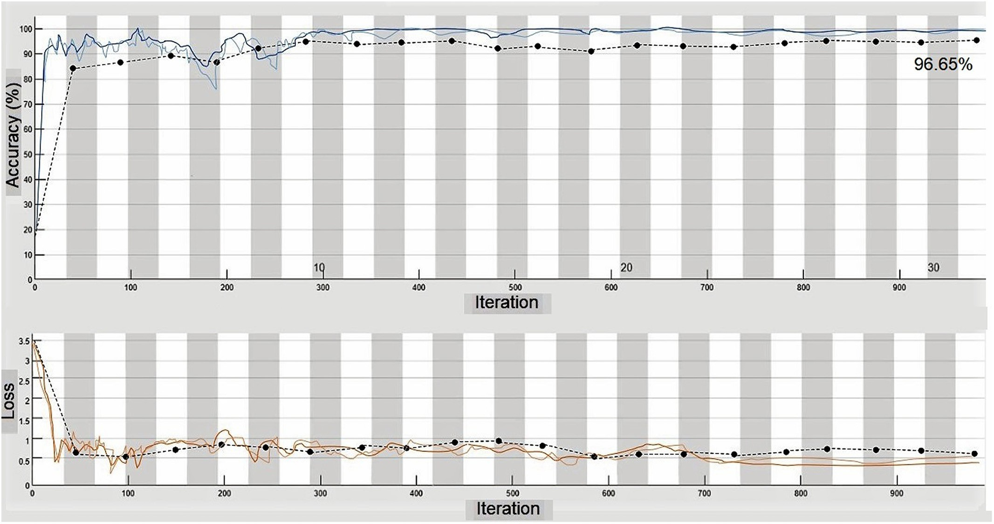

Fig. 7. Plot of validation accuracy and loss graph while training ResNet-50 CNN model.

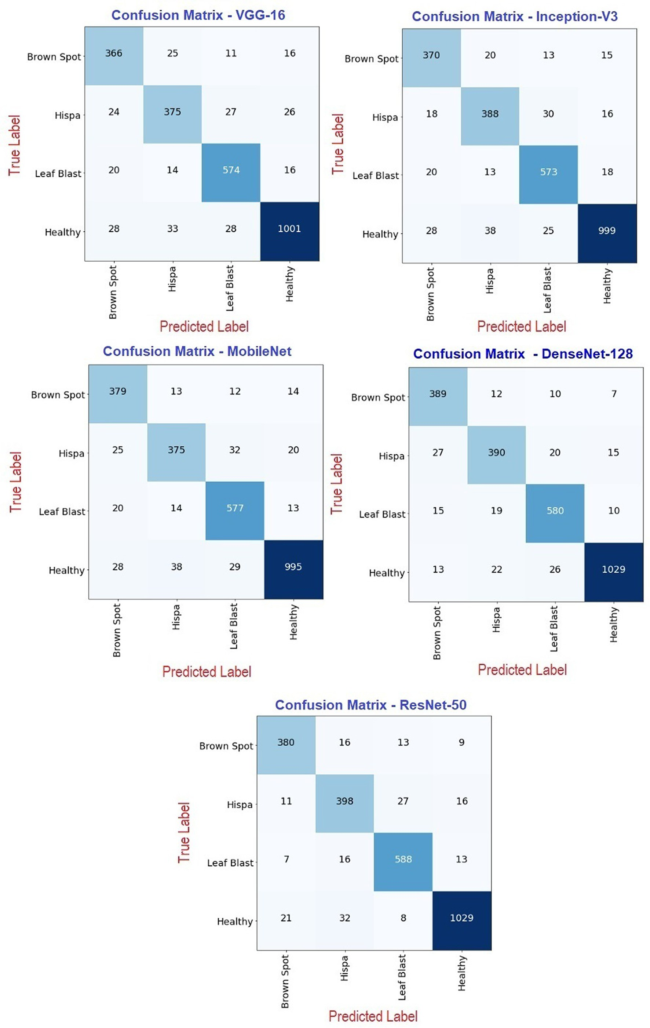

Fig. 8. Confusion matrices plotted on the test dataset for the various trained CNN models.

Table 2

Evaluation metrics derived from the confusion matrices plotted for the CNN models.

|  |  |  |  |  |  |  |  |
| --- | --- | --- | --- | --- | --- | --- | --- |
| Sl. no. CNN model Paddy crop stress class | Performance metrics |  |  |  | Average validation Average testing |  |  |
|  | Test accuracy (%) | Precision | Recall | F1 Score | accuracy (%) accuracy (%) | Time (secs) |
| Brown Spot | 95.20 | 0.88 | 0.84 | 0.86 |  |  |  |
| 1 VGG-16 Hispa | 94.23 | 0.83 | 0.84 | 0.83 | 87.78 89.63 | 1255 |  |
| Leaf Blast | 95.51 | 0.92 | 0.9 | 0.91 |  |  |  |
| Healthy | 94.31 | 0.92 | 0.95 | 0.93 |  |  |  |
| Brown Spot | 95.59 | 0.89 | 0.85 | 0.87 |  |  |  |
| 2 Inception-V3 Hispa | 94.78 | 0.86 | 0.85 | 0.85 | 88.22 90.17 | 4339 |  |
| Leaf Blast | 95.39 | 0.92 | 0.89 | 0.91 |  |  |  |
| Healthy | 94.58 | 0.92 | 0.95 | 0.93 |  |  |  |
| Brown Spot | 96.29 | 0.91 | 0.86 | 0.88 |  |  |  |
| 3 MobileNet Hispa | 94.60 | 0.83 | 0.85 | 0.84 | 91.11 90.74 | 1032 |  |
| Leaf Blast | 95.91 | 0.94 | 0.89 | 0.91 |  |  |  |
| Healthy | 94.68 | 0.92 | 0.96 | 0.94 |  |  |  |
| Brown Spot | 96.75 | 0.93 | 0.88 | 0.90 |  |  |  |
| 4 DenseNet-128 Hispa | 95.55 | 0.86 | 0.88 | 0.87 | 91.56 92.41 | 2578 |  |
| Leaf Blast | 96.13 | 0.93 | 0.91 | 0.92 |  |  |  |
| Healthy | 96.40 | 0.94 | 0.97 | 0.96 |  |  |  |
| Brown Spot | 97.02 | 0.91 | 0.91 | 0.91 |  |  |  |
| 5 ResNet-50 Hispa | 95.36 | 0.88 | 0.86 | 0.87 | 96.65 92.61 | 1626 |  |
| Leaf Blast | 96.71 | 0.94 | 0.92 | 0.93 |  |  |  |
| Healthy | 96.13 | 0.94 | 0.96 | 0.95 |  |  |  |

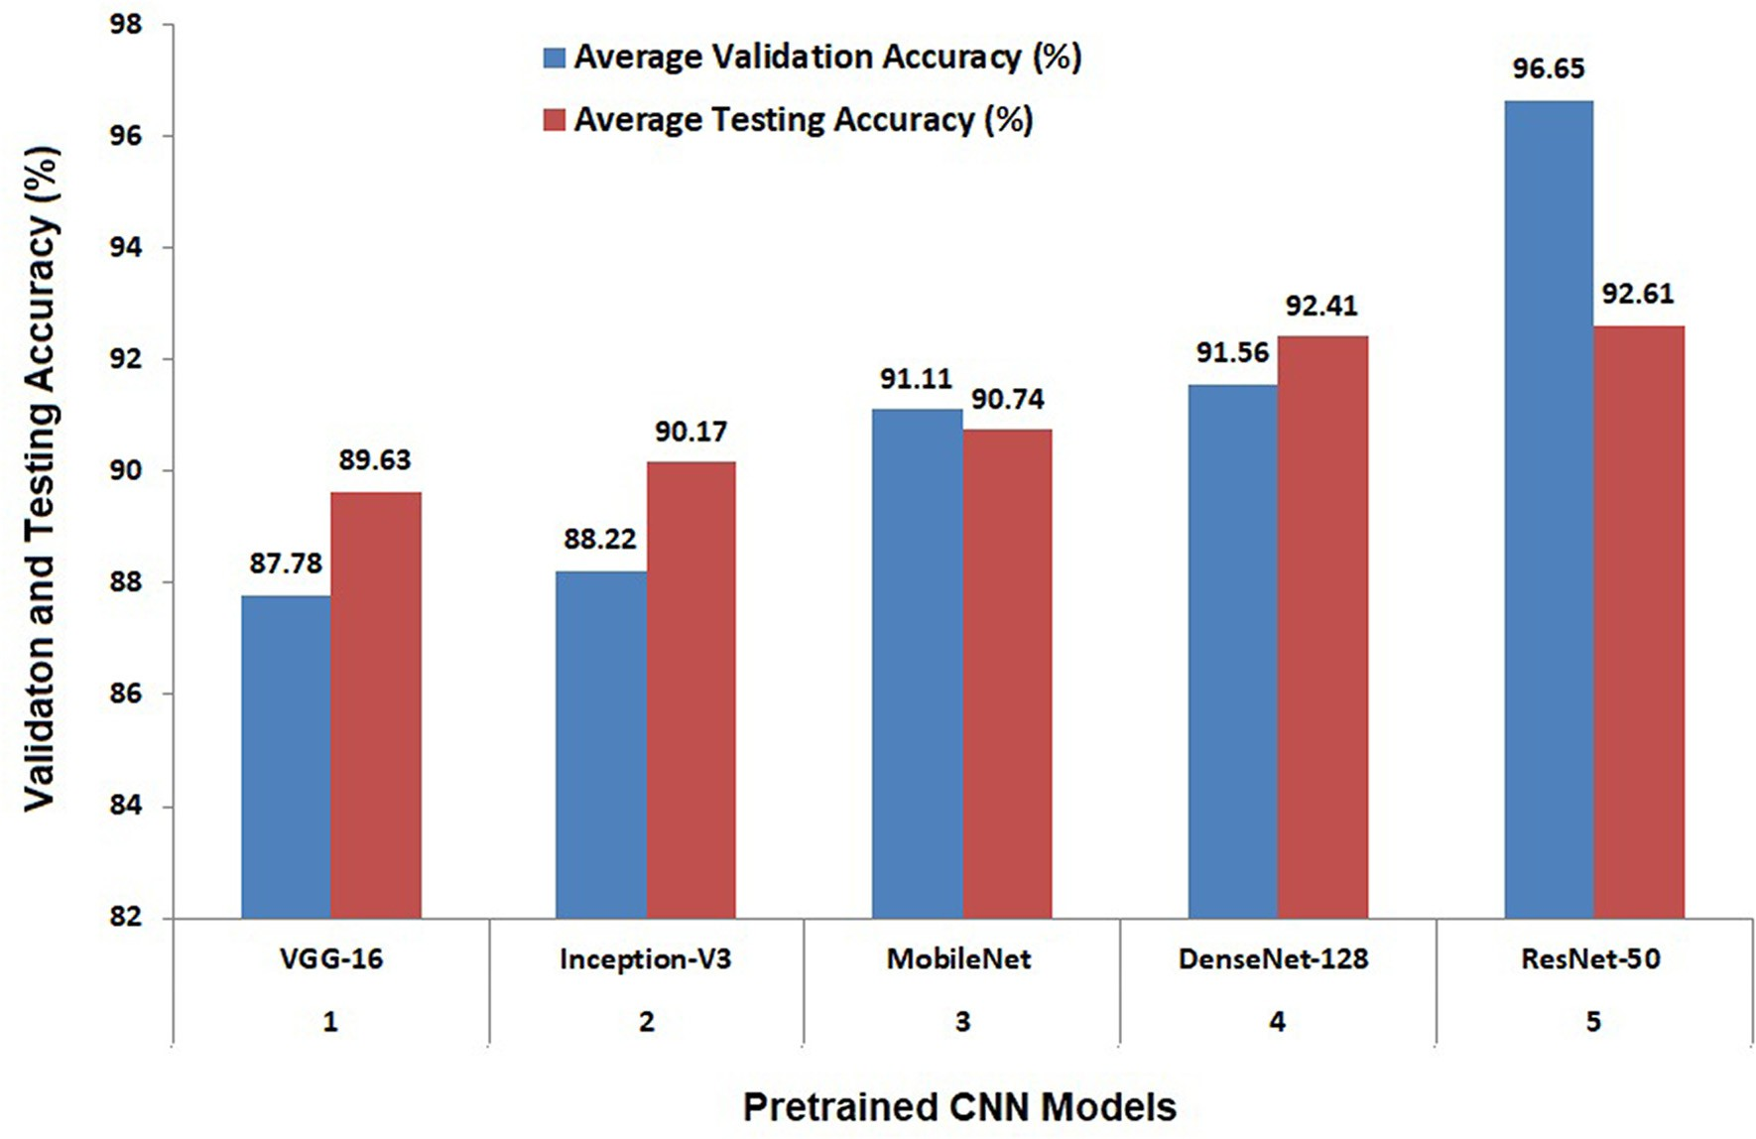

Fig. 9. Performance evaluation results of all the pre-trained CNN models.

technology in the development of more effective field and crop management software.

CRediT authorship contribution statement

Naveen N. Malvade: Conceptualization, Methodology, Software, Writing – review & editing. Rajesh Yakkundimath: Data curation, Writing – original draft, Writing – review & editing. Girish Saunshi: Visualization, Investigation, Supervision, Writing – review & editing. Mahantesh C. Elemmi: Software, Validation, Writing – review & editing.

Declaration of Competing Interest

The corresponding author declares that there is no conflict of inter- est on behalf of all of the authors. There was no specific grant for this research from any funding source in the public, private, or non-profit sectors.

Acknowledgement

Dr. Surendra Palaiah, Principal Scientist, University of Agricul- tural Sciences, Dharwad, Karnataka State, India, willingly assisted us in the collecting of datasets and imparted beneficial agricultural

expertise for the research work, and we gladly acknowledge his aid and collaboration.

References

Anami, B.S., Naveen, N.M., Surendra, P., 2020a. Classification of yield affecting biotic and abiotic paddy crop stresses using field images. Inform. Proc. Agric. 7 (2), 272–285. <https://doi.org/10.1016/j.inpa.2019.08.005>.

Anami, B.S., Naveen, N.M., Surendra, P., 2020b. Deep learning approach for recognition and classification of yield affecting paddy crop stresses using field images. Artific. Intellig. Agric. 1 (4), 12–20. <https://doi.org/10.1016/j.aiia.2020.03.001>.

Chen, J., Chen, J., Zhang, D., Sun, Y., Nanehkaran, Y.A., 2020. Using deep transfer learning for image-based plant disease identification. Comput. Electron. Agric. 1 (173), 105393. <https://doi.org/10.1016/j.compag.2020.105393>.

He, Kaiming, Zhang, X., Ren, S., Sun, J., 2016. [Deep residual learning for image recognition.](http://refhub.elsevier.com/S2589-7217(22)00011-3/rf0025) [Proceedings of the IEEE Conference on Computer Vision and Pattern Recognition,](http://refhub.elsevier.com/S2589-7217(22)00011-3/rf0025)

[pp. 770–778](http://refhub.elsevier.com/S2589-7217(22)00011-3/rf0025).

He, Kaiming, Girshick, Ross, Dollár, Piotr, 2019. [Rethinking ImageNet pre-training. Pro-](http://refhub.elsevier.com/S2589-7217(22)00011-3/rf0030) [ceedings of the IEEE/CVF International Conference on Computer Vision,](http://refhub.elsevier.com/S2589-7217(22)00011-3/rf0030)

[pp. 4918–4927](http://refhub.elsevier.com/S2589-7217(22)00011-3/rf0030).

Howard, A.G., Zhu, M., Chen, B., Kalenichenko, D., Wang, W., Weyand, T., Andreetto, M., Adam, H., 2017. Mobilenets: efficient convolutional neural networks for mobile vision applications. arXiv [https://doi.org/10.48550/arXiv.1704.04861 Focus to learn more](https://doi.org/10.48550/arXiv.1704.04861%20Focus%20to%20learn%20more) preprint arXiv:1704.04861.

Huang, S., Qi, L., Ma, X., Xue, K., Wang, W., Zhu, X., 2015. Hyperspectral image analysis based on BoSW model for rice panicle blast grading. Comput. Electron. Agric. 118, 167–178. <https://doi.org/10.1016/j.compag.2015.08.031>.

Huang, G., Liu, Z., Van Der Maaten, L., Weinberger, K.Q., 2017. [Densely connected](http://refhub.elsevier.com/S2589-7217(22)00011-3/rf0045) [convolutional networks. Proc. of the IEEE Conference on Computer Vision and Pattern](http://refhub.elsevier.com/S2589-7217(22)00011-3/rf0045) [Recognition, pp. 4700–4708](http://refhub.elsevier.com/S2589-7217(22)00011-3/rf0045).

Hughes, D., Salathé, M., 2015. An open access repository of images on plant health to en- able the development of mobile disease diagnostics. arXiv [https://doi.org/10.48550/](https://doi.org/10.48550/arXiv.1511.08060) [arXiv.1511.08060](https://doi.org/10.48550/arXiv.1511.08060) preprint arXiv:1511.08060.

Lu, J., Hu, J., Zhao, G., Mei, F., Zhang, C., 2017a. [An in-field automatic wheat disease diag-](http://refhub.elsevier.com/S2589-7217(22)00011-3/rf0055) [nosis system. Comput. Electron. Agric. 1 (142), 369–379](http://refhub.elsevier.com/S2589-7217(22)00011-3/rf0055).

Lu, Y., Yi, S., Zeng, N., Liu, Y., Zhang, Y., 2017b. [Identification of rice diseases using deep](http://refhub.elsevier.com/S2589-7217(22)00011-3/rf0060) [convolutional neural networks. Neurocomputing 267, 378–384](http://refhub.elsevier.com/S2589-7217(22)00011-3/rf0060).

Mohan, K.J., Balasubramanian, M., Palanivel, S., 2016. [Detection and recognition of dis-](http://refhub.elsevier.com/S2589-7217(22)00011-3/rf0065) [eases from paddy plant leaf images. Int. J. Comput. Appl. 144 (12), 34–41](http://refhub.elsevier.com/S2589-7217(22)00011-3/rf0065).

Mohanty, S.P., Hughes, D.P., Salathé, M., 2016. Using deep learning for image-based plant disease detection. Front. Plant Sci. 7. <https://doi.org/10.3389/fpls.2016.01419>.

Orillo, J.W., dela Cruz, J., Agapito, L., Satimbre, P.J., Valenzuela, I., 2014. Identification of dis- eases in rice plant (*Oryza Sativa*) using back propagation artificial neural network. 2014 International Conference on Humanoid, Nanotechnology, Information Technol- ogy, Communication and Control, Environment and Management (HNICEM), pp. 1–6 <https://doi.org/10.1109/HNICEM.2014.7016248>.

Phadikar, S., Sil, J., Das, A.K., 2012. [Classification of rice leaf diseases based on morpholog-](http://refhub.elsevier.com/S2589-7217(22)00011-3/rf0080) [ical changes. Int. J. Inform. Electron. Eng. 2 (3), 460](http://refhub.elsevier.com/S2589-7217(22)00011-3/rf0080).

Phadikar, S., Sil, J., Das, A.K., 2013. Rice diseases classification using feature selection and rule generation techniques. Comput. Electron. Agric. 90, 76–85. [https://doi.org/10.](https://doi.org/10.1016/j.compag.2012.11.001) [1016/j.compag.2012.11.001](https://doi.org/10.1016/j.compag.2012.11.001).

Pugoy, R.A., Mariano, V.Y., 2011. [Automated rice leaf disease detection using color image](http://refhub.elsevier.com/S2589-7217(22)00011-3/rf0090) [analysis. Third international conference on digital image processing (ICDIP 2011), In-](http://refhub.elsevier.com/S2589-7217(22)00011-3/rf0090) [ternational Society for Optics and Photonics, 80090F](http://refhub.elsevier.com/S2589-7217(22)00011-3/rf0090).

Saleem, M.H., Khanchi, S., Potgieter, J., Arif, K.M., 2020. Image-based plant disease identi- fication by deep learning meta-architectures. Plants 9 (11), 1451. [https://doi.org/10.](https://doi.org/10.3390/plants9111451) [3390/plants9111451](https://doi.org/10.3390/plants9111451).

Sethy, P.K., Barpanda, N.K., Rath, A.K., Behera, S.K., 2020. Image processing techniques for diagnosing Rice Plant disease: a survey. Procedia Comp. Sci. 1 (167), 516–530. <https://doi.org/10.1016/j.procs.2020.03.308>.

Simonyan, K., Zisserman, A., 2014. Very deep convolutional networks for large-scale image recognition. arXiv 1. <https://doi.org/10.48550/arXiv.1409.1556> preprint arXiv:1409.1556.

Szegedy, Christian, Vanhoucke, Vincent, Ioffe, Sergey, Shlens, Jon, Wojna, Zbigniew, 2016. [Rethinking the inception architecture for computer vision. Proceedings of the IEEE](http://refhub.elsevier.com/S2589-7217(22)00011-3/rf0110) [Conference on Computer Vision and Pattern Recognition (CVPR), pp. 2818–2826](http://refhub.elsevier.com/S2589-7217(22)00011-3/rf0110).

Too, E.C., Yujian, L., Njuki, S., Yingchun, L., 2019. [A comparative study of fine-tuning deep](http://refhub.elsevier.com/S2589-7217(22)00011-3/rf0115) [learning models for plant disease identification. Comput. Electron. Agric. 1 (161), 272](http://refhub.elsevier.com/S2589-7217(22)00011-3/rf0115). Yakkundimath, R., Saunshi, G., Anami, B., 2022. Classification of rice diseases using convolutional neural network models. J. Inst. Eng. (India): Series B, 1047–1059

<https://doi.org/10.1007/s40031-021-00704-4>.