[Artificial Intelligence in Agriculture 7 (2023) 27–34](https://doi.org/10.1016/j.aiia.2023.02.001)

Contents lists available at [ScienceDirect](http://www.sciencedirect.com/science/journal/)

Artificial Intelligence in Agriculture

journal homepage: [http://www.keaipublishing.com/en/journa ls/artificial- intelligence- in-agriculture/](http://www.keaipublishing.com/en/journals/artificial-intelligence-in-agriculture/)

[](http://crossmark.crossref.org/dialog/?doi=10.1016/j.aiia.2023.02.001&domain=pdf)A fuzzy risk assessment model used for assessing the introduction of African swine fever into Australia from overseas

Hongkun Liu a,b, YongLin Ren b, Huanhuan Chu a, Hu Shan a,⁎, Kok Wai Wong b,⁎

a *College of Veterinary Medicine, Qingdao Agriculture University, Qingdao, PR China*

b *Murdoch University, 90 South Street, Murdoch, Western Australia 6150, Australia*

# a r t i c l e i n f o

*Article history:*

Received 25 July 2022

Received in revised form 8 February 2023 Accepted 14 February 2023

Available online 16 February 2023

*Keywords:*

Risk assessment Fuzzy model

African swine fever (ASF) ASF introduction Australia

# a b s t r a c t

African swine fever (ASF) is a contagious and lethal hemorrhagic disease with a high case fatality rate. Since 2007, ASF has been spreading into many countries, especially in Europe and Asia. Given that there is no effective vaccine and treatment to deal with ASF, prevention is an important way for a country to avoid the effects of the virus. Australia is currently ASF-free but the disease has been reported in many neighboring countries, such as Indonesia, Timor-Leste, and Papua New Guinea. Therefore, it is necessary for Australia to maintain hyper- vigilance to prevent the ASF introduction. In this paper, we propose the use of fuzzy concepts to establish a fuzzy risk assessment model to predict the ASF introduction risk in Australia. From the analysis, the international passengers (IP) and international import trade (IIT) are concluded as the two main ASF introduction factors based on transmission features and past research. From the established fuzzy risk assessment model based on the analysis of the 2019 and 2020 data, the risks of ASF introduction into Australia are considered to be low. The model further deduced that the Asian region was the major source of potential risks. Finally, in order to val- idate the effectiveness of the established fuzzy risk assessment model, the qualitative data from the Department for Environment, Food & Rural Affairs of the United Kingdom was used. From the validation results, it has shown that the results were consistent when the same data is adopted, and thus proved that the functionality of the established fuzzy risk assessment model for assessing the risk in Australia.

© 2023 The Authors. Publishing services by Elsevier B.V. on behalf of KeAi Communications Co., Ltd. This is an open access article under the CC BY-NC-ND license (<http://creativecommons.org/licenses/by-nc-nd/4.0/>).

1. Introduction

African swine fever (ASF) is a transmittable disease and seriously threatens swine health. It can cause hemorrhagic fever with a high fatal- ity rate, which could sometimes be almost 100% in domestic and wild pigs. This means that if ASF cause an outbreak, a huge damage could be created to the pig industry and the economy of a country (Sánchez-Cordón et al., 2018). For instance, the breeding stock in China had decreased by 40% due to the ASF epidemic in 2018 (Huang, 2020), and the price of pork has significantly increased while the Con- sumer Price Index (CPI) increased by 4%. In recent years, ASF had spread quickly in many countries. In 2007, ASF (genotype II) was first reported in Georgia. After that, ASF was spread from Georgia to the Caucasus and then to the European continent in just a few years (EFSA Panel on Animal Health and Welfare (AHAW) et al., 2019). Since 2014, the infec- tion has spread to Eastern, Central, and Western Europe, including Lithuania, Estonia, Poland, Latvia, Czech Republic, Romania, Hungary,

* Corresponding authors.

*E-mail addresses:* [shanhu67@163.com](mailto:shanhu67@163.com) (H. Shan), [K.wong@murdoch.edu.au](mailto:K.wong@murdoch.edu.au) (K.W. Wong).

Bulgaria, and Belgium (Chenais et al., 2019; Ito et al., 2020). In Septem- ber 2020, Germany has confirmed the first case of ASF (Sauter-Louis et al., 2021). In terms of timeline and geographic location, ASF had spread to Western Europe from Eastern Europe. Asia has not reported any ASF cases before 2018. However, the first ASF case appeared in the city of Shenyang, Liaoning province in August 2018 (Zhao et al., 2019). Since then, ASF had transmitted to many Asian countries and re- gions, including Mongolia, South Korea, Vietnam, Philippines, Laos, Myanmar, Cambodia, Indonesia, Hong Kong, Timor-Leste, and Papua New Guinea (Mighell and Ward, 2021; Food and Agriculture Organisation of the United Nations [FAO], 2022). ASF appears to have followed the pandemic trend, and it may spread to more countries (Ito et al., 2020).

One way to avoid ASF outbreak for a country is to investigate the ASF transmission pathways. ASF transmission has many pathways, involv- ing feral pigs, domestic pigs and pig products, and soft ticks of the genus Ornithodoros (Chenais et al., 2019). Humans are recognised as being responsible for long distance virus transmission (Chenais et al., 2019; Rocque et al., 2011). For instance, in March 2017, an ASF outbreak was recorded in Irkutsk, Russia, and soon, the virus spread thousands of kilometers into Europe.Another recent example is the Timor-Leste

<https://doi.org/10.1016/j.aiia.2023.02.001>

2589-7217/© 2023 The Authors. Publishing services by Elsevier B.V. on behalf of KeAi Communications Co., Ltd. This is an open access article under the CC BY-NC-ND license ([http://](http://creativecommons.org/licenses/by-nc-nd/4.0/) [creativecommons.org/licenses/by-nc-nd/4.0/](http://creativecommons.org/licenses/by-nc-nd/4.0/)).

outbreak situation (Lu et al., 2020), where its outbreak points were 2000 km from the nearest outbreak. International travelers and trade are two important human activity pathways for the introduction of the virus into ASF-free countries. De La Rocque et al. (2011) considered that the development of international travel and trade has increased the risk of the spread of various infectious diseases. According to Ito et al. (2020), there is a negligible risk via feral pig and vehicle movements but there is a risk posed by pork bring into the countries by travelers. Ito et al. (2020) suggested that the pork products in international air passengers' luggage (PPAP) could be a route that ASF introduce into ASF-free country. Jurado et al. (2019a, 2019b) shared similar opinion. Central News Agency [CAN] (2019) reported a packet of pork was de- tected to contain positive ASF virus on February 19, 2019 at Taipei Songshan Airport. It was similar in South Korea, there were pork prod- ucts detected with Chinese passengers in 2018 (Kim et al., 2019). Sugiura et al. (2020) also reported that illegal pork products brought into Japan by international travelers was on the rise, and this could lead to ASF entering Japan. Therefore, PPAP has been proven to be a po- tential route for the spread of ASF across borders. Apart from PPAP, transport-associated routes (TAR) is also a route of ASF introduction into virus free territories, most of those were related to transport for in- ternational travel and import trade (Mur et al., 2012).As an example, contaminated pork and other pig products from international transport had introduced ASF to some ASF-free countries, such as Georgia (Beltrán-Alcrudo et al., 2008).

Jurado et al. (2019a, 2019b)’s quantitative model showed the prob- ability of ASF introduction was related to the weight (kg) of PPAP brought into the region and the probability of PPAP being contaminated with ASF. This study also showed that the size of these two data was re- lated to the number of visitors and the passengers' country of origin. Ac- cording to the OIE-WAHIS (2021) and Jurado et al. (2019a, 2019b)’s research, the countries where ASF has been reported were defined as ASF high-risk. A similar principle was adopted for the variables of TAR from Mur et al. (2012)’s model. The level of ASF introduction risk by TAR was affected by the cargo ships originating from ASF-infected coun- tries. In addition, 90% of global trade is by sea freight (TFG, 2020). There- fore, the larger the import trade could lead to a higher amount of shipping, which could also increase the risk of ASF introduction. It also means that the greater the proportion of passengers and imports from ASF high-risk countries, the greater the risk of ASF introduction.

Building a risk assessment model on ASF can play an important role in the national bio-security. A mathematical model is an effective tool for the prediction of the infection spread (Bhuju et al., 2020). Quantita- tive models were established for the prediction of the risk of ASF intro- duction (Ito et al., 2020; Jurado et al. (2019a, 2019b); Mur et al., 2012). However, the data collection standards are different between the country's statistical bureaus. Many types of data could be difficult to find, such as the annual weight of pork products by passengers, the pos- sibility of passengers carrying pork products. On the other hand, due to the lack of reliable data, many inferred probabilities are not accurate, which seriously affects the accuracy of the quantitative models. For ex- ample, Ito et al. (2020) mentioned that many farmers sell infected pigs with ASF, which has a direct effect on the risk assessment of the pork products. In addition, the models mentioned in Andraud et al. (2021) and Schettino et al. (2021)’s studies may not be appropriate to be ap- plied in all countries. As shown, these models are developed for use in inland countries such as Romania and Kazakhstan. Thus, most of the land ASF risk introduction factors, such as truck transport and wild boar, are not necessary to be taken into consideration. In addition, Schettino et al. (2021) studied national districts ranking based on ASF outbreak risk factors rather than risk assessment of ASF introduction into their countries. The directions of evaluation are different from that of the island countries. Given the different factors for consideration and the availabilities of the data required, it is difficult to use any existing risk assessment models directly for assessing the introduction risk for Australia.

Although Australia is still free of ASF, there is still a risk that the virus could be introduced into the country. Since 2007, in addition to the trend of ASF covering Europe to the West, there is also a trend of the ASF invading the Asia-Pacific region to the south (Fig. 1), meaning very close to Australia geographically. In fact, Mighell and Ward (2021) made similar prediction that ASF is likely to enter Australia in the next few years. However, in order to continue modelling and assessing the risk factors, it is necessary to build a flexible and versatile risk assessment model that can provide insights of the factors. This will enable Australia to improve the prediction, prevention and other mea- sures to maintain its ASF-free status. Therefore, in this work, we en- deavor to establish a new model using fuzzy logic for the assessment of the introduction risk of ASF into Australia.

In medicine and biology fields, many concepts are uncertain or fuzzy (Massad et al., 1999). Massad et al. (1999) mentioned that there are several levels of uncertainty in, in epidemiology of infections. For exam- ple, poor public health conditions could lead to an increased spread of infectious diseases. However, the standard of “poor” is vaguely defined, but somehow being able to be processed by human using logical reason- ing. Human experts normally use such vaguely defined terms for deci- sion making. In this context, many ASF introduction risk factors, such as PPAP and, TAR, are difficult to be quantified accurately for assessing the ASF introduction risk. Therefore, this paper has adopted a new es- tablished model by using fuzzy concepts to deal with unclear, incom- plete or ambiguous data. Fuzzy logic can handle the types of incomplete and uncertain information data (Zadeh, 1975). Fuzzy logic is different from classic logic which is dualistic that can be classified as true or false only (Shapiro and Kouri Kissel, 2018). However, fuzzy logic is used to deal with the concept of partially true or degree between the ‘totally true’ and ‘totally false’, and an effective way to handle the un- certainty and imprecise data (Zadeh, 1988; Zadeh, 2008). Massad et al. (1999) suggested that fuzzy logic is an effective tool to create rules for modelling the prevention of infections spread. Recently, fuzzy logic has been introduced in many models of infections. Arji et al. (2019) showed that the fuzzy logic model had been widely applied in the diag- nosis infectious diseases, such as dengue fever, hepatitis and tuberculo- sis. Bhuju et al. (2020) used fuzzy approach to analyses the transmission dynamics of dengue. Issa et al. (2021) developed a risk model to evalu- ate COVID-19 transmission by fuzzy logic. Besides able to handle incom- plete and vaguely defined variables, fuzzy rule based system can also provide human understandable fuzzy rules, which means that the as- sessment can be traced and understandable by human. Therefore, fuzzy system has been selected as the method to establish the new risk assessment model for Australia in this paper. The methodology pre- sented in this paper can easily be used to build similar risk assessment model with adaption to the factors and availability of data for different countries.

1. Materials and methods
   1. *Data collection & tool*

The first step in building the ASF introduction risk assessment model for Australia is to source for the available data that can contribute to the factors used in the model. The data of international tourism and total imports of goods, by source country was gathered from the Australian Bureau of Statistics (ABS, 2020) and the World Tourism Barometer [UNWTO] (2020; 2021). The figures of international passengers of air- line by uplift country was acquired from the Bureau of Infrastructure and Transport Research Economics (BITRE, 2019; BITRE, 2020). The countries ranking and others information of import values were ac- quired from the Ports Australia and the International Trade Centre (Internatinal Trade Central [ITC], 2020). The list of countries with the ASF situation was from OIE-World Animal Health Information database interface (WAHIS, 2021).

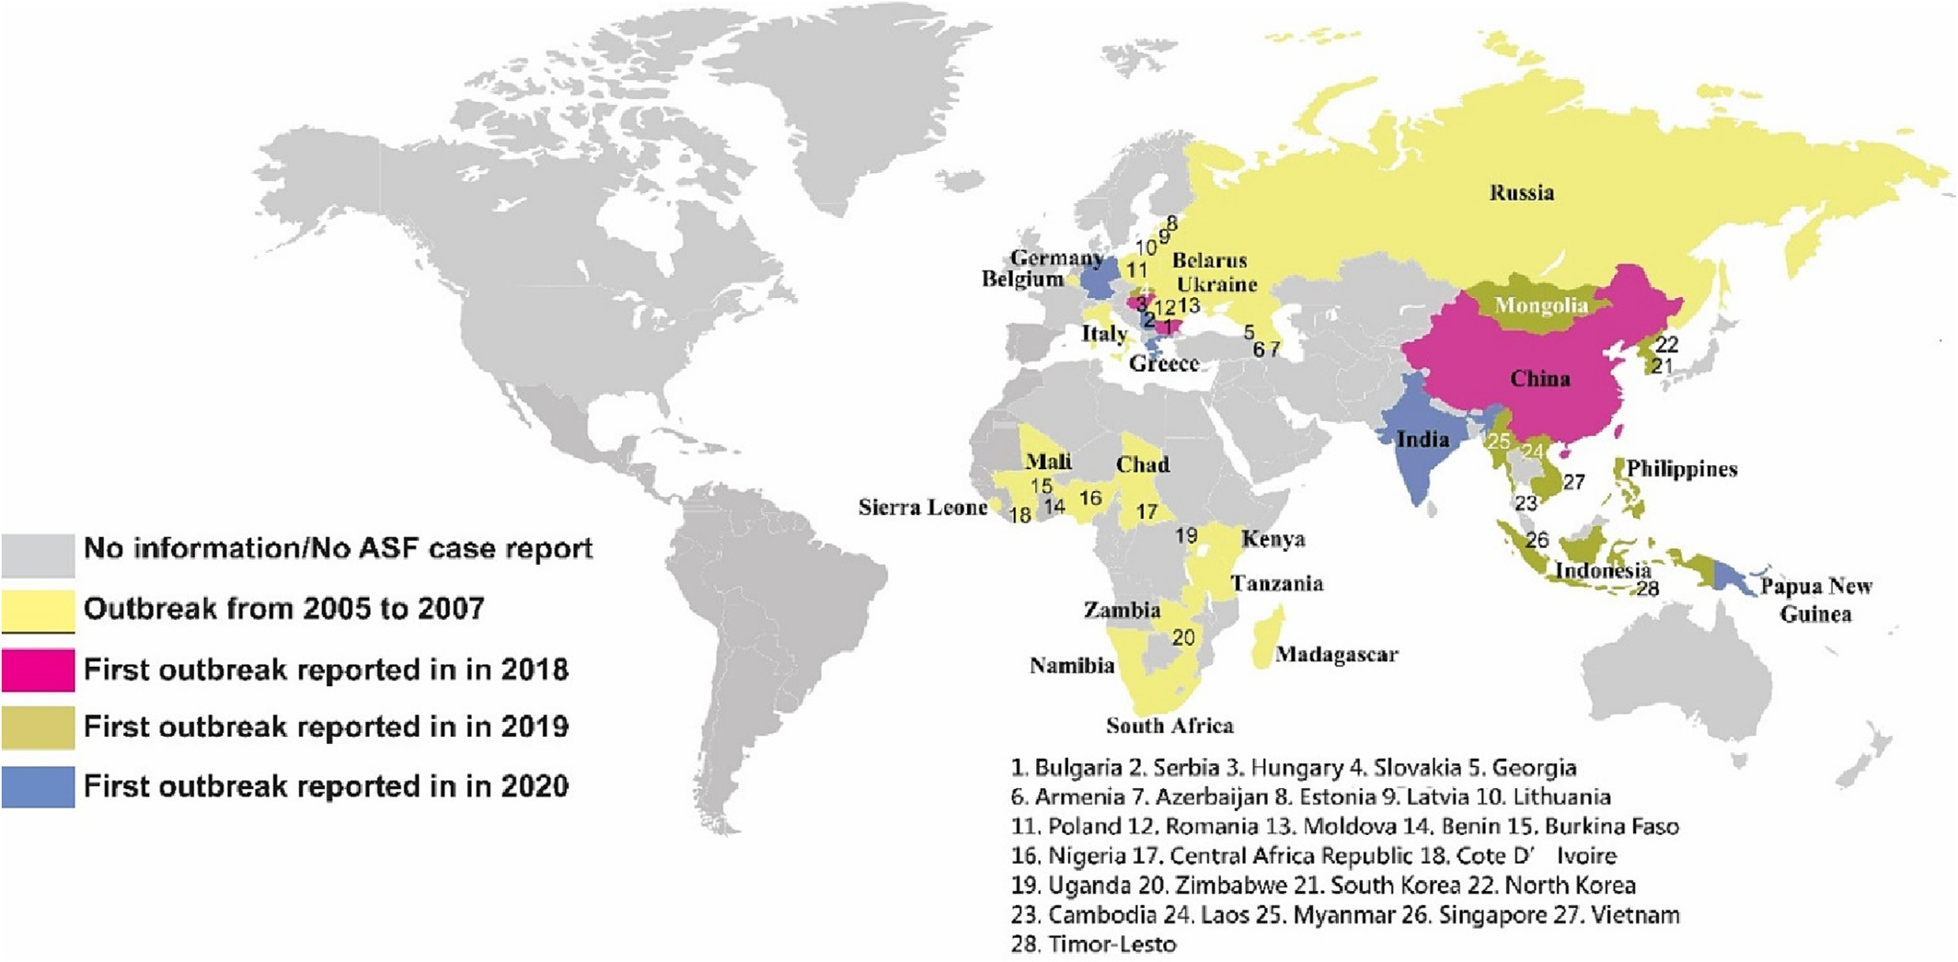

Fig. 1. The global ASF distribution (modified from (Shi et al., 2021)). The different colors represent the ASF situations in different countries.

* 1. *Fuzzy model*
     1. *Fuzzy variables*

The fuzzy risk assessment model is constructed using the MATLAB R2020b software. According to previous research (Jurado et al. (2019a, 2019b); Ito et al., 2020; Mur et al., 2012; De La Rocque et al., 2011), and the location of Australia, international passengers (IP) and international import trade (IIT) have been defined as the two major factors to be considered for assessing the ASF virus intro- duction to Australia. With pork products carried by IP being one of the ASF introduction risks, the number of IP is an important contrib- uting factor. As mentioned earlier, the ASF introduction risk is related to shipping. While independent statistics on maritime transport from Australia open public data is not available, and given that 98% of Australian international trade is via sea freight according to the Ports Australia. It means that the number of the IIT is related to that of the freight, and in turn to ASF introduction risk. Thus, IP and IIT are two variables used to build this model. However, there are some factors which could also affect IP and IIT (Ito et al., 2020; Jurado et al. (2019a, 2019b); Mur et al., 2012). This could suggest that the model can be structured into hierarchical manner using two layers as shown in Fig. 2. Kamthan and Singh (2020) proposed the multiple-input single-output system which was suitable for this paper. A system is divided into several subsystems, each subsystem has specific variables, rules and membership functions. After that, it is hierarchically connected to obtain a single output. The two vari- ables, IP and IIT will then become the variables in the upper layer. Ac- cording to previous research (Ito et al., 2020; Jurado et al. (2019a, 2019b); Mur et al., 2012) and the publicly available information (World Animal Health Information database interface [WAHIS], 2021; TFG, 2020), the annual number of international passengers, import amount, and those percentage from high risk countries could affect annual risk value from IP and IIT. Therefore, IP and IIT are respectively affected by the two variables in the upper layer. The annual number of passengers, percentage of that from ASF high risk countries, and the annual amount of international import and percentage of that with ASF high risk countries will be investigated in the first layer (Fig. 2).

* + 1. *Membership functions and fuzzy sets*

The next step in building the fuzzy risk assessment model for Australia is to define the fuzzy membership functions. There are three commonly used fuzzy membership functions, which are Gaussian, Trap-

ezoid and Triangular (Loan et al., 2014). The domain is defined to ‘*X*', and all elements are denoted ‘*x*', where *x* ∊ *X*. In order to model the ambigu- ity, fuzzy uses the range [0,1] to replace the crisp set (0,1) to describe

the degree of truth for elements belonging to the fuzzy set (Zadeh et al., 1996). According to the previous research, triangular membership function was often used in other type risk assessment models (Issa et al., 2021). In this paper, we have also adopted the triangular membership

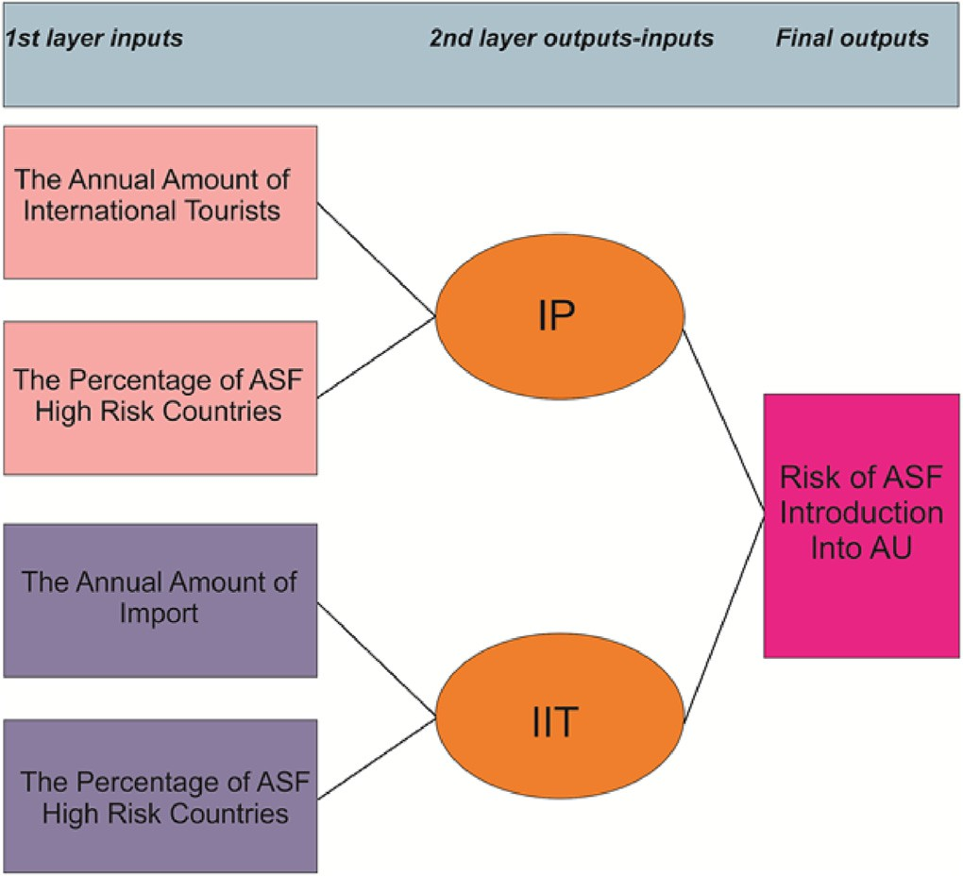

Fig. 2. The structure of the fuzzy risk assessment model. It includes two layers, and there are four input variables in the first layers. IP represents international passengers (IP) and IIT is the international import trade (IIT).

function. Based on the characteristics of the variable, the range of mem- bership function is set to [0,100] in this model to align to the range of percentage, which is between 0 and 100%.

In order to be consistent, the membership function ranges of IP and IIT are also set from 0 to 100. The number of passengers is obtained from the international tourist arrivals-country rankings (World Tourism Barometer [UNWTO], 2020). Since the highest point was always under 90 million in recent decades, 100 million is set to be the upper limit. Thus, the range is set between 0 and 100 million and corresponds to the range from 0 to 100. The range of import was set in a similar man- ner. According to WTO data, the import value of the United State and China are much higher than any other countries. If their import amounts are set as the upper limit, it may affect the effect of the model. Therefore, 10 billion is set as the upper limit. Countries with more than 10 billion are usually only China and the United States. However, in the model, the upper limit is set at 10 billion and it will set to 10 billion when the figure exceeds 10 billion.

In this paper, the membership function is defined as *μ(x).*

The domain is *X*, *A* is the subset of *X*, the range is from *xa* to *xb*, *μA*(*x*) is the membership function of *A*, and their relationship is shown below:

*μA* (*x*) : *X* → [0, 100] (1)

Table 1

The degree and range of the ASF risk.

Risk degree Range

Very low 0–20

Low 20–40

Medium 40–60

High 60–80

Very high 80–100

which is the risk degree of ASF introduction into Australia (RAM), is equal to *j*. The Mandani rule relationship could be shown as follows:

If IP is *p* and IIT is *t*, then RAM is *j.*

In this paper, the matrix approach is used to define the fuzzy rules. The abscissa is represented by *p* (IP) and the ordinate is represented by *t* (IIT). According to the customized grade standard, the grade range of the rectangular area can be determined. For example, very low is from 0 to 20. Then, the upper limit of the very low is 20. Therefore, the very low range of the rectangular area is in the range between 0 and 400 (Fig. 4). Similarly, the rectangular area range of each level could be obtained (Table 3). After that, the median of each degree of the horizon- tal and vertical coordinates is used to determine the fuzzy rules by the level range of the rectangular area (Fig. 4). For instance, when IT is

*A* = (x, *μ*A (x)∣x ∊ X}

low, IIP is medium, and the degree of the output can then be inferred.

(2) The medians of low and medium degrees are 30 and 50 respectively and 30 times 50 is 1500. According to Table 3, 1500 is located in the

Based on past similar research and common fuzzy set partition rules (Issa et al., 2021; Mandal et al., 2012; Mur et al., 2012) the variable is di- vided into 5 fuzzy sets (Fig. 3) to define the output and input level (very low (*VL*), low (*L*), medium (*M*), high (*H*), very high (*VH*)) (Table 1). In this paper, five fuzzy sets cover the entire universe of discourse by using an equidistant distribution method (Fig. 3). Five risk levels are used to define the risk level of the assessment as shown in Table 1. After which, the transitions from one risk level to another are designed using fuzzy overlapping to create the fuzzy membership functions as shown in Fig. 3.

* + 1. *Fuzzy rules and verification*

In this research, we have adopted the Mamdani inference system, and the structure is:

R: if *x* is *A*ᵢ and *x* is *A*ᵢ …*x* is *A*ᵢ then *u* is *U*ᵢ*.*

low range. Thus, when IT is low and IIP is medium, and the output is low. Apart from that, Issa et al. (2021)’s model also provide similar methodology for building the fuzzy rules.

Next, validation is carried to validate the established fuzzy risk as- sessment model. Random figures are entered into the model. Occasion- ally some outputs turn out to be unreasonable. For instance, in some input range, it appears that although the input is increased but the out- put is fixed or decreased. This means that some linguistic variables of the output part are so similar such that the assessment of the model is misguided. Therefore, a small number of rules are revised and opti- mized with reference to the design methodology in Issa et al. (2021)’s model. The rules can be described as follows:

If IP is *low* AND IIT is *low*, then the risk of ASF introduction (RAI) is

*low.*

The rules could be stated in the matrix as shown in Table 2. The rules

ᵢ *1* *1*

*2 2 n n*

of other layers also adopted the same method. In total, the number of

Rᵢ represents the *i-*th fuzzy rule. *A* is the fuzzy set of the input variable, *x*. *U* is the fuzzy set of output variable, *u*. The Mandani inference system is used as it is easier for human to understand the decision made.

In this paper, linguistic variables are adopted to replace the mathe- matical formulas, which is more suitable for inference uncertain con- cepts for human (Zadeh, 1975). The introduction risk is affected by two factor variables, IP and IIT. Until now, there are no commonly agreed standard to define IP and IIT. Therefore, we could not acquire specific data to build the model. Thus, the paper uses common behavior and similar model experience, while literature on other infections was used to define the rules (Issa et al., 2021). Apart from that, it is assumed that two input parameters IP and IIT are equal to *p* and *t*, and the output

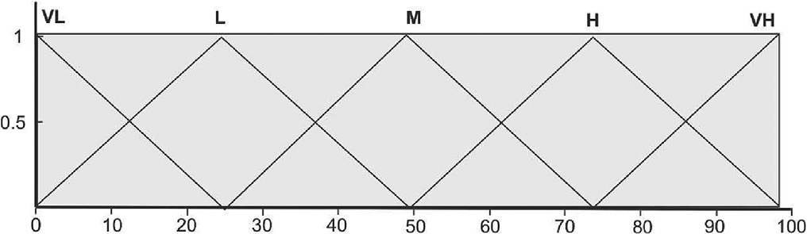

Fig. 3. The membership function of the Fuzzy model. The fuzzy sets adopted equidistant distribution. VL is very low; L is low; M is medium; H is high; VH is very high.

fuzzy rules in this model is 75. After the rule bases are formulated, the

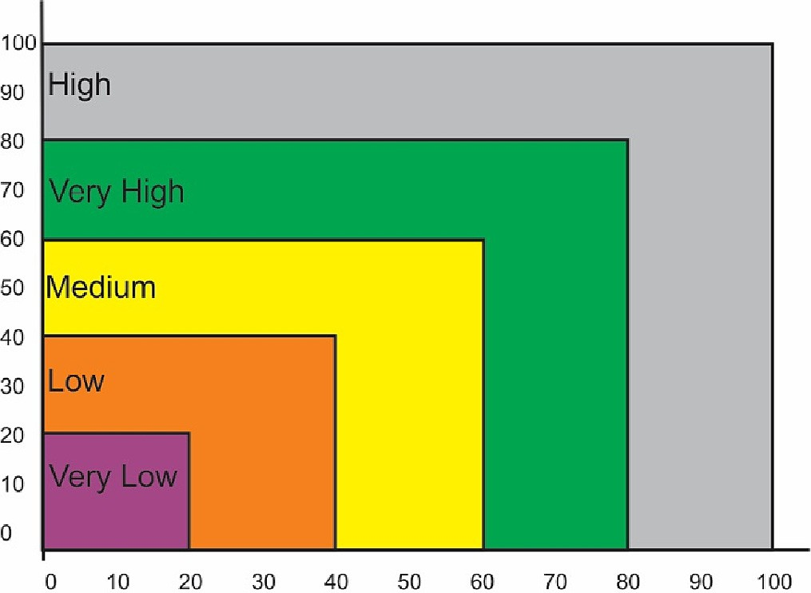

Fig. 4. The function diagram of rectangular area classification. The abscissa represents in- ternational passengers (IP), the ordinate represents international import trade (IIT). The levels are labeled by different colors.

Table 2

Fuzzy rules matrix and linguistic variables for inputs and outputs.

Risk degree Impact on ASF introduction

|  |  |  |  |  |  |  |
| --- | --- | --- | --- | --- | --- | --- |
|  | Very low | Low | Medium | High | Very high |  |
| Very low | Very low | Very low | Low | Low | Medium |  |
| Low | Very low | Low | Low | Medium | Medium |  |
| Medium | Low | Low | Medium | Medium | High |  |
| High | Low | Medium | Medium | High | Very high |  |
| Very high | Medium | Medium | High | Very high | Very high |  |

overall characteristics of the model could be viewed through the three- dimensional function (Fig. 5).

* 1. *The risk of ASF introduction to Australia*

From the Cartesian product:

*A* × *B* = {(*a*, *b*) *A* and *b* ∈ *B*} (3)

*A* and *B* are two input fuzzy set.

It could be adopted to evaluate the two variables of each hierarchical layer of this model. In this paper, all the rules use the ‘AND’ as the fuzzy operator. Thus, the model used two methods for calculation, min and *prod*. The equations are as follows.

*μA*∩*B* (*x*) = *min* [μ*A* (*x*), *μB* (*x*)] (4)

*μA*∩*B* (*x*) = *prod* [*μA* (*x*), *μB* (*x*)] = *μA* (*x*) × *μB* (*x*) (5)

The data of annual international visitors to Australia, the annual per- centage of flight lines by countries, the Australia's import value per year and the proportion of the import value by countries are used (see Table 3). The two outputs of the first layer are then acquired, i.e. the

Table 3

The rectangular area of each level range.

Risk degree Range

Very low 0–400

Low 400–1600

Medium 1600–3600

High 3600–6400

Very high 6400–10,000

results of the risk level of IP and IIT, which are entered in the next layer as the inputs (Fig. 2).

In this paper, the data of the last two years (2019 and 2020) are used and the trend were analyzed by comparing the two-year results.

* 1. *Model validation*

In order to assess the validity of the model, other assessment results can be used to validate the functionality of the established fuzzy risk as- sessment model. According to the Department for Enviorment Food and Rural Affairs of United kingdom government (2018), a qualitative method was used to assess the risk of ASF introduction to the United Kingdom which was also divided into five risk levels (i.e. very low, low, medium, high and very high). DEFRA referred to a variety of data from other European countries and their own country, such as trade amount, pig import amount. Based on the survival time of ASFV in dif- ferent biological environments, the ASF epidemiology and the outbreak situation in Europe, it calculated the risk level of the ASF impact for the UK through different pathways. One parameter of their method, which is transport is similar to the IIT variable of the established fuzzy risk as- sessment model. Thus, the number of United Kingdom import and the percentage of import value are used in our model (Internatinal Trade Central [ITC], 2020). After that, the risk levels generated by the two methods are compared.

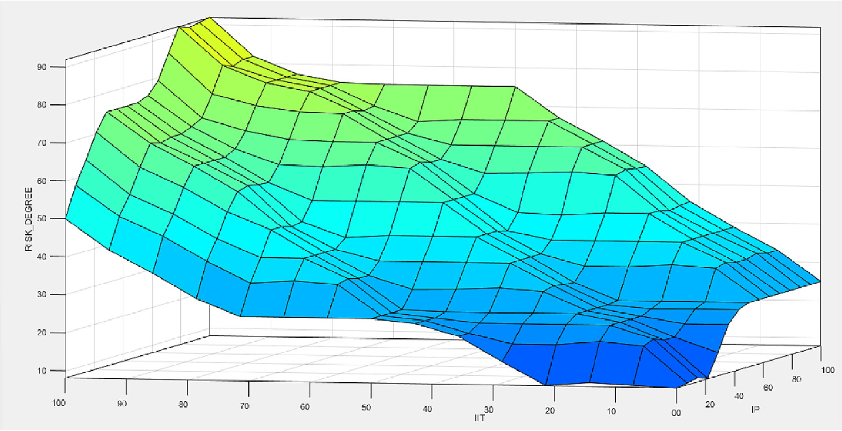

Fig. 5. The surface view of the model. The output (risk degree of ASF introduction into Australia) of the three-dimensional functional relationship is decided by the international passengers (IP) and international import trade (IIT).

1. Results
   1. *The analysis for ASF-introduction to Australia*

According to the statistic of Australian Bureau of Statistics [ABS] (2020) and World Tourism Barometer [UNWTO] (2020), the figure of the international tourism to Australia is 9.47 million in 2019. However, the figure has decreased 80.7% to 1.8 million in 2020 due to the COVID- 19 pandemic. In addition, data from BITRE (2019 & 2020) show that the flight percentage of ASF high risk countries accounted for 28.8% and 24% in 2019 and 2020, respectively. The amount of Australia's import were 214 and 202 billion dollars in 2019 and 2020, respectively (Internatinal Trade Central [ITC], 2020). The probability of import amount from ASF high risk countries (World Animal Health Information database interface [WAHIS], 2021) are 44.9% and 47.0% after calculation based on merchandise imports sheet of Australian Bureau of Statistics [ABS] (2020). Data of the first layer variables are showed in Table 4.

After inferring the first layer, the risk values of IP are 19.9 (2019) and

11.6 (2020) and those of IIT are 24.7 (2019) and 24.8 (2020). All outputs of first layer are then entered to the second layer as inputs. The final out- puts, i.e. the risk of ASF introduction to Australia, are therefore 24.4 (2019) and 21.3 (2020) (Table 5). All of the outputs indicated low risk

(*L*) from the fuzzy risk assessment model. Thus, the risk of ASF introduc- tion in Australia is low risk (*L*). The result is obtained as can be traced back to the first layer of the risk assessment model structure (Fig. 2). The number of tourists, 9.47 million and 1.8 million, input into the model belonged to the *VL* and the percentage, 28.8% and 24% are also belonged to the L. To better understand which fuzzy rule is used to infer such decision, the following fuzzy rule can be observed.

If the annual tourist amount is *VL* and the percentage is *L*, then the IP is *VL*.

For another part, the values of IP are 19.9 and 11.6, both of them are considered as *VL*. It is similar to the calculation of the IIT, the import amounts are 214 and 202 billion (*L*). The figure of percentage, 44.9% and 47.0%, belonged to M. Therefore, the fuzzy rule triggered is as follow.

If the import amount is L and the percentage is M, then the IP is L. Thus, both of the figures, IIT are L (24.7, 24.8).

The rule used is then:

If IP is V*L* AND IIT is *L*, then the risk of ASF introduction (RAI) is *VL*.

As a result, this will provide the final value to indicate the risk level of the ASF introduction into Australia.

Table 4

The list of distribution of international tourists and import trade from countries in 2019 and 2020.

International tourists Import trade

2019 2020 2019 2020

China 8.4% China 5.9% China 25.8% China 28.9%

Table 5

Results of all output by the fuzzy model.

Years 2019 2020

IP 19.9 11.6

IIT 24.7 24.8

Risk of Introduction 24.4 21.3

* 1. *The result of model validation*

The figure of the United Kingdom import amount was 692 billion dollars in 2019 (World Trade Organization [WTO], 2020) and the per- centage of import amount from ASF high risk countries was 47.6% (trad- ing economics). After putting the data into the established fuzzy risk assessment model, the output (i.e. risk level) obtained is 46.7. It belongs to the medium risk level. According to the prediction result of Department for Enviorment Food and Rural Affairs of United kingdom government (2018), the risk of transport was medium. The two predic- tion results are basically the same. Therefore, the prediction of this fuzzy risk assessment model has been validated.

1. Discussion
   1. *Results analysis*

In this paper, the prediction results based on 2019 and 2020 data are due to that, the data of 2019 was highest than past and could represent the highest Australia level in normal years. For compare and analyze the trend after COVID-19 epidemic, 2020 data is cited.

The output value of this model is affected by the second layer input variables (Fig. 2). However, the second layer inputs are the outputs of the first layer. Those are also affected by the first layer inputs. Thus, the final output of the model is ultimately affected by the first layer. However, this presented an opportunity to understand which part of the model provided the effect of the final prediction. The advantage of using fuzzy modelling is the ability to be traced back by using human understandable fuzzy rules. The Australia risk degree is low (24.4 and 21.3), which is due to that some Australia's values of the first layer in- puts are located in the low or very low degree in the world, such as an- nual import amount and annual international tourist amount. In addition, the IP is from 19.9 to 11.6 but is the final output just from

24.4 to 21.3. The drop is not obvious as IP because IIT is relative stable, according to one of the rules as follow:

If IP is VL AND IIT is L, then the risk of ASF introduction (RAI) is VL. However, both of the IP values belong to VL, and IIT values belong to L but both of the final results belong to the L. Although the value (19.9) of IP (2019) belongs to VL but it is very close to the next degree (L). In other words, the attribution degree is closer to the L level than most VL level values, this affected the final output. IP (2020) decrease causes the final result decrease but the final result is also located to L. It may be due to that the intersection and the boundary between fuzzy sets is

New Zealand 17.1%

New Zealand 18.2% USA 12.1% USA 11.9%

large and unclear than those between crisp sets. Thus, the degree loca- tion of output may not be completely corresponding to the fuzzy rules.

Singapore 13.9% Singapore 13.3% Japan 7.0% Japan 6.1% United Arab United Arab Emirates Thailand 4.8% Thailand 4.9%

Emirates 8.2% 8.7%

Indonesia 8.1% Indonesia 7.7% Germany 4.8% Germany 4.7%

USA 7.8% USA 8.1% South Korea 4.0% South Korea 3.1%

In our results, the risks of TAR are similar between 2019 and 2020 but the figure of IP has significantly decreased from 19.9 to 11.6. The major reason is the COVID-19 pandemic, which has led to huge decrease of international tourists. To prevent COVID-19 spread, most countries

Hong Kong

|  |  |  |  |
| --- | --- | --- | --- |
| (SAR) 6.6% |  | | |
| Malaysia 5.7% | Malaysia 5.4% | Singapore 3.4% | Singapore 2.5% |
| Japan 3.6% | Japan 4.1% | New Zealand 2.4% | New Zealand 2.4% |
| Thailand 3.3%  Other countries | Qatar 4.9%  Other countries 18.7% | United Kingdom 2.3%  Other countries | United Kingdom 2.4%  Other countries |
| 17.4% |  | 32.2% | 29.8% |
| Total 9,470,000 | 1,800,000 | 307,550 (m) | 293,251 (m) |

Hong Kong (SAR) 5.0% Malaysia 3.6% Malaysia 3.3%

have adopted lockdown, widely restricted international travel (Sam et al., 2020). World Tourism Barometer [UNWTO] (2020) reported that the international tourism had reduced by 74% or 1 billion. It means that, the risk factors brought by passengers have decreased, and the major risk will be due to the international trade in the next few years. However, international tourism will eventually recover. Behsudi (2020) suggests that international travel may return to the level of 2019 by 2023. The risk will increase again and our model will

provide the direction for such ASF risk from the model. In addition, the major ASF risk will be coming from Asia. According to the data of the im- port with high ASF risk countries (Table 3), three of the top five coun- tries are Asian countries, China, Malaysia, South Korea and the three Asian countries account for about 80% of all high-risk countries. In addi- tion, the top four flights amount from high risk countries or regions are all from Asia. These include China, Indonesia, Hong Kong (China) and Malaysia (Table 3) which altogether account for almost all the high- risk countries. Coincidentally, the other papers also predicted that the introduction risk from Asian countries is high. Ito et al. (2020) suggested that China and Vietnam could be the top countries with highest ASF in- troduction risk into Japan. Jurado et al. (2019a, 2019b) suggests that most of the ASF-introduction risk into the United States is related to flights from China and Hong Kong (China). Therefore, it could be con- cluded that Asia will be the highest risk region of ASF introduction into Australia.

The model is depended on the available data and the features of ASF cross-border spread to provide the corresponding variables. By compar- ing with the inference of the Department for Enviorment Food and Rural Affairs of United kingdom government (2018), the result of this fuzzy model can be validated. However, the fuzzy model objectively infers input values based on the rule base. The size of input represents the ob- jective conditions of the tested country. In reality, high risk does not necessarily mean that it will happen, and low risk does not mean it will never happen. For example, in terms of the number of international tourists and international trade, the United States may be a high-risk country. However, until now, the United States is still ASF-free. Japan, like Australia, is an island country but Japan's import trade is much larger than Australia, and it is closer to high-risk areas such as China and South Korea. Japan is also ASF-free. It shows that the spread of ASF may be also related to others factor such as diagnosis level, public health conditions, and economic level. For example, since ASF outbreak in China in 2018, it has spread to 15 Asian countries by October 2021. However, apart from South Korea, the remaining countries are all not high-income countries (Hamadeh et al., 2021). Therefore, getting more accurate assessment could only be achieved by gathering other types of data. As the methodology presented in this paper, the fuzzy risk assessment can be established and adjusted easily with any new data or knowledge.

* 1. *Fuzzy model features analysis*

Fuzzy model is mostly depended on fuzzy rules to describe the rela- tionships between fuzzy sets, and the fuzzy rules are usually expressed in the form of IF-THEN (Zadeh, 1988; Perfilieva, 2006). Mamdani fuzzy inference is a common fuzzy inference system used in many fields and is very suitable for medical research, due to its computation efficiency and can be directly interpreted (Gayathri and Sumathi, 2015). There are three main advantages. To begin with, the use of fuzzy model is easy to understand and flexible to be build. It also provides a set of human understandable fuzzy rules, which the results can be traced back easily to the variables that determine the output. In addition, the model could be easily modified or changed. The creation of fuzzy model requires the combination of knowledge and data, and it does not require large amount of labeled data that many machine learning techniques require. Taking this research as an example, the data available are inconsistent and could be different from country to country due to the unique condi- tions of each country. If other researchers want to use the established methodology to investigate other countries' situation or other infec- tions, this modelling allows the adding, deletion or replacement of the input variables by using the same principles in creating the model. Fi- nally, fuzzy model could help to deal with uncertain or hypothetical problems. Compared with crisp sets, fuzzy sets generally have overlap- ping boundaries. There is overlap between adjacent fuzzy sets (Mandal et al., 2012) to model the fuzziness between the fuzzy sets. The ability of

modelling the overlapping between the memberships as demonstrated in this paper could model the vagueness and uncertainty better.

All models will normally have some limitations in application or de- velopment. There are some limitations in the proposed methodology in this paper. Firstly, the variables used in this paper is subject to the avail- abilities of the data. For example, some of the international tourists come to Australia by cruise ships. However, there is no information on the nationality distribution of cruise passengers and the number of an- nual arrivals from the Australia's statistical websites. It is good to note that this is a limitation from the available data perspective and not a limitation from the use of the fuzzy modelling. When any new data is available, the steps and methodology reported in this paper that used to establish the fuzzy risk assessment can be repeated easily. Secondly, similar to Issa et al. (2021), the output of the fuzzy model, depend very much on the design of the fuzzy membership. If the range of the value is too big, the output variation could be very small when the fuzzy membership is evenly distributed. The fuzzy model output is also limited by the number of fuzzy memberships used in the input and output model. Using more fuzzy membership will improve the res- olution of the model. However, it is worth noted that with the increase in the number of fuzzy membership (i.e. linguistics terms), the number of fuzzy rules may increase significantly as well, thus making the fuzzy model more difficult to be interpreted. Finally, the model is only a quan- titative analysis and only make a risk assessment based on objective conditions, more study will need to be done to translate the quantitative indication of the risk.

1. Conclusion

In this study, we have built a quantitative fuzzy risk assessment model to assess the ASF introduction risk into Australia. The contribu- tion of this paper is two folds. Firstly, the ASF introduction risk assess- ment model has been established using fuzzy modelling technique. Secondly, the established model is used to provide insights of the risk level for the ASF introduction into Australia. Our analysis is based on the number of international tourists, import amount and the percentage of those from high ASF risk countries. From the analysis of the data col- lected for Australia and by using our fuzzy risk assessment model, the following can be concluded. Australia is a low risk country to ASF intro- duction. The risk from international tourists has shown a downward trend between 2019 and 2020. According to the analysis for import and flight amount, the highest introduction risk will be from Asia coun- tries. This study will help customs and other relevant departments de- velop more effective inspection and monitoring methods to protect Australia's biosecurity.

Authors' statements

HK Liu was responsible for model design, data collection, and manu- script writing. K·W Kevin provided guidance on model design and man- uscript revisions. H Shan provided guidance on model variable selection and manuscript revisions based on research on the epidemiology of African swine fever. YL Ren was responsible for suggestions to supple- ment the overall conception and manuscript revisions. HH Chu assisted in data collection.

Declaration of Competing Interest

No conflict of interest has been declared by the authors.

References

Andraud, M., Bougeard, S., Chesnoiu, T., Rose, N., 2021. [Spatiotemporal clustering and ran-](http://refhub.elsevier.com/S2589-7217(23)00003-X/rf0005) [dom Forest models to identify risk factors of African swine fever outbreak in Romania](http://refhub.elsevier.com/S2589-7217(23)00003-X/rf0005) [in 2018–2019. Sci. Rep. 11 (1), 1–12](http://refhub.elsevier.com/S2589-7217(23)00003-X/rf0005).

Arji, G., Ahmadi, H., Nilashi, M., Rashid, T.A., Ahmed, O.H., Aljojo, N., Zainol, A., 2019. [Fuzzy](http://refhub.elsevier.com/S2589-7217(23)00003-X/rf0015) [logic approach for infectious disease diagnosis: a methodical evaluation, literature](http://refhub.elsevier.com/S2589-7217(23)00003-X/rf0015) [and classification. Biocybernetics Biomed. Eng. 39 (4), 937–95](http://refhub.elsevier.com/S2589-7217(23)00003-X/rf0015)5.

Australian Bureau of Statistics [ABS], 2020. International Trade: Supplementary Informa- tion, Calendar Year Methodology. Retrieved from [https://www.abs.gov.au/](https://www.abs.gov.au/methodologies/international-trade-supplementary-information-calendar-year-methodology/2020) [methodologies/international-trade-supplementary-information-calendar-year-](https://www.abs.gov.au/methodologies/international-trade-supplementary-information-calendar-year-methodology/2020) [methodology/2020](https://www.abs.gov.au/methodologies/international-trade-supplementary-information-calendar-year-methodology/2020).

Behsudi, A., 2020. Tourism-Dependent Economies are Among those Harmed the Most by the Pandemic. Erişim adresi [https://www.imf.org/external/pubs/ft/fandd/2020/12/](https://www.imf.org/external/pubs/ft/fandd/2020/12/pdf/impact-of-the-pandemic-ontourism-behsudi.pdf) [pdf/impact-of-the-pandemic-ontourism-behsudi.pdf](https://www.imf.org/external/pubs/ft/fandd/2020/12/pdf/impact-of-the-pandemic-ontourism-behsudi.pdf).

Beltrán-Alcrudo, D., Lubroth, J., Depner, K., De La Rocque, S., 2008. [African swine fever in](http://refhub.elsevier.com/S2589-7217(23)00003-X/rf0030) [the Caucasus. FAO Empres Watch 1 (8), 1–](http://refhub.elsevier.com/S2589-7217(23)00003-X/rf0030)8.

Bhuju, G., Phaijoo, G., Gurung, D., 2020. [Fuzzy Approach Analyzing SEIR-SEI Dengue](http://refhub.elsevier.com/S2589-7217(23)00003-X/rf0035) [Dynamics. BioMed Research International 2020](http://refhub.elsevier.com/S2589-7217(23)00003-X/rf0035).

Central News Agency [CAN], 2019. Another Pork Packet Tests Positive for African Swine Fever. Retrieved from <https://focustaiwan.tw/society/201902190020>.

Chenais, E., Depner, K., Guberti, V., Dietze, K., Viltrop, A., Ståhl, K., 2019. [Epidemiological](http://refhub.elsevier.com/S2589-7217(23)00003-X/rf0055) [considerations on African swine fever in Europe 2014–2018. Porcine Health Manag.](http://refhub.elsevier.com/S2589-7217(23)00003-X/rf0055) [5 (1), 1–10](http://refhub.elsevier.com/S2589-7217(23)00003-X/rf0055).

De La Rocque, S., Balenghien, T., Halos, L., Dietze, K., Claes, F., Ferrari, G., ... Slingenbergh, J., 2011. [A review of Trends in the Distribution of Vector-Borne Diseases: Is Interna-](http://refhub.elsevier.com/S2589-7217(23)00003-X/rf0060) [tional Trade Contributing to their Spread?](http://refhub.elsevier.com/S2589-7217(23)00003-X/rf0060)

Department for Enviorment Food & Rural Affairs of United kingdom government, 2018. What Is the Risk of Introducing African Swine Fever to the UK Pig Population from European Member States Via Human-Mediated Routes? Qualitative Risk Assessment. Retrieved from [https://assets.publishing.service.gov.uk/government/uploads/](https://assets.publishing.service.gov.uk/government/uploads/system/uploads/attachment_data/file/908399/asf-qra-november2018.pdf) [system/uploads/attachment_data/file/908399/asf-qra-november2018.pdf](https://assets.publishing.service.gov.uk/government/uploads/system/uploads/attachment_data/file/908399/asf-qra-november2018.pdf).

EFSA Panel on Animal Health and Welfare (AHAW), Nielsen, S.S., Alvarez, J., Bicout, D., Calistri, P., Depner, K., ... Gortázar Schmidt, C., 2019. [Risk assessment of African](http://refhub.elsevier.com/S2589-7217(23)00003-X/rf0070) [swine fever in the south-eastern countries of Europe. EFSA J. 17 (11), e0586](http://refhub.elsevier.com/S2589-7217(23)00003-X/rf0070)1.

Food and Agriculture Organisation of the United Nations [FAO], 2022. ASF situation in Asia & Pacific update. Transboundary Animal Diseases (TADs). Retrieved from [https://](https://www.fao.org/ag/againfo/programmes/en/empres/ASF/situation_update.html) [www.fao.org/ag/againfo/programmes/en/empres/ASF/situation_update.html](https://www.fao.org/ag/againfo/programmes/en/empres/ASF/situation_update.html).

Gayathri, B.M., Sumathi, C.P., 2015. [Mamdani fuzzy inference system for breast cancer risk](http://refhub.elsevier.com/S2589-7217(23)00003-X/rf0080) [detection. Paper Presented at the 2015 IEEE International Conference on Computa-](http://refhub.elsevier.com/S2589-7217(23)00003-X/rf0080) [tional Intelligence and Computing Research (ICCIC). 10-12 Dec. 2015](http://refhub.elsevier.com/S2589-7217(23)00003-X/rf0080).

Hamadeh, N., Rompaey, V.C., Metreau, E., 2021. New World Bank Country Classifications by Income Level: 2021–2022. World Bank Retrieved from [https://blogs.worldbank.](https://blogs.worldbank.org/opendata/new-world-bank-country-classifications-income-level-2021-2022) [org/opendata/new-world-bank-country-classifications-income-level-2021-2022](https://blogs.worldbank.org/opendata/new-world-bank-country-classifications-income-level-2021-2022).

Huang, Y., 2020. [Why Did One-Quarter of the world’s Pigs Die in a Year. The New York](http://refhub.elsevier.com/S2589-7217(23)00003-X/rf0090) [Times](http://refhub.elsevier.com/S2589-7217(23)00003-X/rf0090).

Internatinal Trade Central [ITC], 2020. List of Importers for the Selected Product in 2020 Product : TOTAL All Products. Retrieved from [https://www.trademap.org/Country_](https://www.trademap.org/Country_SelProduct.aspx?nvpm=1%7c%7c%7c%7c%7cTOTAL%7c%7c%7c2%7c1%7c1%7c1%7c1%7c1%7c2%7c1%7c%7c1) [SelProduct.aspx?nvpm=1%7c%7c%7c%7c%7cTOTAL%7c%7c%7c2%7c1%7c1%7c1%7c1%](https://www.trademap.org/Country_SelProduct.aspx?nvpm=1%7c%7c%7c%7c%7cTOTAL%7c%7c%7c2%7c1%7c1%7c1%7c1%7c1%7c2%7c1%7c%7c1) [7c1%7c2%7c1%7c%7c1](https://www.trademap.org/Country_SelProduct.aspx?nvpm=1%7c%7c%7c%7c%7cTOTAL%7c%7c%7c2%7c1%7c1%7c1%7c1%7c1%7c2%7c1%7c%7c1).

Issa, U.H., Balabel, A., Abdelhakeem, M., Osman, M., 2021. [Developing a risk model for](http://refhub.elsevier.com/S2589-7217(23)00003-X/rf0100) [assessment and control of the spread of COVID-19. Risks 9 (2), 38](http://refhub.elsevier.com/S2589-7217(23)00003-X/rf0100).

Ito, S., Jurado, C., Sánchez-Vizcaíno, J.M., Isoda, N., 2020. [Quantitative risk assessment of](http://refhub.elsevier.com/S2589-7217(23)00003-X/rf0105) [African swine fever virus introduction to Japan via pork products brought in air pas-](http://refhub.elsevier.com/S2589-7217(23)00003-X/rf0105) [sengers’ luggage. Transbound. Emerg. Dis. 67 (2), 894–90](http://refhub.elsevier.com/S2589-7217(23)00003-X/rf0105)5.

Jurado, C., Mur, L., Aguirreburualde, M.S.P., Cadenas-Fernández, E., Martínez-López, B., Sánchez-Vizcaíno, J.M., Perez, A., 2019a. [Risk of African swine fever virus introduction](http://refhub.elsevier.com/S2589-7217(23)00003-X/rf0110) [into the United States through smuggling of pork in air passenger luggage. Sci. Rep. 9](http://refhub.elsevier.com/S2589-7217(23)00003-X/rf0110) [(1), 1–](http://refhub.elsevier.com/S2589-7217(23)00003-X/rf0110)7.

Jurado, C., Paternoster, G., Martínez-López, B., Burton, K., Mur, L., 2019b. [Could African](http://refhub.elsevier.com/S2589-7217(23)00003-X/rf0115) [swine fever and classical swine fever viruses enter into the United States via swine](http://refhub.elsevier.com/S2589-7217(23)00003-X/rf0115) [products carried in air passengers’ luggage? Transbound. Emerg. Dis. 66 (1),](http://refhub.elsevier.com/S2589-7217(23)00003-X/rf0115) [166–180](http://refhub.elsevier.com/S2589-7217(23)00003-X/rf0115).

Kamthan, S., Singh, H., 2020. [Hierarchical fuzzy logic for multi-input multi-output sys-](http://refhub.elsevier.com/S2589-7217(23)00003-X/rf0120) [tems. IEEE Access 8 206966–206981](http://refhub.elsevier.com/S2589-7217(23)00003-X/rf0120).

Kim, H.J., Lee, M.J., Lee, S.K., Kim, D.Y., Seo, S.J., Kang, H.E., Nam, H.M., 2019. [African swine](http://refhub.elsevier.com/S2589-7217(23)00003-X/rf0130) [fever virus in pork brought into South Korea by travelers from China, august 2018.](http://refhub.elsevier.com/S2589-7217(23)00003-X/rf0130) [Emerg. Infect. Dis. 25 (6), 123](http://refhub.elsevier.com/S2589-7217(23)00003-X/rf0130)1.

Loan, S.A., Murshid, A.M., Abbasi, S.A., Alamoud, A.R.M., 2014. [A novel multi membership](http://refhub.elsevier.com/S2589-7217(23)00003-X/rf0135) [function based VLSI architecture of a fuzzy inference processor. Int. J. Fuzzy Syst. 16](http://refhub.elsevier.com/S2589-7217(23)00003-X/rf0135) [(4),](http://refhub.elsevier.com/S2589-7217(23)00003-X/rf0135) 1.

Lu, G., Pan, J., Zhang, G., 2020. African swine fever virus in Asia: its rapid spread and po- tential threat to unaffected countries. J. Infect. 80 (3), 350–371. [https://doi.org/10.](https://doi.org/10.1016/j.jinf.2019.11.011) [1016/j.jinf.2019.11.011](https://doi.org/10.1016/j.jinf.2019.11.011).

Mandal, S.N., Choudhury, J.P., Chaudhuri, S.B., 2012. [In search of suitable fuzzy member-](http://refhub.elsevier.com/S2589-7217(23)00003-X/rf0145) [ship function in prediction of time series data. Int. J. Comput. Sci. Issues 9 (3),](http://refhub.elsevier.com/S2589-7217(23)00003-X/rf0145) [293–302](http://refhub.elsevier.com/S2589-7217(23)00003-X/rf0145).

Massad, E., Burattini, M.N., Ortega, N.R., 1999. [Fuzzy logic and measles vaccination:](http://refhub.elsevier.com/S2589-7217(23)00003-X/rf0150) [designing a control strategy. Int. J. Epidemiol. 28 (3), 550–55](http://refhub.elsevier.com/S2589-7217(23)00003-X/rf0150)7.

Mighell, E., Ward, M.P., 2021. [African swine fever spread across Asia, 2018–2019.](http://refhub.elsevier.com/S2589-7217(23)00003-X/rf0155)

[Transbound. Emerg. Dis, 68 (5), 2722-2732.](http://refhub.elsevier.com/S2589-7217(23)00003-X/rf0155)

Mur, L., Martínez-López, B., Sánchez-Vizcaíno, J.M., 2012. [Risk of African swine fever intro-](http://refhub.elsevier.com/S2589-7217(23)00003-X/rf0170) [duction into the European Union through transport-associated routes: returning](http://refhub.elsevier.com/S2589-7217(23)00003-X/rf0170) [trucks and waste from international ships and planes. BMC Vet. Res. 8 (1), 1–12](http://refhub.elsevier.com/S2589-7217(23)00003-X/rf0170).

Perfilieva, I., 2006. [Logical foundations of rule-based systems. Fuzzy Sets Syst. 157 (5),](http://refhub.elsevier.com/S2589-7217(23)00003-X/rf0175) [615–621](http://refhub.elsevier.com/S2589-7217(23)00003-X/rf0175).

Rocque, S., Balenghien, T., Halos, L., Dietze, K., Claes, F., Ferrari, G., et al., 2011. [A Review of](http://refhub.elsevier.com/S2589-7217(23)00003-X/rf0185) [Trends in the Distribution of Vector-Borne Diseases: Is International Trade Contribut-](http://refhub.elsevier.com/S2589-7217(23)00003-X/rf0185) [ing to their Spread? 2011;30:119–30](http://refhub.elsevier.com/S2589-7217(23)00003-X/rf0185).

Sam, C., Whiteaker, C., Recht, H., 2020. [Mapping the Coronavirus Outbreak across the](http://refhub.elsevier.com/S2589-7217(23)00003-X/rf0190) [World. Bloomberg. com, Bloomberg](http://refhub.elsevier.com/S2589-7217(23)00003-X/rf0190).

Sánchez-Cordón, P., Montoya, M., Reis, A., Dixon, L., 2018. [African swine fever: a](http://refhub.elsevier.com/S2589-7217(23)00003-X/rf0195) [re-emerging viral disease threatening the global pig industry. Vet. J. 233, 41–48](http://refhub.elsevier.com/S2589-7217(23)00003-X/rf0195).

Sauter-Louis, C., Forth, J.H., Probst, C., Staubach, C., Hlinak, A., Rudovsky, A., ... Schatz, J., 2021. [Joining the club: first detection of African swine fever in wild boar in](http://refhub.elsevier.com/S2589-7217(23)00003-X/rf0200) [Germany. Transbound. Emerg. Dis. 68 (4), 1744–1752.](http://refhub.elsevier.com/S2589-7217(23)00003-X/rf0200)

Schettino, D.N., Abdrakhmanov, S.K., Beisembayev, K.K., Korennoy, F.I., Sultanov, A.A., Mukhanbetkaliyev, Y.Y., ... Perez, A.M., 2021. [Risk for African swine fever introduction](http://refhub.elsevier.com/S2589-7217(23)00003-X/rf0205) [into Kazakhstan. Frontiers in veterinary. Science](http://refhub.elsevier.com/S2589-7217(23)00003-X/rf0205) 8.

Shapiro, S., Kouri Kissel, T., 2018. Zalta, E. N. (Ed.), Classical Logic. The Stanford Encyclope- dia of Philosophy: Metaphysics Research Lab, Stanford University. Retrieved from <https://plato.stanford.edu/entries/logic-classical/>

Shi, J., Wang, L., McVey, D., 2021. Of pigs and men: the best-laid plans for prevention and control of swine fevers. Anim. Front. 11, 6–13. <https://doi.org/10.1093/af/vfaa052>.

Sugiura, K., Lei, Z., Holley, C., Haga, T., 2020. [Assessing the risk of ASFV entry into Japan](http://refhub.elsevier.com/S2589-7217(23)00003-X/rf0220) [through pork products illegally brought in by air passengers from China and fed to](http://refhub.elsevier.com/S2589-7217(23)00003-X/rf0220) [pigs in Japan. PLoS One 15 (5), e0232132](http://refhub.elsevier.com/S2589-7217(23)00003-X/rf0220).

TFG, 2020. Ocean Freight. Retrieved from [https://www.tradefinanceglobal.com/freight-](https://www.tradefinanceglobal.com/freight-forwarding/ocean-freight/) [forwarding/ocean-freight/](https://www.tradefinanceglobal.com/freight-forwarding/ocean-freight/).

The Bureau of Infrastructure and Transport Research Economics [BITRE], 2019. Interna- tional Airline Activity. Retrieved from [https://www.bitre.gov.au/sites/default/files/](https://www.bitre.gov.au/sites/default/files/documents/international_airline_activity_cy2019.pdf) [documents/international_airline_activity_cy2019.pdf](https://www.bitre.gov.au/sites/default/files/documents/international_airline_activity_cy2019.pdf).

The Bureau of Infrastructure and Transport Research Economics [BITRE], 2020. Interna- tional Airline Activity. Retrieved from [https://www.bitre.gov.au/sites/default/files/](https://www.bitre.gov.au/sites/default/files/documents/international_airline_activity_cy2020.pdf) [documents/international_airline_activity_cy2020.pdf](https://www.bitre.gov.au/sites/default/files/documents/international_airline_activity_cy2020.pdf).

World Animal Health Information database interface [WAHIS], 2021. Disease Situation.

Retrieved from [https://wahis.oie.int/#/dashboards/country-or-disease-dashboard](https://wahis.oie.int/%23/dashboards/country-or-disease-dashboard).

World Tourism Barometer [UNWTO], 2020. [Worst Year in Tourism History with 1 Billion](http://refhub.elsevier.com/S2589-7217(23)00003-X/rf0245) [Fewer International Arrivals](http://refhub.elsevier.com/S2589-7217(23)00003-X/rf0245).

World Tourism Barometer [UNWTO], 2021. Basic Tourism Statistics. Retrieved from <https://www.unwto.org/statistic/basic-tourism-statistics>.

World Trade Organization [WTO], 2020. Statistical Tables, 82–83. Retrieved from [https://](https://www.wto.org/english/res_e/statis_e/wts2020_e/wts2020chapter06_e.pdf) [www.wto.org/english/res_e/statis_e/wts2020_e/wts2020chapter06_e.pdf](https://www.wto.org/english/res_e/statis_e/wts2020_e/wts2020chapter06_e.pdf).

Zadeh, L.A., 1975. [The Concept of a Linguistic Variable and its Application to Approximate](http://refhub.elsevier.com/S2589-7217(23)00003-X/rf0260) [Reasoning—I. 8(3) pp. 199–24](http://refhub.elsevier.com/S2589-7217(23)00003-X/rf0260)9.

Zadeh, L.A., 1988. [Fuzzy logic. Computer 21 (4), 83–93](http://refhub.elsevier.com/S2589-7217(23)00003-X/rf0265).

Zadeh, L.A., 2008. [Is there a need for fuzzy logic? Inf. Sci. 178 (13), 2751–2779](http://refhub.elsevier.com/S2589-7217(23)00003-X/rf0270).

Zadeh, L.A., Klir, G.J., Yuan, B., 1996. [Fuzzy Sets, Fuzzy Logic, and Fuzzy Systems: Selected](http://refhub.elsevier.com/S2589-7217(23)00003-X/rf0275) [Papers. Vol. 6. World Scientifi](http://refhub.elsevier.com/S2589-7217(23)00003-X/rf0275)c.

Zhao, D., Liu, R., Zhang, X., Li, F., Wang, J., Zhang, J., ... Wu, X., 2019. [Replication and viru-](http://refhub.elsevier.com/S2589-7217(23)00003-X/rf0280) [lence in pigs of the first African swine fever virus isolated in China. Emerg. Microbes](http://refhub.elsevier.com/S2589-7217(23)00003-X/rf0280) [Infect. 8 (1), 438–447](http://refhub.elsevier.com/S2589-7217(23)00003-X/rf0280).