

[Applied Computing and Informatics (2014) 10, 14–37](http://dx.doi.org/10.1016/j.aci.2014.04.003)

King Saud University

Applied Computing and Informatics

[www.ksu.edu.sa](http://www.ksu.edu.sa/) [www.sciencedirect.com](http://www.sciencedirect.com/science/journal/22108327)

ORIGINAL ARTICLE

A web-based three-tier control and monitoring application for integrated facility management of photovoltaic systems



Apostolos Meliones a,*, Spyros Apostolacos b,1, Angeliki Nouvaki a

a *Department of Digital Systems, University of Piraeus, 80 Dimitriou and Karaoli Str., GR-18534, Greece*

b *inAccess, R&D Center, 12 Sorou Str., 15125 Maroussi, Athens, Greece*

Received 12 November 2012; revised 26 April 2014; accepted 30 April 2014

Available online 10 May 2014

KEYWORDS

Control center; Control service back-end;

Control and monitoring system; Integrated facility management system; Solar park; Photovoltaic system; Photovoltaic plant management system

Abstract The architecture of a control system can be designed vertically with the distinction between functional levels. We adopt this layered approach for the design and implementation of a network-based control and monitoring appli- cation. In this paper we present the design and implementation of a network- based management application for controlling and monitoring the input and output data of remote equipment aiming at performance macro-observation, alarm detection, handling operation failures, installation security, access control, collection and recording of statistical data and provisioning of reports. The main services provided to the user and operating over the public internet and/or mobile network include control, monitoring, notification, reporting and data export. Our proposed system consists of a front-end for field (site-level) control and monitoring as well as a service back-end which undertakes to collect, store

* Corresponding author. Tel.: +30 210 4142762; fax: +30 210 4142715.

1 Tel.: +30 210 6802300.

E-mail addresses: [meliones@unipi.gr](mailto:meliones@unipi.gr) (A. Meliones), [spapost@inaccess.com](mailto:spapost@inaccess.com) (S. Apostolacos), [nouvaki@gmail.](mailto:nouvaki@gmail.com) [com](mailto:nouvaki@gmail.com) (A. Nouvaki).

Peer review under responsibility of King Saud University.

**Production and hosting by Elsevier**

2210-8327 ª 2014 King Saud University. Production and hosting by Elsevier B.V. All rights reserved. <http://dx.doi.org/10.1016/j.aci.2014.04.003>

Integrated facility management of photovoltaic systems 15

and manage data from all remote installations. Hierarchical data acquisition methodology and performance macro-observation are according to the IEC 61724 standard. We have successfully used our control and monitoring applica- tion for integrated facility management of photovoltaic plant installations; nev- ertheless it can be easily migrated to other renewable energy generation installations and remote automation applications in general.

ª 2014 King Saud University. Production and hosting by Elsevier B.V. All rights

reserved.

1. Introduction

Due to the intensifying climate challenge, green growth is expected to be a very important issue in the next decades. Green growth strategies can help economies and societies become more resilient as they work to meet demands for food production, transport, housing, energy and water (Huang and Quibria, 2013; Ja¨nique, 2012; Hallegate et al., 2012; Toman, 2012; Brown and Southworth, 2008; Gill et al., 2007; Rycrofta et al., 2000). A photovoltaic system (PV System) consists of one or more solar panels which convert sunlight into electric power. PV systems present a rapid growth with the installation of hundreds and thou- sands MWp (megawatt peak) per year and with a significant volume of clean power contributed to the electrical grid. The research in PV technology and inverters flourishes (Ekins-Daukes, 2013), while important capital is invested mainly because of favorable conditions in most markets, such as feed-in tariff, subsidies etc. (Fthenakis et al., 2009; Bagnall and Boreland, 2008). Combined with the various initiatives for energy efficiency, the installations of photovoltaic systems are steadily increasing. Photovoltaics are shifting from being a negligible power generation technology to a mainstream source of power (Woyte et al., 2013).

Such systems, however, cannot work efficiently if operations are not automated. Moreover, the need for improved performance of power systems in terms of reliability and higher productivity has necessitated more and more application of condition monitoring techniques (Wagle et al., 2008; Trovao et al., 2008). Therefore, the need of integrated facility management systems which control and monitor the solar park installations is imperative. The development of auto- mated applications in the energy sector is significant, not only in industry but also for end-users. End-users increasingly demand products that use less energy, which conflicts with the growing demand for expanded functionality. Control and automation applications are developing solutions to reduce costs in time, money and effort of procedures aiming to improve the quality of relevant services and products. Fig. 1 depicts a PV system involving the photovoltaic and electrical equipment plus the monitoring system. The photovoltaic equipment comprises the solar panels, the solar panels mounting system, the inverters and the sensor box, while a controller implements the monitoring system.

16 A. Meliones et al.

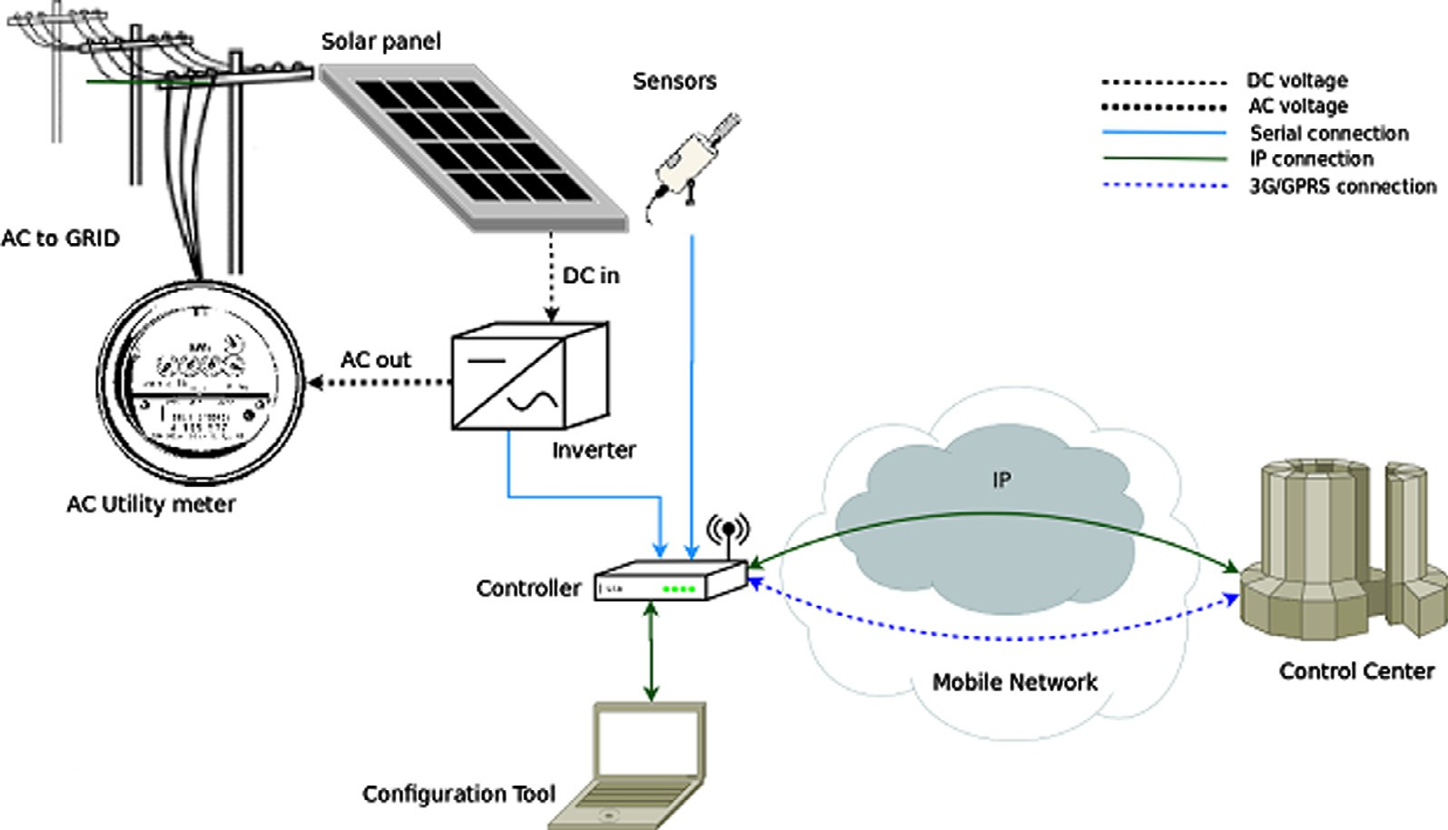

Figure 1 PV System components.

Web-based real-time monitoring systems have been heavily used in the health- care and industrial sectors for many years and can be studied in order to gain sig- nificant experience in diverse application requirements. A typical finding is that several of the applied monitoring principles, concepts and mechanisms can be eas- ily migrated and adapted to other applications. Numerous efforts employing diverse software, field controller, communication and user interface architectures have already empowered users by giving them access to real-time energy plant data and quality observations in a fluid and versatile environment (Lahti et al., 2011; Sa´nchez-Pacheco et al., 2011; Irmak et al., 2013; Konieczny et al., 2012; Dobriceanu et al., 2009, etc.). A PV plant management solution aims at providing fundamental services and other facilities to business entities in charge of the super- vision of a number of remote installations. The interaction of the users with the solution relies on the public internet and the GSM/3G network. In this paper we present the design and implementation of a network-based solar park/PV plant management application for controlling and monitoring the input and output data of the PV equipment aiming at performance macro-observation, alarm detection, handling operation failures, installation security, access control, collection and recording of statistical data and provisioning of reports which are stored locally or sent automatically to the users. The paper defines a three level architecture involving the application, equipment, signals, alarms, and implemented services. The proposed management solution has been designed to provide a number of services to the end user for all remote installations:

1. A monitoring service, operating over the public internet (Web). The user is capable, through an Internet browser, to get information (parameters, events and status) regarding the installations of interest to him/her.
2. A control service, also operating over the public internet (Web). The user is capable, through an Internet browser, to control certain aspects of the oper- ation of the remote installations.
3. A notification service, operating both over the Web and the mobile network and delivering notifications to the mobile phones or e-mails of the users who have subscribed to the service whenever certain events related to the installa- tions of interest to them occur.
4. A report generation and delivery service, operating over the Web and deliv- ering reports to the e-mails of users who have subscribed to the service in a periodical manner. These reports include information on the installations regarding operational, maintenance and financial aspects.
5. A graphing service, creating comprehensive graphs of parameters and events to be presented through the Web interface of the monitoring service or to be included in reports, created by the report generation and delivery service.
6. An export service, allowing the user to store locally in his/her computer data retained within the PV system management solution.

The rest of the paper is organized as follows. The automation system architec- ture is presented in Section 2. The main control and automation services provided are described in Section 3. A description of the solar park installation, the moni- tored signals and implemented alarms follow in Section 4. Section 5 illustrates the implemented services via the application screenshots, while Section 6 presents the technology used to build the proposed application and the database schema.

1. Automation system architecture

The architecture of a control system can be designed vertically, with the distinction between functional levels (Passino, 2005). Our presented architecture shown in Fig. 2 consists of three levels. Each of them represents an aspect of system function- ality, presenting the incarnation of the automation pyramid for a solar park automa- tion system (Kastner et al., 2005). The bottom level or the level of devices interacts with the real world and is constituted by the basic equipment of an automation sys- tem. This includes sensors or other measure means according to the field of applica- tion, actuators, data converters (digital to analog data and reversely) and routers (Dorf and Bishop, 2010). In addition, PLCs or PACs are employing all necessary interfacing and storage functionality deployed at each installation separately. After the collection of data through measurement, counting, metering, they are trans- formed into a representation suitable for transmission and processing (see Fig. 3). The role of the field controllers is very important. They recognize failures and generate alarms derived either directly from signals I/O or complex algebraic,

Internet

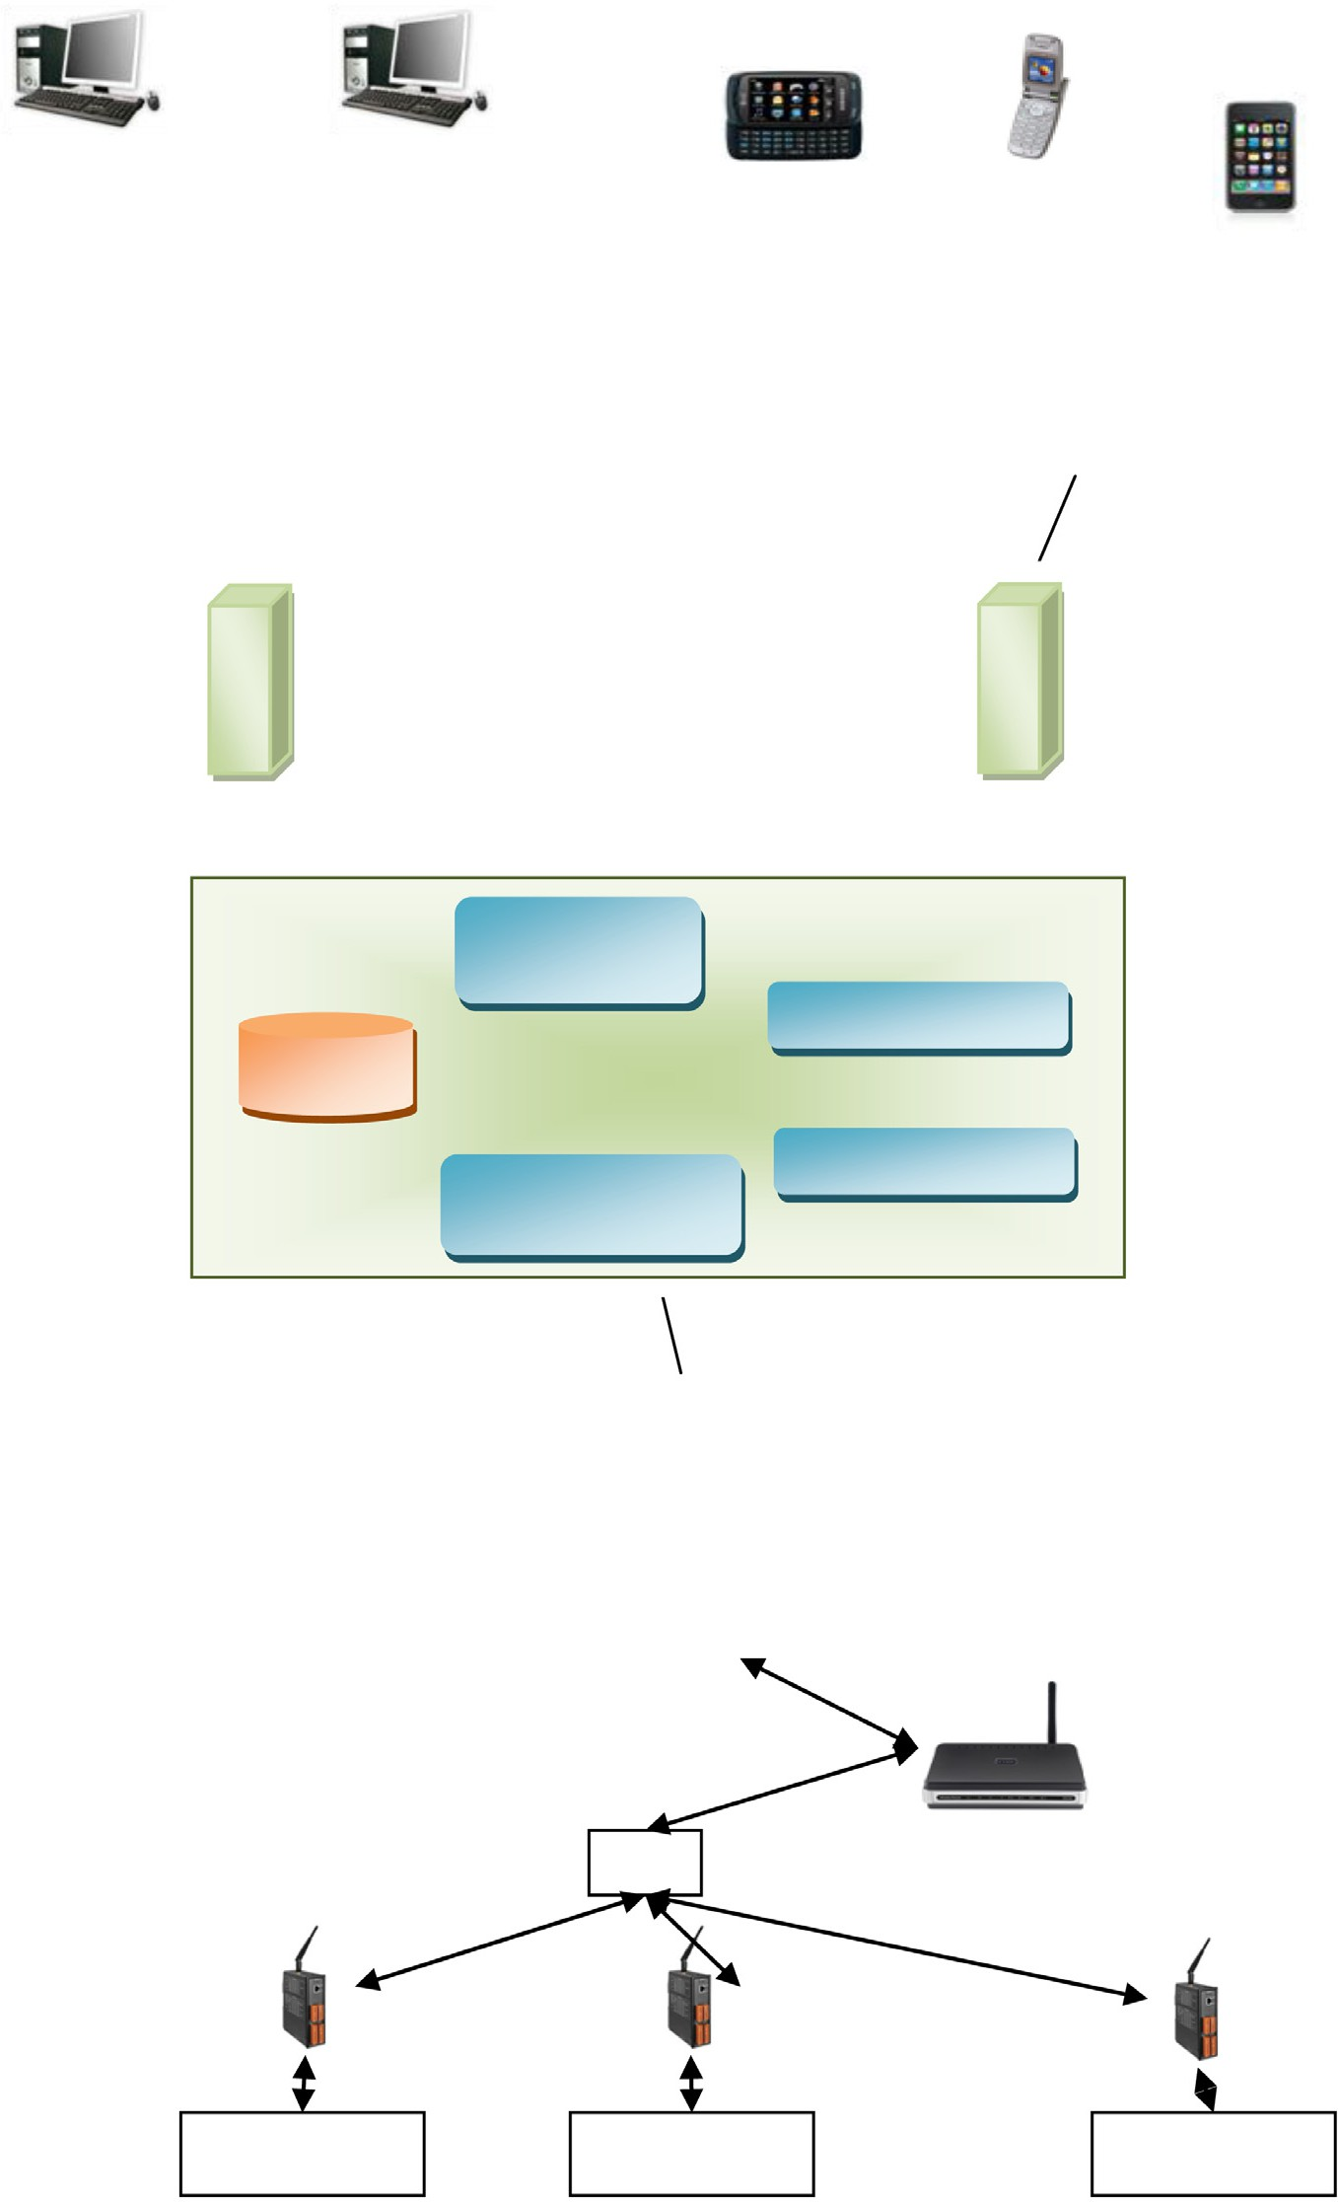

**Router**

LA N

**PLC**

**PLC**

**PLC**

Sensors, actuators, other equipment

Sensors, actuators, other equipment

**…**

Sensors, actuators, other equipment

Wireless network (2G/3G)

**Internet gateway**

**SMS gateway**

Application Logic Module

Reporting Module

Database

**Service Back-**

Communication Module

Notification

**Control/Data**

**Center**

Private/public network

Figure 2 Automation system architecture.

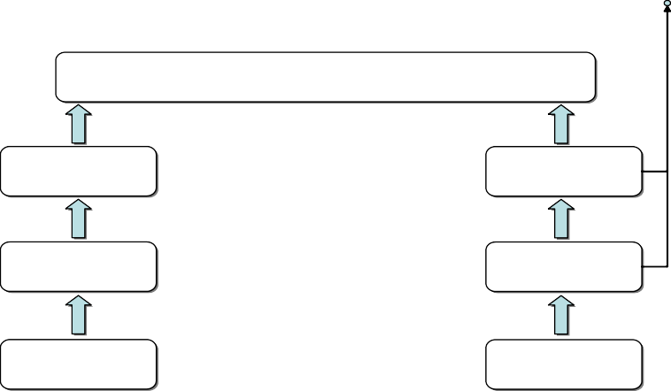

State-change events

Derived parameters

Calculation

Calculation

Primary Max/min **…** Max/min Primary parameter value value parameter

Calculation

Calculation

Real time data

**…**

Real time data

Calculation Calculation

Acquisition Acquisition

Equipment/ sensor

**…**

Equipment/ sensor

Figure 3 The data acquisition methodology supported by the solution.

combinatorial or sequential functions and processes. Subsequently, they catego- rize and prioritize, store, generate alerts and reports and communicate the status of the installation to the management centers. There are important reasons as to why an integrated facility management solution (IFMS) needs a stand-alone infra- structure (the site-level control/monitoring system) installed at the field:

* Due to the vast variety of equipment that may exist in the installation, it is expected that the solution has to interface them using an equivalent variety of physical connection methods and protocols.
* Though occasional loss of communication may occur, the nature of the application does not leave much room for data loss, so storage in the field is a necessity.
* Scarce bandwidth may be available (e.g. communication with the installa- tion may be carried out through a GPRS connection), so some form of data reduction has to be applied.
* There are certain requirements that mandate the existence of logic in the field, which operates irrespective of whether a connection to the outside world is operational or not.

This infrastructure is essentially a set of programmable networked controllers employing all necessary interfacing and storage functionality deployed at each installation separately. Therefore, it undertakes the responsibilities of:

* Interfacing with all equipment installed in the field to acquire data, irrespec- tive of the connection method and/or protocol.
* Reducing the volume of data to something representative, yet less band- width hungry.
* Conveying events that are generated directly by field equipment upon their occurrence and generating events that are necessary yet not implemented within the equipment in the field.
* Storing all necessary parameters and events in a cyclical manner in the case of failure of the communication with the outside world.
* Implementing all necessary control loops that have to operate locally and in an independent manner.

The middle level is the Data Center which communicates through a public and/ or private network with the bottom level. It is also known as automation level. Its role is to monitor and control all installations in a centralized manner. The main part of the Data Center is the service back end, which undertakes to collect, store and manage data from all remote installations. More specifically, the service back end has the following responsibilities:

* To collect, store and manage data from a variety of remote sites.
* To transform data and prepare values for vertical access from the manage- ment level.
* To store and manage information regarding the users accessing the service.
* To allow the users to configure the service back-end itself or the field- deployed controllers.
* To allow the users to carry out control functions on the installation.
* To carry out any post-acquisition calculations that may be necessary.

The back-end is scalable to accommodate any number of measurement points merely through the addition of new servers and storage subsystems. The service back-end can also provide external interfaces to other software entities, depending on the customer needs. The service back-end has been designed to provide inter- operation with a variety of third-party controllers and PLCs. For this reason, an independent module, denoted as the Communications Adapter Module (CAM) in the ensuing, has been implemented, which undertakes the task of acquiring data from the remote installation and feeding them to the service back-end as well as conveying data from the service back-end to the remote site. Multiple CAMs are supported. The service back-end also incorporates an Appli- cation Logic Module (the ALM), which calculates the derived parameters. This module can be extended at will with new calculation functions. Other service back-end modules include the Notification Server Module (NSM), which under- takes the notification of the PV management solution users via SMS or e-mail as well as the Reporting Server Module (RSM), which handles the generation and delivery of reports. All necessary data are stored in a database.

The top level is the management level. At this level, information from the entire system is accessible. The PV management solution includes a front-end, capable of operation with a standard Web browser (Internet explorer, Mozilla Firefox or Google Chrome). A unified interface is presented to the operator and end-users

for manual intervention in the system. It provides vertical access to the values of the automation level, including the modification of parameters such as timetables. Alarms are generated for exceptional situations such as technical errors or critical conditions. The long-term storage of historical data with the ability to give com- mands for reports and statistics is also part of this level.

1. Main control and automation services

The PV management solution models the remote installation as a hierarchical tree structure. The nodes of the tree can be broadly categorized either as nodes repre- senting virtual entities, or nodes representing equipment entities. The former do not contain actual equipment installed in the field. Such entities are for example the installation itself, a room etc. These nodes are denoted as virtual segments in the ensuing. The latter contain a specific piece of equipment installed in the field. Such entities are for example the numerous sensors/transducers, specific equipment etc. These nodes are denoted as asset segments in the ensuing. Both vir- tual and asset segments are used in the ensuing as placeholders for the data that are handled by the PV management solution. It has to be noted that certain parts of the tree may be absent in certain cases. This model can be arbitrarily extended to match further customer requirements.

* 1. *Installation monitoring basics*

The monitoring service of the PV management solution is based on the methodol- ogy presented in the figure below. The PV management solution supports the col- lection, storage, visualization and post-processing of the whole history of a large variety of types of information for each node of the hierarchical model presented above. These include:

* + - Primary parameters: Primary parameters are calculated as the time-series aver- age of real-time data after a certain set of validations have been applied. The span of this average (the recording period) has to be an integer sub-multiple or multiple of an hour. The PV management solution supports any recording interval, though it has to be the same for the whole of a single installation. Daily, monthly and yearly averaged values are also supported for each primary parameter separately. Data acquisition and the calculation of primary parame- ters are considered to be carried out by field-deployed controllers in order to reduce the data that are conveyed to the service back-end and minimize band- width requirements.
    - Maximum/minimum value parameters: These parameters are assumed to be calculated in much the same way as primary parameters, except for the opera- tion applied on the real-time data. Daily, monthly and yearly maximum/ minimum values are also supported. The calculation of maximum/minimum

value parameters is considered to be carried out by field-deployed controllers in order to reduce the data that are conveyed to the service back-end and minimize bandwidth requirements.

* Derived parameters: Derived parameters are calculated using a specific mathe- matic formula which operates on a specific set of values or vectors of values of primary (and/or other derived) parameters. The PV management solution provides the infrastructure that is necessary to carry out all derived parameter calculations in the service back-end so as to further minimize the necessary bandwidth and storage at the remote site. In the case that derived parameters are calculated in the field, they can be considered as primary parameters within the service back-end. Daily, monthly and yearly values are supported for each derived parameter separately.
* Raw, real-time data: The service back-end has been designed to store raw, real- time data sets as they are acquired from the field-deployed controllers.
* Real-time monitored data: In certain cases, it is necessary to present to the user the real-time data as they are recorded by the field-deployed controllers, without any processing or storage. This functionality has to be supported by the equip- ment deployed at the installation.
* Status, states and state-change events: The concept is presented in detail in the remaining paragraphs of this section.

Each parameter sample and event are collected, stored and visualized with their acquisition time-stamp and engineering unit. Primary and derived parameters as well as raw real-time data are collected from the field based on a time schedule, aligned with the recording period. Status-change events are collected upon their occurrence and real-time monitored data upon user request.

The PV management solution records and presents to the user the current status of entities that are either internal or external to the solution. The status is consid- ered to be a powerful tool in terms of the user getting an immediate grasp on whether any entity of the installation being monitored or even the PV management solution itself operate properly or not. Status information actually encodes the severity of the condition of each entity independently, which is a number on a scale from 0 (everything normal) to 100 (complete disaster). The status update mecha- nism shall become apparent in the ensuing.

Apart from status information, the PV management solution also supports an arbitrary number of state-sets per entity. Each state set encodes a set of states, which are mutually exclusive, i.e. the entity can be found in only one of them. Each state of each state set also has a preset severity level associated with it. Changes among states are triggered by state-change events, which are either directly gener- ated by sensors and equipment connected to the PV management solution (pri- mary events), or by the PV management solution itself (derived events). The PV management solution provides all means necessary for the user to acknowledge (validate) that he/she has been notified on any specific state-change event and

has taken appropriate actions. This acknowledgement is a simple form of book- keeping of user actions for further investigation. Each state-change event is stored and presented to the user per state set with a list of data, including the entity gen- erating the event, the state the event led to in a descriptive form, the event date/ time in the timezone of the installation, the date/time of the reception of the event in the timezone of the installation, and the event acknowledgment status and acknowledgment text.

Since all entities are organized in a hierarchical structure, the current status of a certain entity cannot depend solely on the state (or states) it is into, but the sta- tuses of all underlying entities within the hierarchy are used as well. This is a basic concept within the PV management solution, since it enables the efficient notifica- tion of the user if something calls for his/her attention. Moreover, this hierarchical status propagation, as it will be denoted in the ensuing, can help the user realize the effect that an entity being in a certain state of a certain state set has on the operation of the installation as a whole.

The status of each entity of the installation hierarchy is always equal to the maximum severity of the states of all underlying entities at any given point in time. The statuses of all involved entities are presented to the user in an easily under- standable form (e.g. color encoding, based on a set of severity thresholds) so that his/her attention is drawn not only to a specific event but also to the effect it has on the operation of the whole installation. The approach is further clarified through Fig. 4, presenting an exemplary hierarchy with the related statuses and state-sets for each node. The related severities are also depicted, so that the hier- archical status propagation is apparent.

* 1. *Monitoring service*

The main duty of the PV management solution is to provide, in a timely and con- cise manner, information to its user on the operation of a group of remote sites. As far as the monitoring service is concerned, the flow of data through the solution architecture is presented in Fig. 5. The CAM retrieves information necessary for the addressing of data items within the site-level control/monitoring system from the service back-end. It then connects to the field-deployed equipment based on a schedule, collects the necessary data and submits them to the service back-end,

 Status State-set



80

0 51

80

9

51

39

80

5

9

51

39

21 80

Figure 4 The hierarchical status propagation concept.

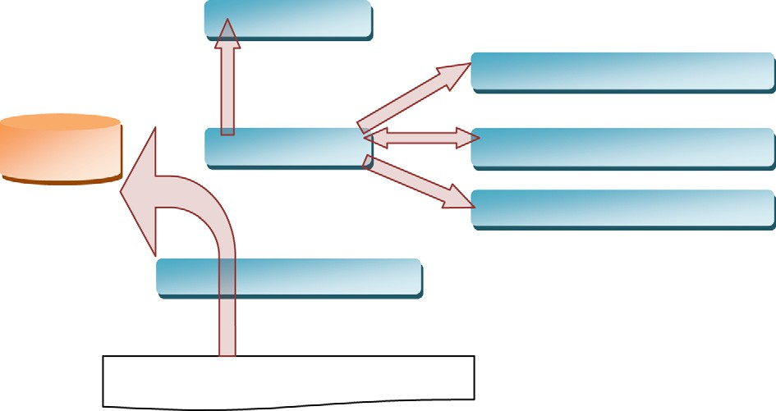

User Interface

Reporting Module

Database

Back-end Service

Application logic module

Notification Module

Communication Module

Monitoring & Control System

Figure 5 Monitoring service architecture.

which caches them in case some other module requests them and writes them to the database. The ALM retrieves the necessary primary data to calculate the derived values, also based on a schedule and submits the results to the service back-end, which again caches and stores them in the database. The remaining software modules (the Graphical User Interface, the Reporting Server Module and the Notification Server Module) connect to the back-end, either in a scheduled manner or upon user request and collect data in order to depict them or use them in reports or notifications.

* 1. *Control service*

The PV management solution allows the user to issue commands toward the equipment within the installation or the solution itself. This functionality is imple- mented through the notion of settings, whose values are considered constant from the time they are set until they are reset. Each setting event is stored and visualized with its timestamp and engineering unit. A user-inserted comment is also stored. The user is notified whether his/her action has been successful or not as well as whether it has been applied yet. As far as the control service is concerned, the flow of data through the solution architecture is presented in Fig. 6. A control

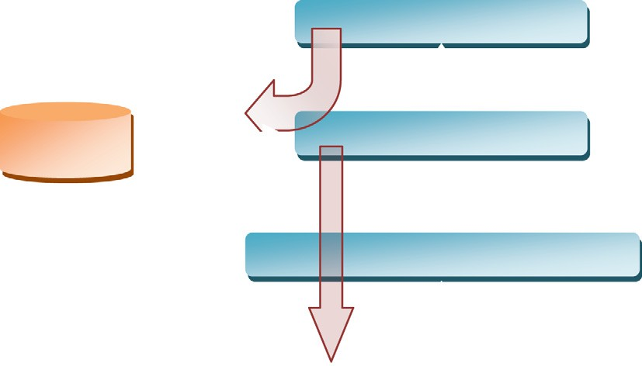

User Interface

Database

Back-end Service

Communication Module

Monitoring & Control System

Figure 6 Control service architecture.

command is issued via the GUI toward the service back-end. This software mod- ule stores the command to the database and forwards it to the CAM, which retrieves information necessary for the addressing of the controls within the site-level control/monitoring system from the service back-end. It then connects to the field-deployed equipment and propagates the command. At all times, the user is notified via the GUI on the progress of the command he/she has issued.

* 1. *Notification service*

The Notification service informs the user on the occurrence of critical events. Notification is via emails (internet gateway) or SMS (SMS gateway). The gener- ation of such notifications is not triggered by individual state-change events but rather by the status changes of each node of the hierarchy which is affected by them. More specifically, if the severity of the status goes above a certain user con- figurable threshold and remains there for a preset period of time, a notification is generated to alert the user. Additionally, if the status falls below the same thresh- old, another notification is generated in order to notify the user on the expiration of the criticality. The user is capable of subscribing to the status changes of and configuring the severity thresholds for each hierarchy node separately. It is understandable that if he/she, depending on the subscription he/she has config- ured, may receive multiple notifications upon occurrence of the same event or set of events affecting the statuses of a certain set of nodes in the hierarchy. Moreover, the user is capable of subscribing separately to the positive edge (sta- tus going above threshold) or the negative edge (status going below threshold) for each hierarchy node separately. Finally, the PV management solution logs all notifications sent.

* 1. *Reporting service*

A very important function is the automatic generation of reports. This service uses the Web and delivers reports to e-mails or mobile phones of users who have subscribed to the service. These reports include information on the operation, maintenance and financial situation of the entire system or specific facilities. The timing and scope are determined by the administrator and the choices of the user.

* 1. *Data export service*

The Data export service allows the user to store locally data that are stored in the application. The source of data is primary or derived parameters from any mon- itored entity. The extracted data are in xml file format or graphic representations. The time frequency of data extraction and export is determined by the user.

1. Solar park installation

The operation of solar parks/PV plants is based on the photovoltaic effect. The photovoltaic effect is the basic physical process in which a photovoltaic cell con- verts sunlight into electricity. A solar park consists of solar panels. Each panel is a set of solar cells and numerous other protective and functional coatings installed onto an aluminum frame as a means of support. They are connected in series until we get the desired effect on current output and in parallel until they reach the desired voltage. As a result, solar panel connection is very important during installation.

A critical equipment of solar parks is battery. The battery stores solar energy to provide electricity during periods of absence of sun, such as nights and cloudy days. It must be able to be discharged and recharged. Rechargeable batteries are a bit more expensive than the reserve batteries. Without batteries, a PVC sys- tem can provide electricity only with sunlight. Along with the battery there should be a charge controller. Its role is to provide electricity to the batteries from the solar panel in a way that prevents the solar panels from overloading the battery. Lastly, solar parks have power inverters. Solar panels generate electricity to DC (direct current) power. Some devices are powered directly from the panel. How- ever, most devices use high voltage AC (alternating current) power. The power converter performs this procedure. It converts low voltage DC from the battery to high voltage alternating current AC that is required by most household

appliances.

* 1. *Signals*

Every control and monitoring application controls a number of signals using the appropriate sensing elements. Each transducer gives some type of digital (binary or discrete) or analog (continuous) signal, or more complex signals in the form of a protocol, e.g. serial. The type of signal depends on the observed physical size and the transducer used. Controllers inside an automation system can control and monitor digital, analog and serial data from sensors, actuators and devices (Nof, 2009). Our implementation for controlling and monitoring the power of a solar park uses the following signals:

* + - Power signal: It is an analog signal. This paper suggests an implementation which uses AC power. This consists of three components:
      * *Real/active power:* The amount of energy consumed; measured in Watts.
      * *Apparent power:* The amount of energy delivered from a source to a charger. It must always be greater than that needed from a device to work; measured in Volt-Amperes (va).
      * *Reactive power:* The amount of energy that returns to the source in each cycle because of the stored energy; measured in reactive Volt-Amperes (var).
* Temperature signal: It is an analog signal used for checking the proper function- ing of the system in extreme environmental conditions. Sensors measure the temperature of the installation, both internal (module temperature) and external (air temperature). The ideal temperature for solar power plants is 25 °C (77 °F). When temperature increases, the current increases slightly, while the voltage is reduced too quickly. This results in a lower overall energy output. A general rule is that the performance of a cell drops by 0.5% per 1 °C above the 25 °C.
* Humidity signal: It is an analog signal. A sensor measures the humidity of the environment which is used for monitoring the proper functioning of the system especially when the signal value goes over/under a specified threshold.
* Wind signal: It is an analog signal used for the same reason as humidity signal.

The system has been tested with real data. These were collected during a period of one year from a real PV installation which collected and monitored the above signals. Fig. 7 depicts the annual power produced in our monitored park in relation with air temperature and humidity in the park area. The maximum per- formance is in May, while the minimum appears in mid-December. The perfor- mance increases during the summer months due to the favorable climate. Apparently, performance change is proportional to temperature change. Mini- mum performance has been recorded during the day of the year with minimum air temperature. This synchronization between the two plots does not happen for maximum performance. That means that temperature is not the only factor

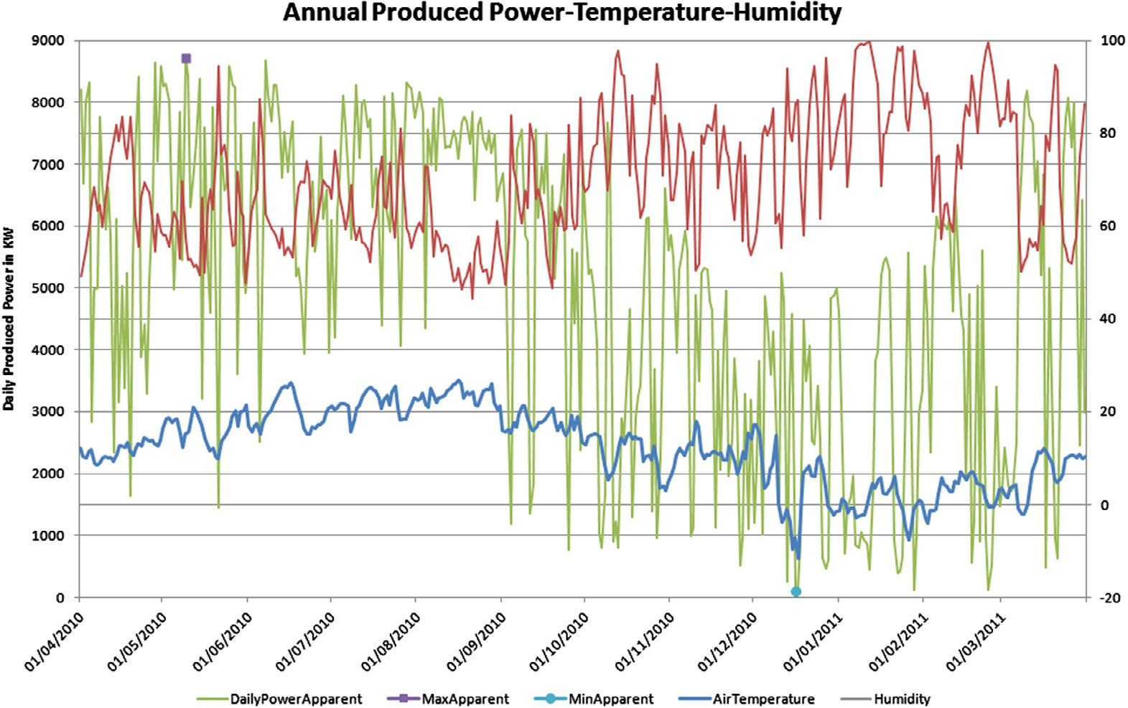

Figure 7 Annual produced power vs. air temperature and humidity.

affecting the performance of a solar park. Accurate weather data are essential to the performance evaluation of the solar plant (inAccess, 2013). The total annual power produced by the solar park reached 1.82 MW.

Fig. 8 depicts the power and temperature values across a winter and a summer day. Recordings on 12 August 2010 – a hot summer day with an outside tempera- ture of an average 30 °C – show a peak of 900 KW. Recordings on 12 December 2010 – a cold winter day with an outside temperature of a mere 5 °C – show that it is easily and permanently possible to achieve the goal of 70 °C and a thermal energy of almost 1.5 MWh in the storage units: a very good result for almost the shortest and coldest day of the year. In both cases, it is observed that the energy produced (apparent power) by the park is entirely consumed (active power).

* 1. *Alarms*

Alarms are binary signals which depend on one or more signals and activated by the changes of their values and situation. In the case of binary digital signals the alarm is activated by the state change of the signal. In case of analog signals, activation of the alarm takes place when the signal value exceeds or goes under a threshold. Our solar park control and monitoring application implements the following alarms:

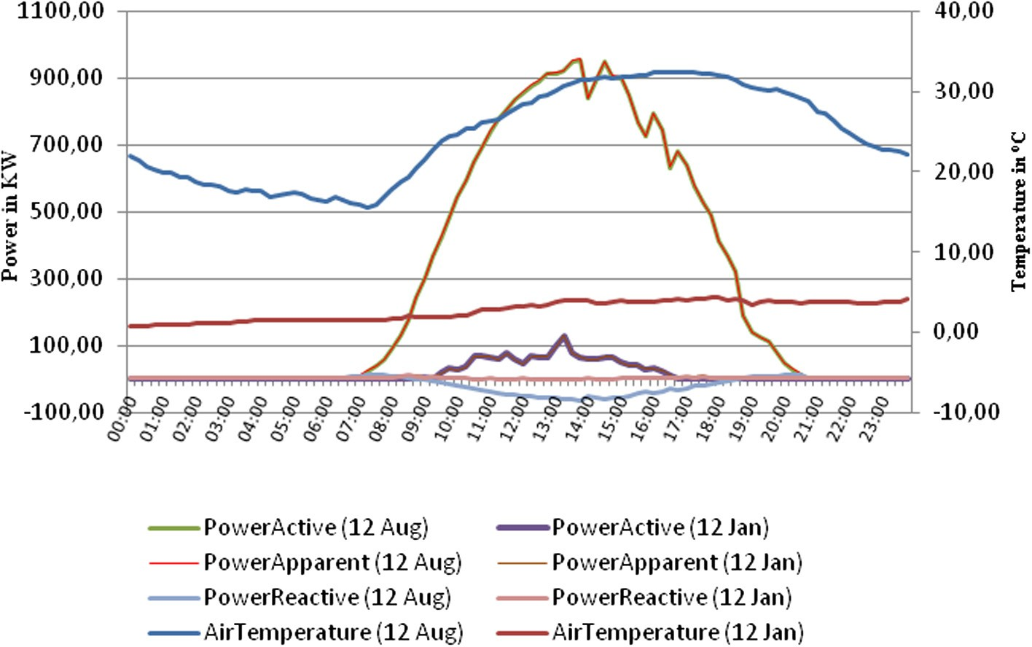

* + - Temperature alarm (air and module alarm): The manufacturer or user sets min- imum and maximum values for air and module temperature in order to control the environment of a solar plant system in extreme weather conditions, such as frosts or large heat waves. Temperature alarms are created when values exceed these thresholds. The ideal temperature for solar power plants is 25 °C (77 °F).

Figure 8 AC power vs. temperature (12 Aug and 12 Dec).

* Power loss alarm: This alarm is activated by a combination of factors. Some of them are long periods of shadow, battery performance and temperature. As mentioned before (see temperature signal), the increase in temperature results in a lower overall energy output.
* Battery alarm: The amount of kW per hour that a solar panel can produce with battery life depends on temperature and on sun exposure. The manufacturer or user sets minimum/maximum thresholds and when the temperature value is out of this range for a long period then a battery alarm is created. The performance of a battery is reduced below a threshold and battery stops charging over a tem- perature limit.
* Mold alarm: It is created with the logic of specified thresholds for valid values, as described in temperature alarm.
* Security alarm: Allows a user to control the installation of any disasters/ violations, through optical fibers applied to solar panels or used for installa- tion’s fence.

1. Implemented services

The developed PV management solution for controlling and monitoring solar parks implements a group of services, as these are specified at the previous sections.

* 1. *Surveillance*

Every installation has cameras in specified areas according to pairs of coordinates (south, north, west and east). The user can monitor with live video every plant by specifying the direction s/he wishes, and even handling PTZ (pan, tilt, zoom) func- tionality if available (see Fig. 9).

* 1. *Performance*

This service is very important because it allows the user to monitor very quickly the total performance of the park. The user can monitor the current performance as well as define specific periods of time to view a graph of the recorded values. This service allows for macro-observation of the performance of the PV system in field conditions. The user can compare the performance values between days, months, years or certain time intervals and draw useful conclusions (see Fig. 10). Performance analysis and evaluation are based on the procedures and performance indicators defined in the IEC 61724 standard (International Electrotechnical Commission, 1998; Emery et al., 2013), extended properly to support state-sets and state-change events. Performance monitoring is significantly affected by the quality and calibration interval of the measurement hardware and

30 A. Meliones et al.

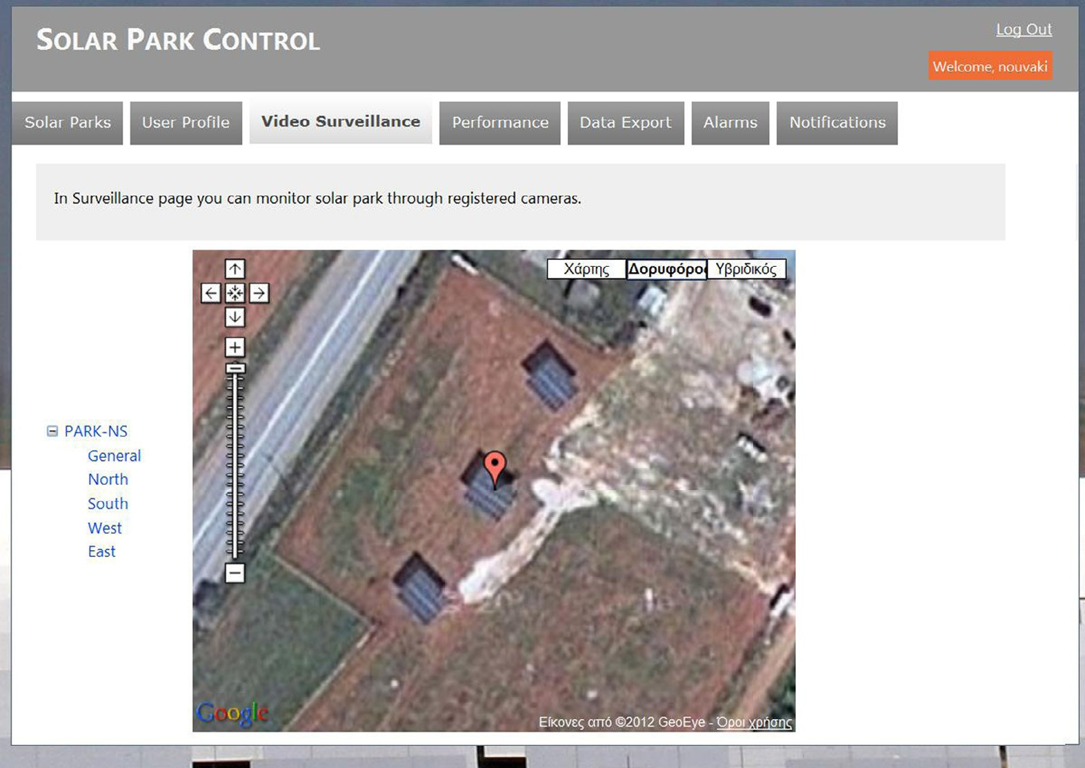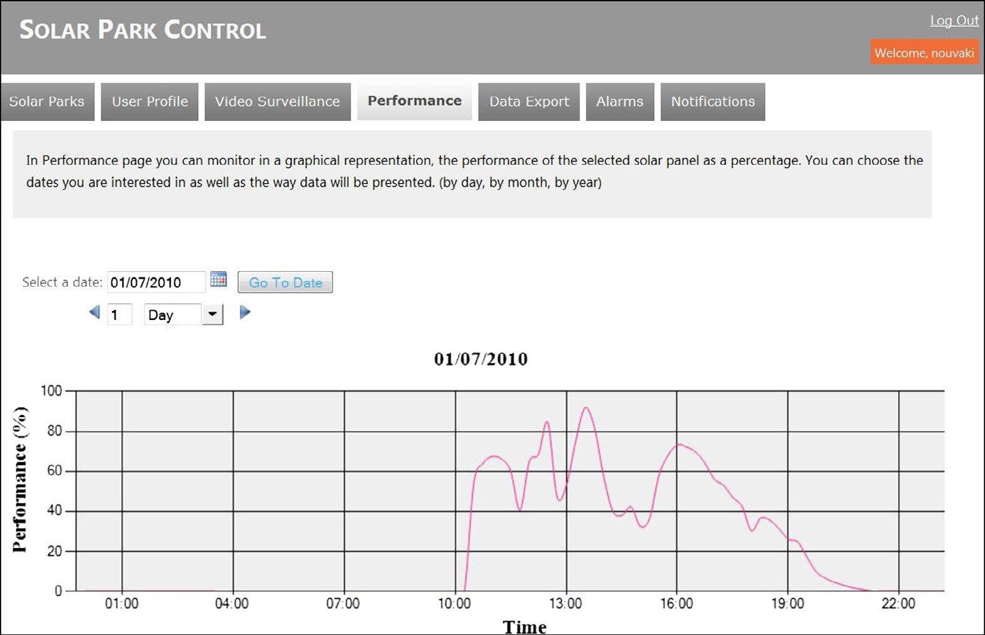

Figure 9 Surveillance service.

Figure 10 Performance service.

the professionalism of the installation. The dominant error source in determining the system power is determining the plane-of-array irradiance (Emery and Smith, 2011).

Following the IEC 61724 directives, the PV Management System acquires real time measurement data from the PV equipment (DC–DC converter or inverter, sensors like pyranometer, temperature and humidity sensors etc.) on fixed periods of time. The completeness of real-time data is determined and used for further pro- cessing. Derived parameters are calculated using mathematic formulas that oper- ate on specific sets of values or vectors of values of primary (and/or other derived) parameters covering a set of specific time spans (always in multiples of the record- ing period), called ‘‘reporting periods’’. IEC61724 presents a number of derived parameters, related to efficiency, yields, losses and performance ratio which can be used to monitor the performance of a PV system. The ones selected for the PV management system are mean array efficiency, array capture losses, and per- formance ratio.

Mean array efficiency represents the mean energy conversion efficiency of the PV array, which is useful for comparison with the array efficiency at its nominal output power. The difference in efficiency values represents diode, wiring, and mis- match losses as well as energy wasted during plant operation. The array capture losses represent the losses due to array operation and indicate the amount of time during which the array would be required to operate at its rated power to provide such losses. The maintenance performance ratio is calculated per PV array, PV array group and the PV plant as a whole only for values of total irradiance which are above the standard specified threshold. This threshold is the same for all per- formance ratio calculations.

The PV management system must be capable of calculating derived parameters for a variety of time spans, which extend into the past. It is understandable that since the values of all primary parameters are stored within the solution for every recording period, it is possible to post-process that data to produce derived param- eters for any reporting period.

* 1. *Data export*

Through the data export page the user can select one monitored signal or a group of signals, the time period of interest for which a plot shall be produced (‘‘from/ to’’ selection) and the unit (*X* axis) of representation (days, months, years). The results are being represented by graphical plots. The user further has the opportu- nity to store these values locally in an xml file or send them via email (see Fig. 11).

* 1. *Alarm*

The alarm service allows the user to check the thresholds and priority for each supported signal. The administrator can further set these values. Alarm

32 A. Meliones et al.

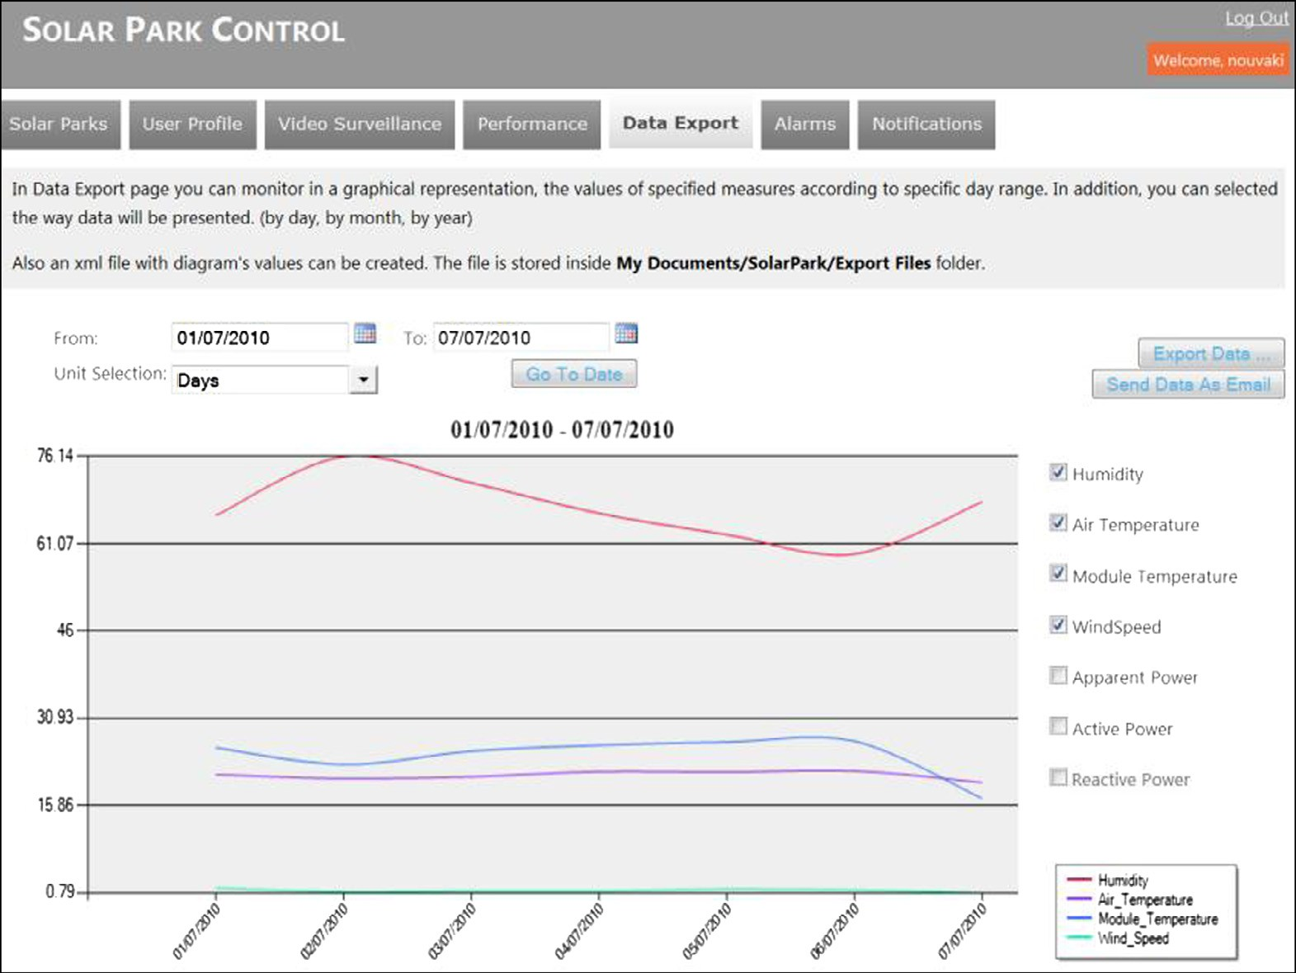

Figure 11 Data export service.

notifications are generated based on these values. Two specific alarms – battery and performance – are generated automatically by functions inside the service back-end. For these two alarms the user can only define their threshold in percent- age mode, e.g. a notification is being generated when battery reaches 15% of max- imum performance. In addition, this service displays a graphical representation for the selected alarm in the specified period allowing the user to easily spot values exceeding the predefined threshold which is depicted with a blue area (see Fig. 12).

* 1. *Notification*

The user defines in his/her profile page which type of communication channel will be used per type of notification and alarm. Three channels are provided by the system: (i) SMS to receive notifications in a mobile phone. (ii) Email, where the user receives notifications in the email address filled in the registration form.

(iii) Inbox, which is implemented through a web page of the PV management sys- tem called ‘Notifications’. This page is accessible through the system environment of a logged user. It is easy to use and very practical because all the information is gathered together (see Fig. 13).

Integrated facility management of photovoltaic systems 33

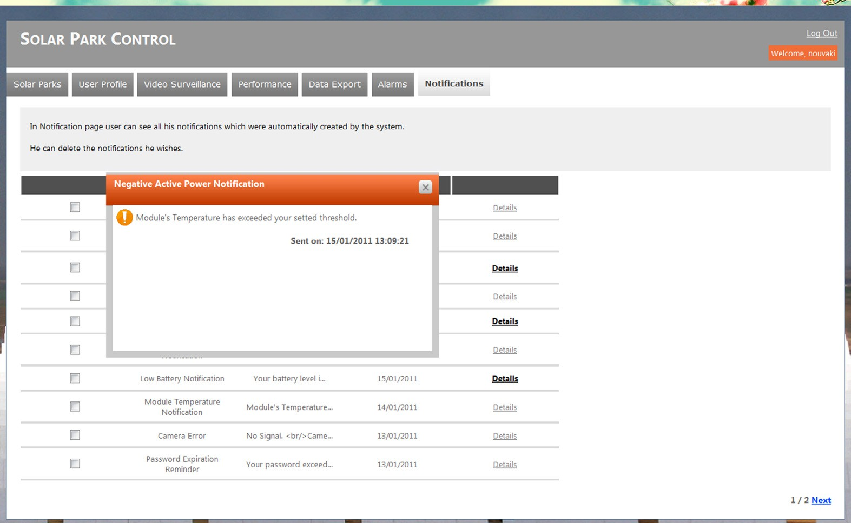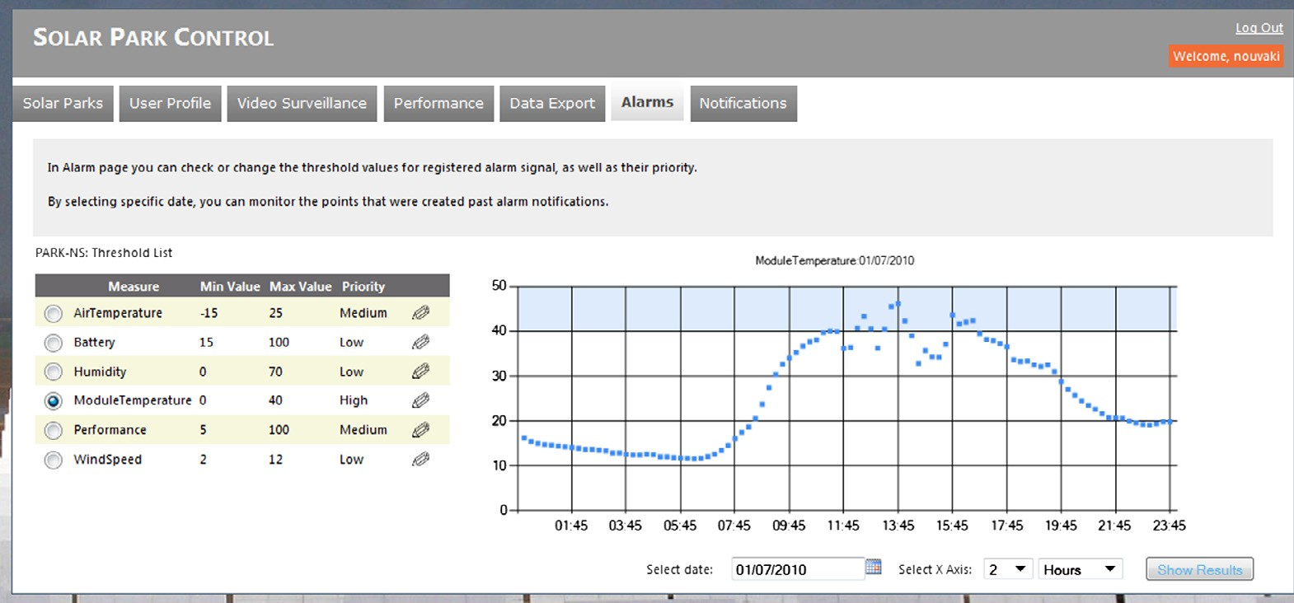

Figure 12 Alarm service.

Figure 13 Notification inbox service.

1. Technology framework

The proposed PV management system has been implemented in Visual Studio 2010 with Framework .NET 4. The programming language used is the object- oriented C# language v4.0. The application consists of three projects. The first project is a web site where all .aspx pages are implemented. The aspx pages

34 A. Meliones et al.

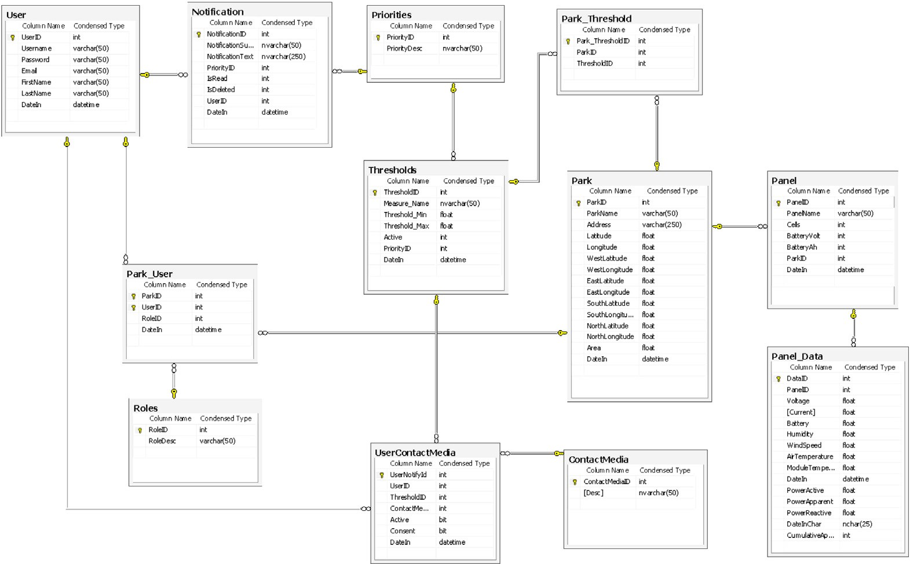

Figure 14 Database ER diagram.

comprise the user interface. Each page has its own file code behind which imple- ments functions of the Application Logic Module.

The second one is a Class Library project named DBTier. This project provides the Database Access Layer of the PV management solution and establishes the connection to the system database. It contains files for each database table and communicates with the Application Logic, Reporting Module and Notification Module by carrying out insertions and updates or returning feedback via query results for every function they operate.

The last project is a WCF Service Library project, which implements the Web Service of the PV management application. WCF is an API in the .NET Frame- work for building connected, service-oriented applications. Our PV management application has implemented a Mail Sender Web Service, which sends notification emails when an alarm is created. For this purpose we used the System.Net.Mail library of the .NET framework. This library contains classes in order to send email to a designated SMTP server for delivery. Notification mails include reports as attachments.

The Visual Studio Integrated Development Environment includes the creation of WCF Service Library for Web Services implementation. The WCF Service Library is a compiled component that can be expanded as a Web Service or Win- dows Service or even as part of a custom application hosting. When the debugger starts, the WCF Service Host (WcfSvcHost.exe) implements the hosting of the Web Services projects. Then it opens the WCF Test Client (WcfTestClient.exe) and displays a list of service endpoints that have been defined in a configuration

file. Therefore, the Wcf Test Client tool helps experience the implementation of Web Services and allows the users to test their Web Services without having to exe- cute the web application, and to implement the WcfSvcHost hosting without the need for setting up of Web Services using the IIS (Internet Information Services) Microsoft web server.

The Graphical representations of our application were implemented using Charting Controls which are embedded in Framework 4.0. With these tools we can specify the type of graph, the format of the source of data and the filter of data. The database on the service back-end was implemented in Microsoft SQL

Server 2008 and consists of twelve tables (see Fig. 14):

* Park: contains all registered parks.
* Panel: contains all registered panels, each connected to a single park.
* User: contains data for registered users who have access to a solar park.
* Panel data: stores signals’ values. These values derive from the CAM, which acquires data from the remote installation and calculates values’ average of a time span of 30 s. The values stored are: battery, humidity, wind speed, air and module temperature, as well as active, reactive and apparent power.
* Contact media: contains all available contact media (email-sms-inbox).
* UserContactMedia: registers the media by which the user is notified for each alarm.
* Notification: saves all inbox notifications which are automatically created by the system.
* Priorities: contains all available priorities for system’s notification (low- medium–high).
* ParkUser: connects users with parks defining a role for each relation.
* Roles: contains the supported user roles of the system.
* Thresholds: provide minimum and maximum value for all measured signals.
* ParkThreshold: relates each park with its active thresholds.

1. Conclusions

We have developed a flexible modular network-based application which supports all key services for automatic remote control and management of photovoltaic parks. Our implemented PV management application fully achieved the system objectives meeting successfully the initial user requirements. We have presented in detail a three-tier layered architecture and the according design and implemen- tation of a modular service back-end system including database, notification, reporting and arithmetic logic system components. The presented integrated sys- tem allows the easy and convenient monitoring of a real operational environment and helps the executives to administer their solar parks. The service back-end can provide online customized monitoring of signal groups and system status, energy

36 A. Meliones et al.

production and environmental benefits in real-time. We have tested our system with real data collected and monitored during a period of one year from a 2MWp PV plant installation. The monitored panel data included several signals: active, reactive and apparent power, air and module temperature, battery, humid- ity and wind speed.

The presented system is a successful paradigm of automation technology and integration of front- and back-end system components which can be easily migrated to solar buildings and even entire solar cities for solar energy exploita- tion, as well as other types of renewable energy generation installations and remote automation applications. The presented remote installation management solution targets application areas in need of advanced control and monitoring functionality, including:

* Interfacing with a variety of equipment employing different communication methods and protocols.
* Support of on-site logic and storage to enable remote control loops and intelligent data pre-processing (e.g. event generation, algorithmic operations on real-time data etc.).
* Storage of near real-time historical data (at a defined sampling rate) to a central location around the clock.
* Calculation and storage of derived parameters (e.g. key performance indica- tors) on a scheduled basis.
* Hierarchical storage and presentation of data to facilitate post-calculations and retrieval.
* Access to the stored data over the Web and via an intuitive front-end operat- ing within the browser with the capability to export data to the operator’s PC.
* Event handling assisted by the concept of status propagation and notifica- tions in order to readily alert users.
* Scalability to any number of measurement points.

Future extensions of the presented work will study more novel approaches for monitoring the current produced by arrays (strings) of photovoltaic modules based on Wireless Sensor Networks (WSN) technology to let the creation of a self-configuring wireless network of low-power and low-cost devices (no wires for data transmission and for supplying power to the devices), in order to dramat- ically reduce the installation cost and time.

References

[Bagnall, D.M., Boreland, M., 2008. Photovoltaic technologies. Energy Policy 36 (12), 4390–4396](http://refhub.elsevier.com/S2210-8327(14)00011-8/h0005).

[Brown, M.A., Southworth, F., 2008. Mitigating climate change through green buildings and smart growth.](http://refhub.elsevier.com/S2210-8327(14)00011-8/h0010)

[Environ. Planning 40 (3), 653–675](http://refhub.elsevier.com/S2210-8327(14)00011-8/h0010).

Dobriceanu, M., Bitoleanu, A., Popescu, M., Subtirelu, E.G., 2009. Electrical stations real-time monitoring using combined protection and control systems. IEEE International Symposium on Diagnostics for Electric Machines, Power Electronics and Drives.

Dorf, R.C., Bishop, R.H., 2010. Modern Control Systems, twelveth ed. Prentice Hall, ISBN-13: 978–0136024583. Ekins-Daukes, N.J., 2013. Routes to high efficiency photovoltaic power conversion. 39th IEEE Photovoltaic

Specialists Conference (PVSC), Tampa, FI, USA.

Emery, K., Smith, R., 2011. Monitoring system performance. Photovoltaic module reliability workshop, National Renewable Energy Lab, USA.

Emery, K., Anderberg, A., Campanelli, M., Ciszek, P., Mack, C., Moriarty, T., Osterwald, C., Ottoson, L., Rummel, S., Williams, R., 2013. Rating photovoltaics. 39th IEEE Photovoltaic Specialists Conference (PVSC), Tampa, FI, USA.

[Fthenakis, V., Mason, J.E., Zweibel, K., 2009. The technical, geographical, and economic feasibility of solar](http://refhub.elsevier.com/S2210-8327(14)00011-8/h0040) [energy to supply the energy needs of the US. Energy Policy 37 (2), 387–399](http://refhub.elsevier.com/S2210-8327(14)00011-8/h0040).

[Gill, S.E., Handley, J.F., Ennos, A.R., Pauleit, S., 2007. Adapting cities for climate change: the role of the green](http://refhub.elsevier.com/S2210-8327(14)00011-8/h0045) [infrastructure. Built Environ. 33 (1), 115–133](http://refhub.elsevier.com/S2210-8327(14)00011-8/h0045).

Hallegate, S., Heal, G., Fay, M., Treguer, D., 2012. From growth to green growth – a framework, the national bureau of economic research, Working Paper No. 17841.

Huang, Y., Quibria, M.G., 2013. Green growth: theory and evidence, world institute for development economics research, Working Paper No. 2013/056.

inAccess, 2013. Solar Plant monitoring: the role and importance of weather data in solar plant performance evaluation. White paper <[http://downloads.inaccess.com/role-and-importance-accurate-weather-data-solar-](http://downloads.inaccess.com/role-and-importance-accurate-weather-data-solar-plant-performance-evaluation) [plant-performance-evaluation](http://downloads.inaccess.com/role-and-importance-accurate-weather-data-solar-plant-performance-evaluation)>.

International Electrotechnical Commission, 1998. International Standard IEC 61724: Photovoltaic system performance monitoring – Guidelines for measurement, data exchange and analysis.

Irmak, E., Bulbul, H.I., Kose, A., Calpbinici, 2013. A web-based real-time industrial energy monitoring system.

4th International Conference on Power Engineering, Energy and Electrical Drives, Istanbul, Turkey.

[Ja¨nique, M., 2012. Green growth: from a growing eco-industry to economic sustainability. Energy Policy 48, 13–](http://refhub.elsevier.com/S2210-8327(14)00011-8/h0075) [21](http://refhub.elsevier.com/S2210-8327(14)00011-8/h0075).

Kastner, W., Neugschwandtner G., Soucek S., Newman H.M, 2005. Communication systems for building automation and control. In: Proceedings of the IEEE, Special Issue on Industrial Communication Systems, 93 (6), pp. 1178–1203.

Konieczny, F., Krumsiek, D., Behr, T., Kruse, A., Aron, R., 2012. Method and control device for controlling an automating system. United States Patents, US 8190274 B2.

Lahti, J.P., Shamsuzzoha, A. Kankaanpaa, T., 2011; Web-based technologies in power plant automation and SCADA systems: a review and evaluation. IEEE International Conference on Control System, Computing and Engineering (ICCSCE), Penang.

Nof, S.Y. (Ed.), 2009. Springer Handbook of Automation, ISBN 978-3-540-78830-0.

Passino, M.K., 2005. Biomimicry for optimization, Control, and Automation. Part I. 7–55, Springer-Verlag, London, UK.

[Rycrofta, M.J., Israelssonb, S., Pricec, C., 2000. The global atmospheric electric circuit, solar activity and climate](http://refhub.elsevier.com/S2210-8327(14)00011-8/h0105) [change. J. Atmos. Solar-Terrestrial Phys. 62 (17–18), 1563–1576](http://refhub.elsevier.com/S2210-8327(14)00011-8/h0105).

Sa´nchez-Pacheco, F.J., Sotorrio-Ruiz, P.J., Heredia-Larrubia, J.R., Pe´rez-Hidalgo, F., Sidrach-de-Cardona, M., 2011. Low cost DC lines PLC based Photovoltaic plants parameters smart monitoring communications and control module. International Conference on Power Engineering, Energy and Electrical Drives (POWER- ENG), Malaga.

Toman, M. 2012. Green growth: an exploratory review. WB Policy Research Working Paper 6067. World Bank.

Trovao, J.P., Santos, F.M., Silva, M.J., Jorge, H.M., 2008. A web-based monitoring approach for power systems in industrial plants. IEEE International Symposium on Industrial Electronics, Cambridge, pp. 1769–1774.

Wagle, A.M., Lobo, A.M., Santosh Kumar, A., Shubhangi Patil, 2008. Real time web-based condition monitoring system for power transformers – case study. International Conference on Condition Monitoring and Diagnosis, Beijing.

Woyte, A., Dierckxsens, C., De Brabandere, K., 2013. Photovoltaics in power systems: legends, challenges and solutions, 39th IEEE Photovoltaic Specialists Conference (PVSC), Tampa, FI, USA.