Available online at [www.sciencedirect.com](http://www.sciencedirect.com/)



AASRI Procedia 3 (2012) 113 – 117

2012 AASRI Conference on Modeling, Identification and Control

Adaptive Algorithm in the Application of Visual Measurement System

Jing Zhoua,*, ShiJun Li a , DongYan Huanga , Hong Wang b, YeChi Zhang c, Wei Wangd

*a College of Information Technology, Jilin Agricultural University, Changchun, 130118, China*

*b Electronic Commerce Department, China United Network Communication Co.LTD.of Changchun City Branch, Changchun, 130021,*

*c China*

*d Department of Public Customer ,China Telecom Corporation Limited Jilin Branch, Changchun, 130033, China*

*Special Market Sales Center, China Telecom Corporation Limited Changchun Branch, Changchun, 130033, China*

**Abstract**

Focus on the problem that noise is existing in the input signals and output signals of visual measurement system , if calculate via the classic least mean square algorithm or recursive least square , it would generate the larger errors ; Or calculate directly , the calculation work loading is too complex . So the solution of weight vector could be as the limited best optimization solution of Rayleigh Quotient of augmentation input vector self correlation matrix , take iteration estimation to the augmentation input vector and set up the function relationship between step factor and error ; The simulation analysis experiment results indicate the standard tolerance of proposed adaptive total least squares algorithm is 0.0375mm ; but the one of normal total least squares algorithm is only 0.0598mm . Obviously , the proposed algorithm has more high precision than normal total least squares algorithm , and its structure is simple , the calculation speed is faster .

© 2012 The Authors. Published by Elsevier B.V. Open access under [CC BY-NC-ND license.](http://creativecommons.org/licenses/by-nc-nd/3.0/)

© 2012 Published by Elsevier B.V. Selection and/or peer rev[iew under responsi](http://creativecommons.org/licenses/by-nc-nd/3.0/)bility of American Applied Science Research Institute

Selection and/or peer review under responsibility of American Applied Science Research Institute

*Keywords:* Adaptive Algorithm; Visual Measurement; Total Least Squares ;

* Corresponding author:Jing ZHOU. Tel.: +(86)-13039127396.

*E-mail address:* [orchid_79@163.com](mailto:orchid_79@163.com) .

2212-6716 © 2012 The Authors. Published by Elsevier B.V. Open access under [CC BY-NC-ND license.](http://creativecommons.org/licenses/by-nc-nd/3.0/) Selection and/or peer review under responsibility of American Applied Science Research Institute doi:10.1016/j.aasri.2012.11.020

# Introduction

In the application of visual measurement system of single camera , the characteristic point is as the target to the measured point . Generally , to achieve the coordinate of measured points via the measurement to the characteristics point . The advanced defined coordinate of the characteristic point is marked as input matrix *A* , the measurement result of the characteristic point is as output matrix *b* , then the transition matrix *x*

between *A* and *b* could be calculated by linear simultaneous equations *A x * *b* .During the data processing

of visual measurement system of single camera , the least square solution of linear simultaneous equations

*A x * *b* has been the general requirement . But only when the noise or error of vector b is 0 , the error's sum

of squares is minimum , the least squares estimation would be close to the best optimization solution . But the error is existing in vector *A* and *b* , the least squares estimation is not the best optimization . In this case , the best way is total least squares (TLS)[1-3]. But in more cases , the TLS algorithm is batch mode based on

direct singular value decomposition , it needs to take singular value decomposition for *N * *N* matrix , its

calculation is too complex and in the case of *N* is too large , it's very difficult to do . Focus on this point , the scientific research workers in domestic and oversea make a lot of research analysis , SUYKENS J. et al., 1999 present Least squares support vector machine classifiers [4]; SANCHEZ A. et al., 1995 presents Robustization of a learning method for RBF net-works [5]; KRUGER U. et al., 2008 present Robust partial least squares regression: part I algorithmic developments [6] . Summary the above research analysis results , to propose one kind of method which is to achieve step length recursion formula of TLS algorithm based on the cost function gradient .

# Normal Total Least Sqares Algorithm

For the solution of linear simultaneous equations *A x*

 *b* , due to the input matrix *A* and the output

matrix *b* are get by actual visual measurement system , so the noise interference error is always existing , least squares estimation is not the best optimized in the statistics viewpoint , its covariation would be increased due to noise interference error . Define the disturbance matrix *E* and vector *e* to calibrate the interference error of matrix *A* and *b* . So :

(*A * *E*)

( *A*,*b*



*x * (*b * *e*)

*E*,*e* ) *x* 0 1

(1)

(2)

Define *A*

[*A*,

*b*], *E*

[*E*,

*e*] , then , (*K*

*E* )*x * 0 .

Restrain *x* is a vector of unit norm. Define *A x*



*E x* ,

*E x* could be as the error vector of least square

solution *x* . Total least square solution *x* is the least square solution which sum of error squares is minimum the least square solution [7].

Define the singular value decomposition of augmented matrix *A* is :

*i*

*AU Diag*(*a*1,

, *a* ) *V H*

(3)

The diagonal element *a*1  *a*2

 *ai * 0 ; and opposite singular value vector are *v*1,*v*2 ,

,*vi* .

The least square solution of *A x*

 0 is the right singular vector oppositing to minimum singular value *ai* .

So the least square solution of *A x * *b* should satisfy :

*x* 1 [*v* ,  ,*v* ]*T * [*v* ,  ,*v* ]

(4)

2 *i* 1 *i* 1

*v*

1

Finally , the least square solution should be as below :

(5)



*n*

*v*

*i*

*x*

*i* 1 *vi* 1

*n*

But TLS algorithm is batch mode based on direct singular value decomposition , it needs to take a long time to have singular value decomposition , its calculation is too complex and it's very difficult to calculate much times , so to present the application in adaptive total least squares algorithm .

# Adaptive Total Least Sqares Algorithm

Define input and output data separately is

*XI* (*k*) and *YO* (*k*) , so :

*XI* (*k*)

 *x*(*k*) 

*YO* (*k*)

*uI* (*k*)

*y*(*k*) 

*uO* (*k*)

(6)

(7)

Among it , *k*

 1,2,..., *n* ; *x*(*k* ) and

*y*(*k* ) are the valid data , *uI* (*k*) and *uO* (*k*) is the interference error of

input and output data . Define the weight vector of system is :

*H* (*k*)

 [*h* (*k*),*h* (*k*),...,*h* (*k*)]*T*

(8)

1 2 *n*

Define the augmentation input vector and weight vector separately are :

*Z* (*k*)

 [ *X T* (*k*),*Y T* (*k*)]*T*

(9)

So output error is :

*W* (*k*)

 [*HT* (*k*),

1]*T*

(10)

*e*(*k*)

 *ZT* (*k*)*W* (*k*)

(11)

Define the cost function is the sum of Rayleigh Quotient and the last element s constrain of the augmentation weight vector :

*f* (*W* (*k*),  )



*W* (*k*) 2

2

*W* (*k*)*T R*(*k*)*W* (*k*)

(1  *W* (*k*)*T*

*en*1 )

(12)

Among it ,

*R*(*k*)

 *E Z* (*k*)*Z* (*k*)*T*

is the autocorrelation matrix of augmentation input vector . Formula

(12) relative to *W*(*k*) take partial derivative, and use the steepest descent method :

*W* (*k*) 2 *R*(*k*)*W* (*k*) *W* (*k*)*T R*(*k*)*W* (*k*)*W* (*k*)

*W* (*k *1)

 *W* (*k*)

(*k*) 2

( *W* (*k*) 2 )2

2

(13)

Among it, (*k*) is iteration step . To suppose *W*(*k*) is convergence , known according to the Rayleigh

Quotient property , its solution is corresponding standardization feature vector of smallest eigenvalue of

*R*(*k*) ,that is total least-squares solution. Generally, define *Z* (*k*)*Z* (*k*)*T* is instantaneous estimate of *R*(*k*) , and

use the nonlinear function relation between step and instantaneous estimate to achieve the iteration update of step . But in fact it s only effictive for specified single s operating environment , the accuracy of convergence

is not perfect . Used the new estimate mode :

*R*(*k*

1)  *Z* (*k*)*Z* (*k*)*T* , and it s more extensive adaptability

relative to nonlinear function iteration , based on the step iteration rules of cost function gradient. Define the formula of step iteration is :

So :

(*k*)

(*k *1)

*f* (*k*)

(14)

*f* (*k*)

*f* (*k*)  *W* (*k*)

 { , }

(15)

Among it ,

(*k* 1)

*W* (*k*) (*k *1)

*f* (*k*)

*W* (*k*) 2 *R*(*k*)*W* (*k*) *W* (*k*)*T R*(*k*)*W* (*k*)*W* (*k*)

*W* (*k*)

2 ;

( *W* (*k*) 2 )2

2

.

*W* (*k* )

(*k* 1)

*f* (*k* 1)

*W* (*k* 1)

# The experimental results and data analysis

In order to validate the performance of the proposed adaptive total least square algorithm , so compare the proposed adaptive total least square algorithm with the normal total least square algorithm . Apply adaptive total least square algorithm in visual measurement system of single camera to calculate the attitude of optical characteristics points . Define the parameters of measurement system is as below: the focus of the camera is

12.026mm;The size of the imaging plane is 8.12*mm * 6.28*mm* ;Locate 5 optical characteristics points in

CMM, their coordinates could be measured directly by CMM. And define randomly the position of fifty determinands , use separately the normal total least-squares algorithm and adaptive total least-squares algorithm to calculate the attitude of their optical characteristics points. Then compare the results calculated by every algorithm with the actual coordinate measured by CMM .

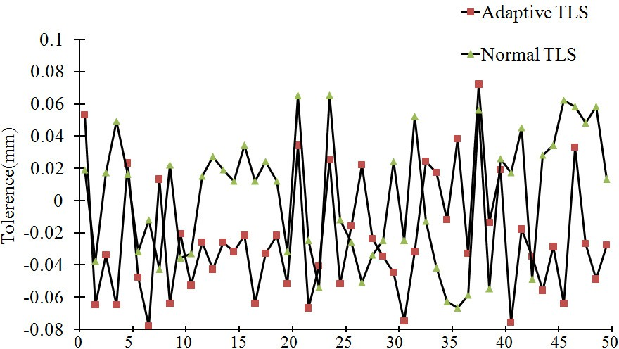

Fig. 1. The curve of measurement tolerance along X,Y,Z of CMM

The experiment results indicate the standard tolerance calculated by normal total least-squares algorithm is 0.0598mm, and the one done by adaptive total least-squares algorithm is 0.0375mm. Compared with normal total least-squares algorithm , the tolerance calculated by adaptive total least-squares algorithm is less .

In order to further validate the calculation speed of the adaptive total least square algorithm , set up the experiment environment : CPU  Intel core i7 3770 RAM  4G Operation system : Windows xp Matlab7.0 . The experiment used the normal total least square algorithm and adaptive total least square algorithm to continue calculating 106 times , separately records the time of five times experiment for every algorithm , shown as Table 1.

Table.1 The comparison between the time consumption

|  |  |  |  |  |  |
| --- | --- | --- | --- | --- | --- |
|  | | | Time(s) |  | |
| Normal TLS | 1.38 | 1.66 | 1.15 | 1.56 | 1.31 |
| Adaptive TLS | 0.86 | 0.77 | 0.89 | 0.83 | 0.92 |

The results of Table. 1 indicate the calculation speed of adaptive total least square algorithm is better than the one of normal total least square algorithm .

# Conclusion

In order to decrease the error tolerance when the noise is existing in both input signals and output signals of visual measurement system , and get the best optimization solution of the relative to the attitude conversion between optical characteristics points and camera , present the method of adaptive total least square algorithm . Firstly , introduce the function expression of normal total least squares algorithm; Then , based on the Rayleigh Quotient property to get the final equation of adaptive total least squares algorithm. Finally , make the simulation comparison experiment , the standard tolerance calculated by normal total least square algorithm is 0.0598mm ; But the one done by adaptive total least square algorithm is 0.0375mm ; The experiment results prove adaptive total least square algorithm has high precision , and calculation speed is better than normal total least square algorithm .

# References

1. GOLUB G. H. , VAN LOAN C. F. et al., An analysis of the total least squares problem[J]. Society for Industrial and Applied Mathematics Journal on Numerical Analysis, 1980, 17: 883~ 893.
2. JIA ZH X. , FENG SH Q. et al. An error analysis of a hybrid method for the least squares problem[J]. Journal of DaLian University of Technology, 2000,40:S1~S4.
3. LU T D. , ZHOU SH J. et al. An Iterative Algorithm for Total Least Squares Estimation[J]. Geomatics and Information Science of WuHan University , 2010,35(11):1351~1354.
4. SUYKENS J. A. K., VANDEWALLE J. et al. Least squares support vector machine classifiers [J]. Neural Processing Letters, 1999, 9(3): 293 300.
5. SANCHEZ A. V. D. et al. Robustization of a learning method for RBF net-works[J]. Neurocomputing, 1995, 9(1): 85~94.
6. KRUGER U, ZHOU Y, WANG X, et al. Robust partial least squares regression: part I algorithmic developments[J]. Journal of Chemo-metrics, 2008, 22(1): 1~13.
7. KARABASSIS E, SPETSAKIS M E. et al. An analysis of image interpolation, differentiation and reduction using local polynomial fits[J]. Graphical Models and Image Processing.1995. 57(3):183~196.