[Array 19 (2023) 100315](https://doi.org/10.1016/j.array.2023.100315)

Contents lists available at [ScienceDirect](http://www.sciencedirect.com/science/journal/25900056)

Array

journal homepage: [www.sciencedirect.com/journal/array](https://www.sciencedirect.com/journal/array)

Affective state prediction of E-learner using SS-ROA based deep LSTM

Snehal Rathi a,*, Kamal Kant Hiran b, Sachin Sakhare a

a *Department of Computer Engineering, Vishwakarma Institute of Information Technology, Pune, India*

b *School of Computer Science and IT, Symbiosis University of Applied Sciences, Indore, India*

A R T I C L E I N F O

*Keywords:*

E-learning Higher education Affective states Deep LSTM

Squirrel search algorithm Rider optimization algorithm and Interaction log

A B S T R A C T

An affective state of a learner in E-learning has gained enormous interest. The prediction of the emotional state of a learner can enhance the outcome of learning by including designated mediation. Many techniques are developed for anticipating emotional states using video, audio, and bio-sensors. Still, examining video, and audio will not confirm secretiveness and is exposed to security issues. Here the creator devises a fusion technique, to be specific Squirrel Search and Rider optimization-grounded Deep LSTM for affect prediction.

The Deep LSTM is trained to exercise the new fusion SS-ROA. Then, the SS-ROA-grounded Deep LSTM clas- sifies the states like frustration, confusion, engagement, wrathfulness, and so on. It is based on the interaction log data of the E-learner. In conclusion, the course and student ID, predicted state, test marks, and course completion status are taken as result information to find out the correlations. The new algorithm gives the best performance in comparison to other present methods with the highest prediction accurateness of 0.962 and the most note- worthy connection of 0.379 respectively. After discovering affective states, students may get the advantage of

getting real comments from a teacher for improving one’s performance during learning. However, such systems should also give feedback about the learner’s affective state or passion because it greatly affects the student’s encouragement toward better learning.

# Introduction

The emergence of E-courses helps to increase learning opportunities for individuals by allowing them to access premium courses at any time and from any location. As a result, the sharing of educational resources can greatly improve the spirit of learning [1]. Throughout many years, a vast range of online learning platforms have emerged. As a result, the quality of online education is regarded as a key component of an educational system [2].

In contrast to traditional learning methods like in-person instruction, research indicates that e-learners are less committed and transmit less knowledge. These poor results have ascribed to an asynchronous nature of interaction and hence lack of learning [3]. In a traditional classroom, it is possible to dynamically monitor student moods, lack of inspiration or focus, and interest in a particular subject. Yet, in digital learning platforms, this kind of sentiment analysis becomes a significant problem [4].

Even though e-learning platforms offer convenient learning ways and plentiful qualitative courses around the globe, they still face the problem of low completion rates [5]. Previous studies have expressed

that rates of completion using these platforms are as low as 7–11%. Less motivation among students and a lower perception of the value of

courses are some causes of this [6]. So, it is crucial to understand and provide comments on the engagement of the learner in real-time [7].

By analyzing interaction logs or educational data, one can forecast a learner’s performance [8]. Due to the diverse motivations of learners for attending the course, the free online course has low commitment and

knowledge transfer [9]. In corporate training, businesses in the USA invest roughly in billions. Employers, however, are not pleased with the knowledge transfer [10].

Research in specific fields such as data mining in education, cogni- tive science, multimodal learning, and psychology has made compelling progress in learning analysis. It is guaranteed to monitor learner engagement and improve learning effectiveness in online learning [7]. Data mining provided relationships between various variables developed based on activity records of students and student perfor- mance. Attributes that show a reasonably high correlation with the performance of students are used as improved predictors. These vari- ables are said to be relevant because they can be used to predict at-risk students [11]. Affordable online education has attracted the attention of

* Corresponding author.

*E-mail addresses:* [snehal.rathi@viit.ac.in](mailto:snehal.rathi@viit.ac.in) (S. Rathi), [kamalkant.hiran@suas.ac.in](mailto:kamalkant.hiran@suas.ac.in) (K. Kant Hiran), [sachin.sakhare@viit.ac.in](mailto:sachin.sakhare@viit.ac.in) (S. Sakhare).

<https://doi.org/10.1016/j.array.2023.100315>

Received 18 April 2023; Received in revised form 25 July 2023; Accepted 30 July 2023

Available online 2 August 2023

2590-0056/© 2023 The Authors. Published by Elsevier Inc. This is an open access article under the CC BY-NC-ND license ([http://creativecommons.org/licenses/by-](http://creativecommons.org/licenses/by-nc-nd/4.0/) [nc-nd/4.0/](http://creativecommons.org/licenses/by-nc-nd/4.0/)).

the government, which provides educational guidelines [12].

Given the classical teaching method and the high student-teacher ratio, the teacher has additional problems in the auditorium. Tradi- tionally, trainers delivered content and learners learned it. This approach usually does not allow the teacher to respond to the individual requirements of the learners [13]. Also, due to the large number of learners in the auditorium, the instructor cannot focus on individual learners [14]. For evaluation, they conduct examination at the end of each course. Despite the large number of learners in the classroom,

skilled teachers typically observe, address, and identify learners’ emotional states [15].

Research in areas such as multimodal learning, psychology, and other fields has made significant progress and has attracted a great deal of attention to improving learning efficiency in e-learning platforms [16]. Most of the applications focus on achieving learning engagement

or identification. Efforts focus on the learner’s emotional state, including anxiety, learner attention, boredom, frustration [17], or evaluation by

quizzes and coursework [7].

Additionally, Predictive Learning Analytics (PLA) [3] helps in- structors improve course quality. At-risk student predictions [3], exam grades, and quiz scores [3] show that is likely to have an absolute impact on the learning experience. The best-known predictive model for pre- dicting the performance of students is the Artificial Neural Network (ANN) [18].

Affect in learning play a very prominent role in education. Accu- rately predicting emotional states can improve learning outcomes using

interference, which fine-tunes changes in a learner’s emotional state [19]. Various methods are available to classify emotions using acoustic,

video, and biosensors. However, systems relying on these modalities cannot ensure confidentiality and are subject to privacy concerns.

It is very essential to apprehend the course complexity of engineering courses and their impacts on the state of E-Learners. Therefore, we want to devise an algorithm for E-Learner’s affective state prediction by

considering engineering courses of different complexity. At first, three

courses, Data Structure and Files (C1), Data Base Management and System (C2), and Human Computer Interface (C3) are viewed for the experimental study. The above noted three courses have High, Medium, and Low complexity. Different learners are made to learn these courses online. Based on the studying behavior of learners in LMS, a log file is recorded.

Each learning behavior log file carries the important points of course ID, topic ID, Lecture ID, lecture type, time spent, opening time, closing time, and the examination rating of the learners. Then, the feature in- dicators are extracted. Based on the features and using Deep LSTM, the affective states of the learners are predicted. The proposed SS-ROA is used to train Deep LSTM. The SS-ROA is devised through a combination of Squirrel Search and Rider Optimization Algorithm. Thus, SS-ROA- based Deep LSTM predicts the different affective states.

The key contributions of this paper are:

* Proposed SS-ROA: This algorithm is devised through a combination of Squirrel Search (SS) and Rider Optimization Algorithm (ROA) and

it optimizes the training of neural network and hence enhances the performance.

* Proposed SS-ROA-based Deep LSTM for prediction of affective states:

The affective states of E-learner are predicted using Deep LSTM

which is trained using proposed SS-ROA

Other sections of the paper include: Section 2 displays an explanation of affective state prediction methods used in earlier works. The proposed method for affective state prediction using SS-ROA-based Deep LSTM is shown in the 3rd Section. The analysis of techniques is depicted in Section 4 and Section 5 provides the conclusion.

# Motivation

With conventional presentation strategies and a high learner- instructor ratio, an instructor faces extraordinary obstructions in the study hall. Generally, instructors convey the teaching material and un- derstudies learn it. With this approach, instructors are typically not ready to react to the individual necessities of learners. Besides, because

of the huge quantities of learners in a study hall, educators can’t concentrate on every individual learner. For learners’ assessment, they often take a test toward the finish of the course. In any case, even though

there is a high number of learners in a study hall, experienced educators normally notice, recognizes, and address the emotional states of the learners.

The talented educator makes an appropriate move to impact learning positively. Yet, the question is what these accomplished educators “see”? How do they turn up at a course of action? Does that action drive

the student in a useful way? Students’ knowledge gain is not only

depending on factors like the educator’s presentation, student’s capa- bility, and prerequisite knowledge but it also depends on the compati-

bility of learning styles and the affective state of the student.

Many times, educators don’t have information about, the level of emotional upset that can interfere with a learner’s learning. Learners in angry, restless, or discouraged states experience difficulties in learning;

individuals trapped in such states don’t take information effectively [20].

The connection between learning and emotions is not simple and straight. Affirmative and depressing affective states generate diverse sorts of thinking and this may hold significant implications from a learning viewpoint. A reliable way out which will synchronize both cognitive and emotional factors is firmly required [21].

Talented teachers change their teaching style and their presentation style as indicated by understudies’ feedback signals. E-learning plat- forms don’t consider these input signals and act similarly for all un- derstudies. Many existing e-Learning frameworks consider only

knowledge acquisition and don’t take care of student emotions. While developing such a framework, affective states, are taken into consider-

ation while organizing the contents and offering them. To make learning effective and to convey customized content, versatile frameworks depend on learners’ objectives, knowledge, and preferences. Thus, a

learning model which incorporates knowledge and inspiration would

lead to more effective and personalized [22].

Converting an e-learning framework of a non-affect sensitive state into a framework that incorporates the learner’s emotional states re- quires going through the affective loop. This includes recognition of a learner’s affect, proper action selection, and the fusion of an accurate inspirational state by the system [23]. Learners, who become trapped in

emotional states, for example, anger or sadness don’t process and take in data proficiently. From this, it can be inferred that a learner’s emotions

have an important role in getting better the effectiveness of online learning [24].

The goal of the educational institutions is to provide quality educa- tion [25]. The improved education system discovers knowledge using educational data and studies the parameter which impacts students’

performance. The acquired information from this data is utilized to

predict academic performance. However, the prediction of learning performance in students is a complex task because of the fundamental infrastructures [26,27] and customized requirements of different in- dividuals. The aforementioned limitation and the challenges of the prior methods are taken as an inspiration for developing a new student af- fective state prediction model.

* 1. *Literature survey*

Emotions and online learning are related to one another. The learning execution mirrors, the emotional circumstance of online learners in education. There has been a lot of enthusiasm among laptop

researchers and designers looking for methods for the enhancement of human-computer interfaces by way of synchronizing emotion and knowledge [28]. Affective Computing makes the chance of developing computational frameworks for acknowledgment of human affective states. It minimizes the gap between intensely emotional individual and the emotionally challenged computer [28]. Subsequently, Affective Computing research is an interdisciplinary area. It investigates human affective involvement with technology by combining engineering and computer knowledge with different domains like brain science, intel- lectual science, humanism, education, and morals [29].

A modern couple of years have considered a flood in the utilization of multidisciplinary techniques to consider the hard position of feelings in learning. Affective computing is a growing subject uniting scientists and professionals from distinctive fields, extending from Artificial Intelli- gence (AI), and Natural Language Processing (NLP) to cognitive and sociology [30]. Emotion data is utilized to enhance studying [31]. Here, affirmative and distrustful feelings are perceived with the aid of the usage of two models, particularly behavioral logs and biosensors. Fusion of it is done using a Bayesian Network [32].

Neurological proof indicates that the online studying surroundings will no longer be luxurious if the affective states or psychological stip- ulations of learners are not considered. Here authors have featured a few consequences from the neurological literature which display that emo- tions play a critical job in individual thoughts and knowledge, but in addition in critical thinking and conclusion-making of humans. Personal Computers (PCs) that will collaborate logically and cleverly with humans have to apprehend and express affect [33].

Sandanayake and team [34] have constructed a gadget to compre- hend college students online learning to know overall performance whilst estimating the emotional state. They utilized a regression approach to categorize emotions. They have gathered the time used up on lessons, studying action, chat gathering, taking a look at marks,

perusing, and course time on LMS. Surveys have been utilized for perceiving the learners’ affective states.

The assessment was carried out by using Khan F.A and group [35]

set-up methodology to get more correct outcomes. Here learners are given a chance to finish lessons at their speed and preferences. The re- cords used to be gathered in the log report and a Bayesian network is used to classify affective states. Correlation between interaction log and questionnaire response used to predict the same. The effects had been practically the same, but larger realness was once obtained via the interaction log method. The model used in this research demonstrates a

real-time method of getting learners’ affective states through the log of interaction and preferences. This effect constantly evaluates modifica-

tions in the learner’s emotional states.

V. Chitraa [31] led a study on pre-processing techniques for behav- ioral logs utilized in web usage mining. The facts were once pre-processed to clean the records and afterward put in an information set. Session ID, Learner ID, and path completion records were used in the dataset. The Apriori algorithm was utilized for finding the patterns. According to investigations of Pekrun [36], the thoughts related to learning change on a massive scale. Anxiety is the most straight was inferred. Aside from this, the accompanying emotions related to study- ing had been boredom, anger, relief, satisfaction, and enjoyment. However, their assessment had a constraint of no longer enabling an actual conclusion structured on motives of feelings.

According to Manasi Chakurkar [37], user logs had been saved to analyze an area of interest of users. This gave customized advice struc-

tured on the learner’s behavior. The result of this web usage content mining was utilized to personalize the e-learning framework itself.

Some experiments perceived feelings using biosensors [38,39], and some made use of a fusion of bio-sensors and facial expressions. The sensors would record changes in the nervous system of the body. They utilized SVM calculations for making ready data and perceiving feelings [40,41].

In a few experiments, information is collected from sensor-based

wearable devices like smartwatches and fit bands. Authors have uti- lized here Emotion Wear Framework [42]. In the Emotion Wear framework, a person sees the content material which is saved on the cloud via a smartphone used in the VR headset. The person wears gloves that produce quite several signals, which are utilized to understand thoughts. The thoughts detected had been specific but there was a delay in investigation and the sensor price was associated with it [42,43].

Raviraj and colleagues [44] have introduced approach for speech emotion recognition using a hybrid meta-heuristic ensemble based classification technique. The collected audio speech signals were pre-processed and features are extracted from it, which are used to train

the model. Here, the authors suggest using a “optimized RNN, DBN, and ANN” as part of an ensemble classifier. The DBN and ANN findings will be used as input to the optimized RNN, which will then provide the

output. The weight of RNN was fine-tuned to increase the precision of speech emotion classification using a hybrid optimization model called the Arithmetic Exploration updated Wildbeast Model, which combines two optimization models, namely the Arithmetic Optimization Algo- rithm (AOA) and Wildebeest herd optimization (WHO). Only basic emotions like happy, sad etc. are detected here.

The method for facial emotion recognition utilizing a novel hybrid deep belief rain optimization algorithm has been presented by Alamgir, F.M., and Alam, M.S [45]. This method combines Rain Optimization Algorithm (ROA) with Deep Belief Network (DBN). This classifier can classify fundamental emotions like happiness, surprise, fear, etc. with greater accuracy. To increase the stability of training even when trained for a greater number of iterations with a wider range of data samples, more optimized models must be created.

A hybrid optimization algorithm has been created by Vedavathi and a colleague [46] as a method for an effective e-learning recommendation system for user preferences. They have employed an improved whale optimization algorithm (IWOA) and deep recurrent neural network (DRNN). IWOA depends on the chasing conduct of humpback whales. Premature convergence causes WOA to become trapped in local optima. In IWOA, this problem is solved. Here authors has proposed an e-learning suggestion approach that is based on DRNN and IWO calcu- lations for prescribing e-learning assets to students in e-learning situa- tions. The new method had demonstrated more accurate results when compared to the existing algorithms.

From the literature survey, it is found that a range of modalities like facial expression recognition, questionnaires, interaction log conduct, and sensing techniques such as Galvanic Skin Response (GSR), Electro- cardiogram (ECG), Electroencephalography (EEG), etc. have been used by researchers to predict emotions. Facial expressions and sensors have privacy issues related to them. There may be a bias from learners when questionnaires had been used. So, an interaction behavior log [47] is an excellent way to predict an affective state of a learner.

The literature survey indicates that most of the researchers have developed tools, envisioned thoughts, or tried to devise methods of adapting content or providing responses to the learner. Due to the response, the enhancements have been determined in the performance. Many of the researchers have used the techniques such as Neural Network, RNN and Deep LSTM.

Optimization has a lot of importance in Neural Networks. Optimizer are a significant piece of the neural network, seeing how they work would assist us with picking which one to use for application. In deep learning, there is an idea of loss; it reveals to us how ineffectively the model is behaving at that current moment. Then, at that point we require utilizing this loss to train our network so it can act upon well. Basically, we have to assume the loss and attempt to limit it, in light of the fact that a lower loss implies our model will do better. The most common way of limiting (or expanding) any statistical expression is called enhancement. Optimizer are techniques used to alter the traits of the neural network like weights and learning rate to lessen the losses. Optimization algorithms help in decreasing the losses and to give the most exact outcomes achievable. Different optimizers are explored in

the couple of years. Few of them are “I) Gradient Descent (GD), II)

Stochastic Gradient Descent (SGD), III) Mini-Batch Stochastic Gradient Descent (MB-SGD), IV) SGD with Momentum, V) Nesterov Accelerated Gradient (NAG), VI) Adagrad, VII) AdaDelta and VIII) Adam”. Each one

of it is enjoying its benefits and inconveniences. They have challenges

like may get trap at local minima, Takes quite a while to converge and computationally costly. To overcome these challenges a novel optimizer is required.

By looking at literature survey, now, it is time to do an investigation of “How to beautify the accuracy of the technique used to predict af- fective state?” and “Will this prediction have any relationship with the

complexity of the course taken by the students? What is the effect of

optimization algorithm while training the Deep LSTM for prediction of affective states?

Here, it is proposed to construct an efficient and accurate prediction algorithm that will pick out the learners’ affective states during learning online engineering courses of different complexity. Affective states get

recognized through the use of an interaction behavioral log. The novel optimization algorithm is designed to train neural networks used for the prediction of affective states.

* 1. *Challenges*

The issues suffered by the classical learning management system are enlisted below.

* To alleviate the impact of lack of supervision.
* Performance prediction due to per-student assessment response sparsity is challenging [10].
* Procrastination is one of the biggest challenge [11].
* Identifying affective states for course is a big challenge.
* The factors affecting student performance due to course complexity, learning styles, and affective states need to be addressed
* Need to identify a novel method for the detection of Affective States.
* Need to have a novel optimization algorithm for training neural networks while predicting Affective States.
* No standard dataset based on interaction logs is available.
* No benchmark for labeling the dataset is available.

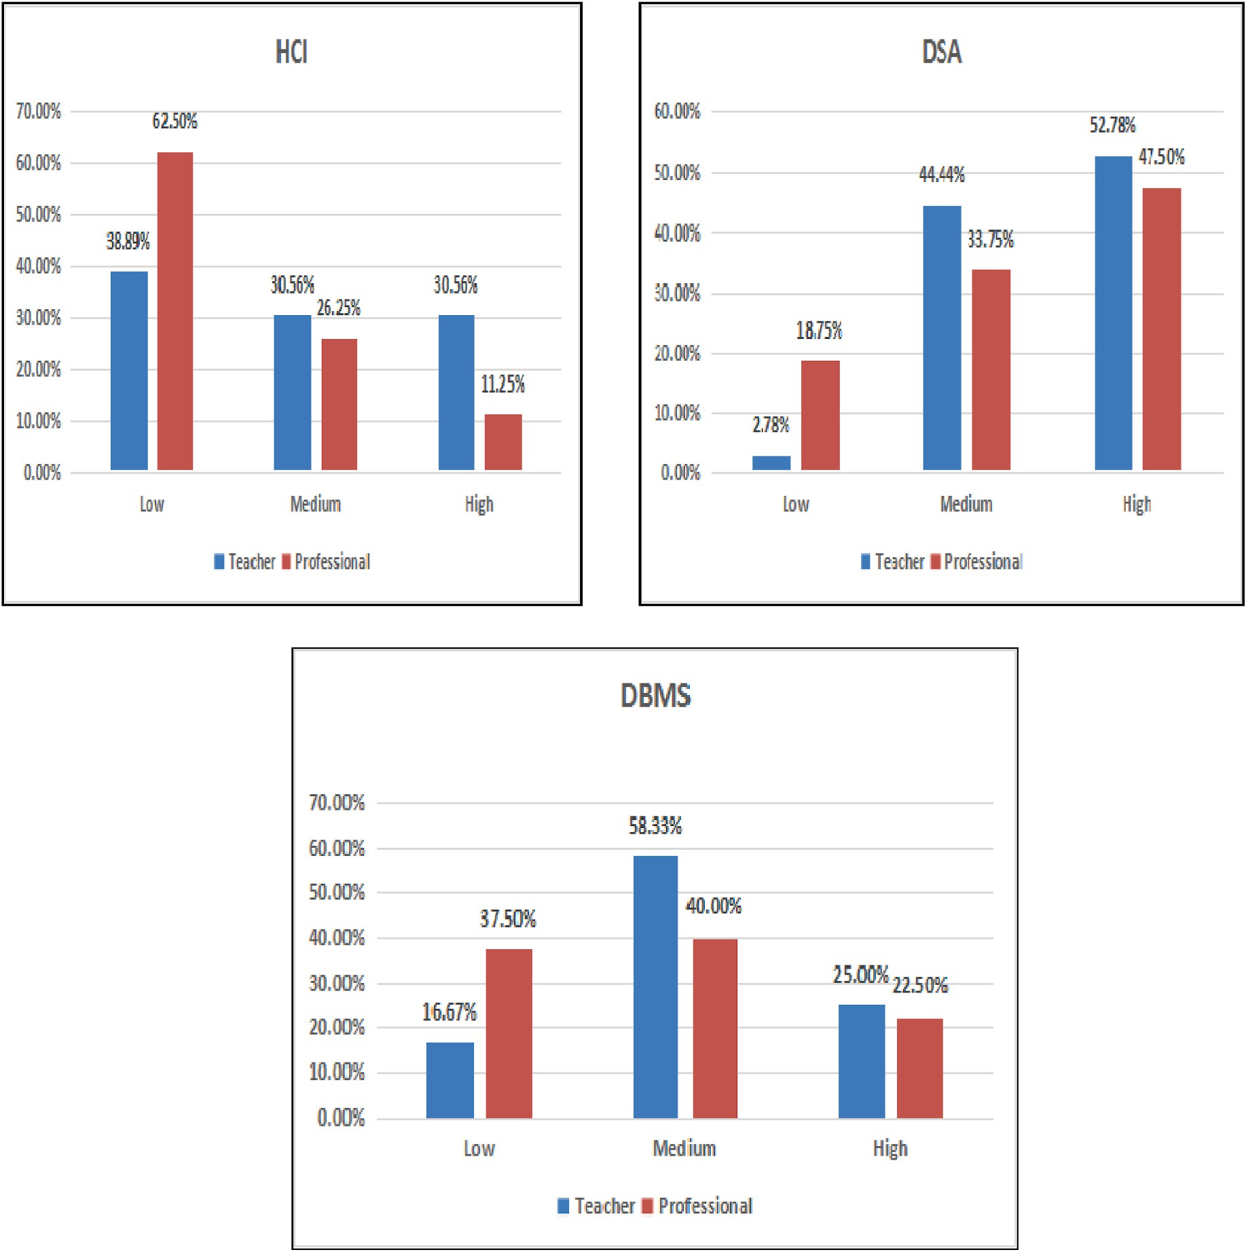

**Fig. 1.** Perceived course complexity: Survey outcome.

# Proposed SS-ROA-based deep LSTM for affective state prediction

An e-Learning system should focus on the acquisition of knowledge and cognition. The system can use affective state recognition for iden- tifying emotions while structuring the courses. This research aims to develop an efficient method of recognizing e-learners’ emotions for HCI

study applied to courses of varied complexity. The three courses that

were selected for the experimental study are Data Structures and Files (C1), Data Base Management and System (C2), and Human-Computer Interaction (C3) have High, Medium and Low complexity respectively. These courses were selected after analyzing data of perceived complexity collected from the survey of professionals and teachers.

To measure the perceived cognitive complexity of various engi- neering courses, a survey of teachers and computer and IT professionals is conducted. As shown in Fig. 1, Data Structures and Files (C1), Data Base Management and System (C2), and Human-Computer Interface (C3) are considered High, Medium, and Low complex subject respectively.

A log of interaction with the Learning Management System (LMS) was recorded to capture the learning behavior. The log file comprises the details of the course, topic, type of topic explored, time spent on

different activities, and the exam score of learners. Then, the features were identified and Deep LSTM [48–50] was performed to identify the learner’s affective state. It was trained using the proposed SS-ROA which was developed through a combination of the Squirrel Search Algorithm

(SSA) [51] and Rider Optimization Algorithm (ROA) [52]. Hence, the SS-ROA-based Deep LSTM was found more effective in predicting the different affective states including engagement, frustration, confusion, boredom, anger, and surprise. Finally, a correlation study was per- formed between affective state outcome with exam scores and course completion. Fig. 2 portrays the block diagram of the affective state prediction model using proposed SS-ROA-based Deep LSTM.

As shown in Fig. 2, the learner’s behavior data is recorded for identified 3 subjects namely data structures and files, database man-

agement and system, and human-computer interface. These subjects have High, Medium, and Low complexity respectively. Each course has five units and each unit has topics with ten lectures which contain four

videos of 1 h, two documents, one PDF, one PPT, and two exams. The log is recorded for more than 100 students while studying these subjects. Student ID, Course ID, Topic ID, Lecture ID, Type of document (Video/ PPT/PDF/DOC), Opening and Closing time is recorded.

Extracted Features from the recorded data are. **EF1:** Signifies the number of lectures covered. **EF2:** Indicates the number of topics covered. **EF3:** Represents the number of videos covered.

**EF4:** Symbolizes the number of documents covered (pdf/doc/ppt).

**EF5:** Indicates the number of exams attended.

**EF6:** Signifies frequency ID (Morning/evening/afternoon/night).

**EF7:** Denotes learning time.

**EF8:** Represents occurrence of sign_in.

The feature vector can be modeled by combining all the aforemen- tioned features.

* 1. *Affective state prediction of the student using proposed SS-ROA- based deep LSTM*

Affective states are events that are used for representing short and long-term emotions that are experienced by the user while doing some activity. Knowing the changes in the affective states of the learner is very helpful in the education field and it is associated with an increase in learning outcomes. Here, the proposed SS-ROA-based Deep LSTM is developed for the affective state prediction of students daily. The fea- tures are given as input to the Deep LSTM [18,22]. The Deep LSTM is trained using the proposed SS-ROA and is obtained by integrating SS and ROA. The proposed algorithm effectively predicts affective states, such as frustration, engagement, boredom, confusion, anger, and surprise. The architecture of Deep LSTM, training of Deep LSTM and the gener- ated output are illustrated below.

* + 1. *Why deep LSTM*

Recurrent Neural Network (RNN) can also handle sequential data. They can memorize previous inputs. They suffer from short-term memory. For long sequences, it is difficult for RNNs to consider the in- formation from previous steps. The major concern associated with RNN

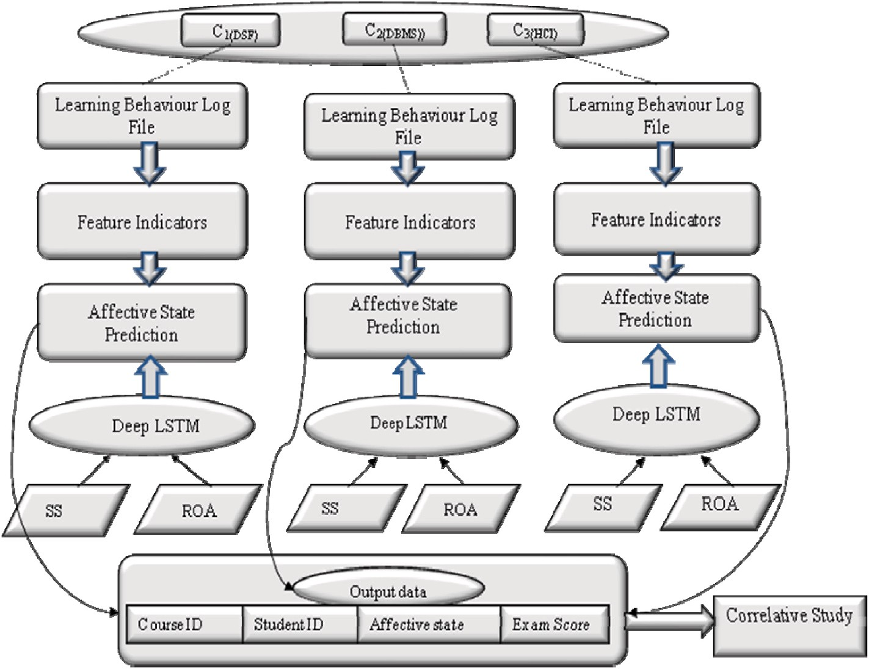

**Fig. 2.** Block diagram of an affective state prediction model using proposed SS-ROA-based Deep LSTM.

is, it suffers from the vanishing and exploding gradient problem. Gra- dients are values that are used for updating the weights of neural net- works. It never finds optimal weight in both cases.

In LSTM architecture, the network “decides” whether to modify its “internal memory” at each step. By doing so, the layer can keep track of important events from earlier time steps to later ones, allowing for much

richer inference. So Deep LSTM is used for the prediction of affective states.

* + 1. *Architecture of deep LSTM*

The resultant extracted features (EF) acquired from interaction logs were fed to the deep LSTM for prediction. It is more beneficial rather than other classifiers. It is exceptionally effective to achieve the emotional state forecast, using the memory cell of the classifier. Deep LSTM uses the previous states and information related to their neigh- boring states for anticipating further states. It offers prediction by setting up the encoding layers. Gates can regulate the flow of information. It makes use of three gates Forget, Input, and Output. These gates have a very important role in LSTM.

Forget gate: This gate decides to remember or forget information. Input Gate: It decides what data to add from the current input.

Output Gate: The output gate decides the next hidden state.

When information is passed and the gate is activated, the informa- tion is fed to the memory cell. The significant benefit of adjusting the cell and the gates is to deal with the information flow. Here, the classifier utilizes the past condition of neighbors and the input cell to assess the further cell state.

Least Mean Squared Error (MSE) is calculated. The outcome with the least MSE is considered the best solution.

*d*

*err* = 1∑[ — Pr ] (1)

*MS ExpectedOutput edictedOutput* 2

*d c*=1

where, *d* is number of samples, such as 1 < *c* ≤ *d*.

Step 3) Estimate updates position:

For determining the winner, the rider’s position is updated. The update of the position is explained below:

According to the Rider Optimization Algorithm, the over-taker’s update position increases the rate of getting success. So formula used for

the same is used in this algorithm. It is represented as,

*Ae*+1(*h*, *i*) = *Ae*(*h*, *i*) + [*DR*(*h*) ∗ *AL*(*L*, *i*)] (2)

*e*

where *DR*(*h*) signifies direction indicator, *i* symbolizes coordinate selector, *AL* indicates leading rider’s position, and *L* indicates leading

*e*

rider’s index.

In Squirrel Search Algorithm, squirrels are allocated arbitrarily at the start. The algorithm consists of three cases in all. As per SSA [20], the updated position of squirrels is expressed as,

*Ae*+1(*h*, *i*) = *Ae*(*h*, *i*) + *prBdAe*(*f* , *i*) — *prBdAe*(*h*, *i*) (3) where *Ae*(*h*, *i*) indicates flying squirrel location that acquired hickory nut stant, *Ae*(*f*, *i*) indicates flying squirrel on acorn nut tree. tree, *pr* represents random gliding distance, *Bd* symbolizes gliding con-

After rearranging equation (3), we get

* + 1. *Deep LSTM training using proposed SS-ROA*

The affect is predicted through deep LSTM, trained by projected SS- ROA. The proposed SS-ROA is devised through a combination of SS and

*Ae*(*h*, *i*) =

*Ae*+1(*h*, *i*) — *prBdAe*(*f* , *i*) (4)

1 — *prBd*

ROA. Here, the SS [51] is obtained by the dynamic foraging actions of squirrels. In warm weather, the squirrels find their foodstuff by gliding

from one to another tree and expose to different locations of the forest. *A*

SSA acquires optimum global solutions with good convergence and

Substitute equation (4) in equation (2)

*Ae*+1(*h*, *i*) — *prBdAe*(*f* , *i*) *R L*

*e*+1(*h*, *i*) = + *D* (*h*) ∗ *A* (*L*, *i*) (5)

1 — *prBd e*

poses the ability for solving complex problems. SSA assists to provide constant effectual accuracy. The update equation used in this algorithm

After rearranging above equation (5), we get the final updated equation of the proposed SS-ROA as

is considered further in the SS-ROA algorithm.

Meanwhile, ROA [52] is propelled by deeds of rider gatherings, which travel to acquire the target to become a winner. Every single

*Ae*+1(*h*, *i*) =

1 — *prBd* —*prBdAe*(*f* , *i*)

—*prBd* 1 — *prBd* +

[

*e*

*DR*(*h*) ∗

*AL*(*L*, *i*)]

(6)

gathering plays out a few procedures for arriving at the target. Subse- quently, it is noticed that it performs affective state prediction with enhanced accuracy. Likewise, the ROA is exceptionally powerful. It undergoes fictional computing to settle the optimization issues. It has less convergence rate and it is more receptive to hyper-parameters. Besides, it follows the multi-directional search space and hence it has a fast convergence rate that depends on the over-taker position.

The ROA considers the four groups of riders. Every group follows its approach to arrive at the target position. As the name implies the bypass rider tries to win by bypassing the leading path. The follower goes after the rider who is in the lead position. The over-taker overtakes to arrive at the leading position. The attacker takes the position by taking the maximum speed to attain the goal.

According to the researchers [52], the update strategy used by over-takers elevates the rate of success so it is used further in SS-ROA. Henceforth, by consolidating SSA with the ROA, the presentation of an emotional state forecast can be altogether improved. Thus, the newly, devised SS-ROA updates the weights of the Deep LSTM. The SS-ROA has the capability of fast convergence by avoiding local minima that mini- mizes the error while mapping the input feature vectors. Thus, a more accurate affective state classification is performed. Besides, the cost and

training time is also being reduced through the optimization process.

The step of proposed the SS-ROA are given as follows, Step1) Random Initialization of Riders:

The preliminary step is the random initialization of riders in groups. Step 2) Error Determination:

Step 4) Riding Off time:

The steps in the algorithm are repeated till a winner is exposed.

* + 1. *Output*

Thus, the affective state is predicted using the proposed SS-ROA- based Deep LSTM. The various states, like confusion, engagement, etc. are predicted. Here, the states are predicted for all students of every course daily. The affective state having maximum frequency is termed an output state.

# Results and discussion

The effectiveness of developed SS-ROA-based Deep LSTM using ac- curacy and correlation is presented. The analysis of every method is done by changing courses. Then, the performance is calculated by varying students’ performance.

* 1. *Experimental set-up*

As shown in Fig. 3, the experimentation is performed using two setups.

***Set-up-1:*** The analysis of methods concerning accuracy considering affective states with varied courses. In addition, the correlative study is analyzed by performing an analysis of affective state versus exam score, affective state versus course completion.

***Set-up-2:*** The analysis of methods concerning accuracy considering

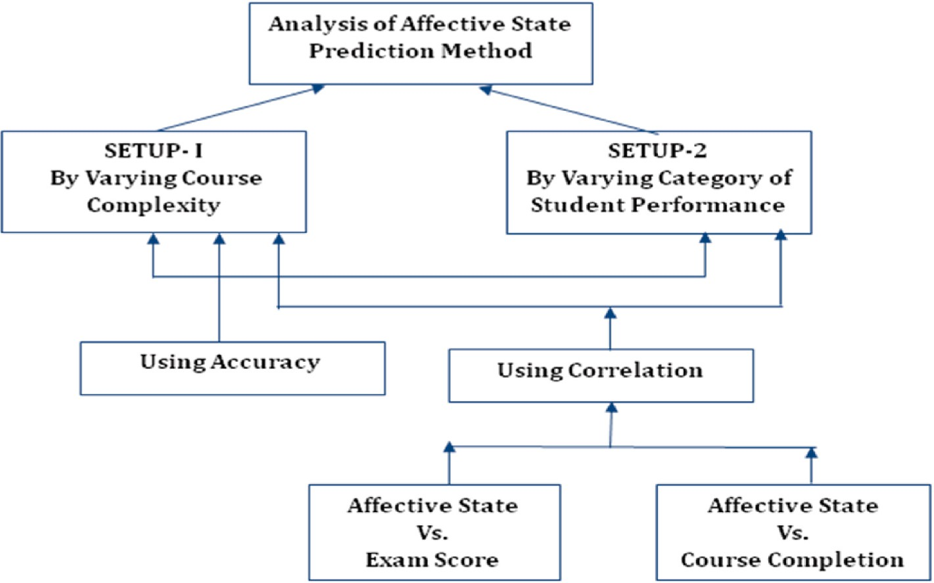

**Fig. 3.** Analysis of affective state prediction method.

affective states with varied student performance. In addition, the correlative study is analyzed by performing an analysis of affective state versus exam score, and affective state versus course completion.

* 1. *Methods used for comparison*

The methods, like Deep LSTM, SVM, and proposed SS-ROA-based Deep LSTM are used for the comparative study.

* 1. *Comparative analysis*

The analysis of techniques using accuracy and correlation is done by varying courses and students’ performance.

* + 1. *Analysis using set-up* = *1*

The analysis of affective state prediction techniques in terms of ac-

curacy is described with varied courses. In addition, the correlative study is analyzed by performing an analysis of affective state versus exam score and affective state versus course completion.

Fig. 4 displays the analysis of methods with accuracy considering affective states with courses. Considering courses 1, 2, and 3, the ac- curacy measured by projected SS-ROA-based Deep LSTM are 0.898, 0.843, and 0.930 respectively. It is higher as compared to the other reputed algorithms Deep LSTM and SVM.

Fig. 5 displays the comparison of techniques with correlation for affective states vs. exam scores. Considering courses 1, 2, and 3, the accuracy measured by projected SS-ROA-based Deep LSTM are 0.379, 0.337, and 0.238 respectively. It is higher as compared to the other reputed algorithms Deep LSTM and SVM.

Fig. 6 displays the comparison of techniques with correlation for affective states vs. course completion. Considering courses 1, 2, and 3, the accuracy measured by projected SS-ROA-based Deep LSTM are 0.200, 0.241, and 0.127 respectively. It is higher as compared to the other reputed algorithms Deep LSTM and SVM.

* + 1. *Analysis with set-up* = *2*

The analysis of affective state prediction techniques in terms of ac-

curacy is described with varied student performance. In addition, the

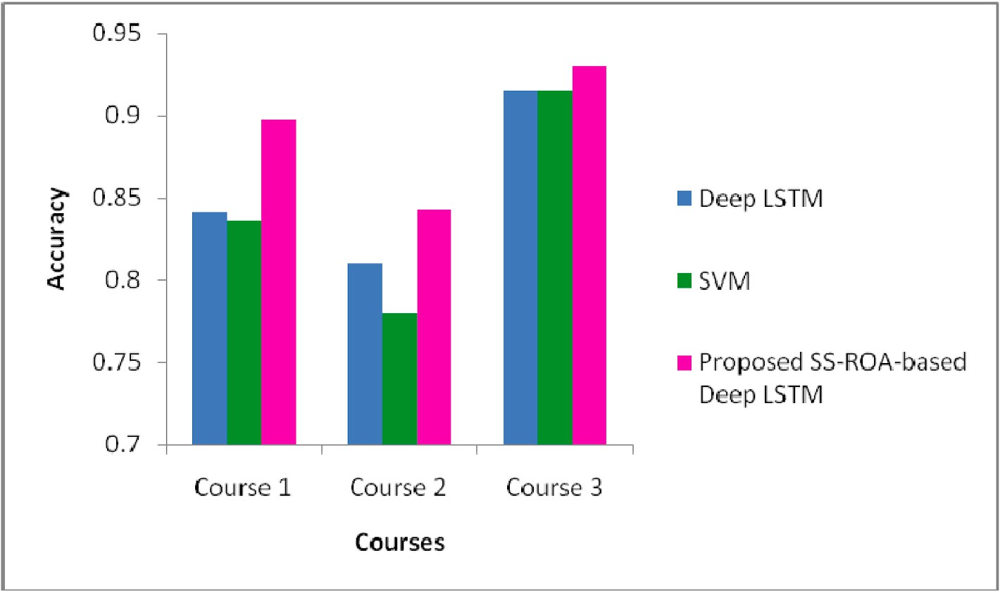

**Fig. 4.** Analysis of methods with accuracy considering affective states with courses

1. Analysis in terms of accuracy considering affective states with courses.

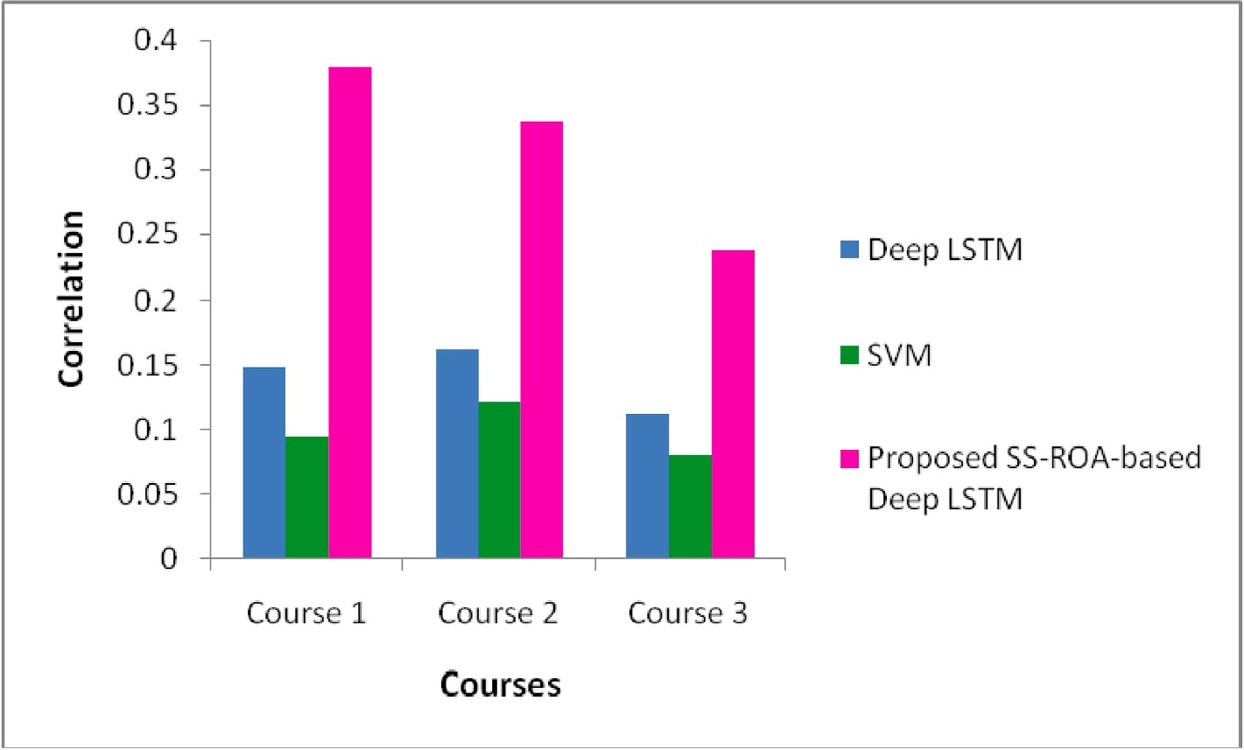

**Fig. 5.** Comparison of Techniques with correlation for affective states vs. exam score

1. Correlation study (Affective state versus exam score).

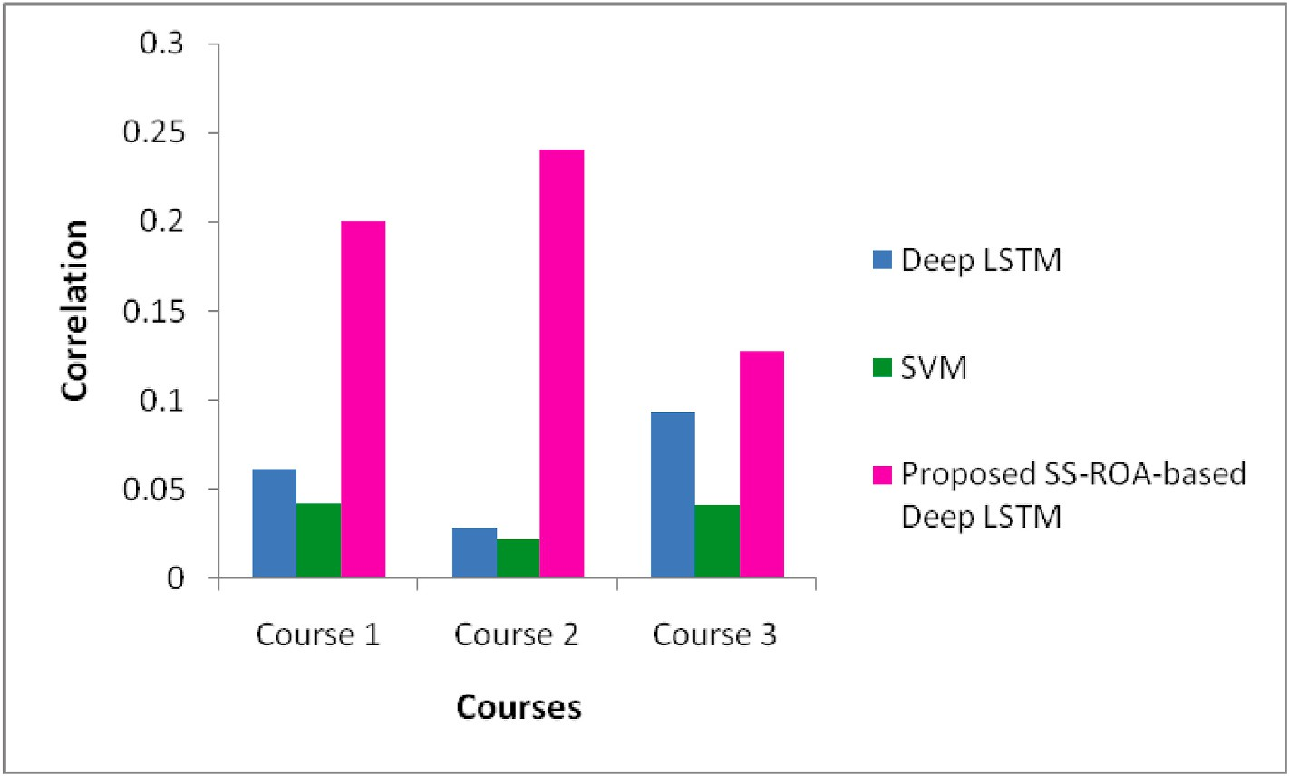

**Fig. 6.** Comparison of techniques with correlation for affective states vs. course completion

d) Correlation study (Affective state versus course completion).

correlative study is analyzed by performing an analysis of affective state versus exam score and affective state versus course completion.

Fig. 7 displays the comparison of techniques with accuracy for af- fective states with student performance. Considering courses 1, 2, and 3, the accuracy measured by projected SS-ROA-based Deep LSTM are 0.949, 0.949, and 0.962 respectively. It is higher as compared to the other reputed algorithms Deep LSTM and SVM.

Fig. 8 displays the comparison of techniques with correlation for affective states vs. exam scores. Considering courses 1, 2, and 3, the accuracy measured by projected SS-ROA-based Deep LSTM are 0.236, 0.190, and 0.138 respectively. It is higher as compared to the other reputed algorithms Deep LSTM and SVM.

Fig. 9 exhibits the comparison of techniques with correlation for affective states vs. course completion. Considering courses 1, 2, and 3, the accuracy measured by projected SS-ROA-based Deep LSTM are 0.227, 0.164, and 0.161 respectively. It is higher as compared to the other reputed algorithms Deep LSTM and SVM.

* 1. *Comparative discussion*

Methods are analyzed by using Setup-1, considering different courses concerning accuracy and correlation parameter. Through analysis, it is observed that maximum accuracy of 0.930 is calculated by projected SS- ROA-based Deep LSTM in course 3. The maximum correlation of 0.379 is measured by projected SS-ROA-based Deep LSTM for course 1. Hence, it can be observed that projected SS-ROA-based Deep LSTM shows improved performance in affective state prediction.

Methods are analyzed by using Setup-2, considering varying student performance concerning accuracy and correlation. Throughout the analysis, it is noted that the highest accuracy of 0.962 is calculated by the proposed SS-ROA-based Deep LSTM for the high-performance stu- dent category. The maximum correlation of 0.236 is calculated by the proposed method in affective states with exam scores for the low- performance student category. Hence, it can be observed that the pro- posed SS-ROA-based Deep LSTM shows improved performance in af- fective state prediction.

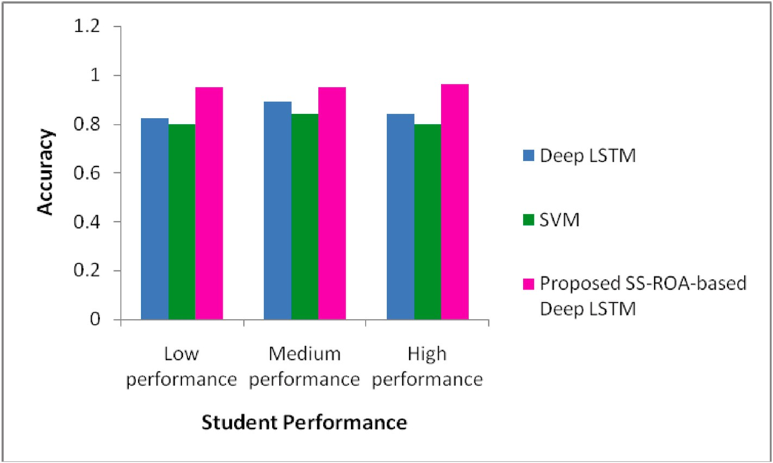

**Fig. 7.** Comparison of techniques with accuracy for affective states with student performance

1. Analysis in terms of accuracy considering affective states.

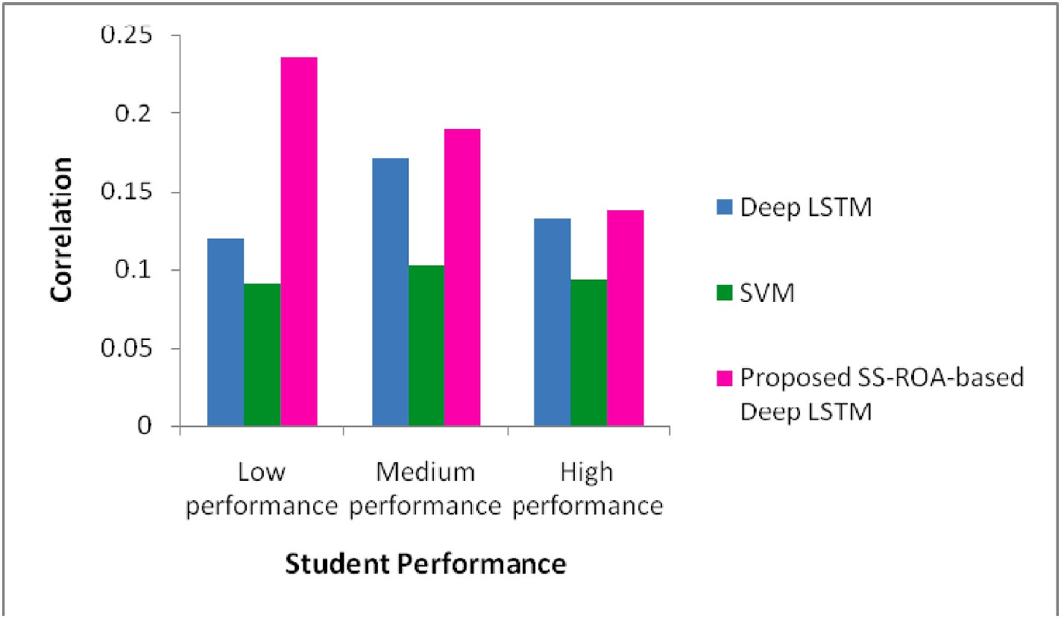

**Fig. 8.** Comparison of techniques with correlation for affective states vs. exam score

1. Correlation study (Affective state versus exam score).

The developed affective state method (SS-ROA-based Deep LSTM) obtained the best performance in terms of accuracy and correlation. The newly devised SS-ROA algorithm has the capability of fast convergence rate with the avoidance of local minima. Besides, the most significant feature selection it also reduces the computational complexity of the network, and the Deep LSTM predicts the time series data more accu- rately. Thus the tuning of the Deep LSTM with the novel SS-ROA opti- mization enhances the prediction accuracy that leads to the better performance of the system.

The affective state prediction using the Deep LSTM obtained an ac- curacy of 0.825 for low performance category students as shown in Fig. 7, which is 13.07% lower than the newly devised SS-ROA-based Deep LSTM technique. Here, the best performance is achieved due to the novel optimization technique that tunes the weights of the classifier with the fast convergence rate by avoiding the premature convergence that makes the more accurate affective state prediction. The accurate affective state prediction makes the correlation study more useful. Similarly, the proposed method outperformed all the other state of art

techniques.

* 1. *Statistical analysis*

The proposed SS-ROA algorithm outperforms the other algorithms concerning accuracy and correlation. If Null Hypothesis is “*H0: The SS- ROA-based Deep LSTM method doesn’t have a significant effect on enhancing*

*the accuracy of prediction of affective states in E-learning scenario”*. After performing a *t*-Test on the proposed SS-ROA based Deep LSTM and SVM results shows that, |t stat|> T Critical and P value < 0.05. So, the Null Hypothesis can be rejected, and the Alternate Hypothesis **“*HA: The SS- ROA-based Deep LSTM method has a significant effect on enhancing***

***the accuracy of prediction of affective states in E-learning scenario”***

can be accepted.

The result of the *t*-Test is shown in Table 1.

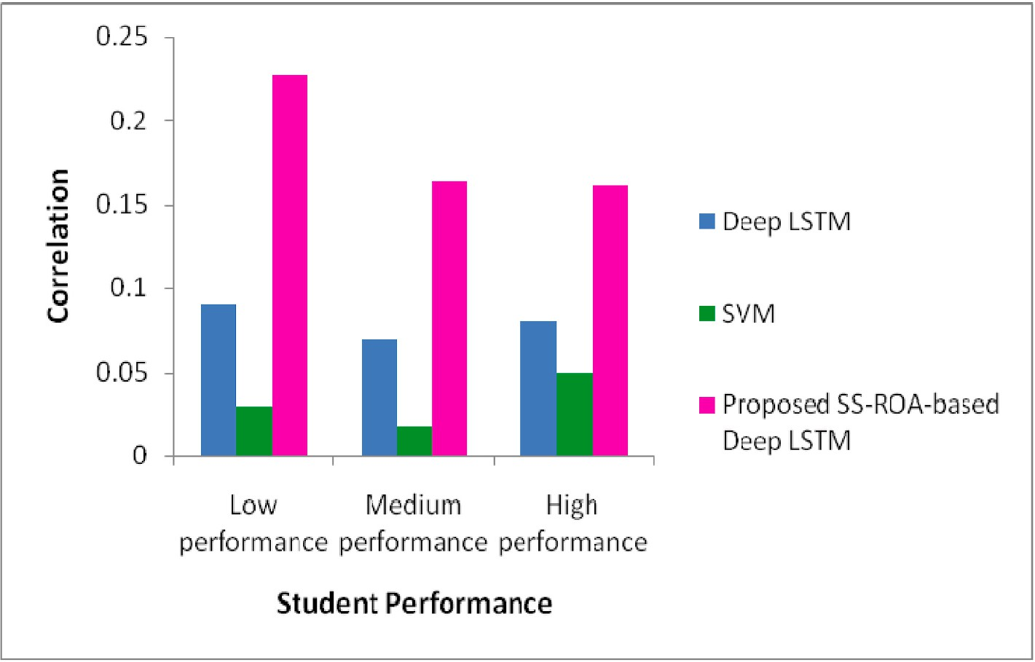

**Fig. 9.** Comparison of techniques with correlation for affective states vs. course completion

d) Correlation study (Affective state versus course completion).

**Table 1**

Result of *t*-Test of SS-ROA based Deep LSTM and SVM.

*t*-Test: Two-Sample Assuming Equal Variances

Mean 0.921833333

Observations 6

t Stat 3.479428884

P(T ≤ t) one-tail 0.00296343

|  |  |  |
| --- | --- | --- |
| t Critical one-tail | 1.812461102 | the work reported in this paper. |
| P(T ≤ t) two-tail | 0.005926859 |  |
| t Critical two-tail | 2.228138842 | **Data availability** |

Resources, Software, Validation, Sachin Sakhare: Writing - Review, Validation, Investigation.

# Declaration of competing interest

The authors declare that they have no known competing financial interests or personal relationships that could have appeared to influence

# Conclusion

This paper devises a strategy for affective state prediction. Initially, three courses Data Structures and Files (C1), Data Base Management and System (C2), and Human-Computer Interface (C3) are employed for the experimental study. The three courses can be modeled as High complex subject, Medium complex subject, and Low complex subject. These courses are studied by different learners using LMS wherein the log file is created based on the learning patterns. Thereafter, the features are extracted which is further utilized for affective state prediction of the learners using Deep LSTM. The Deep LSTM is trained using the proposed SS-ROA and is formulated by combining Squirrel Search Algorithm (SSA) and Rider Optimization Algorithm (ROA). Here, the predictions of affective states like engagement, boredom, anger, happiness, etc. are performed. At last, the course and student ID, affective state, exam score, and course completion are considered for correlation study. The pro- posed algorithm outperformed than other methods with the utmost ac- curacy of 0.962 and the utmost correlation of 0.379 respectively. The developed model was stable for the varied levels of complexity of courses. It is useful for the applications like course recommendation systems, finding students at risk, improving the quality of online cour-

ses, and tracking learners’ progress and performance. In the future other

databases can be considered for providing briefer analysis. It may be possible to develop a multi modal approach that may take input in the form of facial expressions, sensor data, and gestures along with a log file.

# Credit author statement

Snehal Rathi: Conceptualization, Methodology, Formal analysis

The authors are unable or have chosen not to specify which data has been used.

# References

1. [Qiu L, Liu Y, Liu Y. An integrated framework with feature selection for dropout](http://refhub.elsevier.com/S2590-0056(23)00040-1/sref1) [prediction in massive open online courses. IEEE Access 2018;6:71474–84](http://refhub.elsevier.com/S2590-0056(23)00040-1/sref1).
2. [Mane A Abhijeet, Waykar B Sanjay, Dhanesh Narvekar S. Multimedia resource](http://refhub.elsevier.com/S2590-0056(23)00040-1/sref2)

[library using video streaming. Proceedings of the International Conference &](http://refhub.elsevier.com/S2590-0056(23)00040-1/sref2)

[Workshop on Emerging Trends in Technology 2011:1378–9](http://refhub.elsevier.com/S2590-0056(23)00040-1/sref2).

1. [Chen W, Brinton CG, Cao D, Mason-Singh A, Lu C, Chiang M. Early detection](http://refhub.elsevier.com/S2590-0056(23)00040-1/sref3) [prediction of learning outcomes in online short-courses via learning behaviors.](http://refhub.elsevier.com/S2590-0056(23)00040-1/sref3) [IEEE Transactions on Learning Technologies 2018;12(1):44–58](http://refhub.elsevier.com/S2590-0056(23)00040-1/sref3).

[visualization for monitoring online learner emotions. In: Media+ innovate](http://refhub.elsevier.com/S2590-0056(23)00040-1/sref4) [4] [Ghasem Aghaei R, Arya A, Biddle R. A dashboard for affective e-learning: data](http://refhub.elsevier.com/S2590-0056(23)00040-1/sref4) [learning, association for the advancement of computing in education (AACE); June](http://refhub.elsevier.com/S2590-0056(23)00040-1/sref4)

[2016. p. 1536–43](http://refhub.elsevier.com/S2590-0056(23)00040-1/sref4).

1. [Liyanagunawardena TR, Parslow P, Williams S. Dropout: MOOC participants’](http://refhub.elsevier.com/S2590-0056(23)00040-1/sref5) [perspective. 2014](http://refhub.elsevier.com/S2590-0056(23)00040-1/sref5).
2. [Sujatha R, Kavitha D. Learner retention in MOOC environment: analyzing the role](http://refhub.elsevier.com/S2590-0056(23)00040-1/sref6) [of motivation, self-efficacy and perceived effectiveness. International Journal of](http://refhub.elsevier.com/S2590-0056(23)00040-1/sref6) [Education and Development using ICT 2018;14(2)](http://refhub.elsevier.com/S2590-0056(23)00040-1/sref6).
3. [Yue J, Tian F, Chao KM, Shah N, Li L, Chen Y, Zheng Q. Recognizing](http://refhub.elsevier.com/S2590-0056(23)00040-1/sref7) [multidimensional engagement of E-learners based on multi-channel data in E-](http://refhub.elsevier.com/S2590-0056(23)00040-1/sref7) [learning environment. IEEE Access 2019;7:149554–67](http://refhub.elsevier.com/S2590-0056(23)00040-1/sref7).
4. [Hone KS, El Said GR. Exploring the factors affecting MOOC retention: a survey](http://refhub.elsevier.com/S2590-0056(23)00040-1/sref8)

[study. Comput Educ 2016;98:157–68](http://refhub.elsevier.com/S2590-0056(23)00040-1/sref8).

1. [Komal V Aher, Waykar SB. A survey on feature based image retrieval. Int J Adv Res](http://refhub.elsevier.com/S2590-0056(23)00040-1/sref9) [Comput Sci Software Eng 2014;4(10):241–5](http://refhub.elsevier.com/S2590-0056(23)00040-1/sref9).
2. [Yang TY, Brinton CG, Joe-Wong C, Chiang M. Behavior-based grade prediction for](http://refhub.elsevier.com/S2590-0056(23)00040-1/sref10)

[MOOCs via time series neural networks. IEEE Journal of Selected Topics in Signal](http://refhub.elsevier.com/S2590-0056(23)00040-1/sref10) [Processing 2017;11(5):716–28](http://refhub.elsevier.com/S2590-0056(23)00040-1/sref10).

1. [Olive´ DM, Huynh D, Reynolds M, Dougiamas M, Wiese D. A quest for a one-size-](http://refhub.elsevier.com/S2590-0056(23)00040-1/sref11)

[fits-all neural network: early prediction of students at risk in online courses. IEEE](http://refhub.elsevier.com/S2590-0056(23)00040-1/sref11) [Transactions on Learning Technologies 2019;12:171–83](http://refhub.elsevier.com/S2590-0056(23)00040-1/sref11).

1. [Huang L, Wang CD, Chao HY, Lai JH, Philip SY. A score prediction approach for](http://refhub.elsevier.com/S2590-0056(23)00040-1/sref12)

[optional course recommendation via cross-user-domain collaborative filtering.](http://refhub.elsevier.com/S2590-0056(23)00040-1/sref12) [IEEE Access 2019;7:19550–63](http://refhub.elsevier.com/S2590-0056(23)00040-1/sref12).

[styles and affective states in EdMedia+ Innovate Learning. Association for the](http://refhub.elsevier.com/S2590-0056(23)00040-1/sref13) [13] [Khan FA, Weippl ER, Tjoa AM. Integrated approach for the detection of learning](http://refhub.elsevier.com/S2590-0056(23)00040-1/sref13) [Advancement ofComputing in Education (AACE); 2009. p. 753–61](http://refhub.elsevier.com/S2590-0056(23)00040-1/sref13).

1. [Cocea M, Weibelzahl S. Log file analysis for disengagement detection in e-Learning](http://refhub.elsevier.com/S2590-0056(23)00040-1/sref14) [environments. User Model User-Adapted Interact 2009;19(4):341–85](http://refhub.elsevier.com/S2590-0056(23)00040-1/sref14).
2. [Wampfler R, Klingler S, Solenthaler B, Schinazi VR, Gross M. Affective state](http://refhub.elsevier.com/S2590-0056(23)00040-1/sref15)

[prediction based on semi-supervised learning from smartphone touch data. In:](http://refhub.elsevier.com/S2590-0056(23)00040-1/sref15) [Proceedings of the CHI conference on human factors in computing systems; 2020.](http://refhub.elsevier.com/S2590-0056(23)00040-1/sref15)

[p. 1–13](http://refhub.elsevier.com/S2590-0056(23)00040-1/sref15).

1. [Francis BK, Babu SS. Predicting academic performance of students using a hybrid](http://refhub.elsevier.com/S2590-0056(23)00040-1/sref16) [data mining approach. J Med Syst 2019;43(6):162](http://refhub.elsevier.com/S2590-0056(23)00040-1/sref16).
2. [Kai S. Modeling student affective state patterns during self-regulated learning in](http://refhub.elsevier.com/S2590-0056(23)00040-1/sref17) [physics playground”. Doctoral dissertation Columbia University); 2019](http://refhub.elsevier.com/S2590-0056(23)00040-1/sref17).
3. [Ibrahim Z, Rusli NM, Janor RM. Predicting students’ academic achievement:](http://refhub.elsevier.com/S2590-0056(23)00040-1/sref18)

[comparison between logistic regression, artificial neural network, and neuro-fuzzy.](http://refhub.elsevier.com/S2590-0056(23)00040-1/sref18) [In: Proceedings of the international symposium on information technology; 2008](http://refhub.elsevier.com/S2590-0056(23)00040-1/sref18).

1. [Shen L, Wang M, Shen R. Affective e-learning: using “emotional” data to improve](http://refhub.elsevier.com/S2590-0056(23)00040-1/sref28) [learning in pervasive learning environment. Educ Technol Soc 2009;12(2):176–89](http://refhub.elsevier.com/S2590-0056(23)00040-1/sref28).
2. [Goleman D. Emotional intelligence. NewYork: Bantam Books; 1995](http://refhub.elsevier.com/S2590-0056(23)00040-1/sref19).
3. [Kort B, Reilly R. Analytical models of emotions, learning and relationships:](http://refhub.elsevier.com/S2590-0056(23)00040-1/sref20) [towardsan affect-sensitive cognitive machine, vol. 548. MIT Media Lab Tech](http://refhub.elsevier.com/S2590-0056(23)00040-1/sref20) [Report No; 2001](http://refhub.elsevier.com/S2590-0056(23)00040-1/sref20).
4. Cocea M, Weibelzahl S. Eliciting motivation knowledge from log files towards motivation diagnosis for adaptive systems. In: Conati C, McCoy K, Paliouras G, editors. User Modeling 2007: 11th International Conference, UM 2007, Corfu, Greece, June 25-29, 2007, Proceedings (4511 ed., pp. 197-206). (Lecture notes in computer science; No. 4511). Springer; 2007. [https://doi.org/10.1007/978-3-540-](https://doi.org/10.1007/978-3-540-73078-1_23) [73078-1_23](https://doi.org/10.1007/978-3-540-73078-1_23).
5. [D’Mello SK, Craig SD, Witherspoon A, McDaniel B, Graesser A. Automatic](http://refhub.elsevier.com/S2590-0056(23)00040-1/sref22) [detection of learner’s affect from conversational cues. Journal of User Modeling](http://refhub.elsevier.com/S2590-0056(23)00040-1/sref22) [and User-Adapted Interaction 2008;18(1–2):45–80](http://refhub.elsevier.com/S2590-0056(23)00040-1/sref22).
6. Weimin X, Wenhong X. E-learning assistant system based on virtual human interaction technology, ICCS2007, LNCS. Springer Berlin/Heidelberg; 2007. <https://doi.org/10.1111/bjet.12324>.
7. [Singh SV, Hiran KK. The impact of AI on teaching and learning in higher education](http://refhub.elsevier.com/S2590-0056(23)00040-1/sref48) [technology. Journal of Higher Education Theory & Practice 2022;12(13)](http://refhub.elsevier.com/S2590-0056(23)00040-1/sref48).
8. [Hiran KK. Investigating factors influencing the adoption of IT cloud computing](http://refhub.elsevier.com/S2590-0056(23)00040-1/sref47) [platforms in higher education: case of Sub-Saharan Africa with IT professionals. Int](http://refhub.elsevier.com/S2590-0056(23)00040-1/sref47) [J Hum Cap Inf Technol Prof (IJHCITP) 2021;12(3):21–36](http://refhub.elsevier.com/S2590-0056(23)00040-1/sref47).
9. [Hiran KK. Impact of driving factors on cloud computing adoption in the higher](http://refhub.elsevier.com/S2590-0056(23)00040-1/sref49)

[education. In: IOP conference series: materials science and engineering (Vol.1131,](http://refhub.elsevier.com/S2590-0056(23)00040-1/sref49) [No. 1, p. 012016). IOP Publishing; 2021. April](http://refhub.elsevier.com/S2590-0056(23)00040-1/sref49).

1. Calvo Rafael, D’Mello K, Sidney. Affect detection: an interdisciplinary Review of models, methods and their applications. T. Affective Computing; 2010. [https://doi.](https://doi.org/10.1109/T-AFFC.2010.1)

[org/10.1109/T-AFFC.2010.1](https://doi.org/10.1109/T-AFFC.2010.1). 1. 18-37.

1. Picard, R.W. (1995) Affective Computing. M.I.T Media Laboratory Perceptual Computing Section Technical Report No. 321.
2. [Poria Soujanya, Cambria Erik, Bajpai Rajiv, Hussain Amir. A review of affective](http://refhub.elsevier.com/S2590-0056(23)00040-1/sref26) [computing: from unimodal analysis to multimodal fusion. In: Information fusion.](http://refhub.elsevier.com/S2590-0056(23)00040-1/sref26)

[Elsevier; 2017. p. 98–125. 37, September](http://refhub.elsevier.com/S2590-0056(23)00040-1/sref26).

1. [Chitraa V, Dr Davamani AS. A survey on pre-processing methods for web usage](http://refhub.elsevier.com/S2590-0056(23)00040-1/sref32) [data. Int J Comput Sci Inf Secur 2010;7(3)](http://refhub.elsevier.com/S2590-0056(23)00040-1/sref32).
2. [Ashwin TS, Guddeti RMR. Impact of inquiry interventions on students in e-](http://refhub.elsevier.com/S2590-0056(23)00040-1/sref27)

[learning and classroom environments using affective computing framework. User](http://refhub.elsevier.com/S2590-0056(23)00040-1/sref27) [Model User-Adapted Interact 2020:1–43](http://refhub.elsevier.com/S2590-0056(23)00040-1/sref27).

1. [Jason Matthew Harley. Chapter 5 - measuring emotions: a survey of cutting edge](http://refhub.elsevier.com/S2590-0056(23)00040-1/sref29)

[methodologies used in computer-based learning environment research, editor(s. In:](http://refhub.elsevier.com/S2590-0056(23)00040-1/sref29)

[Sharon Y, Tettegah, Gartmeier Martin, editors. In emotions and technology,](http://refhub.elsevier.com/S2590-0056(23)00040-1/sref29) [emotions, technology, design, and learning. Academic Press; 2016. p. 89–114.](http://refhub.elsevier.com/S2590-0056(23)00040-1/sref29) [9780128018569](http://refhub.elsevier.com/S2590-0056(23)00040-1/sref29).

1. [Sandanayake TC, Madurapperuma AP, Dias D. Affective ELearning model for](http://refhub.elsevier.com/S2590-0056(23)00040-1/sref30) [recognizing learner emotions. International Journal of Information and Education](http://refhub.elsevier.com/S2590-0056(23)00040-1/sref30) [Technology 2011;1(No. 4). October](http://refhub.elsevier.com/S2590-0056(23)00040-1/sref30).
2. Khan F.A, Akbar A, Muhammad Altaf, Shujaat Ali Khan, Ayaz Ahmed, “Automatic student modelling for detection of learning styles and affective states in web based

learning management systems”, DOI 10.1109/ACCESS.2019.2937178, [IEEE Access].

1. [Pekrun Reinhard, Goetz Thomas, Titz Wolfram. Academic emotions in students’](http://refhub.elsevier.com/S2590-0056(23)00040-1/sref33) [self-regulated learning and achievement”: a program of qualitative and](http://refhub.elsevier.com/S2590-0056(23)00040-1/sref33) [quantitative research. Educ Psychol 2002;37](http://refhub.elsevier.com/S2590-0056(23)00040-1/sref33).
2. [Chakurkar Manasi, Prof. Deepa adiga: “A web mining approach for personalized E-](http://refhub.elsevier.com/S2590-0056(23)00040-1/sref34) [learning system”. Int J Adv Comput Sci Appl 2014;5(No.3)](http://refhub.elsevier.com/S2590-0056(23)00040-1/sref34).
3. [Han-Wen Guo, Yu-Shun Huang, Chien-Hung Lin, Jen-Chien Chien, Koichi, editors.](http://refhub.elsevier.com/S2590-0056(23)00040-1/sref35) [Heart rate variability signal features for emotion recognition by using principal](http://refhub.elsevier.com/S2590-0056(23)00040-1/sref35) [component analysis and support vectors machine; 2016](http://refhub.elsevier.com/S2590-0056(23)00040-1/sref35).
4. [Abdi H, Williams LJ. Principal component analysis, vol. 2. Wiley Interdisciplinary](http://refhub.elsevier.com/S2590-0056(23)00040-1/sref36) [Reviews: Computational Statistics; 2010. p. 433–59](http://refhub.elsevier.com/S2590-0056(23)00040-1/sref36).
5. [Rigas G, Katsis CD, Ganiatsas G, Fotiadis DI. A user independent biosignal based](http://refhub.elsevier.com/S2590-0056(23)00040-1/sref37)

[emotion recognition method. Lecture Notes In Artificial Intelligence 2007;45(1):](http://refhub.elsevier.com/S2590-0056(23)00040-1/sref37) [314–8](http://refhub.elsevier.com/S2590-0056(23)00040-1/sref37).

1. [Wang C, Wang F. An emotional analysis method based on heart rate variability.](http://refhub.elsevier.com/S2590-0056(23)00040-1/sref38)

[Biomedical and Health Informatics IEEE-EMBS International Conference on; 2012.](http://refhub.elsevier.com/S2590-0056(23)00040-1/sref38)

[p. 104–7](http://refhub.elsevier.com/S2590-0056(23)00040-1/sref38).

1. [Terence KL, Hui, Simon Sherratt R, editors. Coverage of emotion recognition for](http://refhub.elsevier.com/S2590-0056(23)00040-1/sref39) [common wearable biosensorgs; 2018](http://refhub.elsevier.com/S2590-0056(23)00040-1/sref39).
2. [Deigh J. William James and the Rise of the Scientific Study of Emotion. Emotion](http://refhub.elsevier.com/S2590-0056(23)00040-1/sref40) [Review 2013;;46(1):4–12](http://refhub.elsevier.com/S2590-0056(23)00040-1/sref40).
3. Darekar R, Chavan M, Sharanyaa S, Ranjan NM. A hybrid meta-heuristic ensemble

based classification technique speech emotion recognition. Adv Eng Software 2023;180:103412. <https://doi.org/10.1016/j.advengsoft.2023.103412>.

1. Alamgir FM, Alam MS. An artificial intelligence driven facial emotion recognition

system using hybrid deep belief rain optimization. Multimed Tools Appl 2023;82: 2437–64. <https://doi.org/10.1007/s11042-022-13378-x>.

1. Vedavathi N, Anil Kumar KM. An efficient e-learning recommendation system for

user preferences using hybrid optimization algorithm. Soft Comput 2021;25: 9377–88. <https://doi.org/10.1007/s00500-021-05753-x>.

1. [Rathi Snehal, Deshpande Yogesh, Nagaral Shashidhar, Narkhede Ankita,](http://refhub.elsevier.com/S2590-0056(23)00040-1/sref46)

[Sajwani Radhika, Takalikar Varad. Analysis of user’s learning styles and academic](http://refhub.elsevier.com/S2590-0056(23)00040-1/sref46) [emotions through web usage mining. In: 2021 international conference on](http://refhub.elsevier.com/S2590-0056(23)00040-1/sref46) [emerging smart computing and informatics (ESCI). IEEE; 2021. p. 159–64](http://refhub.elsevier.com/S2590-0056(23)00040-1/sref46).

1. [Xingjian SHI, Chen Z, Wang H, Yeung DY, Wong WK, Woo WC. Convolutional](http://refhub.elsevier.com/S2590-0056(23)00040-1/sref41)

[LSTM network: a machine learning approach for precipitation now casting. In:](http://refhub.elsevier.com/S2590-0056(23)00040-1/sref41) [Advances in neural information processing systems; 2015. p. 802–10](http://refhub.elsevier.com/S2590-0056(23)00040-1/sref41).

1. [Waykar Sanjay B, Bharathi CR. Video object retrieval mechanism with the effective](http://refhub.elsevier.com/S2590-0056(23)00040-1/sref42)

[video tracking model based on Deep long-short term memory. International](http://refhub.elsevier.com/S2590-0056(23)00040-1/sref42) [Journal of Advanced Science and Technology 2020;29(No. 7)](http://refhub.elsevier.com/S2590-0056(23)00040-1/sref42).

1. Rathi SR, Deshpande YD. Course complexity in engineering education using E- learner’s affective-state prediction. Kybernetes 2022. [https://doi.org/10.1108/K-](https://doi.org/10.1108/K-09-2021-0806) [09-2021-0806](https://doi.org/10.1108/K-09-2021-0806). ahead-of-print No. ahead-of-print.
2. [Jain M, Singh V, Rani A. A novel nature-inspired algorithm for optimization:](http://refhub.elsevier.com/S2590-0056(23)00040-1/sref45) [squirrel search algorithm. Swarm Evol Comput 2019;44:148–75](http://refhub.elsevier.com/S2590-0056(23)00040-1/sref45).
3. [Binu D, Kariyappa BS. RideNN: a new rider optimization algorithm-based neural](http://refhub.elsevier.com/S2590-0056(23)00040-1/sref44)

[network for fault diagnosis in analog circuits. IEEE Trans Instrum Meas 2018;68](http://refhub.elsevier.com/S2590-0056(23)00040-1/sref44) [(1):2–26](http://refhub.elsevier.com/S2590-0056(23)00040-1/sref44).