Available online at [www.sciencedirect.com](http://www.sciencedirect.com/)

**ScienceDirect**

AASRI Procedia 4 (2013) 173 – 181

2013 AASRI Conference on Intelligent Systems and Control

Airwaves Prediction Model for Shallow Water Marine Control Source Electromagnetic Data

Muhammad Abdulkarima*, Afza Shafieb Wan Fatimah Wan Ahmada and Radzuan Razalib

,

*aDepartment of Computer & Information Sciences, Universiti Teknologi PETRONAS, B/Seri Iskandar, 31750 Tronoh, Perak, Malaysia*

*bDepartment of Fundamental & Applied Sciences, Universiti Teknologi PETRONAS, B/Seri Iskandar, 31750 Tronoh, Perak, Malaysia*

**Abstract**

One of the main challenges of using Marine Control Source Electro-Magnetic (MCSEM) sounding for Hydrocarbon de- tection has been the airwaves phenomena. In shallow water the response from the air half-space often masks the response from the subsurface. In this paper we present a curve fitting approach to identify a mathematical function or model that best describes the pattern of the airwaves data. The identified model can serve as a prediction model for the airwaves. Synthetic data are simulated in a geologic model that is fairly representative of the area where real MCSEM data were collected. Root Mean Square Error (RMSE), Sum of Square Error (SSE) and Coefficient of determination (R2) were used to evaluate the performance of the prediction model. The result indicates that exponential decay function can describe the airwaves data with RMSE of 3.1e-7, SSE of 1.3e-11 and R2 of 0.990.

© 2013 The Authors. Published by Elsevier B.V. Open access under [CC BY-NC-ND license.](http://creativecommons.org/licenses/by-nc-nd/3.0/)

© 2013. Published by Elsevier B.V.

Selection and/or peer review under responsibility of American Applied Science Research Institute

Selection and/or peer review under responsibility of American Applied Science Research Institute

*Keywords:* Airwaves; Coefficient of Determination; Exponential Curve Fitting; Hydrocarbon; MCSEM; RMSE; SSE

# Introduction

Marine Control Source Electro-Magnetic (MCSEM) is a technique of measuring the response of earth's subsurface structures due to the imparted alternating electric current when external electromagnetic field is applied into subsea floor formations. The CSEM technique has provide a means of remotely detecting the presence of high resistive subsea floor structures of the earth's interior such as the hydrocarbon reservoir.

2212-6716 © 2013 The Authors. Published by Elsevier B.V. Open access under [CC BY-NC-ND license.](http://creativecommons.org/licenses/by-nc-nd/3.0/) Selection and/or peer review under responsibility of American Applied Science Research Institute doi:10.1016/j.aasri.2013.10.027

The following describes a typical MCSEM survey. Commonly in practice, an electrode refers to a Hori- zontal Electric Dipole (HED) which serves as electromagnetic source is disposed approximately 30 – 50m above the seabed and connected to the survey recording vessel. The electrode is being charged by the power source on the survey vessel at selected magnitude of alternating current and transmission frequency or fre- quencies. At a selected source receiver distance (offset), an Ultra-low (~ 0.1 – 5Hz) transmission frequency is commonly passed through the seabed into the subsurface of the earth formation. Electric and magnetic sen- sors/receiver designed with a voltage measuring circuit are placed strategically either on the seabed or on a different survey vessel (see Figure 1). The imparted voltages recorded by the receivers on the seabed are then analysed to presume the structural formations beneath the earth surface through their electrical properties [1 – 3].

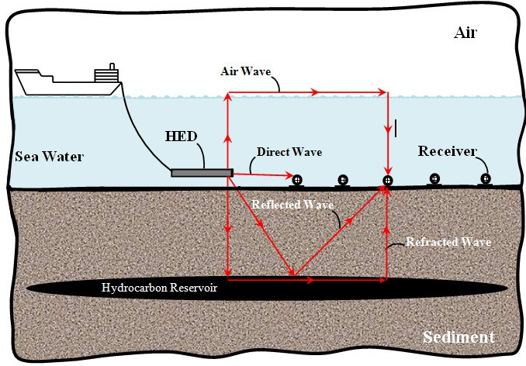

Fig. 1. A sketch of the MCSEM survey area

Theoretically, one of the main physics behind MCSEM is based on the knowledge that when an electro- magnetic (EM) field is propagated through a conductive subsurface, the induced signal is mainly affected by spatial distribution of resistivity. Sediments filled with saltwater in a marine environments typically represent good conductors, whereas carbonates, hydrocarbon filled sediments, salt and volcanic rocks represent exam- ples of resistive bodies that scatter the EM field. Part of the electromagnetic field scattered by subsurface in- homogeneities propagates back to the seafloor where the signal is recorded by receivers equipped with electric and magnetic sensors. The data recorded in shallow water CSEM survey are known to be affected by a noise called “airwaves". The noise component (airwaves) are generated predominantly by the vertically up going diffuse electromagnetic signal component that propagates in form of wave at the air/sea interface with speed

of light and without attenuation before it diffuse back through the water layer vertically down where it is rec- orded by the electromagnetic receivers [4] as illustrated in Figure 1.

There are numerous modeling concepts developed to provide better understanding of systems having fac- tors with nonlinear relationships like the airwaves. The numerical modeling conducted by [5] that used HED as the electromagnetic source, investigated the airwave contribution to the MCSEM data. Their study identi- fied far offset, transmission frequency and relatively shallow seawater depths to have important effect on the airwaves component. Even though, apart from the numerical modeling, no method of computing the airwaves was given in that study. Hankel transform was used by [6] to develop another 1D model through numerical airwaves calculations that resulted into a fast algorithm. The behaviour and physical insight of how airwaves build up in the water layer was not explained by the algorithm.

Study by [4] has also shown the effect of seawater depth would be important at large source-receiver sepa- rations, low frequencies, or in relatively shallow water. It was also pointed out that in principle, the method of modeling-and-subtraction can be used to suppress the airwave component. The effect can be incorporated into the theory if both water depth and source location are accurately determined [6]. Features of the effect of the air wave on the amplitude and phase was described by [2] and reported that the range at which the air wave dominates the response, and information on seabed resistivity is lost, increases with decreasing frequen- cy and water depth.

Furthermore, in the work of [7] and reported by [8] where the angular frequency, conductivity, and mag- netic permeability were respectively represented by , , and , the expression defining attenuation () and propagation () constants for frequencies below 105Hz within the conductive medium is given by:

*(1)*



2

Here *μ* = *μo* (magnetic permeability in free-space) because of nonmagnetic rocks in sedimentary basins. The research done by [4] has shown that the attenuation of electromagnetic energy depends on conductivity, transmission frequency and offset in a situation where the geometry is fixed. The low frequency electromag- netic signal in a distance *x* (m) experience exponential decay expressed as *e*-*x/* where;

*(2)*



2 *

8*10 7 * 2 * *f*

Where,  and *f* denote resistivity (m) and signal frequency (Hz) respectively. The distance required to at- tenuate an EM signal by factor of *e 1* is defined as skin depth and is about 551m in sea water (0.3 m), 1424 m in 2 m sediment and 108 in air (1011 m) for a frequency of 0.25Hz.

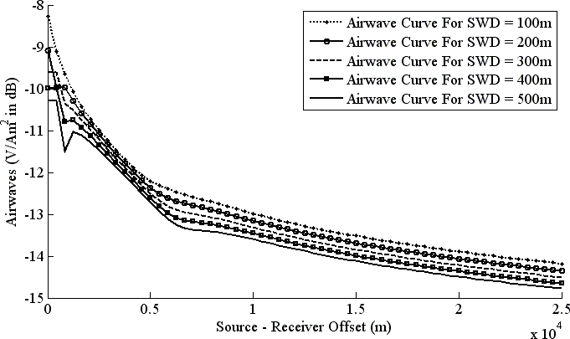

Fig. 2. Magnitude Versus Offset (MVO) plots for airwaves data in 100m – 500m seawater depth

Considering the above studies and the trend pattern of the MVO plot shown in Figure 2 which fairly sug- gests an exponential form of relationship motivates the authors to study the feasibility of applying exponential curve fitting method to model the airwaves data.

# The Exponential Function

An exponential function is a widely used function in fundamental and applied sciences to model a relation- ship in which a constant change in the independent variable gives the same proportional change (i.e. percent- age increase or decrease) in the dependent variable [9]. All forms of exponential function originate from the primitive two (2) parameter family. The variations that exist within this extended family resulted from mere transformations, shifts and stretches of the common stock defined as:

*Y * *f* (*x*)  *x*

*(3)*

Where,  and  are the function parameters that represent the *Y*-intercept and the base for the function re- spectively. The random variable is denoted by *x* where they all determine the exponential function's input- output behaviour [10]. It is worth to note that  is always positive in order to make real and algebraic sense. This implies that *x* is also positive always. Therefore, the output values of the function *f(x)* are either com- pletely positive or completely negative depending respectively on whether the sign of  is positive or negative. In many different applications and indeed calculus, the common choice of base for exponential functions is

= *e*. This is because transformation can easily be made such that for all  > 0 there exist a constant  so that *e*

=  and hence equation 3 becomes:

*f* (*x*)

*x e x*

*(4)*

However, the term exponential function is sometimes used more generally for functions of the form *x*, where the base  is any real positive number, not necessarily *e*.

* 1. *Algorithm of Exponential Curve Fitting*

Basically, curve fitting technique is a process of determining mathematical function that has the best fit to a series of data points, possibly subject to constraints [11]. To accomplish the exponential curve fitting process, suppose that we are given the points *(x1, y1), (x2, y2), … (xn , yn)* and want to fit an exponential curve. We express *Xi's (i = 1, 2, ..., n)* to represent the offset values and *Yi'*s as the corresponding magnitude of the airwaves Looking at Equation (3), the nonlinear least-squares procedure requires finding a minimum of:

*E*(,

)

*i*1



*n*

*i*

*e xi * *y* 2

*(5)*

The partial derivatives of *E*(, ) with respect to  and  are:

*E * 2



*n*

*i *1

*e xi*

 *yi xie xi*

*(6)*

And

*E*

 2

*i *1



*n*

*e xi*

 *yi e xi*

*(7)*

When the partial derivatives in (6) and (7) are set equal to zero and then simplified, the resulting normal equations are:

*n*

 *xie* 2*xi*

*i*1

*n*

 *xi yie xi * 0

*i *1

*(8)*

And

*n*

 *e xi*

*i*1

*n*

 *yie xi * 0

*i *1

*(9)*

Equations (8) and (9) are nonlinear in the unknowns  and . To avoid a time-consuming computation and the iteration involved that requires good starting values for  and  for equations of this nature. We therefore utilize MATLAB software package which has a built-in minimization subroutine for functions of several vari- ables to minimize *E*(, ) directly.

# Methodology

The simulation protocols related to the study data acquisition are explained in this section. Computer Simulation Technology (CST) software was used in designing and solving the different models of MCSEM environment. The area simulated is 25Km. The transmitter is modelled as a short 1250A AC line current segment of length 270m located 30m above the sea bed. The Maxwell’s electromagnetic field wave equation in vacuum in the absence of electric or magnetic sources is solved for the electric field vector *E* inside the computational domains.

Figure 2 (a) is a 1D MCSEM geologic model depicting "No Air Layer Model" and Figure 2 (b) – (f) are "With Air Layer Models" configurations that were simulated to obtain the airwaves data. Note that the fig- ures are not drawn to scale in this text; but in practice all have the same area. The only difference between "No Air Layer Model" and "With Air Layer Models" is the changing of the sea water depth and replacing the space with air layer. We changed the sea water depth at interval of 100m from 2000m down to 100m in order to obtain the airwaves data. In this study, only airwaves data from sea water depth of 500m down to 100m was used. This is because a study by [12] has shown that airwaves have significant effect on the MCSEM survey data within the depth of 100m to 500m.

(a) (b) (c)

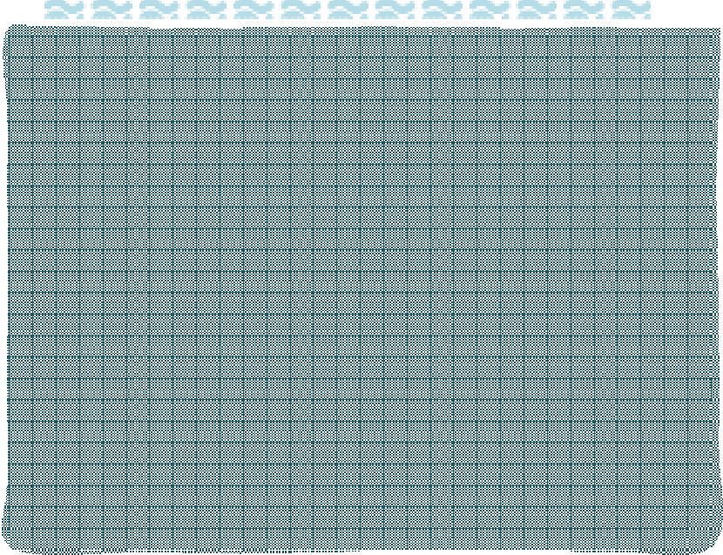

**Air 10-11Sm-1**

**Air 10-11Sm-1**

**Sea Water 3 – 5Sm-1**

**Sea Water 3 – 5Sm-1**

400m

**Sea Water 3 – 5Sm-1**

250m

250m

500m

2000m

(d)

(e)

(f)

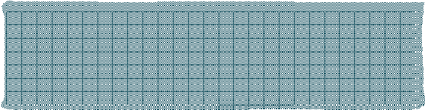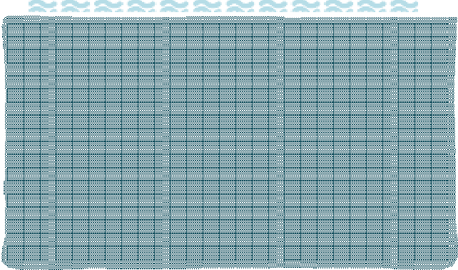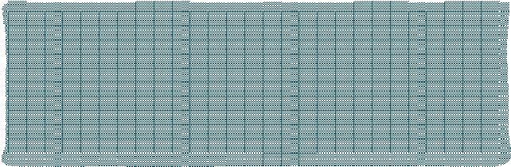

**Air 10-11Sm-1**

**Air 10-11Sm-1**

**Sea Water 3 – 5Sm-1**

300m

200m

**Sea Water 3 – 5Sm-1**

100m

**Sea Water 3 – 5Sm-1**

250m

250m

Fig. 3. Six MCSEM geologic models used to generate the study data

Table 1 present other physical values used for the simulation domains.

Table 1. Values assigned to the domains physical properties

|  |  |  |  |
| --- | --- | --- | --- |
| Domain | Air | Sea Water | Sediment |
| Conductivity ( ) | 1e-11Sm-1 | [3 5Sm-1] | [1 0.5Sm-1] |
| Material Density ( ) | 1.293kgm-3 | 1025kgm-3 | 2600kgm-3 |
| Relative Permeability ( r) | 1.0 | 0.99 | 1.0 |
| Relative Permittivity ( r) | 1.006 | 80 | 30 |
| Thermal Conductivity | 0.024 W(km)-1 | 0.593 W(km)-1 | 2W(km)-1 |

The contribution of the airwaves to the MCSEM data were computed by the method for removing the air wave effect as patented by [13] through the following steps:

 Constructing a MCSEM geometric model of the region having a top air layer, a middle sea water layer, and a bottom earth layer, with the model reflecting known bathymetry of the region and known conductivities of the air, seawater and earth;

 Using the model to compute the electromagnetic field at all receiver locations for each source location;  Replacing the air layer in the model with sea water to create No-Air Layer model;

 Computing the fields for the same source-receiver geometries for the No-Air Layer model; and

 Computing the airwave effect at each seawater depth by subtracting the No-Air Layer Model fields from the corresponding fields of the With-Air Layer Models.

# Results

Table 2 present the performance measure of the exponential curve fitting analysis with parameter values of  and . It can be seen from the results that even in the most shallow water depth of 100m where the airwaves is considered more than in the other deeper seawater depths. The exponential curve fitting technique has achieved the value of R2 of 0.99. While the RMSE and SSE of as low as 3.1e-7 and 1.3e-11 respectively. Furthermore, it can be observed the value of the intercept () is decreasing as the seawater depth is increasing. This is because the onset of the airwaves is being affected by the depth of the seawater. The values for  seem to be fairly the same; this might suggest the stability of the model.

Table 2. Parameter values and the performance measures

|  |  |  |  |  |  |
| --- | --- | --- | --- | --- | --- |
| Sea Water Depth |  |  | RMSE | SSE R2 | |
| 100M | 1.142e-5 | -3.05e-4 | 3.1e-7 | 1.3e-11 | 0.990 |
| 200M | 8.656e-6 | -3.07e-4 | 1.6e-7 | 3.4e-12 | 0.991 |
| 300M | 5.839e-6 | -2.98e-4 | 1.5e-7 | 3.0e-12 | 0.993 |
| 400M | 3.033e-6 | -2.79e-4 | 1.6e-7 | 3.5e-12 | 0.995 |
| 500M | 1.967e-6 | -2.73e-4 | 1.3e-7 | 2.3e-12 | 0.997 |

# Conclusion

Curve fitting technique was used in this study to identify a model that can serve as a shallow water air- waves prediction model. We have identified an exponential decay function of the form *f(x) = ex* to best describe the airwaves data. The study results shows that the exponential decay function can achieve R2 of 0.995, RMSE of 1.6e-7 and SSE of 3.4e-12. The near 1.0 for the coefficient of determination the small RMSE and SSE observed indicates that this prediction model indeed fits the data well. As this study is done with simulated data, the next step is to carry out the experimental work to verify the results.

# Acknowledgements

This research is carried out under the Fundamental and Research Grant Scheme. The authors would like to acknowledge Universiti Teknologi PETRONAS for giving the opportunity to carry out this research work.

# References

1. Constable, S., Srnka, L.J. An introduction to marine controlled-source electromagnetic methods for hydrocarbon exploration. Geophysics 72, WA3 (2007).
2. Hesthammer, J., Boulaenko, M. The potential of CSEM technology, GeoExpro, 4, 2007, pp. 52-58, and HGS Bulletin, pp. 23-43 December, Rocksource ASA: (2007).
3. Johansen, S.E., Amundsen, H.E.F., Røsten, T., Ellingsrud, S., Eidesmo, T. and Bhuiyan, A.H. Subsurface hydrocarbons detected by electromagnetic sounding. First Break, 23(3), 31–36, (2005).
4. Eidesmo, T., Ellingsrud, S., MacGregor, L.M.., Constable, S., Sinha, M.C., Johansen, S., Kong, F.N., and Westerdahl, H. Sea Bed Logging (SBL), a new method for remote and direct identification of hydrocarbon filled layers in deep-water areas. First Break, March 2002, Vol. 20.3.
5. Chave, A. D., and Cox, C. S. Theoretical numerical model study for offshore CESM exploration with a horizontal electric dipole source. Journal of Geophys. Res. 87, 5327-5338 (1982).
6. Anderson, W.L. Numerical integration of related Hankel transforms of order 0 and 1 by adaptive digital filtering. Geophysics, 44, (1979), pp.1287–1305.
7. Anwar B., Tor W., and Stale J. High Resistivity Anomalies at Modgunn Arch in the Norwegian Sea. Technical Article. First Break volume 24, January 2006.
8. Muhammad A., and Afza S.,(2013). Performance Analysis of Transfer Functions in Simulating Air Waves Data. International Journal of Current Engineering and Technology, ISSN : 2277 – 4106.
9. Goldstein, L., and Schneider, A. Brief calculus and its applications, 11th ed., Prentice-Hall, 2006.
10. Lorentzen, L., and Waadeland, H. The exponential function: Continued Fractions. Atlantis Studies in Mathematics, page 268.
11. Coope, I.D. (1993). Circle fitting by linear and nonlinear least squares. Journal of Optimization Theory and Applications 76 (2): 381.
12. Muhammad A., Afza S., Noorhana Y., Radzuan R., and Wan Fatimah Wan Ahmad. A Simulation Study to Identify the Sea Water Depth for the Presence of Air Waves in Sea Bed Logging. “2nd International Confe- rence on Fundamental and Applied Sciences” (ICFAS2012).
13. Xinyou, L., Srnka, L.J., and Carazzone, J.J. Method for Removing Air Wave Effect from Offshore Fre- quency Domain Controlled-Source Electromagnetic Data, U.S. Patent 7 277 806, Oct. 2, 2007.