[Array 5 (2020) 100014](https://doi.org/10.1016/j.array.2019.100014)

 

Contents lists available at [ScienceDirect](http://www.sciencedirect.com/science/journal/25900056)

Array

journal homepage: [www.elsevier.com/journals/array/2590-0056/open-access-journal](http://www.elsevier.com/journals/array/2590-0056/open-access-journal)

An improved face recognition algorithm and its application in attendance management system

Serign Modou Bah, Fang Ming *

*School of Computer Science and Technology, Changchun University of Science and Technology, Changchun, China*

A R T I C L E I N F O

*Keywords:*

Face recognition LBP

Attendance management system Image blending

A B S T R A C T

Face Recognition is a computer application that is capable of detecting, tracking, identifying or verifying human faces from an image or video captured using a digital camera. Although lot of progress has been made in domain of face detection and recognition for security, identification and attendance purpose, but still there are issues hindering the progress to reach or surpass human level accuracy. These issues are variations in human facial appearance such as; varying lighting condition, noise in face images, scale, pose etc. This research paper presents a new method using Local Binary Pattern (LBP) algorithm combined with advanced image processing techniques such as Contrast Adjustment, Bilateral Filter, Histogram Equalization and Image Blending to address some of the issues hampering face recognition accuracy so as to improve the LBP codes, thus improve the accuracy of the overall face recognition system. Our experiment results show that our method is very accurate, reliable and robust for face recognition system that can be practically implemented in real-life environment as an automatic atten- dance management system.

1. Introduction

The human face is a sophisticated multidimensional structure that can convey a lot of information about the individual, including expression, feeling, facial features. Effectively and efficiently analyzing the features related to facial information is a challenging task that requires lot of time and efforts. Recently, many facial recognition-based algorithms for automatic attendance management has been proposed, successfully implemented and used as in Refs. [1–4] and also new algorithms devel- oped or some existing algorithms improved or combined with other methods, techniques, or algorithms to build facial recognition systems or applications as in Refs. [5–8].

Although lot of achievements have been made in devising facial recognition algorithms and systems, but to reach human level accuracy of facial recognition, some major issues associated with these algorithms/ systems should be greatly mitigated or addressed as argued in Ref. [9] so as to realize a reliable and accurate facial recognition-based automatic attendance management system, which can be very useful in the area of substantiation.

The main challenges for successful face detection and recognition systems are; illumination conditions, scale, occlusion, pose, background, expression etc., as highlighted in Refs. [10,11]. Various algorithms and methods have been proposed to address these challenges; N.Pattabhi

Ramaiah Ref. [12] uses illumination Invariant Face Recognition using Convolutional Neural Networks to address illumination conditions, Abass et al Ref. [13] addresses the issues of shift and rotation using complex wavelet transform (CWT) and Fisherface. To address issues related to pose, Kishor et al Ref. [14] proposes robust pose invariant face recognition using Dual Cross Pattern (DCP), LBP and Support Vector Machine (SVM).

In our research work, which is divided into two main sections: The first section focused mainly on improving the face recognition algorithm while the second section focused on the attendance management system based on the recognized human faces. In the first section, a digital live camera will be used at the entrance to capture images of staffs entering an office or a building, which some advanced image processing techniques, such as contrast adjustment, noise reduction using bilateral filter, image histogram equalization, are applied to the captured images to improve their quality, then the Haar Algorithm will be applied to the captured images to detect individual faces, which will be used as an input to the Face Recognition System.

And also the same advanced image processing techniques above, plus Image Blending technique will be applied, a prior, to the training/tem- plate face images, then the improved input images will be compared with the improved training images using the LBP algorithm, to yield an improved LBP codes to recognize faces, thus the facial recognition

* Corresponding author.

*E-mail addresses:* [darouborrom@yahoo.com](mailto:darouborrom@yahoo.com), [smbah@moici.gov.gm](mailto:smbah@moici.gov.gm) (S.M. Bah), [fangming@cust.edu.cn](mailto:fangming@cust.edu.cn) (F. Ming).

<https://doi.org/10.1016/j.array.2019.100014>

Received 11 February 2019; Received in revised form 25 November 2019; Accepted 17 December 2019

Available online 26 December 2019

2590-0056/© 2019 The Authors. Published by Elsevier Inc. This is an open access article under the CC BY license (<http://creativecommons.org/licenses/by/4.0/>).

accuracy will be improved compared to the traditional LBP codes without our method. In the second section, the metadata of the recognized facial images such as date and time are automatically extracted to automati- cally mark attendance of each individual.

1. Related work

Kohonen Ref. [15] is one of the early pioneers of the most famous face recognition system, which employed a simple neural net using network of Eigenfaces by approximating eigenvectors through face images auto- correlation matrix. Although, the method was not very successful to be practically implemented in a real-life environment due to associated high demand for normalization and positioning when run in a large database with many types of face conditions.

In harnessing and improving the work of Kohonen, Kirby and Sirovich in 1990 as in Ref. [16], directly calculated the Eigenfaces using algebraic manipulation with fewer than 100 faces to implement facial recognition, which was further improved by Turk and Pentland in 1991 as in Ref. [17] by determining the exact location and scales of faces and also the use of coding residual error originated from Eigenfaces, but in a minimally constrained environment.

Better and more novel approaches than Kohonen approach for facial recognition using; Principal Component Analysis (PCA), Fisherfaces and the traditional Local Binary Patterns (LBP) were proposed, particularly the LBP, because it has a simple theory with computational simplicity, invariant with respect to any monotonic transformation of gray scale, has powerful rotation-invariant analysis with a uniform pattern and dis- criminates excellently between different various kinds of texture as in Ref. [18], but It is known that the LBP is not as robust as the viola-jones and other algorithms for face detection as highlighted in Refs. [19–21], because of issues such as noise, illumination variation, background, pose, scale and occlusion etc.

In addressing the issue of illumination variation, Ref. [22] mitigated illumination variation in facial recognition by combining the strengths of robust illumination normalization, local texture-based face representa- tions, distance transform based matching and kernel-based feature extraction and multiple feature fusion, but the solution addressed only illumination issues. To address issues of noise in facial recognition, Ref.

[23] employed shearlets and LBP for dealing with heavy noise in face recognition, by taking advantage of robust features and edge detection capabilities of shearlets in the presence of high level of noise. In this method, each face is divided into blocks, individual classifier is used for each block and then combine the similarity scores from all the blocks for better performance, but the solution is limited to noise only.

Recently, different methods, techniques and algorithms were com- bined with either the traditional LBP or modified LBP to achieve facial recognition and enhance facial recognition accuracy. In Ref. [24] a Real-Time Multiple Face Recognition using Deep Learning on Embedded GPU System was proposed and the method used face detection based on

convolutional neural network (CNN) with face tracking and state of the art deep CNN face recognition algorithm.

In addition, in Ref. [25] a Local Binary Pattern Histogram (LBPH)-based Enhanced Real-Time Face Recognition was used to achieve real-time face recognition in low and high-level images and Ref. [26] proposes a method of Improving the Recognition of Faces using LBP and SVM Optimized by PSO Technique, in this method, two feature extrac- tion algorithms namely Principal Component Analysis (PCA) and Local Binary Pattern (LBP) techniques are used to extract features from images. In the recognition process, it uses Support Vector Machine (SVM) for classification combined with Particle Swarm Optimization.

In another approach in Ref. [27], facial recognition was achieved using Modified Local Binary Pattern and Random Forest, which the sign and magnitude features are combined for the improvement of facial texture classification performance and when compared with the tradi- tional LBP for multiple patch variations on a challenging facial dataset, this method proven to be more accurate.

All these techniques, methods, algorithms reviewed does not wholly addresses issues affecting facial recognition accuracy such as illumina- tion variation, noise, scale, sharp, pose in one shot, while our method was able to do that and also our method focuses on enhancing features of input and training images, thus improved LBP codes and achieved better recognition results.

1. Improved LBP algorithm

In our work, we acknowledge the fact that capability of the LBP face recognition algorithm highly depends on the accuracy performance of feature extraction and comparison stage, which also highly depends on the quality of both the input face images and the training/reference images participating in the face comparison process. In order to improve the face recognition accuracy of the LBP algorithm, we exploited the following image quality properties of our input and reference face im- ages: illumination, sharp, noise, resolution, scale and pose, so as to obtain the best quality images that will expose better details of image features for more accurate feature extraction and comparison.

* 1. *Proposed methodology*

Our first improvement approach is to apply the Contrast Adjustment method on our input face images as defined in equation (1). We tested this method with different values of alpha and beta to select the one that gives the best detection and recognition accuracy result, which are 1.5 (α) value and 0.0 (β) value.

*g*(*x*; y)= *α* * *f* (*x*; *y*)+ *β* (1)

In the second approach, we compared effects of these three types of

filters: Gaussian Blur Filter, Median Filter and Bilateral Filter on the ac- curacy performance of our face recognition system. We selected the filter

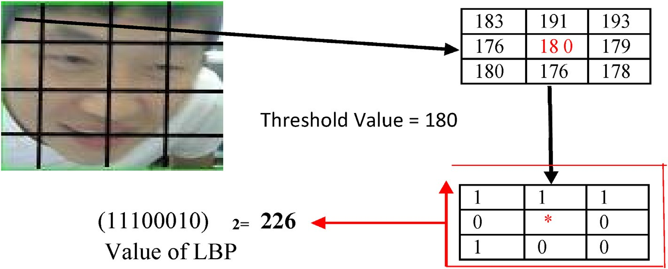

Fig. 1. The original LBP operator.

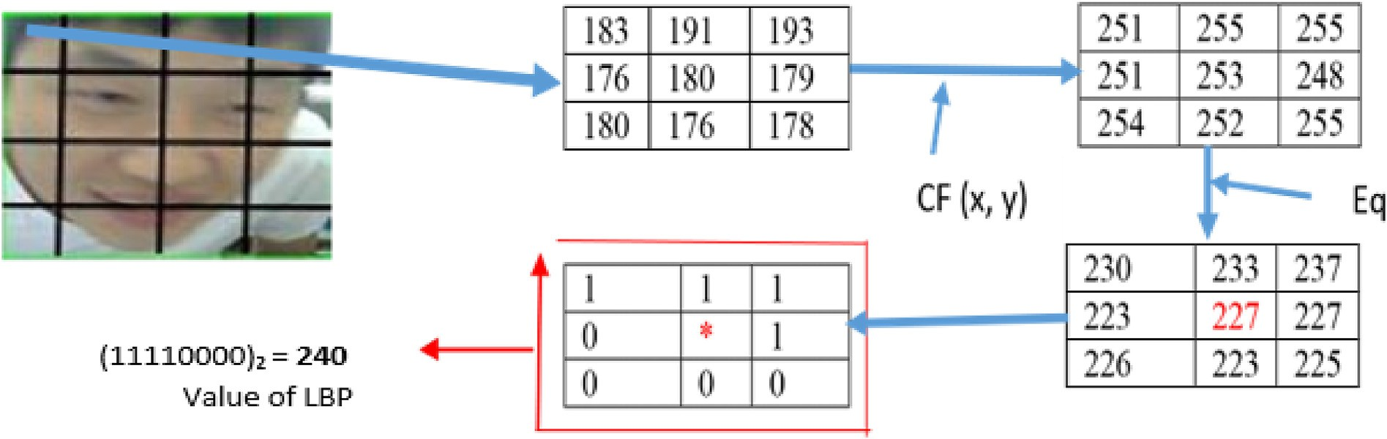

Fig. 2. The modified LBP operator.

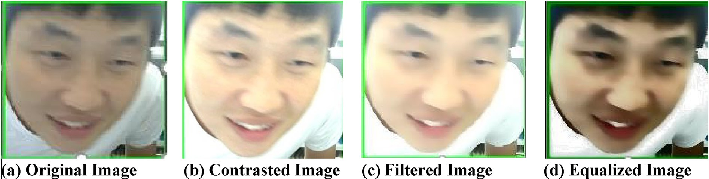

Fig. 3. Shows the original image and processed images defined in equations (1)–(4)

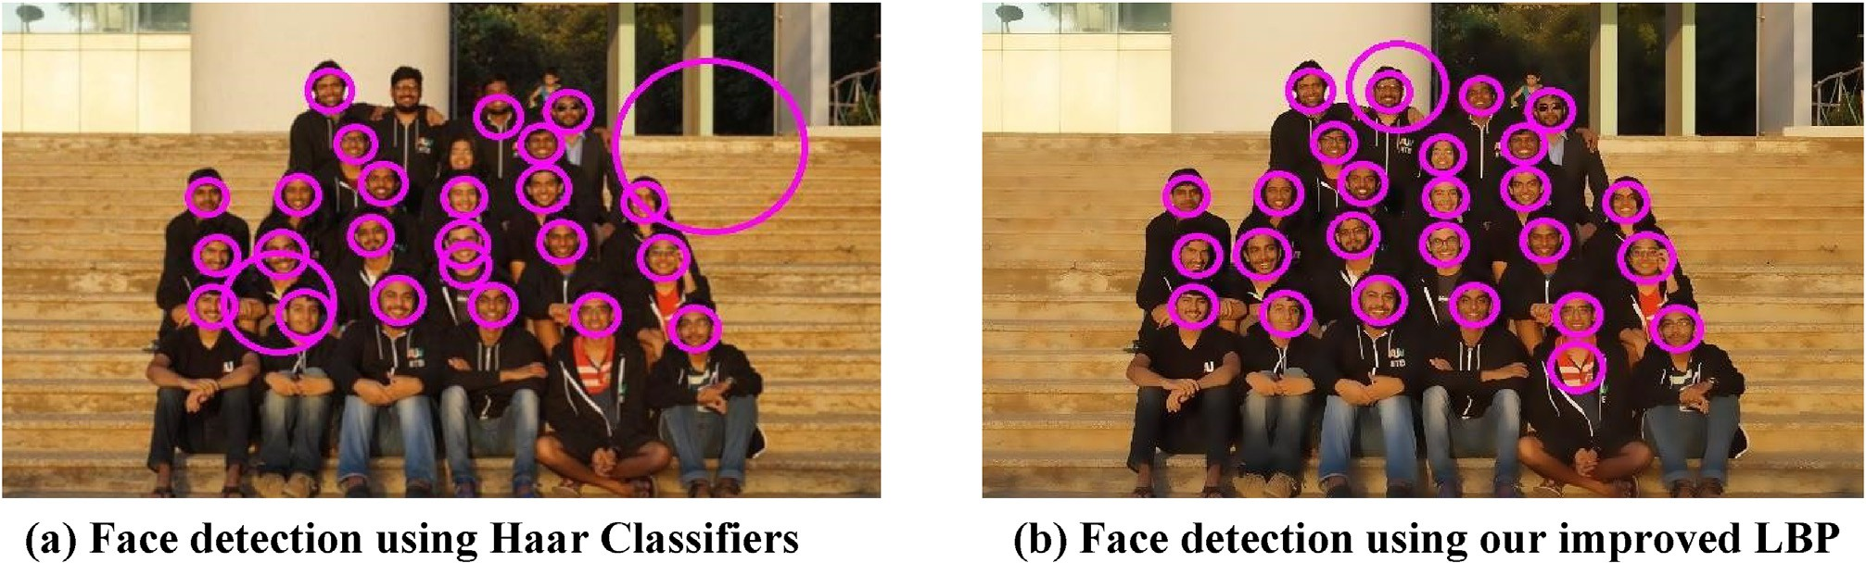

Fig. 4. Shows detected faces using the Haar cascade classifiers and LBP cascade classifier aided with our proposed methods defined from equation (1) to equation (4).

Table 1

Face detection evaluation result.

|  |  |  |  |  |
| --- | --- | --- | --- | --- |
|  | Total Faces | Haar | LBP | Proposed Method |
| True Positive | 226 | 208 | 206 | 215 |
| False Positive | 226 | 18 | 20 | 11 |
| False Negative | 226 | 55 | 41 | 33 |

Detection Accuracy Rate 92% 91% 95%

that gives the best result in our case, which is the bilateral filter as defined in equation (2).

the weighting function, and *F*(*x*; *y*) is the result of the bilateral filter applied on a 2*N* + 1 neighborhood. Now we defined *CF*(*x*; *y*) in equation image neighborhood pixel and the denominator is the normalization of

input images, where *g*(*x*; *y*) in equation (3) is the contrasted image and *F*(*x*; *y*) is the applied filter. (3) as the function to reduce noise and control contrast effects in the

*CF*(*x*; y)= *g*(*x*; *y*)\**F*(*x*; *y*) (3)

The resultant image pixels derived from the above equation are

equalized using the image histogram equalization method defined in

equation (4) to finally address the global lightning issues in the processed facial images.

(2)

P*N* P*N*

*F*(*x*; *y*)= *x*=—*N y*=—*N*

*I*(*x*; *y*)*W*(*x*; *y*)

*N*

P

P

*x*=—*N*

*N*

*y*=—*N*

*W*(*x*; *y*)

*Eq* = *H*’(*CF*(*x*; *y*)) (4)

where *W* (*x*; *y*) is the filter weighting function, *I*(*x*; *y*) is the input face

where *H*’ is the normalized cumulative distribution with a maximum value of 255 as in Ref. [28], finally, we applied the LBP algorithm on our

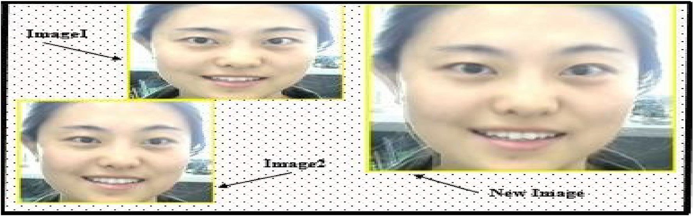

Fig 5. Blending two different images.

Table 2

Shows the performance evaluation of original LBP operator using dataset [I].

where (*Xc*; *Yc*) is gray-level value of the center pixel with *ip* and *ic* being circle neighborhood with a radius *r*, and *S*(X) is the sign function defined the intensity of the neighbor pixel and *p* the surrounding pixels in the in equation (6), it’s used to threshold the fixed 3 *X* 3 neighborhood as in

Ref. [29].

*S* X 1 *if x* ≥ 0

( )=

|  |  |  |  |
| --- | --- | --- | --- |
| Total Faces | False Negatives | Unknown Faces | False Recognition |
| 355 | 18 | 1 | 32 |
| 357 | 6 | 3 | 24 |
| 363 | 27 | 0 | 37 |
| 417 | 7 | 4 | 49 |
| 371 | 10 | 5 | 35 |

0 *if x* < 0

(6)

Face Recognition Rate = 90.49%.

Table 3

Shows the performance evaluation of improved LBP algorithm using dataset [III].

Total Faces False Negatives Unknown False Recognition

In our approach, we demonstrated the effect of using equations

(1)–(4) to improve the overall quality of our input face images so as to boost the accuracy performance of the LBP face recognition algorithm as shown in Fig. 2 below.

Examining each window of the 3 × 3 neighborhood pixels of the

resultant images from equations (3) and (4), the issues of noise, illumi-

nation, sharp, and resolution were highly mitigated. We obtained higher pixel and threshold values as shown in Fig. 2, after applying equations

|  |  |  |  |  |
| --- | --- | --- | --- | --- |
| 764 | 1 | 5 | 1 |  |
| 773 | 0 | 8 | 0 |
| 765 | 0 | 13 | 0 | Table 4 |
| 760 | 0 | 9 | 1 | Face recognition accuracy methods comparison. |

|  |  |  |  |  |  |  |
| --- | --- | --- | --- | --- | --- | --- |
| 762  768 | 2  0 | 4  3 | 0  1 |  | Methods | Accuracy (%) |
| 767 | 0 | 8 | 1 |  | LBP + SVM + PSO [26] | 96.54 |

Face Recognition Rate = 99%.

detected face images for feature extraction & comparison. The first LBP

operator described in literature uses a fixed 3 *X* 3 neighborhood window, as shown in Fig. 1 below:

Table 5

Original LBP [33] 89.3

DCP + LBP + SVM [14] 97.50

Proposed Method 99.0

A more formal description of the LBP operator can be given as follows in equation (5):

Shows database attendance records.

*p*—1

X

|  |  |  |  |
| --- | --- | --- | --- |
| ID | Name | Time_In | Time_Out |
| 1 | Modou Bah | 6/16/2016 09:24 | 6/16/2016 13:48 |
| 2 | Wang Long | 6/16/2016 09:31 | 6/16/2016 13:49 |
| 3 | Tian Ying | 6/16/2016 09:37 | 6/16/2016 13:48 |
| 4 | Mrs.Wudan | 6/16/2016 09:38 | 6/16/2016 13:47 |

LBPp; r(*Xc*; *Yc*)= 2*p*S *ip* — *ic* (5)

*p*=0

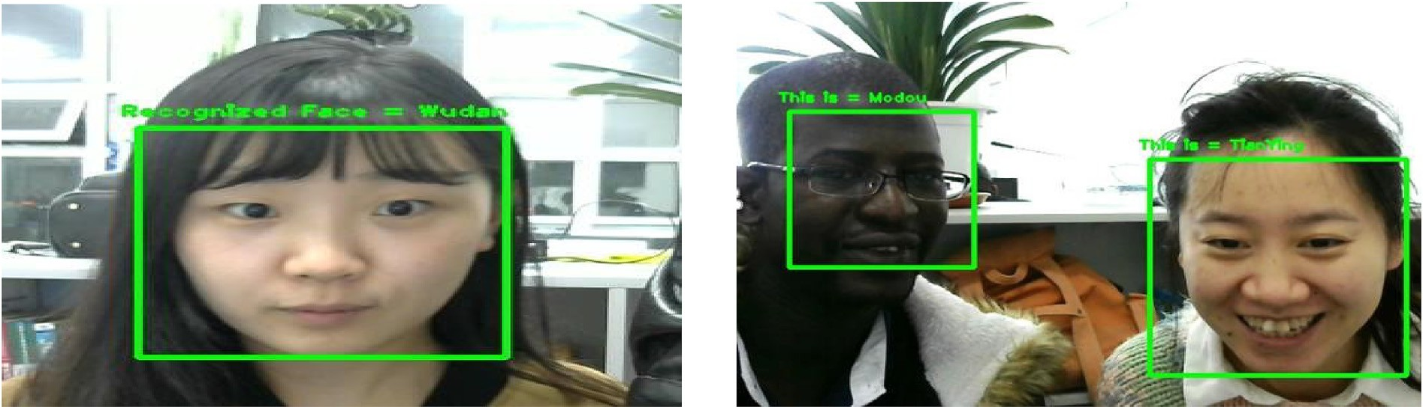

Fig. 6. Face recognition results.

(1)–(4) to the original input images, we obtained an improved high quality images using our method, which implies better image quality that will expose better image features and enabled more accurate image histograms for facial image comparison as shown in section 4, Fig. 3 (a) to (d), thus resulted in an improved LBP codes, that will stimulate the overall face recognition accuracy.

1. Experiments

In this research paper, we present an effective and efficient approach using advanced image processing techniques to improve face recognition accuracy based on local binary patterns algorithm. In this section, we’ll give experiment results from two interconnected parts to demonstrate our method.

In the first part, the LBP cascade classifier is employed for multiple face detection and tracking. first, we’ll capture faces from a live digital camera or sourced from a digital image and apply the LBP cascade classifier algorithm to detect faces. To improve the accuracy of the LBP face detection algorithm to the level of Haar cascade classifier face detection algorithm as in Ref. [30] or even better while maintaining speed, we used image processing techniques defined in equations (1)–(4).

Our experiment result for this part is shown in Figs. 3 and 4 and Table 1. Using our approach, we were able to improve the face detection accuracy rate, which is an integral part of the overall face recognition accuracy rate, while at the same time reducing the number of false positives and false negatives.

In this experiment, the Haar classifier algorithm is used to detect faces in an image as shown in Fig. 4 (a). The Haar classifier algorithm consist of four (4) phases; integral image, Haar-like features. AdaBoost and Cascading Classifier, in which the input face images will be represented as integral images first, to compute Haar-like features, for optimization reason, the AdaBoost will be used for feature selection, then the selected features will be passed through a cascading classifier to classify faces in an image.

Aside the Haar Classifier algorithm, our proposed improved LBP method is also used to detect faces in an image as shown in Fig. 4 (b). Comparing the two methods in Fig. 4, it is shown that our proposed method outperformed, the Haar Classifier algorithm for Face Detection and also in the number of detected faces, represented as true positive or false positive, represented as features that are incorrectly detected as faces or false negative, represented as faces that are not detected as faces in an image. In Table 1, for face detection, the Haar algorithm, the original LBP and the improved LBP using our method are compared using a dataset of 226 images, which our method perform better in all cases.

* 1. *Linear blending of training images*

After the face detection process, we’ll use the LBP algorithm aided with the advanced image processing techniques defined from equation

(1) through equation (4), to better extract facial features so as to compare and recognize human faces.

In the second part, before applying the LBP face recognition algorithm on detected face images, we employed image blending technique on our training images datasets. Image blending is a linear interpolation often used to blend two images f0 and f1 as shown in Fig. 5, in order to improve the visual quality of images by minimizing intensity variations effects. The linear blending is defined in equation (7), where (α) and (1-α) are

blend fractions used in a weighted average of each component of each pixel as highlighted in Refs. [31,32].

*G*(*x*)= (1 — *α*)*f*0(*x*)+ *αf*1(*x*) (7)

different orientations and conditions of faces that are confined to 181 × In our work, we created three different datasets each containing 181 pixels: dataset [I], dataset [II], and dataset [III]. No image

blending was applied in the dataset [I], the linear blending of 1.0 alpha (α) was applied on dataset [II], and linear blending of 0.5 alpha (α) was applied on dataset [III]. We tested the improved LBP face recognition algorithm on these three datasets and selected the one that gives the best face recognition accuracy result in our system, which is dataset [III].

Prior to confining the training images to 181 × 181 pixels, we empirically

tried different pixel values on the training datasets to check whether it

will have any impact on the face recognition accuracy, which it does,

which is 181 × 181 pixels. although the impact is not that much, but the best result was selected,

We improved the quality of both our input face images and training

images, using our proposed methods defined in equations (4) and (5). Now we apply the LBP algorithm aided with our methods to extract more detailed and visible facial features to increase comparison certainty for more accurate face recognition.

In Table 2, we show the performance evaluation of the original LBP algorithm that was run on our dataset [I], the dataset without any image processing. We used the following metrics in our evaluation: False Neg- atives, Unknown faces, and False Recognition. We calculated the face

recognition rate as follows: Face Recognition Rate = (*Total Number of*

*Faces - a total number of False Recognition)/(Total number of Faces) * 100%.*

In Table 3, we show the performance evaluation of our improved face recognition method using equation (3) and (4) that was run on our dataset [III], which was processed using equation (7) with an alpha (α) value of 0.5. Using the same metrics and face recognition rate formula above. Fig. 6 below shows the result of recognized faces of three (3) different people.

In addition, In Table 4, the face recognition accuracy of our proposed method is compared with three (3) other different existing methods in a controlled environment, respectively.

The results in Table 4, shows that our method compared to other different methods, proves to be very robust to be implemented in a controlled real-life environment and the novelty of our method is centered towards the combination of the LBP algorithm with advanced image processing techniques such as contrast adjustment, bilateral filter, histogram equalization and image blending for both input images and training images, which is more of incremental contribution to the LBP improvement.

1. Attendance system

After successfully recognizing human faces, the recognized face im- ages will be fetched into our attendance system to mark attendance of individuals.

* 1. *Attendance database*

In our attendance database, we will extract each recognized face images to mark the attendance of individuals, using date and time educed from recognized face images as shown in Table 5.

* 1. *Flowchart of algorithm*



Figure shows the flowchart of the algorithm. As depicted in the flow- chart, the captured input face images are processed using our proposed image processing techniques, then the face detection algorithm is applied to detect faces. Once faces are detected, the face recognition algorithm aided with our proposed method will be applied to recognize faces. Once faces are recognized, the metadata of the recognized faces will be extracted to mark attendance using the attendance system.

1. Conclusion

In conclusion, in our research, after preprocessing the input face images using some advanced image processing techniques such Contrast Adjustment, Bilateral Filter, Histogram Equalization, so as to have better image features and the same advanced image processing techniques will be applied to the training/template face images plus an image blending method to ensure high quality training/template face images. The pre- processed input face image will be divided into k2 regions, then the LBP code will be calculated for every pixel in a region of the input face image by comparing the center with the surrounding pixel. If the surrounding pixel is greater than or equal to the center pixel, then it is denoted as binary 1, else it is denoted as 0.

This process will be repeated for each and every pixel of all other regions, to get the binary pattern so as to construct the feature vector of the input face images. For every region, a histogram with all possible labels is constructed. These constructed histograms with all its bins represent a pattern and contain the number of its appearance in the re- gion. The feature vector formed is then constructed by concatenating the regional histograms to one big histogram, which is unique for each in- dividual, and is compared with the template face images to recognize faces. This method improves the LBP code and our experiment results show that our method is very accurate and robust for facial recognition system that can be implemented in a real-life environment. It is also important to state that our research does not address the issue of occlu- sion and mask faces in facial recognition, but addressing these issues could be a perfect future work of this paper.

Acknowledgements

We wish to thank everyone at the Machine Vision and Robotic Lab in Changchun University of Science and Technology for their valuable support throughout this research work. This research work is financially supported by Consulting Research Project of Chinese Academy of Engi- neering (2019-Jl-4-2), Marine S&T Fund of Shandong Province for Pilot National Laboratory for Marine Science and Technology (Qingdao) (No. 2018SDKJ0102-6), Science and Technology Plan of Jilin Province (20170307002GX), thus we would also like to acknowldedge their support.

Appendix A. Supplementary data

Supplementary data to this article can be found online at [https://](https://doi.org/10.1016/j.array.2019.100014) [doi.org/10.1016/j.array.2019.100014](https://doi.org/10.1016/j.array.2019.100014).

References

1. [Jadhav Akshara, Jadhav Akshay, Ladhe Tushar, Yeolekar Krishna. Automated](http://refhub.elsevier.com/S2590-0056(19)30014-1/sref1) [attendance system using face recognition. Inter Res J Eng Technol (IRJET) January](http://refhub.elsevier.com/S2590-0056(19)30014-1/sref1) [2017. Volume: 04 Issue: 01, ISSN: 2395-0072](http://refhub.elsevier.com/S2590-0056(19)30014-1/sref1).
2. [Punjani Ali Akbar, Obaid Chowdhary, Yasir Choudhary. Automated attendance](http://refhub.elsevier.com/S2590-0056(19)30014-1/sref2) [management system using face recognition. Inter J Advan Res Computer Eng](http://refhub.elsevier.com/S2590-0056(19)30014-1/sref2) [Technol (IJARCET) August 2017;6(8). ISSN 2278](http://refhub.elsevier.com/S2590-0056(19)30014-1/sref2) – [7798](http://refhub.elsevier.com/S2590-0056(19)30014-1/sref2).
3. [Chaudhari Chetan, Raj Rahul, Shirnath Swajey, Sali Mrs Tanuja. Automatic](http://refhub.elsevier.com/S2590-0056(19)30014-1/sref3) [attendance monitoring system using face recognition techniques. Inter J Innov Eng](http://refhub.elsevier.com/S2590-0056(19)30014-1/sref3) [Technol (IJIET) April 2018;10(1). ISSN: 2319-1058](http://refhub.elsevier.com/S2590-0056(19)30014-1/sref3).
4. [Kowsalya P, Pavithra J, Sowmiya G, Shankar CK. Attendance monitoring system](http://refhub.elsevier.com/S2590-0056(19)30014-1/sref4) [using face detection](http://refhub.elsevier.com/S2590-0056(19)30014-1/sref4) & [face recognition. Inter Res J Eng Technol (IRJET) March](http://refhub.elsevier.com/S2590-0056(19)30014-1/sref4) [2019. Volume: 06 Issue: 03, ISSN: 2395-0072](http://refhub.elsevier.com/S2590-0056(19)30014-1/sref4).
5. [Mallikarjuna Reddy A, Venkata Krishna V, Sumalatha L. Face recognition based on](http://refhub.elsevier.com/S2590-0056(19)30014-1/sref5) [Cross diagonal complete motif matrix. I.J. Image, Graphics and Signal Processing](http://refhub.elsevier.com/S2590-0056(19)30014-1/sref5) [March 2018;3:59](http://refhub.elsevier.com/S2590-0056(19)30014-1/sref5)–[66](http://refhub.elsevier.com/S2590-0056(19)30014-1/sref5).
6. [KAMENCAY Patrik, BENCO Miroslav, MIZDOS Tomas, RADIL Roman. A new](http://refhub.elsevier.com/S2590-0056(19)30014-1/sref6) [method for face recognition using convolutional neural network. Digital Image](http://refhub.elsevier.com/S2590-0056(19)30014-1/sref6) [Processing and Computer Graphics 2017;15(4):663](http://refhub.elsevier.com/S2590-0056(19)30014-1/sref6)–[72](http://refhub.elsevier.com/S2590-0056(19)30014-1/sref6).
7. [Beli Idelette Laure Kambi, Guo Chunsheng. Enhancing face identi](http://refhub.elsevier.com/S2590-0056(19)30014-1/sref7)fi[cation using](http://refhub.elsevier.com/S2590-0056(19)30014-1/sref7) [local binary patterns and K-nearest neighbors. Journal of Imaging 2017;3(37):1](http://refhub.elsevier.com/S2590-0056(19)30014-1/sref7)–[12](http://refhub.elsevier.com/S2590-0056(19)30014-1/sref7).
8. [Gaikwad Ashok T. LBP and PCA based on face recognition system. LBP and PCA](http://refhub.elsevier.com/S2590-0056(19)30014-1/sref8) [based on face recognition system. November 2018. p. 368](http://refhub.elsevier.com/S2590-0056(19)30014-1/sref8)–[73. ISSN 2348](http://refhub.elsevier.com/S2590-0056(19)30014-1/sref8) – [8034](http://refhub.elsevier.com/S2590-0056(19)30014-1/sref8).
9. [Kutty Naeema Mohamed, Mathai Shelmy. Face recognition - a tool for automated](http://refhub.elsevier.com/S2590-0056(19)30014-1/sref9) [attendance system. Int J Adv Res Comput Sci Softw Eng June 2017;7(6):334](http://refhub.elsevier.com/S2590-0056(19)30014-1/sref9)–[6.](http://refhub.elsevier.com/S2590-0056(19)30014-1/sref9) [ISSN: 2277-128X](http://refhub.elsevier.com/S2590-0056(19)30014-1/sref9).
10. [Lal Madan, Kumar Kamlesh, Arain Rafaqat Hussain, Maitlo Abdullah, Ruk Sadaquat](http://refhub.elsevier.com/S2590-0056(19)30014-1/sref10) [Ali, Shaikh Hidayatullah. Study of face recognition techniques: a survey. Int J Adv](http://refhub.elsevier.com/S2590-0056(19)30014-1/sref10) [Comput Sci Appl 2018;9(6):42](http://refhub.elsevier.com/S2590-0056(19)30014-1/sref10)–[9](http://refhub.elsevier.com/S2590-0056(19)30014-1/sref10).
11. [Sharif Muhammad, Naz Farah, Yasmin Mussarat, Shahid Muhammad Alyas,](http://refhub.elsevier.com/S2590-0056(19)30014-1/sref11) [Rehman Amjad. Face recognition: a survey. J Eng Sci Technol Rev March 2017;](http://refhub.elsevier.com/S2590-0056(19)30014-1/sref11) [10(2):166](http://refhub.elsevier.com/S2590-0056(19)30014-1/sref11)–[77](http://refhub.elsevier.com/S2590-0056(19)30014-1/sref11).
12. [Ramaiah N Pattabhi, Ijjina Earnest Paul, Mohan C Krishna. Illumination invariant](http://refhub.elsevier.com/S2590-0056(19)30014-1/sref12) [face recognition using convolutional neural networks. In: IEEE international](http://refhub.elsevier.com/S2590-0056(19)30014-1/sref12) [conference on signal processing, informatics, communication and energy systems](http://refhub.elsevier.com/S2590-0056(19)30014-1/sref12) [(SPICES). Electronic; April 2015. ISBN:978-1-4799-1823-2](http://refhub.elsevier.com/S2590-0056(19)30014-1/sref12).
13. [Miry Abbas Hussien. CWT and](http://refhub.elsevier.com/S2590-0056(19)30014-1/sref13) fi[sherface for human face recognition. Int J Comput](http://refhub.elsevier.com/S2590-0056(19)30014-1/sref13) [Appl May 2016;142(6). 0975](http://refhub.elsevier.com/S2590-0056(19)30014-1/sref13) – [8887](http://refhub.elsevier.com/S2590-0056(19)30014-1/sref13).
14. [Bhangale Kishor B, Jadhav Kamal M, Shirke Yogesh R. Robust pose invariant face](http://refhub.elsevier.com/S2590-0056(19)30014-1/sref14) [recognition using DCP and LB. International Journal of Management, Technology](http://refhub.elsevier.com/S2590-0056(19)30014-1/sref14) [and Engineering September 2018;8(IX):1026](http://refhub.elsevier.com/S2590-0056(19)30014-1/sref14)–[34. ISSN NO: 2249-7455](http://refhub.elsevier.com/S2590-0056(19)30014-1/sref14).
15. [Kohonen T. Self-organization and associative memory. third ed. 1989. p. 185](http://refhub.elsevier.com/S2590-0056(19)30014-1/sref15)–[209](http://refhub.elsevier.com/S2590-0056(19)30014-1/sref15).
16. [Kirby M, Sirovich L. Application of the karhunen-loeve procedure for the](http://refhub.elsevier.com/S2590-0056(19)30014-1/sref16) [characterization of human faces. IEEE Pattern Analysis and Machine Intelligence](http://refhub.elsevier.com/S2590-0056(19)30014-1/sref16) [1990;12(1):103](http://refhub.elsevier.com/S2590-0056(19)30014-1/sref16)–[8](http://refhub.elsevier.com/S2590-0056(19)30014-1/sref16).
17. [Turk M, Pentland A. Eigenfaces for recognition. J Cogn Neurosci 1991;3(1):71](http://refhub.elsevier.com/S2590-0056(19)30014-1/sref17)–[86](http://refhub.elsevier.com/S2590-0056(19)30014-1/sref17).
18. [Huang Di, Shan Caifeng, Ardabilian Mohsen, Wang Yunhong, Chen Liming. Local](http://refhub.elsevier.com/S2590-0056(19)30014-1/sref18) [binary patterns and its application to facial image analysis: a survey. IEEE](http://refhub.elsevier.com/S2590-0056(19)30014-1/sref18) [Transactions on Systems, Man, and Cybernetics, Part C: Applications and Reviews,](http://refhub.elsevier.com/S2590-0056(19)30014-1/sref18) [Institute of Electrical and Electronics Engineers March 2011;4(41):1](http://refhub.elsevier.com/S2590-0056(19)30014-1/sref18)–[17](http://refhub.elsevier.com/S2590-0056(19)30014-1/sref18).
19. [Chehrehgosha Arezou, Emadi Mehran. Face detection using fusion of LBP and](http://refhub.elsevier.com/S2590-0056(19)30014-1/sref19) [AdaBoost. J Soft Comput Appl 2016;(1):1](http://refhub.elsevier.com/S2590-0056(19)30014-1/sref19)–[10](http://refhub.elsevier.com/S2590-0056(19)30014-1/sref19).
20. [Chanchal Amit Kumar, Dutta Maitreyee. Face detection and recognition using local](http://refhub.elsevier.com/S2590-0056(19)30014-1/sref20) [binary patterns. International Journal of Advanced Research in Electrical,](http://refhub.elsevier.com/S2590-0056(19)30014-1/sref20) [Electronics and Instrumentation Engineering October 2016;5(10):7923](http://refhub.elsevier.com/S2590-0056(19)30014-1/sref20)–[9](http://refhub.elsevier.com/S2590-0056(19)30014-1/sref20).
21. [Bilaniuk Olexa, Fazl-Ersi Ehsan, Laganiere Robert, Xu Christina, Laroche Daniel,](http://refhub.elsevier.com/S2590-0056(19)30014-1/sref21) [Moulder Craig. Fast LBP face detection on low-power SIMD architectures, computer](http://refhub.elsevier.com/S2590-0056(19)30014-1/sref21) [vision and pattern recognition workshops (CVPRW). In: IEEE conference on; 2014.](http://refhub.elsevier.com/S2590-0056(19)30014-1/sref21)

[p. 616](http://refhub.elsevier.com/S2590-0056(19)30014-1/sref21)–[22](http://refhub.elsevier.com/S2590-0056(19)30014-1/sref21).

1. [Kalaiselvi P, Nithya S. Face recognition system under varying lighting conditions.](http://refhub.elsevier.com/S2590-0056(19)30014-1/sref22) [IOSR J Comput Eng October 2013;14(3):79](http://refhub.elsevier.com/S2590-0056(19)30014-1/sref22)–[88. e-ISSN: 2278-0661, p- ISSN: 2278-](http://refhub.elsevier.com/S2590-0056(19)30014-1/sref22) [8727](http://refhub.elsevier.com/S2590-0056(19)30014-1/sref22).
2. [Chen Jie, Patel Vishal M, Liu Li, Kellokumpu Vili, Zhao Guoying, Pietik](http://refhub.elsevier.com/S2590-0056(19)30014-1/sref23)€[ainen Matti,](http://refhub.elsevier.com/S2590-0056(19)30014-1/sref23)

[Chellappa Rama. Robust local features for remote face recognition. Image Vis](http://refhub.elsevier.com/S2590-0056(19)30014-1/sref23) [Comput 2017;64:34](http://refhub.elsevier.com/S2590-0056(19)30014-1/sref23)–[46](http://refhub.elsevier.com/S2590-0056(19)30014-1/sref23).

1. [Saypadith Savath, Aramvith Supavadee. Real-time multiple face recognition using](http://refhub.elsevier.com/S2590-0056(19)30014-1/sref24) [deep learning on embedded GPU system. Asia-paci](http://refhub.elsevier.com/S2590-0056(19)30014-1/sref24)fi[c signal and information](http://refhub.elsevier.com/S2590-0056(19)30014-1/sref24) [processing association annual summit and conference (APSIPA ASC). IEEE Explore](http://refhub.elsevier.com/S2590-0056(19)30014-1/sref24) [ISSN Information: Electronic ISSN: 2640-0103 Print on Demand (PoD); November](http://refhub.elsevier.com/S2590-0056(19)30014-1/sref24) [2018. p. 1318](http://refhub.elsevier.com/S2590-0056(19)30014-1/sref24)–[24. ISSN: 2640-009X](http://refhub.elsevier.com/S2590-0056(19)30014-1/sref24).
2. [Deeba Farah, Memon Hira, Ali Dharejo Fayaz, Ahmed Aftab, Ghaffar Abddul. LBPH-](http://refhub.elsevier.com/S2590-0056(19)30014-1/sref25) [based enhanced real-time face recognition. Int J Adv Comput Sci Appl 2019;10(5).](http://refhub.elsevier.com/S2590-0056(19)30014-1/sref25) [2019](http://refhub.elsevier.com/S2590-0056(19)30014-1/sref25).
3. [Nisha Maitreyee Dutta. Improving the recognition of faces using LBP and SVM](http://refhub.elsevier.com/S2590-0056(19)30014-1/sref26) [optimized by PSO technique. Int J Exp Diabetes Res 2017;5(4):297](http://refhub.elsevier.com/S2590-0056(19)30014-1/sref26)–[303. ISSN:](http://refhub.elsevier.com/S2590-0056(19)30014-1/sref26) [2321-9939](http://refhub.elsevier.com/S2590-0056(19)30014-1/sref26).
4. [O’Connor Brian, Roy Kaushik. Facial recognition using modi](http://refhub.elsevier.com/S2590-0056(19)30014-1/sref27)fi[ed local binary](http://refhub.elsevier.com/S2590-0056(19)30014-1/sref27) [pattern and random forest. International Journal of Artificial Intelligence](http://refhub.elsevier.com/S2590-0056(19)30014-1/sref27) & [Applications (IJAIA) November 2013;4(6):25](http://refhub.elsevier.com/S2590-0056(19)30014-1/sref27)–[33](http://refhub.elsevier.com/S2590-0056(19)30014-1/sref27).
5. [Szeliski Richard. Computer vision: algorithms and applications. September 3, 2010.](http://refhub.elsevier.com/S2590-0056(19)30014-1/sref28)

[p. 90](http://refhub.elsevier.com/S2590-0056(19)30014-1/sref28)–[131](http://refhub.elsevier.com/S2590-0056(19)30014-1/sref28).

1. [Rahim Abdur, Hossain Najmul, Wahid Tanzillah, Azam Sha](http://refhub.elsevier.com/S2590-0056(19)30014-1/sref29)fi[ul. Face recognition](http://refhub.elsevier.com/S2590-0056(19)30014-1/sref29) [using local binary patterns (LBP). Global Journal of Computer Science and](http://refhub.elsevier.com/S2590-0056(19)30014-1/sref29) [Technology Graphics](http://refhub.elsevier.com/S2590-0056(19)30014-1/sref29) & [Vision 2013;13(4):1](http://refhub.elsevier.com/S2590-0056(19)30014-1/sref29)–[9. Version 1.0](http://refhub.elsevier.com/S2590-0056(19)30014-1/sref29).
2. [Anh Dang Hoang, Pao Sriprasertsuk, Wataru Kameyama. Fish detection by LBP](http://refhub.elsevier.com/S2590-0056(19)30014-1/sref30) [cascade classi](http://refhub.elsevier.com/S2590-0056(19)30014-1/sref30)fi[er with optimized processing pipeline. IPSJ SIG Technical Report](http://refhub.elsevier.com/S2590-0056(19)30014-1/sref30) [2013/9/12;2013-AVM-82(9)](http://refhub.elsevier.com/S2590-0056(19)30014-1/sref30).
3. Haeberli Paul, Voorhies Douglas. Image processing by interpolation and extrapolation. IRIS universe magazine No. 28. Silicon Graphics; 1994. [http://gra](http://graficaobscura.com/interp/index.html)fi [caobscura.com/interp/index.html](http://graficaobscura.com/interp/index.html).
4. [Rankov Vladan, Locke Rosalind J, Edens Richard J, Barber Paul R, Vojnovic Borivoj.](http://refhub.elsevier.com/S2590-0056(19)30014-1/sref32) [An algorithm for image stitching and blending. Proc SPIE March 2005;5701:190](http://refhub.elsevier.com/S2590-0056(19)30014-1/sref32)–[9](http://refhub.elsevier.com/S2590-0056(19)30014-1/sref32).
5. [Priya TS Vishnu, Vinitha Sanchez G, Raajan NR. Facial recognition system using](http://refhub.elsevier.com/S2590-0056(19)30014-1/sref33) [local binary patterns (LBP). Int J Pure Appl Math 2018;119(15):1895](http://refhub.elsevier.com/S2590-0056(19)30014-1/sref33)–[9](http://refhub.elsevier.com/S2590-0056(19)30014-1/sref33).

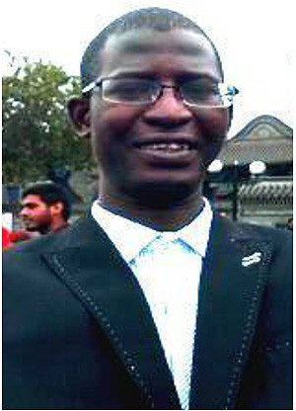Serign Modou Bah, first author was born in Madina Daru, The

Gambia, on June 1984. He graduated from National Taipei University of Technology, Taiwan in 2011 with B⋅Sc. (Hons) degree in Information Technology. He obtained a UN fellow-

ship, under the United Nation Office of Outer Space Affairs (UNOOSA), to pursue a second level specialization master de- gree in Global Navigation Satellite Systems from 2013 to 2014 at University of Politecnico di Torino, Italy and recently ob- tained another master degree program in Computer Application Technology at Changchun University of Science and Technol- ogy, China. Mr. Bah is currently working with Ministry of In- formation and Communication Infrastructure, The Gambia as Principal ICT Officer. His research interest includes face recognition algorithms, Image analysis, Image quality, artificial neural networks, artificial intelligence (AI) and computer vision.

Fang Ming, second author and Corresponding Author was born in Jilin province of China, on Feberary, 1977. He gra- tuated from Changchun University of Science and Technology,

China in 2000 with B⋅S degree in Computer science major.

2008, He was sent to Hokkaido University Japan for doctoral

degree supported by the full national government scholarship. He recieved his Ph.D in Hokkaido University of Japan in the same major,2011. He was promoted to associate professor in 2013. His research interests include machine vision, robot vision and robust image processing etc.