[Array 11 (2021) 100073](https://doi.org/10.1016/j.array.2021.100073)

Contents lists available at [ScienceDirect](http://www.sciencedirect.com/science/journal/25900056)

Array

journal homepage: [www.sciencedirect.com/journal/array](https://www.sciencedirect.com/journal/array)

An improving performance cellular DTV broadcasting with hybrid non-orthogonal LDM and orthogonal eMBMS configuration

Heydar Shariatzadeh a, Saeed Ghazi-Maghrebi a,*, Bahattin Karakaya b

a *Department of Communication,College of Electrical Engineering, Yadegar-e-Imam Khomeini (RAH) Shahre Rey Branch, Islamic Azad University, Tehran, Iran*

b *Department of Electrical and Electronic Engineering, Istanbul University-Cerrahpas¸a, Istanbul, Turkey*

A R T I C L E I N F O

*Keywords:*

CDTB

Hybrid LDM eMBMS BER

Outage probability Non-orthogonal Orthogonal

A B S T R A C T

In this article, we focus on the hybrid of orthogonal and non-orthogonal broadcasting. The hybrid configuration is raised and proposed for improving cellular digital television broadcasting (CDTB) technology. The hybrid scheme is configured as layered division multiplexing (LDM) multiplexed with an evolved multimedia broadcast multicast service (eMBMS) standalone layer is superimposed. The LDM and eMBMS are sub-sections of power division-non orthogonal multiple access (PD-NOMA) and long-term evolution (LTE) respectively. We assume perfect knowledge of the channel state information (CSI) over the Rayleigh fading multipath channel. The bit error rate (BER) and outage probability performance criteria are investigated. The impact of injection level using the fractional transmit power allocation (FTPA) algorithm is discussed. The proposed hybrid can operate in conditions without a subscriber identity module (SIM) card for uplink beamforming and internet protocol (IP). The broadcast network provider selection is feasible by the user equipment (UE) device. Performance analysis is derived based on the exact closed-form expressions, which allows the theory of hybrid proposed LDM/eMBMS consistent with results. Evaluations and performance will be done based on the Monte Carlo iterative method- ology. The results show that the performance and efficiency will be increased when a proposed hybrid LDM/ eMBMS configuration is compared with LDM and eMBMS services individually.

# Introduction

After 5G and beyond (B5G) cellular technology, the trend towards hybrid cellular digital television broadcasting (CDTB) are increased. The cellular hybrid configuration realizes user coverage fairness, low la- tency, massive connectivity, spectral efficiency, compatibility, and selectivity in radio access methods [1–3]. There was created a gap be-

tween the digital terrestrial television broadcasting (DTTB) versus CDTB

in terms of service-layers technology selection [4]. The history of the physical layer of cellular broadband infrastructure generations shows that is changed and shifted approximately once every decade for instance 4G to 5G. While the television broadcast has changed over time, for instance in analog television (ATV) to digital television (DTV) tran- sition the national television system committee (NTSC-3.58) converted to advanced television system committee (ATSC) standard in USA or phase alternation line (PAL) converted to digital video broadcasting-terrestrial (DVB-T) in Europe and NTSC-J converted to integrated service digital broadcast (ISDB) in Japan [5,6]. Besides, there is an approach to broadcasting between broadcast owners to supply and

deploy live video transmission among point to multipoint (PTM) and streaming delivery services [7].

Moreover, restrictions are imposed by the international telecom- munication union (ITU) to reduce broadcast bandwidth and increase broadband bandwidth that is named digital dividend, and the coexis- tence of broadcast and broadband in the ultra-high frequency (UHF) spectrum is regulated by local radio frequency organization policy im- plications [8].

There is a challenge in historical inconsistency for operators to synchronize with different technologies. There are incompatibility and contradictions in DTTB infrastructure versus CDTB technology. For instance era of wideband code division multiple access (WCDMA) in broadband versus digital video broadcasting-handheld (DVB-H) in broadcast technology initially [9–11].

To address these challenges broadcast holders and broadcast owners

are suggested a juxtaposition approach [12]. The subject will offer a set of challenges and opportunities for CDTB recipients and broadcast ser- vice providers (BSPs) [13]. Nowadays, BSPs looking to pick out an alternative to next-generation platform CDTB technology using existing

* Corresponding author.

*E-mail addresses:* [shariatzadeh.heydar@istanbul.edu.tr](mailto:shariatzadeh.heydar@istanbul.edu.tr) (H. Shariatzadeh), [ghazimaghrebi@jdnasir.ac.ir](mailto:ghazimaghrebi@jdnasir.ac.ir) (S. Ghazi-Maghrebi), [bahattin@iuc.edu.tr](mailto:bahattin@iuc.edu.tr) (B. Karakaya).

<https://doi.org/10.1016/j.array.2021.100073>

Received 17 January 2021; Received in revised form 6 June 2021; Accepted 10 June 2021

Available online 30 June 2021

2590-0056/© 2021 Published by Elsevier Inc. This is an open access article under the CC BY license (<http://creativecommons.org/licenses/by/4.0/>).

structures gap physical layers [14]. They are emerged as a possible so- lution to have hybrid technology using a multi-layer delivery system recommended by researchers in the last few years [15]. To develop the provide technologies that can satisfy such mandates, the convergence broadcast and broadband and hybrid broadcast and broadband (HBB) are being researched and developed as a kind of integration methods worldwide for decades [12,16,17].

Furthermore, great advancements are achieved in terms of integra- tion technologies such as using the Long Term Evolution-broadcast (LTE-B) and power division-non orthogonal multiple access (PD- NOMA) simultaneously [18].

The LTE-B introduced evolved Multimedia Broadcast Multicast Ser- vices (eMBMS) as an orthogonal and PD-NOMA introduced layered di- vision multiplexing (LDM) as non-orthogonal service providers [19,20]. The eMBMS operates as a PTM intermediary live big-data transmission. The technology is expected to play a significant role in reducing the loading of delivering multimedia streaming for future cellular broad- casting. Also, the technology will support geographic positioning in- formation updates such as local news, climate and traffic reports, stocks

value and exchange, telemedicine, video conference, mobile TV, and related services [7,21–23].

In recent years studies of the 3rd Generation Partnership Project

(3GPP) TV Enhancements (EnTV) have suggested a further evolved MBMS (FeMBMS), known as 5G broadcast, and it is based on 4G LTE. Authors in Ref. [24] enhanced the FeMBMS feature is flexibility in ca- pacity, which it can allocate up to 100% sub-frames to broadcast mode in Rel-14, while formerly, up to 60% sub-frames and 40% sub-frames to broadcast and unicast mode have been allocated in the eMBMS Rel-13

respectively [25–28]. The LDM is a sub-section of PD-NOMA, which is a form of physical-layer non-orthogonal that uses the available spectrum

resource blocks (RBs) by assigning a different power value to each user. The infrastructure of LDM technology is based on two layers namely, the upper layer (UL) and the lower layer (LL) [29–31]. It can serve as a

platform for both mobile and stationary services, which is used in the

future digital TV standard within 3GPP LTE 5G new radio (NR) releases 15,16,17 for next cellular broadcasting [32]. Also, LDM can achieve high spectrum performance when multiplexing various services (indoor, handheld, mobile, stationary) with different requirements and data rate throughputs standard-definition television (SDTV), high definition television (HDTV), 4k, 8k, surround audio using the same spectrum resource [29]. The LDM has the ability operates to transmit high data rates fixed service on LDM-LL and low data rates mobile service on LDM-UL as non-orthogonality [23,33,34].

The used annotations symbol definitions are illustrated in Table 1.

* 1. *Related works*

In the beginning, Shi et al. [13] proposed Cell-TV, which was a paradigm of cellular digital television (CDTV) broadcasting over mobile networks. Lykourgiotis et al. [15] presented broadcast and broadband combinations for real-time services. Shokair et al. [17] provided a hybrid broadcast/broadband network as a potential solution to mitigate the increasing demand for CDTV. Authors in Refs. [29,30] presented a

**Table 1**

Symbol definitions.

Parameter Definition

*PT* Total transmit power of base station

*PLDM* Total power of LDM technology

*PUL* Total power of Upper layer

*PLL* Total power of Lower layer

*PeMBMS* Total power of eMBMS technology

*ps* Per Subcarrier

*g* Injection power factor

*B* Total Bandwidth

*RB* Resource Block

*M* Total number of RBs

Ψ Total number of LDM RBs

Ω Total number of eMBMS RBs

*γ* SNR(signal to noise ratio)

*K* Total number of sub-carriers, FFT points

*m* RB index

*n* Time domain sample index

*k* Frequency domain frequency index

*KLDM* Total number of LDM sub-carriers

*KeMBMS* Total number of eMBMS sub-carriers

*b* Bits per LL and UL and eMBMS symbols

*αm* Binary coefficients for *m*th RB which indicates whether LDM is allocated

*βm* Binary coefficients for *m*th RB which indicates whether eMBMS is allocated

*T* Multi carrier symbol useful part duration *T*′ = *T* + *TCP* The total Multi carrier symbol duration *Ts* Multi carrier symbol duration

△*f* Sub-carrier spacing

*w*(*t*) Complex additive white Gaussian noise

*h*(*τ*) Base-band notation of Rayleigh channel impulse response

*c*(*τ*) Aggregate TX/RX filter impulse response

*x*(*t*) Time domain Transmit signal

*y*(*t*) Time domain Received signal

*x*(*n*) Discrete transmit signal

*XLDM* LDM transmit signal

*XeMBMS* eMBMS transmit signal

*Xm*[*k*] Discrete transmit signal(in frequency domain)

**Y** Total Discrete received signal vector after FFT block (in frequency domain)

*Ym*[*k*] Discrete received signal at *k*th subcarrier which belongs to

*m*th RB

*y*(*n*) Discrete received signal

*H*[*k*] Discrete base-band channel frequency response

*Xm* [*k*] Equalized received signal by channel (estimated or perfect)

̂

*PUL* (*e*) The average error probability of UL

*PLL* (*e*) The average error probability of LL

*HLL*[*k*] Channel frequency response of the lower layer at *kth*sub- carrier

*HUL*[*k*] Channel frequency response of the upper layer at *kth*sub- carrier

*HeMBMS* [*k*] Channel frequency response of the eMBMS at *kth*sub-carrier *PLDM* (*e*) The average error probability of the LDM

*PeMBMS* (*e*) The average error probability the eMBMS

*ReMBMS* Sum Rate of the eMBMS

*RLDM* Sum Rate of the LDM

*RT* Total Sum Rate

*GLL* , *GUL* The average channel gains of LL, UL layers

*GeMBMS* The average channel gain of eMBMS

comprehensive review of the LDM technology as a physical-layer transmission CDTB system.

*N*0,*LL*, *N*0,*UL*, *N*0,

*eMBMS*, *N*0

Noise power of LL, UL, eMBMS, Gaussian

Zhang et al. [35] investigated the performance of power domain

non-orthogonal multimedia broadcast multicast service (MBMS) trans-

*Km* The *m*th sub-carrier in a RB.

*R*0 The threshold minimum rate for outage operates.

Digital data for eMBMS.

mission in a multi-tier single-frequency heterogeneous network (Het- Net). Kara and Kaya in Ref. [36] proposed a single carrier bit error rate (BER) for both downlink/uplink NOMA with flat fading channels. Jain

̂*deMBMS*,*m*

̂*dUL*,*m* , ̂*dLL*,*m*

Digital data for UL,LL.

et al. [37] presented performance analysis for far and near users in a non-orthogonal based system. L. Zhang et al. [38] investigated non-orthogonal multiplexing in 5G-MBMS in broadband-broadcast convergence. The first planning of hybrid CDTB service in standalone and cooperative digital video broadcasting-next generation handheld (DVB-NGH) and LTE model presented in Ref. [39]. Tusha et al. [40]

suggested a hybrid power domain utilizing an orthogonal/non-orthogonal configuration for downlink transmission with two user devices (UDs). Al-Abbasi et al. [41] according to the varying channel conditions proposed multiple access power allocation techniques that combine the properties of NOMA and the orthogonal

frequency division multiple access (OFDMA). Fam et al. [42] proposed both unicast and broadcast systems are optimally used in a hybrid model. Lykougiotis et al. Chen et al. [43] proposed to incorporate multicast and unicast services into cellular networks using a

**Table 2**

An overview of most literature researches on hybrid broadcast and broadband technologies in recent decade.

Authors Year Objective Method

non-orthogonal transmission configuration based on the LDM in cellular networks. Zhao et al. [44] analyzed the performance gain of LDM over time division and frequency division multiplexing (TDM/FDM) as a potential NOMA approach for simultaneous transmission of broadcast and unicast messages over cellular networks. Boronat et al. [45] intro- duced the concept of hybrid TV media services and media sync is illustrated. L. Zhang et al. [46] characterized and optimized cellular service transfer in LDM-based future generation DTV systems. Christo- doulou et al. [21] presented an LTE hybrid unicast broadcast content delivery configuration. Guo et al. [23] optimized hybrid uni-

J. Mons et al. [7]

Lykourgiotis et al. [15]

J. Zhao et al. [44]

L. Zhang et al. [30]

2012 Joint transfer of PTP/PTM Services in LTE Networks

2014 The BC/BB platform to deliver real-time mobile/ fixed services

2016 Unicast/broadcast non- orthogonal transmission through beamforming and LDM combination on mobile networks

2016 Comprehensive study of

Multi-carrier-LDM

MBSFN streaming/TDM/ FDM

ROMEO novel architecture

SCA/S-procedure/SDR and Dual decomposition- based solution

LDM for extensive ATSC

3.0 compare/TDM-FDM

cast/multicast live video streaming configuration over MBMS-enabled

technology. Fang et al. [47] optimized the energy efficiency of resource scheduling for NOMA compares with orthogonal multiple ac-

Fang et al. [47] 2016 Energy Efficiency of

Resource Scheduling for NOMA

Optimization power allocation by DC Programming/FTPA

cess (OMA) using the DC programming method. Park et al. [48] implemented field laboratory test LDM for DTV systems. Table 2 sum- marizes important studies in the literature in association with hybrid broadcast and broadband technology.

We mentioned at the beginning that in addition to the challenges, there is an opportunity in terms of orthogonal and non-orthogonality. Hence, our interest in this paper is considered on hybrid orthogonal and non-orthogonal multi-layers networks [38]. Eventually, in this paper, to gain victory over the mentioned drawbacks and opportunities. The cellular hybrid LDM/eMBMS configuration is illustrated as an in- termediate method for overcoming the changes in the physical structure gap of mobile and broadcast systems, which has been studied in terms of technology service-layers [49].

Fig. 1 illustrates a simplified schematic proposed configuration. A transmitter and receiver downlink cellular single-cell next-generation base station (gNB). A single input single output (SISO) downlink trans- mission is broadcasting. The LDM non-orthogonal and the eMBMS orthogonal signals are superimposed on the different frequency archi- tecture [34].

In our scenario assumed, there are three BSPs in a single cell, namely, BSP1, BSP2, and BSP3 are superimposed that is based on power level for the LDM-LL, LDM-UL, and eMBMS services in a cellular single-tier respectively. The LDM-LL broadcasts fix service high data rate and LDM-UL and eMBMS mobile broadcasts mobile service low data rate in a channel simultaneously. The BSP1 and BSP2 work in the same radio frequency and BSP3 has a different frequency. The *GLL*, *GUL*, *GeMBMS* denotes channel gains from the gNB station for LL near user and UL far user and eMBMS middle user respectively. The LDM signal carries two users per sub-carrier, while eMBMS carries a single user per sub-carrier simultaneously in a channel [50].

The LL is a near user with strong received signal and lower power transmission and higher channel gain factor from the gNB station, which has a high-level modulation and larger signal constellation for carrying stationary service. The UL is a far user with weak received signal and

L.Zhang et al. [29]

Zhengquan Zhang et al. [35]

Al-Abbasi et al. [41]

J. G. G.et al. [23]

E. Chen et al. [43]

B.Mina.et al. [4]

Kara and Kaya [36]

A. Sho.et al. [17]

L. Zhang.et al. [31]

J. J. Gim. et al. [28]

Shenhong Li et al. [59]

Tusha et al. [40]

2016 Improving LTE eMBMS With Extended OFDM Parameters and LDM

2017 Performance of non-

orthogonal MBMS for multi-tier Single- Frequency HetNet

2017 PA investigation for

combination NOMA and OFDMA.

2018 Optimization hybrid

unicast/multicast adaptive video streaming over MBMS

2018 LDM-based Multicast and Unicast transmission with backhaul limitations

2018 Dynamic NOMA and OMA in 5G

2018 Single Carrier BER for both Downlink/Uplink NOMA flat fading channel

2019 Hybrid broadcast/

broadband network (HBBN)

2019 Using LDM to Deliver Multi-Layer Mobile Services in ATSC

2019 Joint NR-MBMS include FeMBMS broadcasting.

2020 Outage Probability

Analysis for the MC- NOMA Downlink repeater CSI

2020 A Hybrid Downlink

NOMA and OFDM

eMBMS/SFN/longer CP/ Smaller Subcarrier Spacing

Multi-rate/Multi-service MBMS transmission scenarios, Numerical results

Proposed ERPA and ACPA methods/Simulations

Greedy algorithm/ Genetic algorithm

Branch-and-bound algorithm optimaization/ A low-complexity convex- concave algorithm Optimization by linear integer programming problem(LIPP)/DC programming

Exact BER and closed- form expressions for NOMA/Simulations/SIC Numerical results Stochastic Geometry/ Compared via a Point Hole Process (PHP):PPP, Reduced PPP.

LDM mobile/TDM-FDM/ LDM-CL/LDM-EL

Physical layer for NR- MBMS, 5G-NR linear TV and radio Using SFN Probability density function(PDF)/Mellin transform/Fox’s H function.

Indexed modulation IM- NOMA/OFDM-IM

higher power transmission has a lower channel gain factor from the gNB

station, which has a low-level modulation and smaller signal constel- lation for carrying mobile service. The eMBMS is a middle user with average power transmission signal reception has a medium channel gain factor from the gNB base station, which has a high-level modulation and larger signal constellation for carrying mobile service. The LL signal user is modulated as a quadrature phase-shift keying (QPSK) and the UL signal is modulated as a binary phase-shift keying (BPSK) and the

Jain et al. [37] 2020 Far and Near user

performance analysis in NOMA based system with existence of SIC

This research 2021 Performance investigation

a middle configuration non orthogonal/ orthogonal LDM/eMBMS

Optimized PA for the NOMA system. The analytical results/Monte- Carlo simulations CDTB/FTPA/The analytical and Monte- Carlo simulations.

eMBMS signal user modulated as a QPSK in our configuration [36,37].

* 1. *Contribution*

The contributions of this paper are summarized as follows.

* + - Mainly, the paper offers a new configuration middle way with hybrid

non-orthogonal LDM and orthogonal eMBMS broadcasting technol- ogy, considering the existing structure gap between cellular broad- band 2.5G, 3G, 4G, 4.5G, and 5G and DVB-T, DVB-T2 broadcast generations respectively.

* + - The novelty of the CDTB abbreviation is introduced in this article.

**Table 3**

Simulation parameters.

Parameter Value

*B* 5 MHz

*PT* 46 dBm

*M* 16

*K* 8192

*Km* 512

Center frequency *f*0 2.1 GHz

* 1. *System model*

In this subsection, The power-domain downlink hybrid non- orthogonal/orthogonal LDM/eMBMS cellular system model will be introduced. The gNB station, which has an *M* RB, includes *K* sub-carriers and *U* users. We have two group users, called LDM users and eMBMS users. Furthermore, we have two group RBs, the LDM, and the eMBMS. The number of LDM RBs denoted with Ψ, and the number of eMBMS RBs

denoted with Ω. Each RB includes *Km* consecutive sub-carriers. The BS

Total number of users allocation *U* for LDM and eMBMS

Variable

and UDs are equipped with SISO antennas. Fig. 2 describes and extends

SNR per bit 0 — 24 dB

Modulation type for LL, UL and eMBMS QPSK/BPSK/QPSK The LL attenuation path loss(APL) *E*{*HLL* 2 } = 0 *dB*

The UL APL *E*{*HUL* 2 } = 0, — 3, — 5, — 7 *dB*

{ }

The eMBMS APL *E HeMBMS* 2 = 0 *dB*

△*f* 610 Hz

Channel model/fading Rayleigh small scale frequency selective slow fading

Inter-site distance 500 m

Receiver type Multi-carrier + SIC

Injection Level (*g*) for LDM 0 < *g* < 1

The number of BSPs 3

* There is the convenience of choosing a BSPs for the UDs.
* The proposed system is performed based on closed-form exact BER

and outage performance statements over a multi-path downlink Rayleigh fading channel.

* It is possible improving BER performance for the LDM-UL by using varying injection level factors instead of fixed ones to achieve multi-

service multi-rate programs from SDTV up to Ultra-HDTV.

* Due to the feature of broadcasting, the proposed broadcast system

downlink will be able to operate without a subscriber identity module (SIM card) uplink and internet protocol (IP) in times of crisis.

# Proposed system description

In this section, first, the proposed model description is presented and then followed by the basic mathematical formulation theory in sub- sections.

the system model in three sub-figures transmitter-receiver and fre-

quency RBs spectrum as a,b,c.

On the transmission side Fig. 2.a the data generated in two-source, eMBMS, and LDM. So, the LDM has two source layers. In the UL, data pass through the bit interleaved coding modulation (BICM) processes.

Meanwhile, the LL data pass from the BICM process too, then the resultant LL signal is multiplied by, ,*g*, injection power level factor. In

̅̅

the end, output signals of two layers are superposed together in the power domain [51]. Afterward, the LDM output coefficients power layers are normalized to one. The LDM two layers multiplied by, 1/ 1 + *g*, in the entrance of the multiplexer. Thereby, the eMBMS part passes from the BICM and multiplexed with the LDM part. The result is generated total transmitting signal. As seen in Eq. (1), the ultimate signal is converted from serial to parallel, after that, both combination LDM and eMBMS signals are subcarrier-mapped. The mapped signal passes into the Inverse Fast Fourier Transform (IFFT).

√̅̅̅̅̅̅̅̅̅̅̅

IFFT converts the signal from the frequency to the time domain. The guard interval is provided by the cyclic prefix (CP), which CP removes the inter symbol interference (ISI) from the previous symbol. Then the signal is converted from digital to analog and it can be up-converted into a radio frequency (RF) ultra-high-frequency band. The signal passes through the multi-path Rayleigh fading wireless channel. The Rayleigh fading channel is suitable for describing wireless channels in densely high power high tower (HPHT) broadcasting populated urban centers [34,52].

On the reception side Fig. 2.b, is shown that the radio frequency is down-converted and CP is removed [53] from the received signal. The FFT converts the signal from the time domain to the frequency domain and the signal is demodulated. The limitations of the superimposed signal by estimation and equalization block are solved. The LDM signal carries two users per sub-carrier and eMBMS carries a single user

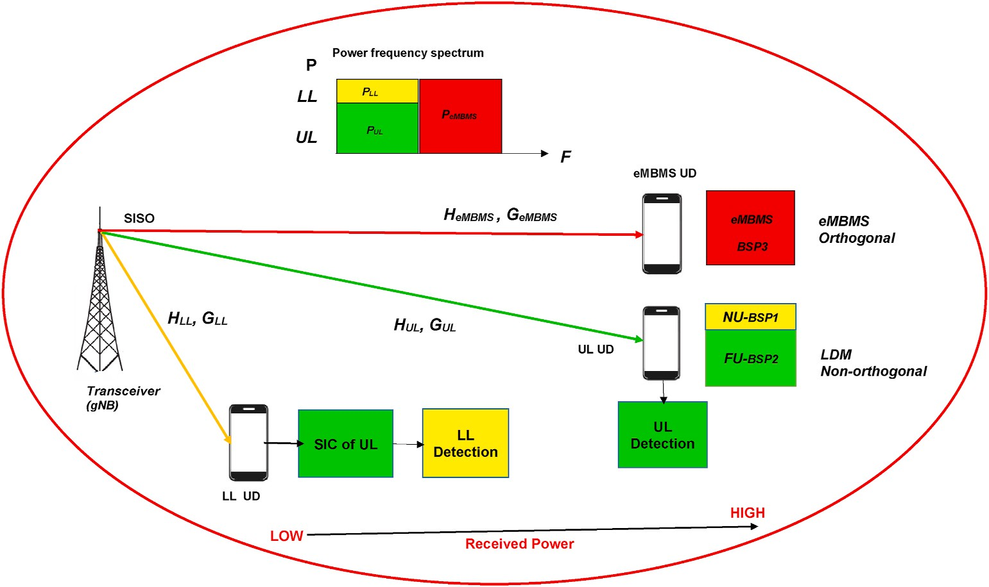

**Fig. 1.** Schematic illustrating the proposed system model.

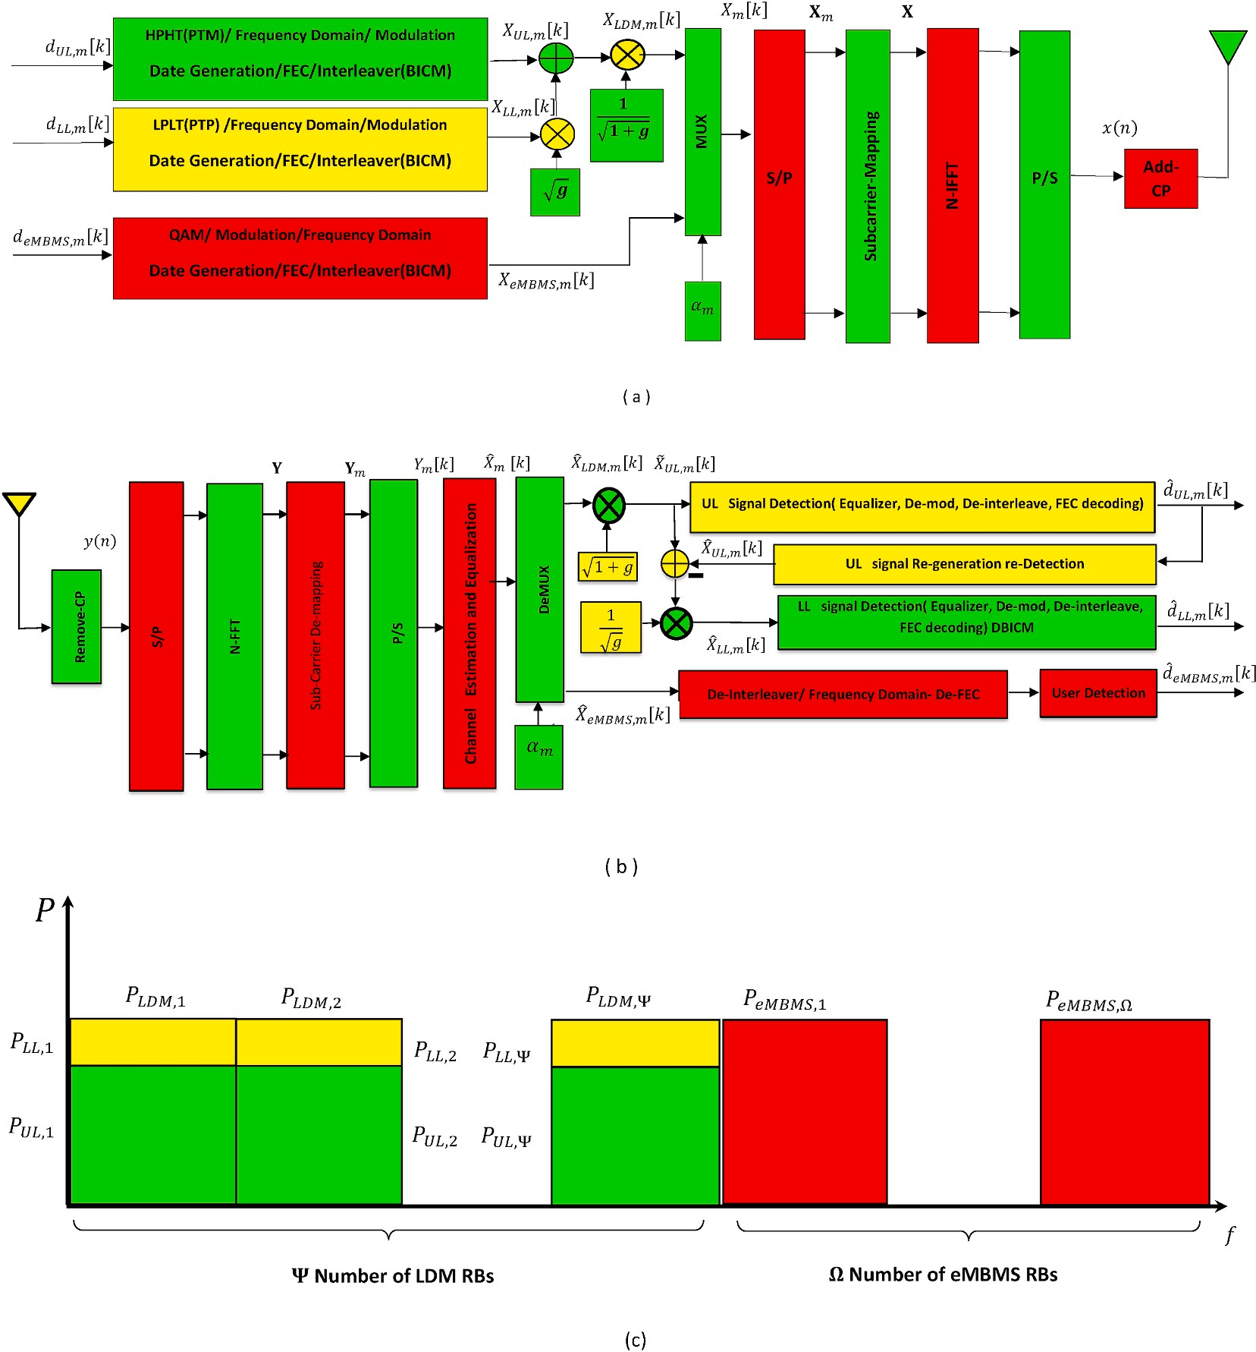

**Fig. 2.** Illustration of Non-orthogonal/orthogonal hybrid LDM/eMBMS (a)TX (b)RX (c)Frequency spectrum of RBs.

simultaneously in a channel [50]. Then de-normalized power for LDM and de-multiplexed composed signal. The LDM signal is demodulated using successive interference cancellation (SIC) two layers. The SIC decoding instruction is based on the ordered channel gain (G) infor- mation.Finally in signal decoding the eMBMS signal will be decoded using the regular receiver [54] that hybrid receiving configuration is shown in Figs. 1 and 2.

The SIC block in the receiver part is explained as follows, the strong user UL signal which is far from gNB station is decoded by treating the LL

signal as interference. Because the strong signal has the lowest inter-

* 1. *Problem formulation*

Assume there are *M* RBs and at the *m*th RB there are *Km* sub-carriers. The number of LDM and eMBMS RBs are Ψ and Ω, respectively. If all the RBs are occupied with LDM and eMBMS data than the total number of RBs can be written in terms of Ψ and Ω as follows *M* = Ψ + Ω. So the *k*th sub-carrier mapping of the LDM or eMBMS symbol to the *m*th RB can be

given as

*Xm* [*k*] = *αm XLDM m* [*k*] + *β* ,*p*̅̅̅*e*̅*M*̅̅̅*B*̅̅*M*̅̅*S*̅̅*XeMBMS m* [*k*]

,

*m*

,

(1)

ference and attempts in coherent decoding without SIC perform. Then UL signal is subtracted from the main composite signal if the UL signal is decoded successfully. Afterward, LL signal near user which has high interference and low power, is decoded with performing SIC. Also, the eMBMS signal is de-multiplexed and decoded by a normal user receiver, because we used multiplexing in the transmitter. At the end of this sub- section, for more interpretation and complete theoretical description of the block diagram the hybrid LDM/eMBMS proposed system model in the frequency domain Fig. 2.c is illustrated.

for *m* = 1, 2, …, *M* and *k* = 1, 2…., *Km*

where *αm* and *βm* are allocating coefficients to *m*th RB for LDM and eMBMS systems respectively. To select LDM symbol for the *m*th RB take *αm* = 1 while *βm* = 0 and to select eMBMS symbol *βm* = 1 while *αm* = 0. Here the symbol carried in the *k*th sub-carrier of *m*th RB in case of LDM allocation, *XLDM*,*m*[*k*], is the summation of UL symbol *XUL*,*m*[*k*] and LL symbol *XLL*,*m*[*k*] with having transmit powers of *PUL*,*m*[*k*] and *PLL*,*m*[*k*]. In

this paper, we assume that these transmit powers do not change sub- carrier to sub-carrier and RB to RB, so we will drop sub-carrier and RB indices. Therefore, the superposed transmit LDM symbol can be written as follows,

*XLDM*,*m*[*k*] = √*P*̅̅̅*U*̅̅̅*L*̅*XUL*,*m*[*k*] + √*P*̅̅̅*L*̅̅*L*̅̅*XLL*,*m*[*k*] (2)

sampled received signal after removing CP samples with using Eq. (12) as

*Xm*[*k*] = *αm*(√*P*̅̅̅*U*̅̅̅*L*̅ *XUL*,*m*[*k*] + √*P*̅̅̅*L*̅̅*L*̅̅ *XLL*,*m*[*k*] )

*K*—1

2

/

(3)

*y n* 1

∑ *X k H k ej πkn K w n*

+*β* ,*p*̅̅̅̅̅̅̅̅̅̅̅̅̅*X*

*m*

*eMBMS*

*eMBMS*

[*k*]

( ) = ,̅̅̅̅

[ ] [ ]

+ ( ) (13)

for*m* = 1, 2, …, *M* and*k* = 1, 2…., *Km*

So in an LDM RB, there can be two users. And for eMBMS RB, only one user can be allocated. LL sub-carriers power is changed with an injection level of g and the summation power is normalized to *PLDM* so the transmit powers of LL and UL can be written in terms of *PLDM* as follows

*PLL* = *g LDM UL*  1 *LDM*

*P* and *P* = *P* (4)

Passing through FFT block, received signal can be seen as follows

*K k*=0

*K*—1

*Y*[*k*] = 1 ∑ *y*(*n*)*e*—*j*2*πkn*/*K* (14)

,̅*K*̅̅̅ *n*=0

*Y*[*k*] = *X*[*k*]*H*[*k*] + *W*[*k*], (15)

where

*W k*] =

1 + *g*

In this paper, we assume equal power allocation to the RBs, so the power of the LDM part can be calculated with

*K*

1 + *g*

1

[ ,̅̅̅̅

∑*w*(*n*)*e*—*j*2*πkn*/*K*. (16)

*n*

*PLDM* = *PT M* (5)

Ψ

Let *T* denote the multicarrier symbol duration and *TCP* denotes the cyclic prefix duration. The total multicarrier block duration is *T*′ = *T* + *TCP*.

The frequency spacing is Δ*f* = 1/*T*. The *k*th sub-carrier is at the frequency.

*fk* = *f*0 + *k*Δ*f* , *k* = 0, …, *K* — 1, (6)

where *f*0 is the first sub-carrier frequency in pass-band and K sub-carriers

With sub-carrier de mapping LDM or eMBMS user can take the received signal *Ym*[*k*] from its own RB/RBs.

*Ym*[*k*] = *Xm*[*k*]*Hm*[*k*] + *Wm*[*k*] (17)

∀*m* ∈{1, 2, …, *M*}.

In this paper, we consider perfect channel state information (CSI). However, we placed the channel estimation [56] and equalization block in Fig. 2.b.

With perfect CSI, the estimated transmit signal at *m*th RB can be found as

are used so that the bandwidth is

*X*̂ *k*

*Ym*[*k*]

(18)

*B* = *K*Δ*f* (7)

Let {*X*[*k*]}*K*—1 denote the information symbol to be transmitted on the *k*th

*k*=0

*m*[ ] = *Hm* [*k*].

If this RB is arranged to an eMBMS user (*βm* = 1), detection of the user

sub-carrier. Let {*x*(*n*)}*K* , be the cyclic prefixed multicarrier word

*n*=—*KCP*

̂

data, ̂*deMBMS*,*m*, is done with this estimated signal. However, if the RB is

sequence obtained as follows

used for LDM signal (*αm* = 1), the UL user data detection, *dUL*,*m*, is ob- tained after signal de-normalization and for LL user data detection,

*x n* 1

*K*—1

*X k*

∑

(*j π k*〈*n*〉*K* ) ̂

( ) = ,̅*K*̅̅̅

*k*=0

[ ]exp 2 *K*

, (8)

*dLL*,*m*, SIC procedure has to be followed by LL receiver. This is because LL

user is the nearest user to the gNB station compare to the UL user and the LL user can remove the inter user interference from the UL user which

for *n* = —*KCP*, …, *K* — 1

while *KCP* = *TCPK*/*T* and 〈*n*〉*K* denotes *n* mod *K*.

The time domain transmitted signal in base-band is then given by

satisfies the SIC condition *GLL*[*k*] > *GUL*[*k*]. Here *GLL*[*k*] and *GUL*[*k*] are the channel gains which are defined as follows

*HLL*[*k*] 2

*x*(*t*) = 1 ∑ *X*[*k*]*ej*2*πk*Δ*ft*, *t* ∈ [0, *T*′ ]. (9)

*K*—1

̅̅̅̅

*GLL*[*k*] =

*N*0,*LL*

(19)

,*N k*=0

The base-band received signal y(t) can be written as

**3. Performance analysis**

*GUL*[*k*] =

*HUL*[*k*] 2

*N*0,*UL*

(20)

*y t* ∫ ∞ *x t*

( ) =

( — ) ( )

—∞

*τ h τ dτ w t*

where *w*(*t*) is the complex additive white Gaussian noise with zero mean and *N*0 variance [55]. And *h*(*τ*) is base-band equivalent of multi-path Rayleigh channel impulse response and can be written as,

+

( ), (10)

*L*—1

∑ *j*2*πf τ*

*h*(*τ*) = *αlc*(*τ* — *τl*)*e*— 0 , (11)

*l*=0

where *c*(*τ*) is the aggregate impulse response of the transmit and receive filters. *αl* denotes the complex path gains of the multipath fading channel and there are L paths. The discrete base-band channel frequency

response at *fk* discrete frequencies can be calculated by using Fourier Transform as follows

*H*[*k*] = *C*[*k*]∑*αle*—*j*2*πfkτl* , (12)

*l*

The received signal is sampled at *t* = *nTs* for *t* ∈ [0, *T*′], we can write

In this section, the mathematical analysis in three sub-sections are followed as 1) The BER performance is investigated and analyzed. 2) Fractional Transmit Power Allocation (FTPA) algorithm for LDM multi- services is considered and analyzed. 3)The outage probability perfor- mance is considered and analyzed.

* 1. *BER analysis*

In this sub-section, BER performance expressions for the UL and LL of the LDM part proposed hybrid system are obtained based on Kara and

Kaya’s derivations [36,37]. We investigated that in Refs. [36,37], their

work considered a single carrier system and over a flat fading channel, our work considers to multicarrier so, some manipulations will be needed to obtain formulas that matched our multicarrier system and multipath Rayleigh channel assumption [49]. The error probability of the UL is as follows

*PUL* (*e*) = 1 [(1 — √̅̅̅̅̅*γ*̅̅*A*̅̅̅̅̅̅ ) + (1 — √̅̅̅̅̅*γ*̅̅*B*̅̅̅̅̅̅ ) ] (21)

4

2 + *γA*

2 + *γB*

*P* (*e*) =

(*b P*

(*e*) + *b P*

(*e*)) (36)

where

1

*LDM*

*bLL* + *bUL*

*LL*

*LL*

*UL*

*UL*

*γA* = (√2̅̅̅*P*̅̅̅*U*̅̅*L*̅̅ + √*P*̅̅̅*L*̅̅*L*̅̅ )2 *GUL* (22)

and

√̅̅̅̅̅̅̅̅̅̅ √̅̅̅̅̅̅̅

*γB* = ( 2*PUL* — *PLL* )2 *GLL*. (23)

The notations *γA* and *γB* are the average signal-to-noise ratios (SNRs) for the different signal constellation points for superposed BPSK

* 1. *FTPA Algorithm for LDM multi-services*

Due to its low computational complexity, FTPA is widely adopted in OFDMA and PD-NOMA systems [47,58]. In the FTPA, the transmit power of LDM RBs on sub-carrier kth (*SCk*) is allocated according to the channel gains of all the multiplexed users on *SCk*, which is given as follows

*E*{*HUL* 2 }—*ξ*

} *ξ*

modulated UL symbols and QPSK modulated LL symbols. The *GLL* and

*GUL* are the average channel gains and can be define as

*PUL* = *PLDME*{*H*

2 }—*ξ* + *E*{*HLL*

(37)

2 —

*UL*

*GLL* =

*G*

*E HLL*2

*N*0,*LL E*{*HUL*2 }

{ }

*N*

(25)

0,*UL*

(24)

*PLL* = *PLDM* — *PUL* (38)

where *ξ* in Eq. (37) (0 ≤ *ξ* ≤ 1) is a decay factor and in the case *ξ* = 0, it corresponds same power between allocated users. The FTPA algorithm is based on the idea that allocating more power to the poorer average

channel response coefficient when *ξ* increases.

Here,*E*{} is the expectation operator. The error probability of the LL can

*UL* =

Here we select it as *ξ* = 0.4. In Tables 4 and 5 power allocation values calculated by FTPA with different average channel coefficients of

be written as follows

*E*{*HUL*2 } =—3, —5, —7 *dB* are given. However, in Table 4, fixed power

*PLL* (*e*) = 1 ⎛⎝1 — √̅̅̅̅*γ*̅̅*C*̅̅̅̅̅̅⎞⎠ + 1 ⎡⎣√̅̅̅̅*γ*̅̅*D*̅̅̅̅̅̅ — √̅̅̅̅*γ*̅̅*E*̅̅̅̅̅̅ — √̅̅̅̅*γ*̅̅*F*̅̅̅̅̅̅ +√̅̅̅̅*γ*̅̅*G*̅̅̅̅̅̅⎤⎦

allocation values, *PLL* = 0.4 and *PUL* = 0.6 are given as without FTPA. In

2 2 + *γC* 8 2 + *γD* 2 + *γE* 2 + *γF* 2 + *γG*

(26)

section 4, from Figs. 5 and 6, we will seen that fixed power allocation

values are fit for —7 dB average channel coefficient powers value. For other average channel coefficient powers values, BER performance is

where in (26) we can be written the definitions of averages of SNRs in Eqs. (27)–(31) as following

*γC* = *PLLGLL*, (27)

*γD* = (√2̅̅̅*P*̅̅̅*U*̅̅*L*̅̅ + √*P*̅̅̅*L*̅̅*L*̅̅ )2 *GLL* , (28)

*γE* = (√2̅̅̅*P*̅̅̅*U*̅̅*L*̅̅ — √*P*̅̅̅*L*̅̅*L*̅̅ )2 *GLL* , (29)

*γF* = (2√2̅̅̅*P*̅̅̅*U*̅̅*L*̅̅ + √*P*̅̅̅*L*̅̅*L*̅̅ )2 *GLL* , (30)

*γG* = (2√̅2̅̅*P*̅̅̅*U*̅̅*L*̅̅ — √*P*̅̅̅*L*̅̅*L*̅̅ )2 *GLL* , (31)

The error probability in eMBMS part of proposed hybrid system [55] obtained and localized which can be written as follows

*PeMBMS* (*e*) = 1 (1 — √̅̅̅̅̅*γ*̅̅*e*̅*M*̅̅̅*B*̅̅*M*̅̅*S*̅̅̅̅̅̅ ) (32)

getting worse compare to the with FTPA case. Moreover, using FTPA has an impact on UL BER performance and obviously on LDM. Since FTPA has no gain on LL BER performance, the effect on LDM is not as clearly visible as UL BER performance.

* 1. *Outage analysis*

Generally, outage probability performance is a relevant criterion for the assessment of the quality of service. It measures the probability of failing to achieve an output SNR threshold value required for the desired service outage probability is defined as the probability that the instan- taneous sum rate falls below a certain pre-determined threshold value, i. e., *R*0 [59–61].

Since the proposed system is a multi-carrier system consisting of the

LDM and the eMBMS parts, we can write the outage probability as sub- carrier based and the summations of LDM and eMBMS sub-carriers outage probabilities as shown in the following equation.

2 2 + *γeMBMS*

*Proverall* = *PreMBMS* + *PrLDM*

(39)

where

*out*

*out*

*out*

where *PreMBMS* and *PrLDM* are the outage probabilities of the eMBMS and

*out out*

*γeMBMS* = 2*PeMBMSGeMBMS* (33)

the LDM part of the proposed system. And can be defined as follows

*KeMBMS*

is the average SNR of the QPSK modulated eMBMS symbols and

*PreMBMS* = 1

∑ *Pr*{*ReMBMS*[*k*] < *R* }, (40)

*GeMBMS* =

*E*{⃒*HeMBMS*

2

| }

. (34)

*out*

*KeMBMS*

*KLDM*

0

[*k*=1]

0,*eMBMS*

*N*

*PrLDM* = 1 ∑ *Pr*{*R*

[*k*] < *R* } (41)

To assess the effect of the number of RBs to the LDM or eMBMS part, we define the average total BER of the proposed hybrid system as follows

*out*

*KLDM*

[*k*=1]

*LDM* 0

*P e* Ψ(*bLL* + *bUL*)*PLDM*(*e*) + Ω*beM*.*PeM*.(*e*)

Ψ(*bLL* + *bUL* ) + Ω*beMBMS*

( ) =

(35)

**Table 4**

Impact of fix power allocation.

Parameter Value

Where *bLL* = log2*MLL* and *bUL* = log2*MUL* and *beMBMS* = *log*2*MeMBMS* de- notes the number of bits per LL and UL and eMBMS symbols, respec-

Average channel coefficient power of *E*{*HUL*

2 }[dB] = Path Loss

—3 —5 —7

tively. Here *MLL*and *MUL* denotes the order of LL and UL symbol modulations.*PLDM*(*e*) denotes the average BER of the LDM part and can be written as

*PLL* 0.4 0.4 0.4

*PUL* 0.6 0.6 0.6

Average channel coefficient power of *E*{*HLL* 2 }[dB] = Path Loss 0 dB

**Table 5**

Impact of FTPA algorithm.

Parameter Value

*pLL*[*k*] = *PLLK*

1

*LDM*

(48)

Average channel coefficient power of *E HUL* 2 [dB]

{ }

= Path Loss

|  |  |  |  |
| --- | --- | --- | --- |
| *PLL* | 0.3625 | 0.3801 | 0.3961 |
| *PUL* | 0.6375 | 0.6199 | 0.6039 |

—3 —5 —7

*pUL*[*k*] = *PUL* 1 , (49)

for all *k* ∈ {1, 2, …, *KLDM*} denotes the transmit powers per subcarrier of

*KLDM*

Average channel coefficient power of *E HLL* 2 [dB] 0 dB

{ }

= Path Loss

In the previous equations, Eqs. (40) and (41) *ReMBMS*[*k*] and *RLDM*[*k*] denotes the sum rates of the eMBMS part and the LDM part at sub-carrier *k*, respectively. And can be given as follows

*ReMBMS*[*k*] = log2 (1 + *γeMBMS*[*k*]), (42)

*RLDM*[*k*] = log2 (1 + *γLL*[*k*]) + log2 (1 + *γUL*[*k*]) (43)

Where in Eqs. (42) and (43) *γeMBMS*[*k*] and *γLL*[*k*] are the SNR and *γUL*[*k*] is the signal-to-interference-plus-noise ratio (SINR), which can be writ- ten as

*γeMBMS*[*k*] = 2*peMBMS*[*k*]*GeMBMS*[*k*] (44)

*γLL*[*k*] = *pLL*[*k*]*GLL*[*k*] (45)

LL and UL, and *KLDM* = Ψ*Km* denotes the total number of LDM subcarriers.

# Simulation results

In the simulation results section, iterative Monte Carlo simulation results will be present to evaluate the performance of the proposed non- orthogonal/orthogonal LDM/eMBMS system based on RBs per sub- carrier spectrum. Simulation parameters are given in Table 3. Simula- tion results presented in three main parts 1) The BER performance illustrated for LDM, eMBMS as individually, and hybrid non- orthogonal/orthogonal proposed configuration. 2) FTPA power alloca- tion algorithm results for LDM is investigated 3) Outage probability performance for LDM, eMBMS as individually, and hybrid non- orthogonal/orthogonal proposed configuration will be shown.

* 1. *BER performance results*

*γUL*

*k*  *pUL*[*k*]*GUL*[*k*]

*pLL*[*k*]*GUL*[*k*] + 1

[ ] =

(46)

As shown in Fig. 3 the LDM BER performance is depicted, while theoretical analysis is given in Eqs. (21), (26) and (36). As can be seen from the figure, the theoretical and simulation results completely

Moreover, the power of eMBMS and LL and UL layers denotes in Eqs.

(47)–(49) as following

matched. Furthermore, the LDM can support two users in each sub- carrier and thus can facilitate meeting the quality of multi-service re-

*peMBMS*

[*k*] = *P*

1

*eMBMSKeMBMS*

(47)

quirements. Since we use QPSK for LL near user and BPSK for UL far user modulations, the bits per symbol for both layers are *bLL* = log24 = 2 and *bUL* = log22 = 1, respectively. The UL user is far from BS compare to LL

for all *k* ∈ {1, 2, …, *KeMBMS*}

near, the near user has a better BER performance than the far user. So, we assume the average frequency domain channel coefficient for UL is 3 dB lower than LL. To compensate for this issue, we adjust fixed

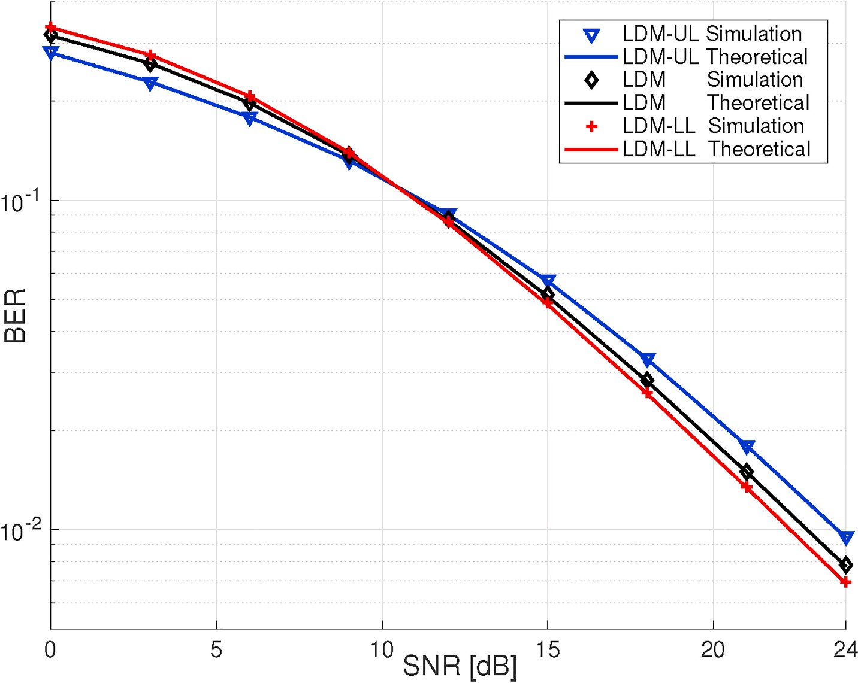

**Fig. 3.** BER performance for LDM layers versus SNR(dB).

normalized transmit powers for UL and LL as *PLL* = 0.4 and *PUL* = 0.6. But still in the SNR to be 10 dB point and increase up to 24 dB, the LDM- LL outperforms BER performance than the LDM-UL. It is assumed an equal number of LDM and eMBMS RB allocations as Ω = Ψ = 8.

Simulation results, as shown in Fig. 4 the BER performance of LDM

and eMBMS with the hybrid proposed framework versus SNR(dB) is compared, which are derived in Eqs. (32) and (35) with LDM technol- ogy. For a fair comparison, we assume normalized average frequency domain channel coefficient for eMBMS users like LL users,

{ } { }

*E HeMBMS*2 = *E HLL*2 = 0 *dB*, and normalized transmit power for

eMBMS users *PeMBMS* = *PLL* + *PUL* = 1. We use QPSK modulation for eMBMS, the bits per symbol is *beMBMS* = log24 = 2. Although we use SIC for LDM users, residual interference causes BER performance degrada- tion, therefore from Fig. 4 it can be seen that the eMBMS performance outperforms the LDM and the proposed overall hybrid system perfor- mance lays down in between. As expected, the hybrid proposed frame- work simulation results are shown that the overall performance average has been located between LDM and eMBMS technologies individually. However, eMBMS can provide better performance since it can support single users, and consequently, the probability to satisfy the isolation constraint will increase in the edge of borders and the coverage region between BSPs.

The BER performance of the proposed system is more than LDM and less than eMBMS compared to the other two technologies. As mentioned the proposed system BER Performance plot is placed lays down between LDM and eMBMS.

* 1. *FTPA algorithm results for LDM*

In this sub-section, we evaluate the impact of the FTPA algorithm on BER performance to achieve *PLL* and *PUL* power allocation for LDM layers, which is shown in Figs. 5 and 6.

In Table 4 fixed power allocation values, *PLL* = 0.4 and *PUL* = 0.6 as without (w/o) FTPA are given. Also, in Table 5 power allocation values calculated with FTPA impact for different average channel coefficient of

*E HUL*2 =—3, —5, —7 *dB* are given. Hence, from Figs. 5 and 6 it can be seen the effect of the FTPA algorithm compared without FTPA out- performs BER performance on both LDM and UL layer. From Fig. 5 it can

be seen that fixed power allocation values match exactly in —7 dB

{ }

channel coefficient power value. For other average channel coefficient values, BER performance is getting worse compare to with FTPA case. Moreover, using FTPA has an impact on UL BER performance and obviously on LDM. Since FTPA has no gain on LL BER performance, the effect on LDM is not as clearly visible as UL BER performance in Fig. 5. As shown in Fig. 6 the impact of the FTPA algorithm on BER per- formance for LDM layers with different path losses are demonstrated. In our novel we assume LL to be set 0 dB, while LDM changes to be (—3, —5,

—7)*d B*, attenuation path loss (channel coefficient gain). In Fig. 6 we evaluate the BER performance of the LDM part with different attenua- tion levels for the UL channel without and with the FTPA algorithm. We assume, that the user in the UL channel is far from the gNB station, and, therefore, path loss attenuation is high. When the UL is looking for different path losses (—3, —5, —7)*dB*, the user in LL is kept to 0 dB. As can be seen from Fig. 6 the worst performance is a value of — 7 dB, and — 3 dB is the best path loss for the LDM. The exact closed-form simulation and theoretical outperforms BER performance for the LDM compared with the UL channel.

In Fig. 7 the simulation results for the proposed overall system with different numbers of eMBMS RBs allocation BER performance is illus- trated. In this figure, in every scenario, the number of occupied RBs is the same and M = 16, but the number of eMBMS RBs, Ω, are sequentially

taken{0, 4, 8, 12, 16}and so the number of LDM RBs,Ψ, are taken {16,

12, 8, 4, 0}. It can be easily seen that while increasing the number of eMBMS RBs, Ω. The proposed hybrid framework led to improved BER performance, on the contrary, decreasing the number of LDM RBs,Ψ,

lead to the proposed hybrid system’s BER performance.

In Fig. 8. The BER performance of the proposed hybrid framework versus the number of eMBMS RBs (Ω) under fixed SNR equal = 24 dB is shown. The number of eMBMS RBs (Ω) increased from 0 to 16 (the

number of LDM RBs (Ψ) decreased from 16 to 0). The result shows that

the overall performance increased with the number of eMBMS

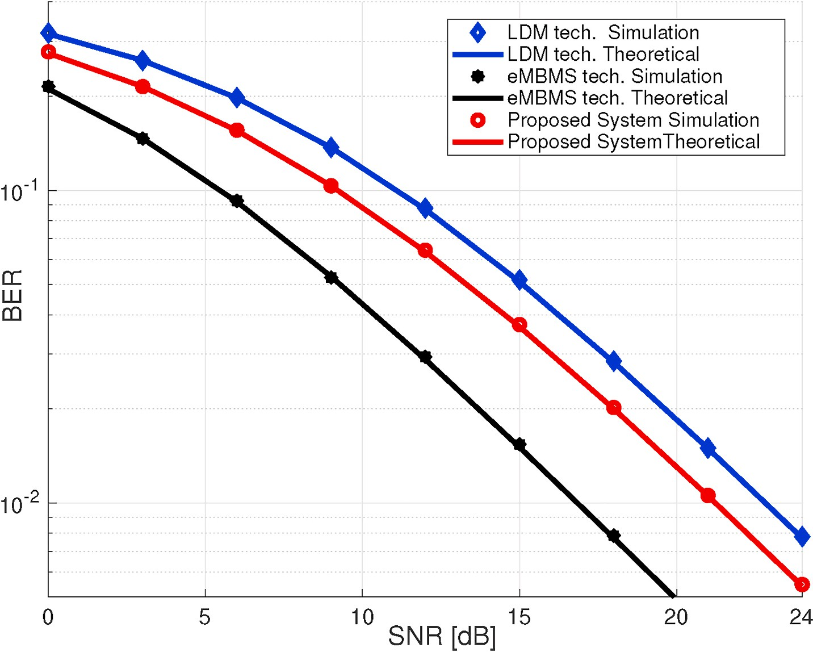

**Fig. 4.** BER performance of proposed system compared with LDM/eMBMS separately versus SNR.

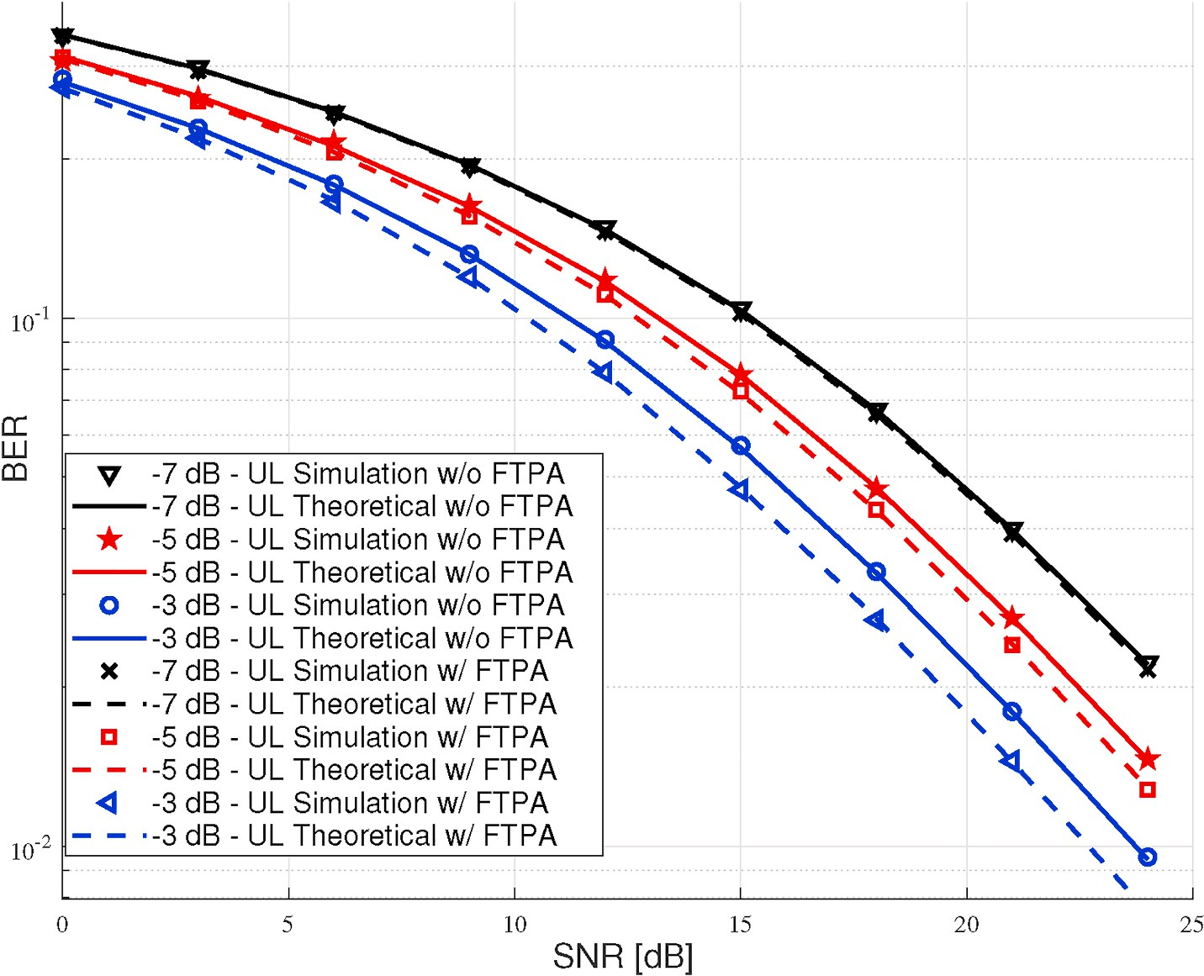

**Fig. 5.** BER performance of UL part with different channel Gain for UL with/without FTPA versus SNR.

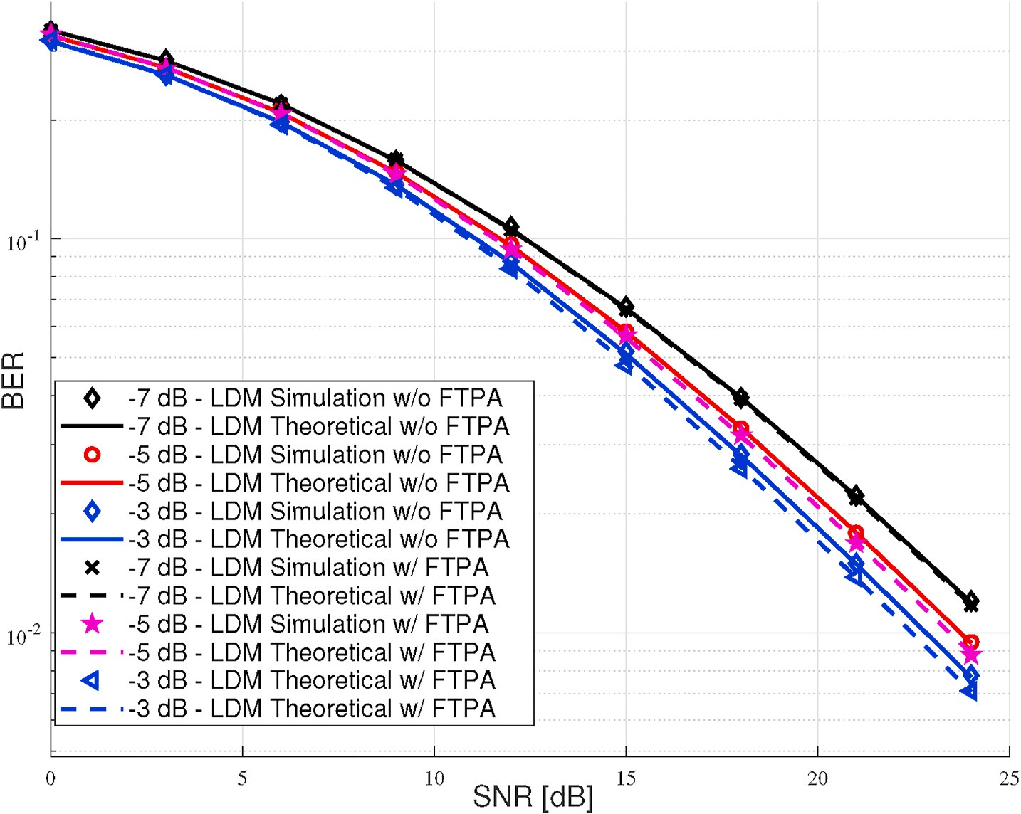

**Fig. 6.** BER performance of LDM of proposed system with different channel gain (attenuation path loss) for UL channel with/without FTPA versus SNR (dB).

technology usage.

* 1. *Outage performance results*

In this sub-section, outage probability simulation results in Figs. 9 and 10 will be shown.

Fig. 9 shows outage probability performance versus the total trans- mitted power. The eMBMS based on the OFDMA technique is operated and carries one user per subcarrier instantaneously, while the LDM two layers which based on NOMA technology carry two users per subcarrier concurrently, hence increase the throughput sum-rate per RBs.The figure shows that the efficiency of LDM is better than the eMBMS

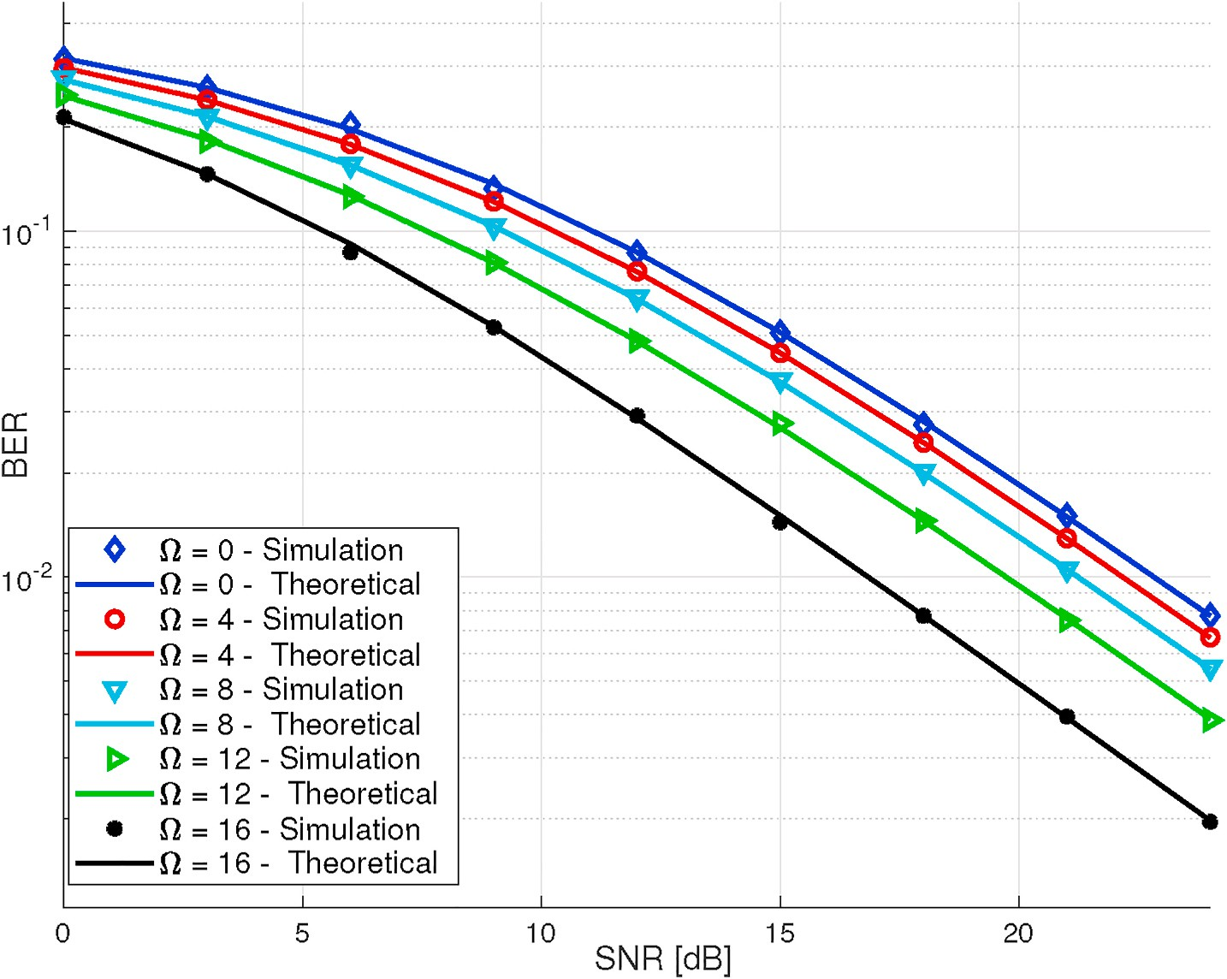

**Fig. 7.** BER performance of proposed system versus SNR with different number of eMBMS RBs.

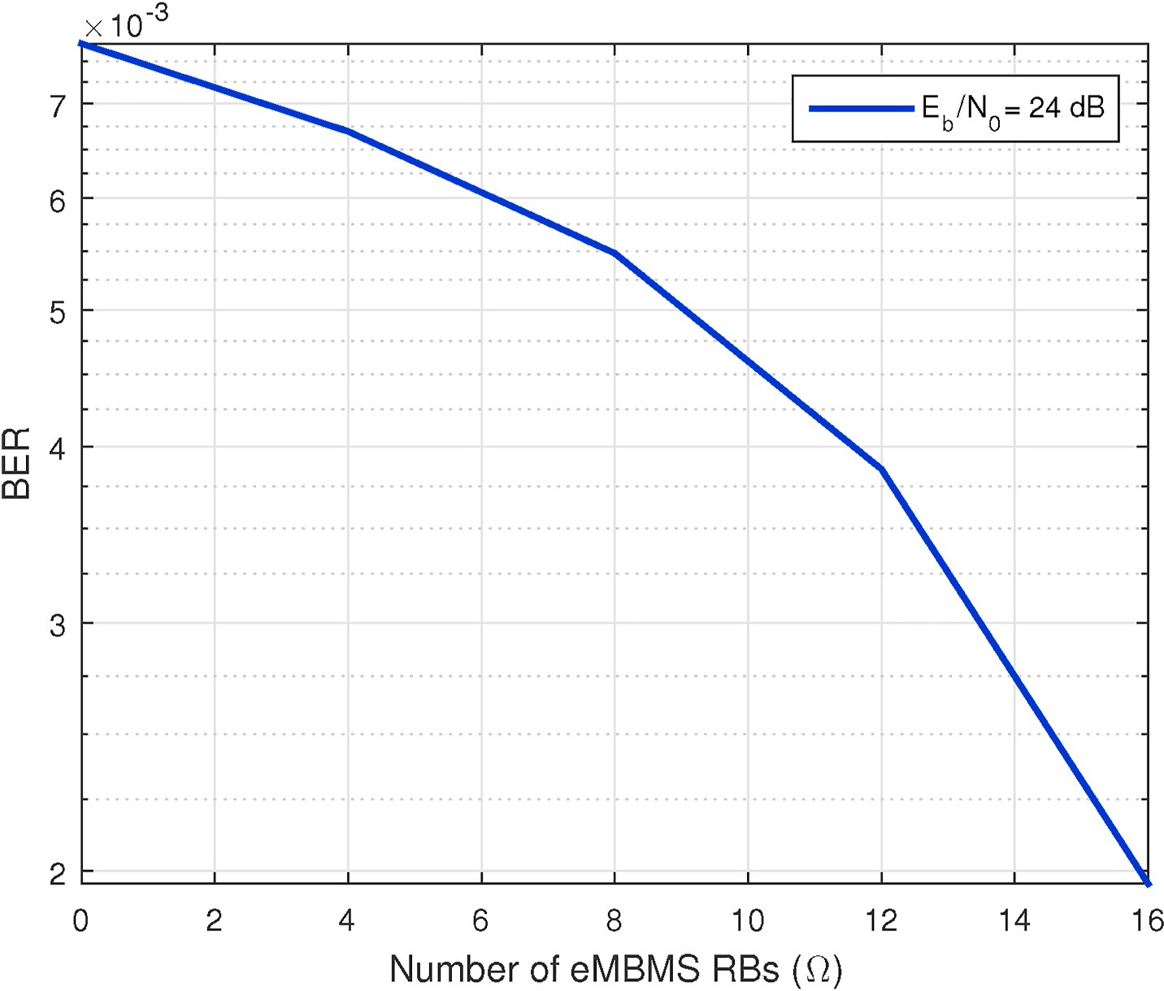

**Fig. 8.** BER performance of the proposed system versus different number of eMBMS RBs Ω in SNR = 24 dB.

performance. So, compared with the eMBMS single-layer mobile system, the efficiency of the LDM has been increased. It can be seen from Fig. 9 results, that the LDM outage probability performance outperforms the eMBMS technology.

As illustrated in Fig. 10 LDM-LL, LDM-UL, and eMBMS technology

outage probability performances are compared with the hybrid pro- posed configuration. The LDM-LL near user has a better outage perfor- mance than the far user LDM-UL. Also, eMBMS user outage performance is increased and match with LDM-LL exactly. The eMBMS layer outage performance outperforms compared with LDM-UL, while the LDM-UL

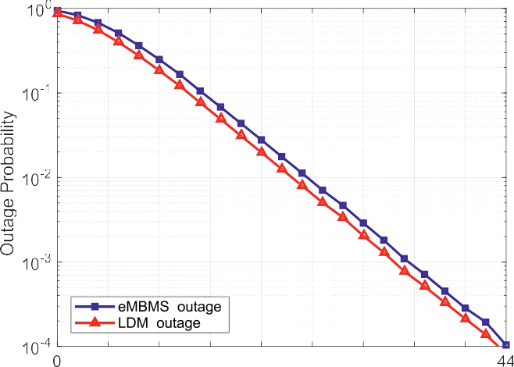

**Fig. 9.** Outage probability for LDM and eMBMS separately versus Transmit power (*PT*).

outage performance decreased. where the eMBMS carries one user and LDM carries two users on the sub-carrier concurrently. Hence, it is increased the efficiency of the LDM two-layer system compared to the eMBMS single-layer mobile system and consequently, overall system performance is increased. As expected from Fig. 10. The hybrid configuration offers the median outage probability. This is due to the proposed hybrid configuration for improving the throughput rate (as mentioned we given outage performance based on sum rate in sub- section 3.3) and flexibility in the radio access selection. Hence, led to improved outage probability performance. This is one of our claims about combination hybrid configuration.

# Conclusion and future suggestions

In this article, we have nominated a novelty approach for radio

access that can dynamically select an appropriate technology among LDM and eMBMS based on the average CSI. This attitude is concentrated on a configuration for CDTB infrastructure technology. The issue sug- gested a hybrid of orthogonal/non-orthogonal multi-radio layers broadcasting multiple services. We investigated the mathematical per- formance of hybrid LDM/eMBMS versus the individual single-layer service provider. We studied the impact of three BSPs through single- cell downlink beamforming over the Rayleigh fading multipath chan- nel for presenting mobile/stationary services. The system has two binary

switches for radio access service selection. The service assignment bi- nary switch has used two factors. These factors illustrated with *αm* and *βm* symbols. The BER performance in LDM and UL channel response gain investigated with FTPA algorithm. An exact closed-form BER and Outage rate performance are analyzed. The system can work without SIM card uplink way and IP for situation crises. MATLAB simulations shown that both theoretical expressions and plots are matched exactly. It

is concluded from this research that non-orthogonal and orthogonal hybrid framework technology has outperformed BER and outage rate performance compared to a solitary technology. Therefore, we proposed that for next-generation CDTV as a middle infrastructure for broadcast network owners. In a special case, we recommend it for next-generation CDTB broadcast.

The optimization problem of the system is one of the most important future directions to continue the work on the orthogonal and non- orthogonal hybrid configuration. We intend to optimize BER and sum- rate versus transmission power for the hybrid system. The stochastic geometric tool are used to study of random hybrid LDM/eMBMS tech- nologies. Utilization of stochastic processes to achieve an optimal output for instance using the Poisson point process will analyze the hybrid configuration network.

# Funding sources

This research did not receive any specific grant from funding agencies in the public, commercial, or not-for-profit sectors. The work has done in collaboration with the Department of Electrical-Electronics Engineering Communication laboratory of Istanbul University -

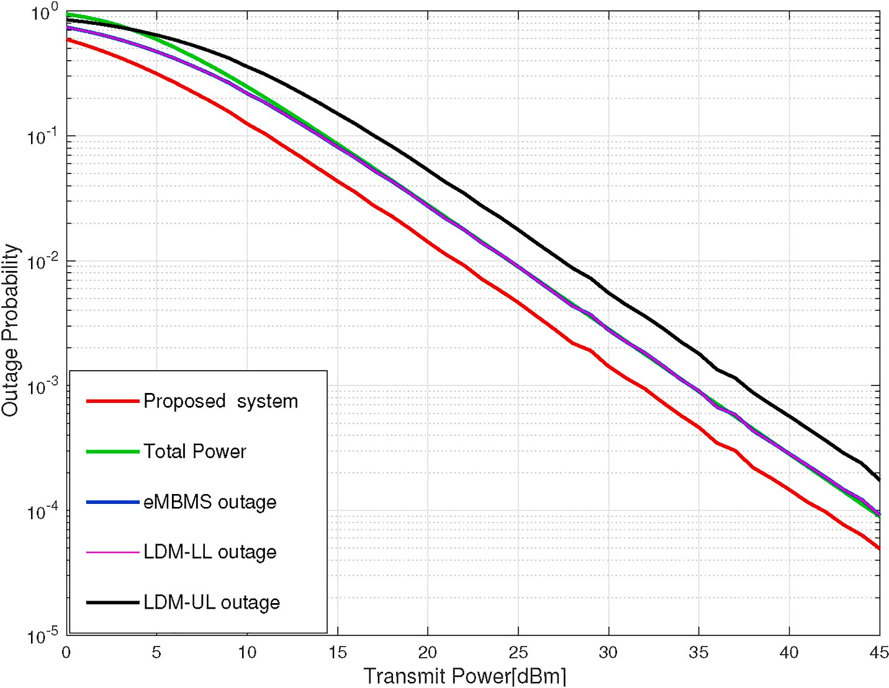

**Fig. 10.** Outage probability for hybrid proposed system compared to LDM and eMBMS individually versus *PT*.

Cerrahpas¸a in times of opportunity study as visiting researcher (July 2019–July 2021).

# Declaration of competing interest

The authors declare that they have no known competing financial interests or personal relationships that could have appeared to influence the work reported in this paper.

# Acknowledgments

Authors would like to thank the anonymous reviewers for the useful comment and suggestions that have helped to improve the manuscript.

# References

1. Doeven J. Trends in broadcasting : an overview of developments. ITU Report; 2013. p. 1–42 [Online]. Available: [https://www.itu.int/en/ITU-D/Broadcasting/](https://www.itu.int/en/ITU-D/Broadcasting/TrendsinBroadcasting.pdf) [TrendsinBroadcasting.pdf](https://www.itu.int/en/ITU-D/Broadcasting/TrendsinBroadcasting.pdf).
2. [Aldababsa Mahmoud, Toka Mesut, Gokcheli Selahattin, Kurt Gunesh Karabulut,](http://refhub.elsevier.com/S2590-0056(21)00021-7/sref2)

[Oguz Kucur. A tutorial on non orthogonal multiple access for 5G and beyond. 2018.](http://refhub.elsevier.com/S2590-0056(21)00021-7/sref2)

[p. 1–24](http://refhub.elsevier.com/S2590-0056(21)00021-7/sref2).

1. [Roy A, Chaporkar P, Karandikar A. Optimal radio access technology selection](http://refhub.elsevier.com/S2590-0056(21)00021-7/sref3) [algorithm for LTE-WiFi Network. IEEE Trans Veh Technol 2018;67(7):6446–60](http://refhub.elsevier.com/S2590-0056(21)00021-7/sref3).
2. [Baghani Mina, Parsaeefard Saeedeh, Derakhshani Mahsa, Saad Walid. Dynamic](http://refhub.elsevier.com/S2590-0056(21)00021-7/sref4)

[non-orthogonal multiple access and orthogonal multiple access in 5G wireless](http://refhub.elsevier.com/S2590-0056(21)00021-7/sref4) [networks”. IEEE Trans Commun 2019;67(9):6360–73](http://refhub.elsevier.com/S2590-0056(21)00021-7/sref4).

1. ITU. Handbook on digital terrestrial television broadcasting networks and systems

implementation. 2016. p. 318 [Online]. Available: [https://www.itu.int/dm](https://www.itu.int/dms_pub/itu-r/oth/R0A0700003B0001PDFE.PDF) [s_pub/itu-r/oth/R0A0700003B0001PDFE.PDF](https://www.itu.int/dms_pub/itu-r/oth/R0A0700003B0001PDFE.PDF).

1. [Alsharif MH, Nordin R. Evolution towards fifth generation (5G) wireless networks:](http://refhub.elsevier.com/S2590-0056(21)00021-7/sref6) [current trends and challenges in the deployment of millimetre wave, massive](http://refhub.elsevier.com/S2590-0056(21)00021-7/sref6)

[MIMO, and small cells. Telecommun Syst 2017;64(4):617–37](http://refhub.elsevier.com/S2590-0056(21)00021-7/sref6).

1. Monserrat JF, Calabuig J, Fernandez-Aguilella A, Gomez-Barquero D. Joint delivery of unicast and E-MBMS services in LTE networks. IEEE Trans Broadcast

jun 2012;58(2):157–67 [Online]. Available: [http://ieeexplore.ieee.org/document](http://ieeexplore.ieee.org/document/6179779/)

[/6179779/](http://ieeexplore.ieee.org/document/6179779/).

1. International Telecommunication Union. Digital dividend: insights for spectrum decisions. Online Access; 2012. p. 1–61 [Online]. Available:[http://www.itu.int/IT](http://www.itu.int/ITU-D/tech/digital_broadcasting/DigitalDividend.pdf) [U-D/tech/digital_broadcasting/DigitalDividend.pdf](http://www.itu.int/ITU-D/tech/digital_broadcasting/DigitalDividend.pdf).
2. [Kornfeld Michael, May Gunther. DVB-H and IP datacast – broadcast to handheld](http://refhub.elsevier.com/S2590-0056(21)00021-7/sref9) [devices. IEEE Trans Broadcast 2007;53(1):161–70](http://refhub.elsevier.com/S2590-0056(21)00021-7/sref9).
3. [Calabuig J, Monserrat JF, Go´mez-Barquero D. 5th generation mobile networks: a](http://refhub.elsevier.com/S2590-0056(21)00021-7/sref10)

[new opportunity for the convergence of mobile broadband and broadcast services.](http://refhub.elsevier.com/S2590-0056(21)00021-7/sref10) [IEEE Commun Mag 2015;53(2):198–205](http://refhub.elsevier.com/S2590-0056(21)00021-7/sref10).

1. Gaspar JC. Broadcasting in 4G mobile broadband networks and its evolution

towards 5G. Ph.D. dissertation. Valencia (Spain): Universitat Polit`ecnica de Val`encia; mar 2015 [Online]. Available: [https://riunet.upv.es/handle/10](https://riunet.upv.es/handle/10251/48561) [251/48561](https://riunet.upv.es/handle/10251/48561).

1. Yamamoto H, Nakamura A, Itami M. A study on LDM-BST-OFDM transmission for the next-generation terrestrial broadcasting. IEEE Trans Broadcast 2019;PP:1–11 [Online]. Available: <https://ieeexplore.ieee.org/document/8802255/>.
2. [Shi L, Obregon E, Sung KW, Zander J, Bostrom J. CellTV - on the benefit of TV](http://refhub.elsevier.com/S2590-0056(21)00021-7/sref13) [distribution over cellular networks : a case study 2015;60(1):73–84](http://refhub.elsevier.com/S2590-0056(21)00021-7/sref13).
3. El-Hajjar M, Hanzo L. A survey of digital television broadcast transmission

techniques. IEEE Communications Surveys & Tutorials 2013;15(4):1924–49 [Online]. Available: <http://ieeexplore.ieee.org/document/6492307/>.

1. Lykourgiotis A, Birkos K, Dagiuklas T, Ekmekcioglu E, Dogan S, Yildiz Y, Politis I, Tanik G, Demirtas B, Kondoz A, Kotsopoulos S. Hybrid broadcast and broadband

networks convergence for immersive TV applications. IEEE Wireless Communications jun 2014;21(3):62–9 [Online]. Available: [http://ieeexplore.ieee.](http://ieeexplore.ieee.org/document/6845050/) [org/document/6845050/](http://ieeexplore.ieee.org/document/6845050/).

1. [Gomez-Barquero D, Lee JY, Ahn S, Akamine C, He D, Montalaban J, Wang J, Li W,](http://refhub.elsevier.com/S2590-0056(21)00021-7/sref16) [Wu Y. IEEE transactions on broadcasting special issue on: convergence of broadcast](http://refhub.elsevier.com/S2590-0056(21)00021-7/sref16) [and broadband in the 5G era. IEEE Trans Broadcast 2020;66(2):383–9](http://refhub.elsevier.com/S2590-0056(21)00021-7/sref16).
2. Shokair A, Crussiere M, Helard J-F, Nasser Y, Bazzi O. Analysis of hybrid

broadcast/broadband networks with multiple broadcasting stations. IEEE Access 2019;7:141226–40 [Online]. Available: [https://ieeexplore.ieee.org/document](https://ieeexplore.ieee.org/document/8843986/)

[/8843986/](https://ieeexplore.ieee.org/document/8843986/).

1. [Dai L, Wang B, Ding Z, Wang Z, Chen S, Hanzo L. A survey of non-orthogonal](http://refhub.elsevier.com/S2590-0056(21)00021-7/sref18) [multiple access for 5G. IEEE Communications Surveys & Tutorials 2018;20(3):](http://refhub.elsevier.com/S2590-0056(21)00021-7/sref18) [2294–323](http://refhub.elsevier.com/S2590-0056(21)00021-7/sref18).
2. [3GPP. Group radio access network; introduction of the multimedia broadcast](http://refhub.elsevier.com/S2590-0056(21)00021-7/sref19) [multicast service (MBMS) in the radio access network (RAN…. 3rd Generation](http://refhub.elsevier.com/S2590-0056(21)00021-7/sref19) [Partnership Project (3GPP); 2018](http://refhub.elsevier.com/S2590-0056(21)00021-7/sref19).
3. Lecompte D, Gabin F. Evolved multimedia broadcast/multicast service (eMBMS) in

LTE-advanced: overview and Rel-11 enhancements. IEEE Commun Mag nov 2012; 50(11):68–74 [Online]. Available: [http://ieeexplore.ieee.org/document](http://ieeexplore.ieee.org/document/6353684/)

[/6353684/](http://ieeexplore.ieee.org/document/6353684/).

1. [Christodoulou L, Abdul-hameed O, Kondoz AM. Toward an LTE hybrid unicast](http://refhub.elsevier.com/S2590-0056(21)00021-7/sref21) [broadcast content delivery framework. 2017](http://refhub.elsevier.com/S2590-0056(21)00021-7/sref21).
2. [Gomez-Barquero D, Navratil D, Appleby S, Stagg M. Point-to-multipoint](http://refhub.elsevier.com/S2590-0056(21)00021-7/sref22)

[communication enablers for the fifth generation of wireless systems. IEEE](http://refhub.elsevier.com/S2590-0056(21)00021-7/sref22) [Communications Standards Magazine 2018;2(1):53–9](http://refhub.elsevier.com/S2590-0056(21)00021-7/sref22).

1. Guo J, Gong X, Liang J, Wang W, Que X. An optimized hybrid unicast/multicast

adaptive video streaming scheme over MBMS-enabled wireless networks. IEEE Trans Broadcast dec 2018;64(4):791–802 [Online]. Available: [https://ieeexplore.](https://ieeexplore.ieee.org/document/8362668/) [ieee.org/document/8362668/](https://ieeexplore.ieee.org/document/8362668/).

1. [Jokela T, Kalliovaara J, Bot M, Kokkinen H, Altman B, Barjau C, Sanders P, Gomez-](http://refhub.elsevier.com/S2590-0056(21)00021-7/sref24)

[Barquero D, Paavola J. Multimedia public warning alert trials using eMBMS](http://refhub.elsevier.com/S2590-0056(21)00021-7/sref24) [broadcast, dynamic spectrum allocation and connection bonding”. IEEE Trans](http://refhub.elsevier.com/S2590-0056(21)00021-7/sref24) [Broadcast 2020;66(2):571–8](http://refhub.elsevier.com/S2590-0056(21)00021-7/sref24).

1. [Report T. TR 126 917 - V15.0.1 - LTE; multimedia broadcast multicast services](http://refhub.elsevier.com/S2590-0056(21)00021-7/sref25)

[(MBMS) and packet-switched streaming service (PSS) enhancements to support](http://refhub.elsevier.com/S2590-0056(21)00021-7/sref25) [television services (3GPP TR 26.917 version 15.0.1 release 15), vol. 1; 2018](http://refhub.elsevier.com/S2590-0056(21)00021-7/sref25).

1. [Gomez-Barquero David, Gimenez Jordi, Beutler Roland. 3GPP Enhancements for](http://refhub.elsevier.com/S2590-0056(21)00021-7/sref26) [television services: LTE-based 5G terrestrial broadcast”. 2020](http://refhub.elsevier.com/S2590-0056(21)00021-7/sref26).
2. [Kuo P. New physical layer features of 3gpp lte release-13 [industry perspectives].](http://refhub.elsevier.com/S2590-0056(21)00021-7/sref27)

[IEEE Wireless Communications 2015;22(4):4–5](http://refhub.elsevier.com/S2590-0056(21)00021-7/sref27).

1. Gimenez JJ, Carcel JL, Fuentes M, Garro E, Elliott S, Vargas D, Menzel C, Gomez- Barquero D. 5G new radio for terrestrial broadcast: a forward-looking approach for

NR-MBMS. IEEE Trans Broadcast jun 2019;65(2):356–68 [Online]. Available: [htt](https://ieeexplore.ieee.org/document/8705278/) [ps://ieeexplore.ieee.org/document/8705278/](https://ieeexplore.ieee.org/document/8705278/).

1. Zhang L, Wu Y, Walker GK, Li W, Salehian K, Florea A. Improving LTE eMBMS with

extended OFDM Parameters and layered-division-multiplexing. IEEE Trans Broadcast mar 2017;63(1):32–47 [Online]. Available: [http://ieeexplore.ieee.or](http://ieeexplore.ieee.org/document/7792158/) [g/document/7792158/](http://ieeexplore.ieee.org/document/7792158/).

1. [Zhang Liang, Li Wei, Wu Yiyan, Wang Xianbin, Park Sung-ik, Kim Heung Mook,](http://refhub.elsevier.com/S2590-0056(21)00021-7/sref30)

[Lee Jae-young, Angueira Pablo, Montalban Jon. Layered-division-multiplexing:](http://refhub.elsevier.com/S2590-0056(21)00021-7/sref30) [theory and practice. IEEE Trans Broadcast 2016;62(1):216–32](http://refhub.elsevier.com/S2590-0056(21)00021-7/sref30).

1. Zhang L, Li W, Wu Y, Salehian K, Lafleche S, Hong Z, Park S-I, Kim HM, Lee J-Y,

Hur N, Wang X, Angueira P, Montalban J. Using layered-division-multiplexing to deliver multi-layer mobile services in ATSC 3.0. IEEE Trans Broadcast mar 2019;65

(1):40–52 [Online]. Available: <https://ieeexplore.ieee.org/document/8423697/>.

1. [Technical Specification. TS 138 202 - V16.1.0 - 5G; NR; Services provided by the](http://refhub.elsevier.com/S2590-0056(21)00021-7/sref32) [physical layer (3GPP TS 38.202 version 16.1.0 Release 16). 0. 2020. pp. 0–18](http://refhub.elsevier.com/S2590-0056(21)00021-7/sref32).
2. Kim SH, Kim J. An opportunistic MCS drop scheme for improved LTE eMBMS

transmission. Wireless Pers Commun 2019;107(3):1431–42. [https://doi.org/](https://doi.org/10.1007/s11277-018-5973-1) [10.1007/s11277-018-5973-1](https://doi.org/10.1007/s11277-018-5973-1) [Online]. Available:.

1. Meabe U, Gil X, Li Caiwei, Velez M, Angueira P. On the coverage and cost of HPHT

versus LPLT networks for rooftop, portable, and mobile broadcast services delivery. IEEE Trans Broadcast jun 2015;61(2):133–41 [Online]. Available: [http://ieeexplor](http://ieeexplore.ieee.org/document/7047756/) [e.ieee.org/document/7047756/](http://ieeexplore.ieee.org/document/7047756/).

1. Zhang Z, Ma Z, Xiao M, Liu G, Fan P. Modeling and analysis of non-orthogonal MBMS transmission in heterogeneous networks. IEEE J Sel Area Commun oct 2017;

35(10):2221–37 [Online]. Available: [http://ieeexplore.ieee.org/document](http://ieeexplore.ieee.org/document/7971899/)

[/7971899/](http://ieeexplore.ieee.org/document/7971899/).

1. Kara F, Kaya H. BER performances of downlink and uplink NOMA in the presence of SIC errors over fading channels. IET Commun sep 2018;12(15):1834–44 [Online]. Available: [https://digital-library.theiet.org/content/journals/10.1049/i](https://digital-library.theiet.org/content/journals/10.1049/iet-com.2018.5278)

[et-com.2018.5278](https://digital-library.theiet.org/content/journals/10.1049/iet-com.2018.5278).

1. Jain M, Soni S, Sharma N, Rawal D. Performance analysis at far and near user in NOMA based system in presence of SIC error. AEU - International Journal of Electronics and Communications feb 2020;114:152993. [https://doi.org/10.1016/j.](https://doi.org/10.1016/j.aeue.2019.152993) [aeue.2019.152993](https://doi.org/10.1016/j.aeue.2019.152993) [Online]. Available:.
2. [Zhang L, Li W, Wu Y, Xue Y, Sousa E, Park S, Lee J, Hur N, Kim H. Using non-](http://refhub.elsevier.com/S2590-0056(21)00021-7/sref38) [orthogonal multiplexing in 5G-MBMS to achieve broadband-broadcast](http://refhub.elsevier.com/S2590-0056(21)00021-7/sref38)

[convergence with high spectral efficiency. IEEE Trans Broadcast 2020;66(2):](http://refhub.elsevier.com/S2590-0056(21)00021-7/sref38) [490–502](http://refhub.elsevier.com/S2590-0056(21)00021-7/sref38).

1. [Razzac AA, Elayoubi SE, Chahed T, El Hassan B. Planning of mobile TV service in](http://refhub.elsevier.com/S2590-0056(21)00021-7/sref39)

[standalone and cooperative DVB-NGH and LTE networks. In: 2013 11th](http://refhub.elsevier.com/S2590-0056(21)00021-7/sref39) [international symposium and workshops on modeling and optimization in mobile,](http://refhub.elsevier.com/S2590-0056(21)00021-7/sref39)

[Ad Hoc and wireless networks (WiOpt); 2013. p. 609–14](http://refhub.elsevier.com/S2590-0056(21)00021-7/sref39).

1. [Tusha A, Do S. A hybrid downlink NOMA with OFDM and OFDM-IM for beyond 5G](http://refhub.elsevier.com/S2590-0056(21)00021-7/sref40) [wireless networks, vol. 27; 2020. p. 491–5](http://refhub.elsevier.com/S2590-0056(21)00021-7/sref40).
2. Al-Abbasi ZQ, So DKC. Resource allocation in non-orthogonal and hybrid multiple

access system with proportional rate constraint. IEEE Trans Wireless Commun oct 2017;16(10):6309–20 [Online]. Available: [http://ieeexplore.ieee.org/document](http://ieeexplore.ieee.org/document/7968335/)

[/7968335/](http://ieeexplore.ieee.org/document/7968335/).

1. [Fam PA, Paquelet S, Crussi`ere M, H´elard J-f, Member S, Br´etillon P. Analytical](http://refhub.elsevier.com/S2590-0056(21)00021-7/sref42) [derivation and optimization of a hybrid unicast-broadcast network for linear](http://refhub.elsevier.com/S2590-0056(21)00021-7/sref42) [services. 2016](http://refhub.elsevier.com/S2590-0056(21)00021-7/sref42).
2. Chen E, Tao M, Liu Y-F. Joint base station clustering and beamforming for non- orthogonal multicast and unicast transmission with backhaul constraints. IEEE

Trans Wireless Commun sep 2018;17(9):6265–79 [Online]. Available: [https:](https://ieeexplore.ieee.org/document/8423458/)

[//ieeexplore.ieee.org/document/8423458/](https://ieeexplore.ieee.org/document/8423458/).

1. Zhao J, Simeone O, Gunduz D, Gomez-Barquero D. Non-orthogonal unicast and broadcast transmission via joint beamforming and LDM in cellular networks. In: 2016 IEEE Global Communications Conference (GLOBECOM), no. December. plus

0.5em minus 0.4emIEEE; dec 2016. p. 1–6 [Online]. Available: [http://ieeexplore.](http://ieeexplore.ieee.org/document/7842028/) [ieee.org/document/7842028/](http://ieeexplore.ieee.org/document/7842028/).

1. [Boronat F, Member S, Montagud M, Marfil D, Luzo´n C. Hybrid broadcast/](http://refhub.elsevier.com/S2590-0056(21)00021-7/sref45) [broadband TV services and media synchronization: demands, preferences and](http://refhub.elsevier.com/S2590-0056(21)00021-7/sref45) [expectations of Spanish consumers. 2017](http://refhub.elsevier.com/S2590-0056(21)00021-7/sref45).
2. Zhang L, Li W, Wu Y, Hong Z, Salehian K, Wang X, Angueira P, Montalban J, Velez M, Park S-I, Kim HM, Lee J-Y. Performance characterization and optimization of mobile service delivery in LDM-based next generation DTV

systems. IEEE Trans Broadcast dec 2015;61(4):557–70 [Online]. Available: [http:](http://ieeexplore.ieee.org/document/7271003/)

[//ieeexplore.ieee.org/document/7271003/](http://ieeexplore.ieee.org/document/7271003/).

1. [Fang Fang, Zhang Haijun, Cheng Julian, Leung Victor CM. Energy efficiency of](http://refhub.elsevier.com/S2590-0056(21)00021-7/sref47) [resource scheduling for non-orthogonal multiple access (NOMA) wireless network.](http://refhub.elsevier.com/S2590-0056(21)00021-7/sref47) [In: 2016 IEEE international conference on communications, ICC 2016; 2016.](http://refhub.elsevier.com/S2590-0056(21)00021-7/sref47)

[p. 1–5](http://refhub.elsevier.com/S2590-0056(21)00021-7/sref47).

1. [Park S-i, Member S, Lee J-y, Member S, Lim B-m, Kwon S, Seo J-h, Kim HM, Hur N,](http://refhub.elsevier.com/S2590-0056(21)00021-7/sref48) [Kim J, Member S. Field comparison tests of LDM and TDM in ATSC 3 . 0. 2017. no.](http://refhub.elsevier.com/S2590-0056(21)00021-7/sref48) [Cl](http://refhub.elsevier.com/S2590-0056(21)00021-7/sref48).
2. [Zeng Jie, Lv Tiejun, Ren Ping Liu, Su Xin, Peng Mingyao, Wang Chang, Mei Jiajia.](http://refhub.elsevier.com/S2590-0056(21)00021-7/sref49) [Investigation on evolving single-carrier NOMA into multi-carrier NOMA in 5G”.](http://refhub.elsevier.com/S2590-0056(21)00021-7/sref49) [IEEE Access 2018;6:48268–88](http://refhub.elsevier.com/S2590-0056(21)00021-7/sref49).
3. Shen Zukang, Andrews J, Evans B. Adaptive resource allocation in multiuser OFDM

systems with proportional rate constraints. IEEE Trans Wireless Commun nov 2005;4(6):2726–37 [Online]. Available: [http://ieeexplore.ieee.org/document](http://ieeexplore.ieee.org/document/1545851/)

[/1545851/](http://ieeexplore.ieee.org/document/1545851/).

1. Vargas D, Kim YJD. Two-layered superposition of broadcast/multicast and unicast signals in multiuser OFDMA systems. IEEE Trans Wireless Commun feb 2020;19

(2):979–94 [Online]. Available: <https://ieeexplore.ieee.org/document/8891918/>.

1. Yin Y, Peng Y, Liu M, Yang J, Gui G. Dynamic user grouping-based NOMA over Rayleigh fading channels. IEEE Access 2019;7:110964–71 [Online]. Available: [htt](https://ieeexplore.ieee.org/document/8793075/) [ps://ieeexplore.ieee.org/document/8793075/](https://ieeexplore.ieee.org/document/8793075/).
2. [Ghazi-Maghrebi S. An efficient OFDM-based system with an insufficient cyclic](http://refhub.elsevier.com/S2590-0056(21)00021-7/sref53)

[prefix via a novel constellation algorithm. Turk J Electr Eng Comput Sci 2017;25](http://refhub.elsevier.com/S2590-0056(21)00021-7/sref53) [(3):2278–92](http://refhub.elsevier.com/S2590-0056(21)00021-7/sref53).

1. [Luo F-L, Zhang CJ. Signal Processing for 5G: Algorithms and Implementations. plus](http://refhub.elsevier.com/S2590-0056(21)00021-7/sref54)

[0.5em minus 0.4em. John Wiley & Sons, Inc.; 2016. p. 143–57](http://refhub.elsevier.com/S2590-0056(21)00021-7/sref54).

1. [Tse D, Viswanath P. Fundamentals of Wireless Communication.. Cambridge](http://refhub.elsevier.com/S2590-0056(21)00021-7/sref55) [University Press; May 2005. p. 70–5](http://refhub.elsevier.com/S2590-0056(21)00021-7/sref55).
2. Dog˘an H, Odabas¸ıog˘lu N, Karakaya B. Time and frequency synchronization with

channel estimation for SC-FDMA systems over time-varying channels. Wireless Pers Commun sep 2017;96(1):163–81 [Online]. Available: [http://link.springer.com/10.](http://link.springer.com/10.1007/s11277-017-4160-0) [1007/s11277-017-4160-0](http://link.springer.com/10.1007/s11277-017-4160-0).

1. [Hadi Majid, Ghazizadeh Reza. Sub-channel assignment and power allocation in](http://refhub.elsevier.com/S2590-0056(21)00021-7/sref58) [OFDMA-NOMA based heterogeneous cellular networks. AEU - International](http://refhub.elsevier.com/S2590-0056(21)00021-7/sref58) [Journal of Electronics and Communications 2020;120:153195](http://refhub.elsevier.com/S2590-0056(21)00021-7/sref58).
2. Li S, Derakhshani M, Lambotharan S, Hanzo L. Outage probability analysis for the

multi-carrier NOMA downlink relying on statistical CSI. IEEE Trans Commun jun 2020;68(6):3572–87 [Online]. Available: [https://ieeexplore.ieee.org/document](https://ieeexplore.ieee.org/document/9031560/)

[/9031560/](https://ieeexplore.ieee.org/document/9031560/).

1. [Wang J, Xia B, Xiao K, Gao Y, Ma S. Outage performance analysis for wireless non-](http://refhub.elsevier.com/S2590-0056(21)00021-7/sref60) [orthogonal multiple access systems. IEEE Access 2018;6:3611–8](http://refhub.elsevier.com/S2590-0056(21)00021-7/sref60).
2. [Marvin M-SA, Simon K. Digital Communication over fading channels. Plus 0.5em](http://refhub.elsevier.com/S2590-0056(21)00021-7/sref61)

[minus 0.4em. John Wiley & Sons, Inc.; 2005. p. 18–20](http://refhub.elsevier.com/S2590-0056(21)00021-7/sref61).

**Heydar Shariatzadeh** was born in Kerend Village, Kerman- shah, IRAN. He received the B.S. in Electrical Engineering from Isfahan University of Technology and M.Sc. degrees in Tele- communication and Computer Networks from Iran University Science and Technology, Tehran, Iran, in 1995 and 2005, respectively. He has been a technical manager engineer in planning of DTV networks in the Islamic Republic of Iran Broadcasting (IRIB) for a decade and pass training Analog and DTV transmitters in Tokyo Japan from NEC Company in 2009. He is currently a Ph.D. candidate in Communication Systems from Islamic Azad University, Iran since 2015. Between July 2019, and July 2021 he was a visiting researcher in the Istanbul University-Cerrahpas¸a Department of Electrical and Elec-

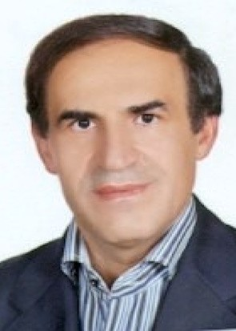tronics.Since 1998, he has been working as Lecturer with the IRIB university of applied

science and technology (UAST) and Islamic Azad University, Tehran, Iran. He has pub- lished a book for DTTB. His current research interests are DVB-T, LDM, NOMA/OFDMA, 5G Broadband and Broadcast Hybrid systems.

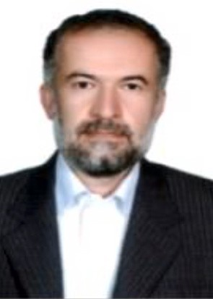**Saeed Ghazi Maghrebi** was born in Iran in 1963. He received the B.S. degree in Electrical Engineering from Kerman Univer- sity, Iran, in 1988, and the M.S. degree from the Khajeh Nasir- edin- Toosi University of technology, Iran, in 1995. He received the PhD degree in digital communications from Islamic Azad University, Iran in 2010. He has published six books. He has received the grade of the second degree of 30th Khwarizmi International Award (KIA) on Feb. 2017. He is designer of Ira- nian national data centre. He is a dean of Azad University, Yadegar-e-Imam Khomeini (RAH) Share-Rey Branch, Tehran, Iran. His current research interests are digital communication, signal processing and adaptive filtering.

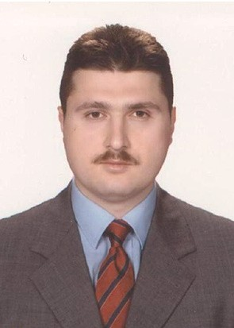**Bahattin Karakaya** received his B.S., M.S. and Ph.D. degrees in Electrical and Electronic Engineering from Istanbul University, Istanbul, Turkey, in 1998, 2002 and 2010, respectively. During his Ph.D. study, he collaborated with the WCSP research group in University of South Florida, FL, USA. He worked as a Post- doctoral researcher in a project at Qatar University from 2011 to 2014. He is currently working as an Assistant Professor in Istanbul University since May 2015. His research interests include channel estimation, OFDM and SC-FDMA based sys- tems, cooperative communication, underwater acoustic com- munications, MIMO, NOMA.