[](Journal%20logo)[Artificial Intelligence in Agriculture 1 (2019) 27–34](https://doi.org/10.1016/j.aiia.2019.03.002)

Contents lists available at [ScienceDirect](http://www.sciencedirect.com/science/journal/)

Artificial Intelligence in Agriculture

journal homepage: [http://www.keaipublishing.com/en/j ournals/artificial- intelligence-in-agriculture/](http://www.keaipublishing.com/en/journals/artificial-intelligence-in-agriculture/)

[](http://crossmark.crossref.org/dialog/?doi=10.1016/j.aiia.2019.03.002&domain=pdf)Application of artificial intelligence for separation of live and dead rainbow trout fish eggs

Abbas Rohani a,⁎, Morteza Taki b, Ghasem Bahrami a

a *Department of Biosystems Engineering, Faculty of Agriculture, Ferdowsi University of Mashhad, Mashhad, Iran*

b *Department of Agricultural Machinery and Mechanization, Agricultural Sciences and Natural Resources University of Khuzestan, Mollasani, Iran*

# a r t i c l e i n f o

*Article history:*

Received 23 January 2019

Received in revised form 20 March 2019

Accepted 21 March 2019

Available online 25 March 2019

*Keywords:* Rainbow trout Fish egg

K-fold cross validation Machine vision system

# a b s t r a c t

In this study a visual machine technology-based intelligent system was developed and evaluated for separation and recognizing the alive and dead eggs of rainbow trout fish. The features derived from imagery processing of alive and dead eggs were used as the decision-making variables in the classifier. Multi-layer Perceptron neural network (MLP) and Support Vector Machine (SVM) models were used as the classifiers. With paired *t*-test, 10 effective features were selected from 15 features for classification. The *k*-fold cross validation method was used for better evaluation the classifiers. By changing the size of the training data set from 80% to 20%, the clas- sifier ability and stability were evaluated. The results showed that in the training phase, all the mean values of the statistical indices for MLP and SVM classifications were complete for all categories (100% of the classification was predicted correctly). Also, in the test phase, the performance indicators of both classifiers were very satisfactory (the average accuracy was 99.45%). Therefore, it is possible to use both classifiers with certainty for separation the rainbow trout fish eggs.

© 2019 The Authors. Publishing services by Elsevier B.V. on behalf of KeAi Communications Co. Ltd. This is an open access article under the CC BY-NC-ND license (<http://creativecommons.org/licenses/by-nc-nd/4.0/>).

1. Introduction

In Iran and some of other countries, healthy fish eggs are separated from the unhealthy ones traditionally and manually. Now, this method is used in many fish farms. But in some fish egg production centers, the eggs were separated by semi-automatically methods. This method is constrained by low speed, low accuracy and high cost. These big disad- vantages have increased the efforts to build a more accurate device by image processing method to solve the problems and improve the effi- ciency. Machine vision system includes a camera for taking a picture and also a computer with efficient software and hardware and lighting system. The quality of the images depends on the light conditions at the time of shooting. So if this factor is better, more accurate processing re- sults will be achieved (Du and Sun, 2004). In this method, images pro- cessing needs the new tools for smart grids to process the images in shorter time with the high level of confidence. The network is based on the general trainings to acquire data and it can be implemented for other data (Mitchell et al., 1996). Color and texture are useful features that can be extracted from the images. Color is regarded as a low-level feature. This feature can be extracted from the homogeneous images and parts of objects in the image (Kim and Hong, 2009). The histological features play a very important role in the classification of pattern. The best algorithms for texture feature are GLCM (Gray-Level Co-

* Corresponding author.

*E-mail address:* [arohani@um.ac.ir](mailto:arohani@um.ac.ir) (A. Rohani).

Occurrence Matrix) (Sengur, 2008). Since counting the number of fish by hand is difficult and also the possibility of error is high, a system based on the image processing in different places and conditions was designed (Zion et al., 2006). The system can count the number of fishes. The algorithm can work with 98% accuracy. In another study, a commer- cial software was designed to count the fish eggs (Friedland et al., 2005). The images were taken from fish eggs. By algorithm dilation erosion, seven geometric and dimensional features were extracted and finally the fish eggs were counted properly. Kunrui et al. (2015), built an egg grading machine (Kunrui et al., 2015). In this system, images were taken when the eggs moved by a typical rails. Then, the images were processed to drive their features such as morphological and color char- acteristics. Six features were extracted from color space. The procedure speed was 5400 eggs per hour. Experimental results showed that preci- sion of this system was approximately 90%. In another research, image processing techniques was applied for analysis the silkworm eggs (Kiratiratanapruk et al., 2014). This technique could detect objects and types of eggs. The experiment was conducted in Thailand Sericulture Center. The authors extracted 60 samples from seven kinds of silkworm eggs. Color properties in RGB, HSV, LAB and YUV domains were ex- tracted. Silkworm eggs processing speed was up to 140 eggs per second. Precision of this system was approximately 90%. Omid et al. (2013), de- signed a technique based on machine vision and neural network to grade the eggs (Omid et al., 2013). This system could detect some fea- tures such as blood clots and egg shell cracking. Color characteristics were extracted from HSV space. Fuzzy inference system was used for

<https://doi.org/10.1016/j.aiia.2019.03.002>

2589-7217/© 2019 The Authors. Publishing services by Elsevier B.V. on behalf of KeAi Communications Co. Ltd. This is an open access article under the CC BY-NC-ND license ([http://](http://creativecommons.org/licenses/by-nc-nd/4.0/) [creativecommons.org/licenses/by-nc-nd/4.0/](http://creativecommons.org/licenses/by-nc-nd/4.0/)).

Nomenclature

MLP Multi-layer Perceptron SVM Support Vector Machine

GLCM Gray-Level Co-Occurrence Matrix MSE mean of the squared error

Trainbr Bayesian regularization back-propagation Trainlm Levenberg–Marquardt back-propagation ANN Artificial Neural Network

BN Bayesian Network

DT Decision Trees

KNN k-Nearest Neighbors

SVDD Support Vector Machine Data Description CI confidence interval

griding. Precision of this system was 95%, 94.5% and 98% for the size, crack and fracture, respectively. In another study, Soltani and Omid (2015), designed a system based on electrochemical impedance spec- troscopy technique and machine vision (Soltani and Omid, 2015). This method was based on the variations of dielectric properties. In this sys- tem, when the eggs were put into the sensor, dielectric properties were changed. The eggs were graded on the basis of some characteristics such as mass, thickness and length. The separation technique involves the Ar- tificial Neural Network (ANN), Bayesian Network (BN), Decision Trees (DT) and Support Vector Machine (SVM). All these methods had a good precision. In a research, applied machine vision systems were pro- posed to detect and identify the sardine eggs (Powell et al., 2003). On- line imaging system was used for detecting and counting the fish eggs included lamps, flow cells, pumps and computer with suitable hardware and software for image processing. Some features such as size, shape and shadow were extracted. These characteristics were used as the in- puts in the regression tree algorithms. With this system, 9987 sardine eggs were counted. Results showed that SVM is a very useful technique for pattern recognition and distinguishing the two groups. Today, appli- cation of SVM and ANN as powerful algorithms for distinguish between the two groups is quite common (Robotham et al., 2010; Cortes and Vapnik, 1995). In the fields of ecological and biological applications, SVM is better than ANN (Morris et al., 2001). Some of researchers used these methods for the ecological and biological subject. Hu et al. (2012), used SVM and ANN technique for the separation of common sardine fish and jack mackerel in south-central Chile (Hu et al., 2012). The extracted features such as morphological, bathymetric, energetica and positional were used for classification the two species. The results showed that this method had 89.5% confidence for the fish classification. To help Chinese fishermen and diagnose fish diseases, Storbeck and Dan developed a method (Storbeck and Daan, 2001). In this system, at the first step, the fishes were taken on the rail. Then images captured from fishes by smartphones. Some characteristics such as width, length, textural properties and statistical properties of wavelet transform were extracted. Multi class SVM was used for grouping the fish species. The results showed that the best method for diagnosing the diseases of fish was the extracting properties of the color in the HSV space and use of one-against-one algorithm in SVM. In another study, two methods including pattern recognition and near infrared was combined for classifying the freshness of egg (Zhao et al., 2010). For classification,

support vector machine data description (SVDD) was used. In this re-

search, the range of spectra for egg was 10–4000 cm−1. For examination of the classification method, some methods like k-Nearest Neighbors (KNN), ANN and SVM were used. At last, SVDD had the best results. Pre- cision of this system was approximately 93.3%. The results showed that this method was an excellent way for solving similar problems.

The above literatures showed that little research was done for sepa- ration and identification the fish eggs especially in Iran. So, the present

study was aimed to develop a visual machine for separation the alive and dead fish eggs. The images were categorized with two classifiers: SVM and MLP. The results of this research can be useful for food engi- neers to construct an accurate device for solve this problem.

1. Materials and methods
   1. *Image acquisition and features extraction*

In this research, images were captured with a Canon Digital Asus 500 VHS. Since the fish eggs were small, the size of images was selected as 280 × 280 pixels. After several image capturing, the camera was fixed at 40 cm above the plate containing the samples. After analysis of im- ages, the quality of the fish eggs was determined. The texture and color features were derived from image processing. This process con- sists of two stages:

1. Image processing technique including:
   * Capturing the images of fish eggs.
   * Resize the images to 280 × 280 pixels.
   * Convert the images from RGB to LAB (for color features).
   * Convert images from RGB to GRAY (for texture features).
   * Labeling the each object.
2. Feature extraction. In this section, color and texture features were ex- tracted from each labeled. Features of the fish egg are including the contrast, correlation, energy, homogeneity, LBP (mean and standard deviation) and LAB (mean, standard deviation and range) values. These features were used for separating the fish eggs. Fig. 1 shows the original and converted image of a sample egg.
   * 1. *Color features*

In this section, at first, backgrounds of the images were omitted. After that, it was needed a color space that was not affected by imaging instrument and condition. RGB color space dos not have this condition. So, LAB color space was used. Unlike the RGB, this system is similar to the human eye. Also, it is not affected by the instrument (Shafiee et al., 2014). In this space, L is the equivalent to brightness and A has an unlimited amount (the positive values represent the red and the neg- ative values are green). The positive value of B is equal to yellow and the negative is equal to blue. In the literatures, most food industry re- searchers use LAB space frequently. For each space of LAB, three statis- tical properties and nine color features were extracted.

Mean is the average of statistical factor or central tendency. Standard deviation (Std) is used to determine the amount of the data dispersion and finally, range is the span between the largest and smallest value (Zion et al., 2006).

* + 1. *Texture's features*

Another aspect of analysis is the extraction of features from texture. For this stage, the images were converted from color to gray. After that, for extract the texture features, functions GLCM and LBP were applied. In this method, the images were converted into a two dimensional ma- trix as a GLCM, where each element was the probability of getting color intensity *i* and *j* in the neighborhood of the distance d and the angle θ (00, 450, 900, 1350). Finally, by using the function, the features were ex- tracted. Before calculating the function on the co-occurrence matrix, each element of the matrix should be normalized. Data were normal- ized by dividing each element by the total numbers of considered pixels pairs. Haralick and Shanmugam (1973) used co-occurrence matrix for the first time to extract texture features of images to troubleshoot grapefruit (Haralick and Shanmugam, 1973). However, the closer the amount of pixels to each other, the more concentrated the main diago- nal matrix and as compared to a simple histogram of pixels in the loca- tion information, location data are lost and only the frequency of pixel

[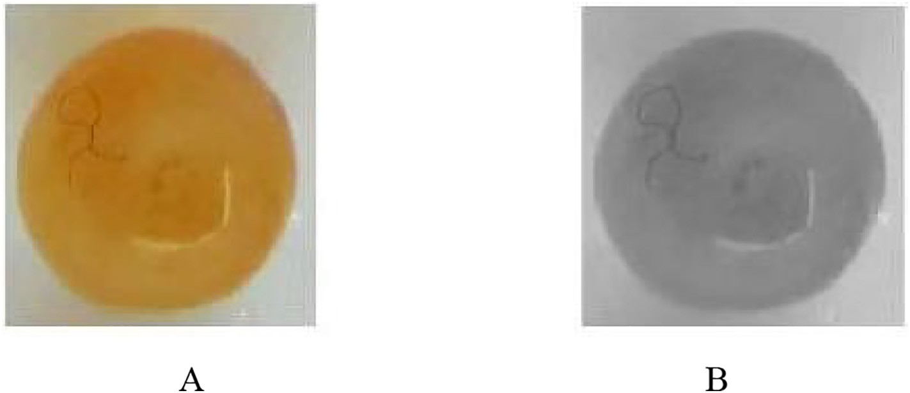](Image%20of%20Fig.%201)

Fig. 1. The original and converted image (A and B) of a sample egg.

gray values is calculated and locations of the pixel matrix are considered.

In this research, energy is a measurement of image homogeneity. Be- cause the homogeneous gray level is low, the values are squared (Gong et al., 1992). Contrast is the local variations in the pixels of an image. Dif- ference between the brightest whites and deepest blacks in an image is defined as contrast. If the difference between these two factors is high, the value of the factors become high and then the quality of the image will increase. Homogeneity is defined as the combination of the ele- ments, parts and characters of the image. Correlation is the linear de- pendence of gray levels in neighboring pixels or certain parts of the image. If the same gray level is high, it implies that the correlation be-

classifier method and composed of at least three layers (Fig. 2). The first layer is the input layer whose size is equivalent to the number of features intended for the classification. There is a weight equivalent to each input. The hidden layer is formed by some neurons. The present re- search, evaluated 3, 5, …, 13 neurons in hidden layer. The number of neurons in hidden layer at most cases, found out by trial and error (Abutaleb, 1991). The output layer was supposed to include two neu- rons since the objective of the present study was to classify fish eggs of alive eggs with optimum output [1 0] and dead ones with optimum output [0 1]. The transfer function of output layer was sigmoid type. Two functions, sigmoid and hyperbolic tangent, were evaluated as transfer function for the hidden layer as below:

tween them is high (Broomhead and Lowe, 1988). In this study, 100 im- ages were derived from both alive and dead eggs. Fifteen features were extracted from each image as shown in Table 1.

* 1. *MLP classifier*

*out* = 1

1 + *e*−∑ *Fiwij*+*b*

*out* = 2

1 + *e*−∑2 *Fiwij*+*b*

(1)

−1 (2)

Multilayer perception (MLP) neural network with back propagation algorithm was used to classify the fish eggs. MLP neural network is a

where, Fi, b and wij denote *i*th input, bias and weight of *j*th neuron, respectively.

Table 1

Features derived from the images of fish eggs.

|  |  |  |  |  |  |  |  |
| --- | --- | --- | --- | --- | --- | --- | --- |
| Feature | Symbol | Feature | Symbol | Feature | Symbol | Feature | Symbol |
| Contrast | F1 | Mean local binary pattern | F5 | Range (in the space L) | F9 | Std (in the space B) | F13 |
| Correlation | F2 | Standard deviation of local binary pattern | F6 | Mean (in the space A) | F10 | Range (in the space b). | F14 |
| Energy | F3 | Mean (in the space L) | F7 | Range (in the space A) | F11 | Range (in the space B). | F15 |
| Homogeneity | F4 | Std (in the space L) | F8 | Mean (in the space B) | F12 | – |  |

[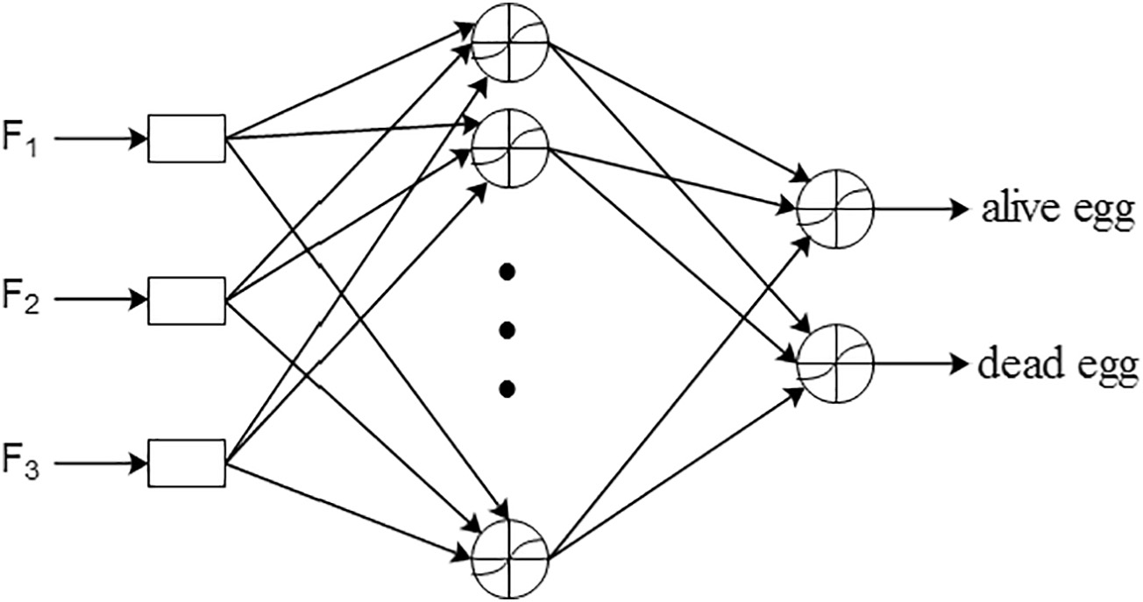](Image%20of%20Fig.%202)

Fig. 2. MLP classifier with three inputs and two outputs.

[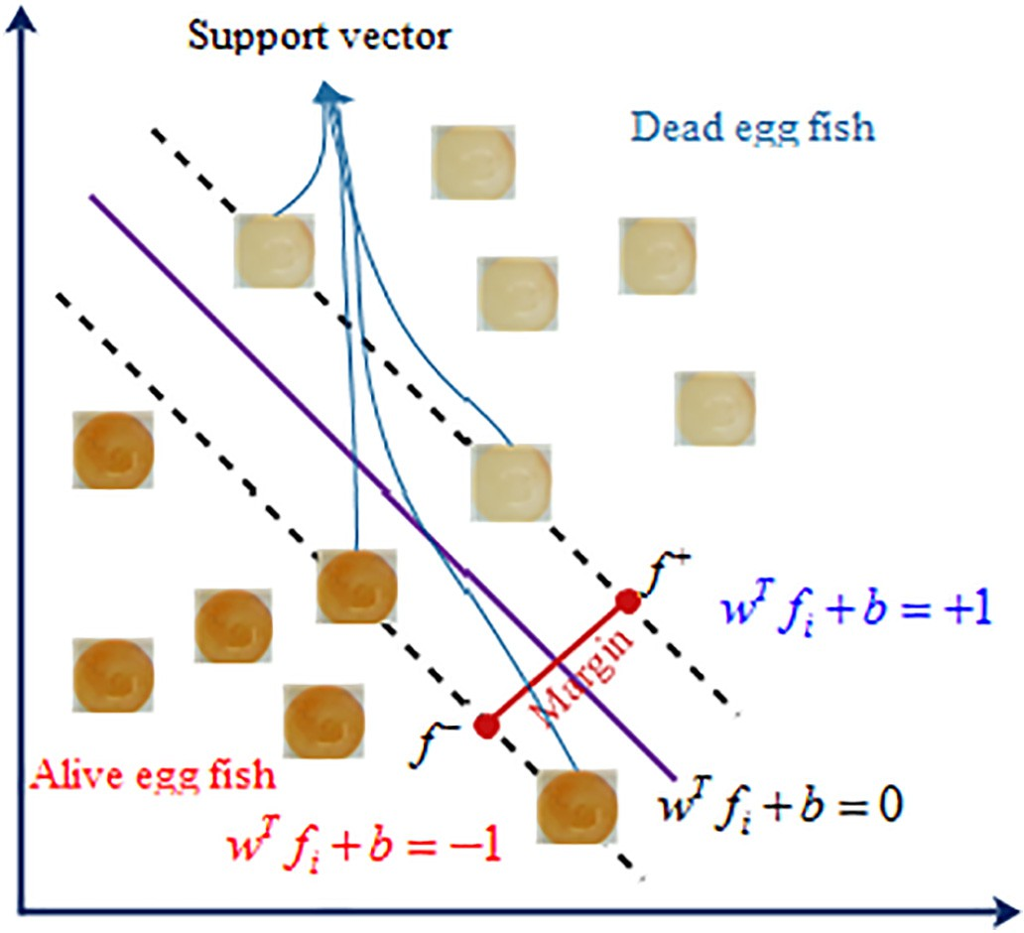](Image%20of%20Fig.%203)

Fig. 3. Linear SVM classifier.

The optimum weights and biases in MLP classifier were derived by training functions. In this research, two functions were used: Bayesian regularization back-propagation (Trainbr) and Levenberg–Marquardt back-propagation (Trainlm), for the training and optimization of

Table 2

Comparison of means for the features.

|  |  |  |  |  |  |  |  |
| --- | --- | --- | --- | --- | --- | --- | --- |
| Feature | Mean |  | p-Value | Feature | Mean |  | p-Value |
|  | Class I | Class II |  |  | Class I | Class II |  |
| F1 | 13,344.3 | 13,088.0 | 0.00⁎ | F9 | 18.809 | 13.195 | 0.00⁎ |
| F2 | 0.0018 | −0.0006 | 0.16ns | F10 | 23.674 | 5.334 | 0.00⁎ |
| F3 | 0.00001 | 0.00001 | 0.35ns | F11 | 1.4971 | 1.1556 | 0.00⁎ |
| F4 | 0.03376 | 0.03351 | 0.00⁎ | F12 | 20.043 | 14.434 | 0.00⁎ |
| F5 | 16.2205 | 16.2205 | 0.09ns | F13 | 51.947 | 36.226 | 0.00⁎ |
| F6 | 35.178 | 28.989 | 0.00⁎ | F14 | 1.2642 | 1.0425 | 0.01⁎ |
| F7 | 69.622 | 59.303 | 0.00⁎ | F15 | 18.465 | 16.913 | 0.08ns |
| F8 | 0.8563 | 0.7860 | 0.213ns |  |  |  |  |

* Significant at 0.01 level.

ns Not significant.

network weights. Mean of the squared error (MSE) criterion was used as the optimization index for MLP network performance:

*n*

= 1 X ( *i i*) ( )

*mse T* −*P* 2 3

*n i*=1

where, Ti and Pi represent target and predicted class, respectively. After each training cycle, the weights of network were updated to reach min- imize MSE (Ripley, 2007).

* 1. *SVM classifier*

Support Vector Machine (SVM) is a classifier based on statistical learning. It uses two strategies of keeping empirical risk at a constant value and minimizing confidence interval (CI) (Vapnik, 2013). The

[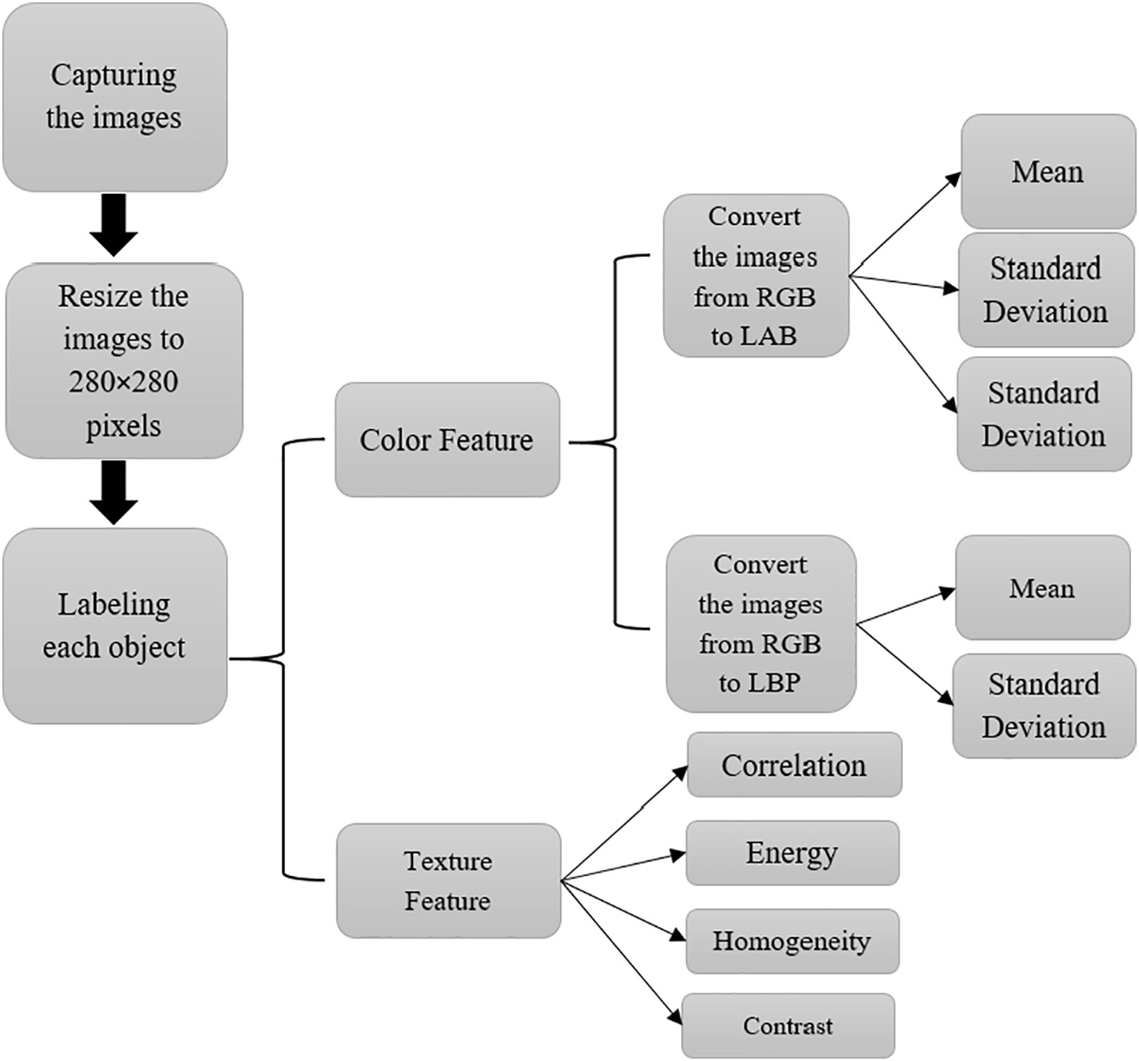](Image%20of%20Fig.%204)

Fig. 4. Flow chart of the present research.

Table 3

The results of statistical indexes for MLP classifier.

|  |  |  |  |  |  |  |  |  |  |  |  |  |
| --- | --- | --- | --- | --- | --- | --- | --- | --- | --- | --- | --- | --- |
| Nn TF | Trainlm |  |  |  |  |  | Trainbr |  | | | | |
|  | Train phase  Accuracy | Precision |  | Test phase  Accuracy | Precision |  | Train phase  Accuracy | Precision |  | Test Phase  Accuracy | Precision |  |
| 3 logsig | 99.99 ± 0.06 | 99.99 ± 0.12 |  | 99.45 ± 1.04 | 99.00 ± 2.01 |  | 99.99 ± 0.06 | 99.99 ± 0.12 |  | 99.65 ± 0.89 | 99.25 ± 1.79 |  |
| tansig | 99.38 ± 0.08 | 99.97 ± 0.16 |  | 99.59 ± 0.93 | 99.19 ± 1.85 |  | 100 ± 0.00 | 100 ± 0.00 |  | 99.35 ± 1.10 | 98.87 ± 2.20 |  |
| 5 logsig | 99.96 ± 0.14 | 99.93 ± 0.29 |  | 99.56 ± 1.05 | 99.10 ± 1.93 |  | 99.53 ± 0.98 | 99.05 ± 1.97 |  | 99.53 ± 0.98 | 99.05 ± 1.97 |  |
| tansig | 99.96 ± 0.32 | 99.98 ± 0.18 |  | 99.28 ± 1.14 | 98.60 ± 2.26 |  | 100 ± 0.00 | 100 ± 0.00 |  | 99.40 ± 1.07 | 98.80 ± 2.14 |  |
| 7 logsig | 99.98 ± 0.10 | 99.96 ± 0.21 |  | 99.30 ± 1.12 | 98.80 ± 2.14 |  | 100 ± 0.00 | 100 ± 0.00 |  | 99.66 ± 0.89 | 99.25 ± 1.79 |  |
| tansig | 99.99 ± 0.06 | 99.99 ± 0.13 |  | 99.42 ± 1.05 | 98.85 ± 2.11 |  | 100 ± 0.00 | 100 ± 0.00 |  | 99.48 ± 1.02 | 98.95 ± 2.04 |  |
| 9 logsig | 99.98 ± 0.12 | 99.95 ± 0.25 |  | 99.38 ± 1.08 | 98.75 ± 2.18 |  | 100 ± 0.00 | 100 ± 0.00 |  | 99.40 ± 0.89 | 98.80 ± 2.14 |  |
| tansig | 99.96 ± 0.15 | 99.93 ± 0.29 |  | 99.58 ± 0.94 | 99.15 ± 1.88 |  | 99.99 ± 0.06 | 98.75 ± 0.12 |  | 99.72 ± 0.78 | 99.45 ± 1.57 |  |
| 11 logsig | 99.99 ± 0.06 | 99.99 ± 0.12 |  | 99.48 ± 1.00 | 99.00 ± 2.00 |  | 100 ± 0.00 | 100 ± 0.00 |  | 99.62 ± 0.89 | 99.25 ± 1.79 |  |
| tansig | 99.99 ± 0.06 | 99.99 ± 0.12 |  | 99.50 ± 1.02 | 99.05 ± 1.97 |  | 100 ± 0.00 | 100 ± 0.00 |  | 99.62 ± 0.89 | 99.25 ± 1.79 |  |
| 13 logsig | 99.98 ± 0.10 | 99.96 ± 0.21 |  | 99.48 ± 1.02 | 98.95 ± 2.05 |  | 100 ± 0.00 | 100 ± 0.00 |  | 99.50 ± 1.00 | 99.00 ± 2.01 |  |
| tansig | 99.96 ± 0.15 | 99.92 ± 0.29 |  | 99.42 ± 1.05 | 99.15 ± 1.88 |  | 100 ± 0.00 | 100 ± 0.00 |  | 99.62 ± 0.89 | 99.25 ± 1.79 |  |

main idea of SVM is to apply a hyperplane to separate the input patterns into two classes. Fig. 3 shows the SVM classifier with a linear hyper- plane. As it was mentioned, in this research, two-class classification problem were examined.

The patterns derived from the processing of fish egg images have an N-dimensional feature vector. The value *y* ∈ {−1,+1} is defined for each input vector *f* as:

f = { f1, f2, f3, …, f*m*}∈*RN* (4)

*2.4. Performance assessment of SVM and MLP classifiers*

To evaluate the performance of the model, some criteria have been used from the literature. In this research the following criteria used to evaluate the classifiers based on the number of patterns recognized cor- rectly (TP), rejected correctly (TN) and also the number of patterns rec- ognized incorrectly (FP) or rejected incorrectly (FN) as the following equations:

And for a linear SVM classifier:

*f* (f) = ( f.w) + *b* (5)

*Accuracy*(%) = *TP* + *TN*

*TP* + *TN* + *FP* + *FN*

*TP*

× 100 (8)

where w ∈ *RN* and b ∈ R. The training dataset was defined as:

*Precision*(%) = *TP* + *FP* × 100 (9)

(*y*1, f1), …, (*yl*, f*l*), *yi*∈{−1, 1} (6)

*Sensitivity*(%) = *TP*

*TP* + *FN*

× 100 (10)

It can be assumed that the training set is linearly separable, whereas the following inequalities hold valid for all members of training set:

*F*−*score*(%) = 2 × *Sensitivity* × *Precision* × 100 (11)

*Sensitivity* + *Precision*

*TN*

w. f*i* + *b* ≥1 if *yi* = 1

w. f*i* + *b* ≤−1 if *yi* = −1

(7)

*Specificity*(%) = *TN* + *FP* × 100 (12)

The optimum hyperplane is unique and is derived during training phase in order to obtain the highest margin. MATLAB 2016b software package was used to develop SVM and MLP models. Fig. 4 shows the total procedure of the work.

*AUC* 1 *TP*  *TN*  13

2 *TP* + *FN TN* + *FP*

= × + ( )

*YI* = *Sensitivity*−(1−*Specificity*) (14)

Table 4

The results of sensitivity analysis for MLP classifier.

Train phase Test phase

Accuracy Precision Accuracy Precision

Table 5

The performance of MLP classifier at three phases (train, test and total).

Accuracy Precision Sensitivity F-score Specificity AUC YI

|  |  |  |  |  |  |  |  |  |  |  |  |  |  |  |
| --- | --- | --- | --- | --- | --- | --- | --- | --- | --- | --- | --- | --- | --- | --- |
| All | 100 ± 0.00 | 100 ± 0.00 | 99.66 ± 0.89 | 99.25 ± 1.79 |  |  | Min | 100 | 100 | 100 | 100 | 100 | 1 | 1 |
| All except F1 | 100 ± 0.00 | 100 ± 0.00 | 99.65 ± 0.86 | 99.30 ± 1.30 |  | Train | Max | 100 | 100 | 100 | 100 | 100 | 1 | 1 |
| All except F4 | 99.25 ± 1.05 | 99.72 ± 0.79 | 97.00 ± 2.31 | 97.60 ± 3.23 |  | | Mean | 100 | 100 | 100 | 100 | 100 | 1 | 1 |
| All except F6 | 100 ± 0.00 | 100 ± 0.00 | 99.65 ± 0.87 | 99.30 ± 1.75 |  | | std | 0 | 0 | 0 | 0 | 0 | 0 | 0 |
| All except F7 | 100 ± 0.00 | 100 ± 0.00 | 99.20 ± 1.17 | 98.40 ± 2.35 |  | | Min | 97.50 | 95.00 | 100 | 97.44 | 95.24 | 0.98 | 0.95 |
| All except F9 | 99.96 ± 0.15 | 99.92 ± 0.29 | 99.40 ± 1.07 | 99.00 ± 2.02 | Test | | Max | 100 | 100 | 100 | 100 | 100 | 1 | 1 |
| All except F10 | 99.98 ± 0.12 | 99.95 ± 0.25 | 99.65 ± 0.87 | 99.30 ± 1.75 |  | | Mean | 99.45 | 98.90 | 100 | 99.44 | 98.95 | 0.99 | 0.99 |
| All except F11 | 100 ± 0.00 | 100 ± 0.00 | 99.60 ± 0.92 | 99.20 ± 1.85 |  | | std | 1.04 | 2.08 | 0 | 1.06 | 1.98 | 0.01 | 0.01 |
| Al except F12 | 100 ± 0.00 | 100 ± 0.00 | 99.60 ± 0.92 | 99.20 ± 1.85 |  | | Min | 99.50 | 99.00 | 100 | 99.49 | 99.00 | 0.99 | 0.99 |
| All except F13 | 100 ± 0.00 | 100 ± 0.00 | 99.35 ± 1.10 | 98.70 ± 2.21 | Total | | Max | 100 | 100 | 100 | 100 | 100 | 1 | 1 |
| All except F14 | 100 ± 0.00 | 100 ± 0.00 | 99.65 ± 0.87 | 99.30 ± 1.75 | Mean | | | 99.45 | 99.78 | 100 | 99.89 | 98.95 | 0.99 | 0.99 |
| F4F9F10 | 100 ± 0.00 | 100 ± 0.00 | 99.45 ± 1.04 | 98.89 ± 2.07 | Std | | | 0.20 | 0.42 | 0 | 0.20 | 1.98 | 0.00 | 0.00 |

[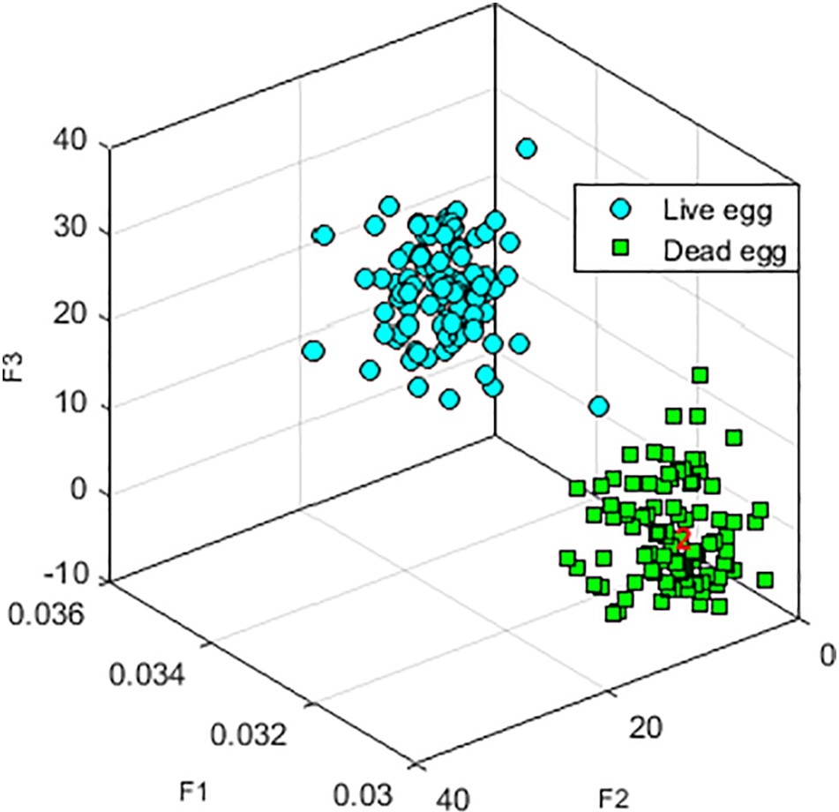](Image%20of%20Fig.%205)

Fig. 5. Dispersion of two classes of alive and dead eggs based on the three selected variables.

1. Results and discussion
   1. *Feature selection*

The number of features can be reduced to minimize the calculations and increase the classification speed. In this research, paired *t*-test was applied for statistical comparison. In this method, the features showing insignificant differences between alive and dead egg classes are re- moved from the set of features (Table 2). As it can show, there are no significant differences (*p*-value N0.05) in five features (F2, F3, F5, F8, and F15) between two classes at the 5% level. The lack of significant dif- ferences between the features of two classes confirms that these two

Table 6

The performance of SVM-rbf classifier at train, test and total phases.

|  |  |  |  |  |  |  |  |
| --- | --- | --- | --- | --- | --- | --- | --- |
|  | Accuracy | Precision | Sensitivity | F-score | Specificity | AUC | YI |
| Train Min | 100 | 100 | 100 | 100 | 100 | 1 | 1 |
| Max | 100 | 100 | 100 | 100 | 100 | 1 | 1 |
| Mean | 100 | 100 | 100 | 100 | 100 | 1 | 1 |
| std | 0 | 0 | 0 | 0 | 0 | 0 | 0 |
| Test Min | 97.5 | 95 | 100 | 97.47 | 95.23 | 0.98 | 0.95 |
| Max | 100 | 100 | 100 | 100 | 100 | 1 | 1 |
| Mean | 99.57 | 99.15 | 100 | 99.56 | 99.19 | 0.99 | 0.99 |
| std | 0.94 | 1.88 | 0 | 0.96 | 1.79 | 0.00 | 0.00 |
| Total Min | 99.5 | 99 | 100 | 99.49 | 99.49 | 0.99 | 0.99 |
| Max | 100 | 100 | 100 | 100 | 100 | 1 | 1 |
| Mean | 99.92 | 99.83 | 100 | 99.91 | 99.91 | 0.99 | 0.99 |
| std | 0.18 | 0.37 | 0 | 0.18 | 0.37 | 0.00 | 0.00 |

classes cannot be distinguished by these features. So other 10 features were selected for classification.

* 1. *MLP classifier*

MLP neural network is used as an intelligent method to separate the fish eggs. Ten selected features (Table 2) were included as the inputs of the MLP model. Table 3 shows the means and standard de- viations of two performance features of the classifiers (accuracy and precision) at the train and test phases. The values in Table 3 were derived from 100 different datasets for train and test by 5-fold cross validation method with 20 replications. Two training algo- rithms (Trainlm and Trainbr) and two transformation functions (logsig and tansig) were used for the neurons of the hidden layer. Also, the number of neurons in the hidden layer was changed from 3 to 13. The value of standard deviation was unequal to zero because the network performance at the train and test phases depended on the datasets selected for the train phase. As it can be observed, the best result in training algorithm (Trainlm) at both training and test phases was derived by tansig transformation function at 11 neurons in the hidden layer. The performance comparison of two training algorithms revealed that the Trainbr algorithm is better

[101](Image%20of%20Fig.%206)

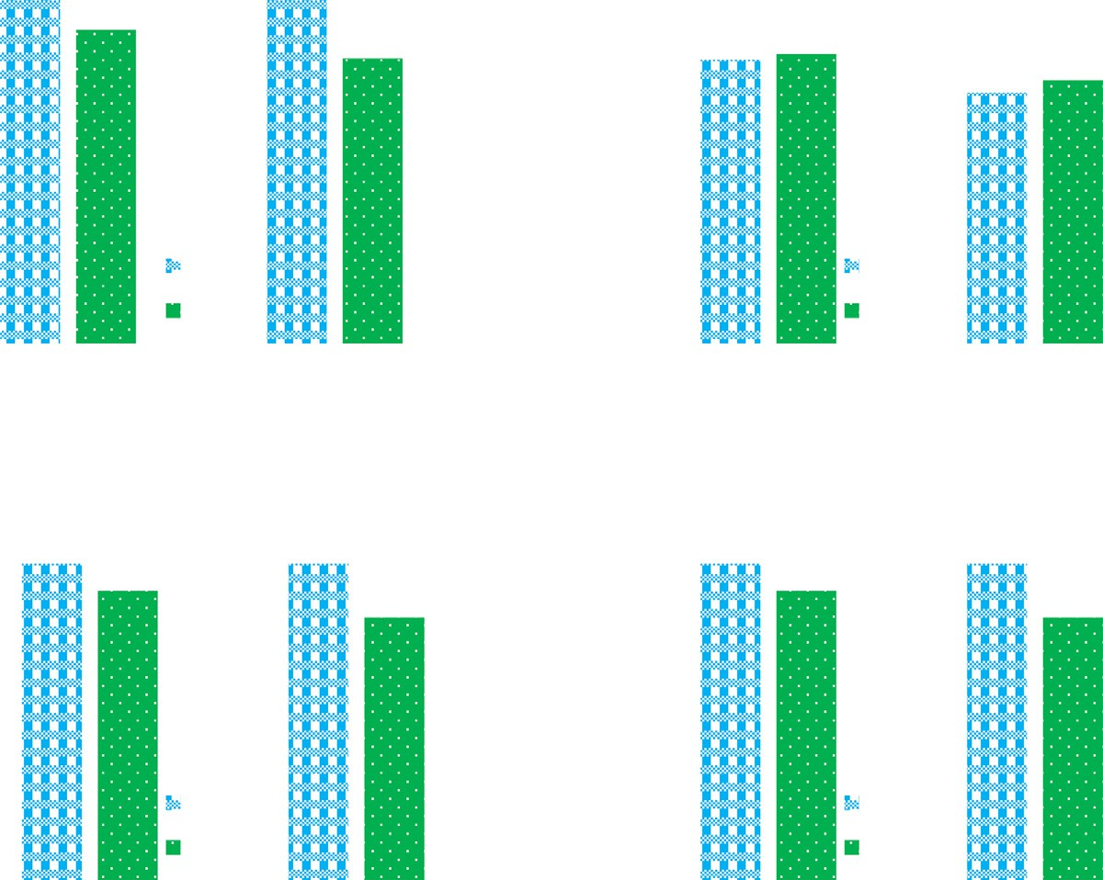

[100](Image%20of%20Fig.%206)

[99](Image%20of%20Fig.%206)

[98](Image%20of%20Fig.%206)

[97](Image%20of%20Fig.%206)

[96](Image%20of%20Fig.%206)

[95](Image%20of%20Fig.%206)

## [(a)](Image%20of%20Fig.%206)

[100 100](Image%20of%20Fig.%206)

[99.57](Image%20of%20Fig.%206)

[99.15](Image%20of%20Fig.%206)

[Train Test](Image%20of%20Fig.%206)

[101](Image%20of%20Fig.%206)

[100](Image%20of%20Fig.%206)

[99](Image%20of%20Fig.%206)

[98](Image%20of%20Fig.%206)

[97](Image%20of%20Fig.%206)

[96](Image%20of%20Fig.%206)

[95](Image%20of%20Fig.%206)

## [(b)](Image%20of%20Fig.%206)

[99.48 99.57](Image%20of%20Fig.%206)

[Train Test](Image%20of%20Fig.%206)

[98.96 99.15](Image%20of%20Fig.%206)

[Accuracy Precision Accuracy Precision](Image%20of%20Fig.%206)

[101](Image%20of%20Fig.%206)

[100](Image%20of%20Fig.%206)

[99](Image%20of%20Fig.%206)

[98](Image%20of%20Fig.%206)

[97](Image%20of%20Fig.%206)

[96](Image%20of%20Fig.%206)

[95](Image%20of%20Fig.%206)

[**(c)**](Image%20of%20Fig.%206)

[100 100](Image%20of%20Fig.%206)

[99.57](Image%20of%20Fig.%206)

[99.15](Image%20of%20Fig.%206)

[Train Test](Image%20of%20Fig.%206)

[Accuracy Precision](Image%20of%20Fig.%206)

[101](Image%20of%20Fig.%206)

[100](Image%20of%20Fig.%206)

[99](Image%20of%20Fig.%206)

[98](Image%20of%20Fig.%206)

[97](Image%20of%20Fig.%206)

[96](Image%20of%20Fig.%206)

[95](Image%20of%20Fig.%206)

[**(d)**](Image%20of%20Fig.%206)

[100 100](Image%20of%20Fig.%206)

[99.57](Image%20of%20Fig.%206)

[99.15](Image%20of%20Fig.%206)

[Train Test](Image%20of%20Fig.%206)

[Accuracy Precision](Image%20of%20Fig.%206)

Fig. 6. Results of SVM based on four types of kernel function: (a: RBF), (b: linear), (c: poly2) and (d: poly3).

Table 7

Evaluation of MLP and SVM with different sizes in training set.

|  |  |  |  |  |  |  |  |  |  |
| --- | --- | --- | --- | --- | --- | --- | --- | --- | --- |
|  | | Classifier | Accuracy | Precision | Sensitivity | F-score | Specificity | AUC | YI |
| Train | 80 | MLP | 100 ± 0.0 | 100 ± 0.0 | 100 ± 0.0 | 100 ± 0.0 | 100 ± 0.0 | 1 ± 0.00 | 1 ± 0.00 |
|  |  | SVM | 100 ± 0.0 | 100 ± 0.0 | 100 ± 0.0 | 100 ± 0.0 | 100 ± 0.0 | 1 ± 0.00 | 1 ± 0.00 |
|  | 60 | MLP | 100 ± 0.0 | 100 ± 0.0 | 100 ± 0.0 | 100 ± 0.0 | 100 ± 0.0 | 1 ± 0.00 | 1 ± 0.00 |
|  |  | SVM | 100 ± 0.0 | 100 ± 0.0 | 100 ± 0.0 | 100 ± 0.0 | 100 ± 0.0 | 1 ± 0.00 | 1 ± 0.00 |
|  | 40 | MLP | 100 ± 0.0 | 100 ± 0.0 | 100 ± 0.0 | 100 ± 0.0 | 100 ± 0.0 | 1 ± 0.00 | 1 ± 0.00 |
|  |  | SVM | 100 ± 0.0 | 100 ± 0.0 | 100 ± 0.0 | 100 ± 0.0 | 100 ± 0.0 | 1 ± 0.00 | 1 ± 0.00 |
|  | 20 | MLP | 100 ± 0.0 | 100 ± 0.0 | 100 ± 0.0 | 100 ± 0.0 | 100 ± 0.0 | 1 ± 0.00 | 1 ± 0.00 |
|  |  | SVM | 100 ± 0.0 | 100 ± 0.0 | 100 ± 0.0 | 100 ± 0.0 | 100 ± 0.0 | 1 ± 0.00 | 1 ± 0.00 |
| Test | 20 | MLP | 99.45 ± 1.04 | 98.90 ± 2.08 | 100 ± 0.0 | 99.44 ± 1.06 | 98.95 ± 1.98 | 0.99 ± 0.01 | 0.99 ± 0.01 |
|  |  | SVM | 99.58 ± 0.94 | 99.15 ± 1.89 | 100 ± 0.0 | 99.56 ± 0.97 | 99.19 ± 1.80 | 0.99 ± 0.01 | 0.99 ± 0.02 |
|  | 40 | MLP | 99.53 ± 0.61 | 99.05 ± 1.22 | 100 ± 0.0 | 99.52 ± 0.62 | 99.07 ± 1.19 | 0.99 ± 0.01 | 0.99 ± 0.01 |
|  |  | SVM | 99.53 ± 0.61 | 99.05 ± 1.22 | 100 ± 0.0 | 99.52 ± 0.62 | 99.07 ± 1.19 | 0.99 ± 0.01 | 0.99 ± 0.01 |
|  | 60 | MLP | 99.57 ± 0.42 | 99.13 ± 0.84 | 100 ± 0.0 | 99.56 ± 0.42 | 99.15 ± 0.82 | 1.00 ± 0.00 | 0.99 ± 0.01 |
|  |  | SVM | 99.56 ± 0.42 | 99.13 ± 0.84 | 99.98 ± 0.16 | 99.55 ± 0.42 | 99.15 ± 0.82 | 0.99 ± 0.00 | 0.99 ± 0.00 |
|  | 80 | MLP | 99.49 ± 0.25 | 98.99 ± 0.49 | 100 ± 0.0 | 99.49 ± 0.25 | 99.00 ± 0.49 | 1.00 ± 0.0 | 0.99 ± 0.00 |
|  |  | SVM | 99.49 ± 0.26 | 99.00 ± 0.50 | 99.98 ± 0.24 | 99.48 ± 0.26 | 99.01 ± 0.50 | 0.99 ± 0.00 | 0.99 ± 0.01 |

than Trainlm at train phase because its recognition error was zero in most cases and its results were better than Trainlm at test phase. The best performance of Trainbr was observed by seven neurons (in the hidden layer) with logsig transformation function. So, the Trainbr algorithm led to a better result than Trainlm with lower number of neurons.

* + 1. *Sensitivity analysis*

At the first step, 10 features that could effectively separate alive and dead fish eggs were selected by statistical comparison. Then, the most appropriate training algorithm and transformation function of neurons in the hidden layer and their number was selected for MLP neural net- work. At this step, the sensitivity analysis was carried out to determine the most sensitive features (Table 4). In this table, MLP performance is shown after the removal of the ten features (one-by-one) at the train and test phases. If the removal of a feature had a negative impact on the performance of the classifier, it would be considered as a highly im- portant feature for the separation of the two classes (alive and dead eggs). So, three variables (F4, F9 and F10) were selected as the most im- portant and effective features in the separation of fish eggs because their exclusion from the inputs, affected the performance of the classifier as compared to the inclusion of all ten features.

Table 5 shows the minimum, mean and standard deviation of the

performance parameters for MLP neural network at train, test and whole phases for 100 various datasets of 5-fold cross validation method. In this section, MLP was trained by three inputs selected at sensitivity analysis step. The results of training phase showed that MLP classifier could perfectly separate the alive and dead fish eggs by the three se- lected features. Also the results of test phase showed that MLP had a good performance at this phase, too. In total, mean precision of MLP neural network was found to be 99.45%.

Fig. 5 shows the features dispersion of alive and dead fish egg classes. Accordingly, these two classes were highly separable based on the three selected variables.

* 1. *SVM classifier*

In the present study, SVM model was used as another classifier. Ac- cording to the results of Table 4, three features (F4, F9 and F10) were se- lected as the inputs of SVM. One important parameter that influences the performance of SVM is the kernel function type. Means and standard deviations of accuracy and precision at train and test phases are shown for different types of kernel functions including linear, second-order polynomial (poly2), third-order polynomial (poly3) and radial basis function (rbf) (Fig. 6). The results showed that rbf function type has the better performance than other function types. However, all the three functions of rbf, poly2 and poly3 had similar mean results, but

standard deviation of rbf was lower than the other two types. Thus, rbf was more stable and had the better generalizability. In this analysis, linear function had the weakest performance. So, the separation of the classes needs a non-linear function.

Table 6 shows some descriptive statistical features of SVM-rbf per- formance parameters at three phases of train, test, and total for 100 dif- ferent datasets of 5-fold cross validation. Similar to MLP, the results of training phase of SVM-rbf was derived with 100% precision for all datasets. Furthermore, results of test phase confirmed the capability of SVM. SVM results were highly similar to MLP (Table 5). So, both classi- fiers were found to be equally capable for recognition and separation of alive and dead fish eggs.

* 1. *Evaluation of data size on the classifier performance*

To evaluate the capability and generalizability of two classifiers,

i.e. MLP and SVM, different sizes of datasets were used for training. So, 80, 60, 40 and 20% of all data were randomly devoted to training set and the rest was proportionately used for test section. So, the models with large (80%) to small (20%) sizes of training set were evaluated. For the evaluation, the same 100 datasets selected by 5- fold method with 20 replications were used and the mean and stan- dard deviation of the performance parameters were estimated at train and test phases (Table 7). Results of train phase showed that both classifiers had perfect capability because their error was zero at train phase. The results of test phase showed that larger size of test set will decrease the total error of prediction and no significant differences were observed between SVM and MLP. So, it can be con- cluding that both SVM and MLP have high capability in separating alive and dead eggs.

1. Conclusion and recommendation

In this paper, 15 features were selected out of 200 images of alive and dead eggs of rainbow trout fish by image processing technique. Be- tween them, 10 features were chosen as the effective ones by statistical comparison of two classes. The 5-fold cross validation technique was used with 20 replications to evaluate the performance of MLP and SVM models. The results showed that the best choice for the classifica- tion for the fish eggs was MLP with Trainbr training algorithm and seven neurons with logsig transformation function in hidden layer. The results of MLP sensitivity analysis showed that with three features (F4, F9 and F10), almost 100% classifications could be achieved. The same features were used by SVM classification. The rbf type was applied as a kernel function for SVM. The results of SVM classification showed insignificant differences between MLP and SVM classifiers. Finally, the generalizability of two classifiers was assessed by reducing the size of

training set. The results showed that both classifiers had the equally high capability. Finally, the proposed method can play an effective role in separating the alive and dead fish eggs. Some recommendations are below:

1. Extracting some of the properties such as the volume and weight of each fish egg can lead to a stronger algorithm design.
2. Designing an algorithm based on a large amount of fish and not one- on-one can play a significant role in the speed of the separating.
3. The design of an algorithm that does not require the removal of eggs from water and can eliminate the noise of water in the photos should be considered in the next researches.

Acknowledgments

Financial supports from the Ferdowsi University of Mashhad and Ag- ricultural Sciences and Natural Resources University of Khuzestan, are highly appreciated.

References

Abutaleb, A.S., 1991. [A neural network for the estimation of forces acting on radar targets.](http://refhub.elsevier.com/S2589-7217(19)30004-2/rf0005)

[Neural Netw. 4 (5), 667–67](http://refhub.elsevier.com/S2589-7217(19)30004-2/rf0005)8.

Broomhead, D.S., Lowe, D., 1988. [Radial Basis Functions, Multi-variable Functional Inter-](http://refhub.elsevier.com/S2589-7217(19)30004-2/rf0010) [polation and Adaptive Networks (Retrieved from)](http://refhub.elsevier.com/S2589-7217(19)30004-2/rf0010).

Cortes, C., Vapnik, V., 1995. [Support-vector networks. Mach. Learn. 20 (3), 273–29](http://refhub.elsevier.com/S2589-7217(19)30004-2/rf0015)7.

Du, C.-J., Sun, D.-W., 2004. [Recent developments in the applications of image processing](http://refhub.elsevier.com/S2589-7217(19)30004-2/rf0020) [techniques for food quality evaluation. Trends Food Sci. Technol. 15 (5), 230–24](http://refhub.elsevier.com/S2589-7217(19)30004-2/rf0020)9.

Friedland, K., Ama-Abasi, D., Manning, M., Clarke, L., Kligys, G., Chambers, R., 2005. [Auto-](http://refhub.elsevier.com/S2589-7217(19)30004-2/rf0025) [mated egg counting and sizing from scanned images: rapid sample processing and](http://refhub.elsevier.com/S2589-7217(19)30004-2/rf0025) [large data volumes for fecundity estimates. J. Sea Res. 54 (4), 307–31](http://refhub.elsevier.com/S2589-7217(19)30004-2/rf0025)6.

Gong, P., Marceau, D.J., Howarth, P.J., 1992. [A comparison of spatial feature extraction al-](http://refhub.elsevier.com/S2589-7217(19)30004-2/rf0030) [gorithms for land-use classification with SPOT HRV data. Remote Sens. Environ. 40](http://refhub.elsevier.com/S2589-7217(19)30004-2/rf0030) [(2), 137–151](http://refhub.elsevier.com/S2589-7217(19)30004-2/rf0030).

Haralick, R.M., Shanmugam, K., 1973. [Textural features for image classification. IEEE Trans.](http://refhub.elsevier.com/S2589-7217(19)30004-2/rf0035)

[Syst. Man Cybern. 3 (6), 610–62](http://refhub.elsevier.com/S2589-7217(19)30004-2/rf0035)1.

Hu, J., Li, D., Duan, Q., Han, Y., Chen, G., Si, X., 2012. [Fish species classification by color, tex-](http://refhub.elsevier.com/S2589-7217(19)30004-2/rf0040) [ture and multi-class support vector machine using computer vision. Comput. Elec-](http://refhub.elsevier.com/S2589-7217(19)30004-2/rf0040) [tron. Agric. 88, 133–14](http://refhub.elsevier.com/S2589-7217(19)30004-2/rf0040)0.

Kim, J.-S., Hong, K.-S., 2009. [Color–texture segmentation using unsupervised graph cuts.](http://refhub.elsevier.com/S2589-7217(19)30004-2/rf0045)

[Pattern Recogn. 42 (5), 735–75](http://refhub.elsevier.com/S2589-7217(19)30004-2/rf0045)0.

Kiratiratanapruk, K., Watcharapinchai, N., Methasate, I., Sinthupinyo, W., 2014. [Silkworm](http://refhub.elsevier.com/S2589-7217(19)30004-2/rf0050) [Eggs Detection and Classification Using Image Analysis (Paper presented at the Com-](http://refhub.elsevier.com/S2589-7217(19)30004-2/rf0050) [puter Science and Engineering Conference (ICSEC), 2014 International)](http://refhub.elsevier.com/S2589-7217(19)30004-2/rf0050).

Kunrui, X., Xi, L., Qiaohua, W., Meihu, M., 2015. [Online automatic grading of salted eggs](http://refhub.elsevier.com/S2589-7217(19)30004-2/rf0055) [based on machine vision. Int. J. Agric. Biol. Eng. 8 (1), 35–41](http://refhub.elsevier.com/S2589-7217(19)30004-2/rf0055).

Mitchell, R.S., Sherlock, R.A., Smith, L.A., 1996. [An investigation into the use of machine](http://refhub.elsevier.com/S2589-7217(19)30004-2/rf0060) [learning for determining oestrus in cows. Comput. Electron. Agric. 15 (3), 195–213](http://refhub.elsevier.com/S2589-7217(19)30004-2/rf0060). Morris, C.W., Autret, A., Boddy, L., 2001. [Support vector machines for identifying organ-](http://refhub.elsevier.com/S2589-7217(19)30004-2/rf0065) [isms—a comparison with strongly partitioned radial basis function networks. Ecol.](http://refhub.elsevier.com/S2589-7217(19)30004-2/rf0065)

[Model. 146 (1), 57–67](http://refhub.elsevier.com/S2589-7217(19)30004-2/rf0065).

Omid, M., Soltani, M., Dehrouyeh, M.H., Mohtasebi, S.S., Ahmadi, H., 2013. [An expert egg](http://refhub.elsevier.com/S2589-7217(19)30004-2/rf0070) [grading system based on machine vision and artificial intelligence techniques. J. Food](http://refhub.elsevier.com/S2589-7217(19)30004-2/rf0070) [Eng. 118 (1), 70–77](http://refhub.elsevier.com/S2589-7217(19)30004-2/rf0070).

Powell, J., Krotosky, S., Ochoa, B., Checkley, D., Cosman, P., 2003. [Detection and Identifica-](http://refhub.elsevier.com/S2589-7217(19)30004-2/rf0075) [tion of Sardine Eggs at Sea Using a Machine Vision System Oceans 2003. Celebrating](http://refhub.elsevier.com/S2589-7217(19)30004-2/rf0075) [the Past… Teaming Toward the Future (IEEE Cat. No. 03CH37492)](http://refhub.elsevier.com/S2589-7217(19)30004-2/rf0075).

Ripley, B.D., 2007. [Pattern Recognition and Neural Networks. Cambridge University Press](http://refhub.elsevier.com/S2589-7217(19)30004-2/rf0080). Robotham, H., Bosch, P., Gutiérrez-Estrada, J.C., Castillo, J., Pulido-Calvo, I., 2010. [Acoustic](http://refhub.elsevier.com/S2589-7217(19)30004-2/rf0085) [identification of small pelagic fish species in Chile using support vector machines and](http://refhub.elsevier.com/S2589-7217(19)30004-2/rf0085)

[neural networks. Fish. Res. 102 (1), 115–122](http://refhub.elsevier.com/S2589-7217(19)30004-2/rf0085).

Sengur, A., 2008. [Wavelet transform and adaptive neuro-fuzzy inference system for color](http://refhub.elsevier.com/S2589-7217(19)30004-2/rf0090) [texture classification. Expert Syst. Appl. 34 (3), 2120–2128.](http://refhub.elsevier.com/S2589-7217(19)30004-2/rf0090)

Shafiee, S., Minaei, S., Moghaddam-Charkari, N., Barzegar, M., 2014. [Honey characteriza-](http://refhub.elsevier.com/S2589-7217(19)30004-2/rf0095) [tion using computer vision system and artificial neural networks. Food Chem. 159,](http://refhub.elsevier.com/S2589-7217(19)30004-2/rf0095) [143–15](http://refhub.elsevier.com/S2589-7217(19)30004-2/rf0095)0.

Soltani, M., Omid, M., 2015. [Detection of poultry egg freshness by dielectric spectroscopy](http://refhub.elsevier.com/S2589-7217(19)30004-2/rf0100) [and machine learning techniques. LWT Food Sci. Technol. 62 (2), 1034–1042.](http://refhub.elsevier.com/S2589-7217(19)30004-2/rf0100)

Storbeck, F., Daan, B., 2001. [Fish species recognition using computer vision and a neural](http://refhub.elsevier.com/S2589-7217(19)30004-2/rf0105) [network. Fish. Res. 51 (1), 11–15](http://refhub.elsevier.com/S2589-7217(19)30004-2/rf0105).

Vapnik, V., 2013. [The Nature of Statistical Learning Theory. Springer Science & Business](http://refhub.elsevier.com/S2589-7217(19)30004-2/rf0110) [Media](http://refhub.elsevier.com/S2589-7217(19)30004-2/rf0110).

Zhao, J., Lin, H., Chen, Q., Huang, X., Sun, Z., Zhou, F., 2010. [Identification of egg's freshness](http://refhub.elsevier.com/S2589-7217(19)30004-2/rf0115) [using NIR and support vector data description. J. Food Eng. 98 (4), 408–414](http://refhub.elsevier.com/S2589-7217(19)30004-2/rf0115).

Zion, B., Doitch, N., Ostrovsky, V., Alchanatis, V., Segev, R., Barki, A., Karplus, I., 2006. [Orna-](http://refhub.elsevier.com/S2589-7217(19)30004-2/rf0120) [mental Fish Fry Counting by Image Processing. Agricultural Research Organization,](http://refhub.elsevier.com/S2589-7217(19)30004-2/rf0120) [Bet Dagan](http://refhub.elsevier.com/S2589-7217(19)30004-2/rf0120).